HVAC Design Project:

**Investigating VAV Systems with Economizers**

*May 7, 2010*

**Project Statement:**

The following is an analytical research project on the implementation of economizer control on a Variable Air Volume (VAV) system in an office building in Austin, Texas. The VAV system will supply adequate heating, cooling, and ventilation from a main air-handling unit to individual VAV boxes for each zone, and will be designed to meet the maximum requirements within each of the zones. The VAV system will also include a reheat coil in each of the VAV boxes in order to optimize energy savings by avoiding wasted heating for the zones with cooler requirements. Energy savings is important for not only sustainability reasons but will also result in lower energy costs of the building.

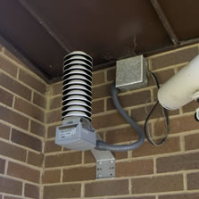Implementing the economizer will further increase energy savings for the building. There are two types of economizers: one controlled by outdoor air temperature and one controlled by outdoor air enthalpy. The economizer consists of a simple set of dampers within each air intake that open and close based on ventilation requirements and outdoor conditions. The idea is that the economizer will bring in additional quantities of outdoor air to provide “free cooling” when the outdoor air temperature or enthalpy is lower than that of the return air. The economizer analyzed in this report is controlled by enthalpy because humidity is a potential problem in Texas.

Figure 1: Outside air temperature and humidity monitor.

<http://highperformancehvac.com/hvac-control-economizer-systems>

This system allows for reduced use of the heating and cooling coil when the outdoor conditions are favorable. There are many combinations of outdoor air conditions in which the use of the economizer optimizes energy savings; however, these outdoor air conditions are not always met in Austin. The use of an economizer also helps to improve the indoor air quality of the building.

Volume flow rate supplied to each zone based on maximum heating and cooling loads will be calculated and analyzed for differing supply air temperatures. The effect of implementing an economizer within this VAV system will then be analyzed through variations of economizer control based on differing outside conditions. The estimated duration of use for an economizer will be determined for three distinct scenarios.

Project Outcomes:

* Volume flow rate of supply air determined for summer and winter loads; VAV Boxes sized
* Supply Air temperatures set and reheat determined when necessary
* Conditions when use of economizer would be beneficial
* Energy saved from use of economizer for a given condition
* Effect on fan power with changing air volumes and temperature set points

**Building Description:**

The building analyzed is a simple, two-story, square office building located in Austin, Texas. The building is about 28,000 square feet with 5 zones on each floor, see Figures 2 & 3: Building Orientation and Zone Diagram. The building is divided into perimeter and core zones and has a cardinal orientation.

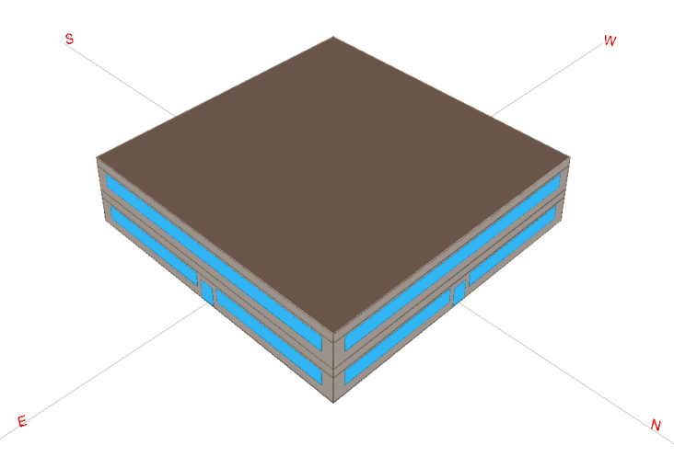

Figure 3: Zone Diagram

Figure 2: Building Orientation

Preliminary heating and cooling loads were calculated through eQUEST. The eQUEST model assumed a plenum space above the first and second floor when in reality the rooms will be at full height with no plenum space above. The preliminary loads can be seen in Figure 4: Preliminary Load Calculations.

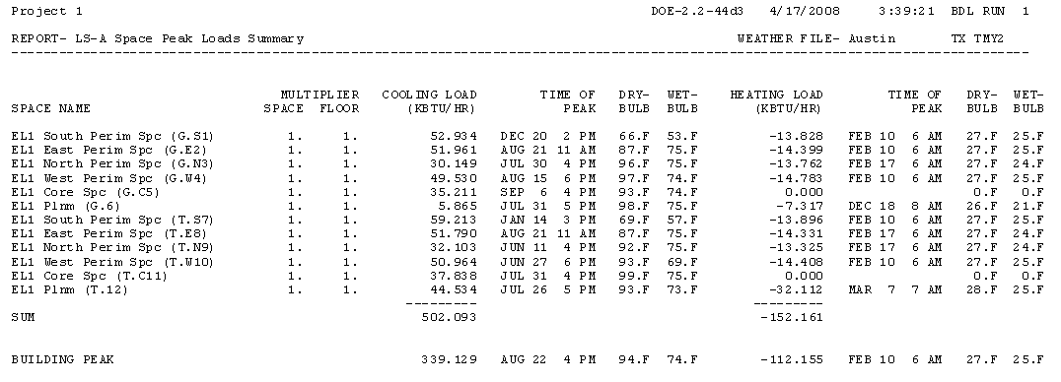

Figure 4: Preliminary Load Calculations

**Methodology:**

*Cooling and Heating Load Calculations:*

The first step in analyzing the VAV system was to calculate the actual heating and cooling loads from the given eQUEST data by correcting each zone load for the plenum space loads by area.

The heating loads for the central zone on the bottom floor will not have any additional load from the plenum since this zone will still need cooling in the winter; plenum loads on the bottom floor will only be transmitted to the perimeter zones.

*VAV boxes:*

Using the corrected cooling and heating loads, we will calculate the volume of supply air for each zone for both summer and winter conditions from equation 1:

Eq. 1

Q = ρVcp(t2 – t1) therefore, V = Q / [ρcp(t2 – t1)]

Where t1 and t2 are supply and room air temperatures, respectively. We will then compare this to the outdoor air requirements for ventilation, and adjust the supply air volume flow rate accordingly. Once the final volume flow rate of the supply air is determined for each zone, we will determine how much reheat energy is needed for the perimeter zones during winter conditions through equation 1 using the temperature difference between zones and solving for Q. We will also analyze how changing the supply air temperature in the central zone will affect the reheat energy for the other zones as well as what affect this would have on the fan power of the system.

*Economizer Scenarios:*

Three scenarios were investigated to determine if an economizer would be appropriate to use with Austin’s climate. We compared the heating and cooling load with and without the economizer using equation 2:

Eq. 2

Q=ρV(h2 – h1)

Where h2 varies depending on the use of an economizer and h1 is the supply air set point enthalpy.

Scenario 1 (shown in Figure 5) occurs frequently in Austin’s climate since cooling is required for the majority of the year. In this scenario, the return air dampers and outside air dampers are partially open and the cooling coil is active. The outside air dampers are open just enough to meet fresh air ventilation requirements.

Example condition to be investigated:

June 10th at 2:00pm

Tdry bulb= 93.02 F  
RH= 46%

Figure 5: Scenario 1

Scenario 2 (shown in Figure 6) occurs intermittently in the moderate fall or spring season when cooling is required but the outside air is closer to the set-point conditions than the room air.

Example condition to be investigated:

November 15th at 2:00pm

Tdry bulb= 69.98 F  
RH= 29%

Figure 6: Scenario 2

Scenario 3 (shown in Figure 7) occurs during the winter for a central zone (not exposed to the outside environment) that requires cooling even during the cold months.

Example condition to be investigated:

January 8th at 2:00pm

Tdry bulb= 37.94 F  
RH= 31%

Figure 7: Scenario 3

*Assumptions:*

* ρ and cp are constant and equal to 0.07 pcf and 0.24 BTU/lb/F respectively.
* Temperature of room air is constant and 75 F.
* Original set points for supply air are 55 F for cooling and 95 F for heating.
* Cooling coil temperature is 45 F
* Without economizer, use 30% outside air (this is governed by zone T.C11 which requires 28.8% outside air)

**Results:**

*Cooling and Heating Load Calculations:*

The corrected heating and cooling loads are as follows:

|  |  |  |  |  |  |
| --- | --- | --- | --- | --- | --- |
| **Ground Floor** | **G.S1** | **G.E2** | **G.N3** | **G.W4** | **G.C5** |
| Qcool [kBtuh] | 54.65 | 52.69 | 30.87 | 50.25 | 38.84 |
| Qheat [kBtuh] | 13.83 | 16.23 | 15.59 | 16.61 | 0 |

|  |  |  |  |  |  |
| --- | --- | --- | --- | --- | --- |
| **Top Floor** | **T.S7** | **T.E9** | **T.N9** | **T.W10** | **T.C11** |
| Qcool [kBtuh] | 64.72 | 57.29 | 37.61 | 56.47 | 65.43 |
| Qheat [kBtuh] | 17.87 | 18.30 | 17.29 | 18.38 | 19.89 |

The results show no heating needed for the central zone, which means this zone will need cooling year round.

*VAV boxes:*

Using the corrected heating and cooling loads, we calculated the volume of supply air needed for each zone in both summer and winter conditions and compared the calculated volume flow rate to the ventilations requirements, as seen below.

|  |  |  |  |  |  |
| --- | --- | --- | --- | --- | --- |
| **Ground Floor** | **G.S1** | **G.E2** | **G.N3** | **G.W4** | **G.C5** |
| Vsa cooling [CFM] | 2711 | 2613 | 1531 | 2493 | 1927 |
| Vsa heating [CFM] | 686 | 805 | 773 | 824 | 0 |
| Voa required [CFM] | 164 | 164 | 164 | 164 | ***846*** |

|  |  |  |  |  |  |
| --- | --- | --- | --- | --- | --- |
| **Top Floor** | **T.S7** | **T.E9** | **T.N9** | **T.W10** | **T.C11** |
| Vsa cooling [CFM] | 3210 | 2842 | 1865 | 2801 | 3246 |
| Vsa heating [CFM] | 886 | 908 | 858 | 912 | 987 |
| Voa required [CFM] | 148 | 148 | 148 | 148 | 935 |

The results showed that the central zone on the bottom floor was not meeting ventilation requirements with the heating load. This is due to the fact that there is no heating load for this zone and therefore needs to be supplied cooling to meet the adequate ventilation requirements of 846 CFM. Thus the cooling required for this zone is 17 kBTU/hr at a volume flow rate of 846 CFM and supply air temperature of 55 F. This results in the main air-handling system treating the air to 55 F and each perimeter VAV box will have to reheat the air to 95 F in order to supply heating to the perimeter zones. A 40 degree reheat has the potential to use a lot of energy, some of which could potentially be saved if the central zone set point temperature were changed to 65 F and the supply air was pretreated by the economizer solely through mixing re-circulated and outdoor air (no heating or cooling coil needed). The table below shows the results of the energy analysis for adjusting the set point temperature.

|  |  |  |  |
| --- | --- | --- | --- |
| **Reheat** | **30 F** | **40F** | **Energy Saved (kBTUh)** |
| Q T.C11 | 29.84 | 39.79 | 9.95 |
| Q G.S1 | 20.74 | 27.66 | 6.91 |
| Q G.E2 | 24.34 | 32.46 | 8.11 |
| Q G.N3 | 23.39 | 31.18 | 7.80 |
| Q G.W4 | 24.92 | 33.22 | 8.31 |
| Q T.S7 | 26.80 | 35.73 | 8.93 |
| Q T.E8 | 27.45 | 36.60 | 9.15 |
| Q T.N9 | 25.94 | 34.59 | 8.65 |
| Q T.W10 | 27.57 | 36.75 | 9.19 |
|  | **Total Energy Saved (kBTUh)** | | **77.00** |

Although increasing the supply air temperature has the potential to save almost 80 kBTUh of energy, this also results in an increase of volume flow rate to the zones in order to obtain the same amount of cooling, which in turn increases the fan power needed. Decreasing the reheat temperature difference by 10 degrees ultimately increases the flow rate by a factor of 1.8, and increasing the flow rate will also affect the fan power needed. In order to simplify analysis, we will assume that supplying air at 65 F will double the flow rate, thus increasing fan power by a factor of 8. In order to determine if increasing the supply air temperature will ultimately save energy, we need to know many parameters of the fan including pressure drop, fan efficiency, motor efficiency, and COP. Since there are many options for fans and thus many varying parameters, we will not calculate the energy used by increasing the fan power by a factor of 8. We will conclude however, that if this increase in fan power results in a greater energy cost than the energy savings tabulated above, it is not a wise decision to increase the supply air temperature to 65 F for the central zone during the winter.

*Economizer:*

The example conditions for each scenario reflect one hour of one day for the ground floor central zone (GC.5).

Figure 8: Scenario 1 Psychrometric Process

Figure 9: Scenario 2 Psychrometric Process

Figure 10: Scenario 3 Psychrometric Process

|  |  |  |  |
| --- | --- | --- | --- |
|  | **June 10th at 2:00pm** | **Nov 15th at 2:00pm** | **Jan 8th at 2:00pm** |
| Qcooling w/ Economizer [Btuh] | 113,308 | 40,467 | 0 |
| Qcooling w/o Economizer [Btuh] | 113,308 | 52,607 | -16,187 |
| Energy usage savings [Btuh] | None | 12,140 | 16,187 |

Note: A positive value indicates the cooling coil is active; conversely, a negative value indicates the heating coil is active.

|  |  |  |  |
| --- | --- | --- | --- |
|  | **Scenario 1** | **Scenario 2** | **Scenario 3** |
| Time applicable [hrs/yr] | 3579 | 847 | 710 |
| Percentage of year | 41% | 10% | 8% |

According to the results, for 41% of the year in Austin the economizer is not providing any savings above that of a standard system without any additional controls. This is due to the fact that the enthalpy of the outdoor air is greater than the enthalpy of the room air. Although it would be best to use only room air, ventilation requirements dictate that 30% of outdoor air must be provided.

Scenario 2 occurs 10% of the year in Austin. In this scenario, the enthalpy of the outdoor air is less than the enthalpy of the room air but greater than the enthalpy of the supply air; therefore the system’s cooling coil is still active. However, using an economizer reduces the cooling load by 12,140 Btuh because the system will be using only outdoor air rather than the 30% outdoor air mixture point.

Scenario 3 occurs only 8% of the year in Austin. In this scenario, the enthalpy of the outdoor air is less than the enthalpy of the supply air and without the economizer the mixture would be heated to the supply air temperature. To achieve the supply air conditions, the economizer adjusts the dampers to provide the right proportion of outdoor air to room air. The heat from the recirculated air is used to reach the set-point temperature. With the use of an economizer the heating coil becomes inactive. For the example provided above, an economizer will reduce the cooling load by 16,187 Btuh.

**Conclusion:**

Our results show that in Austin, only 18% of the year the economizer be providing added energy savings to the VAV system. Additional energy savings could be realized by increasing the supply air temperature from 55 F to 65 F. However, as discussed in the VAV box results section, increasing the supply air temperature also increases the volume flow rate of air required to cool the spaces. Depending on the efficiency of the fans in the VAV boxes, the savings realized by increasing the supply air temperature could be overshadowed by the added electrical cost of operating the fans at a higher rpm.

According to scenario 1, 41% of the year in Austin is too hot for the VAV system with the economizer to function any differently than the VAV system without the economizer. The remaining 41% of the year is too humid for the quantity of outside air to be increased and still maintain comfortable levels of humidity inside. Not only is extremely humid air uncomfortable for occupants, the excessive moisture will damage the VAV system components.

In conclusion, 82% of the year in Austin, the outside air is either too hot or too humid for the economizer to reduce energy usage. Although an economizer is not a huge added expense, the humidistat and thermostat controls for an enthalpy-controlled economizer can be costly. The payback period for adding an economizer in a hot and humid environment like Austin is probably not worth the upfront costs. After analyzing how and when an economizer reduces the energy usage of a VAV system, we recommend that system be utilized in colder and more temperate climates with a relative humidity ranging from 30 to 60%, closer to the ASHRAE comfort zone parameters.