**CE397 Energy Management Systems HW2**

**Due: March 5, 2015**

**Problem 1:**

You have a task to analyze performance of Frigidaire 70-PintDehumidifier, Model: FAD704DWD

For standard testing condition, room with temperature of 24°C and 65% relative humidity, the dehumidifier extracts 2.2 liters of water per kWh of electric energy (Energy Factor is 2.2. Liter/kWh). The airflow rate of dehumidifier is 450 m3/hour and the temperature of the cooling coil (evaporator) is 7 °C.

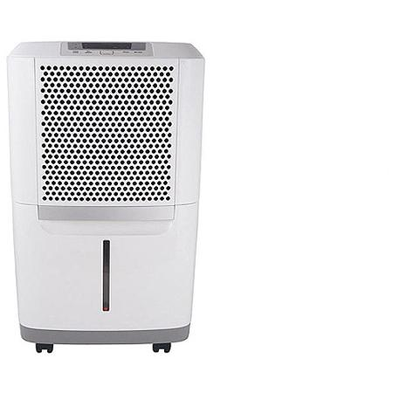Calculate:

1. Latent energy that dehumidifier extracts (in gwater / kgdry air)
2. Draw the dehumidification process in the Psychrometric Chart
3. Calculate the COPcoling for the testing condition
4. Calculate the temperature and relative humidity at the outlet of the dehumidifier
5. If this dehumidifier is in the air-conditioned (cooled) space calculate the

sensible load

Use standard density (1.2kg/m3 ) and specific capacity (1008J/kgK) of air.

**Problem 2:**

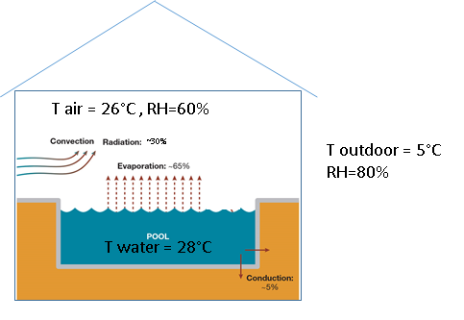

You have a task to calculate sensible and

latent loads for the swimming pool building

as well as to determine how much heating

is needed in the pool and how much energy

is needed for ventilation. The area of the

building is 2500 m2 and the height is 10 m.

The size of the olympic swimming pool is

50x25 m2 and the UA value if the envelope is

5000 W/K *(Q envelope loss = UA*∆T).*

Swimming pool evaporation coefficient

is hM= 30 kg/m2h.

*M evaporation = hM*Awater*(W water surface - Wair).*

*NOTE:* [*evaporation heat of water*](http://www.engineeringtoolbox.com/water-thermal-properties-d_162.html)

hfg *=2270 kJ/kg*

Assume that 25% energy for evaporation is coming from indoor air (air heat loss) and 75% from water (water heat loss). Also, assume that conduction and radiation energy from of the water surface (30% in figure above) ends up in air as sensible heat (air heat gains). Swimming pool is empty and beside this convective-radiative heat gains there is no other heat source. However, to keep chlorine concentration in the air (chlorine evaporated from the water) below the acceptable limit, the ventilation system provides 1 ACH of outdoor air in the pool building.

Calculate:

1. Mass of water that evaporated into the air (kg/h)
2. Sensible and latent loads of the building (in kW of thermal energy for both)
3. Sensible and latent loads of the ventilation system 9kW (in kW of thermal energy for both)
4. Amount of heating that swimming pool needs (in kW of thermal energy)

Assume all unknown variables and show all your work including psychrometric chart.

**Problem 3:**

Using data and solution from Problem 2, size the air handling unit when considering: flow rate, heat exchangers, and heat pump system.

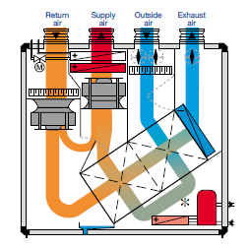

1. Determine the flow rate based on either
2. sensible or (2) latent load of the

swimming pool building. Maximum

supply temperature is 35°C and minimum

humidity ratio of supply 10 g water /kg dry air

1. Assuming the heat recovery effectiveness

of dual plate heat exchanger of 75% (50%

each), and the COP of cooling system of 3,

define the air conditioning, water heating

and ventilation process in the air handling

unit for given wither condition (loads and

set points from Problem 2).

1. Size the heater for the water pool (conden-

ser part 1) air heater (condenser part 2),

steam heater (if needed), cooling coil

(evaporator) and compressor (define the

nominal power in KW).

**Problem 4:**

Use the same AHU as in Problem 3 and define operation condition (draw the process in the psychrometric chart) for the summer operation. The pool temperature and indoor air conditions are the same like in Problem 3 (defined by problem 2). Also, the ventilation rate is the same (1 ACH), and the outdoor air condition is 35 °C with RH of 35%. Assume, the sensible heat gains through building envelope of 130 KW (due to conduction through envelope and solar radiation through windows). The minimum supply air flow rate is 13°C and like in the winter time, the minimum humidity ratio of supply 10 g water /kg dry air. The heat recovery effectiveness and the COP of cooling system are the same like in problem 3.

You need to:

1. Define airflow rate and
2. Draw the process in the psychrometric chart.