CE397 Energy Management Systems HW3 Due: October 16, 2018

Problem 1:

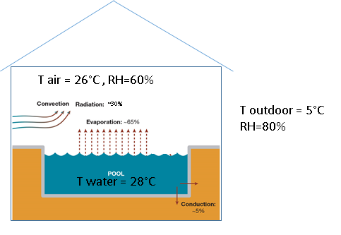
You have a task to calculate sensible and

latent loads for the swimming pool building

as well as to determine how much heating

is needed in the pool and how much energy

is needed for ventilation. The area of the

building is 2500 m² and the height is 10 m.

The size of the olympic swimming pool is

50x25 m² and the UA value if the envelope is

5000 W/K (Q _{envelope loss} = UA*∆T).

Swimming pool evaporation coefficient

is h_{M}= 30 kg/m²h.

M _{evaporation} = h_{M}*A_{water}*(W _{water surface} - W_{air}).
NOTE: evaporation heat of water
h_{fg} =2270 kJ/kg

Assume that 25% energy for evaporation is coming from indoor air (air heat loss) and 75% from water (water heat loss). Also, assume that convection and radiation energy from of the water surface (30% in figure above) ends up in air as sensible heat (air heat gains). Swimming pool is unoccupied and beside this convective-radiative heat gains there is no other heat source. However, to keep chlorine concentration in the air (chlorine evaporated from the water) below the acceptable limit, the ventilation system provides 1 ACH of outdoor air in the pool building.

Calculate:
- Mass of water that evaporated into the air (kg/h)
- Amount of heating that swimming pool needs (in kW of thermal energy)
- Sensible and latent loads of the building only (in kW of thermal energy for both)
- Sensible and latent loads of the ventilation system (in kW of thermal energy for both)

Assume all unknown variables and show all your work including psychrometric chart.

Problem 2:

Using data and solution from Problem 1, size the air handling unit when considering: flow rate, heat exchangers, and heat pump system. Minimum amount of fresh air provides 1 ACH, but it can be larger.
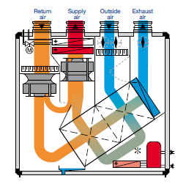
- Determine the flow rate based on either
- sensible or (2) latent load of the

swimming pool building. Maximum

supply temperature is 35°C and minimum

humidity ratio of supply 6 g _{water} /kg _{dry} _{air}
- Assuming the heat recovery effectiveness

of dual plate heat exchanger is approximately 75% (50% each), and the COP of cooling system of 3; define the air conditioning, water heating and ventilation process in the air handling unit for given wither condition (loads and set points from Problem 1).
- Cooling-cycle condenser is split into 2 units

(heaters 1&2). Size the heater for the water

pool (condenser part 1) air heater (condenser

part 2), and steam heater (if needed). Size the

cooling coil (evaporator) and compressor (define the nominal power in KW).

Problem 3:

Use the AHU as in Problem 3 and define operation condition (draw the process in the psychrometric chart) for the summer operation. You can change the flow rates also modify it by adding additional components (heat exchangers) to the AHU. The pool temperature and indoor air conditions are the same like in Problem 3 (defined by problem 2). Also, that minimum ventilation rate is the same (1 ACH), and the outdoor air condition is 35 °C with RH of 35%. Assume, the sensible heat gains through building envelope of 130 KW (due to conduction through envelope and solar radiation through windows). The minimum supply air flow rate is 13°C and like in the winter time, the minimum humidity ratio of supply 6 g _{water} /kg _{dry} _{air.} The heat recovery effectiveness is the same. However, if it is more beneficial for energy efficiency of the process you can bypass the heat recovery.

You just need to:
- Define airflow rate and
- Draw the process in the psychrometric chart.

Problem 4:
Calculate the amount of heating and cooling energy for air-conditioning for problem 1 in a case that you use a standard AHU, which do not recover energy. The schematic of the AHU is below. Assume the values for the missing data (data such as T surface of the cooling coil, etc.).

