Accounting for Ride-Hailing and Connected and Autonomous Vehicle Empty Trips in a Four-Step Travel Demand Model

Aupal Mondal
The University of Texas at Austin
Department of Civil, Architectural and Environmental Engineering
301 E. Dean Keeton St. Stop C1761, Austin, TX 78712, USA
Email: aupal.mondal@utexas.edu

Natalia Ruiz Juri
The University of Texas at Austin
Center for Transportation Research, Network Modeling Center
3925 W. Braker Ln, Stop D9300, Austin, TX 78759, USA
Email: nruizjuri@mail.utexas.edu

Chandra R. Bhat (corresponding author)
The University of Texas at Austin
Department of Civil, Architectural and Environmental Engineering
301 E. Dean Keeton St. Stop C1761, Austin, TX 78712, USA
Email: bhat@mail.utexas.edu
and
The Hong Kong Polytechnic University, Hung Hom, Kowloon, Hong Kong

Arash Mirzaei
North Central Texas Council of Governments
Model Development and Data Management
616 Six Flags Drive, Arlington, TX 76011, USA
Email: amirzaei@nctcog.org

ABSTRACT
The extension of planning tools to consider the impact of new technologies and mobility trends, such as ride hailing (RH) and connected autonomous vehicles (CAVs), is a pressing need among transportation planners and decision makers. This paper discusses the incorporation, into a four-step planning model, of empty (zero-occupancy) trips attributable to RH and CAVs. We estimate RH empty trips using an exogenous constant-multiplier. For CAVs, we consider the vehicle miles of travel (VMT) generated by empty “return home” and “park elsewhere” trips. The “return home” and “park elsewhere” trip fractions are determined using a binary choice model based on distance to home and average parking cost at the destination zone. Parking location choice is modeled using a logit approach that considers parking costs and distance to parking location. The methods developed in this work are incorporated into a model of the Dallas-Fort Worth region that was previously extended to account for RH and CAVs. Results suggest that, for a 40 percent penetration of CAVs and a four percent mode share by RH, empty trips add 22 million vehicle miles and have significant impacts on VHT and traffic congestion. While results depend on modeling assumptions, our experiment illustrates the value of extended models in understanding the implications of policies such as parking costs and limiting the movement of empty vehicles. The four-step process is still the primary tool used for long-term planning, making our proposed modeling approach a feasible option for planning organizations.

Keywords: Four-step model, empty trips, connected autonomous vehicles, ride-hailing services.

- INTRODUCTION
The second decade of the twenty-first century witnessed the emergence and rapid growth of app-based ride-hailing (RH) services as an alternative mode of transportation. The mobility landscape has also been gearing up for the market availability of connected/autonomous vehicles (CAVs), which should become a reality in the not-too-distant future. The advent of such new mobility/technology options will disrupt current activity-travel patterns. To predict the nature and magnitude of the disruption, travel demand models need to extend their consideration of travel modes to include RH and CAVs.
In the context of travel demand modeling, the four-step trip-based model remains the workhorse framework, especially in metropolitan planning organization (MPO) practice. The four-step model, while having clear limitations in its ability to reflect the richness of possible behavioral responses in a changing transportation environment, has the advantage of simplicity and ease of use over activity-based model frameworks, making it attractive as a means to predict order-of-magnitude shifts in travel due to emerging RH services and future CAV options. It is not surprising, therefore, that MPOs have continued to use the four-step model as the foundational platform over which to build and integrate new components to accommodate new travel options (1). Some transportation agencies, including the Atlanta Regional Commission (ARC) in Atlanta, Georgia, the Metropolitan Transportation Commission (MTC) in San Francisco, California, and the Puget Sound Regional Council (PSRC) in Seattle, Washington (2), have considered the impacts of CAVs in their regional transportation planning, while the North Central Texas Council of Governments (NCTCOG) in Dallas-Fort Worth, Texas (3,4), has considered both the inclusion of RH and CAV services as additional transportation modes.
When considering RH and CAVs, it is important to account for the generation of “empty” trips that lead to zero-occupancy miles. Recent studies (see for example, 5–10) suggest that empty trips may constitute a significant portion of the VMT in future year scenarios, and may lead to increased traffic congestion and delays. In this paper, we propose an approach to incorporate empty trips into a four-step model that has already been extended to consider RH and CAVs (3). In this initial effort, we assume that CAVs are individually owned vehicles, rather than deployed as an RH fleet that provides mobility as a service. Beyond this assumption, we provide a reasonably simplified but effective framework to account for the empty miles generated by RH services and (privately owned) CAVs within the four-step demand model, and demonstrate its applicability.
Overall, this paper contributes to the travel demand literature and practice by (a) proposing and implementing a methodology to accommodate empty trips in a four-step model that can be implemented in a straightforward fashion by planning organizations, and (b) illustrating the use of the methodology by predicting the amount of RH-generated and CAV-generated empty miles on the transportation network. We also discuss policy implications of the model results, which may inform the development of future scenarios.
The rest of this paper is structured as follows. The following section provides an overview of previous efforts to model empty trips. Section 3 presents our proposed methodology to incorporate empty trips within the extended RH/CAV trip-based model developed in Dias et al. (3). Section 4 discusses results and policy implications. Section 5 concludes the paper.

- BACKGROUND
Recent studies show that, in addition to regular passenger-trips, ride-hailing (RH) generates a substantial number of empty trips (referred to also as zero-occupancy or deadheading trips). Such trips are a consequence of vehicles traversing from a passenger-drop-off location to the subsequent passenger-pick-up location, or traveling before and after the first and last ride-hailing passenger-trip of the day. A few studies have attempted to address the issue of measuring and quantifying empty trips directly. Cramer and Krueger (5) compared the empty trip durations of app-based ride-hailing and traditional taxis in the cities of Boston, Los Angeles, New York, San Francisco, and Seattle. They estimated the percentage of empty trip distance traveled to be in the order of 36 percent in Los Angeles and 45 percent in Seattle. Analyses of ride-hailing trips in Austin, Texas, have generated estimates of empty trip miles ranging between 37 percent and 45 percent of all ride-hailing VMT (6,11). In a more hands-on approach, Henao and Marshall (12) themselves drove for Uber and Lyft and collected data on their own trips. They estimated that about 41 percent of their ride-hailing VMT corresponded to empty trip miles.
The studies above clearly suggest a significant contribution of RH empty trip VMT to overall VMT, which has led to an interest among MPOs to explicitly consider such empty trips in their long-term modeling efforts. Recently, Xu et al. (13) proposed an algorithm that may be used to extend traffic assignment in a way that accounts for most of the ride-hailing industry’s empty trip VMT. This is achieved by investigating the equilibrium state that results from the interactions between regular traffic and occupied, idle, and deadheading ride-hailing vehicles. In another effort, Nair et al. (7) modeled deadheading at the disaggregate level of individual trips, while also including socio-demographic data, network travel times/distances, built environment data, and employment data. The results presented in Nair et al. (2020) provide valuable insights that are likely to aid in efforts to model the RH mode within traditional MPO trip-based models.
CAVs are also likely to produce empty trips, since fully automated vehicles will not require any intervention by humans in the driving act. For the case in which CAVs are privately owned, empty trip scenarios include sending the CAVs back home after dropping-off a user at their non-home destination, sending the CAVs to park some distance from the destination point, or simply instructing the CAVs to cruise around at a slow speed to save parking costs (8). This last issue is often referred to as the “CAV parking problem.” Although many studies acknowledge that CAVs will generate empty trip miles, only a handful of studies have explored the likely magnitude of this contribution. Using a microsimulation model for the downtown San Francisco area, Millard-Ball (8) studied three potential parking strategies that CAVs are likely to adopt: (i) using free on-street parking on peripheral blocks, (ii) returning home, or (iii) cruising. Their simulation model results indicate that, for about 40 percent of the trips to downtown, the owners already enjoy parking at no cost (mostly provided by employers), and these vehicles will continue to do so without seeking out other options. For about 13 percent of the downtown trips, drivers opt for the free on-street parking option, finding unmetered and unregulated spaces. The study estimated that, based on parking cost, travel time, and travel distance assumptions, about eight percent of users in a CAV future would adopt the return-home strategy. The remaining 40 percent of vehicles are estimated to choose cruising as the “parking” strategy. Because cruising is less costly at lower speeds, a game-theory framework suggests that CAVs also have the incentive to implicitly coordinate with each other, which can exacerbate traffic congestion in and around urban centers. On the other hand, Levin et al. (14) argue that allowing for empty repositioning trips could actually be beneficial to the traffic network, since it reduces the concentration of demand at any point in time. Through the use of a dynamic traffic assignment model for the downtown Austin region, they show that the efficiency in operation achieved through the use of CAVs (beyond a certain market penetration rate) is likely to offset the additional impact of empty trips on the network, resulting in a reduction in overall congestion. In another more naturalistic experiment by Harb et al. (9), thirteen participating households were provided with 60 hours of free chauffer service to mimic a CAV environment. Researchers found an overall increase of 83 percent in VMT during the “chauffer week” compared to the control weeks. Moreover, 21 percent of the induced VMT consisted of zero-occupancy miles.
Although the CAV studies above provide important insights regarding the possible impacts of CAV empty trips on the network, they do not provide a practical methodology to incorporate empty trips within MPO four-step model frameworks. Metropolitan planning organizations (MPOs) are typically disinclined to employ a stand-alone algorithm that adds complexity to their workflows. As a result, empty trips/miles generated by RH services and CAVs are rarely accounted for today in regional planning models. In this study, we present and demonstrate potential methodologies to incorporate RH deadheading and CAVs empty trips in the context of NCTCOG’s four-step travel demand model for the Dallas-Fort Worth region, which can be easily extended and adopted by other MPOs.

- METHODOLOGY
In this section, we propose an approach to accommodate empty trips within a four-step model that already considers RH and CAVs (3,4). Figure 1 summarizes the main characteristics of the approach used to incorporate CAVs, which are assumed to be privately owned. The following sections discuss a methodology to accommodate the CAV empty trips and RH into the model presented in Figure 1.
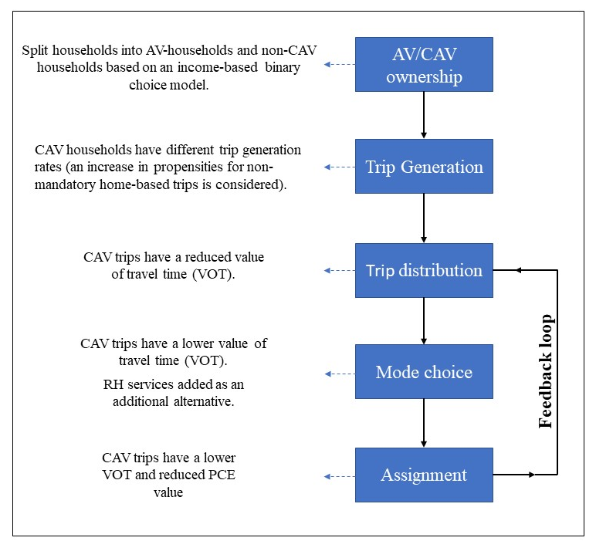
Figure 1 Approach to incorporate CAVs into a four-step model (3,4)

3.1 Methodology to Accommodate CAV Empty Trips
We consider a framework in which only home-based trips, including home-based-work (HBW) and home-based-non-work (HNW) trips, are assumed to generate empty trips for CAVs. This is because non-home based trips are usually shorter in distance, and travelers tend to spend shorter time durations at their destinations, which substantially reduces the possibility of empty trips. In this effort, we consider two types of CAV owners; those who have access to free parking at their destination through employer-provided parking or other alternatives (on-site parking), and those who do not park at their destination (alternative parking). We assume that 40 percent of CAV owners have access to onsite parking and do not generate empty trips, based on the findings by Millard-Ball (8).
The method described below generates empty vehicle trips for home-based trips by CAV owners in the two alternative options to “at-destination” parking: “return home” and “park elsewhere”. HNW trips are expected to use the “park elsewhere” alternative only. The underlying assumption is that “return home” empty trips are mostly likely to occur in the context of work trips, for which the time spent at the destination is typically long
Our method also considers the empty miles generated by the “reverse return” component of an empty trip. We define “reverse return” as a new leg of the home-based tour for CAVs that return home or park away from their destination, in which the empty CAV travels back to the original drop-off point from home or the selected parking location. As an example, if the owner of a CAV chooses to send the empty CAV to a parking zone after being dropped-off at their destination, the vehicle is expected to return to pick up the owner at a later time of day. The latter trip is the “reverse return” empty trip, which generates additional empty miles.
For each home-based tour (e.g., home-to-work trip followed by work-to-home), only one empty trip is generated (in addition to the “reverse return” trip). An empty trip is associated with the home-to-work trip, but not to the work-to-home trip, because the individual is at his/her home location at the end of this trip. This is accomplished by generating empty trips during the PA to OD conversion process. Specifically, only departure proportion factors are considered for the CAV empty trip generation based on the time-of-day (i.e., only the trips originating from the home-end is considered for the empty trip modeling). The timing of all empty trips is discussed in Section 3.1.3.

3.1.1 Estimation of Return-Home CAV Trips
Our approach assumes that the decision between returning home and parking elsewhere is based on the trade-off between the average parking cost around the destination (computed as a distance-based average of the parking cost at all zones) and the distance to home.
The cost of returning home $R_{ji}$ is computed as
$R_{ji} = {2*δ*C}_{ji}$ (1)
where $δ$ is cost/mile of CAV and $C_{ji}$is the inter-zonal distance between origin i and destination j. The factor 2 is introduced because sending an empty CAV away would effectively incur a two-way operating cost (from and back to the original destination).
The cost/mile of operating a CAV is estimated to range between 0.5$/mile and $1.6/mile (see for example, 10,15,16). Such values typically include a fixed cost component to account for the cost of purchasing the vehicle and an annual maintenance cost. We assume that CAV owners are unlikely to consider the fixed cost and long-term maintenance cost when deciding whether to have the vehicle return home or park elsewhere. We assume a conservative value of $0.5/mile as the operating mileage cost of CAVs ($δ$=0.5).
The cost of parking at zone k for trips ending at zone j, $P_{jk}$, is computed as
$P_{jk}= {2*δ*C}_{jk}+P_{k}$ (2)
where $P_{k}$ is the parking cost at zone k known to the analyst.
The average parking cost at zone j $\left(AvgPark_{j}\right)$ is
$AvgPark_{j} =\frac{\left(\sum_{k=1}^{N}{w_{k}P_{jk}}\right)}{\sum_{k=1}^{N}{w_{k}}}, where w_{k}=\frac{1}{distance_{jk}^{2}}$ (3)
where $w_{k}$ is the weight assigned to zone k and is assumed to follow an inverse-distance-squared relationship, and $N$ being the total number of zones.
Based on a binary logit choice model, the proportion of the “return home” CAVs can be determined as follows:
$Proportion of CAVs returning home from zone i to zone j$ (4)
$$=\frac{\exp\left(β_{1}R_{ji}-β_{2}AvgPark_{j}\right)}{1+ exp\left(β_{1}R_{ji}-β_{2}AvgPark_{j}\right)}$$
The values of $β_{1}$ and $β_{2}$ are assumed to be negative, since cost is generally considered as a disutility. In the absence of any data and any prior study or survey focusing on empty trip-generating behavior, we estimate $β_{1}$ and $β_{2}$ values using a trial-and-error method that considers two control points. First, we require that the average “return home” distance have a higher value than the average parking distance. This assumption is reasonable since it is unlikely that, on average, users would send their CAVs farther away to park than the distance to home. The second control point is derived from the assumption that at least 90 percent of the CAV trips for which the trip origin and destination are within the same zone will choose the “return home” option if free parking is not available to them, due to the proximity to their home location. Based on these control points and several trial-and-error iterations, we propose a value of -0.2 for $β_{1}$ and -0.1 for $β_{2}$. The zone pairwise return-home proportion matrix so formed is exogenously defined and is fixed for all iterations, because it depends on distance and fixed parking cost which do not change endogenously.

3.1.2 Estimation of Empty Park-Elsewhere CAV Trips
To select the parking location for CAVs that choose the “park elsewhere” option, we propose a simple multinomial location choice model. The logit-based probability matrix used in our approach is computed using the distance from each destination zone to all other zones, and the corresponding parking cost. Given $P_{jk}$ as in Equation 2 we define the probability of a CAV originating at zone $j$ parking at zone $k$ as:
${Park}_{jk}=\frac{\exp\left(γP_{jk}\right)}{\sum_{m=1}^{N}{\exp\left(γP_{mk}\right)}}$ (5)
with $N$ being the total number of zones.
Since a higher net parking cost is expected to be associated with a lower probability of choosing a zone for parking, the value of $γ$ will be negative and must be assumed in the absence of any data. To determine a reasonable value of $γ$, we once again use a trial-and-error method. Our single control point assumes that 30 percent of the CAV empty trips choosing “park elsewhere” will park within the empty trip origin zone itself. Our process leads to a value of -0.6 for the $γ$ coefficient. The proportion matrix so formed here is exogenous and fixed for all iterations since it is based on distance and fixed parking cost.

3.1.3 Empty Trip Timing
The four-step model in our study considers three time periods in a day: AM-peak, PM-peak and Off-peak. The time definitions of these three periods are 6:30 AM to 9:00 AM for the AM-peak period, 3:00 PM to 7:00 PM for the PM-peak period, and the rest of the day forms the off-peak period. The empty trips generated (based on the methodology just discussed) are assigned in the same time period as the original trip. However, this is not always true for the “reverse return” component in which the CAV returns to the original trip destination (from home or an alternative parking location) to pick up the owner for a subsequent (non-empty) return trip. Given the absence of data, assumptions are needed concerning the time-of-day at which these trips occur. For example, consider that, for a HBW trip, the work location to park location leg of the empty trip occurs in the AM-peak period. For such a trip, it is more likely that the “reverse return” empty leg will occur in the PM-peak rather than the AM-peak. Simple percentage assumptions are made regarding the time-of-day assignment of these “reverse return” trips keeping in mind that a significant percentage of these trips is likely to occur during the PM-peak period that is generally associated with the conclusion of the workday. The overall “reverse-return” time-of-day is assumed as follows:
- For empty trips generated in AM-peak:
Approximate reverse return periods: 10 percent in AM-peak, 30 percent in off-peak, 60 percent in PM-peak
- For empty trips generated in off-peak hours:
Approximate reverse return: 10 percent in AM-peak, 30 percent in off-peak, 60 percent in PM-peak
- For empty trips generated in PM-peak:
Approximate reverse return: 50 percent in PM-peak, 50 percent in off-peak
Figure 2 summarizes our overall methodological framework for modeling the CAV empty trips. This figure is specific to the HBW trips; the only change for the HNW trips is that it has only the “park elsewhere” component as an alternate parking option and no return home option.

3.2 Methodology for Incorporating RH Empty Trips
We implement a simple constant multiplier method to incorporate the empty trip miles associated with RH repositioning. Almost all the studies in the literature discussed earlier suggest that the RH empty miles are generally between 35 percent and 47 percent of the total RH VMT. Our method assumes that RH empty trip VMT is 40 percent of total RH VMT (i.e., for every 100 miles clocked by an RH vehicle, 40 miles are empty trip miles and 60 miles are passenger-miles), which translates into empty miles being 67 percent of the passenger-miles (a distance of 40 miles is 67 percent of 60 miles). In order to include RH empty trips within the model, we take the transpose of the original RH OD matrix ($OD_{RH}^{'}$), multiply it by 0.67, and add it back to the original RH OD matrix. Since the distance between any pair of origin and destination is almost identical in both the directions, the above operation of multiplying the transposed RH trip matrix with a constant multiplier and adding it back to the original RH trip matrix generates the desired increase in VMT assumed.
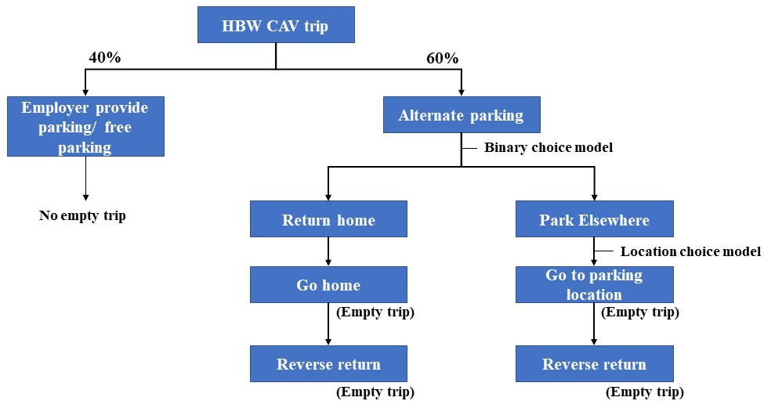
Figure 2 Methodological framework for modeling CAV empty trips

4. NUMERICAL EXPERIMENTS
The experiments described in this section demonstrate the applicability of the proposed model extensions by comparing two scenarios based on the NCTCOG 2045 network and corresponding demographic predictions:
- In the “base” scenario we consider the availability of RH and CAV services as alternative transportation modes, but we do not consider any empty trips associated with the RH and CAV.
- The “experimental” scenario considers the empty trips generated by the RH and CAV services through the methodology presented in Section 3.
The exogenous/assumed parameters considered for the incorporation of RH and CAV modes and for modeling the empty trips are presented in Table 1.
The following sections analyze results including (i) the overall impact of empty trips on the network, (ii) characterization of CAV empty trips and (iii) analysis of congestion at the zone and link class level.

TABLE 1 Exogenous/assumed Parameters for RH and CAV Specific Modes and Empty Trips
Focus | Parameter | Values
Specific to accommodating RH and CAV services in the four-step model* | Overall private CAV ownership rate  (market penetration) | 40%
 | CAV trip generation inflation factor | 5%
 | CAV VOT factor | 25% decrease
 | CAV Passenger Car Equivalent | 0.70
 | Ride-hailing cost/minute | $0.49/min
 | Ride-hailing occupancy | 1.1 occupants/vehicle
Specific to empty trip modeling | Employer provided/free parking | 40%
 | Parameters used in binary and location choice models | $$β_{1}=-0.2$$  $$β_{2}=-0.1$$  $$γ=-0.6$$
 | Ride-hailing empty miles assumption | 40% of overall RH miles
* See Nair et al. (4) for details

4.1 Network-Level Aggregate Impacts
Network-level impacts of incorporating RH and CAV empty miles are described using the following metrics, where i denotes a link.

Total vehicle-miles traveled (VMT), calculated as:
$VMT=\sum_{i=1}^{N}{{VMT}_{i}}=\sum_{i=1}^{N}{\left({link flow}_{i}⋅{link length}_{i}\right)}$ (6)
Total vehicle-hours traveled (VHT), calculated as:
$VHT=\sum_{i=1}^{N}{{VHT}_{i}}=\sum_{i=1}^{N}{\left(\frac{{link flow}_{i}⋅{link length}_{i}}{{link speed}_{i}}\right)}$ (7)
Average link-level speed, calculated as:
$Avg.Speed=\frac{1}{N}\sum_{i=1}^{N}{\frac{VMT_{i}}{VHT_{i}}}$ (8)
Average travel time, calculated as:
$Avg. Time=\frac{ VHT}{60⋅(Number of Trips)}$ (9)
Table 2 presents VMT and VHT by time of day for all trips and for CAV trips in particular. VMTs are observed to increase by about 7 percent when empty trips are incorporated, with the PM-peak period experiencing the highest increase (8 percent increase). A similar pattern is observed for VHTs, which increase by 16 percent in the PM-Peak period (and by 12 percent on average). The greater increase in VHT as compared to VMT is likely a result of the network in the base scenario being already partially congested, and therefore more likely to experience a substantial increase in delays for moderate changes in traffic volumes. CAV VMTs and VHTs increase by 16 percent and 23 percent respectively on average, with the maximum increase observed during the PM-peak period. The VMT increase experienced by RH services due to the incorporation of deadheading trips reflects our original assumption (66.6 percent of the original trips) and is not included in Table 2. RH VMTs in the base scenario are 4.27 million, and their increase to about 7.11 million does not have significant impacts on network performance.
TABLE 2 Overall Network Impacts and CAV-specific Impacts
 |  | Overall Network |  |  | AV-Specific
VMT Analysis | Time of day | Overall VMT for base case (millions) | Overall VMT considering empty trips (millions) | Percentage increase | CAV-VMT for base case (millions) | CAV-VMT considering empty trips (millions) | Percentage increase
 | AM-peak | 56.67 | 60.96 | 7.57% | 22.09 | 26.11 | 18.20%
 | PM-peak | 92.81 | 100.44 | 8.22% | 34.86 | 41.66 | 19.51%
 | Off-peak | 170.48 | 180.24 | 5.73% | 59.28 | 67.18 | 13.33%
 | All | 319.96 | 341.64 | 6.78% | 116.23 | 134.95 | 16.11%
VHT Analysis | Time of day | Overall VHT for base case (millions) | Overall VHT considering empty trips (millions) | Percentage increase | AV-VHT for base case (millions) | AV-VHT considering AV-empty trips (millions) | Percentage increase
 | AM-peak | 2.07 | 2.34 | 13.04% | 0.84 | 1.05 | 25.00%
 | PM-peak | 3.38 | 3.91 | 15.68% | 1.33 | 1.75 | 31.58%
 | Off-peak | 4.31 | 4.79 | 11.14% | 1.57 | 1.81 | 15.29%
 | All | 9.76 | 10.92 | 11.89% | 3.74 | 4.61 | 23.26%

4.2 Characterization of CAV Empty Trips
Table 3 presents a further analysis of empty CAV trips, considering VMT, VHT, and travel times. The morning peak is observed to generate the maximum “return home” miles, which result from the work-to-home empty trip leg, while the PM-peak generates the lowest “return home” miles for the work-to-home empty trip leg. A similar pattern is observed for the work-to-parking empty trip leg of HBW trips. Conversely, the “reverse return” component is highest for the PM-peak as a result of the assumptions described in Section 3.1.3. This “reverse return” component includes empty trips that are associated with the home-to-work leg (for HBW), parking-to-work leg (for HBW), and parking-to-non-work location leg (for HNW).
The average distance traveled by CAV trips that returned home empty is 4.35 miles, while the average parking distance ranges between 3.5 and 3.6 miles. This translates to an average “return home” travel time of around 9.8 minutes for the HBW empty trips during the AM-peak and PM-peak periods, and about 7.5 minutes during the off-peak period. Also, the average parking time for HNW trip type is about 9.5 mins during the AM and PM peaks and about 7 minutes during the off-peak.
TABLE 3 Overall CAV Empty Trip VMT Split and Average Metrics
 | AM-peak | Off-peak | PM-peak
Overall CAV empty trip VMT split
Return-home empty miles in millions (HBW) | 0.492 | 0.309 | 0.048
Parking empty miles in millions (HBW) | 1.506 | 0.930 | 0.144
Parking empty miles in millions (HNW) | 1.542 | 3.041 | 1.478
Reverse return miles in millions (for all types) | 0.526 | 3.583 | 5.121
Average CAV-empty trip VMT
Average return-home miles (HBW) | 4.360 | 4.351 | 4.341
Average parking miles (HBW) | 3.520 | 3.540 | 3.532
Average parking miles (HNW) | 3.611 | 3.602 | 3.608
Average CAV-empty trip time
Average return-home minutes (HBW) | 9.791 | 7.591 | 9.800
Average parking minutes (HBW) | 9.591 | 7.064 | 9.605
Average parking minutes (HNW) | 9.522 | 7.102 | 9.534

Figure 3 illustrates the percentage of CAV trips returning home and parking elsehwere. As indicated earlier, we assume 40 percent of the HBW CAV-trips will have parking at the destination (labeled as “employer-provided parking”). Thus, the split in Figure 3 is mainly relevant to the other 60 percent of the CAV trips. Figure 3 suggests that approximately 47 percent of the CAVs (overall) will park elsewhere, while 13 percent will “return home.” There is no tangible difference across times-of-day because the “return home” probability matrix is defined based on distance and cost, which do not change during the day (Section 3).

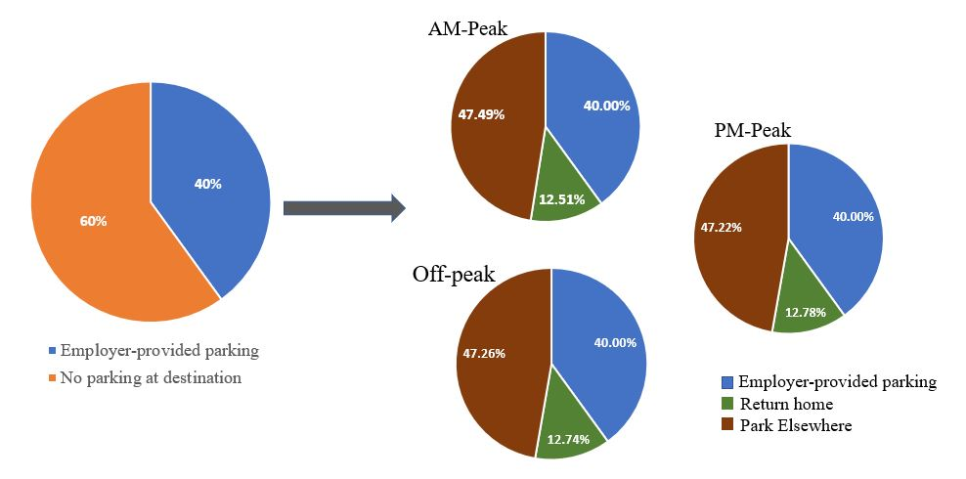
Figure 3 Split between “return home” and “park elsewhere” options

Figure 4 illustrates the distribution of the “return home” percentages based on the home-to-destination location distance for the AM-peak. The off-peak and PM-peak period distributions follow a very similar pattern. The analysis suggests that a majority (65.2 percent) of the AM-peak HBW trips with home-to-work distance within two miles return back to their home empty when employer-provided parking is not available. The fraction drops to 45 percent when the home-to-work distance is between 2-4 miles and is only 1.5 percent when the distance is more than fifteen miles. The observed trend is, of course, a result of the increase of vehicle operating cost as a function of the travel distance.
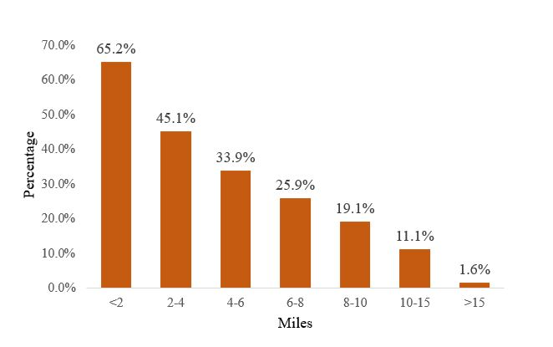
Figure 4 Distribution of “return home” percentages based on home distance: AM-peak

Figure 5 presents the distance and time distributions, respectively, for the “park elsewhere” component of empty HBW and HNW trips. Our results show that about 30 percent of the CAVs that chose to “park elsewhere” park within two miles of the drop-off destination, while a little more than 36 percent park at a distance of two to four miles. Beyond four miles, there is a sharp and continuous decrease in the percentage with distance. The increased fraction of vehicles parking in the two-to-four-mile bracket reflects the tradeoff between parking costs and parking distance. The observed trend suggests that lower parking costs may be an incentive to park farther away from the original destination, but the operating costs offset the savings in parking costs beyond four miles. In terms of travel time, close to 22 percent of the CAVs are predicted to be parked within five minutes of their destination, while 40 percent are predicted to be parked five to ten minutes away, revealing similar pattern to that of distance.

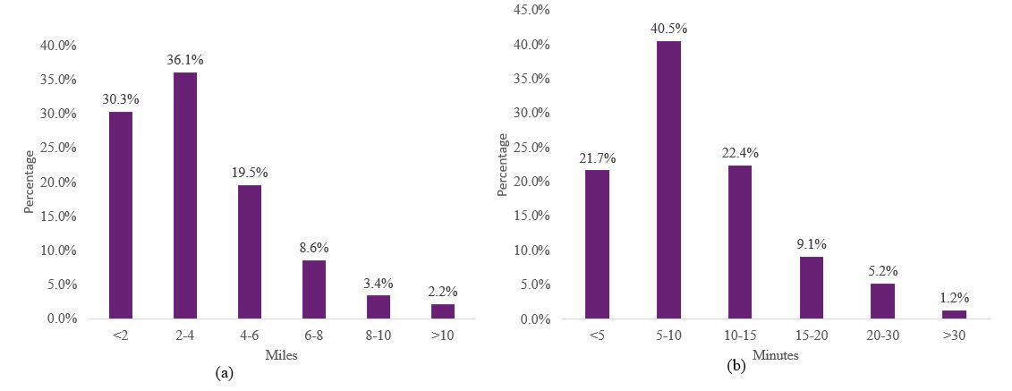
Figure 5 Distance and time distribution of parking

4.3 Congestion Analysis of Zones and Links
Equation 8 defines average link speeds at the zone level, which we use in this work as a metric of congestion for transportation analysis zones (TAZs). Figure 6 highlights the TAZs that experience a reduction of 5 percent or more in average link speed when empty trips are incorporated. The impact during the PM-peak is worse than in the AM-peak primarily because of the “reverse return” component, which in this model represent 27 percent of the empty CAV trips. The maximum impact is observed around the CBD and other city centers that attract work and non-work trips.
We also analyze the impact of empty trips at the link-level by identifying links for which the volume-to-capacity (v/c) ratio increases from below 0.8 to above 0.8. This range change may be considered a proxy for a decrease in level of service (LOS) from C to D. LOS D indicates unstable operations, where a small increase in volume produces substantial increase in delay and decrease in speed. The PM-peak period is the most impacted, with about 1024 miles of road segment (including all link classes) falling to LOS D. The corresponfing length for the AM-peak period is 499 miles.

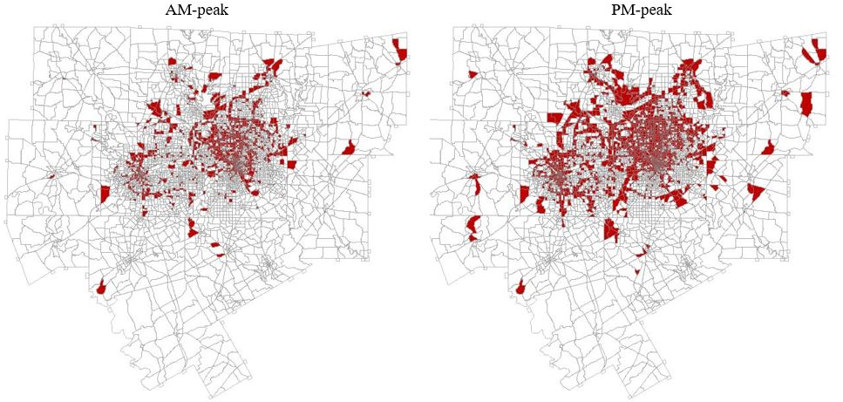
Figure 6 Highlighted zones with 5 percent reduction in speed

Table 4 presents the overall percentage increase in VMT and the percentage decrease in speed by link type. “Collectors” and “minor arterials” experience the largest VMT increase, which suggests they absorb most of the empty miles. This is reasonable, considering that these are likely to occur over shorter distances and, especially for the “park elsewhere” trips, are likely to generate extra miles locally. “Freeways” and “freeway ramps” experience a comparable decrease in speed to that of “collectors” and “minor arterials,” despite absorbing a significantly lower fraction of empty VMT. This is a result of the significant levels of freeway congestion in the base case. The length-weighted average v/c ratio on “freeways” is 0.62 for the PM-peak period, much higher than what is observed for “collectors” (0.164) and “minor arterials” (0.343). Similar patterns are observed even for the AM-peak.

TABLE 4 VMT and Speed Impacts based on Link-Class
Link class | AM-peak |  | Off-peak |  | PM-peak
 | Percentage increase in VMT | Percentage decrease in speed | Percentage increase in VMT | Percentage decrease in speed | Percentage increase in VMT | Percentage decrease in speed
Freeways | 3.39 | 5.15 | 2.19 | 1.22 | 3.76 | 7.64
Principal Arterial | 10.49 | 5.94 | 8.45 | 2.65 | 11.11 | 9.59
Minor Arterial | 14.91 | 4.99 | 12.95 | 2.22 | 16.75 | 8.65
Collectors | 20.52 | 3.31 | 15.50 | 3.67 | 22.77 | 9.85
Freeway-ramps | 8.86 | 5.35 | 6.07 | 1.71 | 9.05 | 8.81
Frontage road | 11.51 | 4.63 | 9.15 | 1.60 | 12.85 | 7.69

5. CONCLUSIONS
In this study, we present a method to incorporate empty trip deadheading associated with ride-hailing (RH) and connected-autonomous vehicles (CAVs) with a four-step trip-based framework. For the RH empty trips, a constant multiplier to the transposed origin-destination matrix method is implemented to incorporate a pre-specified percentage of empty trips in the network. The empty trips generated by CAVs are categorized into two components: (i) “return home” and (ii) “park elsewhere.” The “return home” and “park elsewhere” fractions are determined using a binary choice model based on the cost of returning home and the average parking cost, while the “park elsewhere” location component is determined through a logit-based parking location choice model that is a function of parking cost and distance.
Future research will address current model limitations, with model parameters being a crucial component that can be refined as more data becomes available. Specifically, in the absence of data, the sensitivity estimates used in the binary choice model and the location choice model have been assumed based on exogenously defined control points. For more informed estimates, stated preference surveys should be conducted to elicit users’ parking preferences. The model may also be refined by using time-based probability matrices in the models used for parking location choice. Such matrices would respond to prevalent congestion levels and may lead to more realistic results.
Numerical experiments to estimate the impacts of empty trip VMT suggest that empty trip VMT may have a significant effect on network performance. In our scenario, which considers a 40 percent market penetration of privately owned CAVs and a four percent mode-share by ride-hailing, empty trips lead to about an additional 22 million VMT (which accounts for an increase of about 7 percent in VMT). We observe that, for HBW trips, about 12.5 percent of users will choose to have their CAVs return home after dropping them at their destinations, while about 47.5 percent will choose to have their CAVs park elsewhere. The average return home distance is estimated to be about 4.5 miles (which translates to about 10 minutes in travel time), with more than 65 percent “return home” rate for CAV trips with a home-to-work distance of fewer than two miles. The average distance for empty CAV parking is about 3.5 miles, with more trips observed in the two-to-four mile range than in the zero-to-two mile range due to the trade-off between parking and operating costs. The PM-peak period is affected the most, which is primarily a result of our assumptions concerning the timing of reverse-return trips (trips from an off-site parking location to the original destination of a home-based trip). Our model also suggests that most of the empty miles are absorbed by “collectors” and “minor arterials,” which experience the highest increase in VMT.
This research also provides insights into the development of policies that may mitigate the impact of empty miles and provides a tool to assess the effectiveness of such policies. Potential policy strategies that may reduce empty miles based on our results include:
- Discourage “return home” and “park elsewhere” trips. Policy makers may consider providing reduced parking costs for CAVs at major attraction centers to discourage “return home” trips and reduce the distance traveled to parking. Another policy that may reduce empty trips includes introducing entry cost for CAVs into CBDs and other major attractors during peak periods. There could be an interesting counter play between reducing the parking cost to allow CAVs to park at or near their destinations and imposing an entry cost in the form of congestion pricing to discourage multiple entry and exit instances. Specifically, having minimal parking cost may cause an overall detrimental impact on the network by encouraging higher use of private vehicles (particularly CAVs), but city-center entry cost may act as a tempering factor and reduce the use of CAVs.
- Discourage the use of freeways by empty CAVs. The observed freeway congestion trends suggest that policies directed to limit the use of “freeways” for CAV empty trips may be beneficial. This scenario can be modeled using the framework proposed in this research by classifying empty CAVs as a separate mode and restricting this mode from using certain roadway link classes.
- Reduce travel demand during the PM-peak period. Our analysis suggests that the PM-peak period would be affected the most by an increase in VMT due to empty trips. In the long run, a staggered work-hours policy may substantially help in easing the peak period related congestion, especially in the PM-peak which is likely to shoulder much of the “reverse return” component. Such an arrangement would create multiple peak periods throughout the day (instead of only AM-peak and PM-peak periods), but the traffic volumes during such peaks could result in much lower traffic congestion, especially in a CAV environment.

The method described in this paper may be used to evaluate all of the above scenarios and other variations. It is an imperative that transportation planners proactively develop policies that ease the transition from today’s human-driven world to the upcoming world of CAVs.

Acknowledgments
This research was partially supported by the North Central Texas Council of Governments (NCTCOG) University Partnership Program (UPP) (Project TRN5282). The authors are grateful to Brandy Savarese and Lisa Macias for their help in proofreading and formatting this document.

Author Contribution Statement
The authors confirm contribution to the paper as follows: study conception and design: A. Mondal, N. Ruiz Juri, C.R. Bhat, and A. Mirzaei; data collection: A. Mondal, N. Ruiz Juri, C.R. Bhat, and A. Mirzaei; analysis and interpretation of results: A. Mondal, N. Ruiz Juri, C.R. Bhat, and A. Mirzaei; draft manuscript preparation: A. Mondal, N. Ruiz Juri, C.R. Bhat, and A. Mirzaei. All authors reviewed the results and approved the final version of the manuscript.
REFRENCES
- Bar-Gera, H. Traffic Assignment by Paired Alternative Segments. Transportation Research Part B, 2010. 44(8-9): 1022–1046.
- Guerra, E. Planning for Cars that Drive Themselves: Metropolitan Planning Organizations, Regional Transportation Plans, and Autonomous Vehicles. Journal of Planning Education and Research, 2016. 36(2): 210–224.
- Dias, F.F., G.S. Nair, N. Ruiz-Juri, C.R. Bhat, and A. Mirzaei. Incorporating Autonomous Vehicles in the Traditional Four-Step Model. Transportation Research Record: Journal of the Transportation Research Board, 2020. 2674(7): 348–360.
- Nair, G.S., F.F. Dias, N. Ruiz-Juri, J. Kuhr, and C.R. Bhat. Travel Modeling in an Era of Connected and Automated Transportation Systems: An Investigation in the Dallas-Fort Worth Area. Technical Report DSTOP/2016/143, prepared for the Data-Supported Transportation Operations and Planning Center (D-STOP) of the U.S. Department of Transportation, 2018.
- Cramer, J., and A. Krueger. Disruptive Change in the Taxi Business: The Case of Uber. American Economic Review, 2016. 106(5): 177–182.
- Komanduri, A., Z. Wafa, K. Proussaloglou, and S. Jacobs. Assessing the Impact of App-Based Ride Share Systems in an Urban Context: Findings from Austin. Transportation Research Record: Journal of the Transportation Research Board, 2018. 2672(7): 34–46.
- Nair, G.S., C.R. Bhat, I. Batur, R.M. Pendyala, and W.H.K. Lam. A Model of Deadheading Trips and Pick-Up Locations for Ride-Hailing Service Vehicles. Transportation Research Part A, 2020. 135: 289–308.
- Millard-Ball, A. The Autonomous Vehicle Parking Problem. Transport Policy, 2019. 75: 99–108.
- Harb, M., Y. Xiao, G. Circella, P.L. Mokhtarian, and J.L. Walker. Projecting Travelers into a World of Self-Driving Vehicles: Estimating Travel Behavior Implications via a Naturalistic Experiment. Transportation, 2018. 45: 1671–1685.
- Litman, T. Autonomous Vehicle Implementation Predictions. Implications for Transport Planning. Victoria Transport Policy Institute, Victoria, Canada, 2020.
- Wenzel, T., C. Rames, E. Kontou, and A. Henao. Travel and Energy Implications of Ridesourcing Service in Austin, Texas. Transportation Research Part D, 2019. 70: 18–34.
- Henao, A., and W.E. Marshall. The Impact of Ride-Hailing on Vehicle Miles Traveled. Transportation, 2019. 46(6): 2173–2194.
- Xu, Z., Z. Chen, and Y. Yin. Equilibrium Analysis of Urban Traffic Networks with Ride Sourcing Services. 2019. Available at SSRN: http://dx.doi.org/10.2139/ssrn.3422294
- Levin, M.W., H. Smith, and S.D. Boyles. A Dynamic Four-Step Planning Model of Empty Repositioning Trips for Personal Autonomous Vehicles. Journal of Transportation Engineering Part A, 2019. 145(5): 04019015.
- Childress, S., B. Nichols, B. Charlton, and S. Coe. Using an Activity-Based Model to Explore the Potential Impacts of Automated Vehicles. Transportation Research Record: Journal of the Transportation Research Board, 2015. 2493(1): 99–106.
- Zakharenko, R. Self-Driving Cars will Change Cities. Regional Science and Urban Economics, 2016. 61: 26–37.

