ON THE COMPUTATION OF SKIMS FOR LARGE SCALE IMPLEMENTATIONS OF INTEGRATED ACTIVITY-BASED AND DYNAMIC TRAFFIC ASSIGNMENT MODELS

Natalia Ruiz Juri, PhD
(Corresponding author)
Research Associate, Network Modeling Center
Center for Transportation Research, The University of Texas at Austin
Ph: 512-232-3099, Fax: 512-475-8744
Email: nruizjuri@mail.utexas.edu

Rachel M. James
Graduate Research Assistant
Cockrell School of Engineering, The University of Texas at Austin
Email: rjames6@utexas.edu

Nan Jiang, Ph.D.
Research Associate
Center for Transportation Research, The University of Texas at Austin
Email: jiang@utexas.edu

Jennifer Duthie, Ph.D.
Research Engineer, Network Modeling Center
Center for Transportation Research, The University of Texas at Austin
Email: jduthie@mail.utexas.edu

Abdul Pinjari, Ph.D.
Associate Professor
Civil and Environmental Engineering, University of South Florida
Email: apinjari@usf.edu

Chandra R. Bhat, Ph.D.
Professor
Cockrell School of Engineering, The University of Texas at Austin
King Abdulaziz University, Jeddah 21589, Saudi Arabia
Email: bhat@mail.utexas.edu

ABSTRACT
Integrated activity-based modeling (ABM) and dynamic traffic assignment (DTA) frameworks have emerged as a promising tool to support transportation planning and operations, particularly in the context of novel technologies and data sources. This research proposes an approach to characterize implementations of integrated ABM-DTA models, seeking to facilitate the interpretation and comparison of frameworks, and ultimately the selection of appropriate tools. The importance of the dimensions considered in this characterization is illustrated through a detailed analysis of one such aspect - the computation of skims. Skims are the level-of-service (LOS) metric produced by DTA models, and their computation may impact the performance and convergence of ABM-DTA applications. Numerical results from experiments on a regional ABM-DTA model in Austin, Texas suggest that skims produced at relatively small time steps (10-30 minutes) may lead to a faster integrated model convergence. Finer time grained skims are also observed to capture sharper temporal peaking patterns of the LOS. This work considers two skim computation methodologies; results analysis suggests that simpler techniques are adequate, as the inherent variability of travel times from simulation overshadows any gain in precision from more complex methods. This study also uses promising techniques to visualize and analyze model results, a challenging task in the context of highly dissagregate models that will be the subject of further research. The insights from this research effort can inform both, future research on the implementation of ABM-DTA methodologies and practical applications of existing frameworks.

1. INTRODUCTION
The adoption of advanced models in transportation planning has increased significantly in the past decade. Activity-based models (ABM), which estimate travel demand based on daily activity patterns, allow planning agencies to evaluate the impacts of transportation policies that cannot be represented using traditional trip-based modeling approaches (see 1). From the supply side, dynamic traffic assignment (DTA) models (see 2) are increasingly used for their ability to both capture the variability of traffic conditions throughout the day and explicitly model traffic control and other traffic management strategies. While the incorporation of either of these models into the planning process can lead to more realistic modeling results, the capabilities of ABM and DTA models are better utilized when both approaches are integrated. Further, model integration provides consistency between travel demand and observed levels of service in the transportation system, leading to more meaningful analyses and conclusions. An ABM-DTA integrated modeling approach can better answer policy questions, such as those related to (dynamic) congestion pricing and land-use change instruments, better than other alternative models.
Recent research (e.g. 3, 4, 5, 6) has addressed many of the conceptual aspects of ABM-DTA integration. However, the nature of the results from both models leads to considerable ambiguity in the implementation of such concepts for operational models. The ambiguities in the integration approach are in addition to the complex implementation decisions required for each individual model, which are beyond the scope of this work but deserve careful analysis.
No systematic study has been found in the literature concerning the impact of implementation aspects on the performance of integrated models, but a closer look at the computation of skims illustrates the importance of this topic. Skims refer to the level-of-service (LOS) measure passed from DTA models to ABM in many integrated frameworks, and their computation is probably one of the most ambiguous components of the integration process. ABMs use skims when scheduling individuals’ activities, which ultimately determine the travel demand on the transportation network. The computation of skims is relatively unambiguous in static traffic assignment (STA) models; unique link volumes at convergence lead to a single cost metric based on which origin-destination (OD) level-of-service may be estimated through shortest-path calculations. DTA model results are not as easy to process and interpret, given that link travel times are time-dependent, and OD travel times on any given path may vary considerably as a function of departure times. In this context, selecting a representative LOS for any given time period is more challenging, and the literature provides little guidance to support such decision.
Skim computation is among many implementation decisions in operational integrated models that may benefit from systematic analysis and recommendations. This paper’s contribution is twofold: the authors propose a framework to characterize and compare practical ABM-DTA integrations along four main dimensions and illustrate the impact of one such dimension –the skim computation - on the convergence and performance of integrated models. Additionally, this study explores visualization techniques and metrics useful in the analysis of model results, addressing some of the challenges posed by the temporal and spatial dissagregation of ABM and DTA outcomes.
In Section 2 we define the proposed characterization framework and use it to summarize previous ABM-DTA integration efforts. Section 3 further discusses the topic of skim computation in the context of ABM-DTA models. Sections 4 and 5 describe the methodological approach followed to illustrate the impact of skims computation on integrated models, and present the numerical analyses and corresponding results. Conclusions and further research directions are discussed in Section 5.

2. ON THE INTEGRATION OF ABM AND DTA MODELS
The literature describes two different approaches for the integration of ABM and DTA models: sequential and parallel. In sequential integration approaches, skims result from an equilibrium solution to the traffic assignment problem. Parallel modeling frameworks are exemplified in Pendyala et al. and are not the focus of this work, as they are often more meaningful in the context of traffic operations (5).
Sequential models (e.g. Figure 1) have demand (ABM) and supply (DTA) components run independently until convergence. In every iteration of such a framework, the outputs of the demand model, which consist of an estimation of time-dependent travel demand on a typical day, are used as inputs to the DTA module (see the movement from the CEMDAP model to the VISTA model toward the bottom of Figure 1). The supply component produces a representative estimate of the time-dependent level of service (LOS) of each transportation mode (referred to as a skim) under recurrent traffic conditions to be used in the following iteration of the ABM model (see the movement through the “interzonal travel times (skims)” box toward the top of Figure 1).

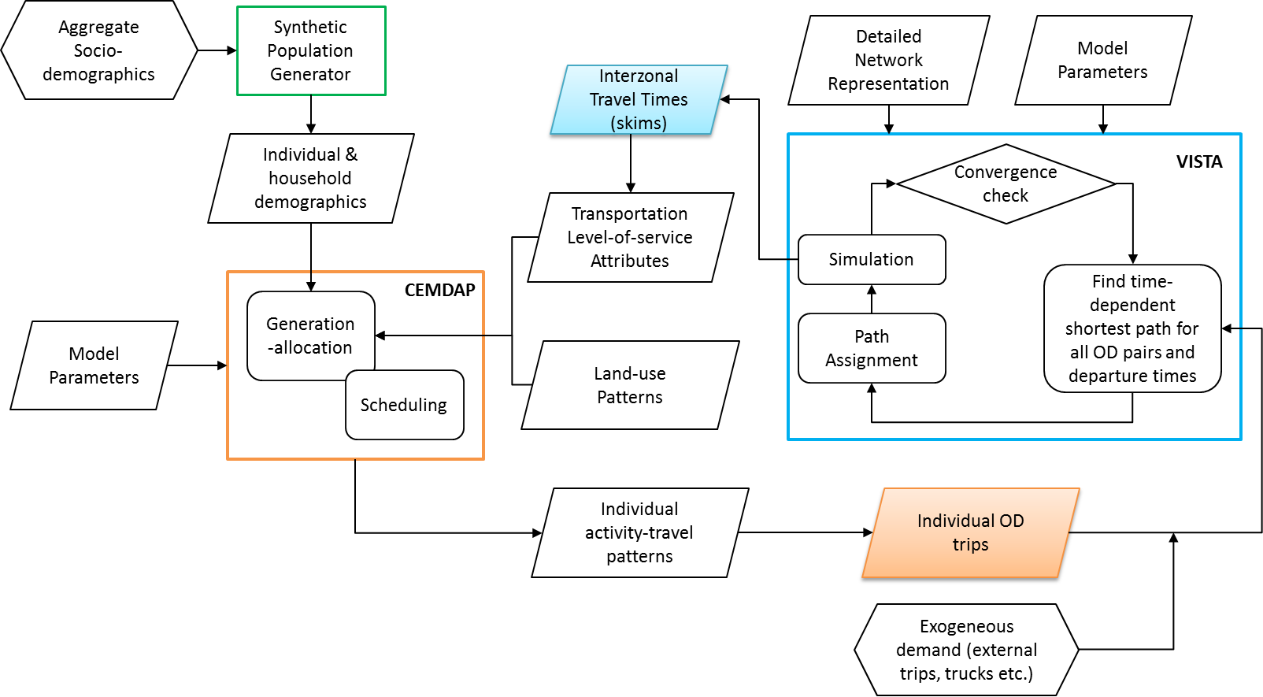
FIGURE 1 Example of a typical sequential ABM-DTA integration framework using VISTA (DTA) and CEMDAP (ABM).

Section 2.1 discusses previous ABM-DTA integration efforts across four dimensions: the temporal consistency of the integrated models, the specification of travel demand, the feedback approach and convergence criteria, and the computation of skims. Each of these aspects, described below, is considered by the authors to play an important role in the performance of the integrated models, the interpretation of their results, and the corresponding computational requirements.
- Temporal consistency refers to the time period modeled by each of the integrated approach components. While ideally all models would represent a typical day, computational constraints often motivate the use of “peak period” models for the DTA component. Such models, which often consider only the two or three highest-congestion hours during the morning or afternoon, require planners to make assumptions regarding appropriate LOS values for the remainder of the 24 hour period. A possible issue with using inconsistent time frames is that it may limit the ability of the integrated approach to realistically capture shifts in travel demand between peak and off-peak periods.
- The specification of travel demand refers to the approach used to model trips in the traffic assignment model based on the results of the ABM component. ABM results typically consist of tours which describe a sequence of trips with specific departure times between origins and destinations (OD) in the network. Depending on the characteristics of the assignment model, such tours may be used directly as an input, broken into individual origin-destination trips with departure times as specified by the ABM model, or aggregated to generate a coarser-level OD matrix (ranging from several minutes to the entire period modeled in the assignment component). While the choice of the specification approach is by large determined by the selected DTA package, the authors argue that the utilization of individual OD trips or tours is likely to lead to a more meaningful integration, in which the LOS estimated at completion is consistent with the activities scheduled by the ATM model. The direct use of tours is essential when integrating models in parallel.
- The feedback strategy and convergence metrics define the interaction between model components, and the stopping criteria for the integrated modeling approach. While the nature of the model interaction is unambiguous, with ABM models producing travel demand estimates and DTA models estimating corresponding LOS metrics, there is some flexibility in the implementation of the feedback process. In the context of this work, “direct feedback’ strategies are those that use DTA outputs from iteration i to define the ABM inputs for iteration i+1. Approaches in which the ABM inputs for iteration i+1 result from a combination of DTA outcomes in iterations i,i-1,…,0 are denoted “indirect feedback” strategies. The method of successive averages (MSA) is a fairly common indirect feedback strategy (8). Because of the nature of the weights used for the combination, MSA-type approaches tend to stabilize, which is not necessarily an indication of convergence. Ultimately, the selection of a feedback strategy is closely related to the corresponding convergence metrics. To the author’s knowledge, there is not an analytical formulation of an integrated ABM/DTA model, or a formal description of what equilibrium involves. A fixed-point type approach is typically adopted in practically implemented frameworks, seeks consistency of input and outputs in successive iterations (3). In this context convergence is measured based on the change in either skims or OD trips. Most of the approaches in the literature define convergence based on the stability of skims, and use percent-root-mean-squared-error or similar measures as the corresponding metric. The authors recommended defining convergence based on the feedback component that’s not averaged across iterations when MSA-type methodologies are used.
- The computation of skims lies at the core of an integrated modeling framework. In the context of an integrated framework, skims provide a meaningful estimate of the time-varying travel cost between each origin-destination pair. ABM models consider travel times when scheduling various activities, and the ability of DTA models to provide better estimates of such travel times is central to producing feasible and realistic schedules. The authors identify three distinct decisions concerning the practical calculation of skims: units, time resolution, and the calculation approach within the selected resolution. In this study time resolution denotes the time interval at which skims are provided. Units may consist of generalized costs or travel times, and this study will focus on travel time skims; the use of generalized costs introduces additional questions that will be the subject of further research. The skim computation approach category includes describes alternative methodologies to produce a single representative LOS metric for a selected time interval, which involves temporal aggregation and assumptions regarding the costs on multiple used routes. The authors believe that the calculation of skims is likely to have a considerable impact on the convergence of the integrated model and its sensitivity, ultimately affecting the accuracy of model results. Section 3 provides a more detailed discussion on the proposed analysis dimensions.

2.1 Synthesis of Earlier Studies
Table 1 summarizes the integrated modeling systems described in the literature, and describes the more relevant aspects of their implementation. For brevity, a more detailed discussion of each project has been omitted (see 3, 4, 5, 6, 9, 10). It is interesting to note that many of the characterization aspects described earlier are not easily found in the previous research summaries. This suggests that focus has been placed on understanding the conceptual aspects of the integration, and assessing its feasibility and value. As ABM-DTA modeling frameworks become more used in practice, a clear and systematic approach to the definition of implementation characteristics is crucial to enable fair comparisons across modeling frameworks, the meaningful interpretation of modeling results, and the appropriate selection of modeling tools.

TABLE 1 Implementation Characteristics of ABM-DTA Integration Efforts in the Literature

Study | Modeling systems |  | Skims |  | Feedback Strategy | Convergence  Metric
 | ABM | DTA | Units | Temporal resolution
Lin et al. (3) | CEMDAP | VISTA | Use link travel time instead of skims | 2.5 hours and higher | MSA | %mean relative error (PMRE)
Hao et al. (4) | TASHA | MATSim | Travel time | AM, PM peak | Direct | Fixed number of iterations
C10A (9) | DaySim | TRANSIMS | Time, Distance, and Cost | 30 minutes and higher | Direct | Not Described
C10B (10) | SACSIM  (Daysim) | DynusT | Travel Times | 30 minutes | Direct | %mean absolute error (PMAE)
Pendyala et al. (5) | OpenAMOS | MALTA | Travel Time | 1 minute | Parallel Framework | N/A
Ziemke et al. (6) | CEMDAP | MatSim | No DTA-ABM Feedback |  | Direct | N/A

3.THE USE OF SKIMS IN INTEGRATED ABM-DTA MODELS

In the context of an integrated ABM-DTA model, skims are used as a representative metric of origin-destination (OD) travel costs. While traditional traffic assignment models produce a single skim value per mode and modeled period, DTA models have the flexibility of providing time-varying skims for the “drive” mode at virtually any desired temporal aggregation.
The characteristics of such skims are likely to vary depending on both, the approach used to compute them, and on the selected temporal aggregation. The following sections discuss the impacts that these two factors may have on the resulting skims. This study assumes that travel time is the only component of travel cost. Practical applications often use a more general definition of cost which introduces additional ambiguity in the computation of skims; these will be addressed in future research efforts.

3.1 Skim Computation
There are various ways to estimate representative OD travel times based on typical DTA model results. The one that best represents model trends involves averaging the travel time of all travelers that depart within each considered time interval, and is denoted the “experienced travel time”. In Equation 1, $OD(od)$ is the set of all OD pairs, $V_{i}^{od}(v)$ denotes all the vehicles departing during time interval $i∈I$ and $t^{v}$ is the corresponding travel time based on DTA model results. $\exp_{i}^{od}$ is the experienced travel time, computed for each OD pair and considered time interval. Experienced travel times are available only for “active“ OD pairs (i.e. those with demand during the considered interval), and are not sufficient to provide meaningful feedback to an ABM model, as they represent a small fraction of all possible OD pairs. In the context of this work, the researchers used experienced travel times as a reference to estimate the precision of alternative skim computation approaches.

$\exp_{i}^{od}=\frac{\sum_{v∈V_{i}^{od}}{t^{v}}}{|V_{i}^{od}|}$ | (1)
In most integrated ABM-DTA approaches, skims are computed by calculating the time dependent shortest path (TDSP) for each OD pair and selected interval. Such TDSP calculations require selecting a departure time within the interval, and often a single point is used. The authors denote this skim computation approach “fixed departure time skims” (11). In Equation 2, $T_{i}$ is the set of all discrete departure times within interval $i$, and $c_{j}^{od}$ is the time-dependent shortest time for a specific $od∈OD$ at departure time $j$, computed using an appropriate algorithm based on the time-dependent link travel times produced by the DTA model. Depending on the size of the skim interval and the time-step at which the time-dependent link travel time are represented in the DTA model, ${fix}_{i}^{od}$ may be more or less representative of average conditions.

${fix}_{i}^{od}=c_{j}^{od} for j∈T_{i}$ | (2)
With the goal of computing skims that are more representative of average traffic conditions, we propose an alternative approach for skim computation through sampling. Equation 3 describes the calculation of such skims, which involves computing several TDSP at different departure times within the selected interval and averaging their values. In Equation 3, $K_{i}$ ⊂$T_{i}$denotes the subset of departure times in $T_{i}$.
$${samp}_{i}^{od}=\frac{\sum_{j∈K_{i}}{c_{j}^{od}}}{|K_{i}|}$$ | ((3)

3.2 Skim aggregation
The use of a single skim value per OD pair and time interval combination (ODT) implies two types of aggregation: temporal and across paths. This work is focused on the temporal aspect of the aggregation. Under equilibrium conditions, all used paths in a DTA model should have equal and minimum travel time (2), which leads to a unique skim per OD. Operational DTA models are usually not in perfect equilibrium at convergence, which is expected to have a minor impact on the resulting skims for low gap values. Non-zero gaps are often due to the limitations of the iterative process used to solve DTA models, and to the discontinuities introduced by explicitly simulating capacity constraints and traffic signals, among others.
The skim temporal aggregation is given by the time step at which skims are reported. Desirable aggregations in practice are constrained by both, computational and behavioral considerations.
The behavioral assumption underlying a specific time-step choice is that decision makers can perceive (or are aware of) changes in typical travel times at such aggregation. While intervals smaller than 30 minutes may seem unrealistically detailed, even for travelers familiar with the network, the widespread use of technology for precise estimation of travel times may justify the use of finer time steps.
Computationally, finer aggregation levels require more calculations and larger memory/disk requirements to store/transfer the resulting skims. However, we posit that these may be desirable for two reasons: they may better capture the “peaking” nature of travel times in real traffic networks (Figure 2b) and they reduce the variance associated with the reported average travel times (Figure 2a). While part of this variability (which may be significant, even in well-converged networks) is inherently related to the explicit modeling of traffic signals and congestion propagation, the use of longer time intervals may introduce additional variability that is related to changes in traffic conditions within the interval.
Figure 2b illustrates how the aggregation used for skims computation may affect both, the highest skim value reported for a given OD pair, and the time of day at which this peak is observed for a typical OD pair in the networks analyzed in Sections 4 and 5. For the same data, Figure 2a exemplifies the range of experienced travel times within assignment intervals, along with the corresponding skim values for the two sampling approaches proposed in Section 3.1.
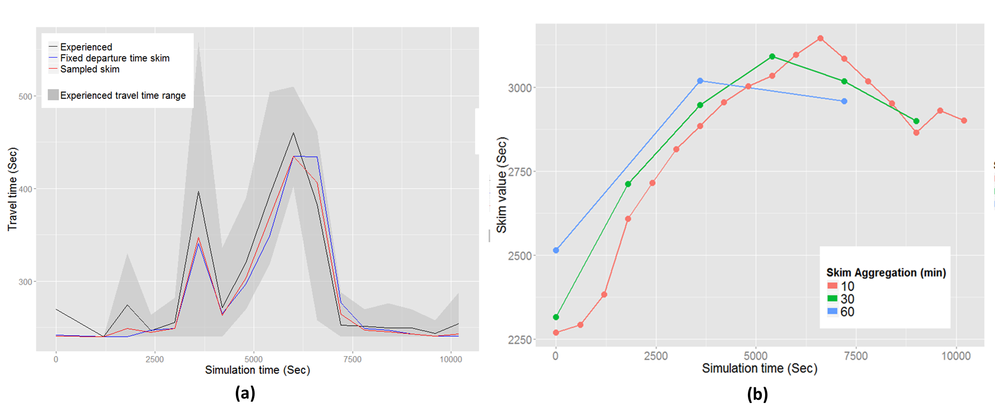
FIGURE 2 Variability of experienced travel times and corresponding skim values when using a 10 minute aggregation (a) and of the peaking behavior of skims computed at different aggregations (b) for a typical OD pair.

To study the effects of the temporal aggregation of skims on their ability to capture the peaking behavior of travel time as a proxy to their ability to capture the overall travel time pattern the researchers propose two indices, the “peak index”, computed as the ratio of the maximum travel time within the modeled period to the corresponding average travel time, and the maximum travel time index”, computed as the ratio of maximum skim value (across the modeled period) and the corresponding maximum experienced travel time.

4. METHOLDOGY AND EXPERIMENTAL DESIGN
This section describes the methodology used to assess the impact of skim computation and aggregation described in Section 3, and the corresponding numerical experiments.
The integrated modeling framework is described in Figure 1, and is consistent with other sequential integration approaches. The DTA model component, VISTA (12) is a simulation-based DTA model developed at Northwestern University, and further extended at UT Austin (e.g. 13, 14, 15). Section 4.1 provides a detailed summary of the proposed integration characteristics based on the framework identified earlier, and section 4.2 presents the experimental design.

4.1 Model Integration
The integration approach follows the process described in Figure 1. The ABM and DTA models represent the same geographic region, and they utilize a common transportation analysis zone (TAZ) structure. However, while the ABM model estimates 24h activity patterns, the DTA component represents only the a.m. peak period (6:00-9:00 a.m.) for computational convenience. Temporal consistency is maintained as described below. The DTA produces a DUE solution at each iteration that is used to inform the following ABM run. The characteristic of the proposed integration, based on the framework introduced earlier, are presented in Table 2. Freight and external trips (defined as those that have at least one end at the boundary of the modeled area) are estimated exogenously and distributed uniformly during the peak period. They remain constant across iterations, and are included in this study to properly represent regional congestion patterns.

TABLE 2 Implementation Characteristics Of The ABM-DTA Framework Used In This Study And Corresponding Data And Model Parameters
Implementation aspect | Description
Temporal Consistency | Temporal consistency across components is ensured by complementing the time-dependent skims produced by the DTA model for the peak period with skims from a static model of the same region.
Specification of Travel Demand | The individual tours produced by CEMDAP are broken into origin-destination trips consistent with the regional TAZ structure. Trip departure times are set based on the schedule proposed by the ABM model. These may result in inconsistencies when the travel times simulated in the DTA model are longer than what was assumed in the ABM model, however such discrepancies are expected to disappear as the model moves to a fixed-point equilibrium solution. External trips (i.e. trips with and end at the boundary of the region), are generated by an exogenous static assignment model of the same area, and remain constant across iterations. Their temporal distribution is assumed uniform throughout the modeled period. Freight trips are not including in this modeling effort.
Feedback Strategy | This integration effort uses direct feedback of both, traffic skims and ABM demand. Our convergence metric is defined based on the stabilization of the trip table, which is expected to reflect a stabilization of activity-travel patterns. The percentage root mean squared error (PRMSE) of trip matrices between successive iterations is used to assess convergence.
Skim computation | Skims are computed in travel time units. Various temporal aggregation and computation approaches are considered, as described in the experimental design section. Skims are in units of time, and they are generated by evaluating the time-dependent-shortest-path (10) at every desired departure time.
Data | The data used in the DTA model corresponds to the regional planning network of Austin, TX. The roadway network used in VISTA is a refined version of the metropolitan planning organization’s (MPO) planning network, which was refined to include additional streets in selected areas and traffic control. The final model consists of a total of 12,480 nodes, 27,000 links and 746 signals; its parameters have been adjusted to realistically reflect the network conditions in year 2010. For the ABM component, the synthetic population for region was generated using PopGen (5) based on TAZ-level data provided by the MPO. Model results were enriched in terms of socio-demographic variables (i.e., variance was added to the socio-demographic characteristics leading to a non-homogenous population) using CEMSELTS (21).
Model Parameters | The model parameters used in running the CEMSELTS and CEMDAP are based on the survey data collected by SCAG (Southern California Association of Governments). The parameters for the simulation component of the DTA model were adjusted based on previous modeling results for the network. The simulation time step was set to six seconds, a typical value for mesoscopic modeling approaches. For time-dependent shortest path calculations, which affect both the DTA convergence and the skim calculation, link travel times were aggregated at a five minute time step, which leads to reasonable computational effort while accurately depicting the evolution of congestion. The DTA model was run until convergence at each iteration of the integrated process.

4.2. Experimental Design
Two types of numerical experiments were conducted, including a preliminary test to assess the impact of the skim computation approach on the precision of the resulting level-of-service (LOS) estimates. Such analysis involved the estimation of skims according to the two techniques described in Section 3, and a comparison of the resulting metrics to the “true” LOS given by$\exp_{i}^{od}$.
The largest component of our numerical analyses involves three separate integrated model implementations using 10, 30 and 60 minutes, respectively, for the temporal aggregation of the skims. Model data and parameters are presented in table 2, and Section 5 discuses experimental results. While different ABM and DTA modeling tools may exhibit different sensitivity to the skims values, the nature and direction of the observed impacts is likely to be consistent across applications.

5.1 MODEL RESULTS

This section begins with a general assessment of the performance of the integrated model after convergence. The impact of skim computation on model precision is presented in Section 5.2, while Sections 5.3 and 5.4 analyze the impacts of the temporal aggregation of skims on model convergence, and on the fidelity of the resulting temporal demand profile.

5.1 General Analysis of Model Results
The results described in this section were obtained after five iterations using a 1-hour skim aggregation. Overall trends were observed to be fairly similar across all tested skim aggregations. The following paragraphs summarize aggregate performance metrics and provide further detail on the temporal and spatial distribution of demand. Congestion patterns in the DTA model were found to be remarkably realistic based on visual inspection of model results and Google typical traffic metrics. These results are omitted for brevity but are available from the authors.

Aggregate Performance Metrics
The aggregate system performance metrics analyzed in this study include average origin-destination travel times, speeds and route length. Total vehicles miles traveled and trips were also analyzed across iterations. The profiles for travel demand, total system travel time and vehicles miles traveled, computed using 15-minute intervals, are bell-shaped, as expected. The analysis of average travel time distribution and path lengths suggests that longer trips take place predominantly early and late during the peak period. This may be capturing the early departure of travelers who reside farther away from the location of their morning activity, as well as a preference for postponing long trips until after the peak hour when possible.
The profiles described earlier were observed to remain fairly constant across iterations, and for different skim aggregations. This is somewhat surprising, particularly given that the travel demand for the first iteration was produced using uniform (i.e. constant in time) skims from a static model. The observed trend suggest that the time-dependency of origin-destination travel times has relatively minor effects on the temporal distribution of activities in this particular implementation. While this may be partly the result of using time-dependent values for only three hours during the day, it may also reflect the weight of other behavioral parameters within the ABM model. The latter is consistent with previous finding by Steed and Bhat (22) for recreational and shopping trips. The authors note that aggregate analysis may obscure more subtle changes in the results of both, ABM and DTA models. While analyzing fully dissagregate data is not likely to facilitate the interpretation of results, further research will study visualization and aggregation techniques to enhance model results interpretation.

Spatio-Temporal Demand Distribution
Figure 4 illustrates the ability of ABM models to produce different demand profiles across OD pairs in the network; this is a considerable improvement to the assumptions typically made in practical regional DTA implementations based on static OD data. In most such cases a single assumption regarding the temporal demand distributions is made for all OD pairs based on available traffic counts. However, travel demand profiles are likely to vary in a large geographic area, which may significantly affect the resulting congestion pattern. In Figure 4, origins for which the peak demand (across all possible destinations) occurs during the first modeled hour are observed to be those further away from the central business district(s), while origins peaking during the second and third hour are progressively closer to the central area. In Figure 3 note that some of the out-most TAZs correspond to network boundaries for which the travel demand profile is not provided by the ABM; these are not meaningful in the context of these analysis. The previous remarks are consistent with the observed travel time distributions during the three modeled hours; these results suggest that most of the longer trips depart during the first hour.
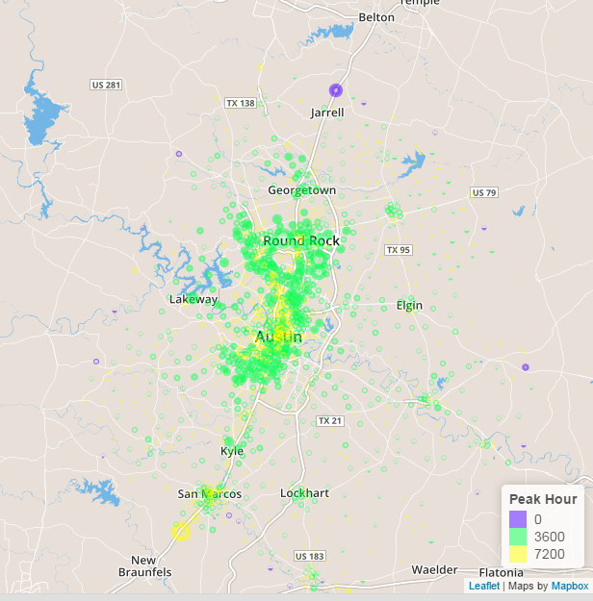
FIGURE 4 Location of TAZs for which travel demand peaks during the 1st, 2nd and 3rd hour. Results correspond to the 5th iteration of the 60-minute aggregation case study, but similar patterns were observed across iterations and case studies.

5.2 Impact of skim computation approach on feedback precision
This section compares the precision of the two skim computation approaches described in Section 3 across different temporal skim aggregations. Precision by time interval is defined as the root-mean squared error (RMSE) of skim travel times (${fix}_{i}^{od}$ and ${samp}_{i}^{od}$) with respect to $\exp_{i}^{od}$ (Equation 5). AOD is the subset of OD pairs for which demand is greater than zero during the considered interval. For the sampled skims, time-dependent-shortest paths were sampled every 5 minutes.

$${RMSE}_{i}=\sqrt{\frac{\sum_{od∈AOD}{{\left({fix}_{i}^{od}-\exp_{i}^{od}\right)}^{2}}}{|AOD|}}$$ | ((5)
Figure 5 presents the RMSE across time intervals for the two skim computation approaches considered in this study. The difference in precision between sampling techniques is negligible compared to the magnitude of the RMSE. Observed RMSE values range between 1 and 2.5 minutes and are higher during the middle hours of the peak period, reflecting the impacts of congestion. Travel time variability during uncongested intervals is likely a result of explicitly simulating the impact of traffic signals. Given that the difference between skim computation techniques is very similar during congested and uncongested periods, the use of a single TDSP to estimate skims seems acceptable. Further research may explore a different approach to computing the RMSE, given that experienced travel times may not be representative of true average travel times for OD pairs with low demand.
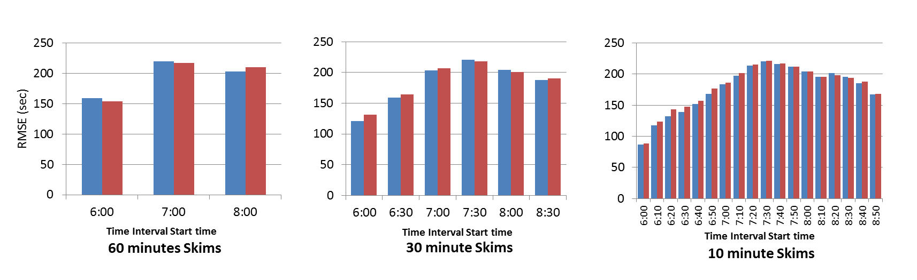
FIGURE 5 Precision of sampled (blue) and fixed-departure-time (red) skims by time interval

5.3 Impact of Skim Aggregation on Convergence
Table 3 presents some metrics of integrated model convergence. In this table infeasible trips are defined as a function of the original tour-based data produced by the ABM. Such model assumes a departure and arrival time for each leg of the tour, which is translated into individual OD trips in the DTA model. These trips depart at the time originally specified in the ABM but may arrive at a different time than expected. Infeasible tours are loosely defined as those for which the departure time for leg i+1 is earlier than the arrival time for leg i, for any leg i along the tour.

TABLE 3 Summary of Convergence Metrics across Iterations
Iteration | Demand |  |  | Infeasible Trips |  |  | PRMSE
 | 1h | 30min | 10 min | 1h | 30min | 10min | 1h | 30min | 10 min
1 | 655,323 | 655,323 | 655,323 | 3,015 | 3,015 | 3,015 | --- | --- | ---
2 | 723,940 | 723,241 | 722,282 | 2,340 | 1,959 | 1,732 | 0.197% | 0.151% | 0.151%
3 | 727,313 | 726,948 | 725,036 | 1,549 | 1,894 | 1,682 | 0.074% | 0.073% | 0.076%
4 | 726,507 | - | - | 1,727 | - | - | 0.070% | - | -
5 | 725,274 | - | - | 1,610 | - | - | 0.067% | - | -
The number of infeasible trips is observed to decrease faster when smaller skim aggregations are used. The former is likely due to the ability of finer skims to better reflect expected conditions during specific time periods, and it ultimately appears to result in better convergence as reflected by the corresponding RMSE values.
The total travel demand for the modeled period stabilizes at around 725,000 trips. Figure 6 shows the major changes in trips productions across iterations by aggregating individual origins and destinations metrics using a raster image. The image is created by defining a grid and computing cell-based trip productions/attractions. Differences at the cell level were observed to be more meaningful than changes in TAZ productions/attractions. The latter is likely to be a result of the variation of TAZs size in terms of population, employment, and area across the region. Densely populated areas, such as the central business district (CBD) are modeled with clusters of small TAZs. While each of those TAZs is relatively a minor contributor to the total change in the demand across iterations, the cluster may play an important role in the regional demand pattern. In this particular network, the central area exhibits the largest change between the first and second iteration. In subsequent iterations the magnitude of the change decreased considerably, and after iteration 3 changes seem to concentrate on similar areas, and the direction of the change oscillates across iterations.
The observed trends, along with the RMSE values and number of infeasible trips across iterations, suggest that the model solution becomes fairly stable from a geographic standpoint after five iterations. An important observation is that there seems to be no major differences across skim resolutions. Further analysis of geographic and temporal patterns may provide insights into the computation of meaningful metrics to assess the spatial component of convergence.

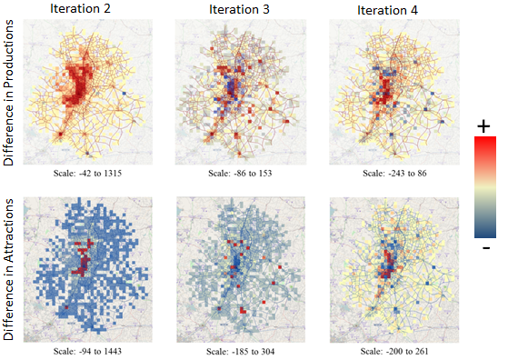
FIGURE 6 Difference in trip productions and attraction across iterations, in number of trips per raster cell. Values shown for iteration i are with respect to iteration i-1.

5.4 Impact of Skim Aggregation on Peaking Behavior
Peak indices values were 1.010569,1.008965, and 1.00663 for skim aggregations of 10, 30 and 60 minutes, respectively. This suggests that smaller aggregation levels are better at capturing the peaking behavior. A similar trend is reflected by the maximum travel time index (0.9141633, 0.9131088, and 0.9077024 for 10, 30 and 60 minute skims, respectively).

6. CONCLUSIONS
Modeling frameworks combining advanced models of travel demand and network assignment are powerful tools to assess the impacts of complex transportation planning and operation decisions. Past experience has shown that the implementation of such frameworks is computationally feasible, and their use in practice is expected to increase in coming years. Some possible applications include analyzing the impacts of dynamic tolls, variable speed limits, and autonomous and connected vehicles.
While the conceptual aspects of the integration of ADM and DTA models have been addressed in the literature, the complexity and level of detail of the outputs of both types of models allows for multiple approaches to implement such concepts. To the authors’ knowledge, there has not been a systematic approach to characterize implementation decisions in practical ABM-DTA applications, or study their impacts on the resulting models.
This contribution of this research is twofold: the authors propose a framework to characterize and compare practical ABM-DTA integrations along four main dimensions, and illustrate the impact of one of such dimensions –the skim computation - on the convergence and performance of integrated models. While the numerical results presented in this effort correspond to a specific case study and cannot be directly generalized, the observed trends and relationships are expected to be relevant to similar integration frameworks.
The impact of the temporal aggregation of skims, and of the various approaches to compute them based on DTA model results, is explored through the detailed analysis of a regional ABM-DTA implementation in Austin (TX). The findings of this effort suggest that skims produced at relatively small time steps (10-30 minutes) may lead to a faster convergence of the integrated model and a faster reduction of infeasible trips. Fine grained skims were observed show sharper and more distinct “peaking” patterns. Results also suggest that the simplest skim computation approaches are adequate, given that the inherent variability of travel times within a time period overshadows any gain in precision from more complex methods. Integrated model solutions were observed to become fairly stable after relatively few iterations, with major changes to the geographic demand pattern occurring only between the first and second iterations. Further research is desirable to develop general guidelines for stopping criteria based on the stability of model outputs, including OD trip matrices and other aggregate metrics such as trip length distribution. Theoretical formulations of supply-demand equilibrium conditions may also lead to more meaningful convergence metrics.
The integrated model was found to produce remarkably realistic network-wide speed pattern, and provide valuable detail concerning the geographic variability of the temporal demand pattern which would be challenging to obtain from data alone.
The temporal profile of aggregate system performance metrics including average trip travel time and length, and vehicles miles traveled, did not change significantly across iterations or skim aggregations. Spatio-temporal demand patterns were also observed to remain relatively constant. Previous work by Steed and Bhat (22) suggests that the LOS may not be the major factor influencing trip departure time for some activity types, which explains this behavior to some extent. However, improved approaches to the visualization and analysis of model results may greatly enhance the interpretation of model results and may reveal more subtle trends. This work proposed some simple visualization techniques that produced promising results, and further research will be conducted to refine and enhance these. Further research is also needed to explore the use of generalized-cost skims which explicitly account for the impact of travel times and toll costs. While the use of generalized costs in DTA models is fairly straightforward, assumptions are needed in order to estimate average travel time and monetary costs across multiple paths.
As ABM-DTA modeling frameworks become more commonly used in practice, a clear and systematic approach to the definition of implementation characteristics is crucial to enable fair comparisons across modeling frameworks, the meaningful interpretation of modeling results, and the appropriate selection of modeling tools. The insights from this research effort are expected to inform both, further research on the implementation of ABM-DTA methodologies, and practical implementation of existing frameworks.

ACKNOWLEDGMENTS
The authors thank Subodh Dubey for his assistance running CEMDAP and processing and analyzing input data and models results.

REFERENCES
- Pinjari, A.R., and C.R. Bhat (2011), "Activity Based Travel Demand Analysis," A Handbook of Transport Economics, Chapter 10, pp. 213-248, edited by A. de Palma, R. Lindsey, E. Quinet, and R. Vickerman, Edward Elgar Publishing Ltd.
- Chiu, Y. C., Bottom, J., Mahut, M., Paz, A., Balakrishna, R., Waller, T., & Hicks, J. (2011). Dynamic traffic assignment: A primer. Transportation Research E-Circular, (E-C153).
- Lin, D.-Y., N. Eluru, S.T. Waller, and C.R. Bhat. Integration of Activity-Based Modeling and Dynamic Traffic Assignment, In Transportation Research Record: Journal of the Transportation Research Board, No. 2076, Transportation Research Board of the National Academies, Washington, D.C., 2008, pp. 52-61.
- Hao, J.Y., M. Hatzopoulou, and E.J. Miller. (2010) Integrating an Activity-Based Travel Demand Model with Dynamic Traffic Assignment and Emission Models: Implementation in the Greater Toronto, Canada, Area. In Transportation Research Record: Journal of the Transportation Research Board, No. 2176, Transportation Research Board of the National Academies, Washington, D.C., 2010, pp. 1-13.
- Pendyala, R.M., K.C. Konduri, Y.-C. Chiu, M. Hickman, H. Noh, P. Waddell, L. Wang, D. You and B. Gardner. An Integrated Land Use – Transport Model System with Dynamic Time-Dependent Activity-Travel Microsimulation. In Transportation Research Record: Journal of the Transportation Research Board, No. 2303, Transportation Research Board of the National Academies, Washington, D.C., 2012, pp. 19-27.
- Ziemke, D., Nagel, K., and Bhat, C. Integrating CEMDAP and MATSim to increase the transferability of transport demand models. Annual Meeting Preprint 15-5516, Transportation Research Board, Washington D.C., 2015. Also UT DR 14-15, see http://repositories.lib.utexas.edu/handle/2152/26234
- SHAP2 Implementation Assistance Program Round 4 Webinar (SR500B) SHAP2 C10/04/05/16 – Advanced Travel Analysis Tools, May, 2014
https://www.nhi.fhwa.dot.gov/resources/webconference/web_conf_learner_reg.aspx?webconfid=27537
- Sheffi, Y. 1985. Urban transportation networks: equilibrium analysis with mathematical programming methods. Prentice-Hall, New York.
- Resource Systems Group, AECOM, Mark Bradley Research & Consulting, John Bowman Research & Consulting, H. Mohammed, R. Pendyala, C. Bhat and S.T. Waller. SHRP 2 C10A – Partnership to Develop an Integrated, Advanced Travel Demand Model and a Fine-Grained Time-Sensitive Network. 2013
- Cambridge Systematics, Inc., Sacramento Area Council of Governments, University of Arizona, University of Illinois at Chicago, Sonoma Technology, Inc. and Fehr & Peers Associates. SHRP 2 C10B – Partnership to Develop an Integrated, Advanced Travel Demand Model and a Fine-Grained, Time-Sensitive Network. Model Design Plan, 2010
- Ziliaskopoulos, A.K. and H.S. Mahmassani. A Time Dependent Shortest Path Algorithm for Real-time Intelligent Vehicle/highway Systems. In Transportation Research Record: Journal of the Transportation Research Board, No. 1408, Transportation Research Board of the National Academies, Washington, D.C., 1993, pp. 94-104.
- Ziliaskopoulos, A. K., & Waller, S. T. (2000). An internet based geographic information system that integrates data, models and users for transportation applications.Transportation Research Part C, Vol. 8 (1), pp. 427-44.
- Jafari, E., Gemar, M.D., Ruiz Juri, N., Duthie, J.C. “An Investigation Of Centroid Connector Placement For Advanced Traffic Assignment Models With Added Network Detail”. Accepted for presentation at the 94th TRB Annual Meeting, December 2015, Washington DC (Transportation Research Record, Upcoming).
- Xu, W., Gupta, A., Perrine, K., Ruiz Juri, N. 2014. “On Scaling Time Dependent Shortest Path Computations for Dynamic Traffic Assignment”. In Proceedings, IEEE Big Data 2014, 796-801
- Levin, M.W., Pool, M., Owen, T., Waller, S.T., Ruiz Juri, N. 2014. “Improving the Convergence of Simulation-Based Dynamic Traffic Assignment Methodologies”. Networks and Spatial Economics (Online First). DOI 10.1007/s11067-014-9242-x
- Network Modeling Center: Projects. http://ctr.utexas.edu/nmc/projects/. Accessed July, 2015
- Daganzo, C.F. The Cell Transmission Model: A Simple Dynamic Representation of Highway Traffic Consistent with the Hydrodynamic Theory. Transportation Research Part B, Vol.28, 1994, pp. 269-287
- Daganzo, C.F. The Cell Transmission Model, Part II: Network Traffic. Transportation Research Part B, Vol. 29, 1995, pp.79-93
- Bhat, C.R., J.Y. Guo, S. Srinivasan and A. Sivakumar. Comprehensive Econometric Microsimulator for Daily Activity-Travel Patterns. In Transportation Research Record: Journal of the Transportation Research Board, No. 1894, Transportation Research Board of the National Academies, Washington, D.C., 2004, pp. 57-66.
- Bhat, C.R., K.G. Goulias, R.M. Pendyala, R. Paleti, R. Sidharthan, L. Schmitt, and H-H. Hu. A Household-Level Activity Pattern Generation Model with an Application for Southern California. Transportation, Vol. 40(5), 2013, pp. 1063-1086
- Eluru, N., Pinjari, A., Guo, J., Sener, I., Srinivasan, S., Copperman, R., & Bhat, C. 2008.” Population updating system structures and models embedded in the comprehensive econometric microsimulator for urban systems”.Transportation Research Record: Journal of the Transportation Research Board, (2076), 171-182.
Citations Excluded:
- Steed, J., and C.R. Bhat (2000), "On Modeling the Departure Time Choice for Home-Based Social/Recreational and Shopping Trips", Transportation Research Record, Vol. 1706, pp. 152-159.

