Online Supplement to

“Analysis of The Impact of Technology Use On Multi-Modality and
Activity-Travel Characteristics”

Sebastian Astroza, Venu M. Garikapati, Chandra R. Bhat (corresponding author),
Ram M. Pendyala, Patricia S. Lavíeri, and Felipe F. Dias.

Descriptive Statistics of the Survey Sample
Table 1 provides descriptive statistics of the dependent variables that are common for both years (2014 and 2015). It can be observed from the table that the differences in distributions of dependent variables across survey years are relatively small. This finding reinforces the ‘transferability of behavior’ assumption made in utilizing the pooled survey dataset (see footnote 1 from the original paper).
Figure 1 is a graphical representation of the relationship between age cohorts, smartphone apps use, and mode choice. For each of the five age categories in the final survey sample, the graphs depict the percentage of individuals that fall in each of the categories defined by smartphone level of use (3 levels) and transportation mode (6 modes). For example, the first blue bar towards the left in the first graph can be interpreted as: about 20% of the individuals between 18 and 34 years old never use their smartphone (to obtain travel information) and usually use a car for their travel needs. The graphs clearly show how the newer modes of transportation (car-sharing and ride-sourcing) are related to the use of smartphone. For younger (18-34 years) individuals, the use of smartphone also increases the use of transit, walking and biking. It can also be observed from the graphs that for older individuals (≥ 55 years), car is clearly the dominant mode of choice.

Computation of the Average Treatment Effects
For the ordinal and binomial variables (multi-modality, tour accompaniment, and recreational tours), the measure of treatment effect due to a change in smartphone ownership is estimated as follows:
where is the dummy variable for the smartphone ownership for the individual q, and g is any category of the ordinal/binomial variable. Similarly, the ATE measure can be computed when represents the dummy variable for smartphone use (0 if the individual does not own and does not use a smartphone for travel information, and 1 if the individual owns and uses a smartphone for travel information). For the continuous variable (average number of stops), the actual predicted value is computed instead of the probability. Since recreational tours impact two other endogenous variables (multi-modality and tour accompaniment), it must be predicted before the other variables. The standard error of the measure is computed using bootstraps from the sampling distributions of the estimated parameters.

Performance of GHDM and IHDM for market segments
In order to use all the information possible in the estimation of a complex model, no observations were left out for an “out-of-sample” fit assessment. To ensure that the superior data fit of the GHDM is not simply an artifact of overfitting on the estimation sample, the performance of the GHDM and IHDM in replicating activity-travel characteristics was evaluated for various market segments of the estimation sample. The market segments were defined using independent variables that played a significant role in the GHDM specification. Results of the market segmentation analysis are presented in Table 2. The predicted and actual (observed) shares for each category for each market segment were compared using the root mean squared error (RMSE) and the absolute percentage error measures.
For each selected variable, the data fit for the market segment with the most number of observations is presented. The results clearly show that the predicted shares from the GHDM are closer to the true shares than the predicted shares from the IHDM for the full sample and for each market segment. All of the measures of fit point to the superior performance of the GHDM over the IHDM.

Table 1. Sample Characteristics of Independent Variables
Socio demographic | Categories | 2014 Distribution | 2015 Distribution
Average number of stops per tour | Mean | 2.08 | 2.10
Importance of having a walkable neighborhood | Very unimportant | 7.2% | 7.1%
 | Unimportant | 6.1% | 6.0%
 | Neutral | 10.4% | 10.6%
 | Important | 30.0% | 30.0%
 | Very important | 46.3% | 46.3%
Importance of being close to public transit | Very unimportant | 15.5% | 15.2%
 | Unimportant | 10.6% | 10.5%
 | Neutral | 14.2% | 14.4%
 | Important | 22.3% | 22.4%
 | Very important | 37.4% | 37.5%
Importance of being within a 30 minutes commute to work | Very unimportant | 11.3% | 11.1%
 | Unimportant | 6.4% | 6.4%
 | Neutral | 16.0% | 15.8%
 | Important | 20.6% | 20.9%
 | Very important | 45.7% | 45.8%
Tour accompaniment | Individual makes all tours alone | 59.1% | 60.2%
 | Individual makes at least one tour with accompaniment | 40.9% | 39.8%
Recreational tours | Individual makes no recreational tours | 60.5% | 56.7%
 | Individual makes at least one recreational tour | 39.5% | 43.3%

Table 2. Measures of Fit in the Estimation Sample

Variable Category/ Measure of Fit | Full Sample |  |  | 65 years or older |  |  | Full-time workers |  |  | Income 100k or more
 | Actual share | GHDM prediction | IHDM prediction | Actual share | GHDM prediction | IHDM prediction | Actual share | GHDM prediction | IHDM prediction | Actual share | GHDM prediction | IHDM prediction
Multi-modality measure
1 mode | 6.6% | 7.0% | 7.3% | 9.0% | 9.4% | 9.6% | 4.3% | 4.9% | 5.0% | 3.2% | 3.7% | 4.0%
2 modes | 23.5% | 24.3% | 24.7% | 34.2% | 34.5% | 34.9% | 16.2% | 16.8% | 17.0% | 13.3% | 13.9% | 14.4%
3 modes | 34.9% | 35.2% | 35.6% | 44.0% | 45.9% | 46.2% | 31.0% | 31.7% | 32.0% | 33.9% | 34.2% | 34.3%
4 modes | 25.6% | 24.2% | 23.9% | 11.9% | 9.8% | 9.0% | 33.2% | 29.9% | 29.3% | 34.9% | 31.7% | 30.5%
5 modes | 7.3% | 6.6% | 6.0% | 0.9% | 0.4% | 0.2% | 11.5% | 11.4% | 11.0% | 11.0% | 10.6% | 10.0%
6 modes | 2.1% | 2.7% | 2.5% | 0.0% | 0.0% | 0.1% | 3.8% | 5.3% | 5.7% | 3.7% | 5.9% | 6.8%
Tour accompaniment
All tours alone | 59.1% | 56.5% | 52.1% | 61.7% | 58.6% | 57.0% | 60.5% | 58.0% | 56.7% | 53.9% | 49.9% | 48.7%
At least one tour with accompaniment | 40.9% | 43.5% | 47.9% | 38.3% | 41.4% | 43.0% | 39.5% | 42.0% | 43.3% | 46.1% | 50.1% | 51.3%
Recreational tours
No recreational tours | 60.5% | 58.7% | 55.6% | 53.6% | 50.7% | 48.6% | 63.4% | 60.3% | 59.1% | 61.2% | 60.1% | 58.9%
At least one recreational tour | 39.5% | 41.3% | 44.4% | 46.4% | 49.3% | 51.4% | 36.6% | 39.7% | 40.9% | 38.8% | 39.9% | 41.1%
Number of Observations | 1371 |  |  | 345 |  |  | 653 |  |  | 436
Root Mean Square Error | -- | 0.10 | 0.25 | -- | 0.15 | 0.23 | -- | 0.17 | 0.20 | -- | 0.13 | 0.21
Absolute Percentage Error | -- | 13.0% | 29.8% | -- | 17.2% | 26.6% | -- | 18.0% | 25.0% | -- | 17.4% | 25.8%

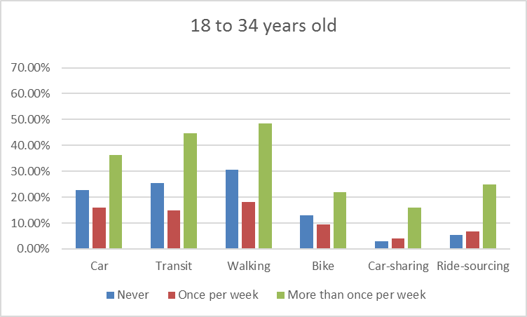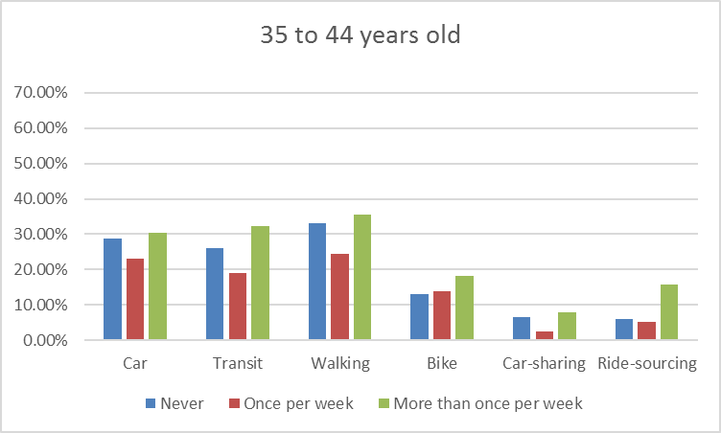
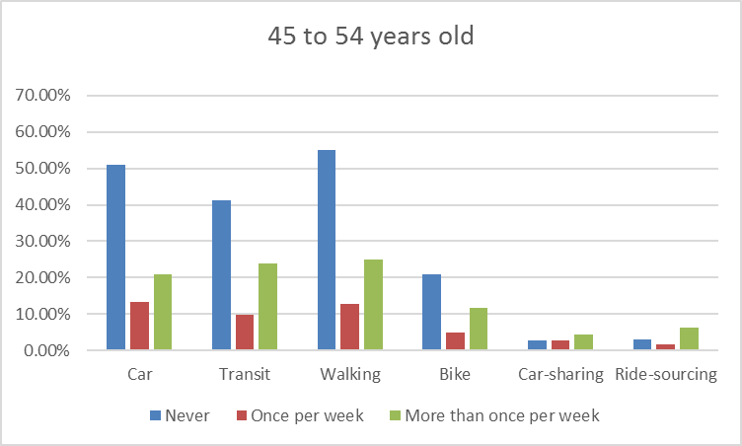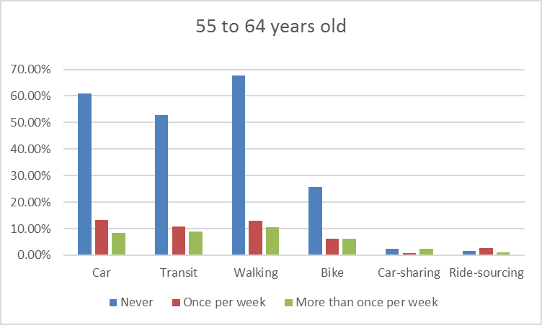
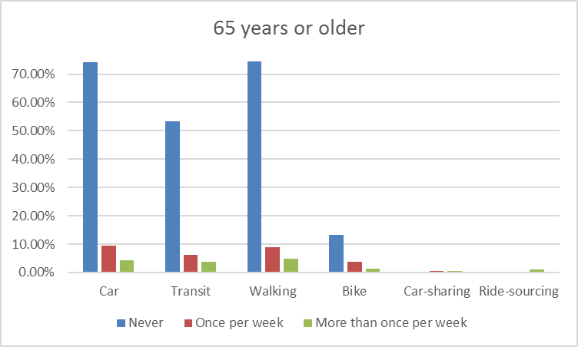

Figure 1. Distribution of Smartphone Use and Transportation Mode by Age Range

