PRELIMINARY REVIEW COPY

Technical Report Documentation Page
1. Report No.  0-4013-1 |  | 2. Government Accession No. |  | 3. Recipient’s Catalog No.
4. Title and Subtitle  DECISION SUPPORT FRAMEWORK FOR THE EVALUATION OF MODAL COMPETITIVENESS |  |  |  | 5. Report Date  October 31, 2004
 |  |  |  | 6. Performing Organization Code
7. Author(s)  Chandra Bhat, Jolanda Prozzi, Michalis Xyntarakis, Sivaramakrishnan Srinivasan |  |  |  | 8. Performing Organization Report No.  0-4013-1
9. Performing Organization Name and Address  Center for Transportation Research  The University of Texas at Austin  3208 Red River, Suite 200  Austin, TX 78705-2650 |  |  |  | 10. Work Unit No. (TRAIS)
11. Contract or Grant No.
0-4013
12. Sponsoring Agency Name and Address  Texas Department of Transportation  Research and Technology Implementation Office  P.O. Box 5080  Austin, TX 78763-5080 |  |  |  | 13. Type of Report and Period Covered  Project Report (9/02–10/04)
 |  |  |  | 14. Sponsoring Agency Code
15. Supplementary Notes
Project conducted in cooperation with the U.S. Department of Transportation,
Federal Highway Administration, and the Texas Department of Transportation.
16. Abstract
This report contains the results of research into the development of a decision support system (DSS) aimed to supplement a systematic ongoing process of strategic evaluation and transportation planning at the statewide and metropolitan levels. Specifically, it is intended to provide TxDOT with a forecasting methodology to qualitatively and quantitatively anticipate changes in modal utilization for intercity freight movements and intracity passenger movements. Presented as a prototype software program, it incorporates the results of recent research on the determinants of mode choice as well as lessons learned in practice regarding the effect of specific policies on mode utilization. The software, which was developed as a relational database in MS Access, comprises a qualitative and a quantitative component. The qualitative component can be utilized to examine the direction of the likely impact of a specific factor on mode utilization as well as to find those factors for which a desired change in modal utilization occurs. The quantitative tool contains interactive charts built from public and private databases that allow the analyst to explore multiple aspects of the data and a freight mode choice model developed for Texas that facilitates custom scenario generation and evaluation. Integrated in the qualitative tool is a prototype Delphi freight expert panel survey conducted by the study team to enhance the knowledge base incorporated in the software.
17. Key Words  Passenger mode choice, freight mode choice, decision support system, policy evaluation |  |  | 18. Distribution Statement  No restrictions. This document is available to the public through the National Technical Information Service, Springfield, Virginia 22161.
19. Security Classif. (of report)  Unclassified | 20. Security Classif. (of this page)  Unclassified |  |  |  | 21. No. of pages  42 | 22. Price
Form DOT F 1700.7 (8-72) Reproduction of completed page authorized



Decision Support Framework For The Evaluation Of Modal Competitiveness

Chandra Bhat
Jolanda Prozzi
Michalis Xyntarakis
Sivaramakrishnan Srinivasan

CTR Research Report: | 0-4013-1
Report Date: | October 31, 2004
Research Project: | 0-4013
Research Project Title | Competitiveness of Alternative Transportation Modes

Center for Transportation Research
The University of Texas at Austin
3208 Red River
Austin, TX 78705

www.utexas.edu/research/ctr

Copyright (c) 2005
Center for Transportation Research
The University of Texas at Austin

All rights reserved
Printed in the United States of America

Disclaimers
Author’s Disclaimer: The contents of this report reflect the views of the authors, who are responsible for the facts and the accuracy of the data presented herein. The contents do not necessarily reflect the official view or policies of the Federal Highway Administration or the Texas Department of Transportation (TxDOT). This report does not constitute a standard, specification, or regulation.
Patent Disclaimer: There was no invention or discovery conceived or first actually reduced to practice in the course of or under this contract, including any art, method, process, machine manufacture, design or composition of matter, or any new useful improvement thereof, or any variety of plant, which is or may be patentable under the patent laws of the United States of America or any foreign country.
Notice: The United States Government and the State of Texas do not endorse products or manufacturers. If trade or manufacturers’ names appear herein, it is solely because they are considered essential to the object of this report.
Engineering Disclaimer
NOT INTENDED FOR CONSTRUCTION, BIDDING, OR PERMIT PURPOSES.

Project Engineer: Dr. Chandra Bhat
Professional Engineer License State and Number: Texas No. 88971
P. E. Designation: Research Supervisor
Acknowledgments
The authors wish to acknowledge the involvement and direction of the Texas Department of Transportation Project Monitoring Committee, which includes Project Director Ron Hagquist (TPP), Project Coordinator Maria Burke (DES), and the project monitoring committee members. Special thanks are also owed to Aswani Yeraguntla and Sudeshna Sen for all their efforts in developing and populating the Decision Support System.

Table of Contents

1. Introduction 1

2. Overview of the Decision Support System 2
2.1 Structure of the DSS 2
2.1.1 Qualitative Assessment 2
2.1.2 Quantitative Assessment 2
2.2 Scope of the Research 3
2.3 Software Structure and Capabilities 3
2.4 Concluding Remarks 4

3. The Qualitative Analysis Tool 5
3.1 Objective-Oriented Analysis 5
3.2 Policy-Oriented Analysis 6
3.3 Concluding Remarks 9

4. The Delphi Expert Panel Survey 10
4.1 An Overview of the Delphi Survey 10
4.2 Application of the Delphi Technique 11
4.2.1 Survey Questionnaire Design 11
4.2.2 Expert Panel 12
4.2.3 Survey Administration 13
4.2.4 Strengths and Weaknesses 13
4.3 Incorporating the Survey Results within the DSS 14
4.4 Concluding Remarks 15

5. The Quantitative Analysis Tool 16
5.1 The Baseline Assessment Component 16
5.1.1 Baseline Assessment for Passenger Traffic 16
5.1.2 Baseline Assessment for Freight Traffic 18
5.2 The Freight Mode Choice Prediction Model 19
5.2.1 The freight mode choice model 19
5.2.2 Model implementation for predicting more shares 22

6. Conclusions and Recommendations 26

References 27

Appendix A 29

List of Figures

Figure 3.1 Sample output display for objective-oriented analysis 6
Figure 3.2 Sample output display for policy-oriented analysis 9
Figure 4.1 Sample output display for a query on the impact of a specific policy action 14
Figure 4.2 Sample output display for a query on section summary 15
Figure 5.1 Sample pivot chart output for passenger traffic baseline assessment 17
Figure 5.2 Sample pivot chart output for freight traffic baseline assessment 19
Figure 5.3 Input screen for freight mode choice forecasting 23
Figure 5.4 Input screen for scenario definition 24
Figure 5.5 Output charts for the base case and the future year scenario 25

List of Tables

Table 2.1 Modal classifications for passenger and freight travel 3
Table 2.2 Qualitative and quantitative analyses that can be performed using the DSS 4
Table 3.1 Primary factors for passenger and freight transport 5
Table 3.2 List of factors supported by the DSS for passenger traffic 7
Table 3.3 List of factors supported by the DSS for freight traffic 8
Table 4.1 Sample survey questions and response alternatives 12
Table 5.1 List of tables and charts available for passenger traffic baseline assessment 17
Table 5.2 List of tables and charts available for passenger traffic baseline assessment 18
Table 5.3 The fraction split model for freight mode choice 21

Introduction
Texas, like other parts of the world, is experiencing changes in social, demographic, economic, land use, and technological patterns that are likely to change the characteristics of passenger and freight travel demand in the state over the next twenty years and beyond. Although many of the factors driving these changes are not directly related to the provision of transportation infrastructure, the manner in which these factors impact the transportation system and its users depends significantly on the actions taken by transportation planning agencies and private stakeholders in the provision and management of transportation systems.
Of particular importance to the Texas Department of Transportation (TxDOT) and to regional and metropolitan transportation planning agencies is the relative importance that different modes of transportation will—and to some extent could or should—play in meeting the mobility needs of the state’s residents and businesses. Over time, the relative competitiveness of specific modes of transportation has changed, as newer technologies have been introduced and as spatial and temporal activity patterns that drive the demand for transportation changed. For example, since the 1950s the use of transit has declined as commuters have shifted to automobiles and have made residential location choices on the basis of automobile accessibility. In addition, over the past decades freight truck traffic has increased more rapidly than passenger traffic at a time when building additional road capacity has become more and more expensive and in many cases undesirable. As a result, highway congestion has increased dramatically, resulting in concerns about environmental and energy impacts.
Decision-makers have thus become increasingly concerned about the negative impacts associated with the growing disparity between transportation demand and capacity. It is therefore essential that TxDOT and metropolitan planning agencies adopt an anticipatory role to accommodate future needs in a way that achieves the sustainable, balanced utilization of alternative modes. In an effort to act proactively, TxDOT has contracted with The University of Texas at Austin’s Center for Transportation Research to explore the competitiveness of alternative transportation modes. Specifically, the study’s main objective is to document those factors and policies that have a significant impact on freight and passenger mode shares. To achieve this objective, the research team has developed a decision support system (DSS) to assist TxDOT and local metropolitan planning agencies in planning for an efficient and balanced multi-modal transportation system for Texas.
This report provides an overview of the DSS and includes examples of its use. Chapter 2 discusses the DSS in general and provides an overview of its structure, scope, and capabilities. Chapter 3 describes the qualitative assessment component of the DSS in detail and describes its two major functions: objective- and policy-oriented analysis. Chapter 4 describes the Delphi survey conducted as part of this research to enhance the freight-related knowledge base. Chapter 5 presents the quantitative assessment component of the DSS, which enables the user to undertake baseline assessments and freight mode share forecasting. Finally, Chapter 5 presents the main conclusions and recommendations of this research.

Overview of the Decision Support System
This chapter of the report provides an overview of the decision support system (DSS) developed to assist the Texas Department of Transportation (TxDOT) with their multi-modal passenger and freight transportation planning process. The overall intent in the development of the DSS was to provide a comprehensive and easy-to-use knowledge base to study the competitiveness of alternative modes for passenger and freight transportation. Section 2.1 describes the structure of the DSS. Section 2.2 identifies the scope of the research, and Section 2.3 discusses the software structure and capabilities.

Structure of the DSS
The DSS is structured to provide a comprehensive and integrated framework for undertaking both qualitative and quantitative assessments of freight and passenger modal competitiveness. The qualitative analysis component of the DSS is discussed in Section 2.1.1, and the quantitative analysis component is described in Section 2.1.2.

Qualitative Assessment
The qualitative assessment component of the DSS is structured to provide the analyst with a comprehensive knowledge base of past research on passenger and freight mode shares and with lessons learned in practice. The knowledge base for passenger travel mode shares is drawn predominantly from published literature. The knowledge base for freight mode shares incorporates expert opinions obtained from a Delphi survey (see Chapter 4 for further details) in addition to published research literature. The need to consult freight experts was motivated by the relative lack of research in this area. The analyst can utilize this knowledge repository in two ways: (1) by undertaking an objective-oriented analysis (i.e., identifying policies and trends that can produce desired modal shifts), and (2) by performing a policy-oriented analysis (i.e., querying the ceteris paribus impacts of policies on mode shares). The qualitative assessment capabilities provided by the DSS software is described in detail in Chapter 3.

Quantitative Assessment
Qualitative assessments provide useful indications of the directional impacts of various policy actions on the mode shares, but they do not provide the analyst with a sense of the magnitude of these impacts. The second major component of the DSS, the quantitative assessment component, is intended to provide the analyst with quantitative data in terms of mode shares and socioeconomic trends. Toward that end, this component comprises two features: (1) a database comprising longitudinal data on mode shares, aggregate performance measures, and useful socioeconomic indicators compiled from several data sources, and (2) a mode choice model for predicting future freight mode shares. Although the longitudinal database provides the analyst with useful information on the current modal shares and historical mode-share trends (querying this data is referred to as baseline assessment), the mode choice model helps the user forecast truck and rail mode shares under different socioeconomic scenarios. The quantitative assessment capabilities of the DSS software are described in detail in Chapter 5.

Scope of the Research
The overall objective of this research project was to develop a DSS that can assist planners with both passenger and freight transportation planning. Within the context of passenger transportation, the analysis is restricted to intracity travel, whereas in the case of freight transportation the focus has been on intercity movements. The modal classification adopted for passenger and freight movements are summarized in Table 2.1.
        - Modal classifications for passenger and freight travel
 | Passenger | Freight
Intracity Travel | Drive alone | Not applicable
Intracity Travel | Shared ride | Not applicable
Intracity Travel | Bus | Not applicable
Intracity Travel | Nonmotorized (walk and bike) | Not applicable
Intercity Travel | Not applicable | Truck
Intercity Travel | Not applicable | Rail
Intercity Travel | Not applicable | Water
Intercity Travel | Not applicable | Air

In the quantitative analysis component, a mode choice model has been embedded to analyze truck and rail mode share for the freight sector. The inability to embed corresponding mode choice models for passenger flows was dictated by data constraints and software limitations.

Software Structure and Capabilities
The prototype DSS was developed as a software program in Microsoft Access. Structurally, the software comprises two major components: (1) the knowledge base and (2) the graphical user interface. The knowledge base forms the core of the DSS software and includes the following.
- A relational database that serves as a repository of information uncovered during an extensive review of passenger and freight mode choice literature. This relational database forms essentially the core of the qualitative analysis component.
- Expert opinions on freight mode choice factors and policies obtained during a Delphi survey that can be viewed as charts or tables.
- Longitudinal data on modal utilizations and socioeconomic trends, incorporated as charts and tables, for undertaking baseline assessments and identifying trends.
- A mode choice model and data for freight mode choice forecasting.
The graphical user interface provides an intuitive and easy-to-use environment for accessing the different components of the DSS. Table 2.2 summarizes the qualitative and quantitative analyses that can be performed in the contexts of passenger and freight traffic.
        - Qualitative and quantitative analyses that can be performed using the DSS
 | Qualitative | Quantitative
Passenger | - Assess the impact of various policies/trends on mode utilization  - Identify all policies/trends that have the desired directional impact on a specific mode | - View information on current mode utilization in Texas
Freight | - Assess the impact of a various policies/trends on mode utilization  - Identify all policies/trends that have the desired directional impact on a specific mode  - Query the opinions of experts on the impact of various policies/trends on mode utilization | - Analyze modal and socioeconomic trends using interactive tables and charts  - Examine the impact of changes in a number of variables on intercounty mode shares

The interface is also designed to provide well-organized output displays. In the context of baseline assessment analysis, the output often has the form of a pivot table or a pivot chart. Hence, the user is not restricted to a precompiled format of the presented data. In addition, the embedded data tables can be easily exported to other spreadsheet applications for further analysis.

Concluding Remarks
It is necessary to mention that the knowledge base included within this software, although substantial, is by no means exhaustive. There are also several regional and national modal share data sources that can be incorporated into this prototype version of the software. The design of the software provides the analyst with the flexibility to enhance the prototype by including additional literature and data sources. This DSS software tool can thus be continually updated with the latest research findings and data trends.

The Qualitative Analysis Tool
As was indicated in the previous chapter, the decision support system (DSS) incorporates a knowledge base of recent, published impacts of various factors on passenger and freight mode utilization. A factor was defined as a policy pertaining to a metropolitan area, state, or region, or a general development relating to the operation of the transportation system (e.g., technology changes). The qualitative analysis component of the DSS allows the analyst to access the knowledge base in two ways: The analyst can (a) conduct objective-oriented analysis or (b) perform a policy-oriented analysis. This chapter is organized as follows. The objective-oriented analysis component is discussed in Section 3.1, and the policy-oriented analysis component is discussed in Section 3.2. Section 3.3 provides some important concluding remarks on the qualitative analysis tool and its use.

Objective-Oriented Analysis
The objective-oriented analysis component of the qualitative analysis tool allows the analyst to view possible factors and policies that can contribute toward the achievement of a selected objective. The objective is specified in terms of the desired directional impact on the mode share of any one the different modes supported by the software. As has already been mentioned, the DSS supports four passenger modes (i.e., drive-alone, shared-ride, transit, and nonmotorized) and four freight modes (i.e., truck, rail, water, and air). The software searches the underlying knowledge base and returns a list of all factors that are known to produce the desired impact. The latter can include both policies available to the analyst to achieve the desired impact as well as developments (possibly beyond the control of the policymaker) that can produce the specified mode shifts. To facilitate the assimilation of the results, the exhaustive list of factors and policies supported by the software has been classified into broad categories called the primary factors (see Table 3.1). The interface sorts the results to the user-specified objective in terms of these primary factors.
        - Primary factors for passenger and freight transport
Passenger | Freight
Land use | Infrastructure provision
Demographics | Logistic trends
Economy | Technology
Technology | Legislation
Legislation
Transportation system

Figure 3.1 presents the output display for the specified objective to increase the transit mode share. The software displays the list of factors and, for each factor, the number of studies in the knowledge base that report the desired impact (e.g., increase in transit share) associated with the factor or policy. By clicking on “References,” the analyst is provided with the citations of the corresponding studies.

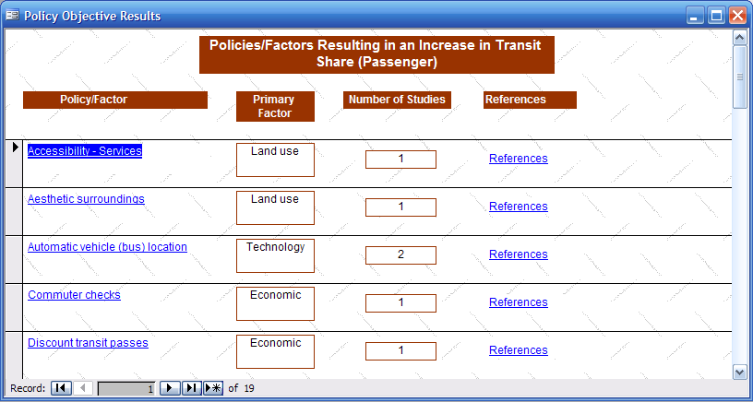
      - Sample output display for objective-oriented analysis

Policy-Oriented Analysis
The policy-oriented analysis component of the qualitative analysis tool allows the analyst to select a factor (as was already stated, a factor can be a policy or an external development) and view the directional impact on modal utilization. The graphical interface allows the analyst to select the factor of interest from among all the factors supported by the software. Again, these factors are sorted on the basis of the primary factors identified in the previous section to facilitate ease of navigation and input selection. The list of factors supported by the software in the context of passenger transportation is presented in Table 3.2, and list of those supported in the context of freight transportation is presented in Table 3.3. In the case of freight transportation, wherever applicable, the output displays for policy-oriented analyses also include links to the Delphi expert panel survey results (see Chapter 4).

        - List of factors supported by the DSS for passenger traffic
Land Use | Economy
Density | Fuel taxes
Employment density | Fuel price
Aesthetic surroundings | Road pricing
Accessibility – services | Parking pricing
Accessibility – employment | Discount transit passes
Accessibility – commercial | Toll for Sov on Hov lanes
Land use mix | Congestion pricing
Lateral separation of sidewalk | Commuter checks
Development intensity | Technology
Short distance trips | Signal preemption
Walking quality factor | Automatic vehicle (bus) location
Transit serviceability indices | Legislation
Transit-oriented development | Employer vanpool
Sidewalks present | Transportation System
Parking supply | Traffic speed
Safe surroundings | Parking controls
Residential density | Park and ride lots
Reduce lane widths | Accessibility — transit
Pedestrian-oriented neighborhood | Add highway capacity
Reduce block lengths | Transit on-time arrival
Proximity to park | Bicycle lanes
Population density | Traffic volume
Demographics | Improve transit schedule reliability
Telecommuters | Traffic calming
Income of household | New railway station
Female passengers | Walking quality factor
Less education level of passengers | Accessibility — automobile
 | HOV lane
 | Bicycle parking

        - List of factors supported by the DSS for freight traffic
Infrastructure Provision | Technology
Establishment of rural railroad districts | Improved internal combustion truck engines
Investments in highway bypasses around metropolitan areas | Web-broker usage
Improvements in highway geometrics | Automated routing and scheduling of trucks
Improved incident management | New AC locomotives for rail
Improved connectivity to rail yards | Innovations in the maintenance of rail trucks
ITS strategies to facilitate truck flow | Centralized computer-aided operations for rail
Lane restrictions for trucks | Enhanced logistic integration through IT
Railway bypasses | Improvements in cargo transfer facilities
Texas trunk system for rural areas | Larger and more efficient aircrafts
Time of day restrictions for trucks | Improvements in air traffic control
Economy/Logistic Trends | Mega container ships
Geographic concentration of production | Legislation/Regulation
Geographic concentration of inventory | Adequate truck parking facilities
Relocation of production/warehousing | CMAQ funding for highway projects
Rescheduling of manufacturing and distribution processes | Drivers hours of service regulation
Concentration of trade through international gateways | Increase in diesel fuel tax
Expansion of the market area | Increase security requirements on Hazmat
Increase in inventory cost | Increased truck size and weight allowances
Security | Innovative state financing for improved rail connectivity to ports
 | ITS funding for trucks
 | Stricter emission controls on heavy-duty truck engines
 | Stricter emission controls on rail locomotive engines
 | 8.25% increase in sales tax on transportation

Figure 3.2 presents the output display for a policy-oriented analysis that queried the impacts of automated routing and scheduling of trucks on the truck mode shares. The output indicates that there are five known studies that indicate a positive impact of this policy on truck mode share. By clicking “References,” the analyst is provided with the citations of these five studies. A negative number indicates the number of studies that found a negative impact on truck mode shares attributable to the automated routing and scheduling of trucks. Because the panel of experts for the Delphi survey also ranked the impact of this policy on truck mode shares, the output display contains a link to the survey results, which can be viewed by clicking “Results.”

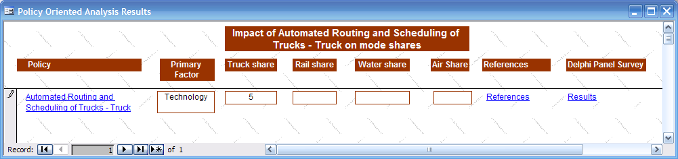
      - Sample output display for policy-oriented analysis

Concluding Remarks
The qualitative analysis tool described in this chapter is intended to facilitate the planning process by documenting a broad range of factors and their impacts on mode shares, as identified by researchers and practitioners. It is, however, important for the analyst to realize that the establishment of a direct and unambiguous relationship between factor and mode share is complex and often context specific. Hence, there is often a lack of consensus on the magnitude of the impact of various factors on mode shares. For the majority of the factors included in the DSS, there has been a general agreement among researchers and practitioners on the direction of the impact on mode shares. Cost, time, and reliability of the transportation service was considered to be the principal level-of-service measures to assess the impacts of various factors on mode shares.
Ultimately, the judgment and expertise of the analyst will determine the final policies that need further, detailed evaluation in a specific context. The DSS and access to the knowledge base of the qualitative component can assist the analyst in making well-informed decisions when identifying policies that are predicted to have the desired and greatest impact on mode utilizations.

The Delphi Expert Panel Survey
Although intermodal freight concerns are receiving increasing attention in the wake of globalization, growing congestion, and changes in the logistics structure of shippers, the research team found a general lack of reliable and robust data and substantive research in the area of freight mode choice modeling. In recognition of the importance of understanding modal utilizations for freight traffic, and given the relative lack of research/knowledge in this area, the Delphi technique was used to survey experts in the area of freight transportation. The survey results were subsequently used to enhance the qualitative freight knowledge base embedded within the decision support system (DSS).
This chapter of the report describes the application of the Delphi technique and the incorporation of the survey results into the DSS. Section 4.1 provides an overview of the Delphi technique. Section 4.2 describes the expert panel survey conducted to assess the anticipated growth in future freight flows and to determine the extent to which specific factors and policies will impact future freight mode choices in the state of Texas. Finally, Section 4.3 discusses how the survey results have been incorporated within the DSS.

An Overview of the Delphi Survey
The Delphi technique is defined as “a method for structuring a group communication process so that the process is effective in allowing a group of individuals, as a whole, to deal with a complex problem” (Linstone and Turoff, 1975). This communication process involves repetitive rounds of questions, with discussions between rounds initiated on the basis of the feedback from each round. During these discussions, the contributions made by the panel members are assessed and the participants are given an opportunity to reconsider and alter their opinions.
The traditional Delphi technique has the three major strengths. First, this survey technique presents an economic and time-efficient method of incorporating the opinions of a panel of experts. Second, the technique requires a repetitive process of obtaining the views from a panel of experts by considering and reconsidering the outcomes of the process in an effort to achieve consensus in their views on subjects that lack empirical evidence (Powell, 2003). Third, this technique involves discussions between the many rounds of question periods, and thus provides a better and a broader understanding of different aspects of the question. The discussion enhances the knowledge of the participants, stimulates new ideas (Powell, 2003), and creates a highly motivating and educational experience (Phil, 1971).
On the other hand, several studies have also been critical of the consensus approach required by the traditional Delphi technique. Powell (2003), Sackman (1975), and Rennie (1981) suggest that consensus does not always reflect the appropriate opinion. Powell (2003) claimed that this technique might become costly and time consuming, depending on the sample size, the number of rounds, and the complexity of the questions. Sackman (1975) expressed concern over the unanimity of the participants’ answers and claimed that it might make the participants liable to making decisions hastily without giving adequate thought to the question.
Notwithstanding the above criticisms, the Delphi technique has been widely recognized and used in several fields of inquiry, including nursing and health (Powell, 2003). In the freight transportation literature, however, very few studies have used the Delphi technique. One example in the freight literature is the work by Mckinnon and Forster (2000), who applied the Delphi technique to produce medium-term forecasts for a broad range of logistical and supply chain variables affecting freight transportation.

Application of the Delphi Technique
This section describes how the Delphi technique was applied to assess anticipated growth in future freight flows and to determine the extent to which specific factors and policies will impact future freight mode choices in the state of Texas. The traditional Delphi technique was enhanced with an electronic voting system to address the technological and administrative challenges that are often faced when a more traditional approach is used. Details about the design of the survey questionnaire are presented in Section 4.2.1. Section 4.2.2 describes the composition of the expert panel that participated in the survey. The survey administration procedure is discussed in Section 4.2.3, and Section 4.2.4 concludes with a brief discussion of this approach’s strengths and weaknesses.

Survey Questionnaire Design
The survey questions presented to a panel of freight experts pertained to future freight modal usage and the modal impact of identified mode choice factors, logistic trends, freight infrastructure and operations measures, technological developments, and legislative measures. The questions were grouped into the following seven sections: (1) future freight flows, (2) factors influencing mode choice, (3) logistic trends, (4) freight infrastructure and operations measures, (5) technological developments, (6) legislative measures, and (7) scenarios consisting of a combination of measures. Each section comprised approximately ten questions. The survey questions were designed to facilitate the evaluation of the posed factor/trend/scenario on a relative rating scale. The rating scales for most of the questions had five relative categories: extremely insignificant, somewhat insignificant, significant, very significant, and extremely significant. For the questions pertaining to future freight flows, the respondents were asked to select the projected freight flow increases defined in percentage bands. All the questions asked at the workshop were piloted on coworkers and volunteers who were knowledgeable about freight transportation. This enabled the identification and resolution of any ambiguities in the questions before the workshop. Sample questions from each of the seven sections and the response alternatives provided to the panelists are presented in Table 4.1. For a detailed list of all the questions asked, see Xyntarakis et al., 2004.

        - Sample survey questions and response alternatives
Section | Sample Question and Response Alternatives
Freight flow projections | With what percentage will domestic freight ton-miles—carried by all modes and with either an origin or destination in Texas—increase between now and 2015?  1 – Less than 20%, 2 – 20 to 30%, 3 – 30 to 40%, 4 – 40 to 50%,  5 – More than 50%
Factors influencing mode choice | How important will reliability be to shippers when making mode choice decisions between now and 2015?  1 – Extremely insignificant, 2 – Somewhat insignificant, 3 – Significant,  4 – Very significant, 5 – Extremely significant
Logistic trends | How significant will the rescheduling of manufacturing and distribution processes be to freight traffic growth (all modes) between now and 2015?  1 – Extremely insignificant, 2 – Somewhat insignificant, 3 – Significant,  4 – Very significant, 5 – Extremely significant
Freight infrastructure and operations measures | How would you characterize the impact of time of day restrictions on truck mode competitiveness between now and 2015?  1 – Extremely insignificant, 2 – Somewhat insignificant, 3 – Significant,  4 – Very significant, 5 – Extremely significant
Technological developments | How would you characterize the impact of automated routing and scheduling of trucks on truck mode competitiveness between now and 2015?  1 – Extremely insignificant, 2 – Somewhat insignificant, 3 – Significant,  4 – Very significant, 5 – Extremely significant
Legislative measures | What would be the direction of mode shift if the diesel fuel tax is increased by 10%?  1 – Significant shift towards rail, 2 – Moderate shift towards rail,  3 – No impact on shares, 4 – Moderate shift towards truck,  5 – Significant shift towards truck
Scenarios consisting of a combination of measures | How effective will the following “package of measures” be in diverting intercity truck traffic to rail?  Policy 1: Increase the diesel fuel tax; Policy 2: The rail infrastructure of the Trans Texas Corridor is built, requiring a rail user fee to operate on the facility; Policy 3: Improve rail connectivity to freight terminals (e.g., ports, airports, inland ports, and rail yards)  1 – Significant shift towards rail, 2 – Moderate shift towards rail, 3 – No impact on shares, 4 – Moderate shift towards truck, 5 – Significant shift towards truck

Expert Panel
Nine panel members, who are recognized for their freight expertise in Texas, were invited to participate in the Delphi survey. The panel included Metropolitan Planning Organization (MPO) freight planners, state freight planners, and port, truck, and rail representatives. The diverse backgrounds of the panel members led to a great deal of interest and discussion, owing to the many different viewpoints that were held. The size of the panel was deliberately limited in an attempt to ensure that every panel member participated in the discussions and to facilitate the efficient exploration of opposing views within a limited time frame through well-managed discussions.

Survey Administration
The University of Texas at Austin’s Center for Transportation Research (CTR) hosted the six-hour Delphi workshop. All the panel members were notified in advance about the nature, duration, and schedule of the workshop and Delphi survey. As was already indicated, the survey questions were divided into seven sections. Prior to posing the questions from each section, a short presentation was made to provide the participants with the context in which to answer the questions to be asked. Statistics and figures about the policy variables to be discussed in that section were also presented. At the end of the presentation, the questions in the section were displayed one by one. Each panel member was asked to “vote” or “select an answer to a posed question.” The panel members were given sufficient time to ponder every question before answering. An electronic voting system called Classroom Performance System (CPS) was used to facilitate answering the questions. The CPS is a software/hardware system that facilitates the recording of (anonymous) electronic responses using remote control devices and a portable receiver that allows instant feedback of the outcome. The panelists were asked to discuss the results obtained for each question, and to revote if no consensus was achieved during the first round of voting. Time constraints restricted the maximum number of rounds of voting to two. Hence, there are three possible survey outcomes: consensus achieved after the first round, consensus reached after the second round of voting, and no consensus reached. Illustrative examples of each of these three outcomes are presented in Appendix A (for complete graphical illustrations of the responses to all survey questions, see Xyntarakis et al., 2004). After each section, the responses were summarized and displayed. A facilitator moderated a discussion to explore any consistencies and discrepancies in the responses.

Strengths and Weaknesses
Even though the CPS technology addressed the technological and administrative challenges often faced by traditional Delphi survey approaches, issues and problems relating to group dynamics were encountered. For example, certain panel members were reluctant to contribute to the discussions, whereas others were found to be more vociferous in expressing their views. To some extent, the issue of group dynamics was exacerbated by the small panel size. This problem can be remedied by expanding the panel size, although this may generate other problems such as difficulty in comprehensively covering the many issues of interest within a limited time frame. Future freight panels should include shipper and airport representatives.
In addition to the issues highlighted above, there are two other precautions that should be taken when applying this technique to the freight sector. First, the questions pertaining to freight flow projections were very difficult for the panel experts to answer. This can be remedied with broader participation from shipper and modal representatives. Second, the questions of the impacts of various “packages of policies/measures” on mode choice were difficult for the panel members to answer, because it delved into relatively abstract concepts. This was aggravated by respondent fatigue, because this section was addressed at the end of the one-day workshop. This can be remedied by reducing the number of issues and policies that are covered during the one-day workshop. Notwithstanding these limitations, the enhanced Delphi survey technique proved to be a relatively inexpensive and efficient approach to obtain an understanding of the freight sector and to obtain qualitative data to incorporate into the DSS.

Incorporating the Survey Results within the DSS
The results from the Delphi survey were included in the DSS. As was described in Section 3.2, wherever applicable, the output displays for policy-oriented analyses of freight transportation include links to the Delphi survey results. In addition, the DSS software allows the analyst to access the survey results directly. The analyst can thus view the survey results in two ways. First, the analyst can view the expert opinions for each of the questions included in the survey. A list of all survey questions classified into the seven major categories is provided in a drop-down list box to facilitate easy navigation. Figure 4.1 presents an example showing how the Delphi panel regarded the impact of automated routing and scheduling of trucks on truck mode competitiveness. Alternatively, the analyst can obtain summary statistics for each section of questions. This allows the user to view the average ratings (averaged across the responses of the nine panelists) for all the questions/issues discussed in a particular section (see Figure 4.2). This enables the user to compare the relative impacts of different actions or scenarios on the competitiveness of a particular mode.

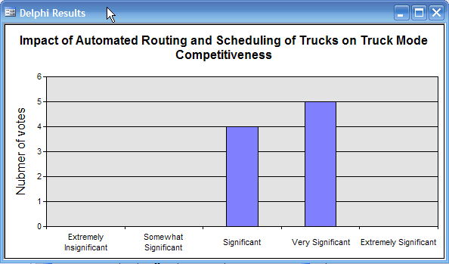
      - Sample output display for a query on the impact of a specific policy action
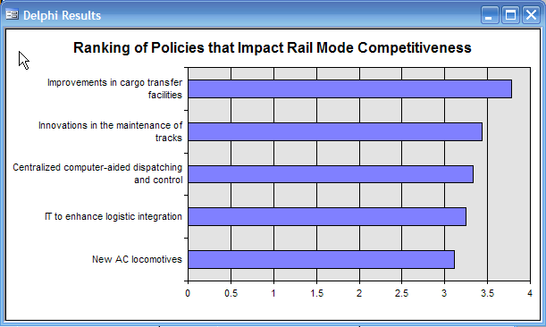
      - Sample output display for a query on section summary

Concluding Remarks
The Delphi technique seemed to be a cost-effective and efficient technique to gain a better understanding of the freight sector and those factors and policies that impact freight mode choice. The results showed general consensus for most of the sections, especially after revoting. The CPS technology enhanced the overall efficiency of conducting the Delphi survey by enabling the real-time display of the voting outcome through informative graphic representations and instant revoting when required.

The Quantitative Analysis Tool
The quantitative analysis component of the decision support system (DSS) consists of two subcomponents: (1) the baseline assessment and (2) the freight mode choice model. The baseline assessment component provides tabular and graphical information on historical trends in freight and passenger mode utilizations and socioeconomic trends. The freight mode choice model enables the analyst to conduct a quantitative analysis of the truck and rail mode shares for intrastate freight movements. Each of these two subcomponents is discussed in detail in Sections 5.1 and 5.2.

The Baseline Assessment Component
The baseline assessment component provides the analyst with access to longitudinal mode utilization data for both passenger and freight traffic from a number of different public and private data sources. In addition, longitudinal information on various socioeconomic factors (e.g., Gross Domestic Product) and aggregate performance measures (e.g., intercity ton-miles by mode) has also been embedded in this component of the software.
Whenever feasible, the precompiled information is presented in the form of a pivot table or a pivot chart. Hence, the analyst is not restricted to a precompiled view of the data presented. Rather, the analyst is able to explore different aspects of the data through the interface. The pivot tables can also be easily exported to other spreadsheet applications for further analysis.
This component of the software provides the analyst with a powerful and integrated tool to access various performance measures related to mode utilization and a number of other indicators of the transportation system in an interactive way. In addition, new data and charts can be incorporated into the software, thereby enabling the analyst to stay up-to-date.

Baseline Assessment for Passenger Traffic
The passenger data included in the DSS are predominantly derived from three sources: (1) the Capital Area Metropolitan Planning Organization (CAMPO, 2004), (2) the North Central Texas Council of Governments (NCTCOG, 2004), and (3) the National Household Travel Survey (NHTS, 2001). The complete list of tables and charts currently available in the DSS is presented in Table 5.1.

        - List of tables and charts available for passenger traffic baseline assessment
Austin CAMPO
Mode share to work (2000)
NCTCOG Report, Spring 2004 (Dallas-Fort Worth Area)
Annual cost of congestion
Annual passengers traveling by air
Annual transit riders
Daily vehicle-miles
Percentage of lane-miles highly congested
Weekday vehicle-miles traveled per household
NHTS 2001 Statistics
Annual miles of travel
Mode of transportation to work
Number of drivers in a household
Number of vehicles owned by a household

As was indicated before, the analyst can customize the output display of many of the pivot tables and charts identified in Table 5.1. A sample output (pivot) chart is presented in Figure 5.1.

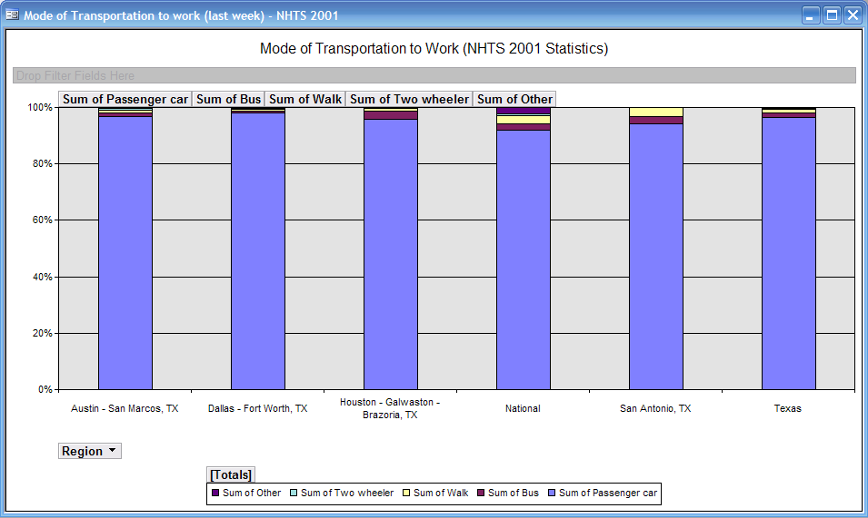
      - Sample pivot chart output for passenger traffic baseline assessment

Baseline Assessment for Freight Traffic
The freight data included in the DSS are predominantly from the following four sources: (1) Transportation in America 1999 (Eno Foundation, 2000), (2) Reebie TRANSEARCH data for 1996 and 1998 (Reebie Associates), (3) Transborder Surface freight data 1998–2002 (BTS), and (4) Waterborne Commerce of the United States 1995–2001 (U.S. Army Corps of Engineers). The complete list of pivot tables and charts currently available to the analyst is presented in Table 5.2.
        - List of tables and charts available for passenger traffic baseline assessment
Eno Foundation
Average length of haul of domestic interstate freight
Basic intercity transportation mileage
Domestic intercity mode shares (based on ton-miles)
Domestic intercity ton-miles by mode (in billions)
Domestic intercity tonnage carried by mode (millions of tons)
Domestic intercity mode shares (based on tons)
GDP
Industrial production index
Intercity ton-miles (billions)
Number of privately and publicly owned transportation units
Population
Public freight carriers’ revenue (revenue per ton-mile in cents)
Trends in new vehicle purchases/shipments
Reebie 1996–1998
Interstate mode shares (weight)
Interstate flows by commodity and mode (weight)
Interstate flows by commodity (weight)
Intrastate mode shares (weight)
Intrastate flows by commodity and mode (weight)
Intrastate mode shares by commodity group (weight)
Interstate mode shares by commodity group (weight)
Interstate flows (weight)
Intrastate flows (weight)
Transborder 1998–2002
Exports to Mexico (by value)
Imports from Mexico (by value and by weight)
Mode shares for imports from Mexico (by value and by weight)
Mode shares for exports to Mexico (by value)
U.S. Army Corps of Engineers
Commodity flows for principal Texas ports 1992–2001
Commodity flows in principal Texas ports
Commodity flows for principal Texas ports—comparison
The analyst can also customize the output display for many of the tables and charts identified in Table 5.2. A sample output (pivot) chart is presented in Figure 5.2.

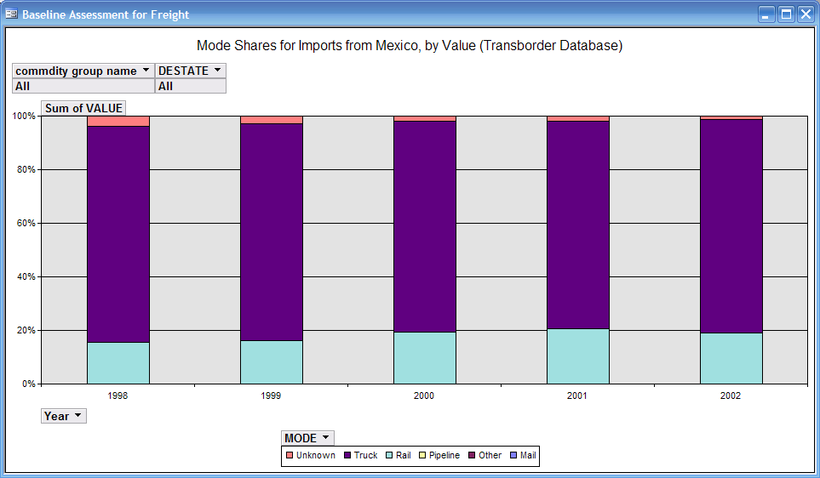
      - Sample pivot chart output for freight traffic baseline assessment

The Freight Mode Choice Prediction Model
This section of the chapter describes the freight mode choice model embedded in the DSS. This component enables the analyst to conduct quantitative analysis of the truck and rail mode shares for intrastate (county-to-county) freight movements. Specifically, the analyst can use this component to determine the truck and rail mode shares for the following five commodity groups: (a) agricultural and related products, (b) hazardous materials, (c) construction materials, (d) food and related products, and (e) manufacturing products. For additional information on how the commodity groups were compiled, see Sivakumar and Bhat (2001). Section 5.2.1 describes the mode choice model embedded within the DSS. Section 5.2.2 discusses how to implement the model for predicting mode shares and undertaking “what-if” analyses.

The freight mode choice model
The embedded freight mode choice models were developed as part of a previous research project (see Sivakumar and Bhat, 2000, and Sivakumar, Srinivasan, and Bhat, 2001). These models—one for each of the five commodity groups—determine the share of intercounty freight movements by rail and truck as a function of the total freight movements (or shipment size) between the counties, the socioeconomic characteristics of the origin and destination counties, and the transportation distance between the counties.
The empirical model results are presented in Table 5.4. If the coefficient of an explanatory variable has a positive sign, it indicates that the explanatory variable increases the share of the rail mode or alternatively decreases the share of the truck mode. For example, the distance of haul was found to have a positive impact on the rail mode share for food and related products (see the positive sign of the coefficient). This means that the longer the shipment distance of food and related product, the higher the rail mode share. For additional information about the data sources, the econometric model structures, the estimation procedures, and a discussion of the empirical model results, see Sivakumar and Bhat (2000).

        - The fractional split model for freight mode choice

Variables | Agricultural and Related Products |  | Hazardous Materials |  | Construction Materials |  | Food and Related Products |  | Manufacturing Products
Variables | Coeff. | t stat | Coeff. | t stat | Coeff. | t stat | Coeff. | t stat | Coeff. | t stat
Constant | −3.403 | −6.695 | −5.235 | −24.688 | −4.586 | −27.577 | −6.689 | −10.243 | −6.158 | −22.803
Distance |  |  |  |  | −0.206 | −3.685 | 0.295 | 2.888 | −0.162 | −2.162
Origin population | −77.960 | −5.063 | 4.429 | 2.159 | −7.374 | −2.456 | −4.595 | −1.695 | 5.701 | 1.888
Dest. population |  |  | 8.058 | 4.493 |  |  | −5.881 | −1.555 | 5.206 | 2.504
Origin area |  |  | 0.285 | 1.982 | 0.546 | 7.020 | −0.742 | −1.231 | 0.505 | 3.337
Dest. area | −0.481 | −1.131 | 0.210 | 2.126 |  |  | 0.525 | 3.977 | 0.417 | 3.748
Origin income | 2.309 | 3.665 | −0.114 | −1.378 | 0.174 | 1.371 | 0.343 | 2.403 | −0.152 | −1.546
Dest. income | 0.187 | 2.113 | −0.163 | −1.791 | −0.141 | −2.437 |  |  | −0.172 | −1.694
Origin emp. count | –106.131 | −2.484 | −15.690 | −5.053
Dest emp. count |  |  | −9.325 | −3.207 | −16.085 | −3.817 | −17.854 | −1.743 | −4.841 | −1.235
Origin payroll | −0.889 | −4.480 | 0.047 | 1.097 | −0.271 | −3.360 | −0.183 | −2.916
Dest payroll |  |  | 0.095 | 1.982 |  |  | −0.154 | −2.299 | −0.054 | −1.041
Origin # estb. (1–500) | 14.905 | 4.142 | 1.163 | 2.768 | 1.211 | 2.929 |  |  | −0.748 | −1.060
Dest. # estb. (1–500) |  |  |  |  | 1.207 | 4.572 | 1.809 | 1.999
Origin # estb. (500–1k) | 25.771 | 1.587 |  |  |  |  | 3.560 | 2.310 | 6.032 | 2.515
Dest. # estb. (500–1k) |  |  |  |  | 8.307 | 3.399 | 12.169 | 2.195 | 4.284 | 1.533
Origin # estb. (>1k) | 21.475 | 4.349 | 3.987 | 4.320 | 2.292 | 2.473 |  |  | −3.206 | −3.415
Dest # estb. (>1k) | −1.998 | −3.106 | 2.035 | 2.167
Total ton | 0.826 | 10.299 | 0.000 | 1.892 | 0.003 | 6.095
Intracounty |  |  | 0.745 | 1.318
Restricted log-likelihood | −577.317 |  | −1,763.628 |  | −1,811.437 |  | −533.228 |  | −1,089.553
Chi squared | 943.715 |  | 1,478.997 |  | 1,544.103 |  | 497.844 |  | 968.863

Model implementation for predicting more shares
The embedded models allow the analyst to predict freight flows by rail and truck among any of the counties in Texas and to examine the impacts of socioeconomic changes in the origin and destination counties on these flows. To enable the forecasting of freight flows, the model parameters have been incorporated into the software. The data corresponding to the explanatory variables of the model have also been embedded within the DSS.
(1) Texas county-to county freight movements captured in the Reebie TRANSEARCH Freight Database (1998)
(2) Centroidal distances between counties and among groups of counties derived from TRANSCAD geographic maps and datasets
(3) Socioeconomic data from the County Business Pattern database
(4) County population data from the U.S. Census Bureau (1998)

A graphical interface displays the map of Texas (see Figure 5.3), from which the analyst can select the desired origin and destination counties—a single county or a group of counties. The model predicts the rail and truck mode shares for each of the five commodity types using the underlying databases and the embedded model parameters. The predicted mode shares are displayed in the form of a chart. When more than one county is selected as the origin or destination, the mode shares for the entire corridor (i.e., all the selected origin and destination counties) are predicted. This is achieved by first determining the mode shares for each of the individual origin–destination county pairs and subsequently computing a weighted average.
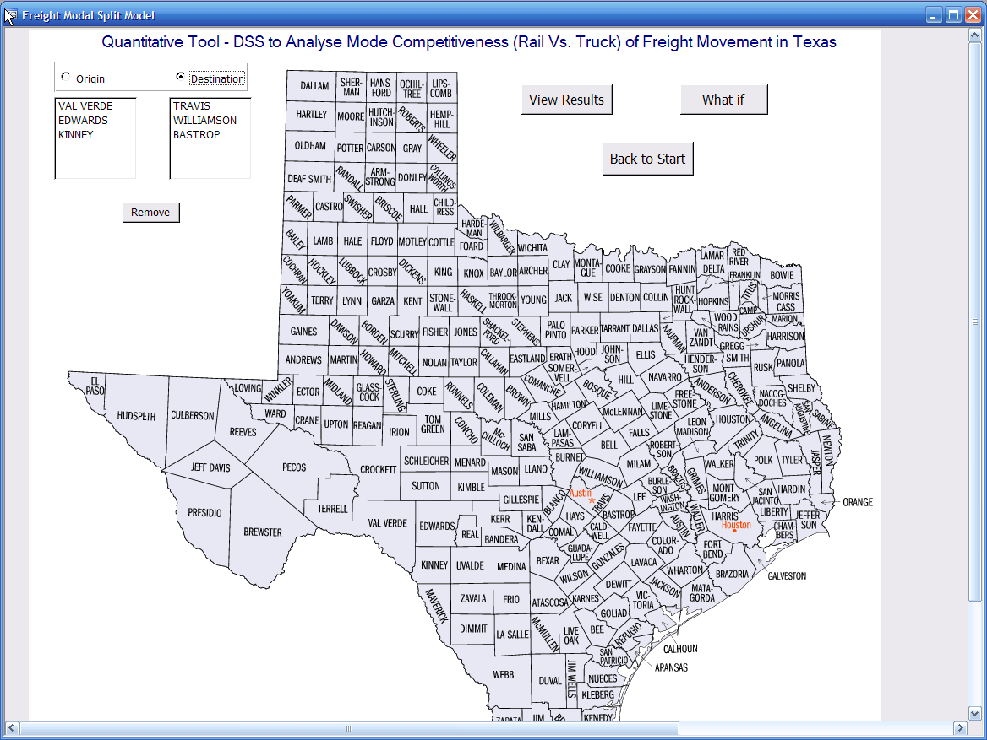
      - Input screen for freight mode choice forecasting
The model also allows the analyst to undertake “what-if” analyses. The analyst can specify a future year scenario by the defining changes (as percentages) to the socioeconomic characteristics of the origin and destination counties. Figure 5.4 presents the input screen for scenario analyses. The specified percentage changes are applied to the appropriate explanatory variables, and the model predicts the future mode shares. The results are again displayed as a chart.
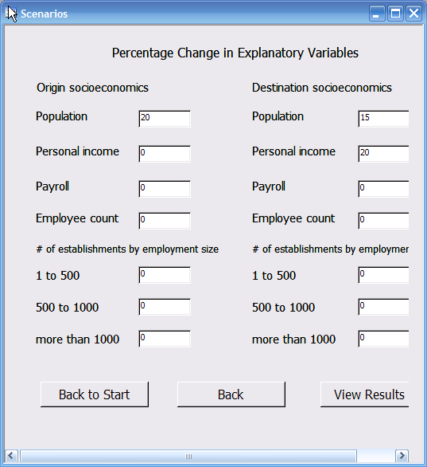
      - Input screen for scenario definition
Figure 5.5 illustrates the predicted mode shares for a randomly selected corridor (comprising Val Verde, Edwards, and Kinney counties as the origins and Travis, Williamson, and Bastrop counties as the destinations) in the base case and for a future year. The future year scenario was defined as follows: a 20 percent increase in the population of the origin counties, a 15 percent increase in the population of the destination counties, and a 20 percent increase in the personal income of the destination counties.

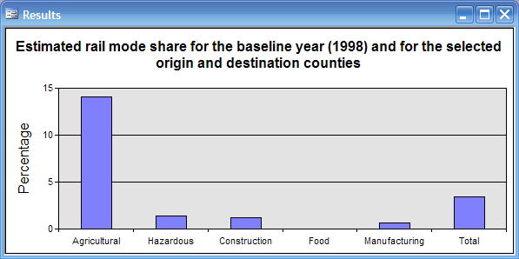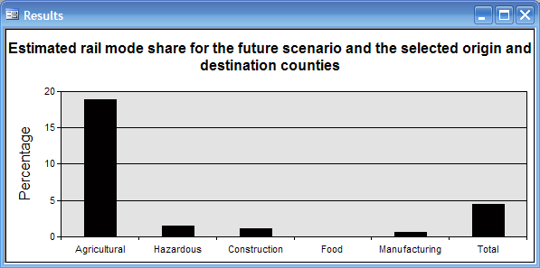
      - Output charts for the base case and the future year scenarios

Conclusions and Recommendations
Numerous potential policies are available to Texas Department of Transportation (TxDOT) planners for implementation to meet the “reliable mobility” objective of the TxDOT strategic plan. To assist TxDOT with the planning process, the research team has developed a prototype decision support system (DSS) to qualitatively and quantitatively assess the impact of a variety of transportation factors and policies relating to multimodal development
The qualitative component of the DSS consolidates recent literature on passenger and freight mode utilizations that is practical and easy to access. It documents the directional impacts of various factors exogenous to the practitioner, as well as transportation policies on mode utilization. In addition, the qualitative knowledge base for freight was enhanced by incorporating the results of a Delphi expert panel survey.
The quantitative component incorporates longitudinal information on mode utilization in an effort to assist planners in monitoring the performance of the transportation system, identifying trends, and assessing benefits. In addition, this component comprises the implementation of a state-of-the-art mode split model to predict intercounty rail and truck mode shares for five different commodity groups. An interactive graphical user interface allows the analyst to evaluate mode shares under alternative socioeconomic scenarios. The DSS has been designed to offer the analyst flexibility, versatility, and customization options. The software has an easy-to-use and intuitive interface, facilitating user interaction in many areas.
In summary, the prototype DSS developed as part of this research has the potential to serve practitioners at the statewide and metropolitan level by providing a single tool in which consolidated information on multimodal utilization and policy effects are documented and with which aggregate-level scenario evaluation can be conducted. The knowledge base and other features of the software can be updated periodically to ensure that the latest information is available to users. For example, (a) the scope of the analysis can be expanded to include intercity passenger and intracity freight movements, (b) the knowledge base can be continually updated, and (c) additional information on the characteristics and utilization of intermodal facilities and the Texas highway and railway system can be incorporated.

References
BTS Transborder Surface Freight Data, Monthly and Annual Detail Data, 1998–2002. Available at http://www.bts.gov/transborder/
CAMPO (2004). CAMPO: Mobility 2030 Plan. Public review draft.
Eno Transportation Foundation (2000). Transportation in America 1999 (17th ed.).
Linstone, H., and M. Turoff (1975). The Delphi Method: Techniques and Applications. Reading, MA: Addison-Wesley.
Lockwood, S.C. (1998) The Changing State DOT. American Association of State Highway and Transportation Officials, 101.
McKinnon, A., and M. Forster (2000). Full Report of the Delphi 2005 Survey: European Logistical and Supply Chain Trends: 1999–2005. Report for TRILOG–Europe.
NCHRP Report 388 (1997). A Guidebook for Forecasting Freight Transportation Demand.
NCTCOG (2004). Transportation: State of the region. North Central Texas Council of Governments, Transportation Department.
NHTS (2001). National Household Travel Survey 2001. Available at http://nhts.ornl.gov/2001/index.shtml
Pill, J. (1971). The Delphi method: Substance, context, a critique and an annotated bibliography. Socio-Economic Planning and Science, 5, 57-71.
Powell, C. (2003). The Delphi Technique: Myths and realities. Journal of Advanced Nursing, 41(4), 376-382.
Reebie Associates (1998). Transresearch Freight Market Data, 1996 and 1998. Available at http://www.reebie.com/
Rennie, D. (1981). Consensus statements. New England Journal of Medicine, 304, 665-666.
Sackman, H. (1975). Delphi Critique. Boston, MA: Lexington Books.
Sivakumar, A., and C.R. Bhat (2000). Freight modal split modeling: Conceptual framework, model structure, and data sources. Report 0-1833-4, prepared for the Texas Department of Transportation, August.
Sivakumar, A., A. Srinivasan, and C.R. Bhat (2001). Freight modal split: Estimation results and model implementation. Report 0-1833-5, prepared for the Texas Department of Transportation, July.
U.S. Army Corps of Engineers. Waterborne Commerce of the United States, 1995–2001. Available at http://www.iwr.usace.army.mil/ndc/
Xyntarakis, M., C.R. Bhat, J. Prozzi, S. Sen, and A. Yeraguntla (2004). Workshop on freight model competitiveness. Report 4013-2, prepared for the Texas Department of Transportation.

Appendix A
Expert Panel Survey Outcomes: Illustrative Examples

This section of the report presents illustrative examples from the Delphi technique corresponding to each of three possible outcomes: (1) consensus achieved in the first round, (2) consensus achieved in the second round, and (3) no consensus achieved.

Consensus Achieved in the First Round

In some sections, such as significance of factors affecting mode choice and impact of legislative measures, consensus was achieved in the first round of voting on almost all the questions. Illustrative examples are provided in Figures 1 and 2. As can be seen from Figure 1, two thirds of the panelists agreed that shippers would consider reliability an extremely significant factor when making mode choice decisions in the future. The survey results (Figure 2) also indicate that there was general consensus that the imposition of stricter emissions controls that would increase truck-operating costs would cause a moderate shift in the modal share from truck toward rail.

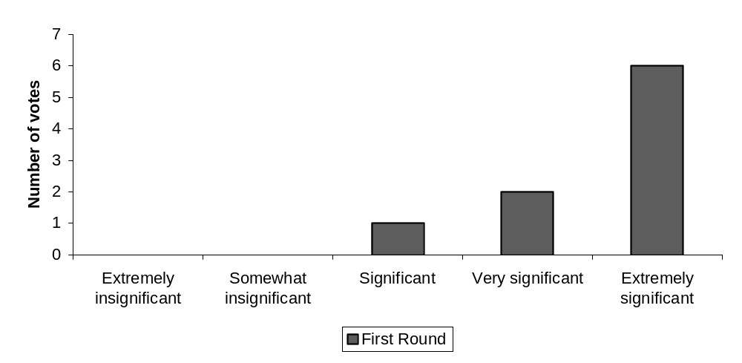
Figure 1: Significance of reliability to the shippers when making mode choice decisions between 2004 and 2015

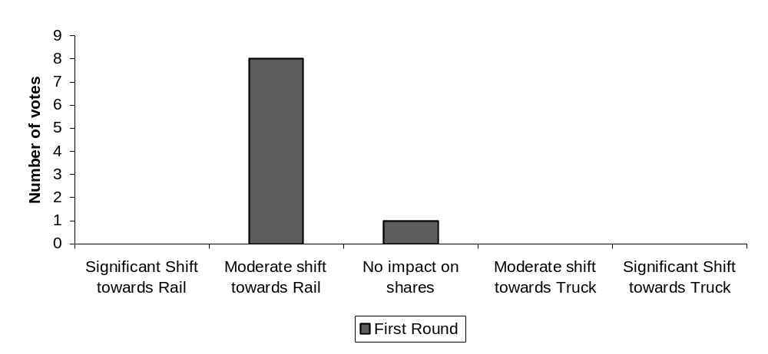
Figure 2: Impact of stricter emission controls on heavy-duty truck engines that result in a 5 percent increase in truck-operating costs

Consensus Achieved in the Second Round

In other sections, such as future infrastructure and operations measures, consensus was achieved only in the second round of voting for most of the questions. The questions asked in these sections required a deeper understanding of the impacts of these measures on freight mode choice. Hence, it is understandable that discussions between the rounds of voting enabled the panel members to gain a better understanding of the various implications of the measures and consequently resulted in consensus in the second round of voting. Illustrative examples are provided in Figures 3 and 4. As can be seen from Figure 3, the outcome from the first round of voting shows a lack of consensus about the future impact of the planned Trans Texas Corridor on rail mode competitiveness. However, after discussion, two thirds of the panel members agreed that the Trans Texas Corridor would have an extremely insignificant impact on rail mode competitiveness in the future. Figure 4 shows that almost half of the panelists changed their opinion about the impact of rescheduling manufacturing and distribution processes on freight traffic growth in the near future between the first and second round of voting. In the second round, most panelists agreed that this measure would have a significant to very significant impact on freight traffic growth between 2004 and 2015.

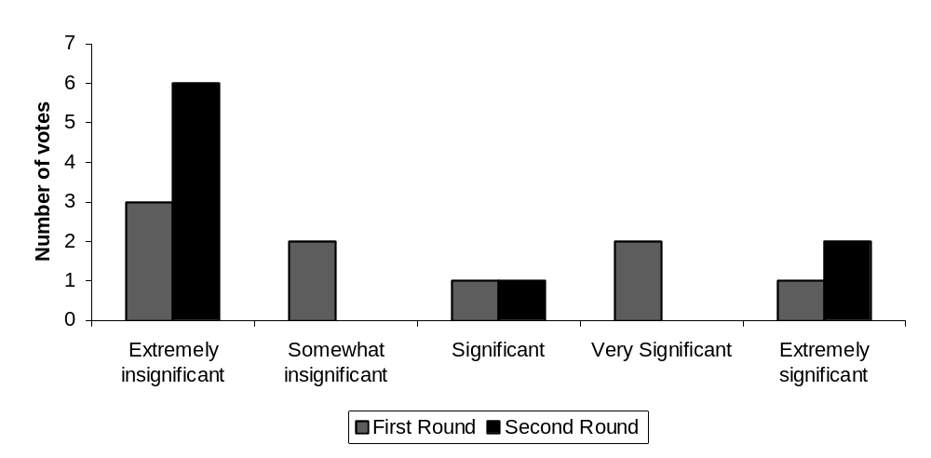
Figure 3: Impact of the Trans Texas Corridor on rail mode competitiveness between 2004 and 2015
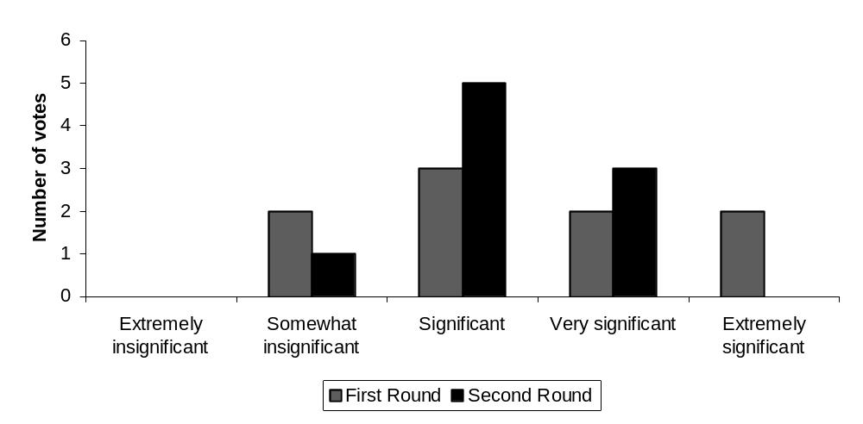
Figure 4: Impact of the rescheduling of manufacturing and distribution processes on the freight traffic growth between 2004 and 2015

No Consensus

Finally, there were a few instances in which no consensus was achieved, even after revoting. This was especially evident in the section on future freight projections. Illustrative examples are provided in Figures 5 and 6. From Figure 5, it is evident that there was no consensus in the initial round of voting concerning the increase in U.S. domestic freight flows between 2004 and 2015, although most respondents (around 45 percent) agreed that U.S. domestic freight flows will increase between 30 and 40 percent. The results show a negligible change in the opinions of the panel members after discussions and the second round of voting. Overall, the panel members seem to have agreed that the U.S. domestic freight ton-miles will grow by at least 20 percent between 2004 and 2015. Figure 6 also shows that no consensus could be reached about the increase in intercity waterborne freight ton-miles with either an origin or a destination in Texas between 2004 and 2015. This was the case even after discussion and revoting.

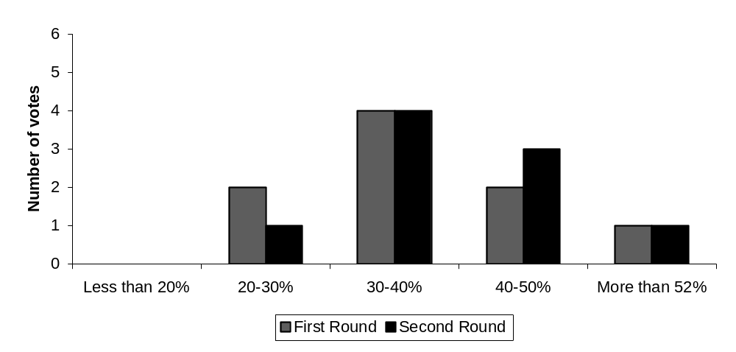
Figure 5: Percentage increase in U.S. domestic freight ton-miles between 2004 and 2015
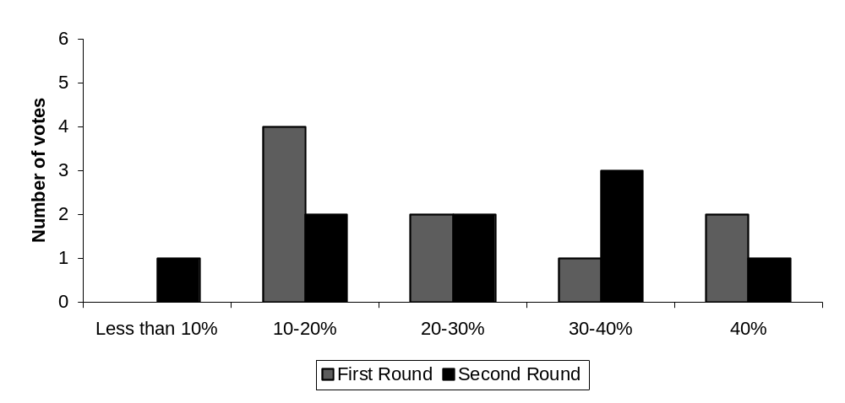
Figure 6: Percentage increase in intercity waterborne freight ton-miles with either an origin or a destination in Texas between 2004 and 2015

