PRELIMINARY REVIEW COPY
Technical Report Documentation Page
1. Report No.  Preliminary Review Copy | 2. Government Accession No. |  | 3. Recipient’s Catalog No.
4. Title and Subtitle  Techniques for Mitigating Urban Sprawl |  |  | 5. Report Date  August 2002
7. Author(s)  Jumin Song, Jayanthi Rajamani, Juchul Jung, Dr. Susan Handy, Dr. Robert Paterson, Dr. Chandra Bhat, Dr. Kara Kockelman |  |  | 6. Performing Organization Code
8. Performing Organization Report No.
0-4420-1

9. Performing Organization Name and Address  Center for Transportation Research  The University of Texas at Austin  3208 Red River, Suite 200  Austin, TX 78705-2650 |  |  | 10. Work Unit No. (TRAIS)
11. Contract or Grant No.

0-4420
12. Sponsoring Agency Name and Address  Texas Department of Transportation  Research and Technology Transfer Section/Construction Division  P.O. Box 5080  Austin, TX 78763-5080 |  |  | 13. Type of Report and Period Covered  Research Report
 |  |  | 14. Sponsoring Agency Code
15. Supplementary Notes
Project conducted in cooperation with the Federal Highway Administration.
16. Abstract
Urban sprawl, driven by population and economic growth, is a pressing issue in the U.S., partly because of its contribution to growing levels of vehicle-miles-traveled (VMT). According to government figures, new development is gobbling land at an alarming rate of 365 acres per hour (Natural Resources Defense Council, 2002). Between 1960 and 1990, the amount of developed land in metro areas more than doubled, while the population grew by less than half (National Resource Defense Council, 2001). In response, various efforts to mitigate urban sprawl have been and are being developed and implemented in different contexts and with different intents under the popular umbrella of “smart growth.” Transportation plays an important role in these efforts: transportation investments and policies can be used to influence development patterns, and policies that promote more compact development can help to slow the growth in VMT. This report identifies transportation-related and growth-management strategies and policy actions used in smart growth efforts and catalogues them with respect to goals, characteristics, and suitability factors in the form of six matrices, designed as a guide for communities in Texas in the selection of sprawl mitigation techniques appropriate to their specific contexts. The matrices were developed based on an extensive review of the literature and a review by an expert panel of leading land use and transportation researchers. The report discusses the problem of urban sprawl and efforts to mitigate it, describes the development of the matrices, presents the matrices and supporting materials, and discusses future research needs.

17. Key Words  sprawl, smart growth, land use, transportation, growth  management, sprawl mitigation |  | 18. Distribution Statement  No restrictions. This document is available to the public through the National Technical Information Service, Springfield, Virginia 22161.
19. Security Classif. (of report)  Unclassified | 20. Security Classif. (of this page)  Unclassified |  | 21. No. of pages  98 | 22. Price
Form DOT F 1700.7 (8-72) Reproduction of completed page authorized

PRELIMINARY REVIEW COPY

Techniques for Mitigating Urban Sprawl

Jumin Song
Jayanthi Rajamani
Juchul Jung
Dr. Susan Handy
Dr. Robert Paterson
Dr. Chandra Bhat
Dr. Kara Kockelman

Research Report 0-4420-1

RESEARCH REPORT-I

Research Project 0-4420

“Techniques for Mitigating Urban Sprawl”

Conducted for the

TEXAS DEPARTMENT OF TRANSPORTATION

by the

CENTER FOR TRANSPORTATION RESEARCH
THE UNIVERSITY OF TEXAS AT AUSTIN

August 2002

DISCLAIMERS

The contents of this report reflect the views of the authors, who are responsible for the facts and the accuracy of the data presented herein. The contents do not necessarily reflect the official views of the Texas Department of Transportation. This report does not constitute a standard, specification, or regulation.
There was no invention or discovery conceived or first actually reduced to practice in the course of or under this contract, including any art, method, process, machine, manufacture, design or composition of matter, or any new and useful improvement thereof, or any variety of plant, which is or may be patentable under the patent laws of the United States of America or any foreign country.

NOT INTENDED FOR CONSTRUCTION, BIDDING, OR PERMIT PURPOSES
Susan Handy, Research Supervisor

ACKNOWLEDGMENTS

The researchers acknowledge the invaluable assistance provided by Jenny Peterman, TXDOT project director for this study. Also appreciated is the guidance provided by the other members of the project advisory committee.

TABLE OF CONTENTS

CHAPTER 1. INTRODUCTION TO SPRAWL 1
1.1 Definition oF Sprawl 1
1.2 Causes of Sprawl 2
1.2.1 Investment Policies 3
1.2.2 Development Policies and Regulations 3
1.2.3 Speculation 3
1.2.4 Land Use Regulation 3
1.2.5 Facility Pricing 3
1.2.6 Development Economics 3
1.2.7 Demographic Changes 4
1.2.8 Lifestyle Trends 4
1.3 Potential Impacts oF Sprawl 4
1.3.1 Negative Impacts 4
1.3.2 Positive Impacts 5
1.4 Indicators of Sprawl 6
1.5 Measuring Sprawl 7
1.6 Smart Growth and Sprawl 8

CHAPTER 2. TRANSPORTATION AND URBAN SPRAWL 11
2.1 Introduction 11
2.2 Impacts of Transportation Investments and Policies on
Development Patterns 12
2.3 Impacts of Development Patterns on Travel Patterns 14
2.3.1 Relationship between Land-Use Patterns and Travel Characteristics 15
2.3.2 Relationship between Land-Use Patterns and Travel Mode Choice 15

CHAPTER 3. STATE DOTS AND GROWTH MANAGEMENT 17
3.1 INTRODUCTION 17
3.2 SURVEY OF STATE DOTS 18
3.3 CONCLUSIONS 24

CHAPTER 4. THE TEXAS CONTEXT 25
4.1 Introduction 25
4.2 MUNICIPAL LEVEL 26
4.2.1 Comprehensive Planning and Zoning 26
4.2.2 Home Rule Provision 26
4.2.3 Annexation 26
4.2.4 Current Trends in Planning Approaches 27
4.2.5 Current Trends in Transportation 27
4.3 ABOVE MUNICIPAL LEVEL 27
4.4 SUMMARY 29

CHAPTER 5. THE SPRAWL MITIGATION MATRIX 31
5.1 Introduction 31
5.1.1 Literature Review 34
5.1.2 Expert Panel Review 34
5.2 Goals Matrix 36
5.3 Characteristics Matrix 38
5.4 Suitability Factors Matrix 39

CHAPTER 6. CONCLUSIONS AND FUTURE RESEARCH 43

REFERENCES 44

APPENDICES 55

APPENDIX A
Table A-1 Legal Authority for Transportation-related Policy Actions 55
Table A-2 Legal Authority for Growth Management-related Policy Actions 57

APPENDIX B
Appendix B-1 Description of Transportation-related Sprawl Mitigation Strategies
and Policy Actions 59
Appendix B-2 Description of Growth Management-related Sprawl Mitigation
Strategies and Policy Actions 72

APPENDIX C
Matrix C-1A Goals of Transportation-Related Strategies and Policy Actions 85
Matrix C-1B Goals of Growth-Management Strategies and Policy Actions 86
Matrix C-2A Characteristics of Transportation-Related Strategies and Policy Actions 87
Matrix C-2B Characteristics of Growth-Management Strategies and Actions 88
Matrix C-3A Suitability Factors of Transportation-Related Strategies and Policy
Actions 89
Matrix C-3B Suitability Factors of Growth-Management Strategies and Policy
Actions 90

CHAPTER 1. INTRODUCTION

Urban sprawl, driven by population and economic growth, is a pressing issue in the U.S. According to government figures, new development is gobbling land at an alarming rate of 365 acres per hour (Natural Resources Defense Council, 2002). Between 1960 and 1990, the amount of developed land in metro areas more than doubled, while the population grew by less than half (National Resource Defense Council, 2001). The contribution of sprawl to a variety of problems in metropolitan areas has been well documented: traffic congestion, air and water quality, equity of economic opportunity, and so on. In response, various efforts to slow urban sprawl and mitigate its effects have been and are being developed and implemented in different contexts and with different intents under the popular umbrella of “smart growth.” Transportation plays an important role in these efforts: transportation investments and policies can be used to influence development patterns, and policies that promote more compact development can help to slow the growth in vehicle-miles-traveled (VMT). However, the list of possible smart growth strategies is long, and transportation agencies and other planning agencies are often at a loss as to what strategies make the most sense for their communities. The challenge is especially acute in states like Texas that have little tradition in managing urban growth.
The purpose of this project was to identify transportation-related and growth-management strategies and policy actions used in smart growth efforts and catalogue them with respect to goals, characteristics, and suitability factors. This catalogue is presented in the form of six matrices, designed as a guide for communities in Texas and elsewhere in the selection of sprawl mitigation techniques appropriate to their specific contexts. This report presents important background for this effort, including an introduction to the topic of urban sprawl in the remainder of this chapter, a discussion of the connections between transportation and smart growth in Chapter 2, an overview of sprawl mitigation efforts in Chapter 3, and a description of the Texas context for sprawl mitigation efforts in Chapter 4. Chapter 5 presents the sprawl mitigation matrices, and Chapter 6 concludes the report with a discussion of future research needs. This remainder of this chapter provides an overview of various definitions of sprawl in the literature, the primary causes of sprawl, its negative and positive impacts, factors that indicate or characterize sprawl, and ways of measuring sprawl. The final section of this chapter introduces the concept of smart growth as a tool for mitigating sprawl.

  - Definition of Sprawl

One of the earliest uses of the word “sprawl” in terms of land use was in a 1937 speech by Earle Draper, then director of planning for the Tennessee Valley Authority: “Perhaps diffusion is too kind a word. ... In bursting its bounds, the city actually sprawled and made the countryside ugly, uneconomic in terms of services and doubtful social value.” Since then, numerous research efforts have attempted to characterize and explain urban sprawl. However, the continually expanding body of literature provides no consensus on the definition or characteristics of sprawl. To complicate matters, the term “sprawl” is applied in many different ways (Galster, et al. 2000): as an aesthetic judgment about a general urban development pattern; as a cause of an externality, such as high automobile dependence, isolation of the poor in the inner city, or loss of air quality; as the consequence or effect of some independent variable, such as fragmented local government, “poor” planning, or exclusionary zoning; or as comparisons with cities such as Los Angeles.
The multi-faceted nature of sprawl leads to different definitions from a diverse set of fields. Most definitions refer to the low-density and uncontrolled expansion of urban areas into suburbia. For example, London Times (1955) defined sprawl as the “straggling expansion of an indeterminate urban or industrial environment into the adjoining countryside.” Similarly, the Vermont Forum on sprawl defined it as “dispersed development outside of compact urban and village centers along highways and rural countryside.” While some studies have concentrated on the inefficient and chaotic patterns of suburban development generated by sprawl (for example, see Kuntsler, 1994), some others have focused on the automobile-dependent aspect of sprawling development (for example, see USHUD, 1999). Nelson and Duncan (1995) present a synthesized definition of urban sprawl as “unplanned, uncontrolled and uncoordinated single-use development that does not provide for an attractive and functional mix of uses and/or is not functionally related to surrounding land uses and which variously appears as low density, ribbon or strip, scattered, leapfrog or isolated development.” In summary, urban sprawl is a term that has been used to describe a variety of conditions. It has been associated with patterns of residential and nonresidential land use, the process of extending the reach of urbanized areas (UAs), the causes of particular practices of land use, and the consequences of those practices. Sprawl has been denounced on aesthetic, efficiency, equity, and environmental grounds and defended on grounds of choice, equality, and economy (Galster et al., 2000”).
Although the term “sprawl” has numerous interpretations, a set of attributes may be considered to characterize sprawl. For the purpose of this project, the ten traits identified by Downs (1998) are used to define sprawl:

1. Unlimited outward extension
2. Low-density residential and commercial settlements
3. Leapfrog development, which leaves large areas undeveloped but fails to provide functional
open space
4. Fragmentation of powers over land use among many small localities
5. Dominance of transportation by private automobile vehicles
6. No centralized planning or control of land-uses
7. Widespread strip commercial development
8. Great fiscal disparities among localities
9. Segregation of types of land uses in different zones
10. Reliance mainly on the trickle-down or filtering process to provide housing to low-income
households; no low-income households outside central cores

  - Causes of Sprawl

According to Fishman (1987), the development of the suburbs in post-war America addressed two conflicting goals: to accommodate households relocating to the suburbs, and to provide the semi-rural environment that suburbanites sought. These competing goals led to the “hopeless jumble of housing, industry, commerce and even agriculture” that characterizes today’s suburbs (Fishman, 1987). According to Nelson and Duncan (1995), urban sprawl is primarily a product of American affluence. Rising standards of living in the postwar period enabled the majority of families to afford an automobile and a house located a considerable distance from work. The suburban boom leading to sprawl was fueled by national investment policies, generous subsidies, and outright discrimination against high-density development (Nelson and Duncan, 1995). Some of the major factors that may contribute to sprawl are as follows:

1.2.1 Investment Policies
Nelson and Duncan (1995) point out that the construction of interstate highways, federal transportation investment policies encouraging construction of new roads over maintenance of existing roads or development of alternative transport modes have contributed to sprawl.

1.2.2 Development Policies and Regulations
Subsidies and regulatory incentives for businesses to relocate from cities and suburbs to previously undeveloped areas contribute to sprawl. Businesses tend to relocate to take advantage of tax incentives and avoid higher land and capital costs in downtown areas (FSCC 1998). The mortgage insurance system, which favors single-family dwellings, has also encouraged low-density suburban development and, until recent changes in tax laws, national tax policy encouraged people to always buy bigger new homes to avoid capital gains (Snyder and Bird, 1998).

1.2.3 Speculation
Nelson and Duncan (1995) claim that a certain amount of sprawl is caused by urban land speculation in the market. Tax policies, preferential assessment policies such as greenbelt taxation, and undervaluation of land for property tax assessment purposes stimulates speculation resulting in more land being withheld from development than is efficient. Speculation also invades open spaces near urban areas (Nelson 1990a, 1992a). Speculators tend to acquire rural land farther away from urban development for speculation, land that loses productivity as speculators are unwilling to make or maintain agricultural investments in production for long periods of time (Berry, 1978).

1.2.4 Land Use Regulation
Zoning regulations contribute to sprawl by limiting population densities and separating land uses (Snyder and Bird, 1998). Land use controls that are more restrictive inside urban areas than outside can make rural areas more attractive for developers (Nelson 1990b, 1992b).

1.2.5 Facility Pricing
Most public facilities are priced based on average costs and not on marginal costs (Blewett and Nelson, 1988). Average cost pricing assesses all development equally, while marginal cost pricing strategies would assess lower density development farther away more then higher density development closer in to reflect the higher cost of providing services to newly developing areas. With average-cost pricing, low and moderate-income households in closer-in development subsidize affluent households farther out (Nelson and Duncan, 1995).

1.2.6 Development Economics
Sprawl makes more economic sense than infill development to the developer. One estimate conducted for the Bay Area in California suggests that the costs of sprawl to the developer are on the order of $100~$132 per square foot, while infill redevelopment costs come in at around $163-$191 per square foot - about 50% more (Bragado et al., 1995). The savings are associated with lower land, construction, and parking costs for developments in areas outside the urban core.

1.2.7 Demographic Changes
Significant demographic changes have contributed to sprawl, including: population growth, reduced average household size, increased average household income, higher auto ownership and so on.

1.2.8 Lifestyle Trends
Significant trends in lifestyles and attitudes in recent decades have also contributed to sprawl. These trends include: -
- The desire for new housing and commercial space at affordable prices
- The desire for a larger house and the resulting growth in the average size of new houses
- The adoption of policies aimed at increasing levels of home ownership
- Perceptions of higher crime levels and lower school quality in urban than suburban areas
- The desire to live in smaller jurisdictions in the hop of ensuring better services and more responsive government
- The desire to live in a homogeneous community historically expressed in racial and ethnic terms but increasingly expressed in terms of income and class

1.3 Potential Impacts of Sprawl

What are the effects of sprawl and why is it important to discourage it? Much of the literature on sprawl describes and studies its negative impacts. For example, the National Research council (1974) notes that the benefits of sprawl are distributed regressively with respect to wealth and that sprawl destroys the city core and leads to the proliferation of fragmented and overlapping governmental units. However, research about urban sprawl lists both positive as well as negative impacts of sprawl and some of them have been listed below.

    - Negative Impacts
Sprawl, by virtue of being a multi-faceted problem, is bound to have multiple impacts. It is no wonder, then, that the literature provides evidence of different kinds of negative impacts of sprawl. While biogeologists claim that sprawling development causes degradation of natural habitats of several species (for example, see Calme, S. and Desrochers, A., 2000; Boone, R.B. and Krohn, W.B., 2000), sociologists blame sprawl for spreading inequities among people by “socially excluding” residents of inner city neighborhoods (for example, see Power, A., 2001), and creating longer distances between jobs, services, shopping, and communities making traveling more expensive, particularly for the disadvantaged (see Horan and Jordan, 1995). Economists hold sprawl responsible for loss of valuable agricultural land resulting in artificially lower land values at the periphery (for example, see Nelson and Duncan, 1995) on one hand, while adding costs on the home owner in urban cores on the other. Infrastructure costs have been proved to be higher in case of low-density sprawling development through analyses that suggest that density has a much stronger effect than urban form on public facility costs (Nelson and Duncan, 1995). Nelson and Duncan (1995) show that although the greatest savings are at fifteen to thirty units per acre, density at ten units per acre is only 10% more costly than density at fifteen units per acre, but it is nearly a quarter less expensive than five units per acre based on contiguous development patterns. At less than three units per acre, development becomes very costly.
In summary, consequences of sprawling development include hidden costs due to automobile dependence, higher infrastructure costs, loss of valuable farmland and open space, urban core disinvestment and traffic congestion. Table 1 categorizes and summarizes the negative impacts of sprawl as laid out by Burchell et al. (1998).

Table 1 Negative Impacts of Sprawl

Substantive Concern | Negative Impact
Public-Private Capital and Operating Costs | Higher Infrastructure Costs
Public-Private Capital and Operating Costs | Higher Public Operating Costs
Public-Private Capital and Operating Costs | Higher Private Residential and Non-Residential Development Costs
Public-Private Capital and Operating Costs | Worse Public Fiscal Impacts
Public-Private Capital and Operating Costs | Higher Aggregate Land Costs
Transportation and Travel Costs | Greater Vehicle-Miles-Traveled (VMT)
Transportation and Travel Costs | Longer Travel Times
Transportation and Travel Costs | Higher Frequency of Automobile Trips
Transportation and Travel Costs | Higher Household Transportation Expenditure
Transportation and Travel Costs | Less Cost Efficient Transit
Transportation and Travel Costs | Higher Social Costs of Travel
Transportation and Travel Costs | Higher Risk of Injuries and Fatalities
Land and Natural Habitat Preservation | Loss of Valuable Agricultural Land
Land and Natural Habitat Preservation | Reduced Farmland Productivity
Land and Natural Habitat Preservation | Reduced Farmland Viability (Water Constraints)
Land and Natural Habitat Preservation | Loss of Fragile Environmental Lands
Land and Natural Habitat Preservation | Loss of Regional Open Space
Quality of Life | Aesthetically Displeasing
Quality of Life | Reduced Community Bonds
Quality of Life | Greater Stress
Quality of Life | Higher Energy Consumption
Quality of Life | Higher Water Consumption
Quality of Life | Greater Environmental Pollution
Quality of Life | Reduced Historic Preservation
Social Issues | Worse Jobs-Housing Imbalance
Social Issues | Foster Suburban Exclusion
Social Issues | Foster Spatial Mismatch
Social Issues | Foster Residential Segregation
Social Issues | Worsen City Fiscal Stress
Social Issues | Worsen Inner City Deterioration

    - Positive Impacts

Although a considerable share of the research done on sprawl describes and studies the negative impacts of sprawl, a few studies mention positive impacts as well. Even so, these positive impacts have limited bearing and are restricted to suburban residents. For example, Snyder and Bird (1998) consider the promotion of low-density residential lifestyles, easy access to open space at home and in the country, relatively short commuting times, and the ability to separate oneself spatially from problems associated with poverty and the inner city as positive impacts of sprawl. Evidently, all of the above-mentioned impacts are borne exclusively by the suburban population. Another study by Downs (1994) mentions benefits such as higher average lot sizes and housing sizes, less intensive traffic congestion (due to lower densities), lower crime rates and higher security, and a wider range of lifestyle choices (arising out of fragmentation of local government). However, very few of these benefits are quantifiable or measurable, particularly on the national scale.

1.4 Indicators of Sprawl
Researchers have observed sprawl using a variety of different indicators such as density, rate of urbanization, population growth relative to vehicle ownership growth or increase in vehicle-miles-traveled (VMT). Observations on the extent and rate of sprawl include:

Figure 1 Growth in the nation’s suburban population relative to urban and rural areas since 1950

• From 1970 to 1990, the density of urban population in the United States decreased by 23 percent (Statesman Journal, December 18, 1991).
- From 1940 to 1970, the population of the Portland urban region doubled and the amount of land occupied by that population quadrupled (The University of Oregon’s Atlas of Oregon, 1976).
- Figure 1 illustrates the comparison of suburban population relative to urban and rural populations over the four decades (1950-1990). The comparison shows a huge 267% growth in the nation’s suburban population during this period, compared to a moderate 50% rise in the urban population (Diamond and Noonan, 1996).
- While the suburban share of the national population increased from 43% in 1980 to 47% in 1990, the central city share declined from 32% to 29% in the same period. Central cities lost 2.5 to 3 million persons per year to the suburbs in the 1980-1990 decade (Eno Transportation Foundation Inc., 1996, p.18).

- From 1970 to 1990, more than 30,000 square miles (19 million acres) of once-rural lands in the United States became urban, as classified by the U.S. Census Bureau. That amount of land equals about one third of Oregon's total land area (Statesman Journal, December 18, 1991).
- Although population grew by only 10% and households by 14% between 1980 and 1990, total vehicles owned by households rose by over 17% (Eno Transportation Foundation Inc., 1996, p.32).
- From 1969 to 1989, the population of the United States increased by 22.5 percent and the number of miles driven by that population (“Vehicles Miles Traveled” or “VMT”) increased by 98.4 percent (Federal Highway Administration, 1989).
- In the 1980s in Oregon, the number of vehicle miles traveled increased eight times faster than the population (TRI-MET Strategic Plan, 1992).

  - Measuring Sprawl

Different ways of measuring sprawl may yield widely different results. Thus, it is vital to carefully consider the particular dimension to be employed to measure sprawl. Galster et al. (2000) have described eight conceptually distinct, objective dimensions of land use that either in isolation or in some combination characterize sprawl and provides measures for these dimensions:

Density may be defined as the average number of residential units per square mile of developable land in an urbanized area. Developable land is land without natural features, public uses and regulatory barriers.

Continuity may be defined as the degree to which developable land has been developed at urban densities in a continuous and unbroken fashion. This dimension indicates the extent of leapfrog development. Bodies of water, protected wetlands, forests, parks, slopes or soils and freeway interchanges are not considered interruptions of continuous development patterns according to Galster et al. (2000).

Concentration may be defined as the degree to which development is located in a small fraction of the total UA rather than well spread out. This dimension distinguishes between those urban areas in which most housing units and employment are located in just a few places at relatively high densities and those in which development is more evenly distributed across the urban landscape.

Compactness or Clustering may be defined as the degree to which development has been bundled to minimize the amount of land in each square mile of developable land occupied by residential or nonresidential uses. Dense and concentrated development does not ensure clustered development. An urbanized area may have low densities and low concentration, but high clustering if all land uses within a particular area are tightly bunched.

Centrality may be defined as the degree to which residential and/or non-residential development is located close to the central business district (CBD) of an urbanized area. The centrality of an urban area increases as the average distance from the CBD decreases. An area exhibits greater sprawl where greater distances from the center are required to contain the same proportion of development.

Nuclearity may be defined as the extent to which an urban area is characterized by a mononuclear (as contrasted with a polynuclear) pattern of development. If its CBD is the only location of intense development, an area will have a mononuclear structure and its nuclearity is maximized. If on the other hand, the same activities are dispersed over several intensely developed locations and each contains a good mix of activities that account for a considerable proportion of the total of such activities in the region, it is polynuclear. Nuclearity and concentration may or may not be related. An urbanized area may have only one nucleus or many nuclei, but if their densities are not significantly greater than the average density of the rest of the UA, concentration will be low.

Diversity may be defined as the degree to which two different land uses exist within the same small area and the extent to which this pattern is typical of the entire urbanized area. As the mixture of uses in a community decreases, travel time and distance of the residents in the area increases. If an urbanized area is characterized by single uses, one would expect an increase in the negative impacts of sprawl such as traffic congestion, trip length and travel times.

Proximity: may be defined as the degree to which different land uses are close to each other across an urbanized area. It is measured by the average distance people must travel from any origin to every other destination. Those urbanized areas where most people must travel great distances have lower proximity between uses and therefore can be considered more sprawling. While proximity of the same uses to each other is a significant feature in the agglomeration of related activities in urban space, it seems a less significant feature of sprawl than the proximity of different but complementary uses, such as housing and employment or consumer goods.

  - Smart Growth and Sprawl

It is important to realize that solving or mitigating sprawl is a question about how and where to accommodate growth rather than whether or not to grow. To address this question, several communities throughout the U.S. are turning to a variety of planning strategies that fall under the umbrella of "smart growth." Smart growth has been defined in various ways. The American Planning Association (2002) defines smart growth as “the planning, design, development and revitalization of cities, towns, suburbs and rural areas in order to create and promote social equity, a sense of place and community, and to preserve natural as well as cultural resources.” Smart growth was introduced in the 107th Congress as “policies that recognize the effects of new growth and development, including the environmental, economic, and social costs and attempt to mitigate those effects in advance so as to avoid or reduce them” (Thomas Legislative Information on the Internet, 2002). Porter (1999) lays out the five goals of Smart Growth as follows: (1) preservation of public goods; (2) minimization of adverse land use interactions and maximization of positive ones; (3) minimization of public fiscal costs; (4) maximization of social equity; and (5), very broadly, maximization of quality of life. The U.S. EPA demonstrates the ten smart growth principles:

- Mix land uses
- Take advantage of compact building design
- Create a range of housing opportunities and choices
- Create walkable neighborhoods
- Foster distinctive, attractive communities with a strong sense of place
- Preserve open space, farmland, natural beauty, and critical environmental areas
- Strengthen and direct development towards existing communities
- Provide a variety of transportation choices
- Make development decisions predictable, fair, and cost effective
- Encourage community and stakeholder collaboration in development decisions

The term “smart growth” thus refers to both a set of general principles or goals that guide planning efforts as well as to the set of policies and practices used to achieve those goals. Smart growth efforts are not solely aimed at slowing or mitigating sprawl, but the problems associated with sprawl are often the prime motivation for smart growth efforts. The chapters that follow draw heavily on the smart growth literature to catalogue strategies and policy actions that communities can use to mitigate urban sprawl.
It should be noted that smart growth strategies can sometimes create unanticipated problems. For example, urban growth boundaries that restrict development in certain areas run the risk of creating artificial shortages of developable land and increasing land prices. Requirements for adequate public facilities may trigger moratoriums when the public finds infrastructure short of needs. The techniques can also impose major planning and administrative requirements on local governments. Growth management programs often call for skilled staff, and more time. Connerly (in Nelson et al., 1992c, p. 362) argues that developers usually transfer the costs of impact fees to others and therefore have an exclusionary impact and are inequitable. Snyder and Stegman (1986) estimate that a $5,000 impact fee increases the minimum income required to purchase the home by around $1,600. Because of the persistent differentials in black and white incomes, housing costs driven up by impact fees will serve as additional barriers to racial integration – a problem that characterized many metropolitan areas (Connerly in Nelson et al., 1992c). In addition, market-based strategies that discourage sprawling development and encourage new downtown development may directly reduce the supply of affordable housing by demolition to clear sites for office tower development. Such strategies may also increase the value of real estate by creating an additional housing demand by new employees attracted to the development (Nelson, 1988). Unanticipated problems like these point to the importance of carefully matching smart growth strategies to the needs and context of the specific community.

CHAPTER 2. TRANSPORATION AND URBAN SPRAWL

  - INTRODUCTION

Transportation has two important connections to urban sprawl: transportation investments and policies influence patterns of development, and patterns of development influence patterns of travel. The first connection provides both an explanation for sprawl and a means for its mitigation. Historically, transportation investments have contributed to sprawl, but alternative investments and policies are now considered an important tool for encouraging less sprawling patterns of development. The second connection contributes both to the costs of sprawl and to the benefits of reducing sprawl. Sprawling patterns of development have contributed to growing levels of automobile travel and its social, environmental, and economic impacts, and alternatives to sprawl are promoted as a means of reducing automobile dependence.
Transportation investments and policies influence patterns of development in several ways. In general, new development tends to concentrate where accessibility as provided by the transportation system is the greatest and where traffic volumes are highest. The speed of the predominant mode of transportation, whether automobile, transit, or walking, determines the feasible separation between activities and thus the viable density of development. The character of the predominant mode influences the layout and design of individual sites. Historically, investments in the automobile system have contributed to the sprawling, low-density development typical of metropolitan areas in the United States. However, investments in alternatives to the automobile may increase the feasibility of higher-density and infill development.
Second, patterns of development shape patterns of travel in several ways. Where development occurs, density, mix of land use, and site design influence the viability of different modes. In low-density development where there is ample separation between land uses typical of suburban areas in the United States, the automobile is the only efficient option. In higher-density, mixed-use developments, transit and walking are possible and even driving trips may be shorter. Vehicle-miles traveled, vehicle-hours traveled, and trip frequencies tend to be higher in traditional, conventional neighborhoods with isolated uses and lower densities.
Because travel patterns, in turn, influence decisions about transportation infrastructure, these connections produce a “self-reinforcing cycle”: investments in transportation influence patterns of development, which influence patterns of travel, which then influence transportation investments (Figure 2). Historically, continued investment in the automobile system leads to patterns of development that encourage automobile use, automobile use then encourages continued investment in the automobile system, and so forth. This “vicious cycle” means that each new attempt to solve the problem of allegedly inadequate road capacity has the ultimate effect of exacerbating it (Downs, 1992). The cycle is potentially broken through a variety of techniques, in particular, through investments in alternatives to the automobile and by encouraging patterns of development that are supportive of these alternatives.

Figure 2 Self-Reinforcing Cycle

2.2 Impacts of Transportation Investments and Policies ON DEVELOPMENT Patterns

While the impact of transportation investments on development patterns seems to be weaker today than it was a century ago, particularly in the last three decades, the relationship remains important. Investments in transportation have the potential to significantly affect land use patterns, urban densities, and housing prices. Transportation investments play a vital role in directing growth and determining the spatial extent of metropolitan regions by acting in unison with other government policies such as zoning and the provision of other public infrastructure.
An extensive literature provides evidence on historic impacts of transportation, the impacts of urban freeways, the impacts of rail transit, and general relationships between transportation investments and development patterns:

- The streetcar systems and commuter rail of the turn of the century made it possible for population to spread out from the central city core and to live at increasing distances from the workplace (Warner, 1962; Fogelson, 1993; Mohl, 1985; Goldfield and Brownell, 1990)
- Decentralization accelerated with the adoption of the automobile and truck in the 1920’s and 1930’s, and has continued to this day (Muller, 1981, 1995; Lowry, 1988)
- Access to highways is one of the most important factors determining the location of firms (Lyne, 1988; Button et al., 1995; Calzonetti and Walker, 1991)
- The interchanges of these high speed highways have given some suburban locations the level of accessibility that previously only occurred in central business districts (Muller, 1995; Leinberger, 1996; Hughes and Sternlieb, 1988)
- In regions with extensive networks, such as Atlanta, Columbus, and Kansas City, the interstate highways have been one of many factors supporting the geographic spread of the region and the development of suburban activity centers at the nodes of interstate network (TRB, 1999). Businesses will outbid households for locations along arterials and highways and especially at the nodes in the transportation system (Downs, 1992)
- Beltways may merely redistribute development, shifting growth from the CBD to the suburbs and thus contributing to the decentralization of cities (Payne-Maxie Consultants, 1980)
- There is a strong positive correlation between highway accessibility and land prices, after controlling for a wide variety of other variables, including parcel size and square footage of development (Kockelman, 1997)
• In regions where transit systems are well developed and integrated into the pattern of development, residential property values were higher near rail transit. In regions where rail transit provide less of an accessibility advantage, home prices are unaffected by proximity to rail stations (Landis et al., 1995)
- Proximity to light rail transit improves residents’ accessibility to the central business district and other urban areas with employment opportunities (Al-Mosaind et al., 1995)
- The interactions of households, businesses, developers, and government determine the physical arrangements of land uses in urban areas (TRB, 1999)
- The supply of developable land is constrained by the public and private resources available to extend roads and other infrastructure systems such as water, sewer, storm water, and transportation systems (Kelly, 1993; Nelson and Duncan, 1995; Miles et al., 1996)
- Typically many of these attributes, such as the supply of developable land, lower costs of development or leasing, access to labor, good access to highways, are more readily available on the urban fringe than in already developed areas (White, Binkley, and Osterman, 1993)
- Major improvements to existing transportation infrastructure should have a strong, positive effect on nearby real estate values. However, the impacts may be highly localized and of a much lesser degree than those caused by the original construction (Landis et al., 1995; Tomasik, 1987)
- Park space and retail-jobs accessibility proved exert positive effects on home valuation and location choice (Srour, Kockelman, and Dunn, 2001)

Transportation investments and policies may be divided into four general categories: highway and automobile-related investments (e.g., new facilities and construction and added lanes), travel demand management (e.g., pricing policies and taxations), transit investments and policies (e.g., new transit facilities and service and fare changes), and non-motorized mode facility investments and policies (e.g., bike/pathway improvement). The impacts of these types of investments and policies are summarized in Table 2. These impacts may include shifts of population and jobs toward more accessible locations such as downtown areas, stations, and major transit corridors, increase in land values, and concentration of development (National Cooperative Highway Research Program, 1999). In their study of the Bay Area Rapid Transit (BART) system, Cervero and Landis (1997) found significant increases in population and employment densities, multi-family housing, retail and commercial establishments around BART stations. Undesirable impacts of transportation investments and policies may include decentralization of population and employment to suburban or exurban areas that imposes a variety of costs, including increased economic costs to construct roadway facilities, increased land requirements for roads, environmental and aesthetic cost from reduced greenspace, and so on (Badoe and Miller, 2000; Litman, 1999). Even though Giuliano (1995) indicates that transportation investments do not have a consistent or predictable impact on land use, she states transportation investments are viewed as critical to growth-management policy objectives.

Table 2 Impacts of transportation investments and policies on development patterns
2.3 Impacts of Development Patterns on Travel Patterns

Many previous studies have focused on analyzing the connection between land use patterns and travel behavior. Travel behavior studies may be categorized as either studies of mode choice or of other travel characteristics such as trip frequency, and length of trips. An extensive body of research on this topic generally supports the assumption that sprawling patterns of development characterized by low-densities and automobile-oriented design are associated with more driving, although some studies point to important complexities in understanding these relationships. Some of the key findings are provided below.
2.3.1 Relationship between Land-Use Patterns and Travel Characteristics

- Trip frequency is lower in traditional communities (typical conventional neighborhoods) and higher than average in planned unit developments (San Diego Association of Governments, 1993)
- Trip times are shorter than average in the traditional city and longer than average in large-lot sprawl (Ewing et al., 1994)
- Trips are shorter in mixed use neighborhoods, PMT (Person Miles Traveled) is lower in mixed-use neighborhoods (McCormack et al., 2001)
- Average vehicle occupancy is higher in mixed-use buildings (Cervero, 1991)
- Shopping trips are shorter at locations with high local or regional accessibility (Handy, 1993)
- Person-miles-traveled for shopping is lower at locations with local or regional accessibility (Handy, 1993)
- Vehicle-hours-traveled (VHT) is lower at more regionally accessible locations (Ewing, 1995)
- Work trips are shorter where commercial uses are nearby (Cervero, 1996)
- Vehicle-miles-traveled (VMT) is lower at higher densities (Dunphy and Fisher, 1996)
- Vehicle trips are less frequent at higher densities (Dunphy and Fisher, 1996)
- VMT for nonwork trips is lower where the intensity factor or amount of vertical mixing is greater (Cervero and Kockelman, 1997)
- Trips are shorter at locations of higher population and residential density (Ross and Dunning, 1997)
- Nonwork auto trip frequency is lower in locations with higher retail employment densities (Boarnet and Greenwald, 2000)

2.3.2 Relationship between Land-Use Patterns and Travel Mode Choice

- Walk and bike shares are higher in traditional communities (San Diego Association of Governments, 1993)
- Transit share is lower in traditional communities (San Diego Association of Governments, 1993)
- Frequency of transit trips is higher in traditional neighborhoods (Kulkarni et al., 1995)
- Frequency of walk/bike trips is lower in planned unit developments (Kulkarni et al., 1995)
- Modes other than auto are more likely to be used for nonwork trips in traditional neighborhoods (Cervero and Radisch, 1996)
- Walk shares are higher in mixed-use neighborhoods (McCormack et al., 2001)
- Transit share of commute trips is higher for the urban and suburban downtowns (Douglas and Evans, 1997)
- Transit trip rates rise with densities; transit trips are more frequent at higher densities (Spillar and Rutherford, 1990)
- Rail transit commute share is greater for higher density residential settings (Cervero, 1994)
- Higher densities induce more walk access trips to rail (Cervero, 1994)
- Use of transit and walk/bike is more likely where commercial uses are nearby (Cervero, 1996)
- Rail ridership is higher at higher densities (Parsons Brinckerhoff Quade Douglas, 1996)
- Land use mix at work sites boosts transit ridership by 120% (Pushkarev and Zupan, 1977)
- Aesthetic urban settings has the greatest influence on transit mode choice (Cambridge Systematics Inc., 1994)
- Use of modes other than auto is more likely in neighborhoods with more intense development (Cervero and Kockelman, 1997)
- A combination of land use mix and compact urban design can reduce automobile trips by 7% after controlling for density and income (1000 Friends of Oregon, 1995)
- Use of walk/bike is more likely at locations of higher regional accessibility or a more balanced mix of land uses (Kockelman, 1997)
- Walk mode shares are greater at higher population and residential densities (Ross and Dunning, 1997)
- Transit mode shares are greatest at the highest population and residential densities (Ross and Dunning, 1997)
- Transit ridership is higher in areas of high employment density (Buch and Hickman, 1999)

CHAPTER 3. STATE DOTS AND GROWTH MANAGEMENT

3.1 INTRODUCTION

State Departments of Transportation (state DOTs) traditionally have focused on responding to metropolitan growth and have given little thought to the role of transportation investments and policies in efforts to manage metropolitan growth. However, a growing recognition of the importance of this role has pushed a growing number of state DOTs to actively participate in growth management efforts. Although the level of participation varies widely, several state DOTs have made growth management an essential component of their approach to transportation planning. These efforts span across the initial stages of establishing goals and strategies, the implementation stages, and the evaluation and monitoring stages. Not surprisingly, the most active state DOTs are found in states with statewide growth management mandates, including Maryland, Oregon, and Washington. Other state DOTs focus on coordinated efforts with local governments rather than statewide comprehensive efforts. The pattern of growth management reform in state DOTs tends to follow the pattern of growth management reform in planning in general, as mapped by the American Planning Association (2002), shown in Figure 3.
The smart growth goals of the most active state DOTs can be summarized as follows:
- Ensure mobility (build and maintain transportation systems and mitigate traffic congestion) to support existing and planned growth areas.
- Support access to existing and planned land uses to greater multi-modal transportation choices (public transportation and non-motorized transportation facilities).
- Emphasize environmental stewardship (open space preservation and air quality) in any transportation planning stage.
- Emphasize urban issues related to quality of life through transportation investments and policies (safety; old town revitalization; ensuring benefits to underserved groups; livability of communities).
- Strengthen state-local partnership relationship in transportation and land use planning process.

Figure 3 States and Planning Reforms

  - SURVEY OF STATE DOTS

To explore the efforts of State DOTs in managing urban growth, transportation professionals in transportation planning divisions within 49 State DOTs were surveyed via email questionnaires. They were asked to provide details of any sprawl mitigation or growth management efforts that are underway or in place, administered and/or led by their agencies. The first survey was conducted between 11/27/2001 and 12/27/2001. The participants were given opportunities to revise or update their information six months later after the first survey in the second survey, which was conducted between 6/9/02 and 7/9/02. Out of the 49 state DOTs that were surveyed, 39 state DOTs responded and provided valuable information, including comprehensive packets and attached word documents as well as email responses. The respondents are listed in Table 3. The list of efforts identified through this survey is not necessarily comprehensive, but it is indicative of the kinds of efforts undertaken by state DOTs.
Overall, the efforts of State DOTs in growth management may be described as “in-progress” at best because there is little assessment or evaluation of their efforts. Since the authority for comprehensive planning, zoning, and subdivision is mostly vested in local governments, state DOTs tend to have no explicit, direct ability to manage growth. Rather, they may pay more attention toward supporting and coordinating their efforts with local land use planning. The efforts currently administered by State DOTs fall into several different categories:

- Statewide Transportation Plans to Manage Growth
Goals, strategies, and approaches in the short- or long-term transportation plans, such as the Statewide Transportation Plan, emphasize the importance of the link between transportation investments and policies and urban growth or development patterns. For example, Maryland DOT’s 2002 Maryland Transportation Plan favors transportation investments that support smart growth.

Table 3 Contact List of State Departments of Transportation
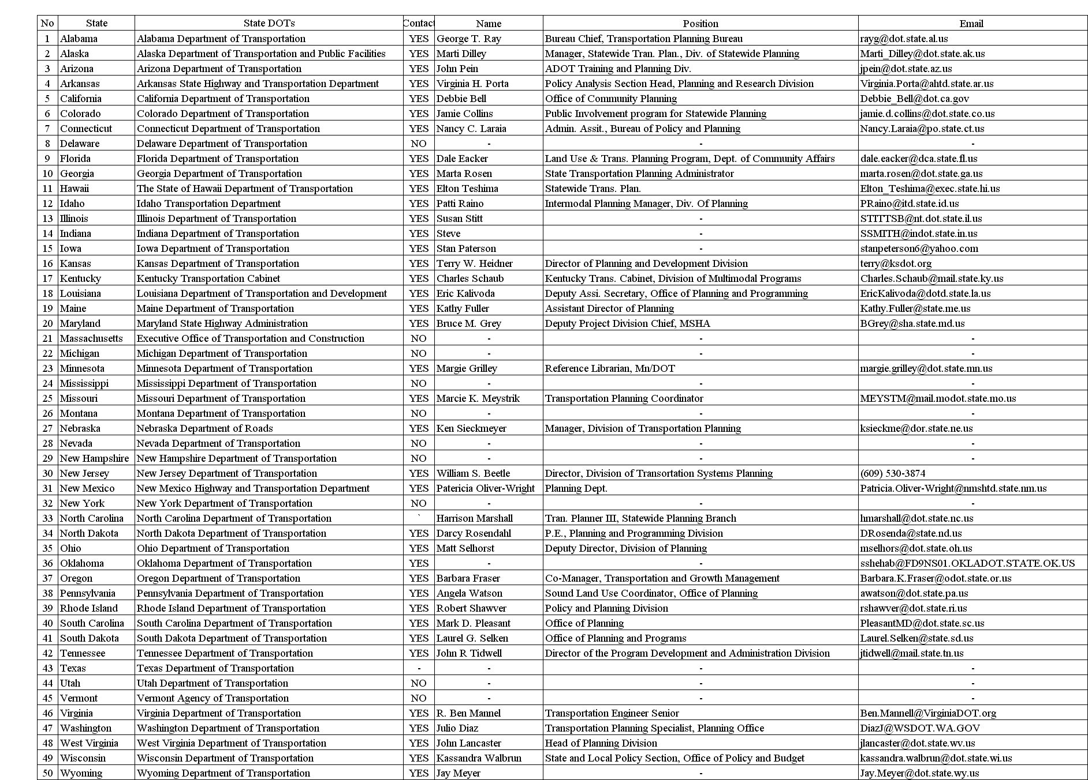
2. New or Revised Initiatives
Several state DOTs have adopted initiatives that encourage growth management efforts on the part of local communities. California DOT (Caltrans) has an on-going Sustainable Communities Initiatives. Pennsylvania DOT (PENNDOT) has a Transportation Project/Land Use Planning Initiative that will provide $1.8 million over the next 3 fiscal years through planning partners to conduct sound land use planning in conjunction with major transportation investments. Colorado DOT established the Short Grass Prairie Initiative through an inter-agency agreement in order to work with resource conservation organizations to manage prairie habitat in eastern Colorado.

3. Legislation Requirements
Imposing legislation is the most powerful and direct way of ensuring some role for the state DOT in growth management efforts. For example, Virginia DOT is proposing a bill in the Virginia General Assembly that demands a transportation element in each region’s comprehensive land use plans and requires that the transportation element be developed in consultation with the Virginia DOT. Similarly, statutes in North Carolina State require that an adopted land development plan be in place before a transportation plan may be initiated. In the state of Washington, several transportation-related sections (including Priority Programming for Highways, Statewide Transportation Planning, and Regional Transportation Planning Organizations) of the Growth Management Act (GMA) have been enhanced to include land use, and the requirements of the amended legislation are being applied to the transportation element (under the guidance of Washington DOT) of a locally adopted comprehensive plan. In Maine, large developments require permits from the state DOT.

4. New Administrative Offices, Commissions, Councils or Strategies Team
A variety of organizational changes have been implemented to facilitate growth management efforts. Caltrans created an Office of Community Planning to address the statewide need for community-sensitive approaches to transportation decision-making. Illinois DOT created and funded several Corridor Planning Councils as multi-jurisdictional planning efforts in major transportation corridors. The Maryland Transit Administration (MTA) under the Maryland DOT includes an Office of Transit-Oriented Development. PENNDOT established a Sound Land Use Strategies Team in May 1999 to develop strategies for incorporating land use into the Department’s transportation investments and policies.

5. New Joint Programs and Multi-Agency Cooperation
Another approach is to establish joint programs between state agencies and other organizations. Oregon DOT has a joint program, called Transportation and Growth Management (TGM), with the Oregon Department of Land Use and Development. The joint program provides grants, development design consulting, code assistance, and outreach to support the local planning required to link the issues of transportation and growth management. In Florida, the state DOT and the Land Use and Transportation Division in the Florida Department of Community Affairs work in collaboration to provide training and technical assistance to local governments regarding transportation planning and concurrency management systems. Similarly, the Indiana DOT works with Indiana Land Resources Council, and Missouri DOT is participating in the Missouri Commission on Intergovernmental Cooperation, which has both a Community Growth and Revitalization Committee as well as a Transportation Access Management Committee. Proposals by the Illinois DOT are presented before the Illinois Growth Task Force, and the Department participates in purchasing open spaces along with the Department of Natural Resources. Illinois DOT is also implementing Transportation Balanced Growth Partnership involving the Illinois Environmental Protection Agency, Northeastern Illinois Planning Commission, the Chicago Area Transportation Study, the Metropolitan Planning Council, and so on. New Jersey DOT (NJ DOT) participates as one of the seventeen members of the State Planning Commission established by the New Jersey State Legislature to create and implement New Jersey’s State Development and Redevelopment Plan. Rhode Island DOT (RIDOT) is participating with other state agencies in the state’s Growth Planning Council. The Transportation Planning Division in the Virginia DOT has worked with the Virginia Transportation Research Councils to study the methods for coordinating land use and transportation planning functions.

6. Grants, Loans or Funding Allocations
Funding provides an important tool for state DOTs to promote growth management efforts. Caltrans awards grants for projects that promote use of existing infrastructure and implement principles that the Federal Highway Administration (FHWA) supports. Colorado DOT established the Environmental Revolving Fund, an internal, departmental loan fund for eco-friendly projects. The Tennessee DOT has a policy that those counties and municipalities that do not have approved growth management plans shall not be eligible for loans or grants from any subsequent federal authorization for transportation funds. The Rhode Island DOT’s Transportation Improvement Program (TIP) allocates the vast majority of available funding to transportation system management and preservation projects and funds few system expansion projects.

7. Staff Training and Hiring Land Use Planners/Coordinators
Several DOTs have recognized the importance of training and hiring staff to focus on growth management efforts. PENNDOT recognizes that a critical first step in coordinated transportation and land use practices is inextricably linked to informing, educating and sensitizing its staff on land use. Wisconsin DOT (WisDOT) also recognizes that the staff’s understanding of the transportation-land use relationship should be enhanced. The Transportation Planning Division in the Virginia DOT has provided in-house training and has sought to hire individuals with urban and regional planning experience.

8. Outreach (Workshops and Developing Guidelines)
Out reach is a crucial component element of most programs. In Oregon, the TGM Outreach program is aimed at increasing the understanding and acceptance of smart development principles through community workshops, partnership programs and technical assistance to local community practitioners. Several State DOTs are developing guidelines for local governments for a specific purpose as well as land use-efficient transportation planning. For example, Caltrans develops practical guidelines and approaches for implementing environmental justice in local planning.

9. Technology and Resource Support
Providing technical and resource support is another way state DOTs can promote growth management efforts. For example, a state DOT might provide a clearinghouse for digitized maps and geodatabases of the transportation and land use inventory. Technical support in the area of integrated transportation-land use modeling may become increasingly important. For example, PENNDOT supports computer simulation technology for predicting the transportation and land use interface of various development scenarios.

10. Evaluation or Assessment Tools
It is also important for state DOTs to evaluate and assess growth management efforts. In 2000, the Maryland Legislature approved legislation requiring Maryland DOT to adopt performance measures that support evaluation of its success in meeting the goals laid out in the Maryland Transportation Plan. Illinois DOT will develop a toolbox for local officials that will help them evaluate various Balanced Growth strategies.

Table 4 summarizes the growth management efforts of state DOTs. The first set of strategies or policy actions consists of those that have been implemented in many states.

Table 4 Sprawl Mitigation Efforts of State Departments of Transportation

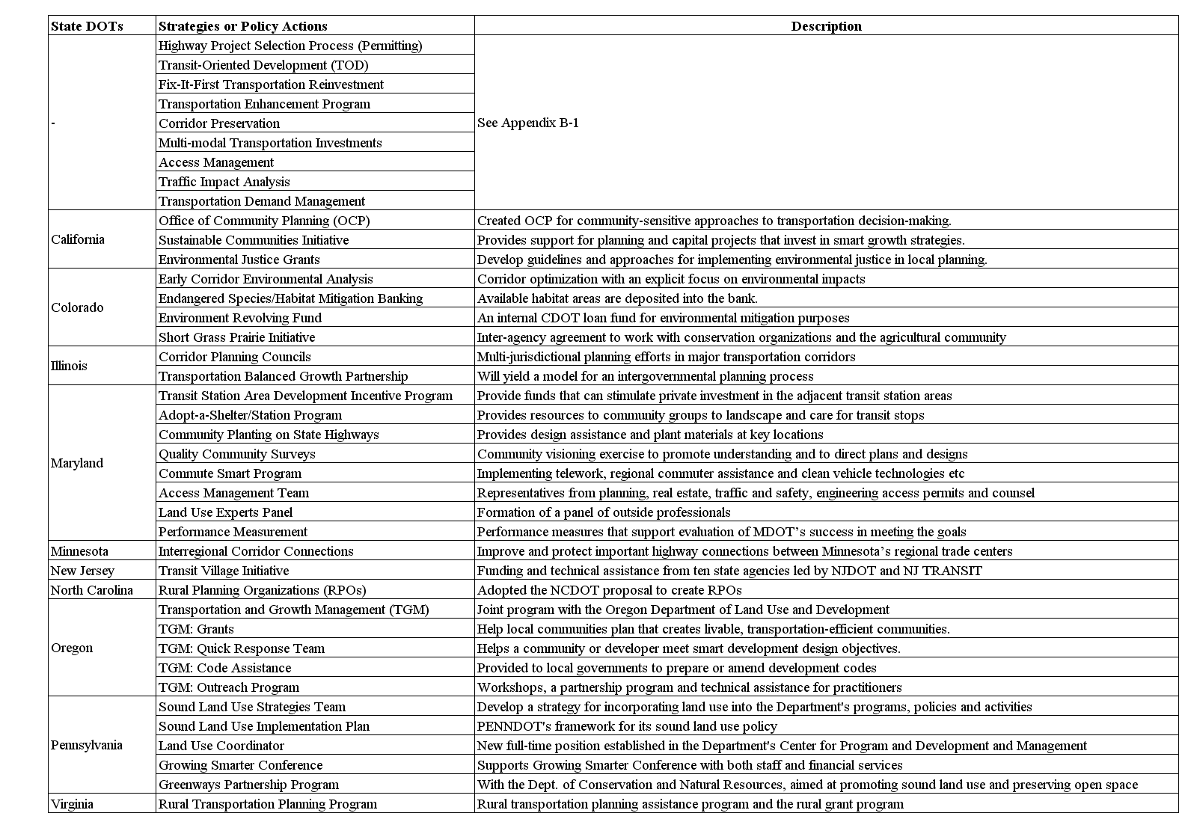

The remainder of the table lists the more specific practices of certain state DOTs, as described below:

1. Highway Project Selection Process (Permitting) to Enhance Sprawl Mitigation
In Louisiana, the highway project selection process includes a provision in the ranking of capacity expansion projects to reward local jurisdictions that have and enforce a growth management policy or plan that meets minimum state requirements. In Maine, redevelopment or reuse of existing abandoned urban developments is exempt from getting a Traffic Movement Permit as a measure to encourage greater urban densities. In Ohio, the selection among capacity expansion projects operates under the purview of the Transportation Review Advisory Council, a permanent body of predominantly non-Ohio DOT personnel. The scoring process for project selection gives additional points to urban revitalization projects.

2. Transit-Oriented Development (TOD)
Maryland DOT has its own TOD incentive as a part of the Transit Station Smart Growth Program and has developed strategies for dedication of Maryland DOT-owned real estate in support of TOD. The Office of TOD in the MTA administers the Neighborhood Conservation Program, the Transportation Enhancement Program, Access 2000, the Transit Station Area Development Incentive Program, and provides other funds to support streetscape improvements in TOD areas and to financially assist TOD projects by local governments. NJ DOT administers the Pilot Transit Villages Initiative. Pilot Transit Villages are compact, mixed-use developments, in which residences are a quarter-to-half-mile walk from a passenger transportation facility. These villages have been provided funding and technical assistance from ten New Jersey state agencies led by the DOT and New Jersey Transit (NJ Transit).

3. Fix-It-First Transportation Reinvestment
Illinois DOT administers its transportation improvement program to focus on repair, rehabilitation and maintenance of its existing transportation system to preserve and update the existing highways and to modernize, rehabilitate and replace aging capital assets. Maryland DOT works with local governments and the Department of Housing and Community Development to identify eligible transportation projects to help to implement local revitalization plans (Neighborhood Conservation Program).

4. Corridor Planning
Colorado DOT administers a Corridor Optimization Program to study specific corridors for transportation alternatives. The Kentucky Transportation Cabinet has developed a tool to help guide a comprehensive planning process for roadway corridors (“Bluegrass Corridor Management Planning Handbook”). Illinois Tomorrow Corridor Planning Grant Program has been designed to help local governments develop land use and infrastructure plans in major transportation corridors. PENNDOT has a Greenways Partnership Program and Congestion Management Corridors. Rhode Island DOT has initiated a Corridor Planning Process that will fully assess the relationship of land use and transportation within the studied corridors. WisDOT also has a statewide Corridor Planning Program.

5. Multi-Modal Transportation Investments
Illinois DOT’s FIRST infrastructure program has provided a significant increase in capital funding for public transportation in Illinois. Maryland DOT’s Access 2000 program improves both pedestrian and bicycle access to transit rail stations. Through its Sidewalk Retrofit Program, the Maryland SHA pays up to 100% of the cost of sidewalks in locally designated revitalization areas.

6. Access Management
Indiana DOT and WisDOT are developing a statewide access management policy to support land use planning and actions as well as to manage safety and traffic congestion. Maine DOT’s access management rule requires a permit to access state or state aid highways, and new alignment projects are built as access control highways. While achieving safe traffic operations and flow along existing highways, Maryland DOT’s Access Management Plans support Corridor Preservation efforts by balancing the provision of access to accommodate land use development.

7. Traffic Impact Analysis
PENNDOT and WisDOT are implementing a policy on traffic impact analyses for proposed developments. In particular, PENNDOT is considering the development of an assessment tool for considering the secondary and cumulative effects of transportation improvements.

8. Transportation Demand Management
Administered by many State DOTs, various pricing approaches, work-based strategies and parking supply management have been applied (See appendix A for descriptions of state-of-art techniques of transportation demand management)

  - CONCLUSIONS

Ms. Kathy Fuller, Assistant Director of Planning of Maine DOT, provides an insightful definition of the role of the state DOTs in growth management and sprawl mitigation efforts:

The subject of [sprawl mitigation] is an issue the Maine Department of Transportation is struggling with. Several policies of the Department have been identified as contributing to sprawl. Because Maine DOT is the owner or manager of the transportation asset, it has a responsibility to educate communities who have land use authority in Maine. It is our responsibility to teach them about the various functions of the system and how they have a responsibility as taxpayers and system users help us take care of the resource and the investment.

Overall, state DOT-administered efforts to mitigate sprawl are on the rise. However, several challenges must be addressed in order to achieve effective implementation. First, because state DOTs have limited power to influence local land use planning, how they support and coordinate with local land use planning agencies is critical. Second, many efforts are still quite preliminary and tentative, and the long-term benefits of innovative techniques are as yet uncertain. Third, budgets may constrain sprawl mitigation efforts on the part of the state DOT. As North Carolina DOT indicates, the current budget situation has not allowed the Department to retain additional staff to provide assistance for sprawl mitigation.

CHAPTER 4. THE TEXAS CONTEXT

4.1 Introduction

Texas is the second-most populous state in the nation and more than 80 percent of its residents live in metropolitan areas (U.S. Census Bureau, 2001, p.3). However, unlike California or Florida, Texas does not require comprehensive planning on a statewide basis. DeGrove (1992), in a review of the history of coastal zone management in Texas, observed Texans as primarily individualists, “with a strong mixture of hierarchical collectivists and members of a hunting and gathering tribal group whose members view short-term profit making as the key to success, both as individuals and a society.” The state’s past reluctance to interfere in local affairs shows the failure of Texas to adopt a federally recognized coastal management program prior to 1991. Curley (1990, p.12) argued that the coastal plan failed because it promoted planning that many Texans regard as inconvenient, and an attitudinal change that would interfere with rapid exploitation of coastal resources.
The following reasons have been identified by previous researches for a laid back approach toward planning in Texas:
- Living in a politically conservative state with a home rule form of local government, Texans have “strong beliefs favoring the free market system, individual property rights, and limited state governmental intervention.” (Burby and May, 1997, p. 67)
- Along with the cultural aspect, the Texas constitution’s home rule provision is considered the main institutional impediment to a state planning intervention (Curley, 1990).
- Counties in Texas have no authority to plan, and county land use controls are limited to subdivision regulations and public health controls (Burby and May, 1997)

Nevertheless, recent trends in Texas seem to show a change is coming. In spite of a lack of interest in regulations, Texas is continuously developing planning tools. Texas enacted the first impact fee statute in the country in 1987 to provide for the imposition by a municipality of reasonable fees to offset a project’s impact on public infrastructure. (Mead, 1993, p. 226) Although there is a recent limitation by a statute of State (Johnson, 2002, p. 120), some most cities and even urban counties can impose impact fee (Section 395.001 (7) of the Texas Local Government Code). There have been some efforts in the direction of regulating development and managing growth via transportation-related strategies.
In Texas, state levels, regional agencies such as Metro and home rule cities have the authority to implement transportation related strategies and policy actions. However, the approach by each governmental level is different. Broadly speaking, the state of Texas deals with market-based strategies such as pricing. The Texas Department of Transportation (TxDOT) and regional agencies such as regional Metro and MPO focus on alternative mode support strategies through facility and system improvements and capital investment. However, most of the authority for transportation-related strategies rests with the home rule cities. Particularly, a few leading and growing home rule cities in Texas are adopting, implementing and practicing a lot of transportation strategies and policy actions such as transportation-efficient land use planning, pricing strategies and alternative mode support strategies. But other approaches used in other states, such as worksite-based strategies, objective-based strategies, and roadway investment strategies, have rarely been used in Texas until recently. Exceptions are the City of Abilene, the City of Brownsville, North Central Texas Council of Governments, Gulf Coast Center and Island Transit (Galveston), City Transit Management Company (Lubbock), and Alamo Area Council of Governments (San Antonio) that employ the Job Access and Reverse Commute Program as one of their objective-based strategies.

4.2 Municipal level

4.2.1 Comprehensive Plans and Zoning
During the 1920’s, Texas adopted the Standard Zoning Enabling Act like many states. The state also adopted the subdivision portion of the Standard City Planning Enabling Act in 1927 but not the comprehensive planning section. Rather than adopting comprehensive plans to use as a guide for zoning, most municipalities have zoned first and planned later. Typically, cities in Texas exercised their power to zone without a comprehensive plan per se.
In 1989, an amendment to Chapter 211 of the Local Government Code was added to Section 211.004 (b) titled “Compliance with Comprehensive Plan”, requiring that an adopted comprehensive plan serve as the basis for subsequent zoning amendments (Mead, 1993). In 1997, a statute enabling comprehensive planning by both general law and home rule local governments was enacted. As a result, Chapter 213 of the Texas Local Government Code does not mandate a comprehensive plan, but enables cities to adopt comprehensive plans, allows them to develop their own definitions of a comprehensive plan and consistency requirement, and specifies procedures for adoption (Johnson, 2002).

4.2.2 Home Rule Provision
Texas has long-standing values of self-reliance and local self-determination associated with its planning and other public policy issues. Cities are allowed to amend charters and pass ordinances as long as they do not conflict with the constitutions or general laws enacted by the state legislature. This ‘bottom-up’ approach toward managing growth and development is based on the Texas constitution’s home rule provision, which is applicable to cities with population exceeding 5000 (Texas Constitution, Article 11, Section 5). The provision grants home rule cities the authority to make their own decisions about planning tools and techniques as long as these tools have not been proscribed by the Texas legislature.

4.2.3 Annexation
Based on the home rule provision, one significant constraint on smart growth opportunities in Texas is the limit on the powers of counties to control land development through zoning and other means. This limit makes annexation an important tool for smart growth efforts in Texas. In 1858 the Texas legislature enacted the first general law pertaining to the incorporation of cities and towns (Rocha, 2002). In 1883, the legislature allowed for the disannexation of territory by action of the municipality and not the legislature. In 1963, the legislature enacted the Municipal Annexation Act. This set out in statute, for the first time, the procedures that a city had to follow in order to annex property (Rocha, 2002).
In addition, the act created the concept of extraterritorial jurisdiction (ETJ). A few changes were made to the annexation statute from 1963 to the 1990s that expanded the authority of general law cities to annex. Previously, a general law city could annex without the consent of the landowner if their population was over 1,000 and they provided water or sewer facilities to the outlying area, but the property rights movement gathered pace in the 1990s and restricted annexation. The Private Real Property Rights Preservation Act of 1995 and the bill SB 89 of 1999 have made annexations harder, more labor intensive, more expensive, more involved, and more contentious (Rocha, 2002).

4.2.4 Current Trends in Planning Approaches
Cities in Texas are reversing their past practice of substituting a comprehensive zoning ordinance and map for a comprehensive plan and developing and/or updating their comprehensive plans (Mead, 1993, p. 229). The use of recently adopted plans by suburban Texas cities for downzoning commercial properties to less intense uses, or more frequently, to rezone property from multifamily to single-family uses indicate changes in planning trends in Texas (Mead, 1993, p. 230). In 1987, legislation was adopted to establish consistent procedures for the use of impact fees, including the development of land use scenarios that requires analysis of future land use development patterns and the resulting demand for infrastructure. Legislators in 2001 amended the state’s impact fee law (SB 243 passed on May 26, 2001). Provisions were added requiring an offsetting credit for ad valorem taxes or users fees that finance infrastructure improvements. The changes will reduce the maximum impact fees cities typically can charge for infrastructure to 50 percent of the actual cost (Johnson, 2002, p. 120). Planning moratoria for residential projects have been restricted owing to a recent 2001 legislation (SB 980 passed on May 26, 2001). Cities had used the tool to preserve the status quo while evaluating new plans and ordinances. The bill limits the moratoria to 120 days and prescribes stringent procedures before a moratorium for residential uses may be enacted (Johnson, 2002, p. 120)

4.2.5 Current trends in Transportation
The City of Austin has tried to integrate land use planning and transportation through Bus-Based Transit-Oriented Development (TOD), Traditional Neighborhood Development (TND), Main Street Program (Downtown Revitalization), Corridor Preservation and Planning, and Neighborhood Conservation Program. The City of Dallas employs Rail-Based Transit-Oriented Development (TOD) and Parking Supply Management (Flexible Requirements). Both Austin and Dallas use capital investment policies such as Alternative Mode Support Strategies. The City of Houston has different policy approaches from Austin and Dallas. The City of Houston uses mainly pricing strategies and facility and system improvements. Specifically they are Road Pricing: Toll Road, Congestion Pricing: High Occupancy Toll (HOT) Lanes, Traffic Calming, Alternative Roadway Design Standards, High Occupancy Vehicle (HOV) Facilities, Non-Motorized Mode Facility Support, Transportation Enhancements Program, and Information Technology Applications for Transit and Ridesharing Modes.

4.3 ABOVE THE MUNICIPAL LEVEL

County Level - Counties in Texas have no authority to plan, and county land use controls are limited to subdivision regulations and public health controls (Burby and May, 1997). Some counter-examples have been listed below:

- The Texas Transportation Commission for funding through the Statewide Transportation Enhancement Program approved a project in Taylor County.
- Local Government /Code Chapter 231 was adopted by the legislature in 1989, requiring the first countywide comprehensive plan in Texas to be done in Ellis County. The initiative for this unusual mandate was the arrival of the development of a superconducting supercollider in the country. It is noteworthy that the county chose to plan first and then zone (Mead, 1993, p. 230).
- In 1999, to address the needs of rural areas facing urban growth and development pressures, county subdivision laws were further strengthened in response to rapid rural growth rates adjacent to metropolitan areas. (Johnson, 2002, p. 122)
- In the 77th Texas Legislature (2001), SB 873 gives certain counties the authority to adopt rules “governing plans and subdivision of land within the unincorporated area of the county to promote the health, safety, morals, or general welfare of the county and the safe, orderly, and healthful development of the unincorporated area of the county.” This is the same authority municipalities have in the extraterritorial jurisdiction (ETJ). It applies only to (1) border counties with a population of 150,000 or more; (2) counties with 700,000 or more; or (3) counties that are adjacent to a county with a population of 700,000 or more and are within the same metropolitan statistical area. Thirty counties in Texas fall within this regulation (Redington, 2002).
- With H.B.1445, the 77th Texas Legislature (2001) has attempted to clarify the requirements for developers by mandating that a city and county enter into a written agreement identifying the governmental entity authorized to regulate subdivision plans and approve related permits in the ETJ. This applies to every city and county except counties within fifty miles of the border, counties eligible for assistance under the Economically Distressed Areas Program (EDAP), and counties that contain any ETJ of the City of Houston (Redington, 2002).

Regional level - Regional transit agencies such as Austin Texas Capital Metro Transit and Metropolitan Transit Authority of Harris County have almost complete authority regarding Alternative Mode Support Strategies. In doing this, the transit agencies cooperate with TxDOT and the municipal governments

State level - In 1991, Governor Ann Richard signed the Texas Coastal Management Plan for Beach Access Preservation and Enhancement, Dune Protection, and Coastal Erosion Act into law. Chapter 295 was adopted by the seventy-second legislature as a result of several decades of work by conservationists, property owners, and public agencies. Both local governments and counties are charged with developing and adopting a plan for preserving and enhancing access to and use of public beaches (Mead, 1993, p. 231-232).

In 1997, the state enacted a statute enabling comprehensive planning by both general law and home rule local governments. The law provides a general description of what comprehensive plans should contain, instead of specific plan elements. Although this does not mandate a comprehensive plan, it enables cities to adopt comprehensive plans, allows them to develop their own definitions of comprehensive plans and consistency requirements, and specific procedures for adoption (Johnson, 2002).
As far as transportation planning is concerned, the State primarily employs pricing strategies. Gasoline Tax Increase (HB3106) and Road Pricing: Toll Road (Section 1216(a) of the Transportation Equity Ac) has been used at the State level. Recently, Distance-based Taxes (HB45) was enacted in the 2001 session of the Texas Legislature. TxDOT focuses on the Facility and Systems Improvements and Capital Investments.

4.4 SUMMARY

In summary, the state of Texas and departments such as TxDOT do not participate in comprehensive statewide land use and transportation planning. Thus, the state may not be classified as a growth management state although trends are changing in recent times. Since it is essential to place the city or county in the right perspective prior to decision-making regarding transportation planning and growth management, appendix tables A-1 and A-2 provide information on legal authority of various local governments with regard to specific sprawl mitigation policy actions.

CHAPTER 5. THE SPRAWL MITIGATION MATRIX

5.1 Introduction

The spectrum of sprawl mitigation policies ranges from information or education to financial assistance to disincentives to regulation to capital investments. Based on an extensive review of existing literature and practices followed by an expert panel review, we developed a comprehensive list of strategies and policy actions that may mitigate sprawl. “Strategies" are defined here as relatively broad categories of policies directed towards a common purpose or reflecting a common approach. "Policy actions" are the more specific steps that agencies would implement as a part of a sprawl mitigating effort. We have broadly classified all strategies as either transportation-related or growth-management strategies.
In general, transportation-related strategies involve investments in transportation infrastructure or policies about transportation. In this category, we include land use policies designed to reduce the demand for driving, or “transportation-efficient land use policies.” Growth-management strategies include traditional and innovative approaches to influencing the location and character of development. Tables 5 and 6 list the transportation-related and growth-management related strategies and policy actions respectively. Appendices B-1 and B-2 describe the transportation-related and growth management-related policy actions, respectively, along with relevant examples and references.
The Sprawl Mitigation Matrix consists of six separate matrices that catalog both transportation-related and growth-management policies according to their goals (Matrices C-1A and C-1B), characteristics (Matrices C-2A and C-2B), and suitability for different kinds of communities (Matrices C-3A and C-3B). Based on an extensive literature review on the topics of growth management, sprawl mitigation, and smart growth, the preliminary matrices were developed. These matrices were then sent to a panel of experts in the fields of transportation and land use. Nine panelists provided comments on the list of policy actions, goals, characteristics, and suitability factors. The feedback of the panel was incorporated into the final versions of the matrices, presented in Appendix C. The literature and expert panel reviews are described in greater detail in the next two sub-sections.

Table 5 Transportation-Related Strategies and Policy Actions

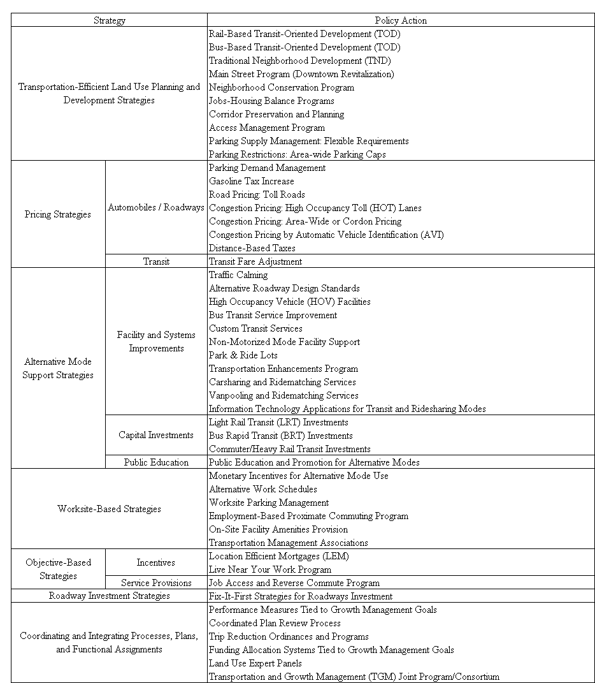

Table 6 Growth-Management Strategies and Policy Actions
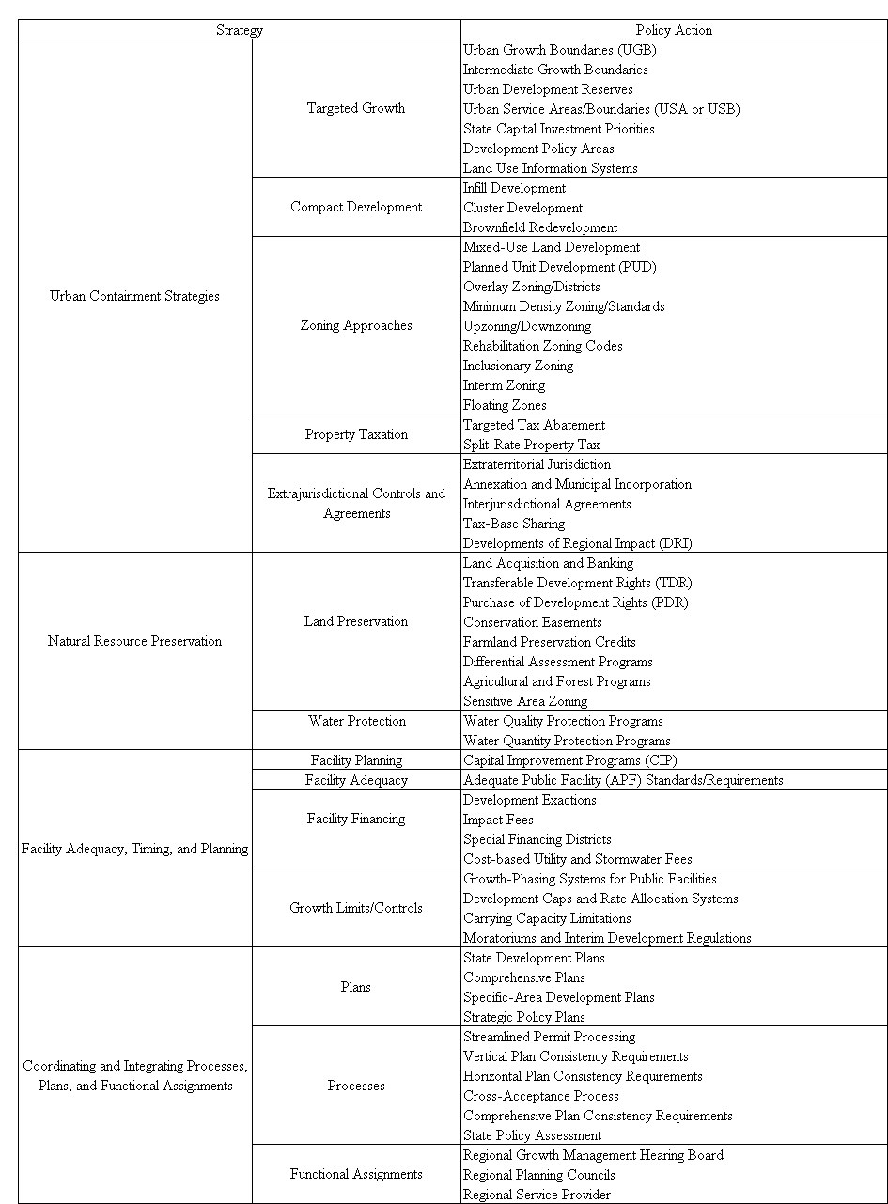
5.1.1Literature Review
An extensive literature review on the topics of growth management, sprawl mitigation, and smart growth provided the basis for the development of the list of strategies and policy actions. This literature review turned up several efforts to catalogue sprawl mitigation strategies, though none as comprehensive as the effort in this study, and none designed to provide guidance to communities in the selection of policy actions appropriate to their specific context. Several of these previous efforts are described below.

- The City of Austin Transportation, Planning and Design Department (2001) uses the Smart Growth Criteria Matrix to analyze development proposals within the desired development zone. This matrix has limited application since it has been tailor-made for a specific city and a department, covering only local actions. It fails to consider many goals of smart growth and focuses exclusively on how and where development occurs, and tax base enhancement. Hence, it can be used only for the purpose of project evaluation.

- The Smart Growth Network (2002) developed a list of 100 smart growth policies for communities to consider. This list does not provide guidance on appropriate contexts for different policies, however. In a similar effort, the National Association of Counties (2001) has developed an extensive list of strategies with corresponding benefits and concerns. This list also does not provide guidance on appropriate contexts.

- Nelson and Duncan (1995) have developed a matrix titled “Technique Effectiveness Continuum” to measure the effectiveness of growth-management related strategies and policy actions. This matrix considers only four goals: resource preservation, urban containment, efficiency of public facilities, and meeting market demands. It does not cover transportation-related policy actions.

5.1.2 Expert Panel Review
An expert panel of thirteen researchers from growth management and transportation was selected to review the preliminary version of the Sprawl Mitigation matrices. A packet that included the matrices, detailed descriptions of the dimensions of the matrices (policy actions, goals, characteristics, and suitability factors), and directions for providing feedback was mailed to the panel in the last week of May 2002. Table 7 lists the nine panelists whose feedbacks were received through the months of June and July. Panelists provided comments on: the specific entries in the matrices; the lists of policy actions and definitions of goals, characteristics, and suitability factors; and the general approach to cataloguing sprawl mitigation strategies and policy actions.

Table 7 List of Panelists

As a first step toward incorporating the feedback from the panelists, a version of the matrices was prepared that showed for each cell in each matrix whether a panelist had recommended a change to that cell. Second, a database of the comments pertaining to each cell in that matrix and the suggested changes was compiled. Third, each of the six matrices was reviewed one at a time, along with the panelists’ comments, in order to determine whether changes should be made. The criteria used in making changes were as follows:

- Only cells having two or more panelists’ comments were considered for modification.
- In cases of multiple but divergent suggestions for changes, majority opinion was considered.
- In matrices C-1A and C-1B, if a cell had originally been left blank (indicating that it is not a goal of the specific policy action) and was suggested by one panelist to be a secondary goal and by another to be a primary goal, then the former’s opinion was accepted. This ensures a conservative and safer estimate of the impact of the policy actions.
- For cells with only one comment, the judgment of the research team was used to decide in favor of or against the suggested changes.

In addition, the list of strategies and policy actions was revised and expanded based on the panelists’ suggestions and joint review by the research team. The matrix cells corresponding to these added policy actions were filled based on the judgment of the research team. These matrices may be further revised as a result of the expert panel review scheduled for the second year of this project.

5.2 Goals Matrix

Appropriate techniques for mitigating urban sprawl depend heavily on the particular aspect of sprawl that requires remedy. As Johnson (2002) points out, different metropolitan areas may face different negative impacts of sprawl and to varying degrees. Hence, it is important for communities to find strategies that effectively address their goals. The Goals Matrices (See Matrix C-1A and C-1B in Appendix C) are designed to help agencies identify possible solutions to the specific sprawl-related problems that they seek to address. The goals defined for the matrices reflect the focus of this project on the role of transportation as a solution to sprawl and a motivation for smart growth. These goals are closely interrelated, yet each reflects a slightly different perspective or concern. In addition, because a strategy or policy action is likely to fulfill many goals if implemented in the right manner, the Goals Matrices thus indicate the direct or “primary” as well as indirect or “secondary” goals of policy actions.

- Provide Transportation Choices: Provide a range of transportation choices beyond the automobile, including transit, walking, and bicycling. This goal is closely related to the goals of promoting social equity, promoting accessibility, and reducing auto vehicle-miles traveled. Policies designed to manage the expansion of the urbanized area can also help to provide transportation choices.

- Reduce Auto Vehicle-Miles Traveled (VMT): Reduce total vehicle-miles-traveled by automobile. This goal is closely related to the goals of managing congestion and minimizing environmental impacts. Policies designed to provide transportation choices can help to reduce auto VMT but do not guarantee that drivers will choose the alternatives. Policy actions that promote infill development also tend to create more multimodal land use and reduce VMT.

- Manage Congestion: Manage congestion in the road system without necessarily reducing vehicle travel. This goal is closely related to the goal of reducing auto VMT but emphasizes policies designed to shift travel out of peak periods.

- Ensure Adequate Level- of-Service: Ensure that the road system provides an adequate level-of-service in terms of travel times and delays, traffic signal coordination, and that the transit system provides an adequate level-of-service in terms of frequencies and geographic coverage. It also entails the prevention of traffic spillover to neighborhood streets. This goal is closely related to the goals of managing congestion and providing transportation choices.

- Promote Land Use Accessibility: Promote accessibility to needed and desired services, including job centers, stores, medical services, parks, etc. This goal emphasizes policies that shape development patterns so that activities are closer together. Policies that promote accessibility also help to provide transportation choices by bringing activities within walking and bicycling distance. This goal is also related to the goals of promoting social equity and strengthening community livability.

- Manage Expansion of Urbanized Area: Manage the expansion of the urbanized area so that land is used efficiently as population grows and scattered pockets of development are avoided. This goal is closely related to the goal of preserving natural resources and open space and to the goal of minimizing environmental impacts. Managing the expansion of the urbanized area requires close coordination between land use and transportation planning.

- Preserve Natural Resources and Open Space: Preserve natural resources and open spaces, including waterways, wildlife corridors, plant and animal habitats, for environmental, economic, and/or social purposes. This goal is closely related to the goal of minimizing environmental impacts but focuses on impacts on land rather than air quality or water quality. Policies that help to manage the expansion of the urbanized area usually also help to preserve natural resources and open space.

- Minimize Environmental Impacts: Minimize the impacts of transportation and development on the environment, particularly impacts on air quality and water quality. Impacts on wildlife habitats and open space are considered in the goal of preserving natural resources and open space. Policies that reduce auto VMT also help to minimize environmental impacts.

- Promote Economic Vitality: Promote the vitality of local economies, particularly in older communities and neighborhoods. This goal is related to the goals of strengthening community livability and promoting social equity.

- Promote Social Equity: Promote social equity by ensuring that “transportation disadvantaged” populations, including low-income households, the elderly, and persons with disabilities, have adequate access to needed and desired activities and do not disproportionately bear the costs of transportation and development. Policies that promote accessibility or reduce cross-subsidies from urban to suburban residents and provide transportation choices usually also promote social equity. Policies that affect the price of transportation or development may work either for or against social equity.

- Strengthen Community Livability: Strengthen community livability by enhancing quality of life environmentally, economically, and socially in existing neighborhoods. Policies that strengthen livability in existing communities help to manage the growth of the urbanized area. This goal is also related to the goal of promoting accessibility.

- Strengthen Coordination: Strengthen coordination between agencies within a region, between agencies at different levels of government, between agencies with transportation and land use responsibilities, between public agencies and the private and non-profit sectors, and in order to achieve growth management objectives. Strengthening coordination helps to facilitate the achievement of all other goals.

Several reviewers provided insightful comments about this list of goals. For example, one panelist commented that corridor preservation does not aim to just preserve rights-of-way for future mobility, but also to prioritize investment and encourage coordination among agencies or levels of government. Another panelist suggested the addition of “providing affordable housing” to the list of goals, citing Traditional Neighborhood Development and Targeted Tax Abatement as examples policy actions directed towards this goal. A third panelist was of the opinion that goals such as minimizing adverse land use interactions, minimizing public costs, and facilitation of urban land cycling might be included. Given the focus of this project on transportation-related strategies, these goals were not included in the final matrices but may be considered in the second year of this project.

5.3 Characteristics Matrix

After identifying policy actions that address the goals of a community, an agency must then consider its practical needs and its available resources. Depending on its characteristics, a particular policy action may not be feasible for a particular community. The Characteristics Matrices (See Matrix C-2A and C-2B in Appendix C) are designed to help agencies eliminate from consideration those policy actions that are infeasible for their communities. The characteristics included in the matrices were selected and defined based on the literature review and comments from the expert panel. The list is not comprehensive, but rather focuses on key characteristics that influence feasibility. Policy actions are categorized on each characteristic, as described below. However, this categorization is often not straightforward. Are urban growth boundaries, for example, a well established or an experimental policy action? In addition, a combination of policy actions implemented together may take on a different set of characteristics than any one of the policy actions on its own. The specific design of the policy action in a particular community may also influence its categorization on these characteristics. The matrices thus provide general guidance on feasibility, rather than a definitive assessment.

- Policy Action Experience (Well-established vs. Experimental). Well-established policy actions are those that have been practiced for a considerable period of time by many local or state governments or other implementing agencies and for which substantial empirical evidence exists to corroborate their effectiveness as a sprawl mitigation tool. On the other hand, experimental policy actions are those that have been implemented by few local governments or states as pilot or demonstration projects and that are primarily backed by theoretical argument rather than empirical evidence.

- Administrative Approach (Planning vs. Market vs. Regulatory vs. Capital Investment). Planning-approach policy actions are those that do not involve regulation, pricing strategies, or capital investments. They may include coordinated planning processes, dissemination of information, guidelines via public-sector plans or the encouragement of alternative choices. Market-based policy actions are those that use market mechanisms such as prices to effect change. Pricing policies can act as either incentives or disincentives and may generate revenue for the implementing agency. Regulatory policies are enacted by law or ordinance and mandate or restrict certain actions. Capital Investment policy actions necessitate capital expenditures on the part of public agencies.

- Estimated Implementation Cost (Medium vs. High). Policy actions with low to medium implementation costs do not impose a significant financial burden on public agencies, regardless of the financial capacity of the public agencies. These policy actions might also generate revenues to offset the cost of implementation. On the contrary, high cost strategies impose a significant financial burden on public agencies.

- Estimated Implementation Period (Short vs. Long). Short-term policy actions may be executed within a year or less. Long-term policy actions require more than a year to implement owing to extensive planning, regulatory changes, environmental analysis, construction, and/or other requirements.

- Enabling Authority Requirements (Low vs. High). Policy actions that do not require special legal authority on the part of the implementing agency have low enabling authority requirements. Policy actions that require significant legal authority on the part of the implementing agency have high enabling authority requirements. Such policies may not be feasible without additional legislative action at the state level and may have long implementation periods. Regulatory approaches and some market approaches tend to fall in this category.

Implementing Agency (State Govt. vs. MPO vs. Transit Agency vs. County Govt. vs. City Govt. vs. Private/Non-profit). State governments are key to both transportation and growth management-related strategies, either as the implementing agency or by delegating appropriate authority to lower levels of government. Primary agencies include the State Department of Transportation and the state agency charged with environmental protection. The power of Metropolitan Planning Organization (MPO) to implement policy actions may vary. MPOs that also serve as regional councils may have more ability to take the lead on coordinated planning efforts. In most cases, MPOs have limited power to implement policy actions. Transit agencies and various city agencies may also serve as implementing agencies for many policy actions. Finally, many policy actions require the participation of private or non-profit sectors. For example, the development sector is a particularly important player in transportation-efficient land use strategies.

The panelists provided interesting comments on this matrix. In several cases, the panelists had mixed views or were themselves unsure. For example, one of the panelists was not certain whether or not Urban Growth Boundaries, Intermediate Growth Boundaries, and Urban Development Reserves should be considered “well-established, given that not many have an historical record. In addition, he mentioned that a combination of approaches can sometimes change the characteristics of individual policies. For example, Transferable Development Rights (TDR) may be characterized as regulatory when combined with downzoning, as is normally the case. Another panelist argued that inclusionary and mixed-use zoning aim to be market-responsive, letting co-benefiting land uses interact and compete with each other and that Adequate Public Facility (APF) Standards can be costly because the marginal cost of expanding infrastructure in urban settings to accommodate new growth can be high. Such comments point to the need to warn users of the matrices that the characteristics of specific policy actions can vary depending on the situation in which it is applied.

5.4 Suitability Factors Matrix

Once an agency has gone through the process of eliminating infeasible strategies from among the entire set, the next step is to make a judicious selection of the most suitable ones for that community. A one-size-fits-all approach is too simplistic in dealing with a problem as complex as sprawl. The Suitability Factors Matrices (See Matrix C-3A and C-3B in Appendix C) are designed to show what kinds of policy actions are appropriate for different kinds of communities and to assist communities in making these selections. The suitability factors describe the context of the community considering sprawl-mitigating policy actions. The factors included in the matrices were selected and defined based on the literature review and comments from the expert panel. The list is not comprehensive, but rather focuses on key factors that influence suitability. Policy actions are categorized on each factor, as described below. Although categories for these factors have been defined quantitatively where possible, a community can also assess its own situation qualitatively on each of these factors. These factors can be assessed at the level of the metropolitan region or for a smaller jurisdiction within the region, depending on the circumstances and the authority of the implementing agency.

- Size of Jurisdiction (Slow vs. Medium vs. Large vs. Very Large). This factor is defined as the population within the area under the jurisdiction of the decision-making body. Four sizes have been defined as follows: Small (population less than 20,000), Medium (population between 20,000 and 200,000), Large (population between 200,000 and 1,000,000) and Very large (population in excess of 1,000,000). The size of the jurisdiction is correlated with many other suitability factors, including growth rate, congestion level and transportation-disadvantaged population.

- Rate of Growth (Slow vs. Fast). This factor is defined by the average annual percentage change in population for a community. It can be either slow or fast depending whether it is below or above the state average growth rate.

- Congestion (Low vs. High). This factor has been measured by the percentage of freeways or arterials operating at levels of service D, E, or F. Levels of service D, E and F are characterized by volume-to-capacity ratios above 0.80. This measure is designated low if less than 60% of a city’s arterials and freeways operate at levels of service D, E and F and high otherwise.

Transportation Disadvantaged Population (Low vs. High). An individual is considered “transportation disadvantaged” when his or her transportation needs are not adequately met by the automobile. This includes individuals who either do not own or drive an automobile for reasons of advanced age, low income, physical handicap and/or mental impairment. The state average is considered the threshold value to distinguish between low and high transportation disadvantaged population.

- Planning and Land Use Authority (Counties vs. General Law Cities vs. Home Rule Cities). The amount of planning and land use authority vested with counties and cities can vary significantly. The county is generally the most limited of the many forms of local government in a state. Cities can fall into two categories. They can either be general law cities, meaning that they are restricted by what the state constitution permits them to do, or they can be home rule cities, in which case they are restricted by what the state statutes prohibit them from doing.

- Planning Culture (Limited Planning and Land Use Control vs. Pro-Planning and Land Use Control). This factor describes the traditional planning approach of a state with regard to growth management and land use control. States that have limited planning and land use control adopt a business-like approach and do not exert development pressures on cities and counties. The political culture in such states does not support the use of public policy instruments to intervene in private real-estate development decision-making. They lack a statewide mandate and communities in these states seek not to manage growth as much as to provide a steady supply of buildable land. On the other hand, pro-planning states pursue and promote proactive growth management approaches. They require growth management plans of their cities and counties. American Planning Association (2002) lists the states that fall into the two above-mentioned categories. The planning culture can also vary from region to region within a state.

The issue of applicability to multiple situations or settings seemed to stand out in this matrix. Two of the panelists mentioned that distinctions between contexts are subtle and many policy actions may also be justified in slow-growing, moderately congested areas. For example, tax-base sharing could be applied equally well to both fast and slow growth settings. Some panelists suggested the addition of certain factors such as development context (urban, suburban, urbanizing, new Greenfield development etc.), and natural (water bodies, hills) and political barriers (state, national, federal/state ownership). A valid argument was put forth by one of the panelists who claimed that pricing reforms may reduce the need for subsidies from non-drivers to motorists that can then be used to improve non-automobile modes, and are therefore not necessarily unsuitable for areas with a high transportation-disadvantaged populace.

CHAPTER 6. CONCLUSIONS AND FUTURE RESEARCH

The Sprawl Mitigation Matrices presented in this report catalogue transportation-related and growth-management policy actions with respect to goals, characteristics and suitability factors. These matrices are designed as a guide for communities in Texas and elsewhere in the selection of sprawl mitigation techniques appropriate to their specific contexts. They were developed through an extensive literature review and a review by a panel of transportation and land use experts. The project was a challenging one, as the list of potential policy actions is long and the dimensions by which they were catalogued are difficult to define and separate. The matrices provide a starting point for communities in their search for appropriate strategies and policy actions rather than definitive advice as to what they should do.
Additional research could help to refine the matrices in a number of ways. First, the issue of implementation is beyond the scope of the current research. However, the execution of a plan is the most crucial of all steps. There have been cases when a particular strategy has been either inappropriately applied to a context or implemented incorrectly. One of the experts on the panel cited the example of Florida, where Adequate Public Facility Standards have discouraged development in close-in areas and encouraged sprawl. To address such issues, another panelist proposed an effectiveness matrix that would use a seven-point rating system for effectiveness ranging from –3 (significant negative rating) up to +3 (significant positive rating). Second, some ambiguity remains in the definitions the dimensions of the matrices. For example, one of the panelists mentioned the importance of measuring cost not only to the agency, but also to the community, developers, and homeowners. Therefore, more precise definitions should be developed in future efforts. Third, several changes in the dimensions of the matrices are possible. For example, a panelist suggested adding a policy action characteristic called Implementation Likelihood to assess the likelihood that the policy action would be implemented (cordon pricing being an example of policy with low likelihood of implementation). Finally, a proposal was received from an expert on the panel, to create a software package based on this work to provide communities with easy access to guidance on appropriate strategies for their communities.

REFERENCES

Books/ Journals/ Materials

Al-Mosaind, M. A., et al. 1995. “Light-Rail Transit Stations and Property Values: A Hedonic Price Approach.” Transportation Research Record 1400, pp. 90-94.

Badoe, D. A. and E. J. Miller, 2000, “Transportation – Land Use Interaction: Empirical Findings in North America, and Their Implications for Modeling,” Transportation Research D, Vol. 5, pp. 235-263.

Berry, D. 1978. “The Effects of Urbanization on Agricultural Activities.” Growth and Change, Vol. 3, pp. 2-8.

Blewett, R.A., and A.C. Nelson. 1988. “A Public Choice and Efficiency Argument for Development Impact Fees.” In Development Impact Fee, edited by A.C. Nelson. Chicago: American Planning Association.

Boarnet, M.G., and M.J. Greenwald. 2000. “Land Use, Urban Design, and Non-Work Travel: reproducing Empirical Tests from Other Urban Areas for Portland, Oregon. Presented at 79th Annual Meeting of the Transportation Research Board.

Boone, R.B. and W.B. Krohn. 2000. “Predicting broad-scale occurrences of vertebrates in patchy landscapes.” Urban Studies, Vol. 15, No. 1, pp. 63-74

Bragado, N., J. Corbett, and S. Sprowls. 1995. “Building Livable Communities: A Policymaker’s Guide to Infill Development.” Center for Livable Communities

Buch, M., and M. Hickman. 1999. “The Link Between Land Use and Transit: Recent Experience in Dallas.” Presented at the 78th Annual Meeting of the Transportation Research Board.

Burby, R.J., P. J. May, P.R. Berke, L C. Dalton, S. P. French, and E. J. Kaiser. 1997. Making Governments Plan: State Experiments in Managing Land Use. Baltimore: Johns Hopkins University Press, pp. 66-71.

Burchell, R.W., A. Downs, S. Seskin, T. Moore, N. Shad, D. Listokin, J.S. Davis, D. Helton, M. Gall, and H. Phillips. 1998. The Costs of Sprawl - Revisited. Transit Cooperative Research Program Report No. 39, Transportation Research Board, National Research Council, Washington, DC

Button, K. J., et al. 1995. “Transport and Industrial and Commercial Location.” Analysis of Regional Science, Vol. 29, No. 2, pp. 189-206.

Calme, S., and A. Desrochers. 2000. Biogeographic aspects of the distribution of bird species breeding in Québec's peatlands. Urban Studies, Vol. 27, No. 3, pp. 725-732

Calzonetti, F. J. and R. T. Walker. 1991. “Factors Affecting Industrial Location Decisions: A Survey Approach.” in Industrial Location and Public Policy. H. W. Herzog, Jr. and A. Schlottman, eds. Knoxville, TN, University of Tennessee Press, pp. 221-240.

Cambridge Systematics Inc. 1994. “The Effects of Land Use and Travel Demand Strategies on Commuting Behavior.” U.S. Department of Transportation. Federal Highway Administration.

Cervero, R. 1991. “Land Use and Travel at Suburban Activity Centers.” Transportation Quarterly, Vol. 45, pp. 479-491.

Cervero, R. 1994. “Rail-Oriented Office Development in California: Evidence on Ridership Impacts. Transportation Policy, Vol. 1, No. 3, pp. 174-183.

Cervero, R. 1996. “Mixed Land Uses and Commuting: Evidence from the American Housing Survey.” Transportation Research A, Vol. 30, pp. 361-377.

Cervero, R., and C. Radisch. 1996. “Travel Choices in Pedestrian Versus Automobile Oriented Neighborhoods. Transport Policy, Vol. 3, pp. 127-141.

Cervero, R., and K. M. Kockelman. 1997. “Travel Demand and the 3 Ds: Density, Diversity, and Design. Transportation Research D, Vol. 2, pp. 199-219.

Cervero, R. and J. Landis, 1997, “Twenty Years of the Bay Area Rapid Transit System: Land Use and Development Impacts,” Transportation Research A, Vol. 31, pp. 309-333

Cervero, Robert and Ewing, Reid. 2000. “Travel and the Built Environment – Synthesis”

Curley, S.J. 1990. Texas Coastal Plan: Analysis of a Failure. Coastal Management, Vol. 18, No.1, pp.1-14.

DeGrove, J. 1992. “The History of Coastal Zone Management in Texas: Political Culture in Texas.” Coastal Zone Management in Texas, II.

Diamond, H.L., and P.F. Noonan. 1996. Land Use in America.Washington DC: Island Press.

Douglas, G.B.III, and J.E. Evans IV. 1997. “Urban Design, Urban Form, and Employee Travel Behavior.” Presented at the 76th Annual Meeting of the Transportation Research Board.

Downs, A. 1992. “How Transportation Arteries Impact Land Value.” In Urban Transportation: Perspectives and Prospects. H.S. Levinson and R.A. Weant, eds. Westport, CT, Eno Foundation, pp. 105-109.

Downs, A. 1994. New Visions for Metropolitan America. Washington DC: The Brookings Institution; and Cambridge, MA: Lincoln Institute of Land Policy.

Dunphy, R.T., and K. Fisher. 1996. “Transportation, Congestion, and Density: New Insights.” Transportation Research Record 1552, pp. 89-96.

Eno Transportation Foundation Inc. 1996. Commuting in America II: The Second National Report on Commuting Patterns and Trends. Lansdowne, VA.

Ewing, R., P. Haliyur, and G.W. Page. 1994. “Getting Around a Traditional City, a Suburban Planned Unit Development, and Everything in Between.” Transportation Research Record 1466, pp. 53-62.

Ewing, R. 1995. “Beyond Density, Mode Choice, and Single-Purpose Trips.” Transportation Research Quarterly, Vol. 49, pp. 15-24.

Federal Highway Administration, “Selected Highway Statistics and Charts, 1989,” quoted in March 1991 in “Special Trends,” by the Urban Land Institute

Fishman, R. 1987. Bourgeois Utopias: The Rise and Fall of Suburbia. Basic Books, New York.

Fogelson, R. M. 1993. The Fragmented Metropolis: Los Angeles, 1850-1930. Berkeley, University of California Press.

Galster, G., et al. 2000. “Wrestling Sprawl to the Ground: Defining and Measuring an elusive concept”, Fannie Mae Foundation, Vol. 2, Issue 4.

Goldfield, D. R. and B. A. Brownell. 1990. Urban America: A History. Second Edition. Boston, Hougton Mifflin Co.

Haider, M. and E. J. Miller. 2000. “Effects of Transportation Infrastructure and Location on Residential Real Estate Values: Application of Spatial Autoregressive Techniques.” Transportation Research Record 1722, pp. 1-8

Handy, S. 1993. “Regional Versus Local Accessibility: Implications for Non-Work Travel.” Transportation Research Record 1400, pp. 58-66.

Hanson, S. 1995. The Geography of Urban Transportation. Second Edition. New York: Guilford Press

Horan, T.A. and D.R. Jordan. 1995. “ITS, land Use and Sustainable Communities” in Forum on Transportation and Sustainable Communities. The Claremont Graduate University.

Hughes, J.W. and G. Sternlieb. 1988 “The Suburban Growth Corridor” in America’s New Market Geography: Nation, Region and Metropolis. G. Sternlib and J. W. Hughes, eds. New Brunswick, NJ Center for Urban Policy Research, Rutgers University.

Kelly, E.D. 1993. “Planning, Growth and Public Facilities: A Primer for Public Officials.” Planning Advisory Service Report No. 447. Chicago, IL, American Planning Association.

Kockelman, K.M. 1997. “Effects of Location Elements on Home Purchase Prices and Rents in San Francisco Bay Area.” Transportation Research Record No. 1606, pp. 40-50.

Kockelman, K.M. 1997. “Travel Behavior as a Function of Accessibility, land Use Mixing, and Land Use Balance: Evidence from San Francisco Bay Area. Transportation Research Record 1607, pp. 116-125.

Kulkarni, A., R. Wang, and M.G. McNally. 1995. “Variation of Travel Behavior in Alternative Network and Land Use Structures. ITE 1995 Compendium of Technical Papers, pp. 372-375.

Landis, J., et al. 1995. “Rail Transit Investments, Real Estate Values and Land Use Changes: A Comparative Analysis of Five California Rail Transit Systems.” IURD Monograph 48. Berkeley, University of California.

Leinberger, C. B. 1996. “Metropolitan Development Trends of the Late 1990s: Social and Environmental Implications.” in Land Use in America, H. L. Diamond and P. F. Noonan, Washington, DC, Island Press.

Litman, T., 1999, “Land Use Impact Costs of Transportation,” Victoria Transport Policy Institute.

Lowry, I. 1988. “Planning for Urban Sprawl.” Transportation Research Board Report No. 220, National Research Council, Washington, DC.

Lyne, J. 1988. “Quality-Of-Life Factors Dominate Many Facility Location Decisions.” Site Selection Handbook, Vol. 33, pp. 868-870.

McCormack, E.G., G.S. Rutherford, and M.G. Wilkinson. 2001. “Travel Impacts of Mixed Land Use Neighborhoods in Seattle, Washington. Transportation Research Record 1780, pp. 25-32.

Mead, S. 1993. “This is Texas, Not California or Florida.” In State and Regional Comprehensive Planning: Implementing New Methods for Growth Management, ed. P.A. Buchsbaum and L.J. Smith. Chicago: American Bar Association.

Miles, M. E., et al. 1996. Real Estate Development: Principles and Process. 2nd Edition. Washington, DC, The Urban Land Institute.

Mohl, R. 1985. The New City: Urban America in the Industrial Age, 1860-1920. Arlington Heights, IL, H. Davidson.

Muller, P. O. 1995. “Transportation and Urban Form: States in the Spatial Evolution of the American Metropolis,” in The Geography of Urban Transportation, 2nd edition. S. Hanson, ed. New York, The Guildford Press pp. 26-52.

Muller, P. O. 1981. Contemporary Suburban America. Englewood Cliffs, NJ, Prentice-Hall.

National Association of Counties, 2001, “Local Tools for Smart Growth: Practical Strategies and Techniques to Improve Our Communities.”

National Cooperative Highway Research Program, 1999, “Land Use Impacts of Transportation: A Guidebook,” NCHRP Report 423A, Transportation Research Board, National Research Council, Washington, D.C.

National Research Council. 1974. “Toward an Understanding of Metropolitan America.” San Francisco: Canfield.

Nelson, A.C. 1988. "Development Impact Fees." Journal of the American Planning Association, Vol. 54, No.1 (Winter), pp.3-6.

Nelson, A.C. 1990a. “Economic Critique of Prime Farmland Protection Programs in the United States.” Journal of Rural Studies, Vol. 6, pp.114-142.

Nelson, A.C. 1990b. “Blazing New Planning Trails in Oregon.” Urban Land 49, Vol. 8, pp. 32-35.

Nelson, A.C. 1992a. “Preserving Prime Farmland in the Face of Urbanization.” Journal of the American Planning Association, Vol. 58, No. 4, pp.467-488.

Nelson, A.C. 1992b. “Improving Urban Growth Boundary Management.” Real Estate Finance, Vol. 58, No. 4, pp. 11-22.

Nelson, A.C, J. Frank, and J. Nicholas. 1992c. "Positive Influence of Impact-Fee in Urban Planning and Development" Journal of Urban Planning and Development, Vol. 118, No. 2, pp. 59-64.

Nelson, A.C. and J.B. Duncan. 1995. Growth Management Principles and Practices. Chicago, IL, American Planning Association.

Nicholas, J.C. 1992 "On the Progression of Impact Fees" Journal of the American Planning Association, Vol. 58, No. 4, pp. 517-524.

1000 Friends of Oregon. 1995. Making the Land Use, Transportation, Air Quality Connection (LUTRAQ): Projections, Vol. 5. Portland, Oregon.

Parsons Brinckerhoff Quade Douglas. 1996. “Transit and Urban Form- Commuter and Light Rail Transit Corridors: The Land Use Connection.” Transit Cooperative Research Program Report 16, TRB, pp. 8-22.

Payne-Maxie and Blayney-Dyett. 1980. “The Land Use and Urban Development Impacts of Beltways.” Final Report No. DOT-OS-90070, U.S. Department of Transportation and Department of Housing and Urban Development.

Porter, D.R. 1997. Managing Growth in America’s Communities. Island Press, Washington, DC

Power, A. 2001. “Social Exclusion and Urban Sprawl: Is the Rescue of Cities Possible?” Urban Studies, Vol. 35, No.8, pp. 731-742.

Pushkarev, B.S., and J.M. Zupan. 1977. Public Transportation and Land Use Policy. Bloomington. Indiana University Press.

Redington, P. 2002. “County Regulation of Subdivision.” Presented in the 6th Annual Conference on Land Use Planning Law, U.T. Law School, Austin, TX.

Rocha, S.C. 2002. “The Strange World of Annexation.” Presented in the 6th Annual Conference on Land Use Planning Law, U.T. Law School, Austin, TX.

Ross, C.L., and A.E. Dunning. 1997. “Land Use Transportation Interaction: An Examination of the 1995 NPTS Data.” U.S. Department of Transportation.

Ryan, S. and McNally, M.G. 1993. “Comparative Assessment of Travel Characteristics for Neotraditional Designs.” Transportation Research Record 1400. pp. 67-77.

San Diego Association of Governments. 1993. “Trip Making in Traditional San Diego Communities.” Working Paper.

Snyder, T.P., and M.A. Stegman. 1986. Paying for Growth: Using Development Impact Fees to Finance Infrastructure. Washington, DC: Urban Land Institute.

Spillar, R.J., and G.S. Rutherford. 1990. “The Effects of Population Density and Income on Per Capita Transit Ridership in Western American Communities. ITE 1990 Compendium of Technical Papers, pp. 327-331.

Srour, I.M., K.M. Kockelman and T.P. Dunn. 2001. “Accessibility Indices: A Connection to Residential Land Prices and Location Choices.” Transportation Research Record.

Statesman Journal. December 18, 1991. “Census: Cities Takeover U.S.” Associated Press article.

Thomas, Michael, et al. “Urban Land Revitalization and Sustainable Development: A Prototype Brownfields Redevelopment Decision Support System.” Dept. of Resource Development, Michigan State University

Tomasik, J. 1987. “Socioeconomic and Land Values of Urban Freeways in Arizona.” Phoenix, AZ: Arizona Department of Transportation.

Transportation Research Board. 1999. “Land Use Impacts of Transportation: A Guidebook.” National Cooperative Highway Research Program Report 423A, National Research Council, Washington, DC

TRI-MET Strategic Plan (Discussion Draft), April 1992, p. 3.

U.S. Census Bureau. April 2001. Census 2000 Brief.

U.S Department of Housing and Urban Development (1999) The state of the cities 1999:3rd Annual Report, Washington D.C.

Warner, S.B. Jr. 1962. Streetcar Suburbs: The Process of Growth in Boston. Cambridge, MA, MIT and Harvard University Press

White, S. B., L.S. Binkley, and J. D. Osterman. “The Sources of Suburban Employment Growth.” Journal of the American Planning Association, Vol. 59, No. 2, pp. 193-204.

On-Line Materials

American Planning Association, 2002, “Planning for Smart Growth – 2002 State of States” at http://c1.planning.org/growingsmart/pdf/states2002.pdf accessed on July 21, 2002.

American Planning Association. Policy Guide on Smart Growth. At http://www.planning.org/policyguides/draftsmartgrowth.htm accessed on April 8, 2002.

Carman, John. 2000. “Committed to Enhancing the Value of Land Assets.” Rodgers and Associates Inc at http://www.rodgers.com/level2/infomuse/prespage/jhcny/ accessed in May 2002.

City of Austin Transportation, Planning and Design Department, 2001, “Smart Growth Criteria Matrix” at http://www.ci.austin.tx.us/smartgrowth/matrix9.pdf accessed on July 21, 2002.

Downs, Anthony. 1998. Transportation Research Conference at http://www.plannersweb.com/sprawl/define.html accessed in May 2002

Draper, Earle. 1937. Tennessee Valley Authority at http://www.plannersweb.com/sprawl/define.html accessed in September 2001.

50 States’ Planning Statutes Summary at http://www.planning.org/plnginfo/GROWSMAR/summary.html accessed in June 2002

Florida Sustainable Communities Center (FSCC). 1998.

Florida DCA’s Land Use and Transportation Planning Program at http://www.dca.state.fl.us/fdcp/DCP/programs/Land%20&%20Trans.htm accessed in January 2002

Galster, George, et al. 2000. “Wrestling Sprawl to the Ground: Defining and Measuring an Elusive Concept.” Fannie Mae Foundation (http://www.fanniemaefoundation.org/programs/pdf/proc_fairgrowth_galster2.pdf)

Georgia’s Growth Management Recommendations (http://www.dca.state.ga.us/planning/georgiasfuture.pdf)

Johnson, D., et al. 2002. “Smart Growth in Texas.” American Planning Association (http://c1.planning.org/growingsmart/pdf/states2002.pdf)

Kuntsler, James. 1994. The Geography of Nowhere. New York: Simon & Schuster.

London Times. 1955. (http://www.plannersweb.com/sprawl/define.html)

Maryland DOT’s Transportation Plan, 2002 (http://www.mdot.state.md.us/transplan/MTPupdate02.html)

Maryland’s Smart Growth Review (http://www.mdp.state.md.us/INFO/download/smartgro.pdf)

Minnesota’s Sustainable Development (http://www.mnplan.state.mn.us/pdf/root3.pdf)

Nationwide Review for Smart Growth and Growth Management, 1999 (http://www.planning.org/plnginfo/GROWSMAR/images/APA_complete1.pdf)

Nationwide Summary for Growth Management Legislation (http://www.naiop.org/membercenter/government/growth/initiatives.pdf)

Nelson, Arthur. 2001. “Designing Smart Growth Laws via Studies.” American Planning Association. March (http://www.asu.edu/caed/proceedings01/NELSON/nelson.htm)

New Hampshire’s Office of State Planning – Sprawl Report (http://www.state.nh.us/governor/sprawl.pdf)

New Jersey: 1997 Statewide Planning and Growth Management Programs in the U.S. (http://www.state.nj.us/osp/doc/trd/osptr113.pdf)

New Jersey: National Overview: Statewide Planning and Growth Management (http://www.state.nj.us/osp/doc/plmemo/ospmv3n2.pdf)

North Carolina Inventory of Growth Management Programs (http://www.enr.state.nc.us/ncgrowth.pdf)

North Carolina: Critical Review for North Carolina’s Trends and Policies, 2000 (http://www.zsr.org/ncfinal.pdf)

Ohio State’s Smart Growth Agenda (http://www.ecocleveland.org/smartgrowth/index.html)

Oregon: Brief Review for Oregon’s Growth Management, 2001 (http://www.lcd.state.or.us/pubspdfs/BiennialReport.PDF)

Oregon: State Highway Plan, 1999 (http://www.odot.state.or.us/tdb/planning/highway/documents/goal1.doc)

Review for Tools for Managing Growth, 18 States
(http://www.lgd-newmarc.net/ddo/pdf/growth.pdf)

Rhode Island’s Transportation Improvement Program (http://www.planning.state.ri.us/tip/default.htm)

Smart Growth Network, 2002, “Getting to Smart Growth: 100 Policies for Implementation” at http://www.smartgrowth.org/pdf/gettosg.pdf accessed on July 21, 2002.

Snyder, K., and B., Lori. 1998. “Paying the Costs of Sprawl: Using Fair-Share Costing to Control Sprawl” at http://www.sustainable.doe.gov/articles/sprawl.shtml accessed in November 2001

Southeast Region’s Smart Growth (http://www.eli.org/pdf/rrsoutheast99.pdf)

Thomas Legislative Information on the Internet, 2002, “Urban Sprawl and Smart Growth Study Act (Introduced in House): H. R. 1739” at http://thomas.loc.gov/cgi-bin/query/z?c107:H.R.1739: accessed on July 21, 2002.

Vermont: Smart Growth Conference Report at (http://www.state.vt.us/dca/housing/Planning/SmartGrowthConf.pdf)

Washington: Coordinating Transportation and Growth Management Planning (1998 Legislative HB 1487 - 'Level of Service Bill') (http://www.wsdot.wa.gov/ppsc/WTP/Archived%20pages/Web_Page_99/Manuel.pdf)

Websites

Department of Land Conservation and Development. Oregon. http://www.uoregon.edu/~pppm/landuse/UGB.html

Greendesign.net. (http://www.greendesign.net/sprawl/solution.html)

Maryland Smart Growth and Neighborhood Conservation Initiative (http://www.dnr.state.md.us/smartgrowth/section7.html)

Metropolitan Transportation Commission, the transportation planning, financing and coordinating agency for the nine county San Francisco Bay Area (http://www.mtc.ca.gov/projects/livable_communities/tlc_links.htm)

Natural Resources Defense Council (http://www.nrdc.org/cities/smartGrowth/contrast/contrinx.asp)

North Carolina Smart Growth Alliance (http://www.ncsmartgrowth.org/)

Northeast Midwest Institute (http://www.nemw.org/smartgrowth.htm)

Oregon’s Transportation and Growth Management Program (http://www.lcd.state.or.us/tgm/)
Oregon Department of Transportation’s Highway Plan (http://www.odot.state.or.us/tdb/planning/highway/pe.htm)

Smart Growth America, a coalition of advocacy organizations working at the national, state, and local levels. (http://www.smartgrowthamerica.com/who.htm)

Smart Growth Colorado’s Future (http://www.state.co.us/smartgrowth/)

Smart Growth News Daily (http://www.smartgrowthnews.com/sgnindex.nsf)

Smart Growth Online, a smart growth network developed and funded through a cooperative agreement between the US EPA and the Sustainable Communities Network (http://www.smartgrowth.org/)

Sprawl Watch Clearinghouse (http://www.sprawlwatch.org/frames.html)

The U.S. EPA’s Smart Growth (http://www.epa.gov/smartgrowth/about_sg.htm)

Virginia Conservation Network (http://www.vcnva.org/)

Washington State Community, Trade and Economic Development, Growth Management Program (http://smartgrowth.wa.gov/)

Other References

California Department of Transportation
Colorado Department of Transportation
The Illinois Department of Transportation & Balanced Growth
Iowa Department of Transportation
Maryland Department of Transportation Smart Growth Approach (See the appendix.)
Maryland: Transportation and Land Use Planning
North Carolina Department of Transportation
Pennsylvania Department of Transportation
Washington: WDOT and Growth Management Act
Washington: WDOT’s Growth Management Act, Position Paper, Nov. 1997
Wisconsin Department of Transportation

The 50 State DOTs’ Websites

Table A-1 Legal Authority for Transportation-related Policy Actions

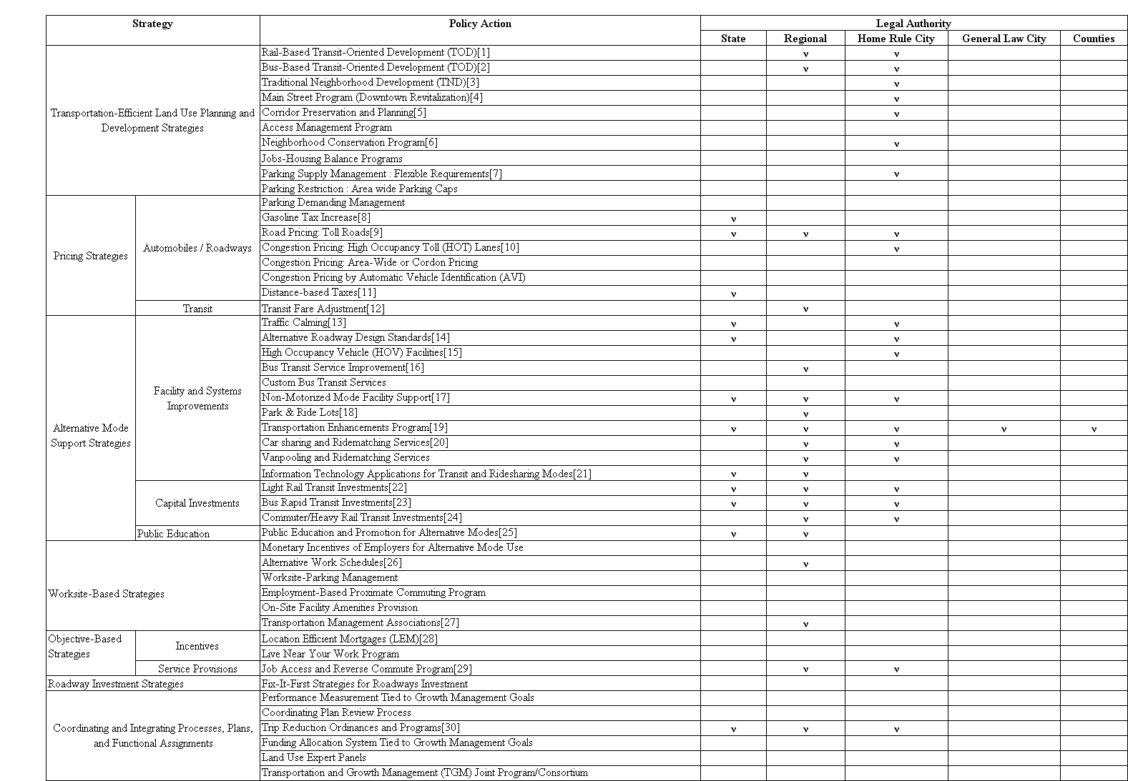

References for Table A-1
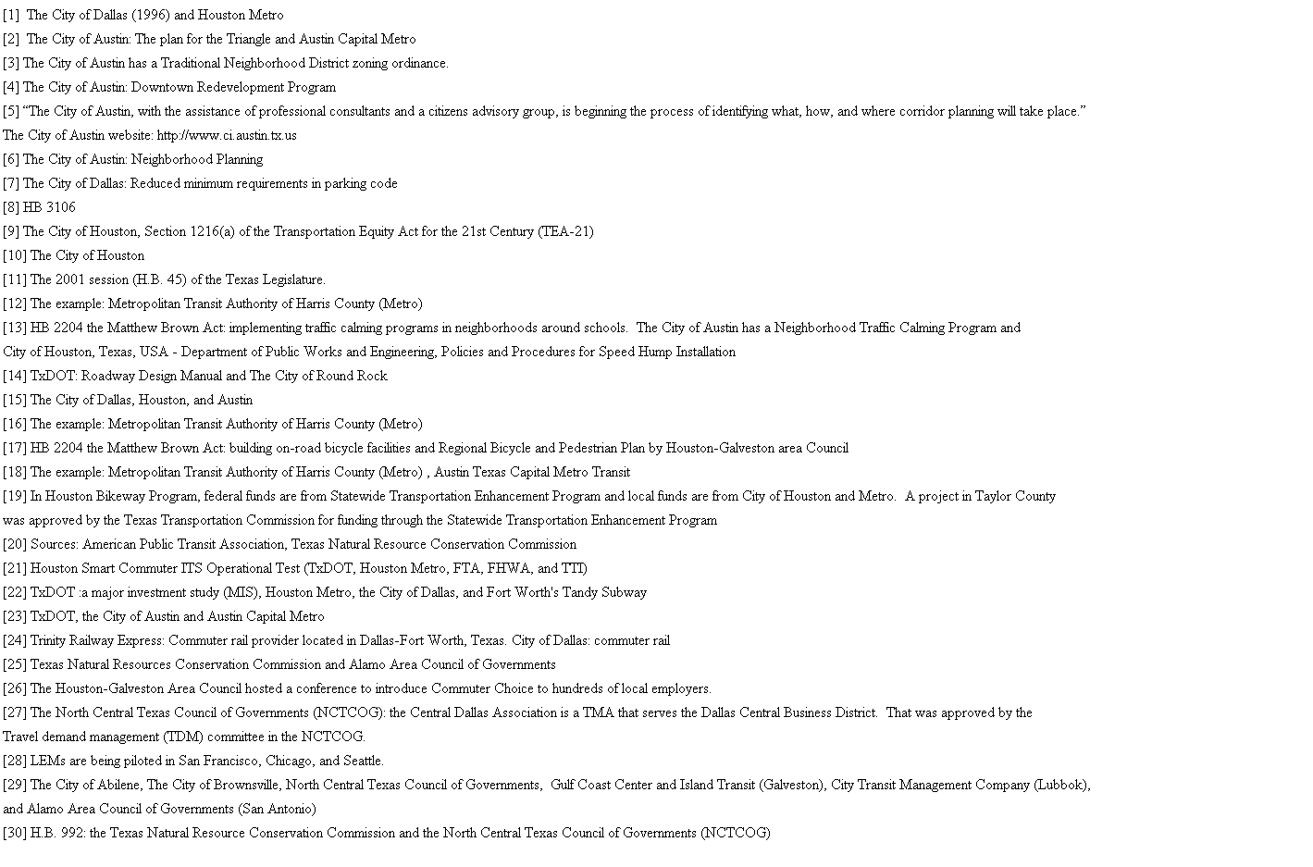

Table A-2 Legal Authority for Growth Management-related Policy Actions
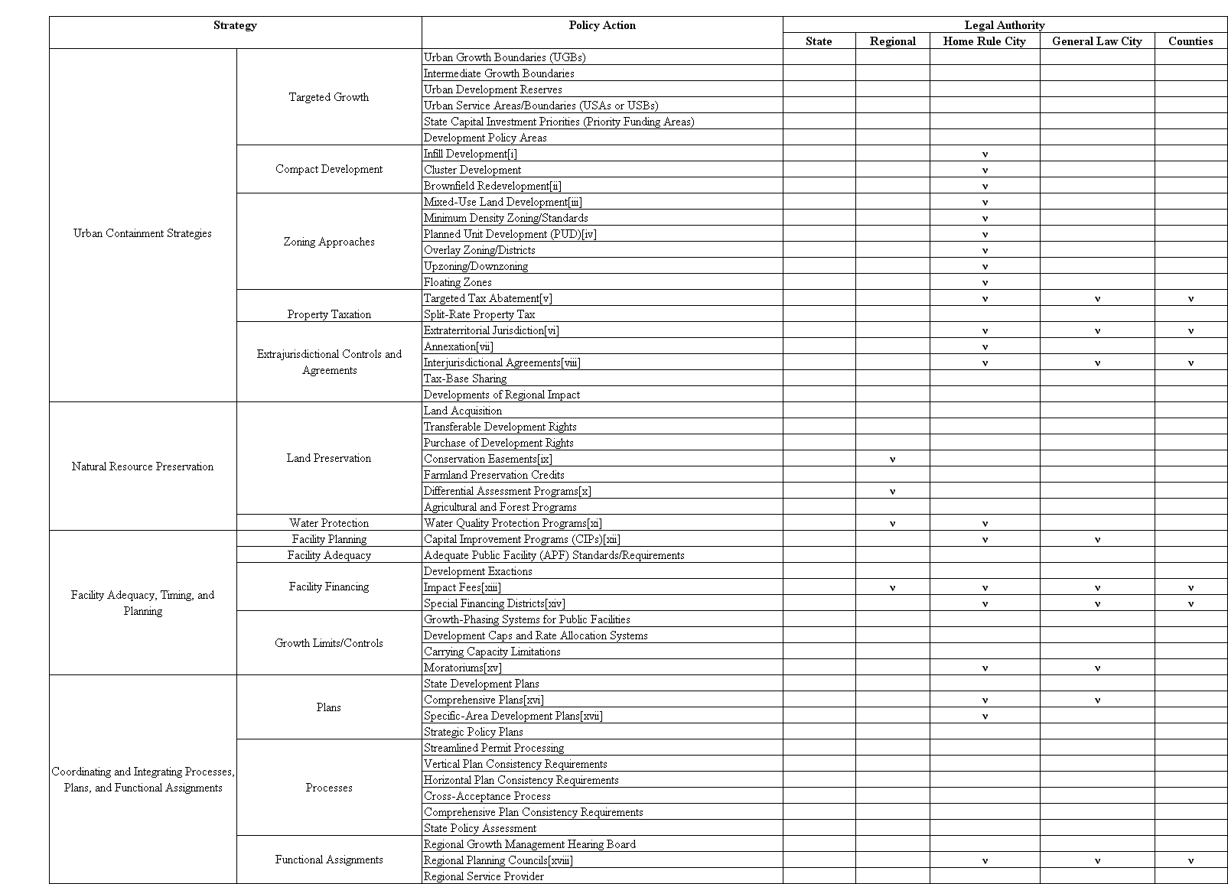
References for Table A-2

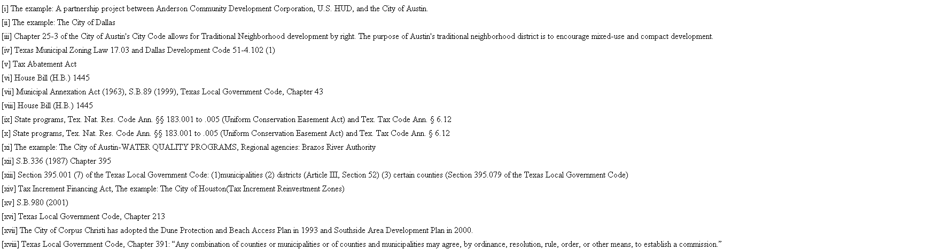

Appendix B-1

Description of Transportation-related Policy Actions for Mitigating Urban Sprawl

Access Management Program
Access management is the coordination of land use and access to the highway. Access management along existing highways occurs over a period of time through the county development process, by directing newly developing or redeveloping parcels to new access points, future service roads or public roads. A major tool of access management is to control local access to highway capacity through plans, regulations and negotiated agreements between appropriate levels of government in ways that ensure that regional needs, adequate system capacity and public health and safety are protected and sprawl is minimized. Case/Example: Access Management Programs of Maine, Maryland, and Oregon DOTs. Source/Reference: Maryland DOT, B.

Alternative Roadway Design
Alternative roadway design strategies fall into two general categories: 1. Local street design, including “connectivity” and “skinny street” ordinances, and 2. Context-sensitive design for freeways and other large-scale projects. Portland, OR, for example, has adopted an ordinance that reduces the maximum allowable block length in new developments to 300(?) feet and the required width for residential streets to 28 feet and sidewalk width of at least 5 feet and landscaped pedestrian buffer strips that include street trees.
The Federal Highway Administration has promoted the concept of flexibility in highway design, enabling state departments of transportation to design new and rebuilt facilities that are sensitive to the local context. Context-sensitive design includes provisions for local traffic, including non-motorized modes, and attention to the aesthetic qualities of facilities. Source/Reference: Portland Metro, 2001.

Alternative Work Schedules
Employers can institute a wide variety of alternative work schedules in order to reduce or redistribute commute trips and/or to make it easier for employees to take advantage of HOVcommuting opportunities. Alternative work schedules take three forms as follows. 1) Compressed work schedules allow an employee to stay home from work on one day each week or one day every two weeks. 2) Flexible work hours or “flex-time” is a strategy whereby an employer allows employees to set their own starting and ending hours. 3) Multiple work shifts can be used for manufacturing operations. Effectiveness of the different scheduling strategies varies. There is a question as to whether compressed work-weeks reduce trips/VMT, or just gives people an extra day to make non-work trips, thereby offsetting any reductions from eliminating commute trips. Source/Reference: WSDOT, 2000, pp. 25-26.

Bus-Based Transit-Oriented Development (TOD)
Maryland DOT defines a TOD as a place of relatively higher density that includes a mixture of residential, employment, shopping, and civil uses and types located within an easy walk of a bus (“Bus-Based TOD”) or a rail transit center (“Rail-Based TOD”). There are two primary types of bus service that impact the urban form of TODs: 1) express buses operating on dedicated rights-of-way, or along HOV lanes on major highways and freeways work in a similar fashion to commuter rail; 2) local shuttle or feeder bus services. Bus rapid transit systems may provide efficient transportation, but they do not perform well as catalysts for economic development since bus routes are not permanent, real estate developers prefer fixed rail’s permanence. Busy local bus routes often are candidates for the application of TOD principles because their routes follow mature corridors that already possess many of the desired characteristics. There are some successful examples of a bus-based TOD. Cities like Ottawa, Canada and Curitiba, Brazil show that bus-based TODs can be as successful as rail-based TODs as long as they are accompanied by foresighted, intelligent planning. Case/Example: Ottawa, Canada and Curitiba, Brazil. Source/Reference: Maryland DOT, 2000, pp. 4-7; Cervero, 2000, pp. 9-10; ARC, A.

Bus Rapid Transit Investments
See Bus-Based Transit-Oriented Development (TOD).

Bus Transit Service Improvement
The provision of good transit service is essential for the success of almost any TDM strategy. Transit services can be improved by making it faster and more reliable, adding new routes, adding express routes, extending operating hours and decreasing headways. Comfort and convenience can also make a difference: for example, air conditioning, upholstered seats that recline, systemwide transit passes, and fast/automatic payment methods. In addition, with the development of exclusive busways, HOV facilities, signal prioritization, and the changing of boarding procedures, bus transit can begin to approach the efficiency of rail transit, known as BRT (Bus Rapid Transit). The average response to frequency improvements for bus service is roughly a 0.68% ridership gain per 1% frequency increase. Decreasing wait times by 1% can result in a 0.3% ridership increase, and decreasing travel time by 1% can result in a 0.6% ridership increase (JHK & Associates, 1995). Source/Reference: WSDOT, 2000, pp. 7-8
Carsharing and Ridematching Services
Shared use cars are placed in neighborhoods (generally in reserved spaces in parking lots) and members may reserve them to use on an hourly basis. Carsharing organizations may be small co-operatives, nonprofits, or third parties - either publicly subsidized or private, moneymaking enterprises. Location-efficient mortgages (which allow people to live in mixed use, compact neighborhoods well served by transit) and carsharing work together especially well by providing synergistic economic incentives. Carsharing reinforces that locational preference by giving people an economic incentive to use transit and only use a car when they need it. In the U.S., several urban areas are experimenting with the carsharing concept, including the San Francisco Bay Area, Boston, Seattle, and Portland. In Washington, ridematching services are most frequently operated by transit/rideshare agencies, which maintain large databases of interested commuters in order to coordinate potential ridesharers. Some employers also operate their own ridematching services in-house. Technical advances have led to demonstrations of dynamic (real time, web-based) ridematching and the utilization of the ridematch concept for non-commute travel. Studies have estimated that ridematching services can achieve reductions in regional VMT from 0.1-3.6% (PSRC, 1994, pp. 26 and PSRC, 1993). Case/Example: San Francisco Bay Area (CA), Boston (MA), Seattle (WA), and Portland (OR). Source/Reference: WSDOT, 2000, pp. 5-6 and pp. 22.

Commuter/Heavy Rail Transit Investments
There are crucial differences in the choice of mass transit technology that affect the patterns of land uses and the arrangement of buildings and public spaces around transit stations and corridors. Characteristically, commuter-rail transit stations need to be 2 to 5 miles apart to allow long acceleration and deceleration times required by diesel powered locomotives. Tracks are generally separated from other urban uses except at stations, where some limited integration with streets and pedestrians is permissible. Conventional commuter rail suffers from several of the same problems as heavy rail systems in terms of difficulties with pedestrian friendly environments along the transit corridor. At the stations, however, because there are no electrical rails or wires a greater degree of integration with vehicles and pedestrians can be achieved. The Metropolitan Atlanta Rapid Transit Authority (MARTA) in Georgia is an example of the type of heavy rail transit system. The heavy rail system is one of high capacity and high speed necessitated by the ridership demand to travel relatively long distances at greater speeds than is typical of the light rail and bus systems. By design the heavy rail system requires greater attention and emphasis on pedestrian environment in and around the transit station rather than along the transit corridors because of essential grade separation for operational and safety reasons. Source/Reference: ARC, A.

Congestion Pricing: Area-Wide or Cordon Pricing
Area-wide cordon pricing defines a restricted area and charges users to enter or exit specified zones such as a downtown central business district or suburban shopping area. Singapore’s pricing scheme, in effect in the city’s CBD since 1975, has reduced inbound peak period trips by 40%. However, afternoon peak congestion has not been reduced significantly, and traffic on bypass roads has increased (Comsis Corporation, 1993b. pp. 5-6). Case/Example: Singapore. Source/Reference: WSDOT, 2000, pp.73-74.

Congestion Pricing by Automatic Vehicle Identification (AVI)
AVI uses an electronic system (transponders and dectors) to identify vehicles and charges an appropriate road fee. The fees can be varied by the time of day, level of congestion, miles traveled, and choice of roadway to create a complex region-wide pricing program. Source/Reference: WSDOT, 2000, pp.73-74.

Congestion Pricing: High Occupancy Toll (HOT) Lanes
HOT lanes charge variable tolls for the use of HOV (High Occupancy Vehicle) lanes that depend on the level of congestion and number of people in the vehicle. HOVs and transit may travel on HOT lanes for free, while SOVs may use them for a price. Examples of HOT lanes can now be found in San Diego, the Katy Freeway in Houston, and SR 91 in Orange County, California. Case/Example: HOT lanes in San Diego and SR 91 in Orange County (CA) and the Key Freeway in Houston (TX). Source/Reference: WSDOT, 2000, pp. 73-74.

Coordinating Plan Review Process
Currently, Maryland DOT (MDOT) reviews and comments on all draft land use plan updates that are submitted by local governments to the state’s Department of Planning (Maryland Department of Planning). These comments are shared with local governments prior to plan finalization. MDOT is exploring opportunities to provide inputs to local planning processes at a point farther upstream in the local planning process. MDOT’s interest in this is grounded in the Department’s belief that MDOT comments would have a greater impact at an earlier stage in the process. However, at present this effort is quite preliminary and tentative. Source/Reference: Maryland DOT, A.

Corridor Preservation and Planning
Corridor preservation is one means of coordinating transportation planning with land use planning and development to protect existing or planned transportation corridors from inconsistent development. Its goal is to prohibit, or at least minimize, development in areas that are likely to be required to meet transportation needs in the future. These areas include lands adjacent to existing roadways which are projected to require capacity expansion; areas which might be needed to construct entirely new routes for urban bypasses or to serve new neighborhoods or commercial developments; and land needed for bicycle, transit and pedestrian facilities. The process of protecting rights-of-way along significant existing and proposed transportation corridors allows for transportation options to remain open while permitting land use changes to occur in accordance with local plans. Corridor preservation promotes efficient land use patterns and lessens the amount of taxpayer dollars expended on future rights-of-ways and prevents costly relocations that disrupt residences and business. Source/Reference: Wisconsin DOT, 1994; Maryland DOT, A.

Custom Transit Services
Transit agencies are increasingly looking to custom transit services to serve transit markets, defined by geographic area or segment of the population or both, where traditional fixed-route transit services is infeasible or ineffective. Some of the various custom transit strategies include shuttles, circulators, feeder buses; Dial-a-Ride (paratransit) services; custom or subscription bus service; Personal Rapid Transit (PRT), Group Rapid Transit (GRT), worker/driver bus service etc. Source/Reference: WSDOT, 2000, pp. 11-12.

Distance Based Taxes
Distance-based taxes are designed to charge drivers in direct proportion to the distance they drive both to increase equity in the application of transportation fees and to discourage excessive consumption of transportation. VMT (Vehicle Miles Traveled) Tax is one such example in which the state or local government collects the tax based on odometer readings taken at the annual registration or inspection, or by using electronic tracking methods. The Puget Sound Regional Council estimates that a VMT tax could produce up to a 11% reduction in VMT and a 10% reduction in vehicle trips with a $0.05 per mile charge (PSRC, 1994. pp. 25). No examples of VMT taxes are currently found anywhere. Pay-as-you-drive vehicle insurance has been proposed as a way of tying insurance costs to distances driven and of converting an indirect cost of driving to a direct, out-of-pocket cost. Case/Example: cents-per-mile pricing for vehicle insurance in Texas; Bill 3871 introduced in the 2001 Oregon legislature provides tax credits to insurers that offer Pay-As-You-Drive pricing. Source/Reference: WSDOT, 2000, pp. 75,Victoria Transport Policy Institute

Employment-Based Proximate Commuting Program
Proximate commuting is an employment-based commute reduction strategy that offers multi-site employers (e.g., banks, retail, post offices, government agencies, manufacturers, etc) a program for minimizing inefficient long distance commuting. Employees of multi-site employers often live closer to several other work sites of the same employer than the site where they work. Through proximate commuting program employee commute patterns are assessed, commuters who could potentially work closer to their homes are identified, and voluntary transfers to alternate shorter-commute sites are facilitated. Case/Example: Pilot Program in Key Bank (WA). Source/Reference: Office of Urban Mobility, 1995, pp. 49.

Fix-It-First Strategies for Roadways Investment
Traditional transportation planning and funding practices often favor capital expenditures over maintenance and operations. This encourages jurisdictions to expand transportation system capacity and implement major new projects even when they have inadequate resources to maintain and operate existing facilities, or when incremental improvements to existing facilities and demand management strategies would provide greater economic benefits. “Fix It First” means that transportation planning and funding give top priority to maintenance, operations and incremental improvements to existing transportation facilities, and major capital projects are only implemented if there is adequate additional funds. Source/Reference: VTPI, C; SELC & ELI, 1999, pp. 21.

Funding Allocation Systems tied to Growth Management Goals
Funding allocation systems can by tied to growth management goals, so that transportation projects that work towards these goals are given priority for funds. Full-cost analysis, which includes lifecycle costs and quantifies externalities, should be incorporated into such systems.. For example, Rhode Island DOT’s Transportation Improvement Plan (TIP) development process has a funding allocation system that prioritizes projects that encourage compact development and penalizes those that encourage sprawl. As a result, the TIP allocates the vast majority of available funding to system management and system preservation projects, and funds very few system expansion projects. Case/Example: Rhode Island DOT’s scoring system. Source/Reference: Governor’s Growth Planning Council, 2001, pp. 7-8.

Gasoline Tax Increase
It is generally acknowledged that a significant fuel tax will be needed to de-subsidize auto use and make the costs of other alternative modes more competitive. Moderately increased fuel costs may be absorbed by the consumer without much change in travel. The Puget Sound Regional Council modeled a $2 per gallon increase in fuel taxes across the four county Puget Sound region and predicted a 7.2% decrease in VMT and an 8.6% decrease in vehicle trips (Puget Sound Regional Council, 1994, pp. 25). Source/Reference: WSDOT, 2000, pp. 71.

HOV Facilities
A comprehensive network of HOV facilities can encourage not only the use of public transit, but also the formation of carpools and vanpools. By reducing travel times for transit or rideshare vehicles, HOV facilities allow them to compete more effectively with private vehicles. There are three methods for providing an HOV lane - adding a lane, utilizing the existing shoulder, and converting an existing general purpose lane to HOV only. HOV lanes are estimated to reduce peak period trips on congested facilities by 2-10% (Ewing, 1993, pp. 343-366). HOV lanes can provide up to a 2% trip reduction and a 1.5% reduction in daily region-wide VMT (Apogee Research, Inc., 1994). Source/Reference: WSDOT, 2000, pp. 15-17.

Information Technology Applications for Transit and Ridesharing Modes
Telecommunication and computer technologies are providing opportunities for innovative TDM programs, and future advances will provide even more options. For example, by collecting information from a variety of service providers (traffic conditions, bus schedules, carpool and vanpool opportunities) and presenting it to the user in one place (telephone system, public kiosk, website), ATIS (Advanced Traveler Information Systems) makes travel information more accessible. Telephone or desktop computer interfaces can allow users to tap into a rideshare agency’s matching computer to automatically learn of, and communicate with, potential carpool partners (dynamic rideshare matching). This added flexibility potentially redefines carpooling - from a permanent arrangement with a set group of commuters to something that changes daily according to one’s need. Source/Reference: WSDOT, 2000, pp. 63-64.

Jobs-Housing Balance Programs
Jobs-housing balance programs are crucial to effecting efficient urban development patterns as part of an urban containment strategy. Failure to improve jobs-housing balance will result in inefficient development patterns and fundamentally undermine the very purpose of growth management to direct development where it is appropriate and away from areas where it is inappropriate. In order to be effective, jobs-housing balance programs must emphasize not only a balance between work and housing, but more importantly, a balance between work and housing that workers can afford. Strategies used to achieve the desired balance include mixed-use requirements, affordable housing density bonuses, linkage programs, and public-private partnerships. “Balanced jobs-housing” cities averaged 12 to 15% less work-trip VMT per employed residents that did “job-surplus” cities (Cervero, 1996b). Case/Example: Sacramento County (CA), Costa Mesa (CA), Program of Southern California Association of Governments (CA), and Durham (OR). Source/Reference: Nelson and Duncan, 1995, pp. 84-85; U.S. EPA, 2001, pp. 64.

Job Access and Reverse Commute Program
The Job Access and Reverse Commute grant program assists states and localities in developing new or expanded transportation services that connect welfare recipients and other low income persons to jobs and other employment related services. Job Access projects are targeted at developing new or expanded transportation services such as shuttles, vanpools, new bus routes, connector services to mass transit, and guaranteed ride home programs for welfare recipients and low income persons. Reverse Commute projects provide transportation services to suburban employment centers from urban, rural and other suburban locations for all populations. Source/Reference: FTA, A.

Land Use Expert Panels
Maryland DOT’s State Highway Administration has used land use expert panels on three projects when important questions arose about the links between the characteristics of a planned road project and local environmental and land use priorities. This approach required the formation of a panel of outside professionals (real estate experts, developers, environmentalists, bankers, experts in growth management and local planners) who aided in the development of alternative, policy-based land scenarios as the basis for project planning, and who helped consider whether land uses were likely to change as a result of planned transportation improvements. Case/Example: Land Use Expert Panels of State Highway Administration (in Maryland DOT). Source/Reference: Maryland DOT, A.

Light Rail Transit (LRT) Investments
LRT can operate on city streets in downtown areas like a bus, providing passengers convenient stops close to work, shopping, and entertainment. Outside the downtown area, LRT operate like a passenger train on a private right-of-way, traveling at speeds up to 55 mph between stations. The impact of light rail on land use and economic development most likely occurs over the intermediate to longer term. Light rail, by itself, may not be a cause for land-use changes or economic development. As a tool, it can best facilitate land use changes and economic development when integrated within a comprehensive land use, economic development and transportation plan. Case/Example: MAX system of Portland (OR) and Hiawatha Light Rail Transit on Construction of Minneapolis/St. Paul (MN). Source/Reference: Greater Austin Chamber of Commerce Staff, 2000, pp. 21; Minnesota DOT, A.

Live Near Your Work Program
Maryland’s Live Near Your Work (LNYW) pilot program provides a minimum of $3,000 in direct cash assistance to home buyers moving to designated neighborhoods surrounding major employers. Local governments designate the LNYW areas and administer the program within their jurisdictions. The following three benefits of the LNYW program are expected: 1. Neighborhoods are strengthened through increased homeownership; 2. Commuting costs are reduced; and 3. Important relationships are forged between employers and their surrounding communities. Participating employers - businesses, non-profits, colleges or universities, or government agencies - must set eligibility requirements, promote the program to their employees and provide matching resources. Case/Example: Maryland’s LNYW program. Source/Reference: Georgia DCA, 1998, pp. 25; Maryland Office of Planning, 1997a, pp. 6; Maryland Office of Planning, 1997b, pp.14.

Location-Efficient Mortgages (LEMs)
Linking transportation and housing policy makes good financial sense. To the degree less is spent on transportation, more income is freed up for housing consumption. The concept of Location Efficient Mortgages (LEMs) has gained currency. If the homebuyer purchases a home in areas that are well-served by transit, they are assumed to be saving money by foregoing auto expenses. This money is counted as income, thus allowing them to qualify for a larger mortgage and buy housing in closer-in areas. LEMs are also good for developers, who gain a larger market by building housing in transit supportive areas. Demonstration programs, co-sponsored by Fannie Mae (federal mortgage insurance agency) and several private banks, are currently under way or being implemented in Chicago, Seattle, San Francisco Bay Area, and Los Angeles. Case/Example: LEM program of Seattle (WA). Source/Reference: Cervero, 2000, pp. 12; WS DOT, 2000, pp. 53-54; Goldstein, 1996.

Main Street Program (Downtown Revitalization)
The Main Street program is designed to improve all aspects of the downtown or central business district, producing both tangible and intangible benefits. Improving economic management, strengthening public participation, and making downtown a fun place to visit are as critical to Main Street’s future as recruiting new businesses and rehabilitating buildings. Building on downtown’s inherent assets - rich architecture, personal service, historic culture and traditional values and most of all, a sense of place - the Main Street approach has rekindled entrepreneurship, downtown cooperation and civic concern. Case/Example: Main Street Programs in Maine, Maryland, and North Carolina. Source/Reference: National Main Street Center.
Monetary Incentives of Employers for Alternative Mode Use
Many employers have found it simple and effective to encourage the use of HOVs or transit by providing their employees with a monetary incentive to do so. Monetary incentives most often take three forms: 1. direct subsidies for transit passes, use of employer vehicles for ridesharing, and parking for HOVs; 2. transportation allowances (employers are free to use this money to pay for parking or transit, or as additional income.); 3. parking cash-outs (parking is considered a workplace benefit, and those employees who do not use it are entitled to instead receive its monthly value.). A reduction in trips of between 8% and 18% can be expected at individual employment sites (Comsis Corporation, 1993b. pp. 3-21). Parking cash-out programs could reduce SOV commuting trips by as much as 24% (Wilson and Shoup, 1990). Source/Reference: WSDOT, 2000, pp. 23-24.

Neighborhood Conservation Program
The Maryland DOT’s neighborhood conservation program provides funding for transportation improvements on roadways and other transportation facilities located in state designated neighborhoods (often referred to as neighborhood revitalization areas) where the improvements will promote economic revitalization and neighborhood conservation and where these improvements will contribute to other revitalization activities. Eligible components include roadway repaving or reconstruction; roadway signing, lighting and traffic controls; conventional sidewalks; bus shelters and transit station access improvements; streetscaping; and etc. Case/Example: Maryland DOT’s Neighborhood Conservation/Urban Reconstruction Program. Source/Reference: Maryland DOT, C, pp. 4-5.

Non-Motorized Mode Facility Support
A Harris poll for Bicycling Magazine in 1991 indicated that 46% of people 18 and older had ridden a bicycle in the previous year. Of these, up to 53% said they would commute to work if better facilities were available. 59% of all respondents reported that they would walk or would walk more if there were safe, designated paths or walkways (FHWA, 1994). Supportive actions include adding and improving paths and bike lanes, providing safe routes to school; providing bicycle carriers on buses; installing bicycle racks, lockers, and changing/shower facilities at Park & Ride lots; and much more. Increasing the walk mode share by 1% would reduce commute trips by 0.5%, and increasing the bike mode share by 1% would reduce commute trips by 0.9% (Comsis Corporation, 1993a, pp.4-31). Source/Reference: WSDOT, 2000, pp. 13-14.

On-Site Facility Amenities Provision
Facility amenities include the physical changes that can be made to an employment facility to employees. Amenities that are trip generators such as daycare centers, bank offices, restaurants, gyms, and coffee/newspaper shops are situated on-site. The effectiveness of on-site amenities provision may be comparable to that of mixed-use development. Establishing private businesses in employment centers/sites may require proof of profitability, and local zoning regulations may prevent or make difficult their implementation. Source/Reference: WSDOT, 2000, pp. 31-32.

Park & Ride Lots
People drive to the Park & Ride lot in the morning, park their car and transfer to a transit to get to work. Park & Ride lots are not restricted to car to transit transfers - they also serve as meeting points for carpools and vanpools and accommodate walk-in or bike-in trips. Lots such as this function more as transit hubs. With the addition of services such as daycare, banks, or markets, Park & Ride lots can free users from the need to make additional errand trips before or after work. Source/Reference: WSDOT, 2000, pp. 19-20.

Parking Demand Management
The demand for parking can be managed through pricing strategies. Parking pricing can be implemented at the employment site, with metered spaces on the street, in commercial parking lots, at destination lots such as shops, malls, parks, public facilities, or through a parking tax to manage demand for parking space. Charging for parking is one of the most effective TDM strategies. Pricing studies indicate that region-wide parking charges can result in a 1-5% reduction in VMT and vehicle trips (PSRC, 1994. pp. 25). In the study of individual employment site, SOP (Single Occupant Vehicle) reductions ranging from 12 to 25% after the elimination of free parking (Comsis Corporation, 1993a. pp. 4-9). Source/Reference: WSDOT, 2000, pp. 69-70.

Parking Supply Management: Flexible Requirements
Flexible parking requirements permit developers to reduce the number of parking spaces provided in exchange for actions such as transit/pedestrian supportive land uses, mixed-use development, provision of bicycle parking, preferential carpool parking, placement of carsharing vehicles on site, shared parking agreements, fees paid in lieu of on-site parking, reductions in off-street parking requirements, etc.. See Washington State Commute Trip Reduction Office, 1999 for an overview of parking policy. Case/Example: HOV parking requirements of Seattle (WA); Placement of parking behind buildings of Everett (WA). Source/Reference: WSDOT, 2000, pp. 47-49; Washington State Commute Trip Reduction Office (in WSDOT), 1999.

Parking Supply Restrictions
A locality can limit overall supply of parking in an area through combined policies targeted to an overall cap. Experience with parking cap policies has been limited and mixed with other transportation policies making it difficult to determine effectiveness with confidence. Portland and San Francisco provide the two relevant cases where it appears the policies possibly are effective in increasing or maintaining transit use. In 1975, the City of Portland set an overall cap of approximately 40,000 parking spaces downtown, including existing space, approved but not built spaces, and a remainder termed “reserve” from which space for new development is allocated. The cap moved up to about 44,000 spaces by the late 1980’s, and has moved up again recently with the implementation of new simultaneous efforts (termed “offsets”) to reduce vehicular traffic. Thus, the case represents a moving rather than fixed cap. The City is generally satisfied with its parking policies and believes it has helped increase transit use from 20 to 25 % in the early 1970’s to a level of 48 % in recent years. The carpool rate is 17 % (Higgins, 1989). Case/Example: Portland (OR) and San Francisco (CA). Source/Reference: FTA, B.

Performance Measurement Adoption
In 2000, the Maryland Legislature approved legislation requiring Maryland DOT to adopt performance measures that support evaluation of MDOT’s success in meeting the goals laid out in the Maryland Transportation Plan (MTP), the overarching policy document that guides all of MDOT’s activities. To advise MDOT on the adoption of performance measures, the legislature established a task force that would recommend a set of suitable measures for the Department to adopt. The task force completed its deliberations in Fall 2001, and the Department is evaluating how to implement the recommended measures. Because the MTP includes land use and smart growth goals, the recommended package will include measures that relate to smart growth and transportation-land use linkages. The package may also include recommendations for the development and/or refinement of additional measures through joint work with interested local jurisdictions, other state agencies, and relevant stakeholders. Source/Reference: Maryland DOT, A.

Public Education and Promotion for Alternative Modes
Public education complements every other TDM strategy by creating a climate that fosters public acceptance and awareness of alternative transportation modes. It is a vital element of a TDM project. Public education campaigns coordinated by a variety of entities, both public and private, are ongoing in most major cities in the U.S. As examples, there are modes of information dissemination such as bike maps and bus schedules; marketing/campaign through the use of mass media; designation of Bike-to-Work Week, Ozone Action Day, Relax Statewide Transportation Choices campaign, Oil Smart campaign, Rideshare Week, One Less Car campaign, Walk to School days; and others. Source/Reference: WSDOT, 2000, pp. 3-4.

Rail-Based Transit-Oriented Development (TOD)
Maryland DOT defines a TOD as a place of relatively higher density that includes a mixture of residential, employment, shopping, and civil uses and types located within an easy walk of a bus (“Bus-Based TOD”) or a rail transit center (“Rail-Based TOD”). Eight strategies that are fundamental to any smart growth planning for a TOD include: 1. maximizing ridership; 2. increasing property values; 3. increasing tax revenues; 4. providing retail opportunities; 5. offering an alternative to auto-dependent developments; 6. providing a stimulus for the revitalization of urban centers and existing neighborhoods; 7. providing choices; and 8. supporting environmental quality. The following categories of challenges and barriers of TOD implementation are: local planning, zoning and code issues; developer costs and risks; location and market issues; public perceptions and acceptance; and government, institutional and policy issues. Planned Unit Development (PUDs) have several similarities, being site specific master plans with a high design content, but PUDs have typically been individual projects that make few connections to transit. As an case of a TOD, Transit Station Area Development Incentive Program (Smart Growth Transit Program), run by the Maryland Department of Transportation in coordination with the Maryland Department of Planning and other departments, provides funds for services and amenities that stimulate private investment adjacent to major transit facilities. Case/Example: Transit Station Area Development Incentive Program and Transit Station Smart Growth Initiative (MD). Source/Reference: Maryland DOT, 2000, pp. 4-7; ARC, A.

Road Pricing: Toll Roads
The concept of toll roads is not new, but in the past tolls have been used to pay for construction/maintenance costs rather than strategies for trip reduction or congestion management. Price elasticity of tolls ranges from -0.1 to -0.4 for urban highways in the U.S. That is, 10% increase in toll rates results in a 1-4% reduction in vehicle use. Source/Reference: WSDOT, 2000, pp. 73-74; VTPI, A; VTPI, B.

TGM Code Assistance
The Oregon TGM code assistance services help communities modify their development ordinances, comprehensive plans, and development review procedures to allow and encourage smart development patterns. Case/Example: Oregon TGM Smart Development Code Assistance. Source/Reference: Oregon DOT & DLCD, D.

TGM Consultants
The Quick Response Program (Oregon TGM consultants) provides planning and design services to help developers and communities create compact, pedestrian-friendly, and livable neighborhoods and activity centers. In response to local requests, property owners, local and state officials, and affected stakeholders come together to review development proposals, develop innovative design solutions, and overcome regulatory obstacles to land use, transportation, and design issues. Case/Example: Oregon TGM Quick Response Program. Source/Reference: Oregon DOT & DLCD, C.

TGM Grants
Since the 1993-1995 biennium, the Oregon TGM program has distributed $21.6 million in planning grants to local governments to accomplish transportation-efficient planning. In the 2001-2003 biennium, grants of approximately $4.9 million have been awarded to local jurisdictions for projects in two categories: 1. Transportation System Planning and 2. Integrated Land Use and Transportation Planning (grants to help local governments develop integrated land use and transportation system plans that promote compact, mixed-use, pedestrian-friendly development and reduce reliance on the automobile.) Case/Example: Oregon TGM Grants. Source/Reference: Oregon DOT & DLCD, B.

TGM Outreach Program
The Oregon TGM Outreach program is aimed at increasing the understanding and acceptance of smart development principles through things like workshops, a partnership program and technical assistance for practitioners. Maine DOT is also looking at creating tools and outreach programs that would link transportation and land use for local decision makers. Case/Example: Oregon TGM Outreach Program. Source/Reference: Oregon DOT & DLCD, E.

Traditional Neighborhood Development (TND)
In the 1960s, new towns and communities were viewed as necessary to better manage urban sprawl and also to divert attention away from the many failures of urban renewal. In recent years, the traditional neighborhood development (TND) has come to be viewed as a new community planning concept. TND is the term used to describe the planning and urban design of new developments that take their urban forms from the structure and layout of pre-automobile neighborhoods. The five main organizing principles are: 1. compact, defined urban neighborhoods, comprising a compatible mix of uses and housing types; 2. a network of connected streets with sidewalks and street trees to facilitate convenient and safe movement throughout neighborhoods for all modes of transportation; 3. focus on the pedestrian over the automobile; 4. integration of parks and public spaces into each neighborhood; and 5. the placement of important civil buildings on key sites to create landmarks and a strong sense of place. In practice, new communities fall neatly into four categories: self-contained, urban node, infill, and isolated resort. The self-contained communities are designed to be self-sufficient in terms of offering enough jobs, shopping, leisure, and housing opportunities for all residents. The urban node-communities are primarily residential and shopping areas with relatively little employment but are tied to rail lines either directly by locating near transit stations or indirectly by dedicated minibus service. Nelson and Duncan (1995, pp 91-92) summarize the general criteria for reviewing new communities in a growth management context. Case/Example: Miami Lakes (FL), Columbia (MD), and Reston (VA) for self-contained communities; Kentland (Washington, DC metro area) for an urban node-community. Source/Reference: ARC, B, pp. 1; Nelson and Duncan, 1995, pp. 88-92.

Traffic Calming
Traffic calming includes a variety of techniques designed to balance the needs of all road users. Techniques for keeping cars moving at speeds that are safe for other road users include T-intersections, on-street parking, brick paving, zig-zag curves, narrowings, raised crosswalks, speed humps, chokers, diverters, median islands, channelization islands, chicanes, stop signs, neotraditional street design, street trees etc. For example, Gainesville, Florida has installed mini-traffic circles in its neighborhoods, and closed many residential streets to outside traffic. Source/Reference: Ewing, 1997, pp. 68-69; Victoria Transport Policy Institute

Transit Fare Adjustment
Many transit agencies use zone-based fares, peak period fares, bus passes, ride-free zones, and special fares for different user groups. The price elasticity of demand for transit is commonly estimated to be -0.3, meaning that a 50% reduction in transit fares will result in a 15% increase in transit ridership. Improving other factors such as the availability, quality, and/or frequency of transit service effectively complements the strategy of transit fare adjustments. Demonstrations of low or free transit fares in urban areas (Denver, Boston) have estimated area-wide VMT reductions of approximately 2%. The Puget Sound Regional Council estimates the potential vehicle trip reduction for transit service fare changes at 1.8% (PSRC, 1994. pp. 24-32). Case/Example: Denver (CO) and Boston (MA). Source/Reference: WSDOT, 2000, pp. 77-78.

Transportation and Growth Management (TGM) Joint Program/Consortium
The Transportation and Growth Management (TGM) program is the joint program/consortium between a state department of transportation and a state agency of land use development and growth management. For example, the Oregon TGM program is the joint program between the Oregon Department of Transportation and the Department of Land Conservation and Development. The TGM program provides non-regulatory technical assistance and grants funding to local communities. Total funding for the joint TGM program during the 1999-2001 biennium is $11.2 million. Of that, about $9.9 million came from federal transportation funds and the remaining $1.3 million is from state general funds. The TGM program offers four main services to Oregon communities: 1) grants to local governments; 2) Quick Response Team; 3) smart development code assistance; and 4) educational outreach.(See TGM Grants, TGM Consultants, TGM Code Assistance, and TGM Outreach Program.) Case/Example: Oregon TGM Joint Program. Source/Reference: Oregon DOT & DLCD, A.

Transportation Enhancements Program
The Federal Transportation Equity Act for the 21st Century (TEA-21) provides funds for transportation-related enhancements. Projects may include bicycle and pedestrian facilities, safety and educational activities for pedestrians and cyclists, acquisition of scenic easements and historic sites, scenic or historic highway programs, preservation of abandoned railway corridors, and so on. Source/Reference: Maryland DOT, A; Maryland DOT, C, pp. 8-9.

Transportation Management Associations
Transportation Management Associations (TMAs) are nonprofit member organizations of businesses and developers (and sometimes local jurisdictions, state government, and transit agencies) dedicated to solving transportation concerns within a specific geographic area. In a more formalized way TMAs generally offer employers a combination of four types of activities: 1. Information, training, and education; 2. Direct facilitation of TDM services such as ridematching, vanpools, and guaranteed ride home; 3. Advocacy for new and improved transportation/transit services; and 4. Assistance in complying with local transportation and air quality regulations. Most TMAs are public-private partnerships and can reduce employers’ costs to implement work site programs. Source/Reference: WSDOT, 2000, pp. 33-34.

Trip Reduction Ordinances and Programs
Trip reduction ordinances (TROs) require developers, employers, or building managers to provide incentives for occupants or employees to use alternative modes. Ordinances can be implemented state/region wide or by local jurisdictions and take many different forms. Ordinances can require a certain reduction in trips with penalties and rewards set for achievement or nonattainment of goals. Other trip reduction programs function on a voluntary or community-based basis. Large companies and commute trips in congested areas are usually the targets of TROs. Washington’s Commute Trip Reduction (CTR) law is similar to TROs. Oregon’s ECO (Employee Commute Options) program requires employers with over 50 employees to reduce drive-alone rates. Case/Example: Commute Trip Reduction Law (WA); Employee Commute Options Program (OR). Source/Reference: WSDOT, 2000, pp. 57-58.

Vanpooling and Ridematching Services
Vanpooling is a travel mode that brings five to fifteen commuters together in one vehicle - typically a van. In Puget Sound Region, vanpooling has achieved a 2% share of the overall commute market. Among commuters who travel over 20 miles each way, vanpooling has reached a 7% market share. Employers frequently subsidize vanpool fares for their employees. IRS regulations allow transit or vanpool subsidies of up to $65 ($100 in 2002) per month, tax-free for employees. Washington State law exempts vanpool commutes from workers’ compensation insurance coverage, and the purchase of a van for vanpooling is exempt from the state sales tax or use tax in the case of a lease. Case/Example: Puget Sound Region (WA). Source/Reference: Office of Urban Mobility, 2000; WSDOT, 2000, pp. 5-6 and pp. 9-10.

Worksite Parking Management
Aggressive parking management programs are possibly the single most effective TDM measure an employer can take to reduce SOV travel. Parking management can take many forms: 1) preferential parking for HOVs/Vanpools (giving carpools or vanpools priority); 2) parking cash-out programs (a cash benefit given to employees); 3) limiting parking supply; and 4) parking pricing (charging the same rate for all vehicles which effectively makes carpools cheaper). Priority parking schemes have a very minimal impact on mode split, but charging for parking can create 20% to 30% reductions in SOV mode share, depending on pricing levels and transit access (Johnston and Ceerla, 1995, pp. 9). Source/Reference: WSDOT, 2000, pp. 29-30.

Sources/References for Transportation-related Policy Actions for Mitigating Urban Sprawl

Apogee Research, Inc. 1994. Costs and Effectiveness of Transportation Control Measures (TCMs): A Review and Analysis of the Literature. Washington, DC: National Association of Regional Counciles.

Atlanta Regional Commission (ARC). A. Community Choices Quality Growth Toolkit - Transit Oriented Development (TOD) Implementation at http://www.atlantaregional.com/qualitygrowth/planning/Toolkits/TOD_TOOL.pdf on March 15, 2002.

Atlanta Regional Commission (ARC). B. Community Choices Quality Growth Toolkit - Traditional Neighborhood Development (TND) Implementation at http://www.atlreg.com/qualitygrowth/planning/Toolkits/TND_TOOL.pdf on March 15, 2002.

Cervero, R. 2000. Transport and Land Use: Key Issues in Metropolitan Planning and Smart Growth. The University of California Transportation Center On-Line Research Paper 436 at http://www.uctc.net/papers/436.pdf on March 15, 2002.

Comsis Corporation. 1993a. Implementing Effective Travel Demand Management Measures: Inventory of Measures and Synthesis of Experience. Final Report Section II-A. Washington, D.C.: Federal Highway Administration/Federal Transit Administration.

Comsis Corporation. 1993b. Implementing Effective Travel Demand Management Measures: Inventory of Measures and Synthesis of Experience. Final Report Section II-B. Washington, D.C.: Federal Highway Administration/Federal Transit Administration.

Ewing, R. 1993. TDM, Growth Management, and the Other Four Out of Five Trips. Transportation Quarterly, Vol. 47, No. 3.

Ewing, R. 1997, Transportation and Land Use Innovations. American Planning Association. Chicago, Illinois.

Federal Highway Administration (FHWA). 1994. The National Bicycling and Walking Study Final Report: Transportation Choices for a Changing America, No. FHWA-PD-94-023.

Federal Transit Administration (FTA). A. Job Access and Reverse Commute Grants at http://www.fta.dot.gov/wtw/jarcgfs.htm on March 15, 2002.

Federal Transit Administration (FTA). B. Parking Supply Management at http://www.fta.dot.gov/library/planning/tdmstatus/FTAPRKSP.HTM#32 on March 24, 2002.

Georgia Department of Community Affairs (Georgia DCA). 1998. Georgia's Future: Beyond Growth Strategies at http://www.dca.state.ga.us/planning/georgiasfuture.pdf on March 15, 2002.

Goldstein, D. B. 1996. Making Housing More Affordable: Correcting Misplaced Incentives in the Lending System at http://www.smartgrowth.org/library/housing_afford_goldstein.html on March 15, 2002.

Governor's Growth Planning Council. 2001. State Programs and Sustainable Development Inventory, Analysis and Recommendation Report at http://www.planning.state.ri.us/GPC/_%20INVENTORY%20ADDENDUM.pdf on March 15, 2002.

Greater Austin Chamber of Commerce Staff. 2000. Light Rail Blue Ribbon Task Force

Higgins, T. J. 1989. Parking Management and Traffic Mitigation in Six Cities: Implications for Local Policy. Transportation Research Record: 1232, pp. 60-67.

JHK & Associates. 1995. CM/AQ (Congestion Mitigation/Air Quality) Evaluation Model. Texas Transportation Institute

Johnston, R. A. and R. Ceerla. 1995. Effects of Land Use Intensification and Auto Pricing Policies on Regional Travel, Emissions, and Fuel Use. Working Paper. University of California Transportation Center.

Maryland Department of Transportation (Maryland DOT). 2000. Report to Governor Parris N. Glendening from the Transit-Oriented-Development Task Force.

Maryland Department of Transportation (Maryland DOT). A. Maryland Department of Transportation - Smart Growth Approach. Draft Provided by Mike Haley, Assistant Division Chief of Regional Intermodal Planning Division at the Maryland State Highway Administration. Received on December 21, 2001.

Maryland Department of Transportation (Maryland DOT). B. Access Management in Maryland at http://www.mdot.state.md.us/us301/pdf/accessmd.pdf on March 15, 2002.

Maryland Department of Transportation (Maryland DOT). C. Discovering Smart Growth Opportunities: A Guide to Local Participation at http://www.sha.state.md.us/oppe/smartgrowth.pdf on March 15, 2002.

Minnesota Department of Transportation (Minnesota DOT). A. Hiawatha Light Rail Project - Frequently Asked Questions and Answers at http://www.dot.state.mn.us/metro/LRT/lrtfaqs.html#1 on March 15, 2002.

Maryland Office of Planning (now Maryland Department of Planning). 1997a. Smart Growth and Neighborhood Conservation: A Legacy for Our Children.

Maryland Office of Planning (now Maryland Department of Planning). 1997b. Smart Growth and Neighborhood Conservation: Managing Maryland's Growth.

National Main Street Center of the National Trust for Historic Preservation. What the Main Street Program is Doing in America's Communities at http://www.mainst.org/AboutMainStreet/aboutmain.htm on March 15, 2002.

Nelson A. C. and J. B. Duncan. 1995. Growth Management Principles and Practices. Planners Press, Chicago, IL.

Office of Urban Mobility. 1995. Proximate Commuting: A Demonstration Project of A Strategic Commute Trip Reduction Program. Final Technical Report WA-RD 400.1.

Office of Urban Mobility. 2000. Puget Sound Regional Vanpool Market Study Executive Summary at http://www.wsdot.wa.gov/mobility/TDM/vpexsm.pdf on March 15, 2000.

Oregon Department of Transportation (Oregon DOT) & Department of Land Conservation and Development (DLCD). A. Transportation and Growth Management (TGM) Program at http://www.lcd.state.or.us/tgm on March 15, 2002.

Oregon Department of Transportation (Oregon DOT) & Department of Land Conservation and Development (DLCD). B. Transportation and Growth Management (TGM) Program - Grants at http://www.lcd.state.or.us/tgm/grants.htm on March 15, 2002.

Oregon Department of Transportation (Oregon DOT) & Department of Land Conservation and Development (DLCD). C. Transportation and Growth Management (TGM) Program - Quick Reponse Program at http://www.lcd.state.or.us/tgm/quickresponse.htm on March 15, 2002.

Oregon Department of Transportation (Oregon DOT) & Department of Land Conservation and Development (DLCD). D. Transportation and Growth Management (TGM) Program - Smart Development Code Assistance at http://www.lcd.state.or.us/tgm/code/codeassist.PDF on March 15, 2002.

Oregon Department of Transportation (Oregon DOT) & Department of Land Conservation and Development (DLCD). E. Transportation and Growth Management (TGM) Program - Outreach Program at http://www.lcd.state.or.us/tgm/outreach.htm on March 15, 2002.

Portland Metro. 2001. Street Connectivity Standards Change at http://www.metro-region.org/transpo/highcap/rtp/factsheets/streetconnect.pdf on August 20, 2002.

Puget Sound Regional Council (PSRC). 1993. Transportation and Air Quality Advisory Committee: Project Notebook.

Puget Sound Regional Council (PSRC). 1994. Update of the Metropolitan Transportation Plan for the Central Puget Sound Region. Technical Paper: MTP 12.

Southern Environmental Law Center (SELC) and Environmental Law Institute (ELI). 1999. Smart Growth in the Southeast: New Approaches to Guiding Development at http://www.eli.org/pdf/rrsoutheast99.pdf on March 15, 2002.

Victoria Transport Policy Institute (VTPI). A. Online TDM Encyclopedia - Road Pricing at http://www.vtpi.org/tdm/tdm35.htm on March 15, 2002.

Victoria Transport Policy Institute (VTPI). B. Online TDM Encyclopedia - Transportation Elasticities at http://www.vtpi.org/tdm/tdm11.htm on March 15, 2002.

Victoria Transport Policy Institute (VTPI). C. Online TDM Encyclopedia - Market Reforms at http://www.vtpi.org/tdm/tdm29.htm on March 15, 2002.

Victoria Transport Policy Institute (VTPI). Online TDM Encyclopedia – Traffic Calming at http://www.vtpi.org/tdm/tdm4.htm on August 8, 2002.

Victoria Transport Policy Institute (VTPI). Online TDM Encyclopedia – Pay As You Drive Vehicle Insurance at VTPI http://www.vtpi.org/tdm/tdm79.htm on August 14, 2002

Washington State Commute Trip Reduction Office (in WSDOT). 1999. Local Government Parking Policy and Commute Trip Reduction. Olympia, WA.

Washington State Department of Transportation (WSDOT). 2000. TDM Guide for Planners: Including Transportation Demand Management (TDM) Strategies in the Planning Process at ftp://www.wsdot.wa.gov/wsdot/mobility/tdm/TDMplanguide/Appendix1.pdf on March 15, 2002.

Wilson, R. and D. Shoup. 1990. The Effects of Employer Paid Parking in Downtown Los Angeles. Los Angeles: UCLA School of Architecture and Urban Planning.

Wisconisn Department of Transportation (Wisconsin DOT). 1994. Corridor Preservation and Access Management Guidance at http://ntl.bts.gov/DOCS/amg.html on March 15, 2002.

U.S. Environmental Protection Agency (US EPA). 2001. Our Built and Natural Environments: A Technical Review of the Interactions between Land Use, Transportation, and Environmental Quality at http://www.epa.gov/smartgrowth/pdf/built.pdf on March 15, 2002.
Appendix B-2

Description of Growth-Management Policy Actions for Mitigating Urban Sprawl

Adequate Public Facility (APF) Standards/Requirements
APF requirements are formal mechanisms used to enforce one of the most fundamental tenets of land use planning - that development should not be permitted where it cannot be adequately accommodated by critical public facilities and services (i.e., minimum required levels of service for water, sewer, drainage, and traffic flow). From Florida to Washington State, APF standards are increasingly used to ensure that urban growth does not overburden municipal facilities and reduce current service. APF ordinances encourage infill development, facilitate municipal service delivery, and direct development toward facility-rich areas. Case/Example: APF Requirements of Florida. Source/Reference: NACo, JCSC, and SGN, 2001, pp. 30-31.

Agricultural and Forest Programs
Agricultural zoning, including forestry zoning, is the most common method of resource land preservation used by local governments. Such zoning restricts land uses to farming and livestock, other kinds of open space activity, and limited home building. Hawaii and Oregon require the use of agricultural zoning by all local governments that have prime agricultural farmland. The most important element of agricultural zoning is the extent to which it restricts the intrusion of new, nonfarm uses into established agricultural areas. Four general approaches to resource-land-use zoning are: nonexclusive use zoning, voluntary agricultural districts, exclusive use zoning, and agricultural buffers. Case/Example: Agricultural zoning of Hawaii and Oregon. Source/Reference: Nelson and Duncan, 1995, pp. 51-54.

Annexation
Most states authorize their municipalities to annex territory to retain some control over urban development. The political possibility of exercising this power, however, varies from state to state. Some states, such as North Carolina and Texas, require only that the city provide or commit to providing urban services in the area annexed. Other states have established elaborate annexation procedures that require affirmative votes from residents of the annexing jurisdiction, the jurisdiction losing territory, and the residents of areas to be annexed - a difficult test in many growing urban areas. Case/Example: Specific Plan in Tracy (CA). Source/Reference: Porter, 1997, pp. 71-72.

Brownfield Redevelopment
Brownfields are abandoned, idled, or underused industrial and commercial facilities where expansion or redevelopment is complicated by real or perceived environmental consequences. Brownfields, like infill sites, have the potential to absorb significant amounts of development. Brownfields in Detroit, Chicago, Milwaukee, and Cleveland could absorb 1 to 5 years of residential development, 10 to 20 years of industrial development, or 200 to 400 years of office space (Simons, 1996). Brownfield sites are different from other urban infill sites because of uncertainties about environmental liability and clean-up costs. Site owners, developers, and lenders often avoid investing in brownfields because of fear of contamination and the costs associated with it. Source/Reference: U.S. EPA, 2001, pp. 38.

Capital Improvement Programs (CIPs)
Capital improvement programs (CIPs) establish a schedule and funding basis for extending and improving facility systems (e.g., streets, water and sewer lines, septic systems, schools, libraries, parks, and other common facilities). If well linked, coordinated, and constantly updated, these ways of managing infrastructure can be effective. Yet many communities find that they must rely on other means to ensure that infrastructure development corresponds to other aspects of community development, especially in meeting funding requirements. Many communities use some or all of the techniques – functional plans; adequate public facility (APF) requirements (See APF standards/requirements.); exactions, impact fees, and special districts for these purposes; and so on. Source/Reference: Porter, 1997, pp. 25-26 and pp. 47-49.

Carrying Capacity Limitations
Carrying capacity is a term borrowed from the ecological sciences. Carrying capacity systems attempt to identify the upper capacity limits of the natural and built environment of a defined geographic area. The notion of carrying capacity usually focuses on natural systems. Man-made systems, however, are also characterized by capacity limitations. Critical population thresholds, roadway networks, water and wastewater systems, and even social systems such as fiscal resources or school systems can be identified that indicate when excess demand is being made on systems. Case/Example: Sanibel (FL). Source/Reference: Nelson and Duncan, 1995, pp. 95 and pp. 110-111.

Cluster Development
In newly developed areas, clustering development into concentrated areas can protect natural habitat. Cluster developments are built at gross densities comparable to conventional developments but leave more open space by reducing lot sizes. Square footage of buildings and residential and commercial capacity may remain the same, but compact clusters reduce the dimensions and geometry of individual lots and shorten road lengths. One of the main advantages of cluster development as a conversion tool is that it does not take development potential away from developers, since it changes the arrangement but not the number of units permitted on a property. It can also reduce costs for developers by requiring fewer miles of roads and water and sewer lines. Source/Reference: US EPA, 2001, pp. 39.

Compact Development
Compact metropolitan development generally means that the space needs of a population can be satisfied with less land area. Compact development can take various forms, and communities can develop more compactly by using three techniques: infill development, brownfields redevelopment, and cluster development. See Infill Development, Brownfields Redevelopment, and Cluster Development. Source/Reference: US EPA, 2001, pp. 37.
Comprehensive Plan Consistency Requirements
A comprehensive plan consistency requirement ensures that all local zoning and land use decisions made by the governing body are consistent with the local comprehensive plan. Several states have included this mandate as part of state planning and zoning legislation. Source/Reference: Georgia DCA, 1998, pp. 24.

Comprehensive Plans
Comprehensive plans include “community vision,” “information and projections (an inventory of what currently exists and what growth in population and land use is expected),” “land classification and zoning,” “economic development,” “residential areas,” and “facilities and infrastructure (Local officials need to know the capacity of current infrastructure and where they anticipate locating future facilities or extensions. A comprehensive plan can assist communities in determining the appropriate timing and location for infrastructure repair and extension).” To be effective, they must be updated regularly. However, many comprehensive plans are outdated and cannot adequately guide new development, respond to growth pressures, and carry out the community vision. Case/Example: Seattle Municipal Plan, “Toward a Sustainable Seattle” (WA); Chester County Land Use Plan (PA); and Lincoln/Lancaster County Joint Comprehensive Plan (NE). Source/Reference: NACo, JCSC, and SGN, 2001, pp. 9-10.

Conservation Easements
Conservation easements involve the transfer of development rights from a property owner to a third party, such as the Conservation Foundation. Conservation easements enable landowners to retain title to an undivided tract and use it for resource purpose. The advantage to the landowner is reducing the value of land to its inherent value for resource activities. For many landowners, this enables them to continue living on their land without facing higher property taxes. It also gives them the altruistic opportunity to preserve resource lands as open space in perpetuity. Local government can play a role in facilitating conservation easements by putting third parties active in acquiring them in contact with potentially receptive resource landowners. Source/Reference: Nelson and Duncan, 1995, pp. 51.

Cost-based Utility and Stormwater Fees
Cost-based Utility and Stormwater Fees are essentially extensions of impact fees in which utilities and municipal taxes are lower for infill development than for urban sprawl locations, due to higher public service costs. The City of Austin, Texas Smart Growth program includes an incentive matrix for infill development in its desired development zone and downtown that includes a sliding scale of reductions in fees and taxes for certain development types and locations that are consistent with their Smart Growth priorities. Source/Reference: City of Austin 2002, http://www.ci.austin.tx.us/smartgrowth/smartmatrix.htm

Cross-Acceptance Process
The cross-acceptance process is the process of comparing the planning policies of different governmental levels in order to attain compatibility between local and state plans. The process is designated to result in written statements that specify areas of agreement or disagreement between local plans and a preliminary state plan. This consensus-building approach was adopted by the State of New Jersey as a way to achieve vertical plan consistency while preserving local home rule. Case/Example: New Jersey’s Cross-Acceptance Process. Source/Reference: Georgia DCA, 1998, pp. 24; New Jersey OSP, A.

Development Caps and Rate Allocation Systems
Rate-of-growth systems typically have annual development caps similar to growth-phasing systems (See Growth-Phasing Systems.), but are less closely linked to public facility constraints. Development caps represent an attempt to set an absolute upper limit on development within a community or some portion of an area, such as Boca Raton (FL)’s 40,000 dwelling unit caps. Development caps are usually accompanied by a carrying capacity analysis. Historically, caps and allocation systems have been enacted by communities experiencing rapid population growth and extreme development pressures. Development rate allocation systems are the growth management systems that set limitations on the total amount of development allowable within a certain time period. Depending on the community’s growth management goals and the purpose of the regulation, most rate allocation systems place an annual cap on the total number of new residential units or commercial space allowable in a community over a period of one to three years. Petaluma (CA) limits the total number of new residential units to a 500 annual average not to exceed 1,500 over a three-year period. Case/Example: Development Caps of Boca Raton (FL); Development Rate Allocation Systems of Boulder and Aspen (CO) and Petaluma (CA). Source/Reference: Nelson and Duncan, 1995, pp. 105-110; Georgia DCA, 1998, pp. 24.

Development Exactions
Development Exactions often require developer contributions of land, facilities, or funding for certain types of public facilities that may serve more than the developer’s project or be located off site. Typical exactions include the dedication of land such as park land, school sites, and road rights-of-way and public facilities such as widening the portion of a substandard street. Nelson and Duncan (1995, pp. 119) divide exactions into four broad categories: mandatory land dedication requirements, negotiated exactions, impact or linkage fees (See Impact Fees.), and development taxes. A major limitation common to the first two types of exactions is that they tend to address only those public improvements that are either on-site or in close proximity to the development. Case/Example: North Carolina and Virginia (negotiated exactions tightly regulated in a state-level). Source/Reference: Nelson and Duncan, 1995, pp. 118-120; Porter, 1996, pp. 10-11.

Development Policy Areas
Known by several terms, including tiers, development policy areas are typically designated to maintain and/or redevelop existing urbanized areas, continue urbanization in developing areas, reserve land for future urbanization, and preserve land for open space, agricultural production, or environmental protection. Policy areas then provide a framework for other planning and zoning requirements. The standard version delineates an “urban” area of established neighborhoods and centers, “urbanizing” areas where most new development will take place, and an “urban reserve” area where open space is preserved until some future date. Source/Reference: Porter, 1997, pp. 44; Porter, 1996, pp. 8.

Developments of Regional Impact (DRI)
DRI requires review of development projects that are of sufficient size to have an impact beyond a local jurisdiction. Review is designed to improve communication among governments on large-scale developments and to provide a means of identifying and assessing potential development impacts before related conflicts arise. Since DRI review processes provide a mechanism for communication on regional land use issues, the DRI process acts as a tool for regional growth management. Case/Example: DRI process of Florida. Source/Reference: Georgia DCA, 1998, pp. 24.

Differential Assessment Programs
Differential assessment programs are programs that allow local officials to assess farmland at its agricultural use value, rather than its fair market value. Since fair market values are generally higher, especially in urban fringe areas, differential assessment can be used as a way to encourage farmers to maintain the agricultural use of their land. This provides an incentive to conserve land, thus limiting urban sprawl. Source/Reference: Georgia DCA, 1998, pp. 24-25.

Extraterritorial Jurisdiction
Municipalities in many states are given powers to oversee planning and zoning for development in a circumscribed area around their boundaries. These powers vary widely from state to state: “oversee” can mean total control over setting development standards, simply the right to review and comment on rezoning and subdivision proposals, or to prepare plans for the areas involved. Case/Example: Raleigh (NC) and Fresno (CA). Source/Reference: Porter, 1997, pp. 45 and pp. 70-71; Porter, 1996, pp. 13.

Facility Financing
In the face of declining federal assistance and local voter opposition to tax and utility rate increases, cities and counties must turn to alternative techniques to finance growth-related capital facilities. These techniques include development exactions, impact fees, special taxing districts, cost-based utility and stormwater fees, and development taxes. Despite their differences, these funding techniques have a common theme: they shift the costs of new infrastructure from the general public to the new developments that create the need. Source/Reference: Nelson and Duncan, 1995, pp. 112.

Farmland Preservation Credits
Farmland preservation credits are the programs that allow farmers to claim state income tax credits to offset their local property tax bills. The credits encourage farmers to continue farming rather than sell their land for development. This eases the development pressure on exurban land. Source/Reference: Georgia DCA, 1998, pp. 25.

Floating Zones
Floating zones are zoning districts and provisions for which locations are not identified until enacted for a specific project. Such zones are used to anticipate certain uses, such as regional shopping centers, for which locations will not be designated on the zoning map until developers apply for zoning. They usually require special review procedures. Montgomery County (MD) has pursued aggressively the development of higher densities around Metro-rail stations. Of particular value in this effort was the creation of floating zones that permit higher densities in some business areas subject to design review and contributions of amenities. The zoning provisions have been applied particularly in rail/bus station areas to encourage transit-friendly development and a high order of design and appearance. Case/Example: Bethesda transit-station area in Montgomery County (MD). Source/Reference: Porter, 1997, pp. 26 and pp. 38.

Growth Limits/Controls
Growth limits/control programs (including development caps and rate allocation systems, carrying capacity limitations, and moratoriums) typically impose quantitative limits or quotas on residential and/or non-residential development, whereas growth management seeks to accommodate growth while directing the location and pattern of new development. Historically, caps and allocation systems have been enacted by communities experiencing rapid population growth and extreme development pressures. Many California and Colorado communities and some local jurisdictions in other states have adopted growth limits/controls. Source/Reference: Porter, 1996, pp. 9; Nelson and Duncan, 1995, pp. 105-111.

Growth-Phasing Systems for Public Facilities
Growth-phasing systems (more closely linked to “public facility constraints,” as compared to development caps) are an attempt to address some of the shortcomings of performance-based adequate public facilities (APF) systems. Unlike APF requirements that are administered on a project-by-project basis, growth-phasing systems limit the amount of new development that can be approved “over a certain period of time,” typically one year. The capacity of a community to absorb growth is a measure that requires continual updating. The factors used to measure compliance with growth-phasing controls must be updated and reevaluated on a regular basis, even though the basic level of service standards by which conformance is measured remain unchanged. Septic system management is part of the equation of Growth-Phasing Systems. Case/Example: Montgomery County (MD), San Jose (CA), Westminster (CO), and Livermore (CA). Source/Reference: Nelson and Duncan, 1995, pp. 100-105.

Horizontal Plan Consistency Requirements
Horizontal plan consistency requirements are the state requirements for uniformity between the plans of adjacent local jurisdictions. Horizontal plan consistency ensures that local governments plan beyond their borders and regulate with adjacent jurisdictions in mind. Consistent local plans can help to ensure uniform regional development standards and efficient regional public facility provision. Horizontal plan consistency is normally achieved either by giving a state or regional organization the authority to require local governments to amend their plans to achieve consistency or by providing a communication process whereby local jurisdictions consult one another about extraterritorial land use issues. Source/Reference: Georgia DCA, 1998, pp. 25.

Impact Fees
Impact fees (also known as development impact fees, system development charges, and the capital expansion component of connection charges) are one-time fees imposed on new development, often to fund off-site public facilities necessitated by that development. Unlike many other financing options, impact fees can encourage efficient development patterns as well as raise revenue. Jurisdictions can use impact fees as a positive growth management tool by encouraging growth (through the use of lower fees) in areas already served by public facilities and discouraging growth (through the use of higher fees) in areas without infrastructure. San Diego is a leading example of this practice. Case/Example: San Diego (CA). Source/Reference: Nelson and Duncan, 1995, pp. 120-124; Porter, 1996, pp. 11.

Inclusionary Zoning
Many communities employ inclusionary zoning practices to avoid exclusion of low-income housing. These strategies include removal of exclusionary barriers and provision of affordable and fairshare housing. The states of California, Florida, New Jersey, and Oregon require forms of inclusionary zoning in local plans.
Source/Reference: Nelson and Duncan, 1995, pp. 83.

Infill Development
Infill development occurs in locations where some development has already taken place and infrastructure is already in place. In urban areas, infill development is typically executed by converting old buildings and facilities into new uses (redevelopment) or by filling undeveloped space within these areas with environmental review exemptions sometimes acting as incentives. Efficiently facilitated infill and redevelopment is needed to ensure that urban areas remain vital, to respond to changing needs when and where needed, and to help dampen urban sprawl pressures. The principle benefits include: making better use of urban land supplies; increasing access of people to jobs, and jobs to labor force; making better use of existing infrastructure and lowering costs of public services; providing affordable housing; promoting economic development (for example, by relocating office buildings to downtowns); reducing the time, money, energy, and air pollution associated with commuting and other use of SOPs; renewing older neighborhoods and housing stock; and preserving historical landmarks. Case/Example: Boulder (CO), Palm Beach County (FL), and Atlanta (GA). Source/Reference: ARC, C, pp. 10; Nelson and Duncan, 1995, pp. 85-87, pp. 148; US EPA, 2001, pp. 37.

Interim Zoning
Interim zoning regulations may be imposed to avoid auto-oriented uses until the time when a specific neighborhood plan can be enacted. The regulations may include any combination of the smart growth zoning approaches.

Interjurisdictional Agreements
Interjurisdictional (interlocal) agreement plays an important role in securing guidance over development outside jurisdictional boundaries. The agreements are allowed in most states to permit agreements between local governments on development plans, standards, and infrastructure extensions in locations of mutual interest. The agreements may be made informally, through such mechanisms as advisory groups, or by formal, signed agreements or compacts, or by contractual understandings for specified services. Case/Example: Raleigh (NC) and Lincoln/Lancaster County (NE). Source/Reference: Porter, 1997, pp. 73-74; Porter, 1996, pp. 13.

Intermediate Growth Boundaries (IGB)
IGBs are short-term development boundaries within long-term containment boundaries. The IGB accommodated development from 1975 to about 1985 (Portland, Oregon), when the IGB was effectively removed and development could extend out to the UGB. Consequently, IGBs are used to prevent the premature development of land located near the UGB before land inside the IGB is first suitably developed. Case/Example: 1976-1985, Portland (OR). Source/Reference: Nelson and Duncan, 1995, pp. 81.

Land Acquisition and Banking
Acquisition of land is the most certain means of preserving the land’s environmental and open space attributes. Land Banking is the process of purchasing land or improved property and holding it for future use. This land is normally used to provide land for government services, redevelop previously developed lands, improve local land markets, and recapture land values created by government activities. The most direct and often-used means of acquisition is outright purchase of fee simple ownership by governments or by nonprofit groups that will hold it in trust for conservation purposes. Many states have voted new taxes or earmarked selected revenues to acquire lands for conservation. Local governments frequently pursue their own acquisition strategies to manage growth. While many states set aside funds for fee-simple open space acquisition, it is more common for states to acquire conservation easements and development rights. Easement acquisition is generally cheaper and allows land to remain in private ownership, thus maintaining property tax revenues. Development right acquisition also relieves the public of the responsibility of maintaining the land. Case/Example: Nantucket Island, Massachusetts. Source/Reference: Porter, 1997, pp.45-46; Georgia DCA, 1998, pp. 26.

Minimum Density Zoning/Standards
Minimum density zoning contrasts with the traditional approach to regulating maximum densities. By setting a minimum number of allowable units per acre or maximum lot sizes, zoning can be used to promote compact urban development patterns in areas targeted for higher density growth. For example, the Oregon Land Conservation and Development Commission (LCDC)’s Metropolitan Housing Rule specifically requires of local governments in metropolitan Portland: for cities with projected populations of less than 8,000, the overall housing density must be at least six units per net developed acre by the year 2000. Such a target can be met only by minimum density standards that are either used formally by regulation or informally in review processes. Case/Example: Metropolitan Housing Rule of Portland (OR). Source/Reference: Nelson and Duncan, 1995, pp. 83-84.

Mixed-Use Land Development
Mixed-use development (or mixed land uses) can occur on a number of levels. On a site-specific basis, individual buildings or complexes can be designed to incorporate a variety of uses. At the neighborhood level, mixed-use development refers to the arrangement of different uses across several blocks or acres of land so that they are not physically isolated from one another. At the subregional level, mixed-use often aims to balance jobs and housing so that people have the opportunities to live closer to their places of employment. Mixed-use zoning represents flexible zoning that allows various types of land uses to be combined with a single district. Land use mixing may influence travel demand in a number of ways, but its greatest impact is thought to be on mode choice (Cervero, 1996a, pp. 363). At sites with TDM incentives, areas with a substantially mixed land use had more than double the transit more share of other site, that is, 6.4% share in centers with a substantial mix compared with 2.9% in those with a limited mix (US DOT, 1994). Controlling for other land use and household factors, a doubling in accessibility results in a 7.5% decrease in the number of vehicles owned (Kockelman, 1997). Source/Reference: US EPA, 2001, pp. 59-65; Smart Growth Network, 2000, pp. 43

Moratoriums
Development moratoriums are temporary growth limits, usually halting all further issuances of building permits for a specified period of time. The moratorium can postpone all development or development of a particular type or in a particular area, such as any residential construction, commercial construction along a congested highway segment, or development in a certain school district. It can be a few months in duration or several years. Case/Example: A six-month moratorium, Calvert County (MD) in 1995, a one-year, Nashua (NH) in the mid-1980s, and an 18-month, San Diego (CA). Source/Reference: Porter, 1997, pp. 80-81.

Overlay Zoning/Districts
Overlay zoning, applied over one or more other districts, creates a second, mapped zone that is superimposed over the conventional zoning districts. Overlay zones typically provide for a higher level of regulations in certain areas such as transit station areas, downtown areas, and historic districts, but may also be used to permit exceptions or less restrictive standards (fewer parking paces in a downtown or transit station area, or more density in an economic development area). Source/Reference: Porter, 1997, pp. 26 and pp. 50; ARC, D, pp. 1-2.
Planned Unit Development (PUD)
The most common form of flexible planning is PUD, which offers options to developers for determining uses, densities, building placement, and other planning and design factors applied to their sites. It allows more flexible site design than ordinary zoning would allow by permitting options or relaxing some requirements. PUD provisions establish overall parameters for development, such as average densities and open space requirements, but allow variable treatment of these factors within a given site. PUDs almost always require special review procedures, including design reviews, to approve these variations from normal requirements. Overlay zoning/districts (See Overlay Zoning/Districts.) can be adopted to provide for special treatment of certain areas such as transit station areas, downtown areas, and historic districts. Source/Reference: Porter, 1997, pp. 26 and pp. 50.

Purchase of Development Rights (PDR)
Government agencies or private land trusts pay landowners for the development rights of a parcel to preserve it from future development. To date, the use of PDR programs is rare. One economic problem with such programs is that they involve taxpayers paying twice for those rights, first through infrastructure investments and development patterns that create development value and again for the value created. Another limitation is that since PDRs are voluntary programs, they suffer from the same limitations as TDRs in not assuring preservation of the critical mass of resource land needed to sustain the regional resource economic base. Case/Example: King County (WA) and Suffolk County (NY). Source/Reference: Nelson and Duncan, 1995, pp. 49-50; NACo, JCSC, and SGN, 2001, pp. 28.

Regional Growth Management Hearing Boards
Regional growth management hearing boards are the quasi-judicial bodies that hear complaints alleging either that a local jurisdiction’s plan is not in compliance with state policy or that a local government is not adhering to the local plan. Washington’s three growth management hearing boards help to ensure vertical consistency between local government plans and the goals stated in the State Growth Management Act. Case/Example: Growth Management Hearing Boards (WA). Source/Reference: Georgia DCA, 1998, pp. 26; State of Washington, A.
Regional Planning Councils
A regional planning council is a multipurpose regional entity that plans and coordinates intergovernmental responses to growth related problems. In Florida, regional planning councils are granted the power to prepare regional plans that are consistent with the state comprehensive plan and include ad hoc regional planning organizations. Local governments must in turn adopt local plans that are consistent with the regional plan. Each regional planning council also establishes a dispute resolution mechanism to resolve planning and growth management issues among local governments. Many cities have appointed regional councils with varying amounts of administrative powers (i.e., enforcement and fundraising abilities). Portland, Oregon, is the only city with an elected regional council with legislative powers. Case/Example: Florida Regional Planning Councils. Source/Reference: Georgia DCA, 1998, pp. 26; NACo, JCSC, and SGN, 2001, pp. 14-15; Florida RCA, A.

Regional Service Provider
Giving a single regional agency the authority to oversee the provision of public infrastructure needed to support new development (e.g., water supply, sewage treatment, and roads) can enhance growth management efforts and guarantee a coordinated approach to development through the region. The Portland metropolitan region (OR) provides garbage disposal services, recycling services, a regional park system, regional entertainment facilities, and regional land use/transportation planning services through its regional service provider, Metro. Case/Example: Metro of the Portland metropolitan region (OR). Source/Reference: Georgia DCA, 1998, pp. 26; Metro, A.
Rehabilitation Zoning Codes
In many metropolitan areas, efforts at infill and adaptive reuse of existing building stock can be hampered by modern zoning and building codes that make the regulatory and redevelopment costs too burdensome. In such cases, communities have had to adopt more parallel codes or special ordinances that provide a more flexible performance-oriented approach so that adaptive reuse can occur while still safeguarding the public health, safety and welfare. Case/Example: States of New Jersey and Maryland and the City of Wilmington, Delaware and Denver Colorado. Source/Reference: Maryland’s 2000 Infill Guidelines, http://www.mdp.state.md.us/planning/m&gs/01-22.htm

Sensitive Area Zoning
Zoning strategies such as Large Minimum Lot Size, and No Minimum Lot Size go toward land preservation by ensuring that adequate residential development necessary to sustain agricultural/forest development is demonstrated. Buffer Zoning can preserve land by separating rural and residential uses from exclusive resource uses.

Special Financing Districts
Special districts are geographic areas within fees or taxes are collected (in addition to jurisdictionwide general taxes) to fund capital investments or special services that clearly benefit properties within the district. The distinctive feature of special district is the very close and visible tie between the facility constructed or maintained and those who benefit from and pay for it. Unlike other financial options (such as development exactions or impact fees) that target new development to pay for a share of communitywide improvements, special districts assess and tax all properties in a defined area, developed and undeveloped alike. Due to the diversity of special district approaches (See Nelson and Duncan, 1995, pp. 127-129), generalizations about this flexible technique should be viewed cautiously. Case/Example: Montgomery County (MD). Source/Reference: Nelson and Duncan, 1995, pp. 127-129.

Specific-Area Development Plans
Neighborhood, downtown, and other special-area plans are increasingly popular. To address special planning problems in parts of their communities, local governments often prepare plans for special areas, such as residential neighborhoods, downtown or other business centers, historic preservation areas, and critical areas of environmental significance. Source/Reference: Porter, 1996, pp. 10.

Split-Rate Property Tax
An approach to property taxation where land and its buildings or structures are taxed at different rates, the rate on land being significantly higher that the rate on buildings. The traditional land-building property assessment method (i.e., the assessment method at same rates) creates an incentive for sprawl as local governments seek development to improve land in their community and increase property tax revenues. Landowners in dense areas or near transit have an incentive to build or improve their properties. The split-rate property tax is a valuable tool for commercial revitalization and compact development. It discourages land speculation and increases redevelopment at sites adjacent to infrastructure. This tool may work very similar to site-value taxation. Source/Reference: Georgia DCA, 1998, pp. 27; NACo, JCSC, and SGN, 2001, pp. 36.

State Capital Investment Priorities (Priority Funding Areas)
State capital investment priorities establish criteria for defining the state’s “priority funding areas.” As a result of a bottom-up process, local governments define the location of all priority funding areas in accordance with the state’s infrastructure and economic development investment priorities. Priority funding areas include existing municipalities, areas planned for industrial development, enterprise zones, neighborhood revitalization areas, and any other area where adequate urban infrastructure and services are available. Similarly, New Jersey has “Focused State Investment Plan.” Case/Example: Priority Funding Areas (MD) and Focused State Investment Plan (NJ). Source/Reference: Georgia DCA, 1998, pp. 27.

State Development Plans
A state development plan defines state urban development goals and delineates local, regional, and state responsibilities in meeting these goals. Effective state development plans can encourage coordination among all players involved in implementing a state growth management program. New Jersey’s State Planning Commission and the Office of State Planning prepare and update the State Plan and ensure that local plans are consistent with the State Plan. In addition to requiring that local plans be consistent with the State Plan, Florida requires all state agencies to adopt a strategic plan that implements some portion of the State Comprehensive Plan. Case/Example: State development plans of New Jersey and Florida. Source/Reference: Georgia DCA, 1998, pp. 27.
State Policy Assessment
A state policy assessment is a detailed analysis of state agency policies, rules, and regulations to determine whether they are in conflict with the state’s growth management goals. The location of state investments, the tax incentives offered to private citizens, the state’s land development regulations, and the criteria for receiving state grants all contribute to shaping statewide development patterns. A state policy assessment can be used to identify which of these policies are inconsistent with statewide development goals. State policy assessments can lead to requiring change of the inconsistent policies by executive order of the governor or other means. Source/Reference: Georgia DCA, 1998, pp. 27.

Strategic Policy Plans
As an example, Tampa Bay (FL)’s regional planning council (See regional planning councils.) has the strategic regional policy plan for the nine areas: affordable housing, economic development, emergency preparedness, natural resources, regional transportation, education, people, public safety, and health. The plan includes trends and conditions statements, regional goals, indicators, policies, a listing of regionally significant resources and facilities, and a listing of agencies to be coordinated in implementing the policies. Case/Example: Tampa Bay (FL)’s state regional policy plan. Source/Reference: Tampa Bay Regional Planning Council, A.

Streamlined Permit Processing
The aim of streamlining is to reduce application review times and increase certainty and predictability in the permitting process. Streamlining can take place in several ways (See NACo, JCSC, and SGN, 2001, pp. 60-61; Nelson and Duncan, 1995, pp. 135-136.). Promising approaches to streamlined permitting include permitting deadlines, exemplified by California and Oregon, and special permitting processes, exemplified by Orlando (FL). Case/Example: Permitting deadlines of California and Oregon; Permitting processes of Orlando (FL). Source/Reference: Nelson and Duncan, 1995, pp. 134-137; NACo, JCSC, and SGN, 2001, pp. 60-61.

Targeted Tax Abatement
Targeted tax abatement is a program that encourages certain types of development in targeted areas through property tax reductions. By tying tax abatement provisions to local growth management goals, tax abatement can act as a financial inducement to those developers who wish to build developments that meet objectives established by the community. Property tax abatement can be used to encourage affordable housing, infill development, or job-creating commercial development in economically depressed areas. Source/Reference: Georgia DCA, 1998, pp. 27.
Tax-Base Sharing
Tax base competition encourages cities to overzone for commercial and industrial development and underzone for land uses that do not generate substantial tax revenues. Most tax-base sharing or tax equalization plans redistribute a portion of the increases in property tax revenues to all jurisdictions within a region. Other plans typically call for redistributing the tax increases to jurisdictions according to need-based formulas or population formulas. Also, creating a financial bond across a metropolitan area can be a sure way to build regional collaboration. Establishing a tax-base sharing program is a daunting task that requires strong local government leadership and broad community support. Case/Example: Minneapolis/St. Paul (MN). Source/Reference: NACo, JCSC, and SGN, 2001, pp. 15-16; Georgia DCA, 1998, pp. 27.

Transfer Development Rights (TDR)
A TDR separates the value of potential development of land from the value of the current use of that parcel and transfers that development value to another site. A TDR program permits owners of land in development-restricted areas called sending districts to sever the development rights from their property and sell those rights to property owners in specified receiving districts. Landowners who purchase development rights are then able to increase the amount of development that can be built on the receiver site. TDRs can be used to save historic structures from demolition, prevent urbanization of farmland, and preserve unique environmental areas and scenic vistas. Case/Example: Montgomery County (MD). Source/Reference: Nelson and Duncan, 1995, pp. 48-49.
Upzoning/Downzoning
One of the principle outcomes of urban containment policies is the reallocation of land to achieve particular results. Upzoning represents selective rezoning of residential land to allow higher density development of single- and/or multi-family housing. If certain rural lands are intended to be used for farming and forestry but are zoned for one-, two-, five-, or even ten-acre minimum lot sizes, their ultimate use will not be farming or forestry but rather small-acreage homesites. Such lands should be downsized to exclusive farm and forest uses with minimum lot sizes (named “Large Lot Zoning”). Case/Example: Ann Arundel County (MD). Source/Reference: NACo, JCSC, and SGN, 2001, pp. 28 and pp. 43; Nelson and Duncan, 1995, pp. 82; Porter, 1997, pp. 108-109.

Urban Containment Strategies
Urban containment strategies represent an attempt to control the spatial pattern of development within a community or region. The benefits of successful urban containment techniques can include greater predictability of the development process, more cost-effective provision of public services, encouragement of infill and redevelopment of existing urban areas, reduction of urban sprawl, and protection of agricultural land and environmental resources. Source/Reference: Nelson and Duncan, 1995, pp. 73.

Urban Development Phasing
When urban development fills in and redevelops inner areas, outer areas must be prepared for future development. For examples, the Twin Cities region (MN) anticipates development needs over a ten-year period by redrawing its urban service limits every five years. Two phasing approaches are used in combination with urban containment boundaries: intermediate growth boundaries and urban development reserves. Source/Reference: Nelson and Duncan, 1995, pp. 81.

Urban Development Reserves
Two phasing approaches are used in combination with urban containment boundaries: intermediate growth boundaries (See, IGBs.) and urban development reserves. Metropolitan Dade County (FL) has a long-term urban growth boundary (UGB) that is designed to meet development needs to about the year 2010. The long term development plans anticipate the need to expand the supply of buildable land into particular areas located within an urban development reserve. This area has sufficient land to accommodate five to ten years’ development when the UGB is filled in. The urban reserves will be managed as to prevent low-density development that could preempt efficient UGB expansion. Case/Example: Metropolitan Dade County (FL) and Metropolitan Portland (OR). Source/Reference: Nelson and Duncan, 1995, pp. 81.

Urban Growth Boundaries (UGBs)
Urban development is allowed within an urban growth boundary, while areas outside the boundary are preserved as rural or agricultural land. UGBs contain development within predetermined areas and preserve the surrounding open space, agricultural lands, watersheds, and other valuable lands. UGBs are generally designated to accommodate growth for a significant period of time - typically 20 years or more and they are updated periodically. The first metropolitan area to establish an UGB was Lexington, KY in 1958, however, Portland (OR, in 1979) is the most well known. Case/Example: Portland (OR) and Lexington (KY). Source/Reference: Georgia DCA, 1998, pp. 28; Nelson and Duncan, 1995, pp. 75; NACo, JCSC, and SGN, 2001, pp. 31.

Urban Service Areas/Boundaries (USAs or USBs)
By defining areas of urban service provision, jurisdictions can avoid unnecessary infrastructure costs associated with extending infrastructure to leap-frog developments and limit the rate of rural to urban land conversion. Generally, USAs are more flexible in expansion than urban growth boundaries because they are drawn mostly consistent with the economics of planned public facilities. Case/Example: Sacramento County (CA). Source/Reference: Georgia DCA, 1998, pp. 28; Nelson and Duncan, 1995, pp. 75.

Vertical Plan Consistency Requirements
Vertical plan consistency requirements are the state requirements for uniformity between local plans, regional plans, and the state plan. Vertical plan consistency requirements help to ensure consistency between state growth management goals and local planning. In states with bottom-up planning, local governments are granted considerable leeway to adopt and forward their own development goals, and the state attempts to develop a state plan that consolidates the goals of the local plans. The state generally acts as a coordinator and mediator of sub-state conflicts. In states with top-down forms of vertical consistency, the state establishes urban development goals that must be implemented by local governments. Source/Reference: Georgia DCA, 1998, pp. 28.

Water Quality Protection Programs
As an example, Austin (TX) has the Water Quality Protection Program. The purpose of the program is to prevent, detect, evaluate, and reduce water pollution in order to protect water quality and aquatic life in creeks, lakes, and aquifers. The program’s staffs protect water quality with a wide range of pollution control strategies. They inspect and permit small businesses to prevent pollution discharges, respond to emergency spills and pollution complaints, educate citizens on ways to prevent pollution, and build water quality ponds to treat contaminated stormwater runoff. Lakes, creeks, and groundwater are also monitored to identify problem areas and to help plan effective protection. Case/Example: City of Austin (TX)’s Water Quality Protection Program. Source/Reference: City of Austin, A.

Water Quantity Protection Programs
Water supply protection programs have been used in many states to ensure the integrity of potable water supply sources for industry, agriculture and municipal users. For example, in 1992, The State of North Carolina’s Environmental Management Commission adopted Water Supply Watershed Protection Rules that require all local governments having land use jurisdiction within water supply watersheds to adopt and implement water supply watershed protection ordinances, maps, and a management plans that meet state standards. The New York City water supply system provides approximately 1.3 billion gallons of high quality drinking water to almost nine million New Yorkers every day. However concerns over the availability of its continued supply and quality has led to an innovative partnership among local, state and federal authorities to protect the water supply through planning, land acquisition and regulations. Source/Reference: Department of Environmental Protection, City of New York

Sources/References for Growth-Management Policy Actions for Mitigating Urban Sprawl

Atlanta Regional Commission (ARC). C. Community Choices Quality Growth Toolkit – Infill Development Strategies at http://www.atlreg.com/qualitygrowth/planning/Toolkits/INFILL_%20DEVELOPMENT_TOOL.pdf on March 15, 2002.

Atlanta Regional Commission (ARC). D. Community Choices Quality Growth Toolkit - Uses of Overlay Districts at http://www.atlreg.com/qualitygrowth/planning/Toolkits/OVERLAY_DISTRICTS_TOOL.pdf
on March 15, 2002.

Cervero, R. 1996a. Mixed Land-Uses and Commuting: Evidence from the Amercian Housing Survey. Transportation Research 30A (5): 361-377.

Cervero, R. 1996b. Jobs-Housing Balance Revisited. Journal of American Planning Association 62 (4): 492-511.

Cervero, R. 2000. Transport and Land Use: Key Issues in Metropolitan Planning and Smart Growth. The University of California Transportation Center On-Line Research Paper 436 at http://www.uctc.net/papers/436.pdf
on March 15, 2002.

City of Austin. A. Watershed Protection Development Review: Water Quality Programs at http://www.ci.austin.tx.us/watershed/waterq.htm on April 6, 2002.

Florida Regional Councils Association (Florida RCA). A. Florida Regional Planning Councils at http://www.ncfrpc.org/state.html on March 15, 2002.

Georgia Department of Community Affairs (Georgia DCA). 1998. Georgia's Future: Beyond Growth Strategies at http://www.dca.state.ga.us/planning/georgiasfuture.pdf on March 15, 2002.

Metro. A. Metro at a Glance at http://www.metro-region.org/glance/glance.html on March 15, 2002.

National Association of Counties (NACo), Joint Center for Sustainable Communities (JCSC), and Smart Growth Network (SGN). 2001. Local Tools for Smart Growth: Practical Strategies and Techniques to Improve Our Communities at http://www.naco.org/programs/environ/sources/localtools.pdf on March 15, 2002.

Nelson A. C. and J. B. Duncan. 1995. Growth Management Principles and Practices. Planners Press, Chicago, IL.

New Jersey Office of Planning (New Jersey OSP). A. New Jersey's Cross-Acceptance Process at http://www.state.nj.us/osp/ospcacc.htm on March 15, 2002.

New York Department of Environmental Protection. 2002. New York City’s Water Supply System at http://www.nyc.gov/html/dep/html/agreement.html on August 29, 2002.

Porter, D. R. 1996. Profiles in Growth Management: An Assessment of Current Programs and Guidelines for Effective Management. Urban Land Institute, Washington, DC.

Porter, D. R. 1997. Managing Growth in America's Communities. Island Press, Washington, DC.

Simons, R. 1996. Brownfields Supply and Demand Analysis for Selected Great Lakes Cities. Cleveland State Univeristy, Department of Planning and Development, Prepared by U.S. EPA.

State of Washington. A. Growth Management Hearing Boards at http://www.gmaboards.wa.gov on March 15, 2002.

Tampa Bay Regional Planning Council. A. Future of the Region: A Strategic Regional Policy Plan for the Tampa Bay Region at http://www.tbrpc.org/srpp/download.htm on April 6, 2002.

U.S. Department of Transportation (US DOT). 1994. The Effects of Land Use and Travel Demand Management Strategies on Commuting Behavior. DOT-T-95-06.

U.S. Environmental Protection Agency (US EPA). 2001. Our Built and Natural Environments: A Technical Review of the Interactions between Land Use, Transportation, and Environmental Quality at http://www.epa.gov/smartgrowth/pdf/built.pdf on March 15, 2002.

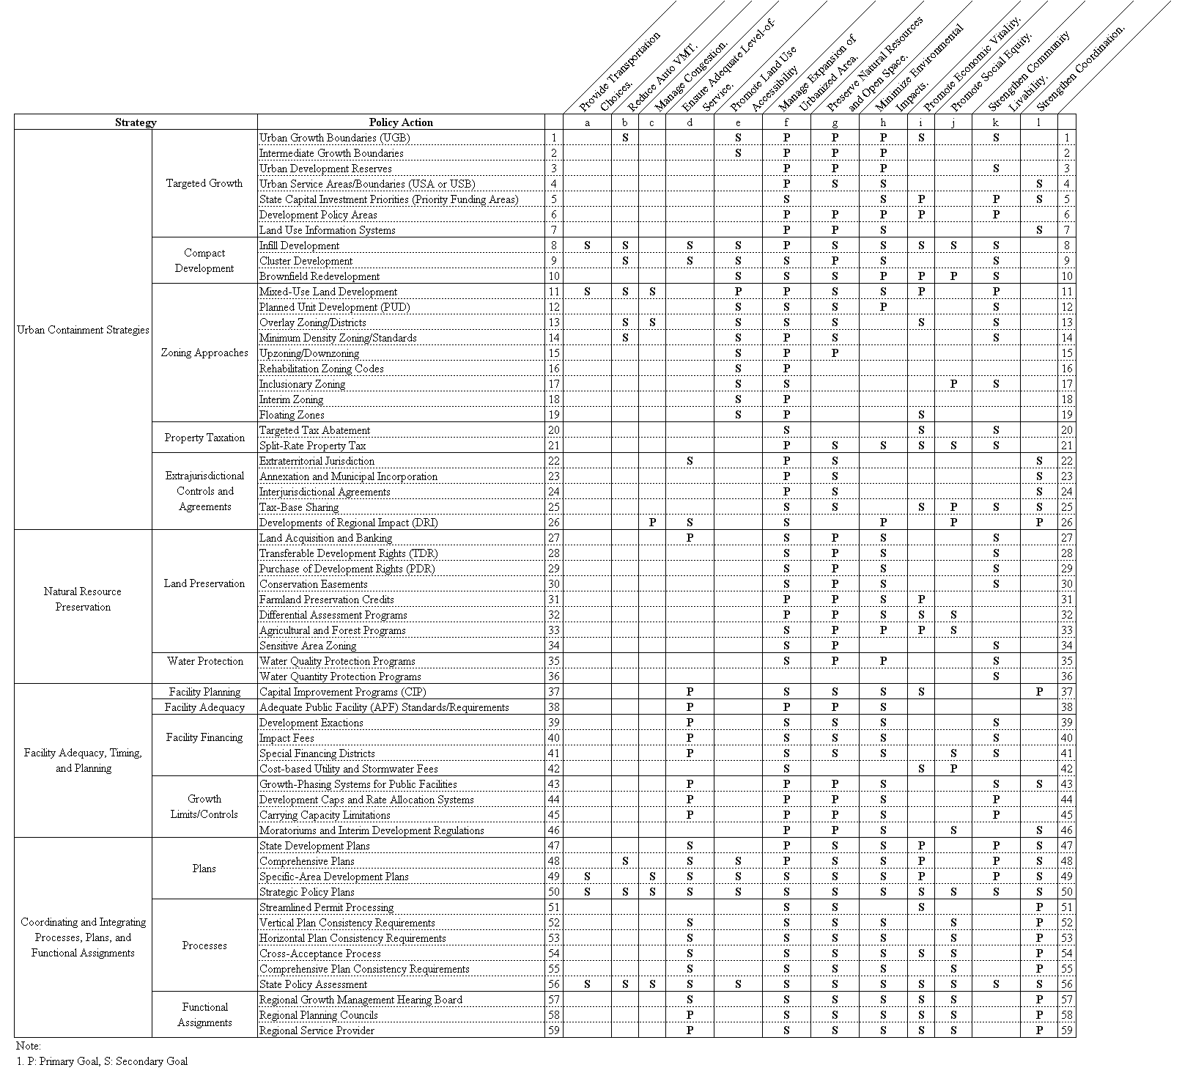
Matrix C-1A Goals of Transportation Related Strategies
and Policy Actions
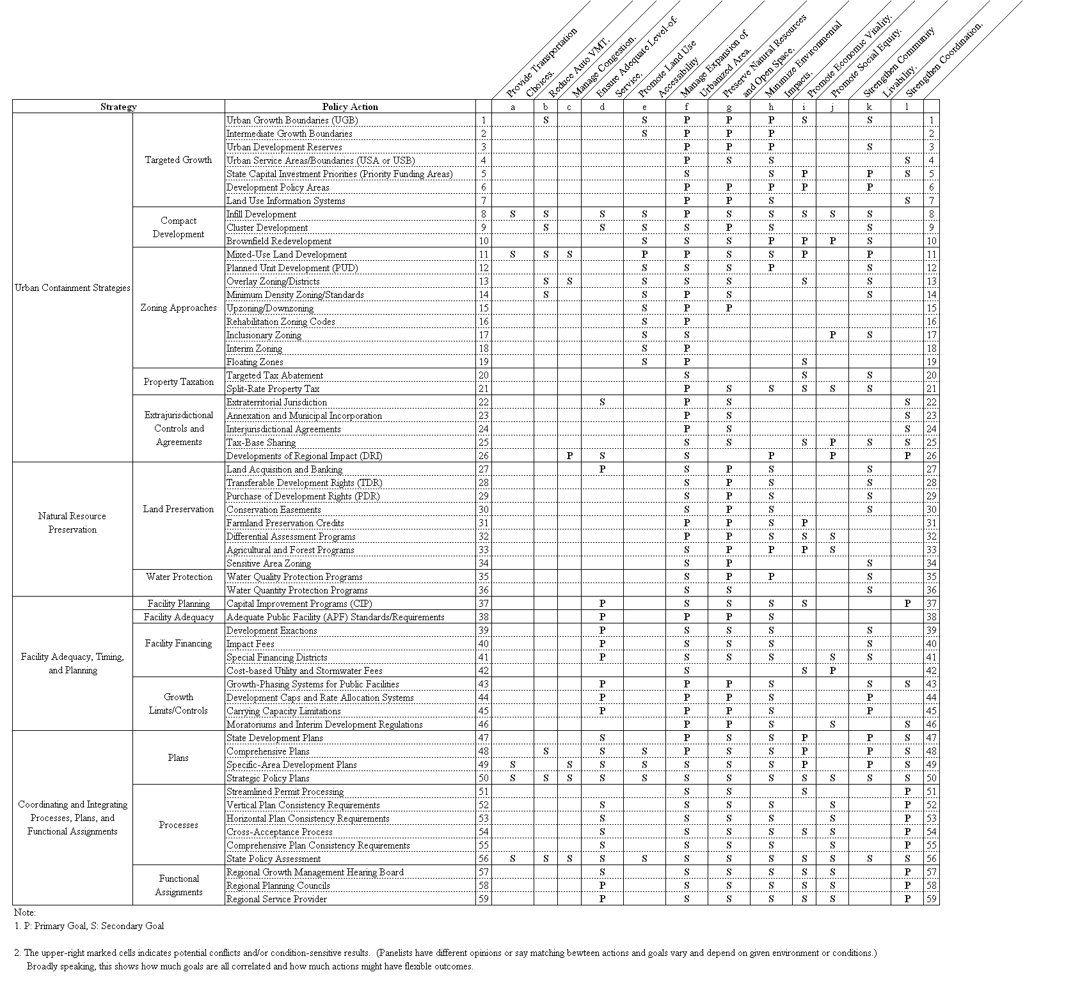
Matrix C-1B Goals of Growth Management Strategies and
Policy Actions
Matrix C-2A Characteristics of Transportation-related Strategies and Policy Actions

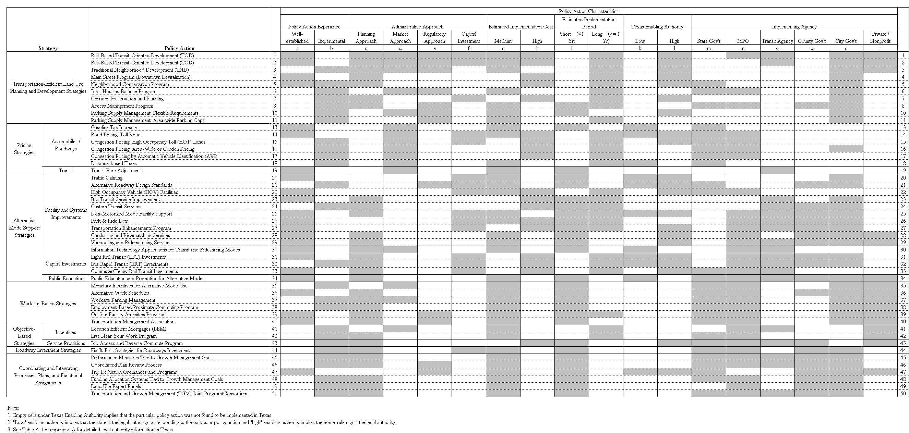

Matrix C-2B Characteristics of Growth Management Strategies and Policy Actions

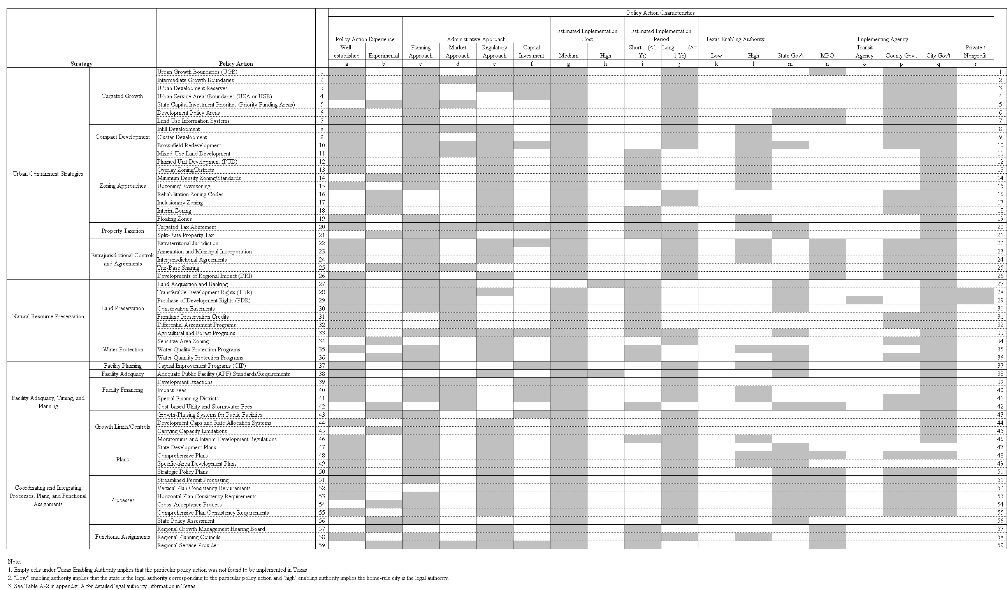

Matrix C-3A Suitability Factors of Transportation-related Strategies and Policy Actions
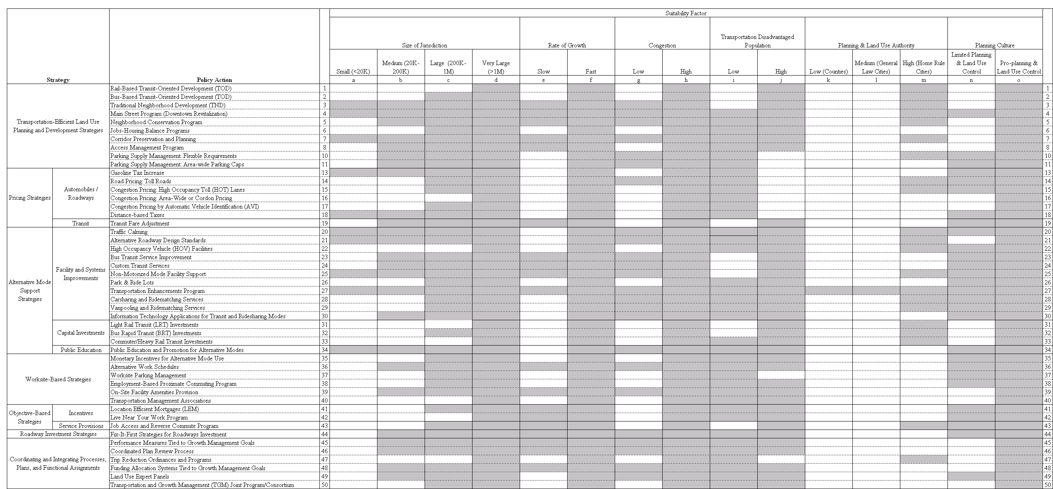

Matrix C-3B Suitability Factors of Growth Management Strategies and Policy Actions
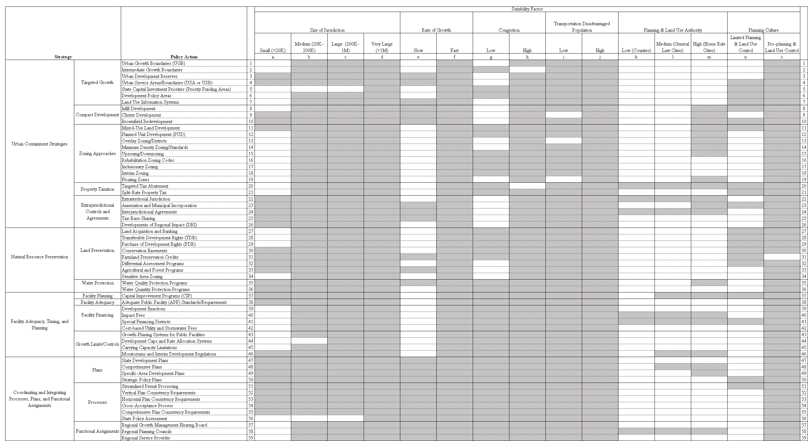

According to Section 395.001 (7) of the Texas Local Government Code, following levels can impose impact fee: (1)municipalities (2) districts (Article III, Section 52) (3) certain counties (Section 395.079 of the Texas Local Government Code)
The references were received (as attached documents) in personal contacts with State DOTs.

