Lab 3b. CONTINUITY EQUATION
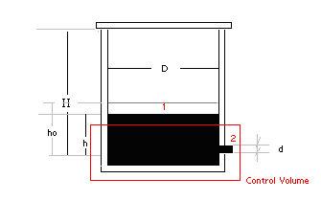
Problem: How long will it take for the water in the tank (below figure) to drop from h_{o} to h?

- Ideal Gas Law
(1)
- Bernoulli’s Equation (to be covered soon in the class)
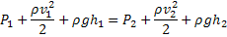
Where P₁ and P₂ are absolute pressures
Assume that v₁ ~ 0 (since v₁A_{t}=v₂A_{h} → v₁=v₂(A_{h}/A_{t}) << v₂), then we have
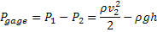
Then (2)
- Continuity Equation
Given a control volume as shown in the figure above, we have
With our case =0, thus
(3)
From Equations 1, 2, and 3, we have
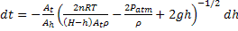 (4)
WITHOUT THE LID ON then P=0, and Equation 4 can be rewritten as
We integrate the differential equation and get
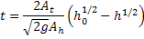
WITH THE LID ON,
From Equation 4 we have
[5]
It is too difficult to integrate Equation 5.
In this case, we can determine when the water in the tank will stop running out of the hole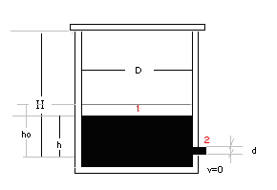
$P_{1}=P_{{}_{2}}−ρ_{H_{2}O}gh$$P_{1}=P_{\text{atm}}−ρ_{H_{2}O}gh [6]$ (using hydrostatic law, since water is standing)

$A_{T}P_{1}\left(H−h\right)=P_{\text{atm}}\left(H−h_{0}\right)A_{T}$ (from ideal gas law, since mass of air=constant and T=constant)
Thus, Equation 6 can be written as: $P_{\text{atm}}\frac{H−h_{0}}{H−h}=P_{\text{atm}}−ρ_{H_{2}O}gh$
or $ρ_{H_{2}O}gh=P_{\text{atm}}\left[\frac{h_{0}−h}{H−h}\right]$
$$→\frac{1}{\text{10}\text{.}\text{33}m}h=\frac{h_{0}−h}{H−h}$$
$$→\left(H−h\right)h=\text{10}\text{.}\text{33}\left(h_{0}−h\right)$$
$$→\text{Hh}−h^{2}=\text{10}\text{.}\text{33}h_{0}−\text{10}\text{.}\text{33}h$$
$$h^{2}−\left(H+\text{10}\text{.}\text{33}\right)h+\text{10}\text{.}\text{33}h_{0}=0$$
Given H=0.2m, and h₀=0.15m
$$h=\frac{(H+\text{10}\text{.}\text{33})±Δ}{2}=\frac{\text{10}\text{.}\text{53}±\text{10}\text{.}\text{23147}}{2}=0\text{.}\text{1492m}$$
→ h is very close to h₀ !!!
h₀=0.15 m
h=0.1492 m
$\bar{V}=\frac{V_{0}+0}{2}=0\text{.}\text{85776}$ m/s
$V_{0}=\sqrt{2{\text{gh}}_{0}}=\sqrt{2×9\text{.}\text{81}×0\text{.}\text{15}}=1\text{.}\text{715}$ m/s
$\text{Δt}=\frac{\text{Δh}}{\bar{V}}=\frac{0\text{.}\text{15}−0\text{.}\text{1492}}{0\text{.}\text{85776}}=9\text{.}3×{\text{10}}^{−4}$ sec
(this is time it takes for the water to stop running out of the hole)

