Lab 3b—Continuity Equation

Name____________________________________Date____________Time___________
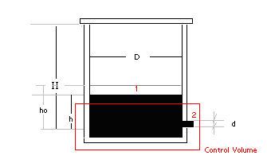

Data

Container: Circular with D=______m A_{t}=________m²

Hole: Circular with d =______m A_{h}=________m²

Assume v_{h}= (2gh)^{1/2} From Bernoulli equation (to be covered soon in class)

h₀=________m

h_{f} =________m

Time readings:
With the lid on: t₁= ______________________ (s)
Without the lid: t₂=_______________________ (s)

a) Estimate how long it would take for the water level to go from h₀ to h_{f} when the container doesn’t have the lid on.

Using the continuity equation, we get (see the lab description for details):

$v_{2}A_{h}=−A_{t}\frac{\text{dh}}{\text{dt}}$ Substituting $v_{2}=\sqrt{2\text{gh}}$ and integrating we obtain:

$t=\frac{−2A_{t}}{\sqrt{2g}A_{h}}h^{1/2}+C_{1}$ When t=0 h=h₀: $C_{1}=\frac{2A_{t}}{\sqrt{2g}A_{h}}h_{0}^{1/2}$

$$t=\frac{+2A_{t}}{\sqrt{2g}A_{h}}\left(h_{0}^{1/2}−h_{f}^{1/2}\right)$$

$$t=\frac{ }{ }\left( − \right)=\text{_______}s$$
Relative Error: $\frac{\left|t−t_{2}\right|}{t}=$_____________

Explain why t is smaller/larger than t₂

b) When the container has the lid on, it requires more/less time (circle the answer). Explain why

Determine when the water in the tank will stop running out of the hole
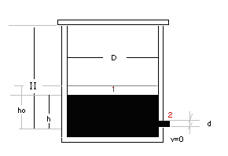

Given

H=________cm

h_{o}=________cm

ρ=ρ_{H20} = ________kg/m³

g=________m/s²

P_{atm} = _________ N/m²

- Hydrostatic law applied since v₂=0 : $P_{1}=P_{2}−ρ\text{gh} → P_{1}=P_{\text{atm}}−ρ\text{gh}$ (1)
- Ideal gas law: $\text{PV}=\text{nRT}=\text{const}$ $\text{thus} P_{1}(H−h)A_{t}=P_{\text{atm}}(H−h_{o})A_{t} → P_{1}=P_{\text{atm}}\frac{H−h_{o}}{H−h}$ (2)

From (1) and (2), we have

$$P_{\text{atm}}\frac{H−h_{o}}{H−h}=P_{\text{atm}}−ρ\text{gh} \text{or} −ρ\text{gh}=P_{\text{atm}}\left[\frac{H−h_{o}}{H−h}−1\right] → \frac{ρg}{P_{\text{atm}}}=\frac{1}{h}\left[\frac{h−h_{0}}{H−h}\right]=\frac{h_{0}−h}{\text{hH}−h^{2}}$$

$$\begin{aligned}C_{2}=\frac{ρg}{P_{\text{atm}}}=\text{________________} \\ \text{Thus} C_{2}=\frac{h_{o}−h}{\text{hH}−h^{2}} → {\text{hHC}}_{2}− C_{2}h^{2}=h_{o}−h \\ h^{2}−h(H+1/{C_{2}})+{h_{o}}/{C_{2}}=0 (∗)\end{aligned}$$

Solve Equation (*), we have
$Δ=\sqrt{(H+1/{C_{2}})^{2}−4h_{0}C_{2}}=$________________________

$h=\frac{(H+1/{C_{2}})±Δ}{2}=$________________________ (m)

Compare h with h₀ ________________________

Time to reach v=0
At t=t₀= 0 $v_{0}=\sqrt{2{\text{gh}}_{o}}=$____________________ (m/s)
At t=t v_{t} = 0 m/s

Assuming v changes linearly with t, we have
$\overline{v}=\frac{v_{0}+v_{t}}{2}=$_______________________ (m/s)

Thus $Δt=\frac{Δh}{\overline{v}}=\frac{h_{o}−h}{\overline{v}}=$ __________________ (s)

