Introduction to Arc Hydro Groundwater
Course exercise for CE 374L Groundwater
University of Texas at Austin
Prepared by Marcelo Somos and David R. Maidment
March 2012
DESCRIPTION
A geographic information system (GIS) is designed to capture, manage, analyze, and display geographically referenced information. This exercise introduces you to GIS and describes how information is derived from the spatial data in a map. Particular attention is given to Arc Hydro Groundwater, which is a customization of the ArcGIS Geographic Information System to describe groundwater data and modeling.

CONTENT
• Goals of the exercise
• Computer and Data Requirements
• Procedure
1. Accessing ArcGIS Online
2. Viewing and querying the layers
3. Calculating the Darcy Flux
• To be Turned in
• Appendix 1: Installation of the ArcGIS Desktop on your computer
GOALS
After completing this exercise, you will be able to understand how data is managed in ArcGIS in thematic layers, visualize and query the attributes of those data layers, and calculate the Darcy flux and flow per unit width at two well locations in an aquifer.
Computer and Data Requirements
To complete course exercises, you need the following software:
▪ ArcGIS Desktop (Only one product in this category is required).
ArcView 10
ArcEditor10
ArcInfo 10
We are going to use ArcInfo 10, the most powerful of these options. You can follow the steps in Appendix 1 to install ArcGIS 10 on your personal computer, or you can use a computer in the Learning Resource Center on the third floor of ECJ, where the software is already installed.
Procedure
1. Accessing ArcGIS Online
The data of this exercise is from the ArcGIS online at http://www.arcgisonline.com/home/
At the upper right of the display, change Show: Web Content Only to Show: All Content.
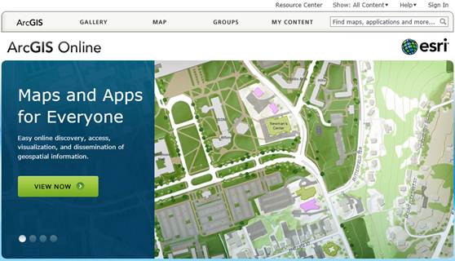
Click Groups and search for Groundwater UT.
And you’ll see a Map Icon called Working with groundwater data (making water level maps)
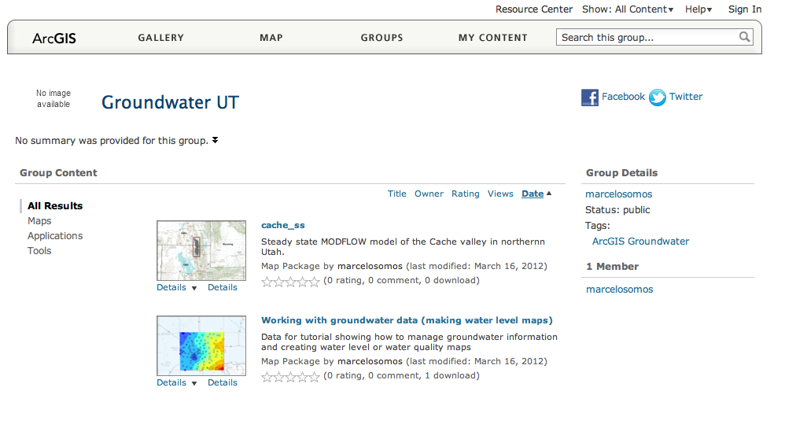
Click on the Working with groundwater data (making water level maps) and you’ll open up the following page, and you want to Open in ArcGIS 10 for Desktop
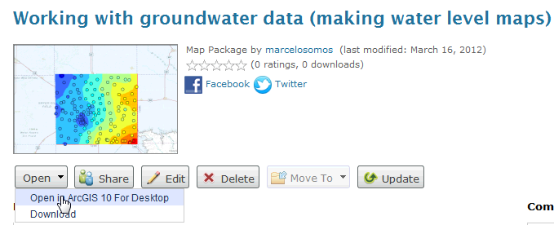
and this automatically opens up ArcGIS 10 Desktop and displays the data in a map. Pretty cool! When you open the map you may see more layers than this displayed. Click off the check marks in the legend bar on the left hand side of the map to show or hide individual map layers. Turn on the RasterSeries layer and move the slider bar in the Time Slider window to see how the Piezometric head field changes from 2000 to 2005. These head field were computed in each year by averaging the water levels recorded during the first quarter of the year when there is not much pumping in the aquifer.
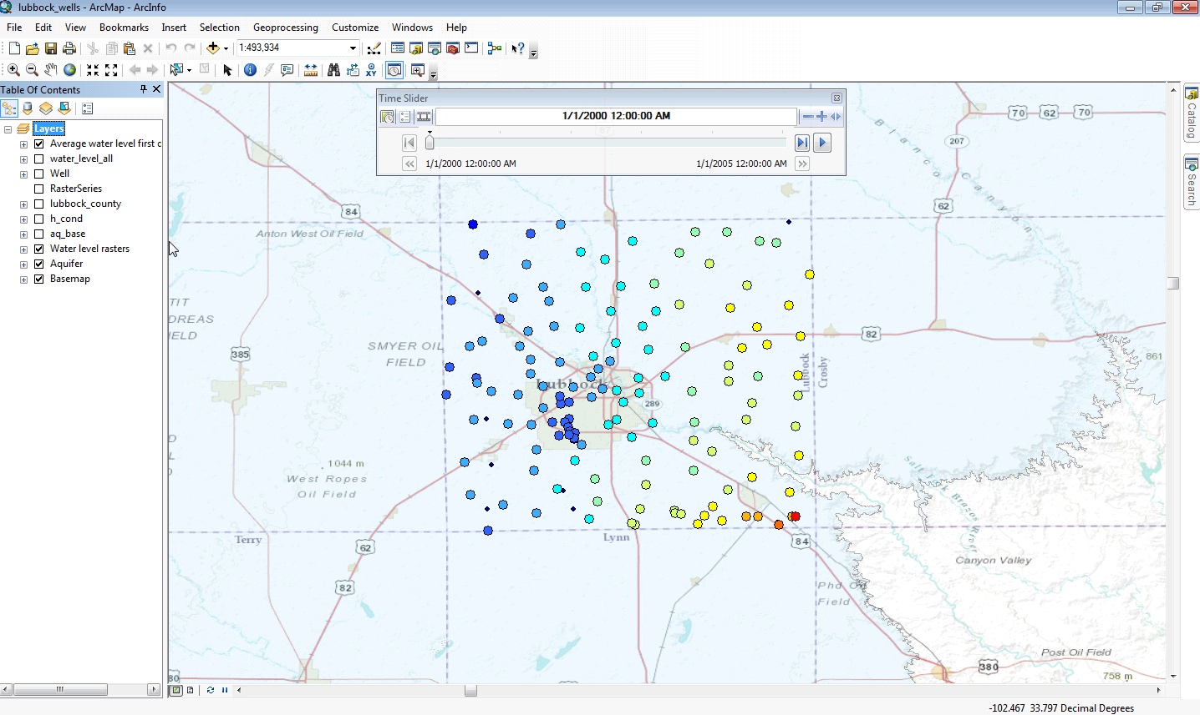
Use File/Save As … to save your ArcGIS Map file, Lubbock_wells.mxd. This preserves the state of your map display so you can reopen it again last as you left it.

2. Viewing and Querying the Layers
In the list of layers on the left of the map, you can click the display of each layer on or off with the check box to the left of the layer name. For example, if you expand [+] Water Level Rasters and check on wl_2005 and check off Average water level first quarter (winter), you’ll get a map like this:
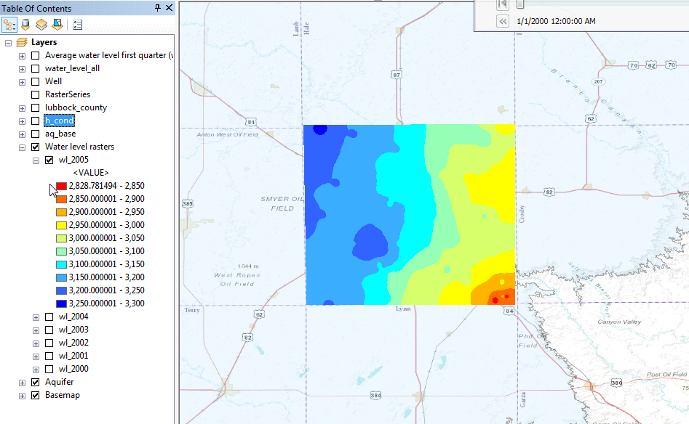
You can edit the color of your layers. For example, if you expand [+] Aquifer and click on the rectangle you can change the display color.
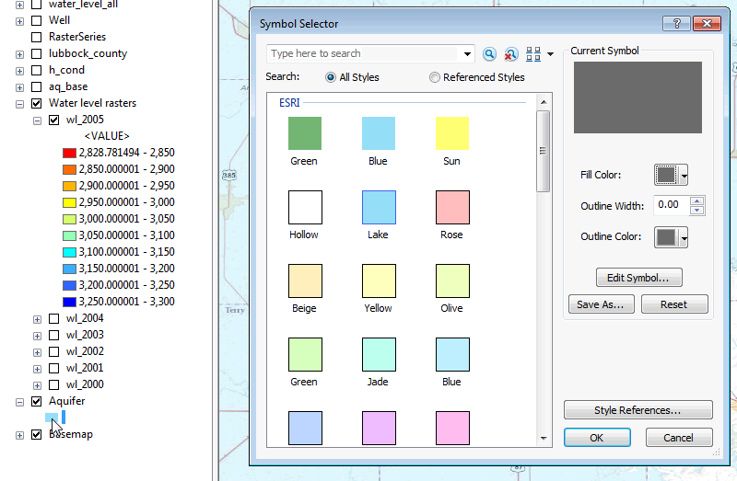
You can zoom to any layer you would like to see by right clicking and selecting, but remember to open that layer by checking the box in front of it first. For example, let’s zoom to the Aquifer layer, and see what happens.
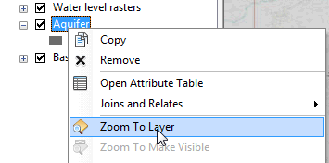

If you mess up the display at some point and want to return to the display you had before, hit the arrow at the top of the display.
This is part of the Ogallala aquifer http://en.wikipedia.org/wiki/Ogallala_Aquifer; which covers an area of approximately 174,000 mi² (450,000 km²) in portions of the eight states. We are working in an area around Lubbock. 2005 water level map is showed below.
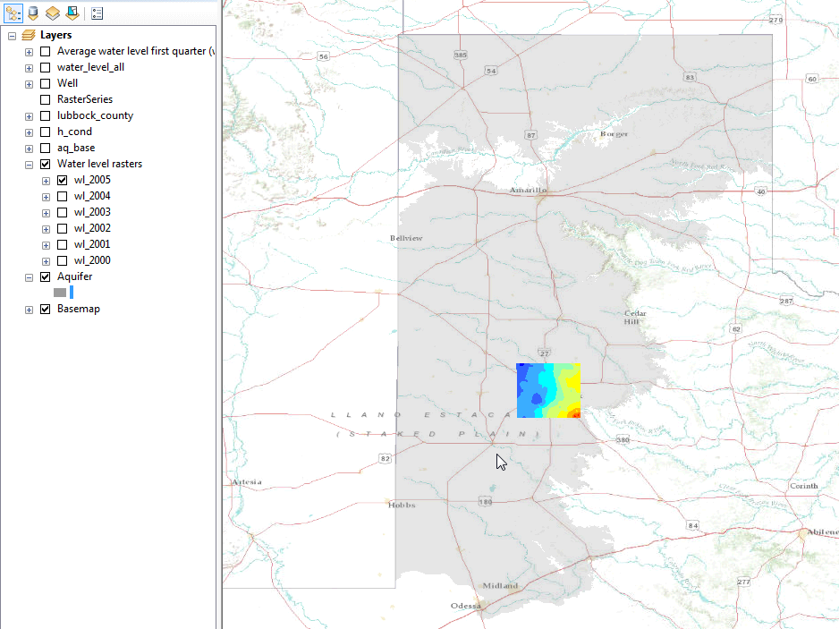

You can access the attributes of a particular feature in a layer by opening the attribute table. For example, right click on Well and select Open Attribute Table
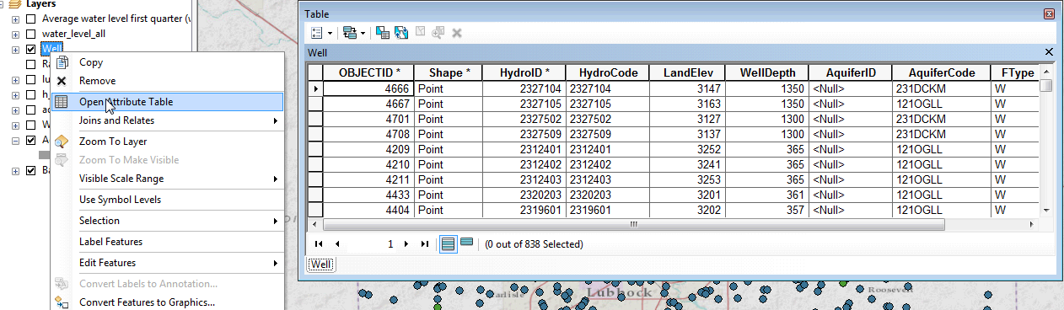
If you click on the row for HydroID* 2327104 in the table, notice how it is selected also in the map. This is a key idea of GIS – the association of the geometry of a feature with descriptive attributes in a table.
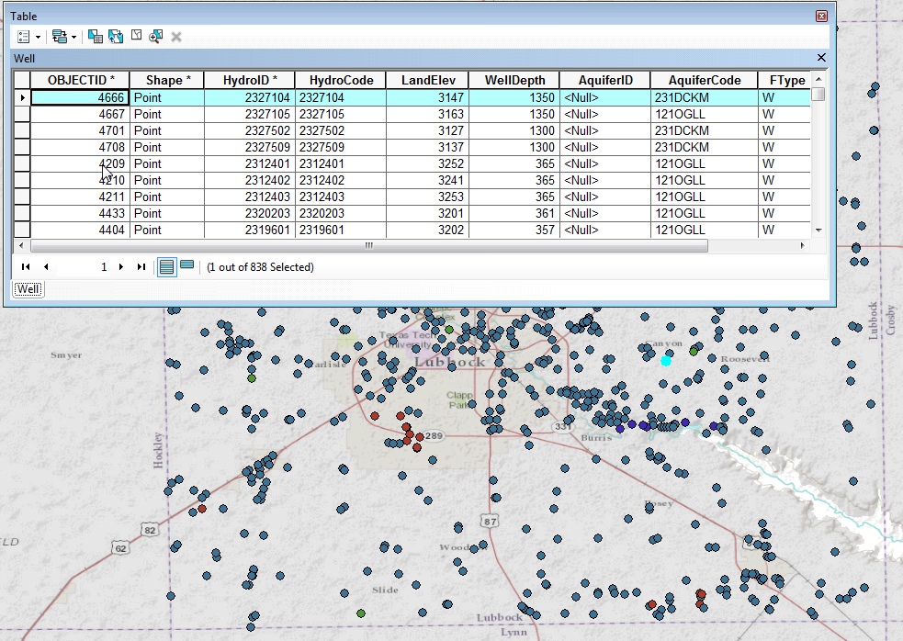
If you scroll along to the end of this table, you’ll see various attributes of each well as Land Surface Elevation (ft above Geodetic Datum) and the Well Depth (ft below the land surface to the bottom of the well).
Use Selection/Clear Selected Features to unselect well 2327104 in the display.
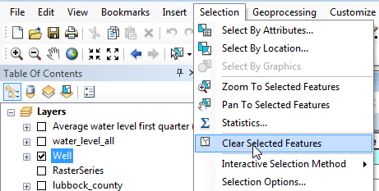

If you click on (Identify), you will be able to access the attributes of an specific point in the map just clicking on it, for example lets select the well HydroID* 2327104 as it was described before. Select (Identify) and click on the well HydroID* 2327104 in the map. Now the atributes of that well are displayed.
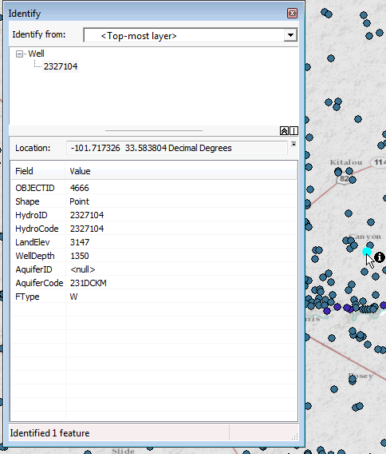

Lets unselect the well HydroID* 2327104, and close the Identify windows. Also let check on just the Water level Rasters\wl_2005 (wl_2005 stands for water level 2005) and Basemap and make a zoom out using . If we check the colors of the map and their value in the wl_2005 legend at the left side of the screen, we can infer that the water gradient decreases from the northwest corner to the southeast corner of the rectangle. Lubbock is more or less in the middle of the rectangle.

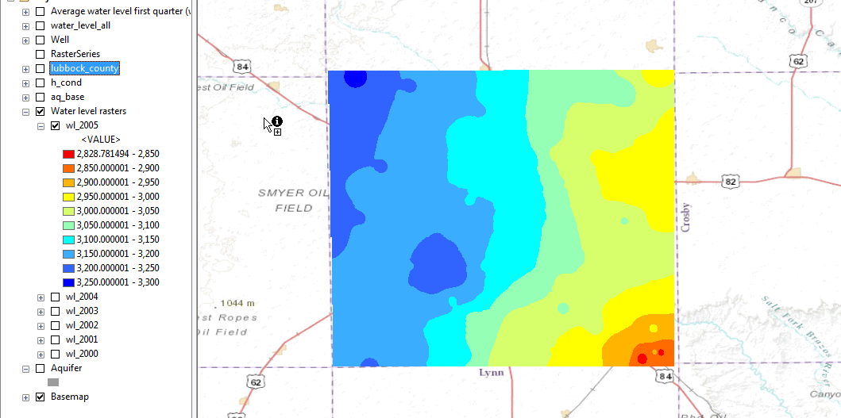

Use File/Save to save your ArcMap map file.

3. Calculating the Darcy Flux

Check off Water level raster and check on the Well feature class. Select the wells HydroID 2325304 and HydroID 2326512 using the following procedure..

Open the Attribute table of the Well feature class and choose Select by Attributes

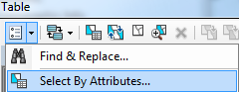

Use the selection expression "HydroID" = 2326512 OR "HydroID" = 2325304

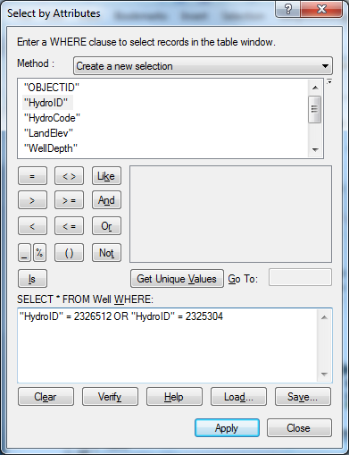

And click on the blue box at the bottom of the attribute Table to isolate the two selected wells in the table.

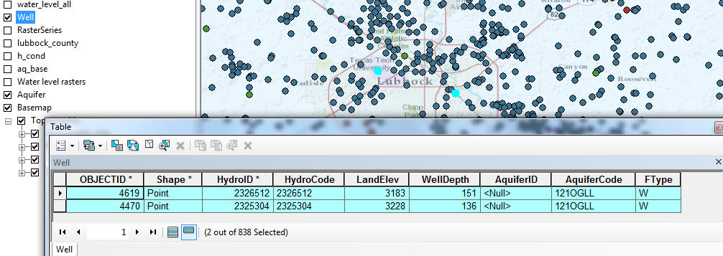

Check on the Water level raster, and use the Identify tool , changing the label Identify from: <Top-most layer> to Water level rasters\wl_2005. The information for the water level 2005 at the location of the well HydroID 2325304 will be shown.

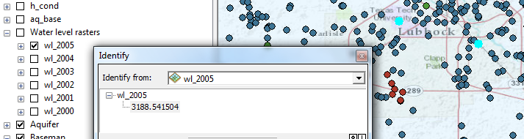

and the elevation is 3188.5 ft above datum.

If this inquiry is repeated the location of the second well, 2326512, the elevation obtained is 3143.7 ft. This means that the head difference between the two wells is 3188.5 - 3143.7 = 44.8 ft.

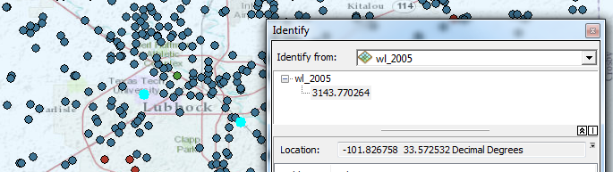

Using (measure) tool, it is possible to measure the distance between the two selected wells. You need to change the distance units to feet as shown below.

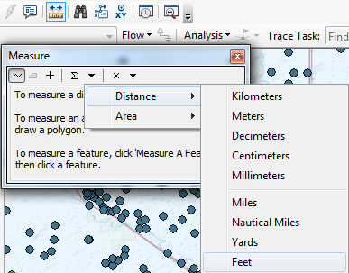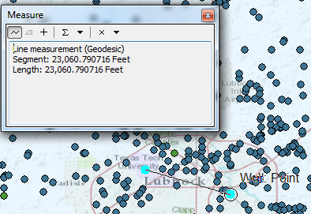

Click on one well and then the other and you’ll see that the distance between the two wells is 23060.8 ft. Hence, the piezometric head gradient is 44.8/23060.8 = 0.001943 or ~ 0.2%.

If we make similar Inquiries of Aquifer Base (aq_base) and Hydraulic Conductivity (h_cond), we find that the values for the two wells are:

Well | Aquifer Base (ft) | Hydraulic Cond. (ft/day) | Piezometric Head | Saturated Thickness (ft)
2325304 | 3079.9 | 75 | 3188.5 | 108.6
2326512 | 3028.8 | 75 | 3143.7 | 114.9

Now, with this information we can estimate the Darcy flux at the two wells (both have the same Hydraulic Conductivity). The head gradient is considered negative because the head decreases in the direction of flow.

$$q=-K\frac{dh}{dx}=-75*\left(-0.001943\right)=0.146 ft/day$$

and the discharge per unit width, Q_{w} is obtained by multiplying the Darcy flux by the saturated thickness of 108.6 ft at Well 2325304:

$$Q_{w}=qh=0.146*108.6=15.8 ft^{2}/day$$

A similar computation for Well 2326512 yields Q_{w} = 16.8 ft²/day

To be turned in:

(1) Prepare a map showing the piezmetric head field of the Ogallala Aquifer in Lubbock County.

(2) Choose another pair of wells somewhere in the aquifer with one well “down gradient” from the other and perform the same computation as shown in the exercise to estimate the Darcy Flux and flow per unit width at each of the two wells.

Ok, you’re done!

Appendix 1
Instructions for Installation of ArcGIS Desktop on your Computer
These instructions assume that you have a CD containing ArcGIS for Desktop for student use.
Installation Steps
1. Check supported operating system before the installation at http://resources.arcgis.com/content/arcgisdesktop/10.0/arcgis-desktop-system-requirements.
2. Insert ArcGIS Desktop DVD and in the menu folder, select quickstart so that you can refer to the installation guidance.
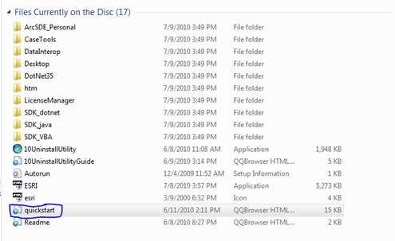
3. Visit http://www.esri.com/software/landing_pages/arcgis/desktop-ed.html to activate your authorization number first (the 12-digit number is inside your CD cover). Select “I have an ArcGIS Education Edition DVD”, create your own account, and enter your authorization number to activate your GIS.
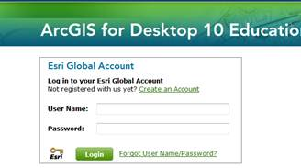
4. Run ESRI.exe you will see a window like this.
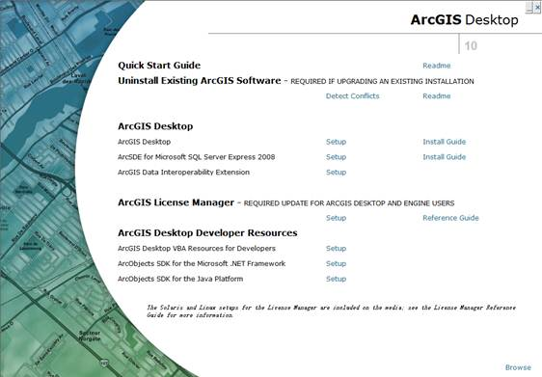

5. Select ArcGIS Desktop and follow the instruction to complete the installation process. Always select “next” until the installation has been finished. It will take you some time to complete the installation, so you can have a cup of coffee and relax during this time.
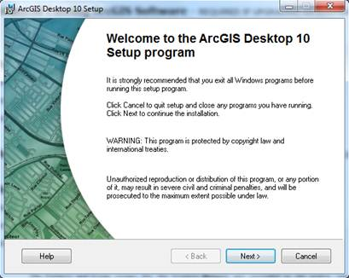
6. Authorize ArcGIS Desktop 10 single use. After the installation, select the desired Single Use product in the ArcGIS Administrator wizard, and click Authorize Now. Select the default option, I have installed my software and need to authorize it. Select Authorize with ESRI now using the Internet, and enter your personal information and your core product authorization number.

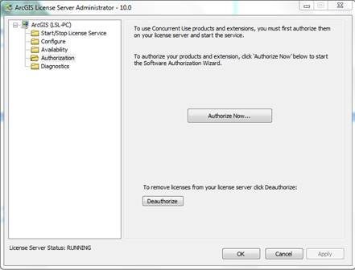

After Authorization, you will see information like this.

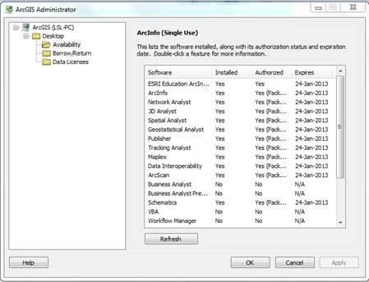
Now you have successfully install ArcGIS Desktop 10 on your computer. You can begin your trip with this magic software.

