Introduction to the Mangatainoka Catchment
Prepared by David R. Maidment
Waterways Centre for Freshwater Research
University of Canterbury
February 2018

Goals of the Exercise
This exercise introduces you to ArcGIS using the Mangatainoka catchment in the Manawatu region as a case study region. You create a map of the catchment, then calculate the length of its rivers and size of its drainage area.

Computer and Data Requirements
To carry out this exercise, you need to have a computer, which runs ArcGIS Desktop version 10.5. This exercise will also work with version 10.4.1 if you do not have access to Version 10.5.
In the first part of this exercise using ArcGIS Desktop, you will be working with the following spatial datasets:
- A polygon shapefile of zones within the Mangatainoka catchment, called SubManagementZones-Mangatainoka
- A line shapefile of river reaches, called Mangatainoka-REC-V4
- A point shapefile of stream gaging sites, called WaterLevelSites-Mangatainoka
You can get these data from this zip file: http://www.caee.utexas.edu/prof/maidment/Canterbury/Ex1/Ex1Data.zip or from the UC Learn web site. You need to establish a working folder to do the exercise. This can be in any convenient location on the computer you are working on (e.g. …\Ex1\Ex1Data). After you have downloaded the zip file Ex1Data.zip double click on the file and you should see Winzip or other zip utility to open the file on your computer (if it doesn’t open you’ll have to unzip this file on a computer that has a zip utility installed).
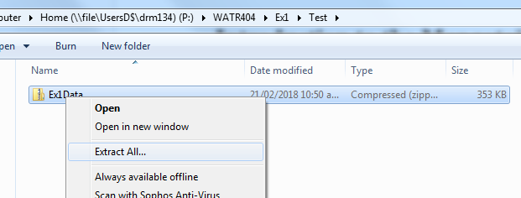
Extract all files from the zip file to the working folder that you’ve set up to do this exercise. You should end up with a file list that looks like this.
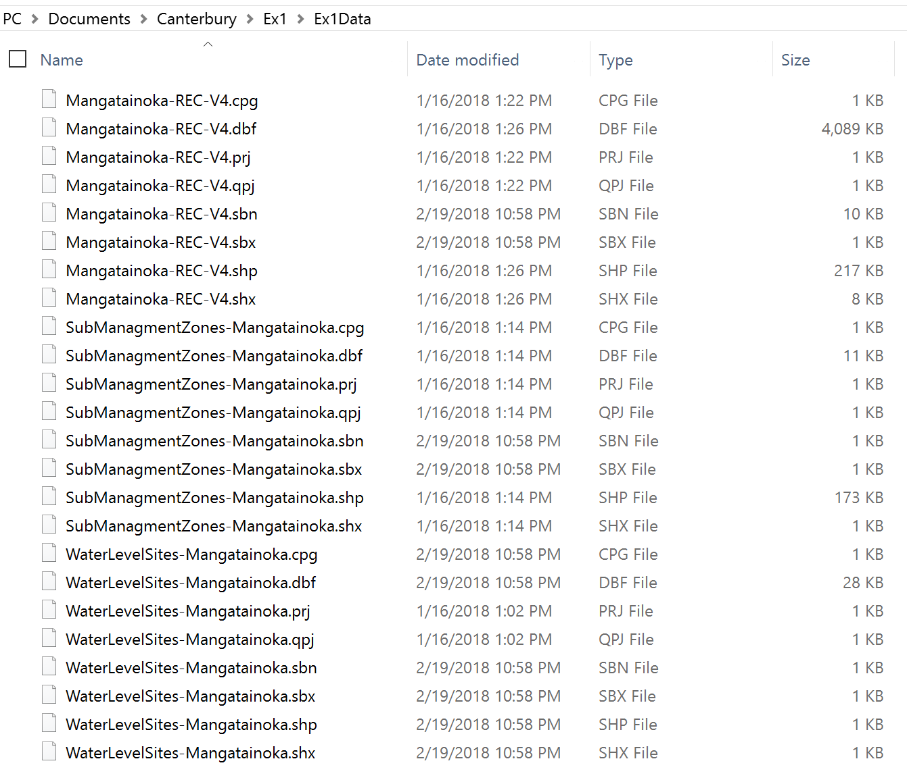

Procedure
Please note that the following procedure is a general outline, which can be followed to complete this lesson. However, you are encouraged to experiment with the program and to be creative.

1. Map of Mangatainoka Catchment
Our goal in this part of the exercise is to prepare a location map of the Mangatainoka Catchment like this:
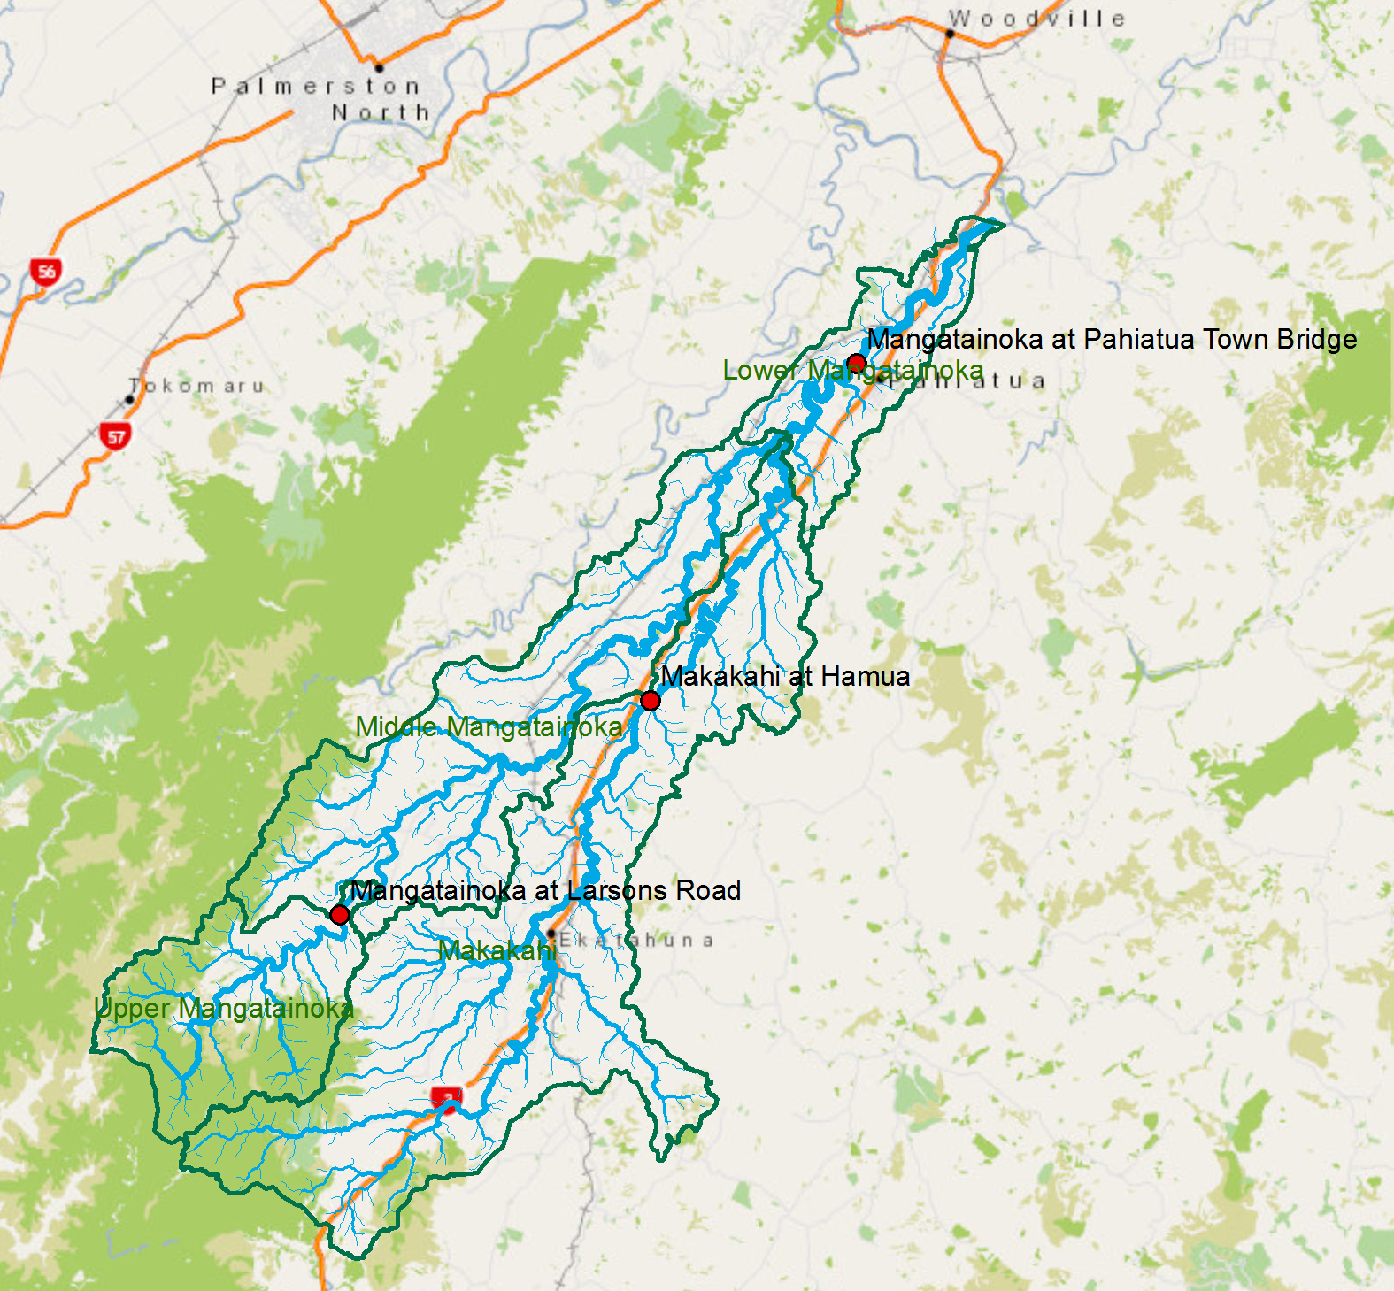

This map is developed using a basemap showing roads, towns and vegetation in the region, and three feature classes:
- A polygon feature class of subcatchments of the Mangatainoka drainage area
- A line feature class of river and stream segments of the Mangatainoka river and its tributaries;
- A point feature class of water level and flow recording sites in the Mangatainoka catchment
Using Windows, hit the Start button and you’ll see a series of options for ArcGIS. The appearance is slightly different depending on whether you are using Windows 7,8 or 10. Here is what you see if you are opening ArcGIS 10.4.1 from Windows 7 on the UC campus
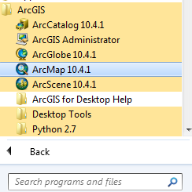
Here is what you see if you are opening ArcGIS 10.5 using Windows 10
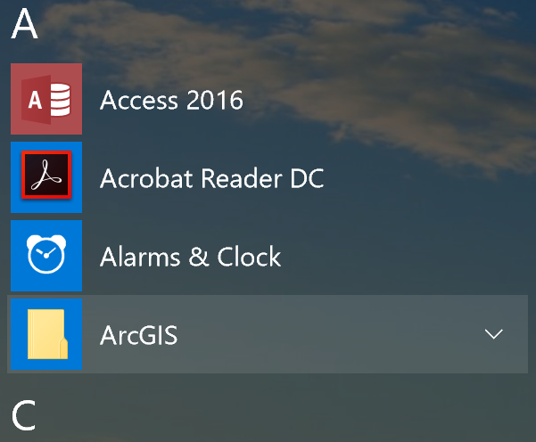
Select ArcMap.
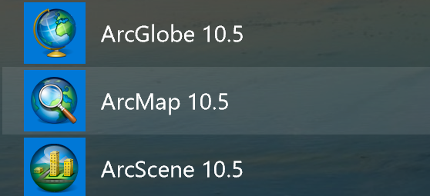
If you are using Windows 8 or 10, then just type “ArcMap..” and you’ll see the program symbol appear.
Click on Ok to select Blank Map for the map display.
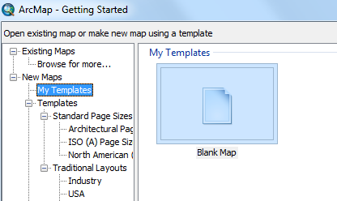
Use the Add Data button to add the data for this exercise to the ArcMap display.
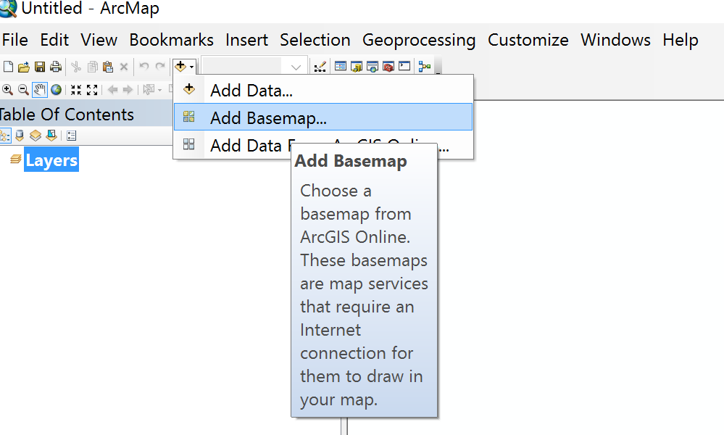
And select the NZ Community in the lower left corner of the display as the Basemap
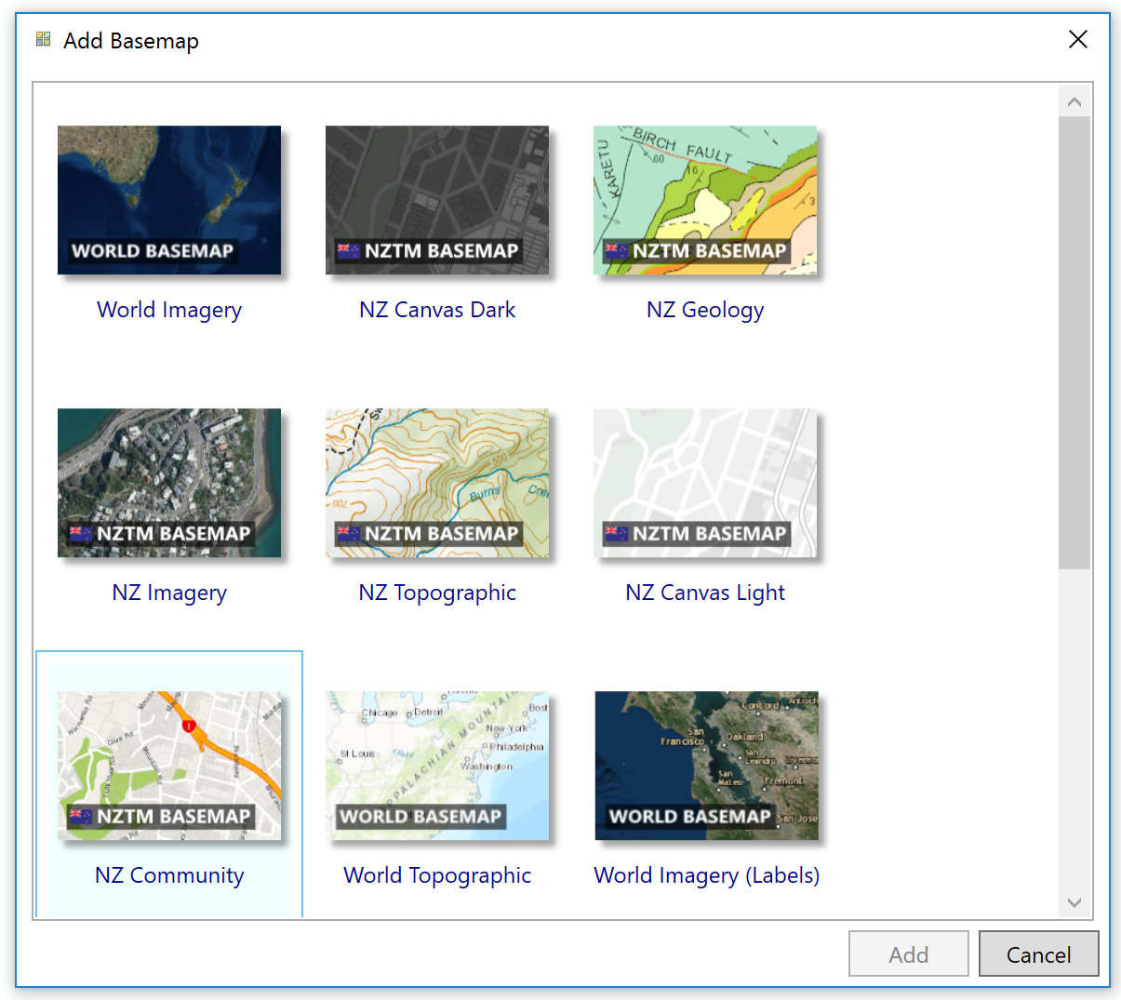

Initially you may not see much in the map display area (it is all blue for the sea!), so right click on the Generic/newzealand label and select Zoom to Layer, and you’ll see a map appear
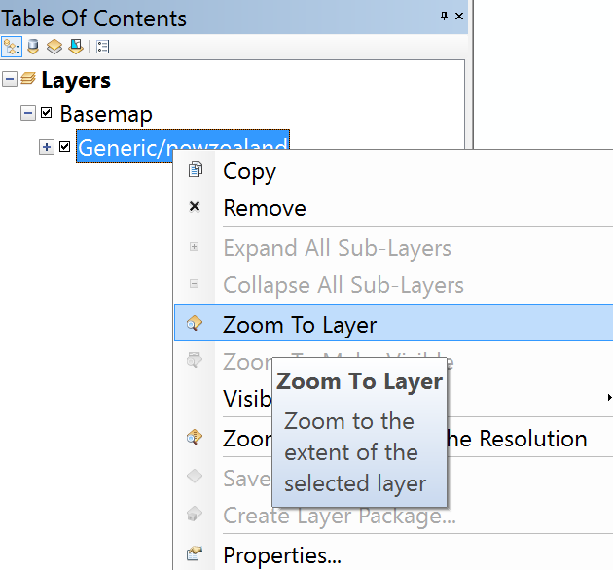
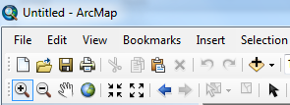
Select the Zoom In button and zoom into the lower North Island and then Pan to centralize the map display on this region.
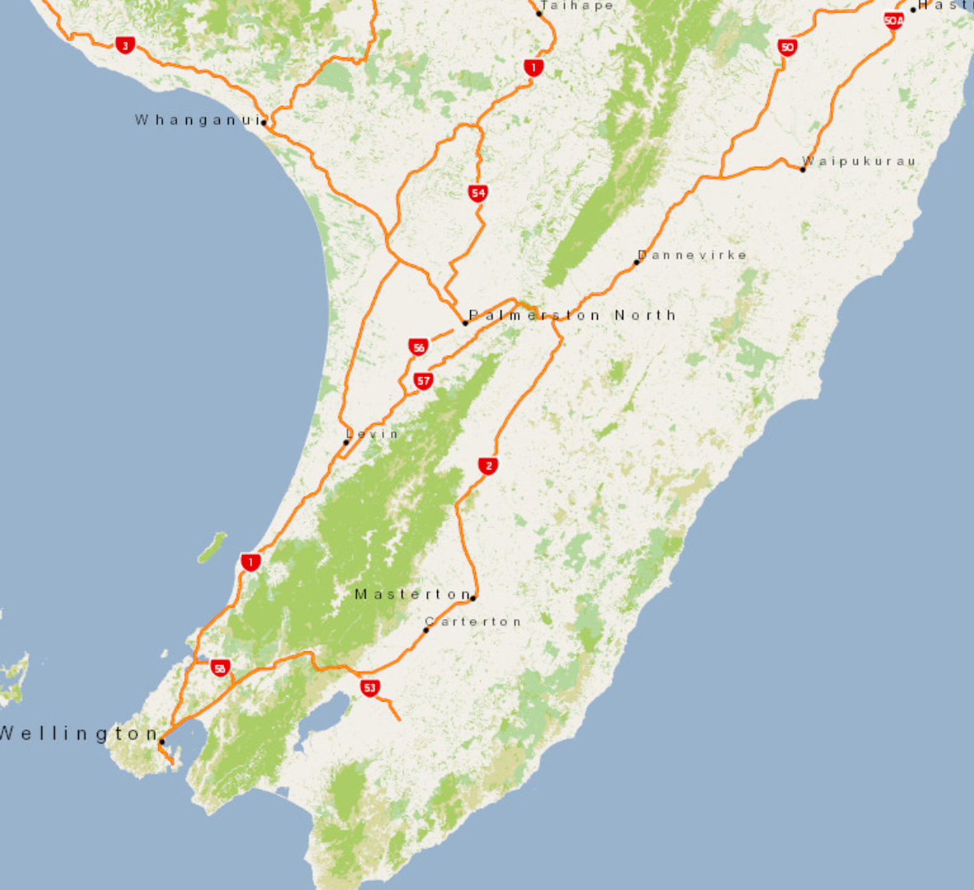
Use File/Save As to save a copy of this map document display as Ex1.mxd. This file stores your choice of feature classes and symbology so that you can restart ArcMap with the current map display shown if you close the program for any reason.
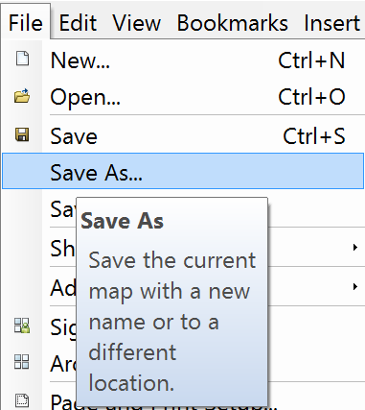
Select the Add Data button again, and to enable navigation to the folder that contains the data, first select Connect to Folder
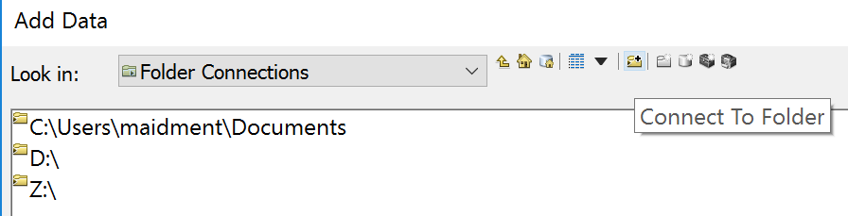
and navigate to the folder that contains your files. Then navigate to the folder containing the exercise data and select all three files at once by using the shift key. Click the Add button to add the data to your ArcMap display.
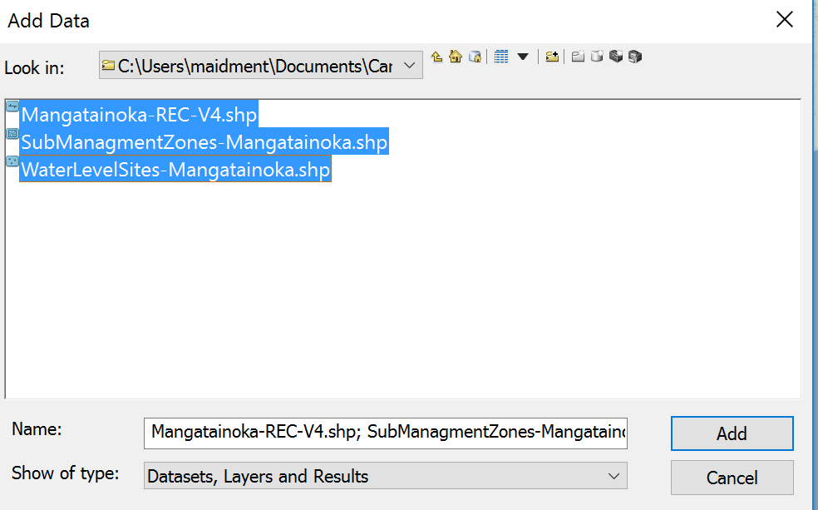
Use the Zoom In button to zoom to the area where your data are displayed. You’ll see a Table of Contents on the left that lists your three feature classes, and a Map Display on the right that shows them with arbitrary color choices.
Use File/Save As to save an updated copy of this map document display as Ex1.mxd. Keep doing this at frequent intervals in case you have a crash at some point.
Now let’s tidy up the map display a bit. Initially when the files are added, they are all shown in blue in the Table of Contents (which means all the feature classes are being treated as one dataset). Just click somewhere lower in the Table of Contents to get rid of this blue display
Double click on the symbol displayed for the Submanagement areas (yours might be a different color than that shown here)
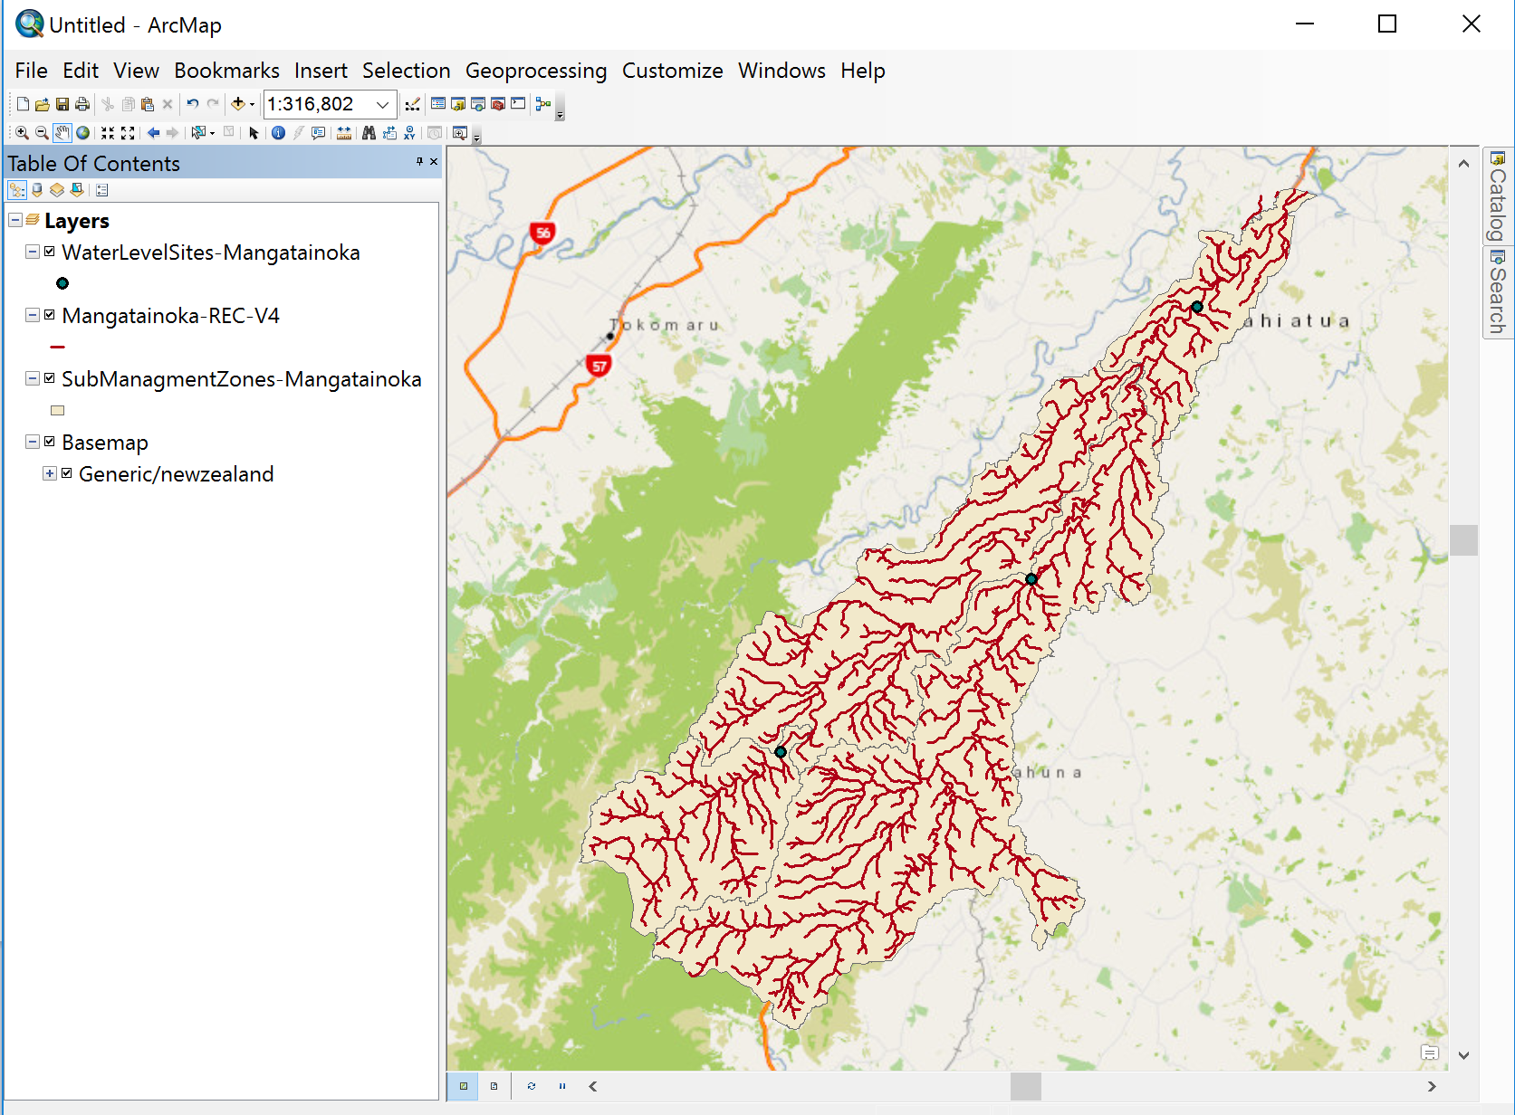
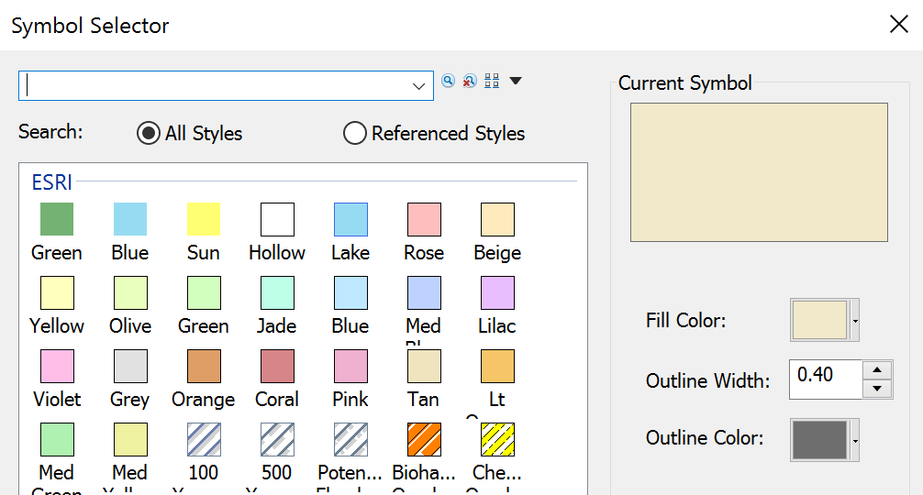
Select Hollow 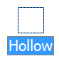with Outline Color Green and Outline Width 2.
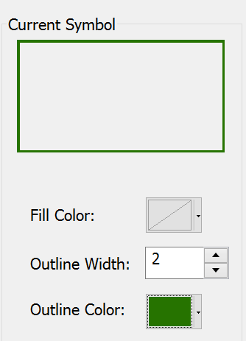
Then hit OK to change the map display to this Symbology. Ok, this looks a bit better now.
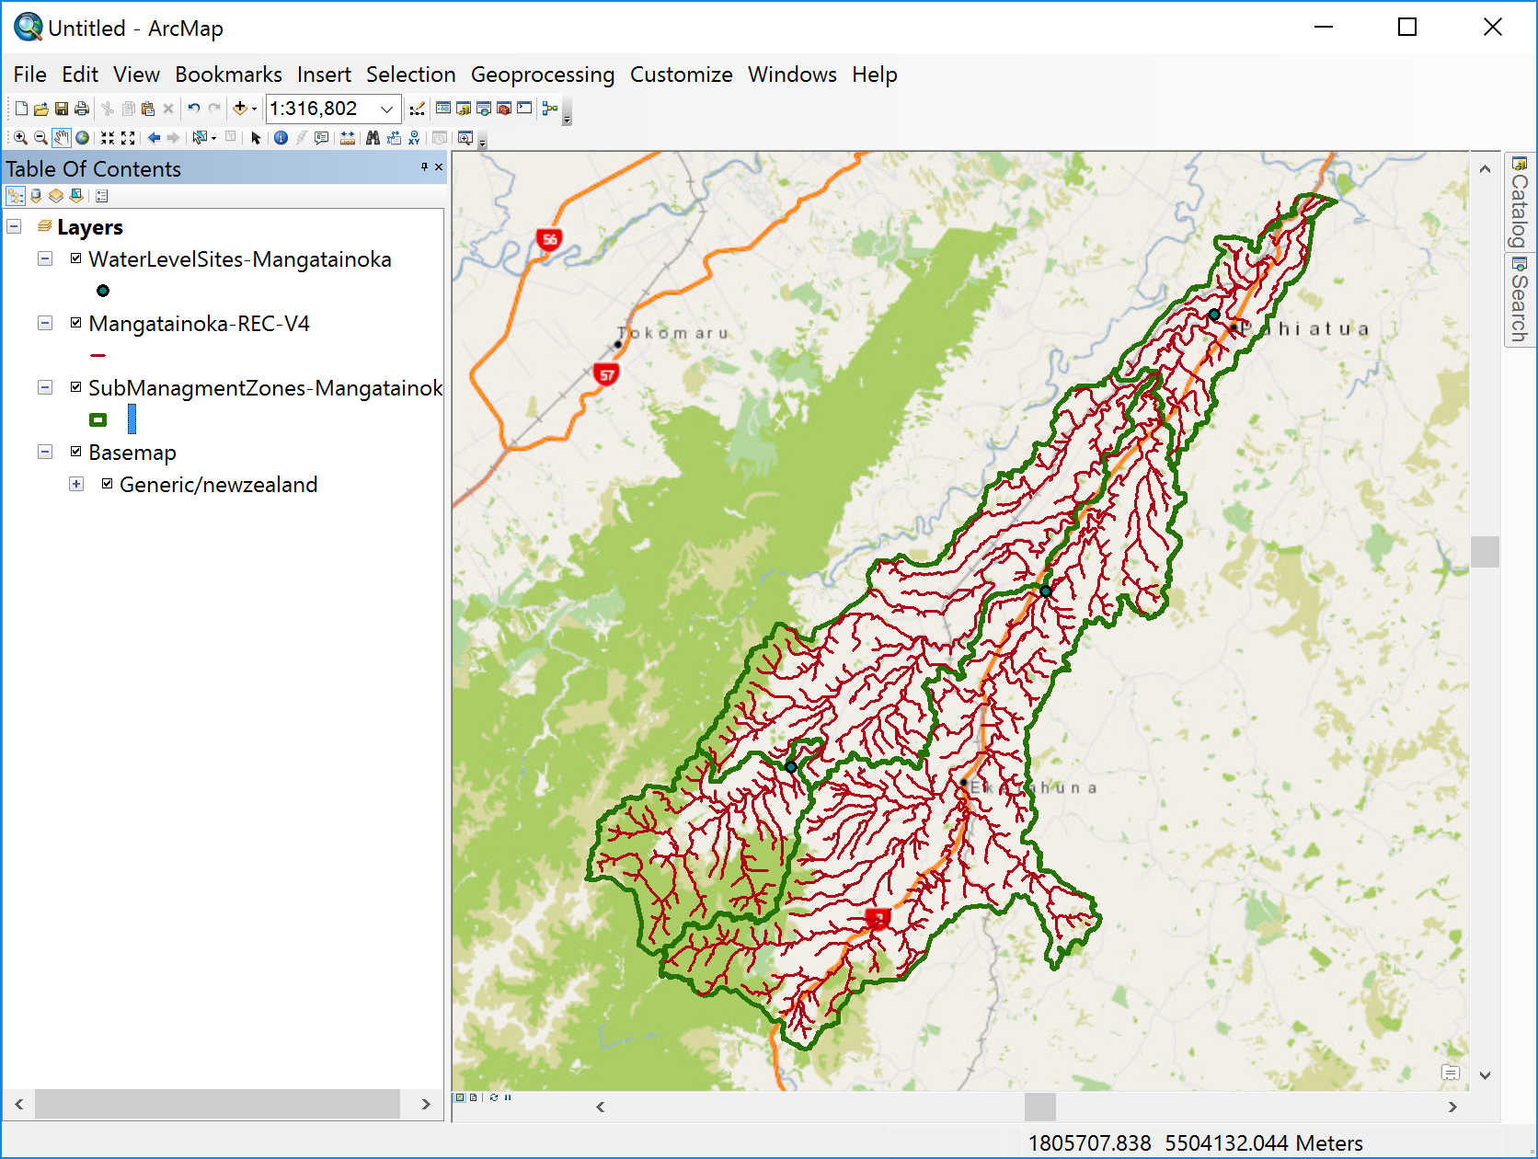
Save this new version of the Ex1.mxd file.
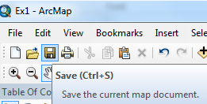
Let’s make the rivers and streams a bit more understandable. Right click on the Mangatainoka – Rec4 layer and select Properties.
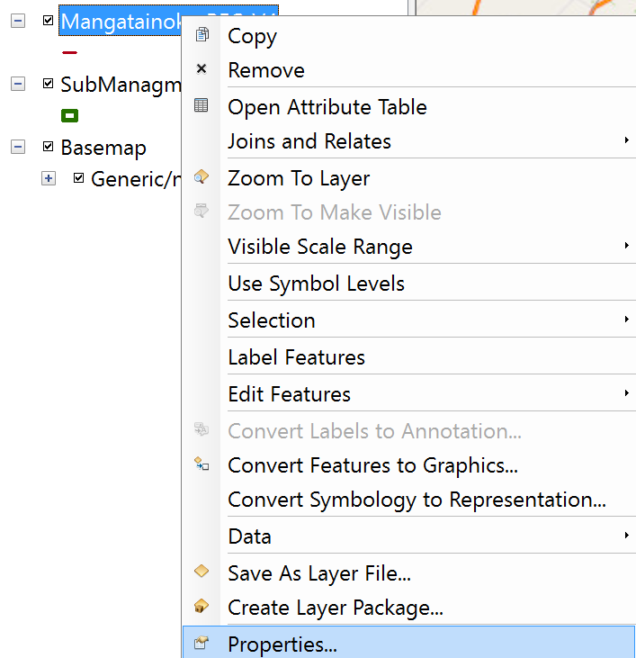
Select Symbology, with Graduated Symbols for Quantities, Value for S-Order, 6 for Number of classes, and light blue for Template 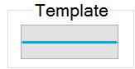. This orders the streams according to the Horton stream ordering system in which 1 is the most upstream tributary and successively larger numbers denote stream reaches downstream of confluences (be careful to choose Quantities/Graduated Symbols to go down the right path here).

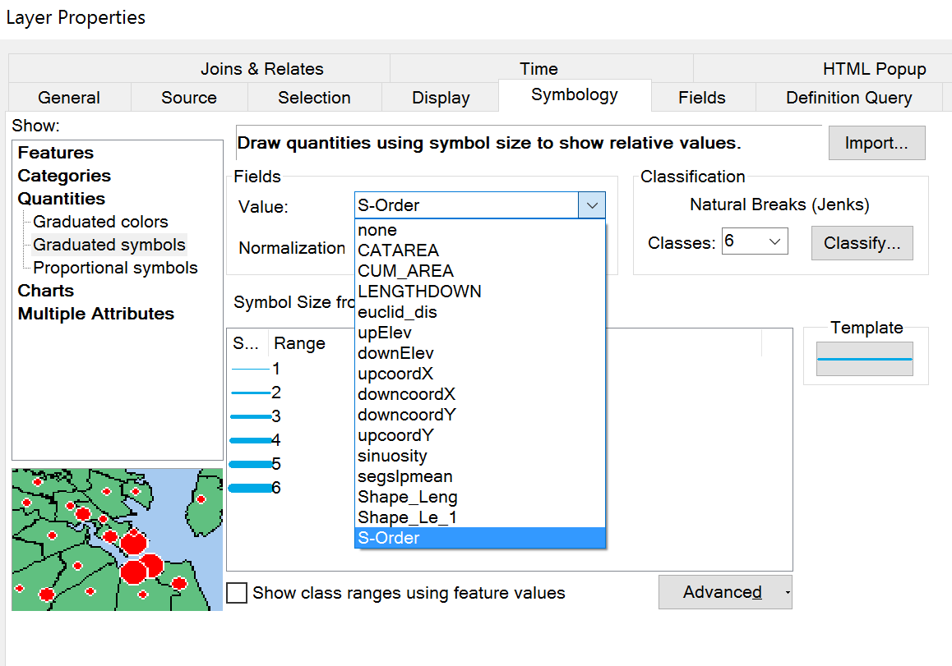
and the result appears as:
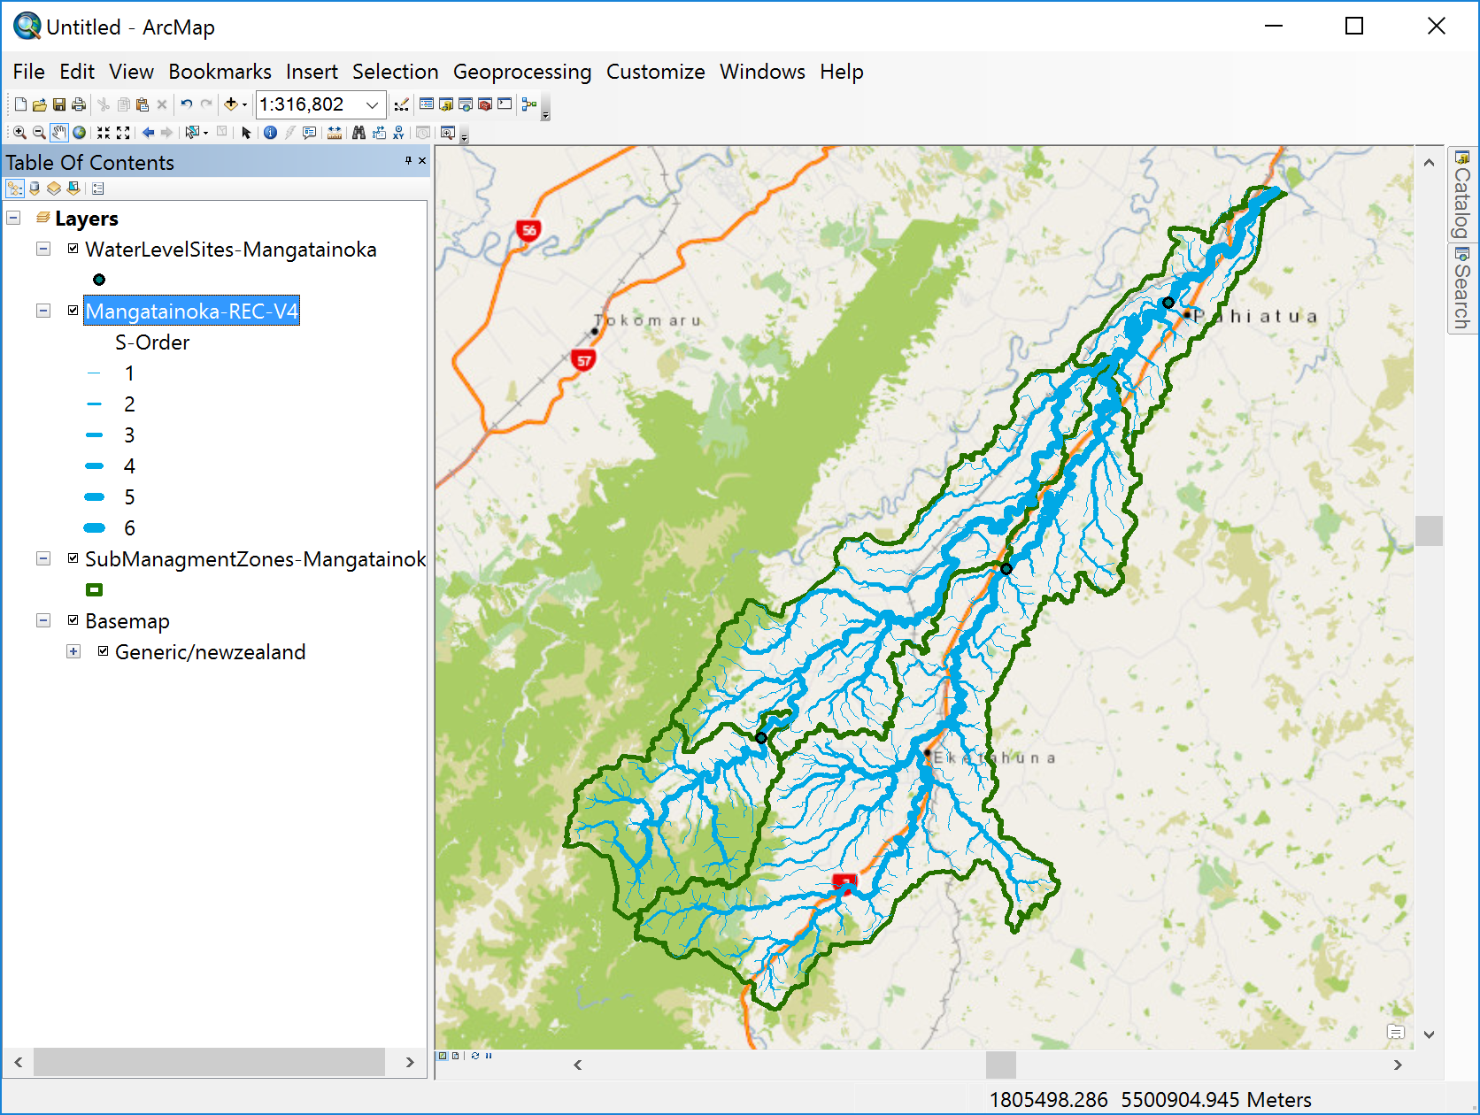
If you change a display and it doesn’t refresh itself on the screen, go to the bottom left of the screen and hit the refresh button
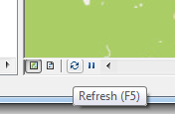
Now let’s highlight and label the stream gaging sites. Click on the Symbol for the WaterLevelSites-Mangatainoka feature class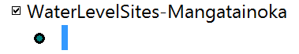(yours may be a different color by default).
Make this red with symbol size 8, and hit Ok to make the gaging stations red.
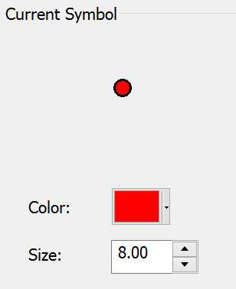
Click on the SubManagementZones feature class in the Table of Contents and drag it above the streams so that you can see the zones more clearly. Ok, this is starting to look more understandable now.
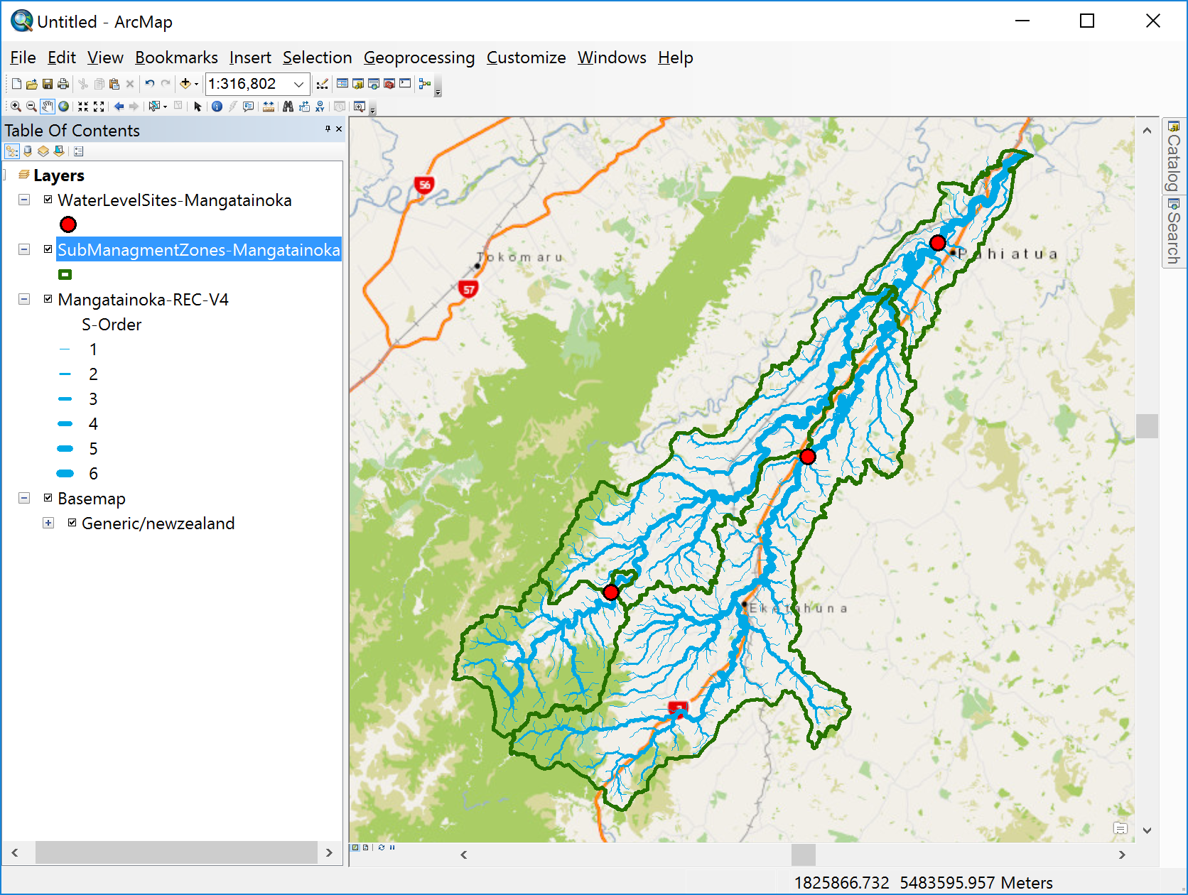
Let’s label the gaging stations with their station names. Right click on the WaterLevelSites feature class and select, and in Properties the Layer Properties window, select the Labels tab with Sitename for the Label field and 12 for the Symbol size. Hit for Ok these choices to be confirmed. Your map won’t change yet.
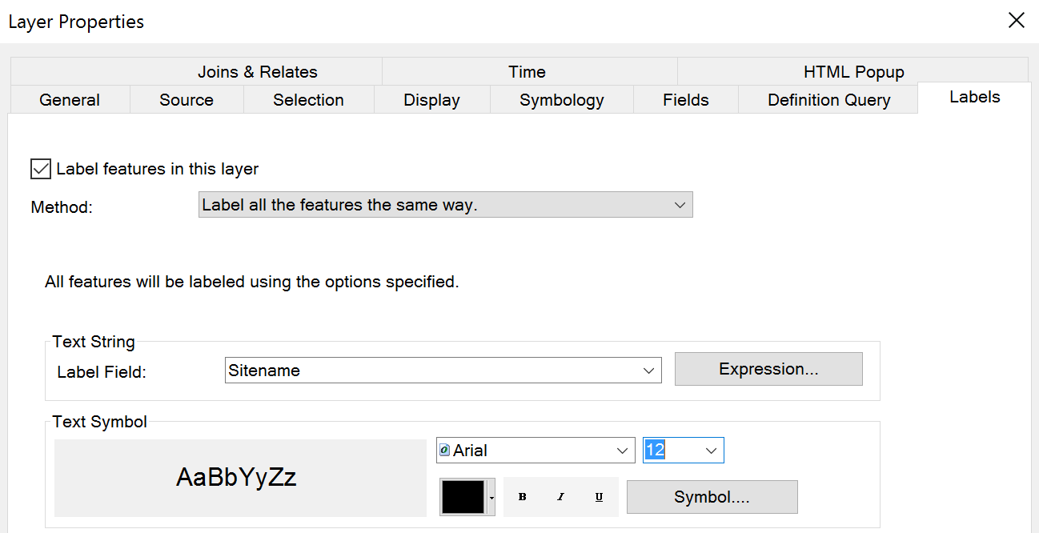
Apply these label choices by right clicking on the WaterLevelSites feature class again and selecting Label features.
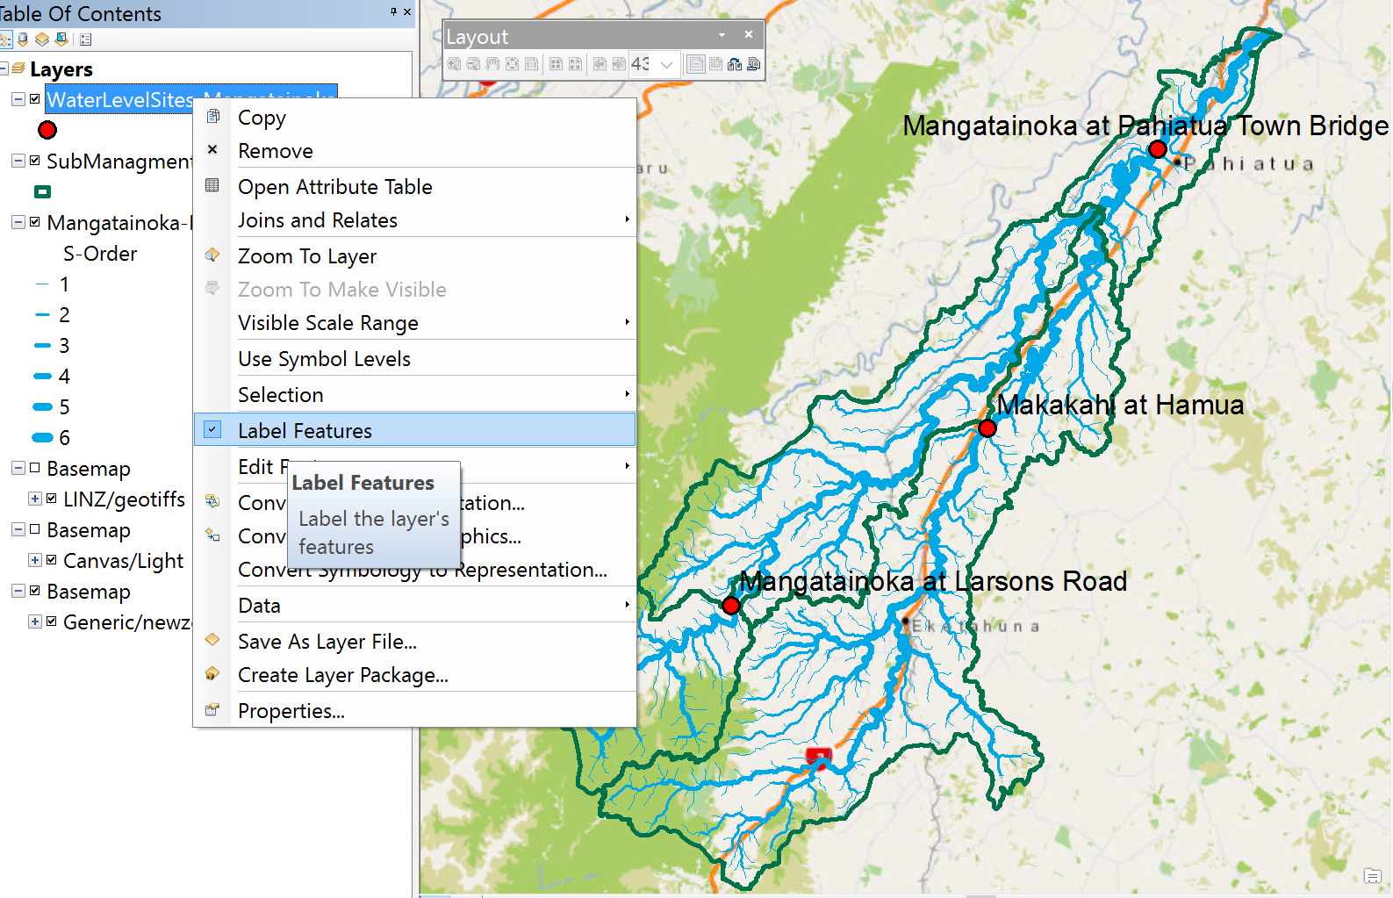
Repeat this labeling function for the SubManagementZones feature class using Catch_Name as the Label Field, Green as the color and 12 as the Text size. Use Refresh if necessary to get the map to display correctly.
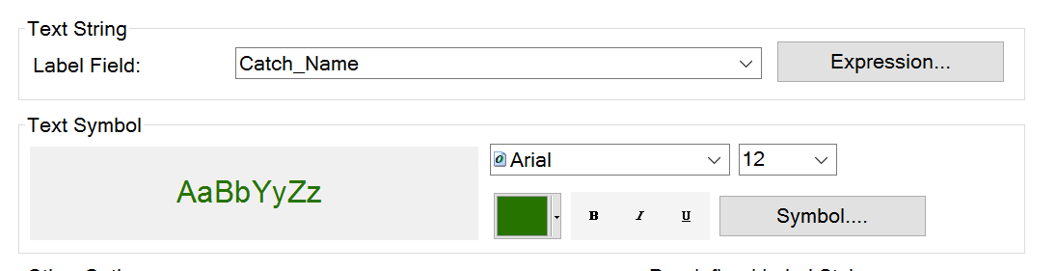
You’ll see the names of the SubManagement Zones appear. These show that the Mangatainoka River has a large tributary called the Makakahi River, and there are four SubManagement zones within the catchment area.
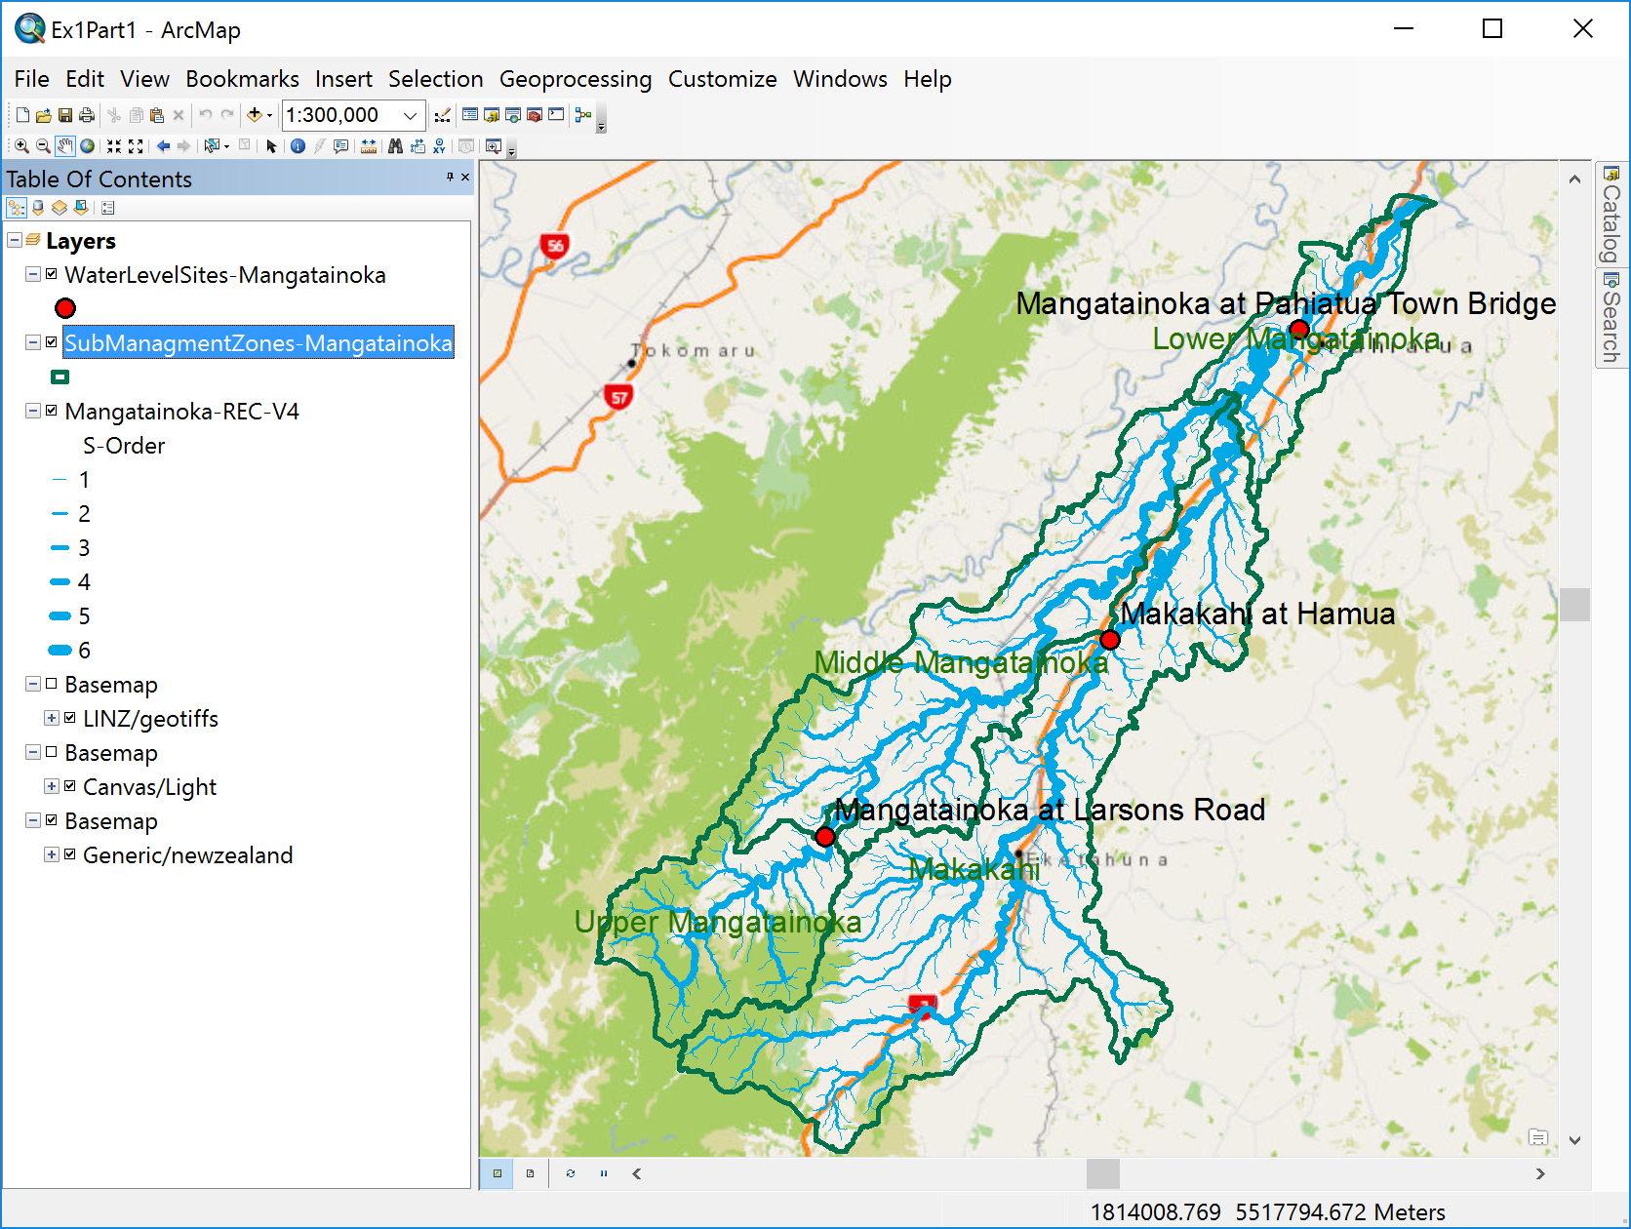
Use the Pan and Zoom tools to recenter your map display so you can get some spatial context for where this catchment is located in relation to cities and towns in the area. Use File/Save As to save a copy of this map document display as Ex1Part1.mxd. You have completed the first part of this exercise.

and use the Snip tool, 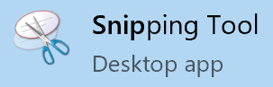
or another screen capturing tool, to capture a copy of the map for your Exercise 1 report.
To be Turned in: A screen capture of a map of the Mangatainoka Catchment, showing the SubManagement Zones, river network, water level sites and a background map.

2. Explore the Rivers
Each feature in a GIS feature class has an associated record in its Attribute table that contains descriptive information about the feature. Let’s explore a few of these attributes. Zoom in to the location of the Mangatainoka at Pahiatua Town Bridge, and turn off the green label for the SubManagementZone. Add labels for the Mangatainoka – REC feature class using HydroID as the attribute to be labeled in blue type-face with size 12. The acronym REC refers to River Environment Classification developed by the National Institute for Water and Atmospheric Research (NIWA) https://www.niwa.co.nz/freshwater-and-estuaries/management-tools/river-environment-classification-0
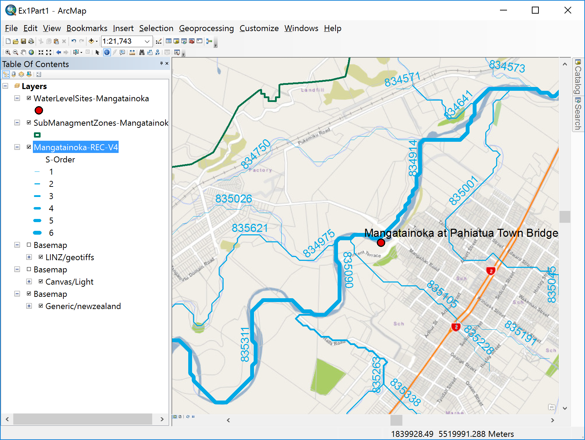
Click on the box next to SubManagementZones to turn off their display. Use the Identify tool to click on the REC blue line next to the Pahiatua Town Bridge gaging site. You’ll see that this reach extends from one river confluence to the next and that it has HydroID = 834914. The next downstream reach has HydroID = 834685. Each reach is one river segment from confluence to confluence and has a unique identifying number. This is a property of the Arc Hydro data model for surface water resources, which was used in building the REC dataset.
Save the new map display using File/Save as Ex1Part2.mxd
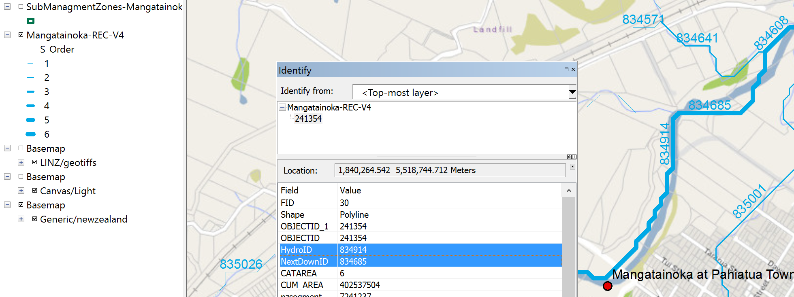
You can see that the reach with HydroID of 834914 has a NextDownID of 834685. This means that each reach knows what reach it flows into.
Right click on the feature class name and select Open Attribute Table.
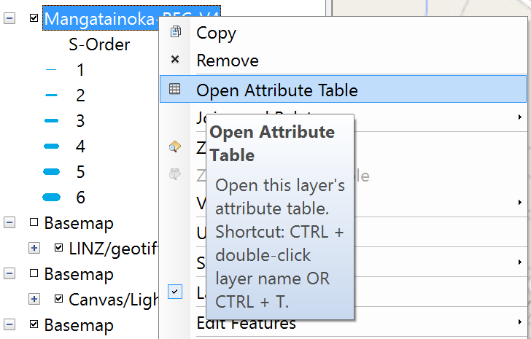
You can select a feature on the map using the select tool

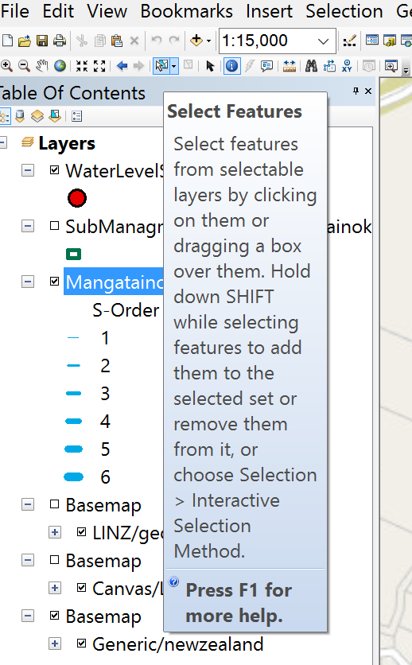
If you then click on the reach 834914 in the map and click on the Show Selected Records at the bottom of the Attribute Table, you’ll see the same attributes as you saw in the Identify tool earlier.
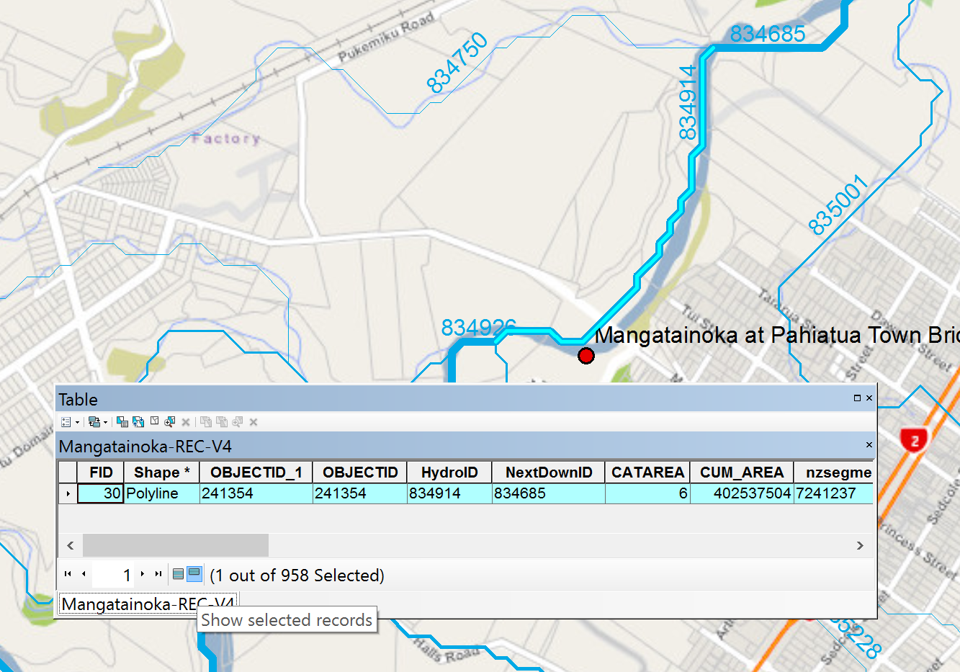
Scroll across this table, and you’ll come to an attribute called Shape_Len. This gives the length of the reach in map units, which are meters. In other words the length of this stream reach is 1224.39 m or 1.22 Km.
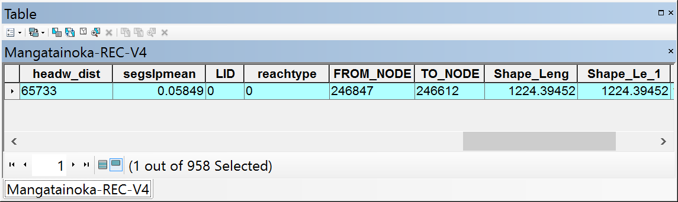
Now let’s look at the lengths of all the river reaches in the Mangatainoka Catchment. Right click on the feature class and select Selection/Clear Selected Features.
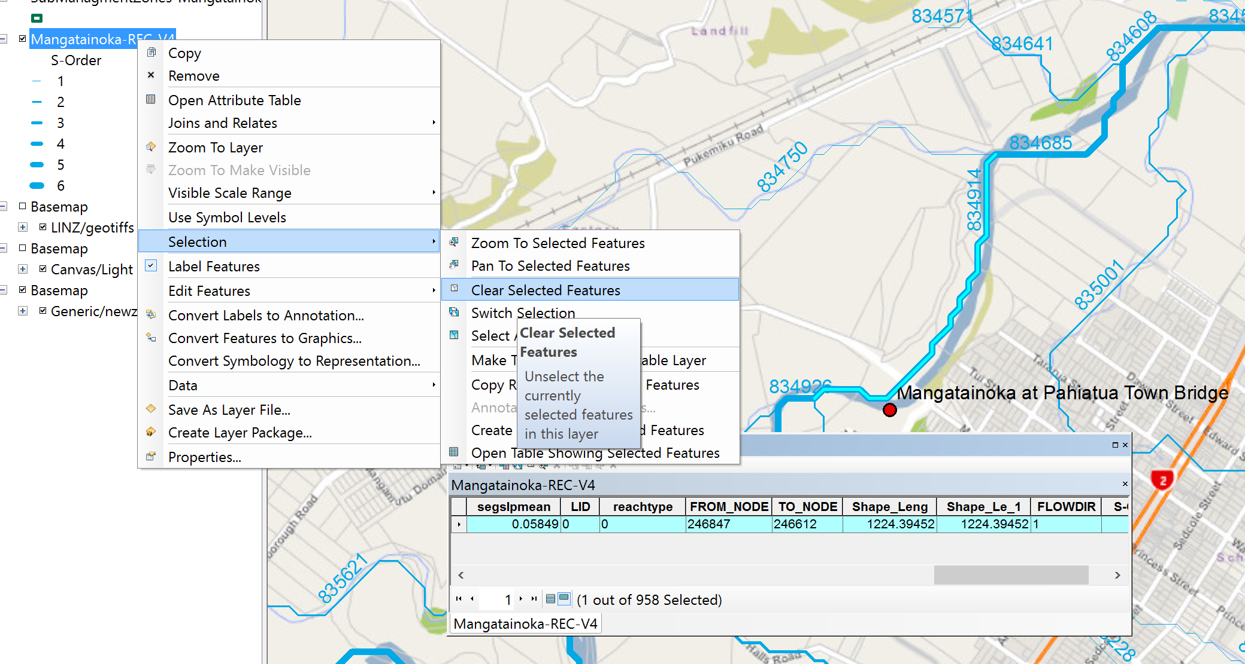
Then click on the box at the bottom of the Attribute Table that says Show All Records. Now you can see them all again.
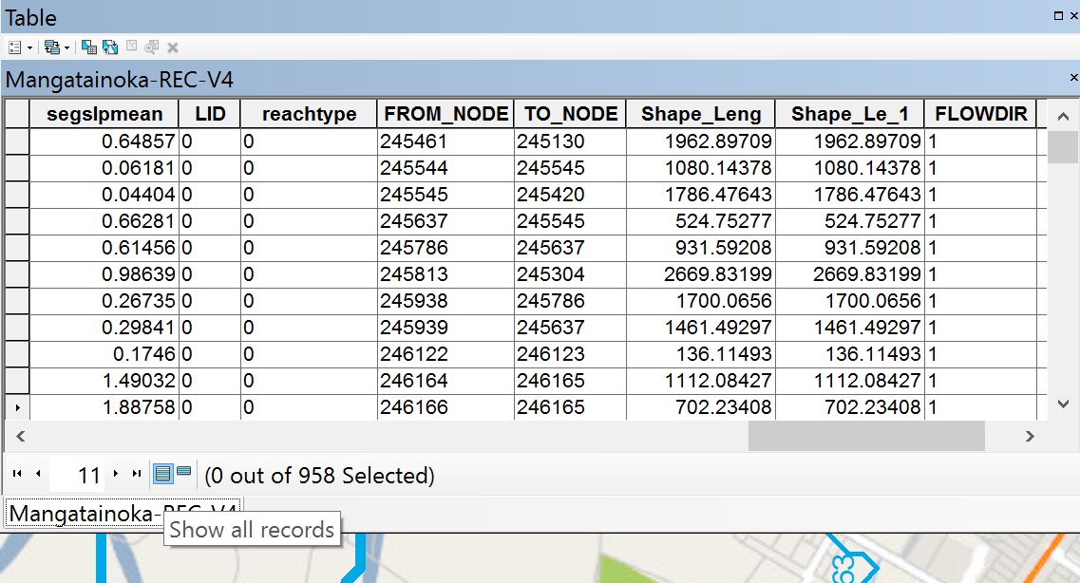
Right click on the Shape_Len field header and select Statistics.
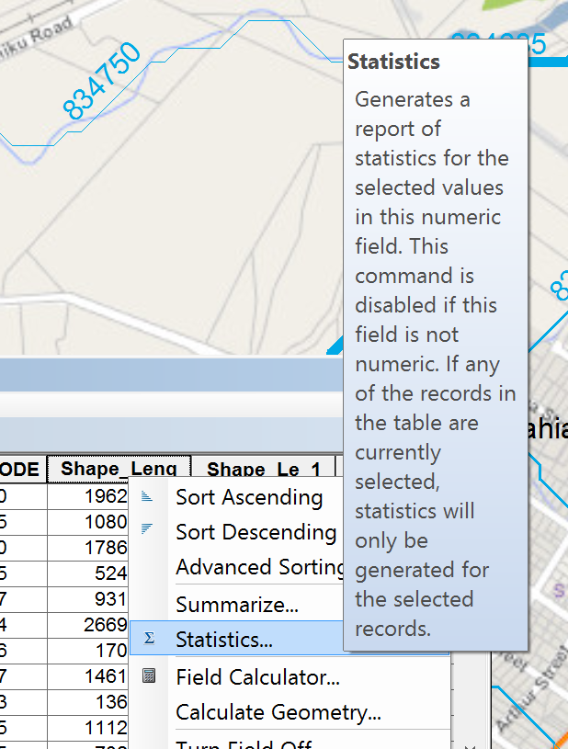
This generates a summary table for the statistics of this field.
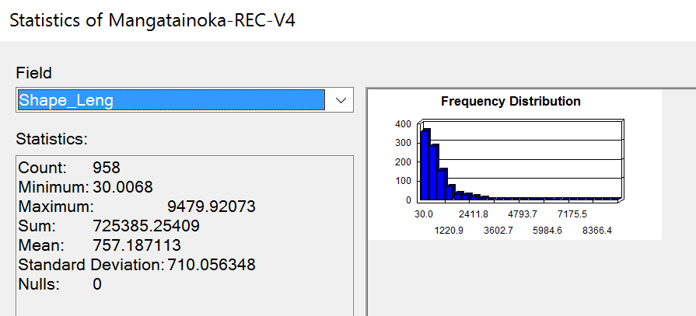
Similarly, you can open the Attribute Table of the SubManagementZone feature class, and you’ll see some information about catchment areas.
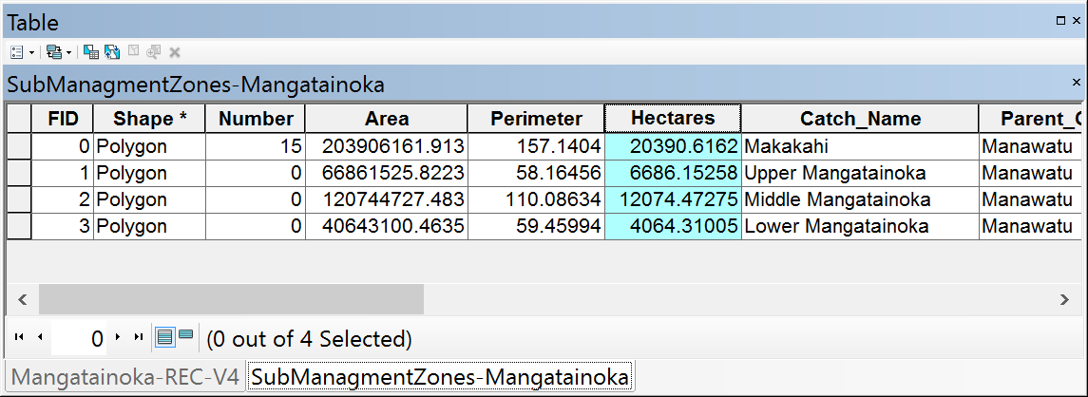
You have completed the exercise. Save your map document as Ex1Part2.mxd.
To be turned in: How many river reaches are there in the Mangatainoka Catchment? What is their total length (Km) and average length (Km). How many SubmanagementZones are there in the catchment? What is their total area (Km²) and average area (Km²)?
___________________________________________________________________________
Summary of Items to be Turned In:
(1) A screen capture of a map of the Mangatainoke Catchment, showing the SubManagement Zones, river network, water level sites and a background map.
(2) How many river reaches are there in the Mangatainoka Catchment? What is their total length (Km) and average length (Km). How many SubmanagementZones are there in the catchment? What is their total area (Km²) and average area (Km²)?

