WATR404/604 Assignment #1
- The web site Land Air Water Aotearoa https://www.lawa.org.nz/ presents comprehensive information about the water resources for regions of New Zealand. Choose one of these regions and prepare a narrative summary of the water quality in that region. Choose one swimming site within the region and prepare a narrative summary of water quality conditions at that site. The total length of the two narrative summaries together cannot exceed two pages. You can include pictures as part of your summary. Make a pdf document out of this summary.
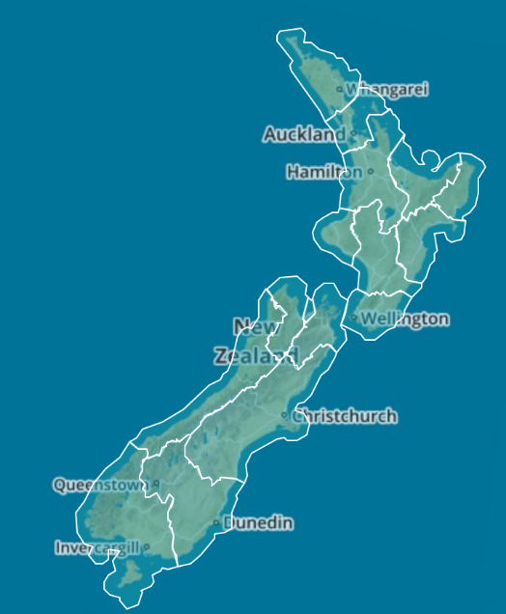
- Complete the GIS exercise “Introduction to the Mangatainoka Catchment.
To be turned in:
- A screen capture of a map of the Mangatainoke Catchment, showing the SubManagement Zones, river network, water level sites and a background map.
(2) How many river reaches are there in the Mangatainoka Catchment? What is their total length (Km) and average length (Km). How many SubmanagementZones are there in the catchment? What is their total area (Km²) and average area (Km²)?
Prepare the items “To Be Turned In” as a pdf document.

- Take the two pdf documents from (1) and (2) and make a single pdf document from them, and submit this to the Learn web site.

