Exercise 1, Part B: GIS on the Web

GIS in Water Resources, Fall 2011

Prepared by David Tarboton, Utah State University

Purpose
The purpose of this part of the exercise is to illustrate and gain experience in using web based GIS functionality to create and share a simple map. In this part of the exercise we create and online map that presents the Texas Pan Evaporation data within ArcGIS.com.

Computer and Data Requirements
To carry out this exercise, all you should need is a computer with internet access. You also need the data you used in the ArcGIS Desktop part of this exercise. You can get these at: http://www.caee.utexas.edu/prof/maidment/giswr2011/Ex1/Ex12011Data.zip

Create ArcGIS.com account
- Go to www.arcgis.com and click on Sign in (top right).
- Click on Create an Account
- Enter the necessary information and review and accept the terms of use and click Create My Account
- Add content to your profile if you desire
- Your account should now have been created. Click on ArcGIS at the top left to return to the ArcGIS.com home page. From there you can explore maps others have created and create your own maps

Join the class group.
- Click on the Groups Button and enter dtarb where it says Search for groups, press Enter. This searches for the group that dtarb (David Tarboton) created.
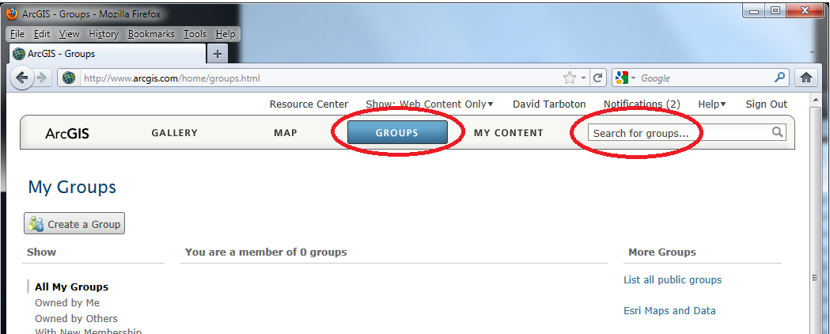
You should see 1 match, the GIS in Water Resources 2011 group that I just created.
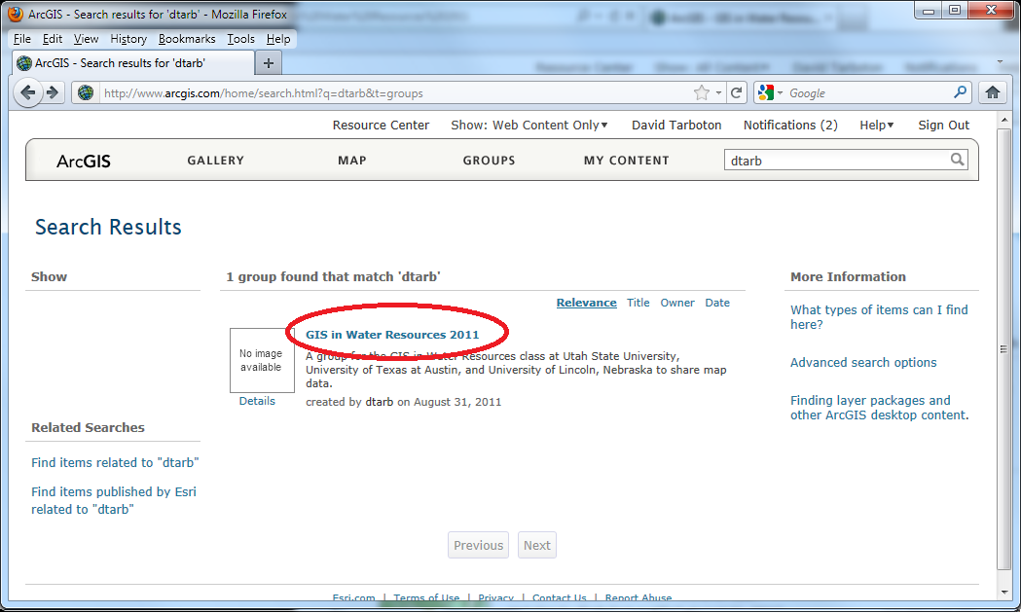
- Click on the link for the group and on the next page click on the Join This Group button and Submit Request.
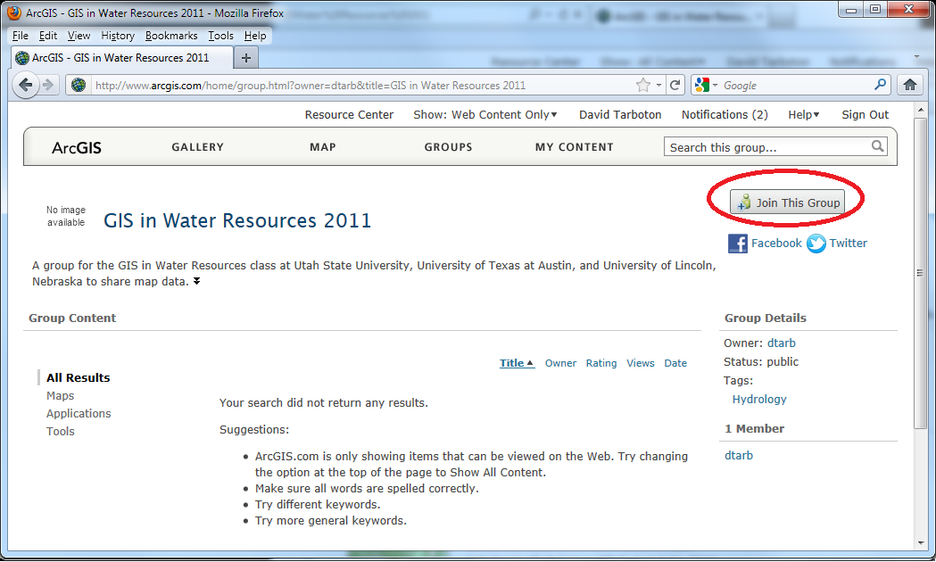
Your request to join will now be sent to me and awaits my approval. I will be as prompt as possible approving these, but the process is not automatic, so you may have to wait a bit. If you are anxious to get your membership approved feel free to send me email at dtarb@usu.edu. Otherwise I will check and approve requests at least once a day while this exercise is active.

Make a map
- Click on the Map button.
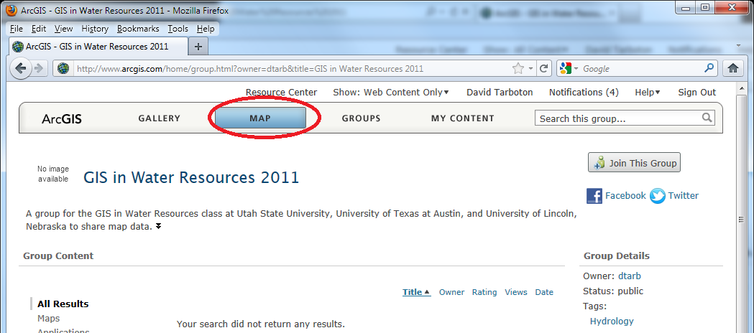
You should now see a screen where you can make your own map. Hover over and click on the items indicated to learn what they do.
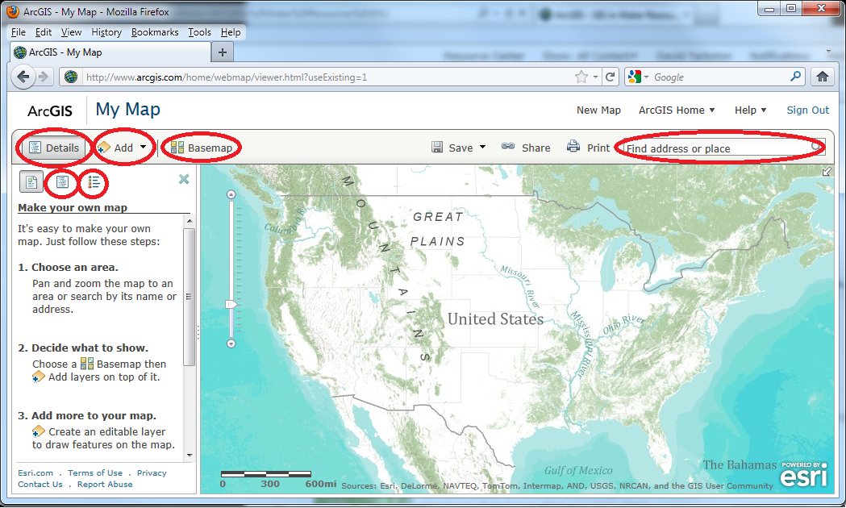
- Click on Basemap and explore the various options. Select one that you like. Zoom in to an area of interest to see greater detail. Try type an address in the Find address or place box.
Next we will add the Pan Evaporation shapefile used in the ArcGIS portion of this exercise.
- Locate the files comprising the shapefile on disk, select them, right click and select Send to Compressed (zipped) folder.
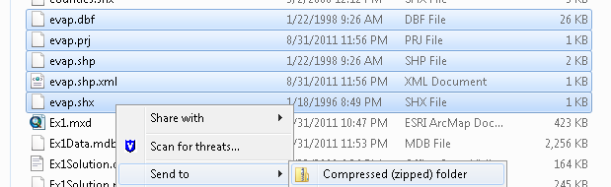
It is important to ensure that you get all pieces of the shapefile and that a .prj file specifying the coordinate system exists for this data.
- If a .prj file does not exist then you need to use the Define Projection tool in ArcGIS to define the projection
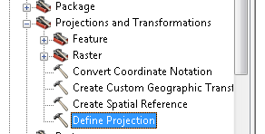
Set inputs as follows. For Coordinate System select the same coordinate system as used with other layers in this exercise. This is most easily accomplished by importing from one of the other layers, e.g. "Texas".
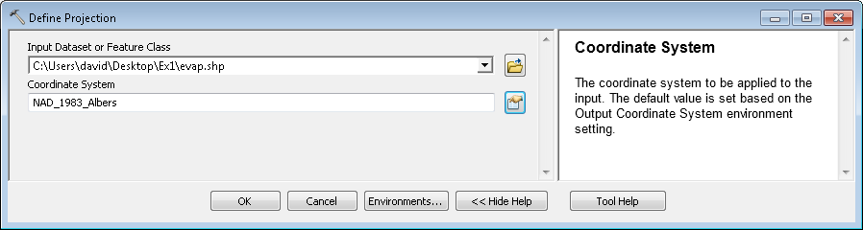
- Back in your map in ArcGIS.com select Add Layer from File
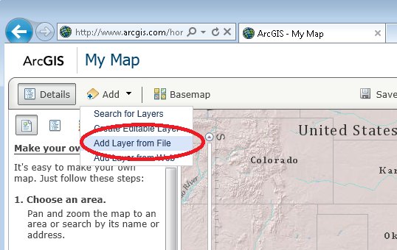
- Browse to the zip file you just created and click on Import Layer
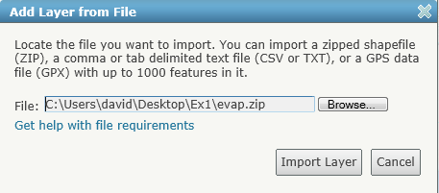
The Texas Evaporation stations should be added to your map.
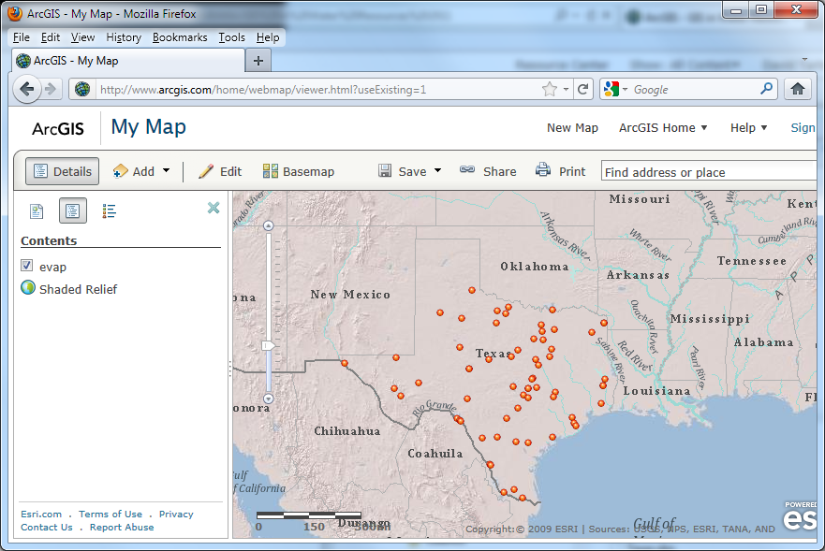
- Hover over the Layer name evap in contents and click the arrow in Contents to get the menu that allows you to change symbols and set an attractive symbology, based on ANN+VAL, the annual evaporation value.
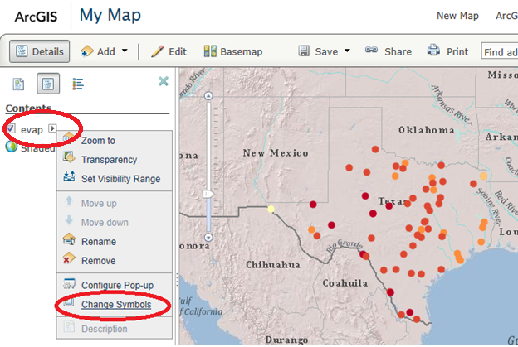
You can use a color scheme like that below. Click Apply and Done at the bottom of the page to show it on the map.
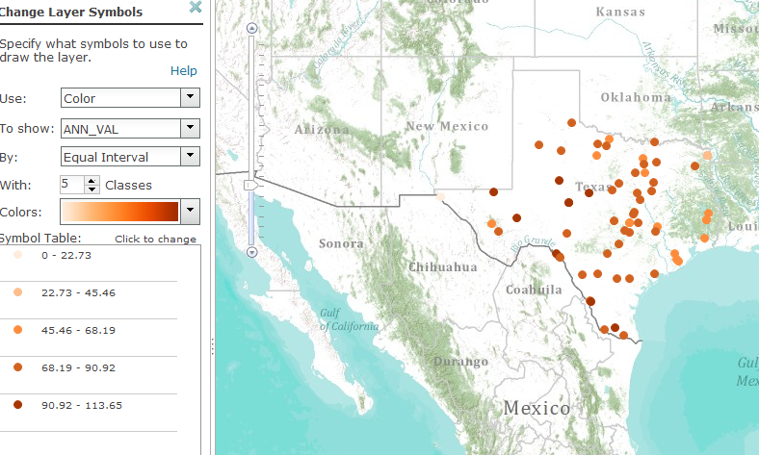
- Hover over the layer name "evap" in Contents and select Configure Pop-up. Click Configure Attributes.
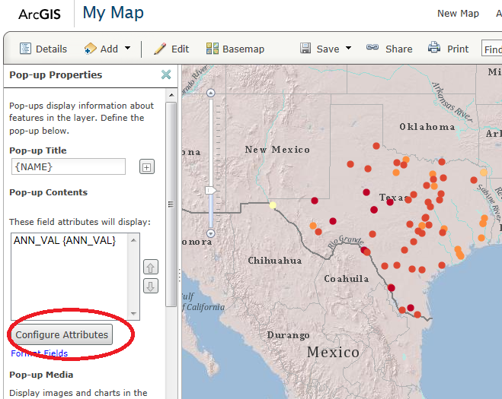
- Set the Configure Attributes to display only the values that you want to Pop-up (here select only ANN_VAL) using the check boxes in the dialog that opens
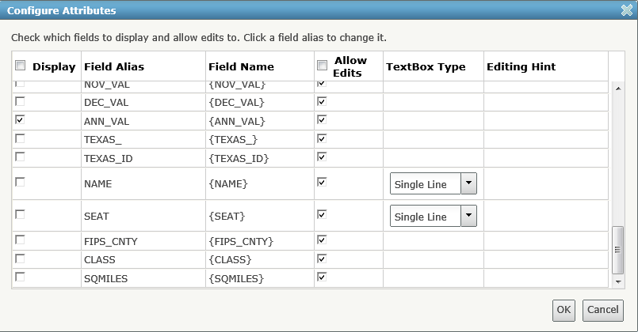
By selecting fields to display you can remove clutter from the box that pops up when you click on the attributes. Note how after doing this the Pop-up Contents lists only the fields you selected.
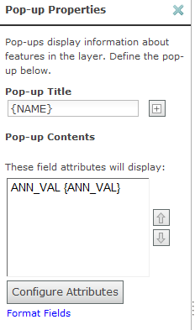
- Click Save Pop-up. Now when you click on an evaporation station in the map you should see a Pop up similar to below
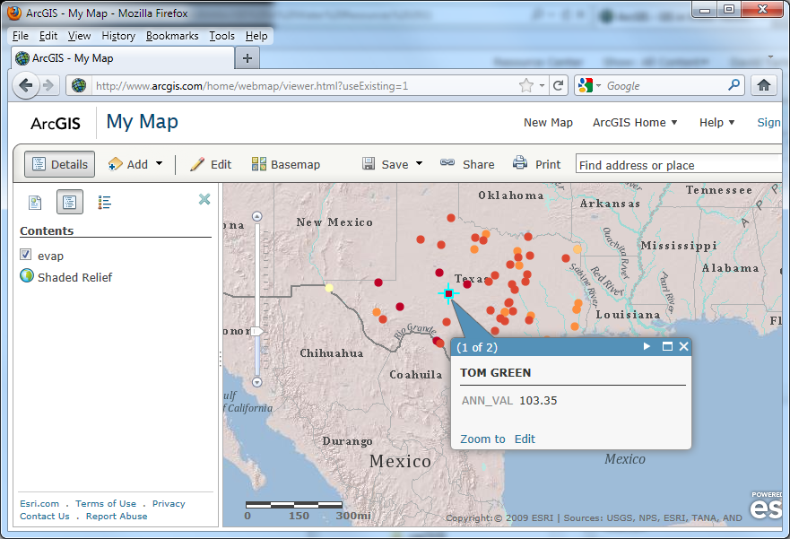
- Open Configure Pop-up again. Further down the Pop-up properties interface you can Add a Column Chart. Set a title and set the Chart Fields to display. Click OK and Save Pop-up
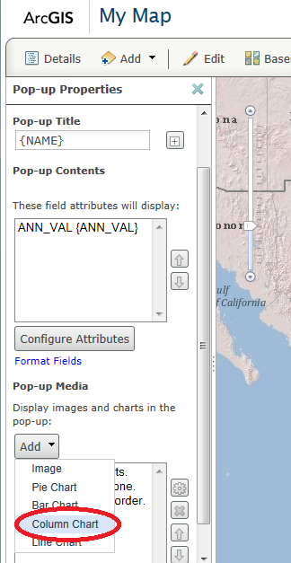 | 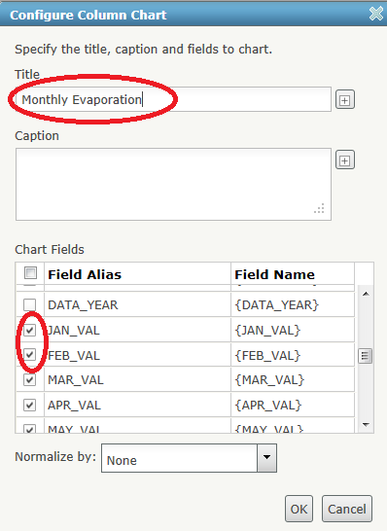

Now you can click on Evaporation Stations and have the Monthly Evaporation chart pop up
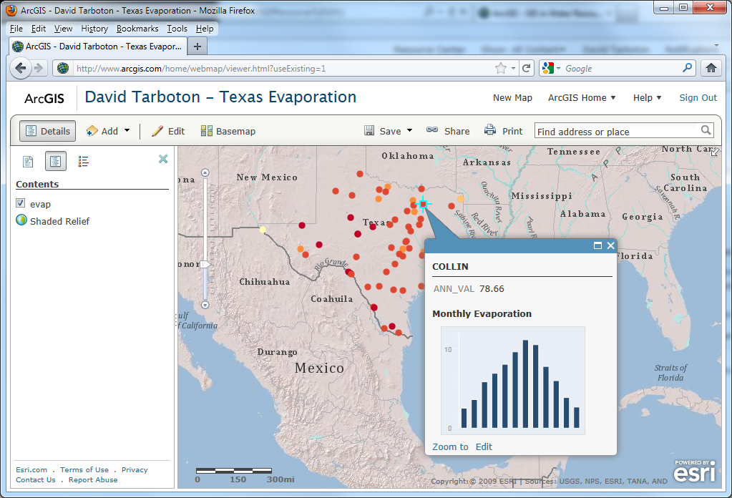
- Click on Add, Create Editable Layer
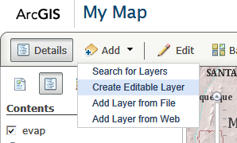

- Leave the name and template at Map Notes and click Create
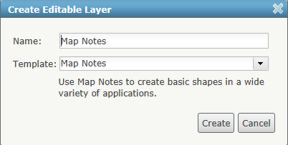
You now have an Add Features toolset that you can use to annotate the map.
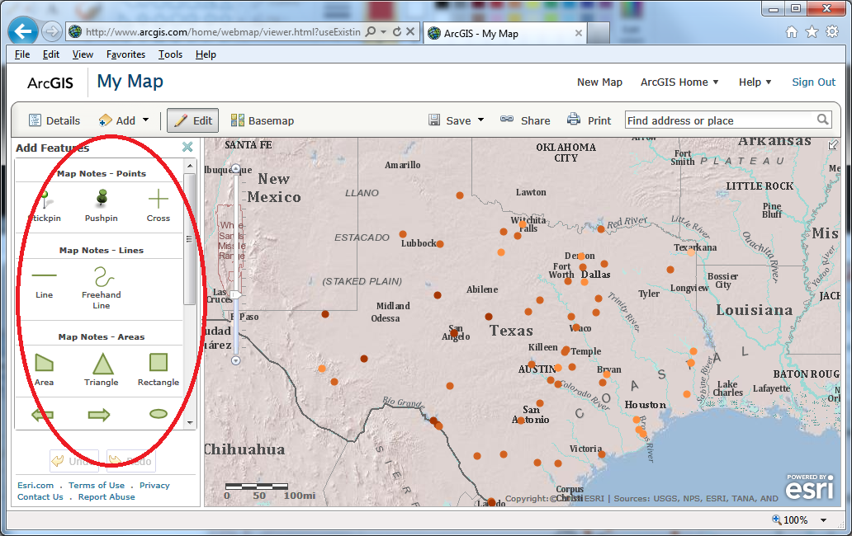
- Use these tools to add some interesting and creative interpretive annotation to your map. For example, I have added a stickpin at the location with highest Pan Evaporation in Texas below.
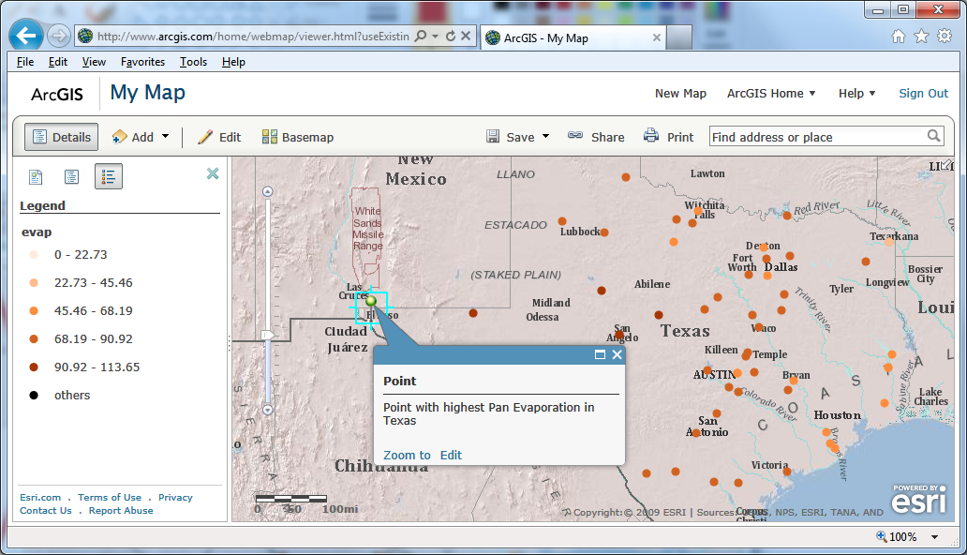
Congratulations, you have now created an interactive web map for the presentation of Evaporation Data in Texas. Although quite simple, this is a powerful tool for sharing geospatially registered information.

Save your map.
- Click on the Save button. [It would actually have been wise to save the map earlier as if you close the browser there is a danger of losing unsaved edits to the map.]
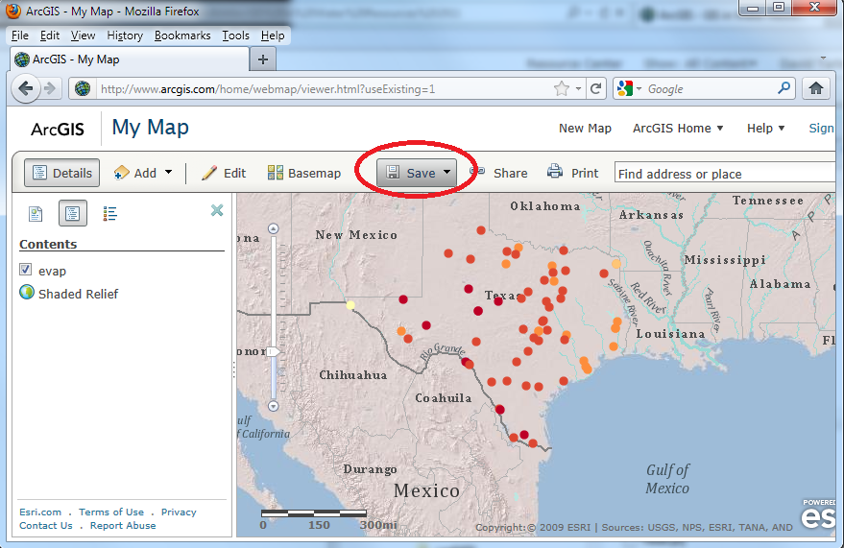
- Enter a Title, Tags, and Summary information. For this class please put your name at the beginning of the title to make it easy for us to identify whose work this is during grading.
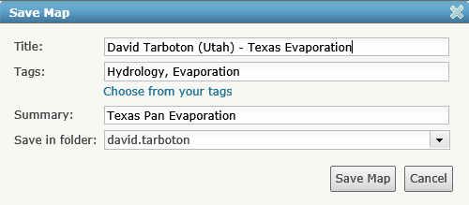

Share your map with the Class Group
- Under ArcGIS.com Home select My Content
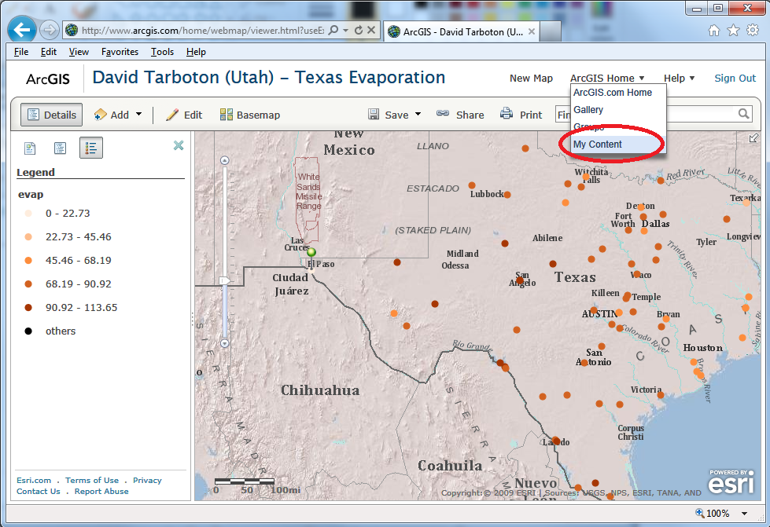
- Place a check next to the object you want to share and click Share
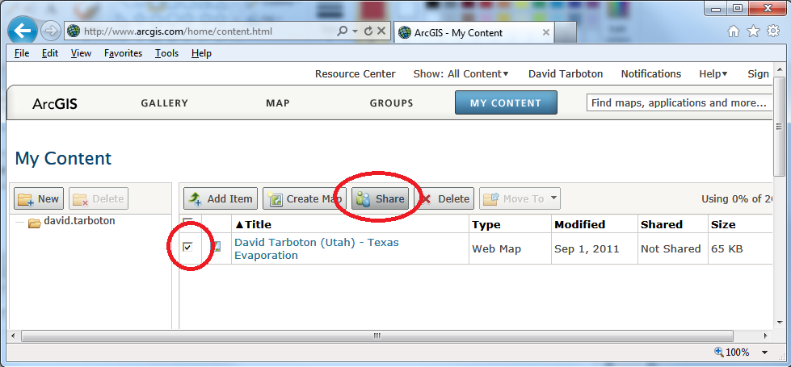
- Select the GIS in Water Resources 2011 group to share this work with. You won’t be able to execute this portion of the exercise until I have accepted you as a member of this group.
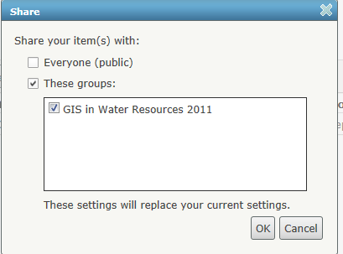

Congratulations. You have now published your map to the class. There is nothing to turn in for this part of the exercise. We will review your maps online. You can also see the maps prepared by other students in the class.

