Student Installation of ArcGIS 10.2.2 for GIS in Water Resources
University of Texas at Austin

Prepared by David R. Maidment
September 2014

There are five steps to this process:
(1) Get an ESRI Account
(2) Prepare your computer
(3) Obtain an authorization number and the software
(4) Install the software and validate your authorizaton number
(5) Start using the software

Here are the instructions for these steps:

(1) ESRI Account

If you already have a Username and Password for your ESRI Account, then skip this step.

If not, go to https://webaccounts.esri.com/CAS/index.cfm and choose Create an Account. Add your name and email address. It is very important to use the same email address here as you are using for the GIS in Water Resources class, and that I have emailed back to you. The email address is how things get connected together inside of the ArcGIS web system.

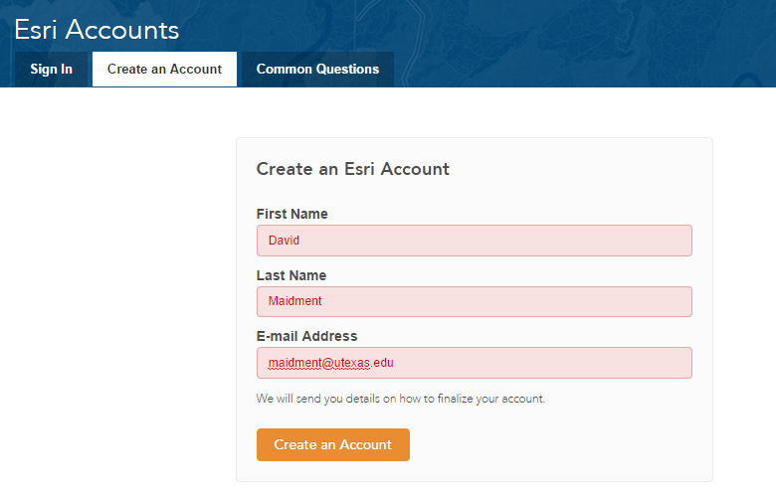

Once you hit “Create an Account”, you will sent an email, as shown below, which you can click on to “Activate your Account”
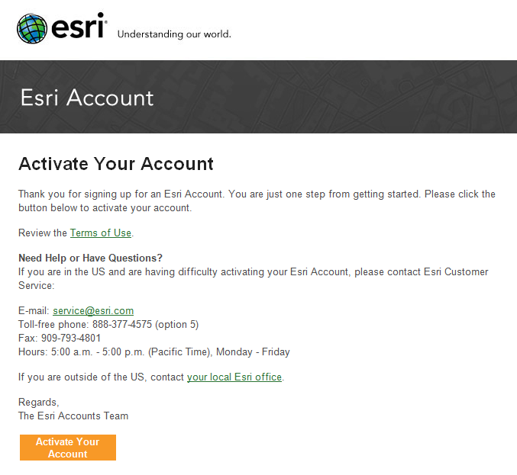

You’ll be presented with a large screen with a lot of information that needs to be filled in. Fill out this screen and choose Create Account at the bottom. For Organization, put University of Texas at Austin.

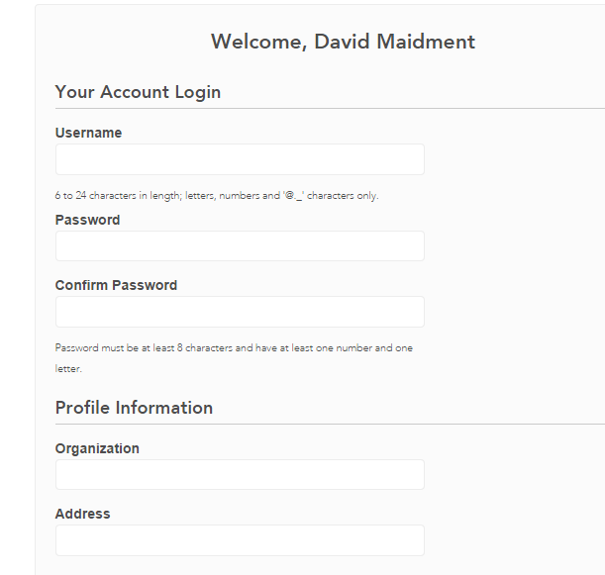

This will establish your User Name and Password for ArcGIS Online and for validating your software.

(2) Prepare Your Computer

(a) Check the ESRI System Requirements to make sure your computer has the required hardware and software to support the installation of ArcGIS

http://resources.arcgis.com/en/help/system-requirements/10.2/

Please note that ArcGIS runs under the Windows operating system and does not run on MacIntosh computers, unless you have a boot option to bring up the MacIntosh using Windows. ArcGIS is a fairly large program and its not well suited for “vintage” laptop or desktop computers. If you have difficulty loading or running the program on your computer, it may not really have enough capacity to do that. In that case, you can use the computers in the Civil Engineering Learning Resource Center on the third floor of ECJ.

Be careful to ensure that your computer has the right operating system and also the necesssary Service Packs installed for that operating system. If you’ve had your computer for a long time and not installed any Service Pack updates, your operating system might not be up to date enough to run ArcGIS Desktop.

(b) If necessary, install the Microsoft .NET Framework. ArcGIS will run with .Net Framework 3.5.1 or later. http://www.microsoft.com/en-us/download/details.aspx?id=22

(c) If you already have a previous version of ArcGIS Desktop installed on your computer, you’ll need to Uninstall it before installing the new one. To do this, Go to Control Panel/Programs and Features and right click on the icon for ArcGIS and follow the Uninstall instructions.

(3) Obtain an Authorization Number and the Software

I will send you a software authorization number with the form EVA123456789. This allows you to use one copy of the ArcGIS Desktop software and its extensions for one year on your own computer.

Go to ArcGIS for Desktop Student Trial
http://www.esri.com/landing-pages/software/arcgis/arcgis-desktop-student-trial
and login with the Username and Password for your ESRI Account. You’ll be asked to input your Authorization Number and then Activate ArcGIS.

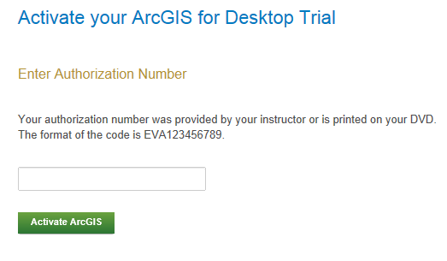

You will be presented with a choice as to Versions, choose Version 10.2.2

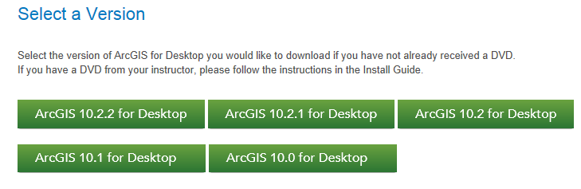

Here are the instructions on how to install the software. Use your EVA number not the one shown below.

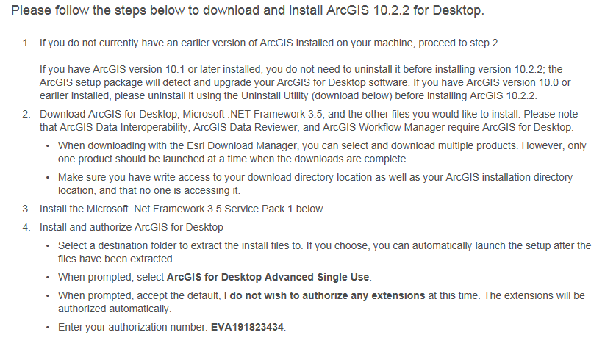

In the succeeding menu, select “ArcGIS for Desktop” Download (811 MB). This takes a little while.
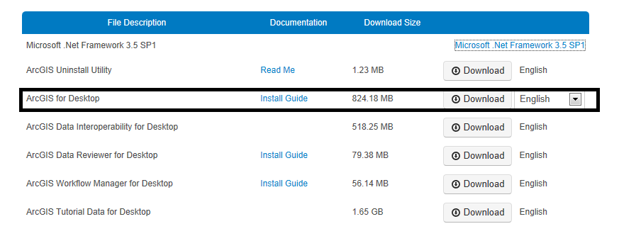

You should end up with a single file that looks like this:

If you don’t succeed in getting this file at this location, contact me and I’ll arrange for you to get a copy in another way.

(4) Install the Software and Validate your Authorization Number

Double click on the file ArcGIS_Desktop_1022_140415.exe and install it on your computer. This takes quite a while, so you might want to get a cup of coffee or do something while the installation goes on. If your screen goes blank, the installation may stop, so move your mouse now and then to keep the screen alive. Hopefully, at the end you’ll see:

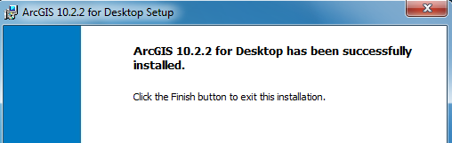

Immediately that your software installation has been completed, you’ll be presented with a ArcGIS Administrator Wizard screen. Select Advanced (ArcInfo) Single Use and you’ll see the button, Launch the Authorization Wizard for Single Use Products be activated.

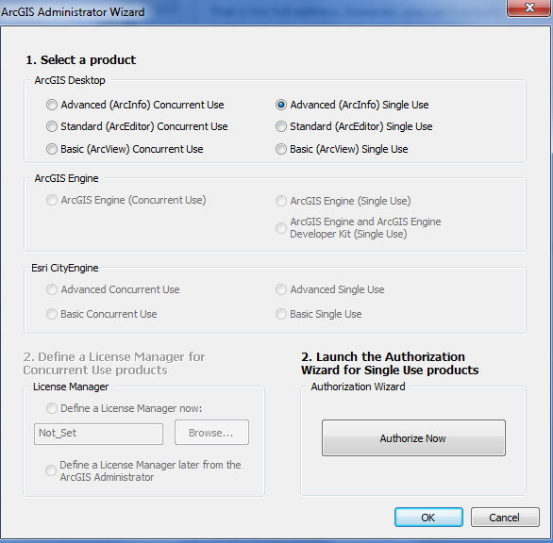

Hit Authorize Now and enter your Authorization Number

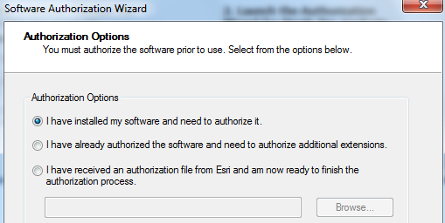

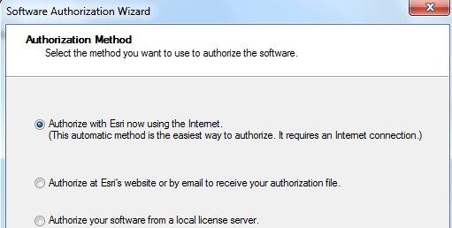

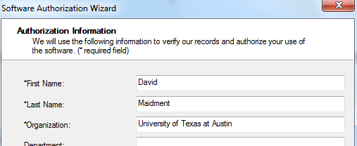

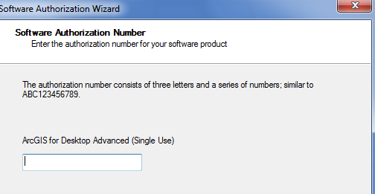

Leave the default option to not Authorize Software Extensions. They will be authorized automatically.

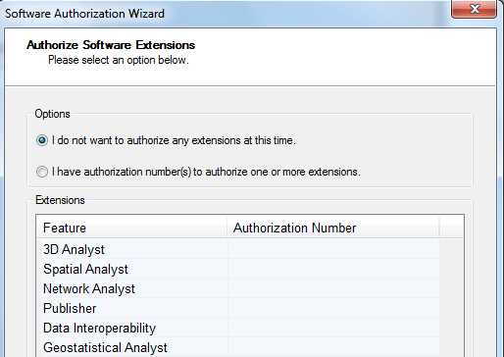

Finish this process and you are done!

5. Start Using the Software
Open ArcMap and select the A new empty map option. If you are using Windows 7 or Windows XP, hit the Start button and you’ll see a series of options for ArcGIS. Select ArcMap.
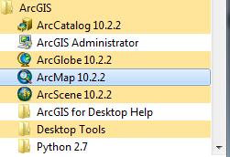

If you are using Windows 8, you’ll see 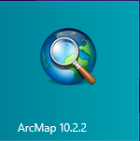 in your Windows display. If you don’t see that, then just type “ArcMap..” and you’ll see the program symbol appear.
You can check the availability of software extensions by choosing Customize/Extensions
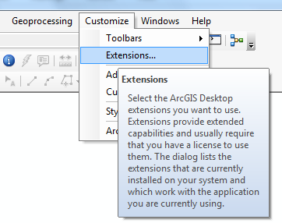
And then select the Extensions that you want to use. We’ll use Spatial Analyst and 3D Analyst in this class.
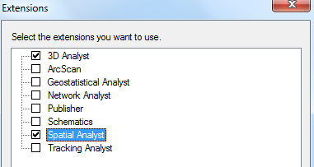
Ok, you are good to go now!

