GIS in Water Resources

Fall 2014

Homework #1

Goal
The goal of this homework is to reinforce the lecture material on Geodesy, Map Projections and Coordinate Systems by having you identify attributes and perform hand calculations related to coordinate systems and distances between points on a spherical earth.

1. Map Projection Parameters

The map below shows Texas and a grid of world latitude and longitude from ArcGIS Online.

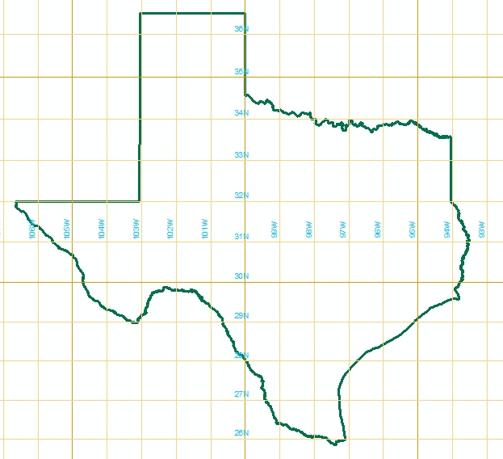

Here are the parameters of the State Plane Coordinate system of Texas, Central Zone:
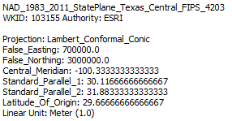
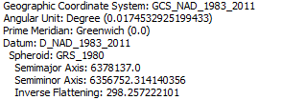

(a) What earth datum is used in this coordinate system?

(b) What map projection is used in this coordinate system?

(c) Sketch on the map the standard parallels, the central meridian and the latitude of origin of this projection.

(d) For this projection, what are the coordinates of the origin (φ_{o}, λ_{o}) (in units of degrees minutes and seconds) and the corresponding (X_{o}, Y_{o}) (in units of meters)?

(e) The geographic coordinates of UT Austin are: 30º 17' 10" N 97º44' 22" W. Assuming a spherical earth with radius 6371.0 km, calculate the distances in meters that UT Austin is north of the latitude of origin and east of the central meridian.

(f) Based on your answers to (e) determine the approximate coordinates of UT Austin in the Texas State Plane Coordinate system.

Note that your answers in (f) are approximate because of the assumption of a spherical earth rather than using the GRS_1980 spheriod and Lambert Conformal Conic projection geometry which is too involved for a hand calculation. Let's use ArcGIS to see how approximate this is.

(g) Use the Display XY data function in ArcGIS to display the UT Austin location from geographic coordinates and from the approximate projected coordinates. Use a basemap to provide context. Label each point and use the distance tool to estimate the distance between these points.

2. Locations on the Earth

Using ArcGIS Explorer Online and zooming to Austin and Logan reveals the following designated locations for these universities. Convert these locations into decimal degrees. Find the great circle distance between Austin and Logan in km if the radius of an equivalent spherical earth is 6371.0 km. Elevations for these locations were determined using Google Earth. 1 ft = 0.3048 m. Compute the slope along the great circle distance and indicate whether, based on this slope, water would flow from Austin to Logan or Logan to Austin along this path.

Elevation 693 ft | Elevation 4789 ft

3. Sizes of DEM Cells

The National Land Data Assimilation System is a dataset produced by NASA to describe the time variation of the land surface hydrology of the United States. Data from this system are produced using 1/8 ° cells. When applied, they are projected to a coordinate system in which the (X,Y) coordinates are in meters. A spherical earth that has the same volume and surface area as a reference ellipsoid has a radius of 6371.0 km. Calculate the corresponding distances AB and AC in kilometers, and the area ABCD in square kilometers, for this cell on a spherical earth at Austin and Logan.

