High Mountain Glacial Watershed Program

USAID Contract No. EPP-I-00-04-00024-00
Task Order No. 11
Project No. 45000.5010.002.004

TRIP REPORT

Kathmandu, Nepal

Prepared By:
Daene McKinney
April 27 – June 7, 2012

Prepared for:
University of Texas at Austin
and
International Resources Group

Summary 3
1. Background 1
1.1. Objectives of the Trip 1
1.2. Potentially Dangerous Glacier Lakes in Nepal 1
1.3. Imja Glacier and Lake 4
1.4. Hinku Valley 5
1.5. GPR Methods 6
1.6. GPR Surveys of Dudh Pokhari, Tama Pokhari and Imja Glacial Lakes 7
2. Daily Activities During Trip 12
3. Recommendations 30
3.1. Refinement of Imja Lake GLOF Model 30
3.2. Vulnerability Analysis of Potential Imja Lake GLOF 30
3.3. Hydrologic Model of Imja Lake 30
3.4. Bathymetric Mapping of Glacial Lakes 30
3.5. Flow Measurements of Glacial Lake Outlets 31
3.6. Flood Model of Tama Pohkari Lake 31
3.7. GPR Survey of Lake 464 31
4. References 32

Summary

This trip achieved several objectives, including:

Deepening the partnership with UNDP on Imja GLOF Project - The USAID High Mountain Glacial Watershed Program (HMGWP) has partnered with UNDP and the USAID ADAPT/Asia project with parallel co-financing on the Imja Lake GLOF Risk Reduction Project. The knowledge of the HMGWP in the area, problems and people of this region bring considerable value to these other two efforts to help communities and the Government of Nepal to deal with the increasing risk posed by the Imja glacial lake. This partnership brings close and immediate collaboration with the Government of Nepal in the HMGWP work and helps to establish a good working relationship with ICIMOD. The HMGWP is in a good position to assist communities potentially impacted by the project to understand their options regarding glacial lake risk and vulnerability reduction.

Design of V&A training approach for July 2012 training sessions and September 2012 community consultations – During this trip Meghan Hartman from IRG in collaboration with other HMGWP team members designed the V&A training modules to be carried out in July 2012. Meghan also interviewed key people while in the Khumbu. The training will now go ahead in July 2012 in Kathmandu with several trainers receiving and participating in training on V&A approaches to vulnerability reduction. This will be followed by three community consultations in the Khumbu region in September 2012.

Physical Survey and Measurements – The HMGWP team performed Ground Penetrating Radar (GPR) surveys in the field of the moraine structures at Dudh Pokhari, Tama Pohkari, and Imja Lakes to determine the amount of buried ice and the basic debris structure of the moraines. Using the backpack mounted GPR system, the Imja glacier was also surveyed to determine the dimensions of the glacier as an input to the water balance model for the lake that is being developed.

Climate change display at KACC in Dingboche – The HMGWP continued its efforts to strengthen in the capacity of the Khumbu Alpine Conservation Council (KACC). Display panels were designed and constructed by the HMGWP for the KACC office in Dingboche that illustrate various environmental aspects of the Khumbu region including biodiversity, climate change impacts, and Imja Lake.

1. Background

1.1. Objectives of the Trip

This trip had several objectives, including:

Deepening the partnership with UNDP on Imja GLOF Project - The USAID High Mountain Glacial Watershed Program (HMGWP) is partnering with UNDP and USAID-ADAPT on the Imja Lake GLOF Risk Reduction Project. The HMGWP knows the area, problems and people of this region well. The project partnering will give us immediate and automatic Government of Nepal acceptance for the HMGWP and its work in Nepal. Establishing a good working relationship with ICIMOD will bring a lot of technical information that we may otherwise have great difficulty in acquiring. The partnering will put us in a good position to assist the communities to understand their options regarding glacial lake risk and vulnerability reduction and not have to simply accept a solution that the UNDP engineering contractors choose.

Design of V&A training approach for September 2012 training sessions – During this trip Meghan Hartman from IRG will be leading the effort to design the V&A training modules to be carried out in September 2012. Meghan will interview key potential participants and other relevant people while we are in the Khumbu (National Park Authorities, some people in Namche, Dingboche, Chukung, Pangboche, etc.). A recommendation from the March McKinney trip report was to consider using interview questions similar to those shown in the papers by Dhal and Hagelman (2011); and Pradhan et al. (2012).

Physical Survey and Measurements – The team will perform Ground Penetrating Radar (GPR) surveys in the field of the moraine structures at Dudh Pokhari, Tam Pohkari, and Imja Lakes to determine the amount of buried ice and the basic debris structure of the moraines. Using the backpack mounted GPR system, we will try to survey the Lotse Shar and Imja glaciers if time permits while we are at Imja Lake to help develop the water balance model for the lake.

Climate change display at KACC in Dingboche - Display panels have been designed for the KACC office in Dingboche that illustrate various environmental aspects of the Khumbu region including biodiversity, climate change impacts, and Imja Lake. The text of the panels has been edited by several members of the team during the past month. We have had these printed and mounted on display panels and will present them to the KACC for display at the KACC office in Dingboche.

1.2. Potentially Dangerous Glacier Lakes in Nepal

The International Center for Integrated Mountain Development (ICIMOD) has developed a list of Potentially dangerous Glacial Lakes (PDGL) in Nepal. This list was generated primarily from remotely sensed data (Mool et al., 2001; Bajracharya et al., 2007; ICIMOD, 2011), but the top three lakes on the list (Tsho Rolpa, Imja and Thulagi Lakes) have recently been the subject of field investigations which have resulted in somewhat ambiguous results in terms of prioritizing the risk posed by the lakes (ICIMOD, 2011). The ICIMOD PDGL prioritization has not included socio-economic or cultural criteria and is based primarily on physical criteria derived from remotely sensed data. More recently, in Bhutan prioritization has been carried out to screen the Bhutanese portion of the ICIMOD PDGL list based on more refined criteria (see Komori 2012).

Several glacial lakes in Nepal are, or perhaps should be, considered PDGLs, including:

- High priority lakes requiring extensive field investigation and mapping (Category I lakes, Table 5.1, ICIMOD 2011):

Tsho Rolpa Lake
Lower Barun Lake
Imja Lake
Lumding Lake
West Chamlang Lake

- Lakes removed from the ICIMOD PDGL list (Mool et al., 2001) in 2011 but still potentially dangerous:

Dudh Pokhari Lake in the Hinku valley (this lake was removed purely based on remotely sensed data)

- Lakes not on the 2011 ICIMOD PDGL list but recently surveyed by our team and found to be extremely dangerous:

Lake 464 in the Hongu Valley

- Lakes which have had GLOFs in the recent past, but continue to pose a flooding threat to communities:

Tama Pokhari in the Hinku Valley (ICIMOD Category II medium priority lake that requires close monitoring and reconnaissance field surveys)

The Khumbu region of Nepal (including the Dudh Koshi basin) is regularly mentioned as an area particularly prone to GLOF events and containing important sites for possible GLOF projects (especially in the Imja Khola). Most of this attention stems from the fact that two previous GLOFs that have occurred there in recent years.

Nare GLOF (1977) - Nare is situated in the Dudh Koshi watershed on the southern slope of Ama Dablam in the Mingbo Valley a tributary of the Imja Khola. The lake was formed by an ice-cored moraine dam. A GLOF event on 3 September 1977 in the Imja Khola occurred when a small glacial lake located at a higher elevation discharged into the Nare Lake causing the lake to overtop its damming moraine and creating a GLOF into the Imja Khola and finally the Dudh Koshi below. The discharge was estimated variously to have been 400,000 m³ (Fushimi et al., 1985) and 500,000 m³ and reached Pangboche about 45 minutes after the intial outburst (Buchroither et al., 1982). Several lives were lost in the flood and all bridges were destroyed for 35 km downstream (Mool et al., 2001; Ives et al., 2010; Buchroithner et al., 1982; Fushimi et al., 1985; Zimmerman et al., 1986).

Dig Tsho GLOF (1985) – The Dig Tsho (Langmoche) glacial lake contacts the Langmoche glacier and drains into the Bhoti Koshi tributary of the Dudh Kosi. The lake burst on 4 August 1985 destroying the nearly completed Namche Hydropower Plant (11 km from the moraine dam of the Dig Tsho), 14 bridges, trails, cultivated land, and caused the loss of several lives. The GLOF was triggered when an ice avalanche fell into the glacial lake, which had little freeboard at that time, resulting in a wave that overtopped the moraine dam and caused a breach in the dam. The GLOF was estimated to have a volume of 6-10 million m³ and drained in about 4 hours. Eyewitnesses reported at least two GLOF surges coming from the lake. The mix of water and debris in the resulting flood wave significantly increased the destructive power of the flood. Since the 1985 GLOF, the lake has not been considered dangerous (Mool et al., 2001; Ives 1986; Vuichard and Zimmerman 1986, 1987; Ives et al., 2010)

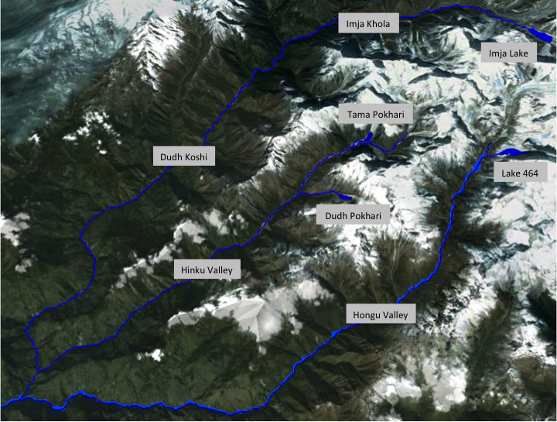
Nepal Himalaya showing the Dudh Koshi, Hinku, and Hongu Valleys.

The ICIMOD approach for characterizing the risk of glacier lakes includes the following lake and glacier characteristics listed in Table 1 (ICIMOD 2011). Table 1 notes where Imja, Dudh Pokhari or Tama Pokhari Lakes meet these criteria.

Table 1. Potentially Dangerous Glacier Lakes Characteristics with Emphasis on Imja, Dudh Pokhari or Tama Pokhari Lakes.
Characteristic | Imja | Dudh Pokhari | Tam Pokhari
Large size and rapid expansion | yes |  | maybe
Increasing water level | yes |  | yes
Intermittent activity of supra-glacial lakes
Position of lake in relation (adjacent) to moraines and associated glacier |  |  | yes
Moraine dam condition
Narrow crest |  |  | yes
No drainage outflow or outlet not well formed
Steep moraine walls | yes
Existence and stability of ice core and / or permafrost within moraine | yes
Height of moraine | yes
Mass movement (or potential for it) on the moraine slopes | yes
Lake breached in the past and refilling |  |  | yes
Seepage through moraine walls | yes
Glacier characteristics
Condition of associated glacier | yes
Hanging glacier in contact with or close to lake |  |  | yes
Large glacier area | yes | yes | yes
Rapid glacier retreat | yes
Debris cover on lower glacier tongue | yes
Slope of glacier tongue | yes
Presence of crevasses of ice from the glacier front | maybe
Ice bergs breaking off glacier terminus and floating into lake | yes |  | yes
Physical conditions and surroundings
Potential rock fall and / or slide sites around the lake |  |  | yes
Large snow avalanche sites immediately above |  |  | yes
Neo-tectonic and earthquake activity | yes | yes | yes
Climatic conditions, especially large inter-annual variations
Recent moraines of tributary glaciers that were previously part of a former glacier complex, and with multiple lakes that have been developed due to retreat of several glaciers in close proximity | yes
Sudden advance of a glacier towards a lower tributary or main glacier that has a well developed frontal lake.

1.3. Imja Glacier and Lake

Imja Lake (or Imja Tsho) is located in the Nepalese Himalaya, about 9 km south of Mount Everest. The lake has experienced rapid growth in area and volume over the last 50 years, leading to concern over the risk of a catastrophic GLOF event. A GLOF from Imja Lake could affect those villages that are nearby downstream, such as of Dingboche 8 km downstream of the lake’s terminal moraine. Figure 1 shows the geographic locations of Imja Lake and Dingboche village.

The area of the Imja basin is 141 km² with altitude ranging from 4355 to 8501 m and 38% covered by glaciers (Konz et al., 2005). Monsoon circulation dominates the climate in the basin, with easterly winds in the summer and westerly winds from October to May. About 70–80% of annual precipitation falls during the monsoon period. Runoff in the Imja river also follows the monsoon with about 64% of annual discharge occurring from June to September. Winter discharge is about 15% of the annual discharge. Mean discharge from December to April is about 1.3 m³/s (Konz et al., 2005).

Imja Lake is bounded on the east by Imja glacier, on the north and south by lateral moraines, and to the west by a terminal moraine. Figure 2 shows the layout in an aerial photo from 2007.

The Imja glacier has been extensively researched in the past (e.g., Watanabe et al. 1994; Sakai et al. 2007; Bolch et al. 2008; Hambrey et al. 2008; Lamsal et al., 2011). Lamsal et al. (2011) provide a general description of the evolution of the Imja glacier and lake since the early 1960s. The dimensions of the lake in 2007 were ~2000 m in length, ~650 m in width, and ~1.03 km² in area (Watanabe et al. 2009). The development of Imja Lake has been discussed by Bajracharya et al. (2007a), Byers (2007), Yamada (1998), Watanabe et al. (2009) and Ives et al. (2010). The potential GLOF hazard posed by Ijma Lake has been discussed by Bajracharya et al. (2007b). The Imja glacier still covers the area beneath Imja Lake and melting of this ice has caused the lake level to fall in recent decades (Watanabe et al. 1995; Fujita et al. 2009). Knowledge of the vertical lowering of the Imja Glacier and Lake as well as the terminal moraine complex is minimal. The lake has developed rapidly from several supraglacial ponds in the 1950s to recent (2007) dimensions of 2000m in length and 650m in width (Watanabe et al., 2009).

The terminal moraine is about 700m wide and 50m high with a dead-ice core (Watanabe et al., 2009). The moraine has sparse vegetation and numerous kettle holes and ponds. The lake level inside the moraine is about 40 m below the lowest point on the crest. Drainage from the lake, and hence the entire glacier, is focused on a single channel that winds its way between the hummocks (Hambrey et al., 2008). Figure 2 gives a general idea of the size and geology of the terminal moraine. The minimum relative height between the lake level and the lateral moraine crest is about 47m (Watanabe et al., 2009).

1.4. Hinku Valley

The Hinku valley, between the Dudh Koshi and the Hongu valleys, has no known GLOF threats at this time, but Dudh Pokhari was on the original ICIMOD PDGL list and there has been no site visit to confirm the risk level. A Terrain Unit Analysis of the Hinku Valley was carried out by Osti et al. (2010). TMI is well known in the communities and has a good reputation there. V&A training should not be difficult to transfer from the Khumbu V&A training once that has been developed. Access to the Hinku is somewhat difficult, requiring 3 days trek over a 4600m pass (Chetra La) from Lukla to Khote, the main village in the valley and the site of the National Park administration office. There has been no previous risk or vulnerability assessment done for the area that we are aware of. There was a GLOF from Tama Pokhari lake at the head of the Hinku Valley in 1998 and it has been studied extensively (Osti and Egashira, 2009; Osti et al., 2010). That lake is not considered dangerous at this time and we will verify this on the May trek. There are no known donor projects in the area.

Tama Pokhari Glacial Lake and GLOF - Tama Pokhari is situated at the tongue of the Sha (Sabai) Glacier in the headwater of the Hinku Valley of the Dudh Koshi sub-basin. It burst at 5:00 am on 3 September 1998 when an ice avalanche fell into the lake creating a surge wave that overtopped and breached the terminal moraine, resulting in a GLOF that lasted for 20 hours. The GLOF killed two people downstream in Waku and Pawai, damaged four suspension bridges and two wooden bridges, buried farmland, destroyed seven houses in Tagnag and blocked the Dudh Kosi River for two years (Mool et al., 2001; Osti and Egashira 2009; Osti et al. 2010))

1.5. GPR Methods

Ground-penetrating radar (GPR) is a geophysical technique developed for the non-invasive investigation of subsurface features (Davis and Annan, 1989). GPR techniques were first developed in the 1950’s to determine ice sheet thickness in Greenland and Antarctica. Applications grew rapidly through the 1970’s to portable GPR systems for glaciological research in the 1980’s (Woodward and Burke, 2007). Using GPR, transmitted energy is reflected at the interface of different materials and the reflection picked up by a receiver and displayed as a plot of signal amplitude against two-way travel time (Davis and Annan, 1989).

Electromagnetic radiation (EMR) is emitted when electric or magnetic fields fluctuate. Short wavelengths have high energy, and long wavelengths have low energy. The wavelengths used in GPR are in the microwave range (5 – 100 MHz). EMR in air travels at about 3x10⁸ m/s. Substances through which EMR moves are characterized by their permittivity (the degree to which the material modifies the electric field of the EMR) and their permeability (the degree to which the material affects the magnetic flux of the EMR). The permeability of the EMR is not affected by a transparent medium like ice, so the EMR velocity in a transparent medium (ice) is determined by the permittivity. The interface between materials of different permittivity causes reflection of EMR. A high permittivity differences between materials results in more reflection.

Identification of subsurface structures with GPR involves transmitting EMR pulses into the ground and measuring the time elapsed between transmission, reflection off a subsurface discontinuity, and reception back to a surface receiving antenna. Imaging of the subsurface is possible due to the large contrast between the electromagnetic properties of rock, ice, water, and sediments (Annan and Davis, 1976).

GPR pulses are polarized monopulses (a pulse of one wavelength at a specified center frequency) and can penetrate 50 – 1000 m in depth (depending on the antenna used). The transmitter generates a very short, high-voltage pulse and transmits it into the terminals of the antenna of the transmitter, which emits it at the specified frequency into the surrounding area. GPR antennae are made of two identical wire arms. The transmitter causes electrical currents to oscillate along the wires, such that one complete round trip of the electrons (i.e., to the end of the antenna and back) represents one oscillation cycle; thus, the length of each antenna arm represents ¼ of a wavelength . Since the radar wave moves at roughly constant speed through the glacial material, the frequency of the emitted and received signal is inversely related to the length of each antenna arm. GPR antennae are constructed of wire with electrical resistors spaced equidistant along the antenna arms. In the antennas, resistors of differing values are spaced at intervals. The resistance of each resistor depends on the number of resistors and the amount of “damping” desired. The antenna resistor spacing and resistance values for the antennas used in this expedition are shown in Table 2 for 5, 10, 20, and 50 MHz antennae.

Table 2. GPR Antenna Resistor Spacing and Resistance Values for 400 ohm Damping
Frequency f | 5 MHz |  | 10 MHz |  | 20 MHz |  | 50 MHz
Resistor # | Spacing | Resistance | Spacing | Resistance | Spacing | Resistance | Spacing | Resistance
 | (m) | (Ω) | (m) | (Ω) | (m) | (Ω) | (m) | (Ω)
1 | 0.50 | 42.1 | 0.50 | 88.9 | 0.25 | 88.9 | 0.10 | 88.9
2 | 1.00 | 47.1 | 1.00 | 114.3 | 0.50 | 114.3 | 0.20 | 114.3
3 | 1.00 | 53.3 | 1.00 | 160.0 | 0.50 | 160.0 | 0.20 | 160.0
4 | 1.00 | 61.5 | 1.00 | 266.7 | 0.50 | 266.7 | 0.20 | 266.7
5 | 1.00 | 72.7 | 1.00 | 800.0 | 0.50 | 800.0 | 0.20 | 800.0
6 | 1.00 | 88.9 | 0.50 |  | 0.25 |  | 0.10
7 | 1.00 | 114.3
8 | 1.00 | 160.0
9 | 1.00 | 266.7
10 | 1.00 | 800.0
 | 0.50
Arm length L | 10.0 m |  | 5.0 m |  | 2.5 m |  | 1 m

1.6. GPR Surveys of Dudh Pokhari, Tama Pokhari and Imja Glacial Lakes

The overall purpose of the GPR surveys of the glacial lakes is to provide additional information to characterize the potentially dangerous glacial lakes in terms of GLOF potential, vulnerability of downstream communities, and the risk posed to local inhabitants or visitors. The potential impact on the communities downstream of glacial lakes in the Nepal Khumbu region are considered, including the Dudh Khosi and Imja Khola subbasins below Imja Lake, the Hinku subbasin downstream of the Dudh Pokhari and Tama Pokhari Lakes.

In order to meet this aim the following specific objectives are addressed:

- Dudh Pokhari Lake - The terminal moraine of Dudh Pokhari Lake (Lake Kdu_gl 422 in Ives et al., 2010) in the Hinku Khola will be surveyed on this trek using GPR. This lake has been designated as potentially dangerous in some glacial lake surveys (ICIMOD, 2001; Ives et al., 2010) and not in others (ICIMOD 2011). However, no site visit by the authors of those reports has been made. During this field mission we will attempt a transverse GPR survey across the terminal moraine of the lake. This will be accompanied by regular GPS measurements of altitude and latitude-longitude position. Extensive photographs will be taken to document the survey. In addition, informal interviews of downstream residents will be undertaken.

- Tama Pokhari - The terminal moraine of Tama Pokhari Lake in the Hinku valley will be surveyed using ground penetrating radar (GPR). This lake had a GLOF in 1998 (see above). During this survey a transverse GPR survey line of the terminal moraine will be completed. This will be accompanied by regular GPS measurements of altitude and latitude-longitude position. Extensive photographs will be taken to document the survey. In addition, informal interviews of downstream residents will be undertaken. Extensive terrain unit analysis information will be collected form the reaches below Sabai Tsho to better understand the impact of GLOFs by inspecting the area first-hand.

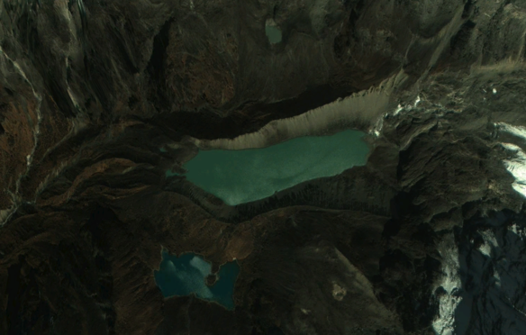 | Dudh Pokhari Lake (imagery from Google Earth November 2, 2008)

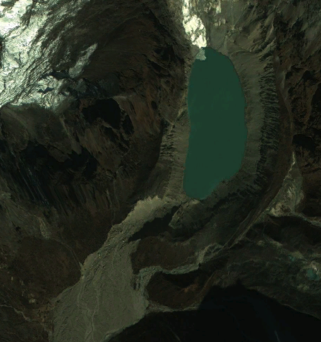 | Tama Pokhari Lake (imagery from Google Earth November 2, 2008)

- Imja Lake - The terminal moraine complex of Imja Lake in the Imja Khola will be surveyed using GPR (see Figure 3). Survey transects will be taken on both sides of the lake outlet complex, longitudinal surveys on each side of the lake outlet, and surveys of the lateral moraines. The data collected in this survey will be compared to the survey lines used by Reynolds (2003). The GPR surveys will be accompanied by continuous GPS measurements of altitude and latitude-longitude position. Extensive photographs will be taken to document the survey. In addition, the area of groundwater/ice melt seepage form the basin of the terminal moraine will be surveyed and transverse survey lines of the lateral moraines will be made. An attempt will be made to estimate the thickness of ice under the lake bottom near the downstream shore.

In general, potential GLOF indicators include: lake area and lake-area expansion rate; up-glacier and down-valley expansion rate; dead-ice melting; seepage; lake water level change; and surge wave by ice or rock avalanche and ice calving. In the case of Imja Lake, risk of GLOFs from rock and/or ice avalanches from the surrounding area are minimal because of the wide valley configuration, i.e., the surrounding source area is far away from the lake and the high lateral moraines (Watanabe et al., 2009).

As the ice core melts the terminal moraine continues to decrease in altitude, or sink. The altitude where the spillway channel cuts through the terminal moraine has remained stable at about 4992m for the past several years. The lake level was 5004 m in 2006. If the dead ice were to continue melting and if the western shoreline reached the same altitude as the spillway channel, then the lake could burst (Watanabe et al., 2009). Current estimates are that more than 100 years would be needed for the western shoreline of the lake to reach the terminal moraine elevation. However, this prediction is highly uncertain. It does seem accurate enough that there is no immediate danger of the lake draining due to expansion (Watanabe et al., 2009).

Down-valley expansion may develop conditions favorable for seepage to occur. Seepage could occur through the surrounding moraines at locations where the altitude is lower than the lake level. In the case of Imja Lake, seepage in the terminal moraine and dead-ice area are of greatest significance. The lateral moraines are unlikely to be a risk since the lake water level is lower than the base of the lateral moraines. As the dead-ice melts, the total volume of water below the terminal moraine increases, raising the possibility of triggering a GLOF by seepage, especially along the spillway. No signs of seepage were found during repeated visits to the study site between 1989 and 2006 (Watanabe et al., 2009). However, seepage from the terminal moraine was found during a visit in September 2011 and increased seepage during this visit in May 2012.

Imja Lake is located in a very active seismic region. During a visit in September 2011 a major earthquake was experienced with an epicenter in the Sikhim region of India. The impact in the Imja area was considerable and may have resulted in rearrangement of ice in the terminal moraine area. Future seismic events could lead to weakening of the terminal moraine and eventual failure leading to a GLOF.

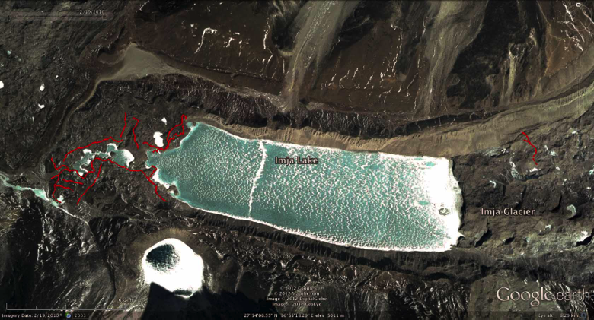
Imja lake (2010 imagery from Google Earth) showing locations of May 2012 GPR surveys (red lines).

- Amphu Lapsa, Imja, and Lotse Shar glaciers - Time permitting, the Amphu Lapsa, Imja, and Lotse Shar glaciers will also be surveyed.

GPR surveys were carried out using a backpack-mounted GPR system with one person carrying the transmitter and one person carrying the receiver. In addition, one person moves in the lead and tows the forward antenna and two people are needed to keep the antennae from getting caught on rocks.

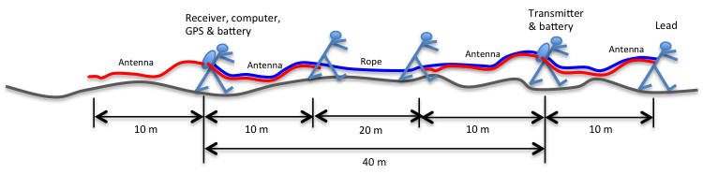
Diagram of backpack mounted GPR system deployment.

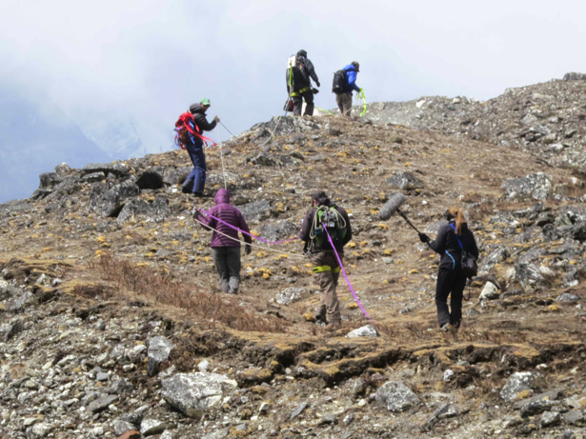 | Backpack mounted GPR system: picture of system deployment in the field at Imja Lake

The structure of the subsurface is surveyed using the GPR with 4kV pulses and antennas operating at 5 MHz (10 m half-length), 10 MHz (5 m half-length), 20 MHz (2.5 m half-length) and 50 MHz (1 m half-length), depending on which antenna provides the best resolution for the depth of the moraine and ice. The GPR results are correlated with the GPS measurements and post-processed using MATLAB software.

One of the hypotheses considered in this research is that global temperature increase has caused the ice core inside the terminal moraine complex of Imja Lake to melt resulting in a smaller ice core than that observed in the previous survey of Reynolds (2003). This information will provide a differential signal of the likely progression of the deterioration of the terminal moraine and provide inputs to the Imja Lake community-based glacial lake risk assessment and decision making project.

2. Daily Activities During Trip

Friday, April 27 - Sunday, April 29, 2012 Travel Austin, Texas to Kathmandu, Nepal via Tokyo, Japan and Bangkok, Thailand

Met in Kathmandu with Kate Voss and Alton Byers from TMI and Marcelo Somos from UT and discussed all details of the expedition and made plans for the meetings in Kathamndu during April 30, May 1, and 2.

Monday, April 30, 2012 Kathmandu, Nepal

Prepared for the trek, checked equipment and purchased last-minute items.

Tuesday, May 1, 2012 Kathmandu, Nepal

Meeting at ICIMOD with Director General David Molden, Madav Karkhi, Pradeep Mool, and Eklabya Sharma – Director Programme Operations. There was a general discussion about ICIMOD global activities followed by a discussion of the HMGWP partnering with UNDP in the Imja Lake GLOF Risk Reduction Project. We discussed the HMGWP planned work on the social component of this project. They mentioned that there are a lot of stakeholder groups in the Khumbu and that we will need to touch base with all of them. They mentioned that the people in the Khumbu want:

- Early Warning System (this is contrary to what we have heard from them and contrary to what UNDP is planning this Imja project)
- Hazard mapping and risk assessment
- Micro-hydropower stations (someone at ICIMOD is working on design of a station for Imja. It is not clear if they are thinking of siting the station at the Lake or at the community.)
- Risk management plans and activities

Traditional knowledge about how the communities have been or are facing difficulties related to climate, glaciers, and the environment (natural hazards) would be very helpful since this information is not known or reported.

The vulnerability of communities and infrastructure downstream is mostly unknown and needs to be estimated. It is necessary to know the expected benefits of flood protection measures in order to determine which ones should be implemented. ICIMOD has not done this yet and they don’t seem prepared to take this on.

Dudh Pokhari lake in the Hinku valley has an overhanging glacier ice and is becoming very dangerous. This is contrary to the images and reports that we have seen.

We asked about Imja Lake bathymetry data and were told that the 2009 ICIMOD EchoSounder survey is the latest data.

Wednesday, May 2, 2012 Kathmandu, Nepal

Training session and preparation for trek.Chris Rainier of the National Geographic Society gave a workshop on still, video and social media aspects of field work. This was a seminar for the TMI field staff in Kathmandu to prepare them for V&A training as well as their other field activities

Meeting at UNDP with Anupa Lamichhane and Vijaya Singh who are leading the UNDP Imja Lake GLOF Risk Reduction Project. We informed them of our program for the trek to the Hinku and Khumbu Valleys and our intention to perform GPR surveys at Dudh Pokhari, Tama Pokhari and Imja Lakes.

We discussed the UNDP Imja Lake project, which is a Community-based Disaster Risk Reduction project. USAID-ADAPT/AISA is handling the Tsho Rolpa Emergency Warning System and Practical Action is working on Tsho Rolpa and might work on future UNDP projects.

The MOU between USAID and UNDP will include both the HMGWP and ADAPT/ASIA. UNDP/Nepal needs to know the USAID budget for the HMGWP work in Nepal for the GEF project proposal. The schedule for the UNDP-GEF project at IMJA is to submit the project document at the of June, get comments from GEF Specialists and receive GEF Board approval at the end of November. Gaps in the UNDP project original design invlude: Micro-hydroelectricity and a prefeasibility study is being performed by Kathmandu University. Micro-Hydro is intended to satisfy the Imja community’s desire for “action” on the ground. ICIMOD has not been able to conduct community-based work in the field and UNDP wants TMI to do this. UNDP would like HMGWP to develop a relationship with ICIMOD for the Imja project and have HMGWP information transferred into ICIMOD. ICIMOD is preparing a draft project document that contains both technical and community-based information. The UNDP concept for the project is that it is mainly about risk reduction and it is community based. Disaster Reduction Management (DRM) groups analyze the risks. If a flood happens, who will be affected? What will happen to travel routes? What will happen to livelihoods? What will happen 1 hour, 2 hours, 3 hours, etc. after flooding starts? Training is needed for rescue and recovery, first responders. Materials are needed for rapid response.

Labor for the Imja Lake project will be difficult. Some small equipment may be sued for construction.

Data – it is unclear what hydrologic data is being for the design of the project.

How will the community benefit from the GLOF risk reduction project? This needs to be quantified. The community beeds to be integrated into the project and they need to feel involved. Hazard mapping of the community is needed.

Thursday, May 3, 2012 Kathmandu

We were scheduled to travel today from Kathmandu to Lulka and start the trek to the Hinku valley, but the weather prevented the flight. Weather delays are common this time of year, immediately before the start of the monsoon season.

Friday, May 4, 2012 Kathmandu to Lukla, Nepal

Finally traveled from Kathmandu to Lulka to start the trek to Hinku valley. Then we hiked to Chutanga (3450m, 11318 ft) and camped for the first night of the trek.

Saturday, May 5, 2012 - Sunday, May 6, 2012 Chatunga to Tuli Karka via Karkatang

We ascended from Chutanga to Karkatang for the second night’s camp. We crossed the very steep and high Chetra La pass (4600 m, 15091 ft), traversed the ridge and continued on to Tuli Karka (4250 m, 13943 ft) for the third night’s camp. At Tuli Karka we stayed at the Sherpa Lodge since there was a heavy thunderstorm and snowstorm.

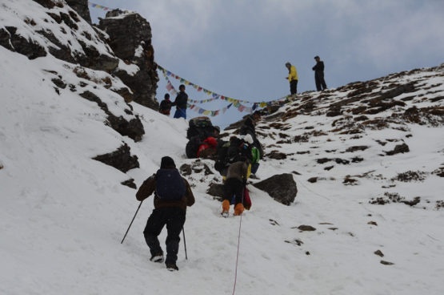 | Crossing Chetra La pass to reach the Hinku Valley

Monday, May 7, 2012 Tuli Karka to Khote

This was a very intense downhill hike with several exposed snow traverses at the beginning followed by the steep descent and then up and down along the river. Today we got our first glimpse of the devastation of the 1998 Tama Pokhari GLOF. The deep incisions in to the river canyon were very prominent. The formerly flat river valley bottom is now completely eroded and all of the farmlands were obviously swept away from the river bottom.

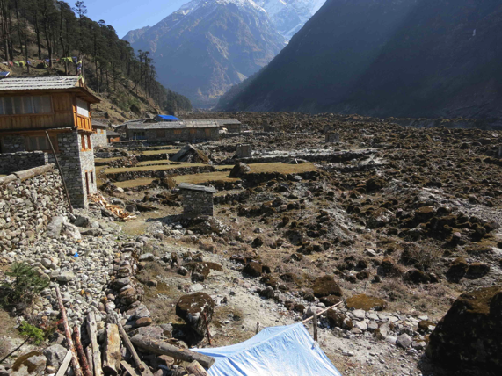 | Debris from the 1998 Tama Pokhari GLOF in the Hinku River at Khote.

Tuesday, May 8, 2012 Khote

Today was a rest day in Khote (3600 m, 11811 ft) to recover from crossing the 4600m Chetral La pass in 3 days and to test the GRP equipment in preparation for our climb up to Dudh Pokhari glacial lake tomorrow. We tested the GPR equipment in static (non-moving) and dynamic (moving) modes. Six tests were performed as described in Table 3.

Table 3. GPR survey tests performed in Kote on May 8, 2012
Test # | Time | Frequency (MHz) | Tx-Rx Separation (m) | Static/Dynamic
1 | 12:10 pm | 20 | 15 | Static
2 | 12:12 pm | 20 | 25 | Static
3 | 12:15 pm | 20 | 25 | Static
4 | 12:20 | 10 | 22 | Static
5 | 12:30 | 5 | 12 | Static
6 | 1:30 pm | 20 | 23.3 | Dynamic

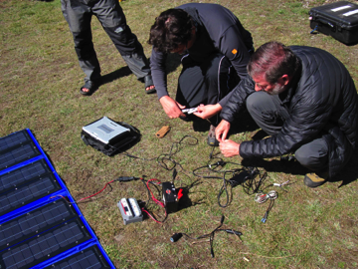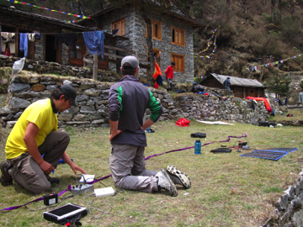
Setting up equipment for static GPR test at Khote. (Photo: James McKinney)

Wednesday, May 9, 2012 Khote to Dudh Pokhari

Today we ascended from the Hinku valley at Khote to the high glacier lake, Dudh Pokhari (4773 m, 15,660 ft).

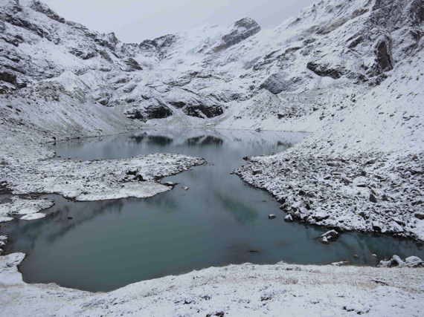 | Dudh Pokhari in the Hinku Valley in the morning

Thursday, May 10, 2012 Dudh Pokhari

Today we did the GPR survey of the terminal moraine at Dudh Pokhari. The lake does not have steep walls capable of sending an ice or rock avalanche into the lake and causing a surge wave. The lake does not seem to have any noticeable GLOF triggers.

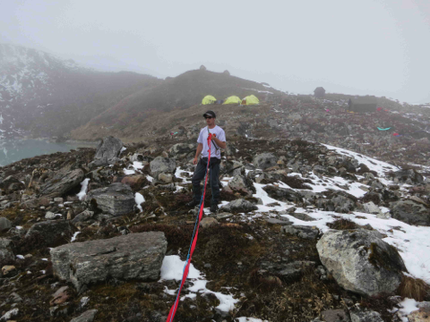 | GPR survey equipment deployed to survey the terminal moraine at Dudh Pokhari

Table 4. GPR survey tests performed in Dudh Pokhari May 10, 2012
Test # | Time | Frequency (MHz) | Tx-Rx Separation (m) | Static/Dynamic | Direction (looking downstream)
1 | 9:25 am | 20 | 15 | Static
2 | 9:42 am | 10 | 25 | Static
3 | 9:50 am | 5 | 40.6 | Static
4 | 10:29 am | 5 | 40.4 | Dynamic | (R to L)
5 | 11:00 am | 5 | 40.4 | Dynamic | (L to R)
6 | 11:25 am | 10 | 25 | Dynamic | (R to L)
7 | 12:20 pm | 10 | 25 | Dynamic | (L to R)

Friday, May 11, 2012 Dudh Pokhari to Tagnag

Today we descended from Dudh Pokhari and trekked up the Hinku Valley to the village of Tagnag (4037 m, 13246 ft). Tagnag was damaged in the 1998 GLOF from Tama Pokhari. One of the very apparent things in Tagnag is the new construction encroaching on the floodplain of the Hinku River.

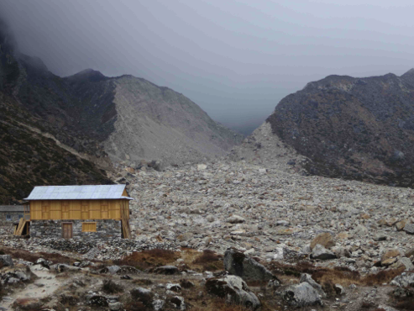 | Tagnag showing the breach in the terminal moraine of Tama Pokhari and the new construction extending out into the GLOF debris

Saturday, May 12, 2012 Tagnag

Today we conducted GPR surveys at the site of the breach in the Tama Pokhari terminal moraine resulting from the 1998 GLOF. Our guide, JB Rai, noted that the size of the lake has increased considerably since 2 years ago. The lake outlet is 51m in width. The GPR transects were about 100m long across the outlet mouth. The walls above the lake do apprear to have the potential to generate rock and ice avalanches that would fall into the lake and create surge waves. The waves would not be blocked by the terminal moaraine and could cause flooding downstream, although not of the size and nature of the 1998 GLOF.

Table 5. GPR survey tests performed in Tama Pokhari May 12, 2012
Test # | Time | Frequency (MHz) | Tx-Rx Separation (m) | Static/Dynamic | Direction (looking downstream)
1 | am | 20 | 20 | Dynamic | (L to R)
2 | am | 20 | 20 | Dynamic | (R to L)
3 | am | 10 | 24.4 | Dynamic | (L to R)
4 | am | 10 | 24.4 | Dynamic | (R to L)

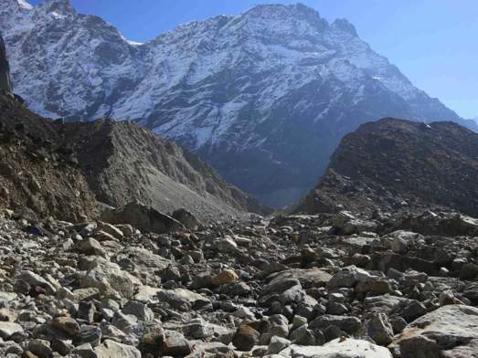 | Breach in the terminal moraine of Tama Pokhari from the 1998 GLOF
.
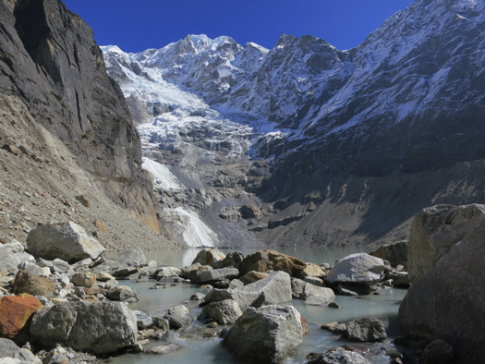 | The outlet of Tama Pokhari glacial lake. Note the lack of any freeboard between the lake level and the lake outlet and the steep walls of the mountains above with the overhanging ice.

Meeting - We met with the Mera Alpine Conservation Group (MACG) in Tagnag after completing the GPR surveys. Lapkha Sherpa (opening statement in the Sept 2011 Imja video). The MACG meets once per month. The MACG provided a list of what they need to be more effective:

- Construction of an office
- Solar heaters for hot water
- Training of lodge cooks using local food
- First-aid training (WEMT)
- Caps and jackets with MACG logos
- Garbage management
- Nursery plantation
- Drinking water management
- Minihydropower
- Flood protection around the Khare River
- Toilet management

We informed them of what we saw and measured at both Dudh Pokhari and Tama Pokhari. We saw that the lake has grown a small amount. Ice cliffs exist above the lake and will eventually cause some ice avalanches that will fall into the lake and cause small floods downstream in Tagnag. These will not be as large as the 1998 GLOF, but they could be damaging if there is encroachment into the flood plain. We need to measure the bathymetry of the lake in order to predict the potential size of the future waves and floods. The MACG members told us that small floods of this type had happened in 2008 and 2011. They estimate the depth of the lake to be 35m, but have no proof of this. The Ministry of Hydrology sent a specialist in 1999 to measure it. A new bathymetric survey is needed in order to estimate the volume of water in the lake and to predict the size of waves and subsequent floods that may be generated by ice avalanches. We need to know the relationship between the volume or mass of ice falling into the lake and the generated wave so that we can predict moraine overtopping and the resulting flood.

In the afternoon, we trekked from Tagnag to Khote.

Sunday, May 13 - Monday, May 14, 2012 Khote to Lukla via Tuli Kharka

Today we trekked from the village of Khote to the lodge at Tuli Kharka, about half way up the Chetra La pass on our way from the Hinku Valley back to the Khumbu Valley at Lulka. The next day we trekked from Tuli Kharka over the Chetra La pass to Lukla.

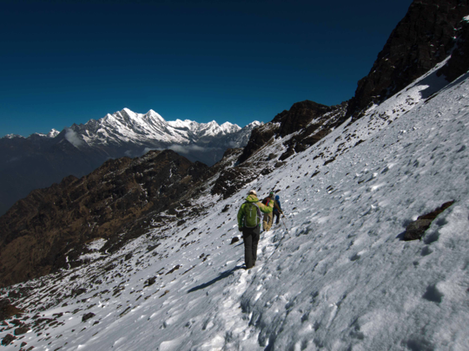 | Approaching Chetra La pass from the Hinku side.

Tuesday, May 15, 2012 Lukla to Monjo

Today we began the second half of our expedition trekking up the Dudh Khosi valley from Lukla to Monjo. We stayed at the Summit Home Lodge in Monjo and the owner showed us the lodge’s all electric kitchen powered by a 100 kW hydroelectric system (the system provides power for 10 lodges).
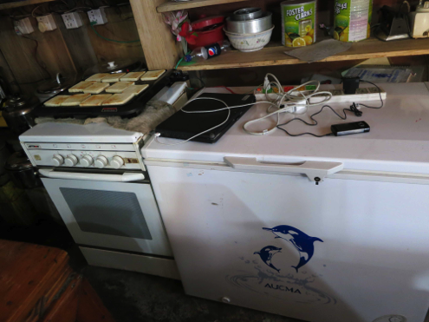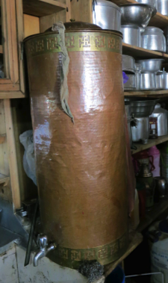
Electric appliances (stove w/ oven, freezer - left, and hot water heater - right) in the Summit Home Lodge.

Wednesday, May 16 - Friday, May 18, 2012 Monjo to Deboche via Namche Bazar

Trekked from Monjo to Namche Bazar. We had an acclimatization day in Namche Bazar. Trekked from Namche Bazar to Deboche via Tengboche. In Tengboche we visited the monastery and delivered a 1956 Fritz Muller photograph to the Rimpoche of the monastery.

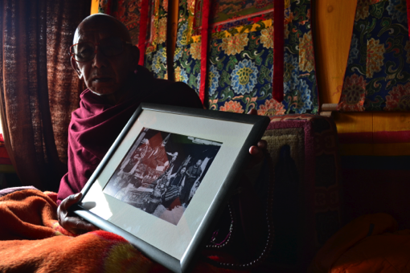 | Rimpoche with Fritz Müller photograph from 1956.

Saturday, May 19 - Sunday, May 20, 2012 Deboche to Dingboche

Trekked from Deboche to Dingboche. We had an acclimatization day in Dingboche and meeting with the Khumbu Alpine Conservation Council (KACC). We presented the KACC with interpretive panels of the Khumbu region for them to display in their office. We also discussed the HMGWP and our plan of work for Imja Lake. There was a lot of discussion with the KACC about why “action” is not yet being taken to reduce the risk posed by Imja Lake. We explained about the UNDP facilitated GEF Imja Lake GLOF Risk Reduction project and that this project is in the development stage and requires certain technical inputs in order to design an intervention at the lake. Most of the KACC members seemed to feel that our GPR surveys are a good thing since they will provide valuable inputs to the GEF project.

Monday, May 21 - Tuesday, May 22, 2012 Dingboche to Imja Lake via Chukhung

Trekked to Chukhung and climbed to Chukhung Ri (5,500 m, 18,044 ft). Trekked from Chukhung to Imja Lake (5010 m, 16,437 ft). We performed static GPR measurements at the Imja Lake Base Camp and dynamic GPR survey traces at the camp, the ridge of the moraine above the camp, the left lateral moraine, and at the lake. We observed an ice wall present in the left lateral moraine. This ice wall may be extensive and could be a weakness in the moraine, especially if there is an earthquake or if the moraine is cut for a control channel.

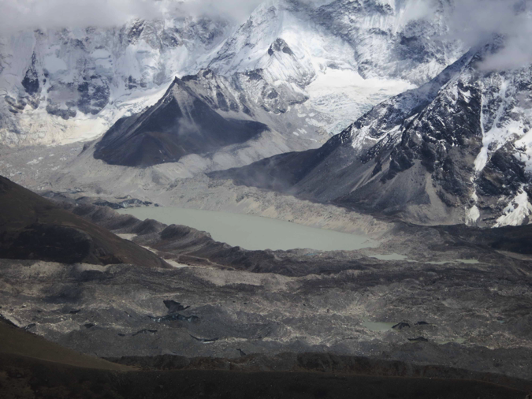 | Imja Lake seen from Chkhung Ri with Imja glacier (back on the left), Amphupalcha glacier (on the right) and Lhotse glacier (in front). The long outlet complex lakes are on the front right of the image.

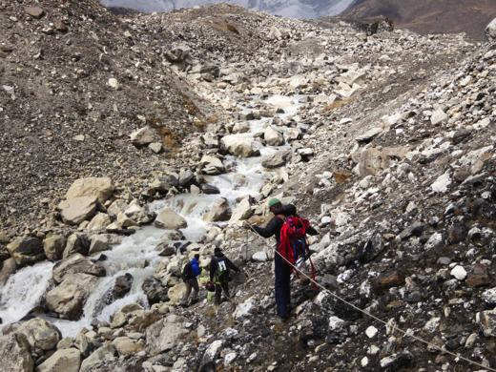 | Performing GPR survey at the outlet of Imja Lake.

Wednesday, May 23 - Saturday, May 26, 2012 Imja Lake

We performed dynamic GPR survey traces at the right lateral moraine, and at the lake. We observed ice in many locations of the moraine. We met with Sonam Hishi of the KACC at the lake and discussed the changes in the lake since September (much higher water level and increased crevasses present).

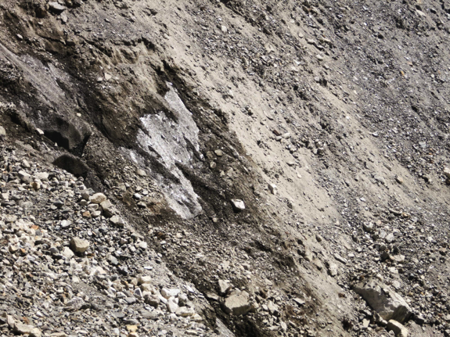 | Exposed glacial ice in the right lateral moraine at Imja Lake.

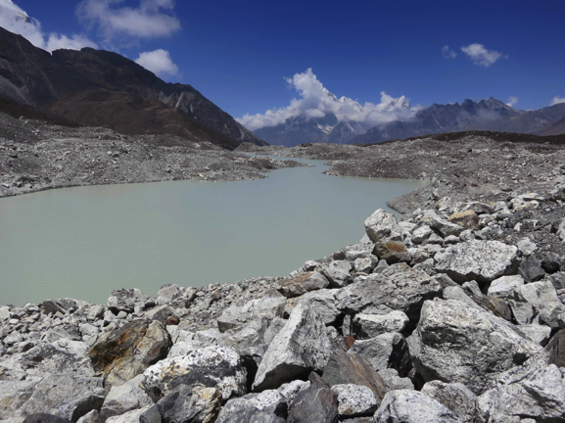 | Outlet complex in the terminal moraine of Imja Lake

The second day at Imja Lake we performed dynamic GPR survey traces at the left lateral moraine of Imja Lake in the area where we observed the ice wall on Tuesday. This ice wall is very extensive horizontally and about 25 m tall with about 1 m of debris on the top.

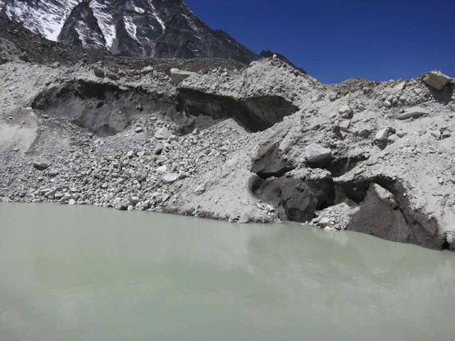 | Exposed glacial ice wall in the left lateral moraine at Imja Lake.

On Friday hiked up to the base of the Lhotse Shar glacier and attempted to descend to the surface of the glacier, but we found that this was too difficult and that we might not be able to ascend back up to the trail after we completed a GPR survey. We were able to descend to the Imja Glacier and performed dynamic GPR survey traces on the glacier.

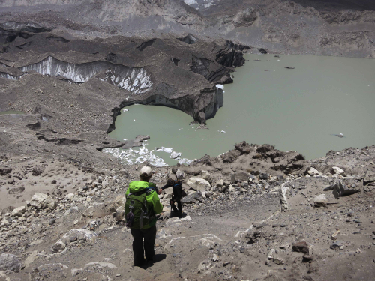 | Descending (250 m) to the Imja glacier from the Island Peak base camp trail.

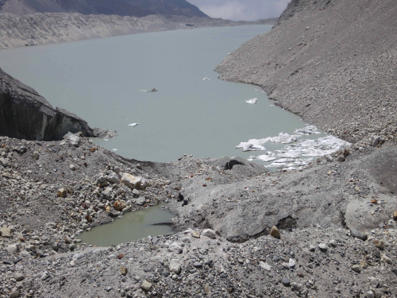 | Imja lake from the glacier snout.

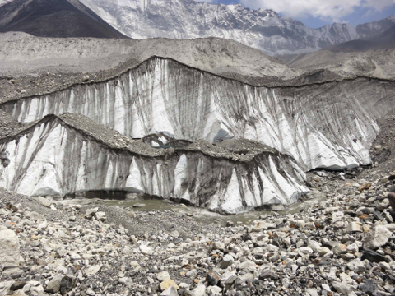 | Ice cliff and stream in the center of the Imja glacier.

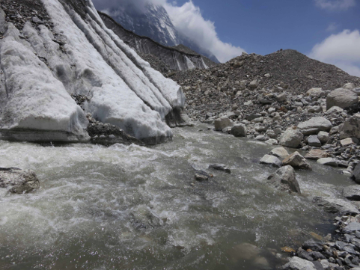 | Meltwater in stream at the center of the Imja glacier.

On Saturday we performed final dynamic GPR survey traces at the left and right lateral moraines, especially in the area of observed seepage from the left terminal moraine. The seepage from the lower levels of the moraine indicates that there is a direct flow network through the lake or the melting ice core of the moraine. The seepage observed on this trip in May 2012 was signifantly greater than the seepage observed in September 2012 and it was in a different location on the terminal morain. It is possible that the September 2011 earthquake rearranged materials in the moraine causing the shift in seepage location. Continued seepage will wash finer materials out of the moraine in the path of the seepage and potentially weaken the moraine, possibly leading to failure.

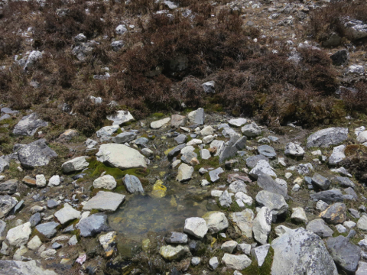 | Source spring of seepage in terminal moraine at Imja Lake.

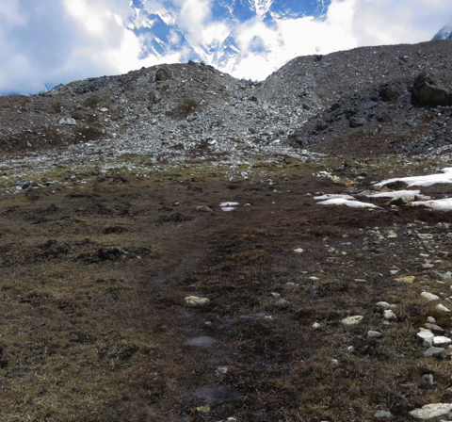 | Seepage from terminal moraine at Imja Lake.

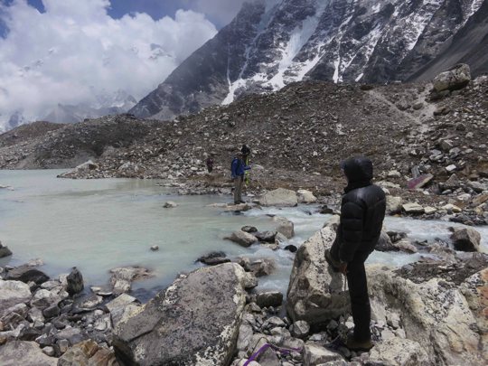 | Taking GPR survey across the outlet of Imja Lake

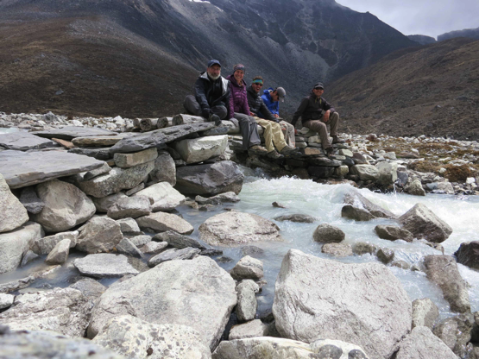 | Bridge across the Imja Khola just downstream of the Imja Lake outlet. Site of flow measurement

Flow calculation – The flow from the Imja Lake outlet was roughly estimated using the “float method” where an object is timed as it floats a known distance down the stream. In this case a Yak chip was used as the float. It took the chip 14 seconds to float 18.4 m downstream from the bridge over the stream. The water depth at the bridge was measured in three places

Table 6. Imja Khola Flow Calculation Measurements
 | Distance, d (m) | Depth, h (m)
Location 1 | 0.5715 | 0.2667
Location 2 | 1.143 | 0.4826
Location 3 | 0.5715 | 0.3302

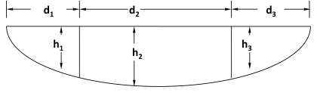 | Stream cross section for flow measurement calculation

V = (L/T)(C) C = 0.8 for a rocky stream
= (18.4 m/14 s)(0.8)
V = 1.05 m/s

A = Σd_{i}h_{i} = d₁h₁+d₂h₂+d₃h₃
= 0.5715*0.2667+1.143*0.4826+0.5715*0.3302 m²
A = 0.893 m²

Q = AV
= 0.893 m² * 1.05 m/s
Q = 0.938 m³/s

Sunday, May 27 to Thursday, May 31, 2012 Imja Lake to Lukla

Friday, June 1, 2012 Lukla to Kathmandu

The Lukla airport was closed for several days due to weather and almost all flights had been cancelled. Several hundred trekkers had been stuck without flights in Lukla for 5-6 days. Today 6 or the remaining 7 members of our team flew by helicopter from Lukla to Kathmandu.

Saturday, June 2, 2012 Lukla to Kathmandu

Today I flew by airplane from Lukla to Kathmandu. This was one of three flights that made it out of Lukla today. JB Rai and Bheem were still in Lukla due to lack of space on the flights. About half of our luggage also remained in Lukla. I met briefly with the ADAPT-Asia team, including Cesar Portocarrero, upon my arrival in Kathmandu.

Sunday, June 3, 2012 Kathmandu

Today was a rest and recovery day in Kathmandu.

Monday, June 4, 2012 Kathmandu

Meeting with Vijaya and Anupa of UNDP/Nepal. We updated them on the trip and our observations of three lakes (Dudh Pokhari, Tama Pokhari and Imja). There seemed pleased to have some information from the field and I got the feeling that, other than the team from Kathmandu University, no other team has been in the field for several years except for us this time and in September. We talked about the increasing observation of exposed ice in the moraine at Imja and they seem to be concerned about this. The GEF Project Document has been delayed for at least one week due to the recent political events here in Nepal. They promised that the document would be circulated to our team for comments some time after they receive it. They asked me to send them a couple of paragraphs describing the activities that HMGWP is undertaking so that they can include it in the section describing what other donors are doing related to Imja/GLOFs. I will try to send them something soon. We also talked about the project implementation. The GEF Board should have the Project Document to consider at the November board meeting. They expect to receive approval at that time. The PIU for the project has not been decided and they hope that the Department of Hydrology and Meteorology will agree to be the PIU. However, the Director General of the DHM has said that he has no interest in the project and he will only be in position for 4 more months anyway. UNDP is in the process of speaking with the Deputy DGs at DHM to see if any of them has interest in the project. In the event that DHM does not take on the PIU, UNDP will have to act as PIU and implement the project themselves. They did not seem to expect that, given current political realities in Nepal, that any GoN office is likely to take on implementation of such a complex project management/construction effort. Regarding the Environmental Impact Assessment, UNDP does not intend to perform an assessment, nor do they seem to consider it necessary. I mentioned our schedule for processing the GPR data and preparing a report for presentation in the September workshop and they were positive about the impact that the data may have on the design options for Imja and they are looking forward to the workshop. They are also very interesting in the GLOF modeling and risk/vulnerability analysis we are doing. We have contacted the EVK2 staff regarding the enhanced topography data that they may have.

Tuesday, June 5, 2012 Kathmandu to Bangkok

Today we traveled from Kathmandu to Bangkok and prepared for a meeting the next day with UNDP.

Wednesday, June 6, 2012 Bangkok

Meeting with Gernot Laganda and Martijn Gough of UNDP Asia-Pacific Regional Centre in Bangkok today. Gernot will be leaving UNDP for IFAD in July and Martijn will be taking over the Imja GLOF Risk Reduction Project. The UNDP GLOF portfolio of projects is growing with new activities underway in Pakistan and Nepal after the success of the project in Bhutan. We briefed them on HMGWP recent activities in Thulagi, the Hinku and the Khumbu with emphasis on the Imja Lake activities and the planned next steps (July Training-of-Trainers in Kathmandu, presentation of Imja GPR results in September Workshop in Kathmandu, September community training workshops in the Khumbu, continued GLOF modeling, and vulnerability analysis related to GLOF risk). Gernot said that they are very glad to have these activities ongoing during the time when the GEF secretariat is considering the Imja project proposal. After the anticipated GEF Board approval of the project in November, UNDP is planning an inception workshop for the project in early 2013 and intends to invite major HMGWP participation in the workshop. Gernot sees this as a time for people with knowledge of the Imja Lake situation to get information out on the table and to develop a consensus on what is known and what gaps in knowledge remain (he hopes that the September workshop can also help to clarify this). The implementation of the GEF project will have opportunities for several groups to be involved, including the HMGWP.

We discussed the idea of an Environmental Impact Assessment. The Bhutan GLOF project had an EIA once the concept of the project had been approved for funding and prior to implementation. Gernot thinks that the idea of an Imja EIA prior to GEF board approval and project implementation is premature since the concept of the design is too vague at this time to be able to assess. UNDP will perform and EIA at the beginning of the project implementation phase.

Gernot is very concerned about the issues raised by Cesar (arbitrary 3 m lowering of the lake and presence of ice in the moraine complex). The GEF project document will express that the lake should be lowered "a minimum of 3 m" rather than specifying exactly 3 m. We discussed this for a while and I tried to get the point across that lowering the lake by a few meters may not reduce risk when the most likely trigger is an earthquake. He explained that a specific concept (lake lowering) with a specific target (~ 3 m) is necessary in order to assure donor buy-in otherwise many questions will be raised about vagueness of the project concept.

The possible implementing agency for the GEF project was discussed at length. Gernot expressed great concern that there is little interest in DHM for being the implementing agency. He would like to place a long-term advisor in DHM to ensure that someone is there to keep the staff up to date on the project, even if the PIU is handled by UNDP/Nepal. It seems that the method of implementation will be directly from the UNDPNepal office with a representative of the GoN as the chair of a project Steering Board. The problem will be to find someone within the GoN to chair that Board.

We also discussed hydropower. It was mentioned that hydropower is just one of the options being considered for potential implementation and UNDP does not expect it to be something that will be implemented for many of the reasons we have discussed (few months of the year when people are resident, distance and elevation difference between Imja and potential electricity demand sites, etc.). UNDP wants to be able to show the community that a variety of potential activities have been considered that may have benefits for the community.

Thursday, June 7, 2012 Bangkok to Austin

3. Recommendations

3.1. Refinement of Imja Lake GLOF Model

A hydraulic model of a potential Imja Lake GLOF was created by McKinney and Somos in early 2012. This model assumes that the potential GLOF contains only water as it propagates downstream. This is not correct since there will be considerable sediment transported by the GLOF as well. Some of the sediment could come from the moraine of the lake and some will be picked up (and deposited) from the riverbed downstream. It has been shown (Osti and Egashira, 2009) that by not considering the sediment transport of a GLOF, the destructive power of the GLOF is significantly underestimated. Therefore, it is recommended that the existing Imja GLOF model be improved to consider both the sediment transport from the moraine at the lake as well as deposition and scouring of sediment from the stream channel downstream of the lake.

3.2. Vulnerability Analysis of Potential Imja Lake GLOF

Several of the UNDP staff members that were met on this mission recommended that the benefits of decreasing the risk of a GLOF from Imja Lake should be calculated. The most appropriate way of calculating these benefits is through a formal vulnerability analysis of the communities and assets downstream of the lake and potentially in the path of a GLOF. Using the Imja Lake GLOF model and the knowledge that we are gaining about the downstream communities, a vulnerability analysis should be performed to determine the potiential losses from a GLOF and what the benefits to the communities might be from a lake risk reduction project.

3.3. Hydrologic Model of Imja Lake

Imja Lake has been increasing in size since the early 1960s and the growth rate of the lake has increased in recent years. The risk associated with a potential GLOF from Imja Lake is directly related to the volume of water that might be released from the lake in the event of a GLOF. The evolution of the volume of water in the lake over coming years or even decades can be predicted using a simple hydrologic (or water balance) model of the lake. Using the glacier ice depth data obtained on this mission along with various lake volume estimates made in recent years and globally available climatic data, a rough estimate of the future size and volume of the lake can be made.

3.4. Bathymetric Mapping of Glacial Lakes

Bathymetric surveys have been carried out in the Nepal Himalaya using an inflatable boat with an outboard motor. The bathymetric observations are used to estimate lake storage volume; to evaluate the lake bottom condition near the outlets; and to assess stability of the end moraines below the lake surface. The positions (X and Y coordinates or grid) of the bathymetric observation points are recorded using a GPS. Depth measurements are made using equipment such as fish-finder or echo-sounder equipment. The bathymetric measurements should be taken 5 -10 m from shorelines for safety reasons to avoid active sliding of the inner moraine slopes. Bathymetric maps can then be prepared and the surface area and storage volume of the lakes calculated. Bathymetric surveys are needed at Tama Pokhari and Lake 464 (Imja Lake also in case we can not get access to the 2009 ICIMOD survey results).

3.5. Flow Measurements of Glacial Lake Outlets

None of the glacial lakes that we visited on this mission have stream gauges installed to measure the flow from them. In addition, most of the streams in these areas do not have any flow measuring on a regular basis. It is recommended that a simple flow measuring device be installed at the bridge in the Imja Khola downstream of the outlet to Imja Lake. This device could be a very simple self-contained recording device form which flow measurements could be retrieved form time to time when someone makes a trip to the lake. A device installed in the Hinku Khola below Tama Pokhari would also be a good idea.

3.6. Flood Model of Tama Pohkari Lake

In our survey of Tama Pokhari we noted that ice and rock avalanches would continue and that they would create surge waves and resulting floods from the lake that endanger downstream communities like Tagnag. In the meeting with the Mera Alpine Conservation Group, they mentioned to us that these flood s have been happening every 2-4 years in the recent past (including 2011) and that they are concerned since they do not know what size floods could occur or how to prepare for them. A model of potential avalanches (ice or rock) with associated wave generation and flood propagation could be built to test various scenarios of flooding from Tama Pokhari.

3.7. GPR Survey of Lake 464

As noted in the 2009 and 2010 expeditions of Byers et al., Lake 464 in the Hongu Valley is considered one of the most likely lakes in Nepal to experience a major GLOF event in the next few years. One of the major unknown factors about this lake is the structure of the terminal moraine and the existence of an ice core in the moraine. In addition, the volume of the lake cannot be estimated since no bathymetry data exists for the lake. It is recommended that GPR and bathymetric surveys be conducted at this lake in the near future (fall 2012).

4. References

Annan, A. P., J. L. Davis, (1976). Impulse radar sounding in permafrost. Radio Science 11, 383–394.

Bajracharya, S. R., P. K. Mool, B. R. Shrestha (2007a). Impact of Climate Change on Himalayan Glaciers and Glacial Lakes Case Studies on GLOF and Associated Hazards in Nepal and Bhutan, International Centre for Integrated Mountain Development (ICIMOD), Kathmandu, Nepal (ICIMOD, 2007)

Bajracharya B., A. B. Shrestha, L. Rajbhandari (2007b). Glacial lake outburst floods in the Sagartmatha regions: hazard assessment using GIS and hydrological modeling. Mountain Research and Development 27: 336ñ–344.

Bolch, T., M. F. Buchroithner, J. Peters, M. Baessler, S. R. Bajracharya (2008). Identification of glacier motion and potentially dangerous glacier lakes at Mt. Everest area/Nepal using spaceborne imagery. Natural Hazards and Earth System Sciences 8: 1329-1340

Buchroithner, M.F., G. Jentsch, B. Wanivenhaus (1982). Monitoring of recent geoligical events in the Khumbu Area (Himalaya, Nepal) by Digital Processing of Landsat MSS Data. Rock Mechanics 15, 181–197.

Byers, A. (2007). An assessment of contemporary glaciers fluctuations in Nepalí’s Khumbu Himal using repeat photography. Himalayan Journal of Sciences 4(6): 21ñ–26.

Dahal, K.R and R. Hagelman (2011). People’s risk perception of glacial lake outburst flooding: a case of Tsho Rolpa Lake, Nepal, Environmental Hazards 10, 154-170

Davis, J. L., A. P. Annan (1989). Ground-penetrating radar for high-resolution mapping of soil and rock stratigraphy. Geophysical Prospecting 37 (5), 531–551.

Fujita K, A. Sakai, T. Nuimura, S. Yamaguchi, R. R. Sharma (2009). Recent changes in Imja Glacial Lake and its damming moraine in the Nepal Himalaya revealed by in-situ surveys and multi-temporal ASTER imagery. Environmental Research Letters 4, 045205 (045207pp), doi:045210.041088/041748-049326/045204/045204/045205.

Fushimi, H., K. Ikegami, K. Higuchi, and K. Shankar (1985). Nepal Case Study: Catastrophic Floods, IAHS Publication 149: 125–130

Hambrey, M. J., D. J. Quincey, N. F. Glasser, J. M. Reynolds, S. J. Richardson, S. Clemmens (2008) Sedimentological, geomorphological and dynamic context of debris-mantled glaciers, Mountain Everest (Sagarmatha) region, Nepal. Quaternary Science Reviews 27: 2361–2389.

ICIMOD (2011), Glacial lakes and glacial lake outburst floods in Nepal. International Centre for Integrated Mountain Development (ICIMOD), Kathmandu, Nepal

Ives, J. (1986). Glacial Lake Outburst Floods and Risk Engineering in the Himalaya, International Centre for Integrated Mountain Development (ICIMOD) Occasional Paper No. 5, Kathmandu

Ives, J. D., R. B. Shrestha, P. K. Mool, (2010). Formation of glacial lakes in the Hindu Kush-Himalayas and GLOF risk assessment. International Centre for Integrated Mountain Development (ICIMOD), Kathmandu, Nepal (ICIMOD, 2010b)

Komori, J. (2012). GLOF risk assessment in the Bhutan Himalayas, Knowledge sharing for effective risk management of hydro-meteorological hazards in the Hindu-Kush-Himalayan region, United National Development Program, Kathmandu, Nepal, 21-23 March 2012

Konz, M., L. N. Braun, W. Grabs, A. Shrestha, S. Uhlenbrook (2005). Runoff from Nepalese Head Watersheds based on Measurements and Modelling, IHP/HWRP-Report by the Federal Institute of Hydrology, Koblenz, Germany

Lamsal, D., T. Sawagaki, and T. Watanabe (2011). Digital Terrain Modelling Using Corona and ALOS PRISM Data to Investigate the Distal Part of Imja Glacier, Khumbu Himal, Nepal. J. Mt. Sci. 8: 390-402 DOI: 10.1007/s11629-011-2064-0

Mool, P. K., S. R. Bajracharya, S. P. Joshi, (2001) Inventory of glaciers, glacial lakes, and glacial lake outburst floods: Monitoring and early warning systems in the Hindu Kush-Himalayan regions - Nepal. International Centre for Integrated Mountain Development (ICIMOD), Kathmandu, Nepal (ICIMOD, 2001)

Osti, R., and S. Egashira (2009). Hydrodynamic characteristics of the Tama Pokhari Glacial Lake outburst flood in the Mt. Everest region, Nepal, Nepal Hydrol. Process. 23, 2943–2955

Osti, R., S. Egashira, K. Miyake, and T. N. Bhattarai (2010). Field Assessment of Tama Pokhari Glacial Lake Outburst Flood in Khumbu Region, Nepal, Journal of Disaster Research, 5(3)

Pradhan, N.S., V. R. Khadgi, L. Schipper, N. Kaur, T. Geoghegan, (2012). Role of Policy and Institutions in Local Adaptation to Climate Change – Case studies on responses to too much and too little water in the Hindu Kush Himalayas. Kathmandu: ICIMOD (it is in the Dropbox folder)

Reynolds Geo-Sciences Ltd (RGSL) (2003). Development of glacial hazard and risk management protocols in rural environments – Guidelines for the use of geophysical methods in the assessment of glacial hazards, Report R7816.142, Appendix A4. RGSL, Mold, UK.

Sakai A, M. Saito, K. Nishimura, T. Yamada, Y. Lizuka, H. Harada, S. Kobayashi, K. Fujita, C. B. Gurung (2007). Topographical survey of end moraine and dead ice area at Imja glacier in 2001 and 2002. Bulletin of Glaciological Research 24: 29–36.

Vuichard, D. and M. Zimmermann (1986). The Langmoche Flash-Flood, Khumbu Himal, Nepal, Mountain Research and Development, Vol. 6, No. 1 (Feb., 1986), pp. 90-94

Watanabe T., J. D. Ives, J. E. Hammond (1994). Rapid growth of a glacial lake in Khumbu Himal, Himalaya: prospects for a catastrophic flood. Mountain Research and Development 14(4): 329–340.

Watanabe T., S. Kameyama, T. Sato (1995). Imja glacier dead-ice melt rates and changes in a supra-glacial lake, 1989-1994, Khumbu Himal, Nepal: Danger of lake drainage. Mountain Research and Development 15(4): 293ñ–300.

Watanabe T, D. Lamsal, J. D. Ives (2009). Evaluating the growth characteristics of a glacial lake and its degree of danger of outburst flooding: Imja Glacier, Khumbu Himal, Nepal. Norsk Geografisk Tidsskrift 63(4): 255–267.

Woodward, J. and M. J. Burke (2007). Applications of Ground-Penetrating Radar to Glacial and Frozen Materials, J. Environmental and Engineering Geophysucs, March 2007, Volume 12, Issue 1, pp. 69–85

Yamada T. (1998). Glacier lakes and its outburst flood in the Nepal Himalaya. Monograph No.1, Data Centre for Glacier Research, Japanese Society of Snow and Ice.

Zimmermann, M., M. Bichsel, H. Kienholz (1986). Mountain Hazards Mapping in the Khumbu Himal, Nepal, Mountain Research and Development, Vol. 6, No. 1, pp. 29-40

