TRIP REPORT

Lima and Huaraz, Peru

Prepared By:
Daene McKinney and Alton Byers
June 30 – July 22, 2012

1. Background

1.1. Objectives of the Trip

This trip had several objectives, including:

Palcacocha Lake - Improve the previously developed GLOF model of Lake Palcacocha through GPR survey of the terminal moraine in the vicinity of the 1941 breach in the glacial terminal moraine. Present the results of the GLOF model to a group of interested stakeholders in Huaraz. Obtain access to updated information about the lake and potential new GLOF risk reduction system. Develop new relationships with stakeholders including the Office of Civil Defense of the Ancash Department.

Pastaruri Glacier - Map the thickness of the ice in the Pastaruri glacier using GPR in order to provide needed information to the Huascaran National Park and the Municipality of Catac. The Park and Municipality have received funds to create an outdoor climate change museum using the popular Pastaruri glacier as the centerpiece. The GPR data, once processed, will be used in interpretive maps of the current extent of glacier ice. Modeling of theglacier will allow prediction of the future extent of the ice.

Arteson Glacier - Perform GPR survey of the Arteson glacier in order to estimate the future evolution of the newly forming glacier lake at its base. This lake has been identified as one of the newst risks forming in the Cordillera Blanca and the Glaciology Office is monitoring its mass balance monthly. GPR data will allow a mapping of the ice thickness and the bedrock location, an indicator of the potential for dangerous glacial lake formation.

Progress on Major Deliverables for Year 1 – Provide guidance and inputs for major deliverables in Year 1, including: Glacier Lake Control and Management Handbook; Glacier Lake Risk Perception Study; and High Mountain Issue Paper.

Workplanning for Year 2 – Major development of the second year workplan and budget is carried out during this mission. This includes discussions between TMI Nepal, TMI Peru, TMI HQ, and UT Austin.

2. Daily Activities During Trip [University of Texas at Austin and TMI]

Saturday, June 30, 2012 Travel Austin, Texas to Lima Peru via Atlanta

Sunday, July 1, 2012 Lima, Peru

Meeting with Kate Voss from TMI in Lima with and discussed details of the trip and made plans for meetings in Lima during July 2. Checked on status of lost luggage at airport.

Worked on Small Grants Proposal Reviews.

Monday, July 2, 2012 Lima, Peru

Retrieved the GPR equipment from customs at Lima Airport and received permission to use the equipment in Peru.

Meeting with Professor Wilfried Haeberli of University of Zurich is directing a Swiss Development Agency project “513 Glaciers” to strengthen the capacity of the Glaciology Unit of ANA. The project is implemented by CARE in Peru with the assistance of the University of Zurich. Prof. Haeberli has developed a GIS-based approach to determining the future formation of glacier lakes and is applying this technique to the glaciers of the Cordillera Blanca. Our GPR surveys may be useful in collaboration with his technique to determine the future extent, volume and risk of glacier lakes that have begun to form or may form in the future. We will be following up on this collaboration in the coming months.

Meeting at ANA with Director General. We met with the General Director of ANA and explained the basic purposes of the HMGWP. He was very supportive of our efforts to assist various communities and groups in the high mountain areas develop adaptation methods to deal with climatic change. He attended the following workshop and listened to each presentation with interest.

Presentation of the High Mountain Glacial Watershed Program at the National Water Authority of Peru. CARE, the University of Zurich, and the Swiss Agency for Development and Cooperation Conference "Effects on Water Reduction by High Mountain Glaciers" organized by Professor Haeberli. The audience consisted of about 150 staff members of ANA including the General Director. Other presentations were by Prof. Haeberli, Jorge Recharte of TMI, Jesus Gomez of the Glaciology Unit, and Wilson Suarez of the ANA Meteorology Department.

Prof. Haeberli has agreed to present his work on “New/future lakes in de-glaciating mountains” at the American Geophysical Union (AGU) session “Global Environmental Change: Water Supply in Glacierized Mountain Watersheds - Monitoring Hydrological Transitions and Assessing Vulnerability in a Changing Climate,” San Francisco December 3-7, 2012 which has been organized by HMGWP Community of Practice members.

Worked on Small Grants Proposal Reviews.

Tuesday, July 3, 2012 Lima to Huaraz, Peru

Traveled by bus from Lima to Huaraz, Peru.

Worked on Small Grants Proposal Reviews.

Meeting with Alton Byers, Kate Voss, Marcelo Somos, Jorge Recharte and Cesar Portocarrero to review objectives for the trip and the development of the second-year workplan.

Wednesday, July 4, 2012 Huaraz, Peru

Meeting with Alton Byers, and Kate Voss to develop the second-year workplan and budget.

Worked on Small Grants Proposal Reviews.

Thursday, July 5, 2012 Huaraz, Peru

Trek to Lake Palcacocha by Kate Voss and Marcelo Somos to conduct GPR survey of the terminal moraine of the lake. The beginnings of a new GLOF risk reduction project were seen in the form of 5 siphons that were being used to lower the lake before beginning a new cut in the moraine to install a new system. Only 1 of 5 siphons was operational and the other 4 were under repair. This lake lowering system is being upgraded due to the inability of the prior system to handle the current melt rates of the glaciers and expansion of the lake.

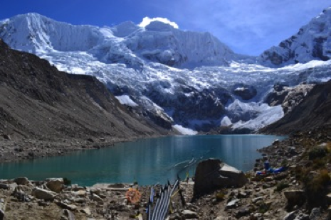 | Palcacocha Lake showing siphon pipes leading to the lake. Note the proximity of the hanging ice to the lake.

Worked on processing Imja Lake data and preparing report.

Friday, July 6, 2012 Huaraz, Peru

Worked on Small Grants Proposal Reviews.

Saturday, July 7, 2012 Huaraz, Peru

Worked on Small Grants Proposal Reviews.

Sunday, July 8, 2012 Huaraz, Peru

Worked on Small Grants Proposal Reviews.

Monday, July 9, 2012 Huaraz, Peru

Worked on Small Grants Proposal Reviews.

Meeting with Cesar Portocarrero to discuss the effort of Huascaran National Park and the city of Catac to develop a climate change museum around the glacier recession at Pastaruri glacier. The National Park and the city are interested to have us perform a GPR survey of the glacier to map the thickness of the ice and include this as a display in the museum.

Tuesday, July 10, 2012 Huaraz, Peru

Meeting with Director (Sr. Martin) and Dep. Director of Huascaran National Park in Huaraz to discuss the climate change museum related to the glacier recession at Pastaruri glacier. We agreed that the Director would accompany us on the GPR survey of the glacier along with a representative of the city of Catac.

Worked on Small Grants Proposal Reviews.

Wednesday, July 11, 2012 Huaraz, Peru

We conducted a GPR survey of the Pastaruri Glacier in the Cordillera Blanca. Pastaruri is one of the fastest receding glaciers in the Cordillera Blanca and a major tourist site (over 1000 people participated in a ski-snowboard competition on the glacier in June this year). The municipality of Catac and the Huascaran National Park have received funds to construct an interpretive outdoor museum illustrating the impact of climate change on the glacier and document its recession over the past decades.

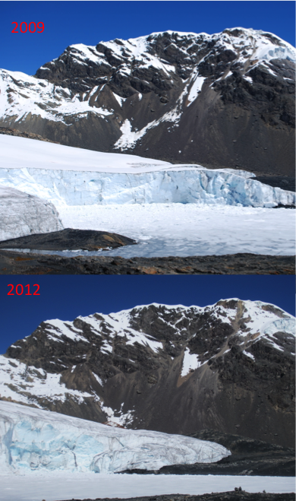 | The terminal end of Pastaruri glacier in 2009 (top) and 2012 (bottom), illustrating the recession of the glacier over this period.

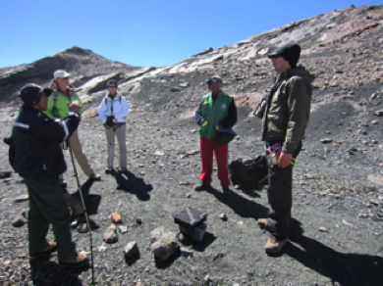 | 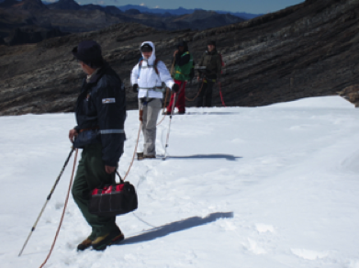
Meeting with Huascaran National Park Director (Sr. Martin) and an official from the Catac Municipality (Jesus) at Pastaruri glacier. | Conducting GPR survey on Pastaruri glacier.

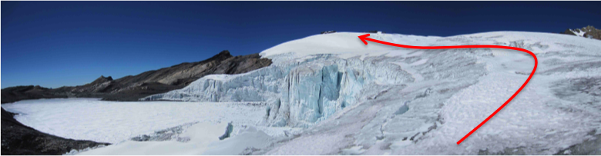 Pastaruri glacier lake, snout and main body of the glacier. GPR data (approximate route indicated by red line) was taken on a line up to the top of the glacier in the picture.

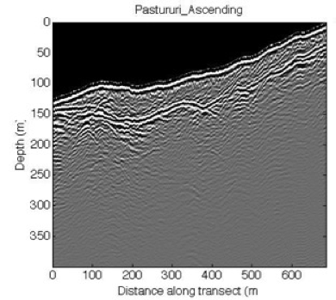 | Image of GPR data on ascent of Pastaruri glacier. The top of the ice is seen as the white and black lines at the top of the image and the bedrock below the ice is seen as the lower black and white line about 50-60 m below the ice surface.

Thursday, July 12, 2012 Huaraz, Peru

Worked on Small Grants Proposal Reviews and Year 2 Workplan and Budget.

Friday, July 13, 2012 Huaraz, Peru

Presentation of HMGWP work to Huascaran National Park staff and other interested persons (office of Civil Defense and Unit of Glaciology) on Palcacocha Lake GLOF modeling. The Director of Civil Defense for Ancash Department invited us to make presentation to the Ancash Department Governor.

Worked on Small Grants Proposal Reviews and Year 2 Workplan and Budget.

Saturday, July 14, 2012 Huaraz, Peru

Finalized Small Grants Proposal Reviews and Recommendations and worked on Year 2 Workplan and Budget.

Sunday, July 15, 2012 Huaraz, Peru

Work on Year 2 Workplan and Budget.

Monday, July 16, 2012 Huaraz, Peru

Meeting with Jesus Gomez at the Glaciology Office to finalize the plan for a GPR survey at the Arteson glacier. We me the temporary head of the Glaciology Unit and they are very interested in using GPR to map the thickness of ice at many of the glaciers in the Cordillera Blanca in order to be prepared for dealing with the problems of newly forming glacier lakes. The Galciology office has an existing GPR system, but it is very low power and limited to a single frequency (50 MHz which is too high for most glacier ice surveys).

Tuesday, July 17, 2012 Huaraz, Peru

We performed a GPR survey of the Arteson glacier. Kate Voss lead the survey team and we received good data form the survey (still being processed). There is a new glacier lake (Alto Artesoncocha) forming at the base of the glacier. The lake was not present in satellite images prior to 2003 and it has been growing quite rapidly since then. The GPR survey will allow us to estimate the ice depth and help to determine if a large glacial lake is likely to form at this site. If there is a dip in the ice in back of the current tongue, then a lake may form there. If not then the melt water will probably run off harmlessly into the lower lake.

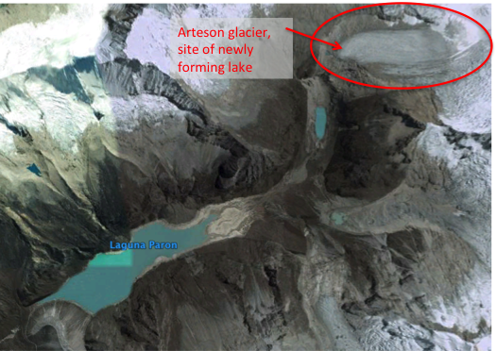 | Google earth image (2005) of Lake Paron and the Arteson glacier. Arteson glacier is the site of the newly forming glacier lake.

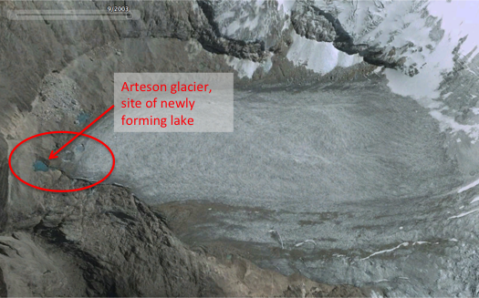 | Google earth image (2005) of Lake Paron and the Arteson glacier. Arteson glacier is the site of the newly forming glacier lake. The glacier is 1.6 km longitudinal length (4730 m to 4900 m), 0.5 km transverse length.

Rough estimates of the lake evolution by Prof. Haeberli (personal communication, Wilfried Haeberli, University of Zurich, July 20, 2012) indicate that: the lake will probably develop at an increasing rate; the depth is likely to reach more than 50 m; the length of the lake is likely to be about 1500 m; and a volume of at least 20 million m³.

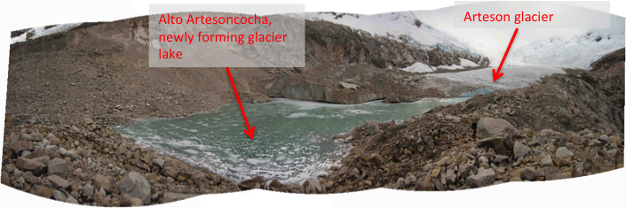
Image of Alto Artesoncocha, the newly forming glacier lake at the base of the Arteson glacier (July 2012).

Wednesday, July 18, 2012 Huaraz, Peru

Work on Trip Report.

Thursday, July 19, 2012 Huaraz, Peru

Work on Trip Report and prepare to depart to Lima and USA.

Friday, July 20, 2012 Huaraz to Lima, Peru

Travel from Huaraz to Lima by bus. Air Conditioning in bus broke down and we had to stop a lot. A 7 hour trip turned into a 10 hour trip.

Saturday, July 21, 2012 Lima, Peru

Work on trip report.

Sunday, July 22, 2012 Lima, Peru to Austin, Texas

Travel from Lima to Austin via Atlanta.

3. Recommendations

3.1. Refinement of Palcacocha Lake GLOF Model

A hydraulic model of a potential Palcacocha Lake GLOF was created by McKinney and Somos in 2011. This model assumes that the potential GLOF contains only water as it propagates downstream. This is not correct since there will be considerable sediment transported by the GLOF as well. Some of the sediment could come from the moraine of the lake and some will be picked up (and deposited) from the riverbed downstream. It has been shown (Osti and Egashira, 2009) that by not considering the sediment transport of a GLOF, the destructive power of the GLOF is significantly underestimated. Therefore, it is recommended that the existing Palcacocha GLOF model be improved to consider both the sediment transport from the moraine at the lake as well as deposition and scouring of sediment from the stream channel downstream of the lake.

3.2. Vulnerability Analysis of Potential Palcacocha Lake GLOF

Benefits of decreasing the risk of a GLOF from Palcacocha Lake should be calculated. The most appropriate way of calculating these benefits is through a formal vulnerability analysis of the communities and assets downstream of the lake and potentially in the path of a GLOF. Using the Palcacocha Lake GLOF model and the knowledge that we are gaining about the downstream communities, a vulnerability analysis should be performed to determine the potiential losses from a GLOF and what the benefits to the communities might be from a lake risk reduction project.

3.3. Hydrologic Model of Pastaruri Glacier

Pastaruri Glacier has been decreasing in size since the early 1960s and the recession rate of the glacier has increased in recent years. The local municipality of Catac and the Huascaran National Park have initiated a project to develop a Climate Change Exhibit at the glacier to demonstrate the impact of climate change on the region with Pastaruri Glacier and its recession as a centerpiece. The evolution of the volume of ice in the glacier over coming years or even decades can be predicted using a simple hydrologic (or mass balance) model of the glacier. Using the glacier ice depth data obtained on this mission along with various glacier volume estimates made in recent years and available climatic data, a rough estimate of the future size and volume of the glacier can be made. In addition, the GRP survey of the glacier can be repeated next year (2013) during the International Workshop and those results compared with the results obtained on this mission to obtain a more accurate estimate of melt rate.

3.4. Hydrologic Model of Arteson Glacier and GLOF Model of Newly Forming Glacier Lake

Arteson Glacier has been decreasing in size since the early 2000s and the recession rate of the glacier has increased in recent years. The office of Glaciology has become increalingly concerned about a potential GLOF from the newly forming glacier lake at the base of the glacier. The evolution of the volume of ice in the glacier over coming years or even decades can be predicted using a simple hydrologic (or mass balance) model of the glacier. Using the glacier ice depth data obtained on this mission along with various glacier volume estimates made in recent years (available from the Glaciology office) and available climatic data, a rough estimate of the future size and volume of the glacier and melt into the glacier lake can be made. In addition, the GRP survey of the glacier can be repeated next year (2013) during the International Workshop and those results compared with the results obtained on this mission to obtain a more accurate estimate of melt rate.

4. Year 1 Deliverables and Other Initiatives [TMI and UT]

The Peru trip provided the opportunity to conduct daily meetings and/or phone conversations with TMI's Andean Program director, Jorge Recharte, staff, and other project colleagues and participants.

1. TMI Subcontract with AECOM: In March-April 2012, TMI was requested by AECOM/Bangkok to recruit Ing. Cesar Portocarrero on a subcontract basis to assess the technical work completed to date for the UNDP Imja lake management project by ICIMOD and Kathmandu University. The subcontract specified four (4) deliverables that include the following:

1. Presentation on the key aspects that must be taken into consideration in the draining of Imja Lake (within 2 days of start of first visit to Nepal) - 20% of the total payment (15 days upon submission of the deliverable)
2. Assessment report on available technical studies on Imja Lake and additional studies required. – 20% of the total payment (15 days upon submission of the deliverable)
3. Assessment and recommendations report on ICIMOD’s work to date (one week after start of first visit to Nepal). – 20% of the total payment (15 days upon submission of the deliverable)
4. Assessment and recommendations report on the sections of the draft ProDoc that pertain to the draining of Imja Lake and key points that should be taken into consideration at the final design stage and, in addition, preparation of a standalone 4-5 page case study on the key lessons and best practices learned from the advisory assignment - 40% of the total payment (15 days upon the submission of the deliverable)

Deliverables 1 and 2 were finalized and submitted on 4 July 2012. Because neither the ICIMOD nor UNDP ProDoc reports were available when Ing. Portocarrero was in Nepal, AECOM representative Lee Baker, Alton Byers, and Daene McKinney worked to revise deliverables 3 and 4 in ways that promise to provide even greater benefit to all project participants. Following a phone conversation between Baker and Byers on 23 July, 2012, the revised deliverables are now as follows:

Prepare a detailed 10-15 page technical note, including sketches and illustrative calculations, that will provide guidance, to the extent possible, on the steps involved in the design of methods that either lower and/or decrease the risk of Imja Lake, including required background information, technical studies (e.g., detailed GPR and flood modeling, lake risk assessment surveys, drainage depth scenarios, geotechnical borings of the terminal moraine, etc.), consultations with local people, etc. The range of examples provided could include schematic drainage systems (e.g., canal and pipe), siphons, re-enforced terminal moraines, use of natural flood barriers downstream, or no action, depending on the outcome of the recommended studies. Given the present level of understanding and knowledge prevailing in Nepal, this document will prove very useful to UNDP staff, relevant government institutions, and local engineering consultants, who will have a role to play in detailed engineering design during the implementation phase of the project. For deliverable #4, The consultant will then visit Nepal in August 2012 to conduct a detailed review of the GEF ProDoc prepared by UNDP and the Kathmandu University Imja lake drainage design, and present his review and recommendations of these documents to a to a wide range of stakeholders, including UNDP, government, and local engineering consultants.

2. Glacial Lake Handbook: Ing. Cesar Portocarrero was contracted to author a handbook describing examples of Peru’s successful control of potentially dangerous glacial lakes since the 1950s, following devastating floods in the 1940s that killed over 10,000 people in the Cordillera Blanca region. The handbook is intended to be a catalogue of engineering control methods, from the simplest of drainage canals (e.g., Laguna Cohup) to the engineering wonder at Laguna Paron were a tunnel was drilled through 1000 m of solid rock and fitted with lake level control valves. Approximately 15 case studies will be included, with the final draft report available 31 July 2012. Following that, TMI will work with IRG to complete any necessary editing, formatting, and for the final publication and distribution of the handbook.

3. Risk Perception Study: Dr. Jorge Recharte and Ing. Gabriela Lopez organized and implemented this activity in the rural and urban areas historically impacted by the Palcacocha lake glacial lake outburst flood in the 1940s, and which continues to represent a major threat today. Interviews in the second half of April and May 2012 were conducted with key informants in three communities located below Palcacocha lake (Unchus, Llupa and Marian). The mapping of institutional stakeholders in the city of Huaraz, and review of secondary literature, was completed, yielding information critical to the design of both the focal groups and the quantitative survey on risk perceptions posed by Palcacocha lake. Between June and the first week of July, focal group discussions were conducted with (i) 12 representatives of the Ministry of Education, including teachers and student associations from schools located in the area of GLOF impact; (ii) 21 representatives of government organizations that have direct or indirect responsibilities connected to GLOF prevention or emergency response, including the local public university; (iii) 14 representatives of community and grass roots organizations located in the upper basin of Cojup (Palcacocha Valley); (v) and seven representatives of NGOs operating in the geographic area of impact or active in natural disaster prevention/response. During this period, a GLOF risk perception survey was designed (this is a statistically significant sample of 360 interviews with residents in urban and rural areas of the impact zone). The questionnaire was developed with input from key informants and focal group discussions, then tested with a small sample and applied (survey is to be completed July 12). Interviews and focal group discussions have identified the difference in perceptions amongst urban and rural residents, the latter favoring an integrated approach to watershed management and security of water for agriculture and fish farming, which are core livelihood activities in the valley. Participants in urban and rural areas have identified the lack of information, coordination and mechanisms for citizen participation as a significant problem to promote projects that reduce the risk of GLOFs in an effective way. The final report is currently under preparation.
4. High Mountain Glacial Watershed Issues Paper: World-renowned mountain geoecologist Dr. Jack Ives was subcontracted to author a detailed outline for a HMGW Issues Paper that covered high mountain geography, physical and social attributes and characteristics, contemporary problems, research gaps, and resource bibliography. The outline was completed on 11 July 2012 and provided to IRG and USAID. During the next reporting period, Dr. Dion Alford will be recruited to write the full paper using the Ives conceptual piece as a general guideline. He will be assisted by Alton Byers, Jack Ives, and Daene McKinney. Once the draft has been completed, TMI anticipates working with IRG for the final editing, layout, publication, and distribution,

5. 2013 HMGWP Workshop: During the reporting period both TMI and UT spent considerable time assessing the feasibility of a 2013 HMGWP workshop and field expedition in Tajikistan. Following discussions with a number of experts, it was decided to hold the next workshop in the Cordillera Blanca of Peru, location of the 2009 “Adapting to a World without Glaciers” workshop, since the region is a “living laboratory” of high mountain projects and research in both the social and physical sciences. Invitees will include a larger contingent of Central Asians as well as Climber-Scientist grant awardees, 2011 Andean-Asian Glacial Lake Expedition participants, prominent high mountain social and physical scientists, government and NGO representatives. The workshop will include a number of all-day, field-based training courses that may include V&A, community water quantity and quality projects, GPR training, bathymetric survey training, and others. A Central Asian Workshop and Field Expedition Planning Group will be assembled with the objective of beginning the preliminary planning and logistics necessary to host workshop, field visit, and pilot project(s) in Tajikistan in 2014.

6. Community of Practice: Under the direction of TMI Program Officer Kate Voss, CoP membership, platform, website, services, and newsletter are moving forward and interest among existing and new members is growing. Each item is covered in detail in the March-July 2012 CCRD quarterly report submitted to IRG on 4 July 2012.

7. Climber-Scientist Solicitation: 32 proposals from individuals and organizations were reviewed and ranked as per the proposal review forms provided by IRG. The completed review forms and summary recommendation spreadsheet were forwarded to IRG on 13 July 2012.

8. August-December 2012 Budgets: Detailed August-December 2012 TMI and UT budgets, LOE, and budget narratives were developed by project co-managers Byers and Mckinney, and Program Officer Voss, during the Peru trip. They were submitted to IRG, along with an illustrative January-July 2013 budget, on 13 July 2012.

