Viewing a NFIE-Hydro Database for Travis County
By Fernando R. Salas and David R. Maidment
Center for Research in Water Resources
University of Texas at Austin
17 February 2015
Contents
Introduction 1
Base Map 2
Atmospheric Forcing 3
Land Surface Modeling 20
River Routing 41
To Be Turned In 52

Introduction
The National Flood Interoperability Experiment (NFIE) is being undertaken by the academic community and the National Weather Service and its federal partners to demonstrate how a high spatial resolution flood forecasting system for the United States could be developed at the National Water Center, newly opened on the Tuscaloosa campus of the University of Alabama. It is assumed that this new system will cover the continental United States and be based on a high spatial resolution geospatial database that is being assembled to support the NFIE by federal agencies coordinated by the Subcommittee on Spatial Water Data.
In a previous exercise, a geodatabase called NFIE-Geo was created for Travis County, Texas, to provide the geospatial underpinning for this work. In this exercise, a sequence of steps needed to obtain the data to run the NFIE-Hydro forecasting model are presented. This exercise requires the use of the ArcGIS geographic information system, version 10.2.2. This exercise does not involve running NFIE-Hydro, but rather looking at the data files that are used at each step in that process.
The base data for the exercise are in a zip file of size 344 MB at: http://www.caee.utexas.edu/prof/maidment/CE397Flood/NFIEHydro/NFIEHydro.zip Obtain this file and unzip it. You’ll find two folders, one the NFIEGeo geodatabase developed previously, and a second one called Resources that contains the information to be added in this exercise.
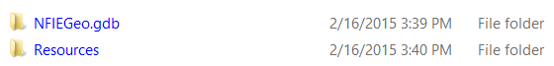
The Resources folder contains three items:
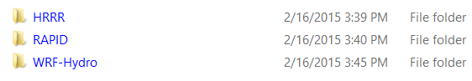
HRRR is the High Resolution Rapid Refresh weather model describing the atmospheric circulation
WRF-Hydro is the hydrologic modeling system which converts precipitation to runoff on the land surface
RAPID is the streamflow routing system that moves the flow through the stream and river network.
Extract this information from the zip file and place it in a directory of your choice that will be called in this exercise script Ex3/Data.

Base Map
Open ArcMap and from the NFIEGeo geodatabase, add the Boundary, MFlowline and Catchment feature layers to your map and symbolize each appropriately. Use the attribute Natur_Flow to get the variably sized streams in the MFlowline feature class.
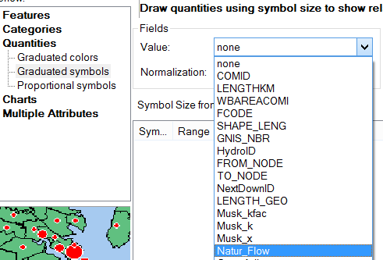
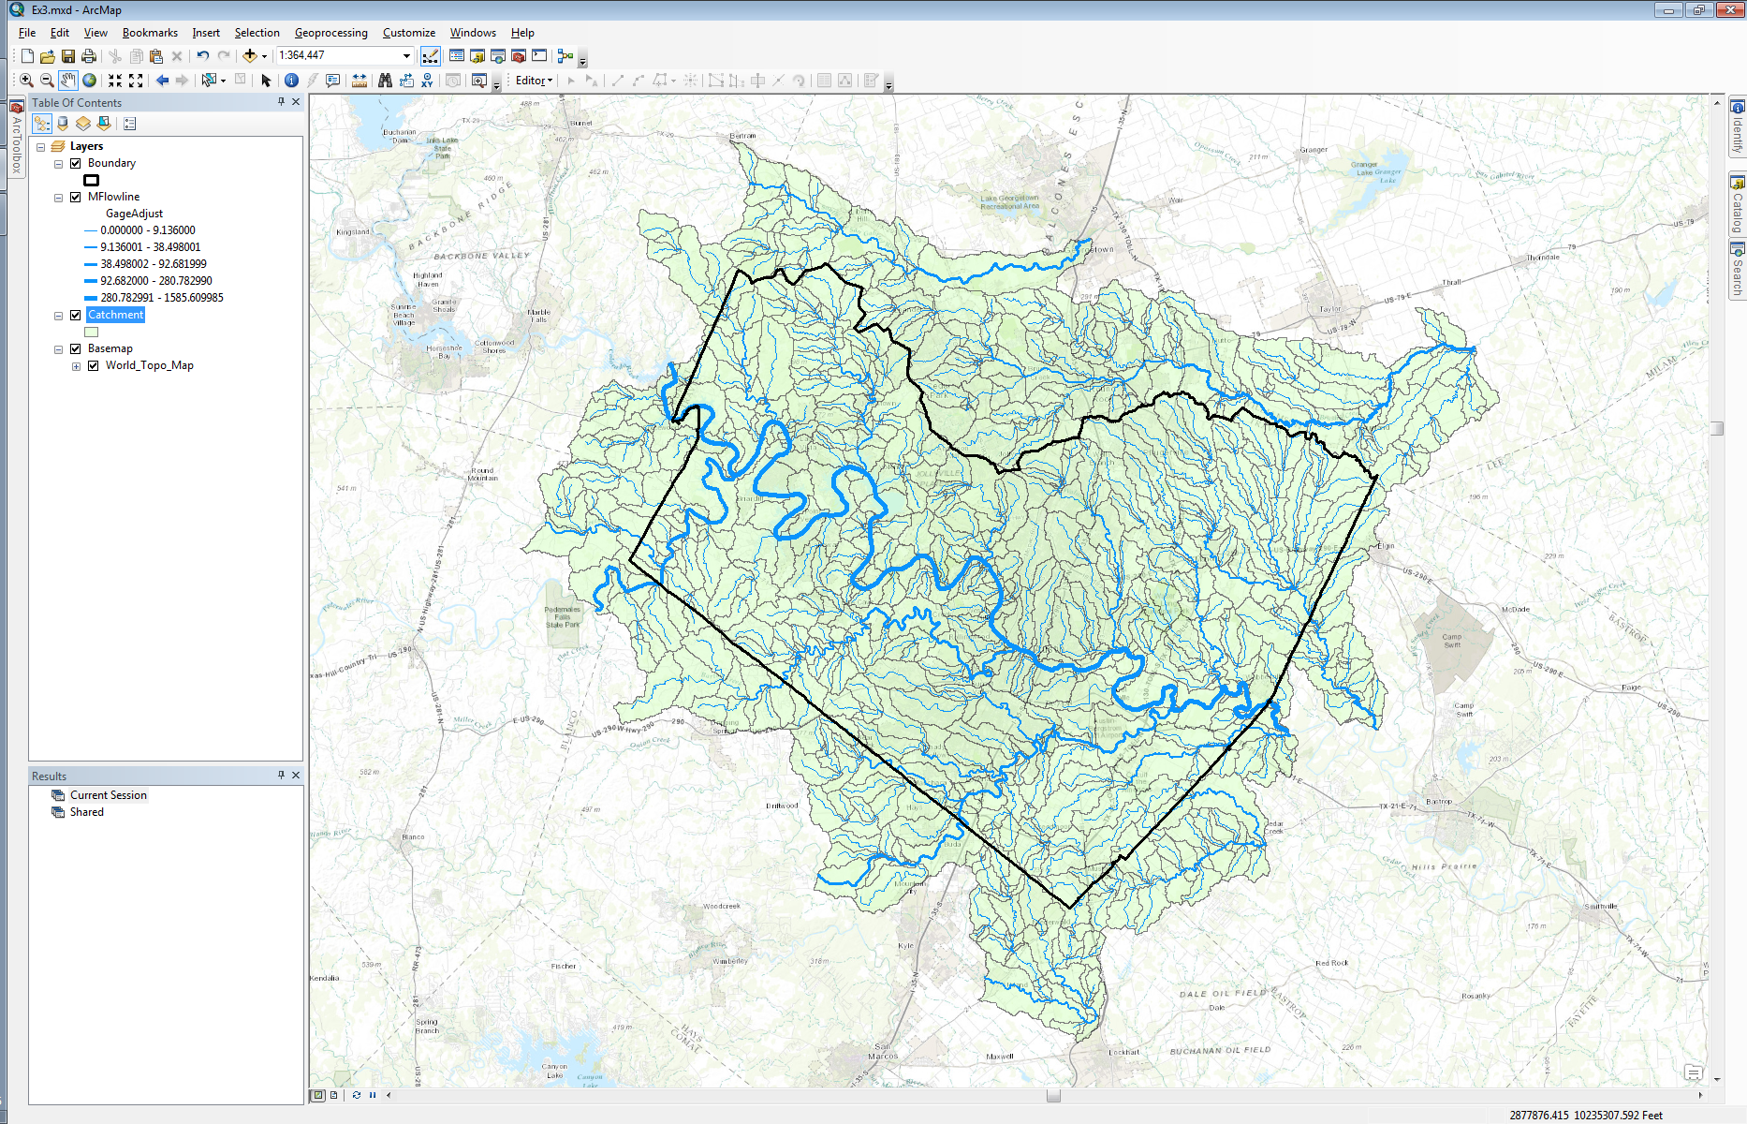

Atmospheric Forcing
The Unidata program within the University Corporation for Atmospheric Research (UCAR) has a mission to “provide data services, tools and cyerinfrastructure leadership that advance earth system science”. The Thematic Realtime Environmental Distributed Data Services (THREDDS) Data Server is a server deployment created by Unidata to distribute scientific metadata and data using a variety of remote access protocols such as web services. In practice, THREDDS servers are commonly used to distribute large quantities of gridded data stored in netCDF or other similar data formats (e.g. GRIB, HDF). Although this is common practice, THREDDS servers can also be used to distribute irregular gridded data stored in netCDF such as gaged streamflow. In order to take advantage of all the functions offered by THREDDS, it is important for datasets to comply with Climate and Forecast Conventions (CF Conventions). CF Conventions, among other things, provide a standard naming convention for observed phenomena to ensure that scientists across the world are referring to the same. For example, Scientist A could refer to surface pressure as “surface_pressure” in units of Bar whereas Scientist B could refer to it as “pressure_surface” in units of Pascal. CF Conventions are a collaborative effort to eliminate confusion within datasets that are widely shared.
The Earth System Research Lab (ESRL) within NOAA, is an entity that leverages THREDDS to distribute scientific data such as model outputs from the High Resolution Rapid Refresh (HRRR) model. The HRRR model is an operational atmospheric model used by NOAA to forecast atmospheric phenomena over the continental US. The HRRR model is high resolution in that its’ resolution in space is 3 km and resolution in time is 1 hour over a 15 hour moving forecast window. Although the HRRR model is run every hour, some of the model outputs are updated every 15 minutes. Below is the link to the ESRL THREDDS catalog containing HRRR model outputs:
http://esrl.noaa.gov/gsd/thredds/catalog.html
You will see a set of folders one of which called “hrrr”. You’ll also notice a “13kmruc” folder and a “rap” folder. These folders contain model outputs from the Rapid Update Cycle (RUC) model and the Rapid Refresh (RAP) model; both used previously by NOAA as operational atmospheric models. Both the RUC and RAP have now been replaced by the HRRR. Within this implementation of THREDDS, ESRL distributes HRRR model outputs for the previous day.
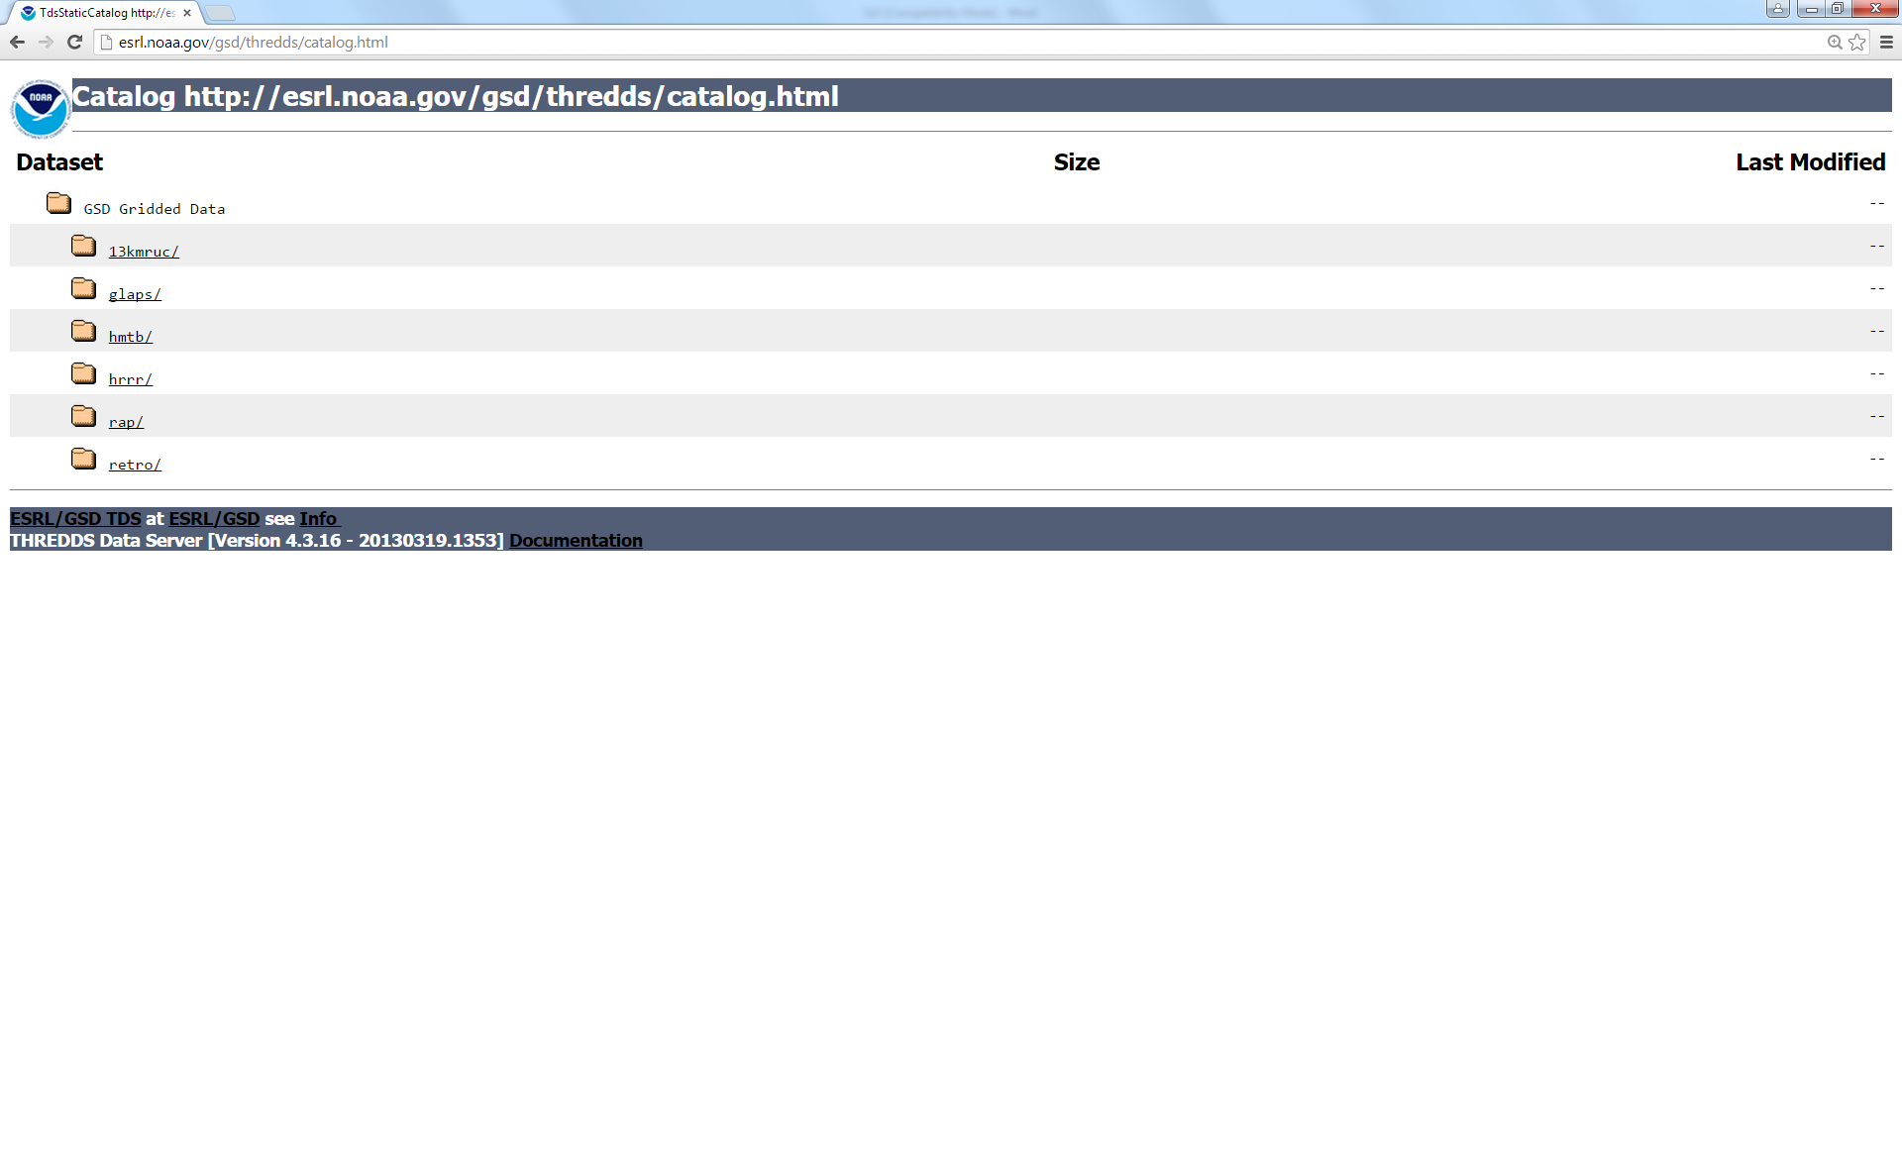
Access HRRR data:
- Click on “hrrr” folder.
- Click on “wrfnat” folder under “conus”. The complete link to this folder is below:
http://esrl.noaa.gov/gsd/thredds/catalog/hrrr/conus/wrfnat/catalog.html
- The “Forecast Model Run” folder contains HRRR model outputs for each HRRR run in the previous day; each dataset is named by the date and time (UTC) of the model run date.

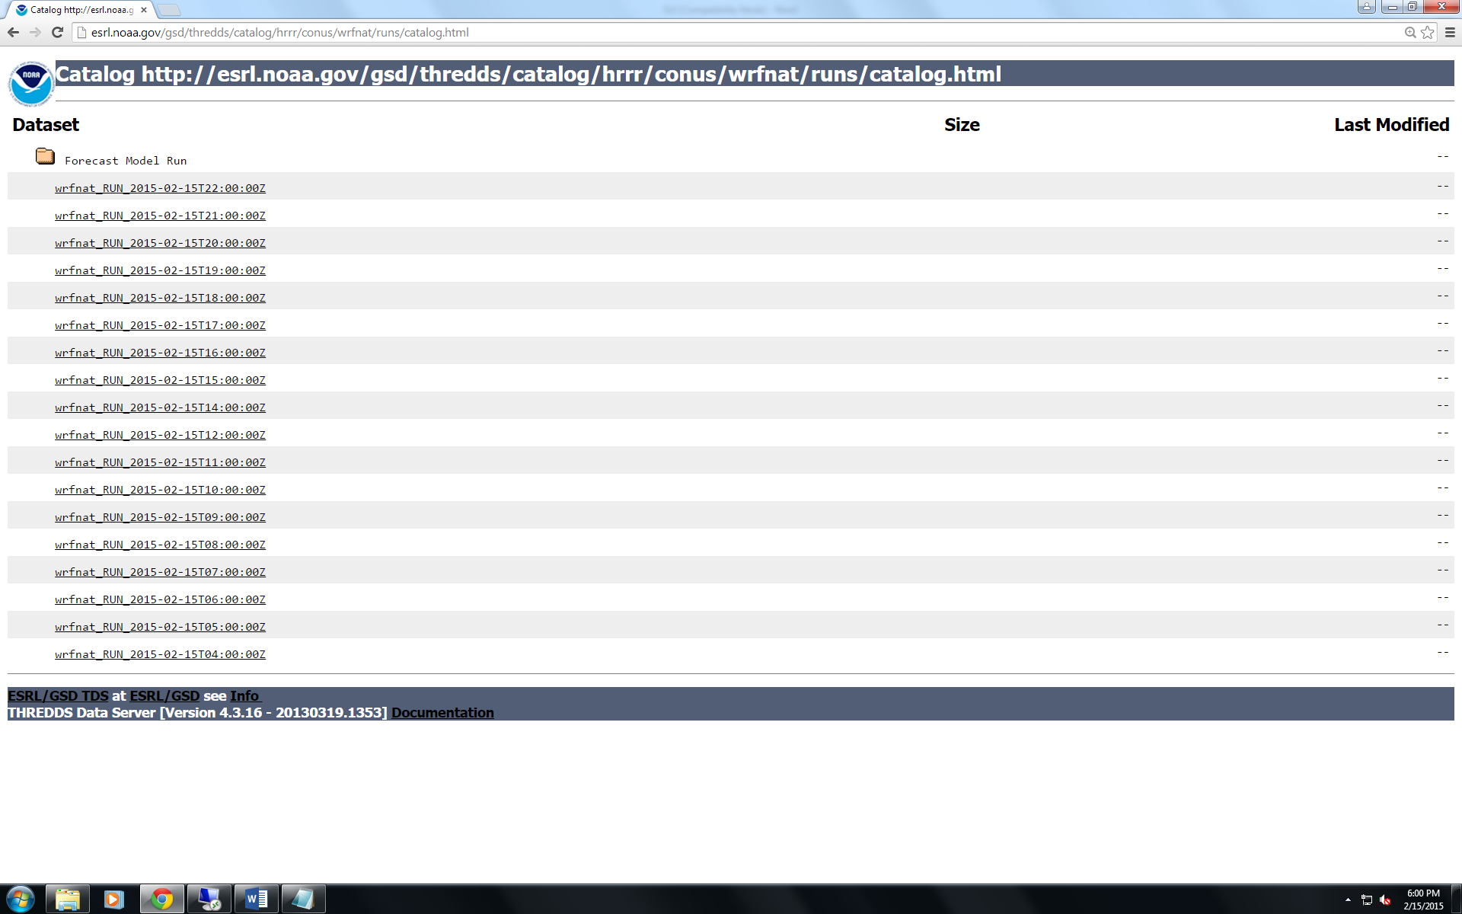

The “Best Time Series” stitches together the “0-hour” forecast of each model run output within the THREDDS server and the latest forecast. This is called the “best time series” because it is theoretically the best modeled output through time over the previous day. Click on “Best Time Series”.

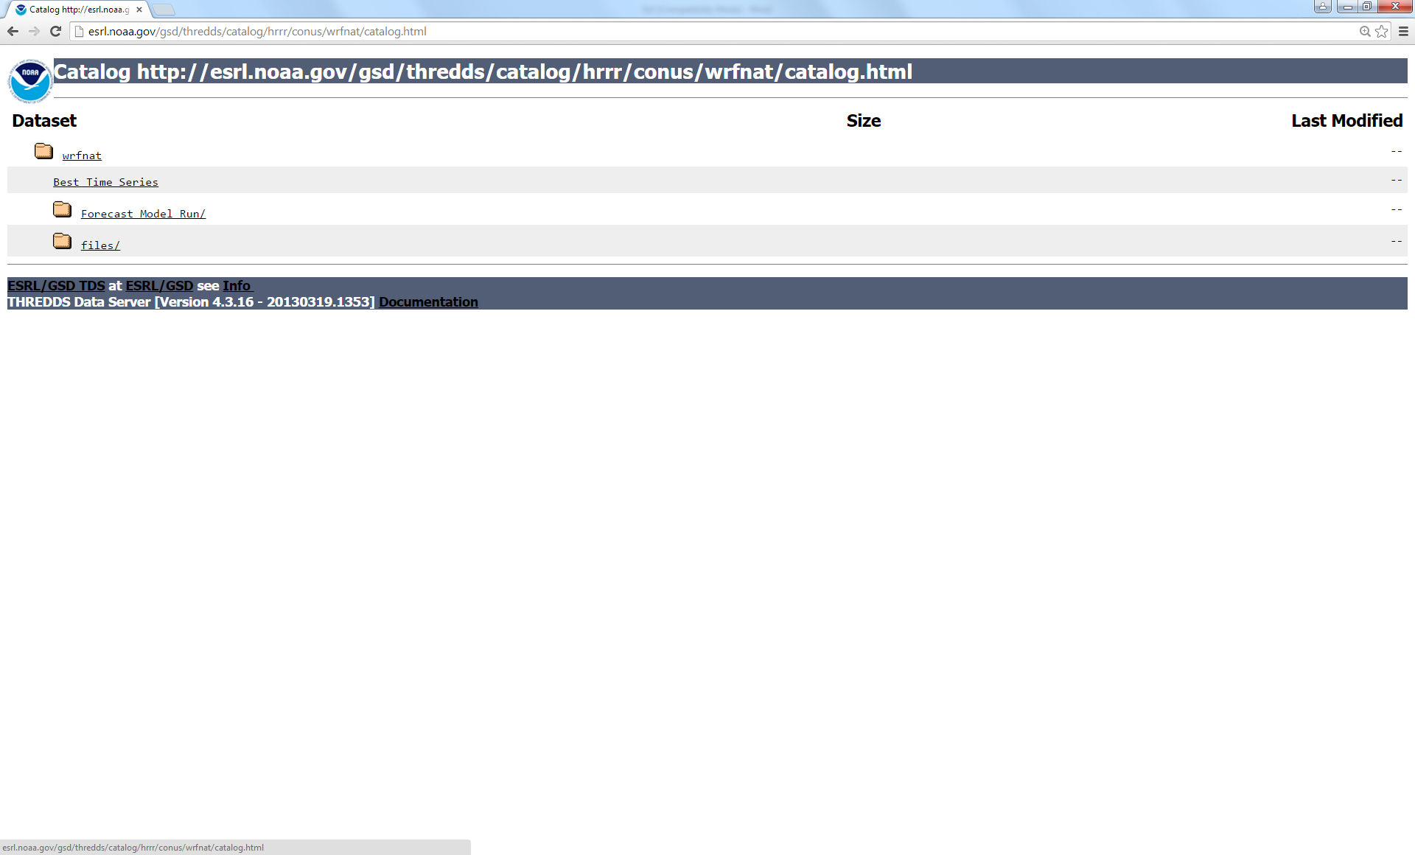

- There are several remote access protocols on this page. Click on the link next to “NetcdfSubset”. The complete link to this dataset is below:
http://esrl.noaa.gov/gsd/thredds/ncss/grid/hrrr/conus/wrfnat/wrfnat_best.ncd/dataset.html
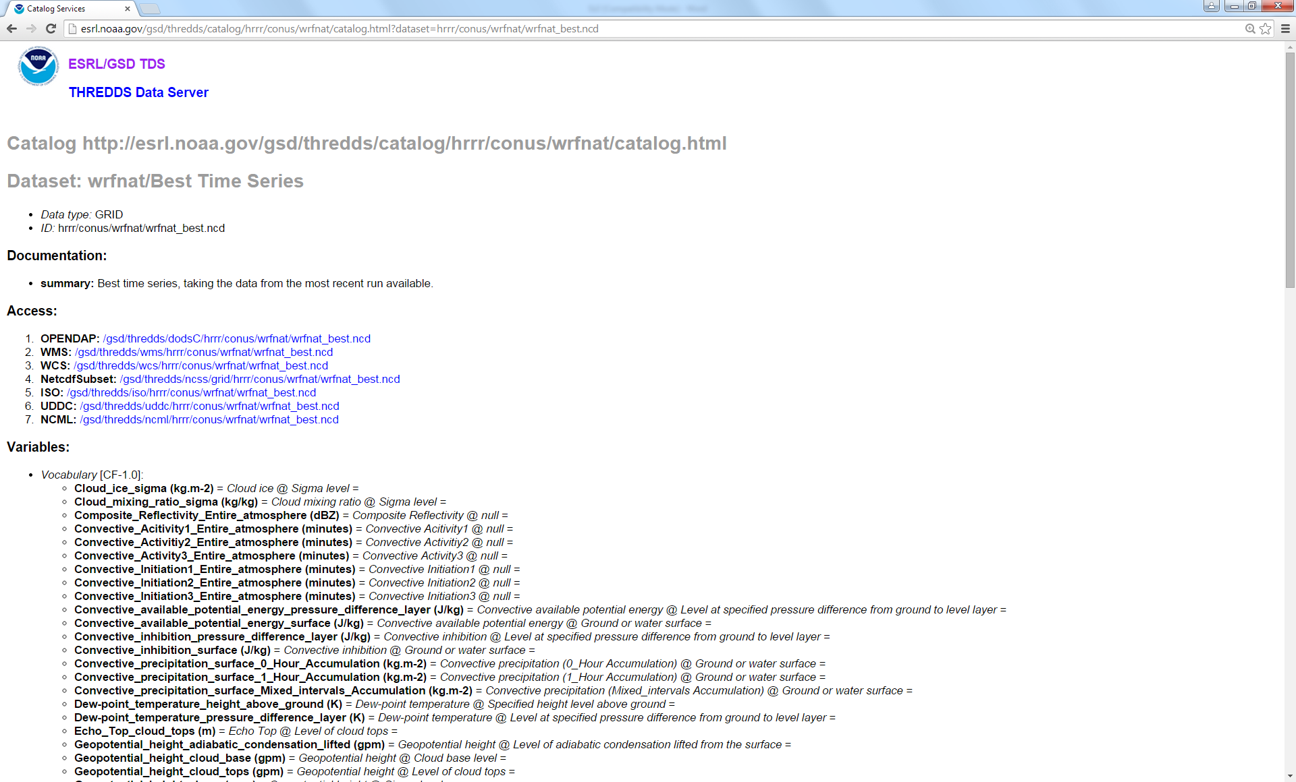
- On this page you will see a list of variables contained within the HRRR model output. On the left you can select any of the variables you are interested in. On the right you can subset the data in space by lat/long coordinates and time (UTC). To run the Noah-MP model using the WRF-Hydro framework, we need eight variables from the HRRR model output:

- Radiation_surface (W/m²)
- Pressure_surface (Pa)
- Specific_humidity_height_above_ground (kg/kg)
- Relative_humidity_height_above_ground (%)
- Temperature_height_above_ground (K)
- u-component_of_wind_height_above_ground (m/s)
- v-component_of_wind_height_above_ground (m/s)
- Precipitation_rate_surface (mm/s)
Note: The “Radiation_surface” variable represents incoming shortwave radiation. All the variables specified as “height_above_ground” refer to a reference elevation of 2 meters above the land surface.
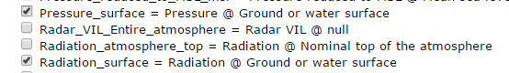
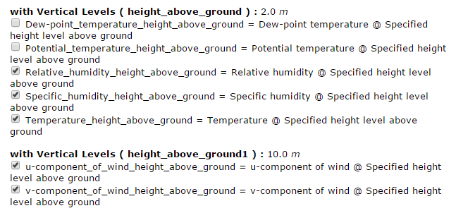
On the left, select all the variables in the list above except for “Precipitation_rate_surface” (we will download this variable from another location on the ESRL THREDDS server).

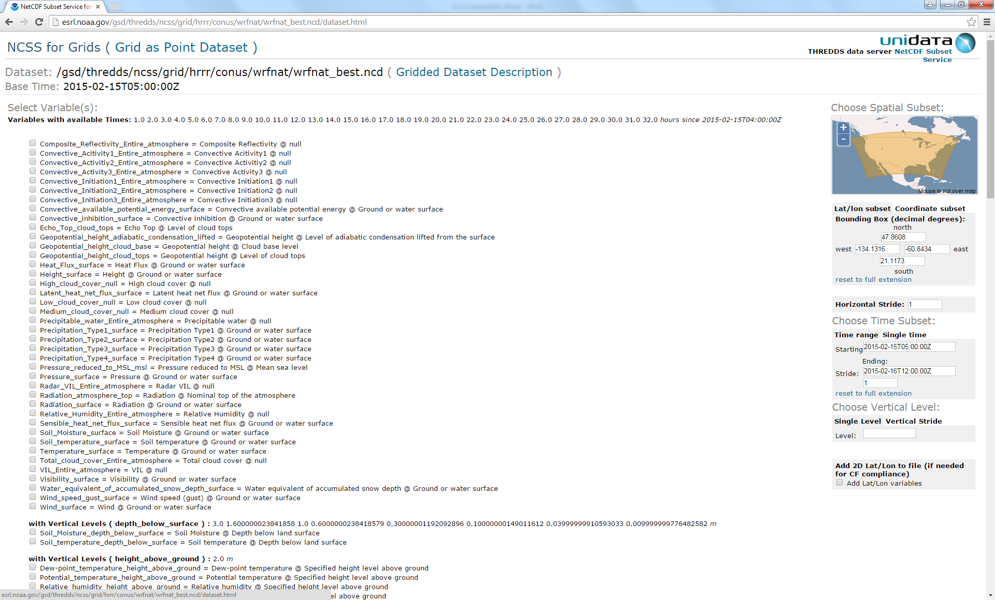

- On the right, replace the coordinates in the “Lat/lon subset” box with the following (we are subsetting over Texas):

North: 34.793
South: 25.564
West: -103.5
East: -93.326

Make note of the “Starting” date in the “Time Range” box underneath “Choose Time Subset”. We will use this date when downloading the precipitation data.

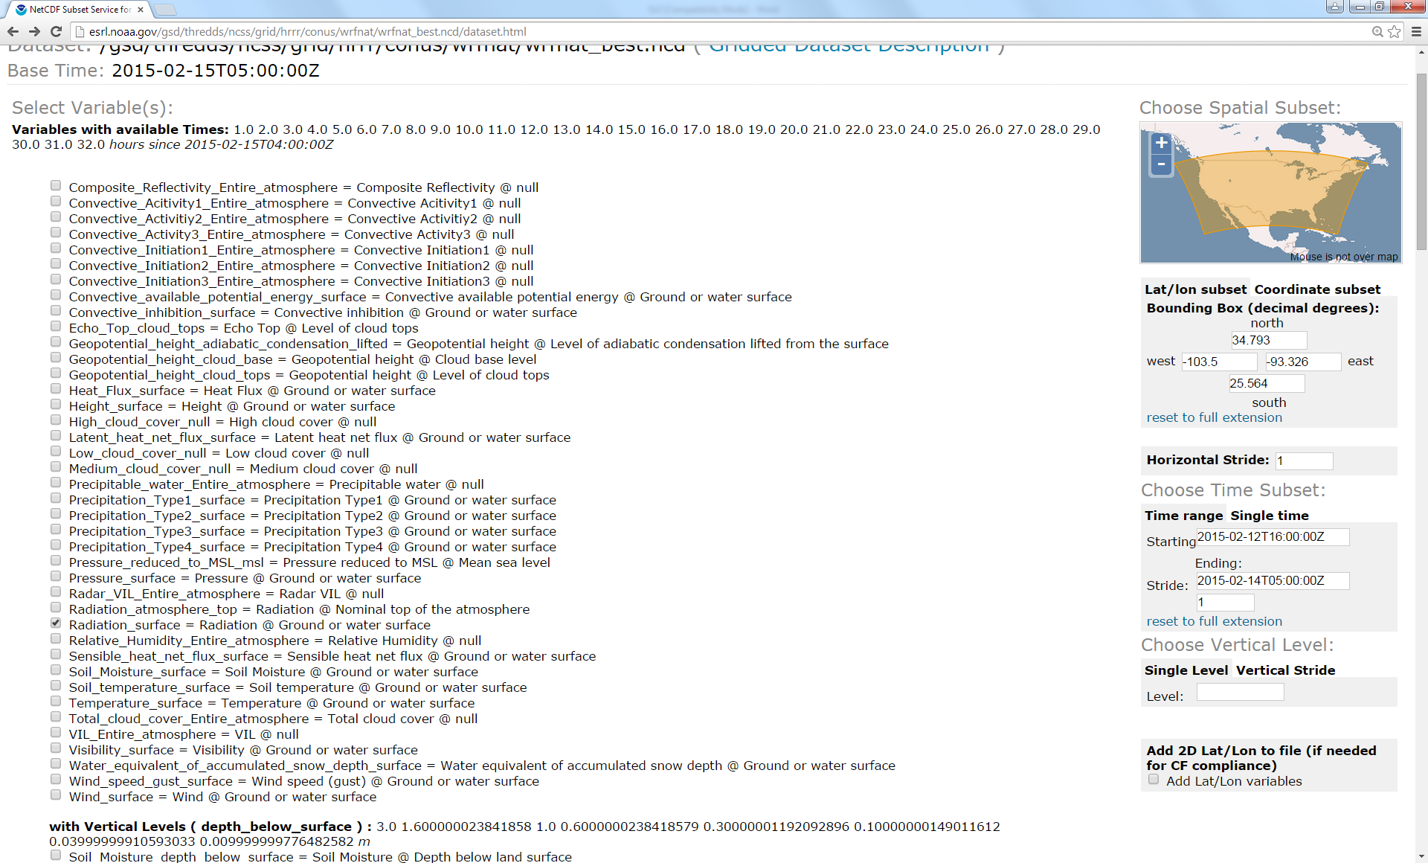

- After selecting the variables and the replacing the subsetting coordinates, scroll to the bottom of the page and click “Submit”. A netcdf file should download to your computer. Move the netcdf file to the “Ex3/Data” folder.
The URL link used to download this data follows the form below (the “time_start” and “time_end” date and times will be different for you):
http://esrl.noaa.gov/gsd/thredds/ncss/grid/hrrr/conus/wrfnat/wrfnat_best.ncd?var=Radiation_surface&var=Pressure_surface&var=Specific_humidity_height_above_ground&var=Relative_humidity_height_above_ground&var=Temperature_height_above_ground&var=u-component_of_wind_height_above_ground&var=v-component_of_wind_height_above_ground&north=34.793&south=25.564&west=-103.5&east=-93.326&horizStride=1&time_start=2015-02-13T01:00:00Z&time_end=2015-02-14T05:00:00Z&timeStride=1&vertCoord=&accept=netcdf
- Go back to the HRRR catalog page:

http://esrl.noaa.gov/gsd/thredds/hrrr.html

- Click on “wrftwo_subh” under “conus”. This folder contains HRRR model outputs every 15 minutes. The “wrfnat” folder contained hourly data. The complete link to this folder is below:
http://esrl.noaa.gov/gsd/thredds/catalog/hrrr/conus/wrftwo_subh/catalog.html
- Click on “Best Time Series”.
- Click on the link next to “NetcdfSubset”. The complete link to this dataset is below:

http://esrl.noaa.gov/gsd/thredds/ncss/grid/hrrr/conus/wrftwo_subh/wrftwo_subh_best.ncd/dataset.html

- On the left, click on “Precipitation_rate_surface” variable.
- On the right, enter the same spatial subsetting coordinates as above.
- In the “Time Range” box, enter the “Starting” date you made note of above to ensure that both downloaded datasets start at the same time.
- Scroll to the bottom of the page and click “Submit”. Another netcdf file should download to your computer. Move this file to the “Ex3/Data” folder as well.
The URL link used to download this data follows the form below (the “time_start” and “time_end” date and times will be different for you):
http://esrl.noaa.gov/gsd/thredds/ncss/grid/hrrr/conus/wrftwo_subh/wrftwo_subh_best.ncd?var=Precipitation_rate_surface&north=34.793&south=25.564&west=-103.5&east=-93.326&horizStride=1&time_start=2015-02-13T01:00:00Z&time_end=2015-02-14T05:00:00Z&timeStride=1&vertCoord=&accept=netcdf
Display HRRR data in ArcMap:
- In ArcToolbox under “Multidimensional Tools”, double click on the “Make NetCDF Raster Layer” tool.

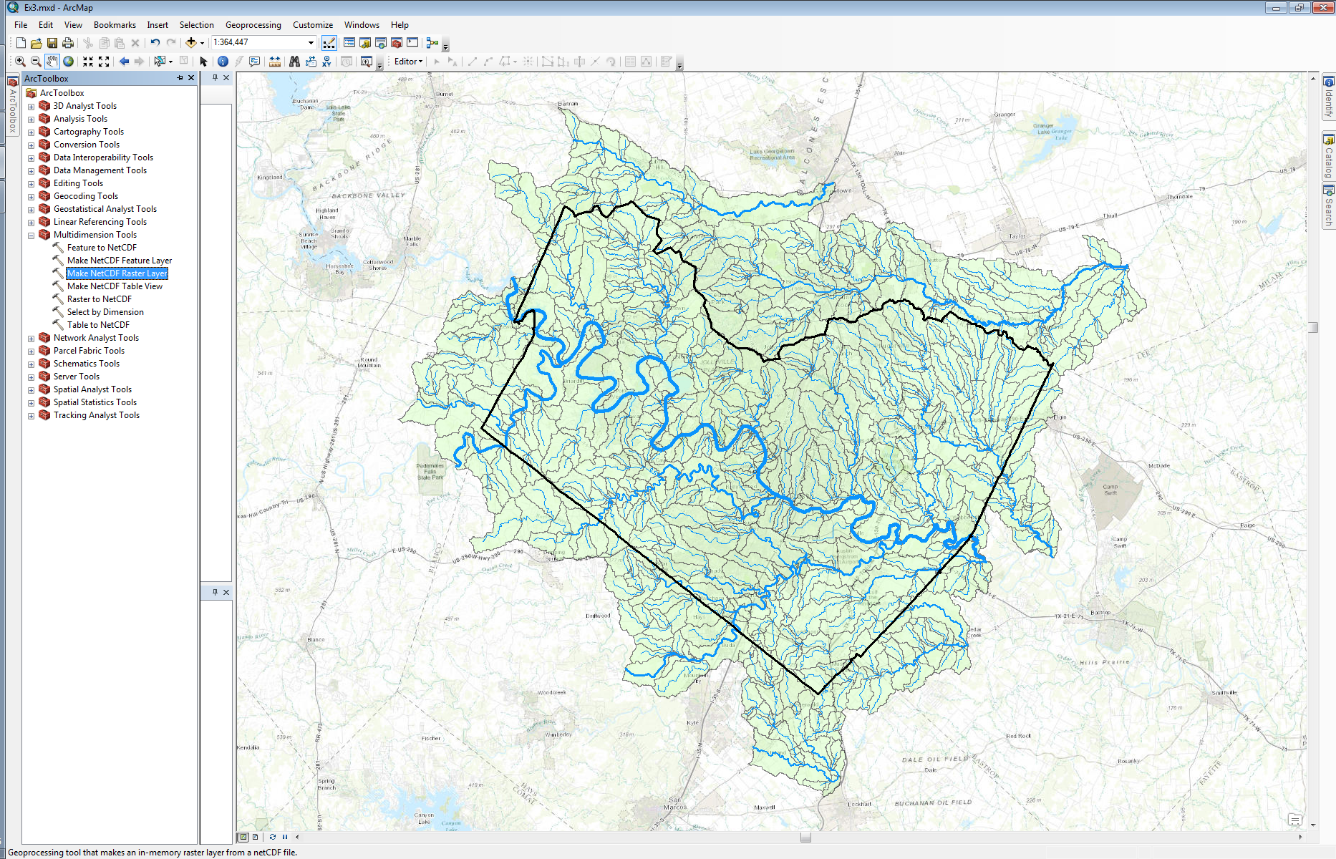

- Fill in the boxes in the “Make NetCDF Raster Layer” window appropriately. Navigate to the “wrfnat_wrfnat_best.nc” file on your computer. We’ll take a look at temperature at a height of 2 meters above ground first; its’ XY coordinate dimensions are “x” and “y” which are in the Lambert Conformal Conic projection.

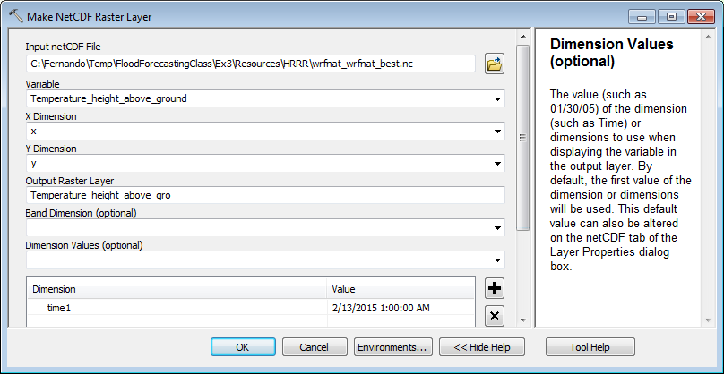

- Select “time1” as the dimension value; the “time1” dimension will be added to the dimension list. Once it is added to the list, click in the empty space under “Value” and select the first date and time listed in the dropdown menu; these are all the date and times within the netCDF file.

- Click on “OK. The netCDF raster layer will be projected on the fly to the coordinate system of your existing map. If you have already loaded layers from the Travis country GDB, your map will be in the State Plane coordinate system.
- Right click on the “Temperature_height_above_gro” layer in the “Table of Contents” pane and select “Zoom to Layer”.
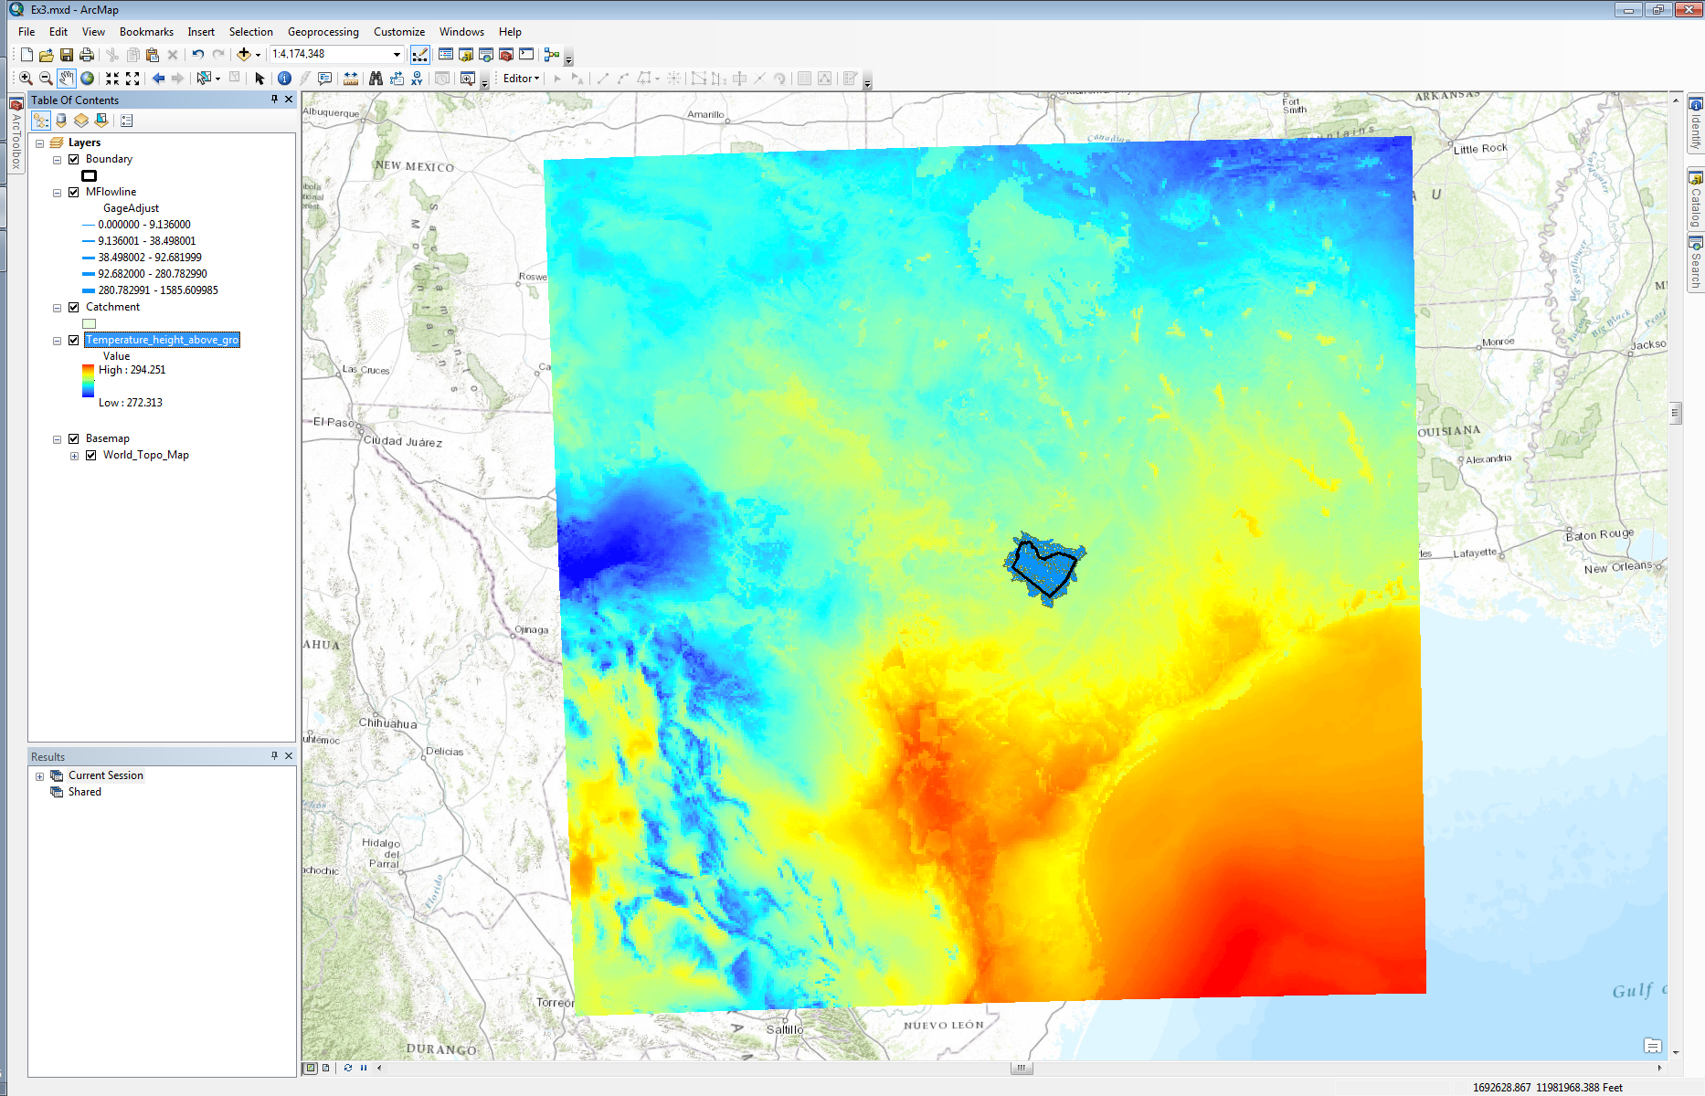

- Right click on “Catchment” feature layer in the “Table of Contents” pane and select “Zoom to Layer”.
- Use the “Identify” icon to explore temperature values in the area.

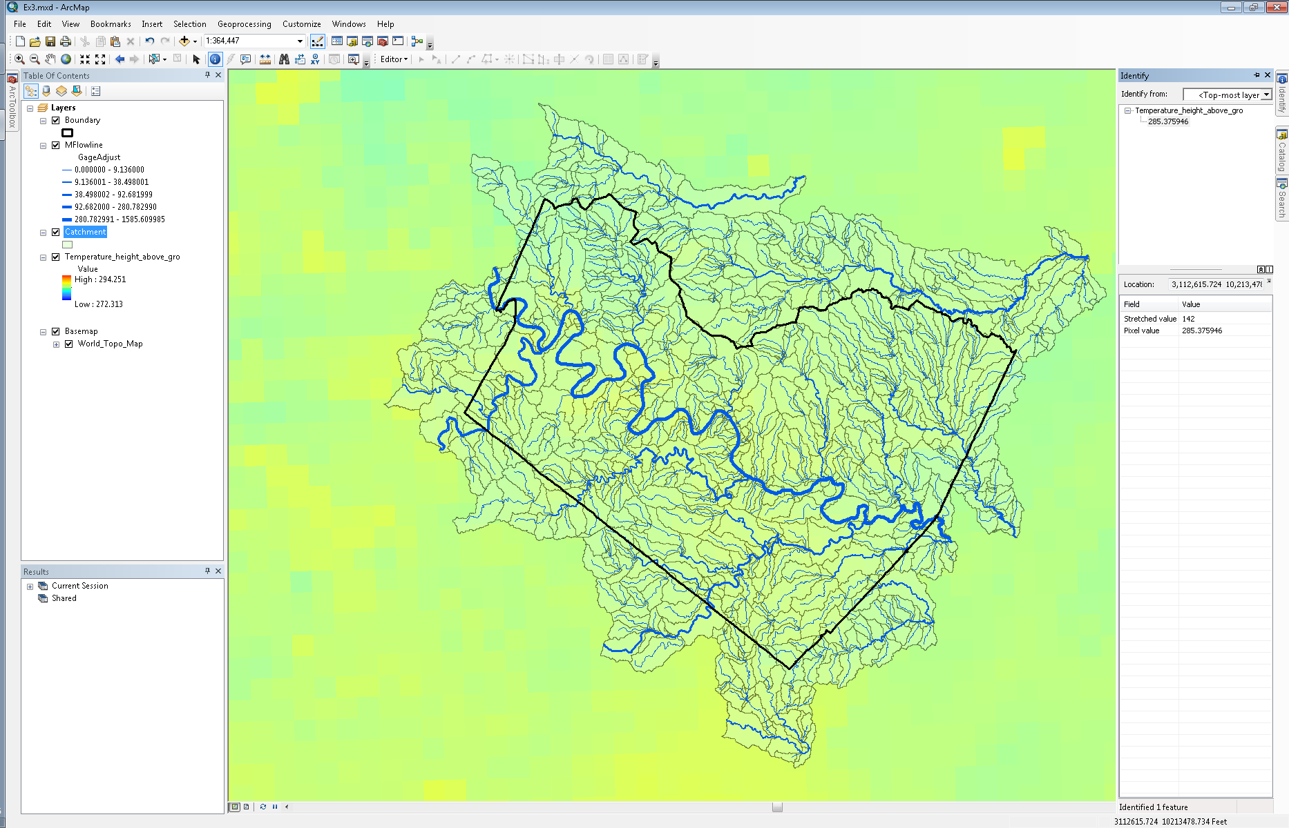
Animate HRRR Data in ArcMap
- Right click on the “Temperature_height_above_gro” layer in the “Table of Contents” pane and select “Properties”.

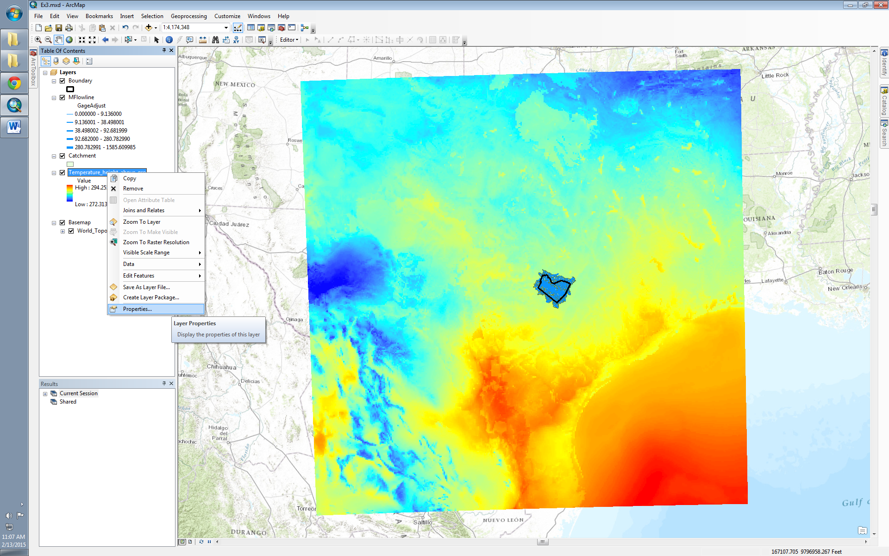

- Go to the “Time” tab.
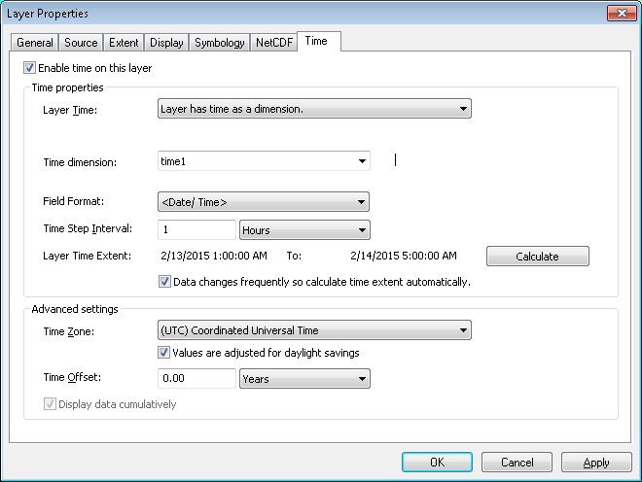
- Check the “Enable time on this layer”.
- Select “time1” as your “Time dimension”.
- Click on “Calculate” to populate the “Layer Time Extent”. Make sure that the start and end date and times are correct.
- Input “1” as the “Time Step Interval” and make sure the interval is in “Hours”.
- Select “(UTC) Coordinated Universal Time” from the “Time Zone” dropdown menu.
- Go to the “NetCDF” tab. Here you can manually change the dimensions in the netCDF file. In the “Variable” dropdown menu you will see the list of variables we downloaded from the ESRL THREDDS server. Under “Dimension Values”, you will see the “time1” and “height above ground” dimension. There is only one reference height in this netCDF file however more could be stored; 2 meters is usually the reference height for surface temperature in atmospheric models.

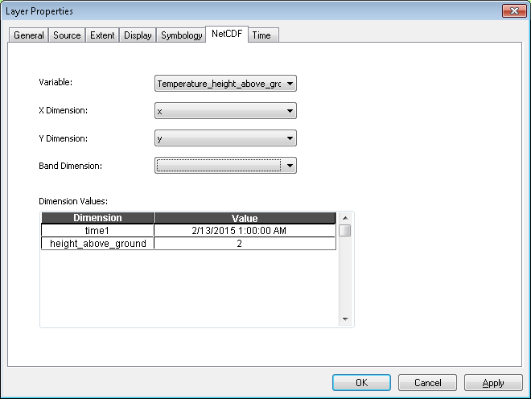

- Click on the date and time next to the “time1” dimension, you will see all the date and times in the netCDF file listed. You’ll notice the date and times are spaced hourly. By selecting any of the date and times and clicking “Apply”, the Temperature layer in your map will change and display the data for the date and time selected.
Note: Remember that the last 15 date and times listed in the dropdown menu are from the last HRRR model run and thus represent forecasted values. The first set of and date and times listed are the 0-hour forecasts for the previous HRRR model runs.
If you’d like to see what the forecasted temperature is in Austin, select any of the last 15 date and times listed and use the “Identify” icon in the map window to explore temperature values in the area.
- Click “OK”.
- Click on the “Time Slider” icon at the top of your ArcMap window to display the time slider.

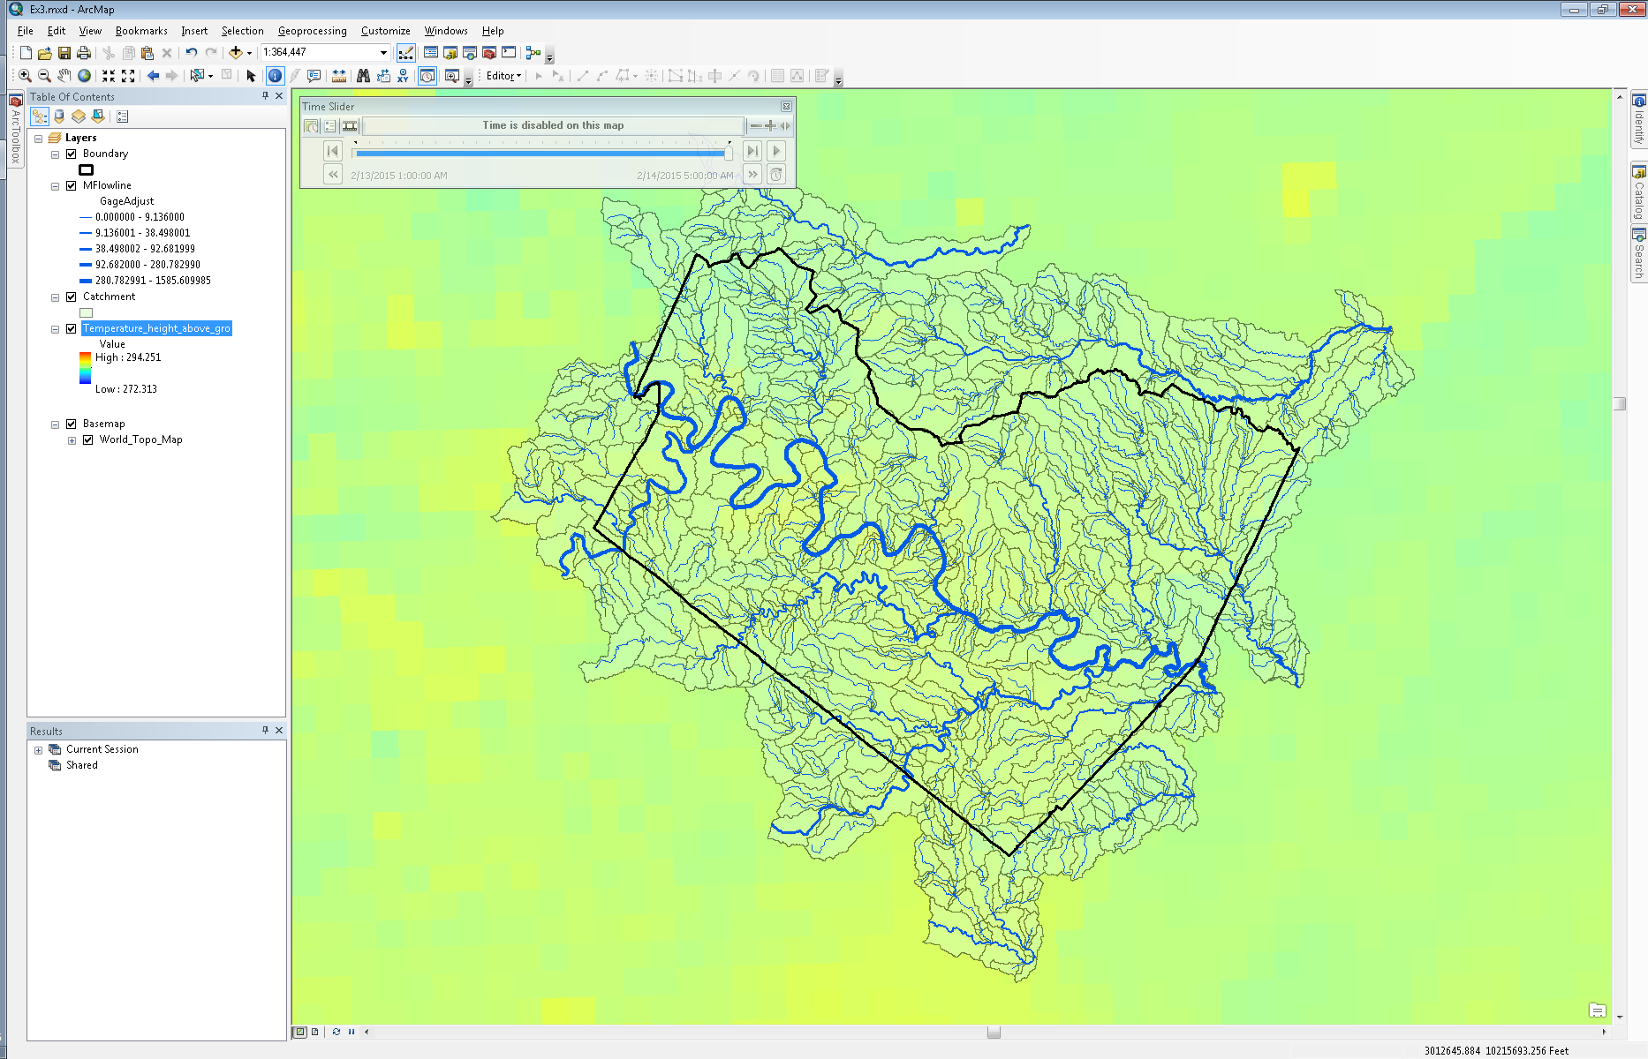

- Click on the “Enable time on map” icon two icons to the left of the movie reel in the “Time Slider” window.

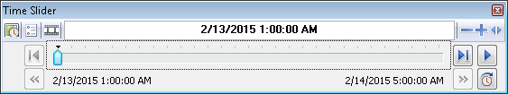

- Click on the “Options” icon to the left of the movie reel in the “Time Slider” window.

- In the “Time Display” tab, select Central Time as the “Time zone”.

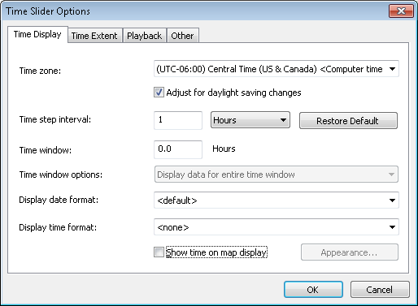

- Input 1 hour as the “Time step interval”.
- Click “OK”.
- Click on the double arrow icon on the bottom left of the “Time Slider” window multiple times until it greys out and scroll the ticker all the way to left to display the proper start time in CST.

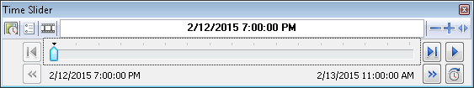

- In the “Time Slider” window, click on the “Play” icon to animate the layer.
- Explore the other variables in the netCDF file. You’ll have to enable “time” in each layer you want to animate.

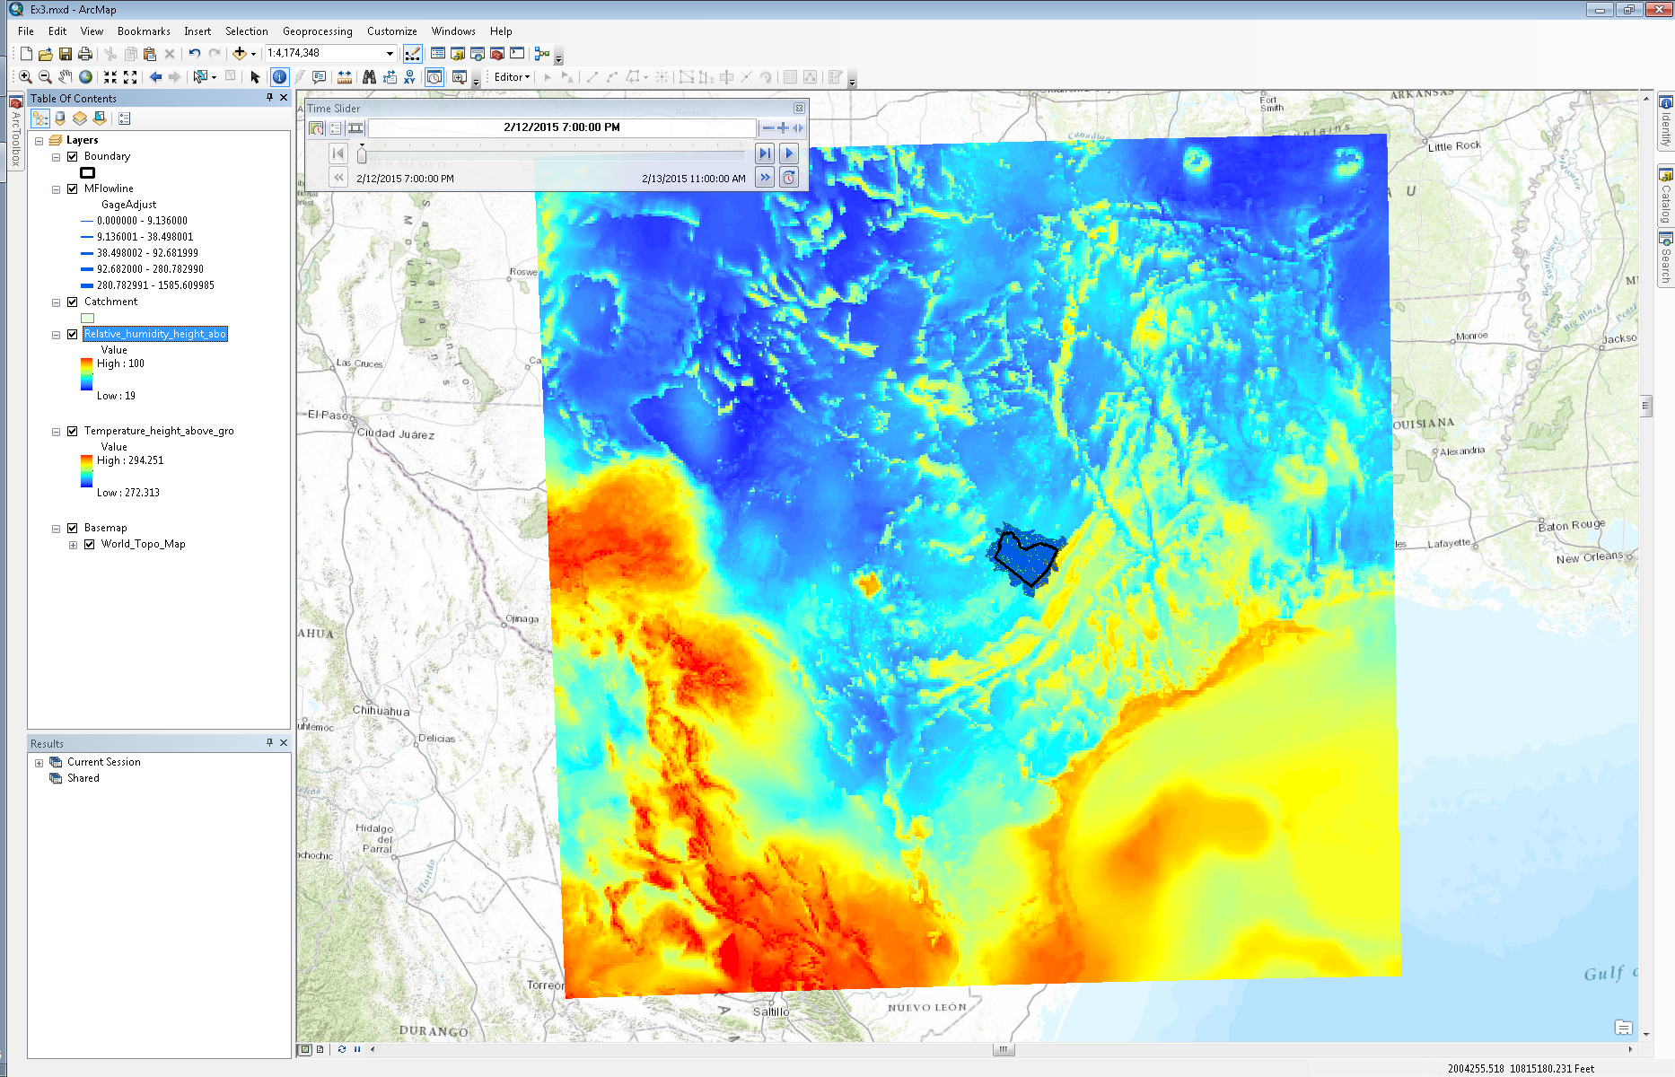
Animate HRRR Precip Data in ArcMap
- In ArcToolbox under “Multidimensional Tools”, double click on the “Make NetCDF Raster Layer” tool.
- Fill in the boxes in the “Make NetCDF Raster Layer” window appropriately. Navigate to the “wrftwo_subh_wrftwo_subh_best.nc” file on your computer. The “Precipitation_rate_surface” variable should automatically populate along with the X and Y dimensions.

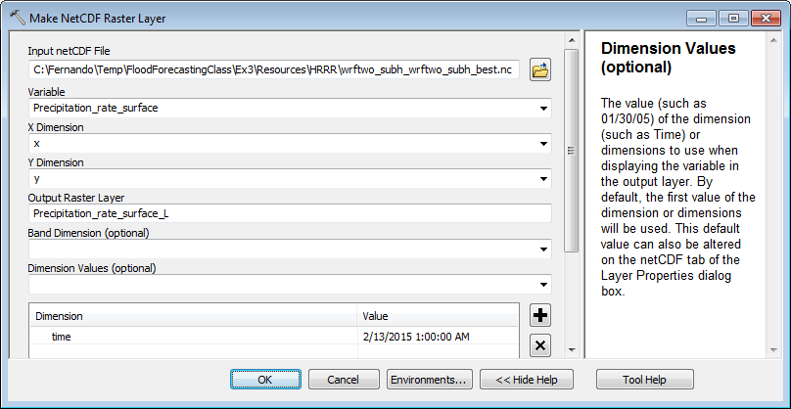

- Select “time” as the dimension value; the “time” dimension will be added to the dimension list. Once it is added to the list, click in the empty space under “Value” and select the first date and time listed in the dropdown menu; these are all the date and times within the netCDF file.
Note: Notice that these date and times are spaced every 15 minutes instead of hourly as the previous netCDF file. The precipitation variable within the HRRR model outputs is one of the variables that is updated every 15 minutes even though the model itself is run every hour.
- Click on “OK. The netCDF raster layer will be projected on the fly to the coordinate system of your existing map.

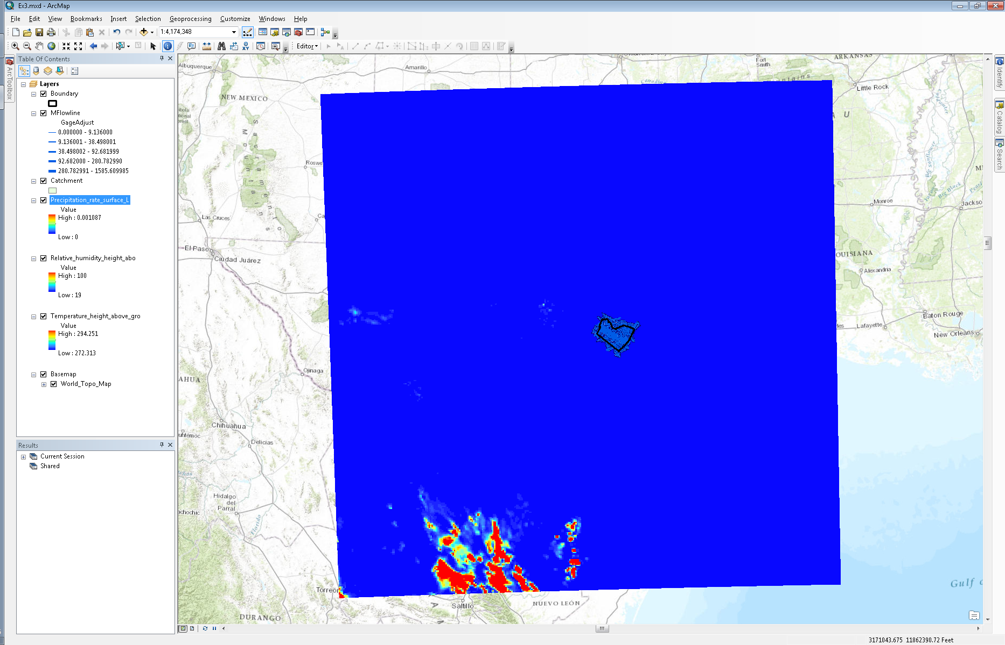

- Right click on the “Precipitation_rate_surface” layer in the “Table of Contents” pane and select “Properties”.
- Go to the “Symbology” tab and select “Stretched” on the left.

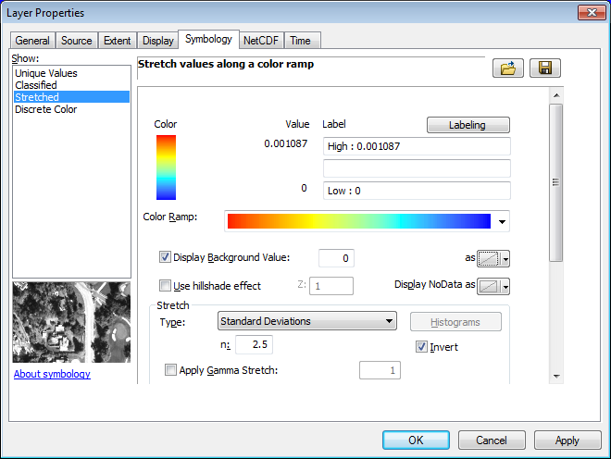

- Select the “Color Ramp” above.
- Check “Display Background Value” and fill in “0” in the empty box.
- In the “Stretch” section, check “Invert”.
- Click “OK”.
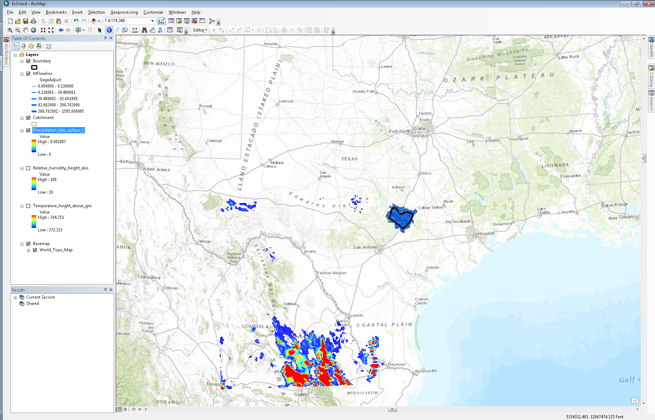
- Right click on the “Precipitation_rate_surface” layer in the “Table of Contents” pane and select “Properties”.
- Go to the “Time” tab.
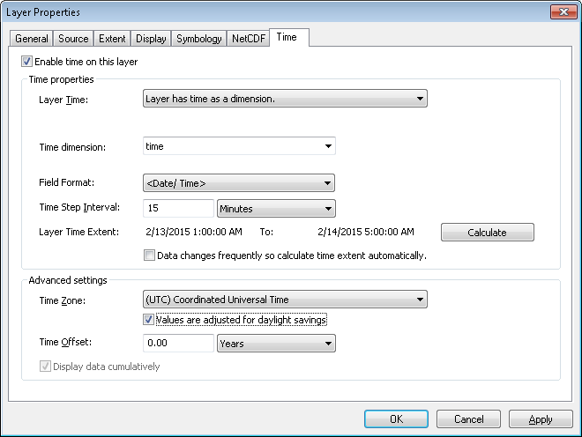
- Check the “Enable time on this layer”.
- Select “time” as your “Time dimension”.
- Click on “Calculate” to populate the “Layer Time Extent”.
- Select “(UTC) Coordinated Universal Time” from the “Time Zone” dropdown menu.
- Click “OK”.
- If your “Time Slider” window is not displayed, click on the “Time Slider” icon at the top of your ArcMap window to display the time slider.
- Click on the “Options” icon to the left of the movie reel in the “Time Slider” window.
- In the “Time Display” tab, make sure Central Time is selected for the “Time zone”.
- Input 15 minutes as the “Time step interval”.

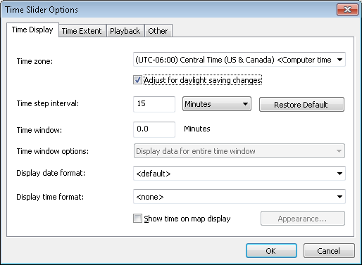

- Click “OK”.
- In the “Time Slider” window, click on the “Play” icon to animate the layer. When animating the precipitation at a 15 minute time step, it’s best not to display the Temperature and other HRRR layers you have ingested.

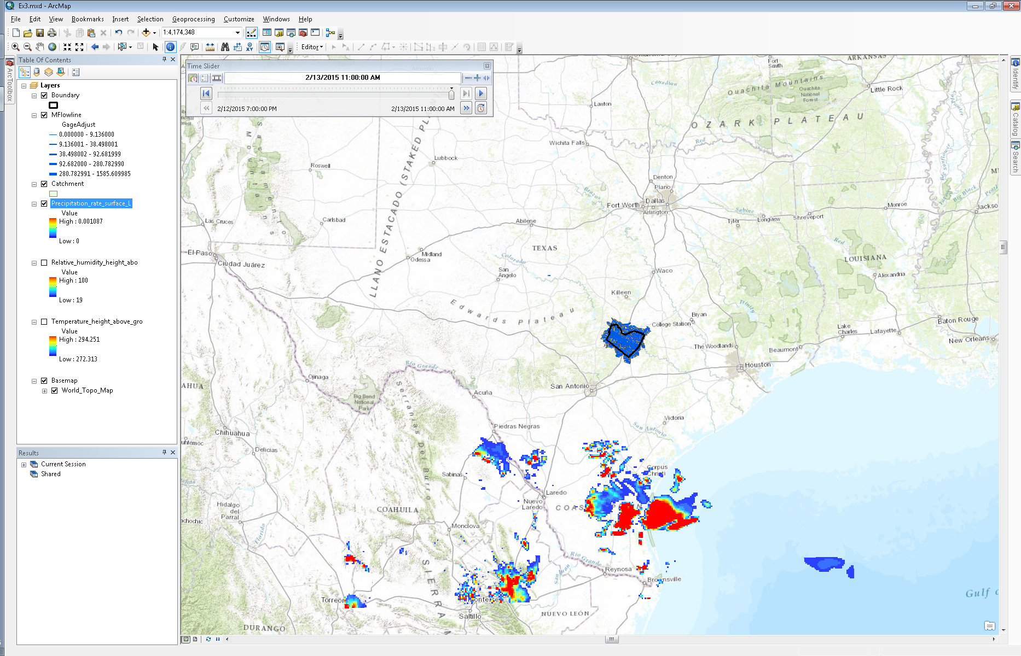
To be turned in: Present a short sequence of maps that shows precipitation evolving over Texas.

Land Surface Modeling
Within the NFIE and NFIE-Hydro framework, WRF-Hydro is used as a modeling framework for running the Noah-MP land surface model; WRF-Hydro was created by NCAR as a framework for coupling the WRF atmospheric model to various distributed hydrology models (e.g. land surface, channel routing, groundwater, water management etc.) Within the WRF-Hydro framework, one can select various different physics options and modeling components. For example, one could use the Noah-MP land surface model with the CASC2D channel routing model and WEAP water management model. This is similar to the WRF model where one can select various different cloud physics options.
Within NFIE-Hydro, WRF-Hydro is being used to run the Noah-MP land surface model. Instead of running WRF within WRF-Hydro to model the atmosphere, we will the model outputs from the operational HRRR model run by NCEP within NOAA. Similarly, instead of running RAPID within WRF-Hydro, we will use the WRF-Hydro Noah-MP outputs to run the RAPID model separately.
There are two primary inputs to the Noah-MP model:
- A GEOGRID file (a netCDF file) that contains various land surface characteristics AND
- Atmospheric forcing (several netCDF files)
In order to run Noah-MP, the GEOGRID file must contain the following information:
- Elevation
- Land use
- Soil type
- Vegetation fraction
- Albedo
In order to run Noah-MP, the atmospheric forcing files must contain the following information:
- Precipitation rate (mm/s)
- Air temperature at 2 meters above the surface (K)
- U-component of wind at 2 meters above the surface (m/s)
- V-component of wind at 2 meters above the surface (m/s)
- Incoming longwave radiation (W/m²)
- Incoming shortwave radiation (W/m²)
- Specific humidity (kg/kg)
- Surface pressure (Pa)
You may notice that the HRRR model outputs do not provide incoming longwave radiation. Thus, using a python script, we derive the incoming longwave radiation from temperature and relative humidity using the Brutsaert (1982) equation for estimating longwave radiation during clear sky conditions.
Display data within GEOGRID file in ArcMap
- In ArcToolbox under “Multidimensional Tools”, double click on the “Make NetCDF Raster Layer” tool.
- Navigate to the “Ex3/Resources/WRF-Hydro” folder in the “Ex3” folder. Select the “geo_em.d01_conus_3km.nc” file.
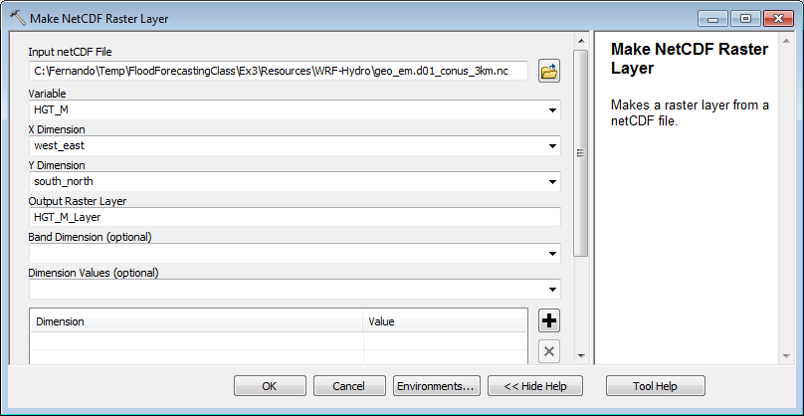
- Select the “HGT_M” variable from the dropdown menu. You will see several variables in the dropdown. The “HGT_M” variable contains elevation data at 3 km resolution for the continental US.
- Select “west_east” as the X dimension and “south_north” as the Y dimension.
- Click “OK”.

Note: After clicking “OK” you will not see the data displayed in the proper coordinate system because the GEOGRID netCDF file is not CF compliant meaning that the coordinate data within the netCDF file is not where ArcMap expects it to be. Because of this, ArcMap will not display the data in the right coordinate system.

- Right click on the “HGT_M_Layer” layer and select “Zoom to Layer”.

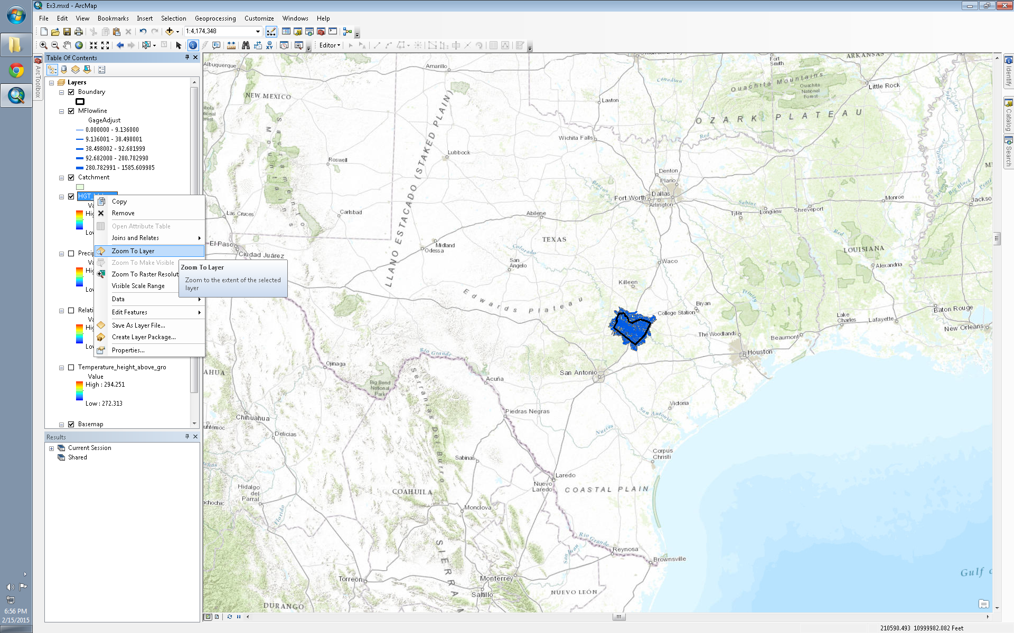

- After zooming to the “HGT_M_Layer”, move your mouse cursor to the bottom left of the grid and look at the coordinates in the bottom right of the ArcMap window. You’ll notice that the coordinates are close to 0 feet in the X direction and 0 feet in the Y direction. Again, this is because the coordinate data in the GEOGRID netCDF file is in the wrong place. Therefore, ArcMap plots the values in space by counting the cells in the X and Y direction. As a test, move your mouse cursor to the bottom right of the grid. The coordinates should be 1536 in the X direction and 0 in the Y direction. That is because there are 1536 columns in the grid.
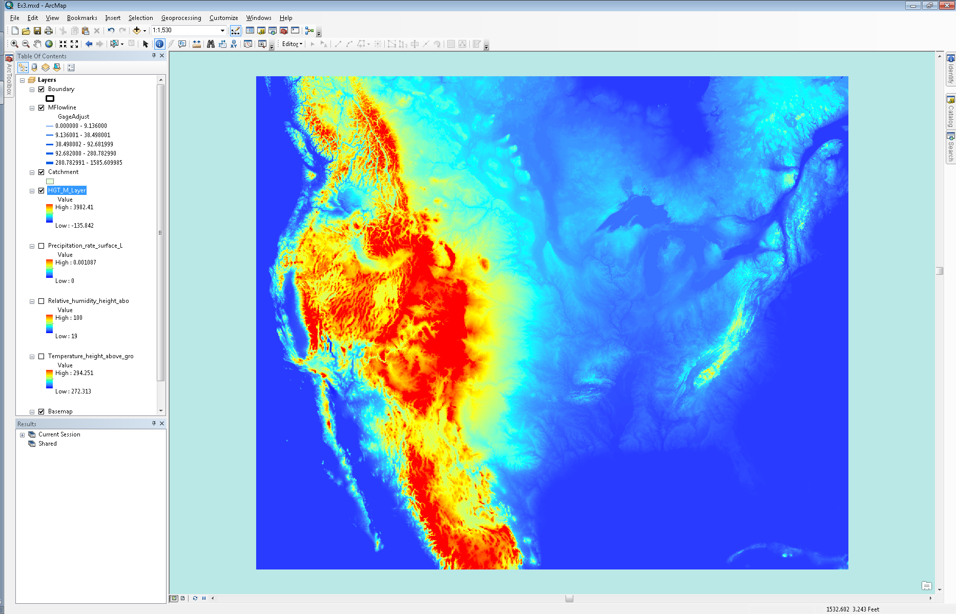
- To display the grid in the correct coordinate system, go to the “Catalog” on the right of the ArcMap window. Navigate to the “Ex3/Resources/WRF-Hydro/GEOGRID_PREPROCESSOR” folder. You will see an ArcGIS toolbox called “GEOGRID_STANDALONE.pyt”. This toolbox was created by NCAR to work with GEOGRID files within ArcMap.

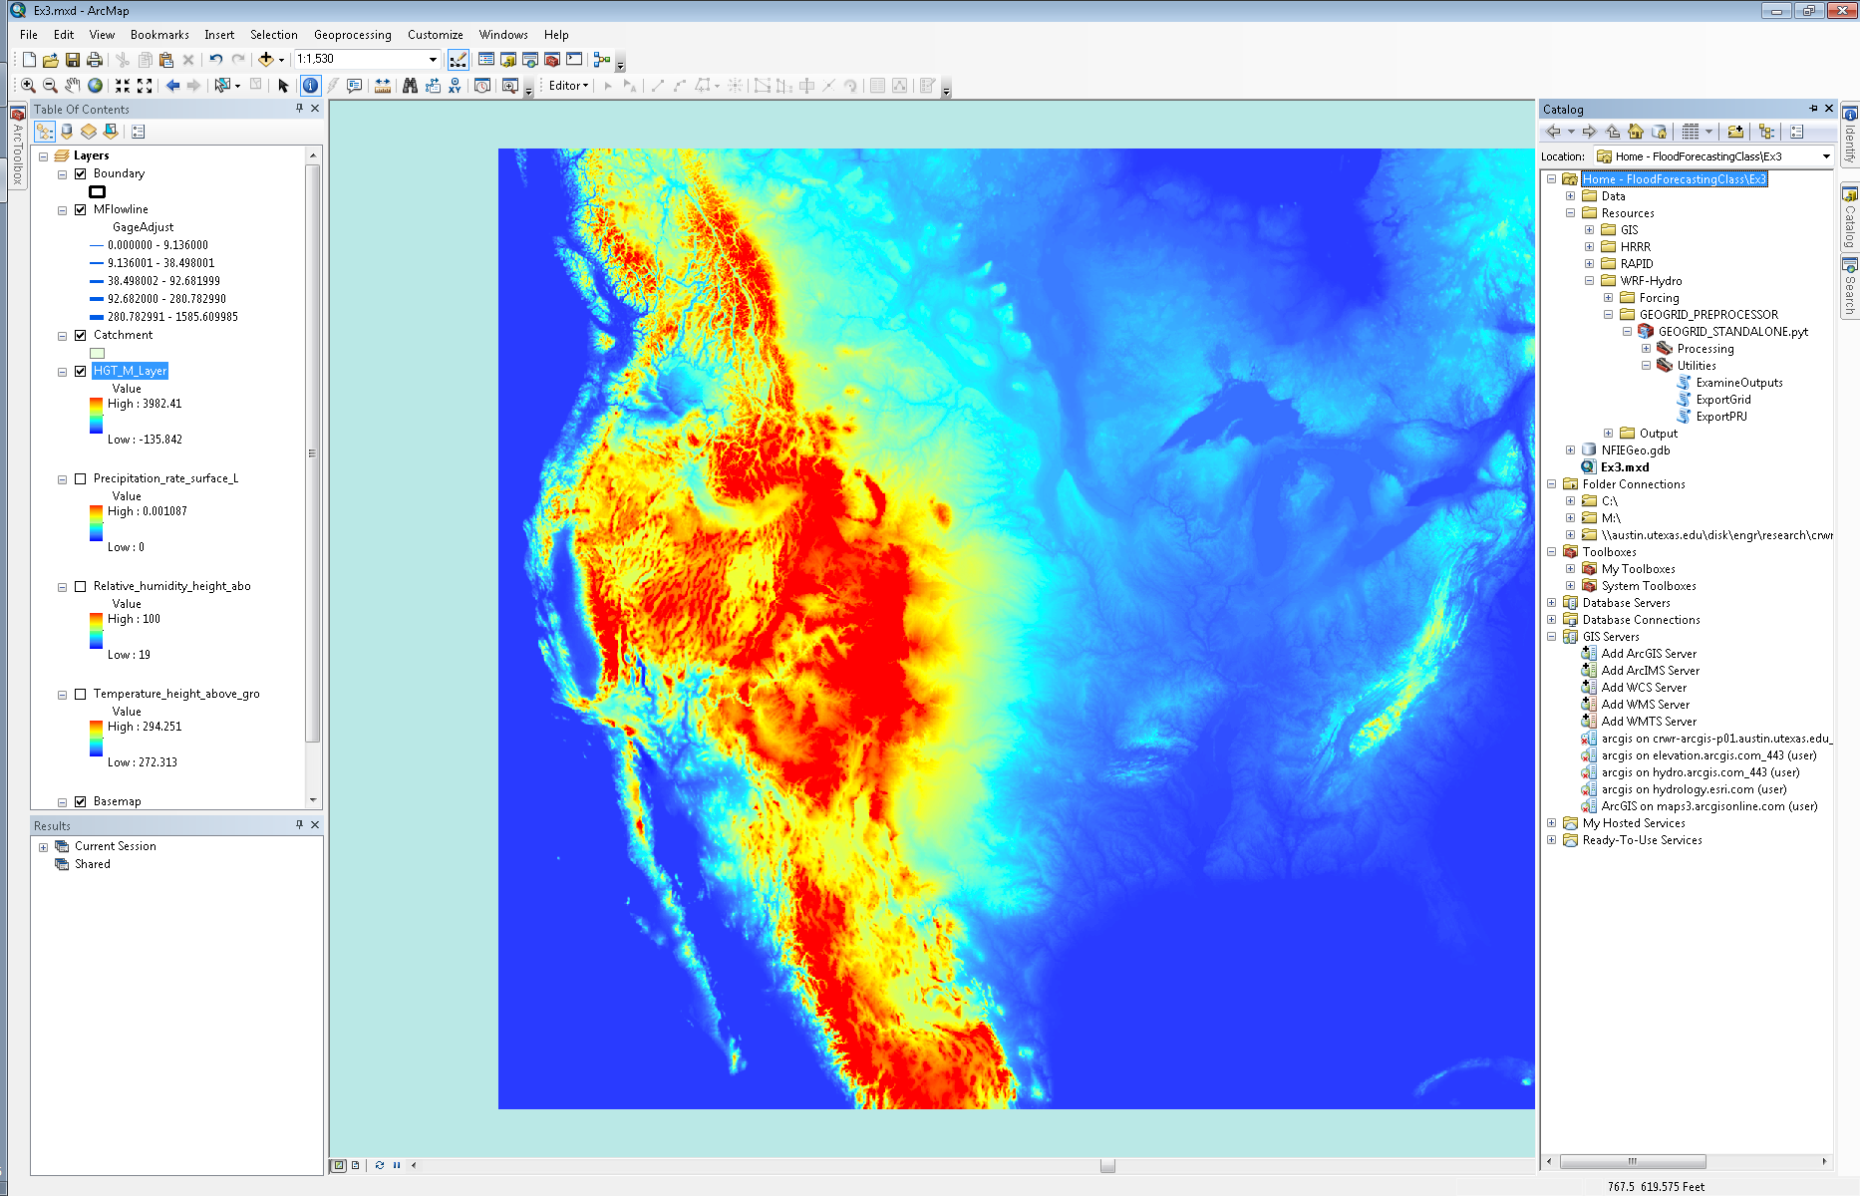

- Expand the toolbox and select the “ExportGrid” script under “Utilities”.
- Navigate to the “geo_em.d01_conus_3km.nc” GEOGRID file and select the “HGT_M” variable.

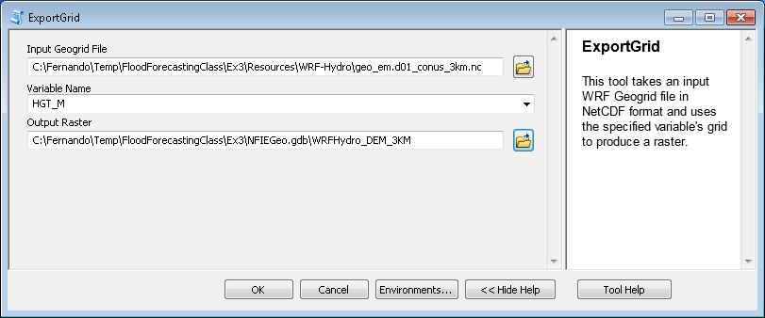

- Save the “Output Raster” in the same geodatabase as the Travis county data.
- Click “OK”.
- Right click on the new layer and select “Zoom to Layer”.

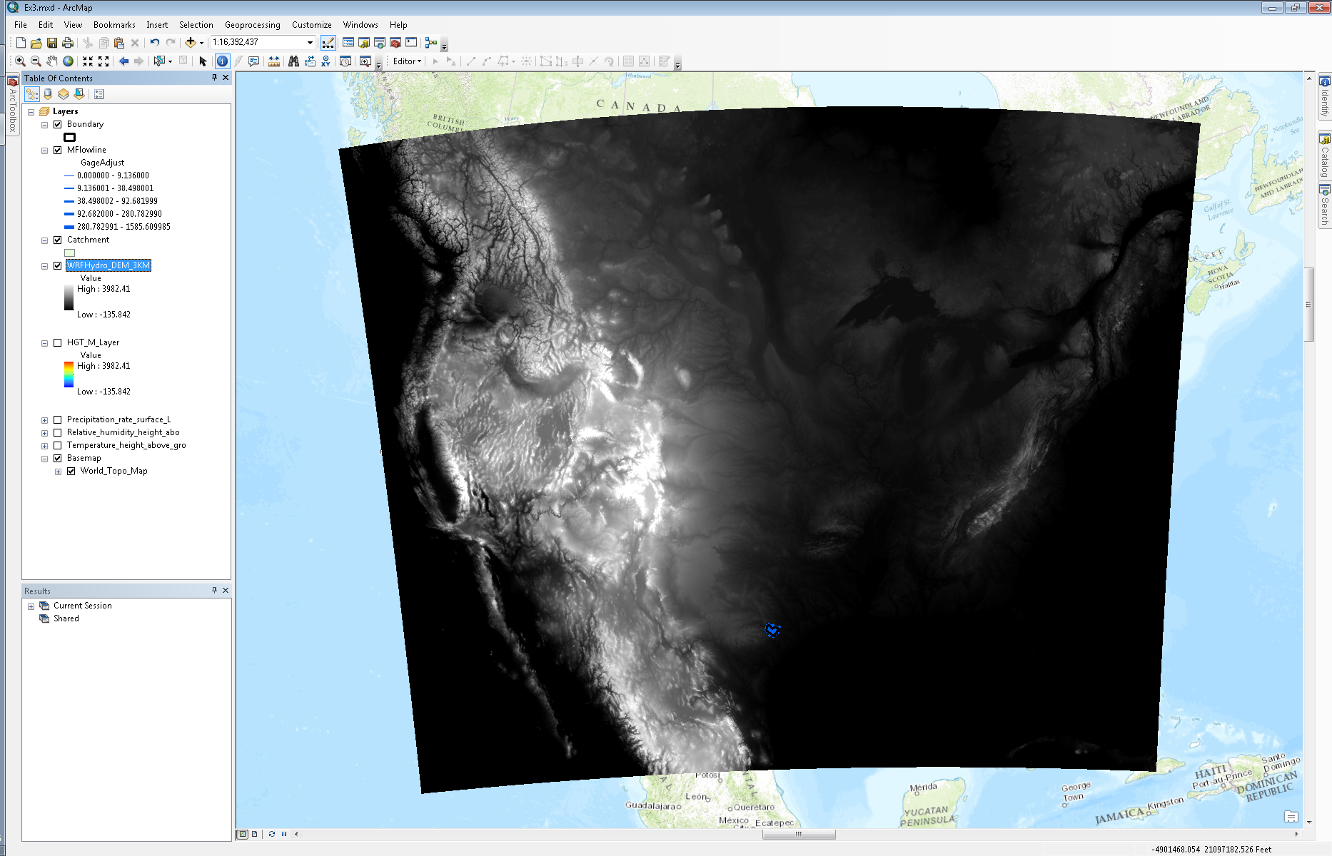

- Right click on the same layer and select “Properties”.
- In the symbology tab select the appropriate “Color Ramp” and “Display Background Value” as 0.
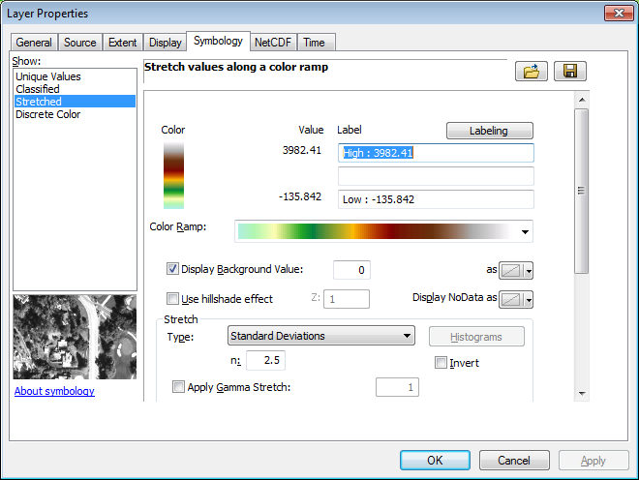
- Click “OK”.
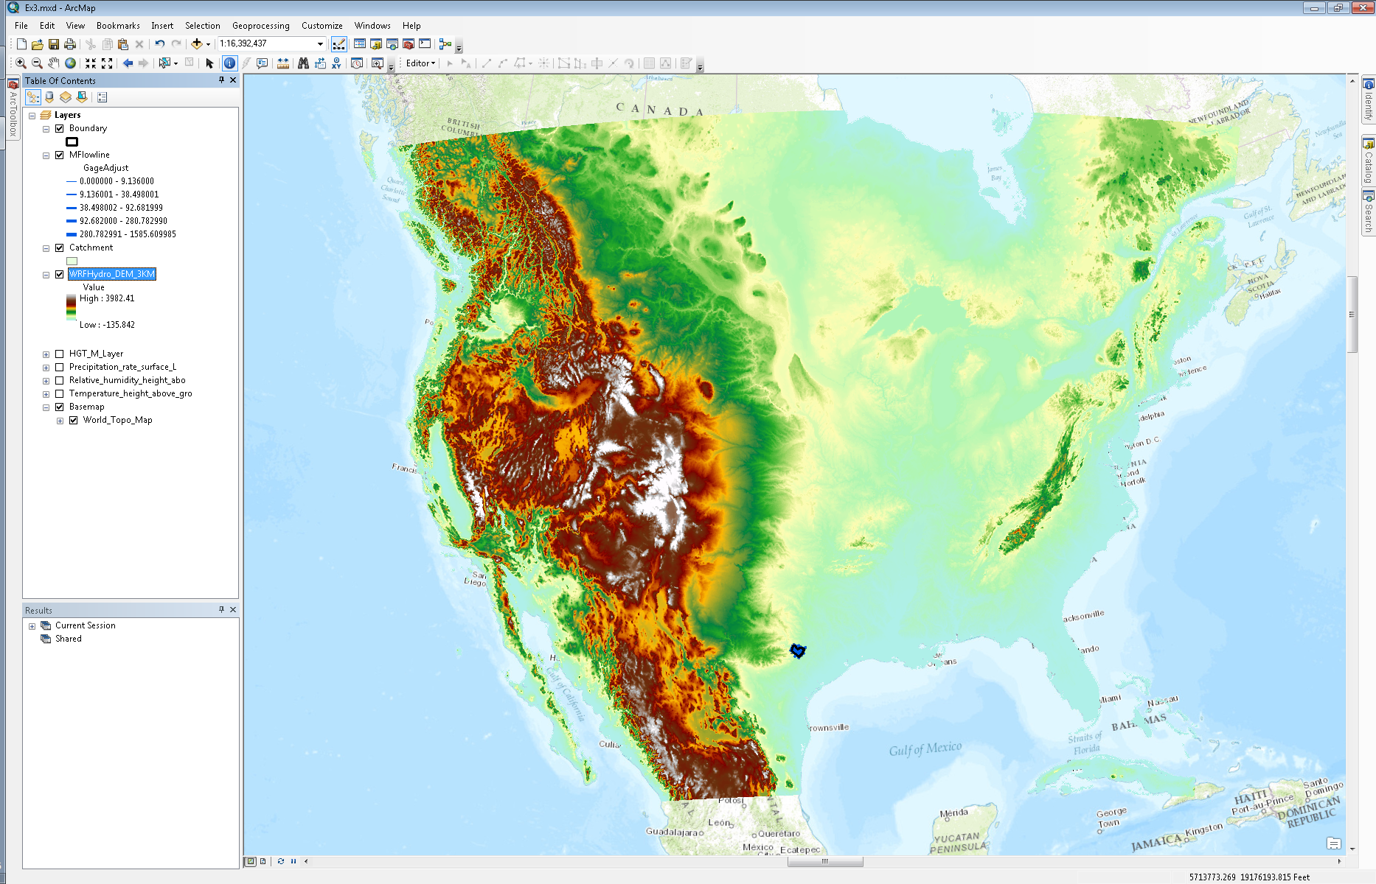
- Navigate to the “GEOGRID_STANDALONE.pyt” toolbox in the “Catalog” on the right.
- Double click on the “ExportGrid” script.
- Navigate to the same GEOGRID file and select the “LU_Index” variable from the dropdown menu. The “LU_Index” variable contains land use data for the continental US.
- Save the grid in your geodatabase.

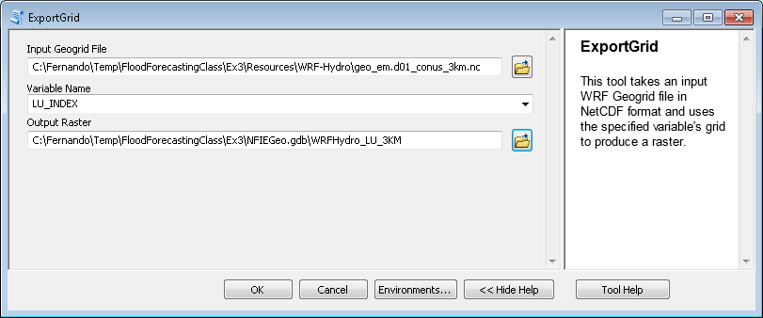

- Give the new layer an appropriate “Color Ramp” under the symbology tab in the layer’s “Properties”. The values of the grid vary from 1 to 24. These values are codes for land use based on the USGS Land Use/Land Cover system. You will find the land use codes in Appendix 3 of the link below:

http://edc2.usgs.gov/glcc/globdoc2_0.php
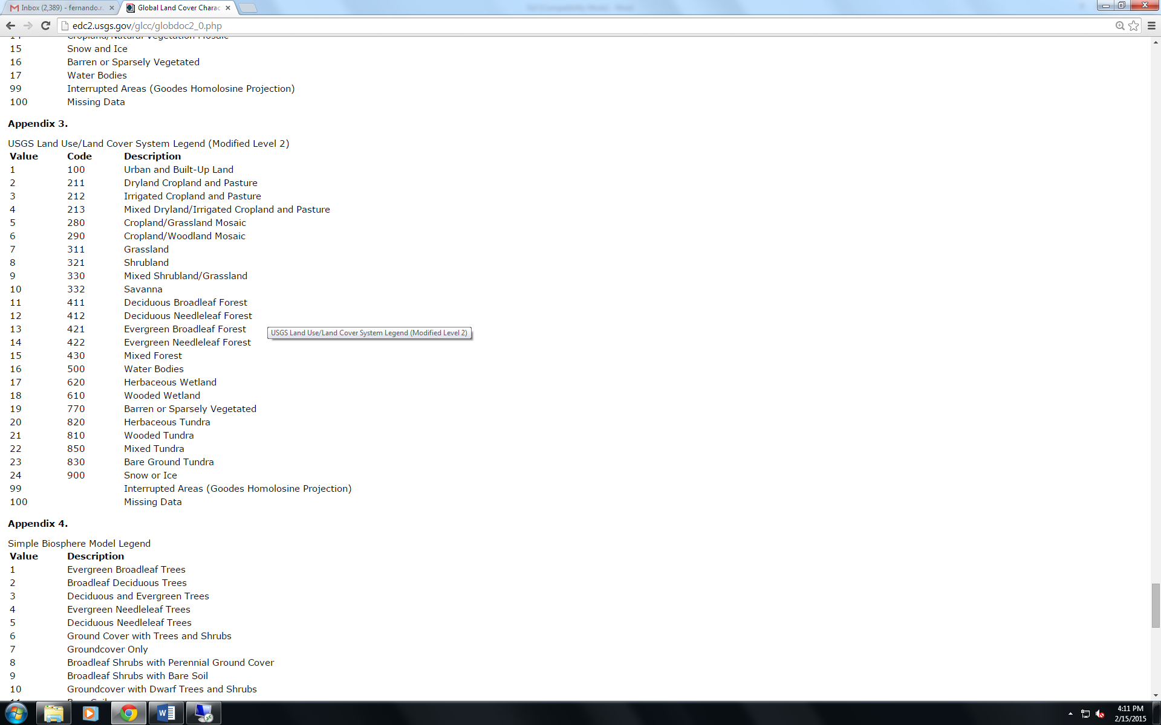
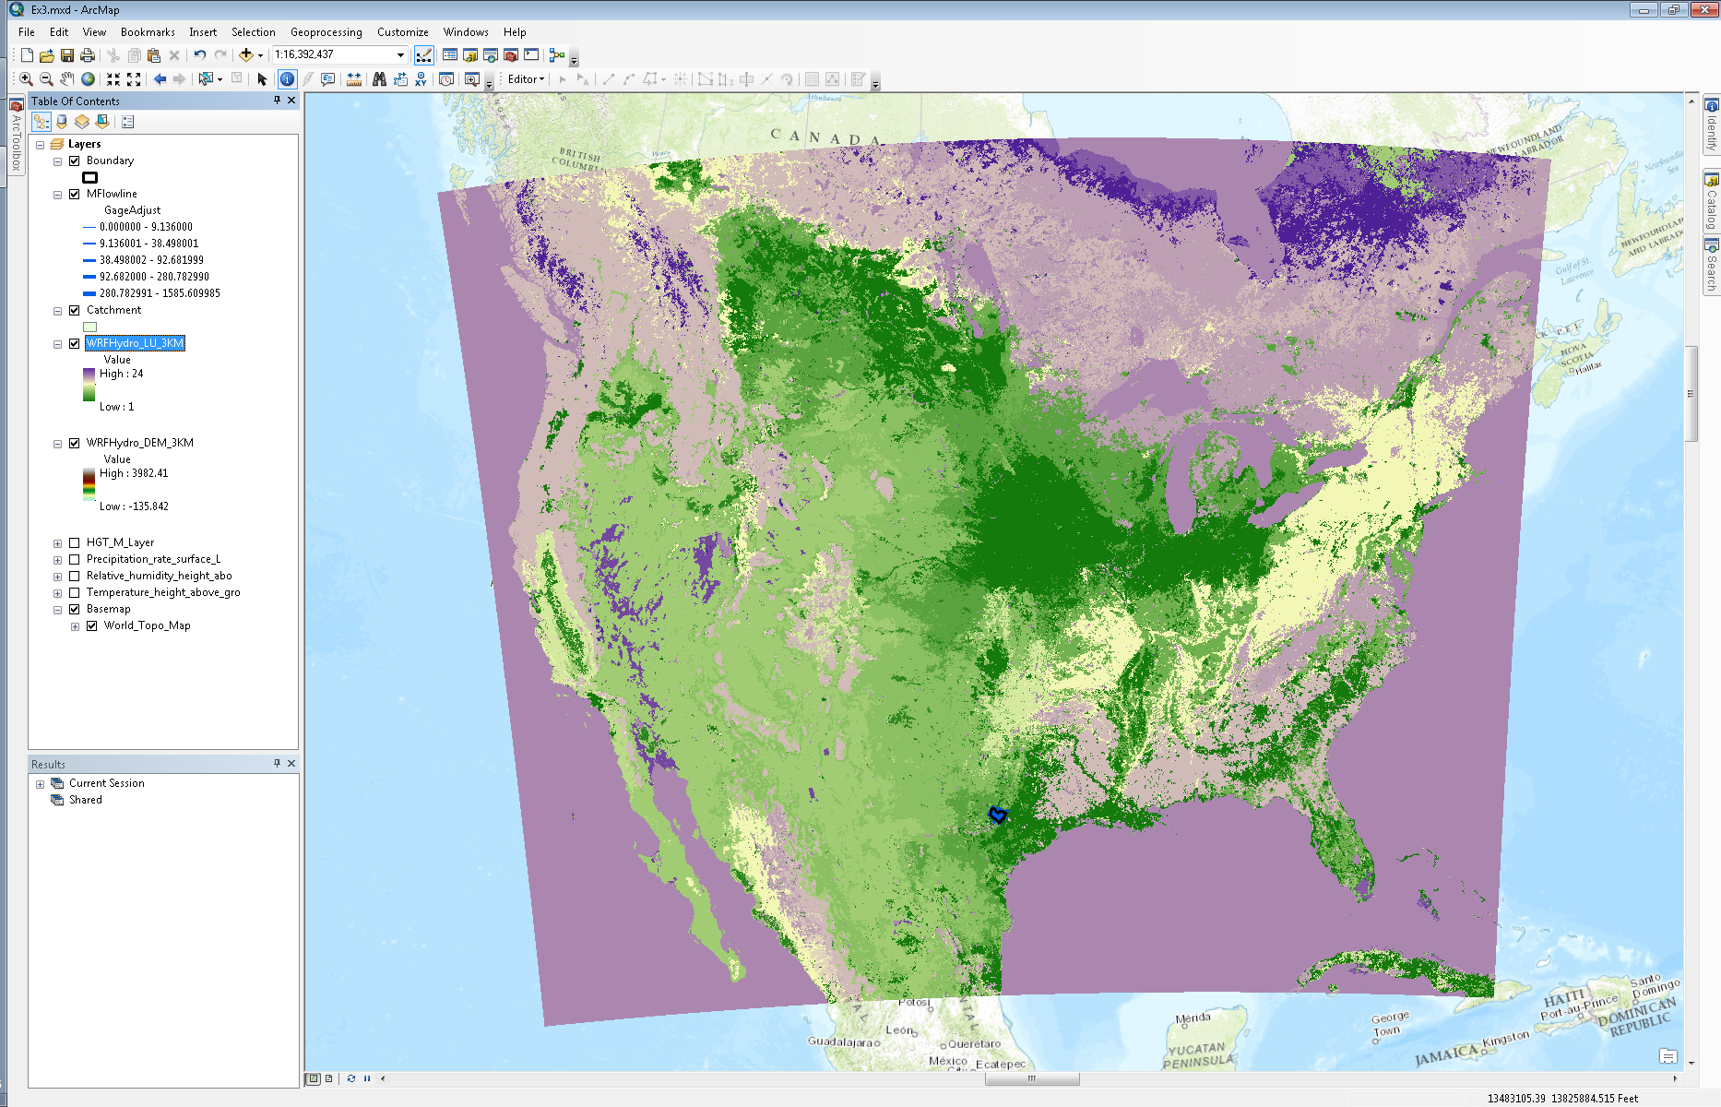
- Several of the other variables in the GEOGRID file cannot be displayed in the proper coordinate system using the “ExportGrid” script (e.g. GREENFRAC variable). This is because the GREENFRAC variable contains vegetation fraction data for each month and the script isn’t able to handle the multidimensional nature of the variable. However, to display this variable, you may use the “Make NetCDF Raster Layer” tool in the “Multidimensional Tools” toolbox to display the data in the wrong coordinate system.
- Select the “GREENFRAC” variable and select “west_east” as the X dimension and “south_north” as the Y dimension.

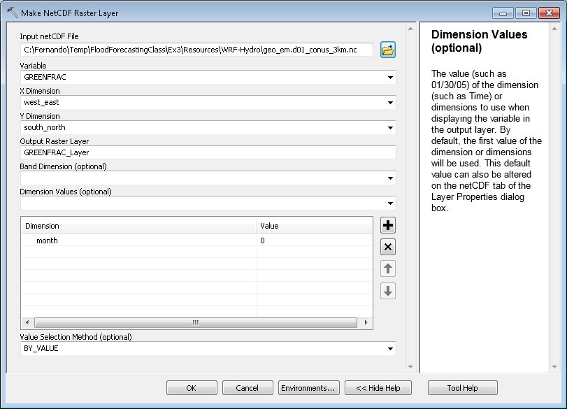

- Select “month” as the dimension.
- Click “OK”.
- Right click on the new layer and select “Zoom to Layer”.

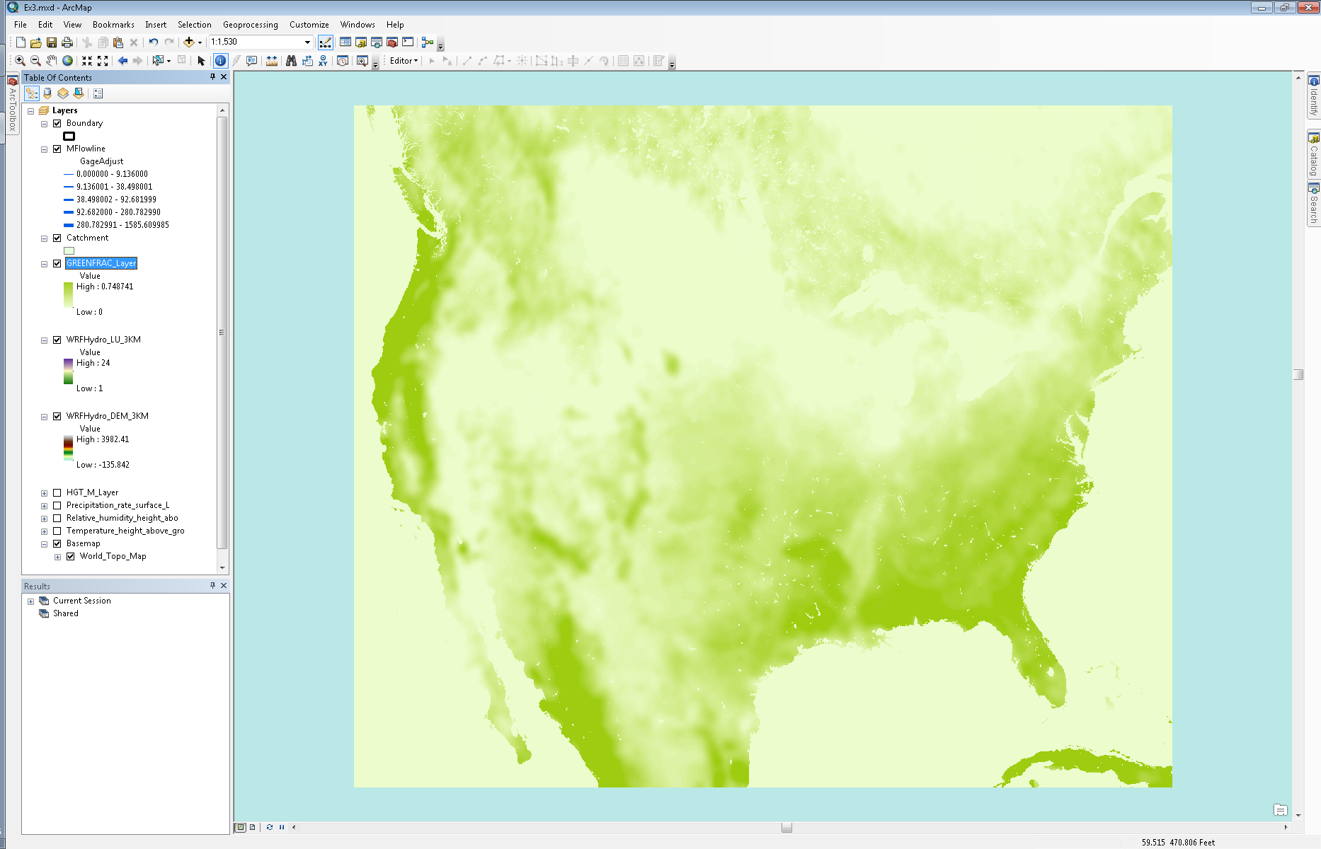

- In the “NetCDF” tab of the new layer’s “Properties”, you can select the month you’re interested in displaying on the map.
Note: The “month” values in the “Dimension Values” are not 1-12, they are instead 0-11. This is because the metadata in the GEOGRID file is not complete and does not specify the proper month numbers. Therefore value “0” is actually “1” or January. Similarly, value “10” is actually “11” or November.
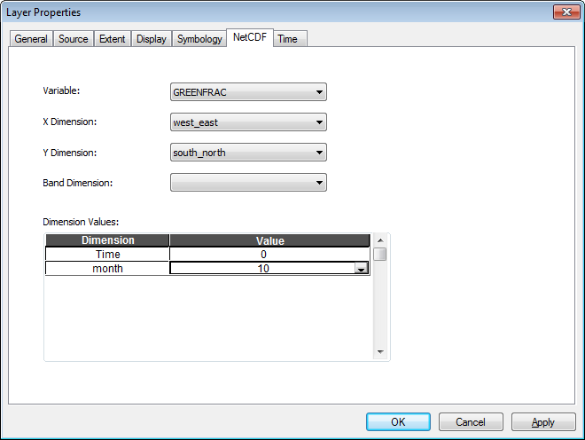
Display WRF-Hydro inputs for modeling over Texas
Although we will be modeling the entire continental US within the NFIE-Hydro framework, we are currently testing the modeling workflow over Texas.
- Use the “ExportGrid” script to display the “HGT_M” variable over Texas. Navigate to the “geo_em.d01_Texas_3km.nc” file in the “Ex3/Resources/WRF-Hydro” folder.

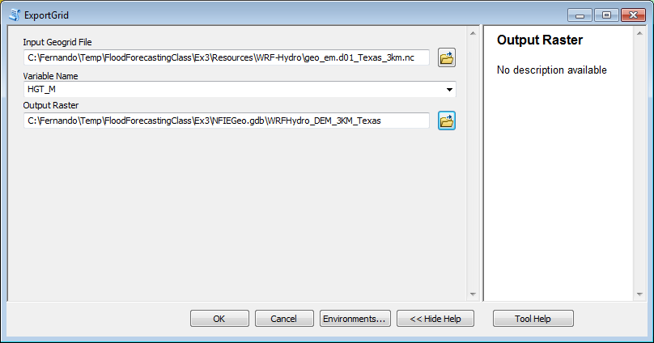
- Click “OK” and then “Zoom to Layer”.
- Select the same symbology as the national “HGT_M” grid by going to the “Symbology” tab within the new layer’s “Properties”. Click on the import icon in the “Symbology” tab. It is the button next to the floppy disk icon. Select the layer containing the national elevation data.
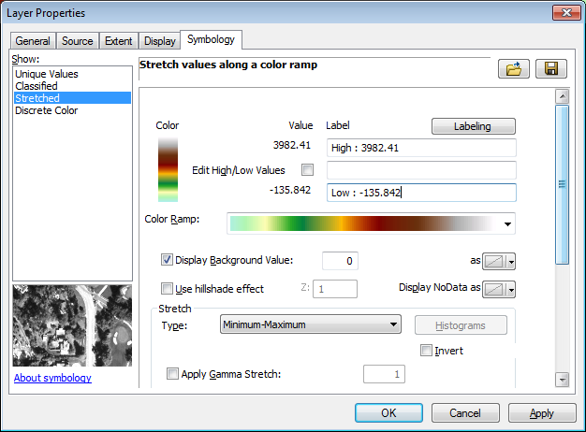
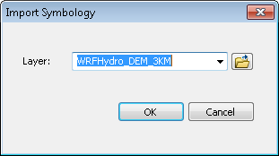
- Click “OK” in the “Import Symbology” and “Layer Properties” windows.

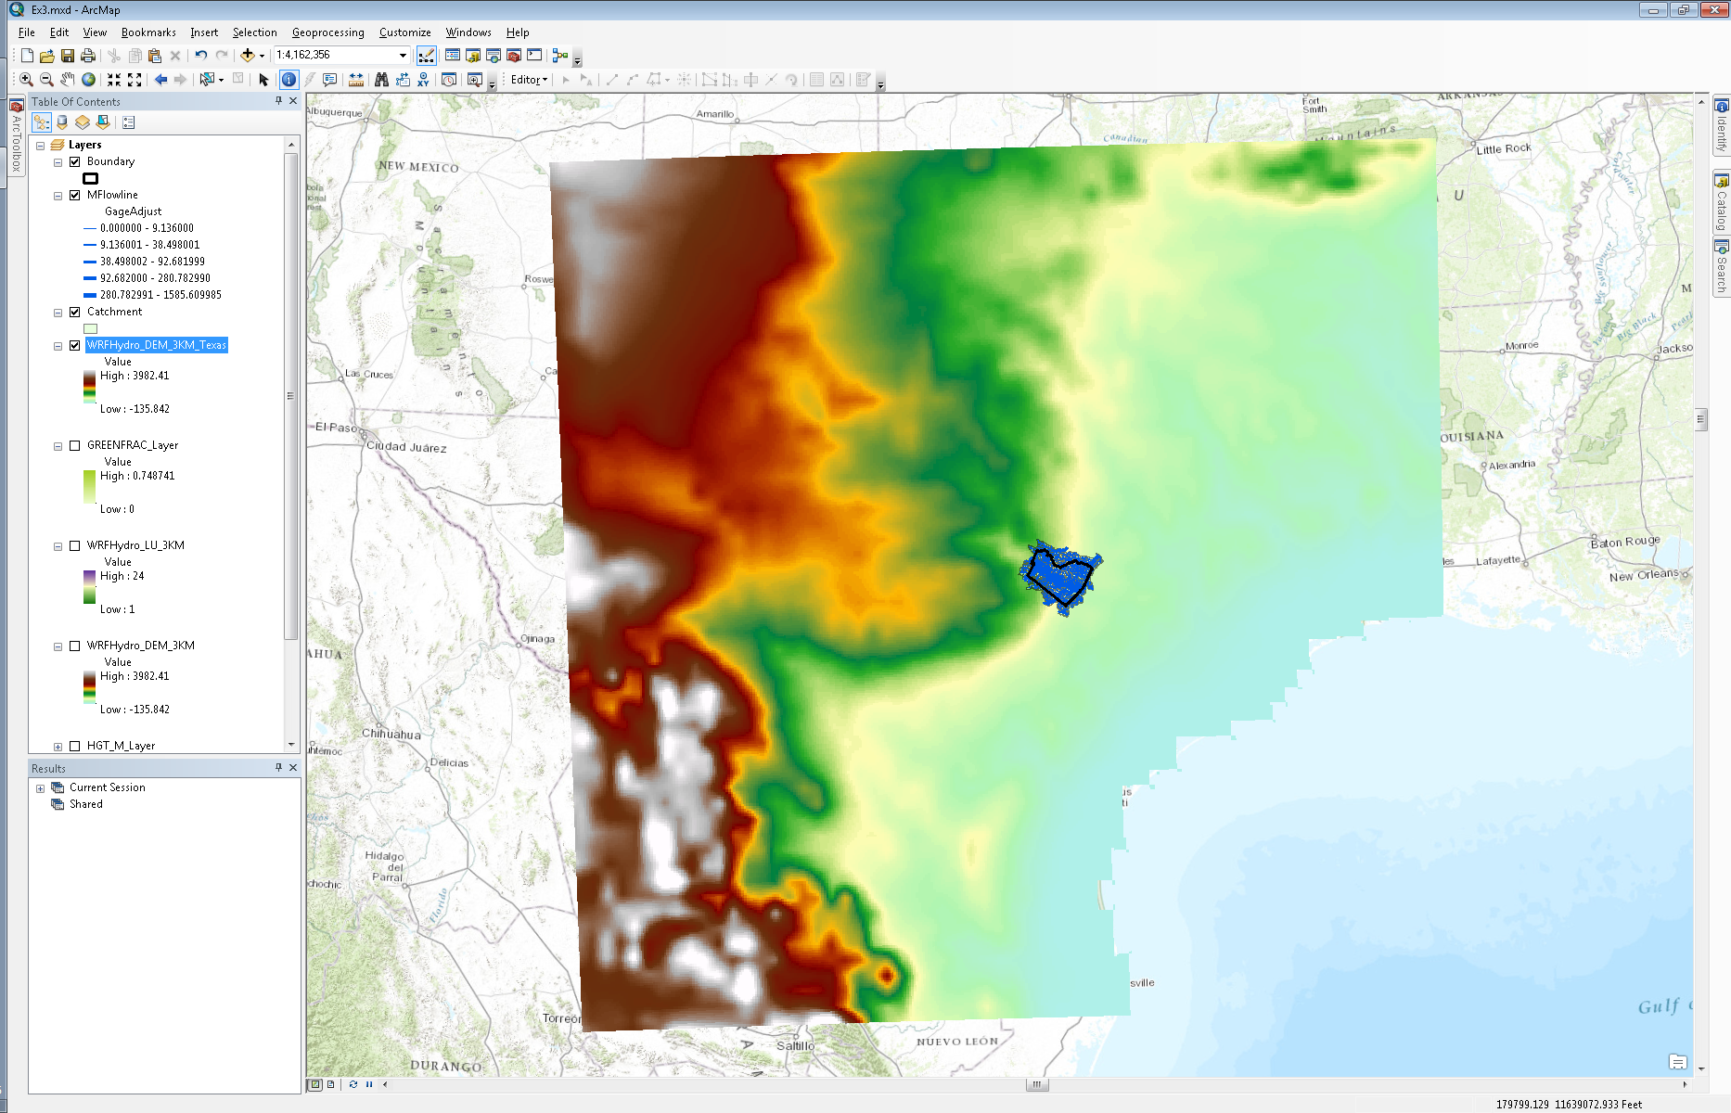

- Turn on the national elevation grid and the elevation grid over Texas. You’ll notice that the resolution of the data appears to be different and it is. The underlying data used to create the Texas elevation grid is coarser than the national grid. However, the grid size for both the layers is the same, 3 km. The coarse grid over Texas will be replaced with finer resolution data within NFIE-Hydro. This is simply for demonstration purposes.

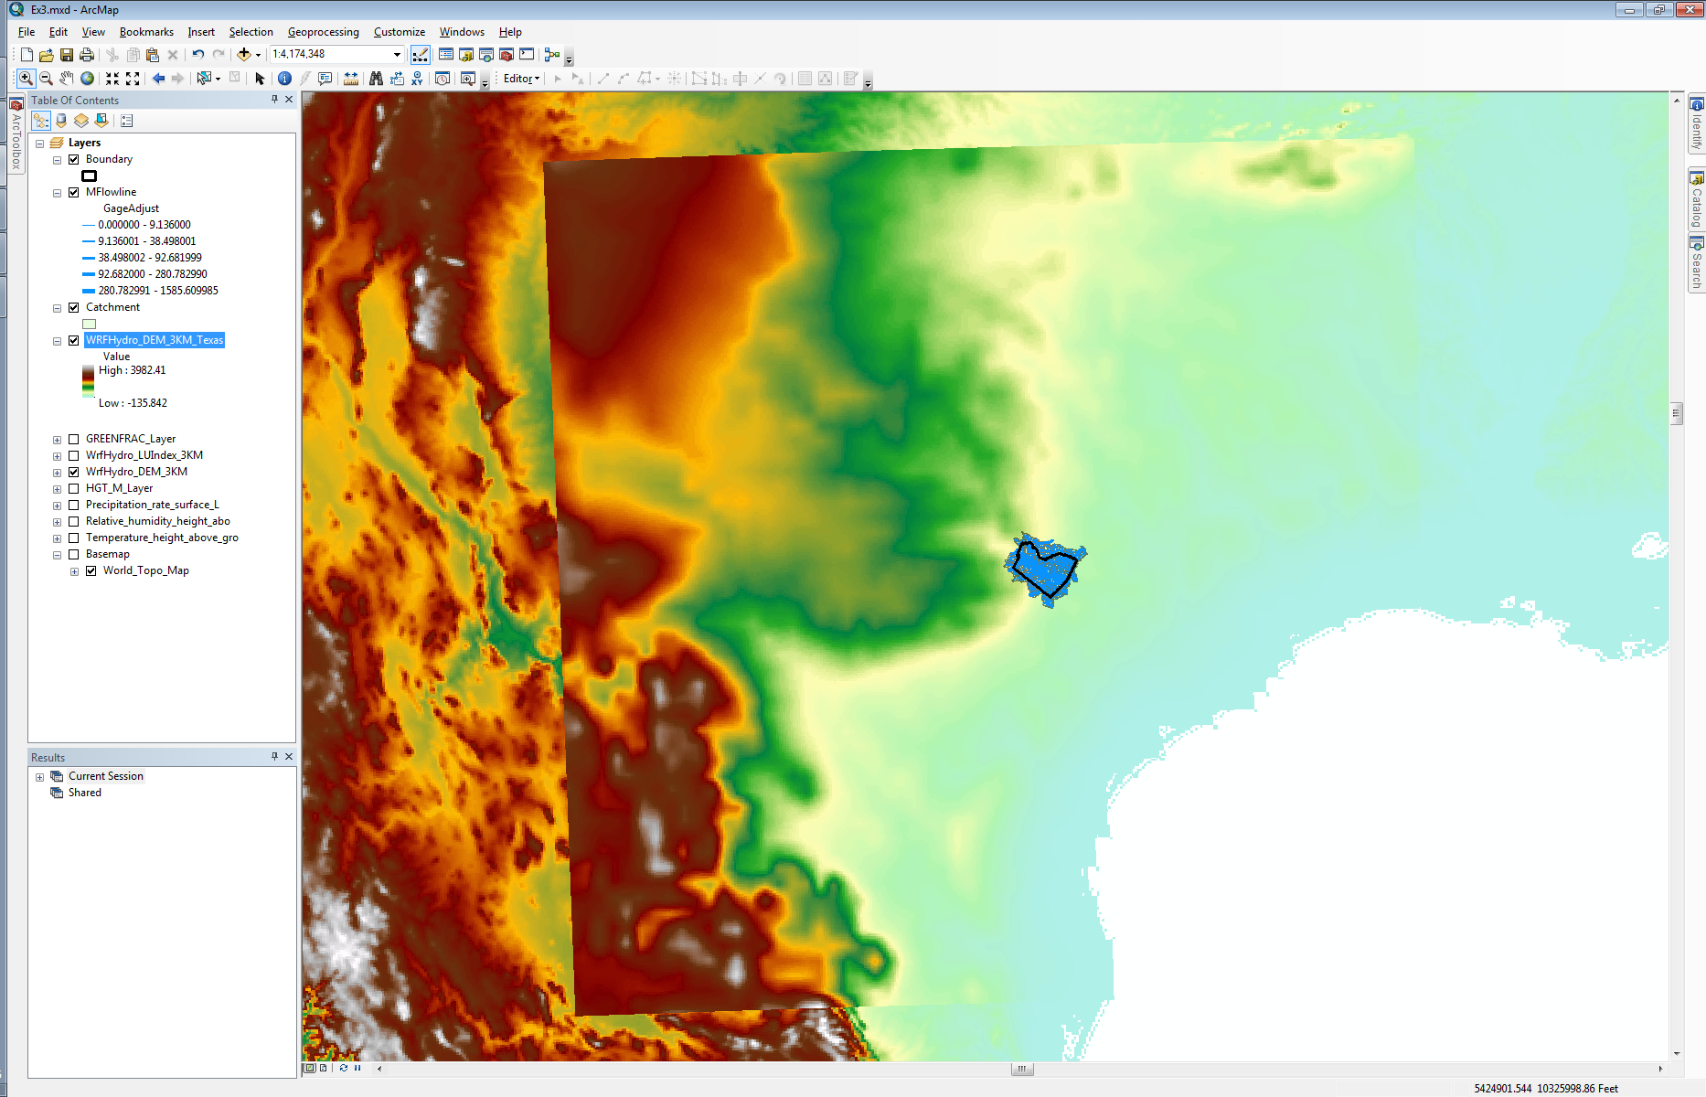

- Turn on the “Temperature_height_above_gro” layer at the same time as the elevation data over Texas. You’ll notice that the two grids overlap in space. This step is to show that the input data from the GEOGRID file and the HRRR data are consistent for modeling.
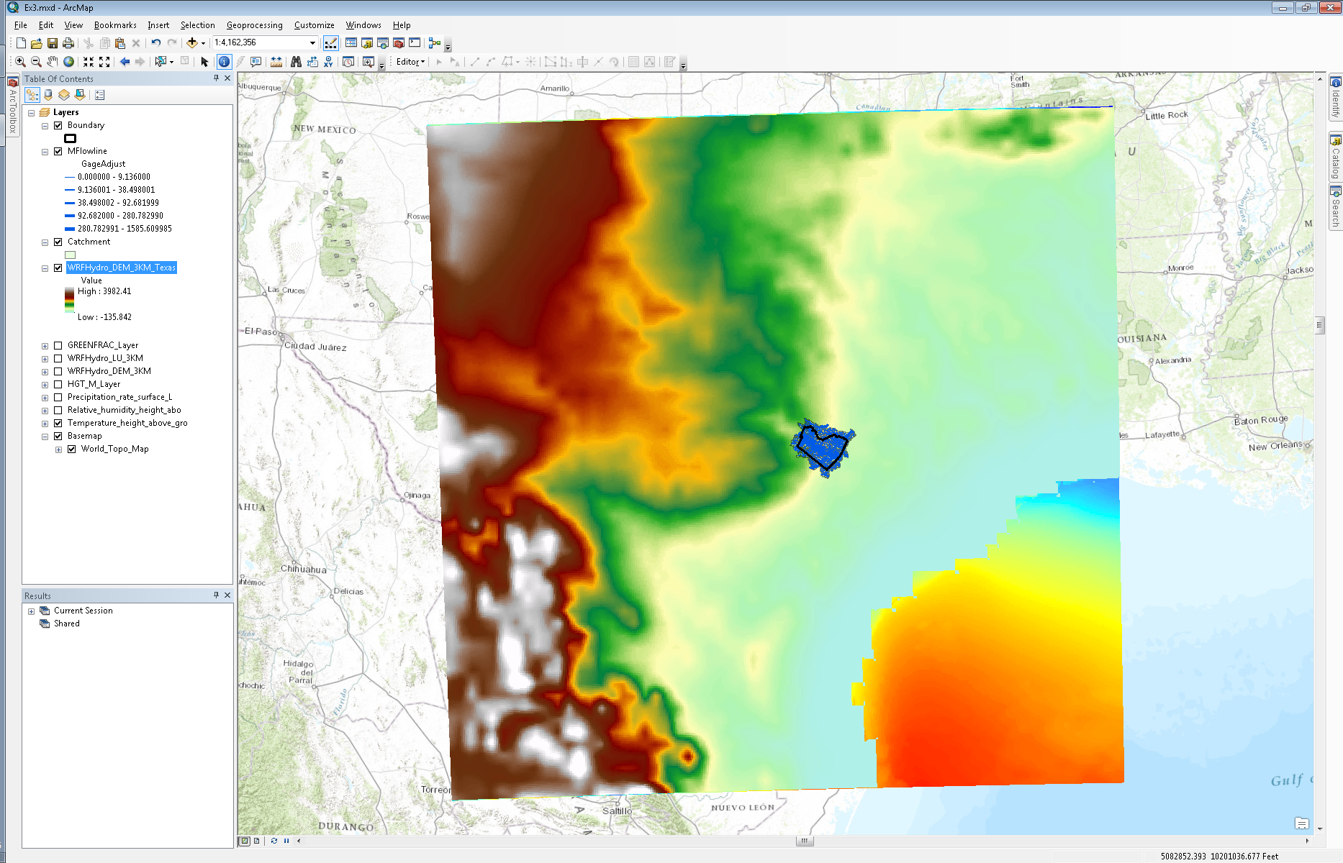
- Now, in order to run the WRF-Hydro Noah-MP model, one cannot simply use the two netCDF files we downloaded from the ESRL THREDDS server. The data must be processed and converted to the data format that WRF-Hydro expects. Within the NFIE-Hydro framework, this is done through a Python script. Some sample input data can be found in the “Ex3/Resources/WRF-Hydro/Forcing” folder. You will see the following files listed:

2015021301.LDASIN_DOMAIN1
2015021302.LDASIN_DOMAIN1
2015021303.LDASIN_DOMAIN1
2015021304.LDASIN_DOMAIN1
2015021305.LDASIN_DOMAIN1

Each file contains 7 variables for the date and time stamp listed in the file name. This data was created using the two netCDF files in the “Ex3/Resources/HRRR” folder. These files contain HRRR model output starting from 02/13/2015 01:00 UTC. The forecast portion of the data begins at 02/13/2015 15:00 UTC.
- Use the “Make NetCDF Raster Layer” tool in the “Multidimensional Tools” toolbox to display the “T2D” (i.e. temperature at 2 meters above the land surface) variable within the “2015021301.LDASIN_DOMAIN1” netCDF file.

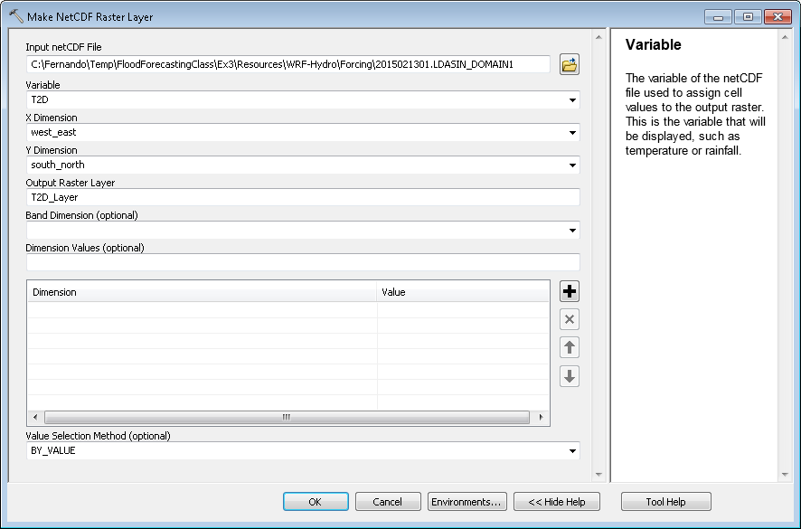

- After filling out the fields in the “Make NetCDF Raster Layer” window, click “OK” and then “Zoom to Layer”.
- Again, this data will display in the incorrect coordinate system because the metadata in the netCDF file is incomplete; the coordinate system is not listed within the netCDF file. However, these files DO contain projected coordinates as dimensions within the netCDF file and can be displayed correctly by exporting the grid and defining the layer’s projection in ArcMap.

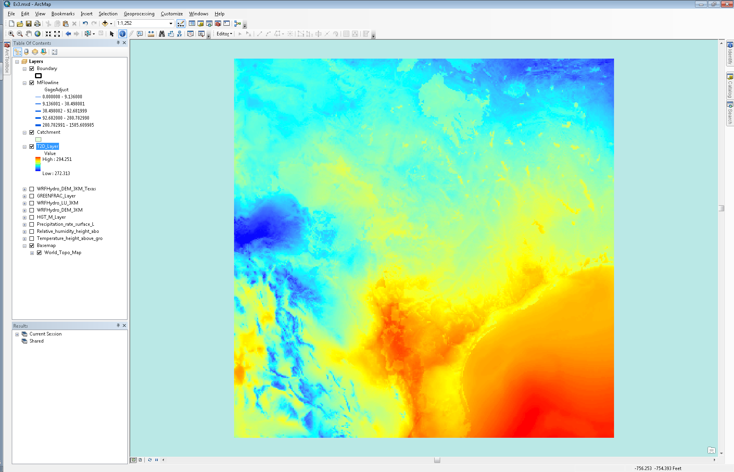

- Right click on the “T2D_Layer” and under “Data”, click on “Export Data…”.

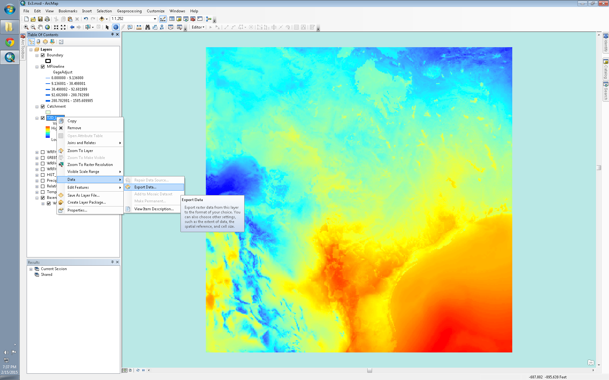

- Save the grid to your geodatabase, click “OK” and add the layer to your map.

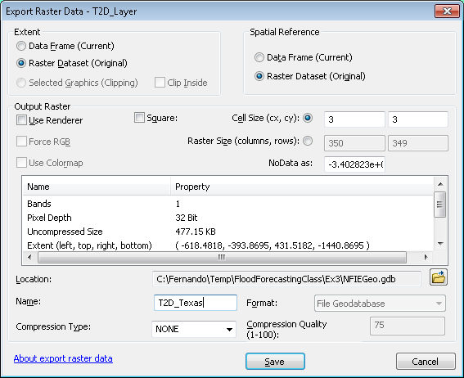

- In “ArcToolbox”, go to the “Define Projection” tool under “Data Management Tools/Projections and Transformations”.
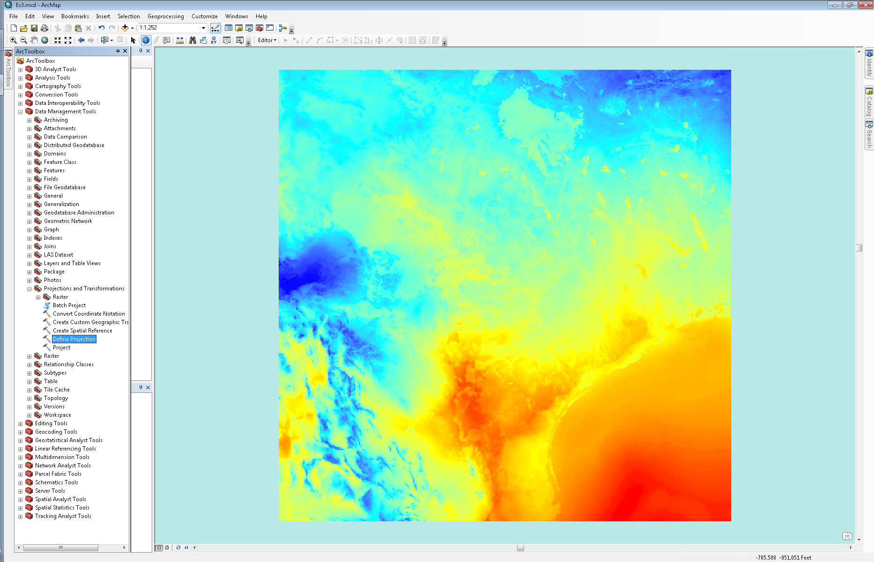
- Select the layer you just added to your map as the “Input Dataset” and click on the icon next to the “Coordinate System” box.

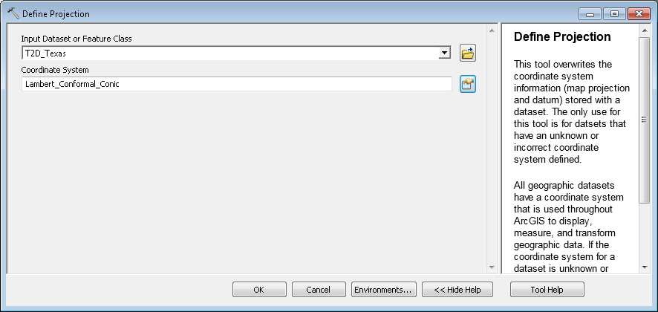

- In the “Spatial Reference Properties” window, select “Lambert_Conformal_Conic” in the “Layers” folder.
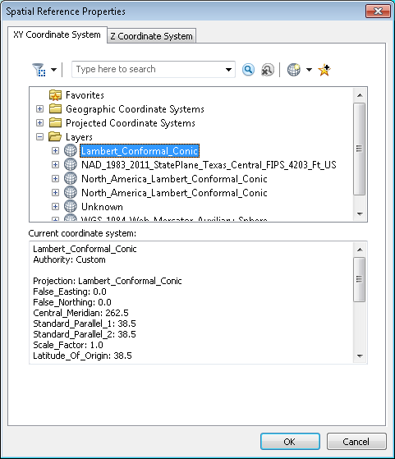

- Click “OK” and then click “OK” again. Your grid will now be displayed in the correct coordinate system.
- Right click on the layer and “Zoom to Layer”.

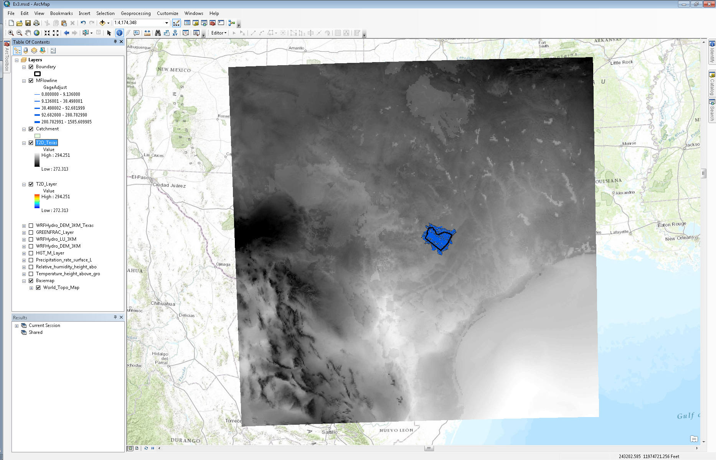

You can repeat these steps for any of the layers in the WRF-Hydro forcing files. The following variables are contained within the WRF-Hydro forcing files:

LWDOWN (W/m²)
PSFC (Pa)
Q2D (kg/kg)
RAINRATE (mm/s)
SWDOWN (W/m²)
T2D (K)
U2D (m/s)
V2D (m/s)

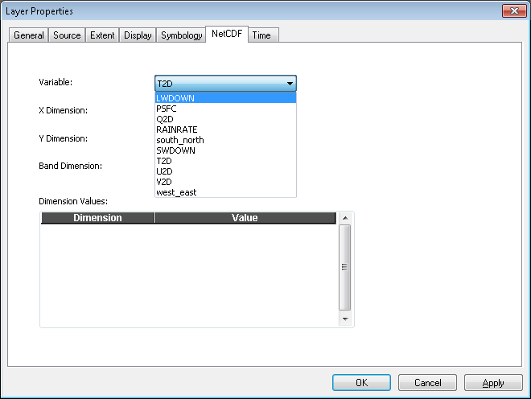

For each forcing file, you can display each variable by going to the “NetCDF” tab in the “Properties” of the netCDF layer.
Display WRF-Hydro outputs over Texas
Using the HRRR data in the “Ex3/Resources/HRRR” folder, the WRF-Hydro Noah-MP model was run and a sample set of the outputs has been stored in “Ex3/Resources/WRF-Hydro/Output”. You will find the following files in that folder:
2015021301.LDASOUT_DOMAIN1 (Hour 1 of model simulation)
2015021320.LDASOUT_DOMAIN1 (Hour 20 of model simulation)
- In ArcToolbox under “Multidimensional Tools”, double click on the “Make NetCDF Raster Layer” tool.
- Navigate to the 2015021301.LDASOUT_DOMAIN1 file as the “Input netCDF File” and select the “SOIL_M” variable from the dropdown menu. This variable contains soil moisture data for four distinct layers in the soil column.

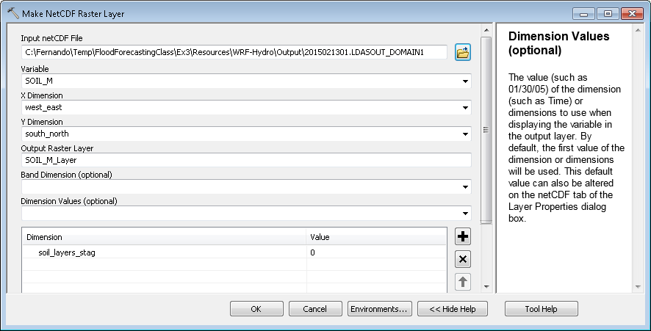

- Click “OK” and “Zoom to Layer”. Again, the WRF-Hydro netCDF outputs do not contain the proper metadata and dimensions to display the data in the proper coordinate system. However, we can still visualize the outputs.

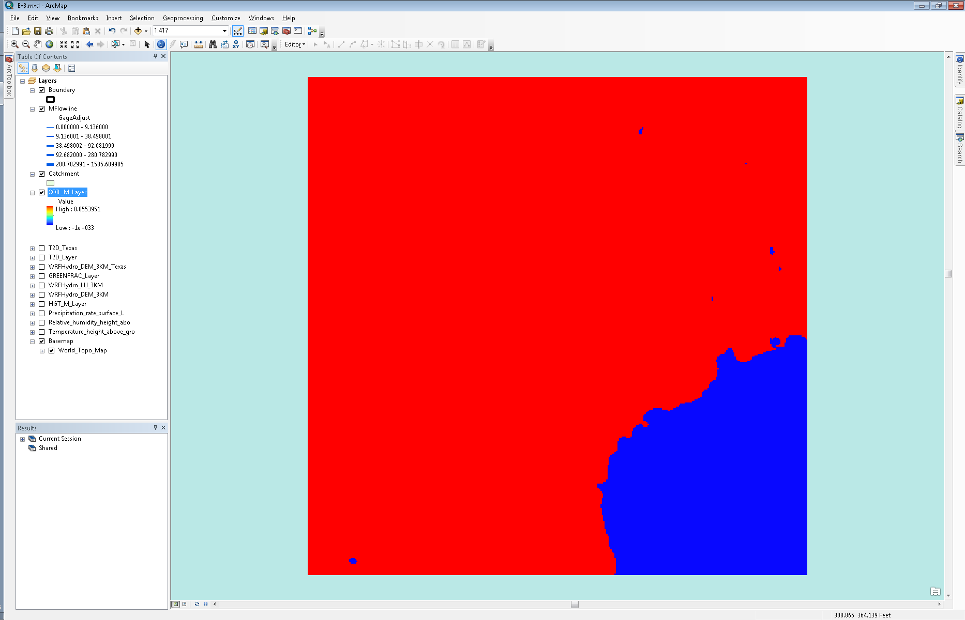

- Right click on the “SOIL_M_Layer” and select “Properties”.
- In the “Symbology” tab, set the appropriate “Color Ramp”.
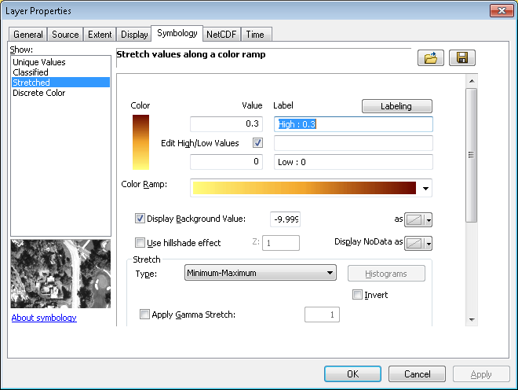
- Under “Stretch” and “Type”, select “Minimum-Maximum” from the dropdown menu and then toggle the “Edit High/Low Values” box.
- Enter “0” as the low value and “0.3” as the high value.
- Toggle the “Display Background Value” box and enter the following value in the text box next to it: -999999994495727290000000000000000.000000. Just copy and paste this value into the text box. For some reason, WRF-Hydro outputs this value as the no data value.

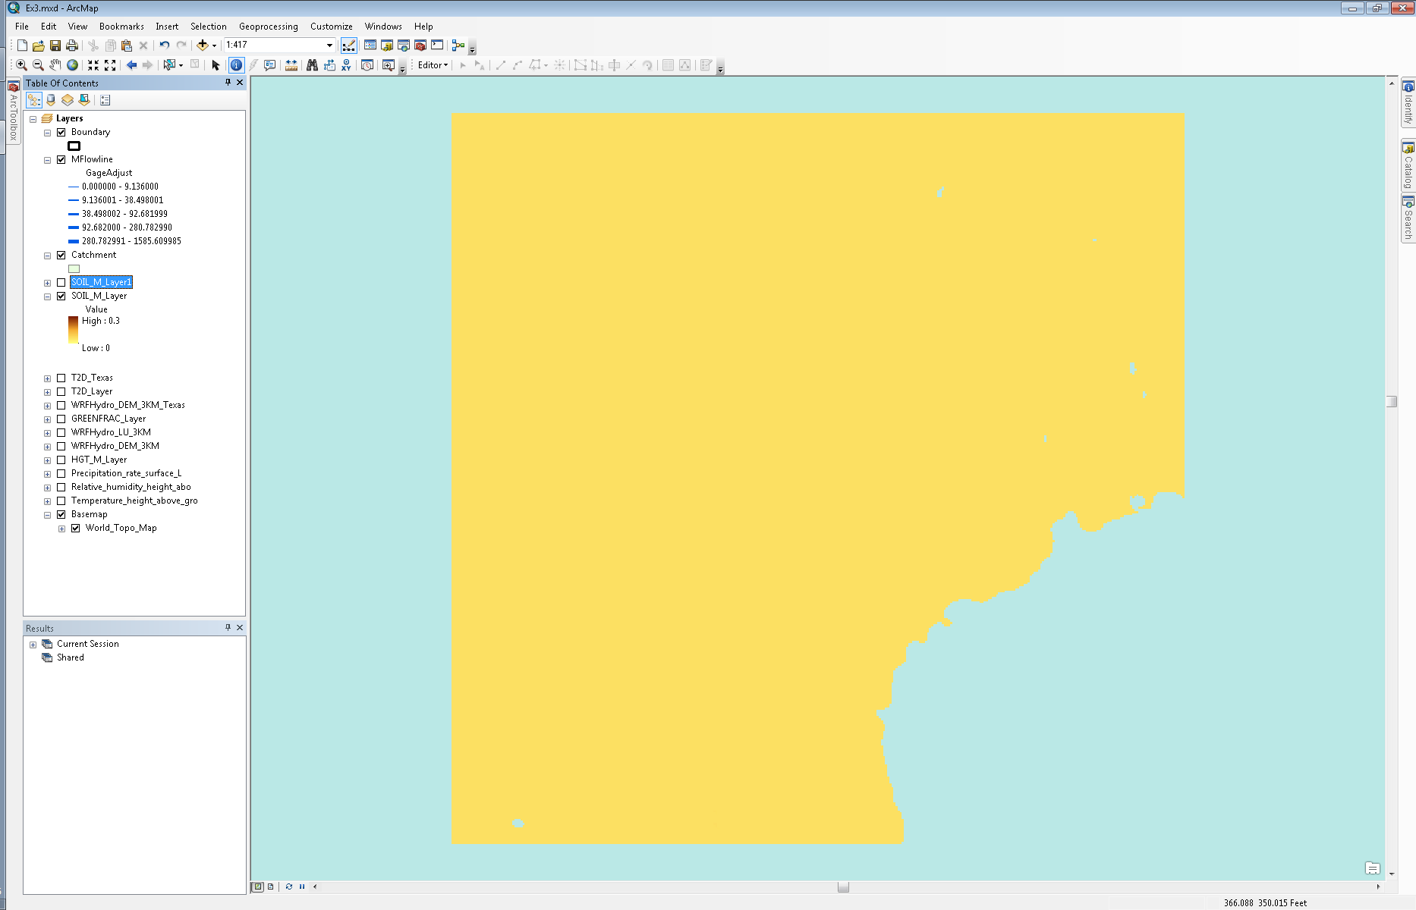

You’ll notice that the soil moisture is low everywhere in the modeling domain.

- In ArcToolbox under “Multidimensional Tools”, double click on the “Make NetCDF Raster Layer” tool again.
- Navigate to the 2015021320.LDASOUT_DOMAIN1 file and select “SOIL_M” as the variable.

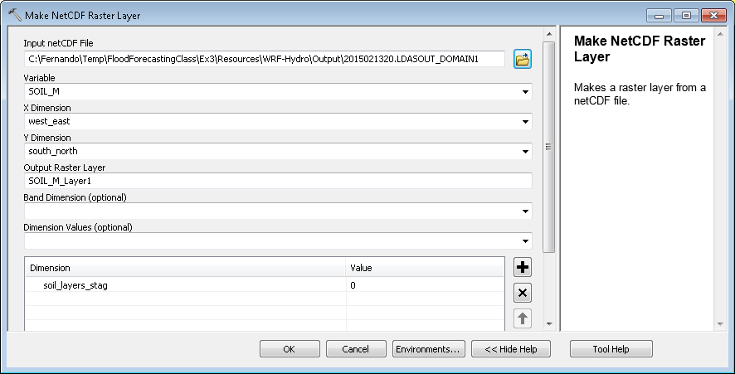

- Click “OK”.
- Import the same symbology as the “SOIL_M_Layer”.
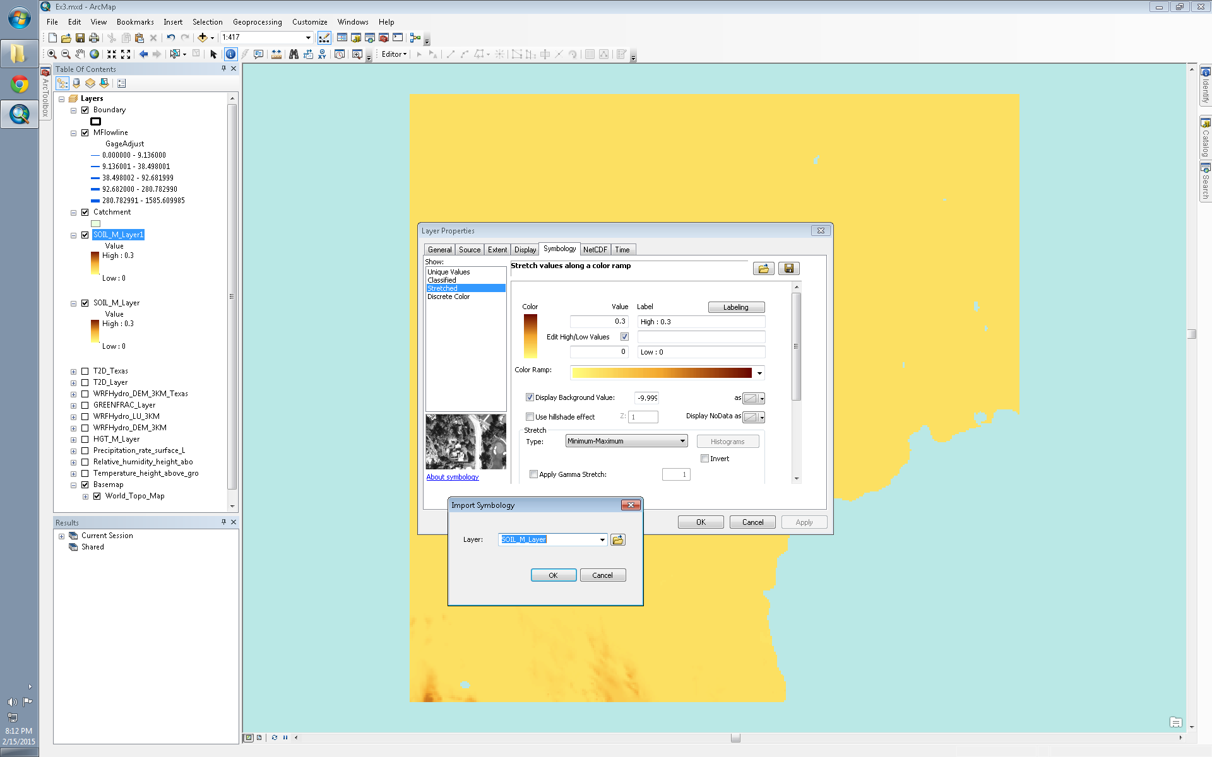

- Return to the map and notice that at the bottom of the screen you’ll see higher soil moisture values. This is the result of rain near the bottom of the modeling domain. If you scroll up to the section of this document that talks about displaying the HRRR data, you’ll see screenshots of precipitation and you’ll see that it rained in the same area where the soil moisture increased. If you’d like to see for yourself, the HRRR data used to run the WRF-Hydro Noah-MP model for this exercise can be found in the “Ex3/Resources/HRRR” folder.
To be turned in: Prepare two maps, one showing the Geogrid over North America and another showing one of the outputs of the WRF-Hydro computation over Texas.

River Routing
Within the NFIE-Hydro framework, the RAPID (Routing Application for the Parallel Computation of Discharge) model is one of the models used to route water through a river network. The RAPID model uses the Muskingum method to route water and is based on two parameters, a k and x parameter, for each computational node (i.e. river reach or segment) within the model. The k parameter is a time lag parameter and the x parameter is a water storage parameter which varies from 0 to 0.5.
The RAPID model is primarily driven by runoff time series (surface and sub-surface), which represent lateral inflows at computational nodes, and can be driven by gaged or modeled forcing time series at particular points within the network. For example, in the figure below, runoff and sub-surface runoff is aggregated over each NHDPlus catchment and provides lateral inflow to its’ corresponding river reach (linked by COMID). At Granger Lake, one can specify the reservoir release at the Granger Lake dam as a time series and route the released water through the network instead of the flow upstream of the reservoir. By specifying such forcing, one essentially breaks the routing network within the model at the specified location.
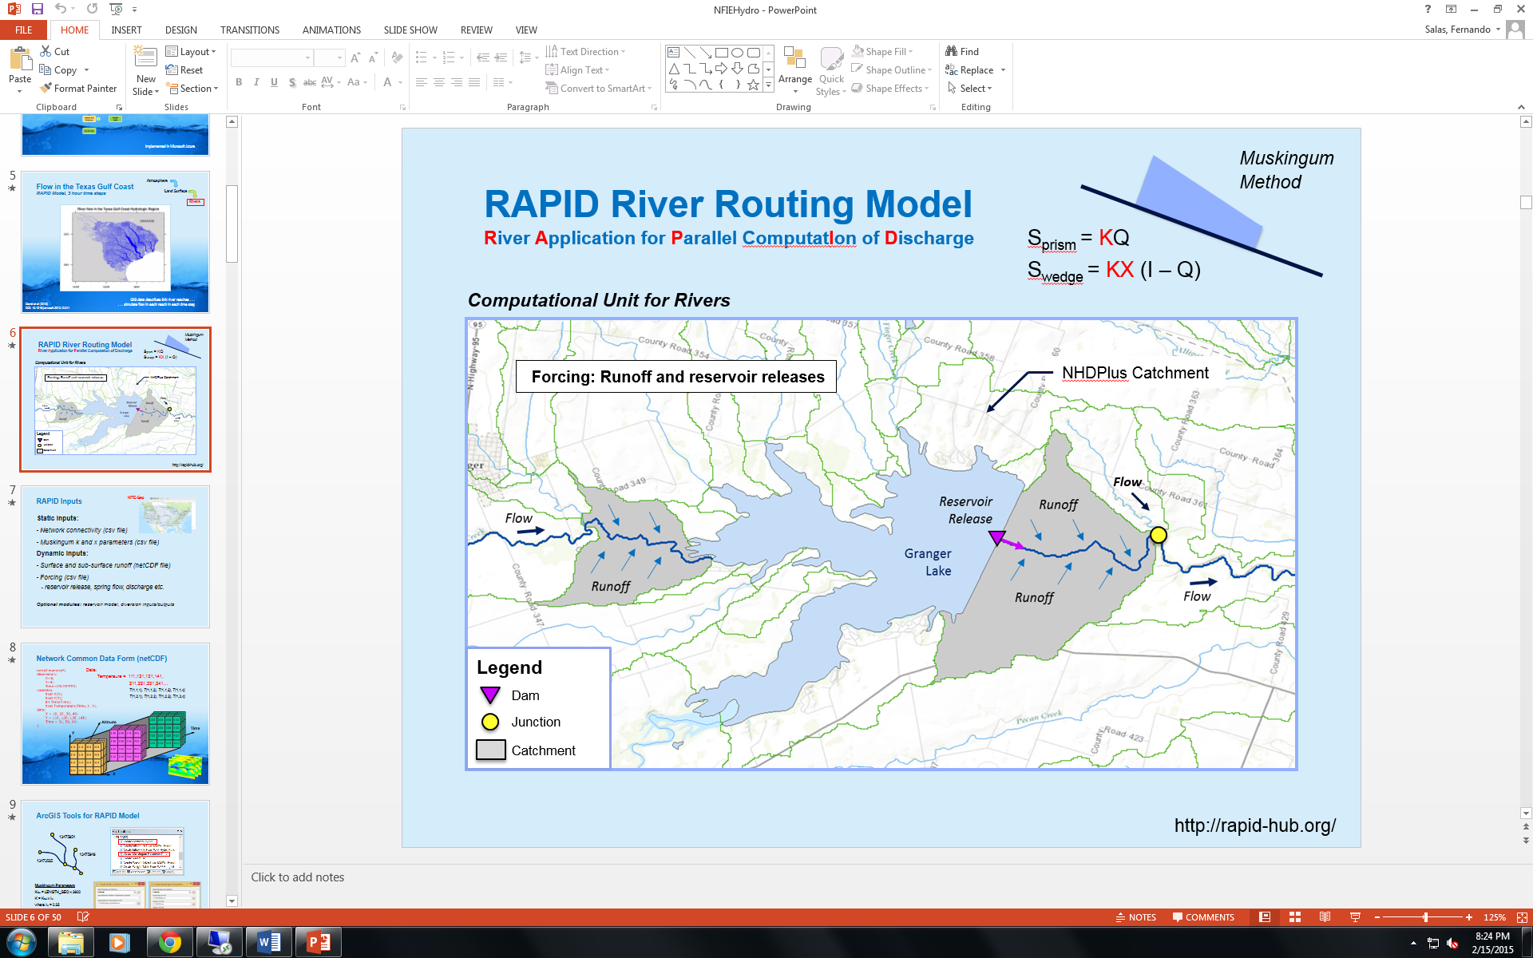
Within the NFIE-Hydro framework, surface and sub-surface runoff from the WRF-Hydro Noah-MP model will be used as one of the drivers of the RAPID model. This requires a data transformation from several structured gridded model outputs (as you can see in the “Ex3/Resources/WRF-Hydro/Output” folder) to one unstructured gridded model input (one file stored in netCDF that contains surface and sub-surface runoff for each river segment in the modeling domain); this is called unstructured because the X and Y coordinates of the river segments are not evenly spaced.
The RAPID model needs at a minimum five files to run:
- Basin file – list of all the river segments within the network
- Connectivity file – connection details between each river segment within the network; there are 7 columns within the file. The first column contains the river segment of interest, the second column contains the downstream river segment, the third column contains the number of upstream river segments, the fourth through seventh columns contain the upstream river segments up to four segments (stored as a csv file)
- K file – k parameters for each river segment; the values are sorted in the same order as the first column of the connectivity file (stored as a csv file)
- X file – x parameters for each river segment; the values are sorted in the same order as the first column of the connectivity file (stored as a csv file)
- Runoff file – surface and sub-surface runoff volume time series, in m³, for each river segment (stored as a netCDF file)
Create RAPID input files using ArcGIS tools
The tools used in this section have been created by ESRI to facilitate channel routing using the RAPID model. In order to utilize these tools, you will need to install the netCDF4 library for python. You can find the library here:
https://code.google.com/p/netcdf4-python/downloads/list
- Download the “netCDF4-1.0.7.win32-py2.7.exe” file and run it. Follow the installation instructions.
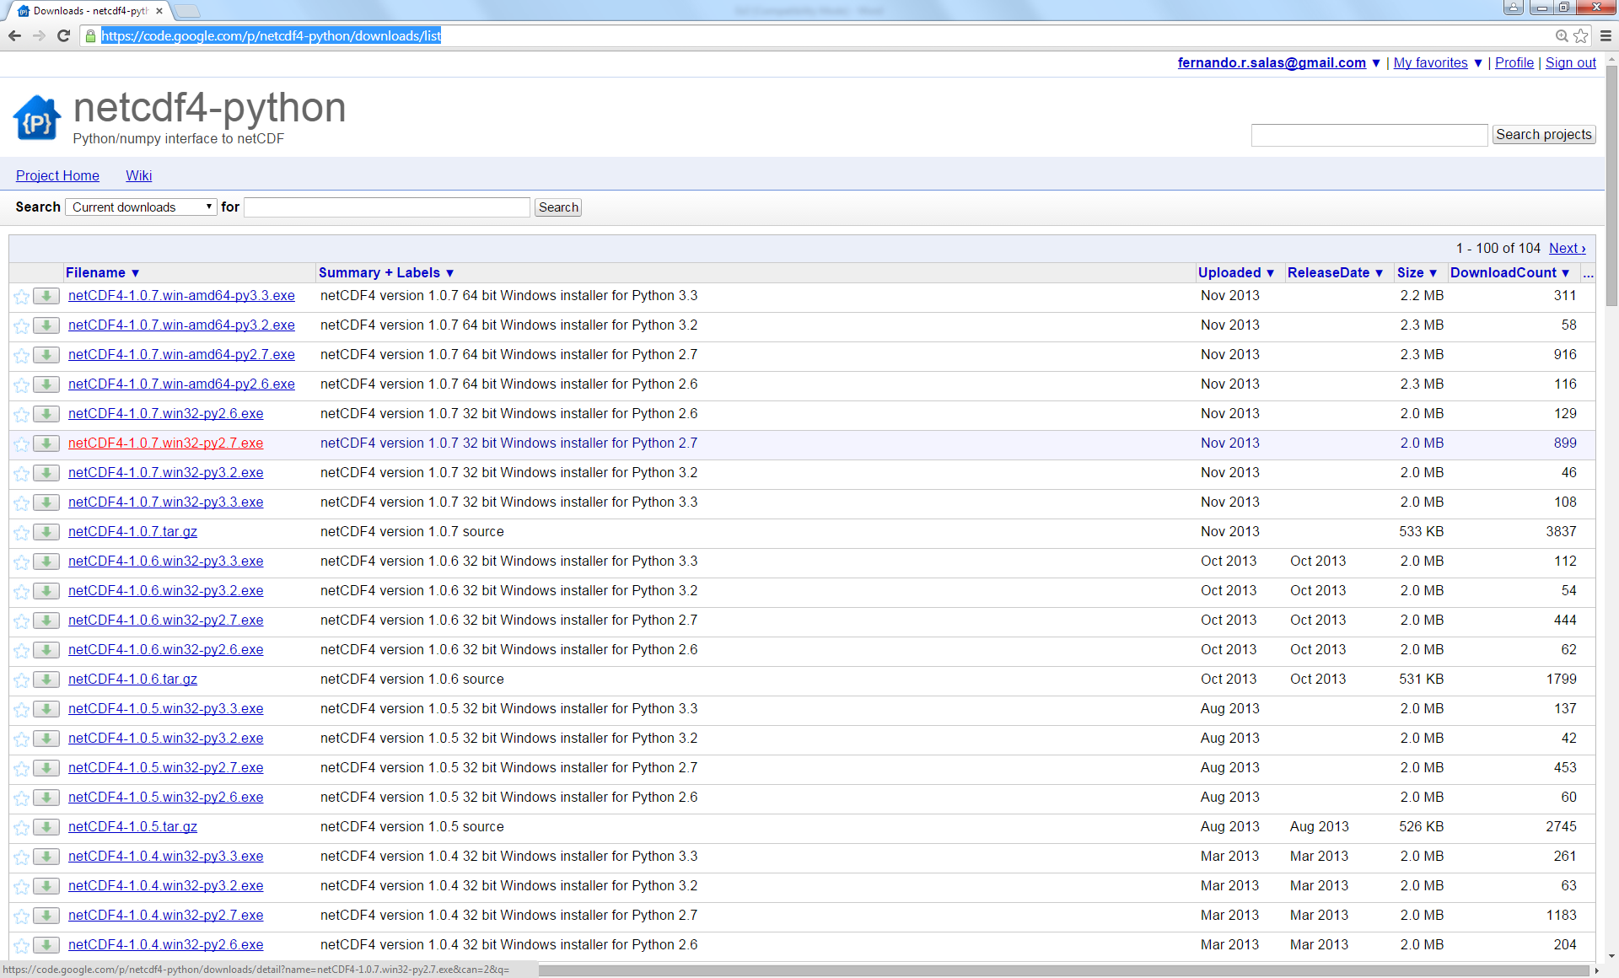
Note: After installing the library, it is probably best to save your map, close and reopen ArcMap.
- Navigate to the “RAPID.pyt” toolbox in the “Catalog” on the right. The toolbox is located in the “Ex3/Resources/RAPID/Tools/RAPID_tools_v2.2_02122015” folder.

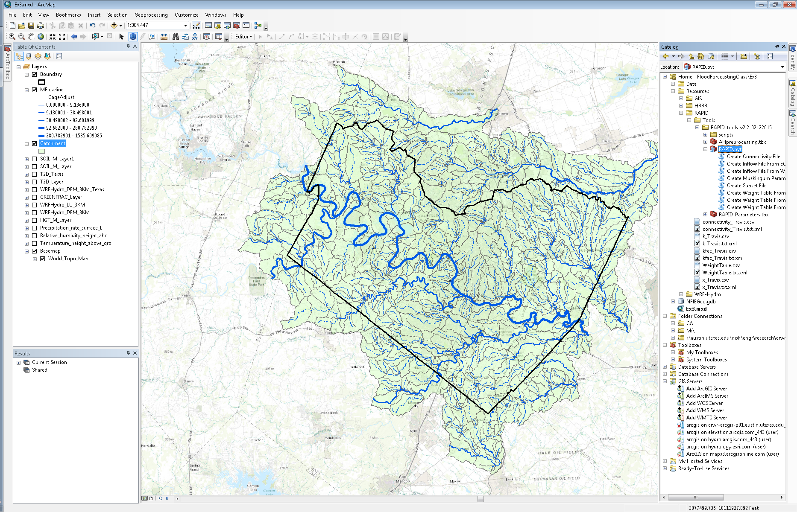

- Double click on the “Create Subset File” script.
- Select “MFlowline” as the “Input Drainage Line Features” and save the output in the “Ex3/Data” folder.
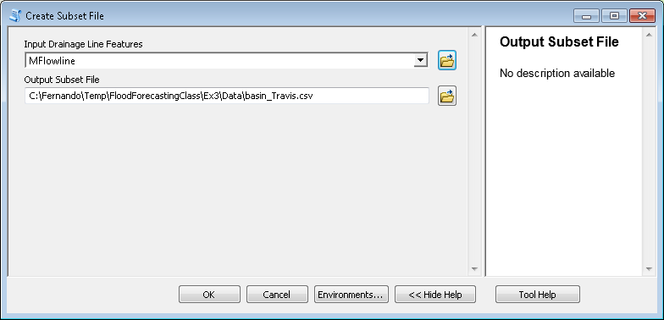
- Click “OK”. The basin file will be added to your map as a table and you can open it by right clicking on the basin table in the “Contents” pane on the left. The basin table will contain the same number of rows as the “MFlowline” feature layer.
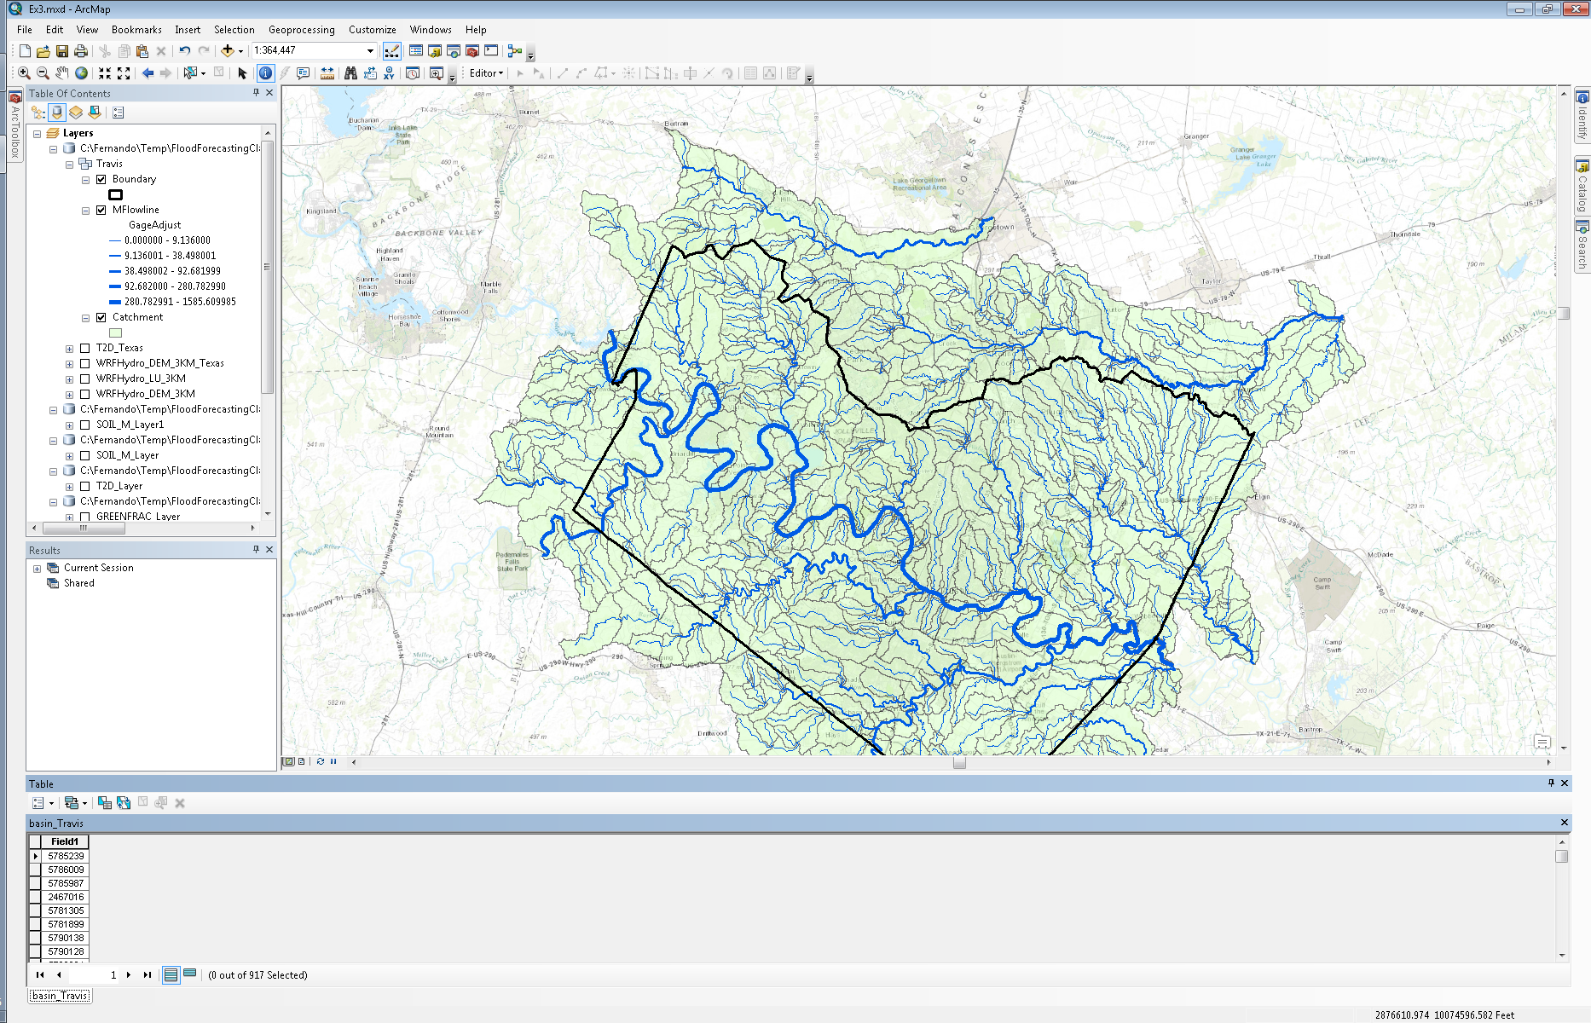
- Double click on the “Create Connectivity File” script in the “RAPID.pyt” toolbox.
- Select “MFlowline” as the “Input Drainage Line Features” and save the output in the “Ex3/Data” folder.

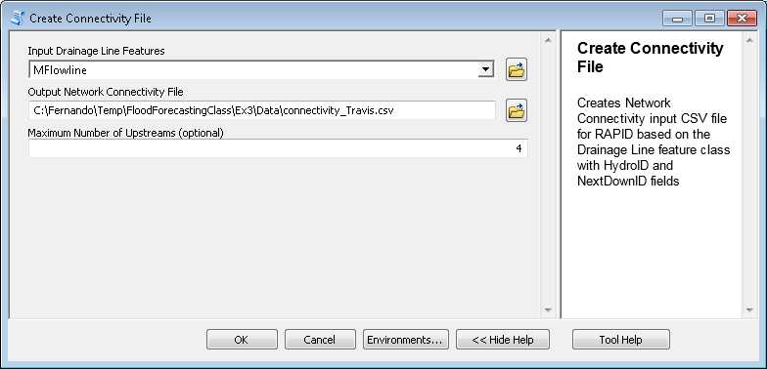

- Input “4” as the “Maximum Number of Upstreams”.
- Click “OK”. The connectivity file will be added to your map as a table and you can open it by right clicking on the connectivity table in the “Contents” pane on the left. The connectivity table will contain the same number of rows as the “MFlowline” feature layer.

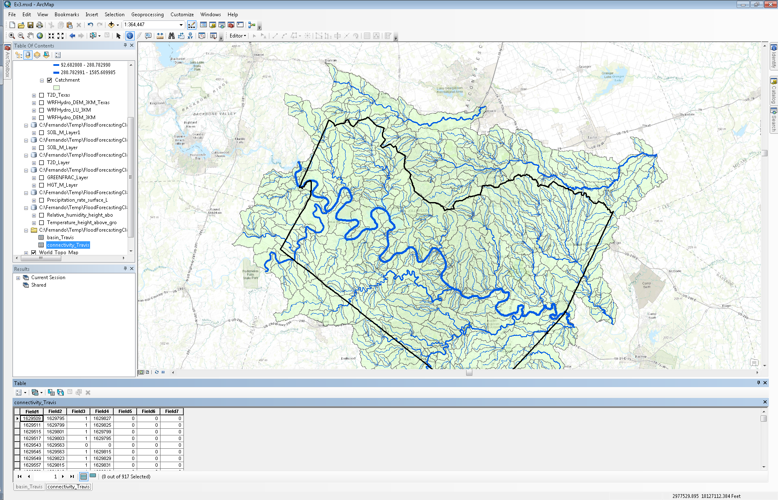

The rows in the connectivity table will contain the COMIDs within the MFlowline feature layer. The script itself uses the “NextDownID” field in the MFlowline feature layer; it has already been populated as part of NFIE-Geo.
- Double click on the “Create Muskingum Parameter Files” script in the “RAPID.pyt” toolbox.
- Select “MFlowline” as the “Input Drainage Line Features” and save the outputs in the “Ex3/Data” folder.

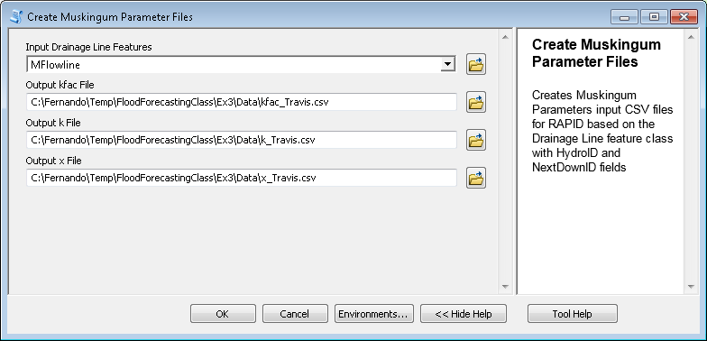

Note: The kfac file is part of the output of this script however is not required to run the RAPID model; kfac values are used to derive k values. If you open the attribute table of the “MFlowline” feature layer, you’ll see a field called “Musk_kfac” which has already been populated as part of NFIE-Geo.

- Click “OK”. The kfac, k and x files will be added to your map as tables and you can open them by right clicking on the tables.

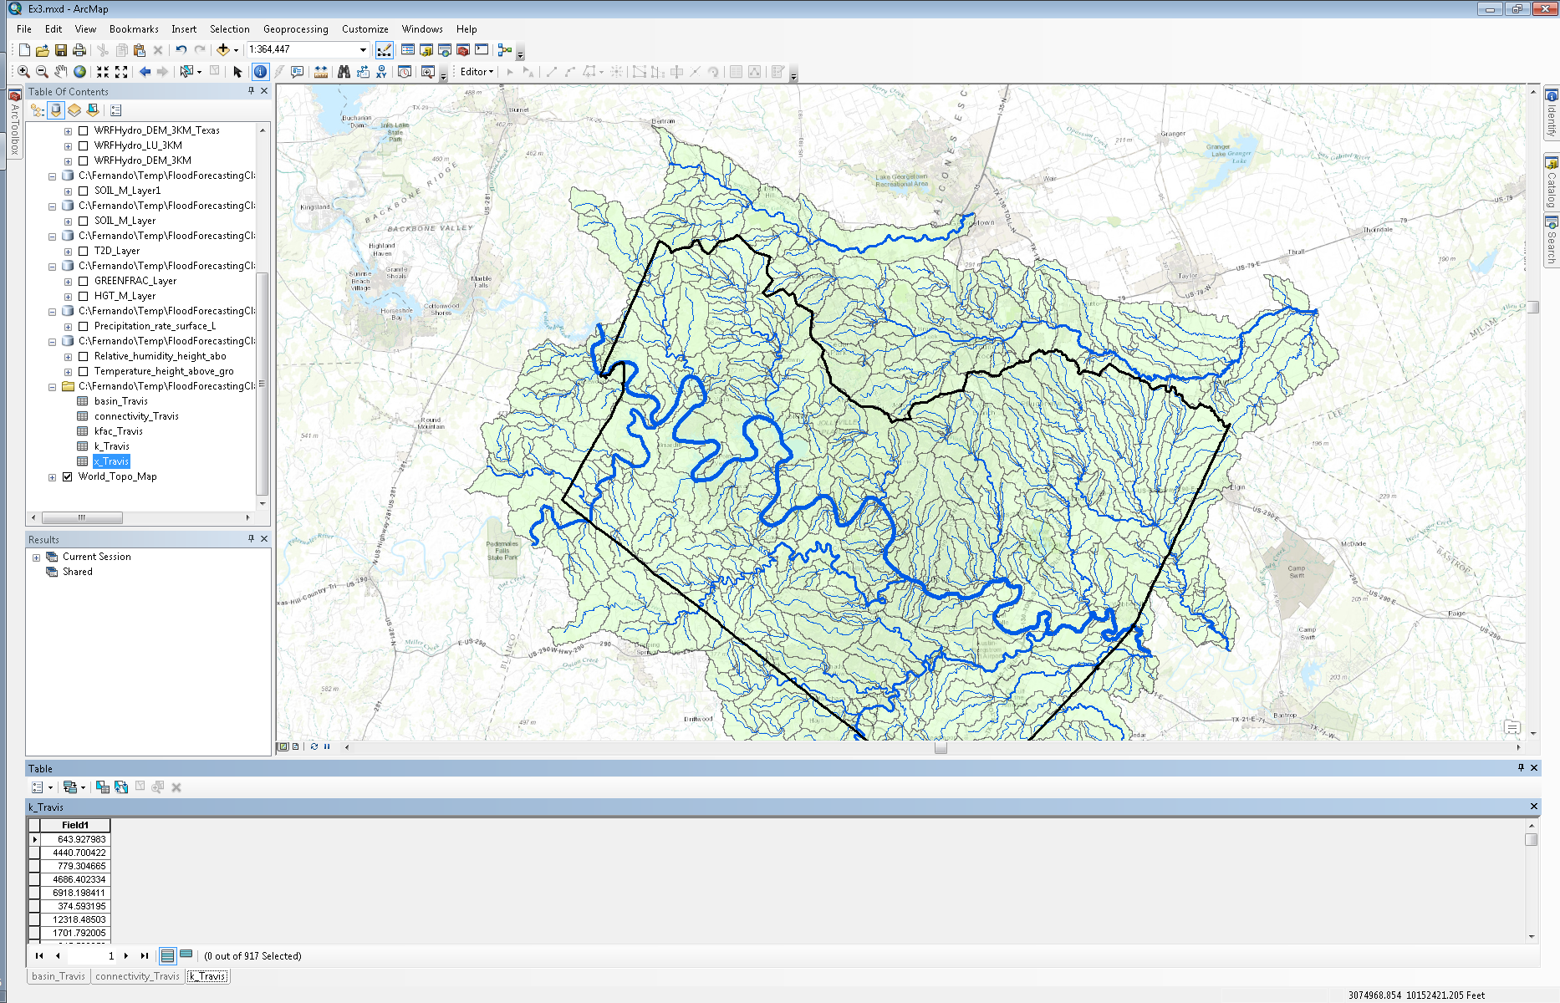

The values within the kfac, k and x tables are derived from the “Musk_kfac”, “Musk_k” and “Musk_x” fields within the “MFlowline” attribute table. These fields have already been populated as part of NFIE-Geo. The following equations have been used to calculate the kfac, k and x parameters:

K_{fac} = LENGTH_GEO x 3600
K = K_{fac} x λ_{k}
where λ_{k} = 0.35 as suggested by the Dr. Cedric David (RAPID model developer) as an initial guess

Note: “LENGTH_GEO” is a field within the MFlowline feature layer and has already been populated as part of NFIE-Geo; the units of “LENGTH_GEO” are kilometers.

X = λ_{x} x 0.1
where λ_{x} = 3 as suggested by the Dr. Cedric David (RAPID model developer) as an initial guess

- Double click on the “Create Weight Table From WRF Geogrid with Four Map Projections Supported” script in the “RAPID.pyt” toolbox.

This tool will create a weight table by overlapping a WRF-Hydro GEOGRID file with a catchment feature class. This table can be used to create a RAPID runoff file by providing information which helps translate runoff from a WRF-Hydro gridded output to a RAPID catchment input.

- Navigate to the “geo_em.d01_Texas_3km.nc” GEOGRID file.

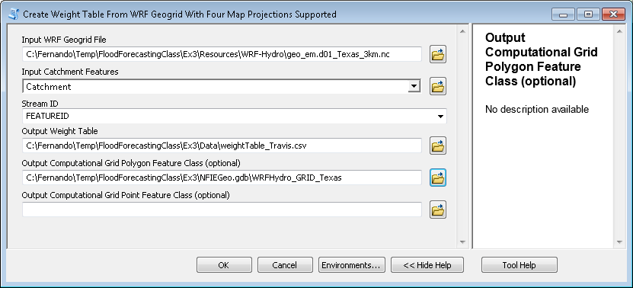

- Select the “Catchment” features.
- Select “FEATUREID” as the “Stream ID”
- Save the table in the “Ex3/Data” folder.
- Save the “Output Computational Grid Polygon Feature Class” in you geodatabase.
- Click “OK”. The script will take approximately 10 minutes to run.

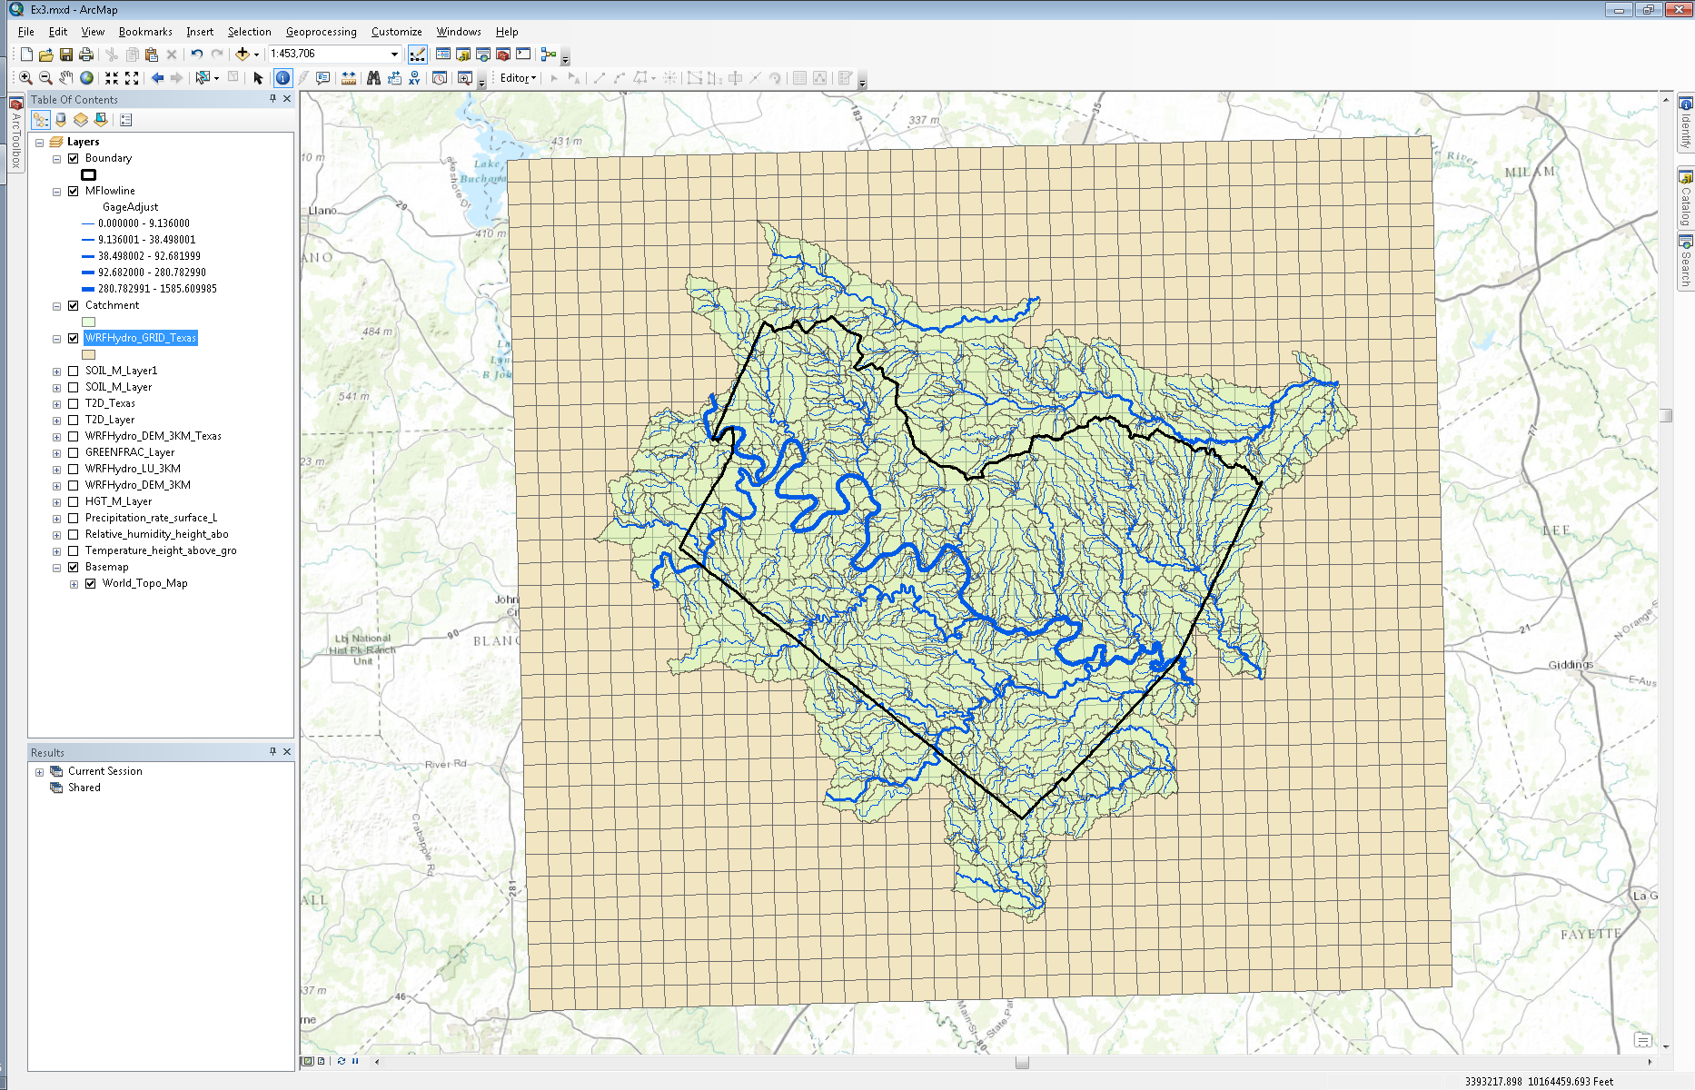

Navigate to the weight table you just created and open it in Excel. You will see that catchment with COMID “1629509” overlaps with “4” grid cells.

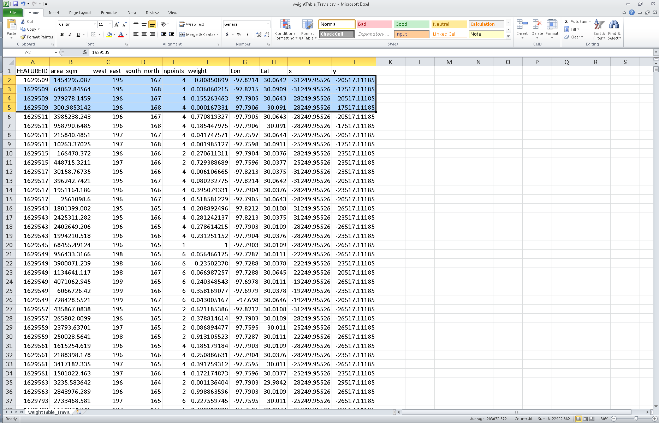

- Open the attribute table of the “Catchments” feature layer.
- Right click on the “FEATUREID” field and select “Sort Ascending”.
- Select the first row, which has “1629509” listed as its “FEATUREID” and then click on the “Zoom to Selected Features” icon.

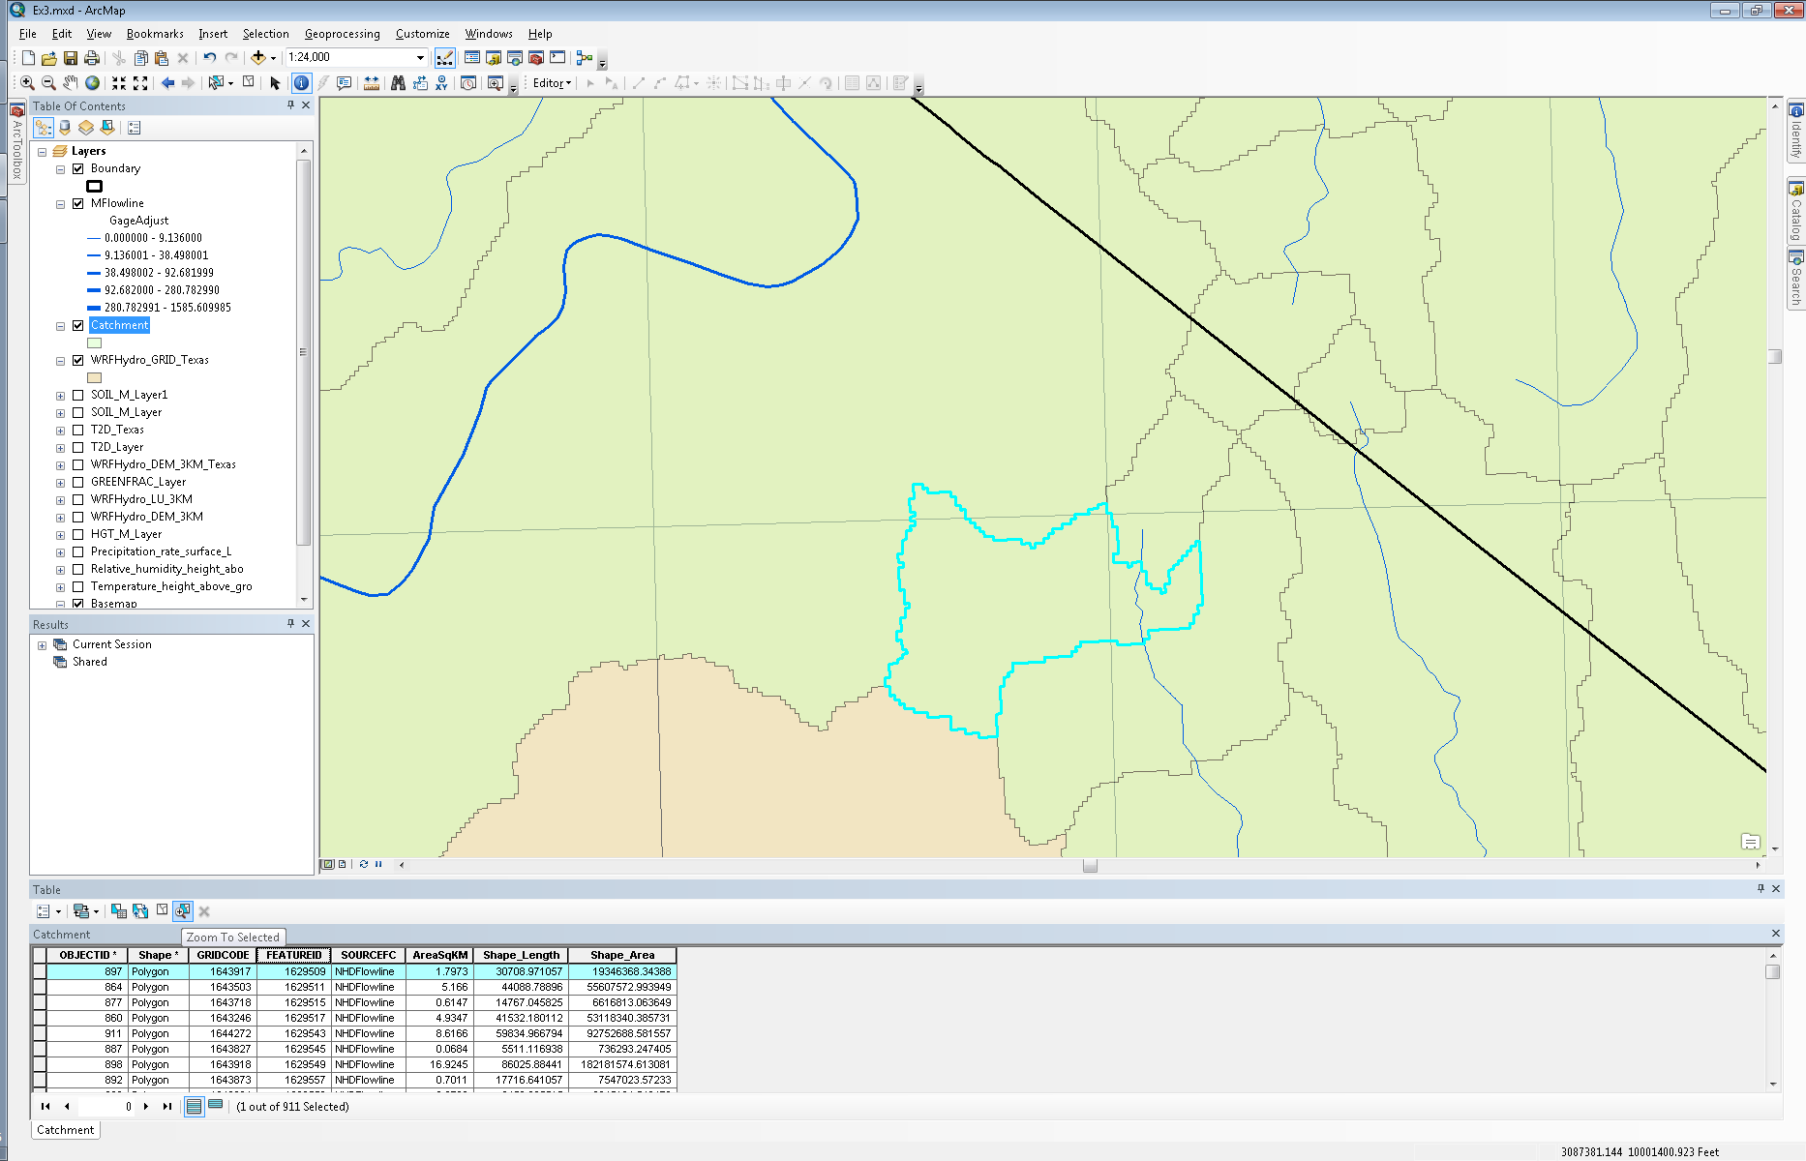

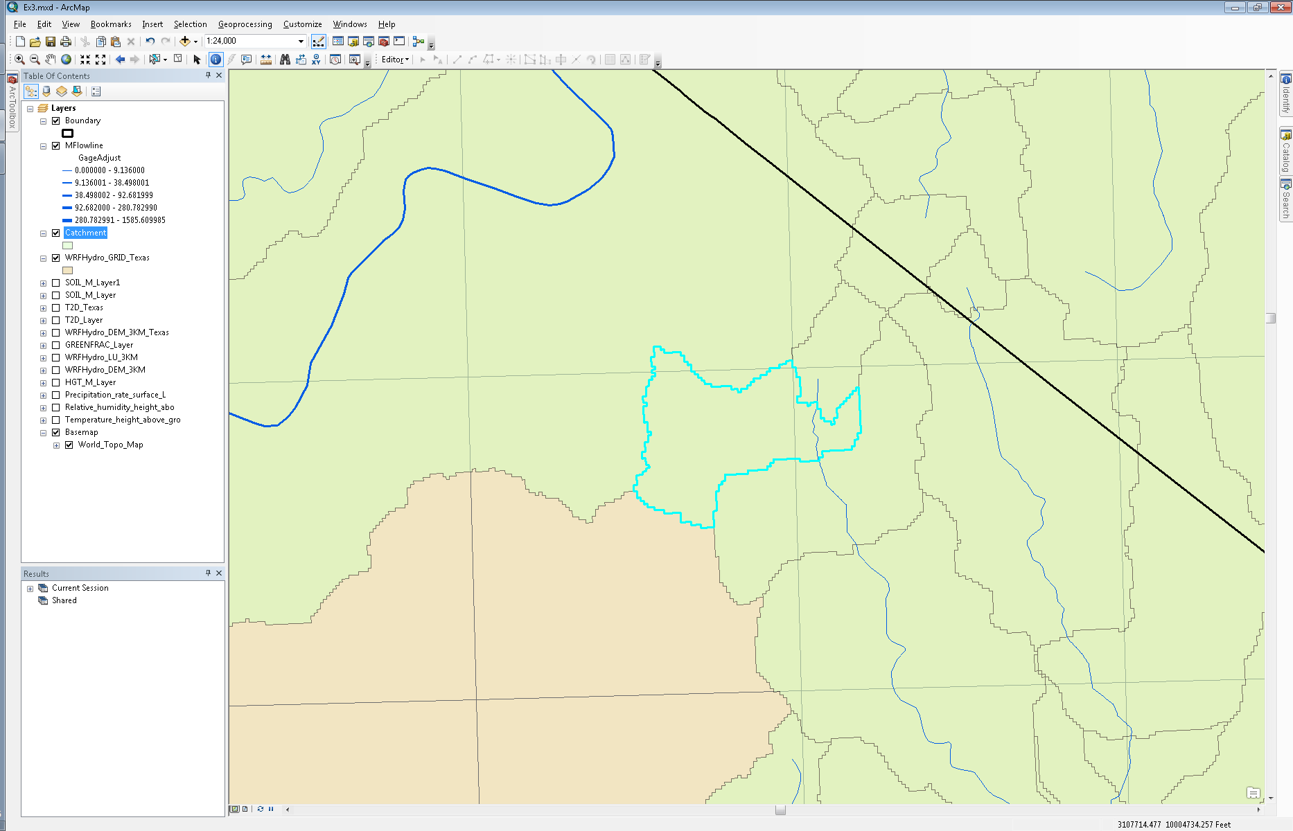

You’ll notice in your map that the selected catchment, “1629509”, overlaps “4” grid cells as is stated in the weight table.

The “west_east” and “south_north” fields indicate the index of the grid cells in the WRF-Hydro output files. For example, if you zoom to the “SOIL_M_Layer” layer, you can use the coordinates in the bottom right hand corner to find the (195, 167) coordinate.

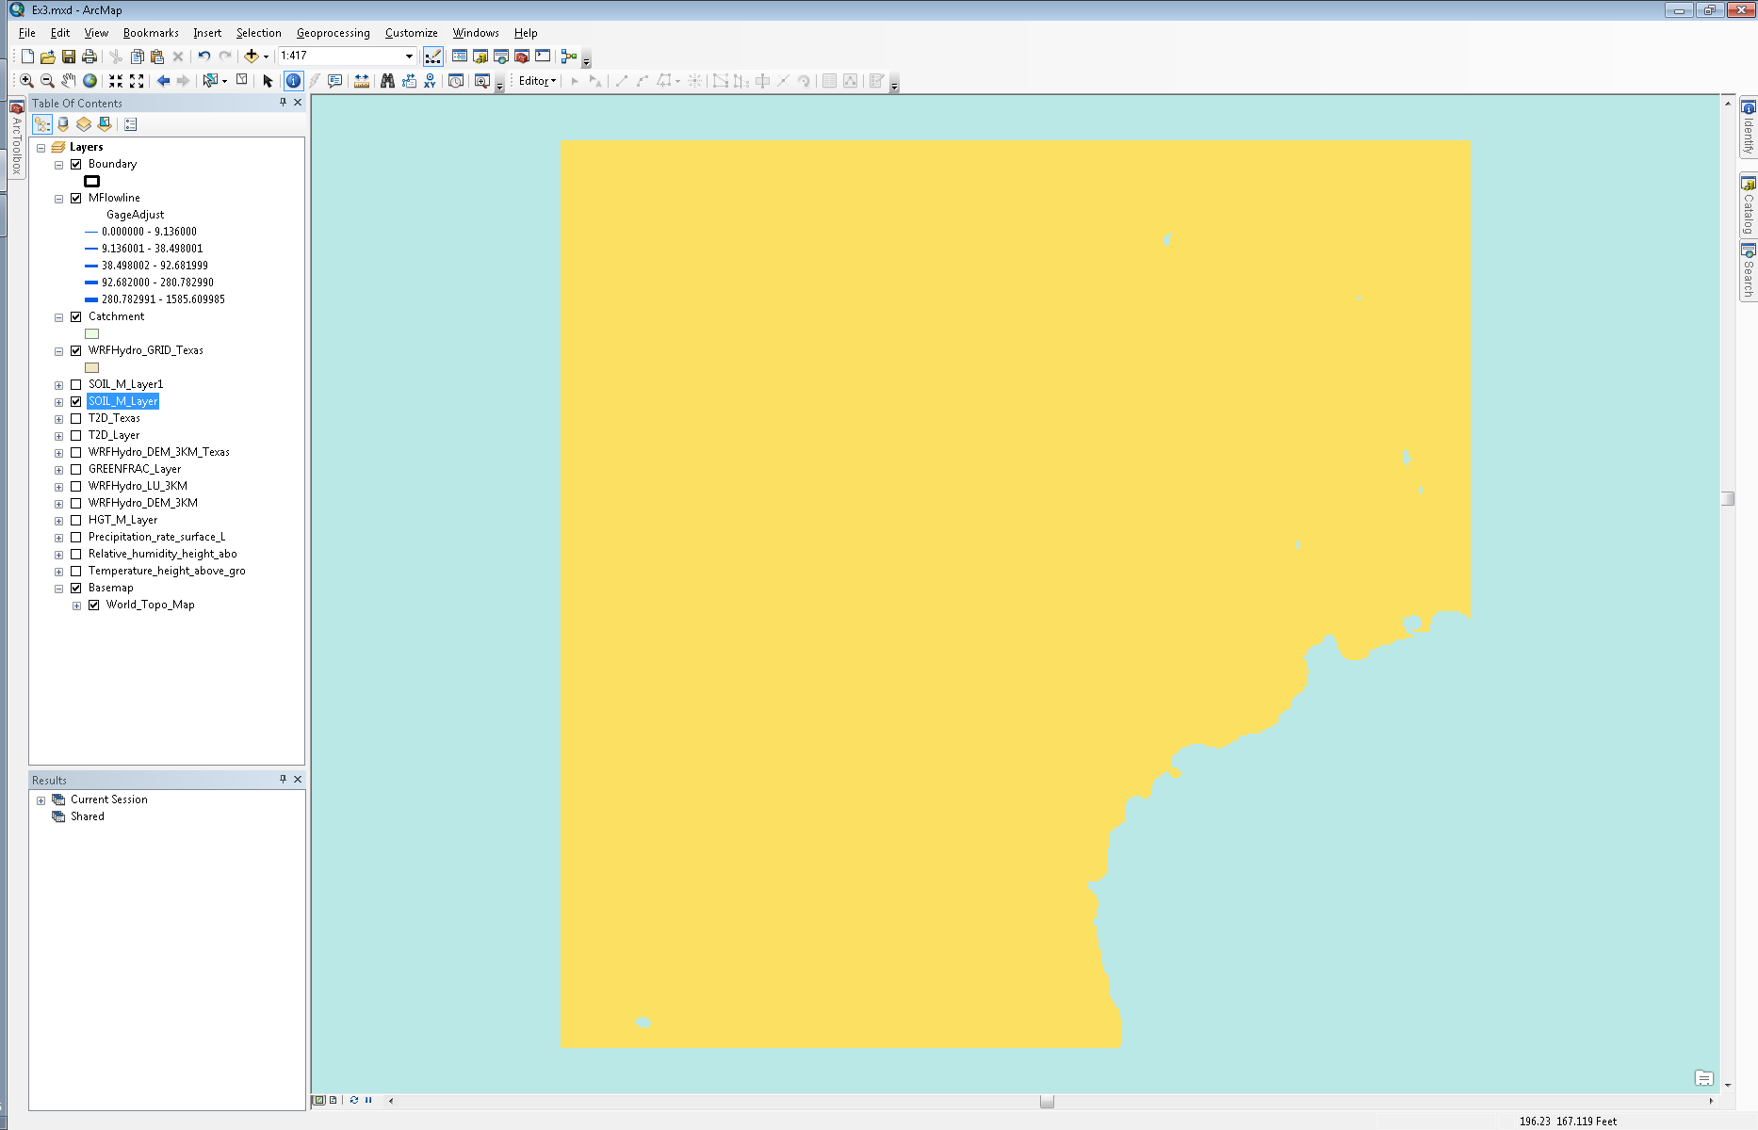
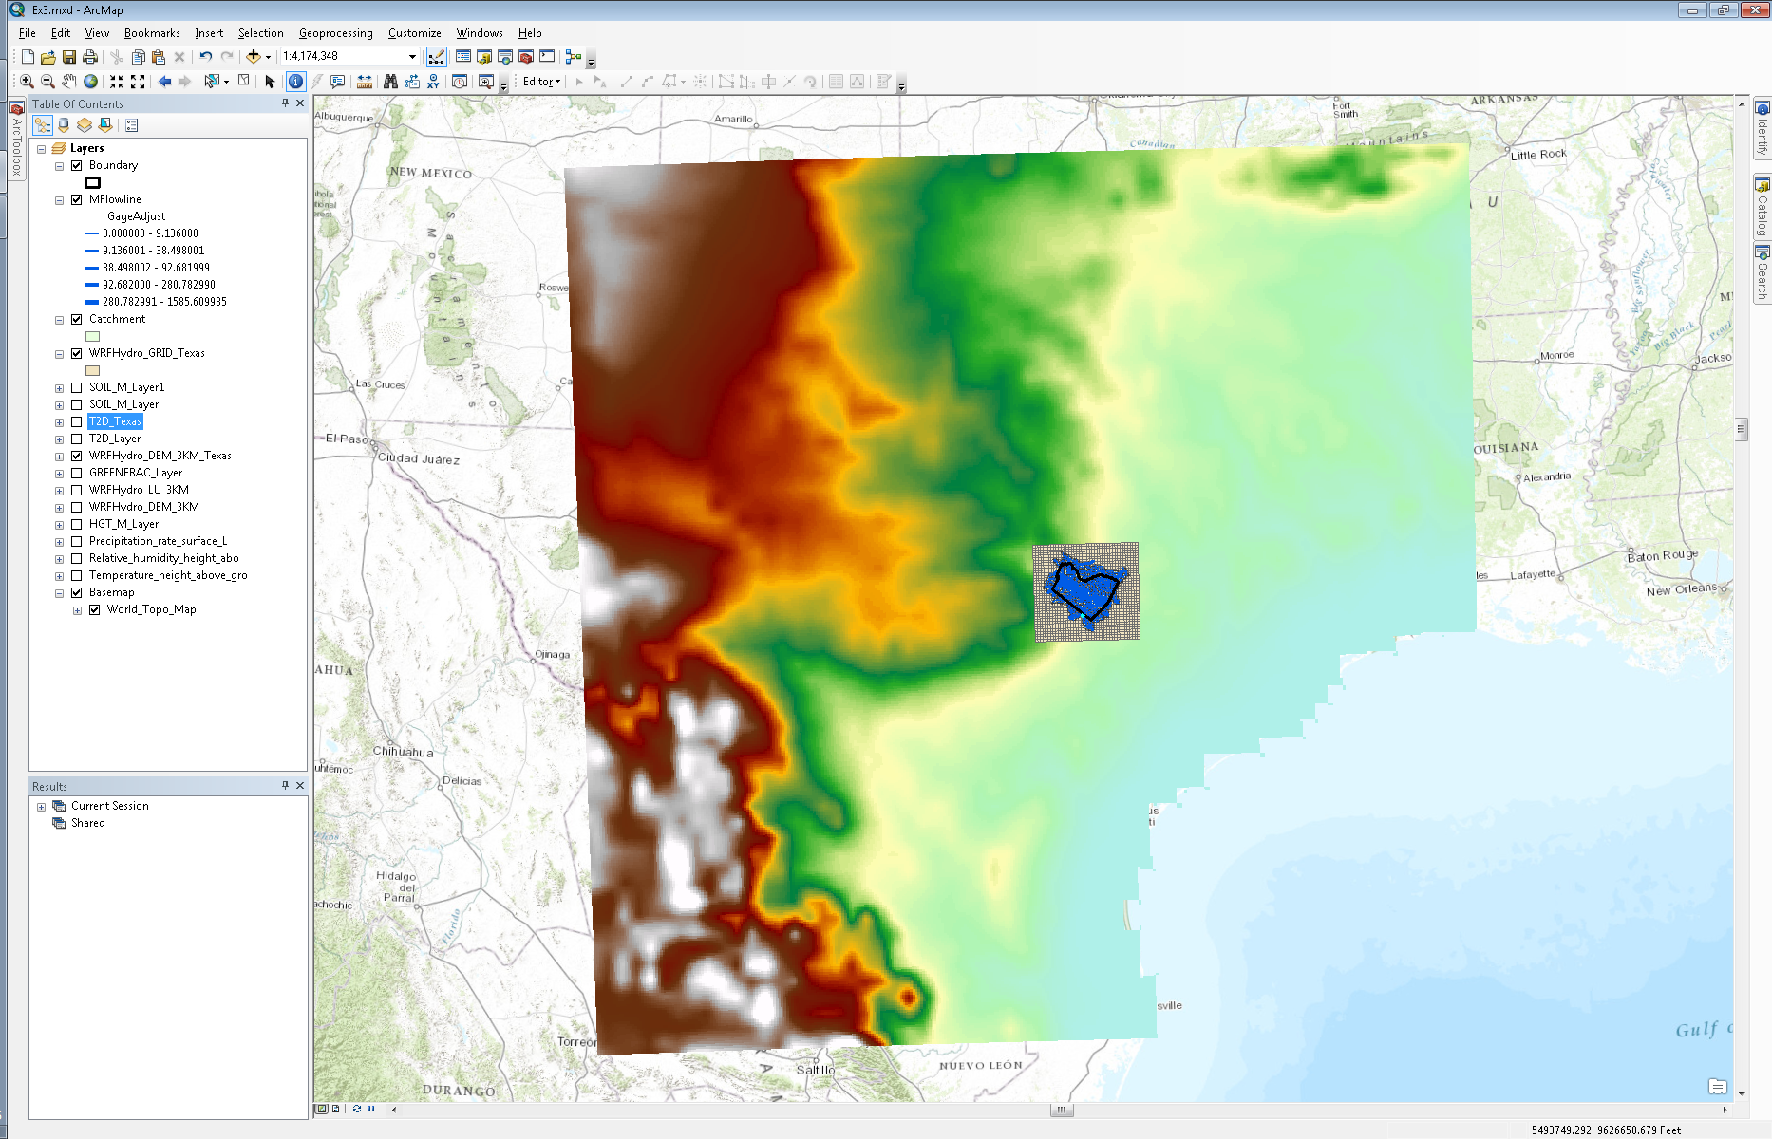

The “weight” column indicates the percent of the catchment area that overlaps the indicated grid cell. For example, the first row says that 80.85% of catchment “1629509” falls within grid cell (195, 167). Therefore, when calculating the total runoff for catchment “1629509”, one would multiply the runoff value in grid cell (195, 167), units of runoff are in mm/unit area, by the area of the catchment and then by the weight.

Runoff (m³) = [RunoffValue] X (1/1000) X 1454295.087 X 0.8085

This step is repeated for each grid cell that overlaps the catchment and then the values are summed up.
To be turned in: Select reach catchment 5781369 within the Travis County NFIE-Geo coverage and make a map of this catchment overlaid by the WRF-Hydro geogrid mesh. Determine the weight table needed to convert WRF-Hydro runoff to produce input flows for RAPID for this catchment. Explain how this would be used to compute total runoff for this catchment. Specify the Muskingum routing parameters for the flowline of this catchment.

To Be Turned In
(1) Present a short sequence of maps that shows precipitation evolving over Texas.
(2) Prepare two maps, one showing the Geogrid over North America and another showing one of the outputs of the WRF-Hydro computation over Texas.
(3) Select reach catchment 5781369 within the Travis County NFIE-Geo coverage and make a map of this catchment overlaid by the WRF-Hydro geogrid mesh. Determine the weight table needed to convert WRF-Hydro runoff to produce input flows for RAPID for this catchment. Explain how this would be used to compute total runoff for this catchment. Specify the Muskingum routing parameters for the flowline of this catchment.

http://www.unidata.ucar.edu/about/
See WRF-Hydro manual here: http://www.ral.ucar.edu/projects/wrf_hydro/images/User_Guide_v1.0.pdf
The RAPID model homepage can be found here: http://rapid-hub.org/
Further documentation of the tools can be found in the “Ex3/Resources/RAPID/Tools” folder.

