Spring 2007

CE 394K.2

Ex 1

Prepared by,

Ernest To and David Maidment

20070130
CE 394K.2 Exercise 1:

Analyzing water data from the USGS NWIS and EPA Storet Systems

1. Find the names and code numbers of the NWIS and Storet stations at Neuse River near Clayton, North Carolina. Find the period of data and number of available records for NWIS streamflow and Storet Nitrate + Nitrite as Nitrogen (note the NWIS streamflow data actually go from the given start date right up to the present).

Table 1: Names, code numbers and periods of records for stations located at Neuse River near Clayton, North Carolina

Source and Network | SiteName | SiteCode | Variable | Period of Record
USGS NWIS | NEUSE RIVER NEAR CLAYTON, NC | 02087500 | Daily discharge, cubic feet per second | 08/01/1927 to present  (Value count = 29036 samples)
EPA Storet | NEUSE RIV AT HWY 42 NR CLAYTON | 21NC01WQ:J4170000 | Nitrogen, Nitrite (NO2) + Nitrate (NO3) as N | 08/17/1972 to 12/30/1996  (Value count = 270 samples)
EPA Storet | NEUSE RIV AT NC 42 NR CLAYTON | 21NC02WQ:J4170000 | Nitrogen, Nitrite (NO2) + Nitrate (NO3) as N | 01/06/1997 to 08/14/2001  (Value count = 124)

2. Make a plot of the time series of the whole record from 1927 to present, and cumulative frequency, frequency histogram and box and whisker plots of these data. Make screen captures of these plots and turn them in as part of your solution.

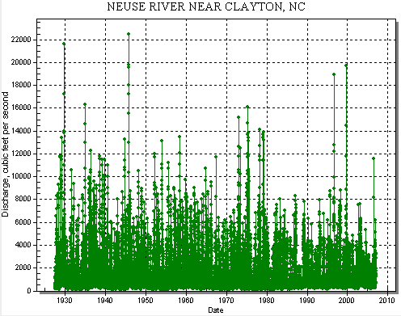
Fig 1. Time series of daily discharge (cfs) at Neuse River near Clayton, NC for entire period of record (08/01/1927 to present).

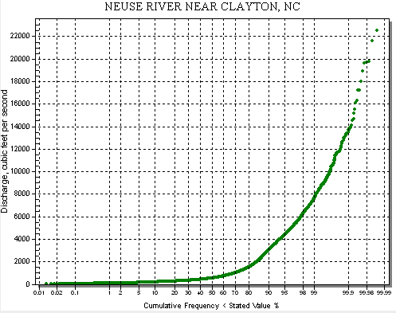
Fig 2. Cumulative frequency of daily discharge (cfs) at Neuse River near Clayton, NC for entire period of record (08/01/1927 to present).
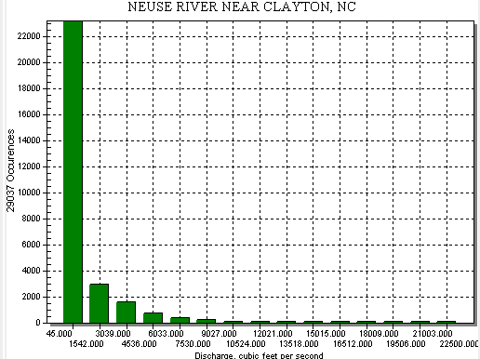
Fig 3. Frequency histogram of daily discharge (cfs) at Neuse River near Clayton, NC for entire period of record (08/01/1927 to present).

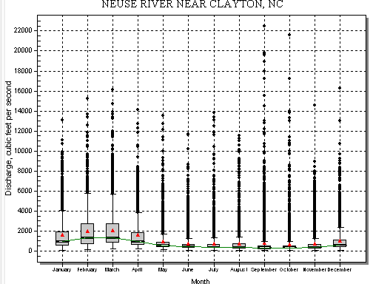
Fig 4. Box and whiskers plot of daily discharge (cfs) at Neuse River near Clayton, NC for entire period of record (08/01/1927 to present).

3. Use HIS Server to identify the period of streamflow record at another USGS station somewhere else in the nation and make similar plots for that station.

The location of the USGS station at Neuse River at Smithfield is shown in the map below:
Fig 5. Location of the Neuse River at Smithfield, NC gage.

The USGS gage at Neuse River near Smithfield,NC (02087570) is located approximately 27 miles downstream from Neuse River near Clayton, NC. Data are only available from 10/01/1970 to 09/30/1991 for Neuse River near Smithfield, NC. To make sure that we are not comparing apples to oranges, only data from the same period in time at Clayton, NC were used for comparison between the two gages.

The following graphs show the flow characteristics of the two gages from 10/01/1970 to 09/30/1991:

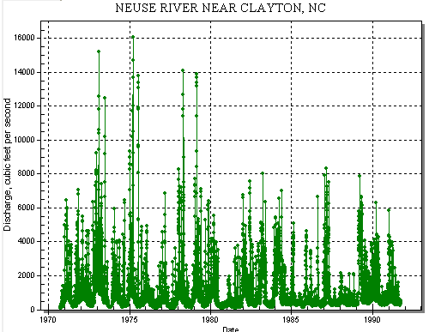
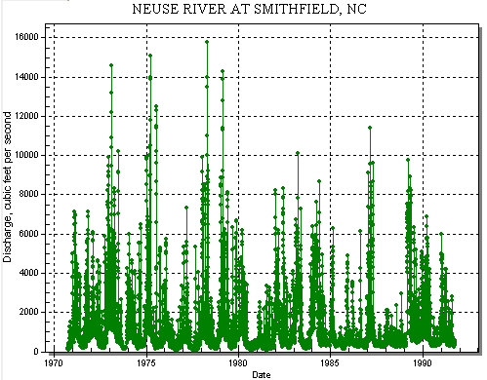

Fig 6. Comparison of time series of daily discharge (cfs) at Neuse River at Clayton, NC and Smithfield, NC from 1970 to 1991..
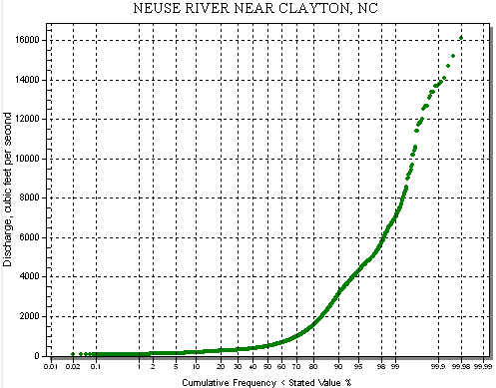
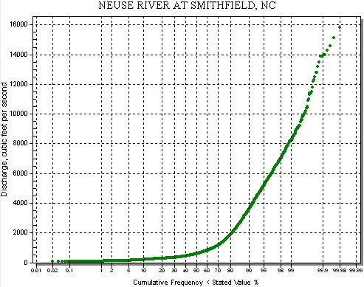

Fig 7. Comparison of cumulative frequencies of daily discharge (cfs) at Neuse River at Clayton, NC and Smithfield, NC from 1970 to 1991.
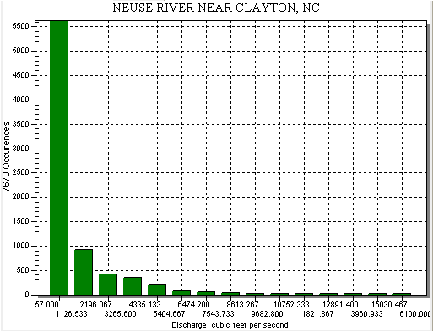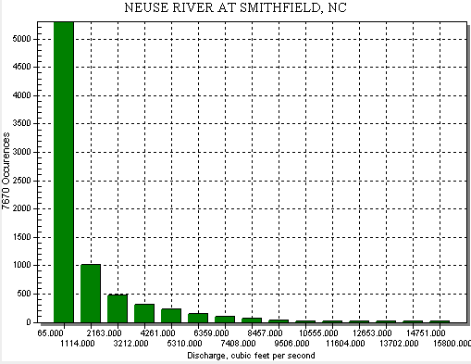

Fig 8. Comparison of frequency histograms of daily discharge (cfs) at Neuse River at Clayton, NC and Smithfield, NC from 1970 to 1991.
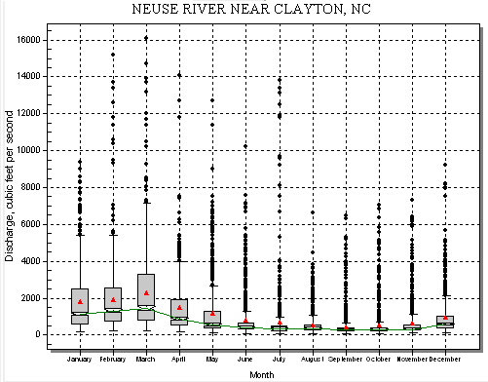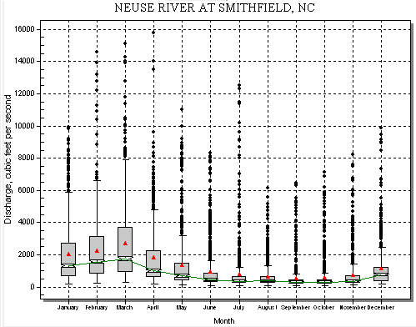
Fig 9. Comparison of box and whisker plots of daily discharge (cfs) at Neuse River at Clayton, NC and Smithfield, NC from 1970 to 1991.

The following table compares the flow characteristics at the two gages:

Table 2: Comparison of flow characteristics at Neuse River nr Clayton and Neuse River at Smithfield.
 | Smithfield, NC (~27 miles downstream) | Clayton, NC (upstream)
Arithmetic Mean | 1304 | 1116
Geometric Mean | 695.9 | 604.5
Maximum | 15800 | 16100
Minimum | 65 | 57
Standard Deviation | 1761 | 1552
Coefficient of Variation | 135% | 139%
10th percentile | 198 | 178
25th percentile | 306 | 283
Median | 587 | 490
75th percentile | 1430 | 1220
90th percentile | 3560 | 3120
# Observations | 7670 | 7670

The Neuse River gains an average of 188 cfs (14% of total flow) as it travels from Clayton to Smithfield (~27 miles). The shapes of the cumulative frequencies and histograms at both stations are positively skewed which suggests lognormal distributions. The seasonal patterns are similar – both stations experience high flows in March and low flows with scattered storm events in July. From the map, it is observed that no major tributaries enter the Neuse River between Clayton and Smithfield; and thus the gain in flow is largely attributed to runoff from the surrounding catchment.

4. Study the USGS and EPA variable code lists, as given at http://nwis.waterdata.usgs.gov/usa/nwis/pmcodes and http://www.epa.gov/Storet/legacy/ref_tables.htm for the way that they each characterize nitrogen data. Describe how each specifies Nitrogen data and which variable code values would have to be used to extract the N data from each of these systems. Get the Nitrate + Nitrite as N data from NWIS Instantaneous Irregular values using the NWIS Analyst download option. The complete list of these codes is given as an Excel file at: http://www.ce.utexas.edu/prof/maidment/Ex1/VariableCodes.xls

Assumption: Per the instructions in class on 01/30/2007, it is assumed that “Nitrogen data” refers to the combined concentration of nitrite and nitrate for this problem.

I noticed that the parameters codes for EPA Storet shown in
http://www.epa.gov/STORET/legacy/parameter.zip were different from the Storet codes in VariableCodes.xls. However, they are similar to the USGS codes in the same spreadsheet. For the sake of consistency I used information in the VariableCodes.xls spreadsheet to answer this question.

The various forms of nitrogen (Total Nitrogen, Ammonia, Nitrite, Nitrate, Organic and Inorganic Nitrogen, etc) are referenced by Storet codes 327 through 336 and USGS codes 600 through 636. EPA Storet assigns a variable code to each unique chemical type. For instance, the storet code for nitrogen, nitrite plus nitrate is 336. USGS is more specific than EPA in that it assigns a variable code not just to each unique chemical type but each unique combinations of chemical type, medium type (e.g. suspended solids and filtered water) and units (e.g deg C versus deg F). For instance, the USGS code for Nitrite plus nitrate, water, unfiltered, milligrams per liter as nitrogen is 630 while the the USGS code for Nitrite plus nitrate, water, filtered, milligrams per liter as nitrogen is 631.

To extract Nitrogen data for the calculation of total nitrite and nitrate load in the Neuse River near Clayton, the most direct method is to use Storet code 336 or USGS code 630. USGS code 630 is preferred over other USGS measurements in other media (e.g. filtered water [631] and suspended sediment [628]) because the unfiltered water sample accounts for the entire water column and thus the entire load carried by the river.

In the absence of Storet code 336 or USGS code 630, one will have to take into account the relationship between the different variable codes in order to estimate the nitrite and nitrate concentrations:

For instance, by definition we know that:
[NO₃⁻ and NO₂⁻] as N = [NO₃⁻] as N + [NO₂⁻] as N
Therefore Storet Code 336 = Storet Code 334 + Storet Code 335

By definition, we also know that:
[Nitrite plus nitrate, water, unfiltered] = [Nitrite plus nitrate, suspended sediment] + [Nitrite plus nitrate, water, filtered, milligrams per liter as nitrogen]
Therefore USGS Code 630 = USGS Code 631 + USGS Code 628

Based on the definition of inorganic nitrogen we know that:
[NO₃⁻ and NO₂⁻] as N = [Total Inorganic Nitrogen] as N - [NH₄⁺] as N
Therefore Storet Code 336 = Storet Code 332 - Storet Code 330

5. Nutrient enrichment from the Neuse watershed is leading to algal blooms and contamination of the Albemarle-Pamlico Sound downstream. By combining the streamflow and water quality data for Nitrate and Nitrite as Nitrogen, make an estimate of the annual Nitrogen load flowing in the Neuse River at Clayton, NC (kg/year).

The first step was to develop a rating curve for Nitrogen (Nitrite and Nitrate) Load (kg/yr) vs. Flow (cfs). The initial intention was to multiply instantaneous flow data at the time of the nitrogen sampling event with the measured nitrite and nitrate concentration to get the instantaneous load in the river. Unfortunately, USGS instantaneous data collected before the past 31 days were not available. As a compromise, historical daily discharge flows were used instead to calculate the loads.

The nitrogen load kg/yr for each sampling event was calculated using the following formula:

Load (kg/yr) = Nitrite and Nitrate Concentration (mg as N/L) * Daily discharge on day of sampling (cfs) * 1e-6 kg/mg * 28.317 L/ft³ *86400 s/d * 365.25 d/yr

The resulting loads are shown in the appendix of this report.
The loads calculated for the 81 nitrite and nitrate sampling events were plotted in the load vs flow graph below. Since this is a simple analysis, a linear model was assumed for the rating curve. If a more sophisticated model is desired, the reader is encouraged to look into USGS’s LOADEST software(http://pubs.usgs.gov/tm/2005/tm4A5/pdf/508final.pdf) which uses more complex regression analysis to determine the rating curve.

Based on linear regression, the formula of the rating curve was determined to be:

Load (kg/yr) = 304.78 * Flow (cfs) (Y-intercept for was forced to zero to better honor the smaller load values)
Fig 10. Rating curve for Nitrogen load vs Flow.

The next step was to apply the rating curve formula on the daily discharge values at Clayton, NC to estimate the daily load. Because nitrite and nitrate data were collected between 08/29/1973 and 09/13/2006, I only applied the rating curve to discharge values measured within this period. A comparison of the estimated daily loads (based on the rating curve) with the measured daily loads is shown in the graph below. The graph shows fairly reasonable agreement between measured and estimated loads.

Annual average =
322,000 kg as N/yr
Fig 11. Comparison of loads estimated using rating curve with measured loads.

The annual Nitrogen load flowing in the Neuse River at Clayton, NC was estimated by averaging the daily loads (kg/yr) throughout this period. The resulting annual Nitrogen load was 322,000 kg as N/yr.

Appendix

Loads estimated at Nitrogen sampling events
Station | Date | Variable Code | Flow (cfs) | Nitrite and Nitrate (mg as N/L) | Flow (L/s) | Load (kg/yr)
2087500 | 8/29/1973 13:30 | 630 | 354 | 0.9 | 10024.218 | 284706.2358
2087500 | 9/12/1973 15:15 | 630 | 192 | 1.2 | 5436.864 | 205889.2552
2087500 | 10/30/1973 9:15 | 630 | 202 | 0.66 | 5720.034 | 119136.9597
2087500 | 1/15/1974 9:20 | 630 | 788 | 1 | 22313.796 | 704169.8486
2087500 | 1/29/1974 9:45 | 630 | 4820 | 0.57 | 136487.94 | 2455122.135
2087500 | 1/30/1974 9:30 | 630 | 5930 | 0.45 | 167919.81 | 2384615.788
2087500 | 2/1/1974 10:25 | 630 | 3000 | 0.51 | 84951 | 1367233.336
2087500 | 4/4/1974 13:30 | 630 | 1490 | 0.52 | 42192.33 | 692374.1101
2087500 | 5/12/1974 13:45 | 630 | 3600 | 0.6 | 101941.2 | 1930211.768
2087500 | 5/13/1974 15:30 | 630 | 4070 | 0.49 | 115250.19 | 1782139.504
2087500 | 5/16/1974 10:00 | 630 | 3070 | 0.41 | 86933.19 | 1124795.163
2087500 | 5/20/1974 9:30 | 630 | 895 | 1 | 25343.715 | 799786.8205
2087500 | 6/21/1974 9:45 | 630 | 343 | 1.3 | 9712.731 | 398463.6237
2087500 | 8/4/1974 15:30 | 630 | 2270 | 0.9 | 64279.59 | 1825658.63
2087500 | 8/4/1974 18:20 | 630 | 2270 | 0.87 | 64279.59 | 1764803.343
2087500 | 8/5/1974 9:20 | 630 | 2270 | 0.39 | 64279.59 | 791118.7399
2087500 | 8/7/1974 9:25 | 630 | 4450 | 0.38 | 126010.65 | 1511105.602
2087500 | 8/7/1974 14:20 | 630 | 4450 | 0.5 | 126010.65 | 1988296.844
2087500 | 8/10/1974 16:00 | 630 | 700 | 0.54 | 19821.9 | 337787.0594
2087500 | 10/15/1974 10:20 | 630 | 202 | 1 | 5720.034 | 180510.545
2087500 | 1/15/1975 10:30 | 630 | 9360 | 0.08 | 265047.12 | 669140.0795
2087500 | 1/22/1975 12:25 | 630 | 3240 | 0.42 | 91747.08 | 1216033.414
2087500 | 3/19/1975 14:30 | 630 | 16100 | 0.24 | 455903.7 | 3452934.385
2087500 | 4/28/1975 14:45 | 630 | 537 | 0.94 | 15206.229 | 451079.7668
2087500 | 6/9/1975 11:05 | 630 | 277 | 1.7 | 7843.809 | 420804.0377
2087500 | 7/16/1975 14:30 | 630 | 11800 | 0.26 | 334140.6 | 2741615.604
2087500 | 8/26/1975 11:34 | 630 | 233 | 1.7 | 6597.861 | 353961.5191
2087500 | 9/23/1975 9:10 | 630 | 592 | 0.96 | 16763.664 | 507860.1629
2087500 | 9/25/1975 9:45 | 630 | 3090 | 0.43 | 87499.53 | 1187348.322
2087500 | 12/23/1975 13:10 | 630 | 380 | 0.83 | 10760.46 | 281846.6628
2087500 | 2/3/1976 14:05 | 630 | 4010 | 0.38 | 113551.17 | 1361692.913
2087500 | 3/15/1976 9:00 | 630 | 710 | 0.76 | 20105.07 | 482195.4953
2087500 | 4/5/1976 14:20 | 630 | 609 | 0.65 | 17245.053 | 353738.115
2087500 | 5/17/1976 9:45 | 630 | 1020 | 0.63 | 28883.34 | 574238.0009
2087500 | 7/20/1976 12:45 | 630 | 123 | 3.5 | 3482.991 | 384701.9287
2087500 | 7/29/1976 9:10 | 630 | 95 | 4.5 | 2690.115 | 382021.0791
2087500 | 11/30/1976 14:45 | 630 | 644 | 0.71 | 18236.148 | 408597.2355
2087500 | 2/10/1977 9:15 | 630 | 383 | 0.96 | 10845.411 | 328564.9365
2087500 | 3/14/1977 11:00 | 630 | 6860 | 0.34 | 194254.62 | 2084271.263
2087500 | 5/25/1977 7:00 | 630 | 992 | 0.5 | 28090.464 | 443233.8134
2087500 | 7/8/1977 10:30 | 630 | 85 | 1.5 | 2406.945 | 113936.1113
2087500 | 7/28/1977 16:30 | 630 | 65 | 2.1 | 1840.605 | 121978.6603
2087500 | 12/21/1977 14:00 | 630 | 2640 | 0.67 | 74756.88 | 1580628.97
2087500 | 1/9/1978 16:00 | 630 | 4620 | 0.48 | 130824.54 | 1981684.082
2087500 | 1/10/1978 13:30 | 630 | 4460 | 0.42 | 126293.82 | 1673922.539
2087500 | 1/11/1978 14:30 | 630 | 4710 | 0.43 | 133373.07 | 1809841.617
2087500 | 1/14/1978 13:15 | 630 | 5860 | 0.5 | 165937.62 | 2618296.518
2087500 | 1/16/1978 11:30 | 630 | 5140 | 0.48 | 145549.38 | 2204730.775
2087500 | 1/20/1978 14:45 | 630 | 8300 | 0.46 | 235031.1 | 3411828.023
2087500 | 1/30/1978 15:31 | 630 | 6860 | 0.45 | 194254.62 | 2758594.318
2087500 | 4/4/1978 12:00 | 630 | 639 | 0.64 | 18094.563 | 365453.4281
2087500 | 4/26/1978 10:30 | 630 | 5350 | 0.43 | 151495.95 | 2055764.894
2087500 | 4/29/1978 11:15 | 630 | 12700 | 0.3 | 359625.9 | 3404679.091
2087500 | 7/6/1978 10:00 | 630 | 169 | 0.88 | 4785.573 | 132898.6547
2087500 | 10/12/1982 11:15 | 630 | 192 | 3.9 | 5436.864 | 669140.0795
2087500 | 12/9/1982 10:00 | 630 | 657 | 1.5 | 18604.269 | 880659.1191
2087500 | 12/13/1982 14:00 | 630 | 3860 | 0.6 | 109303.62 | 2069615.951
2087500 | 12/16/1982 8:30 | 630 | 2910 | 0.6 | 82402.47 | 1560254.512
2087500 | 1/19/1983 9:10 | 630 | 352 | 1.6 | 9967.584 | 503284.8461
2087500 | 2/16/1983 9:30 | 630 | 4770 | 0.4 | 135072.09 | 1705020.395
2087500 | 3/23/1983 11:40 | 630 | 4790 | 0.2 | 135638.43 | 856084.6637
2087500 | 5/12/1983 12:45 | 630 | 401 | 0.8 | 11355.117 | 286672.1922
2087500 | 9/7/1983 13:00 | 630 | 128 | 2.6 | 3624.576 | 297395.5909
2087500 | 9/29/1983 15:00 | 630 | 146 | 2.5 | 4134.282 | 326170.0441
2087500 | 10/26/1983 12:45 | 630 | 193 | 1.1 | 5465.181 | 189714.7955
2087500 | 11/28/1983 14:55 | 630 | 269 | 2.1 | 7617.273 | 504803.9943
2087500 | 12/7/1983 15:30 | 630 | 1720 | 0.6 | 48705.24 | 922212.2891
2087500 | 1/31/1984 8:30 | 630 | 1340 | 0.6 | 37944.78 | 718467.7136
2087500 | 2/29/1984 11:00 | 630 | 2440 | 0.6 | 69093.48 | 1308254.643
2087500 | 3/9/1984 14:40 | 630 | 4730 | 0.4 | 133939.41 | 1690722.53
2087500 | 3/27/1984 11:15 | 630 | 2140 | 0.4 | 60598.38 | 764935.7747
2087500 | 4/11/1984 12:00 | 630 | 4340 | 0.3 | 122895.78 | 1163488.76
2087500 | 4/25/1984 12:15 | 630 | 1800 | 0.4 | 50970.6 | 643403.9226
2087500 | 5/16/1984 10:00 | 630 | 567 | 1 | 16055.739 | 506680.5891
2087500 | 5/31/1984 13:45 | 630 | 2360 | 0.3 | 66828.12 | 632680.5239
2087500 | 6/19/1984 12:15 | 630 | 443 | 1.3 | 12544.431 | 514633.7764
2087500 | 6/27/1984 9:00 | 630 | 398 | 1.3 | 11270.166 | 462357.2077
2087500 | 7/11/1984 15:15 | 630 | 361 | 1.5 | 10222.437 | 483893.3668
2087500 | 7/26/1984 16:00 | 630 | 2480 | 0.1 | 70226.16 | 221616.9067
2087500 | 8/20/1984 10:30 | 630 | 642 | 0.9 | 18179.514 | 516331.6479
2087500 | 9/13/1996 12:50 | 630 | 6240 | 0.14 | 176698.08 | 780663.4261

There is a tendency for higher N concentrations to occur at lower flows.

And if you don’t force the intercept to go to 0, you get an equation
Load = 236.27Q + 425664 kg/yr, which, with Q = 1116 cfs mean flow for the period, gives a load of 689,341 kg/year, which is probably more reasonable.

