CE 397 Statistics in Water Resources
Exercise 5

Analyzing Trends

by:
Cody Hudson, Ashlynn Stillwell, Patrick Frasier and David Maidment
University of Texas at Austin
February 2009

Contents

Introduction 1
Simple Linear Regression 2
Characterizing Outliers 8
Multiple Linear Regression 10
To be turned in 14

Introduction
In this exercise we will explore how to deal with trends. How can we tell if Y is dependent on X? How do we tell if a data point is an outlier? How can we tell if Y is dependent on X1, X2, X3 or more variables?

Goals of this Exercise
To answer these questions, we will evaluate two different data sets. In the first we will evaluate data to see if there is a trend between two variables using simple linear regression methods. We will use the same data set to determine if a data point is an outlier. Finally, we will evaluate the case where there may be multiple explanatory variables.

Computer Requirements
This exercise is to be performed in Microsoft Excel (2007 version used here) using the Data Analysis Toolpack from Exercise #2. The data for this exercise is at: http://www.ce.utexas.edu/prof/maidment/StatWR2009/Ex5/Ex5Data.xls

The data used in this exercise were derived from the following web sites:

Census (links to each decade): http://www.census.gov/popest/archives/index.html
TWDB Historical Water Use: http://www.twdb.state.tx.us/wushistorical/DesktopDefault.aspx?PageID=1
Fresh Water Withdrawal by Country: http://www.worldwater.org/data.html
Population by Country: http://en.wikipedia.org/wiki/List_of_countries_by_population
GDP by Country: https://www.cia.gov/library/publications/the-world-factbook/fields/2195.html
Average annual rainfall in largest city: http://www.worldclimate.com/

Simple Linear Regression

Simple Trend Analysis

We all love Texas. We all want Texas to continue to have enough water to serve its residents. This part of the exercise evaluates water use in Texas over the past 35 years. We will look at water use in Texas and plot it versus census population data starting in 1974. Water use data was taken from the Texas Water Development Board (TWDB). Population census data was taken from the census.gov webpage.
Lets make a simple study of the trends in these data through time.

Analysis 1: Population Growth vs Time. First, create a graph for population growth versus time. Add a trendline to this graph by right-clicking on the data points, selecting ‘Add Trendline’, and selecting linear. Check the boxes to add the equation and R² value to the chart as shown below.

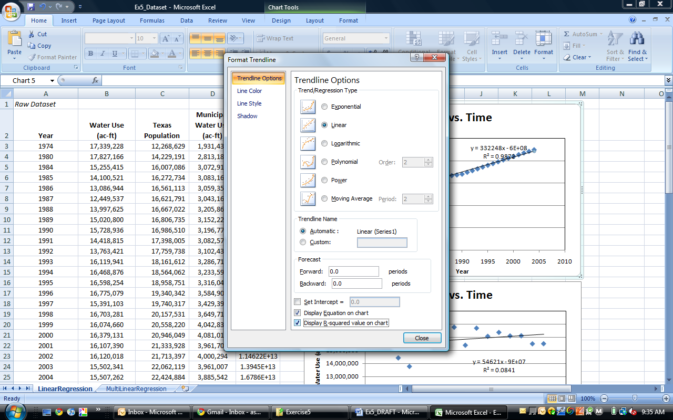

With this graph we see a strong trend of increasing population growth with time.

Analysis 2: Water Use vs Time. Next, graph water use versus time with a trendline. What did you expect to see?

Analysis 3: Water Use vs Population. Finally, graph total water use versus population growth with a trendline. Does there appear to be a trend in the data? The total water use includes all sources, including manufacturing, steam electric, irrigation, mining, and livestock. These water uses are most likely not affected by increased population.

Analysis 4: Municipal Water Use vs Time. Now let’s consider municipal water use only.

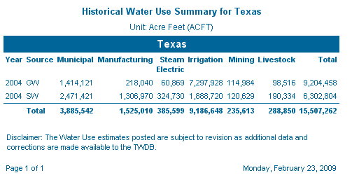

Graph municipal water use versus time with a trendline. What did you expect to see?

Analysis 5: Municipal Water Use vs Population. Finally, graph municipal water use versus population with a trendline. Does there appear to be a trend in the data?

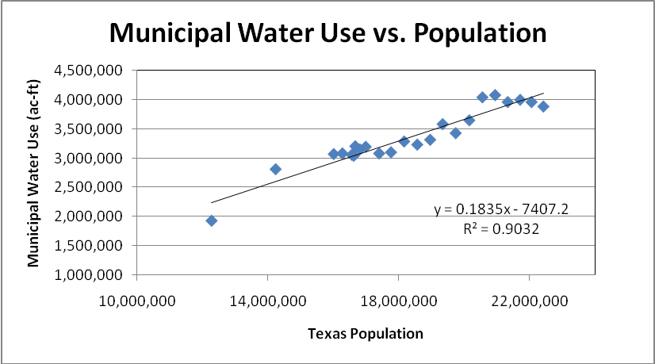

To be turned in: A graph of the data with the trend lines and equations for Analyses 1-5, plus a table that summarizes the five trend equations and their R² values. Discuss the results. Which relationships do you think are statistically significant? What is the population growth rate per year in Texas?

Interpreting Regression Statistics

Now, anybody can fit trend lines but the differences among the equations you have just fitted need to be examined more closely and the significance of the individual coefficients studied. We can do this with the Regression Statistics. Let’s take a closer look at the trendline for municipal water use versus population using the Excel Regression function from the Data Analysis Toolpack. Under Data, click on Data Analysis, Regression.

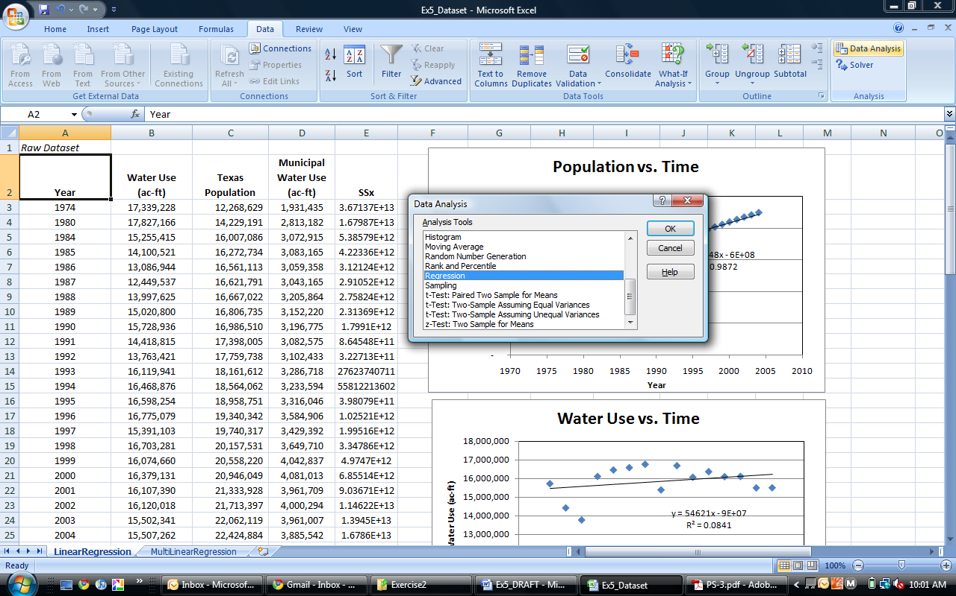

The Input Y Range will be the municipal water use and Input X will be population. Check labels as appropriate. We’d also like to have the 95% confidence level and residuals for later, as shown below.

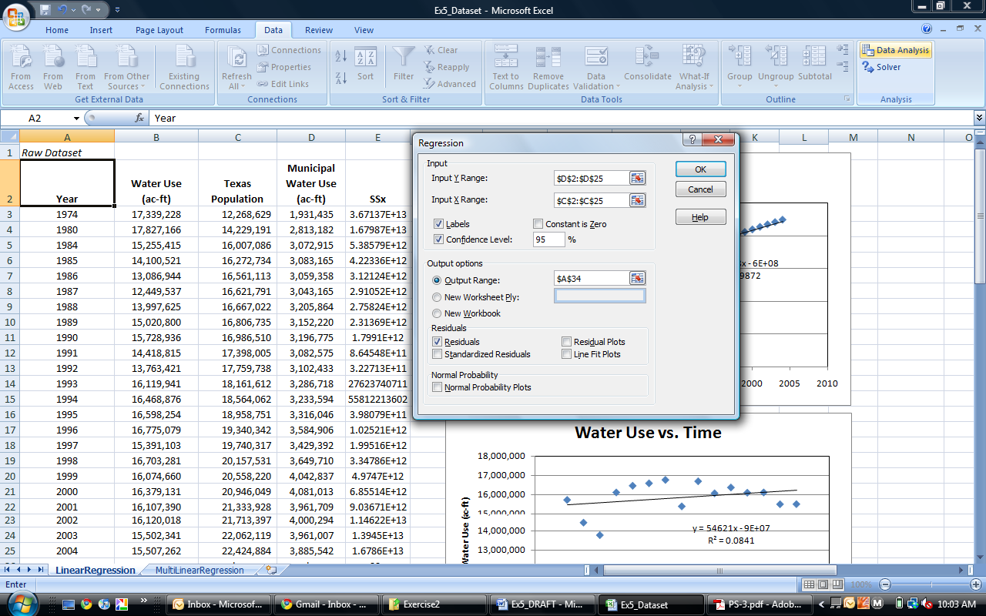

Excel gives us lots of fun output regarding the relationship between municipal water use and population. I’ll explain more about how to interpret this information in class. Being able to do this properly is what separates naïve statistics from properly informed statistical analysis.

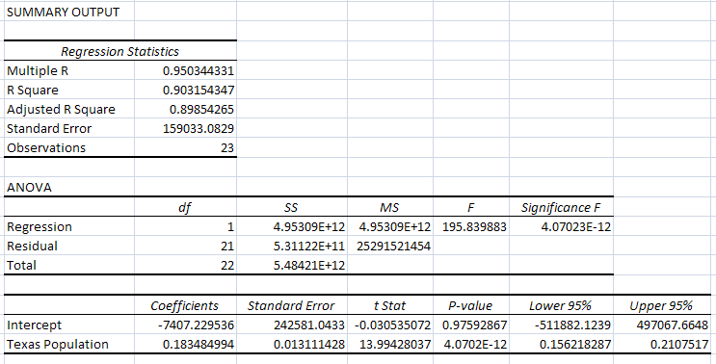
The right way to describe this equation is:

Water Use = -7407.22 + 0.18348 * Population R² = 0.903 S_{e} = 159033 F = 195.83
(-0.03053) (13.994)

The numbers in parentheses under the coefficients are the t-values that tell you how significant the coefficients are. The R² value tells you what % of the variability in Water Use is explained by the equation. The Standard Error (S_{e}) value defines the vertical uncertainty around the line for estimates made by this equation. The F-ratio is a more formal measure of the statistical significance of the equation as a whole than R².

We also get p-values for the parameter estimates for the intercept (0.976) and population slope coefficient (4.07E-12). Since the p-value for the intercept is not less than a significance level (α) of 0.05, we fail to reject the null hypothesis that the intercept is zero, thus the intercept estimate is not statistically different from zero. Another way we can determine whether a parameter estimate is statistically significant is to look at the upper and lower 95% confidence intervals. For the intercept, zero is contained within the interval, thus the estimate is not statistically significant. On the other hand, the slope coefficient estimate for population is highly significant.

Repeat the Regression analysis but this time check the box that sets “Constant is Zero”. This eliminates the intercept of the equation.

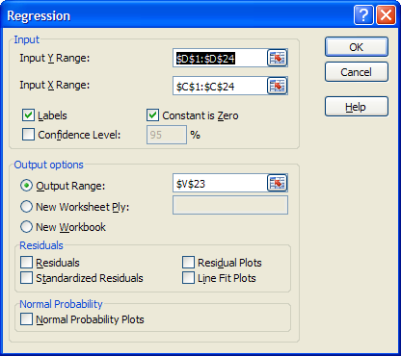

TO BE TURNED IN: The table of interpretive statistics from the simple regression of municipal water use vs population for the regressions with and without an intercept. Write both equations in the format illustrated above. Which equation has the greater statistical significance? What is the average municipal water demand in gallons per capita day in Texas? Is it changing through time? Note: 1 acre-ft = 325,851 US gallons.

Characterizing Outliers

We’re going to use the same data set to evaluate if can consider a data point to be an outlier. Use the information from the regression function in the Data Analysis Toolpack. The summary will contain the value of the standard error, s.

According to Helsel and Hirsch p.246, “leverage is a measure of an ‘outlier’ in the x direction.” A high leverage point is one where 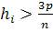 , where p is the number of coefficients in the model and n is the number of data use. In our case, p = 2 and n = 23, so 3p/n = 3*2/23 = 0.261. The idea is to check the degree of deviation of an individual point from the regression line in the x and y directions with this value.

For deviation in the x-direction, the statistics h_{i} is computed as:

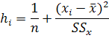
Where SS_{x} is the sum of the squares x.

For deviations in the y direction we use the standardized residual e_{si}. It is the actual residual divided by its standard error, S_{e}. The estimated y can be calculated using the trendline equation. Alternatively, the residual can be found in the residuals output of the regression analysis. Then
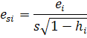
Where the s in this equation is the standard error of estimate of the regression equation.
An extreme outlier is one for which |e_{si}|>3.

Outlier?

Using the information in the Excel regression summary, determine if the 1974 data point is an outlier in the x and y.

To be turned in: Without making any calculations, does the point for municipal water use in 1974 appear to be an outlier? Why or why not? Using the procedure outlined above from Helsel and Hirsch, does the point for municipal water use in 1974 have high leverage? Is this point an outlier?

Multiple Linear Regression

Mulitple Linear Regression is used when it is thought that the (y) variable is dependent on multiple (x) variables. For example, stormwater runoff is not just dependent on rainfall but on soil types and land slopes as well. Expanding the model for the (y) variable will help us determine which factors are statistically important and which do not affect the (y) variable.

Data was compiled concerning multiple countries. We are interested in which factors would affect water use such as Gross Domestic Product (GDP), population, and annual rainfall. Annual rainfall was approximated as the annual rainfall in the most populated city of the country. In some cases (small countries) an approximate national average was obtained. GDP and population data were taken from the most recent data available.

 | Annual Fresh Water Withdrawals  (km³/year) | Population | GDP  ($ billion) | Average Annual Rainfall of Largest City  (mm)
US | 477 | 305,862,000 | 14330 | 960
Canada | 44.72 | 33,563,000 | 1564 | 817.5
Mexico | 78.22 | 106,682,500 | 1143 | 749
Australia | 24.06 | 21,597,121 | 1069 | 1200
China | 549.76 | 1,335,962,132 | 4222 | 970
Brazil | 59.3 | 190,769,000 | 1665 | 1350
India | 645.84 | 1,144,810,000 | 1237 | 2200
Sudan | 37.32 | 38,560,000 | 62.19 | 250
Cameroon | 0.99 | 18,549,000 | 25 | 4060
Ukraine | 37.53 | 46,191,022 | 198 | 615
UK | 11.75 | 61,612,300 | 2787 | 584
France | 33.16 | 65,073,482 | 2978 | 642
Japan | 88.43 | 127,704,000 | 4844 | 1565
Vietnam | 71.39 | 87,375,000 | 90.88 | 1976
Saudi Arabia | 17.32 | 24,735,000 | 528.3 | 81
Honduras | 0.86 | 7,106,000 | 13.78 | 907

Source: The World's Water, Pacific Institute; Wikipedia; CIA

Here we have three independent variables and one dependent variable, thus we cannot graph our data. To determine which factors were important we use multiple linear regression. Use the Data Analysis Toolpack to do a regression analysis on the data. Highlight all the independent variables as the input X range and the fresh water withdrawals and the dependent Y variable. We will not use residuals in this step.

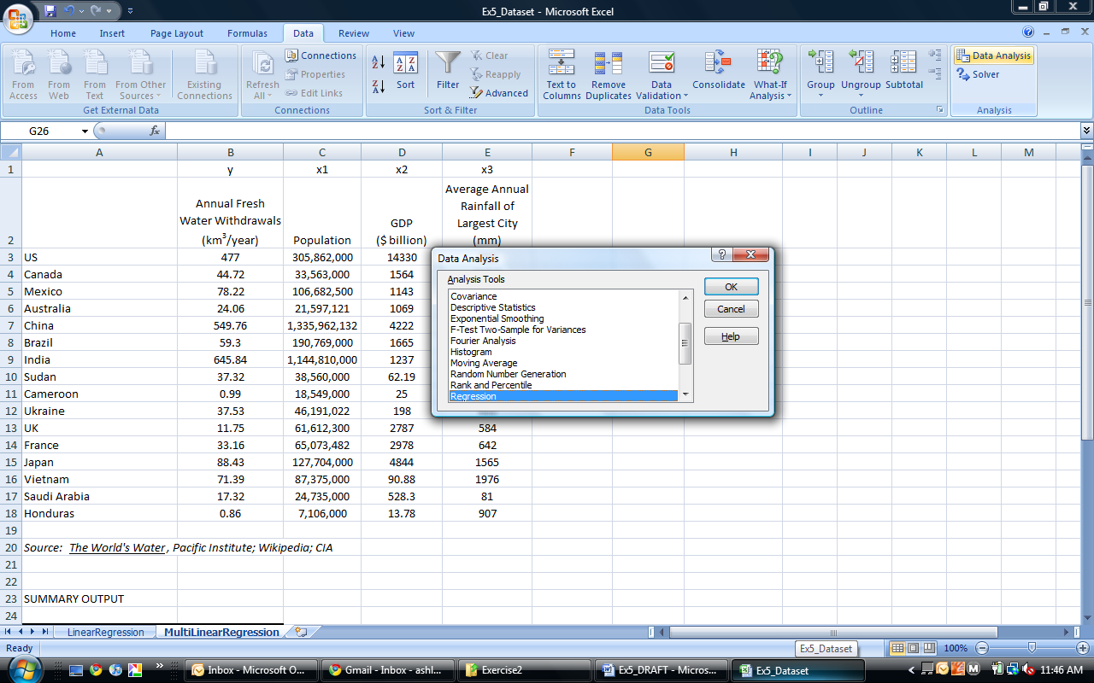

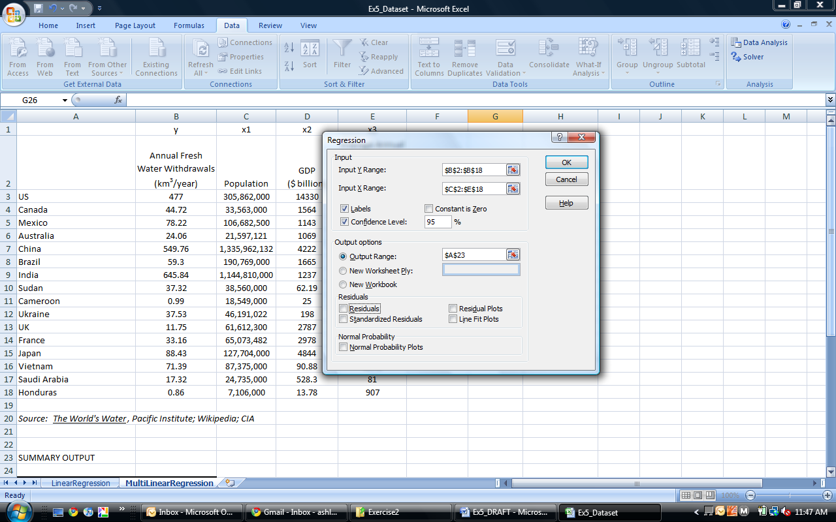

Note the p-values for each coefficient estimate in the output of the regression analysis. Which do you think is the most significant factor? What other issues could be affecting this model that were not accounted for?

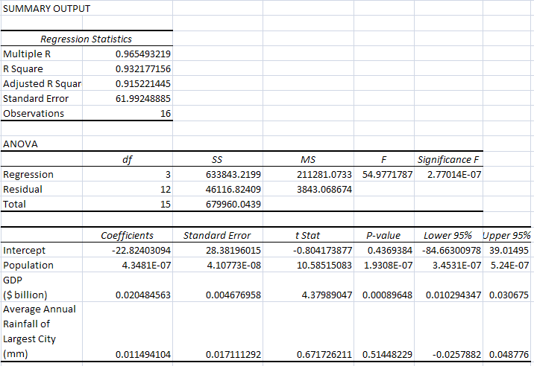

To be turned in: Present the output table of regression statistics and write the estimated model for a country’s fresh water withdrawals as a function of population, GDP, and average annual rainfall in the standard form with t-statistics, R², S_{e} and F ratio. Are there any coefficient estimates that are not statistically significant? If so, which ones? How can you tell? What is the average fresh water withdrawal per person (gpcd) derived from the equation? Compare this to the values derived directly from the data for each country. How is the average value of gpcd derived from the equation different from the average of the gpcd values derived directly from the data? What is the significance of the positive coefficient on GDP? [1 cubic meter = 264.17 US gallons].

To be turned in

- A graph of the data with the trend lines and equations for Analyses 1-5, plus a table that summarizes the five trend equations and their R² values. Discuss the results. Which relationships do you think are statistically significant? What is the population growth rate per year

- Using the procedure outlined above from Helsel and Hirsch, does the point for municipal water use in 1974 have high leverage? Is this point an outlier?

- The table of interpretive statistics from the simple regression of municipal water use vs population for the regressions with and without an intercept. Write both equations in the format illustrated above. Which equation has the greater statistical significance? What is the average municipal water demand in gallons per capita day in Texas? Is it changing through time? Note: 1 acre-ft = 325,851 US gallons.
- Present the output table of regression statistics and write the estimated model for a country’s fresh water withdrawals as a function of population, GDP, and average annual rainfall in the standard form with t-statistics, R², S_{e} and F ratio. Are there any coefficient estimates that are not statistically significant? If so, which ones? How can you tell? What is the average fresh water withdrawal per person (gpcd) derived from the equation? Compare this to the values derived directly from the data for each country. How is the average value of gpcd derived from the equation different from the average of the gpcd values derived directly from the data? What is the significance of the positive coefficient on GDP? [1 cubic meter = 264.17 US gallons].

