Land Change Modeler Exercise

CE 394K3 GIS in Water Resources

Prepared by Virginia Smith using Software from Clark Labs

November 2007

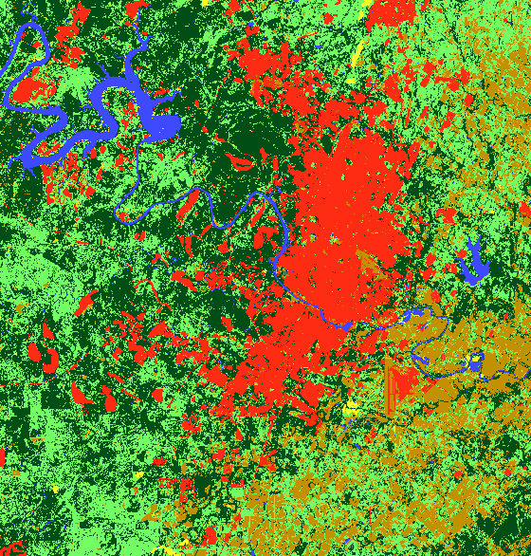

This exercise is an introduction to the Land Change Modeler (LCM) developed at Clark Labs. http://www.clarklabs.org/products/Land-Change-Modeler-Overview.cfm This tool is used for rapid exploration and analysis of land change through time. Through the LCM graphs of gains and losses, net change, persistence and specific transitions can be quickly created. This exercise is designed to be an introduction to the tool; however, it does not dive into the possible depth of this tool.

To big this exercise you will first need to download and install LCM.
You will also need the following files: Austin_roads.shp, Austin92.rst and Austin01.rst. These files represent Austin roads and the land cover of the Austin area in 1992 and 2001. They were both created from products of the USGS. These data are available at LandChangeData.zip

*To repeat this process in the future with other files it is important that both files have the same spatial parameters and reference system. This includes the same projection, cell size, spatial extent, spatial resolution, rows and columns. In addition, the files must also have the same categories and sequential order. The categories must be labeled identically. For more information on preparing files to be used in the LCM see the appendix.

Procedure

1. Create a new project called LANDCOVER92_01. Add Austin92.img to the project. This map shows the land cover of Austin during 1992.

2. Now add Austin01.img to the project. This is a land cover map create by the USGS this year.

3. Display the legend for both of the land cover files. You should notice that they match. By turning on and off the top layer you can visualize the change in land cover in Austin during that time period. Now add the Austin_roads.shp file to the map. This file should give you a general idea of the map scale and range.

4. Now open the Land Change Modeler (LCM) extension for ArcGIS (assuming LCM has been installed and registered). First, make sure the Land Change Modeler extension box is selected.
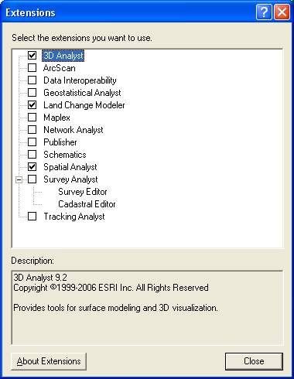

Then open the LCM by clicking on the Land Change Modeler icon button. This will launch the LCM.

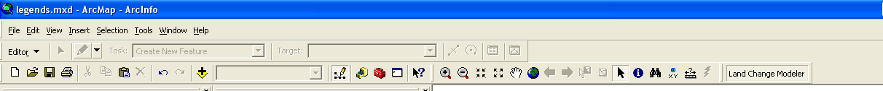

5. The first thing you will notice when you launch the LCM is that it is a tabbed environment, with each tab consisting of a series of panels. In many cases, moving through panels and tabs are done sequentially, i.e., some panels will not open if previous steps have not been completed. As we move through the exercise, you will start to understand the logic. Each time you use the LCM, you must begin by defining a project.

6. In the LCM Project Parameters panel, click the Create a new project option and click the first box with three dots (…) to navigate to the location you want to save this project.

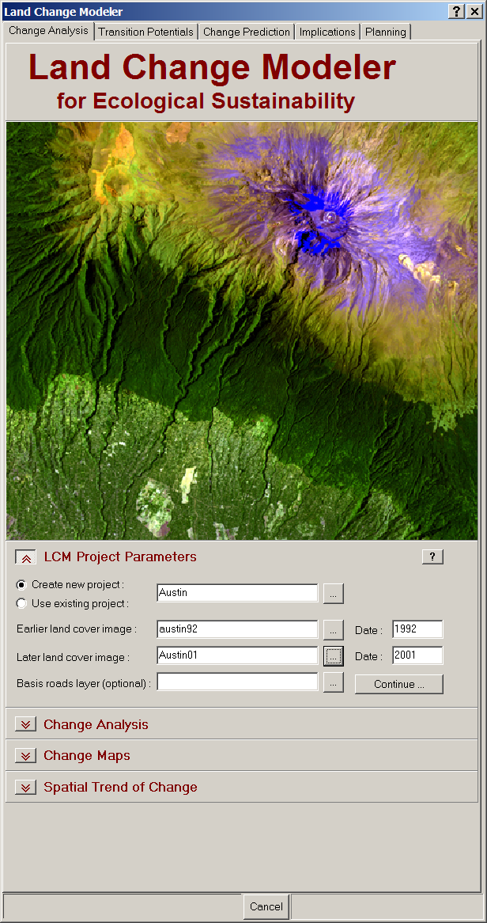

7. Enter the land cover files starting with 1992 and then the 2001 file.
Press “Continue”.

8. You are presented with a graph of gains and losses by category. Notice that the biggest gains are in the grassland and urban categories. Notice that the default unit measure is cells.

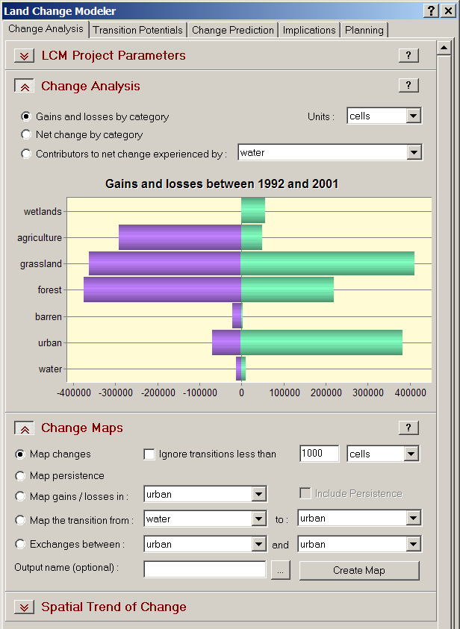

9. Change the measurement units to hectares.

10. Now click on the “Contributors to net change experienced by:” options. Change the category to urban.

This shows the amount the loss or gain to urbanization in each category. Is this what you would have expected for Austin in this time period? Why?
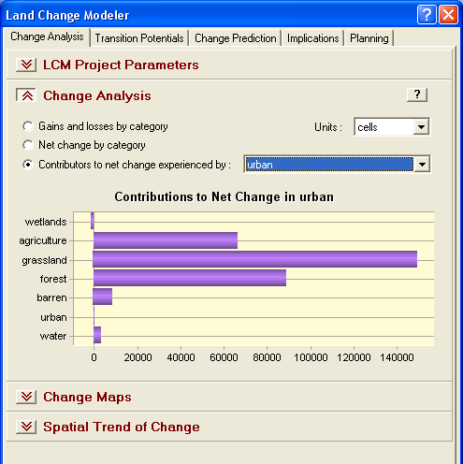

11. Now return to the “Gains and losses” option.

Notice that grasslands and forest are both losing and gaining substantially. What are some possible reasons for this?

12. Select barren and grassland in the “Contributors to net change drop-down list.

What does this information tell you about the natural characteristics of land change and the human influences in this area?

13. Return the “Gains and losses” option again. Change the unit measure to percent change.

What can you imply from this graph as opposed to the graph with units of hectares?

14. To complement these graphs, go to the “Change Maps” panel. Select “Map changes”, specify an output name for the temp file. Then, select “Create Map”.

This map shows the changes that have occurred from 1992 to 2001.

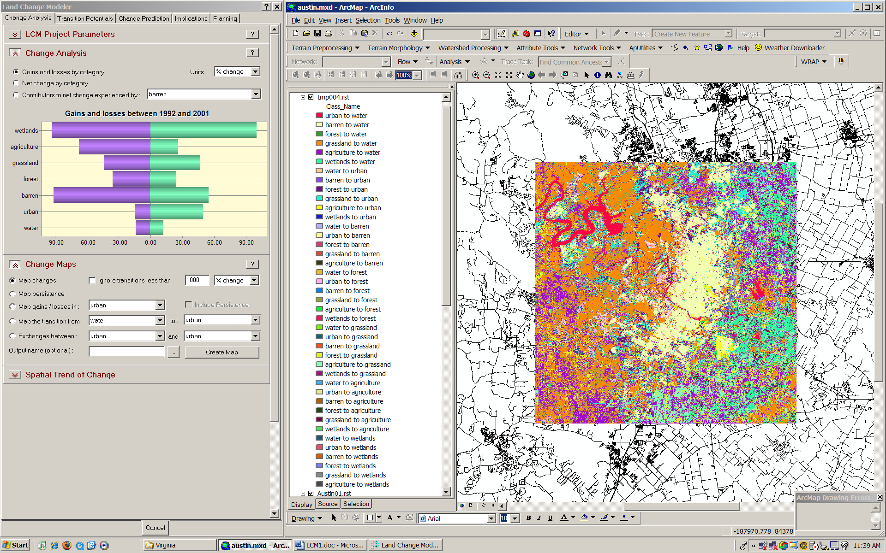

- In the “Change Maps” panel, click the “Map the transition” option. In the first drop-down list choose the “All” item. Then, in the second drop-down list choose “urban”. Click “Create Map”.

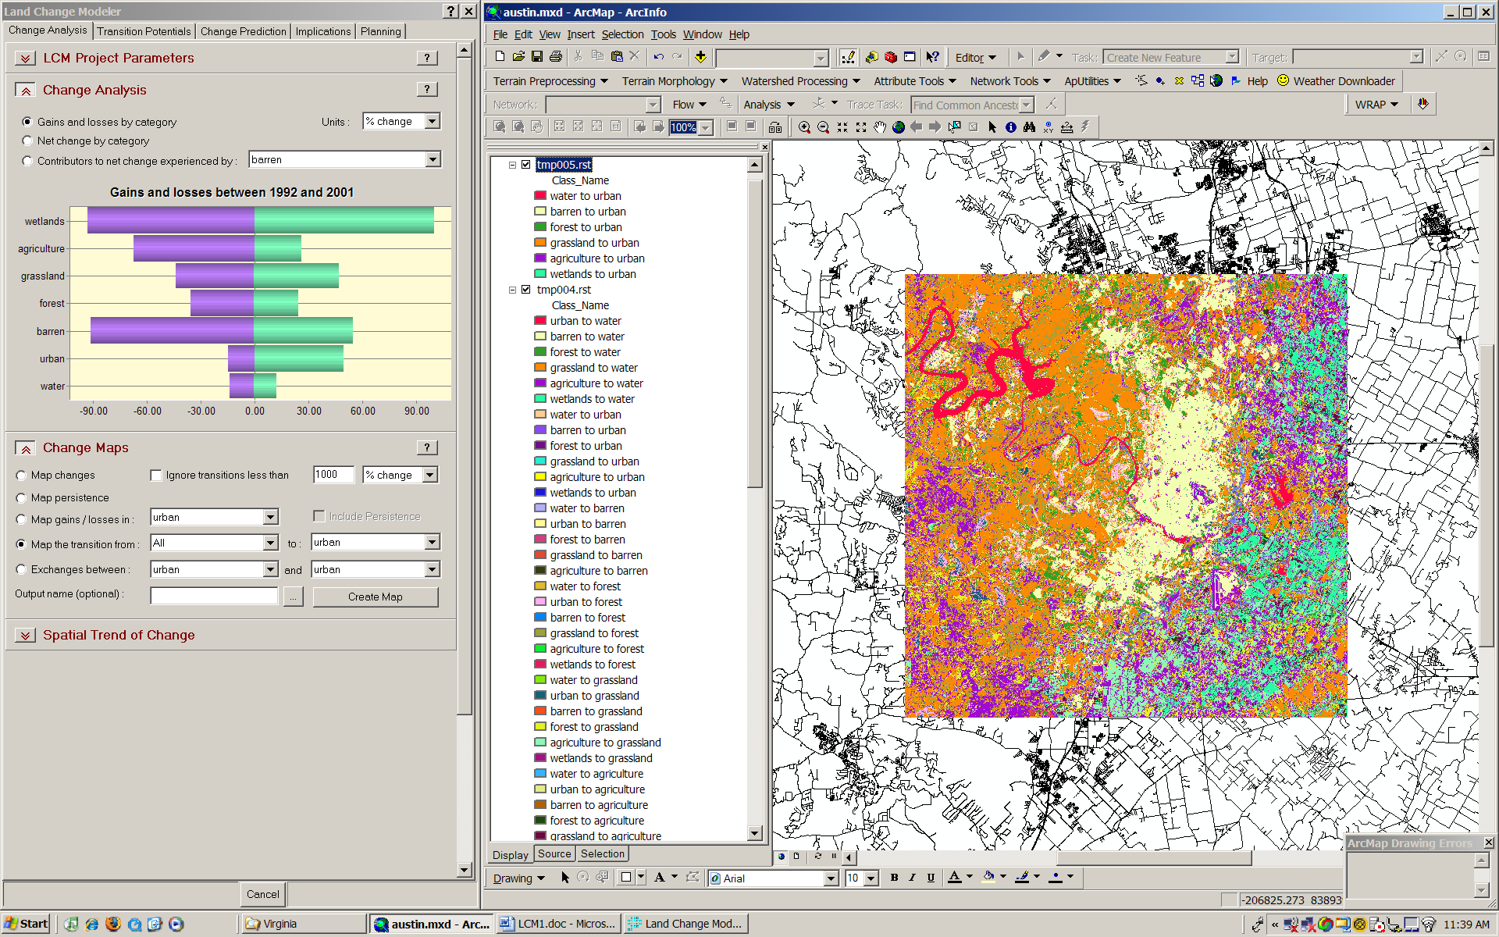

This shows all the areas that changed to the urban category by the origin category. This starts to show us a pattern. However, the spatial trends tool can tell us more.

16. Now select the “Spatial Trends of Change” panel.

17. In the first drop-down list choose the “All” item. Then, in the second drop-down list choose “urban”. Click “Map Trend”.

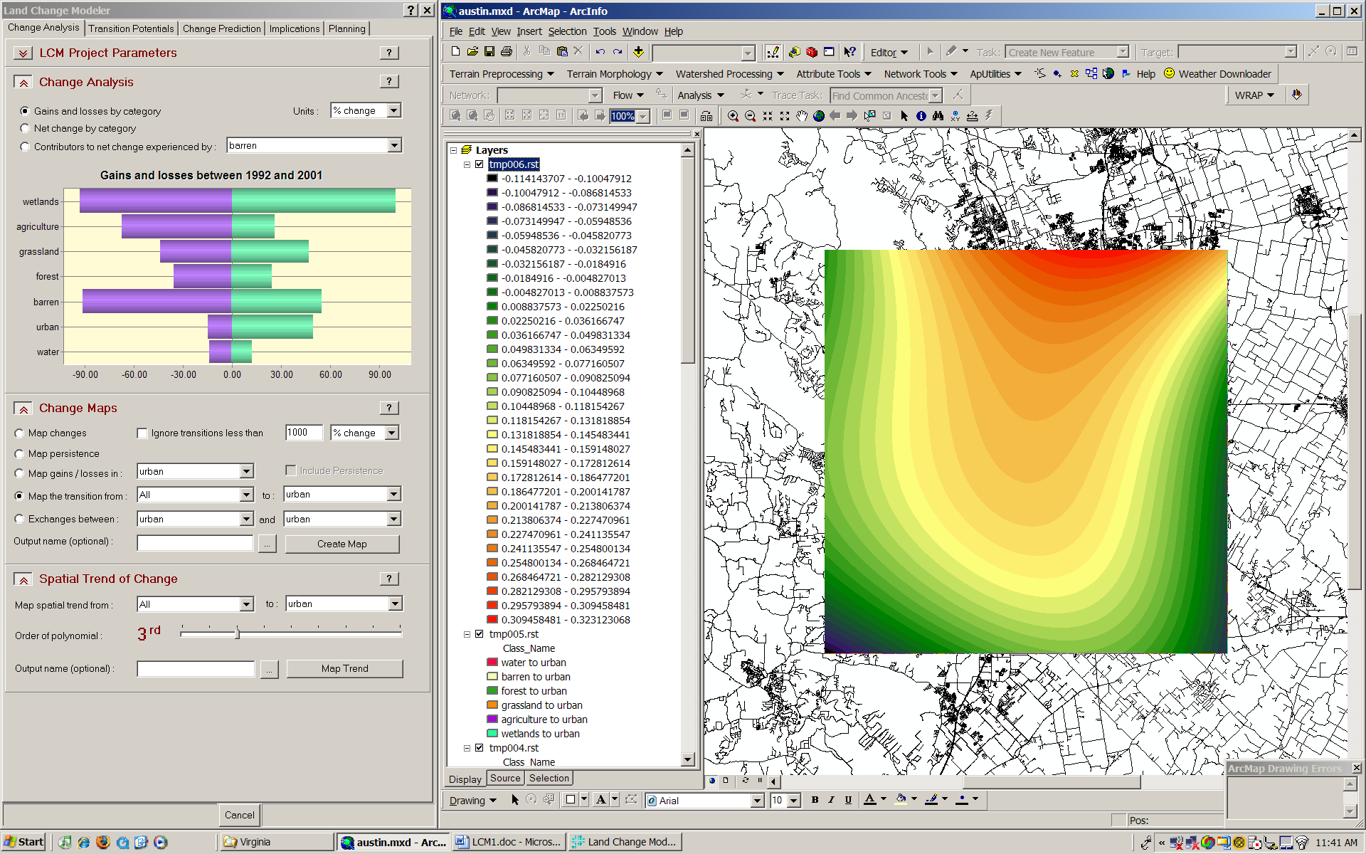

As you can see, this analysis takes considerably longer than the simple change analyses. However, it provides a very effective means of generalizing the trend.

What does this map imply about the spatial development of Austin? Where is development concentrated?

Appendix

Guidelines for Preparing Files to be used in the LCM
1. All files used in the same project in Land Change Modeler (LCM) for ArcGIS must have the same spatial parameters and reference system. This includes the same projection, cell size, spatial extent, spatial resolution and rows and columns.
2. All land cover maps must contain the same categories and sequential order. Labels must be specified in the attribute table for the category names to be displayed in the LCM interface. For example, if you have a land cover map for 1986 and category 6 is labeled water, then category 6 in the land cover map for the same area for 1994 must also represent and be labeled water. Background or flag values must be the same for each image, both the values and the spatial extent.
3. When using vector files for certain operations in Land Change Modeler for ArcGIS, the main ID field must contain the attribute IDs, not the sequential IDs.
4. Land Change Modeler for ArcGIS uses data only in IDRISI format. However, any raster file format supported by ArcGIS, including grid files can be loaded into the LCM interface. These files will be converted automatically to the IDRISI raster or vector formats having the extensions .rst/.rdc or .vct/.vdc, respectively.
5. Depending on the reference system, converting files to the IDRISI file format may result in an extra row or column with the value of this extra row or column containing the NoData value specified in either ArcGIS or in the metadata Flag Value field of the IDRISI. This extra row or column is the result of ArcGIS using the cell-center as the point of origin and IDRISI using the lower-left corner of a pixel as origin. Since pixels can not be split, the conversion adds the column or row, if necessary, to accommodate the initial x and y extent, ensuring that no data will be lost.
6. The current version of ArcGIS 9.2 SP3 does not properly convert shape files to IDRISI vector files. The reference system is not properly carried over which can result in a mismatch of reference systems with other files. As a result, Land Change Modeler for ArcGIS will edit the incorrect IDRISI vector file with the reference system used for the raster images for any panel.
7. If you are starting with grids or shape files, they must be in either 4-byte floating point, 2-byte signed integer, and unsigned byte to be used with LCM. You may have to use the Reclassify tool in ArcGIS to change the NoData value in the grid file so that it is in the range of the data formats above. For example, if you have a land cover map with 11 categories and the NoData value is set to -32767, you will need to Reclassify the NoData value to 255 or 0. The output data type will be unsigned byte which can then be used for Change Analysis.
8. If you have grids with multiple label fields, LCM will recognize fields in the following order: Class_Name, Category. If these fields do not exist, it will use the first text field.
9. Currently, Land Change Modeler for ArcGIS does not access Geodatabase files.
Using and Converting IDRISI files for use in Land Change Modeler for ArcGIS
10. The current version of ArcGIS 9.2 SP3 does not fully support IDRISI raster files that have legends. If you have a raster image in IDRISI that contains legends and want to use that map in LCM or display this map in ArcGIS with legends, you will need to create an IDRISI palette file (.smp) of the same name as the map. Those familiar with IDRISI could simply copy the QUAL.SMP palette file to the name of the image you want working with LCM.
11. If you are converting IDRISI rasters to grids using the ArcGIS command Copy Raster, you will want to define flag values first in the IDRISI metadata for that file. Given that IDRISI only supports 4-byte floating point, 2-byte signed integer, and unsigned byte data formats, giving an appropriate flag value in the metadata will ensure that the Copy Raster command will choose the appropriate data type to be accepted by LCM.
12. If you want to convert categorical data to grids that have values ranging from 1 to 255, and no 0 values in the image, define the Flag Value as 0 background. If the image contains a valid zero, i.e., background, choose a Flag Value greater than any actual value contained in the image.
13. If you are converting floating point files, choose a Flag Value that is not contained in the image, e.g., -9999. This will ensure that ArcGIS does not assign negative or positive infinity NoData value to the resulting file from Copy Raster.

