Nexrad Precipitation Time Series over a Basin
By David R. Maidment and Kate Marney
Center for Research in Water Resources
University of Texas at Austin
October 2008
Stage IV radar data is available on the NCDC THREDDS server at http://www.ncdc.noaa.gov/thredds/catalog/radar/StIV/catalog.html. The NCDC is currently serving various stage IV data, including daily, 6 hour, 1 hour, and aggregated year long daily data sets. Follow the link provided to access the server.

Selecting Data
This guide follows the example of downloading daily data during a flood period in Texas in 2002. The aggregated data is daily data, so this will be used. Select the file ‘ST4_Agg_2002-TEST.nc’. This takes the user to a new page, as shown below.
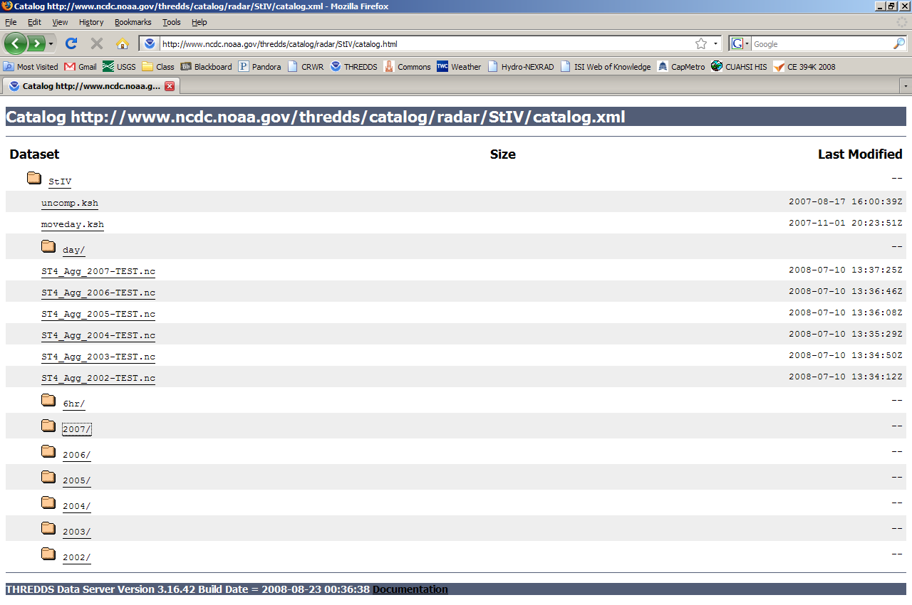
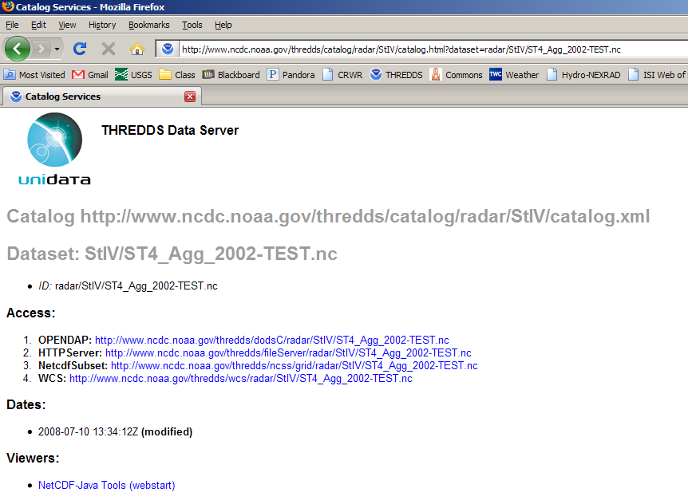
We will be importing the NetCDF files into ArcMap to create rasters, so select Access option 3. We are able to enter parameters on the next page. First, select the variable Total_precipitation. Next select all the data or enter the latitude and longitude coordinates of a bounding box in decimal degrees. In this case the bounding box surrounds the San Marcos subbasin and the coordinates are provided below.
North | 30.2
West | -98.5
East | -97.4
South | 29.5

Lastly, enter the starting and ending date-time of the desired data. In this case the starting date is 2002-06-28T12:00:00Z, where the date-time is in YYYY-MM-DDTHH:MM:SSZ format, and the ending date is2002-07-20T12:00:00Z. After entering the parameters, the page should appear as below.
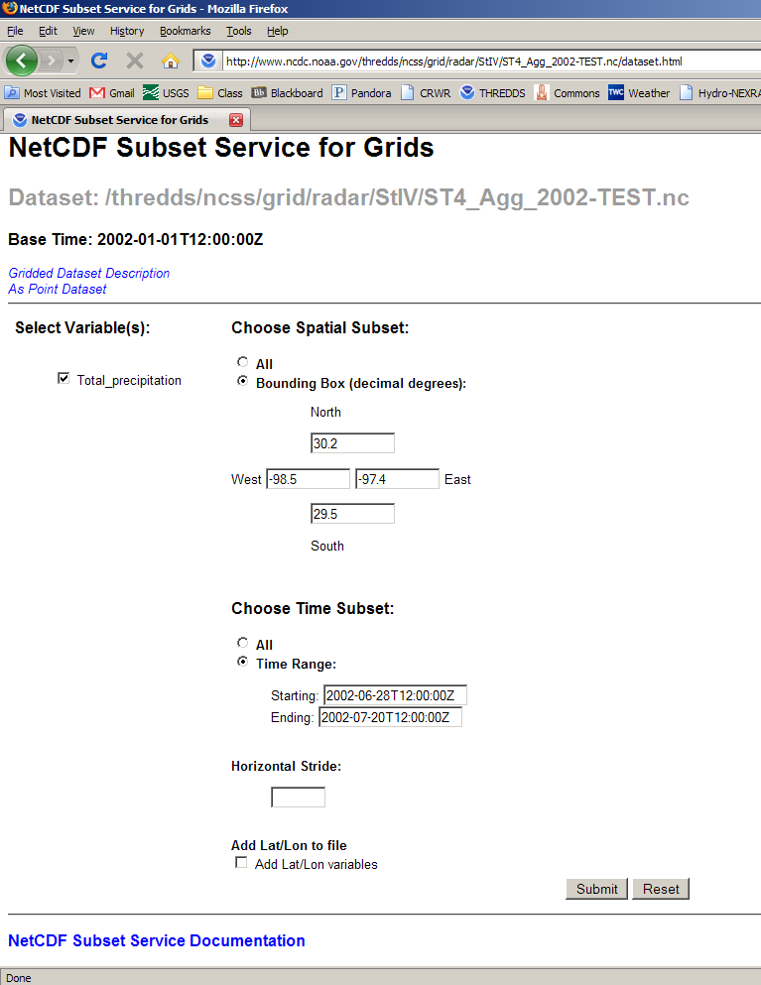
Hit submit and select Save to File.
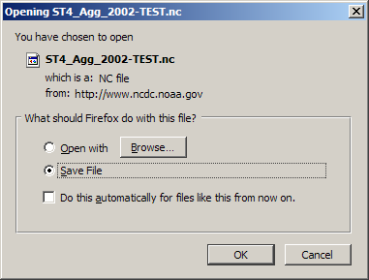
The file will most likely save to the desktop. Move this file to a working directory if you so desire. A file of Nexrad precipitation for June 28 through July 18, 2002 for the San Marcos Basin, can be found at:
http://www.ce.utexas.edu/prof/maidment/giswr2008/Ex4/Nexrad/ST4_Agg_2002-TEST.nc
In ArcMap, open Arc Toolbox and select the Multidimension Tools/Make NetCDF Raster Layer
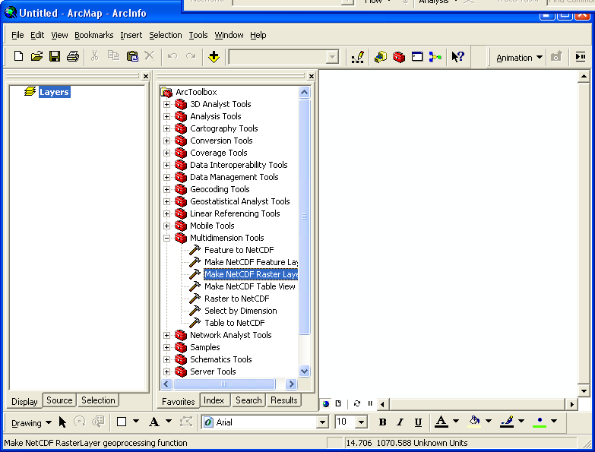

Select this netCDF file for the tool and select time as the Dimension Value
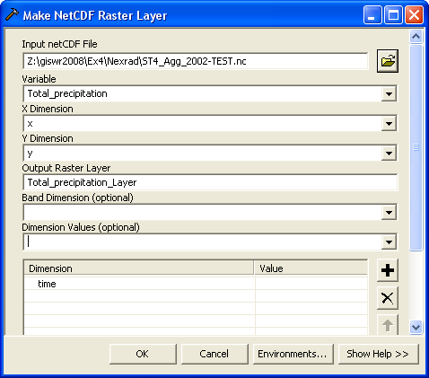
This shows precipitation over all of the United States for these days. Add the San Marcos Basin to the display and zoom to it:
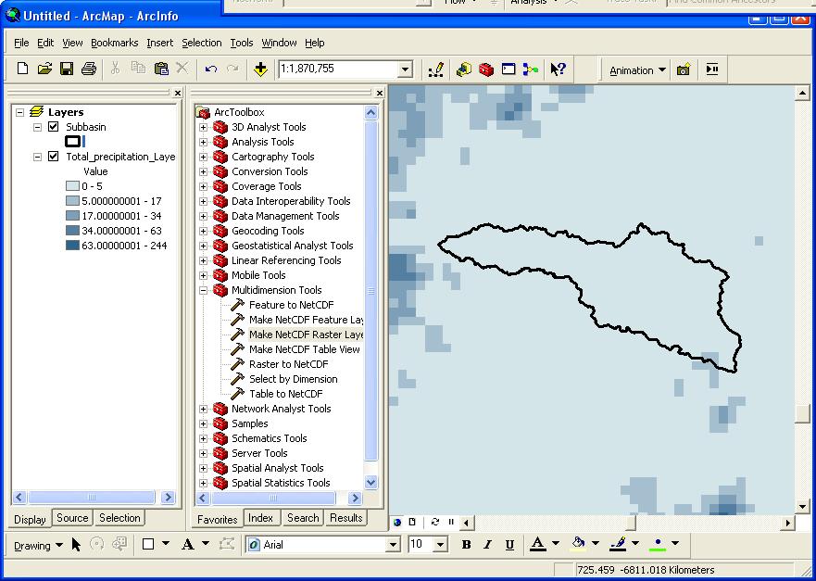

Create a time layer animation
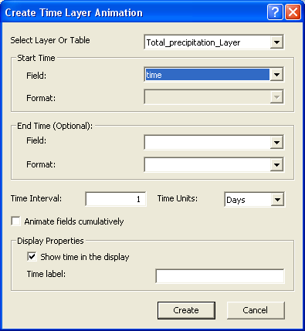

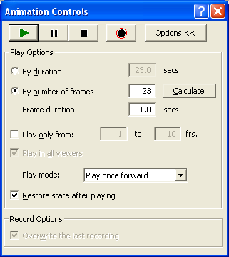

And it works!!
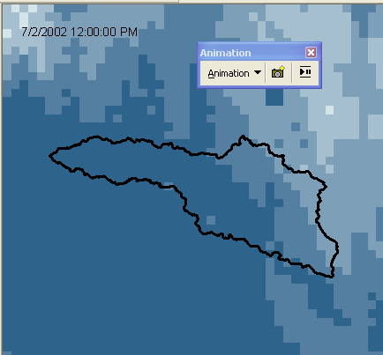

Iterating on time to obtain mean precipitation over an area
Now we will use a tool that was developed to obtain the mean precipitation throughout time over the San Marcos Basin. The tool and necessary files are available at http://www.ce.utexas.edu/prof/maidment/giswr2008/precipitation/Precip_Tool.zip Unzip the folder and save it in a convenient location.
The file folder contains several different files, as shown below.
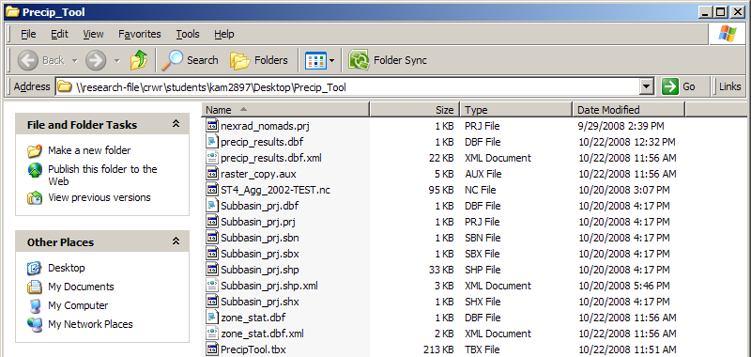
Open a new ArcMap document. First, in the Tools menu, select Extensions and make sure the Spatial Analyst box is check.
Next, in the Tools menu, select Options. Navigate to the Geoprocessing tab and make sure the box is check next to Overwrite the outputs of geoprocessing operations then hit OK to exit.
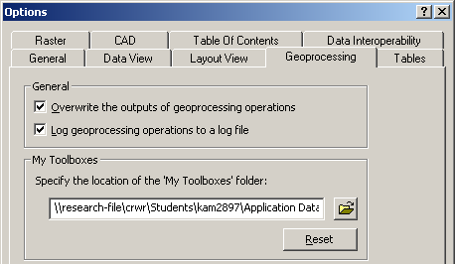
In ArcToolbox, right click and select Add Toolbox.
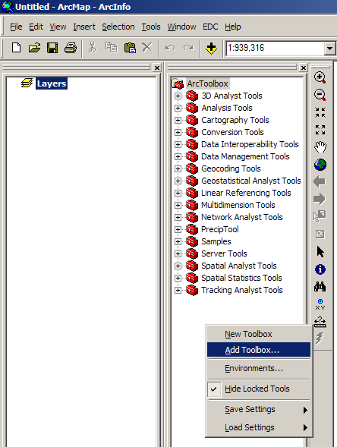
Navigate to the file folder you unzipped and select the toolbox PrecipTool and hit Open.
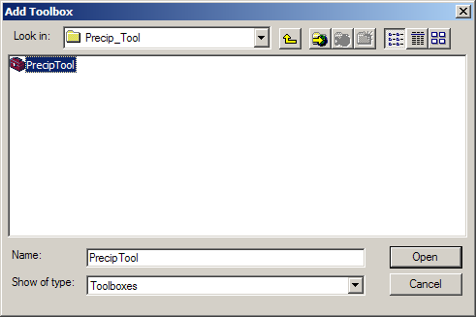
The toolbox called PrecipTool should now appear in ArcToolbox. Expanding that toolbox should reveal one model called precip_raster. Right click on the precip_raster model and select Edit.
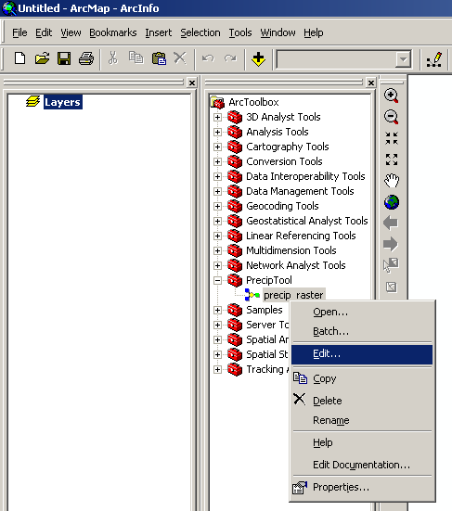
Scroll to the end of the model and double click 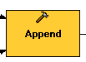to open the append tool. In order for the tool to know which column to put the appended data into, the fields have to be mapped. Right click on the field MEAN (Float) and select Add Input Field.
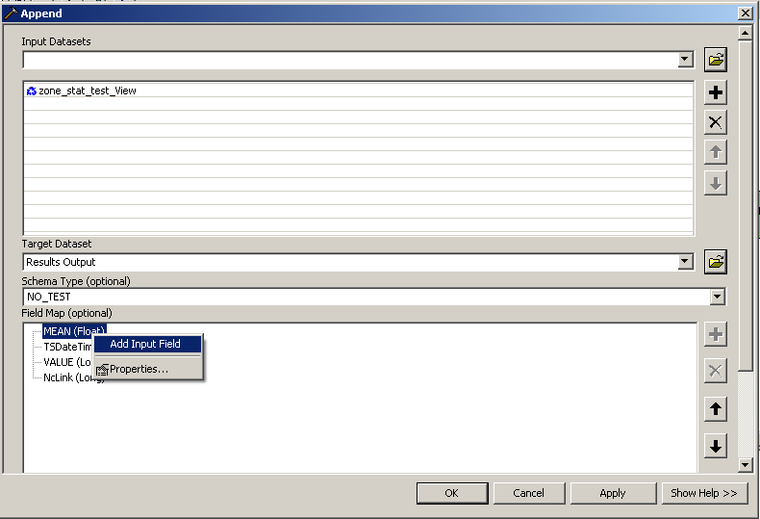
We want the mean from the zonal stats to be mapped to the mean field in the results table, so select the name of the field that ends with .MEAN and hit OK.
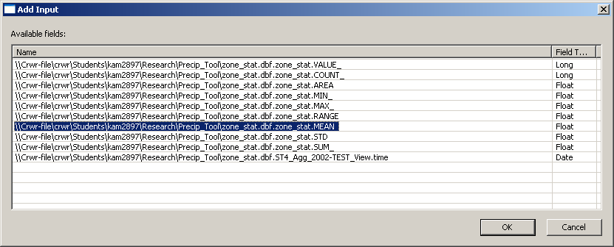
Repeat this process for the field TSDateTime and select the last available field that ends with _View.time and hit OK. Save the model before exiting. Now open the tool from ArcToolbox by right clicking and selecting open. Select the correct netCDF input file if it is different than the one provided and change the location to which the files are saved if you so desire. Hit OK to run the model.
To view the results, add the precip_results table. The model is set to iterate 1 time by default. To change this, right click on the model and select Edit. From the Model menu in the top left corner, select Model Properties. In the model properties menu, select the Iterations tab, then change the number of iterations to reflect the number of time stamps you wish to obtain the mean precipitation for.
