On Accommodating Spatial Dependence in Bicycle and Pedestrian Injury Counts by Severity Level

Sriram Narayanamoorthy⁺
Parsons Brinckerhoff
400 SW Sixth Avenue, Suite 802
Portland, OR 97204
Phone: 503-478-2862
Email: narayanamoorthys@pbworld.com

Rajesh Paleti⁺
Parsons Brinckerhoff
One Penn Plaza, Suite 200
New York, NY 10119
Phone: 512-751-5341
Email: paletir@pbworld.com

Chandra R. Bhat*
The University of Texas at Austin
Dept of Civil, Architectural and Environmental Engineering
301 E. Dean Keeton St. Stop C1761, Austin TX 78712
Phone: 512-471-4535, Fax: 512-475-8744
Email: bhat@mail.utexas.edu
and
King Abdulaziz University, Jeddah 21589, Saudi Arabia

⁺ This research was undertaken when Sriram Narayanamoorthy and Rajesh Paleti were students at UT Austin

*corresponding author

Original Version: July 23, 2012, First Revised Version: April 14, 2013,
Final Revised Version: June 29, 2013
Abstract
This paper proposes a new spatial multivariate count model to jointly analyze the traffic crash-related counts of pedestrians and bicyclists by injury severity. The modeling framework is applied to predict injury counts at a Census tract level, based on crash data from Manhattan, New York. The results highlight the need to use a multivariate modeling system for the analysis of injury counts by road-user type and injury severity level, while also accommodating spatial dependence effects in injury counts.

Keywords: Multivariate count data, spatial econometrics, crash analysis, composite marginal likelihood.

- INTRODUCTION
The continued dependence of individuals on motorized automobiles for transportation, along with rapid population growth, has led to increasing traffic congestion in most urban areas in the U.S. (see Schrank et al., 2011). While several strategies are being considered to alleviate the increasing urban traffic congestion, many metropolitan planning organizations (MPOs) have started to invest in non-motorized mode infrastructure to promote the use of walking and bicycling modes (Pucher et al., 1999, Metropolitan Transportation Commission, 2009, Southern California Association of Governments, 2012). In addition to reducing traffic congestion, the promotion of these transportation modes can also offer ancillary benefits to society in terms of improved health, better air quality, energy independence, and enhanced quality of life (see Pucher et al., 2010 and Gotschi and Mills, 2008). However, even as MPOs look to the promotion of non-motorized modes of travel, it is illustrative to note that, according to the 2009 National Household Travel Survey (NHTS), non-motorized modes accounted for only 11.9% of all weekday trips, and 0.9% of total weekday person travel mileage. On the other hand, many cities in Europe and other nations boast substantially higher non-motorized shares in terms of trips and mileage (Bassett et al., 2008).
The higher non-motorized mode shares in Europe and other nations may be attributable to many factors, including higher built environment density, expensive gas and auto ownership costs, and better land-use mix. But another important factor in travel mode choice decisions is safety from traffic crashes. In fact, studies have now established that safety from traffic crashes is a key determinant of a person’s mode choice decision (see Winters et al., 2010 and Sener et al., 2009). In this context, Beck et al. (2007) have found that, relative to passenger vehicle occupants, bicyclists and pedestrians in the U.S. are 2.3 and 1.5 times, respectively, more likely to be fatally injured on a given trip. In cross-country comparisons, Pucher and Dijkstra (2003) found that, after controlling for travel exposure in terms of mileage, U.S. pedestrians (bicyclists) are about 3 times (2 times) as likely to get killed in traffic accidents as German pedestrians (bicyclists) and over 6 times (3 times) as likely to be killed as Dutch pedestrians (bicyclists). In another more recent study at a metropolitan area level (rather than a national level that can mask risk variation within countries), McAndrews (2011) observed that the risk of a fatal traffic crash injury for pedestrians in San Francisco is 4.1 times higher than for pedestrians in Stockholm, while the corresponding figure is 1.7 for bicyclists. Overall, these studies clearly reveal the underperformance of the U.S. in terms of pedestrian and bicyclist safety relative to other advanced economies. At an absolute level, about 4280 pedestrians and 618 bicyclists were killed in traffic accidents in the year 2010 in the U.S., constituting 15% of all fatalities that year (National Highway Traffic Safety Administration or NHTSA, 2012) while non-motorized mode mileage comprises only 0.9% of total travel mileage.
To summarize, the promotion of non-motorized modes of transportation should involve, as one essential element, an understanding of the risk factors associated with pedestrians and bicyclist-related injuries. This can allow the identification of high risk crash environmental settings and inform the design of appropriate transportation policy countermeasures. Accordingly, there have been several efforts in the past that focus on modeling the frequency of non-motorized crashes as a function of relevant built environment and socio-economic indicators. In this paper, we contribute to this literature by formulating a multivariate model to jointly analyze, at a “neighborhood” level, the count of pedestrians and bicyclists involved in traffic crashes by injury severity sustained. The spatial unit we use to characterize a “neighborhood” is the Census tract. We do so because the more disaggregate spatial units (roadway street segment, intersection, Census block, and Census block group) can routinely experience zero pedestrian and bicyclist-related crashes for multiple years at a stretch, which reduces the variability of the count variables across such disaggregate spatial units and decreases our ability to tease out the risk factors associated with pedestrian and bicyclist crash involvement. The use of the more aggregate Census tract level avoids these problems, while also representing a reasonably homogenous spatial unit of an urban area (see Delmelle et al., 2011). Besides, the Census directly provides socio-economic data at the level of the Census tract, facilitating analysis at this spatial scale.
Two important issues are of significance in the current research. First, the reason for our emphasis on the count of pedestrians and bicyclists injured by severity level is to acknowledge that accident costs vary substantially by severity level (see Wang et al., 2011). Second, the multivariate model proposed in this paper recognizes many econometric issues at once: (a) It acknowledges the count nature of the number of injuries, (b) it conveniently addresses excess zeros (or any other excess count value for that matter) within a multivariate count setting, (c) it accommodates the potential presence of unobserved Census tract factors that can lead to dependence, within the Census tract, in the risk propensities for the different road-user type-injury severity combinations (road-user, in our analysis, may be pedestrians or bicyclists), and (d) it considers spatial dependence effects across Census tracts that are likely to be present because of the spatial nature of the analysis.
The rest of this paper is structured as follows. Section 2 presents an overview of the relevant earlier literature and positions the current study. Section 3 presents the model structure and estimation procedure. Section 4 describes the study area, data source and important sample characteristics. Section 5 presents the empirical estimation results and their implications for reducing non-motorized user injury severity in crashes. Finally, Section 6 concludes the paper.

- EARLIER STUDIES AND THE CURRENT PAPER
Several methodological challenges arise when modeling crash frequency-related data (see Lord and Mannering, 2010 for a good review). The focus of the current paper is on addressing two specific methodological challenges that lead to the proposed spatial multivariate count model.

  - Modeling Count Data by Type
Crash data include information on the individuals who are hurt and the level of injury sustained by each individual (typically in such categories as no injury, possible injury, non-incapacitating injury, incapacitating injury, and fatal injury). At an aggregate level of a Census tract, one can then obtain, over a specific time period, the number of pedestrians and bicyclists involved in traffic crashes by injury severity level. This leads to a multivariate count system within each Census tract because of the presence of unobserved Census tract factors that (1) influence the risk propensity for a specific injury severity level across both pedestrian and bicyclist injuries (for instance, motorists within a certain Census tract may have an unaccommodating attitude toward sharing the road with non-motorists, which may increase the risk of fatal injuries for both pedestrians and bicyclists - for future reference, we will label such unobserved factors as type a unobserved factors), (2) intrinsically increase or decrease the propensity for pedestrian injuries across all injury levels (for example, the absence of sidewalks in a Census tract may lead to a general increase in risk propensity for pedestrians across all injury levels), (3) intrinsically increase or decrease the propensity for bicyclist injuries across all injury levels (for example, discontinuous bicycle paths in a Census tract may lead to a generic increase in risk propensity for bicyclists that permeates across all injury levels (we will label the unobserved factors corresponding to (2) and (3) as type b unobserved factors), and (4) impact the overall propensity of non-motorized injuries (for instance, because of a generally high propensity to use non-motorized modes in a Census tract; we will label the unobserved factors corresponding to (4) as type c unobserved factors).
There have been two commonly used approaches in the literature to formulate and estimate multivariate count data models. One common approach has been to use multivariate versions of the Poisson or negative binomial discrete distributions (see, for example, Ladrón de Guevara et al., 2004, Buck et al., 2009, and Bermúdez and Karlis, 2011 for applications of these methods). Such multivariate count models have the advantage of a closed form, but they become cumbersome as the number of correlated counts increases (see Herriges et al., 2008 for a discussion). A second common approach is to use a mixing structure, in which one or more (typically) normally distributed random terms are introduced in the parameterization of the expected value of the discrete distribution (so that the expected value is not only a function of exogenous variables, but also includes one or more additive random terms within the exponentiation). If the same error term enters in the means of multiple count variables, this generates correlation (see Chib and Winkelmann, 2001, Lee et al., 2006, Park and Lord, 2007, Aguero-Valverde and Jovanis, 2009, El-Basyouny and Sayed, 2009 and Chiou and Fu 2012 for examples of such an approach). However, it is difficult in these mixing approaches to account for excess zeros (Lee et al. 2006, Alfò and Maruotti, 2010, Herriges et al., 2008). Furthermore, these mixing approaches require rather cumbersome and time consuming simulation estimation approaches (Müller and Czado, 2005, Aguero-Valverde and Jovanis, 2006, and Ver Hoef and Jansen, 2007 for discussions).
Another important point is that extending the multivariate approaches just discussed to accommodate spatial dependency becomes impractical, if not literally infeasible.

  - Spatial Dependency Effects
Spatial dependency is important to recognize because of the mapping of crash locations to spatial units of analysis, such as Census tracts in the current paper. In the spatial analysis literature, the two workhorse specifications to capture spatial dependencies are the spatial lag and the spatial error specifications (Anselin, 1988). The spatial lag specification, in reduced form, allows spatial dependence through both spatial spillover effects (observed exogenous variables at one location having an influence on the dependent variable at that location and neighboring locations) as well as spatial error correlation effects (unobserved exogenous variables at one location having an influence on the dependent variable at that location and neighboring locations). The spatial error specification, on the other hand, assumes that spatial dependence is only due to spatial error correlation effects and not due to spatial spillover effects. The spatial error specification is somewhat simpler in formulation and estimation than the spatial lag model. While these spatial specifications have been used primarily in the case of a continuous dependent variable, the past decade has seen increasing use of these spatial specifications for non-linear discrete choice models. The specifications are similar to the linear models, except that they are now applied to the latent continuous propensity variables underlying the observed discrete variable. However, the spatial lag and spatial error specifications saw little use in the context of count models until Castro, Paleti, and Bhat (2012) (CPB for short in the rest of this paper), who showed that even count models can be recast in the form of an underlying latent continuous variable framework (so that the spatial specifications can again be applied to the latent continuous propensity variables). Before CPB, a common approach was to map the count variable into an approximate continuous variable (typically also applying a log-transformation to ensure positive predictions, and sometimes also normalizing by an exposure measure to obtain crash rates or taking ratios of different types of crashes), and then apply well-established estimation methods developed for continuous models. Examples of such efforts in the safety literature include LaScala et al. (2000), Quddus (2008), Ha and Thill (2011), and Delmelle et al. (2011). While useful, these efforts may be viewed as approximations, since they generate “continuous” variables from underlying count data. Especially as the focus shifts from modeling total crashes to total crashes by injury severity type and/or road-user type, the count data will show less variation (and a preponderance of zero counts), rendering the approximation in the translation to a continuous variable more inappropriate. It is, therefore, no surprise that none of the studies listed above that use this “continuous” transformation method consider crashes by type, instead focusing on total crashes.
Another alternative approach to incorporate spatial dependency in count models in the past has been to use a conditional autoregressive (CAR) or a joint prior on a spatial random effect term that is introduced multiplicatively in exponential form in the parameterization of the expected value of the discrete distribution for the count variable. The resulting model is estimated using Bayesian hierarchical methods. Examples of such efforts include Miaou and Song, 2005, Aguero-Valverde and Jovanis, 2006, 2010, Mitra, 2009, Wang et al., 2011, Siddiqui et al., 2012). Unfortunately, this approach (which is essentially a mixing approach of the type discussed in the previous section, except with the mixing undertaken over space) can be difficult as the number of spatial units increases, and extending the approach to modeling crashes by type is extremely challenging (if not impractical). Besides, this approach considers spatial error correlation effects, but not a spatial spillover effects.

2.3 The Current Paper
In the current paper, we recognize and retain the count nature of the number of pedestrian and bicyclist injuries by injury severity level. In doing so, we address the multivariate nature of the counts within a Census tract. In addition, we also simultaneously recognize spatial lag dependency effects across Census tracts. To our knowledge, this is the first paper to develop such a spatial multivariate count model in the literature. The approach we use is based on recasting the basic count model as a special case of a generalized ordered-response (GOR) model, as proposed by CPB. The likelihood function for the resulting model is analytically intractable, and simulation approaches are of little use. To overcome this issue, we use a composite marginal likelihood (CML) inference approach that is simple to implement and is based on evaluating lower-dimensional marginal probability expressions.
The proposed model is applied to examine, at the spatial level of a Census tract, the number of pedestrian and bicyclist injuries by injury severity level. An important aspect of modeling crash frequency is to identify a measure to quantify the exposure to crash risk. In the current context, an appropriate exposure measure of crash risk within a Census tract is the number of pedestrian/bicyclist miles of travel and motorized vehicle miles of travel. More often than not, however, these exposure measures are difficult to obtain or construct accurately. So, it is common in the literature to use surrogate exposure measures such as population density (LaScala et al., 2000), income (Loukaitou-Sideris et al. 2007), land-use (Loukaitou-Sideris et al., 2007, Ha and Thill, 2011), road-network characteristics (Ha and Thill, 2011), and activity intensity characteristics (Mitra and Washington, 2012). This approach, which is akin to a reduced-form approach, has the advantage that exposure is internalized in the system, and so it is possible to identify Census tracts that are likely to have a high number of crashes based purely on the readily available Census tract demographic factors and built environment characteristics. We use this approach in the current study to accommodate exposure effects.
The data for our analysis is drawn from a bicyclist and pedestrian crash database maintained by New York City (see Section 4 for details on how the data was assembled). Several groups of Census tract-based risk factors are considered in our analysis based on earlier research, including (1) socio-demographic characteristics (such as population density, proportions of the population by age, income, and race/ethnicity), (2) land-use and road network characteristics, (3) activity intensity characteristics, and (4) commute mode shares and transit supply characteristics.

- METHODOLOGY
  - Model Formulation
Let q (q = 1, 2,…, Q), j (j = 1, 2,…J), and s (s = 1, 2,…., S) be indices for observation units (Census tracts in our analysis), type of non-motorized user injured (pedestrian or bicyclist), and injury severity level sustained by the non-motorized road-user, respectively, where Q is the total number of observation units in the sample, J is the total number of types of non-motorist road-users (J=2 in our empirical analysis, with j=1 representing pedestrians and j=2 representing bicyclists), and S is the number of injury severity levels. Let $m_{\text{qjs}}$ be the observed count of road-users of type j injured at severity level s within the q^{th} observational unit over a predefined time period (we considered a time period of one year for the empirical analysis in this paper; note also that $m_{\text{qjs}}$ may take a value in the range from 0 to $∞)$. Next define a latent risk propensity for injury at severity level s for road-user type j in observation unit q as $y_{\text{qjs}}^{}$. Then, consider the following structure for $y_{\text{qjs}}^{}$ in the GOR representation for count models (see CPB):
$y_{\text{qjs}}=m_{\text{qjs}}$ if $ψ_{\text{qjs},m_{\text{qjs}}−1}y_{\text{qjs}}^{}ψ_{\text{qjs},m_{\text{qjs}}},$ (1)
where is the usual distance-based spatial weight corresponding to spatial units and (with ) for each (and all) is the spatial autoregressive parameter, is a $(K×1)$ column vector of exogenous variables (excluding a constant), and is a corresponding $(K×1)$ column vector capturing the effects of the exogenous vector on the latent risk propensity$y_{\text{qjs}}^{}$. The error terms in Equation (1) are as follows: (1) the term captures unobserved spatial unit-specific factors that affect the propensity of injury of severity level s for all road-users (bicyclists and pedestrians; these are the type a factors discussed in Section 2.1); is assumed to be a realization from a univariate normal distribution with variance , (2) the term captures unobserved spatial unit-specific factors that impact the propensity of injury for road-user type j (corresponding to the type b factors in Section 2.1); is assumed to be a realization from a univariate normal distribution with variance , (3) the error term captures unobserved factors specific to spatial unit q that impact the overall propensity of non-motorized injuries (corresponding to the type c factors in Section 2.1); is assumed to be a realization from a univariate normal distribution with variance , and (4) the term captures unobserved spatial unit-specific factors that influence the propensity of injuries of type s for road-user type j; this term is assumed to be independent and identically standard normal distributed across road-user types, severity levels, and spatial units.
The thresholds in Equation (1) take the following form:
$ψ_{\text{qjs},m_{\text{qjs}}}=Φ^{−1}\left(e^{−λ_{\text{qjs}}}\sum_{l=0}^{m_{\text{qjs}}}{\frac{λ_{\text{qjs}}^{l}}{l!}}\right)+α_{\text{js},m_{\text{qjs}}}\text{, } λ_{\text{qjs}}=e^{γ_{\text{js}}^{'}z_{q}}, α_{0}=0, α_{\text{js},m_{\text{qjs}}}=α_{\text{js},L_{\text{js}}} \text{if} m_{\text{qjs}}L_{\text{js}},$ (2)
where $Φ^{−1}$ is the inverse function of the univariate cumulative standard normal, (this restriction is needed for identification, given the parameterization of the thresholds; see CPB), is a vector of exogenous variables (including a constant) associated with observation unit q (there can be common variables in and ), is a corresponding coefficient vector to be estimated for road-user type j and severity level s, and is an appropriate count level that may be determined based on the empirical context under consideration and empirical testing. Of course, as in the typical ordered-response framework, the values of should be such that the ordering condition on the thresholds $(−∞<ψ_{\text{qjs},0}<ψ_{\text{qjs},1}<ψ_{\text{qjs},2}<\text{.}\text{.}\text{.}\text{.})$ is satisfied. While this can be guaranteed using a reparameterization (of the type suggested in Greene and Hensher, 2010, page 109 and Eluru et al., 2008), the ascending nature of the first component of the threshold and its size relative to the $α_{\text{js},m_{\text{qjs}}}$values guaranteed the ordering conditions on the overall threshold values. This is a result we have also observed in several other applications of our recasting of the count model (similar to the lack of a need to explicitly constrain the thresholds in a simple ordered-response model). At the same time, the presence of the term provides flexibility to accommodate high or low probability masses for specific count outcomes without the need for using hurdle or zero-inflated mechanisms that can become cumbersome when dealing with multivariate counts.
The GOR framework for count models, as just discussed, not only provides useful computational benefits to accommodate statistical, econometric, and spatial considerations, but may also be motivated from an intuitive standpoint for count data in a manner similar to that for ordinal data. For example, in our empirical context, consider the count of pedestrian fatalities (the following discussion is applicable to all road-user type-injury severity level combinations, but we focus on pedestrian fatalities simply for illustration). The interpretation of the GOR framework is that there is a latent “long-term” (and constant over a certain time period) risk propensity of a pedestrian (j=1) in Census tract q being involved in a crash leading to death (s=4, since the pedestrian injury severity categories in our empirical analysis are “possible” injury, “non-incapacitating injury”, “incapacitating injury”, and “fatal” injury). This “long-term” propensity may be impacted by such Census tract-specific variables as population density (a higher population density can be viewed as a surrogate measure of pedestrian street exposure, as well as high traffic levels, leading to higher pedestrian fatalities) and commute mode share of pedestrians (for similar reasons as the effects of population density). These variables would then get manifested in the vector. On the other hand, there may be some specific Census tract characteristics (embedded in ) that may dictate the likelihood of a pedestrian being fatally injured in a crash at any given instant of time for a given long-term crash propensity . For instance, a high proportion of commercial or residential land-use in a tract may lead to higher levels of distraction and/or pre-occupation among drivers around these land-uses (relative to around open and recreational land-uses). In this situation, the effect of the high proportion of commercial or residential land-use is to increase the “instantaneous” likelihood of a crash resulting in a pedestrian being fatally injured. This risk-to-outcome translation effect (which we will also refer to as the “threshold” effect) is relatively localized, and separate and different from the effects that these same variables may have to increase the long-term risk propensity of pedestrian injuries (due to higher pedestrian activity and exposure in and around areas with high levels of commercial or residential development). Further, the GOR framework in Equation (1) accommodates spatial dependency in counts through spatial lag (“spillover”) effects and spatial correlation effects in the “long-term” latent crash propensity, not through the elements that affect the localized and “instantaneous” translation of the propensity to whether or not a pedestrian injury occurs at any given time (and, therefore, not the threshold elements that affect the mapping of the latent propensity to the observed count outcome).

  - Model Estimation
To proceed forward, we first write the equation system in (1) compactly. To do so, define the following (S×1) vectors of vertically stacked propensities, count outcome indices, observed count outcomes, and combined error terms ; $y_{\text{qj}}^{}=(y_{\text{qj}1}^{},y_{\text{qj}2}^{},\text{.}\text{.}\text{.}\text{.},y_{\text{qjS}}^{})^{'}$, $y_{\text{qj}}=(y_{\text{qj}1},y_{\text{qj}2},\text{.}\text{.}\text{.}\text{.},y_{\text{qjS}})^{'}$, $m_{\text{qj}}=(m_{\text{qj}1},m_{\text{qj}2},\text{.}\text{.}\text{.}\text{.},m_{\text{qjS}})^{'}$, and $η_{\text{qj}}^{}=(η_{\text{qj}1}^{},η_{\text{qj}2}^{},\text{.}\text{.}\text{.}\text{.},η_{\text{qjS}}^{})^{'}$. Also, define additional vectors and matrices: $y_{q^{}}=[(y_{q1}^{})^{'},(y_{q2}^{})^{'},(y_{q3}^{})^{'},\text{.}\text{.}\text{.},(y_{\text{qJ}}^{})^{'}]^{'}$ (JS×1 vector), $y_{q}=[(y_{q1})^{'},(y_{q2})^{'},(y_{q3})^{'},\text{.}\text{.}\text{.},(y_{\text{qJ}})^{'}]^{'}$ (JS×1 vector), $m_{q}=(m_{q1}^{'},m_{q2}^{'},m_{q3}^{'},\text{.}\text{.}\text{.},m_{\text{qJ}}^{'})^{'}$ (JS×1 vector), $η_{q}=(η_{q1}^{'},η_{q2}^{'},η_{q3}^{'},\text{.}\text{.}\text{.},η_{\text{qJ}}^{'})^{'}$ (JS×1 vector), $y^{}=[(y_{1}^{})^{'},(y_{2}^{})^{'},(y_{3}^{})^{'},\text{.}\text{.}\text{.},(y_{Q}^{})^{'}]^{'}$ (QJS×1 vector), $y=[(y_{1})^{'},(y_{2})^{'},(y_{3})^{'},\text{.}\text{.}\text{.},(y_{Q})^{'}]^{'}$ (QJS×1 vector), $m=(m_{1}^{'},m_{2}^{'},m_{3}^{'},\text{.}\text{.}\text{.},m_{Q}^{'})^{'}$ (QJS×1 vector), $η=(η_{1}^{'},η_{2}^{'},η^{'},\text{.}\text{.}\text{.},η_{Q}^{'},)^{'}$ (QJS×1 vector), $b_{j}=(b_{j1}^{'},b_{j2}^{'},b_{j3}^{'},\text{.}\text{.}\text{.},b_{\text{jS}}^{'})^{'}$ (SK×1 vector), $b=(b_{1}^{'},b_{2}^{'},b_{3}^{'},\text{.}\text{.}\text{.},b_{J}^{'})^{'}$ (JSK×1 vector), ${\tilde{x}}_{q}=I_{\text{JS}}⊗x_{q}^{'}$ (JS×JSK matrix; $I_{\text{JS}}$ is an identity matrix of size JS), and $\tilde{x}=({\tilde{x}}_{1}^{'},{\tilde{x}}_{2}^{'},{\tilde{x}}_{3}^{'},\text{.}\text{.}\text{.}{\tilde{x}}_{Q}^{'})^{'}$ (QJS×JSK matrix). Collect all the weights into a row-normalized spatial weight matrix With these definitions, Equation (1) may be re-written as:
$y^{}=δ(W⊗I_{\text{JS}})y^{}+\tilde{x}b+η,$ (3)
After further matrix manipulation to write in reduced form, we obtain:
$y^{}=C\tilde{x}\text{b }+\text{ Cη},\text{ where }C={\left[I_{\text{QJS}}−δ\left(W⊗I_{\text{JS}}\right)\right]}^{−1}\text{.}$ (4)
The reduced form above should make it clear that the spatial lag specification implies both a spillover effect (because the $C$ matrix applies to the matrix $\tilde{x}$ of observed exogenous variables) as well as a pure error correlation effect (as captured by the $C$ matrix operating on the $η$ vector). The spatial error specification, on the other hand, captures only the latter effect. The expected value and variance of may be obtained from the above equation after developing the covariance matrix for the error vector. To do so, note that the error vector $η$ is distributed multivariate normal with a mean vector of zero and covariance matrix (of size QSJ×QSJ), where $Λ$ is the covariance matrix implied by the common error components in the elements of the error vector. Finally, we obtain $y^{}\text{\sim }{\text{MVN}}_{\text{QT}}(Β,Σ)$, where
(5)
The parameter vector to be estimated in the model is where is a column vector obtained by the vertical stacking of the parameters across severity levels and road-user types, and is a column vector obtained by vertically stacking the elements $σ,τ_{1},τ_{2},\text{.}\text{.}τ_{J},π_{1},π_{2},\text{.}\text{.}\text{.}, \text{and} π_{S}$. The likelihood function for the model is:
(6)
where
$D_{y^{}}=$ and $φ_{\text{QJS}}(\text{.}|Β,Σ)$ is the multivariate normal density function of dimension QJS (with mean B and covariance matrix Σ), m is a QJS×1 - vector of observed count outcomes. The integration domain $D_{y^{}}$ is simply the multivariate region of the elements of the vector determined by the observed vector of count outcomes. The dimensionality of the rectangular integral in the likelihood function is QSJ. Existing estimation methods including the Maximum Simulated Likelihood (MSL) method and the Bayesian Inference method become cumbersome and encounter convergence problems even for moderately sized Q, J, and S (Bhat et al., 2010). The alternative is to use the composite marginal likelihood (CML) approach. In the current study, we use the pairwise composite marginal likelihood method based on the product of the likelihood contributions from pairs of count observations across all combinations of spatial units, road-user types, and severity levels. To write this function, define the following vectors:
Let g be an index that can takes the values from 1 to QJS. Then,
$\begin{aligned}L_{\text{CML}}\left(θ\right)= \left(\prod_{g=1}^{\text{QSJ}−1}{\prod_{g^{'}=g+1}^{\text{QSJ}}{P\left({\left[y\right]}_{g}={\left[m\right]}_{g},{\left[y\right]}_{g^{'}}={\left[m\right]}_{g^{'}}\right)}}\right) \\ = \\ \end{aligned}$ (7)
where
In the above expression, represents the $g^{\text{th}}$ element of the column vector and similarly for other vectors. represents the ${\text{gg}}^{\text{th}}$ element of the matrix . The CML estimator is obtained by maximizing the logarithm of the function in Equation (7).
Under usual regularity assumptions, the CML estimator of θ is consistent and asymptotically normally distributed with asymptotic mean $θ$ and covariance matrix given by the inverse of Godambe’s (1960) sandwich information matrix (see Zhao and Joe, 2005, and Bhat, 2011). To ensure the constraints on the autoregressive term, we parameterize it as . Once estimated, the estimate can be translated back to an estimate of .

3.3 Model Selection
For the purpose of comparing two nested models estimated using the CML approach, one can use the adjusted composite likelihood ratio test (ADCLRT) statistic, which is asymptotically chi-squared distributed similar to the likelihood ratio test statistic for the maximum likelihood approach. The reader is referred to Pace et al. (2011) and Bhat (2011) for details regarding the computation of the ADCLRT test statistic.

- STUDY AREA DESCRIPTION AND DATA
The crash data used in this paper has been obtained from the CrashStat website, which is the result of a project undertaken by the New York City’s (NYC) Transportation Alternatives organization The CrashStat website maintains geo-coded data for crashes involving bicyclists and pedestrians over several years, with the latest year being 2009. The data was compiled using crash reports from local reporting agencies, including the New York Police Department and the New York State Department of Motor Vehicles (for details on how the data was compiled and processed, please refer to http://crashstat.org/sites/default/files/about/CrashStat3 GIS Documentation.pdf).
In addition to the CrashStat data, we used other data sources to obtain the land-use, demographic, and network information of the Census tracts (which is the spatial unit of analysis used in this study). Specifically, we obtained (a) the socio-demographic information from the 2010 Census data and the American Community Survey five-year estimates, (b) the land-use and road network variables from the 2009 zoning district maps and the street network map of the NYC Department of City Planning (NYC-DCP) for the Manhattan region, (c) the activity intensity variables from the tax lot details and the selected facilities and program sites data of NYC-DCP and (d) the commute mode shares and transit supply variables from the American Community Survey five-year estimates and the New York Metropolitan Transportation Council (NYMTC) data. The 2010 TigerLine shape files were used to aggregate the data from these data sources to the Census tract level. All the geographic data processing was accomplished using ArcGIS 10.0 and the open source Geospatial Modeling Environment (see: http://www.spatialecology.com/gme/).

  - Sample Formation and Description
Bicycle and pedestrian crashes that occurred in the year 2009 in Manhattan constitute the sample used for the analysis in this study. The injury severity of each non-motorized road-user in a crash was recorded on a four point ordinal scale: (C) possible injury, (B) non-incapacitating injury, (A) incapacitating injury and (K) fatal injury. For our analysis, all crashes in 2009 involving non-motorized road-users within the limits of Manhattan were extracted from the CrashStat database, and were mapped to one of 285 Census tracts. The counts of pedestrians and bicyclists injured per crash by severity level were next aggregated up to the Census tract level, to obtain the count of bicyclists and pedestrians injured by severity level in each of the 285 Census tracts. Across all Census tracts, the sample included a total of 2512 injured pedestrians and 845 injured bicyclists (the term “injured” as used here includes fatally injured individuals).
The distribution of the number of injured non-motorists by injury severity level (across all Census tracts in Manhattan) is presented in Table 1. For both pedestrians and bicyclists, the dominant injury types are “possible” and “non-incapacitating” injuries, with a lower share of “possible” injuries and higher share of “non-incapacitating” injuries for bicyclists relative to pedestrians. This is to be expected because of the speed of travel of bicyclists. In the category of “fatal” injuries, Table 1 reveals that there were no fatal injuries recorded amongst crash-involved bicyclists in Manhattan in 2009. However, there were 39 pedestrians killed in roadway crashes during the same period, reinforcing the higher density of pedestrian movement in Manhattan (in the nation as a whole, the number of bicyclist fatalities in roadway crashes was 15% of the number of pedestrian fatalities; see NHTSA, 2012). Overall, 1.2% of non-motorized users involved in a roadway crash were fatally injured in Manhattan, according to the CrashStat database (see Table 1, last column and penultimate row). In comparison, 4% of non-motorized users involved in a roadway crash were fatally injured in the nation as a whole, according to the NHTSA. The general skew toward less serious injury severity levels for both bicyclists and pedestrians in Manhattan may be attributed to high traffic congestion levels and consequent low motorized vehicle speeds. For example, according to the New York City (NYC) Department of Transportation, the speed of an average taxicab is 7.7 mph for the Midtown area of Manhattan (NYCDOT, 2010). Also, Manhattan has a high number of pedestrians and bicyclists due to its dense development. So, it is possible that a “safety in numbers” situation is at play, wherein the injury severity risk faced by pedestrians or bicyclists decreases as the number of pedestrians or cyclists increases (see Bhatia and Wier, 2011).
We next examine the sample distributions of non-motorized injuries by Census tract. The total number of non-motorized individuals injured during the year in traffic crashes per Census tract in Manhattan varied between 0 and 48, with an average of about 12 injuries per Census tract. Figures 1a-1d present the distribution (across Census tracts) of the count of pedestrian injuries alongside that of bicyclist injuries for different injury severity levels in the study area for the year 2009. Several observations may be made from the figures. First, and as expected, there is a preponderance of Census tracts with zero count values for each road-user type-injury severity level. Further, for the possible injury severity level in particular, we also observe local spikes at non-zero count values. Such count accumulations (or inflations) in discrete probability mass are easily accommodated in our proposed model using the threshold parameters . Second, it is clear from the figures that the count range and the distribution pattern of injuries across Census tracts varies substantially by road-user type as well as severity level, confirming the need to study injury counts by road-user type and severity level rather than pooling all injuries together.
Figure 2 is a thematic map displaying the total number of non-motorized injuries in each Census tract. The obvious spatial clustering in Figure 2 in the number of non-motorized injuries reinforces the notion that spatial dependency effects are likely to be at play when modeling injury counts at the Census tract level (or at any other unit of space).
Table 2 presents the sample characteristics of the 285 Census tracts. The average area of a Census tract is 19.7 x 10⁴ sq. meters, though Table 2 indicates a wide variation, which also manifests itself in the population density variable. Further, an extensive analysis of the descriptive statistics for the socio-demographic variables in the study area with the corresponding national statistics indicates a more racially diverse, relatively affluent and highly educated population in Manhattan relative to the country as a whole, though there is a huge variation in the population characteristics across tracts within Manhattan.
Among the land-use and road network variables, the proportion of land-use in a specific type of development is computed as the ratio of the tract land area in that specific type to the total tract land area. The New York City zoning regulations govern these designations of permitted land-use. The statistics for the land-use variables in Table 2 show that the land-use in the Census tracts of Manhattan is predominantly residential (an average proportion of 0.57) and commercial (an average proportion of 0.30), with some tracts being completely invested in residential or commercial land-uses. The road network variables are constructed as the ratio of the total length of a specific road type in the Census tract to the total length of the road carriageway (including bicycle lanes and trails) in that Census tract. As can be observed from Table 2, the Manhattan Census tracts have a very high proportion of local neighborhood roads and city streets.
The activity intensity variables are included to proxy the intensity of non-motorized travel in the Census tracts. The number of schools in the Census tract refers to the total number of elementary, middle and high schools (both public and private) present in the tract. The number of Universities is the number of post-secondary degree granting institutions in the Census tract. The park area shows substantial variation across counties. The last two variables in this category of variables, the intensity of office activity and the intensity of retail activity, are computed as the ratio of total floor space allocated for office use and retail use, respectively, to the total land area of the Census tract. This serves as a measure of the extent to which office and retail activities are concentrated in a Census tract. There is clear evidence of high office activity in the Manhattan Census tracts, which is to be expected as Manhattan is the nerve center for many financial institutions. The intensity of retail activity is modest in comparison.
The commute mode share and transit supply variables toward the end of Table 2 reveal the high transit and walk mode shares in the region. The final statistic in Table 2 provides information on the Euclidean distance between centroids of Census tracts, which is used as the metric to characterize spatial proximity when constructing spatial weight matrices. The average inter-Census tract distance is 3.78 miles, with a minimum of 0.09 miles and a maximum of 13.15 miles (the maximum distance corresponds roughly to the length of the line from Battery Park at the southern tip of Manhattan to the Marble Hill neighborhood at the northernmost end of Manhattan; see Figure 2).

- EMPIRICAL ANALYSIS
  - Variables Considered
We considered all the variables listed in Table 2 for the analysis, and several variable specifications and functional forms for the variables, in the process of arriving at the final model specification. Many of the Census tract variables (such as age and race/ethnicity distribution, educational attainment, land-use type distribution, roadway type distribution, and commute mode share) were introduced as categorical variables. Several other Census tract variables (total area, median household income, population density, area of parks, and intensity of office and retail activity) were introduced in a continuous form (for the total area, population density and median household income, we also considered a logarithmic transformation; such a transformation could not be considered for the other continuous variables because these other variables did take the value of zero for some Census tracts. In addition, spline effects of the continuous variables as well as dummy variables created from the continuous variables were considered to introduce non-linearities. Other variables (number of schools and universities, number of bus stops, and number of subway stops) were introduced as is, in the form of exogenous count variables. All the above variables were introduced in both the latent variable and threshold specifications.
The variables retained in the final model specification are based on their statistical significance and intuitive explanatory power. Overall, the results suggest that there are substantial differences in the factors that impact the number of injured non-motorists across road-users as well as across injury severity levels.
We also examined several alternative specifications for the construction of the spatial weights. These included inverse of distance, inverse square of distance, inverse of exponential distance, contiguity based weight matrices, and weights based on k-nearest neighbors. At the end, the inverse of distance specification offered the best fit, and is the one retained in all results presented in the next section.

  - Estimation Results
We estimated three different model formulations –
- Independent flexible count (FC) model - A set of seven independent models – one for each combination of non-motorized road-user type and injury severity
- Joint flexible count (JFC) model - A joint model allowing for cross-correlation effects among the count variables based on the error components in Equation (1), but no spatial correlation
- Spatial joint flexible count (SJFC) model - A spatial joint model allowing auto-regressive spatial dependency as well as cross- correlation effects
Table 3 presents the estimation results. Estimation results for the SJFC Model alone is presented here due to space constraint.

- Pedestrian Injury Model Component
- Long Term Injury Risk Propensity
The variable effects in Table 3a suggest that Census tracts with a high population density have a high risk propensity for fatal pedestrian injuries. This is a manifestation of a pedestrian exposure effect on the street network. In particular, regions with high residential population density are known to be, in general, areas of low income and relatively good transit service, leading to a substantial fraction of walk trips. In addition to an exposure effect, this result could also be a result of a social deprivation effect due to relatively poor cross-walk and pedestrian facilities. Several earlier studies have found a similar effect of population density on total pedestrian crashes (see, for example, Ha and Thill, 2011). However, our study, which partitions injuries by severity level, indicates that this effect of population density is particularly disturbing, because of the loading on fatal pedestrian injuries (with no impact on the number of pedestrian injuries at lower severity levels). There is a suggestion that the quality and availability of pedestrian facilities, and more generally, access facilities, in dense urban areas have to be reviewed and evaluated carefully, both from a traffic safety standpoint and from an environmental justice standpoint (see Lyons et al., 2008). The result above is reinforced by the next finding that tracts with a large proportion of Hispanic population appear to be particularly at risk for pedestrian injuries at all severity levels except for fatal injuries (where it has no effect) (see also Loukaitou-Sideris et al., 2007). The socio-demographic variable effects in Table 3a also indicate that tracts with a high proportion of the population 14 years of age or below have a lower long term risk propensity of experiencing pedestrian injuries at the non-incapacitating and fatal injury severity levels (as also observed by LaScala et al., 2000). Further, a high proportion of teenagers in the age group of 15-19 years decreases the long term risk propensity of pedestrian injuries at all severity levels except the incapacitating injury level. These effects may be related to an exposure effect, where tracts with a high share of children and teenagers generate fewer walking trips and walking mileage (presumably related to the general reluctance of parents to allow children to walk due to safety and security concerns; see Sidharthan et al., 2011). Finally, within the set of socio-demographic variables, Table 3a reveals the strong impacts of education level on pedestrian risk propensity. While education levels have seldom been included in earlier studies (but see LaScala et al., 2000), our results indicate a lower risk propensity of fatal pedestrian injuries, and “possible” pedestrian injuries in tracts with a high proportion of adults (age 18 years and above) with a bachelor’s degree or higher. These education-related effects may be capturing another dimension of exposure (for instance, individuals with low education are more likely to be blue collared field workers, who are then exposed more to roadway hazards), or may be a reflection of higher safety awareness and consciousness levels among highly educated individuals. While the reasons for the influence of education, as provided above, are admittedly speculative, they do suggest the importance of the education dimension in the 4Es of safety - engineering, enforcement, education and emergency medical services - as identified by the Federal Highway Administration (FHWA, 2006) and highlight the need for conducting educational campaigns to promote safe pedestrian and roadway practices across the region and particularly in areas with low education levels.
Among the land-use and road network variables, four variables turned out to be statistically significant (at the 0.1 level or lower). Interestingly, each of these variables had an impact on injury risk propensity for only one of the four possible injury severity levels, strongly supporting the count analysis of pedestrian injuries by injury severity level (as opposed to modeling the count of total pedestrian injuries regardless of severity level). Table 3a shows a high risk propensity of non-incapacitating pedestrian injuries in tracts with a high proportion of commercial land-use, presumably a reflection of higher levels of walking in and around commercial land-uses (this is also consistent with the results of Loukaitou-Sideris et al., 2007). The road network variable effects indicate the lower risk propensity for non-incapacitating pedestrian injuries in tracts with a high proportion of highways and local neighborhood roads/city streets, relative to tracts with a high proportion of other road-way types (driveways, alleys, etc.) (perhaps capturing the heightened pedestrian alertness levels on roadways with high automobile volumes), though there are no effects of these network variables on pedestrian injuries for other severity levels. The effect of the final network variable, “proportion of bicycle lanes and trails”, indicates the benefits of providing exclusive non-motorized mode use facilities to reduce pedestrian injuries.
The influence of the activity intensity and the “walk commute mode share” variables are all as expected, and indicate the heightened long term risk propensity for injuries of various severity levels caused by increased pedestrian activity.

- Threshold Parameters
The threshold parameters include the threshold specific constants ($α_{\text{js},1},α_{\text{js},2},α_{\text{js},2},\text{.}\text{.}\text{.}α_{\text{js},L_{\text{js}}}$ values), as well as the parameters associated with the $γ$ vector (see Equation 2). The threshold specific constants do not have any substantive interpretations. However, their presence provides flexibility in the count model to accommodate high or low probability masses for specific outcomes (after controlling for the effect of other exogenous variables). In the pedestrian models, our analysis indicated no need for these flexibility terms for all injury severity categories except for the possible injury category (consistent with the initial observations from Figure 1a). The elements in the $γ$ vector are presented next in Table 3a. The constants within the $γ$ vector for the four injury severity levels do not have any particular interpretation. For the other variables, a positive coefficient shifts all the thresholds toward the left of the injury propensity scale, which has the effect of reducing the probability of the zero injury outcome (increasing the overall probability of the non-zero outcome). A negative coefficient, on the other hand, shifts all thresholds toward the right of the injury propensity scale, which has the effect of increasing the probability of the zero injury outcome (decreasing the overall probability of the non-zero outcome; see CPB). The results in Table 3a indicate that high median household income Census tracts tend to have a higher observed level of non-zero pedestrian non-incapacitating injuries than other Census tracts, for the same level of long-term risk propensity of such injuries, an observation that needs more research to tease out the precise relationship between income levels and pedestrian injuries by severity level. High proportions of commercial, industrial, and residential land-uses (relative to open and recreational land-uses) in a tract also lead to an increase in non-zero count values for incapacitating pedestrian injuries, perhaps for the reasons identified in Section 3.1. Finally, the effects of the remaining variables reflect the higher likelihood of non-zero “non-incapacitating” injuries in tracts with many schools, a reduction in incapacitating injuries in tracts with a high transit commute mode share (perhaps due to the consequent reduction of motorized vehicle trips), and an increase in the count of non-zero “possible” injuries in tracts with a high walk commute mode share.

- Bicyclist Injury Model Component
For the bicyclist injury component of the model system, only three severity levels are considered: possible injury, non-incapacitating injury, and incapacitating injury. This is because, as discussed in Section 4.1, there were no bicyclist fatalities in any of the Census tracts in Manhattan in the year 2009.

      - Long Term Injury Risk Propensity
Among the socio-demographic variables, Census tracts with a high proportion of teenage populations aged 15 to 19 years of age have a low long term risk propensity for non-incapacitating and incapacitating injuries. This is similar to the result found for the case of pedestrian injuries. This reduction in non-incapacitating and incapacitating injuries may be attributable to the New York State law that requires NYC bicyclists under 13 years of age to wear a state approved helmet (Lee et al., 2005, Kim et al., 2007). Because of the helmet law enforcement at a young age, it is possible that teenage bicyclists continue to use a helmet and bicycle more safely. However, a more in-depth causal analysis needs to be undertaken before a definitive connection can be drawn between helmet use and the fewer number of bicyclist injuries.
The effects of the land-use and road network variables in Table 3b reveal a high risk propensity of non-incapacitating bicyclist injuries in tracts with a high proportion of commercial and industrial land-use, likely attributable to the higher levels of bicycling in and around commercial and industrial land-uses. Also, the presence of bicycling lanes and trails greatly decreases the long-term risk propensity of incapacitating bicyclist injuries. This is intuitive, because of the resulting separation of motorized and bicycle traffic. Interestingly, however, the presence of bicycling lanes and trails does not affect the risk propensity for injuries at other severity levels. The results also indicate the exposure-related positive effects of the number of schools, office intensity, and park area in the tract on the long term risk propensity for “possible” injuries.
In the group of the commute mode share and transit supply variables, there is a heightened long term risk propensity for non-incapacitating bicyclist injuries in tracts with a high walk commute mode share, presumably caused by generally higher bicyclist activity in zones with high walk commute mode share (the bicycling commute mode share, which would have been a more direct measure, was almost zero in the Census tracts in Manhattan; however, the walk commute mode share can be viewed as a surrogate measure of overall bicycling activity). Finally, Census tracts with a high percentage of workers who telecommute have a high risk propensity for “possible” and “non-incapacitating” bicyclist injuries. There is some evidence in the literature that telecommuting generates new short distance non-motorized trips during the middle parts of the day and in the evening (Andreev et al., 2010). Such non-motorized trips would lead to an exposure-triggered higher bicyclist risk propensity.

- Threshold Parameters
Among the effects of the land-use and road network variables, two turned out to be statistically significant. High proportions of commercial and industrial land-uses, and high retail intensity, in a Census tract lead to an increase in non-zero count values for the “possible” bicyclist injury category.

- A Summary of Results and Implications
The results in the previous few sections provide several important general planning insights. First, socio-demographics appear to be much more of an influencing factor for the count of pedestrian injuries of all severity levels than for the count of bicyclist injuries. This is intuitive, since socio-demographics may be viewed, in part, as being proxy measures of exposure. In this context, pedestrian travel is generally dictated by the lack of availability of other modes of travel (which is related to demographics), while bicycle travel is more associated with a choice-based decision mechanism wherein bicycling is pursued for exercise and recreation (Xing et al., 2010, Coogan et al., 2007) Overall, Census tracts with a high population density, high proportion of Hispanic residents, high proportion of the population over 19 years of age, and with low education levels are particularly vulnerable to pedestrian injuries. As indicated earlier, this could be an exposure result, but could also be related to discrimination across neighborhoods in the level of non-motorized mode facility planning and investment. There is a clear need to continue to emphasize environmental justice considerations in traffic engineering and project planning/prioritization. Second, as anticipated in Section 3.1, the results for both pedestrian and bicyclist injuries indicate the particularly strong influence of land-use variables through the threshold effects, reinforcing the notion that distraction and pre-occupation among motorized drivers around commercial, industrial, and residential land-uses (relative to open and recreational land-uses) are issues of concern. At the same time, Census tracts with high built-up commercial and industrial land-use have a high long-term risk propensity of non-motorized injury (due to an exposure effect caused by higher pedestrian and bicycling activity). A similar situation applies to Census tracts with high office and retail intensity. Overall, there appears to be a situation of “dangerous convergence” where distraction and pre-occupation combine with high non-motorized mode activity, suggesting the institution of information campaigns (and enforcement mechanisms) to ensure that motorized vehicle drivers, and non-motorized mode users, are particularly vigilant and avoid cell phone use and related distraction activities in densely built-up areas. Third, the results unequivocally underscore the need to invest in non-motorized mode infrastructure as a precursor to any actions directed toward increasing the share of non-motorized modes for the commute. That is, transportation policy actions that attempt to increase non-motorized mode use through mixed land-use development or road pricing strategies, without concurrent investment in improved non-motorized mode facilities, are likely to be unsuccessful on three counts: (a) safety is a consideration in mode choice decisions (see Section 1), and there will be less traction in increasing non-motorized mode use without a clear information campaign on the safety investments being made to reduce non-motorized user safety risk, (b) any increase in non-motorized mode use in response to mixed land-use or pricing actions (notwithstanding the earlier comment) will lead to a higher count of non-motorized mode user injuries in general, and fatal pedestrian injuries in particular, if the status quo is maintained in terms of non-motorized mode infrastructure (as per our estimation results), and (c) those “financially-challenged” segments of the population who may turn to non-motorized modes to avoid additional financial burden (in response to actions such as road pricing, even without investment in non-motorized facilities) become more exposed to injury risk, reinforcing what already appears to be environmental justice problems in the planning process. On the other hand, investment in non-motorized mode facilities, such as investment in bicycle lanes and trails, when undertaken in concert with other demand management actions, addresses the three obstacles just identified. More generally, our results underscore the need to carefully consider safety issues when exploring demand management actions, even those demand management actions that may appear to be innocuous from a safety standpoint. For example, our estimation results suggest an increase in bicyclist injuries as the telecommuting share increases. Finally, the presence of schools and universities increases the long term risk propensity of injuries, even though limited to only the less severe injury categories, emphasizing the need for the continuation of federal programs such as the Safe Routes to School program (U.S. Department of Transportation or USDOT, 2005).

- Error Components and Spatial Effects
Table 3c provides the estimates of the error components and spatial parameters. The variances of the error components generate cross-correlations among the injury counts by road user type and injury severity level. Among the parameters of the error terms (see Sections 2.1 and 3), only $π_{1}$ turned out to be statistically significant, suggesting the presence of Census tract-specific unobserved factors that impact the long-term risk propensity of the “possible injury” severity level for both pedestrians and bicyclists. In the set of $τ_{s}$ parameters, only of error term $u_{q2}$ appears in the final specification, indicating Census tract-specific unobserved factors impacting pedestrian injury risk at all severity levels. The standard deviation of the error term $v_{q}$ is positive and statistically significant, reflecting the presence of common Census tract-specific unobserved factors that affect the risk propensity for all types of injuries at all severity levels. Overall, the results demonstrate the importance of considering a multivariate count modeling approach rather than estimating independent and univariate count models for each road-user type-injury severity level combination.
The spatial autoregressive parameter in the final spatial lag formulation is also highly statistically significant, with a positive value of 0.486. This result supports the hypothesis that the number of non-motorized injuries in a Census tract is not just a function of its characteristics, but is also influenced by the observed factors (such as retail intensity, land-use type, and road network characteristics) and unobserved factors (such as county regulations, unobserved design features, and driving attitudes of the people in the neighborhood) of spatially proximate Census tracts. As we will demonstrate in Section 5.3, ignoring these spatial effects can substantially bias the estimated effects of exogenous variables on the count of injuries.
The spatial joint flexible count model (SJFC) is superior to both the joint flexible count model (JFC) model and the independent flexible count model (FC), as should be evident from the statistically significant spatial lag autoregressive parameter and other error components in Table 3c. Another way to demonstrate these improvements is by undertaking the adjusted composite likelihood ratio test or ADCLRT (see Bhat, 2011). The ADCLRT statistic for the comparison between the SJFC and JFC models is 7.07, which is greater than the critical chi-squared value corresponding to one degree of freedom even at the 0.01 level of significance. Similarly, the ADCLRT statistic for the comparison between the SJFC model and the FC model is 427.29, which is higher than the critical chi-squared table value corresponding to four degrees of freedom at any reasonable level of significance.

  - Aggregate Elasticity Effects
The estimated model parameters in Table 3, and discussed in Section 5.2.1, do not directly provide the magnitude of impact of variables on injury frequency. In this section, we compute the aggregate-level “elasticity effects” from the SJFC models for selected variables (we focus only on the SJFC model, and only on selected variables, to focus the presentation and conserve on space). The variables selected are based on the discussion in Section 5.2.3, and include the following: (1) population density, (2) proportion of Hispanic population, (3) proportion of commercial land-use, and (4) proportion of bicycle lanes and trails. For each variable, the “elasticity” computed is a measure of the percentage change in total injury count (for each road-user type-injury severity level combination) across the entire study region (see Appendix A for details). To compute the aggregate level “elasticity effect” of population density, we increase the population density of each tract by 20%. For the remaining variables, we increase the proportion by 0.2 for each Census tract.
The elasticity effects for the SJFC model (along with their t-statistics) are presented in Table 4. The first entry in the second row of the table indicates that an increase in the proportion of the Hispanic population by 0.2 in a tract would, on average, result in about a 24.9% increase in the tract in the annual count of “possible injury” pedestrian injuries, while the second entry in the same row indicates a 54.3% increase in the annual count of “non-incapacitating” pedestrian injuries. Other entries may be similarly interpreted. The results indicate the statistical significance of all the implied elasticity effects. Further, three other important observations may be made. First, it is obvious that each variable can have quite different impacts on the counts of injuries based on road-user type and injury severity level, highlighting the potential pitfalls of using an aggregated total non-motorized injury count as the dependent variable. Second, the elasticity effects combine the effects of variables on both the long-term risk propensity as well as the threshold parameters. Thus, the effect of commercial land-use on the expected number of “possible” and “incapacitating” pedestrian injuries originates from the threshold effect, while its effect on the expected number of “non-incapacitating” injuries originates from the long-term risk propensity effect (which goes to reinforce our observations in 5.2.1). Third, we also computed the elasticity effects for the simple FC model that ignores the jointness of counts (in the number of injuries by road-user type and severity level) and spatial dependence. In general, the elasticity effects from the SJFC model are higher in magnitude than those from the FC model, a consequence of the “spillover” effects in the SJFC model that causes a spatial multiplier effect. Specifically, a change in a variable in one Census tract influences the injury count in other Census tracts that then has a circular ripple impact back on the initial Census tract. The FC model ignores such spatial spillover effects because it considers the injury count in one Census tract to be independent of injury counts in other Census tracts. The result can be quite different estimates of variable effects. For instance, a 0.2 increase in the proportion of bicycle lanes and trails in a tract, as per the FC model, would result in only a 38% (67%) decrease in pedestrian (bicycle) non-incapacitating injury counts. In contrast, the SJFC model in Table 4 indicates a 62% (89%) decrease in pedestrian (bicycle) non-incapacitating injury counts. This, and other similar results for other variables, underscores the potentially misinformed investments in crash-related injury reduction countermeasures if jointness across counts of different types and/or spatial dependencies are ignored.

- CONCLUSIONS
This paper has proposed a new econometric approach to specify and estimate a model of non-motorized injury frequency. It is based on the recasting of count models as a special case of a generalized ordered-response (GOR) framework, which then conveniently allows for the accommodation of zero inflation, cross-correlation, and spatial dependency in spatial multivariate count model systems. A composite marginal likelihood inference approach is used to estimate the model parameters. To our knowledge, this is the first such formulation of a spatial multivariate count model in the literature.
The paper has modeled the number of pedestrian and bicycle injuries by injury severity level in the Census tracts within Manhattan, New York. The empirical results highlight the need to (1) differentiate injury counts by road-user type as well as injury severity level, (2) use a multivariate modeling system for the analysis of injury counts by road-user type and injury severity level, rather than estimating independent univariate count models for each road-user type-injury severity level combination, and (3) accommodate a spatial lag structure to accommodate dependence effects in injury counts across space. Accommodating these important econometric considerations is not simply an esoteric scholarly issue, but has very real implications for accurately capturing variable effects, for predictive ability, and for informed decision-making.
From a substantive standpoint, Census tracts with a high population density, minority population groups, low education levels, and high built-up density are particularly vulnerable to pedestrian and bicycle injuries. This suggests a need to examine environmental justice considerations in non-motorized mode facility provision, as well as consider information campaigns (and enforcement mechanisms) to encourage motorized vehicle drivers, and non-motorized mode users, to exercise particular caution and avoid distraction when driving in densely built-up areas. Our results also underscore the need to invest in non-motorized mode infrastructure and improve non-motorized road-user safety as a precursor to implementing travel demand management actions (such as mixed land-use development and road pricing) directed toward promoting non-auto mode use.

ACKNOWLEDGEMENTS
The authors are grateful to Lisa Macias for her help in typesetting and formatting this document. Two referees provided valuable comments on an earlier version of the paper.
REFERENCES
Aguero-Valverde, J., Jovanis, P.P., 2006. Spatial analysis of fatal and injury crashes in Pennsylvania. Accident Analysis & Prevention 38(3), 618-625.
Aguero-Valverde, J., Jovanis, P.P., 2009. Bayesian multivariate Poisson lognormal models for crash severity modeling and site ranking. Transportation Research Record: Journal of the Transportation Research Board 2136, 82-91.
Aguero-Valverde, J., Jovanis, P.P., 2010. Spatial correlation in multilevel crash frequency models. Transportation Research Record: Journal of the Transportation Research Board 2165, 21-32.
Alfò, M., Maruotti, A., 2010. Two-part regression models for longitudinal zero-inflated count data. Canadian Journal of Statistics 38(2), 197-216.
Andreev, P., Salomon, I., Pliskin, N., 2010. Review: State of teleactivities. Transportation Research Part C 18(1), 3-20.
Anselin, L., 1988. Spatial Econometrics: Methods and Models. Kluwer Academic, Dordrecht, The Netherlands.
Bassett, Jr., D.R., Pucher, J., Buehler, R., Thompson, D.L., Crouter, S.E., 2008. Walking, cycling, and obesity rates in Europe, North America, and Australia. Journal of Physical Activity and Health 5(6), 795-814.
Beck, L.F., Dellinger, A.M., O’Neil, M.E., 2007. Motor vehicle crash injury rates by mode of travel, United States: Using exposure-based methods to quantify differences. American Journal of Epidemiology 166(2), 212-218.
Bermúdez, L., Karlis, D., 2011. Bayesian multivariate Poisson models for insurance ratemaking. Insurance: Mathematics and Economics 48(2), 226-236.
Bhat, C.R., 2011. The maximum approximate composite marginal likelihood (MACML) estimation of multinomial probit-based unordered response choice models. Transportation Research Part B 45(7), 923-939.
Bhat, C.R., Varin, C., Ferdous, N., 2010. A comparison of the maximum simulated likelihood and composite marginal likelihood estimation approaches in the context of the multivariate ordered-response model. In Greene, W., Hill, R. C. (eds.), Advances in Econometrics: Maximum Simulated Likelihood Methods and Applications, 26, 65-106, Emerald Group Publishing Limited, Bingley, UK.
Bhatia, R., Wier, M., 2011. “Safety in Numbers” re-examined: Can we make valid or practical inferences from available evidence? Accident Analysis & Prevention 43(1), 235-240.
Buck, A.J., Blackstone, E.A., Hakim, S., 2009. A multivariate Poisson model of consumer choice in a multi-airport region. iBusiness 1(2).
Castro, M., Paleti, R., Bhat, C.R., 2012. A latent variable representation of count data models to accommodate spatial and temporal dependence: Application to predicting crash frequency at intersections. Transportation Research Part B 46(1), 253-272.
Chib, S., Winkelmann, R., 2001. Markov chain Monte-Carlo analysis of correlated count data. Journal of Business & Economic Statistics 19(4), 428-435.
Chiou, Y.-C., Fu, C., 2012. Modeling crash frequency and severity using multinomial-generalized Poisson model with error components. Accident Analysis & Prevention 50, 73-82.
Coogan, M., Karash, K., Adler, T., Sallis, J., 2007. The role of personal values, urban form and auto availability in the analysis of walking for transportation. American Journal of Health Promotion 21(4 Suppl), 363-370.
Delmelle, E.C., Thill, J.-C., Ha, H.-H., 2011. Spatial epidemiologic analysis of relative collision risk factors among urban bicyclists and pedestrians. Transportation 39(2), 433-448.
El-Basyouny, K., Sayed, T., 2009. Collision prediction models using multivariate Poisson-lognormal regression. Accident Analysis & Prevention 41(4), 820-828.
Eluru, N., Bhat, C.R., Hensher, D.A., 2008. A mixed generalized ordered response model for examining pedestrian and bicyclist injury severity level in traffic crashes. Accident Analysis and Prevention 40(3), 1033-1054.
Federal Highway Administration, 2006. Strategic highway safety plans: A champion’s guide to saving lives. Retrieved from: http://safety.fhwa.dot.gov/safetealu/guides/guideshsp040506/
Godambe, V.P., 1960. An optimum property of regular maximum likelihood estimation. The Annals of Mathematical Statistics 31(4), 1208-1211.
Gotschi, T., Mills, K., 2008. Active transportation for America: The case for increased federal investment in bicycling and walking. Rails to Trails Conservancy, Washington, DC. Retrieved from: http://www.railstotrails.org/resources/documents/whatwedo/atfa/ATFA_20081020.pdf
Greene, W.H., Hensher, D.A., 2010. Modeling Ordered Choices: A Primer. Cambridge University Press, Cambridge.
Ha, H.-H., Thill, J.-C., 2011. Analysis of traffic hazard intensity: A spatial epidemiology case study of urban pedestrians. Computers, Environment and Urban Systems 35(3), 230-240.
Herriges, J.A., Phaneuf, D.J., Tobias, J.L., 2008. Estimating demand systems when outcomes are correlated counts. Journal of Econometrics 147(2), 282-298.
Kim, J.-K., Kim, S., Ulfarsson, G.F., Porrello, L.A., 2007. Bicyclist injury severities in bicycle–motor vehicle accidents. Accident Analysis & Prevention 39(2), 238-251.
Ladrón de Guevara, F., Washington, S., Oh, J., 2004. Forecasting crashes at the planning level: simultaneous negative binomial crash model applied in Tucson, Arizona. Transportation Research Record: Journal of the Transportation Research Board 1897, 191-199.
LaScala, E.A., Gerber, D., Gruenewald, P.J., 2000. Demographic and environmental correlates of pedestrian injury collisions: a spatial analysis. Accident Analysis & Prevention 32(5), 651-658.
Lee, B. H.-Y., Schofer, J.L., Koppelman, F.S., 2005. Bicycle safety helmet legislation and bicycle-related non-fatal injuries in California. Accident Analysis & Prevention 37(1), 93-102.
Lee, A.H., Wang, K., Scott, J.A., Yau, K.K. W., McLachlan, G.J., 2006. Multi-level zero-inflated Poisson regression modelling of correlated count data with excess zeros. Statistical Methods in Medical Research 15(1), 47-61.
Lord, D., Mannering, F., 2010. The statistical analysis of crash-frequency data: A review and assessment of methodological alternatives. Transportation Research Part A 44(5), 291-305.
Loukaitou-Sideris, A., Liggett, R., Sung, H.-G., 2007. Death on the crosswalk: A study of pedestrian-automobile collisions in Los Angeles. Journal of Planning Education and Research 26(3), 338-351.
Lyons, R.A., Towner, E., Christie, N., Kendrick, D., Jones, S.J., Hayes, M., Kimberlee, R., Sarvotham, T., Macey, S., Brussoni, M., Sleney, J., Coupland, C., Phillips, C., 2008. The advocacy in action study: A cluster randomized controlled trial to reduce pedestrian injuries in deprived communities. Injury Prevention 14(2), e1-e5.
McAndrews, C., 2011. Traffic risks by travel mode in the metropolitan regions of Stockholm and San Francisco: a comparison of safety indicators. Injury Prevention 17(3), 204-207.
Metropolitan Transportation Commission, 2009. Regional bicycle plan for the San Francisco Bay Area 2009 Update. Retrieved from: http://www.mtc.ca.gov/planning/bicyclespedestrians/MTC_Regional_Bicycle_Plan_Update_FINAL.pdf
Miaou, S.-P., Song, J.J., 2005. Bayesian ranking of sites for engineering safety improvements: Decision parameter, treatability concept, statistical criterion, and spatial dependence. Accident Analysis & Prevention 37(4), 699-720.
Mitra, S., 2009. Spatial autocorrelation and Bayesian spatial statistical method for analyzing intersections prone to injury crashes. Transportation Research Record: Journal of the Transportation Research Board 2136, 92-100.
Mitra, S., Washington, S., 2012. On the significance of omitted variables in intersection crash modeling. Accident Analysis & Prevention 49, 439-448.
Müller, G., Czado, C., 2005. An autoregressive ordered probit model with application to high-frequency financial data. Journal of Computational and Graphical Statistics 14(2), 320-338.
National Highway Traffic Safety Administration (2012). Quick facts 2010. National Highway Traffic Safety Administration, U.S. Department of Transportation. Retrieved from: http://www-nrd.nhtsa.dot.gov/Pubs/811616.pdf
New York City Department of Transportation (2010). Green light for midtown evaluation report. Retrieved from: http://www.nyc.gov/html/dot/downloads/pdf/broadway_report_final2010_web.pdf
Pace, L., Salvan A., Sartori, N., 2011. Adjusting composite likelihood ratio statistics. Statistica Sinica 21(1), 129-148.
Park, E.S., Lord, D., 2007. Multivariate Poisson-lognormal models for jointly modeling crash frequency by severity. Transportation Research Record: Journal of the Transportation Research Board 2019, 1-6.
Pucher, J., Dijkstra, L., 2003. Promoting safe walking and cycling to improve public health: lessons from the Netherlands and Germany. American Journal of Public Health 93(9), 1509-1516.
Pucher, J., Komanoff, C., Schimek, P., 1999. Bicycling renaissance in North America? Transportation Research Part A 33(6), 625-654.
Pucher, J., Buehler, R., Bassett, D. R., Dannenberg, A.L., 2010. Walking and cycling to health: A comparative analysis of city, state, and international data. American Journal of Public Health 100(10), 1986-1992.
Quddus, M.A., 2008. Time series count data models: An empirical application to traffic accidents. Accident Analysis & Prevention 40(5), 1732-1741.
Schrank, D., Lomax, T., Eisele, B., 2011. The 2011 urban mobility report. Texas Transportation Institute. Retrieved from: http://mobility.tamu.edu
Sener, I.N., Eluru, N., Bhat, C.R., 2009. Who are bicyclists? Why and how much are they bicycling? Transportation Research Record: Journal of the Transportation Research Board 2134, 63-72.
Siddiqui, C., Abdel-Aty, M., Choi, K., 2012. Macroscopic spatial analysis of pedestrian and bicycle crashes. Accident Analysis & Prevention 45, 382-391.
Sidharthan, R., Bhat, C.R., Pendyala, R.M., Goulias, K.G., 2011. Model for children’s school travel mode choice. Transportation Research Record: Journal of the Transportation Research Board 2213, 78-86.
Southern California Association of Governments, 2012. Bike Ped Plan Wiki. Accessed on 06/25/2012 from: http://bikepedwiki.scag.ca.gov/bikepedtransportation/node/7
U.S. Department of Transportation, Federal Highway Administration, 2005. Safe, Accountable, Flexible, Efficient Transportation Equity Act: A Legacy for Users (SAFETEA-LU). Joint Explanatory Statement of the Committee of the Conference, House Report 109-203, 866-867. Retrieved from: http://safety.fhwa.dot.gov/saferoutes/overview/legislation.cfm
U.S. Department of Transportation, Federal Highway Administration, 2009. 2009 National Household Travel Survey. Retrieved from: http://nhts.ornl.gov
Ver Hoef, J.M., Jansen, J.K., 2007. Space-time zero-inflated count models of harbor seals. Environmetrics 18(7), 697-712.
Wang, C., Quddus, M.A., Ison, S.G., 2011. Predicting accident frequency at their severity levels and its application in site ranking using a two-stage mixed multivariate model. Accident Analysis & Prevention 43(6), 1979-1990.
Winters, M., Davidson, G., Kao, D., Teschke, K., 2010. Motivators and deterrents of bicycling: comparing influences on decisions to ride. Transportation 38(1), 153-168.
Xing, Y., Handy, S.L., Mokhtarian, P.L., 2010. Factors associated with proportions and miles of bicycling for transportation and recreation in six small US cities. Transportation Research Part D 15(2), 73-81.
Zhao, Y., Joe, H., 2005. Composite likelihood estimation in multivariate data analysis. Canadian Journal of Statistics 33(3), 335-356.
LIST OF FIGURES
Figure 1a: Distribution of percentage of Census tracts associated with each count of possible pedestrian injuries alongside possible bicyclist injuries

Figure 1b: Distribution of percentage of Census tracts associated with each count of non-incapacitating pedestrian injuries alongside non-incapacitating bicyclist injuries

Figure 1c: Distribution of percentage of Census tracts associated with each count of incapacitating pedestrian injuries alongside incapacitating bicyclist injuries

Figure 1d: Distribution of percentage of Census tracts associated with each count of fatal pedestrian injuries alongside fatal bicyclist injuries

Figure 2: Thematic map of non-motorized injuries aggregated to Census tracts

LIST OF TABLES
Table 1: Distribution of Number of Injured Non-Motorists by Injury Severity Level

Table 2: Descriptive Statistics of Census Tracts (285 Observations)

Table 3a: Model Estimation Results for Pedestrian Injuries (Weight Matrix: Inverse of distance, Distance Band: 5 miles)

Table 3b: Model Estimation Results for Bicyclist Injuries (Weight Matrix: Inverse of distance, Distance Band: 5 miles)

Table 3c: SJFC Model: Additional Parameters and Summary Statistics (Weight Matrix: Inverse of distance, Distance Band: 5 miles)

Table 4: Aggregate-Level Elasticity Effects of SJFC Model
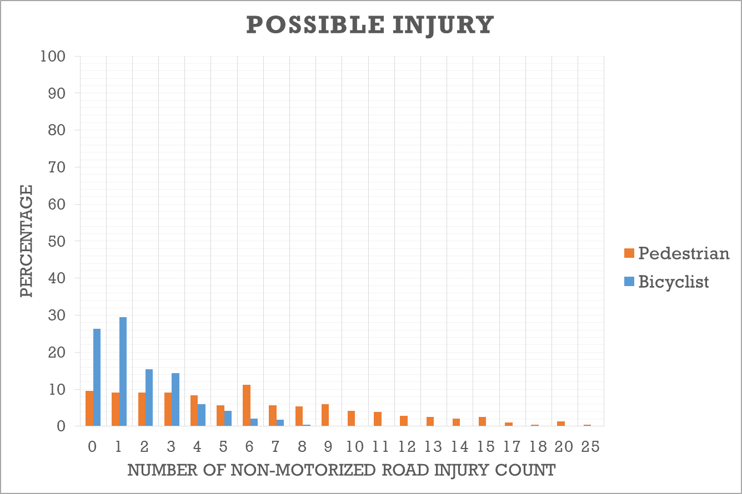
Figure 1a: Distribution of percentage of Census tracts associated with each count of possible pedestrian injuries alongside possible bicyclist injuries

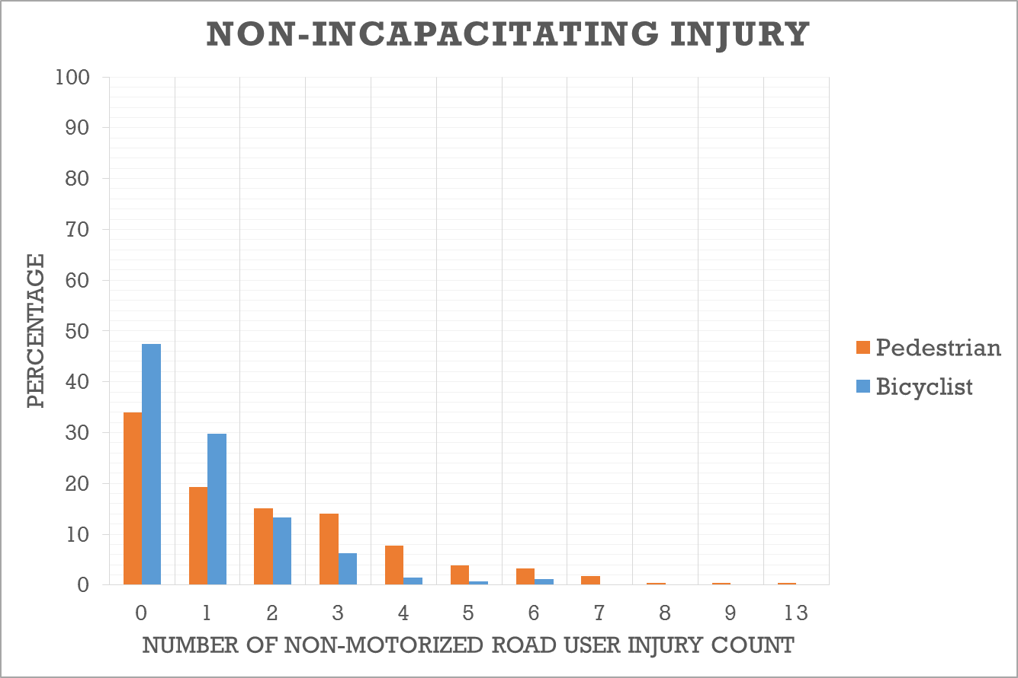
Figure 1b: Distribution of percentage of Census tracts associated with each count of non-incapacitating pedestrian injuries alongside non-incapacitating bicyclist injuries
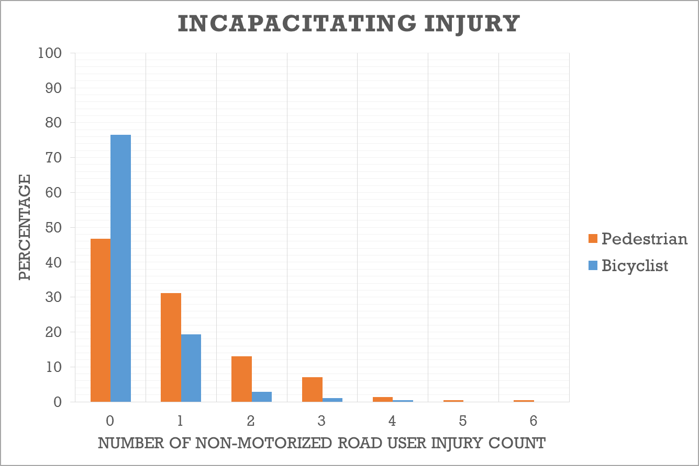
Figure 1c: Distribution of percentage of Census tracts associated with each count of incapacitating pedestrian injuries alongside incapacitating bicyclist injuries

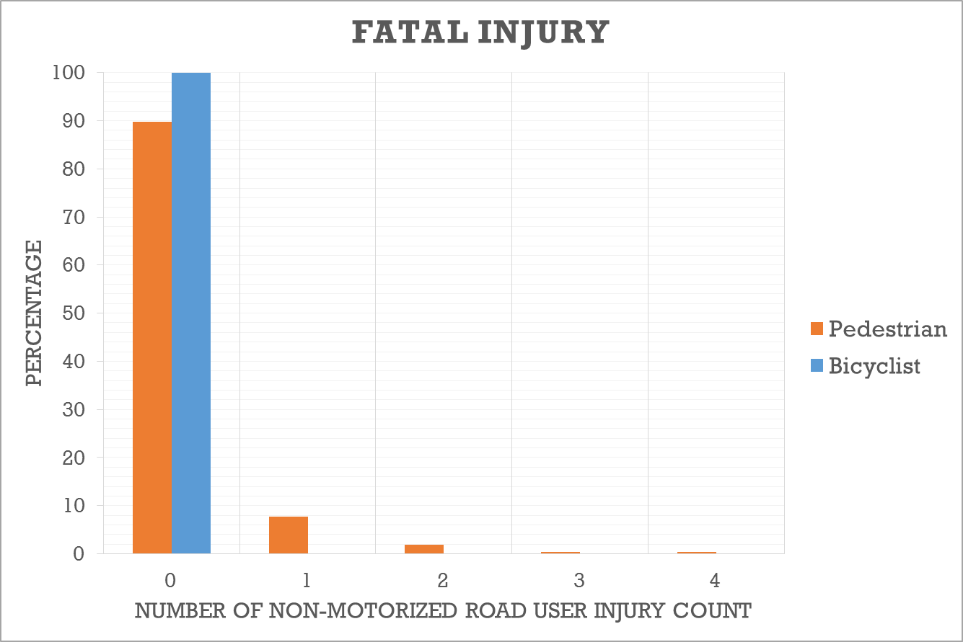
Figure 1d: Distribution of percentage of Census tracts associated with each count of fatal pedestrian injuries alongside fatal bicyclist injuries
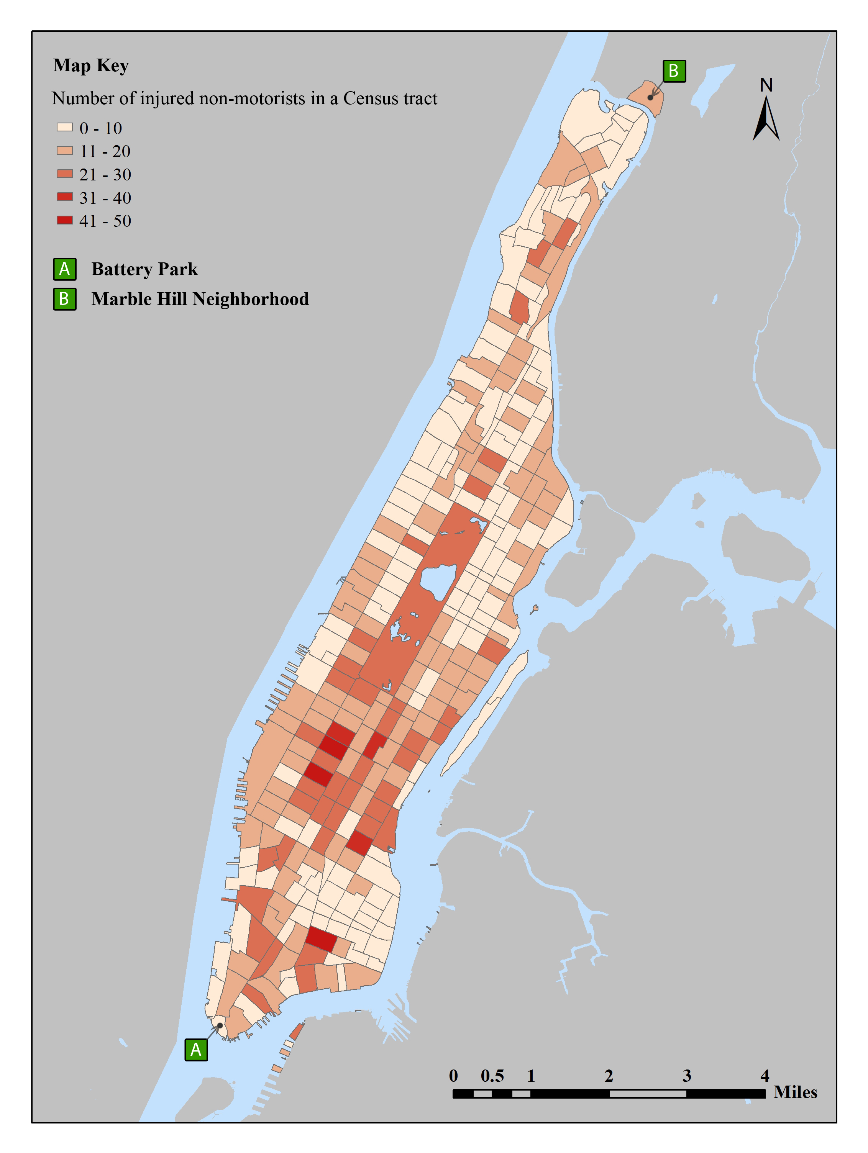
Figure 2: Thematic map of non-motorized injuries aggregated to Census tracts

Table 1: Distribution of Number of Injured Non-Motorists by Injury Severity Level

Injury Severity | Pedestrian |  | Bicyclist |  | All Non-Motorists
Possible injury | 1700 | 67.7% | 502 | 59.4% | 2202 | 65.6%
Non-Incapacitating injury | 523 | 20.8% | 259 | 30.7% | 782 | 23.3%
Incapacitating injury | 250 | 10.0% | 84 | 9.9% | 334 | 9.9%
Fatal injury | 39 | 1.5% | 0 | 0.0% | 39 | 1.2%
Total | 2512 | 100.0% | 845 | 100.0% | 3357 | 100.0%

Table 2: Descriptive Statistics of Census Tracts (285 Observations)
Variable | Minimum | Maximum | Mean | Std. Dev.
Socio-Demographic Variables
Total area in square meters (scaled by 10000) | 4.13 | 293.99 | 19.70 | 19.67
Population density (population per sq-meter) | 0.00* | 0.08 | 0.03 | 0.02
Race/Ethnicity Variables
Proportion of non-Hispanic White population | 0.00 | 0.91 | 0.48 | 0.30
Proportion of non-Hispanic Black and African American population | 0.00 | 0.81 | 0.15 | 0.20
Proportion of non-Hispanic Asian population | 0.00 | 0.88 | 0.12 | 0.13
Proportion of Hispanic population | 0.00 | 1.00 | 0.23 | 0.23
Proportion of all other non-Hispanic population | 0.00 | 0.05 | 0.02 | 0.01
Percent below poverty level | 0.00 | 0.54 | 0.18 | 0.13
Age Distribution
Proportion of population aged 14 years and below | 0.00 | 0.24 | 0.12 | 0.05
Proportion of population aged 15-19 years | 0.00 | 0.50 | 0.05 | 0.05
Proportion of population aged 20-29 years | 0.00 | 0.67 | 0.21 | 0.10
Proportion of population aged 30-64 years | 0.15 | 0.82 | 0.49 | 0.07
Proportion of population aged 65 years and above | 0.00 | 0.37 | 0.13 | 0.07
Educational Attainment Distribution
Proportion of population 18 years and above without high school degree | 0.00 | 0.51 | 0.15 | 0.15
Proportion of population 18 years and above with high school degree | 0.00 | 0.44 | 0.14 | 0.09
Proportion of population 18 years and above with some college or associate's degree | 0.00 | 0.63 | 0.17 | 0.07
Proportion of population 18 years and above with Bachelor's degree or higher | 0.05 | 1.00 | 0.54 | 0.26
Median household income (scaled by $10,000) | 0.98 | 23.28 | 7.28 | 4.21
Land-use and Road Network Variables
Land-use type Distribution
Proportion of commercial land-use | 0.00 | 1.00 | 0.30 | 0.32
Proportion of industrial land-use | 0.00 | 0.96 | 0.07 | 0.17
Proportion of residential land-use | 0.00 | 1.00 | 0.57 | 0.35
Proportion of other land-uses (vacant lots, open space, recreational etc.) | 0.00 | 0.95 | 0.06 | 0.15
Roadway Type Distribution
Proportion of highways | 0.00 | 0.78 | 0.02 | 0.07
Proportion of local neighborhood roads and city streets | 0.22 | 1.00 | 0.91 | 0.14
Proportion of bicycle lanes and trails | 0.00 | 0.40 | 0.03 | 0.07
Proportion of other road types (alleys, driveways etc.) | 0.00 | 0.45 | 0.04 | 0.11
Activity Intensity Variables
Number of schools | 0.00 | 10.00 | 1.81 | 1.94
Number of universities | 0.00 | 5.00 | 0.15 | 0.50
Park area in US Acres | 0.00 | 7.06 | 0.06 | 0.44
Intensity of office activity | 0.00 | 9.57 | 0.79 | 1.72
Intensity of retail activity | 0.00 | 1.62 | 0.18 | 0.24
Commute Mode Shares and Transit Supply
Mode Share Distribution
Drive alone | 0.00 | 0.23 | 0.07 | 0.04
Shared ride | 0.00 | 0.17 | 0.02 | 0.02
Transit | 0.00 | 0.91 | 0.57 | 0.15
Walk | 0.00 | 1.00 | 0.22 | 0.15
Telecommuting | 0.00 | 0.38 | 0.06 | 0.04
Other modes (taxicab, motorcyclist etc.) | 0.00 | 0.39 | 0.06 | 0.04
Transit Supply
Number of bus stops | 0.00 | 60.00 | 8.03 | 5.95
Number of subway stops | 0.00 | 6.00 | 0.49 | 0.81
Distance between Centroids of Census Tracts (miles) | 0.09 | 13.15 | 3.78 | 2.52
* All Census tracts had a non-zero value of population density. But the value of this variable for some Census tracts is very low (of the order 0.001 or lower), and so the minimum is listed as 0.00.
Table 3a: Model Estimation Results for Pedestrian Injuries
(Weight Matrix: Inverse of distance, Distance Band: 5 miles)
Injury Severity | Possible |  | Non-Incapacitating |  | Incapacitating |  | Fatal
Parameters | Estimate | t-stat | Estimate | t-stat | Estimate | t-stat | Estimate | t-stat
Long Term Risk Propensity
Socio-Demographic Variables
Population density (logarithmic) |  |  |  |  |  |  | 0.152 | 8.45
Proportion of Hispanic population | 1.552 | 14.21 | 1.788 | 9.15 | 0.745 | 4.26
Proportion of population aged 14 and below |  |  | -4.283 | -4.93 |  |  | -1.956 | -12.47
Proportion of population between ages 15-19 | -0.035 | -12.26 | -0.044 | -8.38 |  |  | -0.083 | -9.36
Proportion of population 18 years and above with Bachelor's degree or higher | -2.782 | -12.04 |  |  |  |  | -2.271 | -21.79
Land-use and Road Network Variables
Proportion of commercial land-use |  |  | 1.099 | 7.78
Proportion of highways |  |  | -3.305 | -6.03
Proportion local neighborhood roads and city streets |  |  | -0.944 | -4.99
Proportion of bicycle lanes and trails |  |  |  |  | -2.741 | -3.28
Activity Intensity Variable
Intensity of office activity |  |  |  |  | 0.136 | 3.28
Number of schools | 1.143 | 11.12
Number of universities |  |  | 0.181 | 2.87
Commute Mode Shares and Transit Supply
Walk commute mode share |  |  | 1.169 | 3.50 |  |  | 2.275 | 26.79
Threshold Parameters
Threshold Specific Constants
α₄ | -0.075 | -4.87
α₅ | -0.245 | -11.66
α₁₁ | -0.255 | -9.13
γ Vector
Constant | 1.238 | 20.19 | 0.990 | 4.26 | -1.223 | -3.88 | 1.043 | 7.28
Socio-Demographic Variables
Median household income |  |  | 0.030 | 5.12
Land-use and Road Network Variables
Proportion of commercial land-use | 0.781 | 22.04 |  |  | 1.073 | 3.11
Proportion of industrial land-use |  |  |  |  | 1.668 | 4.35
Proportion of residential land-use |  |  |  |  | 1.112 | 3.41
Activity Intensity Variable
Number of Schools |  |  | 0.421 | 5.93
Commute Behaviors and Transit Supply
Transit commute mode share |  |  |  |  | -0.972 | -2.88
Walk commute mode share | 1.065 | 13.23

Table 3b: Model Estimation Results for Bicyclist Injuries
(Weight Matrix: Inverse of distance, Distance Band: 5 miles)
Injury Severity | Possible |  | Non-Incapacitating |  | Incapacitating
Parameter | Estimate | t-stat | Estimate | t-stat | Estimate | t-stat
Long Term Risk Propensity
Socio-Demographic Variables
Proportion of population between ages 15-19 |  |  | -0.044 | -4.87 | -0.023 | -1.81
Land-use and Road Network Variables
Proportion of commercial land-use |  |  | 0.591 | 2.19
Proportion of industrial land-use |  |  | 0.872 | 3.25
Proportion of bike lanes and trails |  |  |  |  | -4.228 | -3.48
Activity Intensity Variable
Number of schools | 1.515 | 3.74
Intensity of office activity | 0.128 | 2.50
Park area in US acres | 0.655 | 18.85
Commute Behaviors and Transit Supply
Walk Commute mode share |  |  | 1.148 | 1.73
Telecommuting share | 7.074 | 6.77 | 2.755 | 1.74
Threshold Parameters
Threshold Specific Constants
α₂ |  |  |  |  | -0.219 | -3.79
α₃ |  |  |  |  | -0.433 | -6.08
α₄ |  |  | -0.486 | -4.78
α₅ |  |  | -0.877 | -4.79
γ Vector
Constant | -1.693 | -26.79 | -1.239 | -2.81 | -0.908 | -3.99
Land-use and Road Network Variables
Proportion of commercial land-use | 1.121 | 5.21
Proportion of industrial land-use | 1.901 | 8.59
Activity Intensity Variable
Retail Intensity |  |  |  |  | 0.507 | 2.59

Table 3c: SJFC Model: Additional Parameters and Summary Statistics
(Weight Matrix: Inverse of distance, Distance Band: 5 miles)
 | Estimate | t-stat
Error Components
$π_{1}$ – S.E. of error linked with “possible injury” injuries in a Census tract | 1.041 | 21.31
$τ_{2}$ – S.E. of error linked with pedestrian injuries in a Census tract | 0.421 | 2.45
$σ$ – S.E. of error linked with individual Census tract | 0.597 | 5.67
$δ$ (spatial correlation parameter) | 0.486 | 8.01
Number of observations | 285
Number of parameters estimated | 59
Log-composite likelihood at convergence | -1694396.25

Table 4: Aggregate-Level Elasticity Effects of SJFC Model
Variable | Pedestrian |  |  |  |  |  |  |  | Bicyclist
Variable | Possible |  | Non-Incapacitating |  | Incapacitating |  | Fatal |  | Possible |  | Non-Incapacitating |  | Incapacitating
Variable | Elasticity | t-stat | Elasticity | t-stat | Elasticity | t-stat | Elasticity | t-stat | Elasticity | t-stat | Elasticity | t-stat | Elasticity | t-stat
Population density | 0.00 | - | 0.00 | - | 0.00 | - | 8.68 | 2.98 | 0.00 | - | 0.00 | - | 0.00 | -
Proportion of Hispanic population | 24.85 | 6.31 | 54.33 | 3.54 | 24.76 | 3.82 | 0.00 | - | 0.00 | - | 0.00 | - | 0.00 | -
Proportion of commercial land-use | 16.33 | 17.37 | 32.19 | 3.70 | 17.33 | 2.72 | 0.00 | - | 11.83 | 4.07 | 18.92 | 0.53 | 0.00 | -
Proportion of bicycle lanes and trails | 0.00 | - | 0.00 | - | -61.66 | -4.12 | 0.00 | - | 0.00 | - | 0.00 | - | -89.41 | -6.97

APPENDIX A: Procedure to Predict the Expected Count Values for each Census Tract
The expected value of injury count in Census tract q for each road-user type j and injury severity level s may be written as:
$E(y_{\text{qjs}})=\sum_{k=0}^{∞}{P(y_{\text{qjs}}=k)⋅k},$ (8)
where $P(y_{\text{qjs}}=k)$ is the probability of occurrence of k injuries of type j and injury severity level s in Census tract q. Although the summation in the equation above extends until infinity in our count model, we consider counts only up to k = 25 in our prediction procedure (this value represents the maximum count of injuries across Census tracts and across combinations of road-user type and injury severity level in the estimation sample, corresponding to the possible injury severity level for pedestrian injuries; see Figure 1a). Beyond the count value of 25, the probabilities are very close to zero and hence do not have any significant impact on the predicted value. The expected value in Equation (8) is a function of the (QSJ×1) matrix of exogenous variables for all Q Census tracts,$x=(x_{1},x_{2},x_{3},\text{.}\text{.}\text{.},x_{Q})^{'}$, as well as a function of the variable vector $z_{q}$ embedded in the thresholds in Equation (2).
The estimate of $P(y_{\text{qsj}}=k)$ in Equation (8) for the FC model is obtained from Equation (1) in a fairly straightforward manner. For the JFC model, we need to accommodate the effects of the error covariances across different severity levels and road-user types within a Census tract, and, for the SJFC model, we also need to consider the spatial dependency effects across Census tracts. To estimate $P(y_{\text{qsj}}=k)$ in these models, we simulate the QSJ×1 – vector$y^{}$, from Equation (4), five hundred times using the estimated values of , b, and the QSJ×1 – vector . Subsequently, we compare each of the 500 draws of the $q^{\text{th}}$ element of $y^{}$ with the corresponding thresholds for the $q^{\text{th}}$ element from Equation (2), and assign the count value for each of the 500 draws based on this comparison. The share of each count prediction is taken across the 500 draws to estimate$P(y_{\text{qsj}}=k)$.

Note also that the count variable used in our model corresponds to the number of pedestrian and bicyclist injuries by injury severity level within a Census tract, not the number of crashes within a Census tract by the most severe level of injury incurred by a pedestrian or bicyclist in the crash. The latter approach would not appropriately consider situations where multiple non-motorized individuals are injured (and to different levels) in a single crash.
The number of severity levels may vary across different non-motorized road-user types. However, for notation simplicity, we assume the same number of severity levels across both pedestrian and bicyclists.
Some explanatory variables may not be important for specific road-user and/or severity levels. This situation is accommodated within our notation system by letting the corresponding elements in the vector $b_{\text{js}}$be equal to zero.
The scale of the $ε_{\text{qjs}}$ term is normalized to one for identification.
Manhattan is divided into 288 Census tracts. However, we excluded three Census tracts from the analysis, corresponding to Liberty Island, Governor’s Island, and Randall’s and Ward’s Islands. Of these, the first two tracts are primarily tourist attractions and recorded zero residential populations. Randall’s and Ward’s Islands, which together constitute one Census tract, predominantly consist of parks and public facilities (such as the Manhattan Psychiatric Center and the Kirby Forensic Psychiatric Center), with limited public access and residential populations. Also, all these three Census tracts recorded zero bicycle and pedestrian crashes in 2009.
Many variables in Table 2 did not turn out to be statistically significant in our final empirical model; however, these variables are included in Table 2 to provide a sense of the variables considered in our analysis as well as for completeness in characterizing the study area.
In cities such as Manhattan, the net floor area in, for example, office activity in a Census tract can be more than the land area of the Census tract (because of the vertical build-up). Thus, the intensity measures can be higher than 1 (the land-use measures previously discussed, however, are confined to the 0-1 range).
In these sections, the base categories for the categorical explanatory variables correspond to those not listed in the tables.
There was multicollineraity among the Census tract-level socio-demographic variables of population density, proportion of minority populations, median household income, and percent below poverty level. At the end, the best specification was achieved with the first two variables in the long term risk propensity, and the median household income in the threshold effects discussed in the next section. The “percent below poverty level” variable turned out to be statistically insignificant after accommodating the other three variables.
Strictly speaking, we should modify other proportions within appropriate groups of variables. For example, the sum of all land-use proportions after increasing the proportion of commercial land-use by 0.2 should continue to remain at 1.0 for each tract; this may be easily achieved by drawing away from each non-commercial land-use in direct proportion to the current distribution of each non-commercial land-use share in the tract. However, doing so makes it difficult to isolate the impacts of the variables under study because of the changes in other variables too. So, we follow a more straightforward approach to assess the impact of each proportion variable by simply increasing its value by 0.2.
For the few cases where the FC model has a higher elasticity magnitude, the corresponding variable effect is through the thresholds and not through the long-term risk propensity variable that contributes to the spillover effect. Population density is the only exception, and the higher FC elasticity for this variable is because of the logarithmic transformation used for this variable.
The predictions were not sensitive to the number of draws beyond about 400 draws, and so we settled on 500 draws.

