Additional Information on Data Sources and Sample Description

Supplemental note to
“On Modeling Telecommuting Behavior: Option, Choice, and Frequency”
by Palvinder Singh, Rajesh Paleti, Syndney Jenkins, and Chandra Bhat

Data Sources
The primary data for the current study is drawn from the 2009 National Household Travel Survey (NHTS) conducted by the U.S. Department of Transportation during the period from March 2008 through May 2009. The survey was administered by telephone using a random digit dialing (RDD) procedure and computer-assisted telephone interviewing (CATI) technology, and allowed respondents to provide information in English or Spanish. The survey collected information from respondents aged five years or more for about 150,000 households, including details of household demographics, person level attributes, household vehicle fleet characteristics, and trip characteristics on the survey day (see U.S. DOT-NHTS, 2009).

Sample Description
Table A presents the sample descriptive statistics for key explanatory variables considered in our analysis. The sample statistics in Table A are quite close to the corresponding population statistics for the San Francisco Bay region. For instance, among the individual demographics, the first variable indicates that the workforce for the San Francisco Bay Area in the data set is about equally split between males (51.42%) and females (48.58%). The corresponding split obtained from the statistics presented by “San Francisco Department on the Status of Women” shows 54% male and 46% female involvement in the labor force. Similarly, among the work characteristics, the first variable indicates that about 80% of individuals worked full time (greater than 34 hours per week), while about 20% worked on a part time basis. These percentages are close to the overall percentages of full-time (78.58%) and part-time (21.42%) workers in the State of California (see Census, 2000). Also, in Figure 1, we present the distribution of frequency of telecommuting days in the past one month of telecommuting.

References
Census (2000) Summary File 3 for California Region, Table P47 (Work Status in 1999 by usual hours worked per week).
SFGov (2009) Status of Women in San Francisco 2009. City & County of San Francisco, Department on the Status of Women. http://www.sfgov3.org/index.aspx?page=1751
U.S. Department of Transportation, Federal Highway Administration (2009). National Household Travel Survey. Available at: http://nhts.ornl.gov.

Table A: Sample Characteristics
Explanatory Variables |  |  | Count |  | Sample Share (%)
Individual Demographics
 | Gender
 |  | Male | 1318 |  | 51.42
 |  | Female | 1245 |  | 48.58
 | Marital Status
 |  | Married | 1637 |  | 63.87
 |  | Single | 926 |  | 36.13
 | Age
 |  | 16 to 35 years | 462 |  | 18.03
 |  | 36 to 50 years | 1025 |  | 39.99
 |  | 51 to 65 years | 964 |  | 37.61
More than 65 years |  |  | 112 |  | 4.37
 | Education
 |  | High School | 432 |  | 16.86
 |  | College or Associate's Degree | 675 |  | 26.34
 |  | Bachelor's Degree (BA, AB, BS) | 742 |  | 28.95
 |  | Graduate/Professional Degree (MA, MS, MBA, MD, PhD, EdD, ID) | 714 |  | 27.85
 | Internet Usage
 |  | Rarely in one month | 278 |  | 10.85
 |  | Several times a week | 241 |  | 9.40
 |  | Almost everyday | 2044 |  | 79.75
 | Walk trips in past one week
 |  | Zero trips | 701 |  | 27.35
 |  | 1 to 4 trips | 982 |  | 38.31
 |  | 5 trips | 880 |  | 34.34
 | Bicycle trips in past one week
 |  | zero trips | 2238 |  | 87.32
 |  | 1 to 4 trips | 247 |  | 9.63
 |  | 5 trips | 78 |  | 3.05
Work Characteristics
 | Employment status
 |  | Part-time (34 hours per week) | 513 |  | 20.02
 |  | Full-time ( > 34 hours per week) | 2050 |  | 79.98
 | Flexibility to start work time
 | Yes |  | 1263 |  | 49.28
 | No |  | 1300 |  | 50.72
 | Occupation
 |  | Sales/service | 510 |  | 19.90
 |  | Clerical or admin. Support | 339 |  | 13.23
 |  | Manufacturing, construction, maintenance or farming | 243 |  | 9.48
 |  | Professional, managerial or technical | 1454 |  | 56.73
 |  | Other | 17 |  | 0.66

Table A (Contd.): Sample Characteristics
Explanatory Variables |  |  |  | Count | Sample Share (%)
Work Characteristics
One-way commute Distance
Less than or equal to 3miles |  |  | 530 |  |  | 20.68
Between 3-7 miles |  |  | 543 |  |  | 21.19
Between 7-12 miles |  |  | 434 |  |  | 16.93
Between 12-20 miles |  |  | 483 |  |  | 18.84
More than 20 miles |  |  | 573 |  |  | 22.36
Have more than one job
Yes |  |  | 199 |  |  | 7.76
No |  |  | 2364 |  |  | 92.24
Household Demographics
 | Presence of children in the household
 |  | No child | 1643 |  |  | 64.11
 |  | Less than or equal to 5 years old | 343 |  |  | 13.38
 |  | Between 6 to 15 years old | 577 |  |  | 22.51
 | Presence of a non-working senior citizen in the household
 |  | Yes | 206 |  |  | 8.04
 |  | No | 2357 |  |  | 91.96
 | Number of workers in the household
 |  | One | 289 |  |  | 11.28
 |  | Two | 1635 |  |  | 63.79
 |  | Three or more | 639 |  |  | 24.93
Household Income (in U.S. dollars)
 |  | Less than 30 K | 187 |  |  | 7.30
 |  | Between 30-60 K | 357 |  |  | 13.93
 |  | Between 60-100 K | 613 |  |  | 23.92
 |  | More than 100 K | 1406 |  |  | 54.85
 | Number of vehicles in the household
 |  | Zero | 42 |  |  | 1.64
 |  | One | 359 |  |  | 14.01
 |  | Two | 1159 |  |  | 45.22
 |  | Three or more | 1003 |  |  | 39.13
 | Household race
 |  | Caucasian | 1828 |  |  | 71.32
 |  | African American or Hispanic | 194 |  |  | 7.57
 |  | Asian | 430 |  |  | 16.78
 |  | Multiracial | 27 |  |  | 1.05
 |  | Other Race | 84 |  |  | 3.28

Table A (Contd.): Sample Characteristics
Explanatory Variables |  | Count |  | Sample Share (%)
BE Characteristics of Residential TAZ
 | TAZ Location
 | Rural area | 204 |  | 7.96
 | Urban area | 1106 |  | 43.16
 | Suburban area | 810 |  | 31.60
 | Second City | 443 |  | 17.28
Descriptive Statistics
Explanatory Variables |  | Minimum | Maximum | Mean | Std. Dev.
 | Total number of households | 15 | 7787 | 2606.07 | 1137.99
 | Total Population | 74 | 22141 | 6997.35 | 3181.25
 | Length (mileage) of bicycle lanes | 0 | 56.43 | 4.76 | 5.96
 | Length (mileage) of highways | 0 | 54.77 | 1.59 | 3.86
 | Employment accessibility | 13.33 | 260.02 | 59.84 | 28.62
 | Accessibility to recreational (open spaces) opportunities | 46.88 | 166.49 | 74.69 | 13.88
 | Accessibility to eat-out opportunities | 0.12 | 2.36 | 0.49 | 0.32
 | Accessibility to religious opportunities | 0.04 | 0.51 | 0.16 | 0.09
 | Accessibility to maintenance activities | 0.66 | 9.18 | 2.71 | 1.41
 | Accessibility to automotive/carwash/repair centers | 0.09 | 0.91 | 0.35 | 0.15
 | Accessibility to personal business centers | 0.27 | 3.18 | 1.09 | 0.52
 | Accessibility to medical centers | 0.24 | 4.28 | 1.03 | 0.62
 | Number of zones accessible by bicycle from the home zone within 12 miles | 1 | 222 | 85.07 | 59.96
 | Number of zones accessible by bicycle from the home zone within 3 miles | 0 | 78 | 14.13 | 12.58

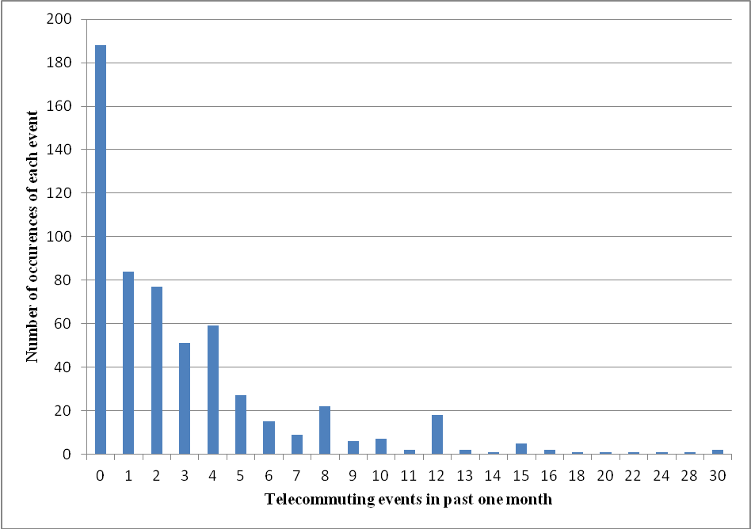

Figure 1. Distribution of frequency of telecommuting days in past one month

For presentation ease, and as in Table 1 and Table 2 (in the paper), we include three variables; internet usage characteristics, whether the individual made any walk trips during the past week, and whether the individual made any bicycle trips during the past week; within the category of individual demographics. Similarly, we include location factors such as “TAZ in rural area or suburban area” as well as TAZ demographics (such as population and number of households) within the category of built environment measures. This presentation structure has also been used in the paper.

