Workshop Resource Paper – Full Version

Emerging Issues in Travel Behavior Analysis

Ram M. Pendyala, Department of Civil and Environmental Engineering, University of South Florida, 4202 E. Fowler Avenue, ENB118, Tampa, FL 33620-5350. Ph: (813) 974-1084; Fax: (813) 974-2957; Email: pendyala@eng.usf.edu

Chandra R. Bhat, Department of Civil Engineering, The University of Texas at Austin, Ernest Cockrell Jr. Hall, 6.810, Austin, Texas 78712. Telephone: (512) 471-4535; Fax: (512) 475-8744; Email: bhat@mail.utexas.edu

ABSTRACT
This paper is a resource paper on emerging issues in travel behavior analysis that have implications for the future of the National Household Travel Survey (NHTS) in the United States. The paper provides an overview of recent trends in activity and travel behavior research, both from a behavioral perspective and a methodological perspective. Based on these recent and emerging trends, the paper presents a series of suggestions regarding how the future NHTS can be enhanced, augmented, and modernized to serve the future needs of planners and researchers in the field. In particular, the paper suggests that the NHTS move towards an activity-based time use survey format incorporating questions about attitudes, perceptions, values, information acquisition and use, and decision making processes. In addition, it is suggested that a component of the NHTS be converted into a multi-day rotating panel to provide data on both short- and longer-term behavioral dynamics. These suggestions need to be weighed carefully against the increased respondent burden and survey costs that might be involved with their implementation.

1. INTRODUCTION
This resource paper provides an overview of several recent and emerging issues in travel behavior analysis, primarily in the U.S. context. The intent of the paper is to identify and discuss the range of issues of interest to the travel behavior analysis community and the broad implications for travel data needs and collection in the future. Although the paper is not a comprehensive review of travel behavior research, it is hoped that the issues and data implications discussed in the paper will serve as a starting point for discussions to take place in the workshop at the conference.

The paper addresses three broad aspects related to emerging issues in travel behavior analysis. They are:

- 1. What are some of the key recent, emerging, and future travel behavior trends and issues?
- 2. What are the implications of these trends for travel behavior analysis and modeling now and in the future?
- 3. What are the implications of the first two items in terms of travel survey data needs and collection, particularly in the context of the NHTS?

Thus, this paper explicitly relates the key issues in travel behavior analysis with the data that is needed for addressing the recent and emerging issues in the field. However, the paper does not include any discussion about the actual measurement of travel behavior; topics such as survey administration method, non-response, and so on are beyond the scope of this resource paper. Also, the paper only addresses emerging travel behavior issues from a passenger travel demand context and does not address the freight travel behavior arena at all. It is noteworthy, however, that many of the issues identified here are pertinent to freight travel behavior as well and it is envisioned that some of the data implications discussed in this paper would carry over to the freight data collection arena as well.

This paper is organized as follows. In the next section, several emerging travel behavior issues are discussed. In addition, some of the recent trends in demographics and travel demand are presented within this section. The third section focuses on modeling methods and analysis tools that are being used to address the issues identified in the second section of the paper. The fourth section provides a discussion of the data implications of emerging travel behavior trends and analysis methods and offers suggestions on how the NHTS of the future can be enhanced for addressing future travel behavior challenges.

2. TRAVEL BEHAVIOR TRENDS
This section presents an overview of recent and emerging travel behavior trends that are likely to have important implications for travel behavior analysis and data collection, at least in the near future.

- 2.1 Demographics and Travel Demand
Any discussion of trends in travel behavior would be incomplete without an examination of basic demographic and travel demand characteristics over time. While it is impossible to offer a comprehensive presentation of demographic and travel demand characteristics within the scope of this paper, a few illustrative graphs are presented in this section to provide illustrative examples showing how the NHTS and other similar data sets (Census Journey-to-Work, CTPP, etc.) continue to be powerful tools for understanding demographic and travel demand characteristics over time. Much of this section is based on recent analysis of the 2001 NHTS data and 2000 Census data done by Polzin and Chu (2004).

Figure 1 shows the growth in household vehicle miles of travel (VMT) relative to population growth from 1977 to 2001.

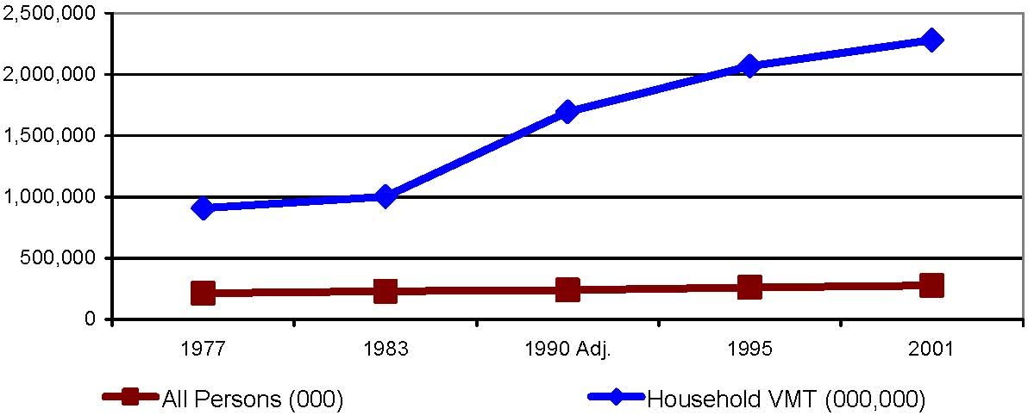

Figure 1. Population and Household VMT Growth (1977 to 2001)
Source: Polzin and Chu (2004)

Household VMT growth has clearly outpaced population growth over the past several decades. This generally indicates that population growth does not account for all of the household VMT growth and that there is substantial increase in trip making on a per capita basis. Indeed, the annual trip rate on a per capita basis has increased 49 percent from 1977 to 2001 (Polzin and Chu, 2004). Concomitant increases are seen in average travel time expenditures which have increased from about 46 minutes per person per day in 1983 to about 79 minutes per person per day in 2001 (Polzin and Chu, 2004). However, it is noteworthy that the line graph depicting household VMT over the years is showing a gradual decline in the growth rate suggesting that the growth of household VMT in the future may not be as rapid as in the past.

Figure 2 shows the average household size over time. The decline in household sizes have generally been associated with increases in per capita trip making over the past several decades. There are two potential reasons for this. First, smaller household sizes (lower number of dependents) leaves a larger share of income for discretionary expenditures and associated activities. With greater disposable income, people pursue more discretionary activities outside home. Second, smaller household sizes are generally associated with lower and looser constraints. Children and other dependents may impose activity engagement constraints that limit the amount of travel that can be undertaken on a per capita basis. Thus, as household sizes decreased, per capita trip making increased. However, even this trend appears to be nearing stability with average household sizes virtually bottoming out at about 2.6 persons per household.

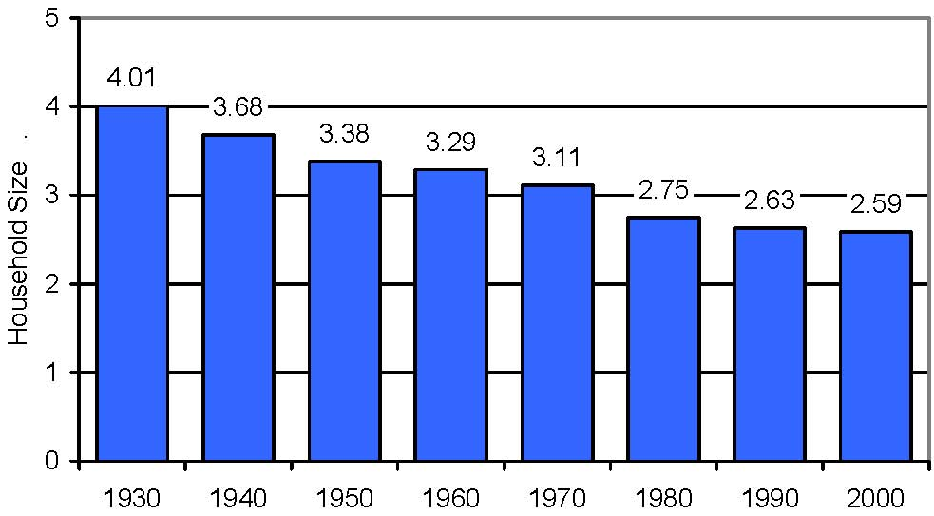

Figure 2. Declining Household Sizes in United States (1930 to 2000)
Source: Polzin and Chu (2004)

Two other reasons that have contributed to the increase in travel demand over the past several decades are the increased labor force participation of women and the increased driver license holding status for women. While these trends played key roles in increasing travel demand in the past, it is likely that these phenomena will no longer be key factors in shaping travel demand in the future. For example, Figure 3 shows the percent of males and females over 15 years licensed to drive. The percent of males licensed to drive has generally held steady at about the 90% mark. As for females, the percent licensed to drive has consistently increased and has now reached a point where the percent males and percent females licensed to drive are almost equal to one another. Thus, it appears that driver license holding is approaching saturation for both women and men. Similarly, the percent of women participating in the labor force in the United States is also approaching saturation (Figure 4).

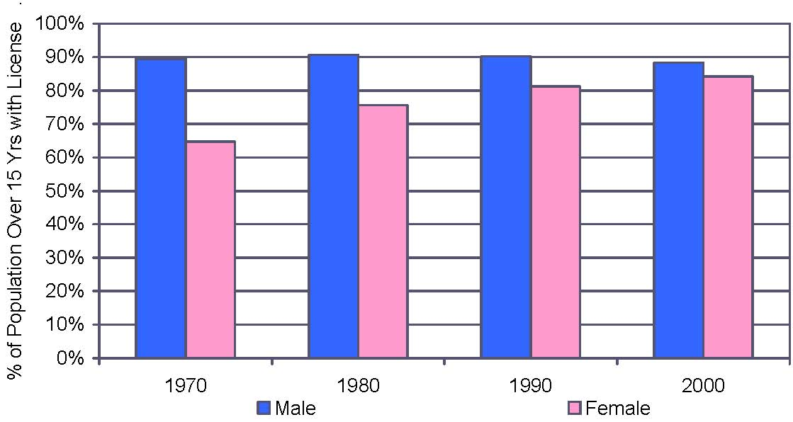

Figure 3. Driver License Holding by Gender (1970 to 2000)
Source: Polzin and Chu (2004)

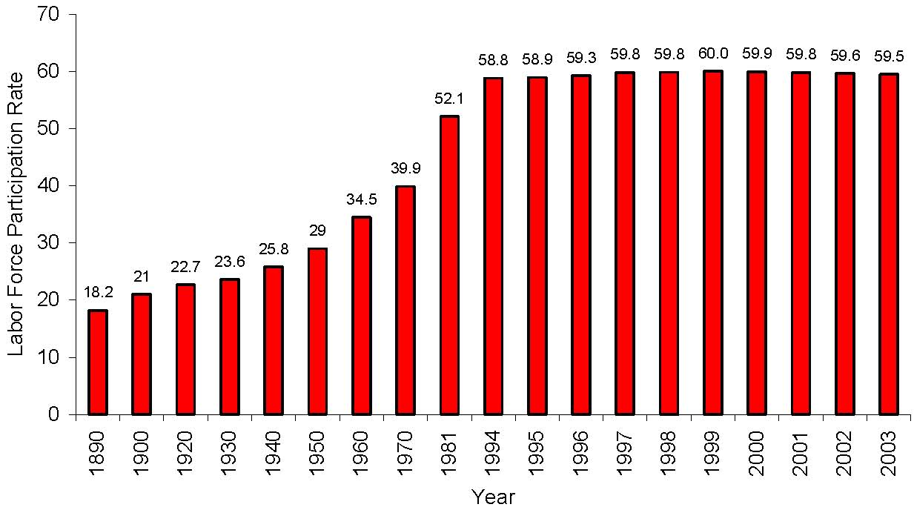
Figure 4. Female Labor Force Participation Rates (Ages: 16 and Over)
Sources: 1890-1981 (Smith, 1985); 1994-2003 (Bureau of Labor Statistics, US Department of Labor)

Figure 5 shows the average annual per capita trip rate from 1977 to 2001. While substantial increases in per capita trip rates occurred from 1983 to 1995, the increase from 1995 to 2001 has been quite modest. This appears to suggest that there is a potential slowing of the growth in per capita travel; on the other hand, the average trip length, represented by person miles of travel per person trip (PMT per PT), has shown a more substantial increase of nearly one mile per trip.

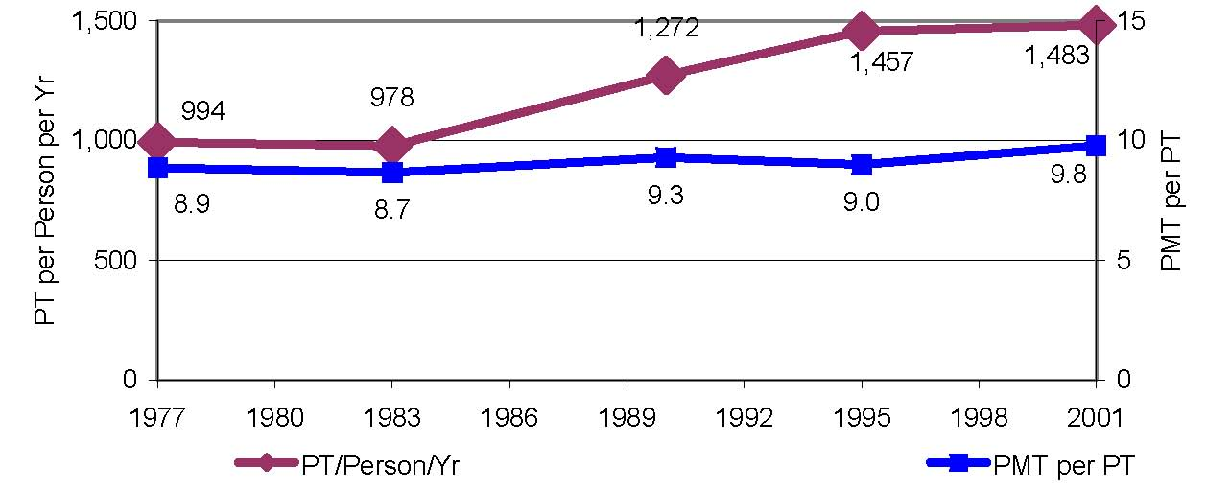

Figure 5. Person Trips and Trip Lengths (1977 to 2001)
Source: Polzin and Chu (2004)

The increased use of the automobile and decentralization of housing and jobs have generally contributed to greater speeds allowing people to travel farther within the same amount of time. This trend was particularly prevalent up to about the late 1980s, as seen in Figure 6 which depicts the vehicle miles of travel per person hour of travel (VMT per person hour). This graph shows a composite effect of mode use and modal performance. It appears that, since the early 1990’s, there has been a decline in performance. With increasing levels of congestion in both urban cores and suburban areas, it is not surprising that this decline has occurred. The trend in Figure 6 suggests that vehicle miles of travel is likely to grow more slowly as congestion spreads across the time-space continuum and begins to catch up with travelers (TTI, 2004).

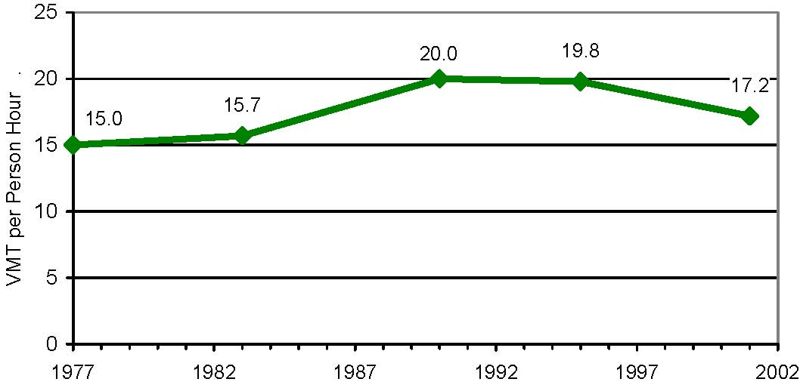

Figure 6. VMT per Person Hour of Travel (1977 to 2001)
Source: Polzin and Chu (2004)

The discussion in this section provides an illustration of the types of trends and descriptive analysis that can be done using national level data sets such as the NHTS. The NHTS is a rich source of information for understanding the past in terms of demographic and travel behavior trends and identifying clues that might suggest how these trends might play out in the future. The analysis and graphs presented in this section suggest that a case might be made for a more moderate growth in trip making and vehicle miles of travel in the future as many of the demographic trends that contributed to rapid growth in travel demand stabilize and play themselves out (Polzin and Chu, 2004).

While there is no doubt that future generations of travel behavior researchers will continue to analyze travel demand in relation to socio-economic and demographic trends, there are many other trends, issues, and phenomena that merit attention in travel behavior analysis. The next few subsections present brief discussions regarding these issues and phenomena with a view towards serving as a point of departure for discussions at the workshop.

- 2.2 Travel Behavior and Technology (ICT)
The relationship between telecommunications and travel behavior and the impact that technology has on travel characteristics have been of much interest to the travel behavior analysis community for over a decade. Starting with the early work (Mokhtarian, 1990; Pendyala, 1991; Mannering, 1995; Handy, 1996; Mokhtarian, 1997; Mokhtarian, 1998; Stanek, 1998; Varma, 1998; Mokhtarian 2000) that examined the impact of telecommuting on work travel and overall trip-making, research and analysis in this arena has now broadened to address the impacts of a wide array of information and communication technology (ICT) use on activity and travel characteristics (Krizek, et al., 2005a; Krizek, et al., 2005b).

The adoption and market penetration of technology has been increasing rapidly worldwide. The use of cell phones, personal computers, and the internet has increased by leaps and bounds, particularly in the past decade or so. Figures 7 through 9 show the rapid penetration of various technologies in the U.S. consumer market. It should be noted that these trends may approach saturation in about a decade or so as the rates of growth (see inset graphs) slow down in the future.

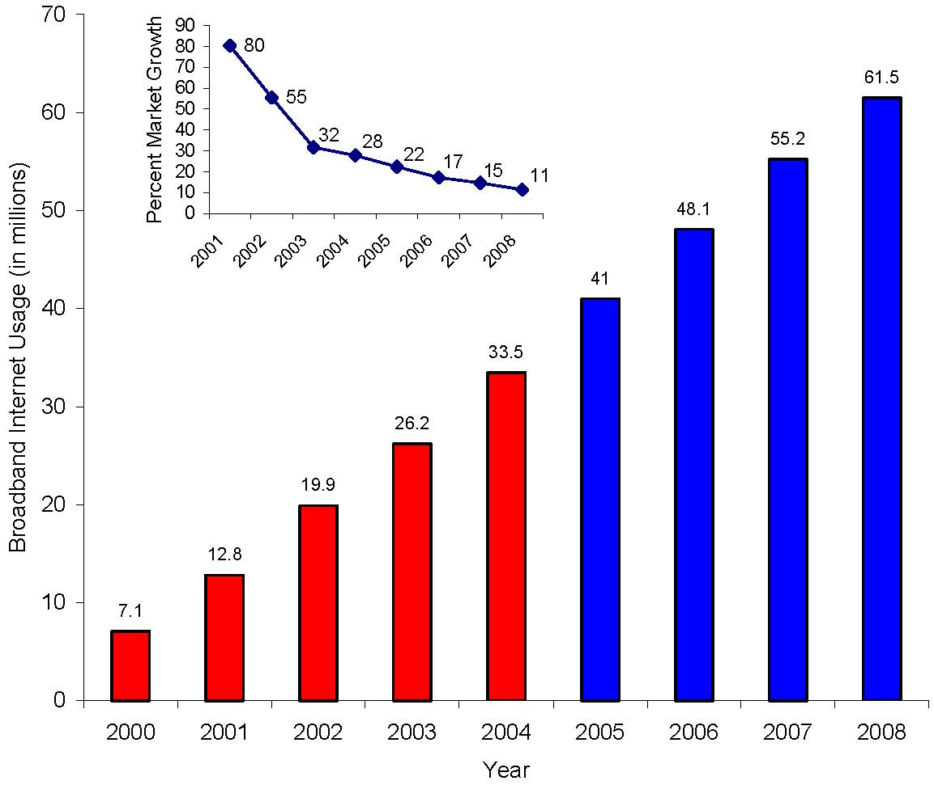

Figure 7: U.S Broadband Internet Usage at Home, 2000 – 2008 (Projected)
Inset: Projected Percent Market Growth (2000-2008)
Note: Includes cable modem, DSL, T1 lines, broadband wireless, satellite, first mile fiber, and powerline broadband. Source: Yankee Group, August 2003
Reference: http://www.internetworldstats.com/

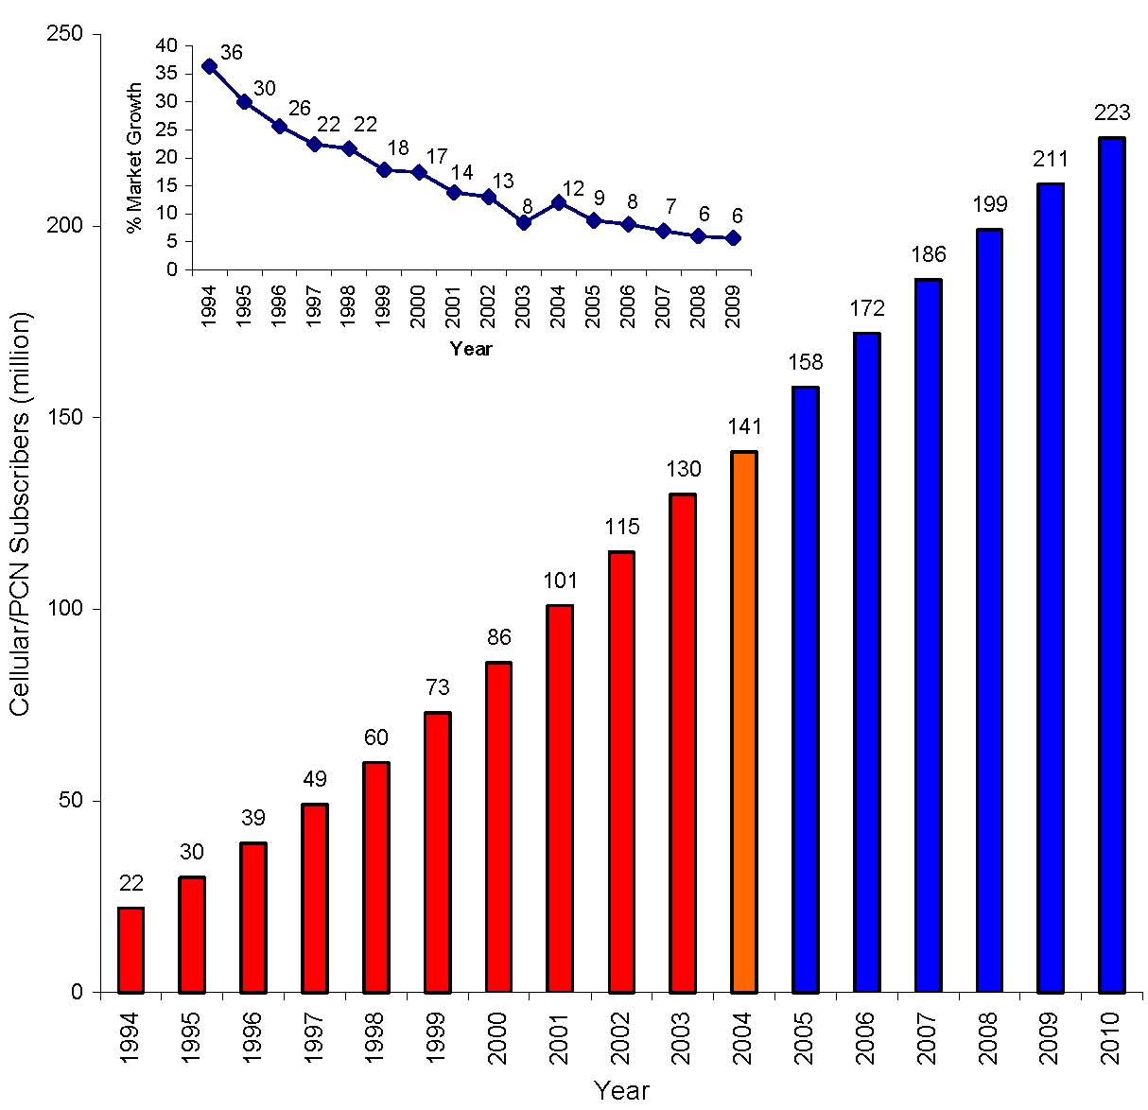

Figure 8. U.S Cellular/PCN Phone Subscriber, 1994-2010 (Projected)
Inset: Percent Market Growth
Source: L. K. Vanston and C. Rogers (1995)

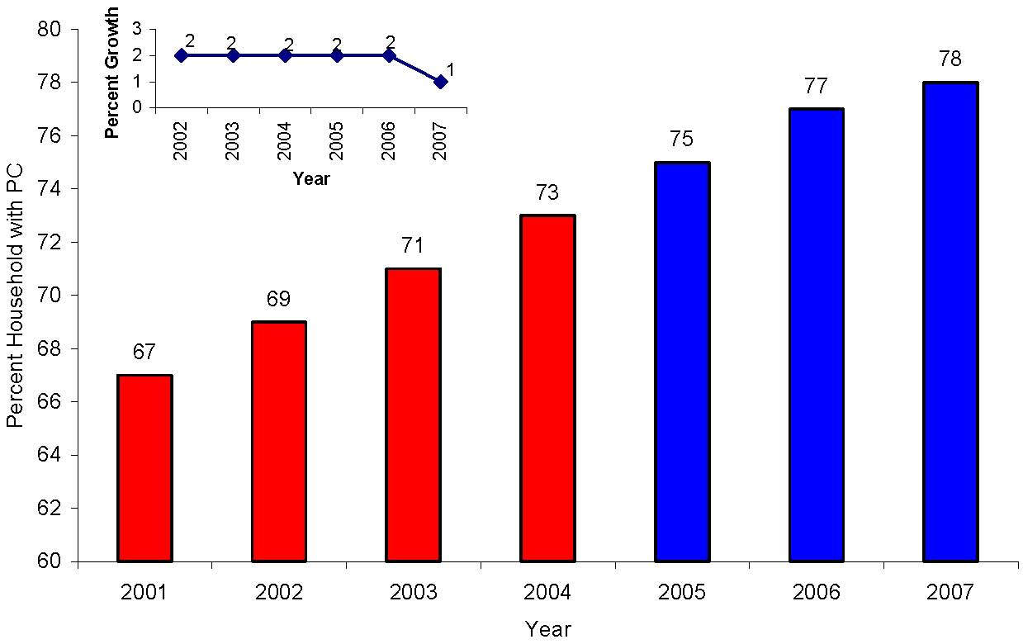

Figure 9. US Household PC Growth and Penetration
Inset: Percent Market Growth, 2001-2007 (Projected)
Source: Jupiter Research
Reference: http://www.infoplease.com/

The study of the impact of ICT on travel behavior has been the focus of much research in the recent past (e.g., Golob, 2001; Golob and Regan, 2001). One can clearly expect ICT use to affect activity and travel patterns from both a scheduling and an execution standpoint. From a scheduling perspective, cell phones and other mobile technology allow individuals to plan and organize activities virtually in real-time with little or no prior advance preparation. Particularly among younger age groups who have embraced these technologies, it is possible that real-time activity planning facilitated through mobile technologies significantly affects the scheduling and execution of activities and trips. Viswanathan and Goulias (2001) and Viswanathan, et al. (2001) have used the data available in the recent waves of the Puget Sound Transportation Panel to analyze the effects of ICT on individual travel behavior.

E-commerce has allowed a diverse array of activities to be undertaken through personal computers and wireless technologies. Gaming, shopping, air/hotel/car travel reservations, banking, research, and personal communication are but a few of the online activities that can be undertaken in addition to full-fledged work and work-related activities. The use of e-commerce to undertake such a wide array of activities without having to travel clearly offers individuals the potential to save time that they would have otherwise spent undertaking similar activities (and consequently travel) outside home (Gould, 1998; Gould and Golob, 1999; Marker and Goulias, 2000; Graaff, 2003). Thus, the examination of the impacts of technology on travel behavior is inextricably linked to an understanding of the time-space interactions and time use patterns of individuals. How do people choose to use the time saved through the use of e-commerce? Due to the different ways in which e-commerce can affect travel demand, deriving a deeper understanding of the substitution and complimentary effects of e-commerce on travel behavior is critical for analyzing and forecasting travel demand accurately.

From a longer term perspective, there is the idea that ICT provides for the “death of distance”. In other words the introduction of ICT into the transportation sector has changed the conventional geographical definition of “accessibility”. In this context, Shen (1999, 2000) provided some insight on accessibility measures in the light of the transportation and ICT ensemble. Spatial separation between home and work, home and shopping, businesses and clients, and so on is no longer a major impediment for conducting business, communications, and transactions (Bashur, 1997; Chatzky, 2002; Fox, 2002). Thus, there is the potential for ICT penetration and use to allow individuals and households to live farther away in exurban and rural areas and businesses to locate in low-cost outlying areas far away from clients without adversely affecting activity goals of individuals and businesses (Giuliano, 1998; Boden 1999). Such longer term residential and business location choices will inevitably have impacts on shorter-term car ownership and activity and travel decisions of households. Similarly, on the commercial side, business location decisions and e-commerce have important implications for service and truck delivery trips where goods and services are brought to the individual as opposed to the individual having to travel to access these goods and services outside home. Are potential travel savings offered by ICT being negated by the rise in residential delivery trips?

- 2.3 Travel Behavior and Natural and Built Environment
The interaction of individuals with their surroundings has generally been studied for many decades in terms of the impacts of land use development patterns and residential location choice on travel behavior and in terms of whether neo-traditional and pedestrian- and transit-friendly neighborhoods have an impact on travel choices that people make (Handy, 1997; Bagley, 2002). There is a rich body of literature on the impacts of land use on travel behavior and travel choices with findings generally indicating that higher density, mixed use, and transit/pedestrian-friendly environments are associated with lower vehicle ownership and use, higher transit and walk mode shares, and shorter trips (Boarnet, 2001; Krizek, 2002; Waddell, 2002).

The entire debate regarding the effects of the natural and built environment on people’s travel behavior has gained new momentum in light of the growing concern about the health and well-being of people (Ewing, 2001; Handy, 2002; Hoehner, 2003). Obesity, both in adults and children, is now considered to have reached epidemic proportions and the transportation infrastructure and land development patterns are being scrutinized for their role in contributing to obesity and poor public health in general (Ewing, 2003). Suburban development patterns, separation of residences, businesses, and employment centers, absence of pedestrian and bicycle facilities, inability to serve outlying areas with reliable and high-frequency transit service, and the absence of grid-pattern street networks are all seen as factors contributing to high levels of automobile dependency and consequently, obesity.

While transportation and land use are important considerations in promoting active lifestyles and curbing the problem of obesity, one also needs to consider the socio-economic changes that have occurred over time to more fully appreciate the nature of the problem. Over the years, discretionary incomes have risen, people have become more time-challenged, and lifestyles have become far more time-efficient through the use of technology and fast services. The cost and time associated with eating out has considerably declined over the years. These factors are contributing to increasing levels of eat-out activities undertaken by individuals and households. In a highly competitive environment, restaurants are forced to “supersize” their meals and serve them at modest prices. In general, eating out is associated with weight gain as food eaten in restaurants tends to be richer in calories and fat content. People are generally conditioned to consume everything that is served to them or to pack the excess for consumption later at home.

Walk and transit mode shares have generally been on the decline for many years. But it appears that these modal shares may have bottomed out as seen in Figures 10 and 11. Figure 10 shows the work trip walk mode share and it appears to have bottomed out at about 2.5 percent. Similarly, the transit mode share (as a share of person miles of travel) appears to have hit its low point at a little over one percent. Walking, bicycling, and using transit are seen as signs of active lifestyles and various attempts are being made to promote and further the cause of active lifestyles.

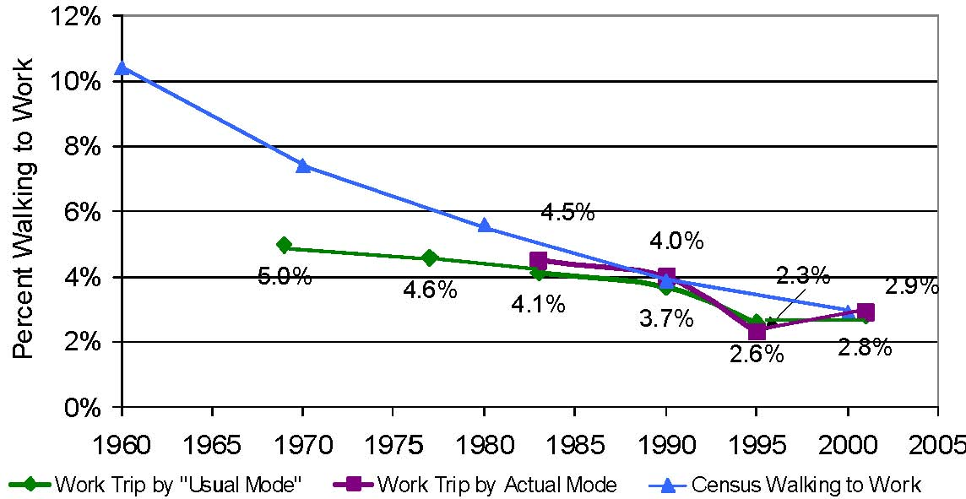

Figure 10. Work Trip Walk Mode Share (1960 to 2001)
Source: Polzin and Chu (2004)

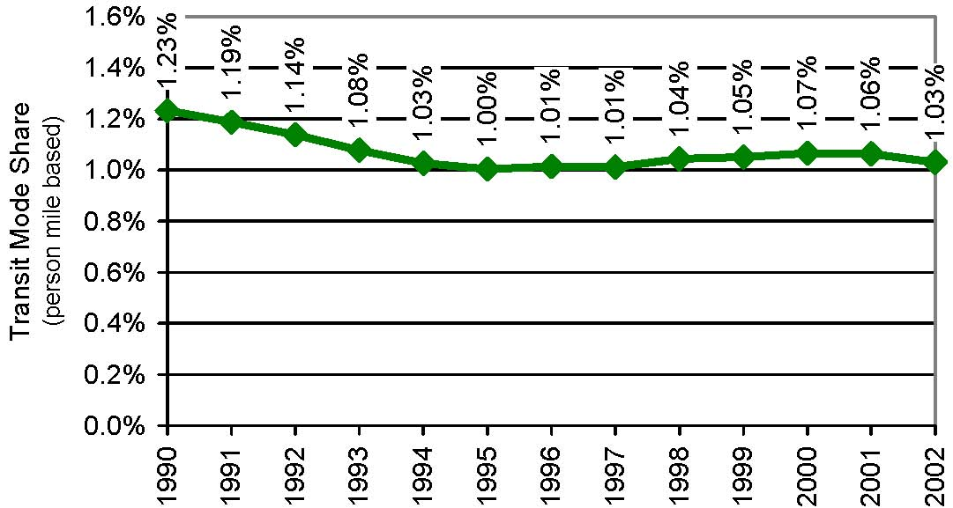

Figure 11. Transit Mode Share Based on Person Miles of Travel (1990 to 2002)
Source: Polzin and Chu (2004)

In this regard, it is important to understand the cause and effect relationships underlying the influence of the natural and built environment on travel behavior and choices. Although there is evidence to suggest that high density mixed land use development patterns that are pedestrian and transit friendly are associated with fewer vehicle trips, shorter trips, and lower auto ownership even after controlling for socio-economic characteristics, it is not clear if the causation is true or spurious. This is because there is some evidence suggesting that attitudes, values, and perceptions may play a very important role in shaping where people choose to live and how people choose to travel (Kitamura, et al., 1997). In other words, if those who live an active lifestyle are pre-disposed to doing so by virtue of their attitudes and beliefs, then the natural and built environment may have little to do with their travel choices. Such individuals would probably lead active lifestyles in any type of environment.

Finally, continued attention is being paid to the issue of latent, suppressed, and induced travel demand that are usually associated with capacity increases. Critics of highway expansion policies argue that any capacity increase is quickly filled up by induced demand as individuals choose to undertake additional trips, longer trips, and/or switch to the auto mode as a result of the capacity increase. Again, this issue is inextricably linked to the time use patterns of individuals and the evidence appears to suggest that highway expansion is associated with a certain level of induced demand although the evidence is mixed and conflicting in nature (e.g., Cervero, 2003; Cervero and Hansen, 2002; Mokhtarian, et al., 2002; Noland and Lem, 2002; Levinson and Kanchi, 2002; Hartgen, 2003). The question is how will individuals use the additional time savings that becomes available as a result of capacity expansion (and reduced travel times)? Will additional activities outside the home (and consequently new trips) be undertaken? Will existing activities and trips be modified with respect to their timing and location? To what extent will mode shifts occur due to increases in highway capacity? These are questions that need to be addressed to fully understand the influence of the natural and built environment on travel behavior and choices.

2.4 Travel Behavior of Special Market Segments
Considerable emphasis is being placed on analyzing travel behavior of special market segments with a view to understand their unique travel needs and choices. Such analysis can be used to formulate transport policies to meet transport needs of special groups, assess the potential adverse impacts of policies on different groups, and conduct environmental justice and equity studies.

Lave and Crepeau (1994) analyzed travel behavior patterns of zero car households using the 1990 NPTS data sets. Figure 12 shows the declining percent of households that fall into this category. It appears that the percent of households in this category has reached a bottom at about 8% of all households. As expected, persons living in these households tend to be less mobile (make fewer trips and show a higher percent of zero-trip making) and are more dependent on alternative modes of transportation such as transit, ride sharing, taxi, and non-motorized modes of transportation. However, it is interesting to note that about 40% of all trips undertaken by people in these households are by personal vehicle. From a broader travel demand perspective, the decreasing percent of households with zero cars has contributed to an increase in travel demand over the years. However, that trend appears to have hit a bottom and this factor may not contribute to any increases in future travel demand.

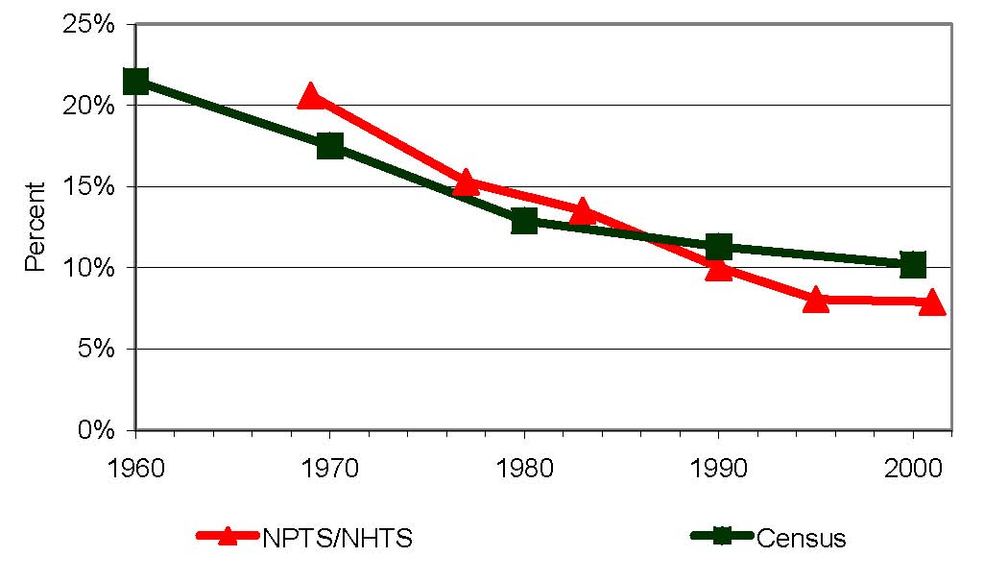
Figure 12. Percent of Households with Zero Vehicles (1960 to 2001)
Source: Polzin and Chu (2004)

There have been numerous studies that have looked at special populations. Gender based studies include a study of the potential saturation in men’s travel by Rey, et al. (1995) and a study of women’s travel behavior by Rosenbloom (1995a). Rosenbloom (1995b) also studied the travel behavior of the elderly population and found them more dependent on alternative modes of transportation. As expected, the elderly show greater proportions of non-work travel involving shopping, personal business, social visits, and medical/dental. All of these studies were based on the 1990 NPTS data sets. Kim and Ulfarsson (2004) studied the travel mode choice of the elderly and examined the effects of personal, household, neighborhood, and trip characteristics on mode choice. Georggi and Pendyala (2001) used the 1995 ATS data set to examine the long distance travel behavior of elderly and low income households. Given the importance of long distance travel to the nation’s economy, the NHTS should continue to collect such data and more work on studying long distance travel behavior should be done in the future.

Rosenbloom and Clifton (1996) and Clifton (2002) studied the travel behavior of low income households. Evidence suggests that people in poor households make fewer trips, travel shorter distances, and take more time to reach their destinations due to their reliance on alternative modes of transportation such as transit and non motorized modes. Clifton (2002) related the differences in travel patterns across income groups to differences in resources, constraints, and choices.

Clifton (2003) examines the pursuit of travel and activities by teenagers using data from the 1995 NPTS. In particular, the first trip made directly after school is examined to evaluate the degree of independence in travel. It was found that young teenagers switch to the auto mode from non-auto modes as soon as the automobile becomes available and is a viable alternative.

Rosenbloom and Clifton (1996) examine the interplay between income and race in the context of transit use and note that transit agencies may find potential markets in high income minority groups. Very detailed analysis of minority travel characteristics and demand has been performed by Polzin, et al. (2001). Their paper compares mobility trends by group using information from the 1983, 1990, and 1995 NPTS databases. Mode choice differences across groups are analyzed by examining how patterns of difference in mode choice vary with personal, household, geographic, and trip characteristics as reported in the 1995 NPTS. The exhaustive analysis examined a variety of distributions and tabulations and uses logistic regression to further explore mode choice differences between racial/ethnic groups. The analysis indicates that the differences in non-work travel behavior for the various racial/ethnic groups has changed dramatically over time with minority travel behavior more closely matching majority behaviors. Mobility for minority travelers has increased and mode choice behavior, while still different, more closely resembles that of the aggregate.

The NHTS and its predecessor NPTS series have been key sources of data for examining the travel characteristics of special market segments. Most urban area travel surveys do not have sample sizes large enough to support analyses of small market segments defined by a multitude of cross-classifying dimensions. The NHTS is probably one of the only surveys that can support rigorous analysis of these very important market segments. Formulation of transport policies, transport safety strategies, and transportation options for the transportation disadvantaged relies on the ability to conduct such analysis.

2.5 Nature of Travel Demand
Travel behavior data sets such as the NHTS have been used extensively to probe and analyze the fundamental nature of travel demand. There are a number of recent and emerging issues that have been the topic of considerable debate and analysis in the field. The 1990 NPTS data set was used by Strathman and Dueker (1995) to analyze trip chaining behavior. There is evidence suggesting that trip chaining (trip linking) has been consistently on the rise. Trip chaining has important implications for mode choice as complex journeys make it difficult to switch to alternative modes of transportation (Ye, et al., 2004).

There has been a growing debate recently in the literature about travel time expenditures, travel time budgets, and the potential evidence that travel may be undertaken for its own sake, i.e., travel may actually offer a positive utility. As seen in Figure 13, average travel time expenditure is on the rise in the United States. The reasons for the increases are probably multi-fold. Rising incomes and affordability of out-of-home activities (such as eat-meal, movies, and other recreational activities), increasing number of serve passenger trips, greater efficiency brought about by technology, increasing vehicle availability, increasing participation in the labor force, and so on are all reasons contributing to rising travel time expenditures. As some of the trends discussed previously in the paper stabilize in the future, it is possible that increases in travel time expenditure will dampen.

Recent work examining the nature of travel time expenditures seriously questions the notion of travel time budgets postulated in the late 1970s (Zahavi and Ryan, 1980; Zahavi and Talvitie, 1980). Chen and Mokhtarian (2004) provide a comprehensive review of the empirical evidence on travel time and money budgets and suggest that travel time expenditures are not constant, but are in fact strongly related to household and personal attributes, attributes of activities, and residential location characteristics. They also suggest the existence of an unobserved ideal travel time budget that individuals try to achieve. Their work and data showing increasing travel time expenditures worldwide suggest that the notion of constant travel time budgets may not be valid. The questions pertinent to this issue are: How much can travel time increase in the future? What is a travel time budget? Is it the same as the travel time expenditure? Although the literature has generally considered travel time expenditure to be representative of the travel time budget, Banerjee, et al. (2004) propose drawing a distinction between the notion of a “budget” and the actual “expenditure” of travel time.

On the flip side, there is a growing body of evidence and increasing interest in the notion of the positive utility of travel. That is, travel is undertaken (at least, in part) for its own sake because people derive satisfaction and positive utility from the act of traveling itself. Thus, conventional utility-based models which are based on the traditional notions that all travel entails a disutility and that all travel is derived, may not be universally valid in all contexts. There may actually be situations where travel offers a positive utility and people incur a disutility by not traveling at all. Mokhtarian and Salomon (2001) and Redmond and Mokhtarian (2001) provide additional discussions related to the notion of the positive utility of travel. The NHTS is a valuable source of travel time expenditure data that can be used to examine and test hypotheses related to the notions of the travel time budget and positive utility of travel.

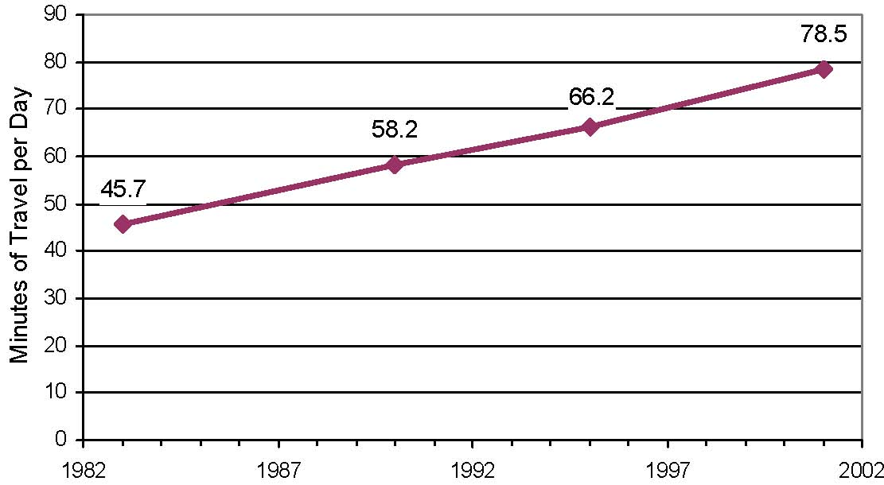

Figure 13. Increase in Average Daily Travel Time Expenditures (1983 to 2001)
Source: Polzin and Chu (2004)

Most travel behavior research has generally focused on weekday activity and travel characteristics. As most planning was oriented towards weekday peak period travel, this is quite understandable. However, there is a growing realization of the importance of studying weekend activity-travel patterns. The 2001 NHTS allows an in-depth analysis of both weekday and weekend travel characteristics, although differences between weekday and weekend travel behavior can not be determined while controlling for individual specific characteristics. This is because the NHTS does not offer multiple days of data for the same individuals. This is a potential area of enhancement for the NHTS, i.e., collect at least one weekend and one weekday of travel data from each individual in the sample. Agarwal and Pendyala (2004) have analyzed weekday and weekend activity and travel patterns using the 2001 NHTS. Bhat and Gossen (2004), Bhat and Srinivasan (2005), and Bhat and Lockwood (2004) are key examples of recent work into the analysis and modeling of weekend activity and travel patterns, particularly in the context of recreational activity episodes and physically active versus passive activity engagement. Yamamoto, et al. (2004) examine differences in temporal vertices of time-space prism constraints between working and non-working days and show that there are substantial differences in time-space prism constraints between these two types of days.

- 2.6 Vehicle Ownership and Utilization
Vehicle ownership and utilization has always been a topic of much interest to researchers in the travel behavior arena. Most travel demand management strategies and transport policies are aimed at managing and reducing the amount of car use. Vehicle ownership and utilization patterns have recently garnered additional attention for several reasons beyond the classic travel demand management perspective. First, there are considerable safety implications and concerns associated with the trend towards acquisition and use of larger vehicles (such as SUVs and vans) for routine daily travel. Second, there are considerable fuel consumption implications associated with the move towards larger and less fuel efficient vehicles. Third, with the recent rise in gasoline prices (to about $2 per gallon), there are questions regarding how and when travelers will begin to adjust their behavior. If travelers were to adjust their behavior, will there be an adjustment in terms of the vehicle fleet mix or in terms of the trip making patterns and attributes or both? In response to rising gasoline prices, people may choose to acquire smaller, more fuel-efficient, or hybrid vehicles and may also choose to alter their trip making patterns. It is absolutely critical that the NHTS continue to collect detailed vehicle ownership and utilization information in the future to support this type of analysis.

Pinjari, et al. (2004) provide a detailed analysis of vehicle ownership and utilization patterns in the United States using data from the 2001 NHTS. In particular, they examined the role of the primary driver in the use of different vehicle types and as expected, found women to constitute a higher proportion of primary drivers for minivans and found men to constitute a higher proportion of primary drivers for SUV’s and pickup trucks. Kockelman and Zhao (2000) did a similar analysis earlier using the 1995 NPTS data set. Bhat, et al. (2004) applied a multiple discrete continuous extreme value model to analyze the holdings and use of multiple vehicle types by households using data from the 2000 San Francisco Bay Area survey. Their modeling methodology is a major breakthrough in the ability to model and describe phenomena where people can choose multiple options. With these types of breakthroughs in modeling techniques, it is envisaged that more analysis of vehicle type choice and usage patters will be undertaken in the future.

Polzin and Chu (2004) have used the 2001 NHTS and secondary data sources to perform a comprehensive analysis of factors influencing vehicle use and household VMT growth. They find that vehicle availability as represented by the relative number of vehicles to adults plays a significant role in distinguishing between high and low trip making. Figure 14 illustrates this finding.

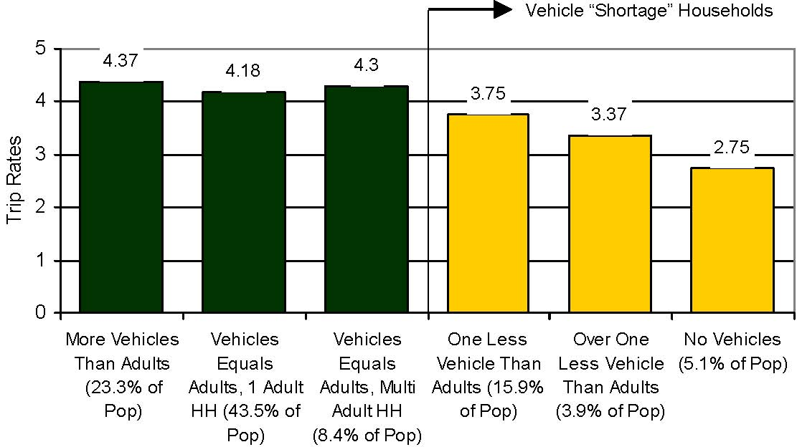

Figure 14. Trip Rates by Vehicle Availability (NHTS 2001)
Source: Polzin and Chu (2004)

They note that many of the factors that have traditionally contributed to household VMT growth may be stabilizing suggesting that future growth in household VMT may be more moderate than in the past. Figure 15 shows the stabilizing patterns of vehicle ownership ratios since the early 1990’s. Figure 16 shows that the relative share of the car/van pool mode for the work trip may be reaching a low point. Whereas about 20% of commuters reported carpooling to work in the 1970s, the percent has dropped to about 12% in 2000. Similarly, auto occupancy trends as seen in Figure 17 appear to be reaching a low point as well. All of these findings suggest that per capita vehicle use may be approaching saturation or at least a stage of slower growth into the future.

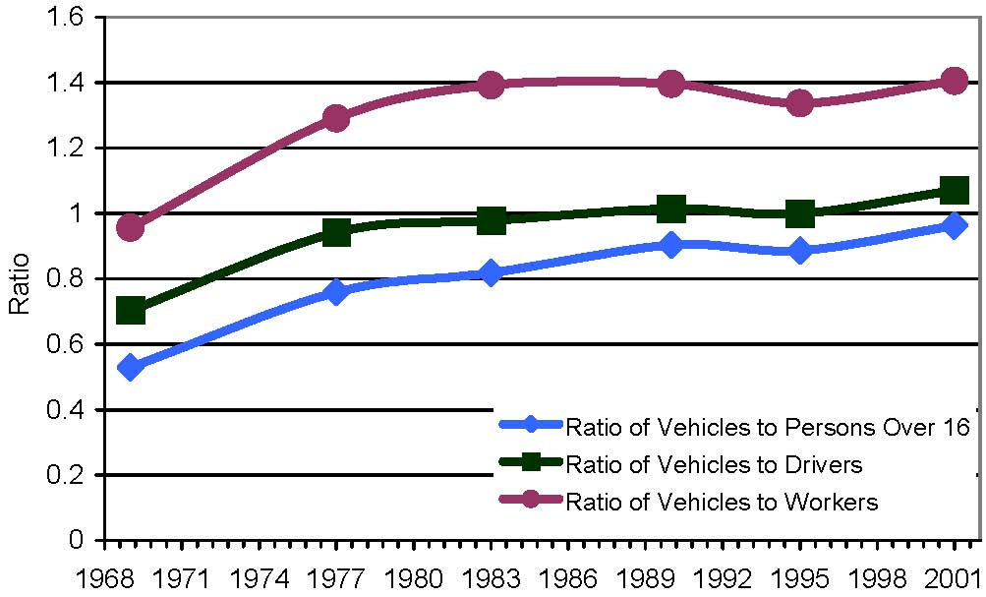

Figure 15. Vehicle Ownership Ratios (1969 to 2001)
Source: Polzin and Chu (2004)

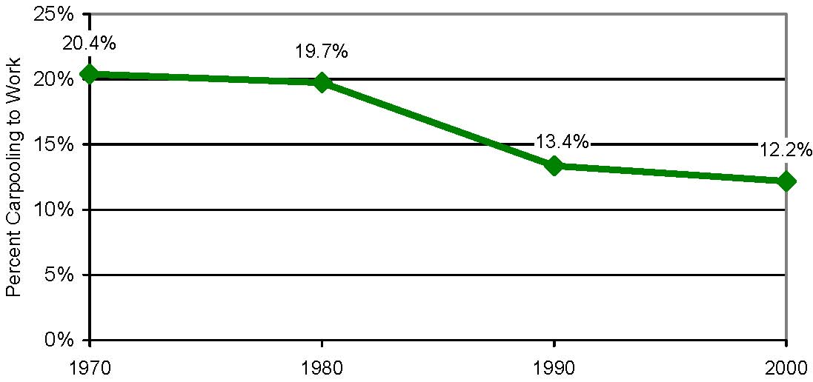

Figure 16. Car/Van Pool Mode Share for Work Trips (1970 to 2000)
Source: Polzin and Chu (2004)

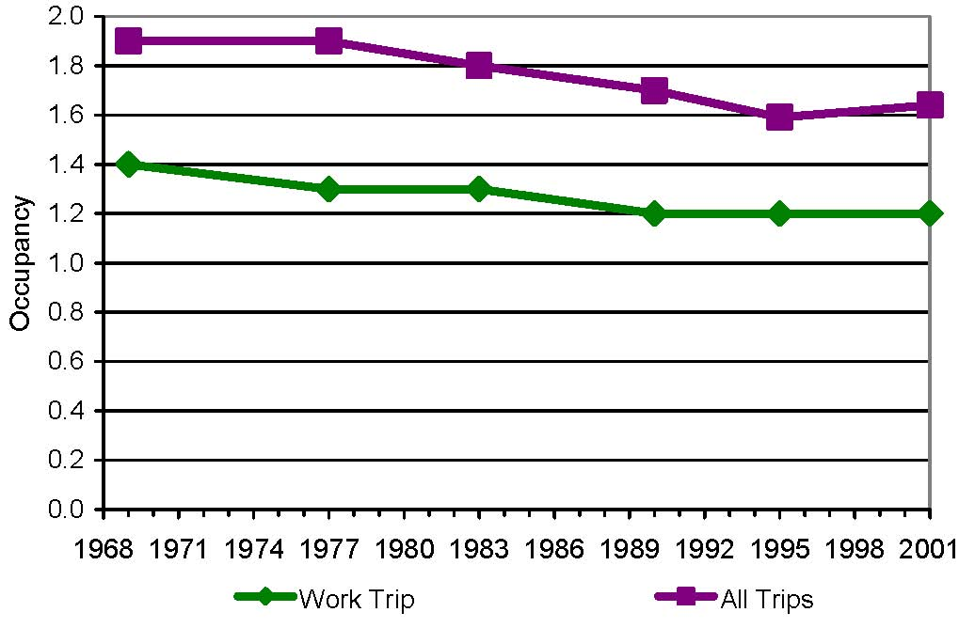

Figure 17. Vehicle Occupancy (1969 to 2001)
Source: Polzin and Chu (2004)

One of the major reasons often noted for the high level of auto use in the United States is the high level of affordability of owning and driving a car. Indeed, over the past few decades the relative cost of driving a car relative to personal income has been falling. Figure 18 shows the diverging trend lines between cost of owning and driving a car and personal income. As long as these trend lines diverged (i.e., the relative cost of vehicle ownership and use declined), the nation experienced high growth rates in VMT. However, that trend appears to have stabilized. The cost of owning and driving a car appears to have reached a bottom and in fact, appears to be inching back up. At the same time, personal incomes are rising albeit at a slightly slower pace. The more gradual divergence in these curves in the future may suggest that household VMT and personal vehicle use may not increase as rapidly in the past. Couple this with time availability constraints (Pendyala, 2003; Robinson and Godbey, 2000) and rising levels of congestion (TTI, 2004) and the potential for increased per capita vehicle use and growth dampens even further.

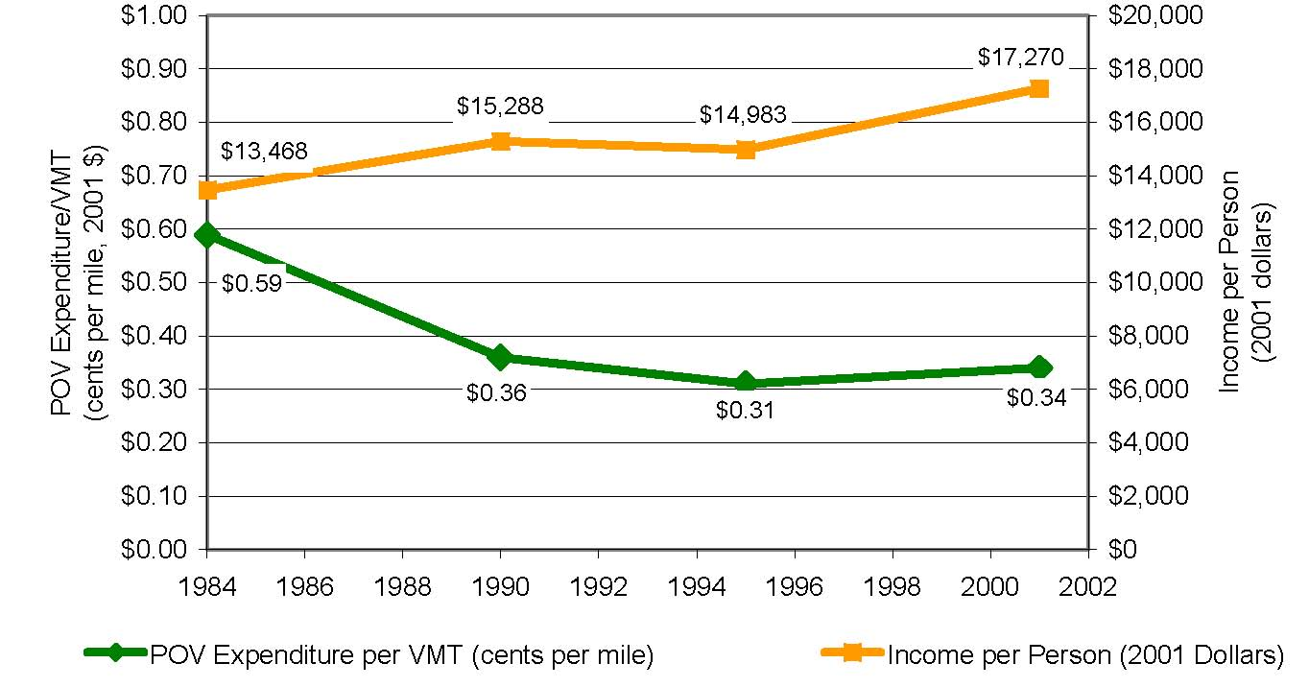

Figure 18. Cost of Driving versus Personal Income (1983 to 2001)
Source: Polzin and Chu (2004)

3. ANALYSIS AND MODELING OF TRAVEL BEHAVIOR
This section presents a brief overview of the new analysis and modeling methodologies that are being employed in the travel behavior research arena. The analysis tools and modeling methodologies that are being brought to bear in the profession could benefit from new and improved household travel survey data that not only provides richer information about outcomes, but also about processes.

- 3.1 Activity-based Analysis and Interagent Interactions
Activity based approaches to travel demand analysis explicitly recognize the derived nature of travel demand and the many constraints that govern activity-travel behavior (Axhausen and Garling, 1992). Activity based approaches to travel behavior analysis have been the subject of much discussion in the literature for many years (e.g., Jones, et al., 1990; Kitamura, 1988). Activity based travel demand analysis is based on the premise that travel is undertaken to accomplish activities that are distributed in time and space. Activity-based concepts are increasingly forming the basis of new and innovative travel demand forecasting models in urban areas around the United States including Portland, New York, and Columbus (Vovsha, 2004). Activity-based analysis is inextricably linked to the notion of time use (Pendyala, 2003; Bhat and Koppelman, 1999) and provides a framework for examining and modeling the impacts of transport policies and transportation system changes on people’s time use patterns and quality of life (Pendyala, 2003; Pendyala, et. al., 1998).

An emerging area of interest in the field of activity-based analysis is that related to interactions among agents. There are several kinds of inter-agent interactions in activity-travel decision-making, including those related to within household interactions (i.e., between individuals in a household) and across household interactions (i.e., across individuals in different households, such as carpooling arrangements and joint activity participations). Most research to date has focused on intra-household interactions in activity engagement and time allocation.

The inter-dependencies among the activity-travel characteristics of members in a household are a consequence of several factors. Individuals within households interact to satisfy and meet personal and household maintenance needs (Bhat and Koppelman, 1999; Srinivasan and Bhat 2004), enjoy companionship and undertake activities jointly (Fujii et al., 1999; Scott and Kanaroglou, 2002; Chandrasekharan and Goulias, 1999), share a household vehicle, and serve household members with restricted mobility (Srinivasan and Bhat, 2004). All of these factors influence activity-travel patterns and schedules of household members. For example, “serve passenger” activity could impose spatial and temporal constraints on the overall activity-pattern of individuals (Pendyala, et al., 2002). Models that fail to recognize these interpersonal interactions may result in erroneous predictions of changes in travel patterns due to changes in land-use, transportation system, and demographic characteristics (Scott and Kanaroglou, 2002; Vovsha et al., 2003).

Much of the research to date has accommodated household interaction effects by using household characteristics as explanatory variables in the individual-level choice models. However, there have been some efforts recently to model interpersonal interactions more explicitly. Meka et al. (2001), Simma and Axhausen (2001), and Golob and McNally (1997) have explored interpersonal interactions in activity and travel engagement between household heads using structural equations approaches. These studies used a day as the unit of analysis. On the other hand, Van Wissen (1989) examined weekly time allocation by household heads independently and jointly in various non-work activities. Other recent studies on interpersonal interactions have used discrete-choice or share modeling methods. Scott and Kanaroglou (2002developed trivariate ordered-probit models to jointly determine the number of non-work episodes undertaken by household heads. Wen and Koppelman (1999, 2000) examined the generation and allocation of maintenance activities within a household. Gliebe and Koppelman (2002) developed a proportional-shares model of daily time-use in a two adult household. The model determines the proportion of time invested, independently and jointly, by each household head, in different types of activities. Zhang et al. (2002) seek to model the time allocation in four kinds of activities (home, independent, allocated, and shared) between the household heads as a group decision-making problem. Most recently, Srinivasan and Bhat (2004) have examined the allocation of shopping episodes as well as shopping durations among household adults.

Another area of much work in the recent past in the activity-based travel analysis field is on the relationships and tradeoffs between in-home and out-of-home activity engagement. Goulias (2002), Kuppam and Pendyala (2001), Golob (1998), Lu and Pas (1999), and Mannering, et al. (1994) have examined various aspects of in-home activity engagement, in-home stay duration, and in-home time use allocation patterns in relation to out-of-home activity engagement and travel. The interconnection between in-home and out-of-home activity engagement takes on added significance in light of the growing use of technology and telecommunications inside the home to accomplish numerous technology-enabled activities.

A major tenet of the activity based approach to travel demand analysis is that people’s activity and travel patterns are governed by numerous constraints and opportunities. Constraints may include modal constraints (related to modal availability and accessibility), scheduling constraints(work and school schedules), household and personal constraints (household obligations, physiological needs), and institutional constraints (opening and closing hours of businesses and institutions). There is increasing recognition that the influence of such constraints must be recognized to model the impact of policies on travel behavior (Pendyala, et al., 1998). There is a growing body of research examining the role of constraints in activity-travel demand. For example, Kockelman (2001) developed a model for time- and budget-constrained activity demand analysis. This aspect will be discussed in greater detail in the next section of this paper.

3.2 Understanding Time-Space Interactions
- An underlying theme of the activity based approach is that human activity and travel patterns are undertaken in a time-space continuum. A key aspect of this recognition is that interactions between the time and space dimensions must be incorporated into any analysis of dynamics of human activity and travel patterns (Pendyala, 2003). It is now widely recognized that human activity and travel patterns may be considered as being undertaken within time-space prisms, which represent spatio-temporal constraints that are influenced by social, demographic, economic, and transportation system characteristics (Hägerstrand, 1970; Kondo and Kitamura 1987; Miller, 1991). For example, if one were to consider a simplified representation of a time-space prism as shown in Figure 19, an individual may not be able to leave home (to go to work) prior to time point A, possibly due to the need to take care of household obligations and/or the desire to sleep until a certain time prior to starting the work day. Similarly, the individual may have to arrive at work no later than time point B to comply with work schedules. The prism shown in the figure then represents a time-space continuum in which an individual can undertake activities and travel without violating the time constraints. The spatial boundaries (or constraints) that dictate the range of destinations (activity locations) that the individual can visit are governed by the speed of travel, v, in the figure. This value, in turn, is directly dependent on the transportation system characteristics (level of service). If speed of travel increases, the time space prism increases in size and the individual can undertake more activities, spend more time at the same activities, or visit destinations farther away. If speed of travel were to decrease (say, due to increased congestion), then the prism shrinks and the individual is more constrained with respect to activity engagement and locations that can be visited. Thus, the time-space prism concept provides a framework for analyzing the induced (or suppressed) travel effects of capacity increases (or decreases).

Recent work in this arena has focused on the modeling and representation of time space prism vertices or boundaries to understand how individuals perceive constraints and how their perceptions of constraints in turn influence their activity and travel patterns (Kitamura, et al., 2000; Pendyala, et al., 2002; Yamamoto, et al., 2004). Travel behavior researchers are concerned with understanding how humans perceive time-space constraints, time-space constraints influence activity-travel patterns, time-space constraints change over time, and GIS, GPS, and sensor technologies can be used to measure, visualize, and capture the dynamics of time-space interactions. Understanding time-space interactions directly contributes to the development of models of dynamics of activity and travel decision making processes.
Time
B
A
Work
Home
Space
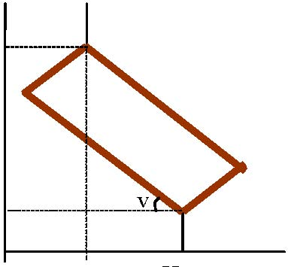

Figure 19. Simplified Representation of Time-Space Interactions Using the Prism Concept

- 3.3 New Analysis and Modeling Methods
Developments in analytical modeling approaches have broadly occurred in three major arenas. They are as follows:

Econometric Models of Choice: Advanced econometric choice models have witnessed a literal revolution in recent years, as the ability of the analyst to incorporate and estimate realistic behavioral structures has been enhanced considerably. Examples of recent books containing numerous chapters describing advances in econometric and statistical modeling methodologies include those edited by Hensher (2001) and Hensher and Button (2000). There are two reasons for the revolution in econometric modeling of travel choices. One is that, after a long hiatus, new model structures are being discovered and introduced within the framework of Generalized Extreme Value (GEV) models. The flexibility that such new GEV constructs offer are very valuable, especially since the resulting choice probability and likelihood functions still retain a desirable analytic closed-form structure. Second, there has been substantial progress in simulation methods to estimate likelihood functions involving analytically intractable multidimensional integrals. This has allowed analysts to estimate practically any choice model structure, without limiting the specification to mathematically convenient, and behaviorally less desirable model forms. Further, recent modeling advances in new formulations and simulation techniques also allow the estimation of rather general forms of hazard duration and discrete-continuous models (e.g., Pendyala and Bhat, 2004). Overall, there is a sense today of absolute control over the behavioral structures one wants to estimate in empirical contexts and renewed excitement in the modeling field (see Bhat, 2003 for a comprehensive review of recent advances in econometric modeling).

Heuristic and Rule-Based Methods: These methods are based on a set of learning rules, normally in the form of condition-action (IF-THEN) pairs, that specify how a task is solved (see Arentze and Timmermans, 2004 for detailed discussions and applications of such methods). The approach focuses on the process of decision-making and captures heuristics and short-cuts that are involved, as opposed to assuming overriding paradigms such as utility maximization (e.g., Ettema, et al., 1993; Garling, et. al., 1994; Pendyala, et. al., 1998). Thus, these methods offer substantial flexibility in representing the complexity of travel decision-making. They are also well-suited to accommodate inter-agent interactions, such as the interactions in activity-travel decision-making among individuals in a household. One limitation of such methods, however, is that they lack a statistical error theory, making it sometimes difficult to generalize their outcomes and apply them to policy evaluation.

Microsimulation Methods: The desire to move land-use and activity-travel models – both econometric models and the heuristic/rule-based models - into operational practice has stoked the interest in microsimulation, a process through which the choices of an individual are simulated dynamically based on the underlying behavioral models driving household and individual decisions (Miller, 2003). Microsimulation systems provide a means of forecasting the impacts of a given policy at many different levels, including at an individual level, at a subpopulation level, and at the aggregate population level. To date, partial and fully operational activity-based microsimulation systems include the Micro-analytic Integrated Demographic Accounting System (MIDAS) (Goulias and Kitamura, 1996), the Activity-Mobility Simulator (AMOS) (Kitamura et al., 1996), Prism Constrained Activity-Travel Simulator (PCATS) (Kitamura and Fujii, 1998), SIMAP (Kulkarni and McNally, 2001), ALBATROSS (Arentze and Timmermans, 2001), TASHA (Miller and Roorda, 2003), the urban simulator (UrbanSim) (Waddell, 2002), Florida’s Activity Mobility Simulator (FAMOS) (Pendyala, 2004), CEMDAP (Bhat et al., 2004), and other systems developed and applied to varying degrees in Portland, Oregon, San Francisco, and New York (see Bradley et al., 2001; Vovsha et al., 2003).

An underlying common theme to all of these developments is the move towards an activity-based approach to travel demand analysis and modeling and the desire to more accurately and realistically capture behavioral processes, decision-making behavior, and interactions among agents in models. While the NHTS may not be able to offer all of the data needed to fuel these modeling methods, it is within the realm of possibilities to enhance and augment the NHTS so that the data obtained from the NHTS can be used to derive a greater and deeper understanding of activity and travel choices in time and space.

- 3.4 Understanding Attitudes, Values, and Perceptions
Traveler attitudes, perceptions, and values have long been recognized as important determinants of behavior. Travel behavior data collection efforts have often included stated preference questions to measure such items as public awareness, empathy, tolerance, preferences, and priorities. Attempts have also been made at evaluating the reliability and potential usefulness of such data in travel behavior models (Kuppam, et al., 1999). Despite the considerable interest in these types of variables, there has been limited use of attitudinal and preference data in planning practice. This may be attributed to two primary reasons. First, detailed data regarding traveler values, attitudes, and preferences are often not collected in traditional household travel surveys thus precluding the ability to perform rigorous attitudinal analyses. Second, as attitudinal and preference variables can not be easily forecast in the same way as demographic variables, they are not considered useful (from a practical standpoint) for travel demand forecasting purposes.

Analyses of the role of individuals’ perceptions and preferences in travel decision making has been an active area of theoretical and empirical research. This is because individual travel behavior may often be influenced by an individual’s perceptions of travel alternatives, individual preferences for the attributes of various alternatives, and the availability of various alternatives (Koppelman, et al., 1977). The potential relevance of traveler attitudes, preferences, and perceptions in travel behavior modeling has therefore been the subject of a large number of research efforts.

As far back as in the 1970s, Spear (1976) and Dobson, et al. (1977) and more recently, Kuppam, et al. (1999) have found that attitudinal variables account for as much as 60 percent of the explained variation in traveler mode choice and often surpass traditional socio-economic and demographic variables in their explanatory power. These studies found that the inclusion of abstract transportation system characteristics like comfort, convenience, reliability, and safety could significantly improve the explanatory power of conventional mode choice models. With regard to land use characteristics and attitudinal effects, Kitamura, et al. (1997) found that attitudinal variables explained the highest proportion of variation in trip making behavior. It was further concluded that attitudes are more strongly associated with travel than are land use characteristics, and thus land use policies promoting higher densities and mixtures may not alter travel demand materially unless they are accompanied by changes in residents’ attitudes.

Consumer attitudes towards public transit and other alternative modes of transportation has been the subject of several studies dating back to the 1970s (e.g., Haynes, et al., 1977; Fielding, et al., 1976; Jacobson, et al., 1991; Glazer and Curry, 1987; Goulias, et al., 1999). All of these studies have consistently shown that attitudes towards and perceptions of comfort, convenience, reliability, safety and security, proximity, and accessibility play a big role in shaping people’s decisions to use alternative modes of transportation. These studies also show that traveler values and priorities are critical to determining the types of investments and service improvements that are likely to meet with the greatest success. Garling, et al. (2002) offers a comprehensive framework for the analysis of the impacts of travel demand management strategies on private car use. Within this framework, attitudes and perceptions are afforded a prominent explanatory role.

Deteriorating air quality and the potential threat of global warming have prompted numerous attitudinal and value studies regarding the environment and how these attitudes shape traveler choices with particular emphasis on private automobile use (e.g., Golob and Hensher, 1998; Tertoolen, et al., 1998; Hjorthol and Berge, 1997). These research studies address the relationships between an individual’s travel behavior and his or her attitudes and/or support for policies that are promoted as benefiting the environment. In general, it has been found that transit users have a greater level of interest and positive disposition towards policies that curtail private auto use and promote the reduction of greenhouse gas emissions.

Variables representing attitudes, values, and perceptions are not always easily quantifiable and may not be amenable to analysis using traditional quantitative statistical or econometric approaches. Indeed, many attitudinal and values statements may be open ended and anecdotal with little quantitative information per se. In this regard, there is a growing interest in the application of qualitative approaches to travel behavior research so that insights regarding behavior may be derived from attitudinal and qualitative data. These insights can in turn be useful for informing quantitative model specifications and shaping transport policies (e.g., Al-Jammal and Parkany, 2003; Clifton and Handy, 2003).

- 3.5 Probing Behavioral Processes and Dynamics
Travel behavior researchers have been interested in understanding dynamics in residential and work location choices, activity patterns, and travel characteristics for many years. Dynamics in behavior has generally been examined from both a short and long term perspective. Short-term dynamics represented by multiday intra-person variability in travel characteristics has been the subject of considerable research (e.g., Huff and Hanson, 1986; Pas and Sundar, 1995). These studies focused on day-to-day variability in trip rates, travel duration, and vehicle and person miles of travel. Mahmassani and Liu (1999) examined day-to-day dynamics in work trip departure time choice and route choice in the context of traveler information systems and intelligent transportation systems. All of these studies have shown that there is considerable intra-person multiday variability in travel characteristics and that it is important to account for such variability in transport policy formulation. True measures of exposure to pricing policies, for example, can only be determined with knowledge of day to day dynamics in behavior. Pendyala and Pas (2000) provide a more detailed review of research in this topic.

There has also been considerable work into the study of longer term dynamics in behavior. Panel data sets offer a rich source of information for analyzing longer term dynamics, lags and leads in behavior, and in identifying cause and effect relationships (Kitamura, 1990, 2000). Beginning with major work on travel behavior dynamics done using the Dutch National Mobility Panel data set of the 1980’s (e.g., Golob and Meurs, 1986, 1987, 1988), the field has made considerable progress in analyzing longitudinal data and inferring dynamics in activity and travel patterns. In the United States, the Puget Sound Transportation Panel (PSTP) is the only major large scale general purpose panel survey that has been conducted (Murakami and Ulberg, 1997; Murakami and Watterson, 1990). Goulias (1999), Ma and Goulias (1997a, 1997b), and Pendyala and Kitamura (1997) represent key examples of work done using the PSTP. These studies show how dynamics in activity and travel patterns including activity frequencies, activity durations, travel durations, and mode choice transitions can be examined and modeled while controlling for individual specific effects and accounting for panel attrition and choice-based sampling.

The NPTS and NHTS represent a repeated cross-sectional series of surveys. Such longitudinal data are very useful for examining dynamics in terms of aggregate trends (Pendyala and Pas, 2000). Work by Polzin, et al. (2001) represents a key example of the longitudinal analysis of a series of NPTS data sets to monitor and examine changes in behavior over time. Similarly, Pendyala, et al. (1995) illustrate how repeated cross-sectional data can be used to study car ownership patterns over time using disaggregate choice models estimated on repeated cross-sections. However, it is now well documented that true behavioral dynamics and cause and effect relationships can only be identified through the use of panel data where observations are obtained on the same individuals and households at multiple time points (Kitamura, 1990, 2000). Then, changes in activity and travel patterns can be explicitly related to changes in socio-economic, demographic, and other characteristics specific to the individual or household.

The above discussion suggests that there may be merit to enhancing the NHTS to a multiday activity-travel survey with a panel sample component. The panel component may be a rotating panel where members of the rotating panel are deliberately rotated off periodically and refreshed with new members. With respect to the multiday aspect, consideration should be given to increased respondent burden. A multiday diary of two or three days in length, where at least one survey day is a weekend day, would probably be sufficient to permit an examination of day to day dynamics in behavior while also providing an ability to compare weekday and weekend travel patterns.

It is more difficult to say if the introduction of a panel component is as straightforward and meritorious. One major advantage to such a component in the NHTS is the potential availability of long-term panel data that allows the study of longer-term dynamics in residential and work location choices, demographics, and activity and travel characteristics. On the other hand, the introduction of a panel component introduces considerable complexity in logistics and dynamic analysis. First, as the NHTS is done only once in 5-7 years, the tracking of panel participants would require a mechanism where constant contact is maintained through annual or semi-annual correspondence. Also, Kitamura, et al. (2003) note that “discrete-time panels may not be a dependable tool for observing stochastic behavioral processes, since the likelihood and magnitude of error (in estimating the parameters characterizing the behavior process) can both be very significant”. They further note that even annual panel surveys may not be adequate in detecting changes over time in discrete travel behaviors such as travel mode choice. They suggest the inclusion of retrospective recall questions in each survey wave and the establishment of smaller inter-wave spacing to obtain accurate continuous data. Despite their findings and although a discrete time panel survey may not offer richness in terms of the behavioral process underlying dynamics, it may still be useful to introduce a panel component in the NHTS for measuring and observing longer term changes in behavior and demographics.

A key emerging topic area of research in this regard is that related to understanding, probing, and modeling behavioral processes that form the basis of activity and travel choices observed in surveys. It is not necessary to have a panel survey for understanding a behavioral process. In fact, as noted earlier, a panel survey may offer no information about the behavioral process at all while a cross-sectional survey may be able to offer information about behavioral processes by asking questions specifically targeted toward obtaining information about how and why decisions and choices were made. Recent developments in this emerging area of interest include work in understanding activity scheduling and rescheduling decisions using customized computerized survey experiments (e.g., Lee and McNally, 2004; Doherty and Miller, 2000; Doherty, et al., 2002; Doherty, 2003). These studies analyze how people obtain and process information, prioritize and plan activities, schedule and reschedule activities, interact with other household members, and execute an activity agenda. Garling, et al. (2002) discuss how knowledge of behavioral adaptation processes can be very useful for modeling impacts of travel demand management policies.

It is probably not going to be feasible to introduce a specific behavioral process survey within the context of the NHTS. However, Bradley (2004) notes that it is possible to obtain some information about behavioral processes by simply asking a set of relevant questions within the context of a standard household travel survey. By asking questions about how and why decisions were made, by including retrospective and prospective questions, and by probing attitudes and experiences, it may be possible to infer processes that form the basis for behavioral outcomes. Such knowledge can be very useful for informing the specification of advanced econometric models of choice, formulating heuristics and rules for computational process models, understanding potential adaptation to alternative policies, and simulating evolutionary processes in microsimulation models of activity and travel demand. The introduction of a few stated preference type questions may also help serve the need for understanding and probing behavioral processes (Bradley, 1988; Lee-Gosselin, 1996).

- 4. DATA NEEDS FOR EMERGING ISSUES AND CHALLENGES
The discussions presented in the previous sections of this paper have important implications for the future of travel data collection in the United States, and particularly for the NHTS. This section aims to identify the data that are needed to address the recent and emerging issues in travel behavior analysis and to feed the analytical models and tools of the future.

Before discussing the data implications, it should be noted that this section focuses on what may be done differently in the future in relation to what is done now in most U.S. travel data collection efforts, particularly in the NHTS. There are, however, many aspects of the NHTS that are very useful and appropriate for the future. Regardless of recent and emerging issues in travel behavior analysis, it is imperative that the NHTS continues to be a rich source of information for basic demographic, socio-economic, and travel information. The NHTS should continue to collect data on household and person characteristics and basic travel characteristics to facilitate longitudinal analysis of travel behavior and demand characteristics. Emphasis should continue to be placed on collecting data about all aspects of travel across all sections of the society including special groups of interest and hard to reach populations such as the elderly, children, minorities, illiterate, low-income, zero-car households, immigrants and non-english speaking populations, transportation disadvantaged populations, and so on. Survey methods that can better capture information on short and infrequent trips, particularly non-motorized trips, should continue to be implemented so that the complete picture of travel is obtained for each respondent. The full continuum of travel, including both short and long-distance trip making, should continue to be captured in the NHTS in the future. The focus of this section is to answer the question: what can be done differently and how can the NHTS be enhanced, without sacrificing the comparability of surveys over time, while serving the needs of the community in the future?

4.1 Activity and Time Use Data
Clearly, the profession is moving in the direction of activity and time use based analysis and modeling of travel demand. Activity and time use data offer great benefits in terms of the level of activity detail, reporting of short and infrequent trips that might be missed in traditional trip diary surveys, and explicit focus on the time and space dimensions (Harvey, 2003). Activity and time use surveys can be used to obtain both in-home and out-of-home activity and travel information that is crucial to understanding the relationships among in-home and out-of-home activities and among household members. The questions related to substitution and complimentarity of in-home and out-of-home activities can only be addressed and modeled when such data is available. The most powerful example of this is the whole question of how technology use at home might be affecting out-of-home activity engagement and travel. Activity and time use data could offer information about internet use, computer use, and cell phone use in the context of a daily activity-travel pattern.

New models for travel demand forecasting are going to increasingly rely on travel survey data that includes detailed information on activity episodes, time use patterns, and in-home and out-of-home activity engagement. Microsimulation models of travel demand that have been implemented or are in various stages of development, although perfectly capable of utilizing traditional trip diary survey data, would benefit immensely from the availability of detailed activity and time use data on in-home and out-of-home episodes. While some may question whether national level data would ever be used to estimate and calibrate components of activity-based microsimulation models, there are two arguments that may address this question. First, just as national level data have been made available for estimating and calibrating/validating four-step models, so can national level data be used to do the same for activity based microsimulation models. Second, the NHTS is seeing plenty of interest from states and MPO’s interested in participating as add-ons. If the NHTS is going to offer rich activity and time use information useful for estimating and calibrating activity-based microsimulation models, there may be even more interest from individual MPO’s and states in participating as add-ons.

The real question is whether a national household travel survey such as NHTS needs to collect such detailed activity and time use information. There is a survey called the American Time Use Survey (ATUS) that is being undertaken by the Bureau of Labor Statistics (BLS). Detailed activity and time use information is available from ATUS. However, ATUS does not separate the travel episode from the activity episode making it very difficult to use the data for activity-based travel demand analysis. Thus, although switching the NHTS to an activity-based time use survey may involve some duplication with the ATUS, it appears that an activity and time use based survey design for the NHTS would offer unique and measurable benefits to the profession. If nothing else, the activity and time use based format would simply offer richer and more complete trip information, without seriously affecting the ability to compare statistics and characteristics across surveys over time.

The added survey response burden associated with activity and time use surveys can not be ignored. In this context, consideration should be given to introducing substantial GPS-based and other technology-based data collection devices and methods into the NHTS. The technologies are now quite advanced, tools for analyzing and synthesizing the large amounts of data are available and reliable, and the data collected would be very accurate. The survey respondent would have to only provide some of the ancillary data, but would not be burdened with having to report each and every variable associated with a trip or activity. Spatial and temporal information, in particular, would be automatically recorded by the technology. Another major benefit of using this technology is that detailed route choice data would become available. In general, travel surveys have not collected route choice data and introducing a sizeable GPS component into the NHTS can provide route choice data. Such data would be very useful in moving forward the state-of-the-art in route choice analysis and network modeling.

4.2 Attitudes, Values, Experiences, and Perceptions
Travel behavior surveys have traditionally not included much in the way of questions aimed at getting at people’s attitudes, perceptions, values, and experiences. This is because most travel surveys are seen as sources of data for modeling travel demand, developing and calibrating travel forecasting models, and obtaining quantifiable statistics and rates about travel and demographics. As attitudes, values, experiences, and perceptions are not easily quantifiable and are generally never included as explanatory variables in any model system (because they can not be forecast), travel surveys have not included these questions and components. In addition, including these types of questions increases the length of the questionnaire and raises the response burden.

This is precisely where the NHTS should step in and make a difference. While many urban area and regional travel surveys may not include such questions, the NHTS should make an explicit attempt to include a major attitudinal survey component in the future. The NHTS should serve as a basis for understanding behavior, explaining behavior, formulating policy, and intelligently assessing the kinds of impacts that alternative policies might have on demand and behavior. The NHTS is probably not going to be used as the basis for travel demand forecasting models in many areas of the country. But, the NHTS can give a periodic glimpse into the national pulse on priorities, attitudes, perceptions, and values regarding transportation. The availability of such data makes it possible to potentially identify and isolate spurious causation from true causation. In addition, although the survey length and respondent burden issues would apply to the NHTS as well, careful survey design and administration methods may be able to alleviate such potential problems. Also, it is possible that people are more amenable to answering questions where they get a chance to express their own opinions and beliefs in the hope that providing such information will make a difference in decision making.

Some of the topic areas in which data about attitudes, values, and perceptions can be collected include:
- Perceptions of the personal and household action space with respect to both time and space dimensions
- Attitudes, values, experiences, and perceptions related to the performance, comfort, convenience, and importance of different modes and their attributes
- Attitudes, values, and perceptions towards alternative land use configurations including their own residential and work location situations
- Priorities and attitudes towards the environment including noise, air quality, water quality, and fuel consumption and cost
- Attitudes, values, and perceptions related to the use, availability, and reliability of technology and information including intelligent transportation systems, in-vehicle navigation and safety systems, internet communications, and traveler information
- Attitudes and perceptions towards different vehicle types, styles, sizes, and fuel mixes
- Attitudes, values, and perceptions of pricing schemes, cost structures, and tolls/fares

Having data such as the above can be very useful both at a national and local level for formulating policies and understanding/explaining how travelers might react to alternative policies.

- 4.3 Dynamic and Process Data
Much of what is studied and modeled in travel behavior research is dynamic in nature. The repeated cross-sections that the NPTS/NHTS data sets represent have been very useful for studying macro-trends in demographics and travel characteristics over time. However, they have not been as useful for studying micro-trends at the disaggregate level and determining lags and leads in behavior, potential causes and effects underlying behavior, and processes that contribute to dynamics in behavior.

There are short-term dynamics such as day to day dynamics in trip making, departure time choice, mode choice, vehicle occupancy, activity engagement, destination choice, and so on. In the medium- and long-term, there are dynamics related to auto ownership, work location choice, residential location choice, and school location choice. Capturing these dynamics is fundamental to understanding how travelers adapt and change in response to their environment, interact with numerous agents, and make decisions.

The time is ripe for the NHTS to introduce a component that explicitly examines dynamics in travel behavior. At the most fundamental level, there may be merit to converting the NHTS to a two- or three-day activity/travel diary survey to get rich information about day-to-day dynamics in travel demand. At least one of the multiple days could be a weekend day so that comparisons between weekday and weekend day activity and travel patterns can be made while controlling for individual characteristics. Day-to-day dynamics are useful to quantify and understand exposure measures from a variety of standpoints – congestion, safety, pricing, environmental justice, and equity.

At a higher level, it is also time to examine the potential to convert a part of the NHTS into a panel sample. Perhaps 10 or 20 percent of the sample could be a panel sample that is tracked continuously with refreshments added as needed. A part of the NHTS could be made a rotating panel where households are deliberately removed and entered into the panel component during each NHTS. This component of the survey sample would have to be contacted frequently to minimize attrition. However, the data itself may still be collected at the usual NHTS survey years. Having a panel component associated with the NHTS would allow the tracking of longer term dynamics that are difficult to track in typical shorter-term panel surveys. As many local agencies have not been able to undertake panel surveys of their own, the NHTS would fill a much needed gap in understanding dynamics of behavior over longer time spans. At each survey point, the panel component could be asked additional retrospective questions regarding their auto ownership, residential and work locations, and so on to get a fairly complete picture of the dynamics that occurred between two successive NHTS survey contacts.

In this context, one may also wish to consider the notion of “process” data. Earlier in the paper, it was mentioned that greater focus is being placed on understanding behavioral processes that lead to outcomes and decisions that are observed and measured in travel diary surveys. It is certainly possible that “processes” that drive dynamics in behavior can be inferred from a panel survey component. However, even with such disaggregate dynamic data, one must infer processes. The processes are not necessarily directly observed or articulated by the respondent. The analyst observes the behavioral unit at two points in time and then draws inferences about the possible process that might have contributed to the transition from one state to another.

Thus, behavioral process data must be considered distinct and separate from longitudinal, dynamic, or panel data. In fact, one might be able to obtain behavioral process information directly from a cross-sectional survey by asking a series or set of questions that aim to obtain information on how and why certain events occurred and activities or trips were undertaken. There is no way that the NHTS can be converted into a full fledged process survey or can even be augmented with a detailed process survey. That would simply be too complex, expensive, and burdensome. However, it is very possible to include a small set of questions within the standard survey that are targeted towards understanding behavioral processes. These may take the form of open-ended qualitative research type questions that ask individuals to articulate how and why certain decisions were made or choices were exercised. For example, here are some possible questions that could be asked of a respondent:

- 1) How did you decide when to depart to work today?
- 2) How did you and your spouse decide who would drop off/pick up the child at school today?
- 3) Which of the activities that you undertook today did you plan at least 24 hours in advance? Which activities did you undertake at the spur of the moment?

Such questions can offer valuable insights into how people make decisions, interact with other agents, and plan and execute activities. Similar questions regarding information acquisition and use (for example, in acquisition of new automobile, in choosing a residential location, etc.) can also prove valuable in determining the kinds of information that should be made available to individuals to help in their decision making processes. Qualitative research methods that are aimed at analyzing responses to such open-ended questions should be employed to maximize the benefit of including such questions in the NHTS.

4.4 Opportunities, Flexibility, and Constraints
Although many models of travel demand deal with travel choices and time-space constraints, there is very little data that is collected about these aspects. In the past, travel behavior researchers have successfully related many aspects of travel demand to various socio-economic and demographic characteristics. Yet, there was much variation in travel behavior that went unexplained. How much of this variation is truly random? While some of the unexplained variation may be explained by attitudes, perceptions, and values, one can not deny the role played by constraints, flexibility, and opportunities in shaping travel choices and behavior.

There are a variety of constraints that shape individual travel behavior. These include:

- Modal constraints pertaining to the availability of different modes of transportation in time and space including automobile, transit, bike, or walk facilities.

- Institutional constraints that deal with the constraints associated with opening and closing hours of institutions such as businesses, schools, banks, medical facilities and post offices in addition to work schedule related constraints.

- Household and personal constraints that include physiological constraints where a person must spend a minimum amount of time for sleeping, personal hygiene, etc. and household obligations that involve household maintenance, child care, meal preparation, etc.

- Information constraints are those related to the availability of information, dissemination of information, and the amount of information that a person can realistically gather and process at any point in time.

While the above constitute constraints, there are also opportunities and varying degrees of flexibility with respect to various activity and travel attributes that shape individual travel behavior. For example, one may consider the following:

- Locations of activities: There may be alternate locations (opportunities offer flexibility) where certain activities such as shopping, banking, and personal errands may be conducted. The set of destination opportunities and the flexibility they offer would affect destination choice.

- Timing of activities: Certain activities may be flexible in their timing, either within a day, within a week, or even within a month. Knowledge of flexibility regarding timing, scheduling, and sequencing of activities may be critical to understanding how activity agendas are developed and executed.

- Modal options: What are the modal options available for the trip? What modal options could have realistically been used to accomplish the activity, trip, or journey? In other words, a clear definition of the modal choice set is needed to understand the mode choice decision process.

- Parking options: There are possibly different locations with a variety of cost structures for parking an automobile. What are the different parking options in terms of locations and cost structures? This question addresses both the opportunities and the flexibility available in parking location choice.

Collecting data on such constraints, opportunities, and flexibility may offer a basis for further explaining the variation in travel behavior observed in travel data sets.

4.5 Supporting/Secondary Data
Recent developments in travel survey methodology and the integration of activity and time use concepts with travel behavior research have been accompanied by rapid enhancements in the quality, richness, and level of detail and accuracy of activity and travel records. In other words, the profession has done a good job of collecting data related to travel “demand”. However, as discussed throughout this paper, understanding and explaining the variation in travel demand and the relationships among land use, technology, travel behavior, health and well-being, and constraints and interactions calls for collecting and appending a variety of supporting and secondary data to the travel demand data. The NHTS is a prime candidate for accomplishing such data integration and for building comprehensive travel databases that serve a wide variety of policy contexts and planning applications. In fact, the 2001 NHTS did make a significant stride in this direction with the integration of the Claritas variables representing land use measures (ORNL, 2004).

Some of the supporting and secondary data that may be collected either within the NHTS or appended from secondary sources include:

- Technology availability and use patterns: If the NHTS were converted to an activity- and time use based survey, then explicit information about technology availability and technology use episodes (both at home and outside home) may be collected explicitly. This would be a welcome development for those interested in understanding the relationship between technology and travel. However, even if the NHTS were to remain a pure trip-based survey, information regarding technology availability and use can be collected and made available in the data sets. Household and person-level technology availability and average daily or weekly usage statistics can be asked of the respondent to have a reasonable measure of the level of technology adoption in the household. Travel behavior can then be studied in the context of the technology availability and use.

- Personal/public health data: The debate regarding the contribution of the natural and built environment on travel choices, activity lifestyles, and health and well-being is not going to go away anytime soon. In fact, it is likely to only get more intense as health care concerns and costs rise in the future. But would people feel comfortable providing personal health information in a survey of this nature? People do agree to participate in clinical studies on a regular basis; however, they generally do so under the condition and assumption that their health information remains private and anonymous. It is highly unlikely that people would provide accurate information about height, weight, blood pressure, waistlines, heart rates, asthma attacks, blood sugar levels, and so on. Either respondents would not be interested in disclosing such information or they would not know the information themselves. Within the NHTS, it would be possible to include questions that attempt to measure the nature of the lifestyle in general. Questions that pertain to frequency of walking, bicycling, hiking, exercising, and other physical activities may offer some insights into the person’s general lifestyle. Beyond that, it would be necessary to see if there are any secondary public health data sources such as those available from the National Institute of Health (NIH) and Center for Disease Control (CDC) that can be used to augment and enhance the NHTS with aggregate health statistics and measures.

- Transportation supply data: Quite often, it is desired to use major travel survey data sets such as the NHTS to understand travel demand in the context of the transportation supply and network level of service. Network level of service variables for each mode appended to individual travel records would be of tremendous benefit to travel behavior researchers developing models of mode choice. Understanding how travel demand and transportation choices are related to transportation supply is directly related to issues of induced and suppressed demand, mode and departure time choices, and route choice. The NHTS could be used for a wider variety of behavioral and planning analysis if these types of variables were added to the databases.

- Land use data: The NHTS has already made significant strides in augmenting the travel records with land use data through the use of the Claritas variables. The inclusion of such variables is very useful for analyzing the relationships between land use (the natural and built environment) and travel behavior. It is envisioned that these variables and this capability in the data set will see increasing use in the years to come as people become more and more familiar with these variables and how to interpret them. In the 2001 NHTS, nine additional derived variables were added to each record to describe the characteristics of the areas where the NHTS survey respondents live. These variables were derived from 2000 Census data and estimated forward to 2002-2002 by Claritas, Inc.

5. CONCLUSIONS
This paper is aimed to serve as a resource paper for the Workshop on Emerging Issues in Travel Behavior Analysis. The paper provides an overview of the many emerging issues, challenges, and questions that travel behavior researchers are concerned with and that transportation planners are being asked to address, model, and understand. In this context, the paper also provides an overview of the new methodological and modeling paradigms that are defining the field and identifies the directions that travel demand modeling and travel behavior research are likely to take in the years to come.

This section provides a summary of what is being said in this paper. The fundamental question of interest for this workshop is: what are the major trends and issues that are characterizing and defining travel behavior research and what data do we need for addressing these trends and issues? The emphasis in this concluding section of the paper is not on issues, questions, and topics for which the NHTS already provides adequate and sufficient data, but on focus areas where the NHTS falls short. For example, demographic and socio-economic trends in the United States will continue to shape travel behavior for many years to come. However, that aspect is not identified here simply because the NHTS already does a superb job in collecting such information. Due to the limited time available and the myriad issues of interest to the community, the discussions at the workshop should probably revolve around topics where the NHTS has traditionally not been a rich source of data.

For each focus area identified here, the data implications are summarized and presented.
The state-of-the-art in travel behavior analysis is characterized by:

- Focus on emerging questions and trends (e.g., technology, public health, quality of life) Travel behavior research is focusing on emerging questions and trends related to the implications of telecommunications and technology use on travel behavior, the interaction of individuals with their natural and built environment, the impact of transportation infrastructure and land use patterns on travel choices, active lifestyles, and obesity, and the role of transportation in people’s quality of life.

The NHTS can be augmented in several ways to help address these emerging questions:
- Convert to an activity- and time use based approach to obtain explicit information on in-home activities including technology, internet, and telecommunications use and availability.
- If NHTS remains a trip-based survey, then collect general information about daily or weekly patterns of technology and telecommunications availability and use.
- Ask specific questions related to daily or weekly patterns of walking, bicycling, hiking, running, exercising, and so on to obtain information about active lifestyles.
- The NHTS should continue to collect all information about demographics, socio-economics, vehicle fleet information, and household location.

- Focus on activity engagement and time use
The travel behavior research arena is clearly focusing on the activity- and time use based approach to travel demand analysis. Most new microsimulation modeling systems being developed around the world are activity-based models that explicitly consider the time dimension.
- Convert to an activity- and time use based approach to obtain explicit information about activity episodes both in-home and out-of-home. Detailed time-space data associated with each activity episode should be collected. Provide the ability to collect information about secondary and tertiary activities, thus measuring multi-tasking that happens in daily life.
- If the NHTS remains as a trip-based survey, collect general information about the daily or weekly rhythms of in-home activity engagement patterns so that some basic relationships between in-home and out-of-home activity engagement can be studied.

- Focus on constraints, interactions, and inter-dependency
There is an increasing recognition that travel behavior of individuals can not be modeled accurately unless there is explicit consideration of the time-space, modal, household, personal, institutional, and information constraints under which people make travel choices. Similarly, it is very important to consider interactions and inter-dependency among households, among household members within households, and among a broad array of agents that make up the urban activity system.
- Collect information about constraints including work schedule constraints, school schedule constraints, modal availability, and household or personal constraints (e.g., when do you have to be home to take care of children?).
- Collect information about flexibility associated with schedules and constraints. How late can you report to work? How early can you leave work? How late can you arrive home? Similarly, collect information about flexibility and alternative opportunities for destinations, modes, and timing of activities.
- Collect information about “with whom” and “for whom” various activities are conducted. This provides valuable information about interactions, joint trip making, trade-offs in activity engagement, and inter-dependency in activity engagement.

- Focus on behavioral processes/dynamics/learning/adaptation for microsimulation
A major emphasis area in the activity and travel behavior research arena has been in understanding the behavioral decision making processes that lead to the revealed outcomes measured in surveys. Decision making processes underlying activity and travel engagement, mode choice, trip chaining, time of day choice, destination choice, residential location choice, work location choice, vehicle fleet composition, and a host of other choices have been the subject of much research in the recent past. It is envisioned that the availability of this type of data will allow the identification and unraveling of true cause and effect relationships underlying activity and travel behavior.
- Convert the NHTS to a two- or three-day activity/travel diary survey where at least one day involves collecting data on weekend travel behavior.
- Introduce a rotating panel component into the NHTS where a portion of the survey sample is observed repeatedly and subjected to a rotating panel scheme.
- Within the scope of the NHTS, it would be difficult to include a full-fledged set of survey components that purport to collect behavioral process data. As such, it is not recommended that the collection of behavioral process data become a major part of the NHTS.
- However, within the scope of the NHTS, it is very possible to include several questions that are open-ended and aim to gather information about people’s decision making processes. These questions would ask people to report how and why they made a certain choice, with whom they may have discussed and negotiated prior to making a choice, what information they may have gathered and used prior to making a choice, and so on. It is recommended that a set of carefully crafted questions be included in the NHTS (and in all U.S. household travel surveys) for getting a glimpse into decision making processes.
- Some of the questions may take the form of stated preference, stated tolerance, stated intention, stated adaptation, stated choice, or stated prospect type questions (Bradley, 1988; Lee-Gosselin, 1996). Such questions can offer valuable insights into behavioral processes and make the NHTS a more powerful resource for transport policy analysis. However, it is not likely to be feasible to incorporate a major stated preference type survey into the scope of the NHTS. The survey would simply become too complex and burdensome for the respondent.

- Focus on attitudes, values, experiences, and perceptions
Attitudes, values, perceptions, and experiences play an important role in shaping travel behavior. Unfortunately, most travel surveys do not bother to collect such information. The NHTS could potentially play a key role in filling this gap by gathering information about people’s opinions and beliefs.
- Include a section in the NHTS that asks people questions related to attitudes, values, experiences, and perceptions. These may be simple rating-type questions (importance ratings, agreement ratings, satisfaction ratings, etc.) and/or more open-ended questions where people report on specific experiences or opinions. These questions could cover attitudes and perceptions of time and space, lifestyle, modes of transportation, congestion, pricing and cost structures, vehicle use, residential neighborhood, and land use patterns.
- Focus on a holistic approach to travel behavior analysis
The entire travel behavior research field is moving towards a more holistic approach to the understanding and modeling of travel behavior. Travel is no longer being observed and modeled in isolation. Travel is now modeled in the context of activities, time-space interactions, agent-based interactions, transportation network supply characteristics, land use characteristics, lifestyle variables, and land use characteristics. As such, it may be useful to augment the NHTS data sets with secondary and support data that allows a more holistic approach to travel behavior analysis. Secondary and support data may include:
- Modal network level of service variables
- Land use variables and characteristics associated with residential and work locations
- Public health statistics and exposure measures associated with neighborhoods, census geography, or other spatial units for which such data is available

Finally, it should be noted that the suggestions being made here will not come without a cost, both in terms of actual dollar costs for conducting the survey and collecting the data and in terms of questionnaire length and respondent burden. These are very important considerations that must be taken into account when determining the future format and scope of the NHTS. Participants, both in this workshop and in the Survey Methods workshop, will have to carefully weigh the trade-offs among data desired, data needed, respondent burden, and survey cost before developing specific recommendations for the future NHTS.

ACKNOWLEDGEMENTS
The authors thank Amlan Banerjee and Xin Ye, graduate research assistants at the University of South Florida, for their assistance in the preparation of this paper.

REFERENCES
Agarwal, A. and R. M. Pendyala (2004) An Analysis of Weekday and Weekend Activity and Travel Patterns Using the 2001 NHTS. Working Paper, Department of Civil and Environmental Engineering, University of South Florida, Tampa, FL.

Al-Jammal, R. and E. Parkany (2003) Integration of Qualitative and Quantitative Methodologies: Framework and Quick Examples. Transportation Research Record 1854, Journal of the Transportation Research Board, National Research Council, Washington, D.C., pp. 171-179.

Arentze, T. A. and H. J. P. Timmermans (2004a). A Learning-based Transportation Oriented Simulation System. Transportation Research 38B, pp. 613-634.

Arentze, T. A. and H. J. P. Timmermans (2004b) A Micro-simulator of Urban Land Use Dynamics Integrating a Multi-agent Model of Land Development and an Activity-based Model
of Transport Demand, CD-ROM of the 83rd Annual Meeting of the Transportation Research Board, National Research Council, Washington, D.C.

Axhausen, K.W. and T. Garling (1992) Activity Based Approaches to Travel Analysis: Conceptual Frameworks, Models and Research Problems. Transport Reviews 12(4), pp. 323-341.

Bagley, M. N. and P. L. Mokhtarian (2002) The Impact of Residential Neighborhood Type on Travel Behavior: A Structural Equations Modeling Approach. Annals of Regional Science 36(2), pp. 279-297.

Bancroft, G. (1958) The American Labor Force. New York, Wiley.

Banerjee, A., X. Ye, R. M. Pendyala, and A. R. Pinjari (2005) Understanding Travel Time Expenditures Around the World Part II: Exploring the Notion of Travel Time Budgets, To be presented at the 84th Annual Meeting of the Transportation Research Board, January, Washington, D.C.

Bashshur, R. L., J. H. Sanders and G. W. Shannon, eds. (1997) Telemedicine: Theory and Practice. C. C. Thomas, Springfield, IL.

Bureau of Labor Statistics, US Department of Labor. http://www.bls.gov/

Bhat, C. R. and F. S. Koppelman (1999) A Retrospective and Prospective Survey of Time-Use Research. Transportation 26, pp. 119-139.

Bhat, C. R. (2003) Econometric Choice Formulations: Alternative Model Structures, Estimation Techniques, and Emerging Directions, Resource paper for workshop on Econometric Models of Choice: Formulation and Estimation, IATBR Conference, Lucerne, Switzerland, August, http://www.ce.utexas.edu/prof/abstracts/econometric_choice_IATBR2003_Final.doc

Bhat, C. R. and S. Sen (2004) Household Vehicle Type Holdings and Usage: An Application of the Multiple Discrete-Continuous Extreme Value (MCDEV) Model. Department of Civil Engineering, University of Texas at Austin, Austin, TX.

Bhat, C. R. and A. Lockwood (2004) On Distinguishing Between Physically Active and Physically Passive Episodes and Between Travel and Activity Episodes: An Analysis of Weekend Recreational Participation in the San Francisco Bay Area. Transportation Research 38A(8), pp. 573-592.

Bhat, C. R. and S. Srinivasan (2005) A Multidimensional Mixed Ordered-response Model for Analyzing Weekend Activity Participation. Transportation Research 39B(3), pp. 255-278.

Bhat, C. R. and R. Gossen (2004) A Mixed Multinomial Logit Model Analysis of Weekend Recreational Episode Type Choice. Transportation Research 38B(9), pp. 767-787.

Bhat, C. R., J. Y. Guo, S. Srinivasan, and A. Sivakumar (2004) A Comprehensive Econometric Microsimulator for Daily Activity-Travel Patterns, Transportation Research Record (forthcoming), Transportation Research Board, National Research Council, Washington, D.C.

Boarnet, M. and R. Crane (2001) The Influence of Land Use on Travel Behavior: Specification and Estimation Strategies. Transportation Research 35A(9), pp. 823-845.

Boden, R. J. (1999) Flexible Working Hours, Family Responsibilities and Female Self-employment: Gender Differences in Self-Employment Selection. American Journal of Economics and Sociology 58, pp. 71-83.

Bradley, M. (2004) Process Data for Understanding and Modeling Travel Behavior. Resource Paper presented at the 7th International Conference on Travel Survey Methods, Los Suenos, Costa Rica, August.

Bradley, M.A. (1988) Realism and Adaptation in Designing Hypothetical Travel Choice Contexts. Journal of Transport Economics and Policy 22(1).

Bradley, M., Outwater, M.L., Jonnalagadda, N. and E.R. Ruiter (2001) Estimation of Activity-Based Microsimulation Model for San Francisco, presented at the 80th Annual Meeting of the Transportation Research Board, Washington, D.C., January.

Cervero, R. (2003) Road Expansion, Urban Growth, and Induced Travel: A Path Analysis. Journal of the American Planning Association 69(2), pp. 145-163.

Cervero, R. and M. Hansen (2002) Induced Travel Demand and Induced Road Investment: A Simultaneous Equation Analysis. Journal of Transport Economics and Policy 36(3), pp. 469-490.

Chandrasekharan, B. and K. G. Goulias (1999) Exploratory Longitudinal Analysis of Solo and Joint Trip Making Using the Puget Sound Transportation Panel. Transportation Research Record 1676, Transportation Research Board, National Research Council, Washington, D.C., pp. 77-85.

Chatzky, J. (2002) The Check is in the Mail. Not! In Time.

Chen, C. and P. L. Mokhtarian (2002) TTB or not TTB, That is the Question: A Review and Analysis of the Empirical Literature on Travel Time (and Money) Budgets, Institute of Transportation Studies, Department of Civil Engineering, University of California, Davis.

Clifton, K. J. (2002) Non-Work Travel Patterns of Low-Income Households in Austin, Texas, CD-ROM of the 81st Annual Meeting of the Transportation Research Board, National Research Council, Washington, D.C.

Clifton, K. J. (2003) Independent Mobiltiy among Teenagers: Exploration of Travel to After-School Activities, Transportation Research Record 1854, Transportation Research Board, National Research Council, Washington, D.C., pp. 74-80.

Clifton, K. J. and S. L. Handy (2003) Qualitative Methods in Travel Behavior Research. In P.R. Stopher and P. Jones (eds.) Transport Survey Quality and Innovation. Elsevier Science Ltd, Oxford, UK, pp. 283-302.

Dobson, R. and M. L. Tischer. Comparative Analysis of Determinants of Modal Choices by Central Business District Workers, Transportation Research Record 649, Transportation Research Board, National Research Council, Washington, D. C., pp. 7-13, 1977.

Doherty, S.T. (2003) Interactive Methods for Activity Scheduling Processes. In K. G. Goulias (ed) Transportation Systems Planning: Methods and Applications, CRC Press, Boca Raton, FL, pp. 7-1 to 7-25.

Doherty, S. T., E. J. Miller, K. W. Axhausen, and T. Garling (2002) A Conceptual Model of the Weekly Household Activity/Travel Scheduling Process. In E. Stern, I. Salomon, and P.H.L. Bovy (eds.) Travel Behaviour: Spatial Patterns, Congestion, and Modelling. Edward Elgar Publishing, Inc., Northampton, MA, pp. 233-264.

Doherty, S. T. and E. J. Miller (2000) A Computerized Household Activity Scheduling Survey. Transportation 27(1), pp. 75-97.

Ewing, R. and R. Cervero (2001) Travel and the Built Environment. Transportation Research Record 1780, Transportation Research Board, National Research Council, Washington, D.C., pp. 87–114.

Ewing, R., T. Schmidt, R. Killingsworth, A. Zlot and S. Raudenbush (2003) Relationship between Urban Sprawl and Physical Activity, Obesity and Morbidity. American Journal of Health Promotions Inc 18(1), pp. 47-57.

Fielding, G. J., D. P., Blankenship, and T. Tardiff (1976) Consumer Attitudes Toward Public Transit, Transportation Research Record 563, Transportation Research Board, National Research Council, Washington, D.C.

Fox, S. (2002) A PEW Internet Project Data Memo. The Pew Internet & American Life
Project.

Fujii, S., Kitamura, R., and K. Kishizawa (1999) Analysis of Individuals’ Joint Activity Engagement Using a Model System of Activity-Travel Behavior and Time Use. In Transportation Research Record 1676, Transportation Research Board, National Research Council, Washington, D.C., pp. 11-19.

Garling, T, D. Eek, P. Loukopoulos, S. Fujii, O. Johansson-Stenman, R. Kitamura, R.M. Pendyala, and B. Vilhelmson (2002) A Conceptual Analysis of the Impact of Travel Demand Management on Private Car Use. Transport Policy 9, pp. 59-70.

Garling, T., M. Kwan, and R. Golledge (1994) Computational Process Modeling of Household Activity Scheduling. Transportation Research 28B, pp. 355-364.

Georggi, N. L. and R. M. Pendyala (2001) An Analysis of Long Distance Travel Behavior of the Elderly and Low Income. Personal Travel: The Long and Short of It, Conference Proceedings, Transportation Research E-Circular Number E-C026, Transportation Research Board, National Research Council, Washington, D.C., pp. 121-150.

Giuliano, G. (1998) Information Technology, Work Patterns and Intra-metropolitan Location: A Case Study. Urban Studies 7, pp. 1077-1095.

Glazer, L. J. and D. A. Curry (1987) A Ridesharing Market Analysis Survey of Commuter Attitudes and Behavior at a Major Suburban Employment center, Transportation Research Record 1130, Transportation Research Board, National Research Council, Washington, D. C., pp. 9-13.

Gliebe, J. P. and F. S. Koppelman (2002) A Model of Joint Activity Participation Between Household Members. Transportation 29, pp. 49-72.

Golob, T. F. (1998) A Model of Household Choice of Activity Participation and Mobility. In T. Garling, T. Laitila, and K. Westin (eds) Theoretical Foundations of Travel Choice Modeling, Elsevier Science Ltd., The Netherlands, pp. 365-398.

Golob, T. F. (2001) Travelbehaviour.com: Activity Approaches to Modeling the Effects of
Information Technology on Personal Travel Behaviour. In D. Hensher (ed) Travel Behavior Research, The Leading Edge. Elsevier Science/ Pergamon: Kidlington, Oxford. pp. 145-184.

Golob, T. F. and A. C. Regan (2001) Impacts of Information Technology on Personal Travel and Commercial Vehicle Operations: Research Challenges and Opportunities. Transportation Research 9C, pp. 87-121.

Golob, T. F. and D. A. Hensher (1998) Greenhouse Gas Emissions and Australian Commuters’ Attitudes and Behavior Concerning Abatement Policies and Personal Involvement, Transportation Research 3D(1), pp. 1-18.

Golob, T. F. and M. G. McNally (1997) A Model of Activity Participation and Travel Interactions Between the Household Heads. Transportation Research 31B, pp. 177-194.

Golob, T. F. and H. Meurs (1986) Biases in Response Over Time in a Seven-Day Travel Diary. Transportation 13, pp. 163-181.

Golob, T. F. and H. Meurs (1987) A Structural Model of Temporal Change in Multimodal Travel Demand. Transportation Research 21A(6), pp. 391-400.

Golob, T. F. and H. Meurs (1988) Development of Structural Equations Models of the Dynamics of Passenger Travel Demand. Environment and Planning 20A, pp. 1197-1218.

Gould, J. (1998) Driven to Shop? The Role of Transportation in Future Home Shopping. Transportation Research Record 1617, Transportation Research Board, National Research Council, Washington, D.C., pp. 149-156.

Gould, J. and T. F. Golob (1999) E-commerce, Virtual Accessibility and the Potential Growth of Neighborhood Stores. Presented at the National Science Foundation and the European Science Foundation Conference on Social Change and Sustainable Transport. March 10-13, University of California, Berkeley.

Goulias, K.G. (1999) Longitudinal Analysis of Activity and Travel Pattern Dynamics Using Generalized Mixed Markov Latent Class Models. Transportation Research 33B(8), pp. 535-557.

Goulias, K.G. (2003) On the Role of Qualitative Methods in Travel Surveys. In P.R. Stopher and P.M. Jones (eds) Transport Survey Quality and Innovation. Elsevier Science Ltd., Oxford, UK, pp. 319-329.

Goulias, K.G. (2002) Multilevel Analysis of Daily Time Use and Time Allocation to Activity Types Accounting for Complex Covariance Structures Using Correlated Random Effects. Transportation 29(1), pp. 31-48.

Goulias, K.G., and R. Kitamura (1996) A Dynamic Model System for Regional Travel Demand Forecasting. In T. F. Golob, R. Kitamura, and L. Long (eds) Panels for Transportation Planning: Methods and Applications, Kluwer Academic Publishers, Boston, pp. 321-348.

Goulias, K. G., W. Brog, and E. Erl (1998) Perceptions in Mode Choice using the Situational Approach: A Trip-by-trip Multivariate Analysis for Public Transportation. Transportation Research Record 1645, Transportation Research Board, National Research Council, Washington, D. C., pp. 82-93.

Graaff, T. de and P. Rietveld (2003) ICT and Substitution between Out-of-Home and at Home Work; the Importance of Timing. Tinbergen Institute Discussion Paper, TI 2003-061/3. Vrije Universiteit, Amsterdam. (http://www.tinbergen.nl/discussionpapers/03061.pdf)

Hagerstrand, T. (1970) What About People in Regional Science? Papers of the Regional Science Association 24, pp. 7-21.

Handy, S. (1997) Travel Behavior Issues Related to Neo-traditional Developments - A Review of the Research. Summary, Recommendations and Compendium of Papers from the Urban Design, Telecommunications and Travel Forecasting Conference of the Travel Model Improvement Program.

Handy, S. L. and P. L. Mokhtarian (1996) The Future of Telecommuting. Futures 28(3), pp. 227-240.

Handy, S. L., M. G. Boarnet, R. Ewing and R. E. Killingsworth (2002) How the Built Environment Affects Physical Activity: Views from Urban Planning. American Journal of Preventive Medicine 23(2), Supplement 1, pp. 64-73.

Hartgen, D. T. (2003) Highways and Sprawl in North Carolina. A Policy Report prepared for the John Locke Foundation, Raleigh, NC. Available at: http://www.johnlocke.org/policy_reports/2003092541.html

Harvey, A.S. (2003) Time-Space Diaries: Merging Traditions. In P.R. Stopher and P. Jones (eds) Transport Survey Quality and Innovation. Elsevier Science Ltd, Oxford, UK, pp. 151-180.

Haynes, J. J., J. N. Fox, and B. T. Williams (1977) Public Attitudes Toward Transit Features and Systems, Transportation Research Record 649, Transportation Research Board, National Research Council, Washington, D. C., pp. 42-48.

Hensher, D.A., (ed) (2001) Travel Behavior Research: The Leading Edge. Elsevier Science Ltd., Oxford, UK.

Hensher, D.A. and K.A. Button (eds) (2000) Handbook of Transport Modelling. Elsevier Science Ltd., Oxford, UK.

Hjorthol, R. and G. Berge (1977) Environmental Consciousness and Choice of Transport Mode: A Pilot Project on Environmental Attitudes and Everyday Travel Behavior in Two Urban Areas, Transportoekonomisk Institutt (TOEI), Oslo, Norway.

Hoehner, C., L. K. Brennan, R. Brownson, S. Handy and R. Killingsworth (2003) Opportunities for Integrating Public Health and Urban Planning Approaches to Promote Active Community Environments. American Journal of Health Promotion 18(1), pp. 14-20.

Huff., J.O. and S. Hanson (1986) Repetition and Variability in Urban Travel. Geographical Analysis 18(2), pp. 97-113.

Jacobson, L. N., G. S. Rutherford, and R. K. Kinchen (1991) Public Attitude Toward the Seattle Area HOV System and Effectiveness of the Hero Hotline Program, Transportation Research Record 1299, Transportation Research Board, National Research Council, Washington, D. C., pp. 55-62, 1991.

Jones, P. M., F. S. Koppelman, and J. P. Orfueil (1990) Activity Analysis: State of the Art and Future Directions. In P.M. Jones (ed) New Developments in Dynamic and Activity Based Approaches to Travel Analysis, Gower, Aldershot, UK, pp. 34-55.

Kim S. and G. F. Ulfarsson (2004) The Travel Mode Choice of the Elderly: Effects of Personal, Household, Neighborhood, and Trip Characteristics, CD-ROM of the 83rd Annual Meeting of the Transportation Research Board, National Research Council, Washington, D.C.

Kitamura, R. (1988) An Evaluation of Activity Based Travel Analysis. Transportation 15, pp. 9-34.

Kitamura, R. (1990) Panel Analysis in Transportation Planning: An Overview. Transportation Research 24A, pp. 401-415.

Kitamura, R. (2000) Longitudinal Methods. In D. Hensher (ed) Handbook of Transport Modelling. Elsevier Science Ltd., Amsterdam, The Netherlands, pp. 113-129.

Kitamura, R., and S. Fujii (1998) Two Computational Process Models of Activity-Travel Behavior. In T. Garling, T. Laitila, and K. Westin (eds) Theoretical Foundations of Travel Choice Modeling, Elsevier Science, Oxford, pp. 251-279.

Kitamura, R., T. Yamamoto, and S. Fujii (2003) The Effectiveness of Panels in Detecting Changes in Discrete Travel Behavior. Transportation Research 37B(2), pp. 191-206.

Kitamura, R., E. I. Pas, C. V. Lula, T. K. Lawton, and P. E. Benson (1996) The Sequenced Activity Mobility Simulator (SAMS): An Integrated Approach to Modeling Transportation, Land Use and Air Quality. Transportation 23, pp. 267-291.

Kitamura, R., P. L. Mokhtarian, and L. Laidet (1997) A Micro-analysis of Land Use and Travel in Five Neighborhoods in the San Francisco Bay Area. Transportation 24(2), pp. 125-158.

Kitamura, R., T. Yamamoto, K. Kishizawa, and R. M. Pendyala (2000) Stochastic Frontier Models of Prism Vertices. Transportation Research Record 1718, Journal of the Transportation Research Board, TRB, National Research Council, Washington, D.C., pp. 18-26.

Kockelman, K. M. (2001) A Model for Time- and Budget-Constrained Activity Demand Analysis. Transportation Research 35B(3), pp. 255-269.

Kockelman, K. M. and Y. Zhao (2000) Behavioral Distinctions: The Use of Light Duty Trucks and Passenger Cars. Journal of Transportation and Statistics 3(3), pp. 47-60.

Kondo, K. and R. Kitamura (1987) Time-space Constraints and the Formation of Trip Chains. Regional Science and Urban Economics 17, pp. 49-65.

Koppelman, F., J. Prashker, and B. Bagamery (1977) Perceptual Maps of Destination Characteristics based on Similarities Data, Transportation Research Record 649, Transportation Research Board, National Research Council, Washington, D. C., pp. 32-37.

Krizek, K. J and P. Waddell (2002) Analysis of Lifestyle Choices: Neighborhood Type, Travel Patterns, and Activity Participation, Transportation Research Record 1807, Transportation Research Board, National Research Council, Washington, D.C., pp. 119-128.

Krizek, K. J., Y. Li, and S. L. Handy (2005a) Spatial Attributes and Patterns of Use in Household-Related ICT Activity. Paper to be presented at the 84th Annual Meeting of the Transportation Research Board, Washington, D.C., January.

Krizek, K. J., Y. Li, and S. L. Handy (2005b) ICT as a Substitute for Non-Work Travel: A Direct Examination. Paper to be presented at the 84th Annual Meeting of the Transportation Research Board, Washington, D.C., January.

Kulkarni, A. A., and M. G. McNally (2001) A Micro-Simulation of Daily Activity Patterns. CD-ROM Proceedings of the 80th Annual Meeting of the Transportation Research Board, National Research Council, Washington, D.C.

Kuppam, A. R. and R. M. Pendyala (2001) A Structural Equations Analysis of Commuter Activity and Travel Patterns. Transportation 28(1), pp. 33-54.

Kuppam, A. R., R. M. Pendyala, and S. Rahman (1999) Analysis of the Role of Traveler Attitudes and Perceptions in Explaining Mode Choice Behavior. Transportation Research Record 1676, Journal of the Transportation Research Board, TRB, National Research Council, Washington, D.C., pp. 68-76.

Lave, C. and R. Crepeau (1994) Travel by Households Without Vehicles. In Travel Mode Special Reports, 1990 NPTS Report Series, U.S. Department of Transportation, Federal Highway Administration, Publication No. FHWA-PL-94-019, pp. 1-1 – 1-47.

Lee, M. and M. G. McNally (2004) An Empirical Investigation on the Dynamic Processes of Activity Scheduling and Trip Chaining. CD-ROM of the 83rd Annual Meeting of the Transportation Research Board, National Research Council, Washington, D.C.

Lee-Gosselin, M. (1996) Scope and Potential of Interactive Stated Response Data Collection Methods. Conference on Household Travel Surveys: New Concepts and Research Needs. Conference Proceedings 10, Transportation Research Board, National Research Council, National Academy Press, Washington, D.C., pp. 115-133.

Levinson, D. M. and S. Kanchi (2002) Roadway Capacity and the Allocation of Time. Journal of Transportation and Statistics 5(1), pp. 25-45.

Lu, X. and E. I. Pas (1999) Socio-demographics, Activity Participation, and Travel Behavior. Transportation Research 33A(1), pp. 1-18.

Ma, J. and K. G. Goulias (1997a) A Dynamic Analysis of Person and Household Activity and Travel Patterns Using Data From the First Two Waves in the Puget Sound Transportation Panel. Transportation 24(3), pp. 309-331.

Ma, J. and K. G. Goulias (1997b) Systematic Self-Selection and Sample Weight Creation in Panel Surveys: The Puget Sound Transportation Panel Case. Transportation Research 31A(5), pp. 365-377.

Mahmassani, H. S. and Y-H. Liu (1999) Dynamics of Commuting Decision Behavior Under Advanced Traveler Information Systems. Transportation Research 7C(2), pp. 91-107.

Mannering, F. L., E. Murakami, and S. Kim (1994) Temporal Stability of Travelers Activity Choice and Home-Stay Duration: Some Empirical Evidence. Transportation 21, pp. 371-392.

Mannering, J. S. and P. L. Mokhtarian (1995) Modeling the Choice of Telecommuting Frequency in California: An Exploratory Analysis. Technological Forecasting and Social Change 49(1), pp. 49-73.

Marker, J. T. and K. Goulias (2000) A Framework for the Analysis of Grocery Teleshopping. Presented at the 79th Annual Meeting at the Transportation Research Board, January 9-13, Washington D.C.

Meka, S., R. M. Pendyala, and M. A. W. Kumara (2002) Structural Equations Analysis of Within-Household Activity and Time Allocation Between Two Adults. CD-ROM Proceedings of the 81st Annual Meeting of the Transportation Research Board, TRB, National Research Council, Washington, D.C.

Miller, H. J. (1991). Modelling Accessibility Using Space-Time Prism Concepts Within Geographical Information Systems. International Journal of Geographical Information Systems, 5, 287-301.

Miller, E. J. (2003) Microsimulation. In K. G. Goulias (ed.) Transportation Systems Planning: Methods and Applications. CRC Press, Boca Raton, FL, pp. 12-1 – 12-22.

Miller, E. J. and M. J. Roorda (2003). A Prototype Model of Household Activity/Travel Scheduling. CD-ROM of the 82nd Annual Meeting of the Transportation Research Board, National Research Council, Washington, D.C.

Mokhtarian, P. L. (1990) A Typology of Relationships between Telecommunications and Transportation. Transportation Research 24A(3), pp. 231-242.
Mokhtarian, P.L. (1998) A Synthetic Approach to Estimating the Impacts of Telecommuting on Travel. Urban Studies 35(2), pp. 215-241.

Mokhtarian, P.L., F.J. Samaniego, R.H. Shumway, and N.H. Willits (2002) Revisiting the Notion of Induced Traffic Through a Matched-Pairs Study. Transportation 29(2), pp. 193-220.

Mokhtarian, P. L., and I. Salomon (2001) How Derived is the Demand for Travel? Some Conceptual and Measurement Considerations. Transportation Research 35A(8), pp. 695-719.

Mokhtarian, P. L., and C. Chen (1999) A Review and Discussion of the Literature on Travel Time and Money Expenditure. Research report prepared for the Daimler-Chrysler Corporation. Institute of Transportation Studies, University of California, Davis.

Mokhtarian, P. L. and I. Salomon (1997) Modeling the Desire to Telecommute: The Importance of Attitudinal Factors in Behavioral Models. Transportation Research 31A(1), pp. 35-50.

Mokhtarian, P. L. and M. N. Bagley (2000) Modeling Employees' Perceptions and Proportional Preferences of Work Locations: The Regular Workplace and Telecommuting Alternatives. Transportation Research 34A(4), pp. 223-242.

Murakami, E. and C. Ulberg (1997) The Puget Sound Transportation Panel. In T.F. Golob, R. Kitamura, and L. Long (eds) Panels for Transportation Planning: Methods and Applications, Kluwer Academic Publishers, Dordrecht, The Netherlands, pp. 159-192.

Murakami, E. and W. T. Watterson (1990) Developing a Household Travel Panel Survey for the Puget Sound Region, Transportation Research Record 1285, Transportation Research Board, National Research Council, Washington, D. C., pp. 40-46.

Niemeier, D. and G. S. Rutherford (1994) Non-Motorized Transportation. In Travel Mode Special Reports, 1990 NPTS Report Series, U.S. Department of Transportation, Federal Highway Administration, Publication No. FHWA-PL-94-019, pp. 3-1 – 3-25.

Noland, R.B. and L. L. Lem (2002) A Review of the Evidence for Induced Travel and Changes in Transportation and Environmental Policy in the US and the UK. Transportation Research 7D(1), pp. 1-26.

Oak Ridge National Laboratory (2004) 2001 National Household Travel Survey User’s Guide January 2004 (Version 3) (National Sample with Add-ons). Available at http://nhts.ornl.gov/2001/usersguide/index.shtml, June.

Pas, E.I. and S. Sundar (1995) Intrapersonal Variability in Daily Urban Travel Behavior: Some Additional Evidence. Transportation 22, pp. 135-150.

Pendyala, R. M. (2003) Time Use and Travel Behavior in Space and Time. In K. G. Goulias (ed) Transportation Systems Planning: Methods and Applications. CRC Press, Boca Raton, FL, pp. 2-1 – 2-37.

Pendyala, R. M. and R. Kitamura (1997) Weighting Methods in Choice Based Panels with Attrition. In T. F. Golob, R. Kitamura, and L. Long (eds) Panels for Transportation Planning: Methods and Applications. Kluwer Academic Publishers, Boston, MA, pp. 233-258.

Pendyala, R. M. and E. I. Pas (2000) Multiday and Multiperiod Data for Travel Demand Modeling. Invited Resource Paper in Transport Surveys: Raising the Standard, Proceedings of an International Conference on Transport Survey Quality and Innovation. Transportation Research Board E-Circular Number E-C008, Transportation Research Board, National Research Council, Washington, D.C., pp. II-B/1 – II-B/22.

Pendyala, R. M., K. G. Goulias, and R. Kitamura (1991) Impact of Telecommuting on Spatial and Temporal Patterns of Household Travel. Transportation 18, pp. 383-409.

Pendyala, R. M., L. Kostyniuk, and K. G. Goulias (1995) A Repeated Cross-Sectional Evaluation of Car Ownership and Trip Making. Transportation 22, 165-184.

Pendyala, R. M., R. Kitamura, and D.V.G.P. Reddy (1998) Application of an Activity-Based Travel Demand Model Incorporating a Rule-Based Algorithm. Environment and Planning B: Planning and Design 25, pp. 753-772.

Pendyala, R. M. and C. R. Bhat (2004) An Exploration of the Relationship Between Timing and Duration of Maintenance Activities. Transportation 31(4), pp. 429-456.

Pendyala, R. M., T. Yamamoto, and R. Kitamura (2002) On the Formulation of Time Space Prisms to Model Constraints on Personal Activity-Travel Engagement. Transportation 29(1), pp. 73-94.

Pendyala, R. M. (2004) Phased Implementation of a Multimodal Activity Based Modeling System for Florida. FAMOS: The Florida Activity Mobility Simulator. Final Report Submitted to the Florida Department of Transportation, Research Center. Volume I: Technical Documentation Available at: http://www.dot.state.fl.us/research-center/Completed_Proj/Summary_PTO/FDOT_BA496rpt.pdf and Volume II: Users Guide Available at: http://www.dot.state.fl.us/research-center/Completed_Proj/Summary_PTO/FDOT_BA496_Manual.pdf

Pinjari, A. R., A. Agarwal, and R.M. Pendyala (2004) Household Vehicle Utilization Patterns in the United States: Evidence from the 2001 National Household Travel Survey (NHTS). Working Paper, Department of Civil and Environmental Engineering, University of South Florida, Tampa, FL.

Polzin, S. E. and X. Chu (2004) Travel Behavior Trends: The Case for Moderate Growth in Household VMT – Evidence from the 2001 NHTS. Working Paper, Center for Urban Transportation Research, University of South Florida, Tampa, FL.

Polzin, S. E., X. Chu, and J. R. Rey (2001) Mobility and Mode Choice of People of Color for Non-Work Travel. Personal Travel: The Long and Short of It, Conference Proceedings, Transportation Research E-Circular Number E-C026, Transportation Research Board, National Research Council, Washington, D.C., pp. 391-412.

Redmond, L. S. and P. L. Mokhtarian (2001) The Positive Utility of the Commute: Modeling Ideal Commute Time and Relative Desired Commute Amount. Transportation 28, pp. 179-205.

Rey, J., S.E. Polzin, and S. G. Bricka (1995) An Assessment of the Potential Saturation in Men’s Travel. In Demographic Special Reports, 1990 NPTS Report Series, U.S. Department of Transportation, Federal Highway Administration, Publication No. FHWA-PL-95-032, pp. 1-1 – 1-63.

Robinson, J. P. and G. Godbey (1997) Time for Life: The Surprising Ways Americans Use Their Time, Pennsylvania State University Press, University Park, PA.

Rosenbloom, S. (1995a) Travel by Women. In Demographic Special Reports, 1990 NPTS Report Series, U.S. Department of Transportation, Federal Highway Administration, Publication No. FHWA-PL-95-032, pp. 2-1 – 2-57.

Rosenbloom, S. (1995b) Travel by the Elderly. In Demographic Special Reports, 1990 NPTS Report Series, U.S. Department of Transportation, Federal Highway Administration, Publication No. FHWA-PL-95-032, pp. 3-1 – 3-49.

Rosenbloom, S. and K. J. Clifton (1996) The Puzzle of Income, Race and Density: Preliminary Evidence on Transit Use from the 1991 American Housing Survey, Journal of Public Transportation 1(1), pp. 87-102.

Scott, D. M. and P. S. Kanaroglou (2002). An Activity-Episode Generation Model that Captures Interactions Between Household Heads: Development and Empirical Analysis. Transportation Research, 36B, 875-896.

Shen, Q. (1999) Transportation, Telecommunications, and the Changing Geography of Opportunity. Urban Geography 20, pp. 334-355.

Shen, Q. (2000) New Telecommunications and Residential Location Flexibility. CD-ROM of the 79th Annual Meeting at the Transportation Research Board, National Research Council, Washington D.C.

Simma, A. and K. W. Axhausen (2001) Within-Household Allocation of Travel: Case of Upper Austria. In Transportation Research Record 1752, Transportation Research Board, National Research Council, Washington, D.C., pp. 69-75.

Smith, J. P. and M. P. Ward (1985) Time Series Growth in the Female Labor Force. Journal of Labor Economics 3(1), pt. 2, pp. S59-S90.

Spear, B. D. (1976) Generalized Attribute Variable for Models of Mode Choice Behavior, Transportation Research Record 592, Transportation Research Board, National Research Council, Washington, D. C., pp. 6-11.

Srinivasan, S. and C. R. Bhat (2004). Modeling the Generation and Allocation of Shopping Activities in a Household. Technical paper, Department of Civil Engineering, The University of Texas at Austin.

Stanek, D. M. and P. L. Mokhtarian (1998) Developing Models of Preference for Home-Based and Center-Based Telecommuting: Findings and Forecasts. Technological Forecasting and Social Change 57(1-2), pp. 53-74.

Strathman, J. G. and K. J. Dueker (1995) Understanding Trip Chaining. In Special Reports on Trip and Vehicle Attributes, 1990 NPTS Report Series, U.S. Department of Transportation, Federal Highway Administration, Publication No. FHWA-PL-95-033, pp. 1-1 – 1-27.

Tertoolen, G., D. V. Kreveld, and B. Verstraten (1998) Psychological Resistance against Attempts to Reduce Private Car Use, Transportation Research 32A(3), pp. 171-181.

TTI (2004) 2004 Urban Mobility Report. Texas Transportation Institute, Texas A&M University, College Station, TX. Available at: http://mobility.tamu.edu/ums/report/

Van Wissen, L. J. (1991). A Model of Household Interactions in Activity Patterns. Working paper UCTC No. 15, University of California Transportation Center, University of California, Berkeley.

Vanston, L.K. and C. Rogers (1995) Alternative Voice Communications: Competitive Impacts on the Wireline Network. Technology Futures, Inc., Austin, TX.

Varma, K. V., C. I. Ho, D. M. Stanek and P. L. Mokhtarian (1998) Duration And Frequency of Telecenter Use: Once A Telecommuter, Always A Telecommuter? Transportation Research 6C (1-2), pp. 47-68.

Viswanathan, K. and K. G. Goulias (2001) Travel Behavior Implications of Information and Communications Technology in Puget Sound Region. Transportation Research Record 1752, Transportation Research Board, National Research Council, Washington, D.C., pp. 157-165.

Viswanathan, K., K. G. Goulias and T. Kim (2001) On the Relationship between Travel Behavior and Information and Communication Technology (ICT): What Do the Travel Diaries Show? Proceedings of the Seventh International Conference on Urban Transport at the Environment in the 21st Century, Lemnos, Greece, pp. 213-222.

Vovsha, P. (2004) The State of the Practice in Activity Based Modeling in the United States. Presented at the 83rd Annual Meeting of the Transportation Research Board, National Research Council, Washington, D.C., January.

Vovsha, P., E. Peterson, and R. Donnelly (2003) Explicit Modeling of Joint Travel by Household Members: Statistical Evidence and Applied Approach. CD-ROM Proceedings of the 82nd Annual Meeting of the Transportation Research Board, National Research Council, Washington, D.C.

Waddell, P (2002) UrbanSim, modeling urban development for land use, transportation, and environmental planning, Journal of the American Planning Association 68, pp. 297-314.

Waddell, P., M. Outwater, C. Bhat, and L. Blain (2002) Design of an Integrated Land Use and Activity-Based Travel Model System for the Puget Sound Region. Transportation Research Record 1805, Transportation Research Board, National Research Council, Washington, D.C., pp. 108-118.

Wen, C. H. and F. S. Koppelman (1999) Integrated Model System of Stop Generation and Tour Formation for the Analysis of Activity and Travel Patterns. Transportation Research Record 1676, Transportation Research Board, National Research Council, Washington, D.C., pp. 136-144.

Wen, C. H. and F. S. Koppelman (2000) A Conceptual and Methodological Framework for the Generation of Activity-Travel Patterns. Transportation 27, pp. 5-23.

Yamamoto, T., R. Kitamura, and R. M. Pendyala (2004) Comparative Analysis of Time-Space Prism Vertices for Out-of-Home Activity Engagement on Working and Non-Working Days. Environment and Planning B: Planning and Design 31(2), pp. 235-250.

Ye, X., R. M. Pendyala and G. Gottardi (2004) An Exploration of the Relationship between Mode Choice and Complexity of Trip Chaining Patterns. CD-ROM of the 83rd Annual Meeting of the Transportation Research Board, National Research Council, Washington, D.C.

Zahavi, Y. and J. Ryan (1980) Stability of Travel Components Over Time, Transportation Research Record 750, Transportation Research Board, National Research Council, Washington, D.C., pp. 19-26.

Zahavi, Y. and A. Talvitie (1980) Regularities in Travel Time and Money Expenditures. Transportation Research Record 750, Transportation Research Board, National Research Council, Washington, D.C., pp. 13-19.

Zhang, J., Timmermans, H. J. P. and A. Borgers (2002) A Utility-Maximizing Model of Household Time Use for Independent, Shared, and Allocated Activities Incorporating Group Decision Mechanisms. CD-ROM Proceedings of the 81st Annual Meeting of the Transportation Research Board, National Research Council, Washington, D.C.

