CEMSELTS

**USER MANUAL**

**Table of Contents**

Chapter 1…………………………………………………………………………..3

Introduction…………………………………………………………………3

Chapter 2…………………………………………………………………………..6

Econometric Models Implemented in CEMSELTS………………………...6

Chapter 3…………………………………………………………………………...9

Individual Level Models (Base Year)……………………………………… 9

Household Level Models (Base Year)……………………………………..11

Future Additions…………………………………………………………...12

Chapter 4………………………………………………………………………….16

Individual Level Model (Evolution Year)…………………………………18

Household Level Models (Evolution Year)………………………………..23

Chapter 5………………………………………………………………………….26

Installing PostgreSQL……………………………………………………..26

Setting up the CEMSELTS database……………………………………...27

Create Tables……………………………………………………………...28

Query Statement for Table Creation………………………………………29

Load Tables…………………………………………………………….....37

Chapter 6…………………………………………………………………………42

Registering the Input Database……………………………………………44

Input and Output Files…………………………………………………….49

Input Data Specification……………………………………………49

Specify Input Database (Loading the Input Database)……………..49

Data Inputs………………………………………………………….50

Loading Model File………………………………………………...50

Output Data Files…………………………………………………...51

Simulation Run……………………………………………………..52

Retrieve the Output…………………………………………………53

Appendix…………………………………………………………………………54

**Chapter-1**

Introduction

The State of California recently embarked on an aggressive initiative to reduce greenhouse gas emissions (GHG) that contribute to global climate change, promote sustainability, and better manage vehicular travel demand. The recent State Senate Bill 375 explicitly calls for major metropolitan areas in California to meet ambitious GHG emission reduction targets within the next several years. Metro areas are considering a range of policies to meet the emission reduction targets including land use strategies, pricing mechanisms, managed lanes, telecommuting and flexible work hours, enhancement of transit and pedestrian/bicycle modes, and use of technology to better utilize existing capacity. Implementing these policies, and responding to the mandates of legislative actions such as Senate Bill 375, call for the adoption of model systems that are able to accurately represent activity travel patterns in a fine-resolution time-space continuum. Moreover, these model systems are expected to provide a platform for simulating integrated land use and transportation plans that are better able to control emissions in the medium term (5-10 years) and long term (10-25 years).

The Southern California Association of Governments (SCAG), the metropolitan planning agency for the Southern California region (including the counties of Imperial, Los Angeles, Orange, Riverside, San Bernardino, and Ventura), is moving forward with the development of a comprehensive activity-based micro simulation model system of travel demand to enhance its ability to estimate the impacts of a range of policy measures in response to Senate Bill 375. SCAG is also required to develop a “Sustainable Community Strategy” through integration of land use and transportation planning and demonstrate its ability to meet the GHG emissions reduction targets by 2020 (8% GHG per capita per day reduction) and 2035 (13% GHG per capita per day tentatively). These targets are challenging for such a vast region, which includes a population of approximately 18.6 million people in 2008 (expected to grow to 23 million by 2035) and offers an extremely complex multimodal and diverse planning context with multiple actors in different jurisdictions. The new activity-based micro simulation model system was developed to address exactly this diversity in population and contexts. Described in this report, this system is expected to be used in SCAG’s 2016 Regional Transportation Plan (RTP). This model system is the outcome of the second phase of research, development and application of the Simulator of Activities, Greenhouse Emissions, Networks, and Travel (SimAGENT), which is tailored to the Southern California region and is comparable to the four-step model system used in the SCAG 2008 Regional Transportation Plan.

SIMAGENT has four major components, each of which is designed to handle specific tasks. First, PopGen is the model system used to recreate the population (household and person characteristics) of the SCAG area; it was developed at Arizona State University. Second, the Comprehensive Econometric Microsimulator of Socio-Economics, Land Use and Transportation Systems (CEMSELTS) is the component used to give additional socio-economic and demographic attributes for each person in the synthetic population with a view to develop a rich set of input data for the activity-based microsimulation model system. Third, the latest version of the Comprehensive Econometric Microsimulator of Daily Activity-travel (CEMDAP) modified and tailored for the California region, is the component used to give each person a daily schedule of activities and travel. Both CEMSELTS and CEMDAP were developed at The University of Texas at Austin and have been implemented for the DFW region. Lastly, the output from CEMDAP is aggregated to the zonal level to construct origin-destination trip tables, which are loaded onto the transportation network using TRANSIMS, and then the vehicle activity is translated into emissions using EMFAC which is the California specific emissions estimation tool used for all conformity analysis.

In this report, we discuss the CEMSELTS module of SimAGENT. Specifically, the report is organized as follows. Chapter 2 discusses various econometric models implemented in CEMSELTS to generate a rich synthetic population. Chapter 3 discusses the base year module followed by evolution module in Chapter 4. Chapter 5 discusses the database creation required for CEMSELTS. Finally, Chapter 6 discusses the database registration and various input-output operation involved in running CEMSELTS.

**Chapter -2**

Econometric Models Implemented in CEMSELTS

The synthetic population obtained from PopGen includes a host of demographic and socio-economic attributes for each household. These attributes are those available in the sample file[1] (regardless of whether they were used as control variables in the synthesis process). For example, one may have used household size, number of workers, and household income as household-level control variables. In addition to these variables, a host of other household attributes are likely to be available in the sample file, and all of them get carried over into the synthetic population. These variables may include vehicle ownership, number of children, housing unit type, family type, race of householder, age of householder, and ownership of home. Similarly, a host of person-level attributes are also carried over into the synthetic population file.

However, the replication of sample records in the synthetic population results in the loss of a rich variance in population socio-economic characteristics. Moreover, many of the socio-economic choice phenomena are not explicitly modeled as a function of other demographic attributes, thus creating a system where long and medium-term choice decisions are not sensitive to household and individual demographic characteristics. To overcome these limitations and provide a rich set of socio-economic inputs for activity-based modeling, SimAGENT integrates a comprehensive econometric microsimulator of socio-economics, land-use, and transportation systems (CEMSELTS). All the variables that can be simulated by CEMSELTS are stripped away from the synthetic population generated by PopGen and replaced with simulated values from CEMSELTS. The resulting richer set of inputs is then fed to CEMDAP, the core activity-based modeling engine within SimAGENT, to simulate complete daily activity-travel patterns for the population of the region.

Figure 1 depicts the overall framework of CEMSELTS for the base year. CEMSELTS is also capable of evolving the population for any given year in the future. The evolution module of CEMSELTS differs slightly from the base year in terms of range and sequence of econometric models. First, we provide a complete description of the CEMSELTS base year module followed by the evolution module (described in Chapter 4). The base year module of CEMSELTS comprises two components. The first component corresponds to a series of individual level models used to determine a range of individual-level attributes: educational attainment, student status, school/college location, labor force participation, occupation industry, work location, weekly work duration, and work flexibility. The second module corresponds to household-level attributes of interest, including household income, residential tenure, housing unit type, and household vehicle fleet characteristics. The model system may be considered a hierarchical system of sub-models where the outputs of a model higher in the hierarchy serve as inputs to subsequent models lower in the hierarchy. Virtually all of the models constitute econometric choice or duration models. The estimates of all the econometric models used in CEMSELTS are presented in Appendix A.

Education Status

Driving License

Employment Industry

Work Location

Weekly Work Duration

Work Flexibility

Residential Tenure

Housing Type

Vehicle Fleet: Body Type and Vintage Choice

Primary Driver Allocation

Vehicle Make Choices

Household Income

Annual Mileage

Labor Force Participation

College Location

School Location

Individual Level Models

Household Level Models

**Figure 1: CEMSELTS Framework for the Base Year Module**

**Chapter-3**

Individual-Level Models (Base Year)

As shown in Figure 1, the first attribute to model for all individuals is their education status. In this step, all the individuals under five years of age are assumed to not go to school (although they may go to child care facilities ; such activities are modeled in CEMDAP). All the individuals between 5 and 12 years of age are assumed to pursue education using a rule-based assignment for grades kindergarten through seven, based on their age. A rule-based probability model (Table A-2a), constructed using look-up tables of school drop-out rates (Table A-2), is used to determine the education level of individuals between 13-18 years old based on attributes such as age, gender and race. Specifically, for all the individuals between 13 and 18, the school drop-out model is run starting from age 13 through the current age and the likelihood of dropping out of school is determined. Accordingly their education status (grade) is updated. Individuals who continue study till the age of 18 are assigned the status of high school students. For the individuals whose age is equal to or greater than 18 years, first the school drop-out model is run from age 13-18 to determine the likelihood of dropping out before finishing the high school. Then if the individual drops out, the education status is updated accordingly; otherwise a multinomial logit model (MNL) is run to determine individual’s highest education status. The education status MNL (Table A-20) model has following four alternatives : Associate, Bachelors, Masters and Doctorate. Having determined the individual’s highest education status, their current education status is determined based on the current age. For each high school students with an age of less than 18, the corresponding school location is also determined. In order to determine the individual’s school location, a school location choice model (Table A-34, an unlabeled MNL model)[2] is used to determine the school location zone. For individuals over 18 years of age maintaining the student status, a location choice model (Table A-3a, an unlabeled MNL model) is used to determine the college location zone. The college location choice model uses a range of individual socio-demographic characteristics such as race, household income and zone characteristics such as type of zone (low or high income zone), major or minor college zone etc. We do not determine the college location at this stage because the college location choice model contains household income as an explanatory variable, which is undetermined at this point. We revisit the college location model during household-level modeling.

The second step in individual-level modeling is to determine whether an individual holds a driver’s license. A binary logit model (Table A-18) is used to determine this. The third step involves modeling an individual’s decision of whether to participate in the labor force. Once again, a binary logit model (Table A-4) is used to determine this outcome. This model is applied to all individuals who are age 16 years and over, but is not student. Given that the individual participates in the labor force, the employment industry of the individual is determined using an MNL model (Table A-5). The employment industry choice MNL model consists of the following six alternatives: - construction and manufacturing, trade and transportation, professional business, government, retail and other. The work location of all the workers is determined using an MNL model (Table A-6). The universe of zones in the study region forms the choice set for this model. Several zonal characteristics are included as explanatory variables in the work location model. These characteristics include population, fraction of retail employment, fraction of service employment, level-of-service variables such as travel time and travel cost, and accessibility measures capturing the number of employees (in 12 different industry types) that can be reached within different travel time windows from any given zone. In addition, several interaction variables that account for observed heterogeneity among individuals (due to demographic attributes, such as age and gender) are included in the work location model specification. Finally, two additional work characteristics – weekly work duration and work flexibility – are modeled. While weekly time expenditure for work may be modeled as a continuous duration variable, CEMSELTS models weekly work duration using an MNL model (Table A-7) with a view to determine whether an individual works part-time, full-time or over-time. The three alternatives are defined as working less than 35 hours per week, between 35 and 45 hours per week, and over 45 hours per week. Work flexibility is characterized as an ordinal variable with four levels: – none, low, medium, and high degrees of flexibility (as specified by respondents to travel surveys that include such information). An ordered probit model is used to determine an individuals’ work flexibility category (Table A-8). This concludes the individual-level modeling aspects of CEMSELTS and in the next section, we discuss the household-level modeling aspects.

Household Level Models (Base Year)

In the household-level modeling, the first attribute to model is the household’s income category determined using an ordered response model (Table A-9). The household income model has eight annual income categories: less than $10,000, $10,000 to $25,000, $25,000 to $35,000, $35,000 to $50,000, $50,000 to $75,000, $75,000 to $1,500,000, and greater than $1,500,000. Once the annual income category for a household is determined, the ordinal value is converted to a continuous variable by assigning a random income value from the corresponding income category. At this point, we revisit the college location step and determine the final college location for each individual maintaining a student status with age over 18 years. The second step is to determine the household’s residential tenure (owned or rented) using a binary logit model (Table A-10). With household tenure established, separate MNL models are applied to the two home ownership groups (owners and renters) to determine the housing unit type. The alternatives in the MNL model (Table A-11) for households that own their units are single-family detached, single-family attached and mobile home/trailer. The alternatives for those renting their home (Table A-12) are single-family detached, single-family attached and apartment.

Future Additions:

As shown in Figure 1 (Chapter 2), there is a package for modeling the household’s annual mileage and vehicle composition along with the allocation of a primary driver to each automobile. Currently, this package is implemented in an activity based microsimulation framework CEMDAP; soon, we will implement the same in CEMSELTS. Inclusion of this package will make CEMSELTS stand-alone software for modeling the entire range of socio-demographic characteristics of households. Despite the current unavailability of this package in CEMSELTS, we will discuss the process/steps involved in modeling a household’s annual mileage and vehicle composition with primary driver allocation.

The package includes a series of four models that collectively simulate the vehicle fleet composition for each household in the synthetic population. Unlike most models that simulate only vehicle count, it is capable of simulating vehicle fleet composition with each vehicle characterized by body type, vintage- make and model. In addition, each vehicle is assigned a primary driver from the household. This feature allows tracking of vehicle usage later in the activity-travel simulation process, a critical step towards more accurately forecasting energy consumption and GHG emissions in response to alternative policies designed to encourage ownership and use of fuel-efficient and clean vehicles.

We used the residential component of the 2008 California Vehicle Survey data collected by the California Energy Commission (CEC) to estimate the vehicle fleet composition, applying a Multiple Discrete Continuous Extreme Value model (MDCEV). The residential component of the survey had two components: - a revealed preference (RP) and a stated preference (SP) data component. In this analysis, we used the RP data, which contained information on all vehicles currently owned by the household, including vehicle body type, vintage, vehicle year, make, annual mileage, and primary driver, in addition to a detailed household and individual-level demographics. The RP data was collected for a sample of households representative of the California. In the vehicle fleet composition and allocation module, the total annual household mileage (including non-motorized mileage) is first determined using a log-linear regression model (Table A-15). However, the survey data did not collect information about the household’s non-motorized mileage. So, we estimated the non-motorized mileage of each household using a deterministic rule that each individual in the household walks or bikes for half a mile daily. The total annual non-motorized mileage for a household is obtained as 0.5*365*(household size). The output of this model is used as an input to the joint MDCEV-MNL model of vehicle fleet composition (A-13) and primary driver allocation (A-13a). This model uses the total mileage as a travel budget that is allocated across the fleet of vehicles in the household. The MDCEV model formulation explicitly recognizes that vehicle ownership is characterized by multiple-discreteness, with households free to choose multiple vehicle alternatives from among those in the market place.

At this time, each alternative in the MDCEV model is defined as a combination of body type and vintage category. Nine body types are used : sub-compact car, compact car, medium car, large car, sports car, medium sports utility vehicle (SUV), large SUV, van and pick-up truck. Six different vintage categories are used : less than one year old, two to three years old, four to five years old, six to nine years old, ten to twelve years old, and finally more than twelve years old. The fuel type is not yet included as a dimension in the vehicle type choice model because very few observations of alternative-fuel vehicles are found in the vehicle data sets of travel surveys. As additional survey data about ownership of alternative-fueled vehicles becomes available, the vehicle fleet composition simulation framework can be easily expanded to include consideration of fuel type. In the current version, the total number of alternatives in the MDCEV model is 55 (54 combinations of body type and vintage categories plus one non-motorized mileage alternative). An MNL model formulation is used to model the primary driver of each vehicle owned by the household. The CEC survey collected data on primary driver information for each vehicle owned by the household. The number of alternatives in this model component is equal to the number of licensed drivers in the household. This model component includes interaction terms that account for observed heterogeneity due to demographic attributes (such as gender, education and employment) that affects the allocation of drivers to vehicles.

Having determined the vehicle type and primary driver, the next step is to simulate the make and model of all vehicles in the fleet using an MNL model. The MNL model choice set varies by body type and vintage category. There are a total of 759 make and model alternatives across the 54 combinations of body type and vintage categories. The model specifications include numerous variables that describe the attributes of each vehicle make and model. The model is therefore able to include several key vehicle attributes, such as vehicle dimensions, horse power, engine capacity, type of wheel drive, curb weight, GHG rating, annual fuel cost, purchase price, and vehicle manufacturer indicator variables.

This concludes the base year module of CEMSELTS. In the next chapter, we discuss the individual and household-level evolution models. The evolution module includes a wide range of models ranging from emigration, immigration to marriage, relocation, etc. All the models are detailed in the Chapter 4.

**Chapter-4**

As mentioned in Chapter 2, CEMSELTS has an additional module to simulate population for any future year known as the *evolution module*. Similar to the base year module, the evolution module contains a slew of econometric models to synthesize the population for any given future year. The output from the base year model serves as the input to the evolution module. Technically, it takes the base year population and evolves it for the next year (making the new base year), repeating this process until it reaches the required year specified by the user is reached. Broadly, the evolution module has two groups of models: individual and household-level models. Figure 2 presents the CEMSELTS framework for the evolution module.

**Figure 2: CEMSELTS Framework for the Evolution Module**

Emigration and Immigration of single households

Mortality Model

School Model

Individual Mobility Model

Employment Decision

Weekly Work Hour

Employment Industry

Work Location

Birth Model

Marriage Propensity

Divorce

Move-in Propensity

Move-out Propensity

Marriage Update

Move-in, Move- out Update

Residential Mobility Model

Residence Location Model

Residence Owner Model

Housing Type Model

Number of Vehicle

Non-single Household Immigration Model

Update Newly formed Household due to Move-out

Work Flexibility

Individual-Level Models

Updates

Household-Level Models

Individual Level Model (Evolution Year)

As shown in Figure 2, the first step in the evolution process is to model the emigration and immigration decisions of households. Both emigration and immigration models are rate-based models built on US Census Bureau 2009 data. In this step, a single-member household’s emigration (Table A-30) decision is determined first, followed by the immigration decision (A-32) then the database is updated appropriately. The idea here is to determine whether a household with similar characteristics as an existing household will immigrate to the same region. If the decision is positive, a new household with the corresponding household characteristics is added to the database. The point to note here is that both these models are applied only to single- person households. The emigration and immigration decisions of non-single households are modeled later, to save unnecessary computation. A detailed discussion on this is provided later in this chapter.

From the second step onwards, each household is processed one at a time and a series of models are run sequentially for each individual starting from the mortality model and ending with the move-out propensity as shown in Figure 2. A mortality model (a binary logit model, Table A-16) is run first to determine the likelihood of existence. The model contains a slew of variables, the details of which are provided in the appendix. If the individual continues to live, a series of models is run (beginning with the third step, described below); otherwise the next individual is processed.

In the third step, a birth model (A-17) is run to determine the probability of a female giving birth to a child in the current simulation year. This model is run only for females between 15 and 45 years old. The birth model used here is a simple binary logit model, which depends on age of the person under consideration. The

California Department of Public Health data was used to determine the model parameters. If a birth takes place, the parental status of the corresponding persons (husband and wife) is updated and the baby’s gender is determined using random number generation. To determine the gender of the child, a uniform random number is generated between 0 and 1 and if the number is greater than 0.5, the child is assigned the gender male ; otherwise female.

The fourth step models the driver’s license status of individuals. In this step, every individual over the age of 15 is evaluated for driver’s license status. If an individual does not have a driver’s license, a binary logit model (Table A-18) is run to determine the probability of obtaining one and the status is updated appropriately. Similarly, if an individual has a driver’s license, a binary logit model is (Table A-19) run to determine the probability of continuing to maintain the license and the status is updated appropriately. The model used for determining the probability of obtaining a license is based on FHWA Highway Statistics 2010 (California), while the latter is a simple rule-based model.

In the fifth step, education status is updated for each household member. The steps involved here are the exact same as steps discussed under the school model in base year module. Specifically, it contains four steps:

* First for a person with true student status and age 18 years, his highest education attainment is determined (Table A-20) and on the basis of that, his student status in the current simulation year is updated. To be precise, say that an individual’s highest education attainment is Bachelor, then his student status will be true, because she/he cannot obtain the Bachelor’s degree at the age of 18.
* Second, for a person of age greater than 18, his base year education status is checked and the student status is updated appropriately (the updating methodology is same as above).
* Third, for a person aged 5 to 12, his education status is updated using the rule-based model (grades kindergarten to seven based on the current age).
* Finally for individuals aging between 12 and 17 years, a school dropout model (Table A-2a) is run and education status is updated appropriately.

The sixth step in the individual-level modeling models the employment characteristics of an individual. In this step, first an individual aging between 15 and 65 years and unemployed is processed to determine his chances of starting an employment; a binary logit model (Table A-29) is used to determine that. If true, his employment industry, work location, work duration and work flexibility are modeled using the same approach as used in base year module. Similarly for an individual who is employed, a MNL model (Table A-21) is run to determine his work change decisions (continue, switch, quit or retire). Currently a very simple constants only model is used based on Bureau of Labor Statistics, 2012 data. If the person decides to switch, his new employment industry, work location, work duration and work flexibility is determined as above and corresponding employment variables are updated appropriately.

In the seventh step, a marriage propensity model is run to determine an individual’s decision to marry. The marriage propensity model is female-centric (*i.e*., the decision to marry is with the female rather than the male). A binary logit model (Table A-22) is used to determine the female’s decision to marry. The model is based on the Center for Disease Control’s National Survey of family Growth (NSFG) for 2006-2010. The model is run only for unmarried females over 18 years of age. If true, the female’s preference of husband’s age, race and education status is determined using separate MNL models. Like the binary logit model, currently the MNL models are based on NDFG data. The husband’s age preference model (Table A-25) has four alternatives : less than 22 years, between 22 and 28 years, between 28 and 35 years and greater than 35 years of age. The husband’s race preference model (Table A-26) has four alternatives: Hispanic, non Hispanic white, non Hispanic black and non Hispanic others. The husband’s education preference model (Table A-36) has four alternatives: high school, Associate, Bachelor and others. Based on the female’s preference of husband’s characteristics, a list of all unmarried men over 18 years old meeting the required criteria is formed. No matching is performed at this stage and the list is kept intact. Matching is performed only at the end of individual-level modeling with a view to add as many men as possible to the list for a better match.

In the eighth step, a divorce model is run, which is once again female-centric. Currently, a binary logit model (Table A-23) based on NSFG data is used. If the decision to divorce is positive, the husband is separated from the wife and a new single-member household with the husband as the member is added to the database. The household’s income is divided equally between the couple and the child’s custody is given to the wife. Currently, there is no data on the child’s custody in the event of a divorce and it is assumed that the mother gets the custody under such circumstances.

In the ninth step, a move-in propensity model (Table A-35) is run for single households. It determines the individual’s willingness to include a new member in the household. Currently, a constant-only binary logit model is used. If the decision to include a new member in the household is true, the age and gender preference is determined using two separate constant-only binary logit models. Survey data is required for better estimation of move-in propensity and corresponding preference models, as ignoring the move-in process can potentially lead to over-estimation of single person households.

The tenth and the last step in the individual-level modeling is to model the move- out propensity of individuals. It determines the individual’s decision to move out of his current home and form an independent household or join others who seek a roommate. An MNL model (Table A-24) is used to determine the individual’s decision about preferences for moving out. The MNL model contains four alternatives: not moving out, formation of an independent household, joining others who seek a roommate or moving out of the region. Currently, the move-out propensity model is run only for unmarried individuals of age 18 years. However, it can easily be modified to accommodate any range of age. If a person decides to form a new household, the database is updated appropriately. If she/he decides to join an existing household, a gender and age preference model is run to determine the individual’s preference. If she/he decides to leave the region, the person is deleted from the database. The current MNL move-out model is a constant-only model based on Pew Research Center, 2011 data. More comprehensive data is required for refining the model. Note that in the eighth and ninth steps (*i.e*., the move-in propensity and move-out propensity models), only a list of corresponding persons is formed; no matching is performed. Once the individual-level models are finished, a series of updates are performed for marriage, move-in and move-out. This concludes the individual level modeling in the evolution module. Now, at the end of this stage, a series of updates are performed.

The first update involves matching the people wanting to get married as discussed earlier. In this step, all the females with an assertive marriage decision are matched with their preferred male and a new household is formed. The model assumes here that the female will move to the male’s house after marriage - the female will be added to the male’s household list and deleted from her previous household. In matching a female to her preferred male, it may so happen that multiple males satisfying the required female preferences exist in the male list. To tackle this issue, the male list is randomly sorted and the first male in the sorted list is assigned to the female as her husband. The second update is performed to ensure that the married people who may have existed in the move-in and move-out list are removed from the list. The third and last update completes the task of matching move-in and move-out activity. This step is similar to the marriage update step; people are matched as per their preferences.

Household Level Models (Evolution Year)

The first step in the household level modeling is to determine a household’s decision to stay at the same location or move to a new one. A binary logit model (Table A-27) is used to determine the household’s preference of residential mobility. If the household decides to move, a residential location model (Table A-33, an unlabeled MNL) is run to determine the household’s new location (same or different zone). This step is followed by the determination of residential tenure, for which a binary logit model (Table A-10) is used. Depending upon the household’s decision regarding residential tenure, a housing-type model is run to determine the type of house the household will reside in. Two separate MNL models are run to determine the housing type depending upon the household’s decision to own or rent the house. The former (own house) MNL model (A-11) has three alternatives – single-family detached, single-family attached or mobile home/trailer, while the latter (rented house, Table A-12) has the alternatives – single- family detached, single-family attached or apartment.

The second step in the household-level modeling process determines the number of vehicles owned by the household. An MNL model (Table A-28) is used to determine that. The MNL model has five alternatives - 0, 1, 2, 3 or 4+ vehicles.

So far, we have modeled the entire range of socio-demographic characteristics of single and non-single households. The only thing left at this point is modeling the immigration patterns of non-single households and socio-demographic characteristics of the newly formed households arising from an individual’s decision to move-out. We discuss them below in tandem.

We placed the establishment of non-single household immigration pattern at the penultimate position in the model structure in order to obtain a computational advantage. So far we have modeled all the socio-demographic characteristics of non-single households (individual and household models). The only thing required at this point is to evaluate the immigration decision of non-single households (Table A-31) and based on that decision, either create a similar household in the population or leave the population intact. When a non-single household decides to immigrate, the only aspect required is to duplicate the same household in the population (just as in the single-household immigration process, we evaluate the existing households with the purpose of determining if a new household of similar characteristics will immigrate into the region). This way, unnecessary computation (running the whole slew of individual and household models) is avoided. This addresses the first point concerning non-single household immigration patterns.

We now consider the second point regarding modeling of socio-demographic characteristics of newly formed households created as a result of an individual’s move-out. At this point, these newly formed households are modeled for their income, residential zone, housing tenure, housing type and number of vehicle. The modeling approach is same as the one discussed earlier in household-level modeling. Specifically, the household’s income is determined first, followed by residential zone, housing tenure, housing type and number of vehicles.

This concludes the evolution module of CEMSELTS. So far, we have discussed the different modules available in CEMSELTS. In the next chapter, we discuss the database creation, which serves as the input medium to CEMSELTS. All the guidelines required to create the database, upload data, connect to CEMSELTS and finally run a simulation in CEMSELTS is discussed in the next chapter.

**Chapter-5**

In this chapter, we first discuss the operations required for creating the database. To run CEMSELTS, the user needs to provide the individual and household file obtained from PopGen (after the necessary format conversions) as discussed at the beginning of Chapter-2. The user will create a database contain these files along with a zone file containing necessary information about each zone and some empty tables, which are used to write the output. The database used in CEMSELTS is PostgreSQL. It is an open source software with excellent capabilities. This chapter details the steps required to install and setup the database.

# Installing PostgreSQL

1. Go to the PostgreSQL on-line download page at <http://www.postgresql.org/ftp/binary>, and click on the latest folder of PostgreSQL (*i.e*. the click on the folder that is farthest down the page that is not a beta version. Note these instructions are based on version 8.3.14). Next, locate the win32 folder and click on it.
2. Locate and download the file postgresql-8.3.14-1.zip from one of the mirror sites onto a temporary directory (e.g. C:\Temp) on your machine (either http or ftp). (Note the filename changes with the version number).
3. Locate and extract the zip file.
4. Run the Windows Installer postgresql-8.3.14msi (again, the file name varies with the version number).

Follow these installation instructions: <http://pginstaller.projects.postgresql.org/>

*Tips:*

* In the Service configuration page

1. Install as a service.
2. Allow PostgreSQL to auto-generate the password. Note: leave the Account password and verify password section blank (the password is not required for running PostgreSQL). Hit NEXT.

* In the Initialize database cluster page

1. Leave the *Initialize database cluster* check box checked.
2. Choose the *Superuser* name (we recommend using *postgres* as the user name).
3. Enter the password (we recommend using postgres as the password)
4. Please make sure you specify and write down your account name (it serves as your user name and the password). This information will be required for accessing your database later.
5. In the Enable procedural languages page - accept the default settings and Hit Next.
6. In the Enable contrib modules page - accept the default settings and hit Next.
7. In the PostGIS page - accept the default settings and Hit Next.

# Setting Up the CEMSELTS Database

Once PostgreSQL is properly installed on your machine, browse to this location to run PostgreSQL:

Start/Programs/PostgreSQL/pgAdmin III.exe

This opens up a database maintenance window. You should be able to see in the database explorer (left-hand side panel) the name of the database server (e.g., PostgreSQL Database Server 8.3) that you created. To access the database, double- click on the database server name. This will prompt a dialog box for the password. Enter the user password you set up during the installation process.

After you enter the password, the Databases icon will be visible under the database server name. To create a new database, right-click on the Databases icon, and choose *New Database*. This will prompt a new dialog box. In this dialog box, enter the name of the database and note down the given name. *Note*: The name can be whatever the user desires (for example - CEMCELTS_Test_Data). Chose the Encoding option of “SQL_ASCII”, and leave the other fields empty. The procedure for loading data into this empty database is described in the subsequent sections.

## Create Tables

To access the empty database, click on the “+” symbol to the left of the database name (*Note:* you may have to double-click on the database name the first time you access the database. Click OK if a new window pops up). Then, you should be able to see items such as Casts, Languages, Schemas, and Replication listed under the database name in the Explorer. Expand Schemas and expand Public. You will see that the database currently contains no tables (as indicated by Tables (0)). Therefore, the next step is to create the skeleton of CEMDAP input tables.

1. Select Tools → Query Tool from the menu.
2. Paste the query statement provided below into the Query window and press F5 (or select Query-Execute from the menu) to run the query. This message will appear “Query returned successfully with no result…”
3. Exit out of the Query window. Click NO to save changes.

The query creates empty tables (which you can see under Tables) with the appropriate column properties. These columns are empty, and so our next step is to populate the columns with the following query statement -

#### Query Statements for Table Creation

-----------------------------------------Creation of the hh table ---------------------------------------------

CREATE TABLE hh

(

hid double precision,

n_adults double precision,

n_autos double precision DEFAULT -1,

zone_id double precision DEFAULT -1,

kids double precision DEFAULT -1,

structure double precision DEFAULT -1,

hhincome double precision DEFAULT -1,

npers double precision DEFAULT 1,

ownhome double precision DEFAULT -1,

housingtype double precision DEFAULT -1,

evolution_sts double precision DEFAULT (-1)

)

WITH (OIDS=FALSE);

ALTER TABLE hh OWNER TO postgres;

CREATE UNIQUE INDEX hh_1x

ON hh

USING btree

(hid);

-----------------------------------------Creation of the hh_orig table ---------------------------------------------

CREATE TABLE hh_orig

(

hid double precision,

n_adults double precision,

n_autos double precision DEFAULT -1,

zone_id double precision DEFAULT -1,

kids double precision DEFAULT -1,

structure double precision DEFAULT -1,

hhincome double precision DEFAULT -1,

npers double precision DEFAULT 1,

ownhome double precision DEFAULT -1,

housingtype double precision DEFAULT -1,

evolution_sts double precision DEFAULT (-1)

)

WITH (OIDS= FALSE);

ALTER TABLE hh_orig OWNER TO postgres;

CREATE UNIQUE INDEX hh_orig_1x

ON hh_orig

USING btree

(hid);

-----------------------------------------Creation of the hh_hist table ---------------------------------------------

CREATE TABLE hh_hist

(

simyear double precision,

hid double precision,

n_adults double precision,

n_autos double precision DEFAULT -1,

zone_id double precision DEFAULT -1,

kids double precision DEFAULT -1,

structure double precision DEFAULT -1,

hhincome double precision DEFAULT -1,

npers double precision DEFAULT 1,

ownhome double precision DEFAULT -1,

housingtype double precision DEFAULT -1,

evolution_sts double precision DEFAULT (-1)

)

WITH (OIDS= FALSE);

ALTER TABLE hh_hist OWNER TO postgres;

CREATE UNIQUE INDEX hh_hist_1x

ON hh_hist

USING btree

(simyear,hid);

-----------------------------------------Creation of the persons table ---------------------------------------------

CREATE TABLE psn

(

hid double precision,

pid double precision,

emp double precision DEFAULT -1,

stu double precision DEFAULT -1,

License double precision DEFAULT -1,

WorkTSZ double precision DEFAULT -1,

SchTSZ double precision DEFAULT -1,

Age double precision DEFAULT 0,

parent double precision DEFAULT -1,

Gender double precision DEFAULT -1,

pvehavbl double precision DEFAULT -1,

Race double precision DEFAULT -1,

emptype double precision DEFAULT -1,

workflex double precision DEFAULT -1,

workhrs double precision DEFAULT -1,

income double precision DEFAULT -1,

yearsineduc double precision DEFAULT -1,

highestdeg double precision DEFAULT 0,

marital_sts double precision DEFAULT 0,

spuse_psn_id double precision DEFAULT -1,

ColTSZ double precision DEFAULT 0

)

WITH (OIDS= FALSE);

ALTER TABLE psn OWNER TO postgres;

CREATE UNIQUE INDEX psn_1x

ON psn

USING btree

(hid,pid);

-----------------------------------------Creation of the psn_orig table ---------------------------------------------

CREATE TABLE psn_orig

(

hid double precision,

pid double precision,

emp double precision DEFAULT -1,

stu double precision DEFAULT -1,

License double precision DEFAULT -1,

WorkTSZ double precision DEFAULT -1,

SchTSZ double precision DEFAULT -1,

Age double precision DEFAULT 0,

parent double precision DEFAULT -1,

Gender double precision DEFAULT -1,

pvehavbl double precision DEFAULT -1,

Race double precision DEFAULT -1,

emptype double precision DEFAULT -1,

workflex double precision DEFAULT -1,

workhrs double precision DEFAULT -1,

income double precision DEFAULT -1,

yearsineduc double precision DEFAULT -1,

highestdeg double precision DEFAULT 0,

marital_sts double precision DEFAULT 0,

spuse_psn_id double precision DEFAULT -1,

ColTSZ double precision DEFAULT 0

)

WITH (OIDS= FALSE);

ALTER TABLE psn_orig OWNER TO postgres;

CREATE UNIQUE INDEX psn_orig_1x

ON psn_orig

USING btree

(hid,pid);

-----------------------------------------Creation of the psn_hist table ---------------------------------------------

CREATE TABLE psn_hist

(

simyear double precision,

hid double precision,

pid double precision,

emp double precision DEFAULT -1,

stu double precision DEFAULT -1,

License double precision DEFAULT -1,

WorkTSZ double precision DEFAULT -1,

SchTSZ double precision DEFAULT -1,

Age double precision DEFAULT 0,

parent double precision DEFAULT -1,

Gender double precision DEFAULT -1,

pvehavbl double precision DEFAULT -1,

Race double precision DEFAULT -1,

emptype double precision DEFAULT -1,

workflex double precision DEFAULT -1,

workhrs double precision DEFAULT -1,

income double precision DEFAULT -1,

yearsineduc double precision DEFAULT -1,

highestdeg double precision DEFAULT 0,

marital_sts double precision DEFAULT 0,

spuse_psn_id double precision DEFAULT -1,

ColTSZ double precision DEFAULT 0

)

WITH (OIDS= FALSE);

ALTER TABLE psn_hist OWNER TO postgres;

CREATE UNIQUE INDEX psn_hist_1x

ON psn_hist

USING btree

(simyear,hid,pid);

--------------------------------Creating Zones table --------------------------------------

CREATE TABLE zones_clts

(

zid double precision,

shopdist double precision,

rempacc double precision,

rsempacc double precision,

tempacc double precision,

popacc double precision,

dalcbd double precision,

fwcbd double precision,

medinc double precision,

numhh double precision,

numpers double precision,

bemp double precision,

remp double precision,

semp double precision,

totemp double precision,

parkcost double precision,

county double precision,

splluse double precision,

internal double precision,

minttshop double precision,

mintcshop double precision,

lnretarea double precision,

area double precision,

freeway double precision,

parterial double precision,

minorarter double precision,

collector double precision,

ramp double precision,

population double precision,

agri_max double precision,

const_max double precision,

manu_max double precision,

whole_max double precision,

retail_max double precision,

transpo_max double precision,

info_max double precision,

finance_max double precision,

prof_max double precision,

edu_max double precision,

health_max double precision,

arts_max double precision,

food_max double precision,

public_max double precision,

armed_max double precision,

stops double precision,

majeductsz double precision,

mineductsz double precision,

caueductsz double precision,

hisafeductsz double precision,

hinceductsz double precision,

linceductsz double precision,

sclzone double precision,

clossclzone double precision,

colzone double precision

)

WITH (OIDS=FALSE);

CREATE UNIQUE INDEX zones_clts_1x

ON zones_clts

USING btree

(zid);

--------------------------------Creating zone2zone_clts table --------------------------------------

CREATE TABLE zone2zone_clts

(

orig_zon double precision,

dest_zon double precision,

adjacent double precision,

distance double precision,

same_zon double precision,

da_ivtt double precision )

WITH (OIDS=FALSE);

CREATE UNIQUE INDEX zone2zone_clts_1x

ON zone2zone_clts

USING btree

(orig_zon, dest_zon);

--------------------------------Creating households table --------------------------------------

-- Table: households

-- DROP TABLE households;

CREATE TABLE households

(

hid double precision,

n_adults double precision,

n_autos double precision,

zone_id double precision,

kids double precision,

structure double precision,

naunemp double precision,

hhincome double precision,

zeroch double precision,

npers double precision,

multadu double precision,

vehbylic double precision,

sperson double precision,

sparent double precision,

couple double precision,

nuclear double precision,

ohhtype double precision,

numlic double precision,

onech double precision,

twoch double precision,

naemp double precision,

zeroemp double precision,

oneemp double precision,

twoemp double precision,

nastu double precision,

ncnotstu double precision,

ncstu double precision,

ownhome double precision,

sfdunit double precision,

sfaunit double precision,

aptunit double precision,

othunit double precision

)

WITH (OIDS=FALSE);

ALTER TABLE households OWNER TO postgres;

CREATE UNIQUE INDEX households_1x

ON households

USING btree

(hid);

--------------------------------Creating Persons table --------------------------------------

-- Table: persons

-- DROP TABLE persons;

CREATE TABLE persons

(

hid double precision,

pid double precision,

employed double precision,

studying double precision,

license double precision,

work_zon double precision,

stud_zon double precision,

female double precision,

age double precision,

parent double precision,

caucasia double precision,

afriamer double precision,

asian double precision,

male double precision,

pvehavbl double precision,

highflex double precision,

presch double precision,

kgtog4 double precision,

g5tog8 double precision,

g9orhigh double precision,

lowage double precision,

loage1 double precision,

loage2 double precision,

somecol double precision,

assobach double precision,

mastphd double precision,

income double precision,

incomef double precision,

wdurlow double precision,

wdurmed double precision,

emptype1 double precision,

emptype2 double precision,

emptype3 double precision,

emptype4 double precision,

emptype5 double precision,

mother double precision,

father double precision,

nosch double precision,

cnotstu double precision,

aunemp double precision,

adchild double precision,

adult double precision,

hisp double precision,

othrace double precision,

g8orlow double precision,

g9tog12 double precision,

highsch double precision,

workhrs double precision,

wdurhigh double precision,

medflex double precision,

lowflex double precision,

emptype6 double precision,

col_zon double precision,

g6orlow double precision,

g7to12 double precision,

g11orlow double precision,

assdeg double precision,

bachdeg double precision,

posgrd double precision

)

WITH (OIDS=FALSE);

ALTER TABLE persons OWNER TO postgres;

CREATE UNIQUE INDEX persons_1x

ON persons

USING btree

(hid, pid);

## Load Tables

The process of loading data files into the tables takes place in a DOS environment via the command prompt- following these six steps.

1. Open the Command Prompt window.
   1. Click on the Windows Start button and select Run.



* 1. Type cmd and click OK

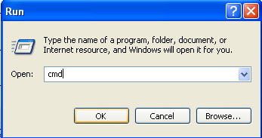

1. At the command prompt, go to the \bin subdirectory under the Postgresql program directory.
   1. At the command prompt type cd \ and press the Enter key.

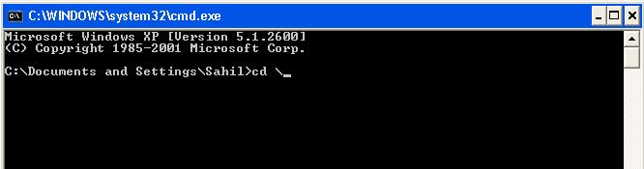

* 1. Type cd Program files\postgresql\8.3\bin and press the Enter key. (Note the number in the string refers to the PostgreSQL version- in this case, the version is 8.3)

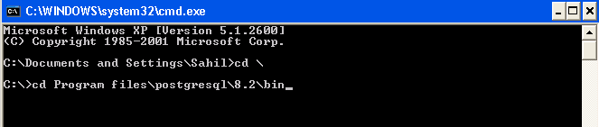

1. Type in the following command, and press the Enter key

psql –d database name –U user name

where *database name* is the name of the data base you are populating and *user name* is the user name you set up when installing the database. For example, if the *database name* is CEMDAP_Test_Data and *user name* is postgres, the command should be:

psql –d CEMDAP_Test_Data –U postgres

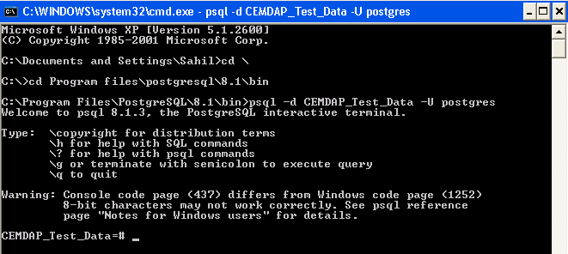

This command will direct you to the corresponding database with the database name as defined above. Note: the prompt is updated as the database name; in the example it becomes CEMDAP_Test_Data= #)

1. Once at the new prompt, type in the following command, and press the Enter key:

\copy name of the table from filename

For example, if the *name of the table* is households and the *filename* is households.dat, the command would be the following:

\copy households from ‘C:\\Program Files\\PostgreSQL\\8.3\\bin\\TestData\\households.dat’

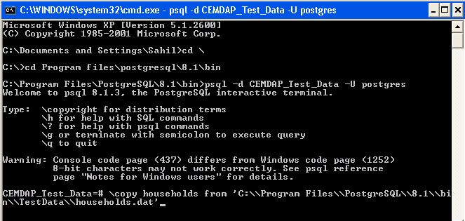

Note: *name of the table* corresponds to an empty table created in pgAdmin III under the Table icon, and *filename* is the complete path name of the file from which data is to be loaded.

1. Repeat Step 4 for each table that needs to be populated with data.
2. Exit the Command Prompt window.

**Chapter-6**

Currently, CEMSELTS is available only as a Visual C++ (VC++) Project. To run CEMSELTS, open the project in VC++. Set the compilation environment as Debug Win32. Compile the file called SimCoordinator.cpp. Once compiled without any error, go to the folder named “Debug” (which should be located inside the place, where you stored your CEMSELTS project). Click on the Debug folder and you will see the application file. Double-click on the application to launch CEMSELTS. By default, CEMSELTS runs for the base year. If you want CEMSELTS to evolve population for some future year, set the variable int numSimYears to its proper value in SimCoordinator.cpp. For example - if the base year population corresponds to the year 2003 and you want to simulate the population for year 2008, set the variable int numSimYears equal to the difference between 2008 and 2003 (2008 - 2003=5). Once, you’ve made all the required changes, compile the file one more time and launch CEMSELTS by double-clicking the application in Debug folder. This opens up the following main window of CEMSELTS, as shown below.



The main CEMSELTS window remains open as long as the software is being used, and it hosts the important menu items and other dialog boxes. The primary functionality of CEMSELTS lies within the menu commands. These commands are available in the menu bar - their functions, are tabulated below.

# Data Menu

|  |  |
| --- | --- |
| Choose… | To… |
| *Input* | Load the input data. The input data must be ‘registered’ prior to loading it (see the next section for instruction) . |
| *Exit* | Quit the CEMSELTS environment. |

# Models Menu

|  |  |
| --- | --- |
| Choose… | To… |
| *Load* | Load the model configurations from file . |

# Simulation Menu

|  |  |
| --- | --- |
| Choose… | To… |
| *Run* | Initiate a simulation run. (Note :the input data must be loaded and the complete model system configured prior to using the *Run* command). |

# Registering the Input Database

The input database, which is in the PostgreSQL database format, must be registered before it can be loaded in CEMDAP. The database registration should be done each time a new database is used. PostgreSQL should be installed in the computer prior to running CEMDAP. Further, data needs to be populated into the PostgreSQL database (the reader is referred to Appendix B for installation and database loading instructions). After installation of PostgreSQL and populating the database, follow the instructions below to register an input file.

1. Click on the Input command in the Data Menu of CEMSELTS.

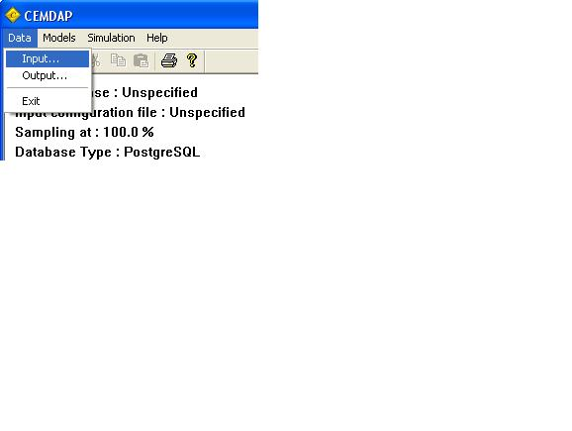

1. In the Select Data Source dialog that opens up, select the Machine Data Source tab and click on the New button.

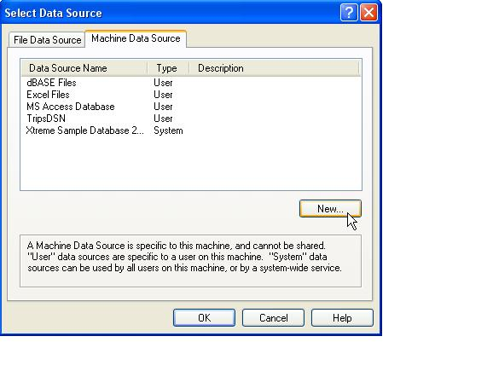

1. In the Create New Data Source dialog that opens up, select the System Data Source button and click on the Next button.

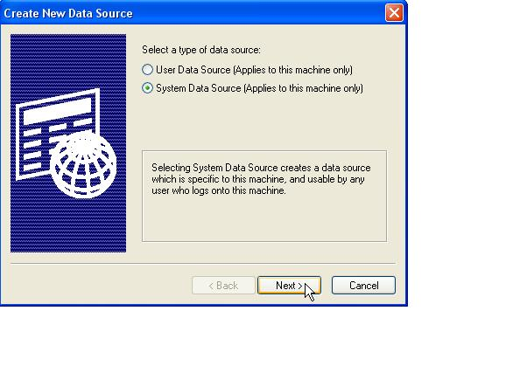

1. Scroll down and select the PostgreSQL ANSI driver from the list of drivers and click Next as displayed below.

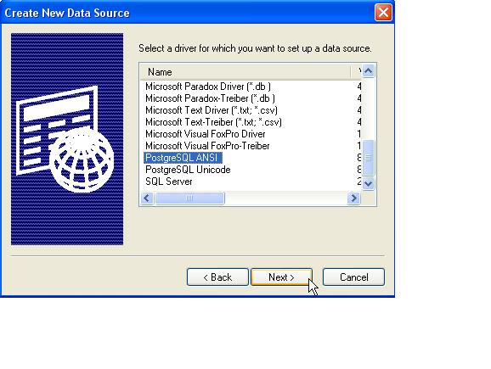

1. Once you click Next, the following box will appear. Then, click Finish to open up the PostgreSQL ANSI ODBC dialog box.

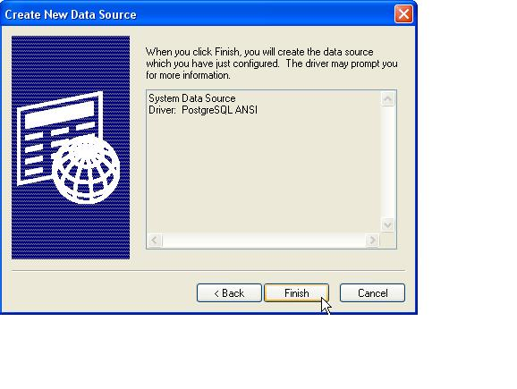

1. The PostgreSQL ANSI ODBC dialog box is shown below; enter the following information.

* Data Source: enter the name of the Data Source. (**Note: the data source can be given any name;** therefore you can simply leave the default name, such as CEM_Test_Data).
* Database: enter the database name. **Note: this name should be the same as the database name that was created during the data loading process described in Chapter 5**.
* Server: enter **localhost** as the name of the server.
* User Name and Password: enter the appropriate user name and password established during installation (as discussed in Chapter 5).
* Description: provide a description of the database (example: Test Data).
* SSL Mode: select prefer as the SSL Mode.
* Port: enter **5432** as the port.

After entering all these items, click Save.

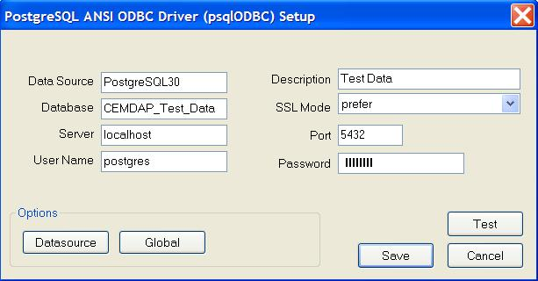

1. Finalize the database registration process by clicking OK to close the dialog boxes. CEMSELTS is now set up to access the database file you registered.

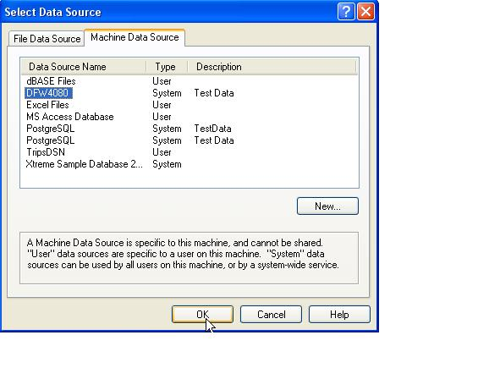

Input and Output Files

# Input Data Specification

The inputs required by CEMSELTS can be broadly classified into two categories: a) **data inputs**, which include the initial population characteristics, zonal descriptive, and level-of-service data of the transportation network; and b) **model parameters** for all the components of the embedded model system.

# Specify Input Database (Loading the Input Data File)

Any PostgreSQL database that satisfies the prescribed format (refer to Chapter 5), and that has been registered as explained above, can be loaded in CEMSELTS as input. The following procedure should be followed to load the input data.

Note: If the database has just been registered, this step (i.e., registering the input database) must be skipped. These steps are essential for loading an already registered database.

1. Click on the Input command in the Data menu.



1. In the Select Data Source dialog box that opens up, select the Machine Data Source tab (shown in Step 2 of the Registering the input Database section), and choose the registered data source to be loaded (for example, CEMDAP_Test_Data).

# Data Inputs

The data inputs to CEMSELTS are provided in the form of tables. There are six main types of tables. The hh and hh_orig tables contain the household-level characteristics of the population, and the Psn and psn_orig tables contain the person-level characteristics, both obtained from PoPGen. The zones_clts table comprises data on the characteristics of each of the traffic analysis zones. The Zone2Zone table includes data such as distance between each of the zonal pairs.

Each table contains several “required” data items or columns. These data include record identifiers (such as household ID and person ID), and other basic information required by the CEMSELTS modeling system. In addition, the Households and Persons tables may also have additional columns corresponding to additional explanatory variables used in the underlying empirical models. Overall, each exogenous variable must have a corresponding column in the appropriate table.

The data inputs must be in the PostgreSQL database format. The input tables in the PostgreSQL database must take titles as specified above and the variables must be of the ‘double’ type. The variable names are not pre-specified; each variable is identified by the specific table (table number) it belongs to, and the position (column number) of the variable in the table.

# Loading Model File

1. Select the Load command from the Models menu. A window will pop up enabling user to specify the model file.

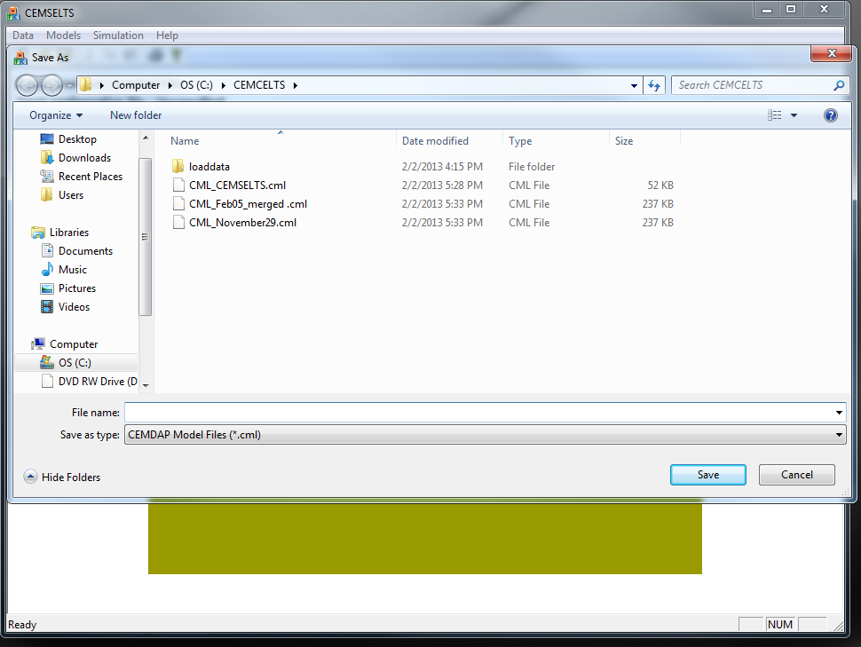

1. Select the required model file and click Save.

# Output Data Files

CEMSELTS writes the output in the database table named persons and households; thus, there is no need to specify a separate output path.

# Simulation Run

1. Click on the Run command in the Simulation menu. A window as shown below will pop up.

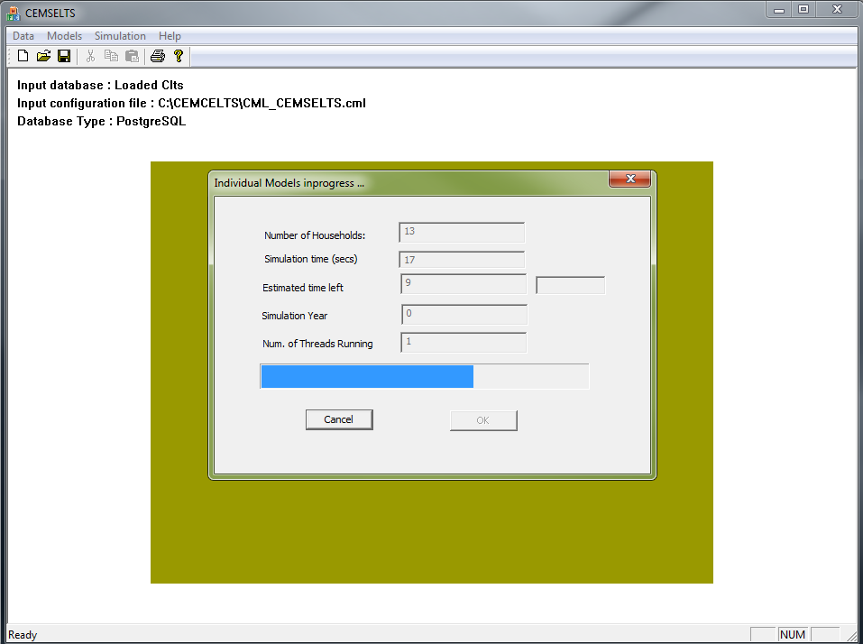

1. Once the simulation is complete, the notification area on the left top will change to “Simulation Completed Successfully”.

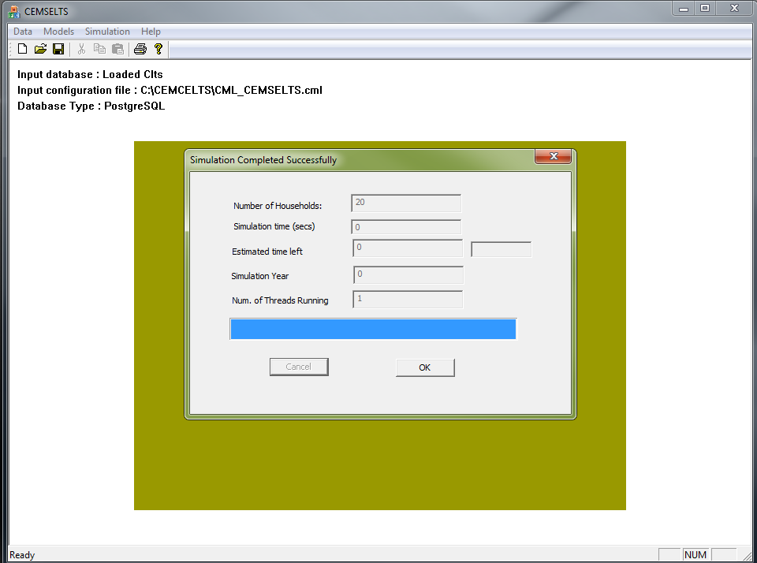

# Retrieve the Output

Open PostgreSQL and select the appropriate database. Go to the table option of database and open the “persons” and “households” tables. The files contain person and household information respectively.

**Appendix**

**Table A-1: CEMSELTS Model Components and Summary**

|  |  |  |  |  |
| --- | --- | --- | --- | --- |
| **Sl. Num.** | **Model Description** | **Model Type** | **Current Data Source** | **Comment** |
| ***Individual Models: Demographics & Mobility*** | | | | |
| 1 | Mortality Model | Binary Logit | California Department of Public Health |  |
| 2 | Birth Model | Binary Logit | California Department of Public Health |  |
| 3 | Base Year License Model | Binary Logit | FHWA |  |
| 4 | Obtain License Model | Binary Logit | Highway Statistics 2010 FHWA (California) |  |
| 5 | Maintain License Model | Binary Logit | *Rule Based* |  |
| ***Individual Models: Schooling Models*** | | | | |
| 6 | School location model | Multinomial Logit | SCAG Survey 2003 |  |
| 7 | College location model | Multinomial Logit | SCAG Survey 2003 |  |
| 8 | Base Year Dropout Rate Model | Binary Logit | SCAG Survey 2003 |  |
| 9 | Base Year Education Attainment Model | Multinomial Logit | SCAG Survey 2003 |  |
| ***Individual Models: Employment Models*** | | | | |
| 10 | Labor Participation Model | Binary Logit | SCAG Survey 2003 |  |
| 11 | Start Employment Model | Binary Logit | SCAG Survey 2003 |  |
| 12 | Employment Industry Model | Multinomial Logit | SCAG Survey 2003 |  |
| 13 | Work Flexibility Model | Ordered Probit | SCAG Survey 2003 |  |
| 14 | Work Duration Model | Multinomial Logit | SCAG Survey 2003 |  |
| 15 | Continue Employment Model | Multinomial Logit | Bureau of Labor Statistics 2012 | Currently a very simple constants only model is used. It is preferable to have a more comprehensive model based on survey data. |
| 16 | Household Income Model | Ordered Probit | SCAG Survey 2003 |  |
| 17 | Work location model | Multinomial Logit | SCAG Survey 2003 |  |

**Table A-1: CEMSELTS Evolution Model Components (Continued)**

|  |  |  |  |  |
| --- | --- | --- | --- | --- |
| **Sl. Num.** | **Model Description** | **Model Type** | **Current Data Source** | **Comment** |
| ***Household Formation Models*** | | | | |
|  |  |  |  |  |
| 18 | Marriage Model | Binary Logit | National Survey of Family Growth - CDC (2006-2010) |  |
| 19 | Divorce Model | Binary Logit | National Survey of Family Growth - CDC (2006-2010) |  |
| 20 | Child Custody Model |  | *No Data* | Need data to estimate model |
| 21 | Resource allocation Model |  | *No Data* | Need data to estimate model |
| 22 | Move In Model | Binary Logit | *No Data* | Need data to estimate model - ignoring the move-in process can potentially lead to over-estimation of single person households. |
| 23 | Husbands Age Model | Multinomial Logit | National Survey of Family Growth - CDC (2006-2010) |  |
| 24 | Move In Age Model | Multinomial Logit | *No Data* | Same as Move-in model |
| 25 | Move out Model | Multinomial Logit | Pew Research Center 2011 | Currently a very simple constants only model is used. It is preferable to have a more comprehensive model based on survey data. |
| 26 | Move In Gender Model | Binary Logit | *No Data* | Same as Move-in model |
| 27 | Husbands Race Model | Multinomial Logit | National Survey of Family Growth - CDC (2006-2010) |  |
| 28 | Husbands Educ Attainment Model | Multinomial Logit | National Survey of Family Growth - CDC (2006-2010) |  |
| ***Household-level long term choice models*** | | | | |
| 29 | Residential Mobility Model | Binary Logit | Rate based model (using data from London, UK) | We need data specific to LA (or California) |
| 30 | Residential Tenure Model | Binary Logit | SCAG Survey 2003 |  |
| 31 | Housing Type for Owners Model | Multinomial Logit | SCAG Survey 2003 |  |
| 32 | Housing Type for Renters Model | Multinomial Logit | SCAG Survey 2003 |  |
| 33 | Vehicle Ownership Model | Multinomial Logit | SCAG Survey 2003 |  |
| 34 | Residential location model | Multinomial Logit | SCAG Survey 2003 |  |
| 35 | Emigration Model | Binary Logit | US Census Bureau 2009 | We currently have a simple rate based model to predict net immigration rate (Immigration rate-Emigration rate). It is preferable to have a more comprehensive model based on household demographics for both emigration and immigration. |
| 36 | Immigration Model for non-single households | Binary Logit | US Census Bureau 2009 |
| 37 | Immigration Model for single households | Binary Logit | US Census Bureau 2009 |

|  |  |  |  |  |  |
| --- | --- | --- | --- | --- | --- |
| **Table A-2 Drop-out rate look-up table** | | | | | |
| **Male** | | | | | |
| **Age** | **Hispanic** | **NH White** | **NH Black** | **NH Native** | **NH Asian** |
| 13 | 0.006 | 0.006 | 0.015 | 0.032 | 0.005 |
| 14 | 0.013 | 0.005 | 0.030 | 0.033 | 0.008 |
| 15 | 0.048 | 0.010 | 0.020 | 0.049 | 0.011 |
| 16 | 0.049 | 0.016 | 0.054 | 0.058 | 0.011 |
| 17 | 0.050 | 0.014 | 0.077 | 0.042 | 0.012 |
| 18 | 0.056 | 0.028 | 0.070 | 0.056 | 0.016 |
| **Female** | | | | | |
| **Age** | **Hispanic** | **NH White** | **NH Black** | **NH Native** | **NH Asian** |
| 13 | 0.010 | 0.001 | 0.015 | 0.032 | 0.005 |
| 14 | 0.015 | 0.007 | 0.030 | 0.033 | 0.008 |
| 15 | 0.032 | 0.018 | 0.076 | 0.049 | 0.011 |
| 16 | 0.026 | 0.013 | 0.039 | 0.058 | 0.011 |
| 17 | 0.032 | 0.017 | 0.029 | 0.042 | 0.012 |
| 18 | 0.035 | 0.016 | 0.035 | 0.056 | 0.016 |

**Table A-2a School Drop-out Model**

|  |  |
| --- | --- |
| **Variable** | **Parameter** |
| Hispanic Male Age 13 | -5.09246 |
| Hispanic Male Age 14 | -4.33474 |
| Hispanic Male Age 15 | -2.99825 |
| Hispanic Male Age 16 | -2.97364 |
| Hispanic Male Age 17 | -2.94430 |
| Hispanic Male Age 18 | -2.82862 |
| White Male Age 13 | -5.13970 |
| White Male Age 14 | -5.38510 |
| White Male Age 15 | -4.55104 |
| White Male Age 16 | -4.13399 |
| White Male Age 17 | -4.25145 |
| White Male Age 18 | -3.53104 |
| African-American Male Age 13 | -4.20430 |
| African-American Male Age 14 | -3.45965 |
| African-American Male Age 15 | -3.86834 |
| African-American Male Age 16 | -2.87102 |
| African-American Male Age 17 | -2.47767 |
| African-American Male Age 18 | -2.58775 |
| Native-American Male Age 13 | -5.13776 |
| Native-American Male Age 14 | -4.69947 |
| Native-American Male Age 15 | -3.56883 |
| Native-American Male Age 16 | -3.72219 |
| Native-American Male Age 17 | -3.44081 |
| Native-American Male Age 18 | -3.30032 |
| Asian Male Age 13 | -5.25072 |
| Asian Male Age 14 | -4.77694 |
| Asian Male Age 15 | -4.52452 |
| Asian Male Age 16 | -4.46401 |
| Asian Male Age 17 | -4.37192 |
| Asian Male Age 18 | -4.09411 |
| Other Race Male Age 13 | -1.89139 |
| Other Race Male Age 14 | -1.86433 |
| Other Race Male Age 15 | -2.33014 |
| Other Race Male Age 16 | -1.86795 |
| Other Race Male Age 17 | -2.55963 |
| Other Race Male Age 18 | -2.13553 |
| Hispanic Female Age 13 | -4.59475 |
| Hispanic Female Age 14 | -4.19154 |
| Hispanic Female Age 15 | -3.42554 |
| Hispanic Female Age 16 | -3.63576 |
| Hispanic Female Age 17 | -3.42151 |
| Hispanic Female Age 18 | -3.30845 |
| White Female Age 13 | -7.12530 |
| White Female Age 14 | -5.01900 |
| White Female Age 15 | -4.00659 |
| White Female Age 16 | -4.29413 |
| White Female Age 17 | -4.06198 |
| White Female Age 18 | -4.11985 |
| African-American Female Age 13 | -4.18537 |
| African-American Female Age 14 | -3.45965 |
| African-American Female Age 15 | -2.49361 |
| African-American Female Age 16 | -3.21360 |
| African-American Female Age 17 | -3.49918 |
| African-American Female Age 18 | -3.31507 |
| Native-American Female Age 13 | -5.13776 |
| Native-American Female Age 14 | -4.69947 |
| Native-American Female Age 15 | -3.56883 |
| Native-American Female Age 16 | -3.72219 |
| Native-American Female Age 17 | -3.44081 |
| Native-American Female Age 18 | -3.30032 |
| Asian Female Age 13 | -5.25072 |
| Asian Female Age 14 | -4.77694 |
| Asian Female Age 15 | -4.52452 |
| Asian Female Age 16 | -4.46401 |
| Asian Female Age 17 | -4.37192 |
| Asian Female Age 18 | -4.09411 |
| Other Race Female Age 13 | -1.89139 |
| Other Race Female Age 14 | -1.86433 |
| Other Race Female Age 15 | -2.33014 |
| Other Race Female Age 16 | -1.86795 |
| Other Race Female Age 17 | -2.55963 |
| Other Race Female Age 18 | -2.13553 |

**Table A-3 Educational Attainment table**

|  |  |  |  |  |  |  |
| --- | --- | --- | --- | --- | --- | --- |
| **Male** | | | | | | |
| **Educational Attainment** | **Hispanic** | **NH White** | **NH Black** | **NH Native** | **NH Asian** | **NH Other** |
| High School | 0.790 | 0.523 | 0.701 | 0.713 | 0.419 | 0.579 |
| Associate's | 0.075 | 0.083 | 0.099 | 0.095 | 0.088 | 0.088 |
| Bachelor's | 0.093 | 0.242 | 0.137 | 0.111 | 0.329 | 0.212 |
| Master's | 0.038 | 0.132 | 0.056 | 0.054 | 0.140 | 0.107 |
| Doctorate | 0.004 | 0.019 | 0.008 | 0.027 | 0.024 | 0.014 |
| **Female** | | | | | | |
| **Educational Attainment** | **Hispanic** | **NH White** | **NH Black** | **NH Native** | **NH Asian** | **NH Other** |
| High School | 0.787 | 0.590 | 0.681 | 0.734 | 0.437 | 0.606 |
| Associate's | 0.082 | 0.093 | 0.109 | 0.092 | 0.107 | 0.102 |
| Bachelor's | 0.089 | 0.214 | 0.142 | 0.115 | 0.352 | 0.202 |
| Master's | 0.039 | 0.095 | 0.063 | 0.048 | 0.096 | 0.078 |
| Doctorate | 0.003 | 0.009 | 0.005 | 0.011 | 0.008 | 0.013 |

**Table A-3a College Location Table**

|  |  |  |
| --- | --- | --- |
| **Variable** | **Parameter** | **t-stat** |
| Maximum employees of agriculture that can be reached within 10 minutes | -0.000227 | -2.26 |
| Maximum employees of transportation that can be reached within 10 minutes | -0.000055 | -6.72 |
| TAZ is a major college TAZ | 2.177 | 33.87 |
| TAZ is a minor college TAZ | 1.324 | 22.37 |
| Distance home to college | -0.138 | -48.39 |
| Person is Caucasian and TAZ belongs to a Caucasian dominated college TAZ | 0.372 | 3.18 |
| Person is Black or Caucasian and TAZ belongs to a Black and Hispanic dominated college TAZ | 0.332 | 2.25 |
| Person’s Household Income is less than 50k and TAZ belongs to low income student TAZ | 0.213 | 2.08 |
| Person’s Household Income is greater than 50k and TAZ belongs to high income student TAZ | 0.206 | 1.76 |
| Person is employed and TAZ belongs to Employed Student TAZ | 0.250 | 2.71 |
| **Goodness of Fit Measures** | | |
| Number of Observations | 2151 | |
| Log Likelihood Function | -6385 | |
| Pseudo R-squared | 0.4271 | |

**Table A-3b TAZ Lookup for College Location Model**

|  |  |  |  |  |  |
| --- | --- | --- | --- | --- | --- |
| **Zones with Colleges** | | | | | |
| 101050000 | 221230400 | 240340500 | 265110200 | 300000614 | 500490001 |
| 101060002 | 221270000 | 240420000 | 270170200 | 300000620 | 500500000 |
| 101070000 | 222181000 | 240670000 | 270220100 | 403030000 | 500570000 |
| 101100008 | 222270001 | 240860100 | 270230000 | 403070000 | 500710800 |
| 101100011 | 222401000 | 246080000 | 270300100 | 403110000 | 500720002 |
| 101110003 | 222460000 | 246340001 | 270300101 | 403140100 | 500730100 |
| 101120103 | 222470000 | 248270100 | 280050201 | 403150100 | 500730102 |
| 101130005 | 223110000 | 250030000 | 290100500 | 404080300 | 500730200 |
| 101130006 | 224200000 | 250400100 | 292033000 | 404140500 | 500840400 |
| 101150001 | 226110100 | 253040000 | 300000044 | 404170200 | 500860002 |
| 101160001 | 226510000 | 254240200 | 300000146 | 404220200 | 500990300 |
| 101200003 | 226530101 | 254330500 | 300000152 | 404220900 | 501000400 |
| 101210002 | 226530104 | 254332100 | 300000153 | 404221100 | 501001200 |
| 211510200 | 226530105 | 254332101 | 300000188 | 404260503 | 501001400 |
| 211520200 | 226530500 | 254350100 | 300000190 | 404271202 | 501041400 |
| 212360100 | 226551000 | 255380100 | 300000191 | 404321601 | 501041600 |
| 213930100 | 227650000 | 255451400 | 300000192 | 404322101 | 501200000 |
| 218160000 | 229430000 | 255452100 | 300000199 | 404350900 | 600150200 |
| 219141000 | 229490000 | 257120000 | 300000226 | 404510700 | 600180001 |
| 219142000 | 229621000 | 257330000 | 300000265 | 404510800 | 600270000 |
| 219200000 | 230080000 | 257350001 | 300000267 | 404570200 | 600280003 |
| 219270000 | 240080000 | 257460100 | 300000341 | 404610200 | 600470300 |
| 220170001 | 240150000 | 257470000 | 300000365 | 500060200 | 600490000 |
| 220310000 | 240180000 | 257490100 | 300000379 | 500160000 | 600500200 |
| 220320000 | 240190100 | 257520100 | 300000415 | 500200901 | 600630100 |
| 220710000 | 240190200 | 260030200 | 300000440 | 500210005 | 600630200 |
| 220872000 | 240240200 | 260360000 | 300000442 | 500450200 | 600760403 |
| 221001000 | 240240300 | 265000100 | 300000536 | 500450201 | 600800200 |
| 221111000 | 240240400 | 265090101 | 300000537 | 500460100 | -- |
| 221220400 | 240320000 | 265090200 | 300000565 | 500490000 | -- |

**Table A-3b (continued) TAZ Lookup for College Location Model**

|  |  |  |  |  |  |  |  |  |
| --- | --- | --- | --- | --- | --- | --- | --- | --- |
| **Major Education TAZ** | **Caucasian Education TAZ** | | **Hispanic African American TAZ** | **High Income Student TAZ** | | | **Low Income Student TAZ** | **Employed Student TAZ** |
| 101120103 | 300000191 | | 101120103 | 101120103 | | | 227650000 | 101210002 |
| 211510200 | 600270000 | | 222401000 | 222401000 | | | 229430000 | 227650000 |
| 222401000 | 600760403 | | 254332100 | 223110000 | | | 240340500 | 229430000 |
| 223110000 | 226510000 | | -- | 226551000 | | | 254332100 | 250030000 |
| 226510000 | -- | | -- | 253040000 | | | 257460100 | 254332100 |
| 246340001 | -- | | -- | 404350900 | | | 300000191 | 257470000 |
| 254332100 | -- | | -- | 501041600 | | | 500450200 | 270300101 |
| 257460100 | -- | | -- | -- | | | 600760403 | 300000620 |
| 260360000 | -- | | -- | -- | | | -- | 500450200 |
| 270220100 | -- | | -- | -- | | | -- | -- |
| 300000191 | -- | | -- | -- | | | -- | -- |
| 300000620 | -- | | -- | -- | | | -- | -- |
| 403070000 | -- | | -- | -- | | | -- | -- |
| 404220200 | -- | | -- | -- | | | -- | -- |
| 500450201 | -- | | -- | -- | | | -- | -- |
| 600270000 | -- | | -- | -- | | | -- | -- |
| 600760403 | -- | | -- | -- | | | -- | -- |
| **Minor Education TAZ** | | | | | | | | |
| 101100011 | | 226530101 | 240340500 | | 265000100 | 300000614 | | 500450200 |
| 101130006 | | 226551000 | 248270100 | | 270230000 | 403030000 | | 500500000 |
| 101210002 | | 227650000 | 250030000 | | 270300101 | 404080300 | | 500840400 |
| 212360100 | | 229430000 | 253040000 | | 300000044 | 404271202 | | 501001200 |
| 213930100 | | 230080000 | 255452100 | | 300000341 | 404350900 | | 501041600 |
| 219142000 | | 240240300 | 257120000 | | 300000442 | 404510700 | | 600180001 |
| 220170001 | | 240240400 | 257470000 | | 300000537 | 500200901 | | 600470300 |
| 222460000 | | -- | -- | | -- | -- | | -- |

**Table A-4 Labor Participation Model**

|  |  |  |  |
| --- | --- | --- | --- |
| **Variable** | | **Parameter** | **t-stat** |
| Constant | | -1.653 | -25.53 |
| Female | | -0.753 | -23.11 |
| *Age* | |  |  |
|  | 16 - 40 years | 2.852 | 62.91 |
|  | 41 - 60 years | 2.514 | 60.86 |
| *Education Level* | |  |  |
|  | High School | 0.520 | 11.08 |
|  | College, associate or bachelors | 0.981 | 20.21 |
|  | Post Graduate, Masters or PhD | 1.370 | 21.78 |
| *Presence and age of own children* | |  |  |
|  | Presence of children of age <16 years | 0.288 | 7.02 |
|  | Female with own children under 6 years | -1.048 | -17.58 |
| *Ethnicity* | |  |  |
|  | White | -0.170 | -3.47 |
|  | Hispanic | -0.184 | -3.43 |
|  | African American | -0.230 | -2.97 |
| **Goodness of Fit Measures** | | | |
| Number of Observations | | 26689 | |
| Log Likelihood Function | | -13504 | |
| McFadden's LRI | | 0.2701 | |

|  |  |  |  |  |  |  |  |  |  |  |  |
| --- | --- | --- | --- | --- | --- | --- | --- | --- | --- | --- | --- |
| **Table A-5 Employment industry model** | | | | | | | | | | | |
| **Variable** | **Construction and Manufacturing** | | **Trade and Transportation** | | **Professional Business** | | | **Government** | | **Retail** | |
| **Parameter** | **t-stat** | **Parameter** | **t-stat** | **Parameter** | | **t-stat** | **Parameter** | **t-stat** | **Parameter** | **t-stat** |
| Constant | -0.417 | -5.88 | -0.368 | -2.66 | 1.363 | | 20.11 | -1.173 | -16.98 | -0.005 | -0.07 |
| Male | 0.919 | 13.95 | 0.586 | 5.33 | -0.491 | | -11.09 | -- | -- | -0.172 | -2.69 |
| Female*Non-Caucasian | -- | -- | -0.594 | -3.87 | -- | | -- | -0.106 | -1.04 | -- | -- |
| Age 16 to 25 years | -0.323 | -3.54 | -0.215 | -1.93 | 0.341 | | 5.02 | -- | -- | 0.665 | 7.66 |
| Age 26 to 40 years | -- | -- | -- | -- | 0.127 | | 3.33 | -- | -- | -- | -- |
| Age 41 to 65 years | -- | -- | -- | -- | -- | | -- | -- | -- | -0.310 | -4.78 |
| *Education Level* |  |  |  |  |  | |  |  |  |  |  |
| High School | -- | -- | -0.153 | -1.58 | -- | | -- | -- | -- | -- | -- |
| Associates | -0.378 | -5.23 | -0.191 | -1.72 | 0.295 | | 5.69 | 0.517 | 5.56 | -- | -- |
| Bachelors | -0.563 | -6.36 | -0.561 | -4.26 | 0.834 | | 12.81 | 0.578 | 5.61 | -0.127 | -1.47 |
| Post Graduate | -0.861 | -6.89 | -0.759 | -4.35 | 1.224 | | 14.76 | 0.719 | 5.65 | -0.796 | -5.54 |
| *Race* |  |  |  |  |  | |  |  |  |  |  |
| White | -- | -- | -0.665 | -7.56 | -0.181 | | -3.28 | -- | -- | -- | -- |
| Asian | -- | -- | -0.423 | -2.33 | -- | | -- | -- | -- | -- | -- |
| Hispanic | 0.263 | 4.01 | -- | -- | -0.270 | | -4.16 | -- | -- | -0.265 | -3.60 |
| African American | -0.547 | -3.85 | -- | -- | -- | | -- | 0.706 | 5.91 | -0.421 | -3.12 |
| **Goodness of Fit Measures** | | | | | | | | | | | |
| Number of Observations | | | | | | 17136 | | | | | |
| Log Likelihood Function | | | | | | 22543 | | | | | |

**Table A-6 Employment location choice model**

|  |  |  |
| --- | --- | --- |
| **Variable** | **Parameter** | **t-stat** |
|
| LN (Population / 104) | -0.066 | -2.54 |
| LN (Total Employment / 104) | 0.758 | 18.37 |
| Fraction of Service employment * Professional business | 1.406 | 5.17 |
| Fraction of retail employment | 3.519 | 3.93 |
| CBD | 0.159 | 1.59 |
| LN (Median Income /1000) | 0.179 | 3.88 |
| Same Zone | 3.148 | 24.40 |
| Adjacent zone | 0.978 | 6.36 |
| Auto IVTT | -0.055 | -22.97 |
| Female*Auto IVTT | -0.013 | -3.71 |
| Grade Less than 11* Auto IVTT | -0.015 | -1.82 |
| Construction & Manufacturing * Maximum Manufacturing accessibility | 0.224 | 2.11 |
| Government*Maximum Armed forces accessibility | 3.844 | 2.47 |
| Professional Business* Maximum Art accessibility | 0.459 | 1.68 |
| **Goodness of Fit Measures** | | |
| Number of observations | 786 | |
| Log-Likelihood | -4478.82 | |

**Table A-7 Work Duration model**

|  |  |  |  |  |  |
| --- | --- | --- | --- | --- | --- |
| **Variable** | | **Work Duration: 35-45 hours** | | **Work Duration: > 45 hours** | |
| **Estimate** | **t-stat** | **Estimate** | **t-stat** |
| Constant | | 0.465 | 6.18 | -0.587 | -5.14 |
| *Age* | |  |  |  |  |
|  | 16 to 40 | 1.082 | 13.88 | 1.351 | 14.17 |
|  | 41 to 60 | 1.099 | 14.09 | 1.443 | 15.24 |
| *Sex* | |  |  |  |  |
|  | Female | -0.820 | -13.26 | -1.414 | -24.32 |
|  | Female with young kid | -0.340 | -4.20 | -0.577 | -5.17 |
|  | Hispanic | -- | -- | -0.437 | -8.53 |
| *Education* | |  |  |  |  |
|  | High School | -- | -- | 0.229 | 3.02 |
|  | Associate or Bachelors | -- | -- | 0.621 | 8.36 |
|  | Post Graduate | -- | -- | 0.879 | 10.42 |
| *Industry* | |  |  |  |  |
|  | Construction | 0.726 | 8.00 | 0.861 | 8.96 |
|  | Government | 1.195 | 8.45 | 1.195 | 6.71 |
|  | Transportation | 0.288 | 2.59 | 0.582 | 4.92 |
|  | Professional * Female | 0.120 | 2.13 | -- | -- |
|  | Government * Female | -- | -- | -0.358 | -1.90 |
|  | Government * age 41-60 | -- | -- | -0.496 | -3.05 |
| **Goodness of Fit Measures** | | | | | |
| Number of Observations | | 14999 | | | |
| Log Likelihood Function | | -14060 | | | |
| Mc Fadden’s LRI | | 0.1467 | | | |

**Table A-8 Work Schedule Flexibility Model**

|  |  |  |  |
| --- | --- | --- | --- |
| **Variable** | | **Parameter** | **t-stat** |
| Threshold 1 | | 0.054 | 2.41 |
| Threshold 2 | | 0.148 | 6.59 |
| Threshold 3 | | 0.339 | 15.08 |
| Female | | -0.323 | -15.22 |
| *Race* | |  |  |
|  | Hispanic | -0.190 | -4.31 |
|  | White | -0.237 | -9.57 |
| *Industry* | |  |  |
|  | Professional | -0.118 | -5.06 |
|  | Government | -0.367 | -7.73 |
|  | Retail | 0.108 | 2.85 |
| *Work Duration* | |  |  |
|  | less than 20 hours per week | 0.589 | 12.23 |
|  | between 20 to 40 hours per week | 0.496 | 18.13 |
| *Education* | |  |  |
|  | Bachelors or Post graduate | 0.158 | 7.20 |
| **Goodness of Fit Measures** | | | |
| Number of Observations | | 15261 | |
| Likelihood Ratio | | 847 | |

**Table A-9 Household Income Model**

|  |  |  |  |
| --- | --- | --- | --- |
| **Variable** | | **Parameter** | **t-stat** |
| Threshold 1 | | 0.000 | -- |
| Threshold 2 | | 0.920 | -- |
| Threshold 3 | | 1.250 | -- |
| Threshold 4 | | 1.610 | -- |
| Threshold 5 | | 2.010 | -- |
| Threshold 6 | | 2.300 | -- |
| Threshold 7 | | 2.710 | -- |
| *Household Characteristics* | |  |  |
|  | White | 0.629 | 45.65 |
|  | Hispanic | 0.150 | 9.15 |
|  | Presence of elderly individuals (age ≥ 65 years) | -0.041 | -2.39 |
|  | Number of individuals having high school degree | 0.222 | 20.47 |
|  | Number of individuals having college degree | 0.487 | 46.39 |
|  | Number of individuals having post graduate degree | 0.708 | 47.43 |
|  | Number of students in household | -0.034 | -5.02 |
| *Employment Type Variables* | |  |  |
|  | Number of people in Trade and Transportation | 0.256 | 17.04 |
|  | Number of workers in Professional business | 0.304 | 29.50 |
|  | Number of workers in Government sector | 0.304 | 29.50 |
|  | Number of workers in Retail and repair | 0.191 | 9.81 |
|  | Number of workers in construction and management | 0.304 | 29.50 |
|  | Number of workers in other business | 0.256 | 17.04 |
| Variance |  | 0.702 | 143.69 |
| **Goodness of Fit Measures** | | | |
| Number of Observations | | 13117 | |
| Log Likelihood Function | | -24056.58 | |

**Table A-10 Residential Tenure Model**

|  |  |  |  |
| --- | --- | --- | --- |
| **Variable** | | **Parameter** | **t-stat** |
| Constant | | -.334 | -4.85 |
| Large Household (size ≥ 5) | | .295 | 3.76 |
| *Income level* | |  |  |
|  | Medium Income ($35,000 - $50,000) | .801 | 13.07 |
|  | Upper Middle Income ($50,00 - $74,999) | 1.388 | 24.17 |
|  | High Income ($75,000 - $150,00 or more) | 2.125 | 33.04 |
| *Household Characteristics* | |  |  |
|  | Hispanic Household | -.456 | -8.85 |
|  | African American Household | -.621 | -10.52 |
|  | Single Adult Household | -2.723 | -24.90 |
|  | Age of the Adult in Single Adult Household | .050 | 24.01 |
|  | Household with elderly persons | 1.782 | 21.26 |
|  | Presence of children in household (age ≤ 15) | .286 | 5.65 |
|  | Number of workers in household | -.131 | -4.20 |
|  | Household with high education persons (at least one post grad student) | .167 | 2.89 |
| **Goodness of Fit Measures** | | | |
| Number of Observations | | 13749 | |
| Log Likelihood Function | | -7260.8995 | |

**Table A-11 Housing Type for Owners**

|  |  |  |  |  |  |  |  |
| --- | --- | --- | --- | --- | --- | --- | --- |
| **Variable** | | **Single-family detached** | | **Single-family attached** | | **Mobile home or trailer** | |
| **Parameter** | **t-stat** | **Parameter** | **t-stat** | **Parameter** | **t-stat** |
| Constant | | -- | -- | -1.397 | -8.42 | -1.699 | -8.71 |
| *Income Level* | |  |  |  |  |  |  |
|  | Middle Income ($35,000-$50,000) | 0.965 | 6.83 | 1.066 | 6.20 | -- | -- |
|  | Upper Middle Income ($50,00 - $74,999) | 1.501 | 10.51 | 1.749 | 10.90 | -- | -- |
|  | High Income ($75,000 - $150,00 or more) | -- | -- | -- | -- | -2.428 | -13.14 |
| *Household Characteristics* | |  |  |  |  |  |  |
|  | Household size | 0.126 | 2.59 | -0.376 | -5.44 | -- | -- |
|  | Single Adult Household | -0.294 | -3.22 | -- | -- | -- | -- |
|  | Household with elderly persons (age ≥ 65) | -0.160 | -1.52 | -0.525 | -4.05 | -- | -- |
|  | Household with children (age ≤ 15) | -- | -- | 0.228 | 1.64 | -- | -- |
|  | Caucasian Household | -- | -- | -- | -- | 0.612 | 4.81 |
|  | Highest education in household is bachelors or higher | 0.602 | 5.79 | 0.969 | 7.61 | -- | -- |
| **Goodness of Fit Measures** | | | | | | | |
| Number of Observations | | 8377 | | | | | |
| Log Likelihood Function | | -4176.75 | | | | | |

**Table A-12 Housing Type for Renters**

|  |  |  |  |  |  |  |  |
| --- | --- | --- | --- | --- | --- | --- | --- |
| **Variable** | | **Single-family detached** | | **Single-family attached** | | **Apartment** | |
| **Parameter** | **t-stat** | **Parameter** | **t-stat** | **Parameter** | **t-stat** |
| Constant | | -1.379 | -8.74 | -1.626 | -11.20 | -- | -- |
| *Household Income* | |  |  |  |  |  |  |
|  | Low Income (< $35,000) | -0.144 | -1.77 | 0.122 | 1.31 | -- | -- |
|  | High Income (> $75,000) | 0.220 | 1.97 | 0.348 | 2.59 | -- | -- |
| *Race of Household* | |  |  |  |  |  |  |
|  | Caucasian | 0.325 | 3.32 | -- | -- | -- | -- |
|  | Asian | -0.364 | -2.28 | -- | -- | -- | -- |
|  | Hispanic | 0.354 | 3.23 | 0.821 | 8.80 | -- | -- |
|  | African American | -- | -- | -- | -- | 0.170 | 1.76 |
| *Other Household Characteristics* | |  |  |  |  |  |  |
|  | Household size | 0.356 | 10.75 | 0.174 | 3.82 | -- | -- |
|  | Household with elderly persons (age ≥ 65) | -0.148 | -1.23 | -0.260 | -1.84 | -- | -- |
|  | Household with children (age ≤ 15) | -- | -- | 0.229 | 2.13 | -- | -- |
|  | Single Adult Household | -- | -- | -- | -- | 0.172 | 2.14 |
|  | Highest education in household is bachelors or higher | -0.338 | -4.35 | -0.278 | -3.14 | -- | -- |
| **Goodness of Fit Measures** | | | | | | | |
| Number of Observations | | 5113 | | | | | |
| Log Likelihood Function | | -4835.68 | | | | | |

**Table A-13 Estimation Results of MDCEV Component for Vehicle Holdings**

|  |  |  |  |  |  |  |  |  |  |  |
| --- | --- | --- | --- | --- | --- | --- | --- | --- | --- | --- |
| **Variable 🡪** | **Household Race** | | | | | | | | **Number of Adult** | |
| **Black** | | **Hispanic** | | **Asian** | | **Caucasian** | |
| **Param.** | **t-stats** | **Param.** | **t-stats** | **Param.** | **t-stats** | **Param.** | **t-stats** | **Param.** | **t-stats** |
| Sub-compact | -1.017 | -1.896 | -- | -- | -- | -- | -- | -- | -0.266 | -2.321 |
| Compact car | -- | -- | -- | -- | -- | -- | -0.0735 | -1.186 | -0.147 | -1.712 |
| mid size car | -- | -- | -- | -- | -- | -- | -- | -- | -0.263 | -3.206 |
| Large car | 0.530 | 2.035 | -- | -- | -- | -- | -- | -- | -0.151 | -1.419 |
| Small SUV | -- | -- | -- | -- | -- | -- | -- | -- | -0.488 | -4.637 |
| Mid Sized SUV | -- | -- | -- | -- | -- | -- | -- | -- | -0.469 | -4.312 |
| Large SUV | -- | -- | -- | -- | -0.316 | -1.575 | -0.1865 | -2.374 | -0.195 | -2.102 |
| Van | -- | -- | -- | -- | -1.336 | -4.158 | -- | -- | -0.121 | -1.252 |
| Pickup | -0.888 | -2.898 | -- | -- | -- | -- | -- | -- | -0.254 | -3.181 |
| Less than 2 years | -- | -- | -- | -- | -- | -- | -- | -- | -- | -- |
| 2 to 3 years | -- | -- | -- | -- | -- | -- | -- | -- | -- | -- |
| 4 to 5 years | 0.234 | 1.305 | -- | -- | 0.334 | 2.286 | -- | -- | -- | -- |
| 6 to 9 years | -- | -- | -- | -- | -- | -- | -- | -- | -- | -- |
| 10 to 12 years | -- | -- | -- | -- | -- | -- | 0.089 | 1.659 | -- | -- |
| More than 12 years | -- | -- | -- | -- | -- | -- | 0.089 | 1.659 | -- | -- |

**Table A-13 (Continued) Estimation Results of MDCEV Component for Vehicle Holdings**

|  |  |  |  |  |  |  |  |  |  |  |  |  |
| --- | --- | --- | --- | --- | --- | --- | --- | --- | --- | --- | --- | --- |
| **Variable 🡪** | **Number of Male Adults** | | **Household Income** | | **Number of Children by age group** | | | | | | **Number of Senior Member** | |
| **0-4 years** | | **5-12 years** | | **13-15 years** | |
| **Param.** | **t-stats** | **Param.** | **t-stats** | **Param.** | **t-stats** | **Param.** | **t-stats** | **Param.** | **t-stats** | **Param.** | **t-stats** |
| Sub-compact | -- | -- | 0.025 | 1.816 | -0.468 | -2.718 | -- | -- | -0.373 | -1.921 | -0.182 | -3.358 |
| Compact car | -0.142 | -2.445 | -- | -- | -0.138 | -2.032 | -0.119 | -1.888 | -- | -- | -- | -- |
| mid size car | -- | -- | 0.033 | 4.943 | -- | -- | -0.201 | -3.230 | -- | -- | -- | -- |
| Large car | -- | -- | 0.068 | 6.134 | -- | -- | -0.232 | -1.761 | -- | -- | 0.207 | 3.142 |
| Small SUV | -- | -- | 0.037 | 2.890 | -0.238 | -1.408 | -0.219 | -1.522 | -- | -- | -- | -- |
| Mid Sized SUV | -0.085 | -0.982 | 0.052 | 5.697 | -- | -- | -- | -- | -- | -- | -- | -- |
| Large SUV | -- | -- | 0.090 | 10.701 | 0.376 | 5.714 | 0.229 | 3.513 | 0.334 | 4.374 | -- | -- |
| Van | -- | -- | -- | -- | 0.353 | 4.187 | 0.476 | 6.427 | 0.481 | 5.382 | -- | -- |
| Pickup | -- | -- | 0.030 | 3.475 | -- | -- | -- | -- | -- | -- | -0.097 | -1.690 |
| Less than 2 years | -- | -- | -- | -- | -- | -- | -- | -- | -- | -- | -- | -- |
| 2 to 3 years | -- | -- | -- | -- | 0.106 | 1.879 | -- | -- | -- | -- | -- | -- |
| 4 to 5 years | -- | -- | -0.011 | -1.431 | -- | -- | -- | -- | -- | -- | -- | -- |
| 6 to 9 years | -- | -- | -0.031 | -5.205 | -- | -- | -- | -- | -- | -- | -- | -- |
| 10 to 12 years | -- | -- | -0.062 | -7.926 | -- | -- | -- | -- | -- | -- | -- | -- |
| More than 12 years | -- | -- | -0.099 | -14.271 | -0.156 | -2.308 | -- | -- | -- | -- | -- | -- |

**Table A-13 (Continued) Estimation Results of MDCEV Component for Vehicle Holdings**

|  |  |  |  |  |  |  |  |  |  |  |
| --- | --- | --- | --- | --- | --- | --- | --- | --- | --- | --- |
| **Variable** | **Highest education level attained in household** | | | | **Number of Workers** | | **mean distance to work calculated among workers (in miles)** | | **Satiation Parameter\*** | |
| **Bachelor or Associate** | | **Postgraduation** | |
| **Param.** | **t-stats** | **Param.** | **t-stats** | **Param.** | **t-stats** | **Param.** | **t-stats** | **Param.** | **t-stats** |
| Sub-compact | -0.202 | -1.571 | -- | -- | -- | -- | -- | -- | 0.806 | 4.797 |
| Compact car | -- | -- | 0.309 | 4.145 | -- | -- | -- | -- | 0.830 | 7.590 |
| mid size car | -- | -- | 0.146 | 2.005 | -- | -- | -0.465 | -2.126 | 0.831 | 7.811 |
| Large car | -0.139 | -1.319 | -- | -- | -0.320 | -4.254 | -- | -- | 0.825 | 5.573 |
| Small SUV | -- | -- | -- | -- | -- | -- | -- | -- | 0.737 | 6.643 |
| Mid Sized SUV | -- | -- | -- | -- | 0.082 | 1.488 | -- | -- | 0.842 | 6.328 |
| Large SUV | -0.179 | -1.962 | -0.375 | -3.434 | -- | -- | -- | -- | 0.806 | 6.749 |
| Van | -- | -- | 0.281 | 2.577 | -- | -- | -- | -- | 0.847 | 5.619 |
| Pickup | -0.142 | -1.738 | -0.595 | -5.542 | -- | -- | 0.469 | 1.999 | 0.793 | 7.418 |
| Less than 2 years | -- | -- | -- | -- | -- | -- | -- | -- | -- | -- |
| 2 to 3 years | 0.072 | 1.078 | -- | -- | -- | -- | 0.598 | 2.665 | 0.836 | 4.109 |
| 4 to 5 years | -- | -- | -- | -- | -- | -- | -- | -- | 0.830 | 4.101 |
| 6 to 9 years | 0.113 | 2.082 | -- | -- | -- | -- | -- | -- | 0.826 | 4.305 |
| 10 to 12 years | -1.017 | -1.896 | -- | -- | -- | -- | -- | -- | 0.808 | 4.230 |
| More than 12 years | -- | -- | -- | -- | -- | -- | -- | -- | 0.737 | 4.570 |

* The t-statistics for the satiation parameters are computed with respect to the value of 1.

**Table A-13 Estimation Results of MNL Component for Primary Driver Allocation**

|  |  |  |  |  |  |  |  |  |  |  |
| --- | --- | --- | --- | --- | --- | --- | --- | --- | --- | --- |
| **Variable 🡪** | **Age** | | | | | | **Female** | | **Race** | |
| **16 to 25 years** | | **26 to 40 years** | | **41 to 65 years** | | **Caucasian** | |
| **Param.** | **t-stat** | **Param.** | **t-stat** | **Param.** | **t-stat** | **Param.** | **t-stat** | **Param.** | **t-stat** |
| No vehicle | -- | -- | -- | -- | -- | -- | -- | -- | -- | -- |
| Sub-compact | -- | -- | -0.271 | -3.062 | -0.294 | -4.250 | -0.248 | -4.590 | -0.274 | -2.057 |
| Compact car | -- | -- | -0.271 | -3.062 | -0.294 | -4.250 | -0.248 | -4.590 | -- | -- |
| mid size car | -0.359 | -3.436 | -0.260 | -2.713 | -0.239 | -3.030 | -0.249 | -4.910 | -- | -- |
| Large car | -0.359 | -3.436 | -0.260 | -2.713 | -0.239 | -3.030 | -0.614 | -8.716 | -- | -- |
| Small SUV | -- | -- | -- | -- | -- | -- | -0.614 | -8.716 | -- | -- |
| Mid Sized SUV | -- | -- | -- | -- | 0.172 | 2.087 | -- | -- | -- | -- |
| Large SUV | -0.627 | -3.449 | -- | -- | 0.151 | 1.721 | -0.231 | -3.204 | -- | -- |
| Van | -0.951 | -4.826 | -0.400 | -3.368 | -- | -- | -- | -- | -- | -- |
| Pickup | -0.825 | -6.856 | -0.215 | -2.242 | -- | -- | -1.987 | -23.144 | -- | -- |
| Less than 2 years | -0.468 | -3.756 | -- | -- | -- | -- | 0.573 | 11.067 | 0.086 | 1.889 |
| 2 to 3 years | -- | -- | -- | -- | -- | -- | 0.573 | 11.067 | 0.086 | 1.889 |
| 4 to 5 years | -- | -- | -- | -- | -- | -- | 0.581 | 9.616 | 0.086 | 1.889 |
| 6 to 9 years | -- | -- | -- | -- | -- | -- | 0.430 | 8.522 | 0.086 | 1.889 |
| 10 to 12 years | -- | -- | -- | -- | -- | -- | -- | -- | -- | -- |
| More than 12 years | -- | -- | -- | -- | -- | -- | -- | -- | -- | -- |

**Table A-13 (Continued) Estimation Results of MNL Component for Primary Driver Allocation**

|  |  |  |  |  |  |  |
| --- | --- | --- | --- | --- | --- | --- |
| **Variable→** | **Education Level** | | **Employment Status** | | **Distance to work less than 10 miles** | |
| **Bachelor or Associate** | | **Worker** | |
| **Param.** | **t-stat** | **Param.** | **t-stat** | **Param.** | **t-stat** |
| No vehicle | -- | -- | -- | -- | -- | -- |
| Sub-compact | -- | -- | 0.143 | 2.346 | -- | -- |
| Compact car | -- | -- | 0.143 | 2.346 | -- | -- |
| mid size car | -- | -- | 0.090 | 1.434 | -- | -- |
| Large car | -- | -- | 0.070 | 0.829 | -- | -- |
| Small SUV | -- | -- | 0.070 | 0.829 | -- | -- |
| Mid Sized SUV | -- | -- | -- | -- | 0.073 | 0.903 |
| Large SUV | -- | -- | -0.231 | -3.626 | 0.073 | 0.903 |
| Van | -- | -- | -0.231 | -3.626 | -- | -- |
| Pickup | -- | -- | -- | -- | -- | -- |
| Less than 2 years | 0.060 | 1.310 | 0.103 | 2.217 | -0.062 | -1.208 |
| 2 to 3 years | 0.060 | 1.310 | 0.103 | 2.217 | -0.062 | -1.208 |
| 4 to 5 years | 0.060 | 1.310 | -- | -- | -- | -- |
| 6 to 9 years | -- | -- | -- | -- | -- | -- |
| 10 to 12 years | -- | -- | -- | -- | -- | -- |
| More than 12 years | -- | -- | -- | -- | -- | -- |

**Table A-14 Vehicle Make Model**

|  |  |  |
| --- | --- | --- |
| **Variable** | **Parameter** | **t-stat** |
| Front Wheel Drive | 0.317 | 6.96 |
| Rear Wheel Drive | 0.214 | 5.28 |
| Base Wheel radius | 0.016 | 4.82 |
| Length | 0.003 | 1.06 |
| Width | 0.007 | 1.69 |
| Height | 0.030 | 7.08 |
| Annual fuel cost ($) | -0.0003 | -4.78 |
| Greenhouse Gas Rating | 0.065 | 6.09 |
| Purchase price($) / Household Income ($) | -0.383 | -6.18 |
| Length of vehicle * Household Size greater than 2 | 0.004 | 1.88 |
| Horse Power | 0.001 | 3.25 |
| Engine Liters | -0.005 | -2.08 |
| Horse Power/Liters | -0.006 | -5.69 |
| Honda | 1.071 | 28.29 |
| Toyota | 1.206 | 36.97 |
| BMW | 0.195 | 2.74 |
| Chevrolet | 0.524 | 13.57 |
| Ford | 0.719 | 20.05 |
| Dodge | -0.192 | -3.55 |
| Nissan | -0.103 | -1.81 |
| Volkswagen | 0.196 | 2.77 |

**Table A-15 Annual Mileage Model**

|  |  |  |
| --- | --- | --- |
| **Variable** | **Parameter** | **t-stat** |
| Constant | 1.937 | 64.00 |
| Household Size | .225 | 11.68 |
| Number of workers | .128 | 8.45 |
| Number of senior adults | -.078 | -4.36 |
| Household Income ($)/1000 | .002 | 11.29 |
| Number of male adults | .028 | 1.24 |
| Number of children ( ≤ 15 years) | -.175 | -7.73 |
| Mean distance to work (miles/100) | .008 | 13.12 |

**Table A-16 Mortality Model**

|  |  |
| --- | --- |
| **Variable** | **Parameter** |
| Hispanic male and age <1 years | -5.12967 |
| Hispanic male and age between 1-14 years | -8.55527 |
| Hispanic male and age between 15-24 years | -6.71741 |
| Hispanic male and age between 25-34 years | -6.7058 |
| Hispanic male and age between 35-44 years | -6.37053 |
| Hispanic male and age between 45-54 years | -5.563 |
| Hispanic male and age between 55-64 years | -4.80439 |
| Hispanic male and age between 65-74 years | -3.92618 |
| Hispanic male and age between 75-84 years | -3.03234 |
| Hispanic male and age >85 years | -2.26224 |
| White male and age <1 years | -5.28379 |
| White male and age between 1-14 years | -8.71705 |
| White male and age between 15-24 years | -7.10765 |
| White male and age between 25-34 years | -6.78714 |
| White male and age between 35-44 years | -6.1616 |
| White male and age between 45-54 years | -5.31466 |
| White male and age between 55-64 years | -4.6324 |
| White male and age between 65-74 years | -3.7669 |
| White male and age between 75-84 years | -2.74781 |
| White male and age >85 years | -1.68452 |
| African-American male and age <1 years | -4.10669 |
| African-American male and age between 1-14 years | -8.10194 |
| African-American male and age between 15-24 years | -6.10557 |
| African-American male and age between 25-34 years | -5.78989 |

**Table A-16 (continued) Mortality Model**

|  |  |
| --- | --- |
| **Variable** | **Parameter** |
| African-American male and age between 35-44 years | -5.51399 |
| African-American male and age between 45-54 years | -4.62897 |
| African-American male and age between 55-64 years | -3.93951 |
| African-American male and age between 65-74 years | -3.32147 |
| African-American male and age between 75-84 years | -2.46496 |
| African-American male and age >85 years | -1.77662 |
| Native American male and age <1 years | -4.58241 |
| Native American male and age between 1-14 years | -8.71232 |
| Native American male and age between 15-24 years | -7.2508 |
| Native American male and age between 25-34 years | -6.55685 |
| Native American male and age between 35-44 years | -5.75545 |
| Native American male and age between 45-54 years | -5.26335 |
| Native American male and age between 55-64 years | -4.60679 |
| Native American male and age between 65-74 years | -4.01462 |
| Native American male and age between 75-84 years | -3.32147 |
| Native American male and age >85 years | -3.13661 |
| Asian male and age <1 years | -5.45408 |
| Asian male and age between 1-14 years | -8.76001 |
| Asian male and age between 15-24 years | -7.53191 |
| Asian male and age between 25-34 years | -7.43961 |
| Asian male and age between 35-44 years | -6.91322 |
| Asian male and age between 45-54 years | -6.07088 |
| Asian male and age between 55-64 years | -5.17398 |
| Asian male and age between 65-74 years | -4.24747 |
| Asian male and age between 75-84 years | -3.25752 |
| Asian male and age >85 years | -2.12229 |
| others male and age <1 years | -5.79852 |
| others male and age between 1-14 years | -8.74828 |
| others male and age between 15-24 years | -7.0278 |
| others male and age between 25-34 years | -6.82355 |
| others male and age between 35-44 years | -6.05899 |
| others male and age between 45-54 years | -5.67495 |
| others male and age between 55-64 years | -4.83243 |
| others male and age between 65-74 years | -4.20246 |
| others male and age between 75-84 years | -3.54592 |
| others male and age >85 years | -3.30837 |
| Hispanic female and age <1 years | -5.33113 |
| Hispanic female and age between 1-14 years | -8.89254 |
| Hispanic female and age between 15-24 years | -8.01537 |

**Table A-16 (continued) Mortality Model**

|  |  |
| --- | --- |
| **Variable** | **Parameter** |
| Hispanic female and age between 25-34 years | -7.79091 |
| Hispanic female and age between 35-44 years | -7.10707 |
| Hispanic female and age between 45-54 years | -6.17936 |
| Hispanic female and age between 55-64 years | -5.33875 |
| Hispanic female and age between 65-74 years | -4.34812 |
| Hispanic female and age between 75-84 years | -3.38369 |
| Hispanic female and age >85 years | -2.37426 |
| White female and age <1 years | -5.36128 |
| White female and age between 1-14 years | -8.93867 |
| White female and age between 15-24 years | -7.92105 |
| White female and age between 25-34 years | -7.51299 |
| White female and age between 35-44 years | -6.71047 |
| White female and age between 45-54 years | -5.85142 |
| White female and age between 55-64 years | -5.0668 |
| White female and age between 65-74 years | -4.1137 |
| White female and age between 75-84 years | -3.08078 |
| White female and age >85 years | -1.84077 |
| African-American female and age <1 years | -4.35286 |
| African-American female and age between 1-14 years | -8.45281 |
| African-American female and age between 15-24 years | -7.63825 |
| African-American female and age between 25-34 years | -6.82822 |
| African-American female and age between 35-44 years | -5.94812 |
| African-American female and age between 45-54 years | -5.06888 |
| African-American female and age between 55-64 years | -4.47217 |
| African-American female and age between 65-74 years | -3.71173 |
| African-American female and age between 75-84 years | -2.85035 |
| African-American female and age >85 years | -1.90087 |
| Native American female and age <1 years | -4.11632 |
| Native American female and age between 1-14 years | -8.38172 |
| Native American female and age between 15-24 years | -7.8163 |
| Native American female and age between 25-34 years | -7.51664 |
| Native American female and age between 35-44 years | -6.36721 |
| Native American female and age between 45-54 years | -5.84884 |
| Native American female and age between 55-64 years | -5.03711 |
| Native American female and age between 65-74 years | -4.07972 |
| Native American female and age between 75-84 years | -3.52363 |
| Native American female and age >85 years | -2.97304 |
| Asian female and age <1 years | -5.71819 |
| Asian female and age between 1-14 years | -8.87631 |

**Table A-16 (continued) Mortality Model**

|  |  |
| --- | --- |
| **Variable** | **Parameter** |
| Asian female and age between 15-24 years | -8.28119 |
| Asian female and age between 25-34 years | -8.18701 |
| Asian female and age between 35-44 years | -7.4329 |
| Asian female and age between 45-54 years | -6.51751 |
| Asian female and age between 55-64 years | -5.62933 |
| Asian female and age between 65-74 years | -4.72526 |
| Asian female and age between 75-84 years | -3.66366 |
| Asian female and age >85 years | -2.39338 |
| others female and age <1 years | -5.6902 |
| others female and age between 1-14 years | -8.82848 |
| others female and age between 15-24 years | -8.41451 |
| others female and age between 25-34 years | -7.4118 |
| others female and age between 35-44 years | -6.87956 |
| others female and age between 45-54 years | -6.20707 |
| others female and age between 55-64 years | -5.40342 |
| others female and age between 65-74 years | -4.48952 |
| others female and age between 75-84 years | -3.70567 |
| others female and age >85 years | -3.2205 |

**Table A-17 Birth Model**

|  |  |
| --- | --- |
| **Variable** | **Parameter** |
| Female aging between 15-19 years | -3.415 |
| Female aging between 20-24 years | -2.426 |
| Female aging between 25-29 years | -2.170 |
| Female aging between 30-34 years | -2.180 |
| Female aging between 35-39 years | -2.807 |
| Female aging between 40-44 years | -4.154 |

**Table A-18 Base Year Driving License Model & Obtain License Model**

|  |  |
| --- | --- |
| **Variable** | **Parameter** |
| Constant | 8.0 |
| Age | -0.1 |

**Table A-19 Maintaining Driving License Model**

|  |  |
| --- | --- |
| **Variable** | **Parameter** |
| Constant | 4.00 |
| Age | -0.10 |

**Table A-20 Base Year Education Attainment Model**

|  |  |  |  |  |
| --- | --- | --- | --- | --- |
| **Variable** | **Alternatives** | | | |
| **Associate** | **Bachelor** | **Masters** | **Doctorate** |
| Hispanic Male | -2.355 | -2.139 | -3.034 | -5.286 |
| Hispanic Female | -2.265 | -2.183 | -3.008 | -5.573 |
| White Male | -1.841 | -0.771 | -1.377 | -3.315 |
| White Female | -1.727 | -0.894 | -1.706 | -4.062 |
| African-American Male | -1.957 | -1.633 | -2.527 | -4.473 |
| African-American Female | -1.861 | -1.597 | -2.409 | -4.943 |
| Native American Male | -2.016 | -1.860 | -2.580 | -3.274 |
| Native American Female | -2.048 | -1.825 | -2.698 | -4.172 |
| Asian Male | -1.561 | -0.242 | -1.096 | -2.860 |
| Asian Female | -1.365 | -0.174 | -1.474 | -3.958 |
| Others Male | -1.884 | -1.005 | -1.688 | -3.722 |
| Others Female | -1.736 | -1.053 | -2.005 | -3.796 |

**Table A-21 Continue Employment Model**

|  |  |  |  |  |
| --- | --- | --- | --- | --- |
| **Variable** | **Alternatives** | | | |
| **Continue** | **Retire** | **Quit** | **Switch** |
| Constant | 2.006 | 0.740 | 0.740 | -10.000 |

**Table A-22 Marriage Model**

|  |  |
| --- | --- |
| **Variable** | **Parameter** |
| Constant | -2.33 |
| Black | -0.275 |
| Hispanic | 0.0674 |
| Female 15-22 years | -0.268 |
| Female 23-30 years | 0.652 |

**Table A-23 Divorce Model**

|  |  |
| --- | --- |
| **Variable** | **Parameter** |
| Constant | -3.412 |
| Black | 0.814 |
| Hispanic | 0.575 |
| Female 15-22 years | 0.612 |
| Female 23-30 years | 0.251 |

**Table A-24 Move out Model**

|  |  |  |  |  |
| --- | --- | --- | --- | --- |
| **Variable** | **Alternatives** | |  | |
| **No** | **Independent Household** | **Join Existing Household** | **Out of Region** |
| Constant | 2.15 | 1.5 | 1.5 | 1.5 |

**Table A-25 Husband Age Choice Model**

|  |  |  |  |
| --- | --- | --- | --- |
| **Variable** | **Alternatives** | | |
| **<22 years** | **22-28 years** | **28-35 years** |
| Constant | -3.452 | -0.189 | 0.7322 |
| White | 0.428 | 0.148 | 0 |
| Black | -0.397 | -0.397 | -0.397 |
| Hispanic | 0.557 | 0 | 0 |
| Female 15-22 years | 7.119 | 3.9484 | 1.0841 |
| Female 23-30 | 3.6168 | 2.995 | 1.172 |

**Table A-26 Husband Race Choice Model**

|  |  |  |  |  |  |  |
| --- | --- | --- | --- | --- | --- | --- |
| **Variable** | **Alternatives** | | | | | |
| **Hispanic** | | **Non-hispanic white** | | **Non-hispanic black** | |
| **Parameter** | **t-stat** | **Parameter** | **t-stat** | **Parameter** | **t-stat** |
| Constant | -2.132 | -10.227 | 0.092 | 0.479 | -1.101 | -3.728 |
| Female 15-22 years | 0 | NA | -0.874 | -4.84 | -0.948 | -3.386 |
| Female 23-30 | 0 | NA | -0.522 | -2.872 | -0.725 | -2.6 |
| *Race* |  |  |  |  |  |  |
| White | 2.544 | 10.4 | 3.911 | 25.781 | 1.138 | 4.456 |
| Black | 2.224 | 6.09 | 0.818 | 2.657 | 5.219 | 18.135 |
| Hispanic | 5.562 | 20.312 | 2.335 | 10.56 | 2.004 | 6.601 |

|  |  |
| --- | --- |
| **Table A-27 Residential Mobility Model** | |
| **Variable** | **Parameter** |
| Constant | -2.785 |

**Table A-28 Vehicle Ownership Model**

|  |  |  |  |  |
| --- | --- | --- | --- | --- |
| **Variable** | **Alternative** | | | |
| **One Vehicle** | **Two vehicle** | **Three vehicle** | **Four and more vehicle** |
| Constant | 1.490 | 1.717 | 1.569 | 0.839 |
| Only one adult age greater than 15 and either student or employed | 0.282 | -2.062 | -3.752 | -3.988 |
| Only one adult age greater than 15 and neither student nor employed | -0.709 | -2.953 | -4.770 | -5.097 |
| Two adult age greater than 15 with one either student or employed and other nothing | 0 | 0 | -1.595 | -2.215 |
| Only two adult age greater than 15 and either student or employed | 0 | 0.538 | -1.064 | -1.774 |
| Only two adult age greater than 15 and neither student nor employed | 0 | 0 | -1.667 | -2.534 |
| Presence of children in household | -0.241 | -0.275 | -0.417 | -0.479 |
| Medium income household (35K-50K) | 1.412 | 2.026 | 2.172 | 1.953 |
| Household income between 50K-75K | 2.093 | 3.062 | 3.386 | 3.694 |
| Household Income >75K | 2.378 | 3.990 | 4.639 | 4.989 |

|  |  |
| --- | --- |
| **Table A-29 Start Employment Model** | |
|  |  |
| **Variable** | **Parameter** |
| Constant | -1.653 |
| Female | -0.753 |
| Presence of child in household | 0.288 |
| Female with a child less than 6 years old in household | -1.048 |
| *Age* |  |
| Age 16 to 40 years | 2.852 |
| Age 41 to 60 years | 2.514 |
| *Education* |  |
| High school | 0.52 |
| Bachelor | 0.981 |
| Post Graduate | 1.37 |
| *Race* |  |
| White | -0.17 |
| Hispanic | -0.184 |
| Black | -0.23 |

|  |  |
| --- | --- |
| **Table A-30 Emigration Model** | |
| **Variable** | **Parameter** |
| Constant | -4.00 |

|  |  |
| --- | --- |
| **Table A-31 Immigration Model for non-single households** | |
| **Variable** | **Parameter** |
| Constant | -2.00 |

|  |  |
| --- | --- |
| **Table A-32 Immigration Model for single households** | |
| **Variable** | **Parameter** |
| Constant | -3.00 |

|  |  |
| --- | --- |
| **Table A-33 Residential location Model** | |
| **Variable** | **Parameter** |
| Number of households in the zone  Variance | 0.000265  0.60 |

**Table A-34 School Location Model**

|  |  |
| --- | --- |
| **Variable** | **Parameter** |
| Is origin-destination zone adjacent to each other | -0.2671 |
| Is origin and destination zone same | 2.4203 |
| Total service and retail employment in the destination zone | 1.2385 |
| Log of population in the destination zone | 0.4366 |
| Variance | 0.5678 |

|  |  |
| --- | --- |
| **Table A-35 Move In Model** | |
| **Variable** | **Parameter** |
| Constant | -5.0 |

**Table A-36 Husband Education Attainment Model**

|  |  |  |  |
| --- | --- | --- | --- |
| **Variable** | **Alternatives** | | |
| **High School** | **Associate** | **Bachelors** |
| Constant | -1.495 | -1.619 | -1.677 |
| Is Female education level is associate | 0.888 | 1.944 | 0.000 |
| Is Female education level is associate | 1.487 | 3.206 | 2.751 |
| Is Female education level is associate | 0.000 | 2.787 | 3.396 |

1. A sample file is a document containing information on different population attributes, such as age, race, household structure, income etc. It provides the marginal/joint distribution of the various attributes. This distribution needs to be maintained in the synthetic population.
2. An unlabeled MNL model is a special form of MNL in which all alternatives share a common utility structure.