Introduction to HEC-HMS (Amended)
Course exercise for CE 374K Hydrology
University of Texas at Austin
Prepared by David R. Maidment
9 March, 2012

Description
HEC-HMS is a Hydrologic Modeling System that is designed to describe the physical properties of river basins, the meteorology that occurs on them, and the resulting runoff and streamflow that are produced. This model is produced by the Hydrologic Engineering Center of the US Army Corps of Engineers in Davis, CA, http://www.hec.usace.army.mil/ A GIS preprocessor called HEC-GeoHMS is also available from the HEC for creating the basin model describing the physical characteristics of the watershed in HEC-HMS.

Content
- Goals of the exercise
- Computer and Data Requirements
- Procedure
  - Install and open HEC-HMS
  - Prepare a basin model
  - Prepare a meteorologic model
  - Prepare a control specification
  - Make a model run
  - Add a reach element
  - Add a reservoir element
- To be Turned in
Goals
After completing this exercise, you will be able to
- Understand how to set up and run a simple hydrologic model in HEC-HMS
- Make some comparisons of the results when varying basin model parameters.

Computer and Data Requirements
To complete this exercise, you need HEC-HMS version 3.5 that can be downloaded from the Hydrologic Engineering Center at: http://www.hec.usace.army.mil/software/hec-hms/ There is a “Quick Start Guide” at http://www.hec.usace.army.mil/software/hec-hms/documentation/HEC-HMS_QuickStart_Guide_3.5.pdf that gives you an overview of the operation of this model.

Procedure
1. Install and Open HEC-HMS
Go to http://www.hec.usace.army.mil/software/hec-hms/download.html and download an appropriate version of HEC-HMS for your operating system. The software is available for Windows, Linux and Solaris machines but not for MacIntosh. If you want to work in the LRC, the software is maintained in rooms ECJ 3.302 and ECJ 3.306. It could occur that you are the first user of the software on one of these machines, and if so, you’ll have to agree to the Terms and Conditions for Use, as described below.
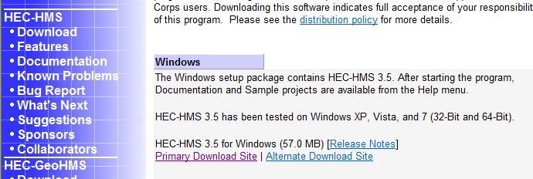
Select the Primary Download Site and use Run as the option on the resulting download package. You’ll see the Install Wizard appear:
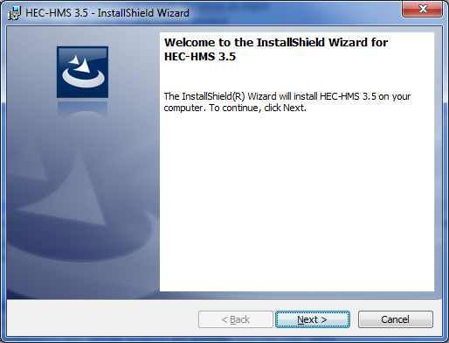
Hit Next and you’ll get the Terms and Conditions for Use and you have to scroll down to the bottom of the page of these conditions before the “I agree to the above Terms and Conditions for Use” button becomes selectable. Select this button and hit Next.
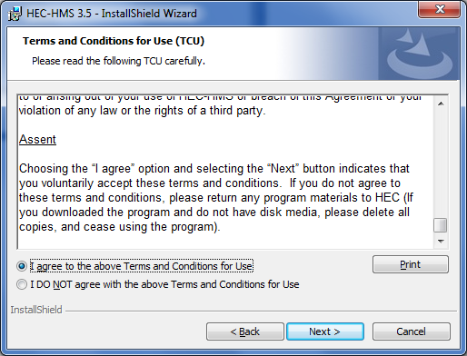
Select a Destination Folder for the program files, or just let the program install it in its default location (I normally just use the default location):
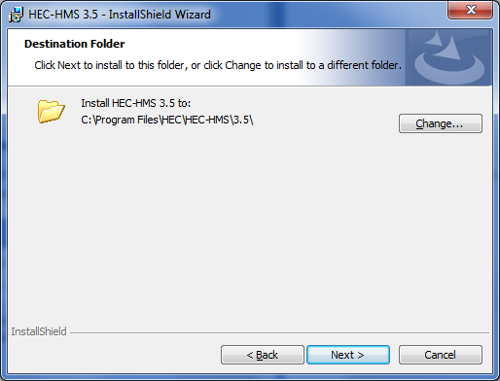
and decide whether you want a Desktop Shortcut – this puts an icon on your Desktop that allows you to directly open HEC-HMS without accessing your full programs list. I usually select this option to make the program easier to use.
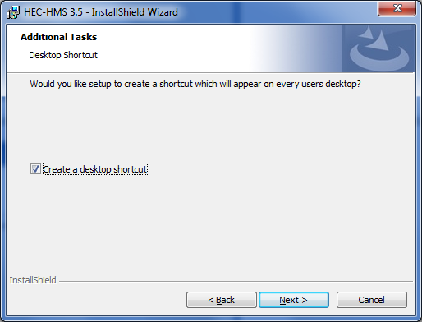
Then Install the program, which takes a few minutes:
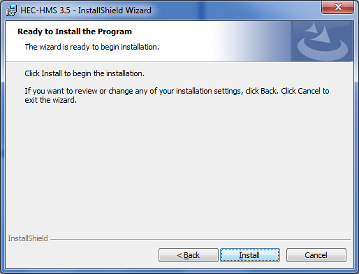
Once the program is installed, hit Finish to complete the Installation Wizard. Use the HEC-HMS icon to open the program:
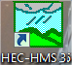
and here is the opening screen of HEC-HMS.
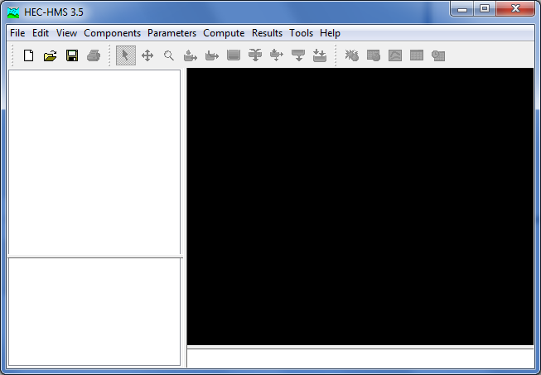

2. Prepare a Basin Model
Now, lets build a simple HEC-HMS model to see how this system works. Choose File/New
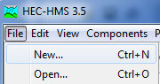
To open a new Project file. Type in a Name and Description for the Project, select a file location, and select a Unit System for the project as US Customary Units (the default is SI units).
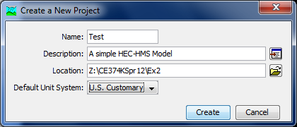
Hit Create to create this Project File.
HEC-HMS contains a series of Components, and in this project, lets start with the Basin Model Manager
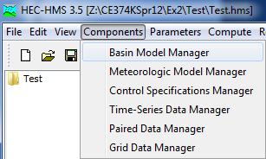
We need to create a New basin model, for which the default name is Basin 1. You should enter a short description of this basin, and select Create.
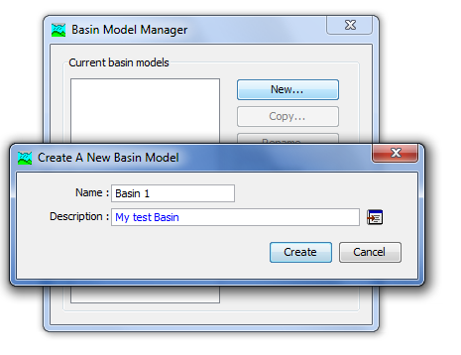
and close the Basin Model Manager window.
Now, when you look back at your HEC-HMS main interface, you’ll see that the Test project now has an entry for Basin Models and if you expand that, you’ll see Basin 1 appears. If you click on Basin 1, you’ll see lots of things open up on your screen:
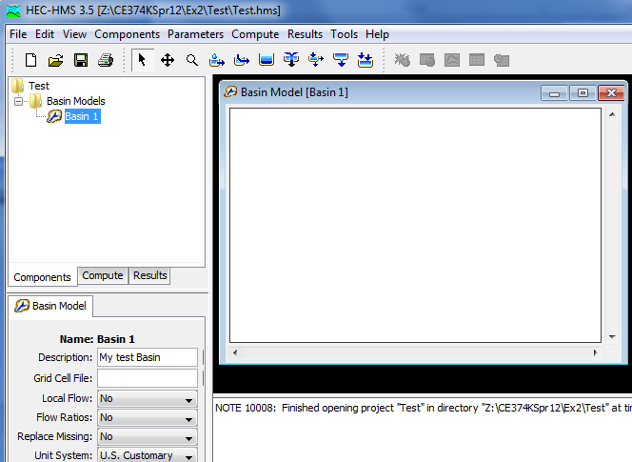
In particular, there are on the top line, a series of Basin Elements
And if you mouse over them, you’ll see what kind of element each one is. Lets select the Subbasin Creation Tool
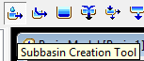
If you click within the Basin Model window, you’ll be able to create a new Subbasin:
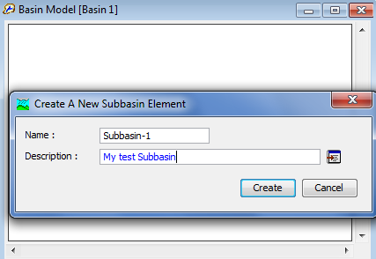
And if you expand your Basin 1 model icon, you’ll find you’ve now got some options to define the properties of your Subbasin.
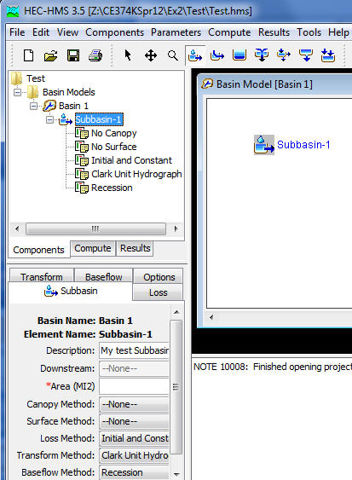

Lets make the area of Basin 1 to be 10 square miles, and select the SCS Curve Number and SCS Unit Hydrograph as the Loss Method and Transform Method options. Select None as the Baseflow Method
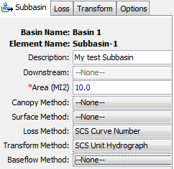
Lets choose a curve number of CN = 80
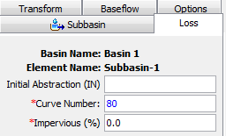
And a lag time of 60 mins
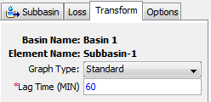
Use File/Save to save the properties of the Basin Model
3. Prepare a Meteorologic Model
Now lets put some precipitation our model.
Select Components/Meteorologic Model Manager
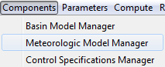
And create a new Test Precipitation called Met 1 for our model
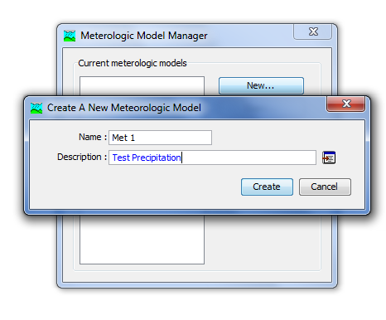
Now, when you return to the main HEC-HMS screen, you’ll see a Met 1 component appear:
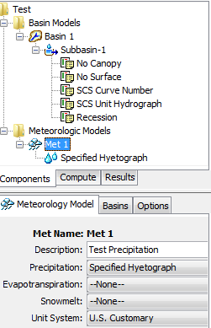
We are going to use the Specified Hyetograph method and put some rainfall in associated with a gage. But, first, lets used the Basins tab to let the Meteorologic Model know that we are applying this meteorology to the Subbasins in this model:
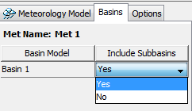
Ok, now lets specify our Hyetograph at a gage. We’ll create an artificial one since we don’t yet have actual gage rainfall to work with.
In the components, select Time Series Manager
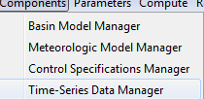
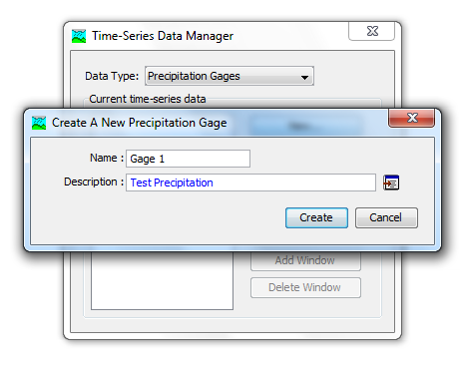
Choose Incremental Inches for the Precipitation and 1 Hour as the Time Interval.
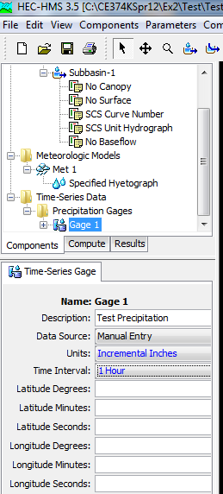
Once you save those choices, you’ll be able to edit the Time Window:
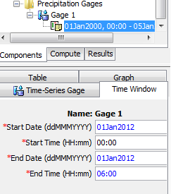
And lets add the precipitation in the Table view, with 2 inches of rain in the first hour and zero thereafter. Note that you cannot enter anything into the first time interval 00:00
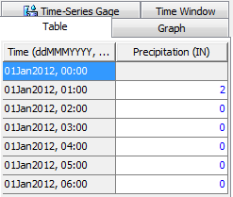
Now, lets go back to the Meteorologic Model and link the Specified Hyetograph to Gage 1
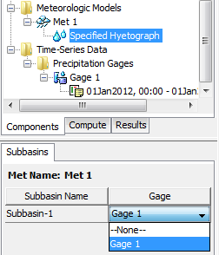
4. Preparing the Control Specifications
The last thing that we need to specify is the Control Specifications Component
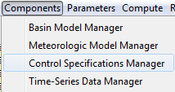
And set up a Control 1 Specification
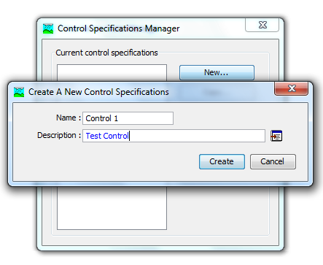
And lets enter the specifications as shown below
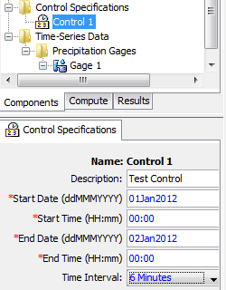
This defines the time period of the simulation and the time interval within that at which computations will be performed.
Ok, after this rather laborious process of specifying all the input information, we are now ready to do a simulation run. Choose Compute/Create Simulation Run
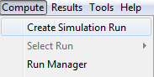
Choose the default name Run 1
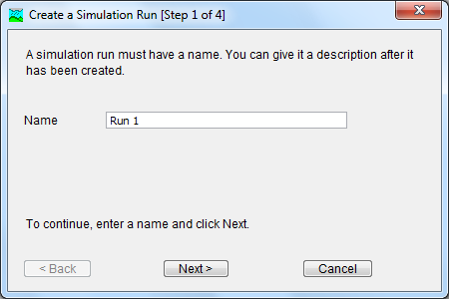
Select your test basin
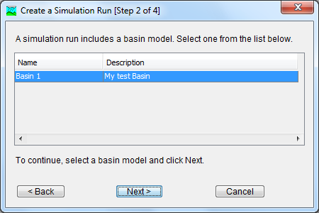
And your Test Precipitation
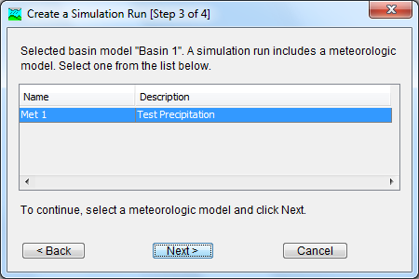
And you Test Control specifications
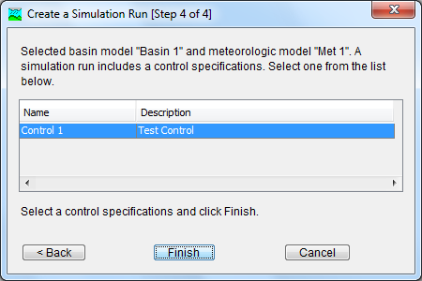
And now you hit Finish and you’re ready to go
5. Make a Model Run
Select Compute Run [Run 1]
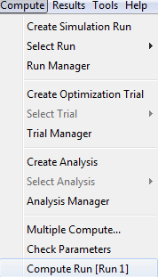
And everything computes. Ignore the warning about missing precipitation values.
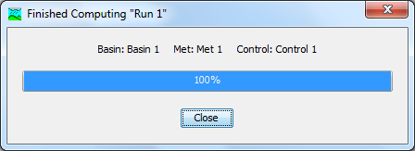
Now, go to the Basin Model display, right click on Subbasin-1 and select View Results [Run 1] Graph
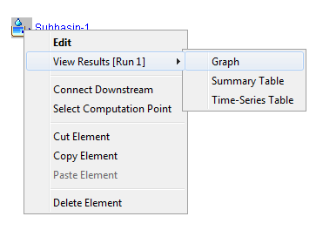
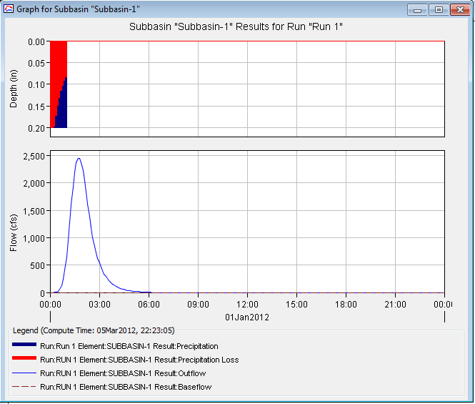
Select View Results [Run 1] Summary Table

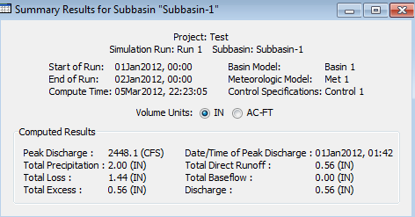
From which you can determine the total precipitation, losses, and amount of excess rainfall.
Select View Results [Run 1] Time-Series Table
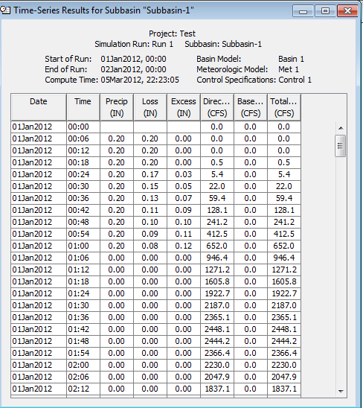
From which you can pick out the peak discharge of the outflow hydrograph.
Ok, now you’ve done the hard work, lets have some fun!
Lets reduce the Curve Number to 60 and see what happens. Wow. Much less flow.
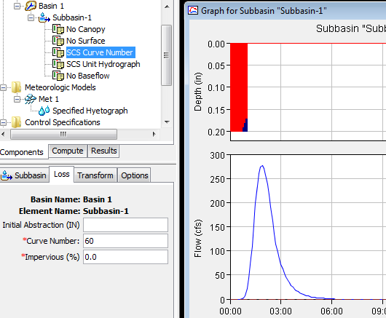
Lets return the Curve Number to 80 (which is what is typical for the soils in Brushy Creek) and now increase the % impervious cover to 25.
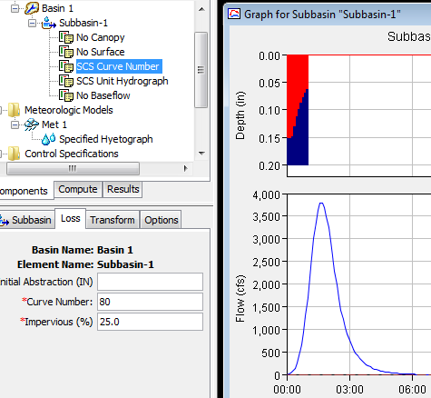
You can see how urbanization and increase in impervious cover increases excess precipition and discharge.
Another impact of urbanization is a reduction in lag time as water moves faster through the basin. Lets reduce the lag time to 50 min, and up go the flows again.
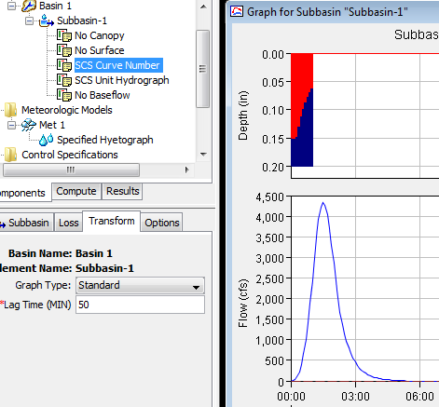
Now, I think you can see how hydrologic modeling creates insight into precipitation, flows and the relation between them.
To be turned in:
1. Verify with hand computation the amount of excess precipitation that results from a 2 inch rainfall in 1 hour falling on a basin with a curve number of 80 and 25% impervious cover.
2. Prepare a graph that shows the relation between the peak discharge and curve number for increments of the curve number of 10 from 60 to 90. Assume zero impervious cover and a lag time of 60 min.
3. For a curve number of 80, prepare a graph that shows the relation between the peak discharge and the % impervious cover for impervious cover 0 to 50% in 10% increments. Assume a lag time of 60 min
4. For a curve number of 80 and zero impervious cover, prepare a graph that shows the relation between peak discharge and lag time for lag times in the range 30 min to 90 min in 10 min increments.
6. Add a Reach Element
Click on the Reach Creation Tool 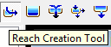 and on the basin model screen, drag a line between two points and create a new Reach element. Make sure that you start away from the Subbasin element and then end at the element to make the graphic look nice. If you just get a dot and no line, it means that the tool didn’t work correctly. Right click on the Reach element and delete it, and then try again.

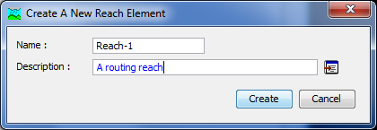
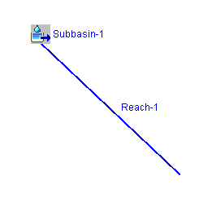
Now, let’s give the reach some parameters using the Muskingum-Cunge method:
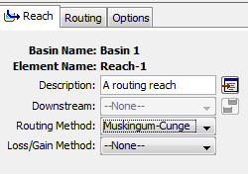
We’ll use a reach length of 10,000 ft (approx. 2 miles), a stream slope of 0.01 or 1% (typical for Austin), a Manning’s n of 0.035 (typical for Austin streams), and a bed width of 100 ft and side slopes of 3H : 1V which seems reasonable from our visit to Brushy Creek.
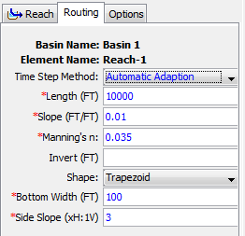
Let’s connect the Subbasin element to the Reach element downstream of it:
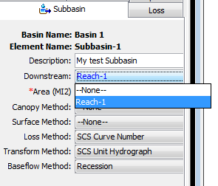
And let’s repeat the run we made before with the routing reach included and the other Subbasin parameters set to CN = 80, % impervious = 0, lag time = 60 min.
And here is the computed result:
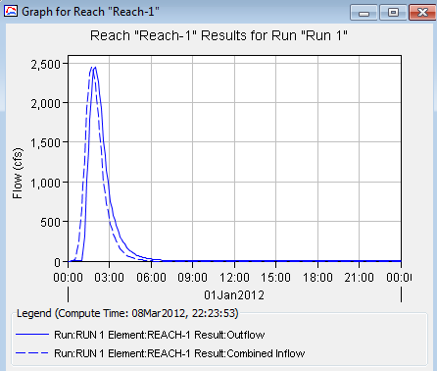
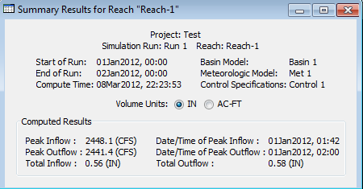
To be turned in: How long (min) does it take the peak to traverse the reach? Change the slope to 0.0001 (typical of slopes in Houston). What effect does this have on the outflow?
7. Add a Reservoir Element
To add a Reservoir Element, we first have to create a new Paired Data table to describe the storage-outflow relationship for the Reservoir.
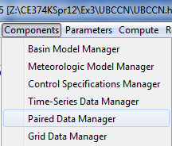
And let’s call this the Dam-7, Storage-Discharge Function table
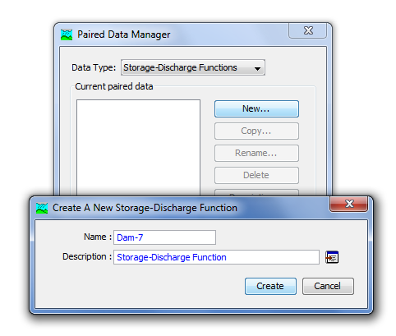
Enter the data manually as the only other option is HEC-DSS, and we don’t have the data stored there yet.
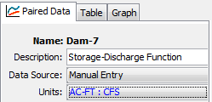
The data to be entered for Dam 7 were obtained from the Upper Brushy Creek Water Control and Improvement District. The discharge represents the flow out of the principal spillway at elevation 805ft above datum, the emergency spillway at 829 ft above datum and even over the top of the dam at 836 above datum
Elevation (ft above datum) Storage (Ac-ft) Total Discharge (cfs)  805.00 0.0 0.0  807.00 109.2 94.6  809.00 238.1 98.9  811.00 385.6 102.8  813.00 561.8 106.6  815.00 772.8 110.3  817.00 1031.5 113.8  819.00 1307.0 117.2  821.00 1608.4 120.6  823.00 1967.2 123.8  825.00 2353.0 127.0  827.00 2775.9 130.1  829.00 3243.9 133.1  829.75 3430.9 387.2  830.50 3631.0 922.3  831.85 4002.9 2486.8  833.50 4501.4 5186.0  836.50 5510.8 14100.1  840.25 7008.9 81641.5  844.00 8692.7 201496.5 | 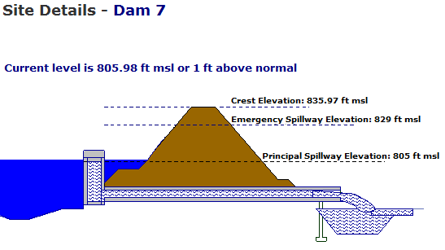
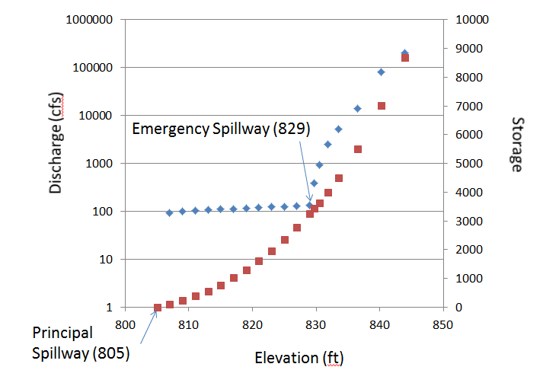
The resulting table appears as:
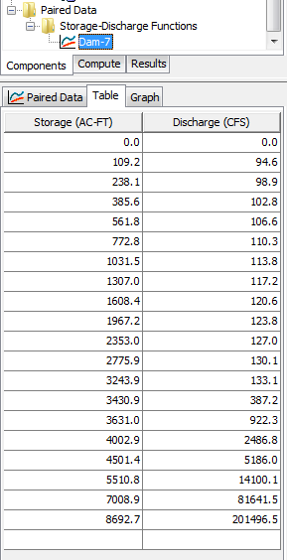
and the graph of the storage-discharge function is:
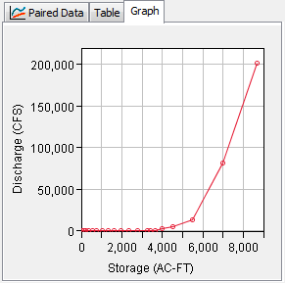
Now, we’ll create a new Reservoir element and call it Dam-7. Locate the Reservoir at the end of the Routing Reach.
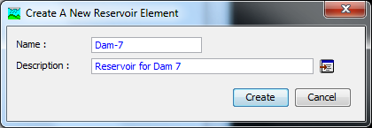
Set the parameters for Dam-7 as:
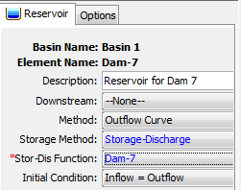
And now let’s connect the Routing Reach so that its outflow goes into Dam-7:
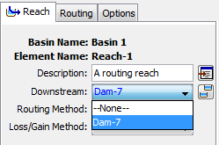
Now, let’s do the run with Dam-7 in place, and the Subasin with CN=60, %impervious cover = 0, lag time = 60 mins, and Routing Reach with slope = 0.01
And check the outflow from Dam-7
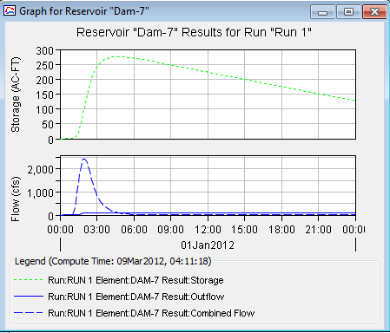
Wow! Flood control reservoirs really work!
To be turned in: By how much does Dam 7 reduce the outflow from the basin? Suppose that you change the rainfall from 2 inches in the first hour to 10 inches, with 5 inches in the first hour and 5 inches in the second hour (this is similar to the “rain bomb” that happened in Tropical Storm Hermine). What is the outflow from the Routing Reach then? By how much does Dam-7 then reduce the outflow? Does water start going over the Emergency Spillway in this case?
Hydrologic Engineering really protects people from flooding!!
Summary of items to be turned in:
1. Verify with hand computation the amount of excess precipitation that results from a 2 inch rainfall in 1 hour falling on a basin with a curve number of 80 and 25% impervious cover.
2. Prepare a graph that shows the relation between the peak discharge and curve number for increments of the curve number of 10 from 60 to 90. Assume zero impervious cover and a lag time of 60 min.
3. For a curve number of 80, prepare a graph that shows the relation between the peak discharge and the % impervious cover for impervious cover 0 to 50% in 10% increments. Assume a lag time of 60 min
4. For a curve number of 80 and zero impervious cover, prepare a graph that shows the relation between peak discharge and lag time for lag times in the range 30 min to 90 min in 10 min increments.

Be careful in answering the questions 5 and 6 that you begin with the options set as CN=80, %imp cover = 0, lag time = 60 mins, channel slope = 0.01 and rainfall = 2 inches in the first hour.
5. How long (min) does it take the peak to traverse the reach? Change the slope to 0.0001 (typical of slopes in Houston). What effect does this have on the outflow?
Return the channel slope to 0.01 before answering Question 6.
6. By how much does Dam 7 reduce the outflow from the basin? Suppose that you change the rainfall from 2 inches in the first hour to 10 inches, with 5 inches in the first hour and 5 inches in the second hour (this is the “rain bomb” that happened in Tropical Storm Hermine). What is the outflow from the Routing Reach then? By how much does Dam-7 then reduce the outflow? Does water start going over the Emergency Spillway in this case?

Ok, you’re done!

