Solution to Exercise 3
WATR 404/604
First Semester 2018
Prepared by David R. Maidment
Question 1
To be turned in: A screen capture of the header of your WaterML response for flow along with the first couple of data values, as shown above. What is the time period of your data request (from date, to date)? What are the units of the flow data? What was the mean daily flow of the Mangatainoka River at Pahiatua Town Bridge on 5 March 2018?

Solution

The web request is:
http://tsdata.horizons.govt.nz/contactrec.hts?Service=SOS&Request=GetObservation&FeatureOfInterest=Mangatainoka at Pahiatua Town Bridge&ObservedProperty=Flow Mean (1 Day)[Water Level]&TemporalFilter=om:phenomenonTime,P2Y
The first portion of the response is:
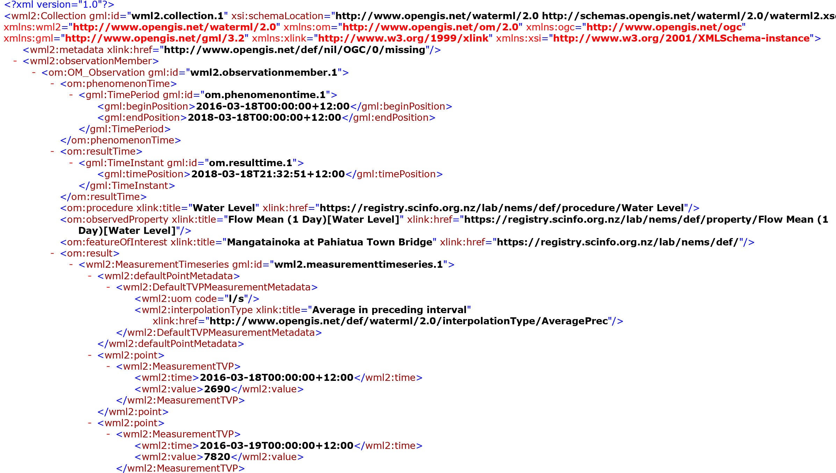

The time period of the data request is: 18 March 2016 to 18 March 2018

The units of the flow data are liters per second (l/s)

The mean daily flow of the Mangatainoka River on 5 March 2018 is 3650 l/s (3.65 m³/s)
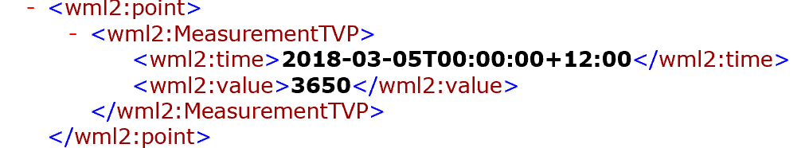

Question 2
To be turned in: A screen capture of the header of your WaterML response for E. Coli along with the first couple of data values, as shown above. What is the Feature of Interest, Observed Property, Procedure of Measurement and Temporal Domain of the Result? What is the time period of your data request (from date, to date)? What are the units of the E. Coli data?

Solution
The web request is:
http://hilltopserver.horizons.govt.nz/cr_provisional.hts?Service=SOS&Request=GetObservation&FeatureOfInterest=Mangatainoka at Pahiatua Town Bridge&ObservedProperty=E. coli by MPN (HRC)[E. coli by MPN (HRC)]&TemporalFilter=om:phenomenonTime,P2Y
The first part of the response is:
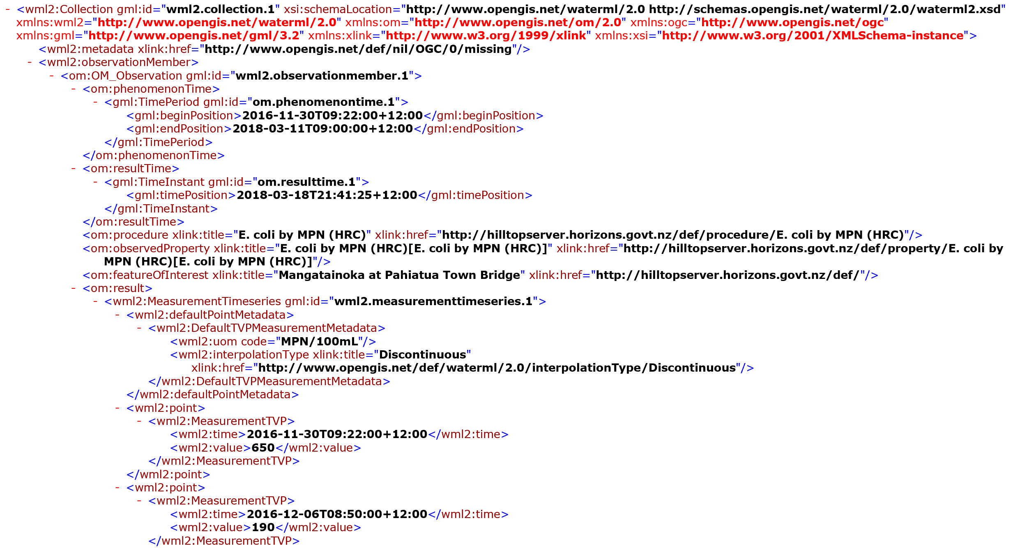

Feature of Interest is: Mangatainoka at Pahiatua Town Bridge

Observed Property is: E. Coli by MPN (HRC)

Procedure of Measurement: Number of Coliform Units Per 100mL of water determined by the MPN method. “There are coliform-bacteria testing methods that rely on color changes but also provide an estimate of the number of bacteria present. These are often referred to as "most probable number" (MPN) methods, which use a statistical relationship to estimate the number of bacteria in your sample based on color changes in multiple test tubes.” https://extension.psu.edu/coliform-bacteria
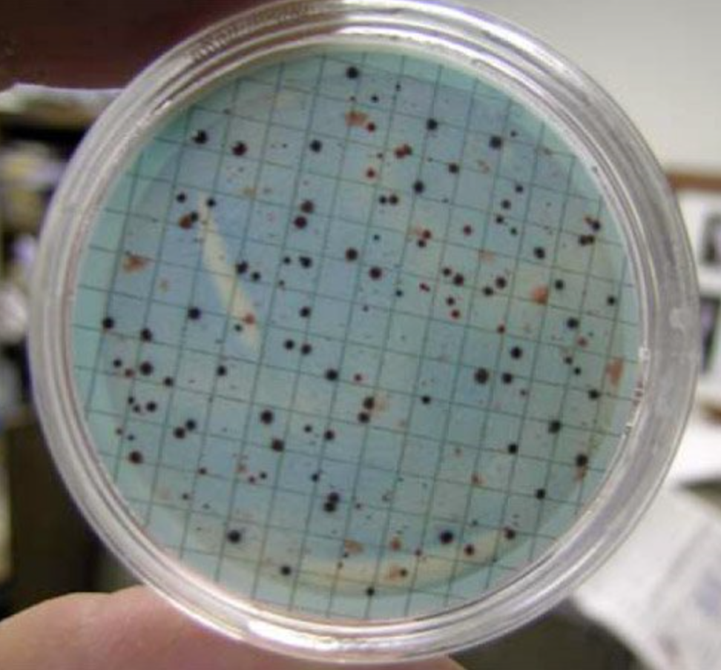
Bacteria cultured on an agar dish and counted

Temporal Domain of the Result: Discontinuous samples from 30 November 2016 to 11 March 2018

Units of E. Coli Data: MPN/100mL

Question 3
To be turned in: Plot a nice time series chart of these data and find the critical percentile values of these data that correspond to the New Zealand coliform data standards. What quality level do these data represent?

Solution
Following the procedure described in p. 6-7 of the exercise script, the data are ingested into Excel:
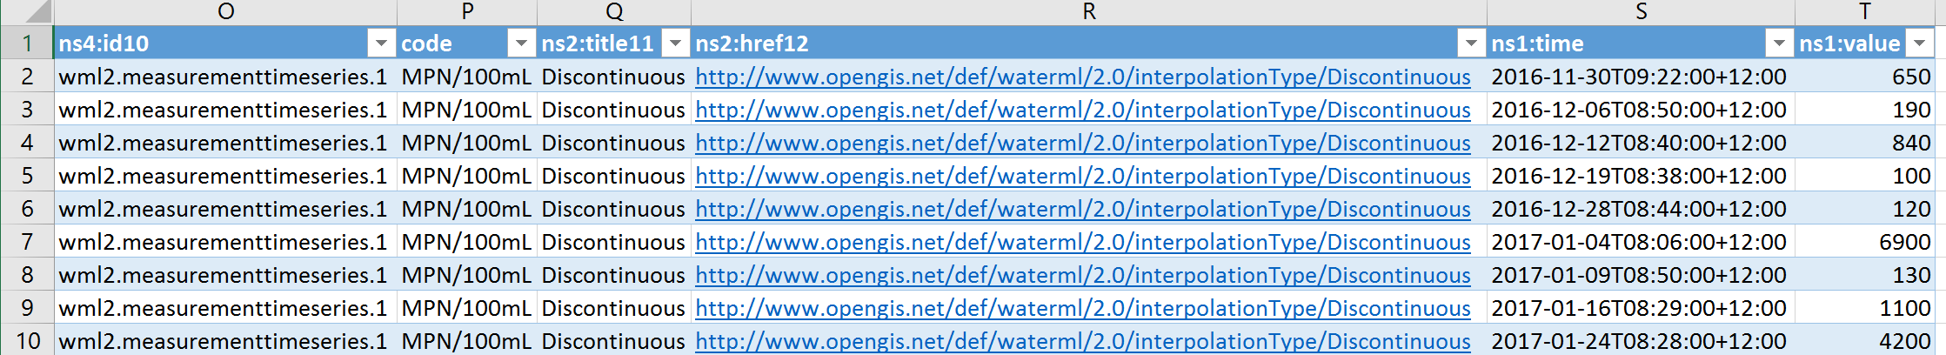
And the time range is converted into an Excel date:
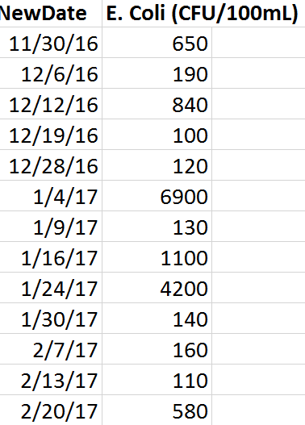
And plotted on a logarithmic scale

The critical values for judging E. Coli concentration are 130, 260, 540, 1000 and 1200 CFU/100mL. There are 41 data points.

These values are added to the chart

The E. Coli Standards are stated in the National Policy Statement for Freshwater Management (2014), p.39 as:

State | %>540 | %>260 | Median | Conc < 95%
A | < 5% | < 20% | < 130 | <540
B | 5-10% | 20-30% | < 130 | <1000
C | 10-20% | 20-24% | <130 | <1200
D | 20-30% | >34% | > 130 | > 1200

This can be stated in word as: to be in State A, the Coliform concentrations should have less than 5% greater than 540 CFU/100mL, less than 20% greater than 260 CFU/100mL, a median concentration less than 130 CFU/100mL and 95% of the samples should be less than 540 CFU/100mL
To find what state these waters are in, let’s first compute the Descriptive Statistics of the data in Excel. The Median value is 305 CFU/100Ml. This value is slightly different than in the Exercise 3 script because two additional week’s data has been recorded since the script was made up that included data up to 27 February 2018
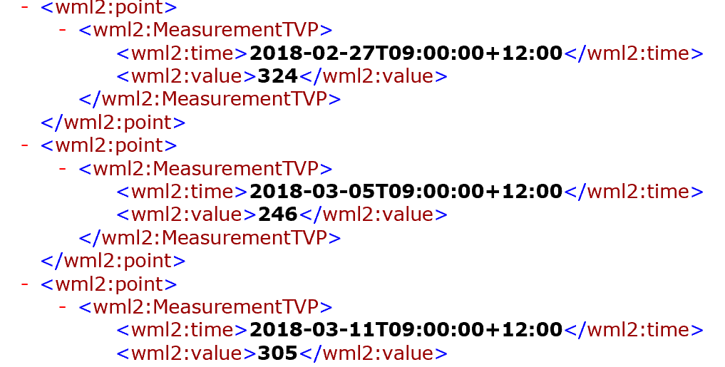

E. Coli (CFU/100mL)
Mean | 690.4146
Standard Error | 196.3586
Median | 305
Mode | 190
Standard Deviation | 1257.309
Sample Variance | 1580825
Kurtosis | 16.11242
Skewness | 3.845868
Range | 6814
Minimum | 86
Maximum | 6900
Sum | 28307
Count | 41

It is immediately apparent that since the median concentration is 305 CFU/100mL and States A, B, C call for a median concentration less than 130 CFU/100mL, that these data cannot satisfy this criterion.

However, let’s pursue the analysis a bit further and compute a histogram of the data, as described in the class exercise on p. 13. The results show that 27% of the data exceed 540 CFU/100mL, 56% are greater than 260 CFU/100mL, and the 90% of the data are less than 1200mL, which means that the 95% level will exceed 1200 mL.
Hence these bacterial levels are in state D, the worst of the 4 states defined in the National Policy Statement for Freshwater Management.

Bin | Frequency | Cumulative % | % Exceedance
0 | 0 | 0.00% | 100.00%
130 | 7 | 17.07% | 82.93%
260 | 11 | 43.90% | 56.10%
540 | 12 | 73.17% | 26.83%
1000 | 5 | 85.37% | 14.63%
1200 | 2 | 90.24% | 9.76%
More | 4 | 100.00% | 0.00%

Question 4
To be turned in: Make a nice map of the Selwyn catchment with a pathway from one of the upstream reaches to Lake Ellesmere/Te Waihora shown as selected. What is the length of this flow path in Km?
Solution
I picked a point on a stream not far from the Selwyn River and also near Highway 1 between Christchurch and Ashburton. I put a barrier flag on the edge of Te Waihora/Lake Ellesmere so as to just trace the distance to the lake.
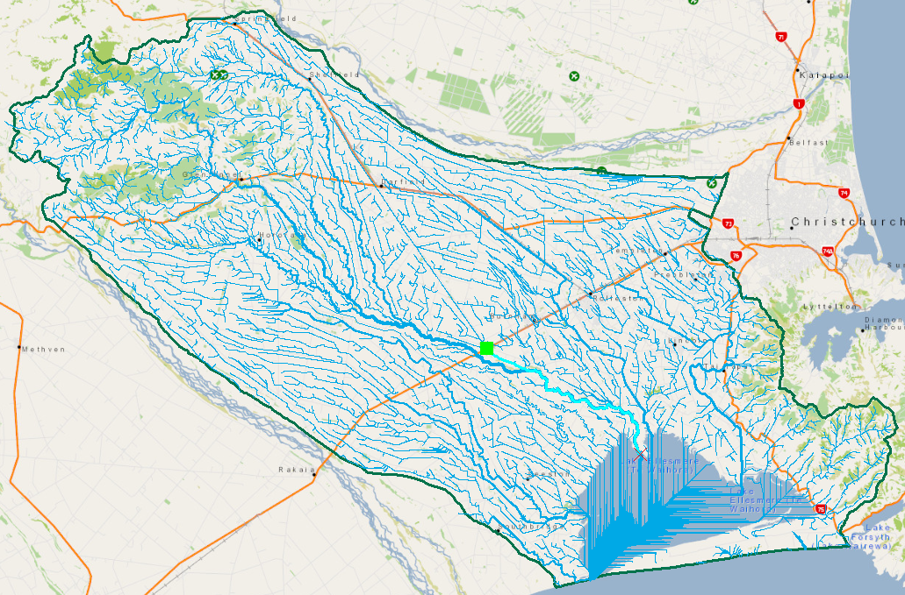

The RiverLines feature class has an attribute Length in meters, and I did Statistics on this attribute
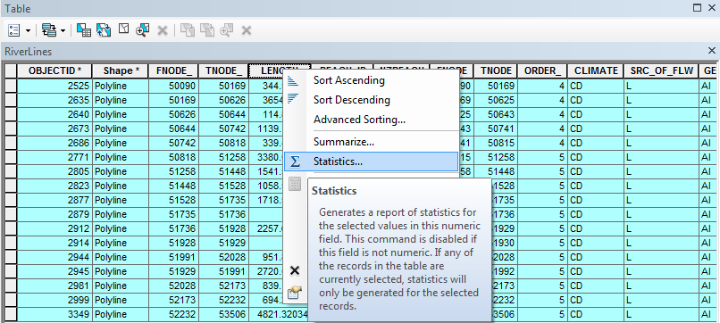

To find that the length along this flow path is 25785 m or 25.785 Km.

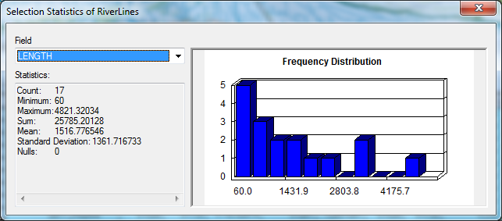

If the velocity of the water is approximately 0.3 m/s along this path, then the flow time to the lake from this location is 25785 * 0.3 = 7735.5 sec or 7735.5/3600 = 2.1 hours. This is not very much time. Any pollutants in the water at this entry point will be transported with little change in concentration into the lake.

