Ex 2: Energy Balance of the San Marcos Basin

CE 394K.2 Surface Water Hydrology
University of Texas at Austin
Spring 2007

Solution prepared by Cédric David and David Maidment

To be turned in: Make a brief summary of the North American Regional Reanalysis – how was it produced, what data summaries does it contain, what is its spatial extent and coverage in time?
The North American Regional reanalysis is an atmospheric climate dataset available for North America. It covers longitudes from -145˚E to -2˚E and latitudes from 0˚N to 46˚N. The time coverage goes from January 1st 1979 to present. NARR has 3-hour, daily and monthly averages. NARR consists of NARR-A and NARR-B. NARR-B focuses on energy data whereas NARR-A focuses on weather data. The spatial resolution of NARR is 32 km. NARR data were created by running the forecast weather model Eta together with the Regional Data assimilation System RDAS.
To be turned in: Make a display of the downward solar radiation for each of the 3 hr intervals for July 2003 and make a similar series of 8 maps for January 2003. At what Z time does the maximum solar radiation occur? Where is the maximum solar radiation located for January? Where is the maximum solar radiation for July? The data you are viewing are solar radiation at ground level, not at the top of the atmosphere. Why is there more solar radiation in the western US during July than in the eastern US?
Downward shortwave radiation for January:
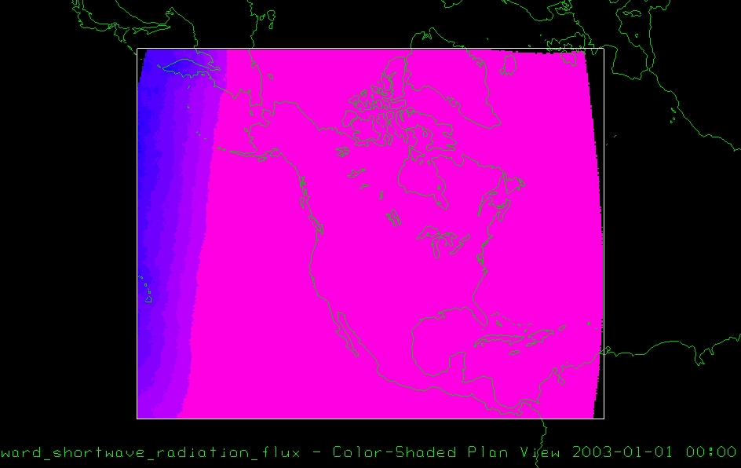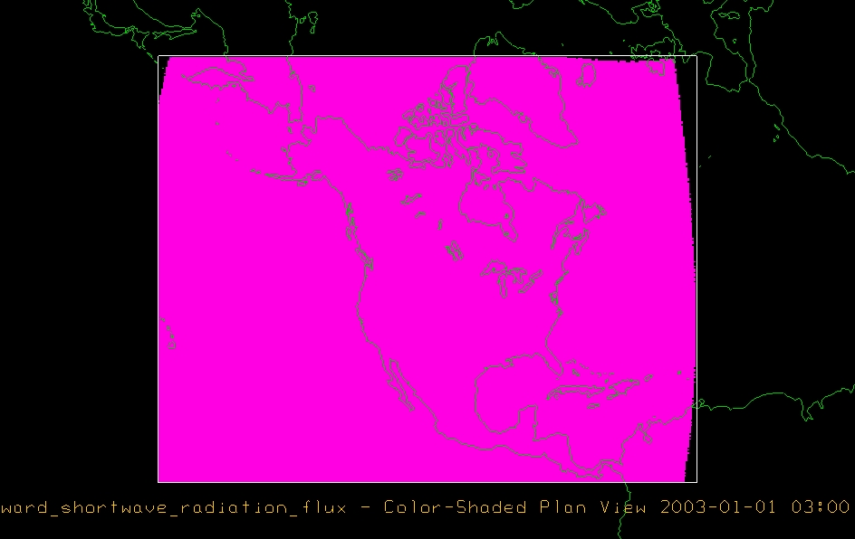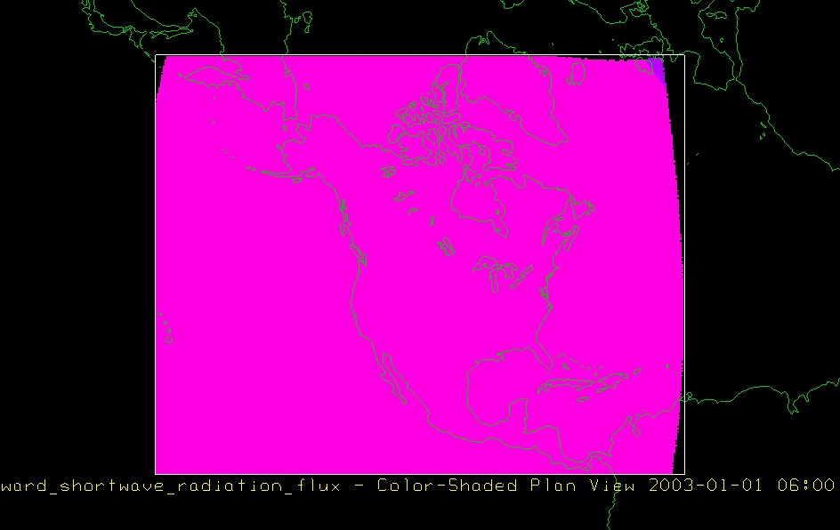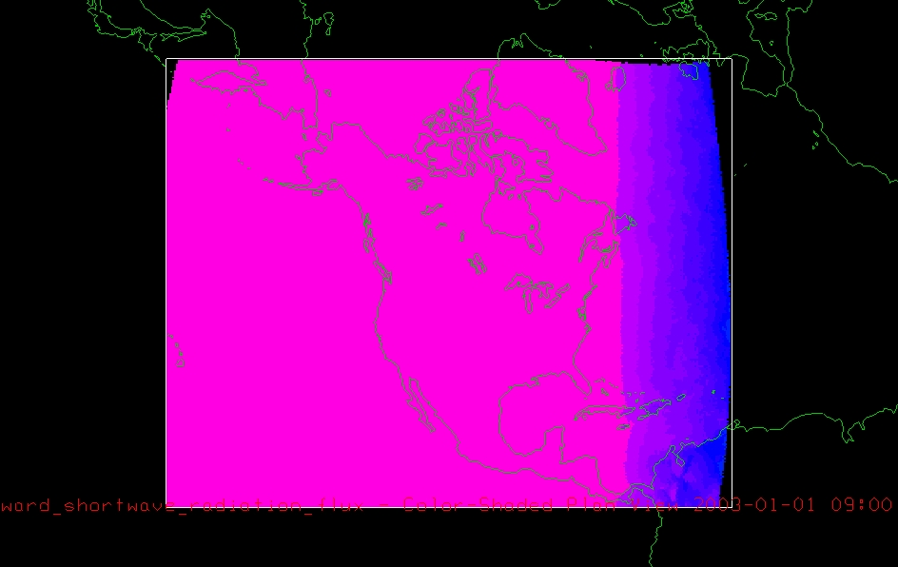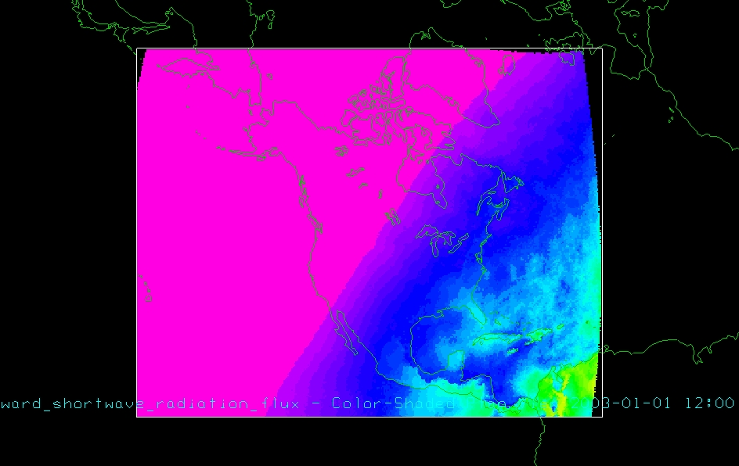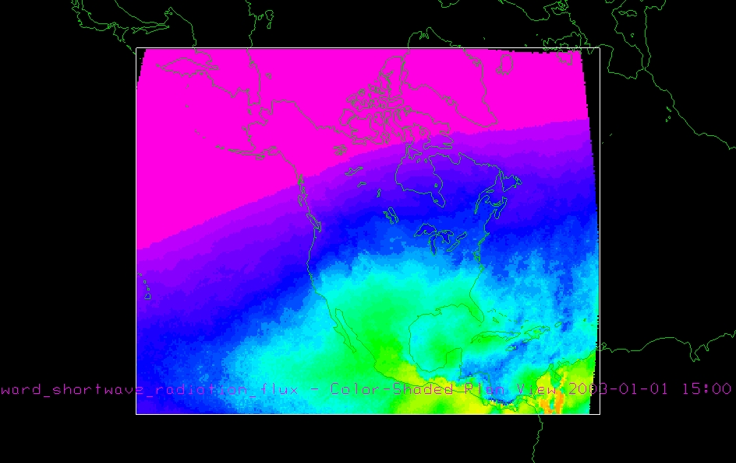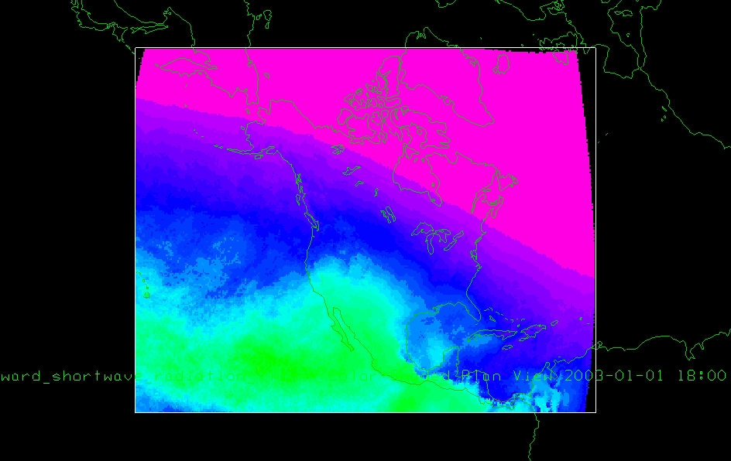
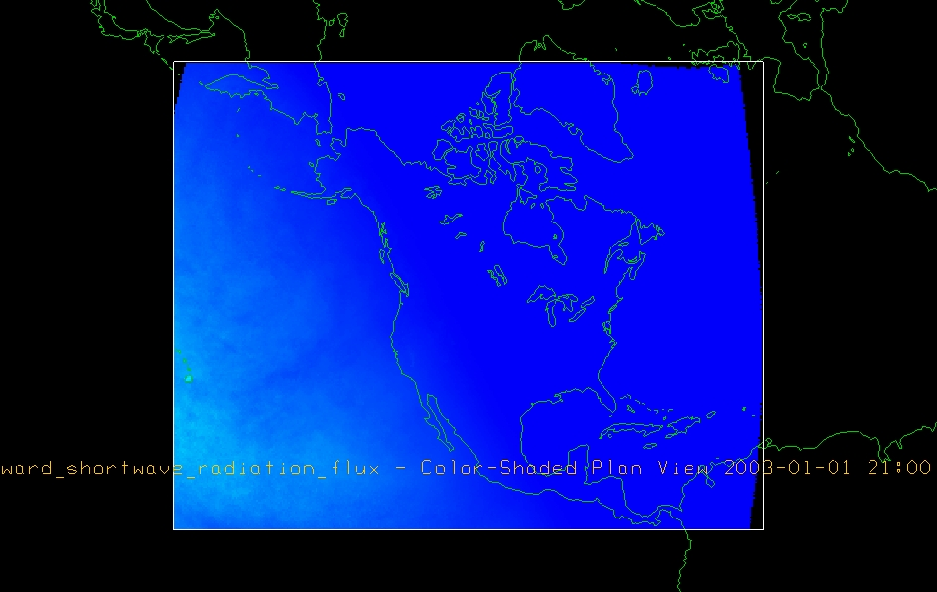
In January, the maximum solar radiation occurs around 1500Z in Central America (near Panama, Colombia and Venzuela). The local time in Venezuela is UTC-4 (they don't observe daylight saving), so 1500Z corresponds to 11AM.
Downward shortwave radiation for July 2003:
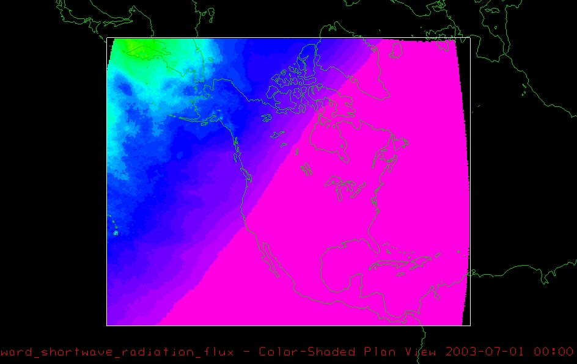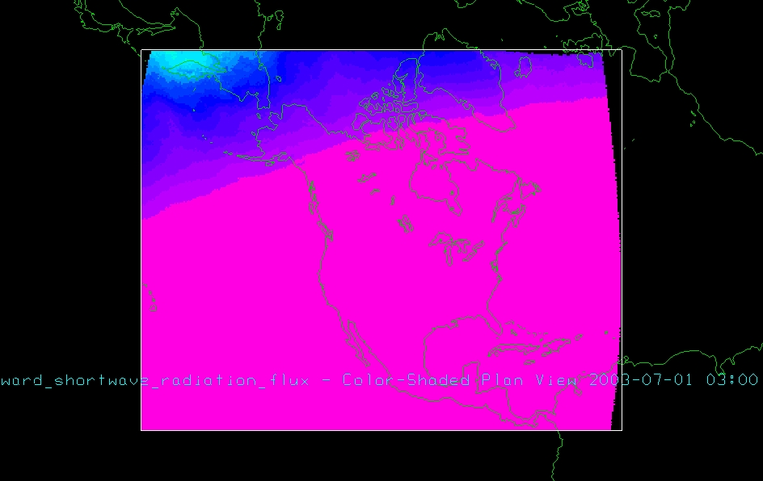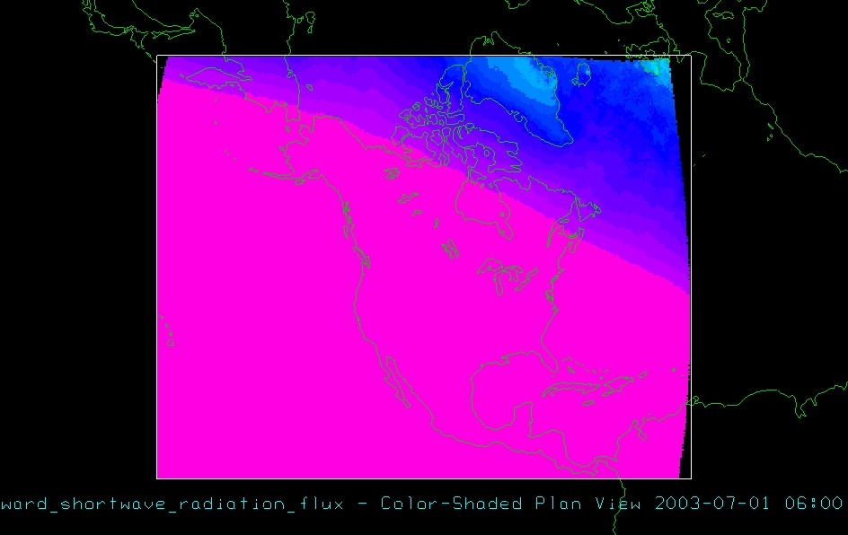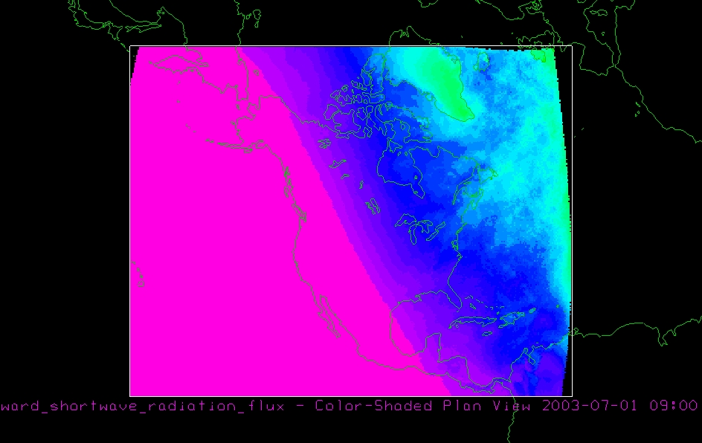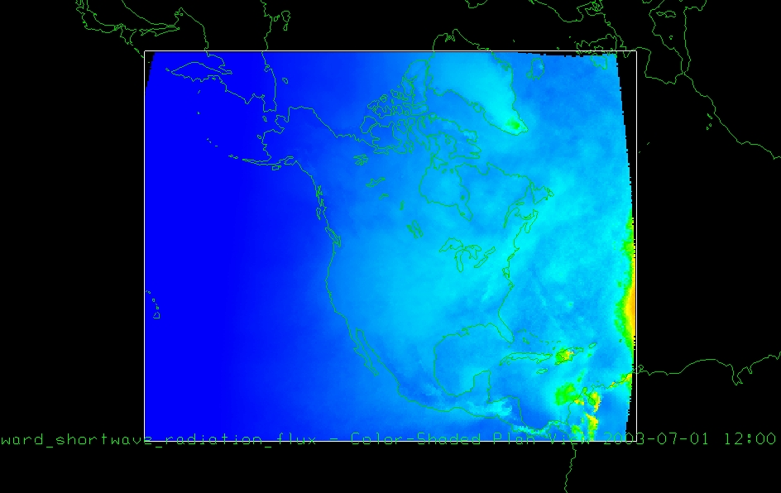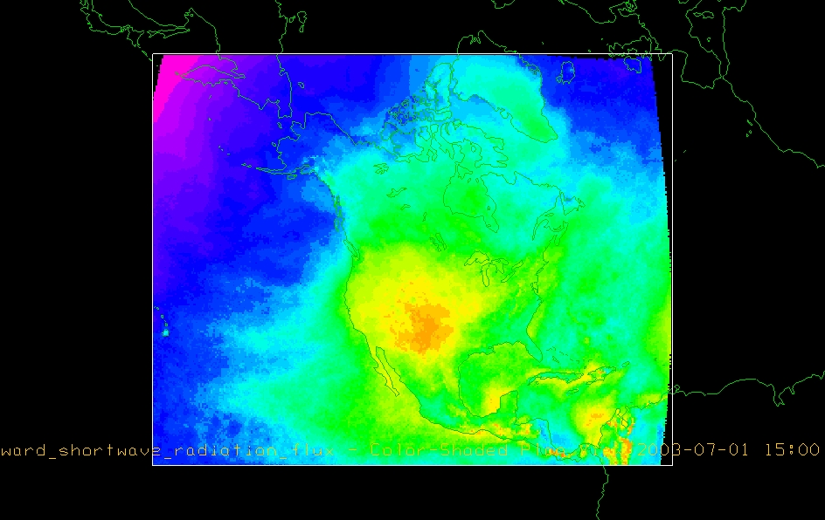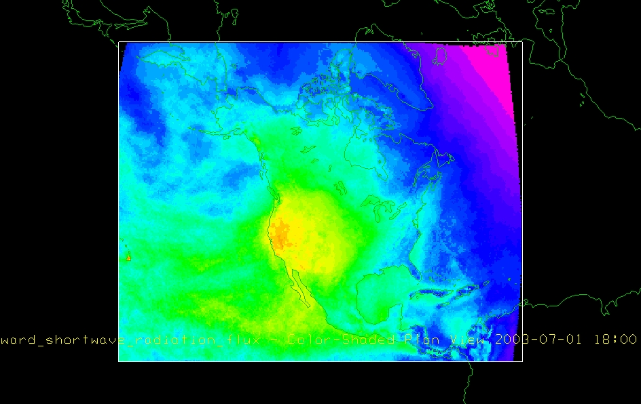
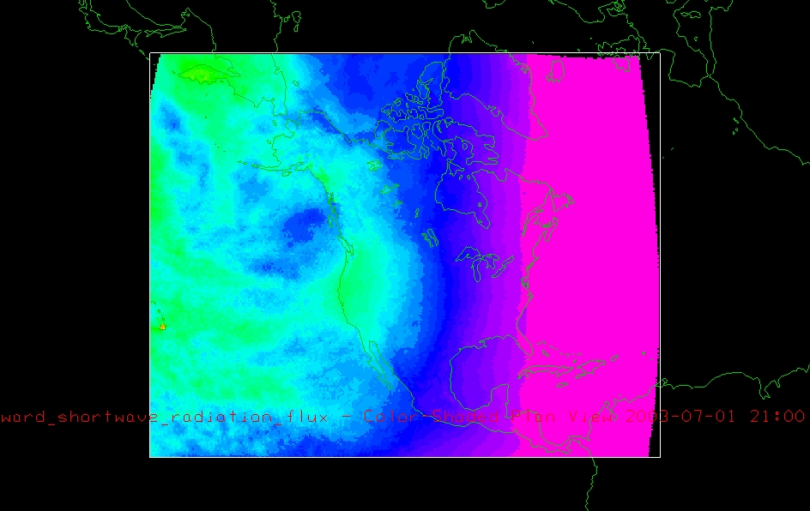
In July, the maximum radiation for North America occurs in the center of the U.S (Texas, Oklahoma, Kansas, Colorado and New Mexico). The western US has clearer skies than the Eastern US during summer This explains why the downward solar radiation reaching the land surface is stronger in the West than the East of the US at that time..
To be turned in: A map display showing the San Marcos basin overlying a short wave radiation flux map.
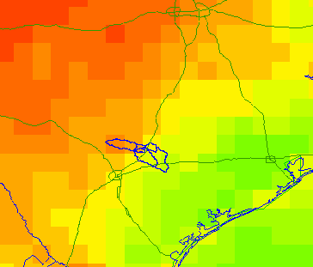
To be turned in: Make a table showing the Downward Short Wave Radiation values for 30.0°N and 98.2°W for each three hour interval during the day in July. Make a similar listing for the values of
1. Downward Longwave Radiation Flux
2. Downward Shortwave Radiation Flux
3. Ground Heat Flux
4. Latent Heat Flux
5. Sensible Heat Flux
6. Upward Long Wave Radiation Flux
7. Upward Short Wave Radiation Flux
Calculate the energy balance for 30.02°N and 98.2°W.
Make graphs showing data series 1-7 as a function of time of the day.
What is average July evaporation in mm/day at this location?
The average latent heat flux for the whole day is 61.62 W/m² averaged over each 3-hour interval. Using the conversion of 28.94W/m² = 1mm/day of evaporation, then 61.62 W/ m² = 61.62/28.94 = 2.12 mm/day over our area of interest in the San Marcos Basin. This seems pretty low given that this is in mid-summer.
Choose a different box of the 72 boxes located in the San Marcos grid that you have been provided with , and make an energy balance study there as for the 30.0N and 98.2 W box that you have already worked with. Does the energy balance change much with location in this region?
Let's look at the energy balance for the top left cell (-99.3 ˚W, 29.0 ˚N)
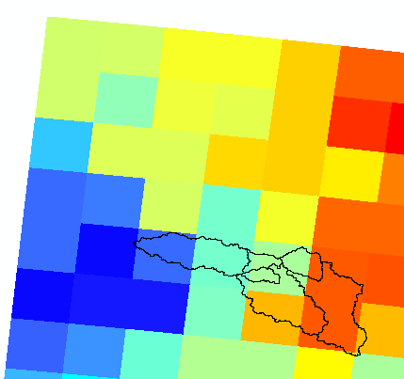
The total energy balance for our first point of interest (30.0°N and -98.2°W) is -172 W/m² on a 3-hour interval. The total energy balance for our second point of interest is -143 W/m²(29.0 ˚N, 99.3 ˚W). This represents a difference of 17 % which is pretty big for the small geographic displacement. However the plot of the energy balance components is pretty much the same as for the first location.

