Exercise 2. Energy Balance of the San Marcos Basin

CE 394K.2 Surface Water Hydrology
University of Texas at Austin
Spring 2007

Revised Version: 13 February 2007
Prepared by David R. Maidment, Jon Goodall and Cédric H. David
Table of Contents
Goals of the exercise
Computer and data requirements
Procedure
1. Making the link to NARR data in IDV
2. Prepare a display
3. Add another data source
4. Map display of the San Marcos basin
5. netCDF files in ArcGIS 9.2, energy balance in the San Marcos BasinData

Goals of the Exercise
The goals of this exercise are for you to become familiar with the Integrated Data Viewer as a way of viewing and querying atmospheric science datasets for the energy balance of the earth, and to construct an energy balance for a typical day in July 2003 for North America, and for a location 30.02ºN and 98.2ºW in the San Marcos basin, using ArcGIS 9.2 capabilities.

Computer and Data Requirements
Integrated Data Viewer
The Integrated Data Viewer (IDV) is developed by Unidata (http://www.unidata.ucar.edu/) a program of the Universities Corporation for Atmospheric Research located in Boulder, Colorado. With the sponsorship of the National Science Foundation, Unidata supplies real-time feeds of atmospheric science information for use in US academic institutions. IDV is a Java program that can be installed in computers with a variety of operating systems. IDV is a public domain software program that is available free of charge. It requires that Java already be installed on the computer on which it will run. You can install IDV by directly clicking on the following link: http://www.unidata.ucar.edu/software/idv/webstart/IDV/idv.jnlp. If you are experiencing problems, please refer to http://www.unidata.ucar.edu/software/idv/webstart/IDV/, having the latest version of Java Runtime Environment usually solves all issues.
For this exercise, we are going to use historical weather model data from the North American Regional Reanalysis (NARR), http://wwwt.emc.ncep.noaa.gov/mmb/rreanl/index.html which is an archive for 1979 to present developed by running the Eta numerical weather prediction model of the National Centers for Environmental Prediction on an historical database of weather observations.
To be turned in: Make a brief summary of the North American Regional Reanalysis – how was it produced, what data summaries does it contain, what is its spatial extent and coverage in time?
Procedure
1. Making the link to NARR data in IDV
Open IDV by using the same link that was used to install it (http://www.unidata.ucar.edu/software/idv/webstart/IDV/idv.jnlp). Two Java windows will open: the Dashboard and the Map Display.
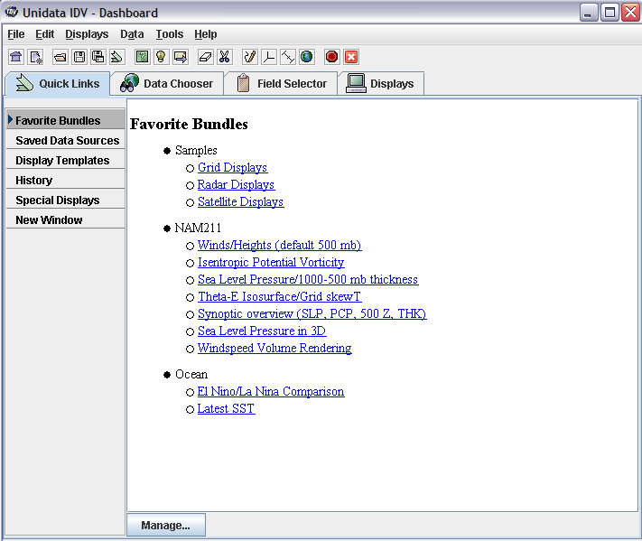
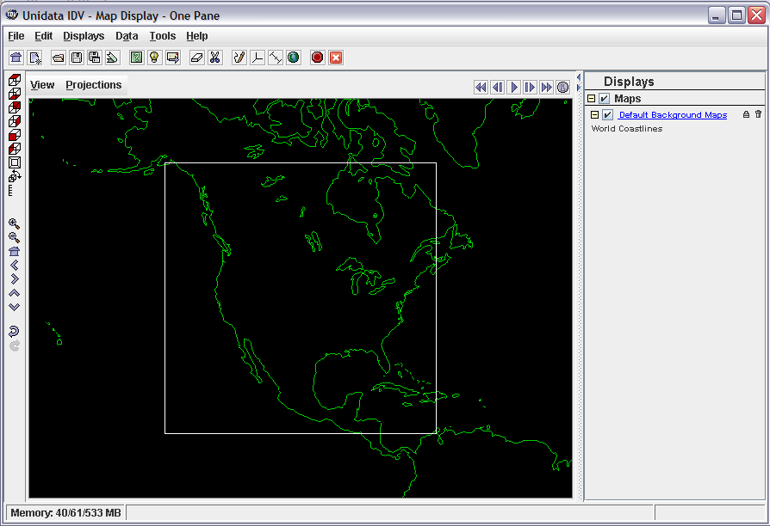
In the Dashboard, select Data Chooser / Catalogs and paste the following link: http://nomads.ncdc.noaa.gov:8085/thredds/catalog/narrmonthly/catalog.xml. Make sure that you have Catalogs highlighted in the left pane of the screen below before you do the paste of the catalog.xml location. 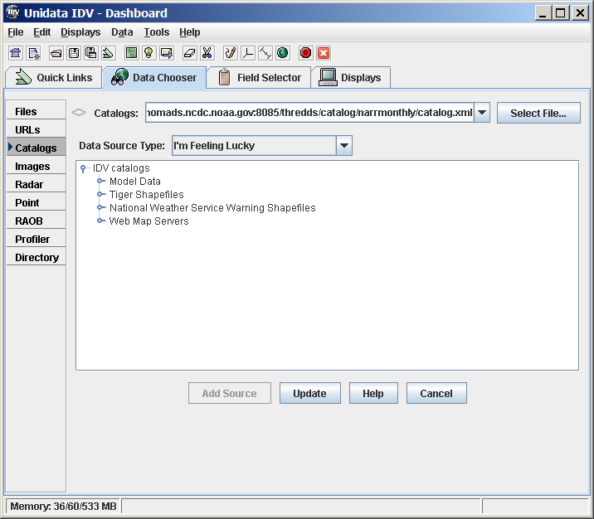

Then hit Update on the button at the bottom of the screen so that you connect to the data source. You are viewing files resident at the National Climate Data Center in North Carolina now.

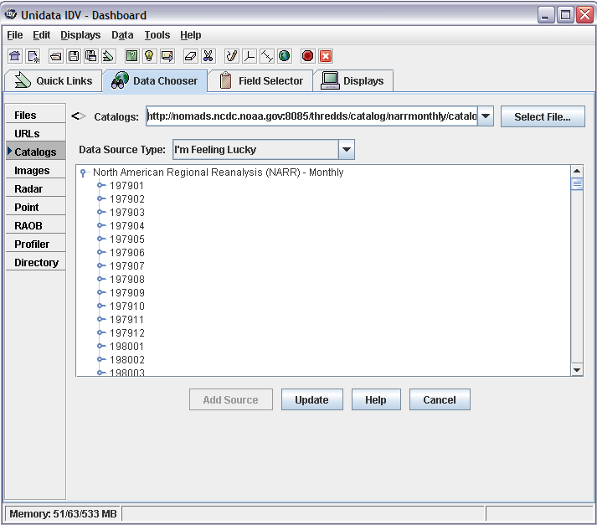
Scroll down to July 2003 and expand, you should see the following:
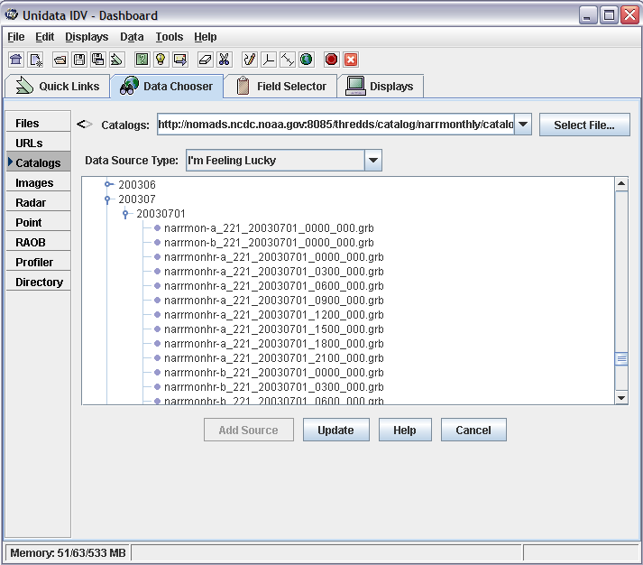
You are viewing files from the NARR monthly dataset for the month of July 2003.
Note: by using the higher hierarchy catalog: http://nomads.ncdc.noaa.gov:8085/thredds/catalog.xml, you will have access to multiple datasets served by NCDC.
2. Prepare a Display
NARR-B Monthly has energy data, let's give a look at narrmonhr-b_221_20030701_1200_000.grb, this file has 3-hour averaged data (from 1200 hours to 1500 hours for every day of July 2003). Double click on at narrmonhr-b_221_20030701_1200_000.grb, the Dashboard will automatically transfer to its Field Selector tab.
Expand 2D grid, select Downward shortwave wave radiation flux, and Color-Shaded Plan View. Then click on Create Display
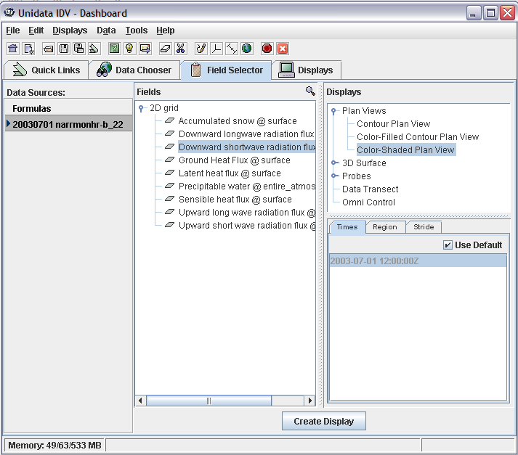
The following Map Display will appear (totally cool!!)
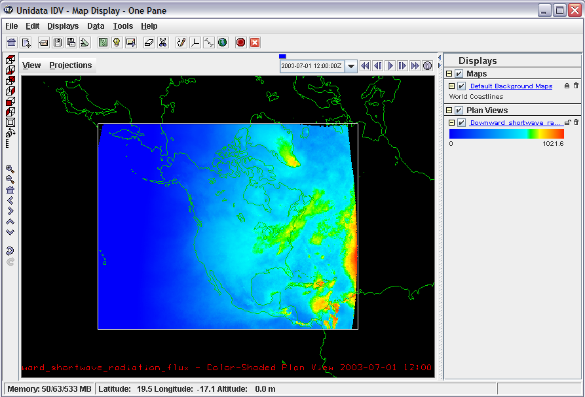
In order to be able to compare multiple files, we need to make the color tables similar. Click on the color table, the Color Table Editor window will open:
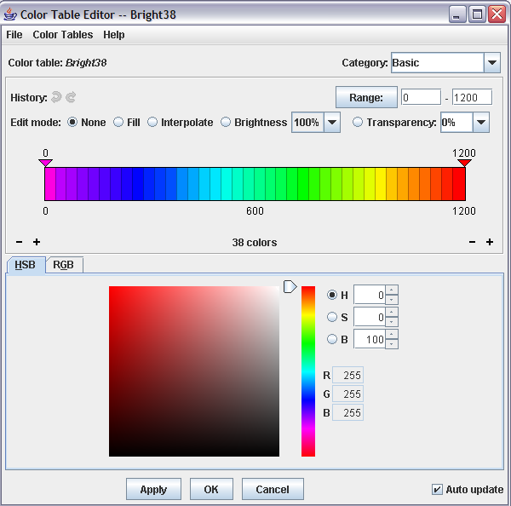
Select Color Tables / Basic / Bright38 as the color table, then set the range to 0 – 1200. Hit Apply at the bottom of the Color Table Editor. The units of downward shortwave variation flux are W / m².
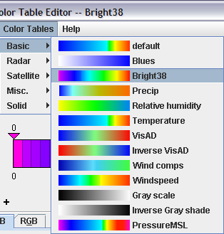
You can capture your display using View, Capture, Image and save as a jpg file.
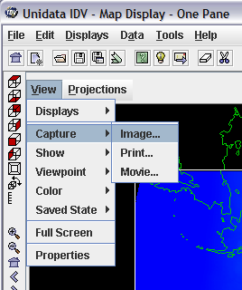
It's good at this point to save the display you’ve created. To do this, use File/Save As from the main IDV Window and save the file as USA_July.xidv. The extension .xidv is a signal that this is an IDV map file.
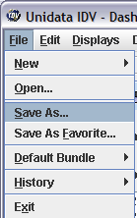
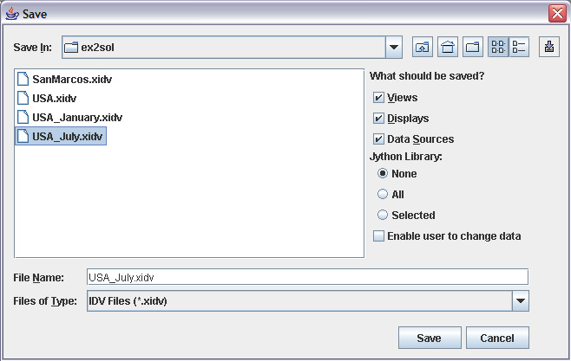
3. Add another Data Source
By repeating the same display process with the other 3-hour intervals of July 2003, you will be able to see the estimated downward shortwave (solar) radiation for a given hour averaged across all the days of July 2003. In the Dashboard, select the Data Chooser tab. Double click on another 3-hour interval, narrmonhr-b_221_20030701_1500_000.grb for example.
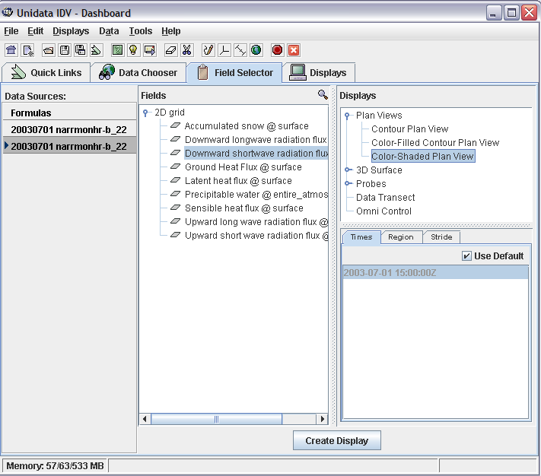
You should see the following display:
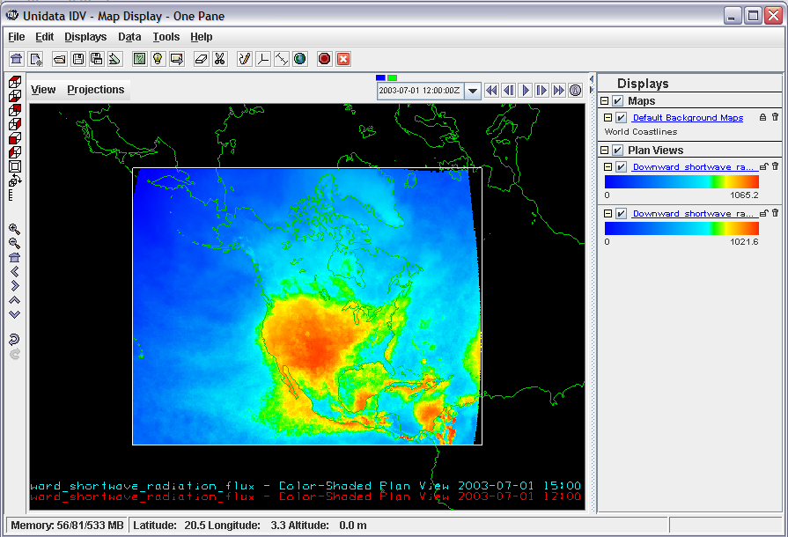

Make all July displays for downward shortwave radiation flux and color them similarly. You can get rid of the unwanted displays with the little garbage can on the right hand side of the legend display.
To be turned in: Make a display of the downward solar radiation for each of the 3 hr intervals for July 2003 and make a similar series of 8 maps for January 2003. At what Z time does the maximum solar radiation occur? Where is the maximum solar radiation located for January? Where is the maximum solar radiation for July? The data you are viewing are solar radiation at ground level, not at the top of the atmosphere. Why is there more solar radiation in the western US during July than in the eastern US?
4. Map Display of the San Marcos Basin
Now let's focus in on the San Marcos Basin. We need a locator map to do this, and we’ll add this in from the IDV map display. You can also add a high resolution map of the US, US County Outlines and US Interstate Highways.
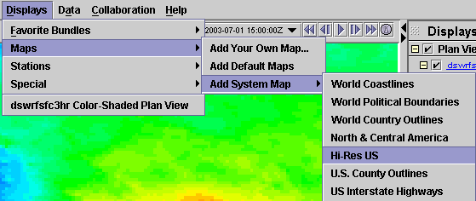
and you’ll get a display with the Hi-Res US like below.
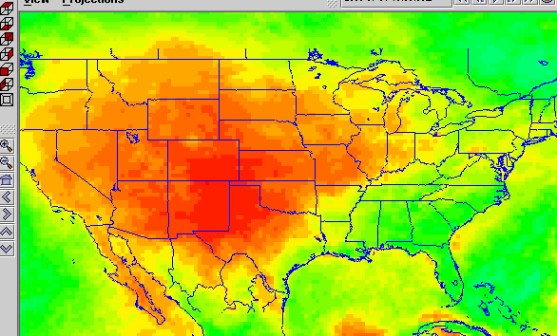
You can use the zoom and arrow tools on the left side of the display to zoom in and center your picture. If the color of an added map is not what you want, click on Map Display 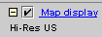 to bring up an editor that lets you change the map colors. If you don’t see the display at all, click on Map display and make sure that the Hi-Res US is clicked on (the default is that it is clicked off) and then you’ll see the Hi-Res map display.
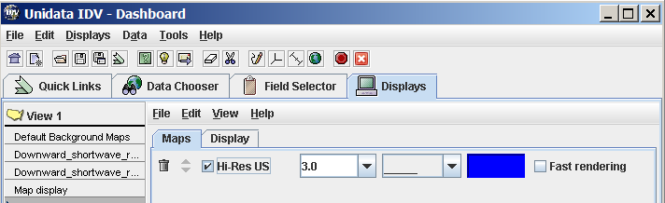
To add a map of the San Marcos basin, Add Your Own Map,
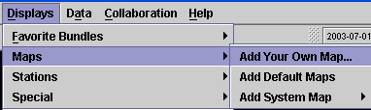
You’ll get a display that says “Add a Map”, hit the Browse button
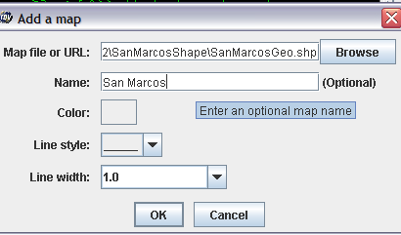
and you’ll get a new window that says Open, Select Files of Type Shape Files (*.shp) at the bottom of the page and you can select individual shape files. You can then rename the map to San Marcos in the Add a Map window above. There is a repeated image in the picture below of SanMarcosGeo.shp because there is a SanMarcosGeo.shp.xml file also in the list. Make sure you choose the .shp file that does not have the .xml extension.
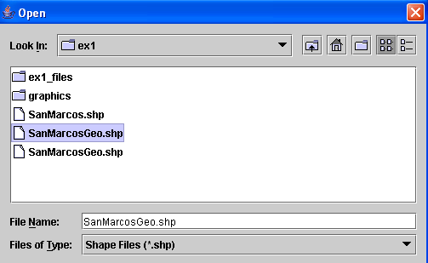
Note that maps must be in geographic coordinates to display correctly in the IDV. You can zoom in on a view of the San Marcos basin with interstate highways also displayed to give a sense of location (highways around Dallas-Fort Worth, Houston and San Antonio are shown in this map). It seems that the IDV can display line or area shape files but I am not sure if it can display point shape files.
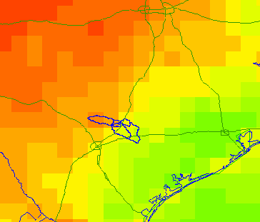
It’s a good idea to use File/Save As to resave your IDV map images now.
To be turned in: A map display showing the San Marcos basin overlying a short wave radiation flux map.
5. netCDF files in ArcGIS 9.2, energy balance in the San Marcos Basin
ArcGIS 9.2
The latest version of ArcGIS has the capability of reading netCDF files. NetCDF are very common in atmospheric sciences.
Data Files
The data files for this exercise are available at ex2.zip. They consist of:
- NARR data in netCDF, text and Excel format, for the San Marcos basin.
- A Shapefile of the San Marcos Basin, in geographic coordinates.
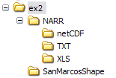
This portion of the exercise assumes that you know how to use ArcMap. If you don’t, please refer to Exercise 1 of my GIS in Water Resources class for an introductory tutorial on using ArcMap: http://www.ce.utexas.edu/prof/maidment/giswr2006/Ex1/Ex12006.doc
Until now, all the files we have viewed remained on the server at NCDC and were not downloaded to your local machine. In order to be able to use the ArcGIS 9.2 environment, netCDF files need to be downloaded on your computer. This task has already been accomplished for you (for July 2003); the files are available in ex2 / NARR / netCDF. If interested in downloading the files yourself, please refer to the tutorial http://www.ce.utexas.edu/prof/maidment/GradHydro2007/docs/NetCDF_Unidata.pdf
Let's now open netCDF files in ArcGIS 9.2! Very cool new stuff!
Open ArcMap, add the SanMarcosGeo shapefile.
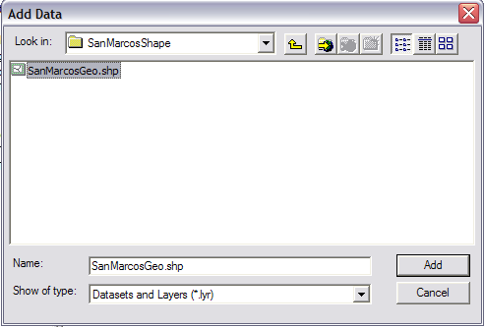
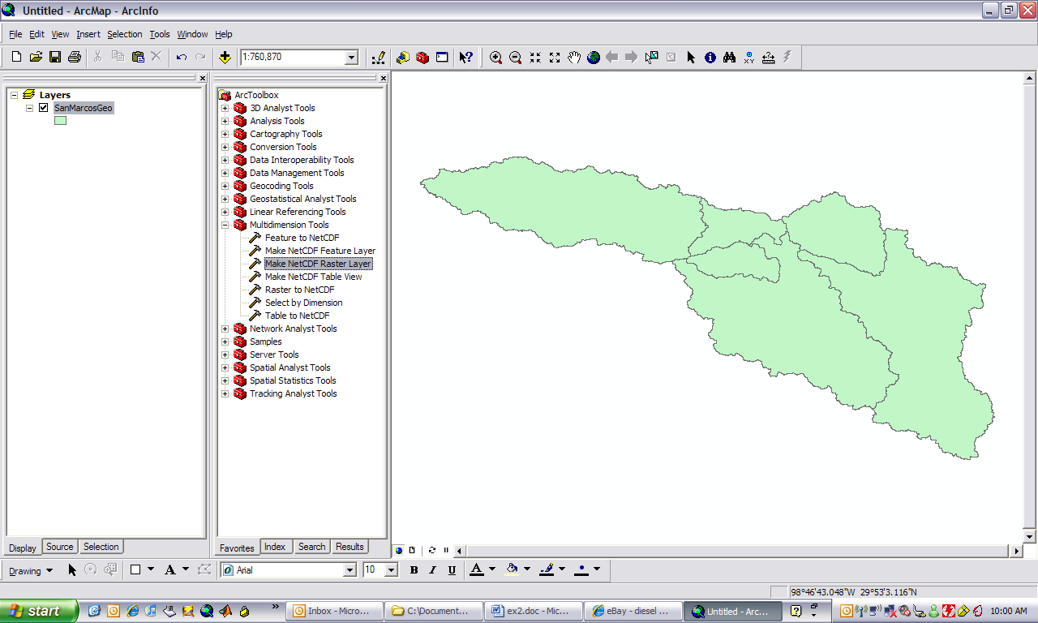
Open Arc Toolbox by hitting the button in the ArcMap toolbar. You need the Multidimension Tools. If you don’t see this option in your ArcToolbox display you can add it (provided you are using ArcGIS 9.2) by right clicking in the white space in the Arc Toolbox area and navigating to the toolbox folder in the ArcGIS program files. I found it at the following location:
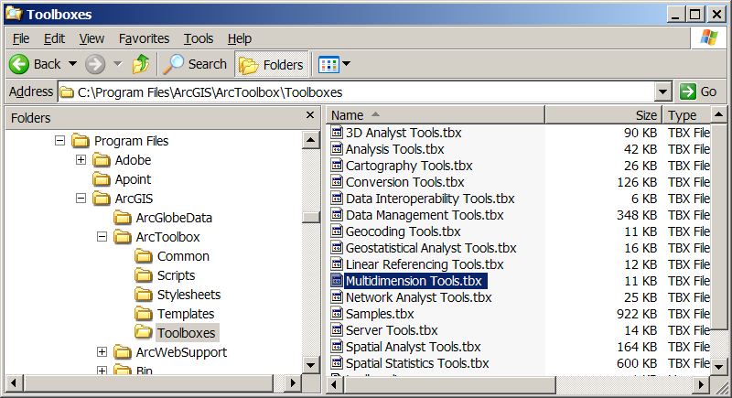
To ensure that you will have the Multidimension Toolbox displayed the next time you open ArcGIS, Right click on the white space below the tools in Arc Toolbox and select Save Settings… To Default, as shown below:
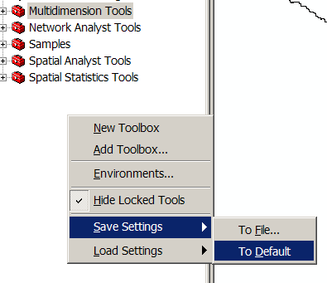
Use the Multidimension tools / Make netCDF raster layer:
Browse to your netCDF file, here narrmonhr-b_221_20030701_1500_000.grb.nc is given as an example. Select the variable desired, and keep all the other parameters as default.
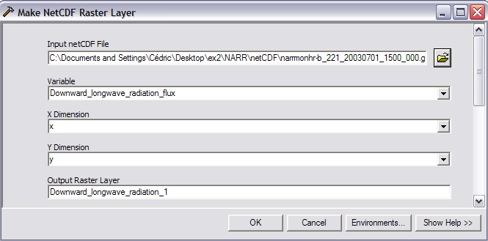
Click OK, you should see the following screen:
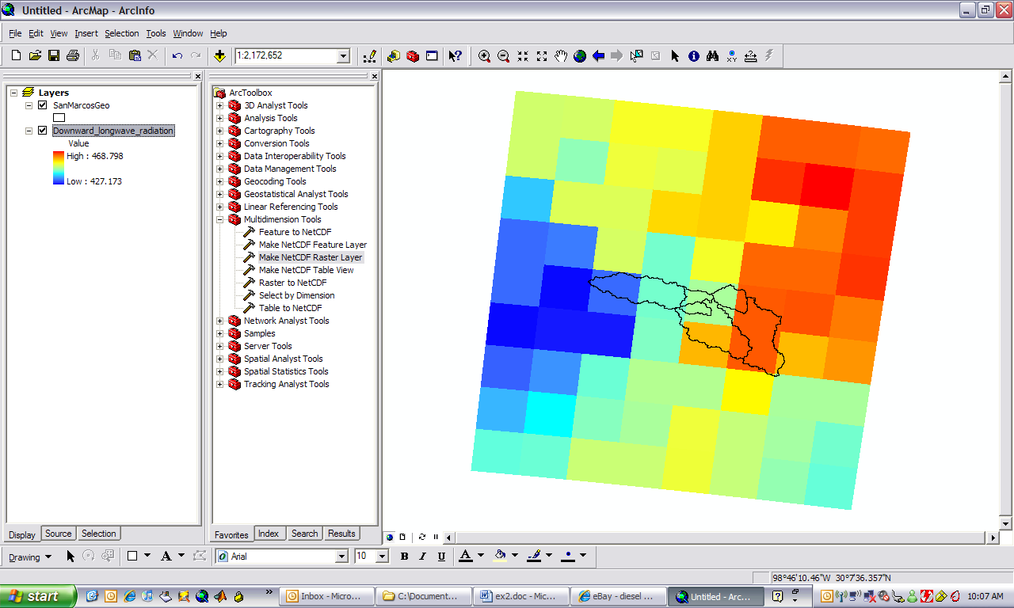
You just created a raster display of a netCDf file in ArcGIS 9.2! There are a total of 72 cells shown in this display, 9 upwards and 8 across, and by viewing the Layers in a Projected Coordinate system, you can find out that the size of the cells is approximately 30.5 km x 30.5 km, or 92 km².
We are now going to perform an energy balance for one point in the San Marcos Basin during the month of July 2003.
The center of the grid shown above corresponds to 30.0°N and 98.2°W, also symbolized with a circle in the picture below. Add to your display Downward and Upward Shortwave radiation flux, Downward and Upward Longwave radiation flux, and Sensible, Latent and Ground Heat flux, a total of seven flux components, order them as shown in the map display below, and use the Identify tool in ArcGIS to query <All Layers> in the map display. You’ll get a sequence of values in the query tool for the 7 components of the energy balance, as shown.
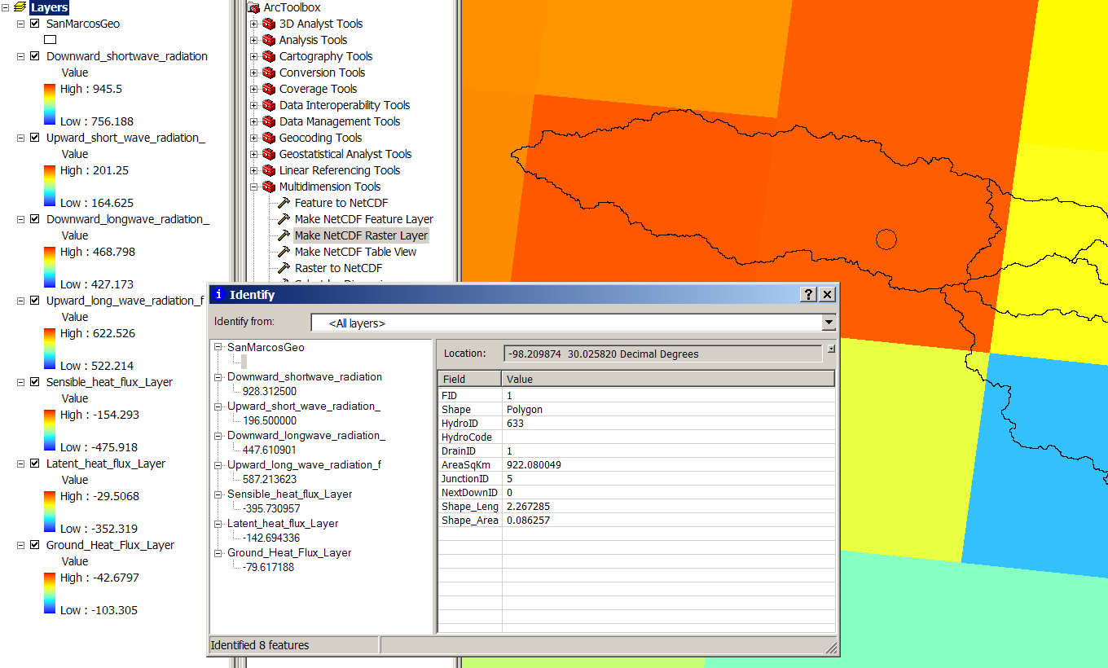
If you transpose these values to Excel, you can make a table and a graph of the energy balance at this time interval (1500Z). Now to translate that into local time, we subtract 5 hours because July is when we are using Central Daylight Time (we would subtract 6 hours if this were January because then we are using Central Standard Time), and we recognize that these data represent an average over a three hour time interval, so what you are looking at this an energy balance from 10AM to 1PM Central Daylight Time in the San Marcos Basin (actually the Blanco watershed near Wimberley, Texas).
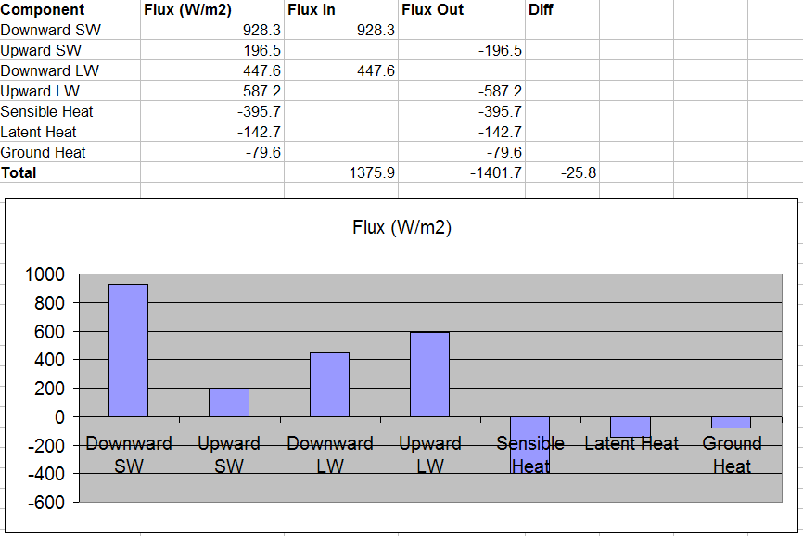
It requires some interpretation to figure out what all the signs mean here. What we are doing is working out the energy balance on a unit area of the land surface, say 1 m². The downward Short Wave flux is that which comes from the sun, the upward Short Wave flux is that reflected from the land surface, so in this instance, the surface albedo is 196.5/928.3 = 0.21. The Downward Longwave is that which comes from reradiation from the clouds and atmosphere and Upward Longwave is the reflected component plus the emission of longwave radiation by the earth itself (which is why the Upward LW is larger than the Downward Longwave). The Sensible Heat is that which goes to heat the air, the Latent Heat is that which evaporates water and the Ground Heat is that which is heating the soil. These last three quantities (Sensible, Latent and Ground Heat) are considered negative when they take heat away from the land surface. Shortwave radiation is that less than 3 μm in wavelength and Longwave radiation is that greater than 3 μm as indicated in the radiation diagram below.
You can make an energy balance by considering all radiation quantities that bring energy flux in to the land surface as positive and all those that have an energy flux out from the land surface as negative, as indicated in the spreadsheet above. Now, in theory, all these quantities should sum to 0 but you can see that there is a small discrepancy here of about 25 W/m².
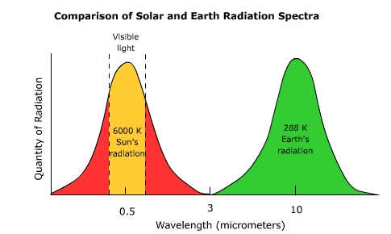
http://www.uwsp.edu/geo/faculty/ritter/geog101/textbook/energy/nature_of_electromagnetic_radiation.html
ArcGIS 9.2 allows you to create rasters, features, and tables out of netCDF files. Lets make a table. Choose the Make NetCDF Table View and navigate to the same file for 1500Z that you were using before: narrmonhr-b_221_20030701_1500_000.grb.nc
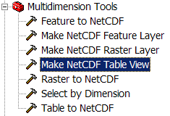
In the Variables scroll box you’ll see all the radiation components. Select them one at a time and use the + button  to add them to the Table View. Lets call the Output Table, Energy1500Z.
Add in the Scrolldown box at the bottom the Row dimensions Time, X, Y. If you don’t do this you will only get one record added to your table rather than all of them.
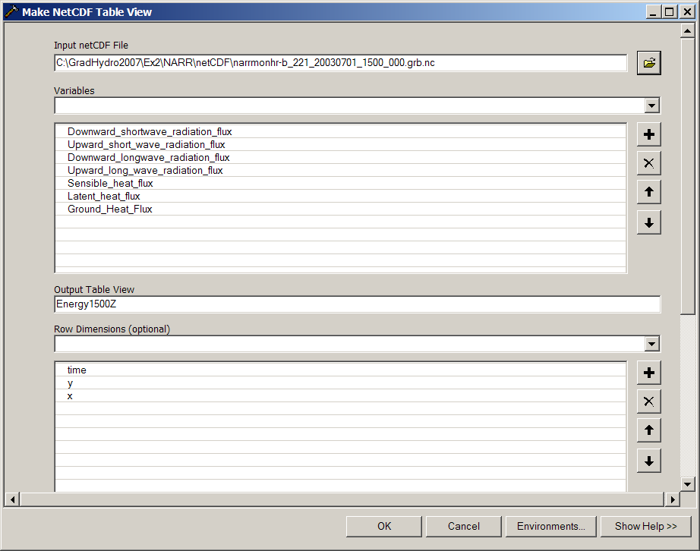
Now if we change the ArcMap Legend tab from Display to Source, the Energy1500Z table shows up.
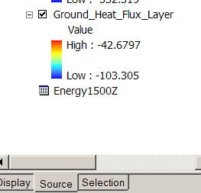
If you open the resulting table, you’ll see 72 rows of energy balance information, with the cell you examined in row 35:
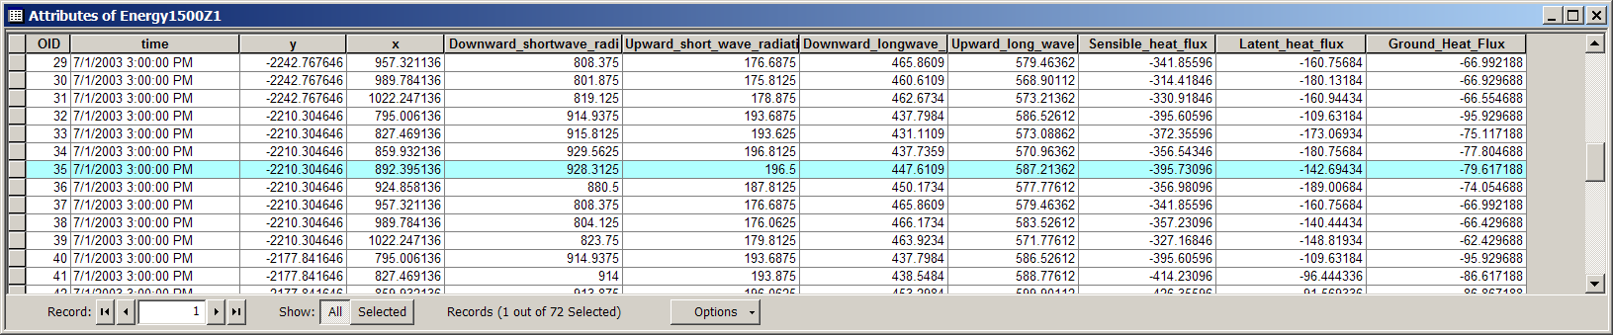
Ok, this is starting to be a lot of information. You can see how netCDF can start to bring some considerable additional detail to our understanding of the landscape. We can also view netCDF files as features, using the Make NetCDF Feature Layer. Proceed as before with the selection of variables and rows.
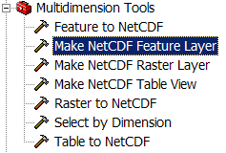
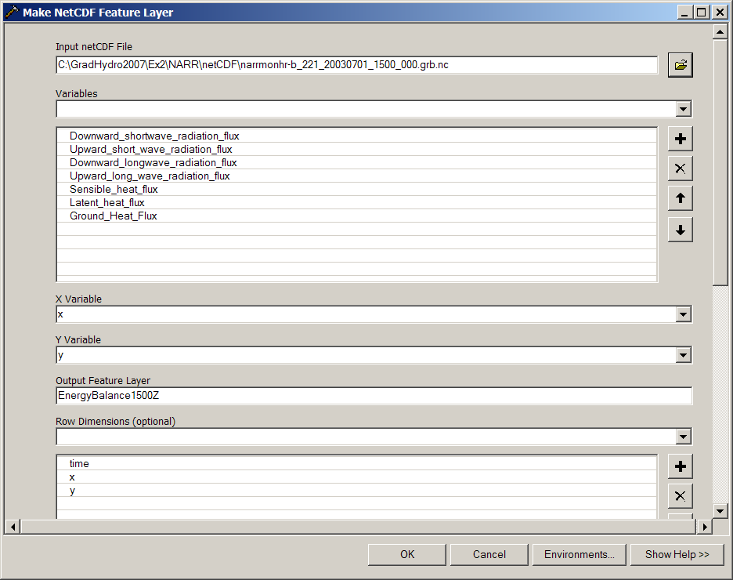
And the result displays as:
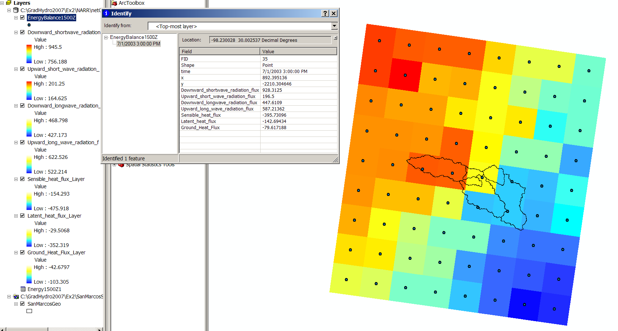
Ok, this is a lot clearer. You can see a point at the center of each cell and if you query the point at the center of the cell we’ve been working on, you can see all the same flux components that we have already examined. To store these data permanently, right click on the EnergyBalance1500Z layer and say it as a shape file. Then you can re-add it to the map, select the point we are interested in, and export its data only to a .dbf file and thus import it into Excel.
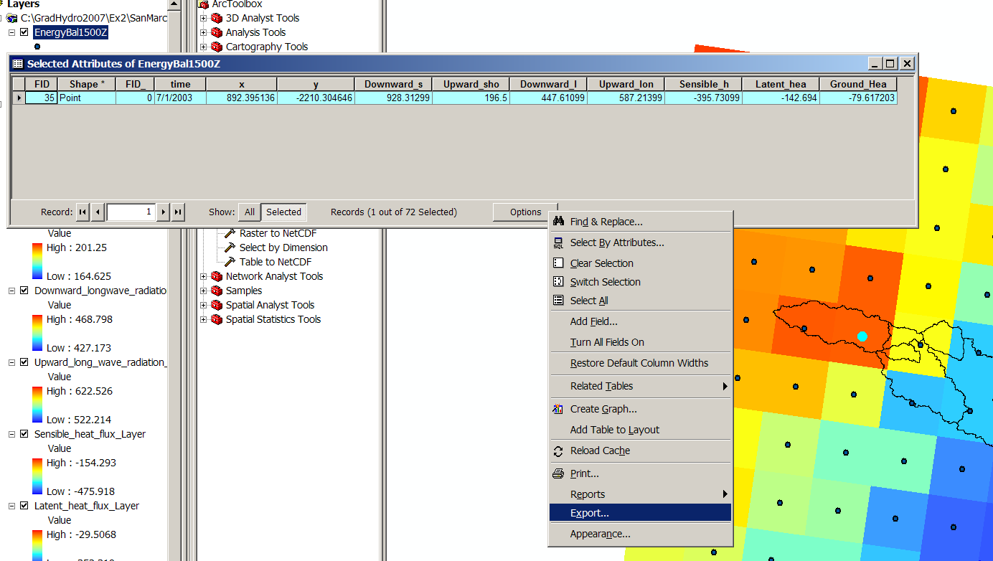
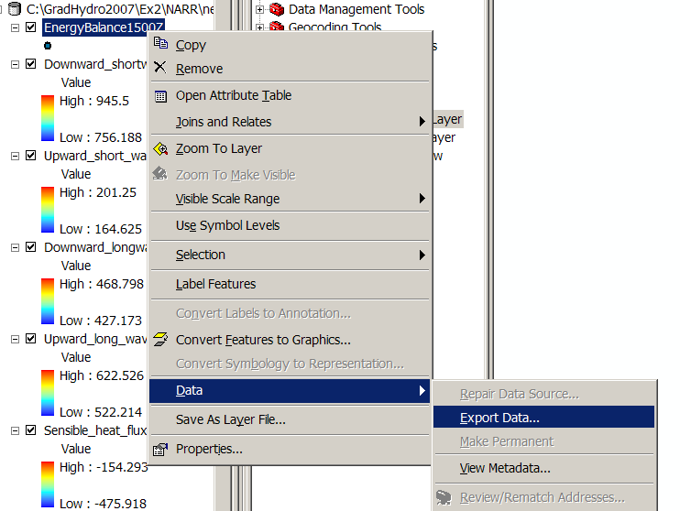

With a process similar to the previous, tables can be created and exported as text files, and can be imported into Excel. This process has aready been accomplished for you and text and Excel files corresponding to the netCDF files in ex2 / NARR / netCDF can be found in ex2 / NARR / TXT and ex2 / NARR / XLS.
The data corresponding to this point has been highlighted in all the Excel files given.

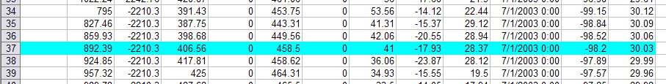
Here is a plot of daily average values of the flux components for the month of July 2003:
The upward longwave and shortwave components have been made negative in this plot to indicate that they are energy losses from the earth’s surface. Net radiation = DownSW + DownLW – UpLong – UpShort. This net radiation is consumed by ground heat flux (G), latent heat flux (L) and sensible heat flux (S). The balance is the sum of the net radiation and G + L + S. It should theoretically go to 0.
To be turned in: Make a table showing the Downward Short Wave Radiation values for 30.0°N and 98.2°W for each three hour interval during the day in July. Make a similar listing for the values of
1. Downward Longwave Radiation Flux
2. Downward Shortwave Radiation Flux
3. Ground Heat Flux
4. Latent Heat Flux
5. Sensible Heat Flux
6. Upward Long Wave Radiation Flux
7. Upward Short Wave Radiation Flux
Calculate the energy balance for 30.0°N and 98.2°W.
Make graphs showing data series 1-7 as a function of time of the day.
What is average July evaporation in mm/day at this location?
Choose a different box of the 72 boxes located in the San Marcos grid that you have been provided with , and make an energy balance study there as for the 30.0N and 98.2 W box that you have already worked with. Does the energy balance change much with location in this region?
Now, if you want to get your own data for another part of the country, you can go to:
http://nomads.ncdc.noaa.gov:8085/thredds/catalog.html in a web browser and find additional files.
Ok, you’re done!
Summary of items to be turned in
To be turned in: Make a brief summary of the North American Regional Reanalysis – how was it produced, what data summaries does it contain, what is its spatial extent and coverage in time?
To be turned in: Make a display of the downward solar radiation for each of the 3 hr intervals for July 2003 and make a similar series of 8 maps for January 2003. At what Z time does the maximum solar radiation occur? Where is the maximum solar radiation located for January? Where is the maximum solar radiation for July? The data you are viewing are solar radiation at ground level, not at the top of the atmosphere. Why is there more solar radiation in the western US during July than in the eastern US?
To be turned in: A map display showing the San Marcos basin overlying a short wave radiation flux map.
To be turned in: Make a table showing the Downward Short Wave Radiation values for 30.0°N and 98.2°W for each three hour interval during the day in July. Make a similar listing for the values of
1. Downward Longwave Radiation Flux
2. Downward Shortwave Radiation Flux
3. Ground Heat Flux
4. Latent Heat Flux
5. Sensible Heat Flux
6. Upward Long Wave Radiation Flux
7. Upward Short Wave Radiation Flux
Calculate the energy balance for 30.02°N and 98.2°W.
Make graphs showing data series 1-7 as a function of time of the day.
What is average July evaporation in mm/day at this location?
Choose a different box of the 72 boxes located in the San Marcos grid that you have been provided with , and make an energy balance study there as for the 30.0N and 98.2 W box that you have already worked with. Does the energy balance change much with location in this region?

