Downloading and Animating Nexrad precipitation data for the San Marcos Basin

1 March 2007
Prepared by Cédric H. David and David R. Maidment
Center for Research in Water Resources
University of Texas at Austin
Table of Contents
Goals of the exercise
Computer and data requirements
Procedure
1. Visualizing Nexrad grid cells on the San Marcos Basin
2. Downloading Nexrad data for the San Marcos Basin
3. Adding Nexrad data in the personal geodatabase
4. Displaying and animating Nexrad data for the San Marcos Basin

Goals of the Exercise
The goals of this exercise are to learn how to download Nexrad precipitation data from a webservice and display and animate a storm on the San Marcos Basin using the animation tool in ArcGIS 9.2. This exercise is adapted from a similar one developed for the Pearl River at Jackson, MS, by Louis Wasson of Mississippi State University. Thanks Louis!

Computer and Data Requirements
Nexrad webservice client
For this exercise you will need to install the Nexrad webservice client ((VS.NET) NEXRAD Web Service Client v0.2 public beta [install]) developed by Tomislav Urban and collaborators the Texas Advanced Computing Center at the University of Texas at Austin. Thanks Tomislav! More information on the webservice and its client can be found at http://nexrad.tacc.utexas.edu/. Microsoft Web Service Enhancements 3.0 is needed for this client to work, if it is not already installed on your computer, please do so.
ArcGIS 9.2
ArcGIS 9.2 is needed for this exercise.
Data Files
The data files for this exercise are available at http://www.ce.utexas.edu/prof/maidment/GradHydro2007/Ex3/Ex3.zip . They consist of:
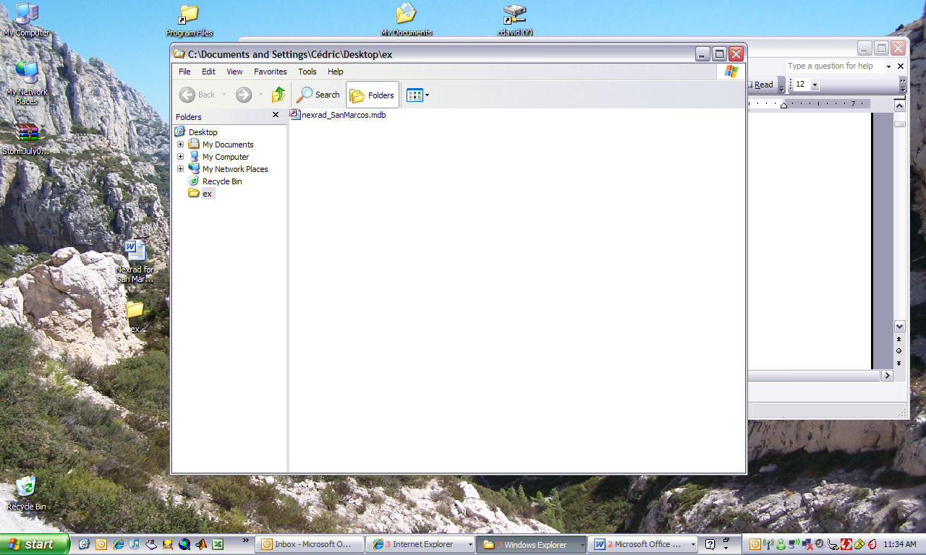
Procedure
1. Visualizing Nexrad grid cells on the San Marcos Basin
Open ArcGIS and add the HydroResponseUnit and HydroResponseUnit_Box feature classes in the nexrad_SanMarcos.mdb personal geodatabase. You should see the following display:

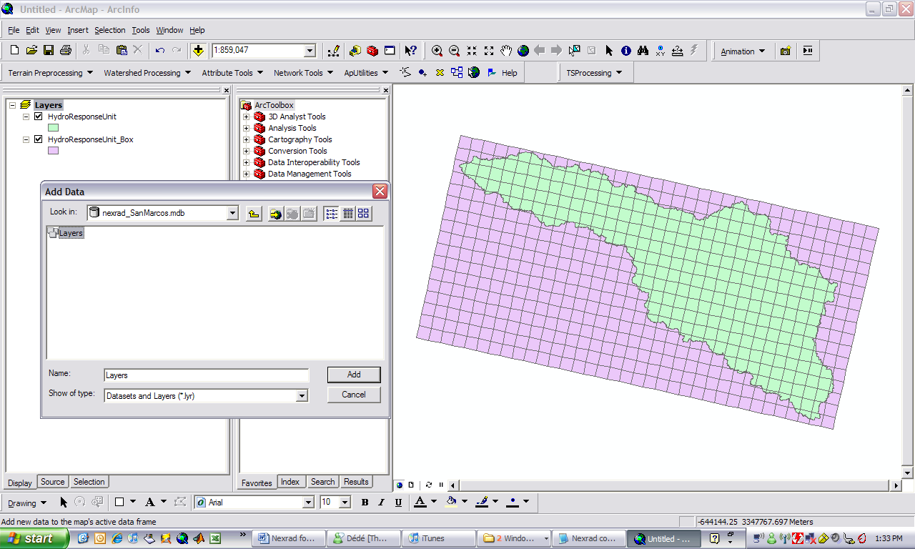

Save your ArcMap display as Ex3.mxd.

The feature class HydroResponseUnit is a clipped version of a feature class for all Nexrad grid cells in the United States that you can obtain at http://www.ce.utexas.edu/prof/maidment/GradHydro2007/Ex3/HRAP_USA.mdb . HRAP is spatial coordinate system used by the National Weather Service to mosaic the Nexrad data from all the weather radars into a single grid for the whole nation. This is described further at: http://www.ce.utexas.edu/prof/maidment/GISHYdro/seann/nexrad.htm The feature class is rather large (280 MB) and will not be used for this exercise but you can access it and use it to get Nexrad data for other locations if you want to. The feature class HydroResponseUnit_Box corresponds to the box surrounding the San Marcos Basin.
You can change the feature class properties, in ArcMap by right clicking on the feature class name, selecting Properties and then Labels, as shown below. Select Pixel_Comm. Then right click on the feature class name and select Label Features. You will see the following at the top end of the San Marcos Basin
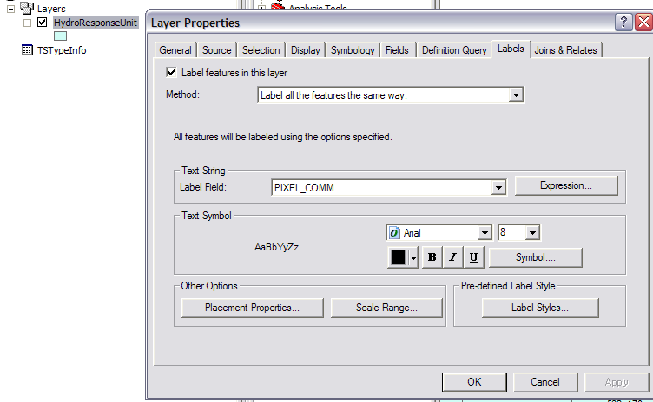
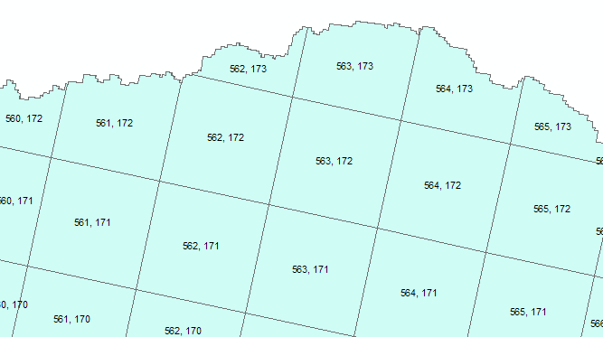
If you use Identify to click on a cell, like 563, 173, you’ll get a display as below. You can see from this that HRAP_X = 563 and HRAP_Y = 173, and these are the X and Y coordinates of this Nexrad grid cell. Each of these cells is itself a polygon and the shape and size of these cells varies continuously across the Nexrad grid.
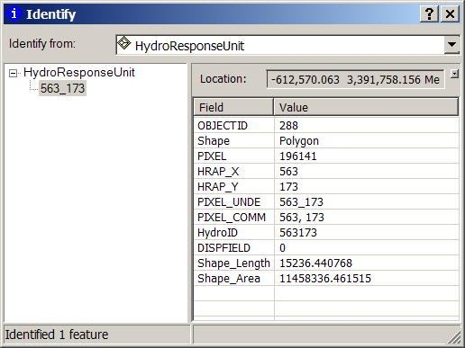
NEXRAD data is displayed in a 4km x 4km rectilinear HRAP (Hydrologic Rainfall Analysis Project) polygon grid. The HRAP polygon grid covers the entire continental United States.
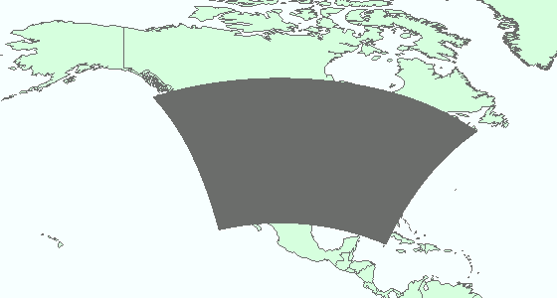

The Grid is laid out in rows and colums with the lower left polygon having the coordintates HRAP_X =1 and HRAP_Y = 1. The upper right polygon has the coordinates HRAP_X = 1120 and HRAP_Y = 820

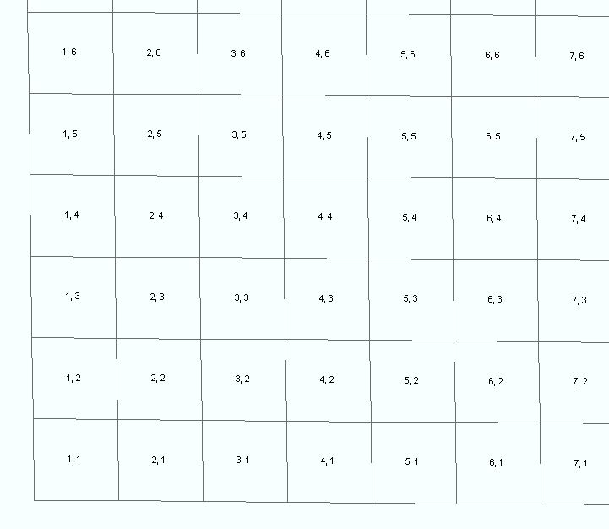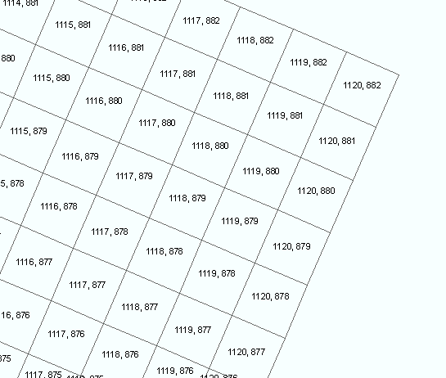
The HRAP grid that covers the San Marcos Basin corresponds to: HRAP_X: 558 - 592
HRAP_Y: 157 – 173.

2. Downloading Nexrad data for the San Marcos Basin
The Nexrad client application is at:
http://nexrad.tacc.utexas.edu/nexradws/samples/vsnet_client_install.zip

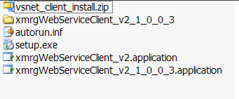

Extract all the files from this zip file and run the Setup.exe file.

You may get an error message:
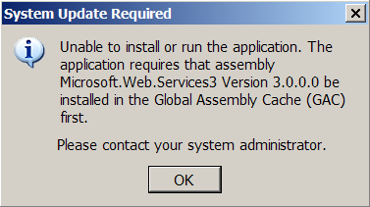

If this happens, get the Microsoft Web Service Enhancements Version 3.0 at:

http://www.microsoft.com/downloads/details.aspx?FamilyID=018a09fd-3a74-43c5-8ec18d789091255d&DisplayLang=en
Open the Nexrad webservice client installed on your computer, it is available at:
Start / Programs / The University of Texas at Austin / xmrgWebServiceClient_v2
Choose a filename, Select the Access Database option, enter the following start time and end time: 2004-07-26 00:00 and 2004-07-29 00:00, enter the HRAP coordinates for the San Marcos Basin, give your email and click OK. The ObjectID field can be left blank.
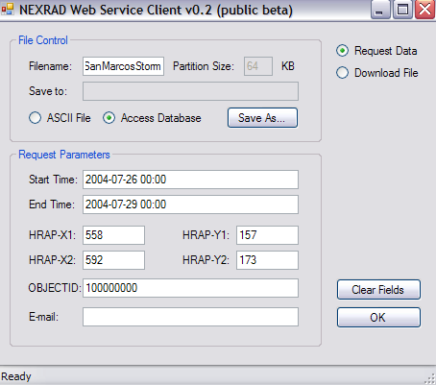
You have to be connected to the internet for this action to operate. You will receive two confirmations by email. If successful, your second confirmation email should give you the following link where your data is ready: http://nexrad.tacc.utexas.edu/nexradws/requested/mdb
Download your file and unzip it. If you don’t succeed in getting a response to the Nexrad download operation, you can get a copy of the SanMarcosStorm geodatabase at: http://www.ce.utexas.edu/prof/maidment/GradHydro2007/Ex3/SanMarcosStorm.mdb
3. Adding Nexrad data in the personal geodatabase
Open ArcCatalog (Start / Programs / ArcGIS / ArcCatalog) and browse to the nexrad_SanMarcos.mdb geodatabase.
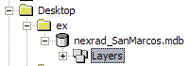
Right click on nexrad_SanMarcos.mdb, select import / table (single)
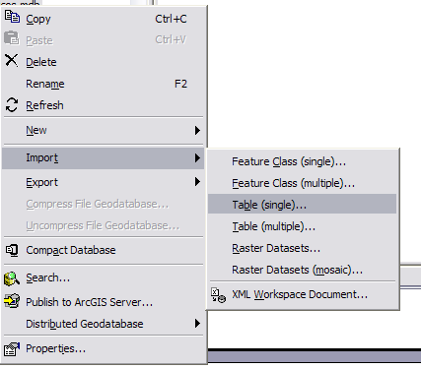
The Input Rows file is the TimeSeries table inside the SanMarcosStorm geodatabase that you previously downloaded and unzipped. The Output Table name should be TS_Nexrad.
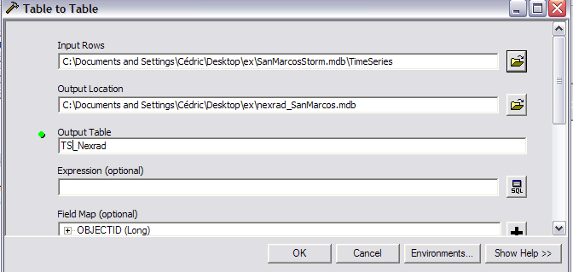
You should now see the following:
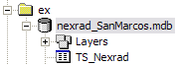
You can now close ArcCatalog.

4. Displaying and animating Nexrad data for the San Marcos Basin
Let's now go back to ArcMap. Reopen your ArcMap project Ex3.mxd. Add the Time Series table TS_Nexrad to the map:
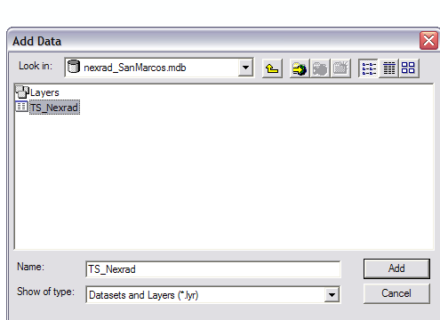
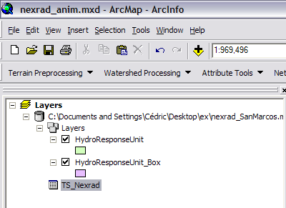
In this case, the TS_Nexrad data are spatially indexed by the attribute FeatureID, which has been set equal to the HydroID of the HydroResponseUnit feature class. This can be seen by labeling the HydroResponseUnit features using their HydroID attribute and displaying the TS_Nexrad table alongside them, as shown below. The HydroID has be set equal to the concatenation of HRAPX and HRAPY coordinate values for the cell. So, if HRAPX = 559 and HRAPY = 172, then HydroID = FeatureID = 559172. There is a record in the TS_Nexrad table for each cell and for each time period in which rainfall occurred. The rainfall data are for hourly time intervals, with the time stamp stored under TSDateTime at the instant the interval begins. The hour immediately following midnight just shows the time stamp for the day and all subsequent ones show the time stamp for the hour as well (this is a convention within relational databases, that all time intervals are time stamped at the beginning of the interval). The units are in hundreths of mm, so 198 = 1.98 mm of rainfall in 1 hour.
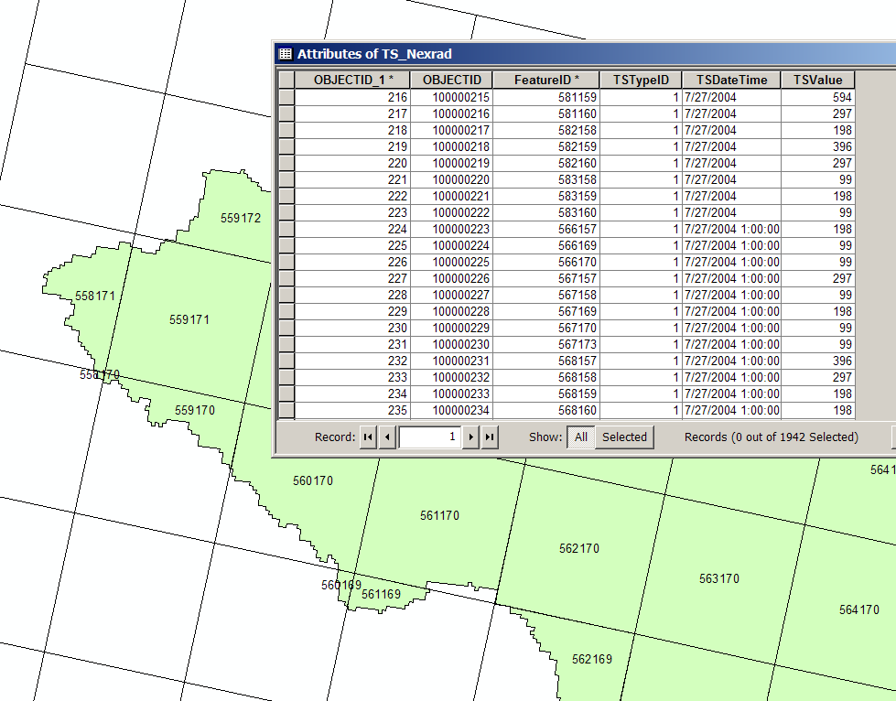
We need to link the HydroResponseUnit layer with the Time Series before animating. Right click on HydroResponseUnit and select join and relate / join. We are going to join the HydroID field of HydroResponseUnit with the FeatureID of TS_Nexrad:
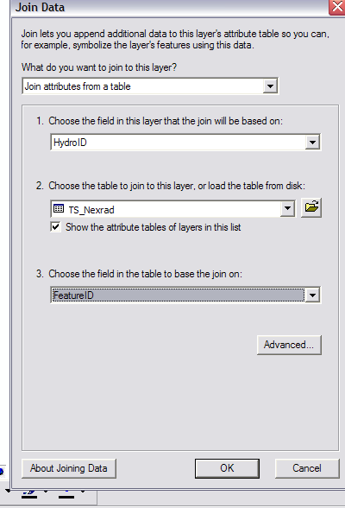
Click OK.
We should also change the display to be able to see the value of the rainfall on each cell. Go to HydroResponseUnit / Properties, select the Display tab and show Quantities Graduated symbols and select TS_Nexrad.TSValue as the field value.
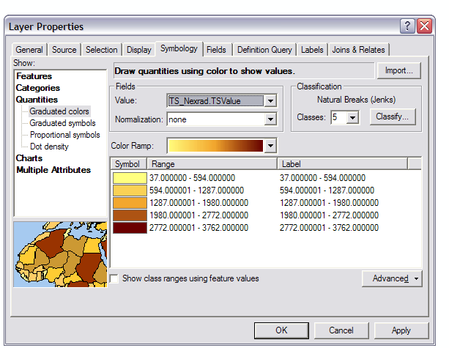
Let's also make the HydroResponseUnit_Box hollow:
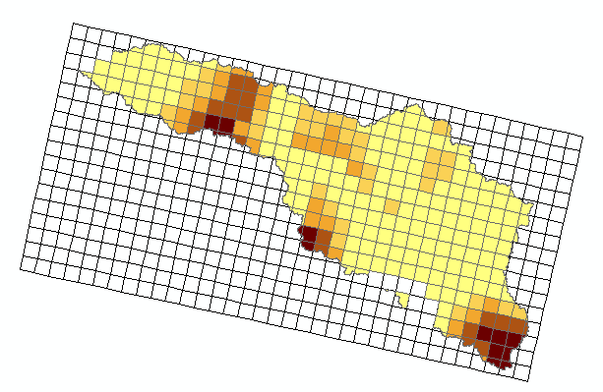
We are now going to use the Animation Tool, a new tool in ArcGIS 9.2! If the tool does not appear on your screen, you need to add it from Tools / Customize and select animation:
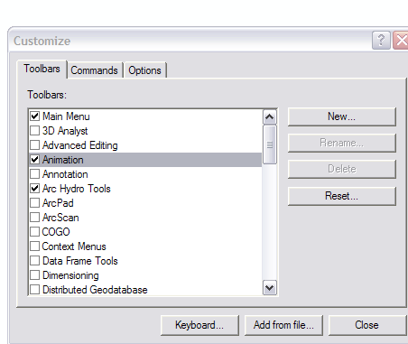
The Animation Tool looks like this:
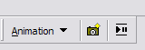
We need to start by creating key frames for the beginning and the end of the animation.
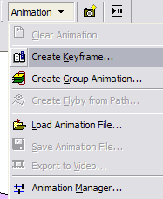
In Type, you need to select Time Layer, because we are going to create a time animation. Give a name to your animation, for example SanMarcosTimeAnim, and click new to create this new animation. Then use create twice to create two key frames named start and end. Finally, close the Create Animation Keyframe tool.
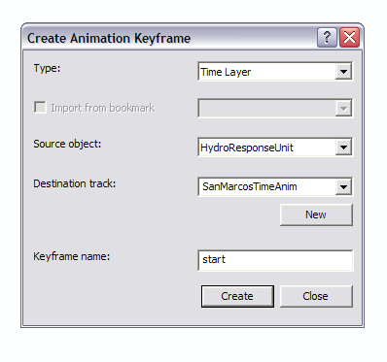
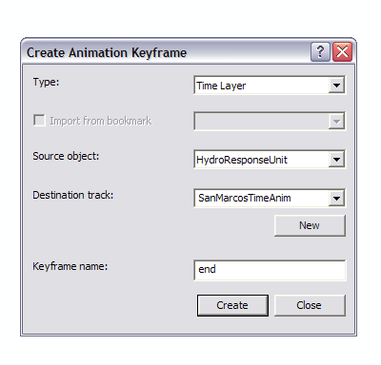
Open the Animation Manager:
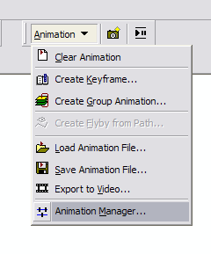
Select the tracks tab, click on Properties:
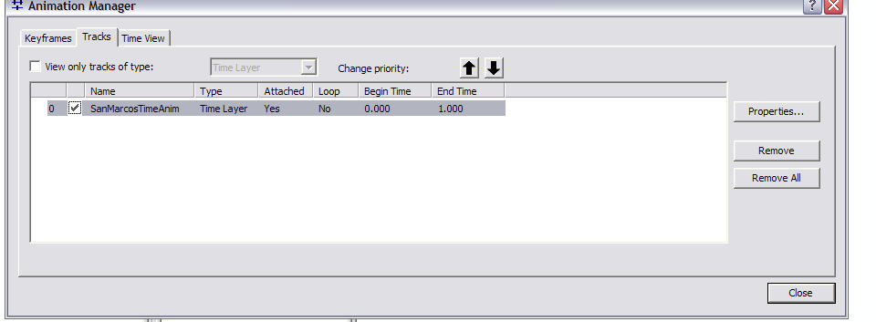
In the Time Track Properties tab, select TS_Nexrad.TSDateTime as the Start time and click on Calculate Times. Click OK.
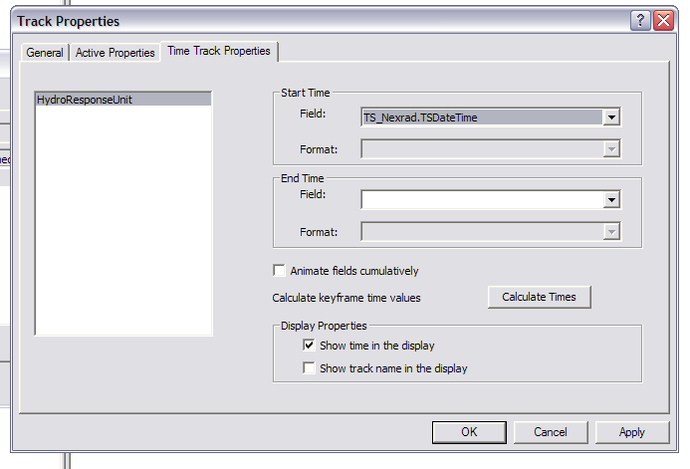
Back in the Animation Manager, select the Keyframes tab and change the interval to 1 hour.
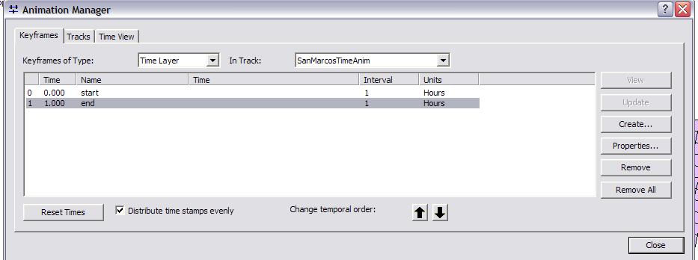
Close the Animation Manager.

Open the Animation Control by clicking on the following button:
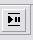
Expand the options click on by number of frames, and calculate. The number of frames should change.
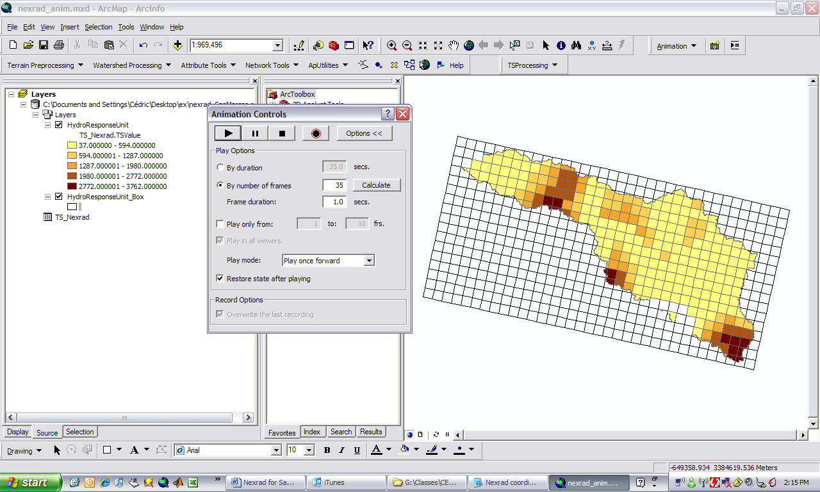
Click on the Play button and the storm will animate on the San Marcos Basin!
OK, you're done!
To be turned in: A screen capture of the animation window with all the data displayed as shown above.

