Bryan Enslein
CE 394K.2 Hydrology
Homework 4
Evaporation at Shale Hills

Solutions using the ODMws Statistics and Charts Worksheet

(1) Plot the diurnal variation in net radiation (Variable SRBHOS: 516) over an average day in July 2006 and January 2007. What is the monthly average value of net radiation for each of these two months (W/m²).

Finding the diurnal variation in net radiation over an average day is made simple by using the Statistics and Charts sheet. Data first must be acquired by selecting the appropriate time span, July 1 2006 – August 1 2006 or January 1, 2007 – February 1 2007 from the TimeSeries worksheet. Selecting the correct time interval of “TimeStep” on the Statistics and Charts sheet displays a plot of the desired data over a day in the data’s original interval, in this case 10 minutes. The data values displayed are the average net radiation for each time step over the entire month. For example, the 2:00 pm data value represents the average net radiation everyday at 2:00 pm. The average net radiation over the entire month is also given in the final row, labeled “Totals”, of the data table.

Average over July 2006: 84.77 W/m²

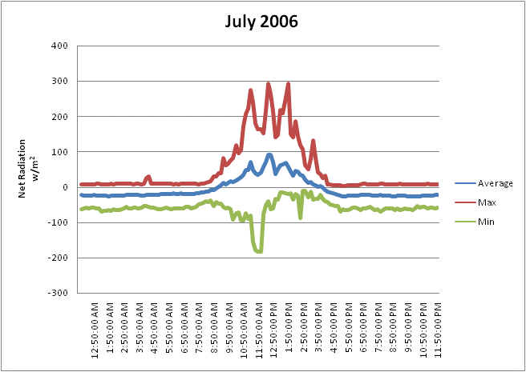
January 2007

Average over January 2007 -4.72 W/m²
(2) Calculate the monthly average net radiation for May 2006 to April 2007 and make a plot of that to show the seasonal variation in this phenomenon. What is the average value of net radiation for this 12-month period (W/m²)?

Again the average net radiation for the span between May 2006 and April 2007 can be found by entering the correct time period and variable information and choosing the “Month” time interval on the Statistics and Charts worksheet.

Average over entire year: 33.60 W/m²

(3) Take the meteorological data for air temperature (SRBHOS:545), wind speed (SRBHOS: 526), relative humidity (SRBHOS: 520), and net radiation and calculate the daily average evaporation (mm/day) for each day in September 2006, and March 2007.

The daily average air temperature, wind speed, relative humidity and net radiation that is necessary to compute the daily average evaporation rate can be downloaded using the Time Series worksheet and then more easily managed using the Statistics and Charts sheet. Each dataset had to be downloaded separately and, using the “day” time interval the average value for each day can be obtained for use in the attached computational spread sheet. The combination method of calculating evaporation is the grouping of the aerodynamic and energy balance methods. Because the energy balance method is a function of the net radiation, it can result in a negative value. In this case I assumed that the aerodynamic method was fully responsible for the total evaporation and ignored any negative values from the energy balance method.

See Attached Spreadsheet

(4) Plot the daily evaporation and precipitation for these two months.

(5) For September 10, 2006 and March 10, 2007, plot the diurnal variation in air temperature, wind speed, relative humidity and net radiation. Calculate and plot the corresponding diurnal variation in evaporation.

Once the spreadsheet from the previous problem was completed the data from this problem was used to find the evaporation over the course of a single day. The only variation that was needed involved converting the evaporation intervals from day to 10 minute time step intervals. Thus the evaporation values in the plot below are per 10 minutes, and the integral over the entire day would yield the total daily evaporation.

