CE 394K.2 Hydrology Homework #6 Spring 2010
The slides for the lecture presented by Dr David Yates on February 25 are at:
http://www.ce.utexas.edu/prof/maidment/GradHydro2010/Visual/Yates.pptx
Slide 3 of this presentation contains the figure below about the components of Radiative Forcing of the earth’s atmosphere:
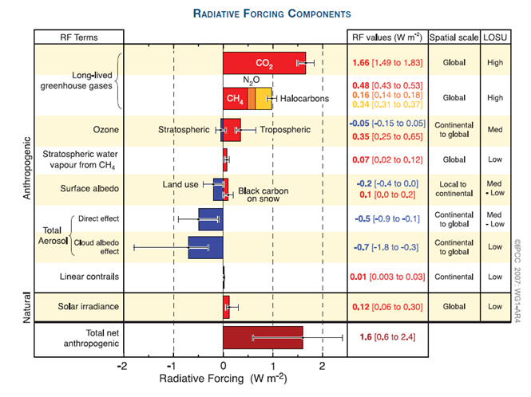
This diagram is taking from a report of the Intergovernmental Panel on Climate Change (IPCC), Working Group 1, the physical science basis of climate change:
http://ipcc-wg1.ucar.edu/wg1/Report/AR4WG1_Print_Ch02.pdf
Please make a 1-page typed summary describing the components of radiative forcing of the earth’s climate.
This homework is due in on Thursday March 4.

