Water Balance of the 1993 Midwest Flood

CE 394K.2 Surface Water Hydrology
University of Texas at Austin
Prepared by David R. Maidment and Pawel Mizgalewicz

Table of Contents
- Introduction
- Goals of the Exercise
- Computer and Data Requirements
- Procedure
- Results to be Turned In

Introduction
In 1993, the Midwestern States of the United States suffered their worst flood in more than 40 years. Heavy rains sustained throughout the summer flooded Iowa and portions of surrounding States. President Clinton appointed a team called the Scientific Assessment and Strategy Team (SAST) to examine the flood events, collect and analyze data, and report on the policy implications of the flood. How could the effects of future floods of this type be mitigated through policy changes? Should levees that breached in the flood be rebuilt? Has the draining of wetlands in the Midwest created flood hazards downstream? If so, what effect would recreating some of these wetlands have on flood discharges? Here are some articles about the 1993 Midwest flood:
http://mo.water.usgs.gov/Reports/1993-Flood/
http://www.nwrfc.noaa.gov/floods/papers/oh_2/great.htm
http://en.wikipedia.org/wiki/Great_Flood_of_1993
The SAST team met and worked for several months at the US Geological Survey's EROS Data Center where they compiled a considerable volume of data, some of it displayed at http://egsc.usgs.gov/isb/pubs/factsheets/fs10399.html In February, 1994, the SAST team convened a meeting of hydrologists and hydraulic engineers from around the United States to review the team's work and to suggest new lines of activity. It was fairly clear at this meeting that hydrologic practice at the time could not address very well the huge regional scope of the flood: the affected region has an area of approximately 700,000 km2, and most of the studies presented at the meeting dealt with areas of the order of 10 to 100 km2.
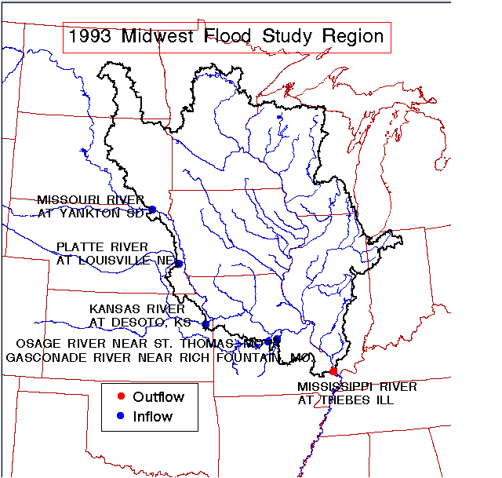
This exercise is based on some of the data generated in that study. The data presented here are for the SAST region taken as a single unit, comprising all the drainage area of the Upper Mississippi River and a portion of the Missouri River drainage, primarily capturing westward flowing water from Western Iowa. There are five inflow points to the study region where flow coming into the Missouri River from Eastward flowing tributaries enters the region. There is one outflow point, the Mississippi River at Thebes, Illinois, just above the confluence of the Mississippi and Ohio Rivers. All inflows and outflow points are monitored by USGS gages reporting daily discharge.
Daily precipitation over the region is estimated by interpolation from records of more than 1000 gages. Daily evaporation over the region is estimated by taking National Weather Service Maps of potential evaporation, and finding the factor (0.775) which when used to multiply the potential evaporation ensures that the annual water balance from January 1 to December 31, 1993, is approximately closed.

Goals of the Exercise
- To provide experience in analyzing the water balance of a large region
- To practice using spreadsheet programs for hydrology
- To learn something about the 1993 Midwest flood.

Computer and Data Requirements
This exercise is intended to be performed on a spreadsheet program on a personal computer.
Download the water balance data.
Excel file: http://www.ce.utexas.edu/prof/maidment/GradHydro2010/Hmwk2/Midwest.xls
The data will display on the screen.
The data consist of:
Column 1: Date expressed as PYYMMDD, where YY is the year (93) MM is the month, and DD is the day of the month
Column 2: Outflow [m3/s] from the region (discharge measured in the Mississippi R. at Thebes, IL.)
Column 3-7: Inflow [m3/s] into the region measured at five sites where rivers drain into the study region from the West:
- Osage River near St Thomas, Missouri
- Gasconade River near Rich Fountain, Missouri
- Missouri River at Yankton, South Dakota (the discharge from the upper Missouri basin which enters the study region)
- Platte River at Louisville, Nebraska
- Kansas River at DeSoto, Kansas
Column 8: Average Precipitation over the Region[mm/d]
Column 9: Average Evapotranspiration over the Region[mm/d]
Drainage area within the study boundary = 698525 km2
Conversion factors:
1 d = 86400 s
1 m = 1000 mm
1 km = 1000 m = 1,000,000 mm
1 cfs = 0.028317 m3/s
1 in = 2.54 cm
1 m = 3.2808 ft

Procedure
The daily water balance is to be constructed for 365 days, 1 January to 31 December 1993.
- Convert the outflow series of the Mississippi River at Thebes, Ill, into a series of equivalent depths in mm/day by converting the daily discharge into an equivalent volume in m3/day and then dividing by the drainage area.
- Aggregate the five inflow series into a single total inflow series and similarly convert the total to an equivalent depth of water in mm/day by dividing by the drainage area.
- Construct a spreadsheet with date in the first column and the succeeding four columns being precipitation, evaporation, inflow and outflow, all in mm/day. To make a date field in Excel, type 1/1/93 in the first column, use a formula to add 1 to get the date in the next row in this column, then copy the result to succeeding rows.
- Add two additional columns, the change in storage each day computed as:
Change in Storage = Precip - Evap + Inflow - Outflow
and the total accumulated storage in the region, assuming that the storage was initially 30mm on 1 January 1993.
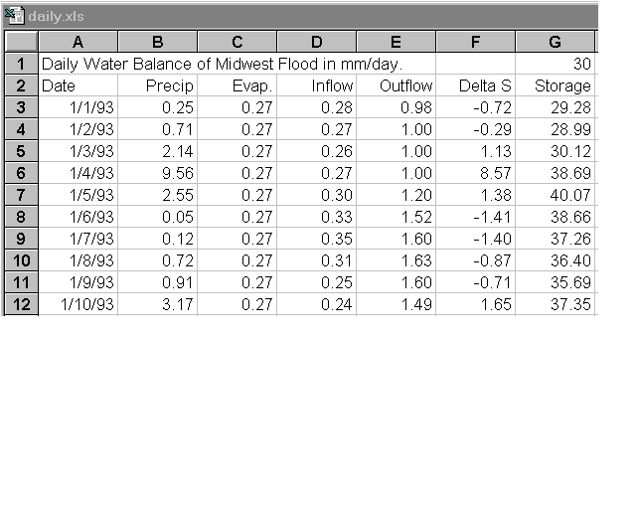
- Determine the annual total precipitation, evaporation, inflow, outflow and change in storage for the region. Is the annual water balance reasonably closed?
- Plot a graph showing the outflow in mm/day and the storage in mm against the date. Prepare the graph in the usual way in Excel and then click on the outflow line once the graph is plotted, bring up a dialog box, click on "axis" and select "secondary" to get both the outflow and the storage plotted with different y axes.
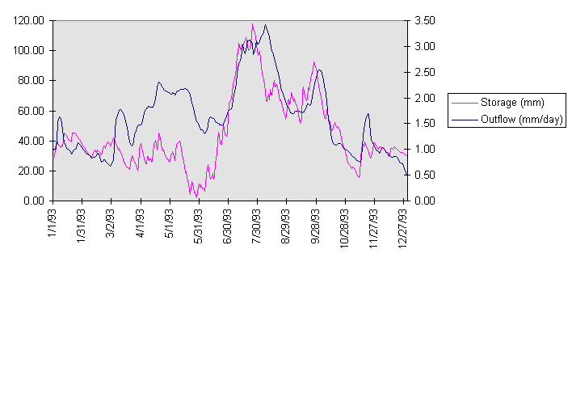
- It appears that the bulk of the flood occurred over a two month period from 1 July to 31 August 1993. Prepare a new spreadsheet for this period. Determine the series (precipitation - evaporation) and (outflow - inflow), all in mm/day and plot them.
- 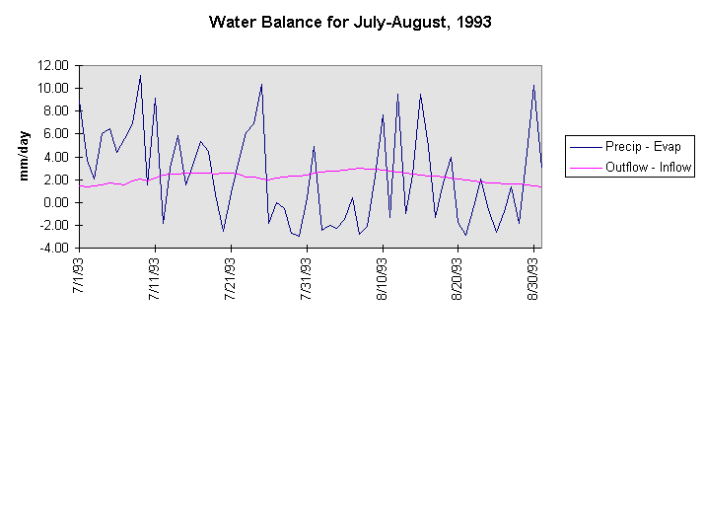
RESULTS TO BE TURNED IN:
- The total annual precipitation, evaporation, inflow, and outflow in mm for 1993. What is the annual net outflow (outflow - inflow) in mm? What percentage of the annual precipitation within the region evaporated and what percentage drained out of the region in the Mississippi River?
- A graph showing the storage (mm) and the discharge (mm/day) for the period Jan 1 to December 31, 1993. What was the peak depth of storage on the land surface? When did it occur? What was the peak discharge (mm/day and m3/s) at the outflow point? When did it occur? What was the lag time between the peak storage and the peak discharge?
- Present a spreadsheet showing the daily water balance analysis for July and August 1993. This should include date, precipitation, evaporation, inflow, outflow, change in storage and storage, in mm. Plot a graph showing (precipitation - evaporation) and (outflow - inflow). What effect does flow through the region have on smoothing the time variations in precipitation?
- For this two month period, what was the total precipitation, evaporation, inflow, outflow and change in storage in mm? What was the net outflow (outflow - inflow) in mm? What percentage of the precipitation left the region as evaporation? What percentage of the precipitation flowed out of the region as net outflow?
- Read some articles about the 1993 Midwest flood and write a 1-page summary describing the character of the flood and its impact on communities in the Midwest.

