CE 397 Statistics in Water Resources
Exercise 1 – Key
Exploring Time Series Data with HydroExcel
Assignment due: 2/5/09

Question 1)
Considering the plot of monthly average, maximum and minimum flow at USGS stream gauge station 08158000 shows a distinct pattern. We can clearly see the impact of the Highland Lake dams, which were put online in the 1940s. The most obvious difference is that peak flows before the dams were an order of magnitude higher than they are after the dam installation. The average mean monthly peak pre-1940, for example, was 13,880 cfs; in the years following 1940, the average was 3,738 cfs. (See table on next page.) Similarly, the maximum of the maximum monthly flows before 1940 was 323,000 cfs; after 1940, it drops to 45,200 cfs.
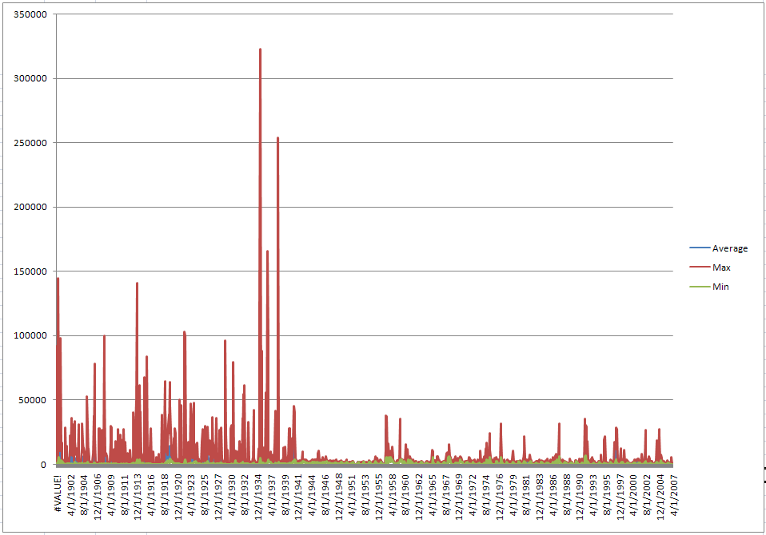

 | Average Monthly |  | Maximum Monthly |  | Minimum Monthly
 | Pre-1940 | Post-1940 | Pre-1940 | Post-1940 | Pre-1940 | Post-1940
Mean (cfs) | 2,737 | 1,874 | 13,880 | 3,738 | 592 | 814
Median (cfs) | 1,228 | 1,461 | 4,040 | 2,335 | 370 | 514
St. Deviation (cfs) | 4,509 | 2,393 | 27,828 | 5,351 | 675 | 968
Maximum (cfs) | 42,634 | 27,271 | 323,000 | 45,200 | 5,100 | 6,480
Minimum (cfs) | 58 | 39 | 88 | 74 | 0 | 2

The average minimum monthly flow increases in the time after the dams, leading to a slightly more regular water supply at this point. The difference between the pre- and post-dam minimums is not as drastic as that between the pre- and post-dam maximum flows, however.
In summary, the dams serve to even out the flow at this gauging location, which reduces the difference between the maximum and minimum/average monthly flows. This reduced spread is shown by the standard deviation of the data. As shown in the table, before 1940 the standard deviation of the monthly averages was 4,509 cfs; after 1940 it reduces to 2,393 cfs. A much bigger decrease is seen the maximum monthly standard deviation, which drops from 27,828 to 5,351 cfs.

Question 2)
Similar to what’s seen in the monthly flow statistics, the maximum yearly flows are much smaller and less erratic in the years after the dam construction than they are in the time before. We can see this difference in the following table which shows a decreased mean, maximum, and standard deviation in the maximum yearly flows before 1940 vs. those after the dams. One result of this change is less variability in the intra-year flows (the spread between the minimum and maximum flows is reduced within each year), which provides a more regular, less erratic water supply at this location.

 | Average Yearly |  | Maximum Yearly |  | Minimum Yearly
 | Pre-1940 | Post-1940 | Pre-1940 | Post-1940 | Pre-1940 | Post-1940
Mean (cfs) | 2,742 | 1,858 | 63,038 | 12,183 | 176 | 146
Median (cfs) | 2,094 | 1,507 | 35,900 | 6,315 | 123 | 48
St. Deviation (cfs) | 1,769 | 1,204 | 64,264 | 14,423 | 174 | 202
Maximum (cfs) | 7,170 | 6,546 | 323,000 | 91,800 | 939 | 762
Minimum (cfs) | 496 | 326 | 7,840 | 2,190 | 0 | 2

Question 3)
The following table shows the mean, median, standard error of estimate, and 95% confidence interval of the log-transformed data, the data converted to cfs and the original set of data (in cfs). We see here that converting the data through log-transformation changes our distribution by shifting the mean and reducing the data spread. These changes are caused by the transformation process de-emphasizing the large values in the original (right skewed) distribution. Since the large values of the original data get less emphasis in the conversion, the mean is reduced. The median value of the transformed vs. original data remains unchanged, however, since it is simply a measure of the middle data value; large and small values get equal weight when calculating a median (unlike the mean).
 | log(flow) | Converted to cfs | Original cfs
Mean | 2.92 | 822.33 | 1587.08
Median | 3.01 | 1020 | 1020
St. Error | 0.0080 | ≈15 | 48.46
95% C.I. | 0.0157 | ≈30 | 95.01

An important thing to note in this exercise is that the standard error and confidence intervals are symmetric about the mean in the log-transformed and original data. In the converted data, however, these intervals are no longer symmetric. We see this by calculating the upper and lower bounds of the standard error and confidence intervals.
$$Boundsofstandarderror\left[log\left(cfs\right)\right]=2.92∓0.008=\left(2.907,2.923\right)$$
Converted back to cfs:
$$Boundsofstandarderror\left[converted | | cfs\right]=\left(807.35,837.59\right)$$
$$Boundsofconfidenceinterval\left[log\left(cfs\right)\right]=2.92∓1.96∗0.008=\left(2.899,2.931\right)$$
Converted back to cfs:
$$Boundsofconfidenceinterval\left[converted | | cfs\right]=\left(793.22,852.51\right)$$
The result of this analysis shows the difference between the upper confidence interval and the mean flow (in the converted data) is 30.18 cfs, while that between the lower confidence interval and the mean is 29.11 cfs. Converting the data with the log-transformation, therefore, does create non-symmetric intervals about the mean. In this case, however, the impact is not very dramatic.

Question 4)
The following plots show histograms of the original and log-transformed data. We can see that the original data have the vast majority of flows in the first bin, creating a skewed distribution with a large spread. The log-transformed data, however, shows three bins with a notable number of data values. The distribution here is more symmetric and has less spread. This result suggests that our data is log-normally distributed.

Question 5)
Many different answers or scenarios were OK here. We wanted you to take us on a tour of the water in the U.S. Show us that you understand how to use HydroExcel and that you can describe temporal variations in stream discharge at a location other than the one used in this exercise.

