CE 397 Statistics in Water Resources
Exercise 3 – Key
Testing Homogeneity of Suspended Sediment Data
Assignment due: 2/19/09

Question 1)
The following table shows the descriptive statistics of each dataset. Following this table are the plots of the datasets over time. Based solely on the descriptive statistics of the datasets, it seems unlikely that the data is all from the same population. We note that the mean values of the USGS1 and TWDB data are fairly close, but the USGS2 mean is an order of magnitude lower. The median values of the 3 datasets are all quite different. We also note, however, that the datasets show very large standard deviations. Each of the means is, in fact, within a single standard deviation of the others. Based on the high variability of the data, therefore, the datasets may not be statistically different from one another. Let’s test them out and see.
 | USGS1 | TWDB | USGS2
Mean | 218,366.48 | 189,388.41 | 96,778.63
Standard Error | 142,988.59 | 53,528.69 | 34,161.12
Median | 240 | 2181.5 | 7182.11
Mode | 0 | 0 | ----
Standard Deviation | 714,942.97 | 586,377.42 | 152,773.16
Sample Variance | 5.11E+11 | 3.44E+11 | 2.33E+10
Kurtosis | 21.40 | 57.75 | 1.13
Skewness | 4.53 | 6.92 | 1.55
Range | 3,534,727 | 5,475,621 | 479,747.1
Minimum | 0 | 0 | 1.9
Maximum | 3,534,727 | 5,475,621 | 479,749
Sum | 5,459,162 | 22,726,609 | 1,935,572.64
Count | 25 | 120 | 20
Confidence Level (95.0%) | 295,113.95 | 105,992.15 | 71,500.04

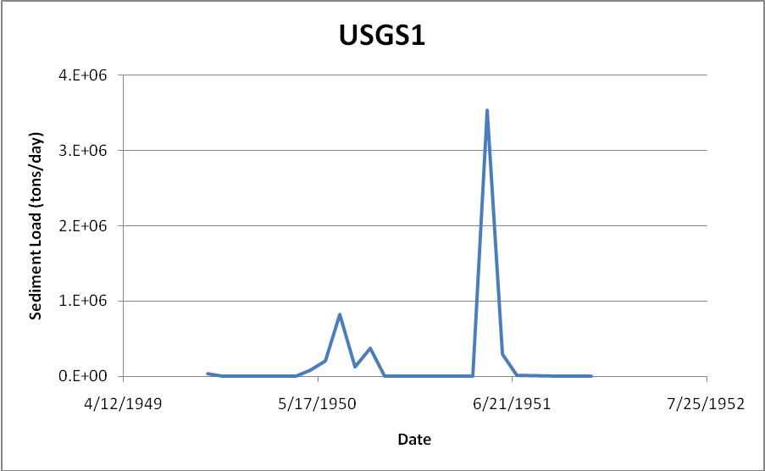

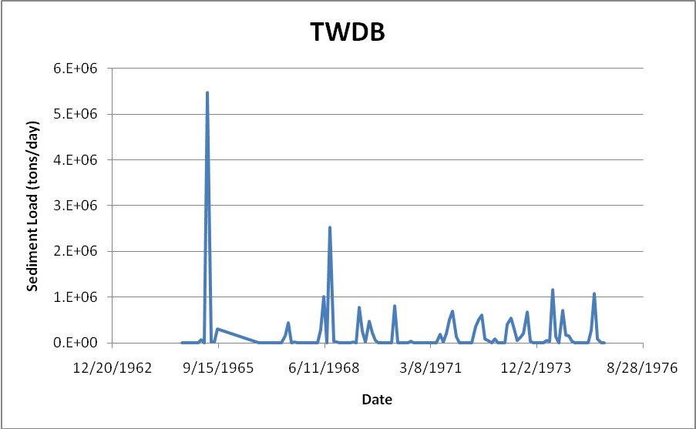

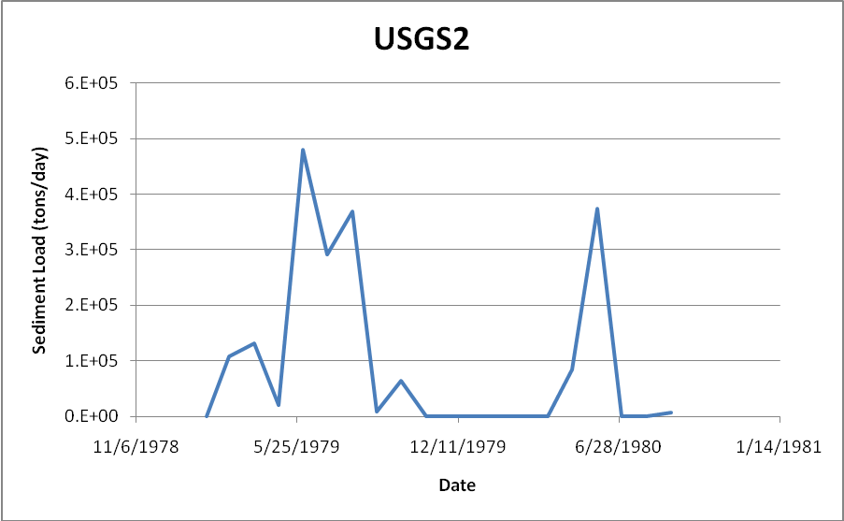

Question 2)
The histograms of the three datasets are shown below. As indicated by the descriptive statistics, the USGS1 and TWDB data are similar in the range of sediment loadings and fairly similar in the distribution of those loadings with the majority of the loads being less than 100,000 tons/day. As mentioned above, the USGS2 data is an order of magnitude less than the other two data sets. All of the datasets show a large right skew. The number of empty bins that separate the largest values from the rest of the data is also notable in each case. Lastly, the cumulative distributions of the datasets are similar, with a large percent of the data being concentrated in the lower values. Note that the USGS2 data, however, is slightly different as it has more outliers and, therefore, the cumulative percentage has a less drastic slope in the lower range.

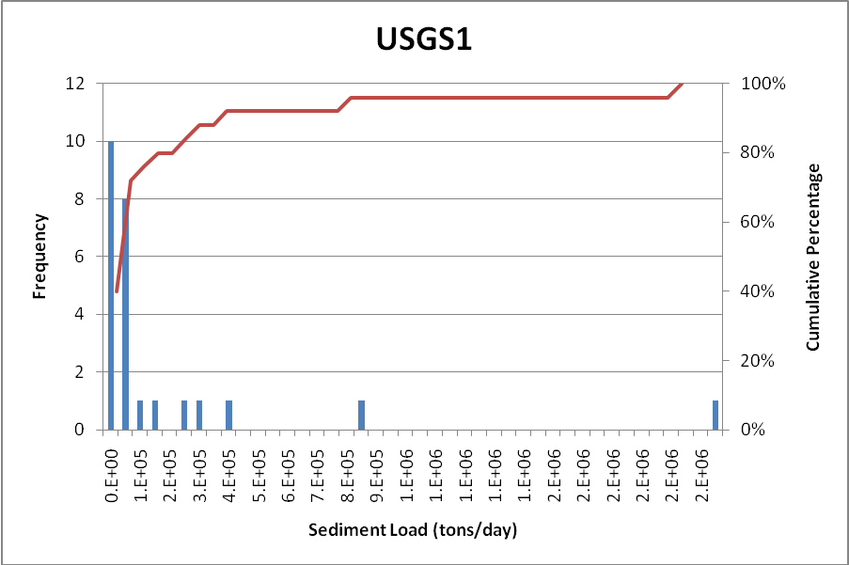
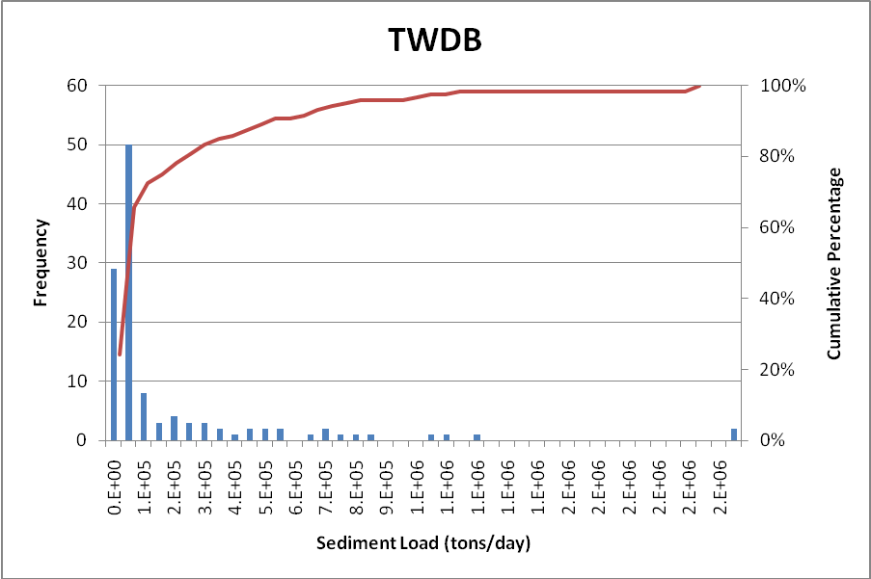
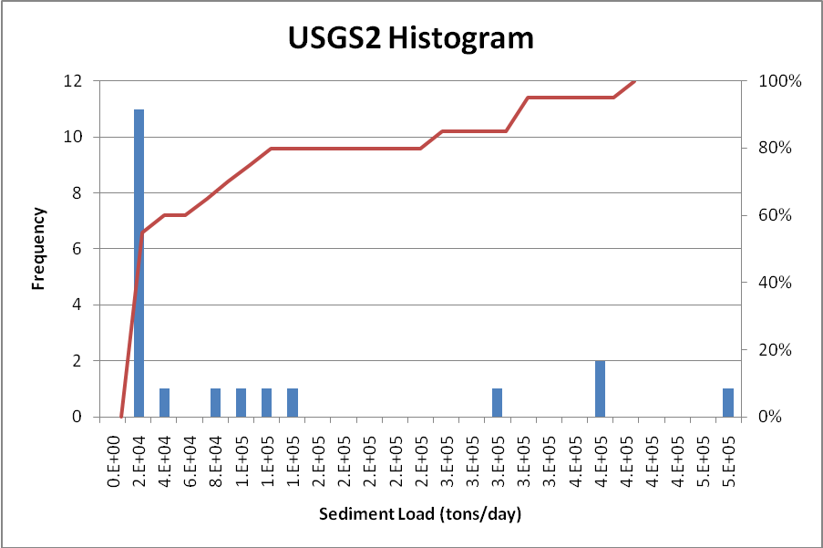

Question 3)
Performing the t-test on the USGS1 and TWDB datasets assuming equal variances gives the following result, which is quite similar to that found when assuming unequal variances. The p values in this analysis are slightly lower. They result in the same outcome, however, that we cannot reject the null hypothesis that the two datasets come from the same population.
t-Test: Two-Sample Assuming Equal Variances
 | USGS1 | TWDB
Mean | 218366.48 | 189388.4083
Variance | 5.11E+11 | 3.44E+11
Standard Deviation | 714943.0 | 586377.4
Coefficient of Variation | 3.27 | 3.10
Observations | 25 | 120
Pooled Variance | 3.72E+11
Hypothesized Mean Difference | 0
df | 143
t Stat | 0.216
P(T<=t) one-tail | 0.415
t Critical one-tail | 1.656
P(T<=t) two-tail | 0.829
t Critical two-tail | 1.977

Performing the F-Test for the USGS1 and USGS2 datasets reveals a p value of 2.46*10⁻⁹, leading us to assume that the variances of the data are statistically different (i.e. “unequal”). We will, therefore, perform the T-test on these datasets assuming an unequal variance. The result of this analysis is shown below; based on this result we do not reject the null hypothesis and, therefore, not able to say that the data is not from the same population. We can perform the analysis assuming equal variances to double check and will find the same result.
F-Test Two-Sample for Variances
 | USGS1 | USGS2
Mean | 218366.48 | 96778.632
Variance | 5.11E+11 | 2.33E+10
Observations | 25 | 20
df | 24 | 19
F | 21.90
P(F<=f) one-tail | 2.46E-09
F Critical one-tail | 2.11
t-Test: Two-Sample Assuming Unequal Variances
 |  |  | USGS1 |  | USGS2
Mean |  |  | 218366.48 |  | 96778.632
Variance |  |  | 5.11E+11 |  | 2.33E+10
Standard Deviation |  |  | 714943.0 |  | 152773.2
Coefficient of Variation |  |  | 3.27 |  | 1.58
Observations |  |  | 25 |  | 20
Hypothesized Mean Difference |  |  | 0
df |  |  | 27
t Stat |  |  | 0.83
P(T<=t) one-tail |  |  | 0.21
t Critical one-tail |  |  | 1.70
P(T<=t) two-tail |  |  | 0.42
t Critical two-tail |  |  | 2.05

t-Test: Two-Sample Assuming Equal Variances
 | USGS1 | USGS2
Mean | 218366.48 | 96778.632
Variance | 5.11E+11 | 2.33E+10
Standard Deviation | 714943.0 | 152773.2
Coefficient of Variation | 3.27 | 1.58
Observations | 25 | 20
Pooled Variance | 2.96E+11
Hypothesized Mean Difference | 0
df | 43
t Stat | 0.75
P(T<=t) one-tail | 0.23
t Critical one-tail | 1.68
P(T<=t) two-tail | 0.46
t Critical two-tail | 2.02

Let’s repeat this analysis for the USGS2 and TWDB datasets. The F-test again shows unequal variances. Similar to before we perform both T-tests and fail to reject the null hypothesis. We cannot say that the data are not from the same population.
F-Test Two-Sample for Variances
 | TWDB | USGS2
Mean | 189388.41 | 96778.63
Variance | 3.44E+11 | 2.33E+10
Observations | 120 | 20
df | 119 | 19
F | 14.73
P(F<=f) one-tail | 1.33E-08
F Critical one-tail | 1.93

t-Test: Two-Sample Assuming Unequal Variances
 | TWDB | USGS2
Mean | 189388.41 | 96778.63
Variance | 3.44E+11 | 2.33E+10
Standard Deviation | 586377.4 | 152773.2
Coefficient of Variation | 3.10 | 1.58
Observations | 120 | 20
Hypothesized Mean Difference | 0
df | 116
t Stat | 1.46
P(T<=t) one-tail | 0.07
t Critical one-tail | 1.66
P(T<=t) two-tail | 0.15
t Critical two-tail | 1.98

t-Test: Two-Sample Assuming Equal Variances
 | TWDB | USGS2
Mean | 189388.41 | 96778.63
Variance | 3.44E+11 | 2.33E+10
Standard Deviation | 586377.4 | 152773.2
Coefficient of Variation | 3.10 | 1.58
Observations | 120 | 20
Pooled Variance | 3.00E+11
Hypothesized Mean Difference | 0
df | 138
t Stat | 0.70
P(T<=t) one-tail | 0.24
t Critical one-tail | 1.66
P(T<=t) two-tail | 0.48
t Critical two-tail | 1.98

From these analyses, we are not able to reject the null hypothesis in any of the cases and, therefore, conclude that we cannot say that the data are from different populations. The practical result of this is that the data do not indicate a difference between sampling periods, location, or methods at these sites. The data, therefore, can be pooled together and considered to reflect the same population.
To determine which datasets are most similar based on these analyses, we will look at the p values of the T-tests. The USGS1 and TWDB data have the largest p value, suggesting that they are the most similar. This confirms what we witnessed in the earlier questions by comparing the descriptive statistics and histograms of the data, which implies that there is less difference shown between sampling methods than between locations.
Though these tests show that the datasets can be assumed to be from the same population we must be careful in how much weight we put on that outcome. Both F and T-tests assume normality in the data, which clearly is not the case here (look at the results of Questions 1 and 2). In general, the T-test is fairly forgiving for non-normality when large datasets are used. In the case of the TWDB data (with 120 points) we may be OK; but we should be careful with the USGS data (where n=20 and 25). Of particular concern is the F-test which is very sensitive to normality and, therefore, may provide questionable results in these analyses.

