CE 397 Statistics in Water Resources
Exercise 4 – Solution
Correlating Streamflow
Assignment due: 3/3/09
- To be turned in: A plot of the flow at Barton Creek and Bull Creek for 1/1/2008 through 6/30/2008 plotted on the same time axis. It might be useful to use a log scale for the flow to show the variations of the low flows more clearly.

Below we see the plots of flow in the two rivers. The original plot doesn’t show much variation, but the plot of the log of the flows shows some seperation in the low flows after mid-March. It is notable that the original flow data shows that negative flows were recorded at these stations in June. This results in the zero log flow values in the second plot.

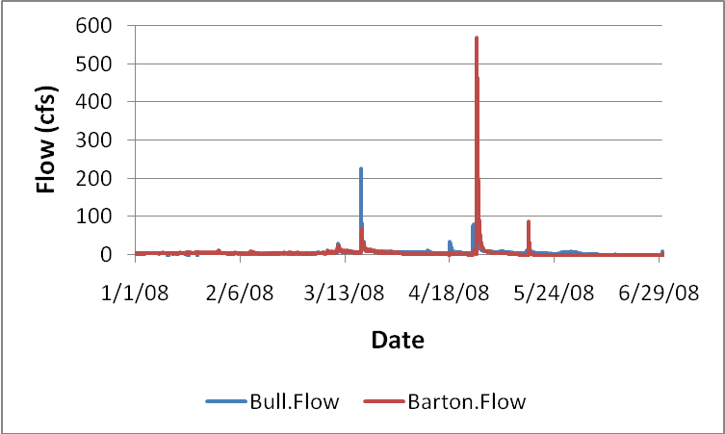

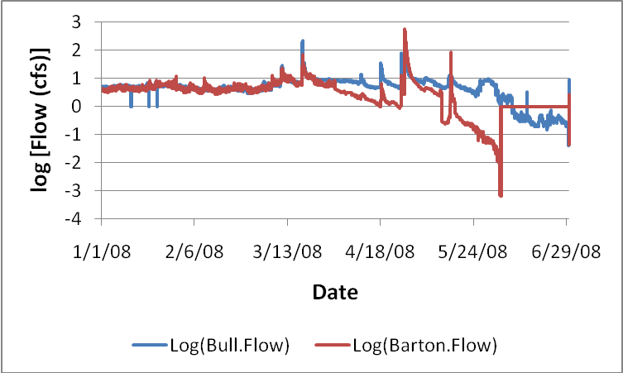

- To be turned in: (a) SAS plot of streamflow against streamflow. (b) Calculate all three correlation coefficients, and discuss the differences among them.

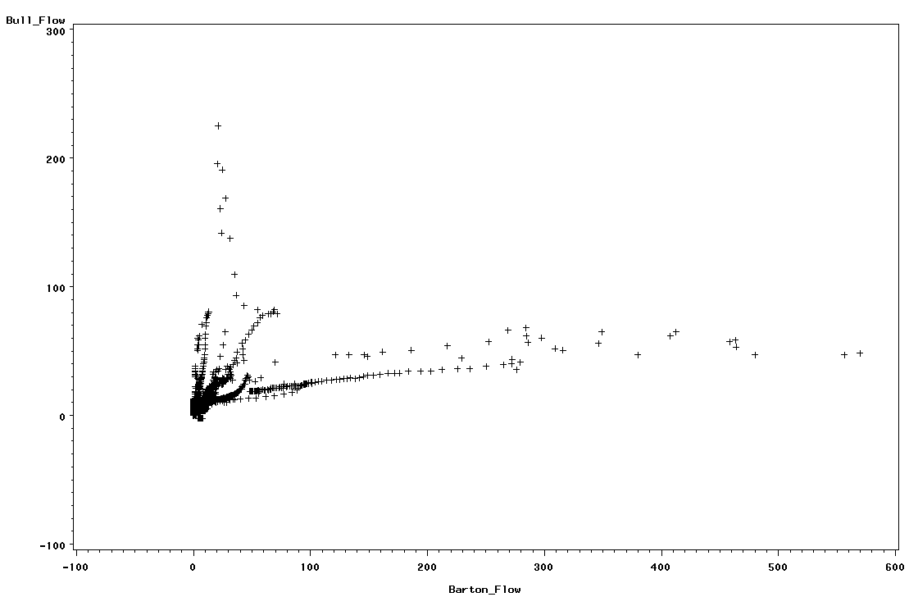

If we plot the two datasets against one another we see a clump of low flow values at both locations. These very low flow values appear to be well correlated showing that when one stream is experiencing very low flows, the other one is typically also at low flow. There are also limbs showing high flows in each stream, however. There is little correlation at these high flow values, with high flows at each location often occurring when the other is under low to average flow conditions.

Correlation coefficients:
Pearson’s: 0.47050 (p <0.0001)
Kendall’s: 0.47360 (p<0.0001)
Spearman’s: 0.60971 (p<0.0001)

The coefficients for all 3 correlation methods are statistically significant (low p values, therefore, reject the null hypothesis that the datasets are independent) but none of the rho values indicate a very strong correlation. The coefficients for the Pearson and Kendall methods are very close in value, showing a positive correlation of about 0.47. The Spearman’s coefficient, however, is a bit stronger at 0.61.

The Pearson’s approach is a parametric test meaning that it’s best used on data with a normal distribution and is sensitive to outliers in the analysis. It’s likely that this is why it has the lowest value; our plot (above) shows that we do have some outliers here. The Kendall and Spearman approaches are non-parametric so they don’t care what distribution the data follows. Kendall compares the ranks of the data and Spearman compares the values of the ranks. Kendall’s is typically considered more reflective of the actual correlation of the data and results in a lower rho value. That is what we find here.

- To be turned in: A plot of the Barton Creek and San Marcos River data

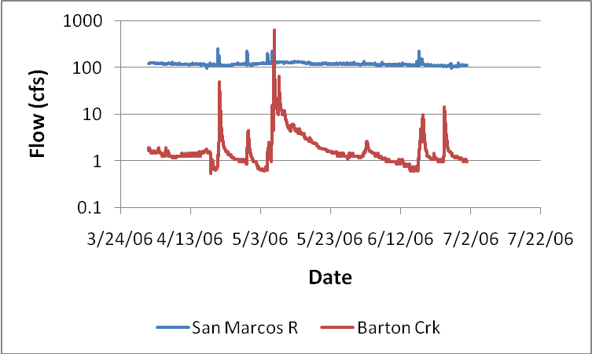

The plot of flows in the San Marcos River and Barton Creek between April and July of 2006 are shown above. As mentioned in the assignment, we see the stability of flow in the San Marcos contrasted with the flashiness of flow in Barton Creek.

- To be turned in: A plot of both correlograms. Autocorrelation length for each gage with a comparison and brief discussion.

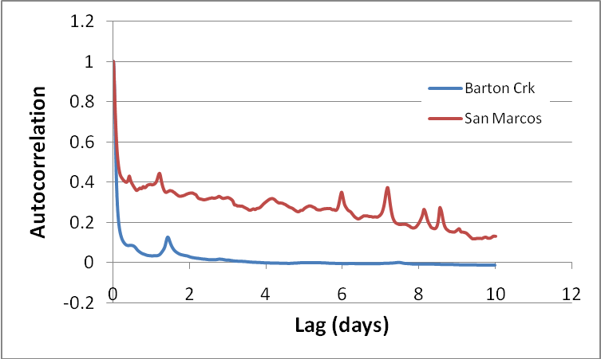

The graph of autocorrelations shows that the flow in the San Marcos River has a larger autocorrelation than flow in Barton Creek. A given day’s flow in the San Marcos River is more dependent on the preceding days’ flow than they are in Barton Creek. This makes sense, as we noted that Barton Creek has flashier flows and San Marcos is pretty steady in its flow.

The correlation length for Barton Creek is approximately 4.49 hours, while the length for the San Marcos River is about 2.78 days. Again, this shows that the flow in the San Marcos River is steadier than it is in Barton Creek. It’s actually likely that the correlation length for the San Marcos River is greater than 2.78 days, as we limited our analysis here to 10 days. If we carry the analysis out until the autocorrelation goes to zero (as we did with Barton Creek), we calculate a correlation length of over 3 days. Either way, this analysis tells us that the flow in the San Marcos River at a given point in time is influential on flows up to 3 days later. Barton Creek flows are only influential for a few hours.

- To be turned in: The plots of each time interval’s autocorrelation for Barton Creek and the San Marcos River as well as a plot of time interval versus correlation length. Do these plots make sense? What would you expect from correlation lengths of more time intervals?

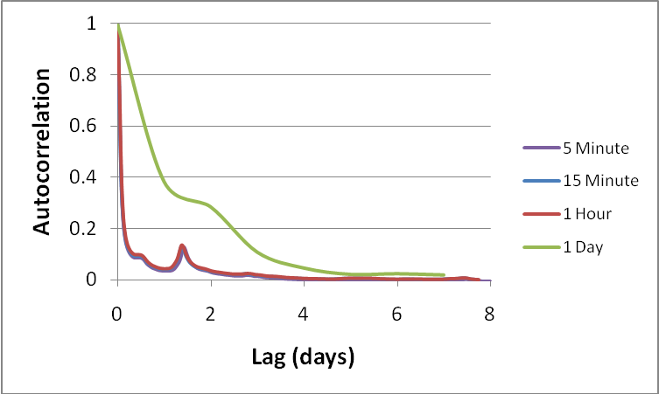

Above we see the plot of autocorrelation versus lag time for Barton Creek under each of the averaging periods. The trends in the 5, 15, and 60 minute data are very similar; the 1 day averaging period, however, disrupts the pattern. Similar results are seen if we look at the autocorrelation length for each of the averaging times (shown below). Here we see that a similar autocorrelation length (of approximately 5 hours) was calculated from the 5, 15, and 60 minute data. When we use the average daily flows, however, our autocorrelation length jumps up to nearly 33 hours. Since the averaging period is greater than the autocorrelation length, in this case, we lose the ability to measure the correlation and our results are incorrect. Also of note is the fact that (in general) the autocorrelation length increases as we increase the averaging time of our data. This is expected since increasing the averaging time lumps more data into each value used in the analysis and smoothes out some of the variation in the original data.

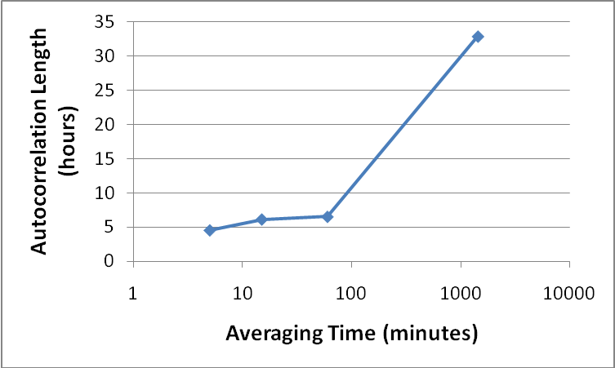

- To be turned in: A plot of cross correlation of streamflow and precipitation for Dripping Springs and Barton Creek near Oak Hill. Determine the lag time and discuss your results.

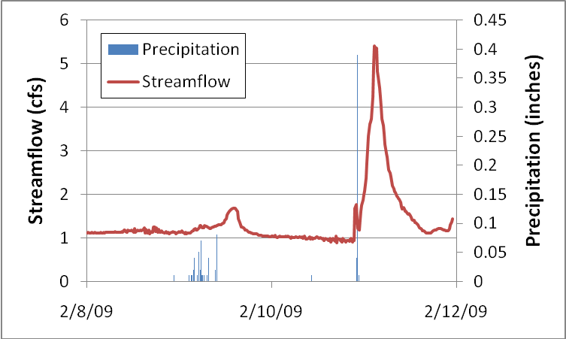
Above is a plot of the streamflow at Barton Creek Hill and the precipitation at Dripping Springs. From this plot it appears that there will be a lag of about 5 hours from when it rains to when we see an increase in flow downstream.
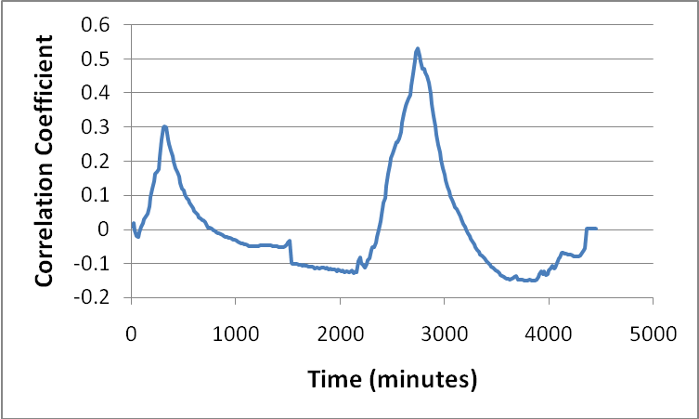
If we plot the correlation coefficient between the precipitation and discharge, we see a spike in the correlation (up to about 0.3) at approximately 300 minutes. This confirms the 5 hours lag that we saw in the plot of streamflow and precipitation (above). The second peak in the correlation coefficient (at around 2700 minutes) doesn’t make physical sense. If we look at the data, we can see that this is actually a function of how we ran our correlation; the analysis is aligning the first precipitation event with the second stream discharge event. So we can disregard this second spike and rely on the first one, showing that the lag time between the rainfall and streamflow at these stations (during this event) is approximately 5 hours.

