CE 397 Statistics in Water Resources
Exercise 7 – Key
Spatially Referenced Regressions On Watershed Attributes (SPARROW)
Assignment due: 4/2/09
- Turn in a map of each different predicted loading. Discuss the results. Which sources contribute the greatest amount of nitrogen to the overall load? How are these loads distributed spatially (i.e. are they concentrated in certain regions, along certain rivers, do the different sources follow different patterns)?
The following figure shows the total nitrogen loading predicted by the SPARROW model across the State of Texas. The smaller figures on page two break the loadings out by source. One important thing to note is that these figures consider the cumulative loading of nitrogen, which impairs our ability to see some of the spatial trends. For now we’ll simply note that limitation and continue with our analysis. However, an interesting follow-up to this work would be to consider the incremental loadings across the State.
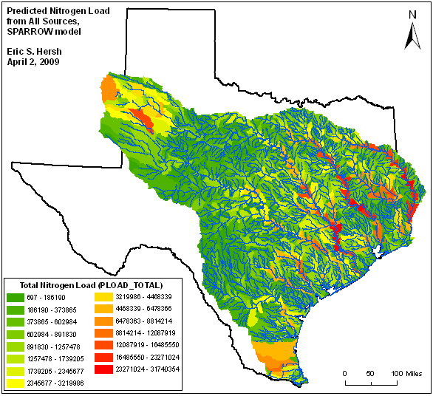
Considering these figures, we first note that the nitrogen loadings are highest immediately surrounding the major rivers. This makes sense as the rivers receive the nitrogen from the surrounding watershed. The rivers then transport the nutrients downstream, where they accumulate. This downstream accumulation is easier seen in the source specific figures (on page 2). It is also notable that the highest nitrogen loadings are found along the Sabine, Trinity, and Brazos Rivers and in far West Texas. Elevated levels are also shown in the southern tip of the State. Let’s look at the individual sources to see why this may be.
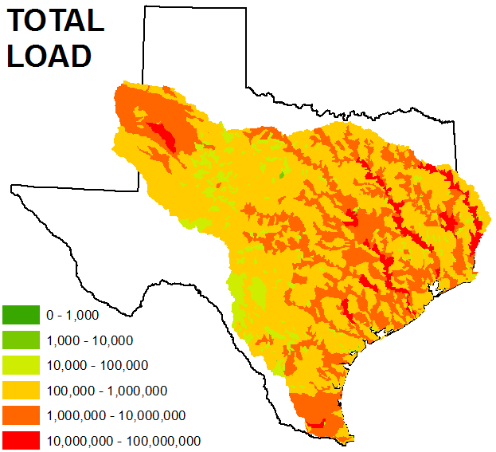  kg/yr | 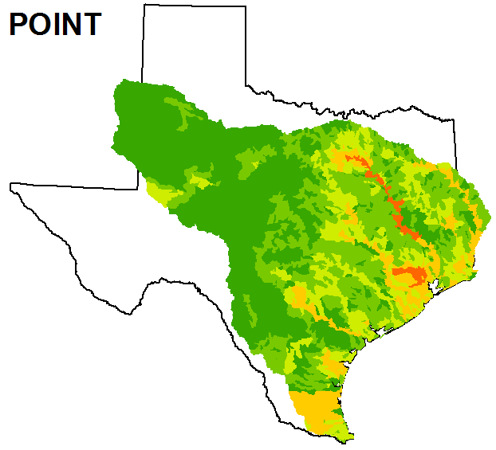
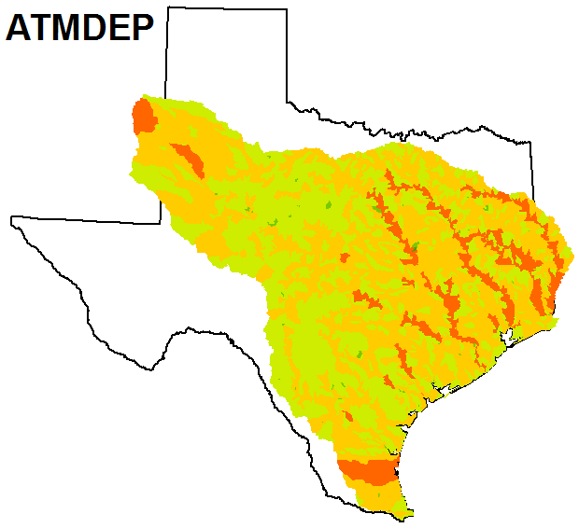 | 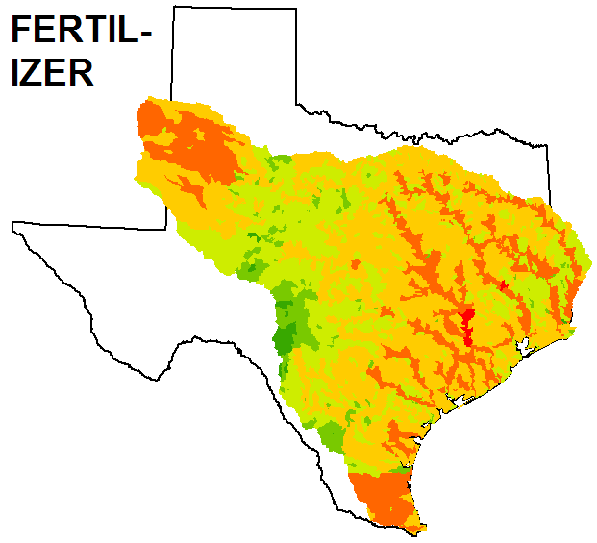
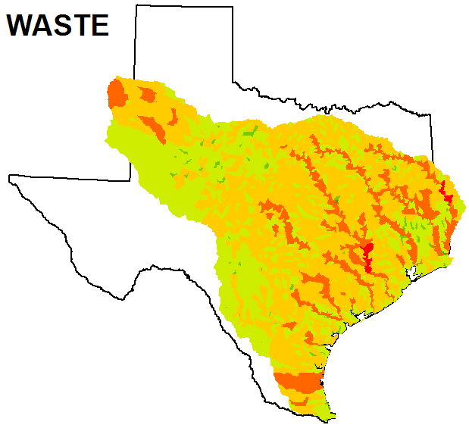 | 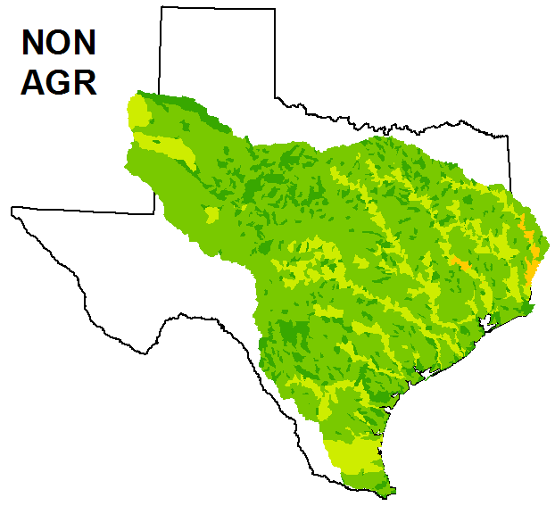

In addition to the source specific figures, let’s quantify each of the sources.
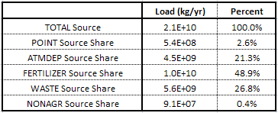
The source specific figures and quantification reveal the following:
- The total predicated annual nitrogen loading from this portion of Texas is 21 billion kilograms. Wow!
- Fertilizer is the largest contributor to the loadings, accounting for nearly half of the total. This makes sense as agriculture is a major part of State’s economy. From this analysis we can also see that it’s a major part of the nutrient contamination in the State.
- Waste and atmospheric deposition make up the next highest loadings at 27 and 21 percent, respectively. The high loadings from waste again show the impact of agriculture. The elevated levels from atmospheric deposition are surprising, however, and show the influence of airborne sources such as automobile and power plant emissions.
- Point and non-agricultural sources of nitrogen are minimal, rounding out the notion that nitrogen loadings are largely a product of nonpoint source runoff from agricultural activities.
- The spatial trends noted in the overall nitrogen loadings are consistent across sources. Elevated levels are concentrated around the river corridors. The center part of the State has minimal loadings.
- It is interesting to note that the high loads in West Texas don’t move downstream as they do in East Texas. This may be a product of low rainfall, essentially immobilizing the nutrients. Or perhaps the nutrients move down into the groundwater in this portion of the State, instead of overland and downstream.
- Point sources are prevalent only in the large metropolitan areas of Houston and Dallas. To a lesser extent, we can also see the impact of San Antonio. [Note that Austin hardly even shows up here. Interesting.]
- The high values in the far west and south of the State are seen in all of the nonpoint sources. This leads us to question whether these trends are a product of the large basin sizes used in these portions of the State.

- “Tell the story“ of the catchment with WaterID 41287 on the Trinity River near Galveston Bay. How much flow and nitrogen loading comes in from upstream and from what sources? How much is added in the local area?
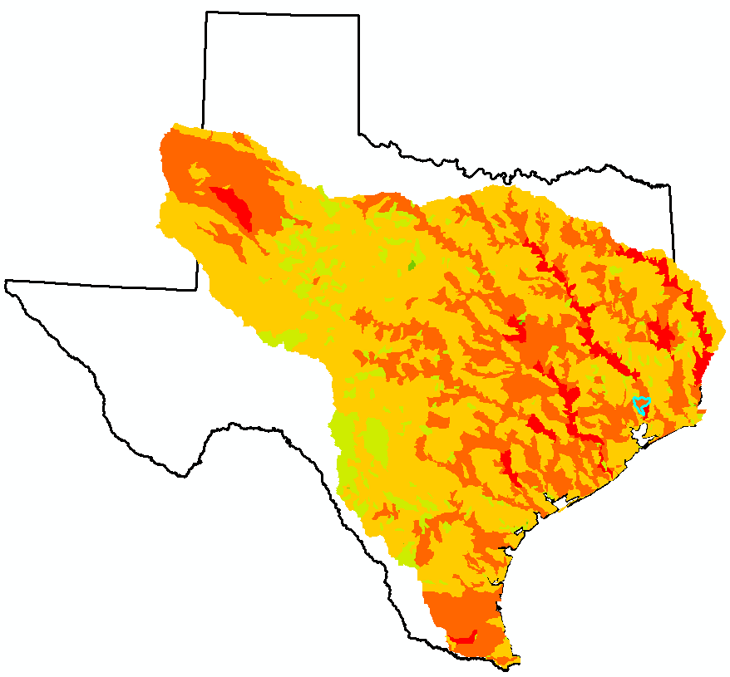
41287

Catchment 41287 is located on the Trinity River near Galveston Bay, as shown above. The catchment itself is 458 km²; its total contributing drainage area is 45,885 km². The mean annual flow in this catchment is approximately 8100 cfs. The incremental flow from the area is about 160 cfs. The following table summarizes the predicted nitrogen loading in the catchment, highlighting the source categories as was done for the State of Texas in the previous question.

 |  | Cumulative N Load | Incremental N Load | Incr/Cum N Load
Total | kg/yr | 9,268,990 | 889,948 | 9.5%
Total | % | 100% | 100%
Point | kg/yr | 266,393 | 8,592 | 3.2%
Point | % | 2.9% | 1%
Atmdep | kg/yr | 2,588,892 | 316,850 | 12.2%
Atmdep | % | 27.9% | 35.8%
Fertilizer | kg/yr | 3,648,975 | 405,812 | 11.1%
Fertilizer | % | 39.4% | 45.9%
Waste | kg/yr | 2,714,829 | 147,943 | 5.4%
Waste | % | 29.3% | 16.7%
Nonagr | kg/yr | 49,901 | 5,751 | 11.5%
Nonagr | % | 0.5% | 0.6%

The total annual nitrogen load in the catchment is 9.3 million kilograms; 890,000 kilograms come from internal sources (about 10%). Similar to what was seen across the State in general, the majority of nitrogen load comes from fertilizer, atmospheric deposition, and waste loads. Fertilizer and atmospheric deposition are slightly more important in the immediate catchment than they are in the upstream area. Nonagricultural and point sources have a minimal impact.

