CE 397 Statistics in Water Resources
Exercise 8

Flood Frequency Analysis
By: Samuel Sandoval, Patrick Sejkora, James Seppi, and David Maidment
Center for Research in Water Resources
University of Texas at Austin
April 2009
Contents
Introduction 1
Goals of this Exercise 1
Computer and Data Requirements 2
Part 1: Using HEC-SSP 2
Part 2: Extreme Value Distribution Type I 12
Part 3 – Extreme Flows for Different Flow Regimes 17
To Be Turned In: 19

Introduction

Every stream or river has instances of extremely augmented flow. Therefore, when designing engineered hydrologic systems it is imperative that Water Resources engineers such as ourselves account for the variability inherent to the water body. Engineers can attempt to understand the temperament of these flows by applying statistics to the recorded flows to determine hydrologic extremes. These values, such as the 100-year flood, assist a designer in enumerating the flow parameters around which a dam or levee must be built in order to minimize risk.

Goals of this Exercise

The primary goal of this exercise is to use various statistical tools to determine the hydrologic extremes for given water bodies. Using flow values from the USGS database, values for given extremes can be calculated using the computer program HEC-SSP. The results from this program can then be compared to calculated values derived from the Bulletin 17B procedure of implementing the Log Pearson Type III distribution http://water.usgs.gov/osw/bulletin17b/dl_flow.pdf (28MB). The Pearson Type III distribution is one of seven types of distributions devised by Karl Pearson, a British statistician, beginning in 1895. Pearson Distributions During the 1970’s, US hydrologists flood peaks to choose a distribution to fit to them, and chose the Pearson Type III distribution applied to the Logs of the flows to base 10. They devised a fitting procedure which is summarized in “Bulletin 17B” that was then and is now the standard distribution in the United States for flood frequency analysis.

Finally, these methods will be applied to compare and contrast three of the nation’s primary flow regimes.

Computer and Data Requirements

To perform this exercise, you will need a computer with the Windows operating system, Microsoft Excel, and access to the internet. We will be using HEC-SSP 1.0, a statistical software package developed by the Army Corps of Engineers. The program can be downloaded from their website: http://www.hec.usace.army.mil/software/hec-ssp/downloads.html. Be sure to download the newest version, Version 1.0 (not the archived beta version!). This program is free and can be downloaded onto a personal computer. It is installed in the computers in the LRC in Room ECJ 3.301. It may take about 45 seconds to load up on its first use, but starts up faster after that. The data files needed for this exercise are available at: http://www.ce.utexas.edu/prof/maidment/StatWR2009/Ex8/Ex8.zip

Part 1: Using HEC-SSP

The enchantment of a historic gauging station is undeniable. Therefore, we will be returning to an old friend from the first exercise: USGS station 08158000 on the Colorado River in Austin. In this part of the exercise, we will use the HEC-SSP program you have downloaded to analyze the hydrologic extremes of the Colorado River here in Austin. The statistical study performed by HEC-SSP is based upon Bulletin 17B “Guidelines for Determining Flood Flow Frequency.” This analysis is based upon flow data, other hydrologic data, and a volume-duration frequency analysis on high and low flows. This data is then applied to a Log-Pearson Type III distribution.

To begin, open up HEC-SSP. Under the File tab, select New Study in order to create the template used in this investigation.



Give your study a descriptive name, Ex8 and place it in a directory where you will be able to find it. Once these have been established, click OK.

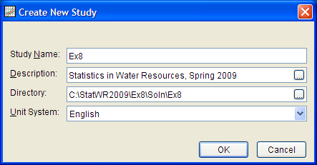

This should create a matrix with a list of folders in a menu on the left of the screen.

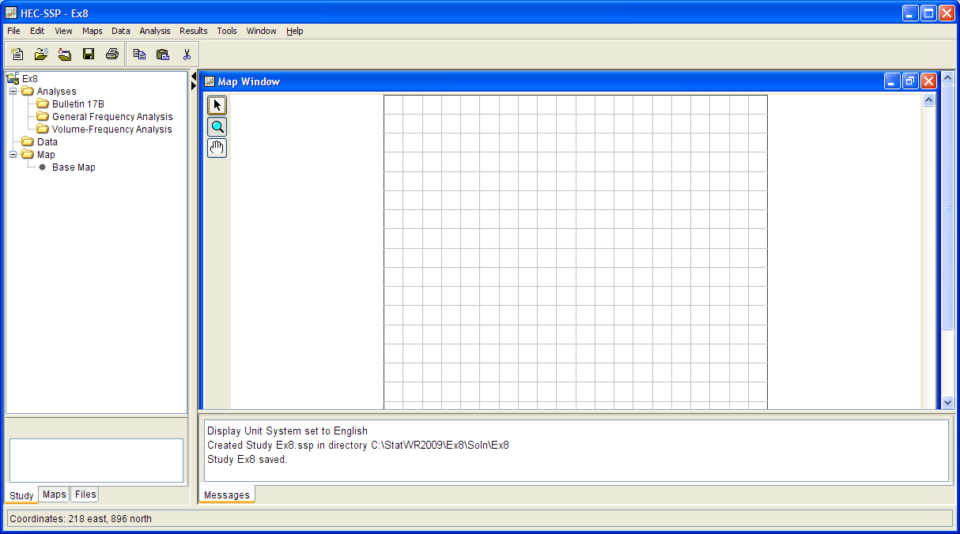

With the new study successfully created, it is time to select data for station 08158000. This is most easily done by importing the data directly through the internet into the HEC-SSP program. Under the Data menu select New.

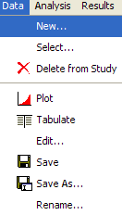
This opens a menu which allows you to select the data you desire. Under the Data Source Tab make sure USGS Website is selected for the source of your data. We will be using the Annual Peak flow data, so be sure this data type is selected. Then click Get USGS Station IDs. This will bring up a menu which will allow you to select a state. Choose Texas and click “OK.” This will bring up a large number of stations, but the desired station can be quickly found by typing the station number into the USGS Station IDs dropbox: 08158000. You can choose Colorado River for Basin and Austin, Tx for Location. Select the dataset and click Import Study DSS File for the Colorado River to continue. As you can see, a dataset has appeared in the menu on the left of the screen.
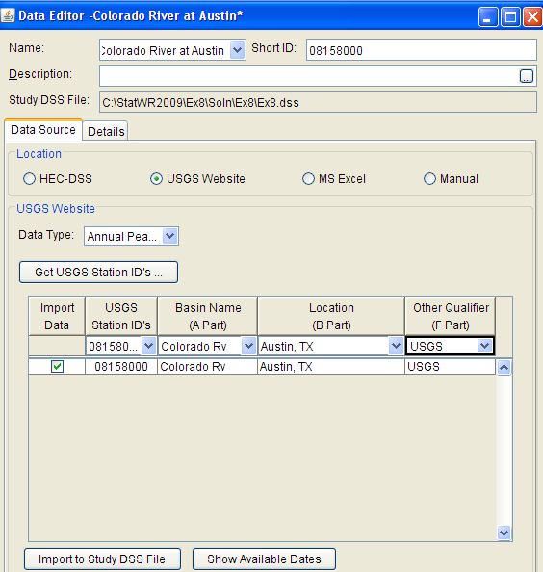

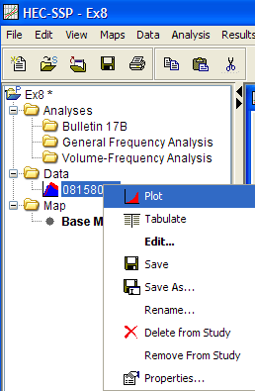

If you right click on the 08158000, and select Plot, a hydrograph appears:

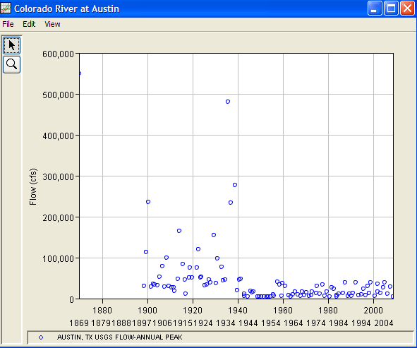
And you can see how pronounced is the effect of the dams built during the 1930’s on reduction in flood peaks in Austin. How much devastation in our downtown area has thus been avoided!! Without this flood protection, always there but perhaps little recognized, our city would not have the vibrant environment surrounding our Colorado River through downtown Austin.

Likewise, if you hit right click on 08158000 and select Tabulate, a table with the dates and flow values is created. It should be noted that each year is not a calendar, but rather a hydrologic year (October 1 through September 30). We are on our way to finding hydrologic extremes!

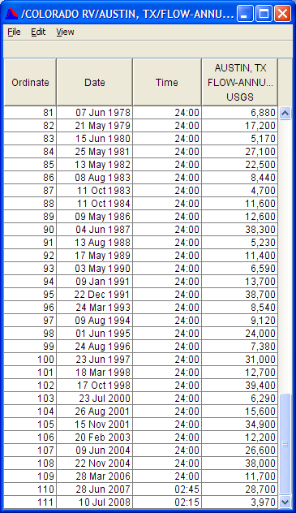

With data successfully imported into the HEC-SSP program, it is ready to be analyzed. To proceed in the analysis, right click the Bulletin 17B folder on the menu on the left side of the screen and select New.

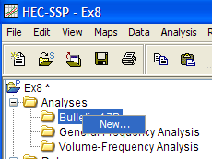

This will bring up the Bulletin 17B Editor. Begin by giving your analysis a name and selecting the Flow Data Set you just created from the Flow Data Set Dropbox. We will be using the Station Skew, Weibull Plotting Position, and Default confidence limits, so keep all of the selections on their default values.
We’ll just work with the data after 1940. In the bottom right of the selection menu, use the Calendar to select a start date of 1 Oct 1940 and an end date of 30 September 2008

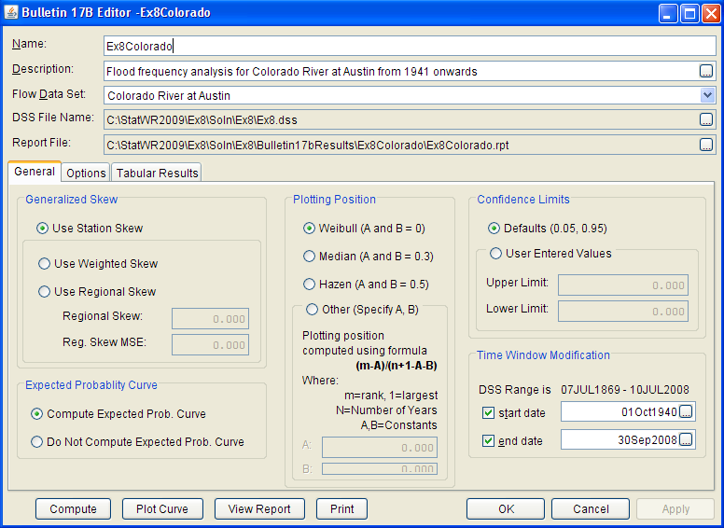
Hit Compute to determine the flood frequency curve. Then hit Plot Curve to see the flood frequency curve.

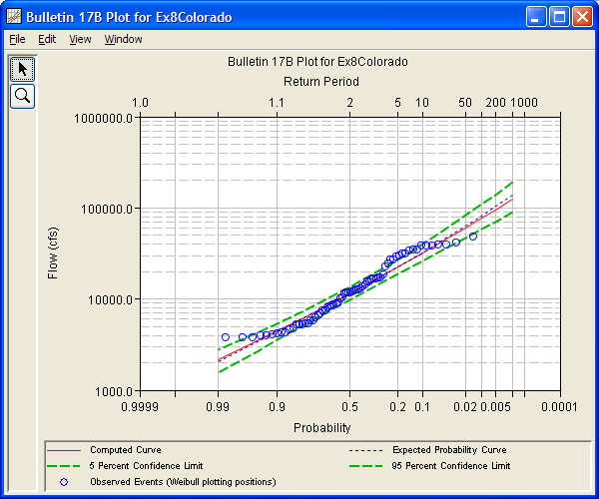

It looks like the data have a pattern that isn’t really fitted that well by the Log Pearson Type III distribution. Never the less, lets continue on. If you hit View Report, you’ll see a report about the flood frequency analysis, ranking of the values, treatment of outliers and so on.

A part of that report is reproduced below. It shows the ranked flows from the largest on downwards, with the associated Weibull Plotting position (p = m/(n+1) where p is the exceedance probability, m is the rank (m =1 is highest flow) and n = 68 = the number of ranked flows). Thus, the exceedance probability of the highest observed flow of 47,600 cfs is p = 1/69 = 0.0145 = 1.45%. From the figures below this, you can see that a discharge of 37,800 cfs is approximately a 10 year flood since p = 1/T and p = 10.14% for this discharge. It is possible to get a reasonable idea of the magnitude of a 10 year flood with 68 years of data since approximately 6 or 7 floods exceeding that magnitude should have occurred during that period. You don’t even really need a probability distribution model like Log Pearson III or Extreme Value Type I to make this assessment.
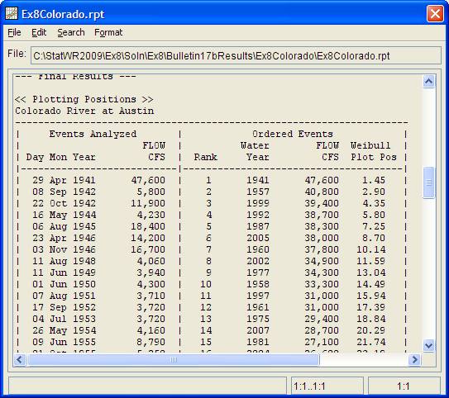

To see the results of the Bulletin 17B analysis, click on the Tabular Results. This should yield an identical menu to the one shown below. As can be seen, the statistical parameters such as the mean, standard deviation, and skew are tabulated. Also, the computed flows associated with each percent exceedance are provided. A 1% exceedance corresponds with a 100-year event, a 50% with a 2 year event, etc. This value can be compared to the expected flow from the Log-Pearson probability function curve. The upper and lower percent confidence intervals (0.05 and 0.95) can also be seen. The tabular results also make note of the presence of any high or low outliers. In this case, there are none.

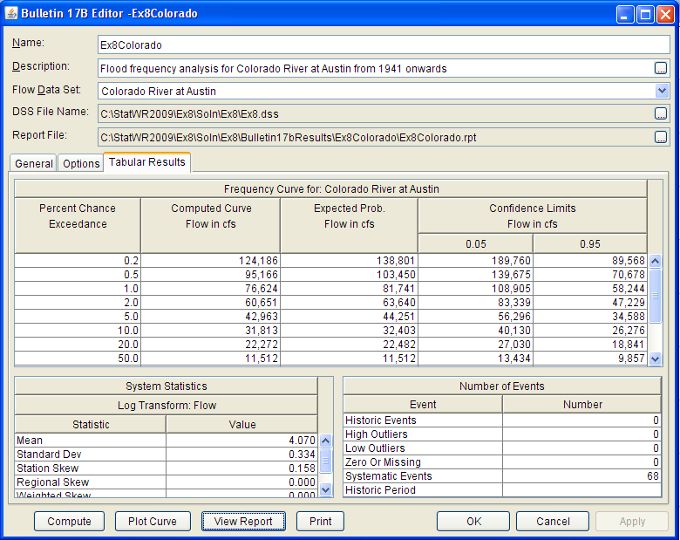

To be turned in: Compare the magnitude of the 10 year and 100 year floods for the data from 1941 onwards. By how much does the flood magnitude increase when you multiply its return period by a factor of ten? Recompute the flood frequency curve for the period from 1900 to 1940 and from 1900 to 2008. Compare the three estimates of the 100 year flood. By how much did the building of the dams on the Colorado River decrease flood magnitudes?

Part 2: Extreme Value Distribution Type I
Now, let’s estimate the maximum annual flow for different return periods using the Type I Extreme Value Distribution (also known as the Gumbel Distribution). This distribution has a cumulative distribution function:
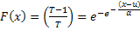 [1]
Where T is the return period. The parameters of the Type I function α and u are expressed by the following equations:
[2]
[3]
Where and are the standard deviation and mean of the maximum annual flow data set. Equation 1 is used for evaluating the cumulative probability given a flow. Now, let’s open the file Type_I.xlsb for the Colorado River maximum annual flows, and save it in a new folder as TypeISoln.xlsb. Let’s calculate the descriptive statistics for the complete period using the Data Analysis tool. Select the flow data and the output to be located in cell F2, and click on Summary Statistics.
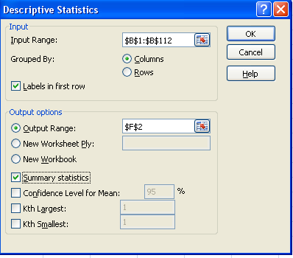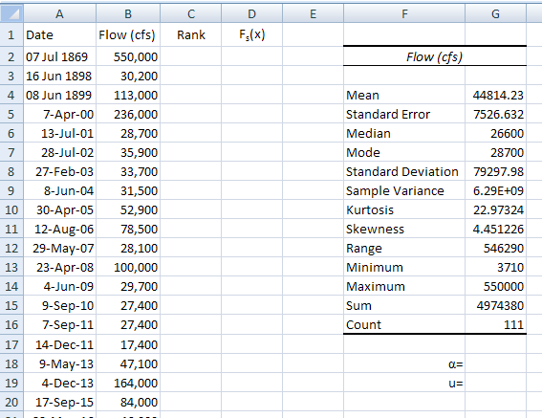
Notice that the mean, 44814 cfs and the standard deviation 79297 cfs have been calculated for us. Let’s use these results to calculate the parameters of the Type I distribution α and u. Using Eq. (2),
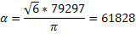
And store the result in cell G18
Similarly, for the parameter u, lets use Eq. (3):
= 44814 - 0.5772*61828 = 9127
And store the result in cell G19
Next, let’s evaluate the probability that the annual maximum flow is greater than 50,000 cfs.
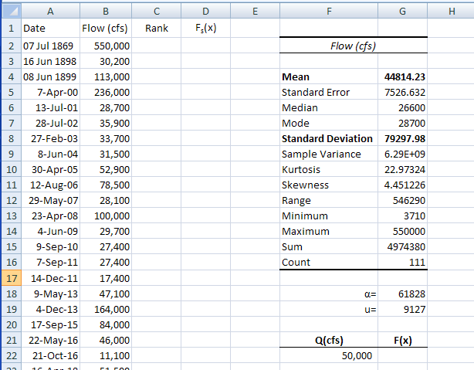
To obtain the cumulative probability function use the following equation and type in cell G22 the following expression: “=EXP(-1*EXP(-1*(F22-$G$19)/$G$18))”.
The following result means that there is a 59.7% chance that the annual maximum flow is less than 50,000 cfs in any year ( P(Q_{max}<=50000)=0.597), or that there is just 40.3% chance that the maximum flow is higher than 50,000 cfs ( P(Q_{max}>50000)=0.103). In order to obtain the return period of an annual maximum flow of 50,000 cfs, the following equation can be used:
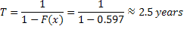
Thus, the return period for a 50,000 cfs in the gage station 08138000 Colorado River using a Type I distribution is 2.5 years.
Now, let’s obtain the expected flow according to a type I distribution for a return period of 100 years.
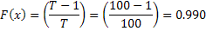
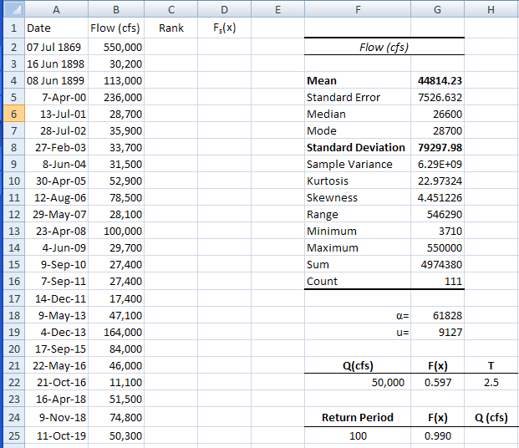
Type in cell H25 the following command “=$G$19-$G$18*LN(LN(1/G25))” in order to calculate the 100-year flood flow.
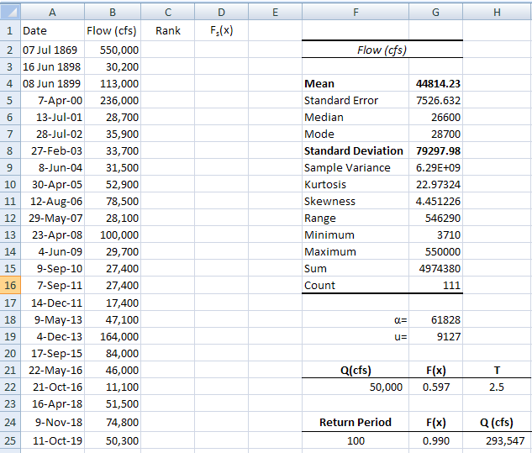
The 100-year flood value is 293,547 cfs.
Now, lets think about this a bit! A flow of 50,000 cfs passing through the center of Austin will flood lots of expensive hotels and buildings located alongside the Colorado River, and that doesn’t happen every year, so there is something a bit odd here.
Lets plot the data:
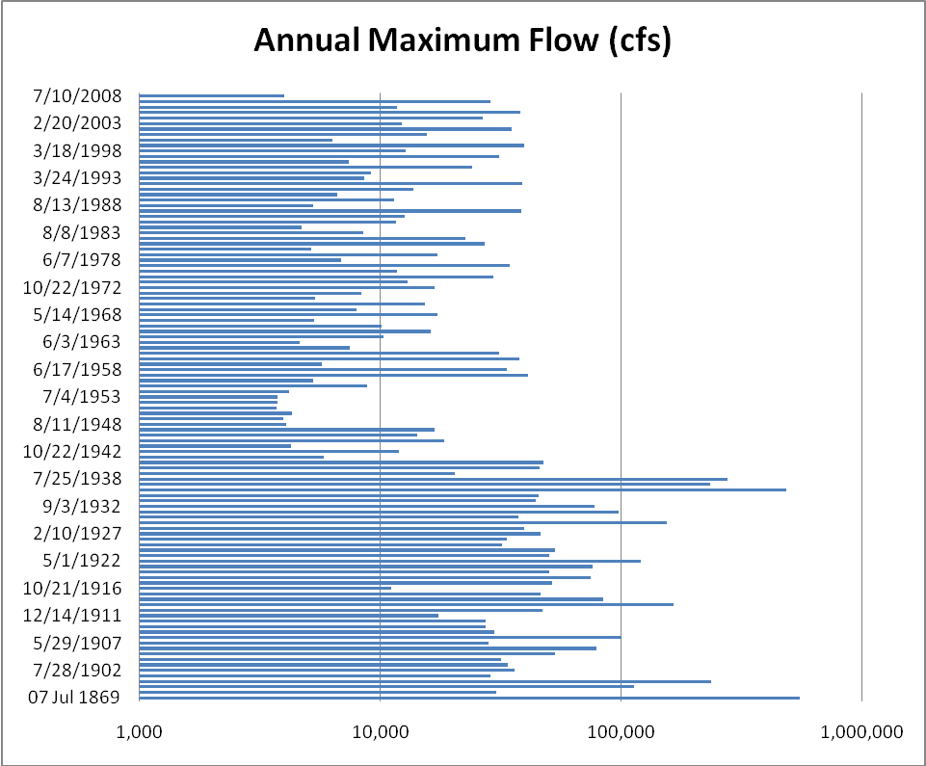
It is evident that since the 1940’s when the large lakes Travis and Buchanan were built upstream on the Colorado River, that annual maxium flows downstream have been significantly diminished. Lets repeat the computation of the parameters for the annual maximum flows on the Colorado River. Choose the After1940 tab in the Type_ISoln.xlsb spreadsheet and repeat the above exercise (you can just copy the formulas from one spreadsheet to the next. Phew! Things are a lot better since the dams were built!

To be turned in:
- A graph of the annual maximum flows for the Colorado River at Austin for the period of record.
- Prepare a table that shows for the Colorado River at Austin the return period (years) of an annual maximum flow of 50,000 cfs, and the magnitude in cfs of the 100 year flood, as computed by the Extreme Value Type I distribution method. Show these values for the full period of record from 1900 and for the flood record since 1940.
- Compare the 100 year flood computed computed since 1940 by the Extreme Value Type I method with that derived from the Bulletin 17B method for the same period of record. Is the difference in the estimates by the two methods significant when compared to the confidence range on the Bulletin 17B estimate of the 100 year flow?

Part 3 – Extreme Flows for Different Flow Regimes
For this part we will use HEC-SSP to compare and contrast three types of stream regimes common in the United States: perennial, ephemeral, and snow-fed.
Perennial streams have continuous flow year-round, and are common on the East Coast of the United States. Ephemeral, also known as intermittent, streams typically have no flow except for periods immediately following precipitation. Ephemeral streams are prone to flash floods, and are common through the Southwest US. Snow-fed streams are like perennial streams in that they support year-round flows, but these flows are dominated by snowmelt water in the spring and early summer. Snow-fed streams are common in the mountainous regions of the Northwest US.
We will be looking at one river of each flow regime for this part of the exercise.
- Rio Puerco at Bernardo, NM [USGS Gage 08353000]
- Patuxent River at Bowie, MD [USGS Gage 01594440]
- Clark Fork at Missoula, MT [USGS Gage 12340500]
The daily discharge data (from 2007) for each of the above rivers has been provided, courtesy of the USGS website (http://waterdata.usgs.gov/nwis/inventory). The collected data is located in Flow Regime Data.xlsx. Lets take a look at a hydrograph for each river, and match each river to the flow regimes described above.
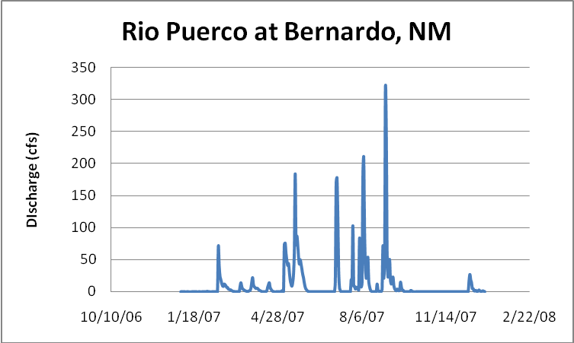
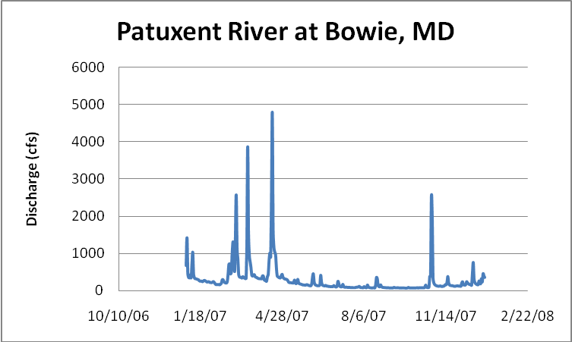

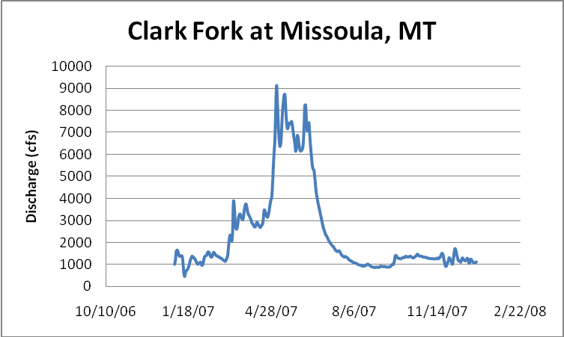

Then, following the procedure outlined in Part 1 of this exercise, use HEC-SSP to
- Download the Annual Peak Flow data for each of these rivers.
- Generate a Bulletin 17B analysis for each river with a table of results and exceedance probability curves.
- Compare the 10-year and 100-year flood flows for each river.
What are the interesting characteristics of each river and flow regime?
To be turned in: HEC-SSP Bulletin 17B analyses for each river, including a table of results, exceedance probability curves, and a comparison of the 10-year and 100-year floods for each river. Discussion of each river and associated regime, with comments on how ‘extreme’ the values for each are.

To Be Turned In:
Part 1: Compare the magnitude of the 10 year and 100 year floods for the data from 1941 onwards. By how much does the flood magnitude increase when you multiply its return period by a factor of ten? Recompute the flood frequency curve for the period from 1900 to 1940 and from 1900 to 2008. Compare the three estimates of the 100 year flood. By how much did the building of the dams on the Colorado River decrease flood magnitudes?

Part 2:
- A graph of the annual maximum flows for the Colorado River at Austin for the period of record.
- Prepare a table that shows for the Colorado River at Austin the return period (years) of an annual maximum flow of 50,000 cfs, and the magnitude in cfs of the 100 year flood, as computed by the Extreme Value Type I distribution method. Show these values for the full period of record from 1900 and for the flood record since 1940.
- Compare the 100 year flood computed computed since 1940 by the Extreme Value Type I method with that derived from the Bulletin 17B method for the same period of record. Is the difference in the estimates by the two methods significant when compared to the confidence range on the Bulletin 17B estimate of the 100 year flow?
Part 3: HEC-SSP Bulletin 17B analyses for each river, including a summary table of results, exceedance probability curves, and a comparison of the 10-year and 100-year floods for each river. Discussion of each river and associated regime, with comments on how ‘extreme’ the values for each are.

