Exercise 8:
Flood Frequency Analysis

Prepared by: Eric S. Hersh
Prepared for: D.R. Maidment
Date: April 9, 2009

CE 397 – Statistics in Water Resources
University of Texas at Austin
Spring 2009
- Compare the magnitude of the 10 year and 100 year floods for the data from 1941 onwards. By how much does the flood magnitude increase when you multiply its return period by a factor of ten? Recompute the flood frequency curve for the period from 1900 to 1940 and from 1900 to 2008. Compare the three estimates of the 100 year flood. By how much did the building of the dams on the Colorado River decrease flood magnitudes?

Period: 1940-2008  10-year flood: 31,813 cfs  100-year flood: 76,624  Ratio of 100 to 10-yr: 2.41 | 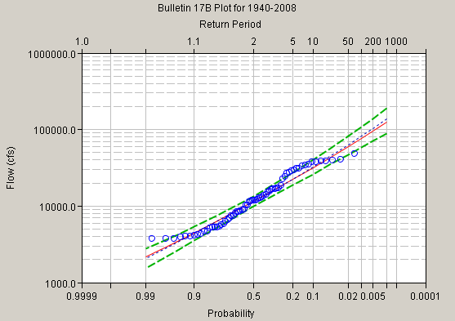
Period: 1900-1940  10-year flood: 150,858  100-year flood: 500,507  Ratio of 100 to 10-yr: 3.32 | 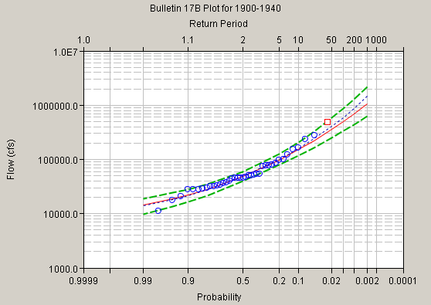
Period: 1900-2008  10-year flood: 82,537  100-year flood: 312,603  Ratio of 100 to 10-yr: 3.79 | 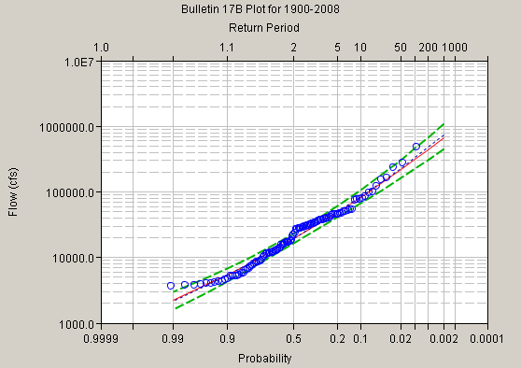

For the period WY1940-WY2008, the computed 100-year flood is approximately 2.4 times as large as the 10-year flood, an increase of 44,811 cfs over the 10-year flood of 31,813 cfs.

As is evident in the above computations, the period of dam construction circa 1940 greatly reduced the threat of flooding in the Austin area. When comparing the post-impoundment period 1940-2008 to the pre-impoundment period 1900-1940, the 10-year flood is 4.7 times as large and the 100-year flood is 6.5 times as large. In fact, the post 100-year flood is only one-half as large as the pre 10-year flood! Analysis of the flood frequency as conducted here shows that the dams are successfully serving their intended purpose as flood control structures.

- A graph of the annual maximum flows for the Colorado River at Austin for the period of record.
- Prepare a table that shows for the Colorado River at Austin the return period (years) of an annual maximum flow of 50,000 cfs, and the magnitude in cfs of the 100 year flood, as computed by the Extreme Value Type I distribution method. Show these values for the full period of record from 1900 and for the flood record since 1940.
- Compare the 100 year flood computed computed since 1940 by the Extreme Value Type I method with that derived from the Bulletin 17B method for the same period of record. Is the difference in the estimates by the two methods significant when compared to the confidence range on the Bulletin 17B estimate of the 100 year flow?

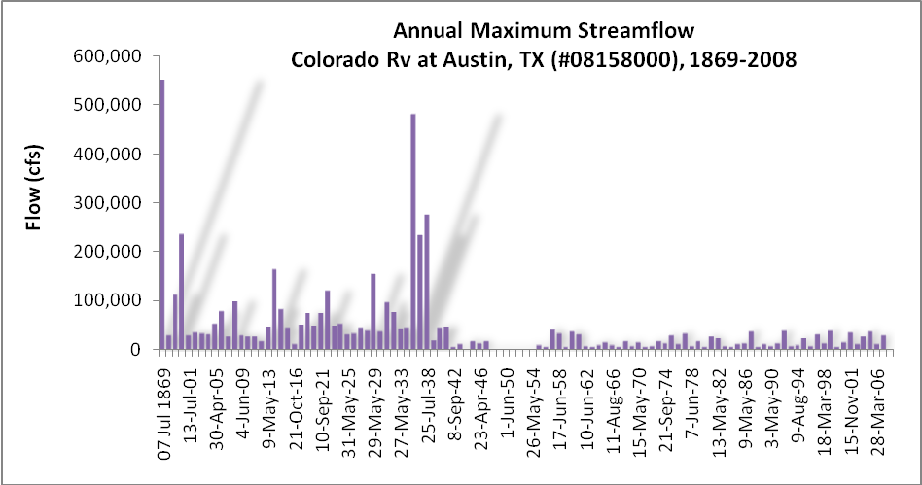

Time Period | Return period for Q = 50,000 cfs (years) | 100-year flood magnitude (cfs) (EV I)
1869-2008 | 2.5 | 293,547
1869-1940 | 1.7 | 444,185
1940-2008 | 71.8 | 53,109

The 100-year flood computed via the Extreme Value Type I distribution is 53,109 cfs for the period 1940-2008 as compared to 76,624 cfs computed via the Bulletin 17B method. The latter has 95% confidence bounds of (58,244, 108,905), so the difference in the flood estimate between these two methods is significant.
- HEC-SSP Bulletin 17B analyses for each river, including a summary table of results, exceedance probability curves, and a comparison of the 10-year and 100-year floods for each river. Discussion of each river and associated regime, with comments on how ‘extreme’ the values for each are.

Flow Regime: Snow-fed  Gage: Clark Fork at Missoula, MT, #12340500  Period: 6/1/1908-5/4/2007  N = 79  Outliers: none  10-year flood: 25,574 cfs  100-year flood: 38,864 cfs  Ratio of 100 to 10-yr: 1.52  Station skew (log-transform): -0.309 | 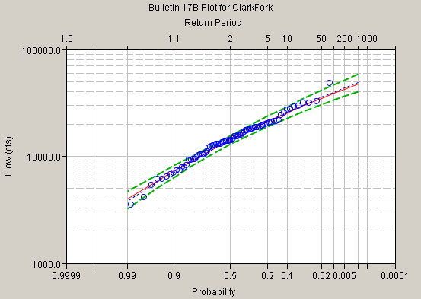
Flow Regime: Ephemeral  Gage: Rio Puerco at Bernardo, NM, #08353000  Period: 8/27/1940-10/12/2006  N = 67  Outliers: none  10-year flood: 8,027 cfs  100-year flood: 19,819 cfs  Ratio of 100 to 10-yr: 2.47  Station skew (log-transform): 0.019 | 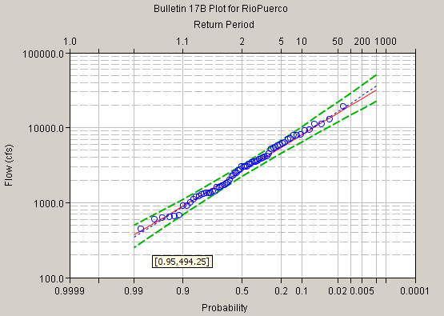
Flow Regime: Perennial  Gage: Patuxent River at Bowie, MD, #01594440  Period: 1/27/1978-5/13/2008  N = 31  Outliers: none  10-year flood: 9,451 cfs  100-year flood: 14,082 cfs  Ratio of 100 to 10-yr: 1.49  Station skew (log-transform): -0.498 | 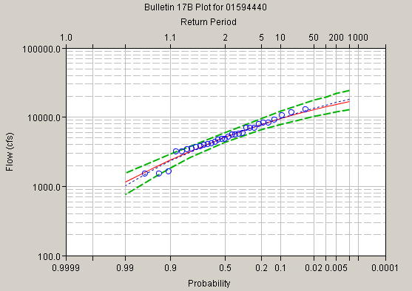

A comparison of these three gaged streams allows for a comparison across the three major flow regime characterizations which they typify: snow-fed, ephemeral (intermittent), and perennial. Clark Fork in Montana is a perennial stream in that it always has flow, but, as compared to the Patuxent River in Maryland, it also exhibits a strong seasonal signal which results from typically high springtime snowmelt runoff. For both Clark Fork and the Patuxent, the 100-year flood is not much larger than the 10-year flood (approximately 1.5 times as large in each case), meaning that the flow regime is less peaked.
The log-transformed annual peak flows for these two gages have a negative skew, which means that the bulk of the distribution lies to the right and a longer tail trails toward zero. Compare this to the intermittent gage in New Mexico that has a ratio of nearly 2.5; this means that the exceedance plot of the annual peak flows at the ephemeral gage has a steeper slope (see plots above) and ‘more-peaked’ peaks. The Rio Puerco exhibits very little skew (0.019).
As is characteristic for these flow regime types, the extreme flow values (such as the 100-year flood) are more extreme at the ephermal New Mexico gage and less (and similarly) extreme at the snow-fed Montana gage and perennial Maryland gage.

