CE 397 Statistics in Water Resources

Personal Exercise

Seasonal and Diurnal Cycles

By: Brandon Klenzendorf, Matt Jordan, Solaleh Khezri and David Maidment
The University of Texas at Austin
March 2009

Contents
Introduction 1
Goals of the Exercise: 1
Computer and Data Requirements 1
Diurnal Cycles 1
Analysis 1: May 2, 2006 Diurnal Cycle 1
Analysis 2: Multiple Diurnal Cycles 3
Seasonal Cycles 4
Analysis 3: Seasonal Cycle 4
Summary 6

Introduction
In this exercise we will explore how to deal with cyclical variation in data with time. We would like to determine how to characterize cyclical changes in a variable, Y, though time. This is analyzed by using a multiple linear regression which we investigated in Exercise 5. Of primary concern are diurnal cycles and seasonal cycles. How does the frequency of these two cycles differ? How does the amplitude of these two cycles compare?

Goals of the Exercise:
In this exercise we will investigate cycles in a dataset using the Fourier series. First we will look at an extended seasonal cycle for daily data and discuss the properties of this cycle. Next, we will investigate two diurnal cycles and how to possibly improve our cyclical model by adding additional frequencies to the Fourier series.

Computer and Data Requirements
This exercise is to be performed in Microsoft Excel utilizing the Data Analysis Toolpack as used previously. The diurnal data used for this exercise were obtained from HydroExcel using the WSDL: http://cbe.cae.drexel.edu/SRBHOS/cuahsi_1_0.asmx?WSDL. These data are for air temperature in Shale Hills at Penn State University. The Site Code is SRBHOS:RTHNet4, Variable Code SRBHOS:545. This consists of temperature data collected every 10 minutes for slightly over a year, for a total of 53,631 data points.

The seasonal cycle data we will analyze was obtained from http://www.soils.wisc.edu/asigServlets/asos/SelectHourlyAsos.jsp and consists of over 14 years of daily air temperature data from a climate station in Wisconsin.

The data for this exercise is accessible at: http://www.ce.utexas.edu/prof/maidment/StatWR2009/Fourier/ExFourierData.xls

Diurnal Cycles

Analysis 1: May 2, 2006 Diurnal Cycle
We will start the diurnal analysis by looking at a single diurnal cycle for May 2, 2006 (located in the “SingleDay” tab in ExFourierData.xls) for data taken every 10 minutes. Here are some of the data. There are 144 values in the Excel file (6 values per hour x 24 hours per day). Fourier series can be applied to data of any duration or number of values but in this instance we are only going to analyze one daily cycle for simplicity.

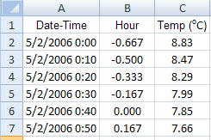

Our assumed period is 24 hours, so that the angular frequency ω = 2π / 24 = 0.261799 radians/hr⁻¹. Let’s start by first finding cos (ωt) and sin (ωt) for each data point in our diurnal cycle. For example, at t = 0.167 hours, cos(ωt) = cos(0.261799*0.167) = 0.999048.

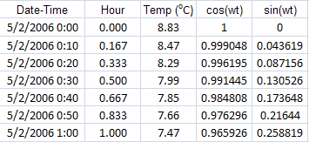

Now, if we use the Excel Regression function from the Data Analysis Toolpack, we can create our diurnal cycle. The input Y range is our hourly temperature data, and the Input X range is the corresponding cos (ωt) and sin (ωt) columns. This will model the temperature using the single period Fourier series. We can include the “Residuals” for the regression analysis if we would like to see how the error changes by adding additional periods.

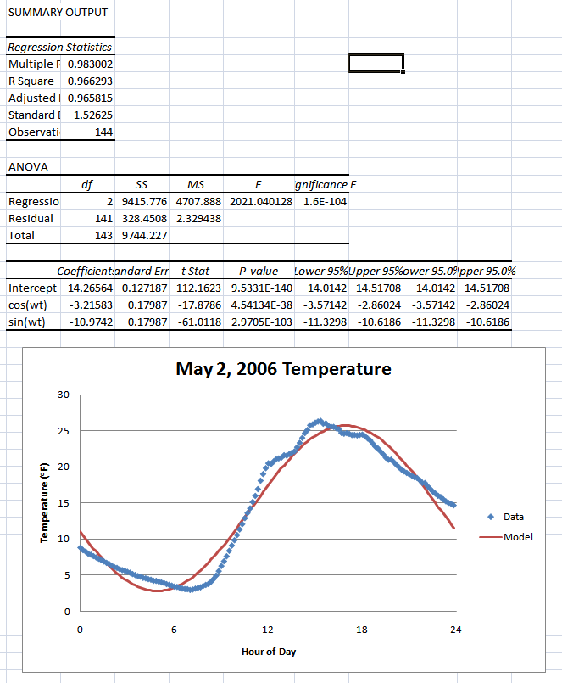

Hence our equation is $\text{Temp}=\text{14}\text{.}\text{26564}−3\text{.}\text{21583}\text{cos}(0\text{.}\text{261799}t)−\text{19}\text{.}\text{9742}\text{sin}(0\text{.}\text{261799}t)$, t is in hours and temperature is in degrees Fahrenheit. This equation is valid only for this day, May 2, 2006. As we saw in Exercise 5, the regression output gives us many important calculations. Of primary interest are the R Square value, F-ratio, Standard Error, and coefficients with associated t Statistics for the Intercept, cos (ωt), and sin (ωt) values. We can also determine the total amplitude of the cycle, R, using the coefficients on the cos (ωt) and sin (ωt) input variables. This is a linear regression analysis, where our linear variables are simply sinusoidal functions that vary depending on when the temperature data were observed.

This solution looks pretty good, but what if we wanted our model to more accurately match the data? For example, what if the data were not as well behaved as this temperature data. To accomplish this, we can simply add another pair of sinusoidal functions with a frequency twice the value of the initial frequency. This is accomplished by calculating cos (2ωt) and sin (2ωt) which is the Fourier series for multiple periods.

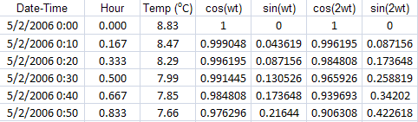

If we repeat the regression analysis with all four input ranges, we can create a graph that is now closer to our observed data. If we continue to add frequencies, we will eventually exactly match the observed data. Although these additional harmonics result in a lower residual standard error and larger R squared value, it decreased the F ratio. This suggests that perhaps adding additional harmonics is not statistically beneficial for this analysis. When we look at a seasonal cycle, this observation will be confirmed.

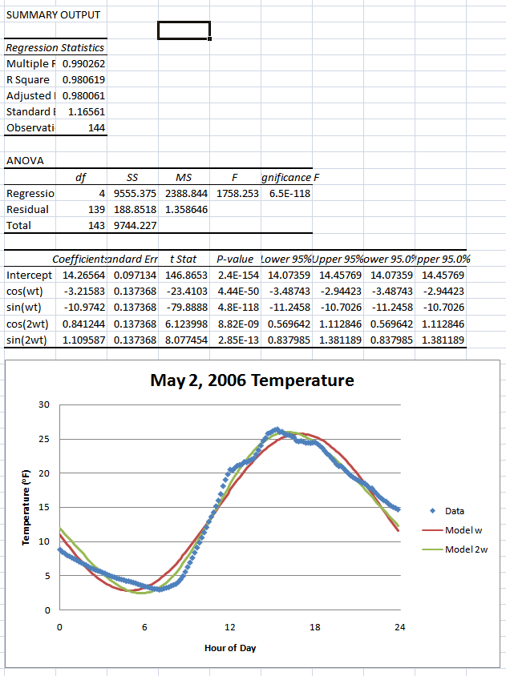

You can see by examining the t-statistics for the coefficients that the second cycle is statistically significant in improving the fit to the data. We could continue this process of adding cycles (i = 3, 4, 5, …) until the t-statistics for the coefficients become not statistically significant (|t| < 2).

Analysis 2: Multiple Diurnal Cycles
Since we don’t except the temperature to have a period of greater than 24 hours for data collected on an hourly time scale, we will only be concerned with the single period Fourier series for this next analysis. Repeat the regression analysis for only the single period Fourier series using 30 days of temperature data, located in the “30Day” tab.

The results prove to be very statistically significant as shown in the high F ratio and near zero p-values. However, the R squared value is less than 0.4. This is a concern! If we graph the data we can see that our model only oscillates around the mean value, whereas the data change throughout the month. This is the impact of the seasonal cycle on the data, which we did not account for.

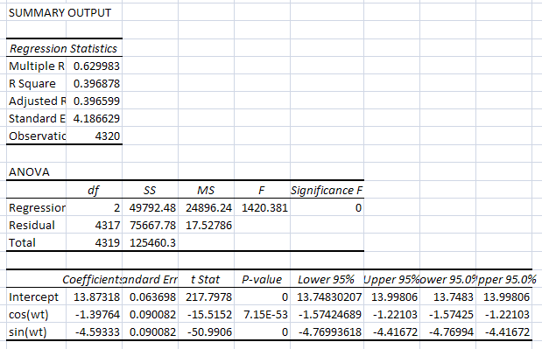

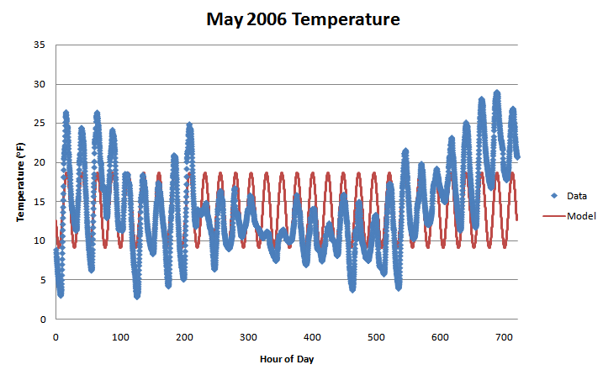

Therefore, although we can closely match a single diurnal cycle fairly accurately with one 24 hour period, applying this model to multiple consecutive days proves to be more difficult unless we add additional frequencies. The analysis does produce a statistically significant result, but that result does not appear to closely match the observed data as shown in the small R squared value. This means we have to be careful about relying solely on the R squared value! There is statistically nothing major wrong with our model (except for accounting for seasonal variations) for this case, but if we based our judgment of the model only on the R squared value, we would probably think this was a bad model.

Seasonal Cycles

Analysis 3: Seasonal Cycle
We expect temperature data to follow a fairly well behaved seasonal cycle throughout the year. The period for a seasonal cycle when using daily data is 365 days. Therefore, the angular frequency is 2π / 365 = 0.0172 radians/day. In the “14Year” tab, the temperature data is reported as daily temperatures and consists of nearly 14 years of data. We can conduct a regression analysis for the single period Fourier series using these daily data.

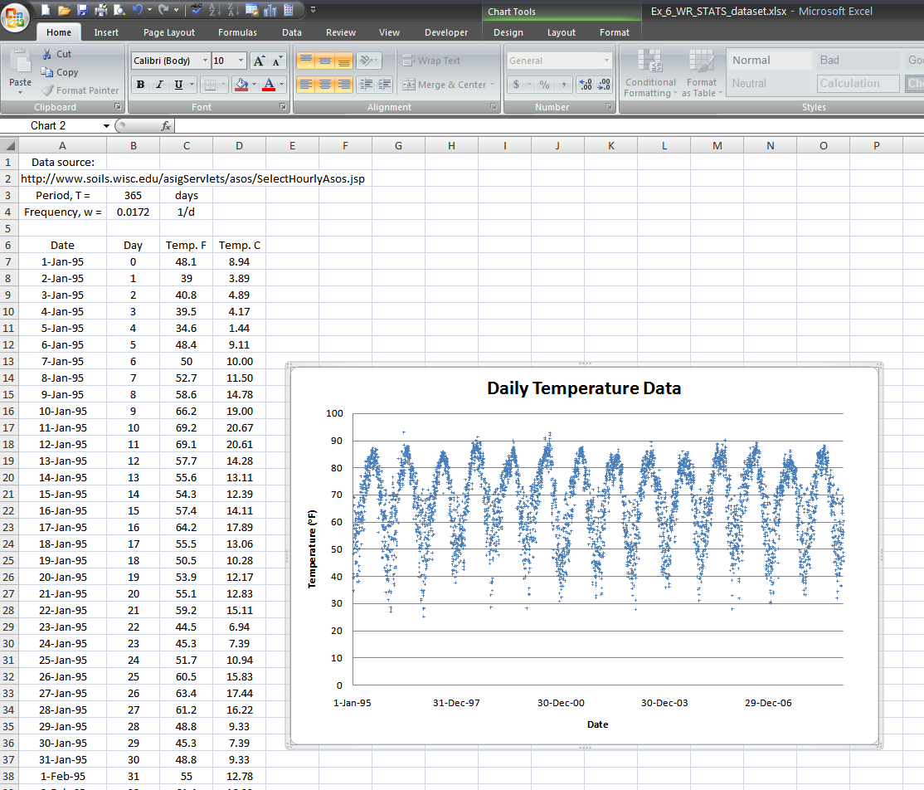

This is accomplished by first converting the date for each data point to a corresponding day value. This is done by simply subtracting the current date from the “reference” date, which is January 1, 1995. Therefore, the first data point is on “Day Zero”. Now, for each data point, calculate the sine and cosine of the frequency times the corresponding day value. This gives a cycle which repeats itself every 365 days.

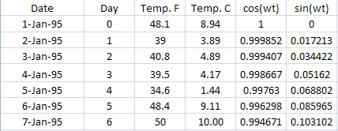

We will now conduct a multiple regression analysis similar to what we did in Exercise 5. This is done by using the Regression function in the Data Analysis Toolpack. The input Y range is our range of daily temperatures. The input X range is our two columns of sine and cosine functions.

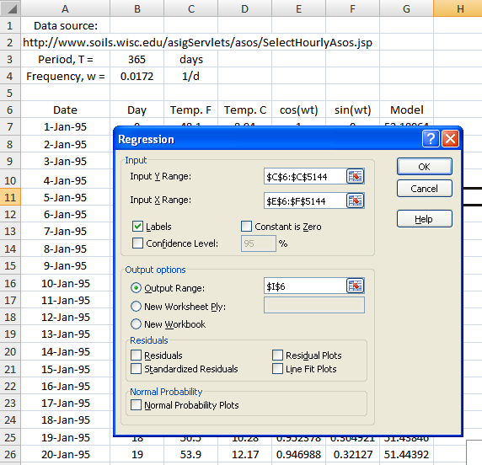

The result gives an adjusted R squared value of 0.734, not too bad for 14 years worth of data! The F ratio is very high at a value of 7,074. And the values of our three coefficients are all extremely significant, as shown in the near zero p-values. Therefore, this appears to be a very good model for our data.

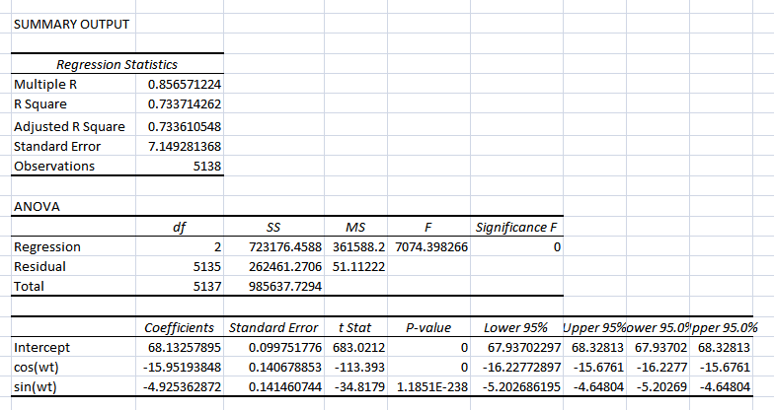

Our model for temperature in degrees Fahrenheit is $\text{Temp}=\text{68}\text{.}\text{133}−\text{15}\text{.}\text{952}\text{cos}(0\text{.}\text{0172}t)−4\text{.}\text{925}\text{sin}(0\text{.}\text{0172}t)$or $\text{Temp}=B_{0}+B_{1}\text{cos}(ϖt)+A_{1}\text{sin}(ϖt)$where B₀ = 68.133, B₁ = -15.952, A₁ = -4.925. This equation can also be written in the form which can be expanded as a sum of cosines to show that $φ={\text{tan}}^{−1}(−A/B)$. If we compute this result for these data,we find $φ=−0\text{.}\text{304}$radians or -(-0.304/0.0172) = 17.4 days. The maximum temperature occurs on July 20 and July 21 which are days 200 and 201, respectively, and 365/2 + 17.4 = 200.9 days.

The mean temperature is simply the intercept of our model, equal to 68.13 ºF. The amplitude of our Fourier series is R, where R² = A² + B². The amplitude is 16.70 ºF. The range of the Fourier series is twice the amplitude, 33.39 ºF. With this, we can determine the maximum expected temperature and minimum expected temperature from the mean plus or minus the amplitude, respectively.

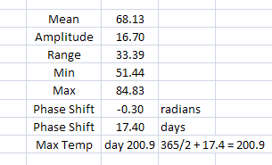

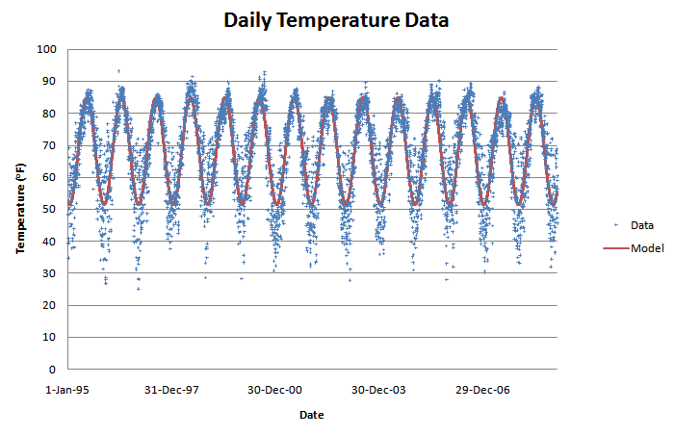

We can conduct the same analysis on a single year of data. If we do this for the year 1995 (located in the “1995” tab), we see that the results are virtually the same. The mean, min, and max temperatures are all slightly different for the 1995 data when compared to the entire dataset. In addition, the regression has a high F ratio (509) and very small p-values for all three coefficients.

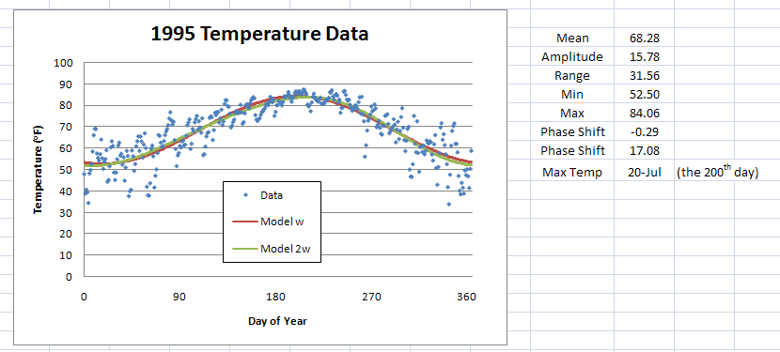

If we want to minimize the standard error of the residuals even further, we can add a second harmonic to the Fourier series. This consists of simply finding the sine and cosine terms for 2ωt. If we conduct a multiple regression on all four sinusoidal functions, we will obtain slightly different coefficient values. This will further minimize the residual standard error. However, when using two harmonics, our F ratio decreased from before. For one harmonic, the F ratio was 509, and now that we added a second harmonic, the F ratio decreased to 261. This suggests that although the residual standard error has decreased, perhaps we did not gain any significant information by adding the second harmonic. Furthermore, if we look at the p-values for the new cos (2ωt) and sin (2ωt) coefficients, they are significantly higher than the single harmonic p-values. Actually, the sin (2ωt) p-value is greater than 0.05 suggesting it may not even be statistically significant. Therefore, although we can more accurately match the observed data with additional harmonics, it may not be beneficial to do so, as in this case.

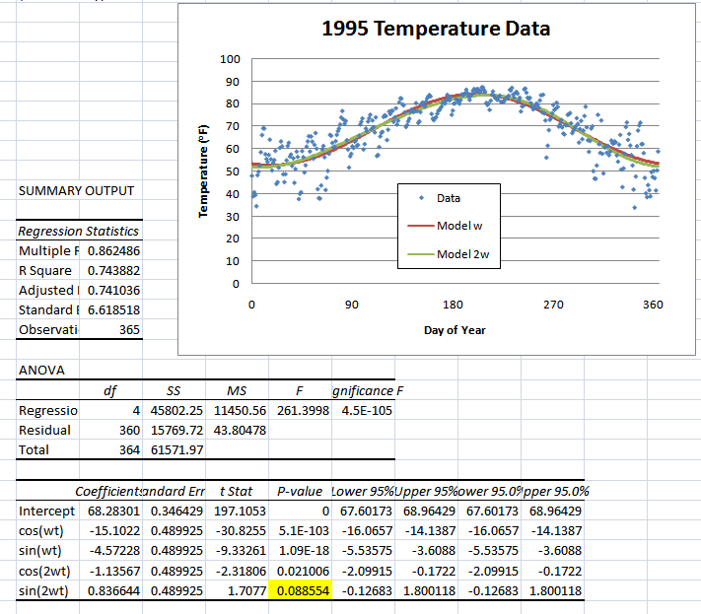

Summary

We have conducted a Fourier series analysis for diurnal cycles on a single day of data as well as 30 consecutive days of data. This used the raw data. If we had averaged the data over multiple days we would have seen a more well behaved diurnal cycle. For example, if we averaged each of the 24 hours for each of the 31 days in the month of May and created a diurnal cycle for the month of May, our single Fourier series would not only be statistically significant, it would also have a large R squared value.

We also conducted a Fourier series analysis for seasonal cycles on daily temperature data. We showed that even with 14 years of data, a single frequency with no harmonics produced very accurate results. We then looked at a single years worth of data and saw that the coefficient values did not change significantly compared to the entire dataset. Finally, we added a harmonic to our Fourier series and discovered that although the residual square error decreased, we did not gain any statistical information about the seasonal cycle. Therefore, only the single frequency Fourier series was adequate for characterizing these data.

