Instructions for Preparing and Posting Term Paper Presentations and Papers

Presentation guidelines
- You must have your material presented using Powerpoint slides. Name your file with your surname, e.g. maidment.ppt
- If you have animations included in your Powerpoint, make sure that the additional files (e.g. .avi) are included with your Powerpoint slides or they won’t be viewable in the classroom. Trying to make fairly exotic connections to ArcGIS from Powerpoint is difficult in the classroom so it is best to avoid that.
- I need to have your slides by 11AM on the day you are due to present. Send them to me either via email, or use the Digital Dropbox for the CE 394K.3 GIS in Water Resources course at http://courses.utexas.edu
- You will have 12 minutes for your talk – 10 minutes for the presentation and 2 minutes for getting started and answering questions. You must not go over time or you will be cut off
- Don’t spend too much time on the introduction, one or two slides is enough, and then get to the heart of what you want to say
- Think of the one concept or image or idea that you want your audience to take away from your talk and arrange all your material around that
- There is not time to say everything important, only what is most important
- Use pictures and diagrams wherever possible, they are more effective than words on slides
- For slides with just words on them
  - Have a maximum of five bulleted points, four is better than five.
  - For each bulleted point, have a maximum of 10 words, preferably 5 or 6 words, less is better than more
  - Highlight in color the one or two key words in each bulleted phrase
- Its ok to be nervous, it means you are focused!
- Its ok for your presentation to be a “progress report” of what you have done so far, and you can indicate what still remains to be done before your paper is completed.
- I will send you by email an evaluation of your presentation and a grade out of 10 points.
- Good luck!! I’m sure your talk will be great!

Posting of Complete term papers
- The final term paper in html must be posted on your web page by 5PM on Friday 9 December. It is critical that you post your paper by this date because your classmates may need to read your paper in order to complete their final exam. After preparing your documents it is important to check that they are viewable correctly from a Browser. Where possible get a friend to check that they can view them to make sure that you are not pointing to something that only you have access to. Sometimes the protection settings on documents get set so that they are not viewable by others. If this occurs, adjust the security properties so that they are readable by everyone.
- I also want to receive a digital copy of your term project in Word or pdf or html (if html, make sure you attach the image folder as well). Please drop this into the Digital Dropbox for the GIS in Water Resources course. This is at http://courses.utexas.edu
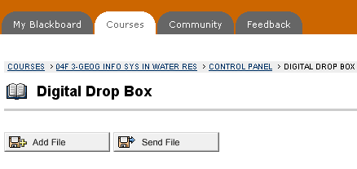
- Your term paper should be prepared as a single html file. There may (and almost always should) be embedded graphics or images, but a single print command should result in the entire paper being printed. Your paper may have links to reference material (e.g. data or sources that you used), but should be printable and self standing, in the sense that a printout tells the complete story without requiring reference to the linked material. You may include a table of contents at the beginning, but please do not make each section a separate page that requires clicking to go to it. Please also embed graphics in preference to requiring the user to click to access them.

