CE 394K.3 Final Exam Fall 2005
GIS in Water Resources

There are three questions on this exam. Do all three questions. For the first two questions, prepare a 2-page typed theme paper. For the third question use ArcGIS to prepare the map and answers requested. Staple all three solutions together in the order of the questions, and turn in the result to Dr. Maidment or give to the EWRE Area Secretary in ECJ 8.612 by 5PM on Friday, December 16. This is a take-home exam. You are honor bound not to discuss this exam with your colleagues in the class. Your answers should be the result of your work and thought alone. Be assured that if essentially the same idea appears in answers from more than one person, it is fairly easy to recognize that when the grading is being done. If that happens, it is not clear from whom the idea originated and who is just using somebody else’s knowledge. So, keep your ideas to yourself!

The term papers that you choose to describe in answering Questions 1 and 2 should be mutually exclusive, that is, if you focus on particular term papers in answering one of the questions, don’t focus on the same papers when answering the other question. The Texas class term project listing can be found at: http://www.ce.utexas.edu/prof/MAIDMENT/giswr2005/docs/TermProjList.htm. The Utah class term project listing can be found at: http://www.engineering.usu.edu/dtarb/giswr/2005/Students.html. You will need to use projects from both locations in preparing your answers.

What I am looking for in grading your answers to the first two questions is:

- Knowledge of the facts. Make sure you lay out the facts of what has actually been done before you start offering opinions about what could have or should have been done. This particularly applies to the discussion of term papers. Make sure you discuss what was actually done in the term paper not just about the general subject itself.
- Thoughtful evaluation. How do you evaluate the advantages and limitations of the principles, methods and data that have been used? How does the knowledge you’ve learned in this class relate to the world around us? I am looking for a sense of reflection here, of seeing you set individual situations and facts in a larger context in an intelligent way.

Questions

1. Compare and Contrast Two Applications Dealing with the same Theme

Choose two term papers that deal with the same or similar themes or topics. Neither of these papers should be your own term paper. Briefly summarize the contents of the papers (the problem examined, the method of analysis, the results achieved). Compare and contrast the approaches to the problem that the two papers took. Which technical approach do you think was more effective? Why? Which paper does a more effective job of communicating its results? Why? Suppose you were undertaking a study of this same subject. Having studied these two papers, what have you learned about how to go about your investigation effectively? What would you do differently from what the authors of these papers did?

2. Write an Assessment of the Utility of GIS in a Particular Application Area

Student term papers on a range of topics have been presented. Select four papers that fall within a similar subject area and present a critique of how effective GIS is in its application in this subject area. What is the scope of the application area? How has GIS been used? What types of problems have been solved effectively? What limitations exist that have yet to be overcome in the application of GIS in this area? In your answer, you must refer specifically to work presented in term papers prepared in this course. In other words, I am not looking here just for a general statement about your opinions in the field but rather a deduction based on the term papers presented in this class of what has been done and how you judge the effectiveness of that. At least one of the papers should be from each of the participating Universities (i.e. you may choose thee papers from Texas and one from Utah, two from each or one from Texas and three from Utah, but not all from the same University.).

3. Potential Great Salt Lake Flooding Analysis

Background and Context. The map following shows the location of Salt Lake City Utah at the SE corner of the Great Salt Lake. The airport and major freeways are shown. Salt Lake City is within the area that in geologic times was ancient Lake Bonneville. The figures below the map from the Utah Geologic Survey show fluctuations of the lake level over geologic time and in the historic record. These figures show that in 1985 and prior to that in 1870 the lake reached a high level of 1284 m (4212 ft). Also, in geologic time as recently as 3000 years ago the lake was at a level of 1292 m (4240 ft). Due to the occurrence of flooding in lower lying areas of Salt Lake City and threats to infrastructure during the high stand in 1985 pumps were installed at great cost on the west side of the Great Salt Lake to pump water into the West desert where it could evaporate.

Question. The zip file http://www.ce.utexas.edu/prof/maidment/giswr2005/final.zip contains the digital orthophoto quadrangle images used in the figure and the national elevation dataset digital elevation model for this region. I have also unzipped these data so that you can reach them directly if you use the LRC computers. The unzipped files are at civil.ce.utexas.edu/class/Maidment/giswr2005/final. Use this data to perform a potential flooding analysis of Salt Lake City Airport and North Salt Lake City.
Figure 1. Transportation Infrastructure and Urbanization adjacent to the Great Salt Lake 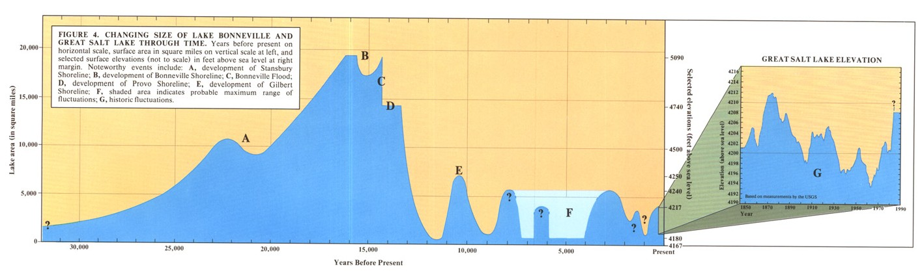
Figure 2. Lake Bonneville area and elevation over recent geologic time. (http://geology.utah.gov/utahgeo/gsl/)
Figure 3. Recorded Great Salt Lake levels (http://geology.utah.gov/utahgeo/gsl/).

a) Give the geographic projection of the data provided in the zip file.

b) Manually create two polygons that demarcate the Salt Lake City Airport and North Salt Lake City (NSLC), defined here as the area bounded by Highways I15, I215 and I80 as indicated in the figures. Use the freeways and other detail visible in the orthoimages to guide your editing. Your polygons should appear similar to the polygons in Figure 4 below. Report the area of each polygon.

Figure 4. Salt Lake City Airport and North Salt Lake City (NSLC)

c) Use the National Elevation Dataset digital elevation model to determine the mean, minimum and maximum elevation in the Airport and NSLC polygons.

d) Suppose that the lake were to rise to a level of 1286 m (4219 ft). Calculate the area within the Airport and NSLC polygons that would be flooded. Report the average depth of flooding in each of these polygons.

e) Prepare a nicely formatted layout map that depicts the extent of flooding of this area should the lake rise to the level of 1286 m.

