Exercise 2. Building a Base Map

CE 394K GIS in Water Resources
University of Texas at Austin
Fall 2007
Prepared by David R. Maidment
- Goals of the Exercise
- Computer and Data Requirements
- Procedure for the Assignment
  - Creating a Geodatabase
  - Get Stream and Watershed Data for Water Resources Region 12
  - Importing Data in the Geodatabase
  - Projecting the Geodatabase
  - Selecting the Guadalupe Basin Watersheds
  - Getting the Guadalupe River Reaches
  - Creating a Point Feature Class of Stream Gages
  - Add Attributes to the Point Feature Class
  - Creating a Chart and Layout
  - Overlaying the Edwards Aquifer
  - Downloading USGS Flow Data
- Summary of items to be turned in

Goals of the Exercise
This exercise is intended for you to build a base map of geographic and streamflow data for a watershed using the Guadalupe Basin in South Texas as an example. The base map comprises watershed boundaries from the US Geological Survey's Hydrologic Unit Code (HUC) coverage and streams from the US Environmental Protection Agency's River Reach File 1 (RF1) coverage. A geodatabase is created to hold all these primary data layers and creating relationships inside the geodatabase is also illustrated. In addition, you will create a point Feature Class of stream gage sites by inputting latitude and longitude values for the gages in an Excel table that is added to ArcMap and the geodatabase. The table is used to create an XY Event and a Point Feature Class. You also compare the locations of the Guadalupe basin surface boundaries, and the Edwards aquifer subsurface boundaries. You’ll link to the US Geological Survey's Real Time data website in Texas, download some streamflow data and make a plot of a flow hydrograph from a gaging site on the Guadalupe Basin.

Computer and Data Requirements
To complete this exercise, you'll need to run ArcGIS 9.2 from a PC.
The HUC boundaries are a subdivision of the US made by the US Geological Survey to show major and minor river basins. There are 2-, 4-, 6-, and 8-digit HUC boundaries, where the larger the number is the smaller the area. The HUC8 boundaries are the basic ones. Each of the 21 Hydrologic Regions in the US are shown below and for this exercise we will focus on Water Resources Region 12, which contains most of Texas.
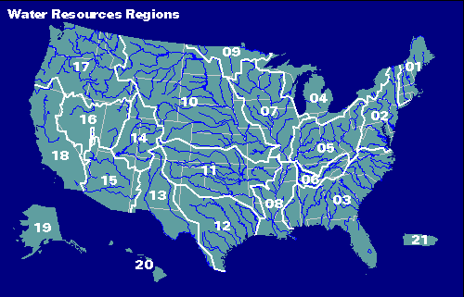
The HUC and RF1 coverages for the United States can be downloaded over the internet:
Hydrologic Cataloging Unit description http://water.usgs.gov/GIS/huc.html
Get the HUC coverages by 2-digit water resource region http://water.usgs.gov/lookup/getspatial?huc250k
Enhanced River Reach File 1 http://water.usgs.gov/lookup/getspatial?erf1
Get the RF1 data for the nation at: http://water.usgs.gov/GIS/dsdl/erf1.e00.gz

Procedure for the Assignment
Logon to the computer of your choice and make a directory in your workspace for this exercise. I've saved the needed files in the LRC class directory (Civil5/LRC/Class/Maidment/giswr/guadalupe/). They may also be downloaded as guadalupe.zip
Unzip the files to get the following:
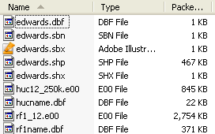

The HUC12 and RF1 files are coverages stored in Arc/Info interchange file format as indicated by the .e00 so you will need to import them using the Import from Interchange file tool in ArcToolbox as you will learn. The Rf1name.dbf and hucname.dbf are tables with name information for your streams and watersheds.

Get the Stream and Watershed Data for Water Resources Region 12
(1) Open ArcMap (Start → Program Files → ArcGIS → ArcMap)
(2) Display the ArcToolbox window by clicking on the 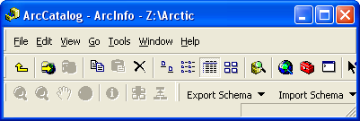 icon. This will add a new dockable window the ArcMap as shown below.
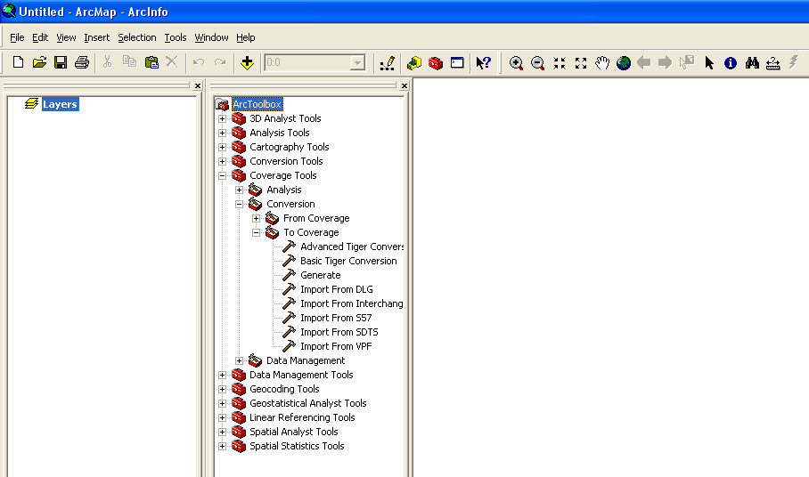
(2) In the ArcToolbox window, select Coverage Tools → Conversion → To Coverage → Import From Interchange File as shown below.
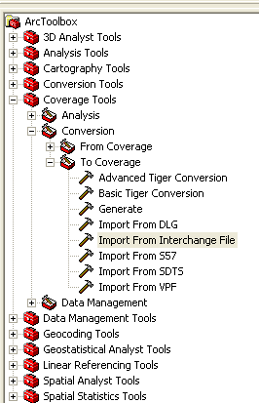
Note: If you don’t see the Coverage Toolbox, it may be because ArcInfo Workstation is not installed on your computer. To check this, open ArcGIS, and you should see ArcInfo workstation as an option, as shown below.
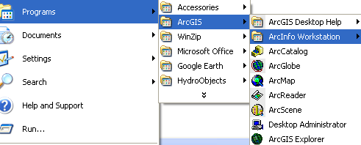
If you don’t have ArcInfo Workstation installed, you’ll need to skip the following section. Just get the Guadalupe.mdb Geodatabase directly from my website: http://www.ce.utexas.edu/prof/maidment/giswr2007/ex2/gdb/guadalupe.mdb and go to Section 4 Projecting the Geodatabase and pick up the narrative from there.
Navigate to the location of the Input file Rf1_12.e00. Then indicate where the output coverage should be located (your data folder) and what it should be called. When importing rf1_12.e00, name the resulting coverage rf1reg12. Be careful to give the full pathname for the Output dataset. Don’t just give the name of the output file and assume that it will be put into the same location as where the input file comes from. If you don’t do this, what will have happen is that the imported coverage will be saved somewhere to a default directory location but you don’t know where it is located. Coverage files don’t like to be named anything that has spaces in the names, so make sure that your names for files and for folders have no spaces in them, as shown below.
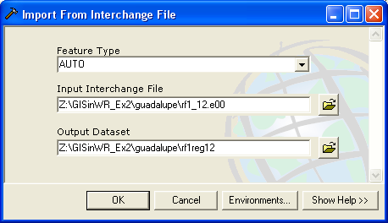

Press OK. Don't worry if processing takes a while, the file is rather large.
(3) Repeat the process with the huc250k.e00 file. When you import huc_250k.e00, name the resulting coverage hucreg12. This is how the result looks in Windows Explorer.
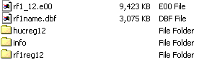
The geospatial data files defining the drainage areas and rivers are in the hucreg12 and rf1reg12 folders, respectively, and the attribute tables for both coverages are in the Info folder. Notice that while the geospatial files for each coverage are held separately, their attribute tables are merged into single Info folder. This means that whenever you wish to copy coverages from one place to another in your workspace, you need to use the Arc Catalog Edit/Copy to copy the coverage rather than just using Copy in Windows Explorer.
If you look inside the rf1reg12 folder, you’ll see the following. The Arc.adf file is where the geometry file for the coverage is stored. The prj.adf file is the projection of this coverage.
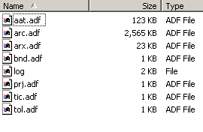
You can open the prj.adf file with a Word processor to see the projection. This is the USGS National Albers projection, a standard for USGS data of the United States.
Projection ALBERS
Zunits NO
Units METERS
Spheroid CLARKE1866
Xshift 0.0000000000
Yshift 0.0000000000
Parameters
29 30 0.000 /* 1st standard parallel
45 30 0.000 /* 2nd standard parallel
-96 0 0.000 /* central meridian
23 0 0.000 /* latitude of projection's origin
0.00000 /* false easting (meters)
0.00000 /* false northing (meters)

Add the two coverages to Arc Map using the 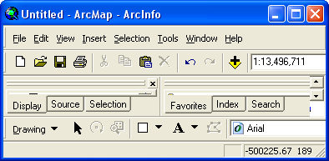 button:
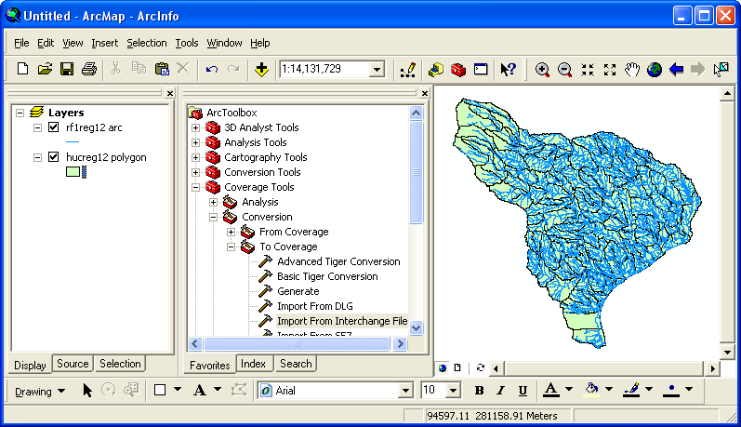

Recolor the themes if you wish. Move the cursor to the lower left corner of the display, and you’ll see the coordinates changing at the bottom of the map display. The ones shown here at (–889403, 288539), which means that point is 889.4 km to the West and 288.5 km to the North of the coordinate origin, which is (0,0) at 23 ºN and 96 ºW in this projection). If you move the cursor to the upper right of the display, you’ll get a different set of coordinate points. I got (521560, 1360524), which means that the upper right location is 521.6km to the East and 1360.5 km to the North of the coordinate origin. The change from negative to positive on the Easting coordinate between these two points is because the central meridian of this projection (96ºW) runs through the middle of Texas. Both the Northing coordinates are positive because the latitude of the projection’s origin 23 ºN) is South of the land mass of the conterminous US.
Creating a Geodatabase
Close ArcMap (you don’t have to save the map document) and open ArcCatalog. Right click on the data folder, press New / Personal Geodatabase. Call the new geodatabase Guadalupe.
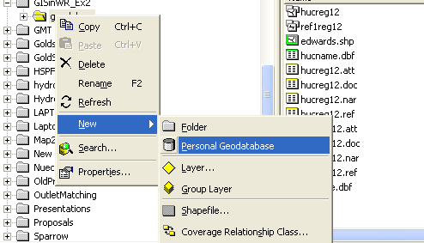
Right click on the geodatabase, and select New Feature Dataset.
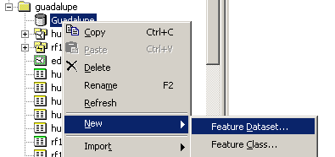
Name the new feature dataset Basemap, and hit Next to set the projection and map extent.
Select Import from the choices in the menu displayed.
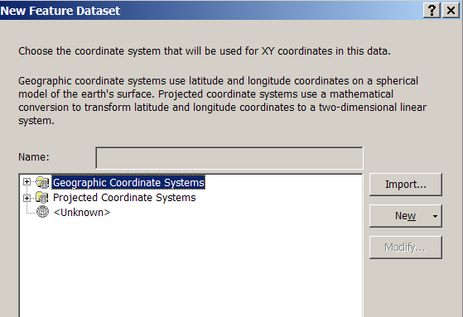
We will import the coordinate system from the prj file of the rf1reg12 coverage.
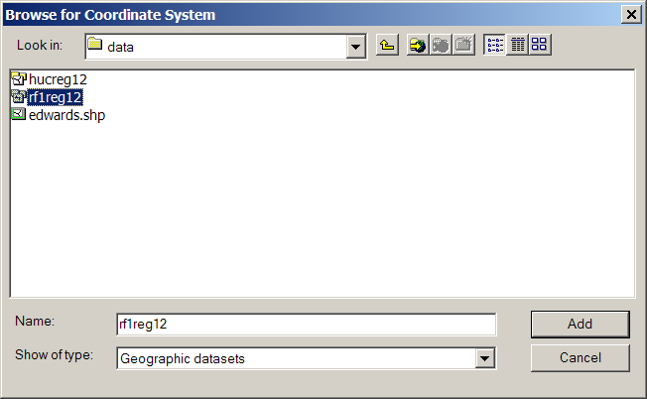
Hit Add to select this horizontal coordinate system. Hit Next and leave the Vertical Coordinate system set at None.
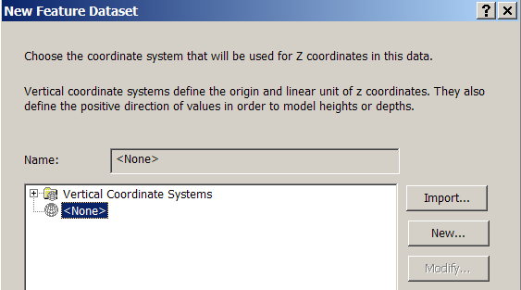
Hit Next and leave the default XY Tolerances as they are, then hit Finish to complete the specification of the spatial reference of the feature dataset. If you right click on the resulting Basemap feature dataset and open Properties, and tab to XY Coordinate System, you’ll see the coordinate system is Clarke_1866_Albers. This signals that the data have the NAD27 horizontal datum, and they use the Albers Equal Area projection. The parameters shown below are for what is called the USGS National Albers projection, whose parameters are optimized for maps of the continental United States.
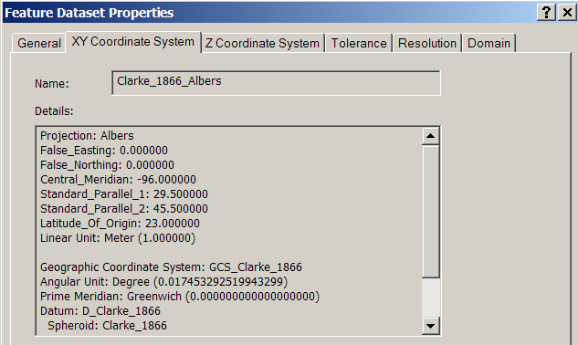
Importing data into the Geodatabase
- Now, you will import the created coverages for the Region 12 into the Guadalupe geodatabase. Right-click on your feature dataset and press Import → Feature Class (multiple)… as shown below.

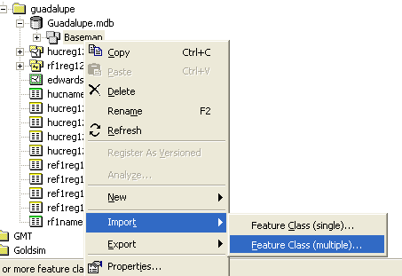

You will be importing the two existing coverages, hucreg12 and rflreg12, into the feature dataset Basemap of the geodatabase Guadalupe. Browse to hucreg12 and add its polygons. Then browse to rf1reg12 and add its arcs (as shown below).
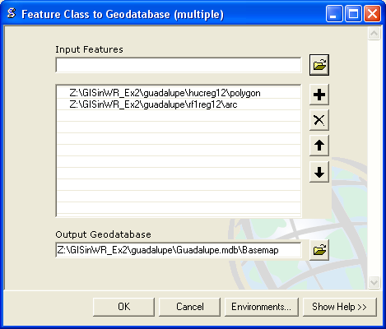

Note that as the data are being imported into the feature dataset, they will be projected to the spatial reference of the feature dataset even if they don’t have that projection in their original condition (this does not apply to the two feature classes you are working with here but might in other situations that you encounter).

Here is the new feature dataset that you’ve just created with its two new feature classes included:
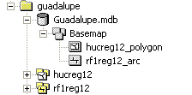

Rename the feature classes by right-clicking on each. Change hucreg12_polygon to hucreg12 and rf1reg12_arc to rf1reg12.

Projecting the Geodatabase

We’ll now project these data into geographic coordinates. Establish a new feature dataset called BasemapGeo. Follow the same procedure as before for the Basemap feature dataset, except that when you are setting the coordinate system, use Select and you’ll see the following choices appear:

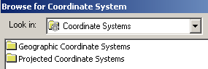

Select the Geographic Coordinate Systems and North American Datum 1927.

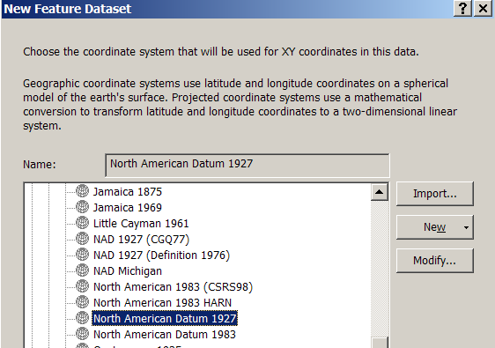

Hit Next and continue as before to complete the properties of the spatial reference of this new feature dataset. Ok, now you’ve got two feature datasets, one in Albers projection and one in geographic coordinates.

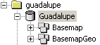

Now lets export the feature classes to the geographic feature dataset. Right click on the hucreg12 feature class and select Export → To Geodatabase (single)…

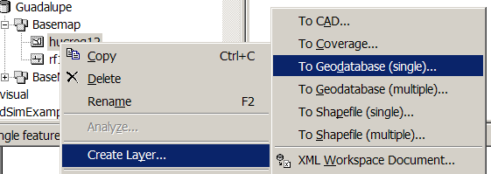

Navigate to the BasemapGeo feature dataset and select it as the output location, and name the output feature class hucreg12geo.

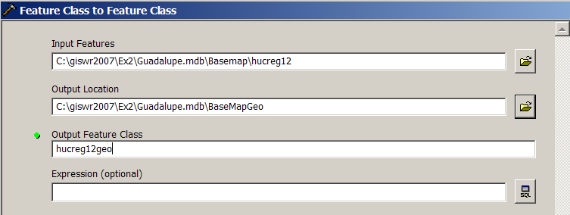

Do the same for to export the Rf1reg12 from Basemap to Rf1reg12Geo in BasemapGeo. You now have two feature datasets, one for each coordinate system:

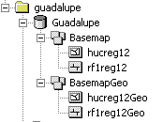

If you right click on BasemapGeo and go to Properties, and then selected Edit, you’ll see the new coordinate system:

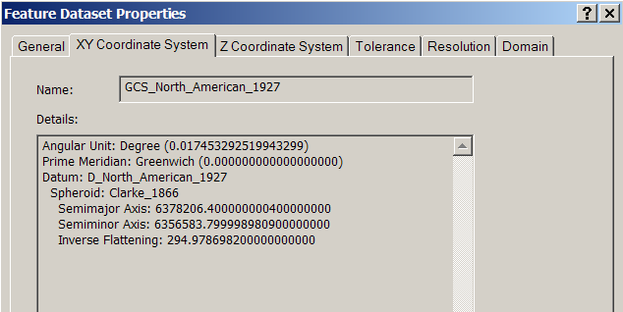

You cannot change the spatial reference of a feature dataset once it has been set, so if you make a mistake in this sequence, you have to start again by establishing a new feature dataset.

Open ArcMap and display the data in the BasemapGeo feature dataset. Notice how the cursor shows Degrees, Minutes and Seconds as you navigate through the display.

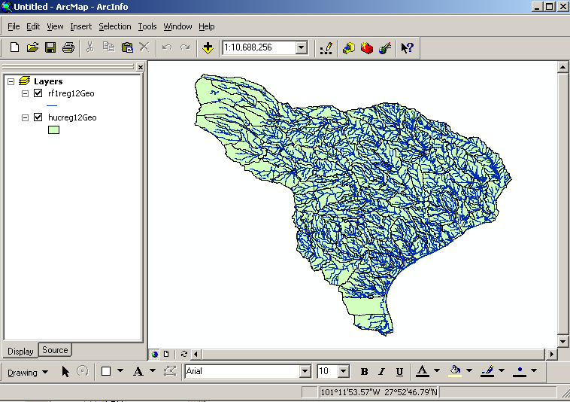

To Be Turned In: What is the approximate map extent of these data in geographic coordinates? Use the Draw Tools in ArcMap to draw a line on the map showing the Central Meridian of the projection at 96ºW and another line showing the Standard Parallel at 29º 30’ N. Screen capture the resulting map display and include it in your solution.

Selecting the Guadalupe Basin Watersheds
The imported Hucreg12 and Rf1reg12 feature classes cover a large region and we only want to work in the Guadalupe Basin. We'll use ArcMap to identify which HUC's cover the Guadalupe Basin and to create new feature classes using pertinent portions of the feature classes for Region 12.
(1) Start up ArcMap and add the Basemap feature dataset to your map document. Recolor the themes as necessary. You can select a symbol font for “River” to color in the blue line rivers.
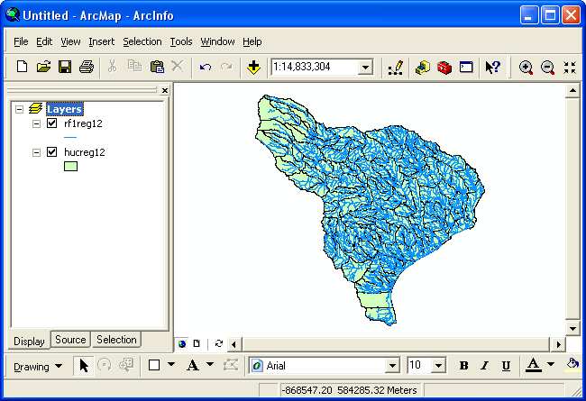
(2) Use File/Save As to save the ArcMap document as Ex2.mxd (to save your own customized colors).
(3) Right click on the hucreg12 theme and select Open Attribute Table to bring up the table of its attributes. Scroll across the fields and see the Hydrologic Unit Code (HUC), Region (first 2 digits of HUC), Subregion (second 2 digits of HUC), Basin (or Accounting Unit) (third 2 digits of HUC) and the Subbasin (or Hydro Unit) (fourth 2 digits of HUC).
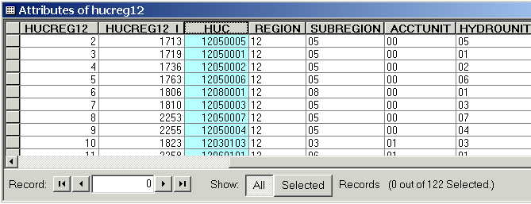
You’ll see that these HUC watersheds are identified by numbers rather than names. We have a separate names file hucname.dbf that was prepared from another HUC coverage that we’ll use to attach names to the HUC polygons.
(5) Hit the Add Data button and in the dialog box that appears, select the hucname.dbf table. The table hucname is added to your map. We’ll join this table to the HUC attributes so that we can identify the HUC watersheds by name. This names file contains the names of all the 2156 HUCs in the continental United States. We don’t need all of these, just the names for the HUCs in region 12, but you can replicate this exercise elsewhere in the country later with this same names file if you want to name the HUC’s in that region.
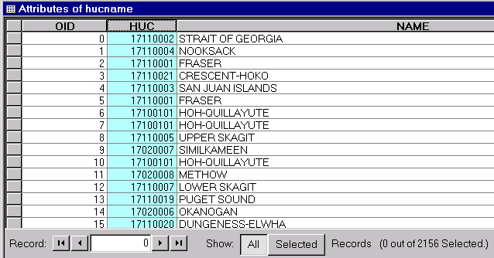
(6) Right Click on the hucreg12 layer in Arc Map and select Joins and Relates/Join.... What you are doing here is associating corresponding records in the two tables using HUC as the key field values that they have in common.
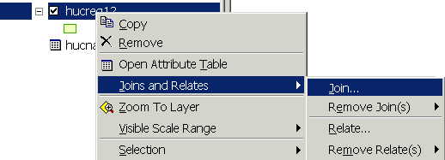
(7) Select the attribute HUC for question 1. For the second question, browse for the hucname.dbf table since it is not a layer in the map and therefore will not be automatically recognized. Again, for the third question select the HUC common attribute. Click OK. (Click No if you are asked to add an index field to the hucname.dbf file)
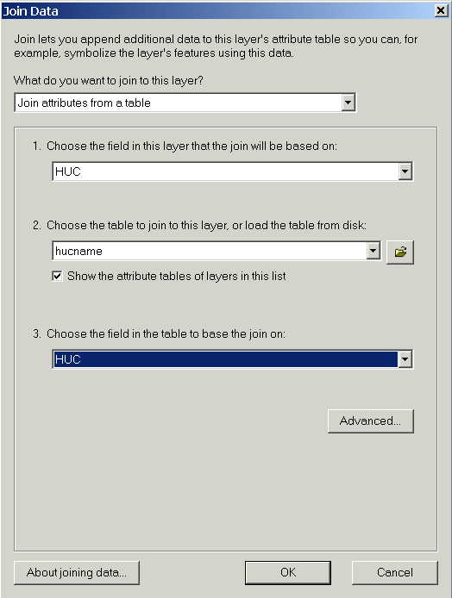
Voila!! Now we have a Name attribute on the Attributes of Hucreg12 table so that it is easier to understand what river basin we are in.
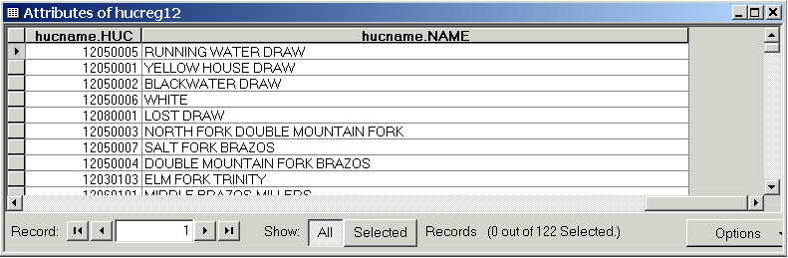
Lets recolor the HUC’s by subregion to get some sense of the river basin organization within Region 12. You do this using the Symbology tab under layer Properties. Right Click on the layer and select Properties. Under Show in the same box choose select Categories/Unique Values, select hucreg12.SUBREGION as the value field to be symbolized. Finally, press Add all values and OK.
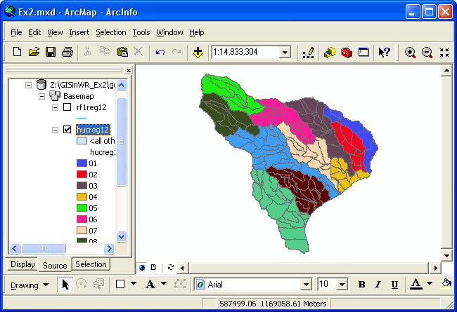
If you use the Information tool 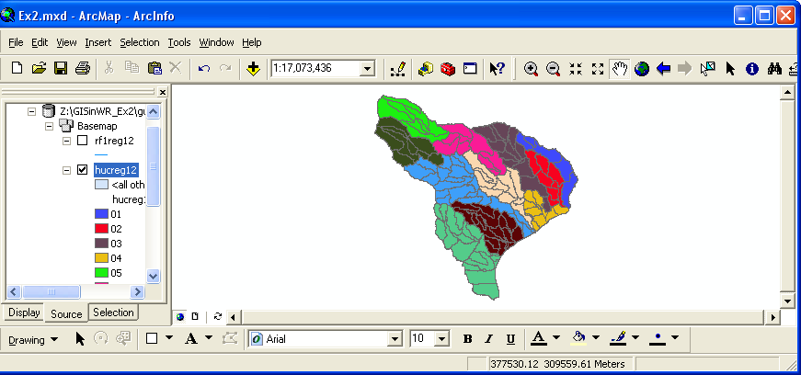 you can click around and get a sense of the names of the river basins and their subunits. (8) Use the Select button and visually select the 4 HUC units in the Guadalupe basin (see image below). Hold down the shift key so that you can select more than one at a time. Open the layer attribute table and press the Selected button. This will show you the items you have selected. You will see that the Guadalupe Basin is comprised of four sub-basins, the Upper [huc=12100201] , Middle [huc = 12100202] and Lower Guadalupe [huc = 12100204] basins and the San Marcos basin [huc = 12100203] selected above and below.
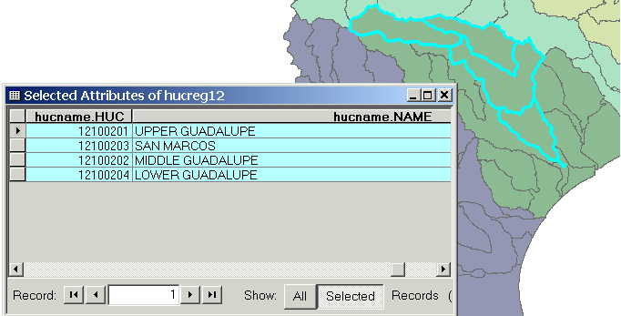
(9) Make sure that Arc Catalog is closed or the next steps won’t work. In ArcMap, Right Click on hucreg12 and select Data/Export Data ... to produce a new theme. If you get a message saying you can’t do this, it means that you haven’t shut down Arc Catalog before trying the data export. Close Arc Catalog and repeat the export steps if this happens.
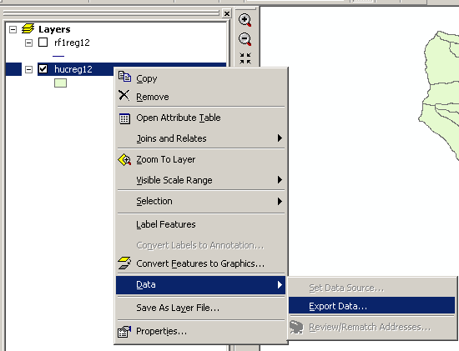
Browse inside your geodatabase to the Basemap Feature dataset (you’ll have to change the Save as Type to Personal Geodatabase feature classes first), name this new feature class as Watershed and save it in the geodatabase as a Personal Geodatabase feature class. Don’t save it as a Shapefile, which is the default option you are first presented with.
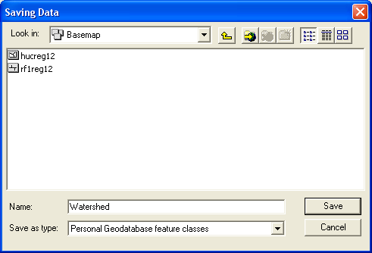
The program will automatically convert only the selected features. Note: By assigning Arc Hydro standard names like Watershed to your feature classes it will be easier to apply the capabilities of the ArcHydro data model as you will see later in this class (See page 32 on Arc Hydro book for standards).
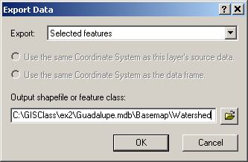
You will be prompted to whether add this theme to the Map, click Yes. Notice the Watershed Feature Class looks identical to the earlier hucreg12 feature class selection for the Guadalupe basin, but the new Watershed class is much smaller. Notice that it carries all the attributes of hucreg12 and the hucname.dbf table that you joined before making the data export.
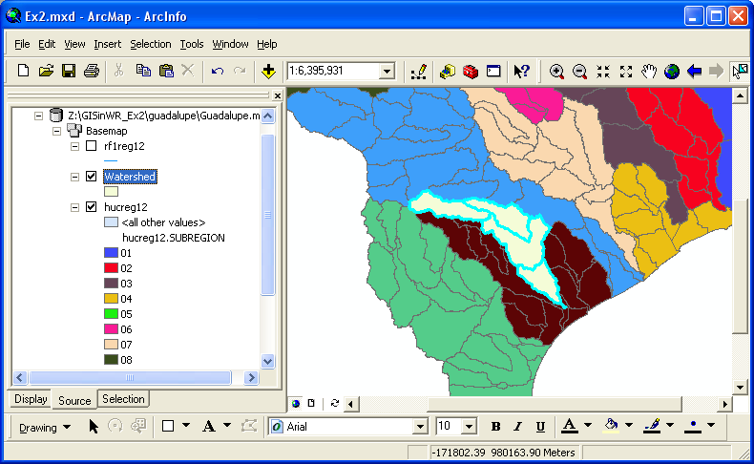
(10) Select Selection → Clear Selected Features to clear the selections you made from Hucreg12.
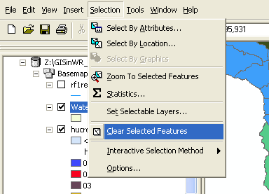

Getting the Guadalupe River Reaches
Now we need to select the rivers in rf1reg12 that fall within the Guadalupe Basin. First, lets give the rivers some names.
(1) In ArcMap, Right Click on the rf1reg12 layer and select Joins and Relates/Join. Select the field RR (River Reach) for question 1. For the second question, browse for the rf1name.dbf table since it is outside of the geodatabase and therefore will not be automatically recognized. Again, for the third question select the RR attribute. Click OK. (Do not add index fields to the table if you are prompted to do so.)
(2) Open the attribute table for the rf1reg12 feature class. Click on the Options/Select by Attribute and a dialog will appear. Use the “Create a new selection” Method and double click on the "rf1reg12.HUC6" field. Set this field equal to 121002 (The 6-digit HUC number for Guadalupe). You'll see that now only the rivers within the Guadalupe River basin are selected. Notice that you are here selecting features using a query on tabular attributes, whereas in the previous section, you selected features (HUCs) using a graphical query on the map.
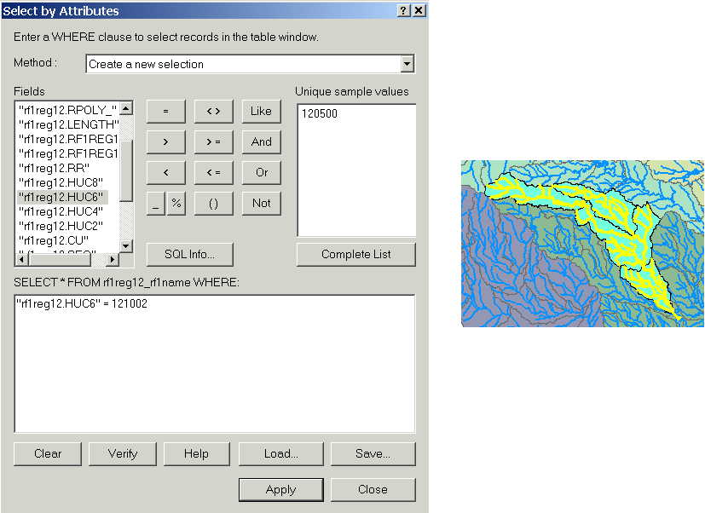
(3) As we did with the selected HUCs, Right Click on rf1reg12 and select Data/Export Data ... to produce a new feature class out of this selection. Browse inside your geodatabase to the Basemap Feature dataset, name this new feature class as HydroEdge (another standard ArcHydro name) and save it in your geodatabase. You will be prompted to whether add this theme to the Map, click Yes.
(4) Highlight the hucreg12 and rf1reg12 themes in the legend bar (use Shift when highlighting the second theme). Right click and press Remove to delete them from the Map. From now on, we'll work with the HydroEdge and the Watershed Feature Classes that correspond to our area of interest and to save time in displaying the layers.
(5) Once you've got the Guadalupe Basin displayed, you can right click on the Watershed layer and select Zoom to layer to bring the Guadalupe Basin up to the full extent of the screen. Now you should be able to see the Guadalupe River Basin with all of its major river reaches.
(6) Open the HydroEdge attribute table. Scroll across to the names of the rivers. PNAME is the name of the river segment. Use the Select by Attributes interface to select "PNAME" = 'GUADALUPE R' and change the table view to the selected records. This shows the main channel of the Guadalupe River. The small gap in the center of the basin is the segment where the Guadalupe River flows through Canyon Lake, which is separately identified in the PNAME field.
(7) Right click on the HydroEdge Feature Class and use Data/Export Data to export a new Feature Class with the main channel of the Guadalupe River, name it guadriver, and add that to your map.
(8) Click on the symbol boxes to recolor your map to the form you want it in. Make a layout of this map, copy it to the clipboard and paste it to a Word file so you can turn it in.
To be turned in: the layout of the Guadalupe Basin streams and watersheds.
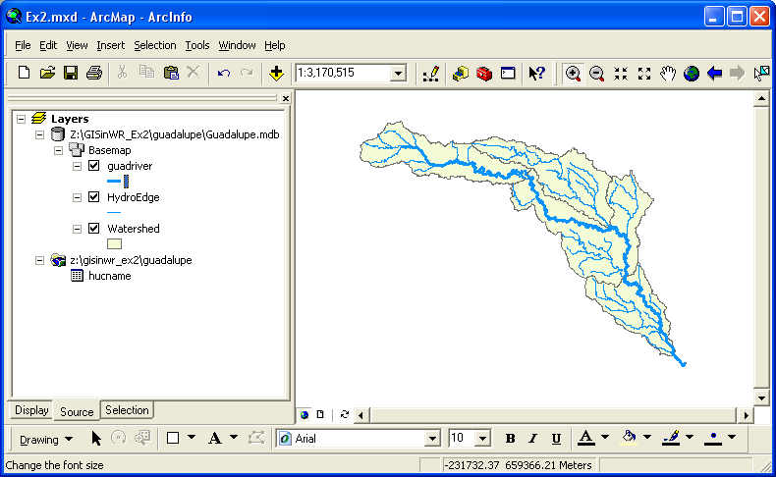
(7) Save your ArcMap document, Ex2.mxd. Exit ArcMap.

Creating a Point Feature Class of Stream Gages
Now you are going to build a new Feature Class yourself of stream gage locations on the Guadalupe. I have extracted information from the USGS stream gage data books information about 7 gages on the main stem of the Guadalupe River (there are many other stream gages in this basin):
Seq# Station# Name Longitude Latitude Mean Annual
Flow (cfs)
1 08176500 Victoria 97 00 46 W 28 47 34 N 2095
2 08175800 Cuero 97 19 16 W 29 03 57 N 2094
3 08168500 New_Braunfels 98 06 35 W 29 42 53 N 552
4 08167800 Sattler 98 10 47 W 29 51 32 N 464
5 08167000 Comfort 98 53 33 W 29 58 10 N 215
6 08166200 Kerrville 99 09 47 W 30 03 11 N 186
7 08165500 Hunt 99 19 17 W 30 04 11 N 81
The location coordinates and flow data for each of the gages was obtained from the USGS Water-Data Report TX-92-3. It can also be obtained from the USGS NWIS server, as described subsequently in this exercise.
(a) Define a table containing an ID and the long, lat coordinates of the gages
The coordinate data is in geographic degrees, minutes, & seconds. These values need to be converted to digital degrees, so go ahead and perform that computation for the 7 pairs of longitude and latitude values. This is something that has to be done carefully because any errors in conversions will result in the stations lying well away from the Guadalupe River. I suggest that you prepare an Excel table showing the gage longitude and latitude in degrees, minutes and seconds, convert it to long, lat in decimal degrees using the formula
Decimal Degrees (DD) = Degrees + Min/60 + Seconds/3600
Remember that West Longitude is negative in decimal degrees. Shown below is a table that I created. Be sure to format the columns containing the Longitude and Latitude data in decimal degrees (LongDD and LatDD) so that they explicitly have Number format with 4 decimal places using Excel format procedures. Note the name of the worksheet that you have stored the data in. I have called mine Latlong. Close Excel before you proceed to ArcMap.
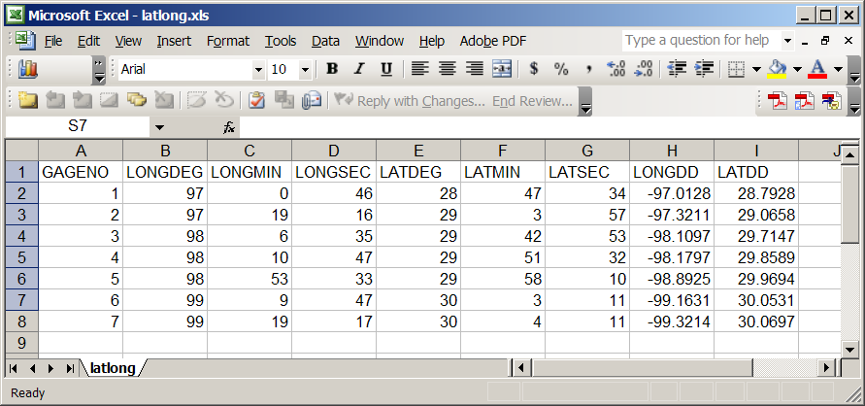
(b) Creating and Projecting a Feature Class of the Gages
(1) Open ArcMap and the Ex2.mxd file you created in the first part of this exercise. Select the add data button and navigate to your Excel spreadsheet
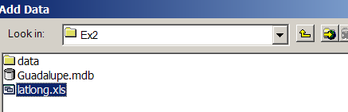
Double click on the spreadsheet to identify the individual worksheet within the spreadsheet that you want to add to ArcMap (it’s a coincidence that they have the same name in this example and that is not necessary in general). Note that ArcMap does not recognize Excel2007 files and if you create the spreadsheet in this format, save it as Excel2003 spreadsheet format so that it is recognizable in ArcMap.
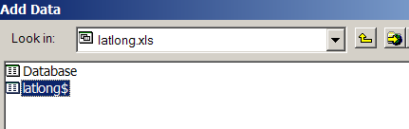
Hit Add and your spreadsheet will be added to ArcMap. Pretty cool!! This is the first time we’ve been able to add worksheets directly in ArcMap. Before ArcGIS 9.2 we had always to save the worksheet as a .dbf file and add that instead.
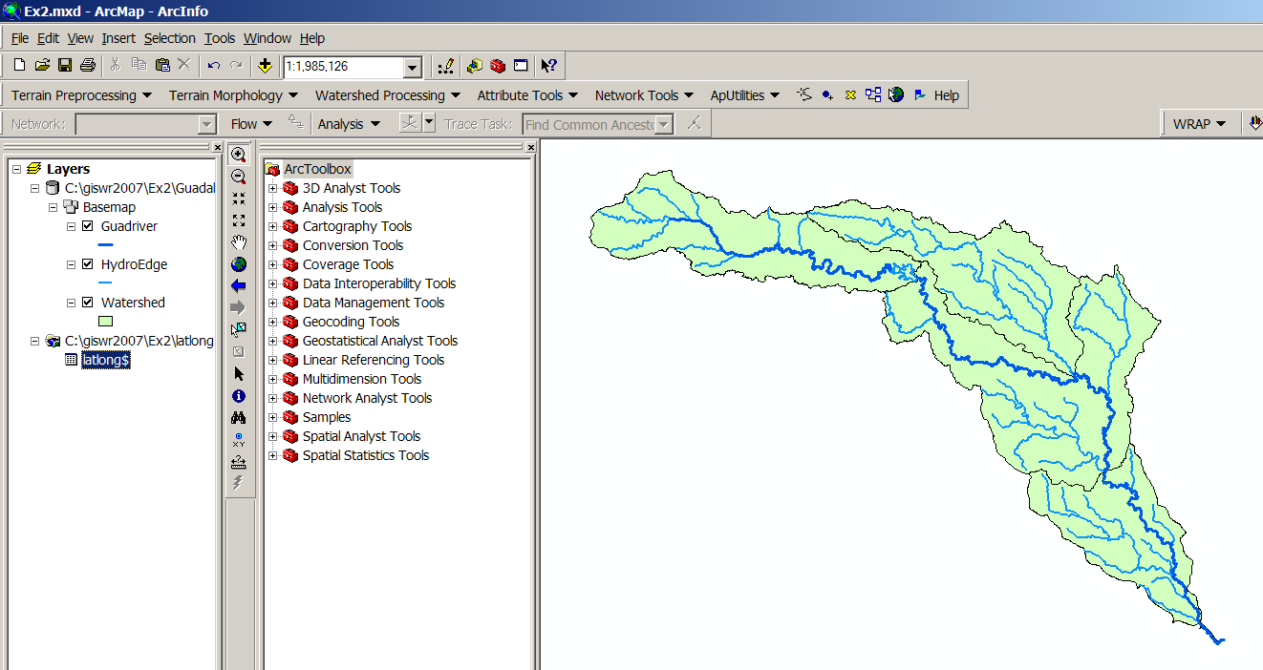
Now we are going to convert the tabular data in the spreadsheet to points in the ArcMap display.
(2) Under Tools, Choose AddXYData
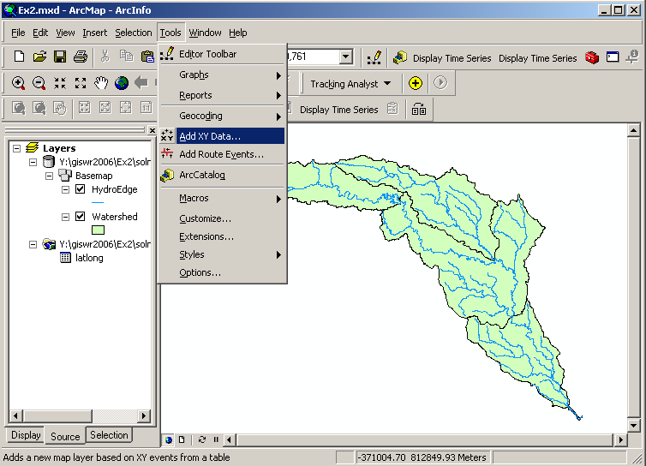
(3) Set the XY Table to latlong, the X Field to LongDD (or Longitude), the Y Field to LatDD (or Latitude), Hit Edit to change the spatial coordinate system, and then Import, and get the coordinate system from the feature dataset BaseMapGeo, and you should end up with a display that looks like the one below.
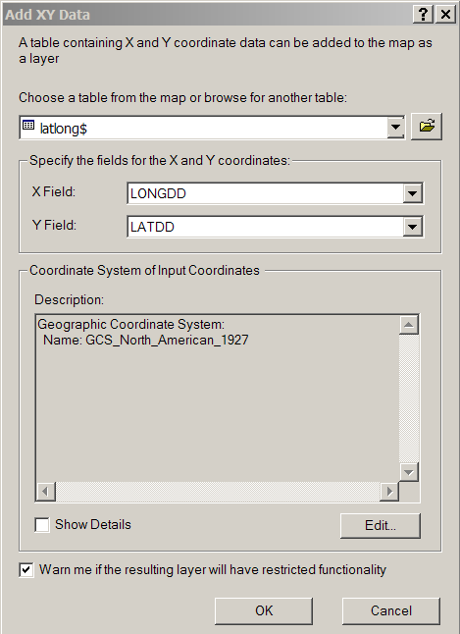
Hit OK, to complete it and you’ll get a warning message about your table not having an ObjectID. Just hit Ok and move on. Hit Ok to add the points and voila! Your gage points show up on the map right along the Guadalupe River just like they should. Magic. I remember the first time I did this I was really thrilled. This stuff really works. I can create data points myself! If you don’t see any points, don’t be dismayed. Check back at your spreadsheet to make sure that the correct X field and Y field have been selected as the ones that have your data in decimal degrees.
Click on the point symbol under the legend label latlong event and recolor and resize the points so that they show up more clearly.
What you have created is called an “event” which means that it is a graphical display in the ArcMap window of latitude and longitude points that are stored in a table. It is not a real feature class yet.
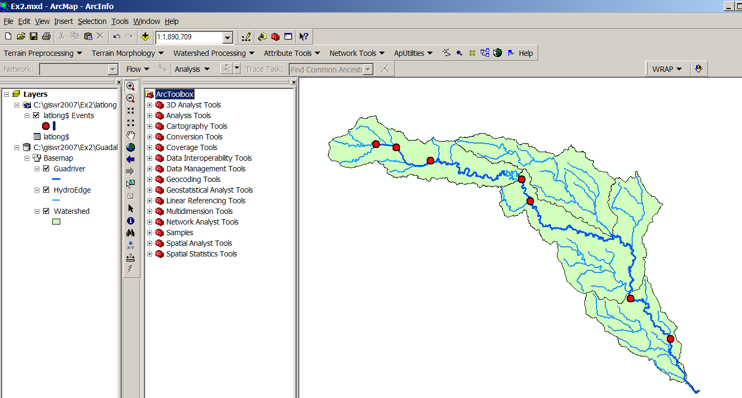
(4) Now, we’ll make a feature class out of the points. Right click on the latlong Events layer and select Data/Export Data
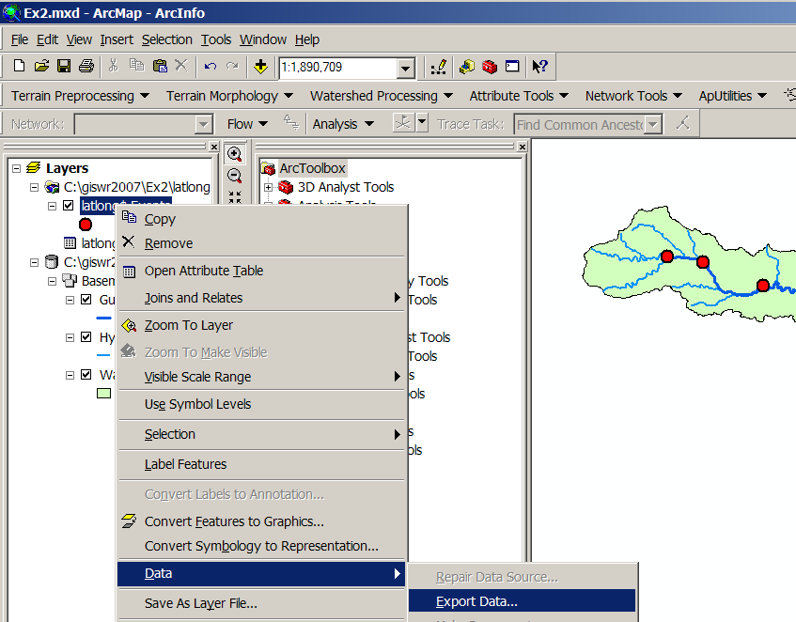
And export the data into the BaseMap feature dataset as the feature class MonitoringPoint. Say Yes when you are asked if you want to add the points to your map, and now you’ve got a new feature class in the BaseMap feature dataset with your points in the Albers project (ArcGIS does the map projection automatically as part of the data export process). Open the Attribute table of the MonitoringPoint feature class so that you can see that all the attributes have been correctly translated from the Excel file.
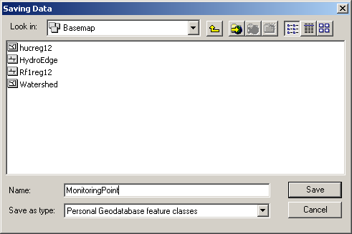
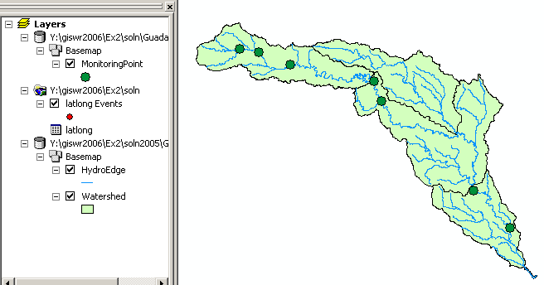
Open ArcCatalog and check out your BaseMap feature dataset. The MonitoringPoint feature class now resides there.
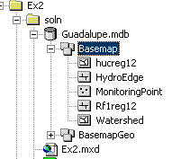
(11) Save your Ex2.mxd ArcMap document, and construct a layout to turn in.
To be turned in: a layout or screen capture of the MonitoringPoint attribute table with the map.

Add Attributes to the Point Feature Class
Now we are going to add the USGS gage ID, gage name, and annual discharge for each gage as new attributes in ArcCatalog.
(1) Open ArcCatalog (make sure ArcMap is closed) and navigate to the Guadalupe geodatabase that contains your data.
(2) In the BaseMap feature dataset, right click on the MonitoringPoint feature class, and click on Properties to open the Feature Class Properties window. Click on the Fields tab and scroll down to the end of the Field Name list. Type the following three entries:
Field Name | Data Type
USGSID | Text
Name | Text
Flow | Long Integer
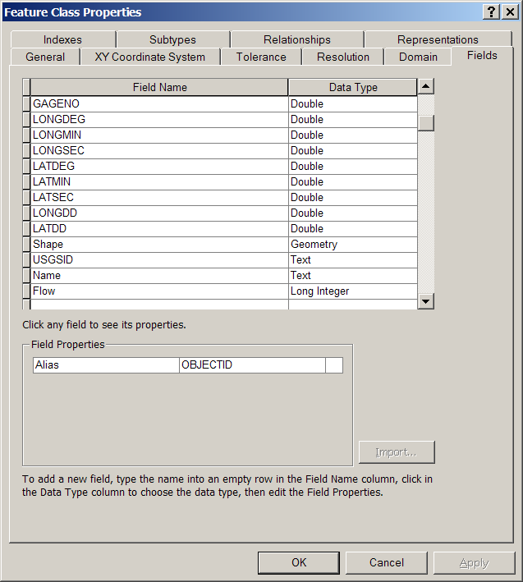
(3) Click OK and open your ArcMap document ex2.mxd.
Adding Data to the Attribute Table
(1) In ArcMap right click on the MonitoringPoint feature class and open the attribute table. Scroll to the right until you see the new fields you have created. Start editing by selecting Editor/Start Editing.
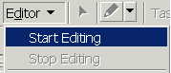
If the Editing Toolbar is not visible it maybe added by selecting View/Toolbars/Editor.
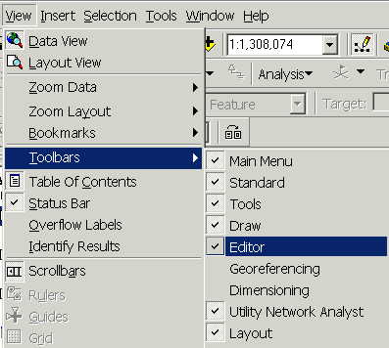
Select Editor/Start Editing and select the Guadalupe geodatabase as the target to be edited:
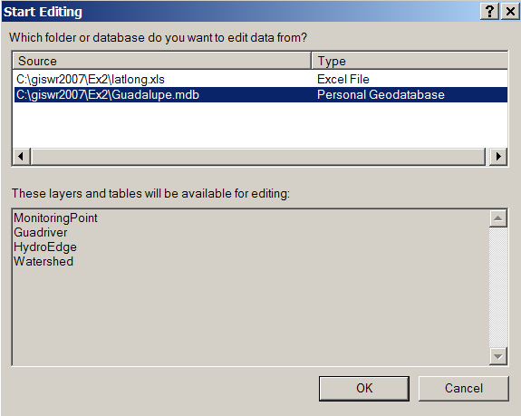
(2) You may now just add the appropriate data values to the table and for the three attribute fields you added. Continue adding the data values until they are all done.
The following data are needed in the table:
Number USGSID Name Flow

1 08176500 Victoria 2095
2 08175800 Cuero 2094
3 08168500 New_Braunfels 552
4 08167800 Sattler 464
5 08167000 Comfort 215
6 08166200 Kerrville 186
7 08165500 Hunt 81
(3) Select Editor/Stop Editing to finish editing and say Yes when it asks if you would like to save your edits. Note that you can only edit tables for which you have write permission (i.e. your own tables not tables in my work area).

Labeling the Gages in the View
Now you can use the Name field that you've added as a label for the gages.
(1) Right Click on the MonitoringPoint feature class and select Properties. Click on the Label tab and from the drop down menu select the label field to be Name. Click OK.
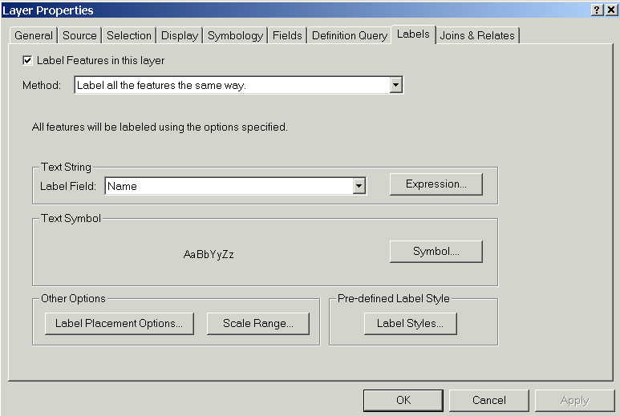
(2) Right click on the MonitoringPoint feature class again and select “Label Features”. You can now create a view like this:
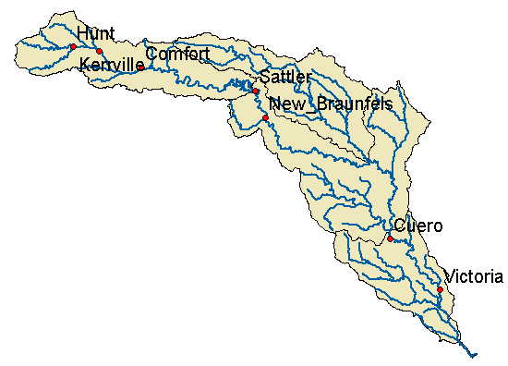
Pretty awesome! If you want to move the labels around to customize your map, you can convert the labels to annotation and then they can be individually moved where you want them to be:
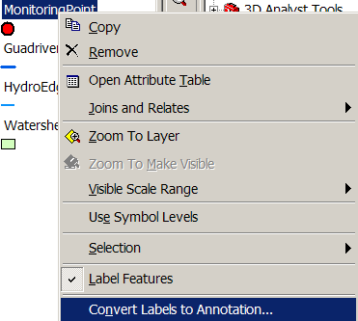
Note that in order to move the labels, you have to open the View/Toolbars/Editor and selected the Guadalupe.mdb geodatabase to edit, and the MonitoringPointAnno as the feature class to be edited:
Then, you can move and change the size of the annotation as you wish . When you are done, say Stop Editing and Save your annotation in its new location. Save the ArcMap document Ex2.mxd also.

Creating a Chart and Layout
(1) Open ArcMap to create a chart of the mean annual flow of the Guadalupe gages. Open the MonitoringPoint Attributes table file and make a chart using the tools available in ArcMap. Alternatively, you can export the attribute table to a .dbf file and map the chart in Excel. You can also open the geodatabase tables directly in Excel by using Data/Get External Data and doing a query on the Microsoft Access file that contains the geodatbase. The chart may look something like this
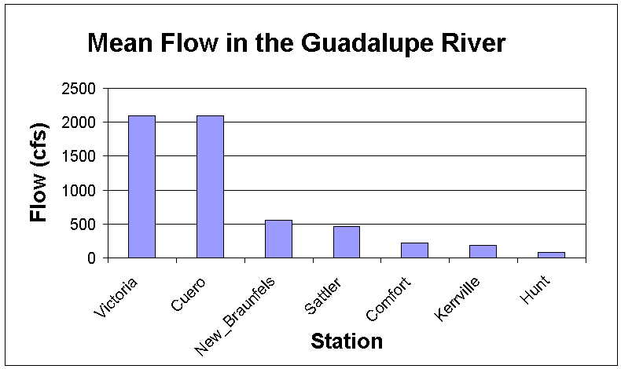
(2) In ArcMap prepare a layout showing a map of the drainage area, the graph of its annual flows at each gage and a table of numerical values describing the gages. You can import your Excel chart and worksheet from the Insert/Object... option in ArcMap. If necessary resize the original chart or table smaller so that it can be displayed in the layout. You'll see in the chart that the flow in the Guadalupe River at Cuero and Victoria is much higher than in the upstream stations. That is because the flow from the San Marcos River joins the Guadalupe upstream of Cuero.
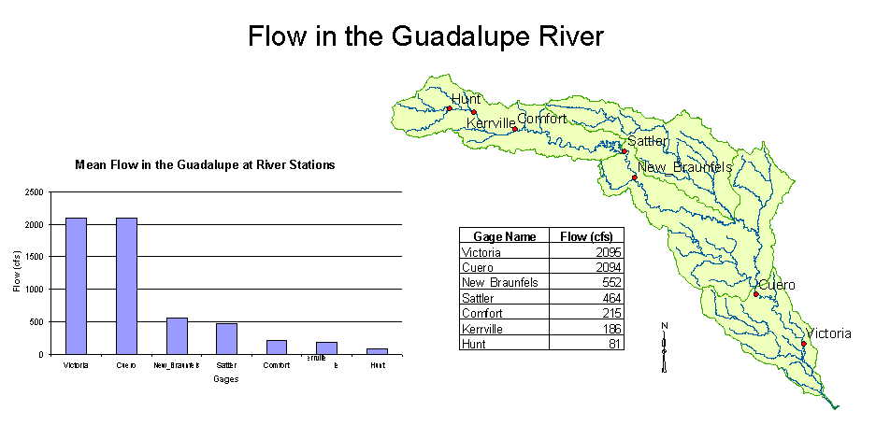
To be turned in: a layout showing the base map, chart and data table for the Guadalupe River flows

Overlaying the Edwards Aquifer
The Edwards aquifer is one of the most critical water resources of Central Texas. It is the main source of water supply for San Antonio, the 10th largest city in the United States. The Edwards aquifer is recharged by infiltration from rivers crossing its outcrop area. To determine where the Guadalupe river crosses, the outcrop area, I obtained a coverage of the Edwards aquifer from the Texas Natural Resource Information System (http://www.tnris.state.tx.us/)
The Edwards aquifer coverage from TNRIS is in Decimal Degree coordinates. We are using an Albers projection because it preserves earth area. I projected the Edwards coverage to Albers TSMS coordinates. This is the Edwards shapefile that you copied from the zip file at the beginning of the exercise.
- Import your Edwards.shp file into the Guadalupe geodatabase. From the Toolbox window in ArcMap, select Conversion Tools → To Geodatabase → Feature Class to Feature Class. Although the name of the tool is feature class to feature class, it will also convert a shapefile to feature class.
- Choose Edwards.shp as the Input Features, the Basemap feature dataset of the Guadalupe geodatabase as the output location, Aquifer as the output feature class name, and leave the rest of the inputs as their default values. Press OK.
This will not only do the conversion from shapefile to feature class, but also add the new feature class to your map.
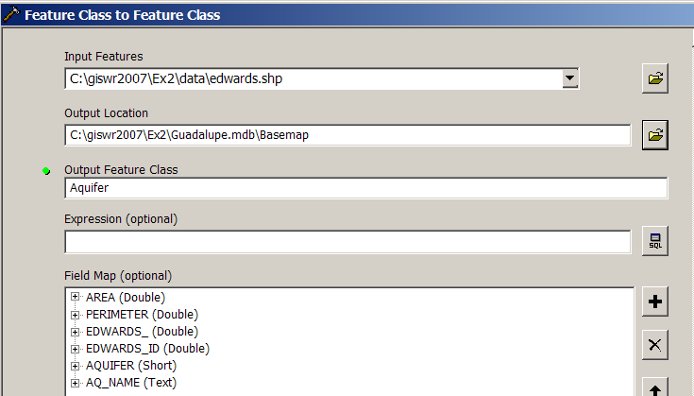
- Right click on the Aquifer feature class and select Properties. Click on its Symbology tab and Label the theme using the attribute Aquifer. This attribute has three values: 1 for outcrop, 2 for downdip and 0 for holes within the outer boundary of the aquifer. Classify the values with Unique Value and color them appropriately.
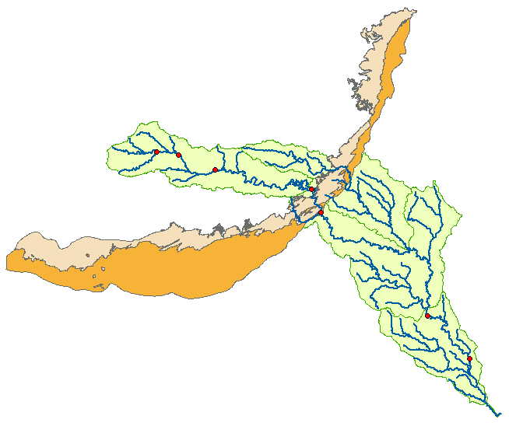
You'll see that as the Guadalupe River flows South East towards the Gulf Coast and it crosses first the outcrop and then the downdip portions of the Edwards aquifer. The downdip region is where the aquifer dips below the land surface and is shielded from the surface rivers by overlying hydrogeological units of low permeability. The Edwards is a fissured limestone aquifer whose fissures lie along its Southwest to Northeast orientation, so its flow moves in that direction, transverse to the direction of flow in the Guadalupe basin. It is thus quite possible for water to drain from the Guadalupe river into the Edwards aquifer and then reappear as a spring further North in another river, such as Comal springs feeding the Comal river. (3) Zoom in to the region where the aquifer crosses the Guadalupe basin for a closer look.
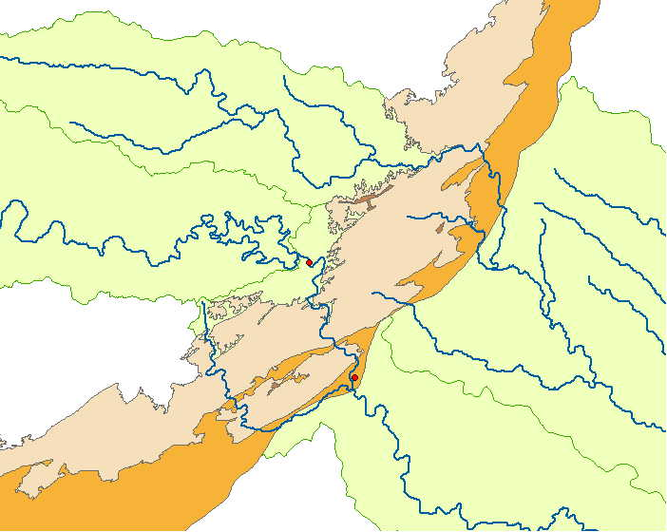
To be turned in: Between which two gaging stations does the Edwards aquifer outcrop area occur? What is the difference in mean annual flow at these two gages? Comment on these data. Do they seem correct to you?

Downloading USGS Flow Data
There are also other sources of flow data. One of them is real time data via Internet from the U.S. Geological Survey (http://water.usgs.gov/realtime.html). This data is taken at the gage sites every 15-60 minutes and is transmitted to the USGS office every 1 to 4 hours. This data relayed using satellite, telephone, and/or radio and can be viewed within minutes on arrival to the office. Notice the difference between the flow conditions in September 2002, 2003, 2006 and this September 2007. In 2002, the Northeast was experiencing a severe drought while in 2006 it was wetter than normal, and today there is drought in the Southeast and very wet conditions in Texas. Hydrology is a wonderful phenomenon – always changing!
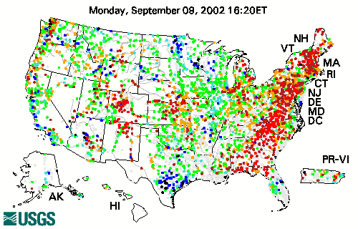
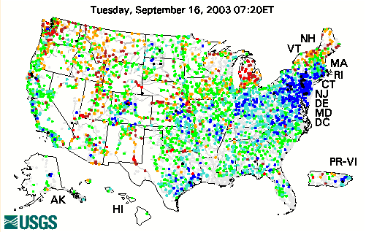
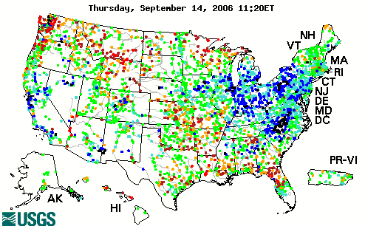

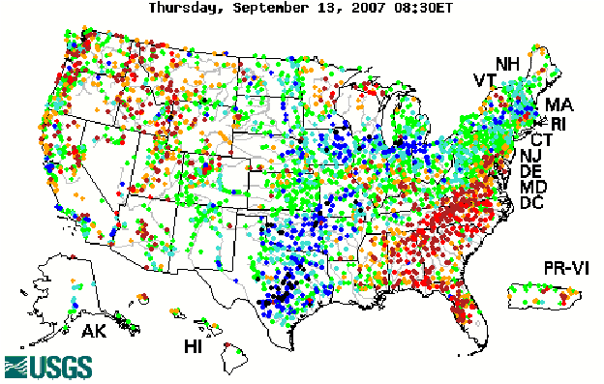
(1) Click on the site http://water.usgs.gov/realtime.html.
(2) Once you have looked around a bit click on Texas on the map of the United States located above. This link will bring you to a web page, which shows real time data for the state of Texas. Click on a gage shown on the map to display a graph. It’s a bit hard to select stations on this map since you can’t zoom into Texas, but you can see the station name on the bar at the bottom of your web browser. The Guadalupe River at Cuero, Texas is station 08175800.
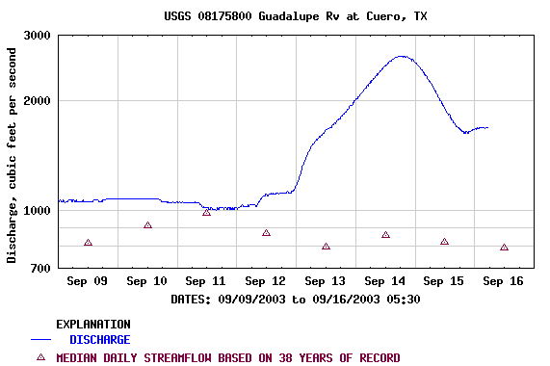
To be turned in: The graph of flow of the Guadalupe River at Cuero printed from the NWIS website. What are the 20%, 50%, and 80% cumulative probability flows for the calendar day on which you do the download? Approximately what % cumulative probability is the flow currently?
Summary of Items to be Turned in:

1. A layout of the Guadalupe Basin streams and watersheds.

2. What is the approximate map extent of these data in geographic coordinates? Use the Draw Tools in ArcMap to draw a line on the map showing the Central Meridian of the projection at 96ºW and another line showing the Standard Parallel at 29º 30’ N. Screen capture the resulting map display and include it in your solution.
3. A layout or screen capture of the MonitoringPoint attribute table with the map.

4. A layout showing the base map, chart and data table for the Guadalupe River flows.

5. Between which two gaging stations does the Edwards aquifer outcrop area occur? What is the difference in mean annual flow at these two gages? Comment on these data. Do they seem correct to you?

6. The graph of flow of the Guadalupe River at Cuero printed from the NWIS website. What are the 20%, 50%, and 80% cumulative probability flows for the calendar day on which you do the download? Approximately what % cumulative probability is the flow currently?

