Amendments to Exercise 2 Script

Fall 2007
Prepared by David R. Maidment

1. In Computer and Data Requirements, the following has been added:
Note: If you don’t see the Coverage Toolbox, it may be because ArcInfo Workstation is not installed on your computer. To check this, open ArcGIS, and you should see ArcInfo workstation as an option, as shown below.
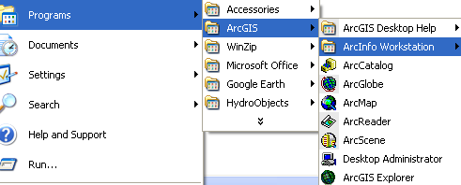
If you don’t have ArcInfo Workstation installed, you’ll need to skip the following section. Just get the Guadalupe.mdb Geodatabase directly from my website: http://www.ce.utexas.edu/prof/maidment/giswr2007/ex2/gdb/guadalupe.mdb and go to Section 4 Projecting the Geodatabase and pick up the narrative from there.
2. Within Section 8, Add Attributes to the Point Feature Class, the following has been added:

Note that ArcMap does not recognize Excel2007 files and if you create the spreadsheet in this format, save it as Excel2003 spreadsheet format so that it is recognizable in ArcMap.

3. At the end of section 8, “Adding Data to …” the following has been added:

Note that in order to move the labels, you have to open the View/Toolbars/Editor and selected the Guadalupe.mdb geodatabase to edit, and the MonitoringPointAnno as the feature class to be edited:
Then, you can move and change the size of the annotation as you wish . When you are done, say Stop Editing and Save your annotation in its new location. Save the ArcMap document Ex2.mxd also.
4. Set of requirements to be turned in at the end formerly had a section in it that read:
“6. A map showing map images added to your basemap information from the Geography Network.”
This has been deleted because we are not working with the Geography Network this year. The “to be turned in” now reads:
5. Between which two gaging stations does the Edwards aquifer outcrop area occur? What is the difference in mean annual flow at these two gages? Comment on these data. Do they seem correct to you?

6. The graph of flow of the Guadalupe River at Cuero printed from the NWIS website. What are the 20%, 50%, and 80% cumulative probability flows for the calendar day on which you do the download? Approximately what % cumulative probability is the flow currently?

Enjoy!

