GIS in Water Resources Exercise #3 Solution

Part 1.
1.1 Slope at grid cell A

Grid cell size 100m
60 a | 55 b | 53 c
71 d | 60 e A | 55 f
56 g | 50 h | 47 i

(i) standard slope function
$$\frac{\text{dz}}{\text{dx}}=\frac{(\text{a }+\text{ 2d }+\text{ g})\text{ - }(\text{c }+\text{ 2f }+\text{ i})}{\text{8 * x_mesh_spacing}}$$
$$\frac{\text{dz}}{\text{dx}}=\frac{(\text{60 }+\text{ 2*71 }+\text{ 56})\text{ - }(\text{53 }+\text{ 2*55 }+\text{ 47})}{\text{8 * 100}}$$
$$\frac{\text{dz}}{\text{dx}}=0\text{.}\text{06}$$
$$\frac{\text{dz}}{\text{dy}}=\frac{ (\text{g }+\text{ 2h }+\text{ i})−(\text{a }+\text{ 2b }+\text{ c})}{\text{8 * y_mesh_spacing}}$$
$$\frac{\text{dz}}{\text{dy}}=\frac{(\text{56 }+\text{ 2*50 }+\text{ 47})−(\text{60 }+\text{ 2*55 }+\text{ 53}) }{\text{8 * 100}}$$
$$\frac{\text{dz}}{\text{dy}}=−0\text{.}\text{025}$$
standard slope = 0.065
atan(0.06/(-0.025)) = -67.3º + 180 = aspect of 112.6º
Aspect = 112.6 º

(ii) The 8 direction pour point model
(This in an Excel Object so you can click on it to see formula's)
D8 slope = 0.10
D8 flow direction = 4
(iii) The D∞ algorithm

The red annotation above indicates the interpretation of each of the angles. Slope was evaluated for each triangular facet using
$$S=\sqrt{{\left(\frac{e_{\text{adj}}−e_{\text{diag}}}{Δ}\right)}^{2}+{\left(\frac{e_{\text{center}}−e_{\text{adj}}}{Δ}\right)}^{2}}$$
Angle evaluated using
$$α_{1}=\text{atan}\left(\frac{e_{\text{adj}}−e_{\text{diag}}}{e_{\text{center}}−e_{\text{adj}}}\right)$$
The slope on a triangular facet is valid only if it is in the range 0 to 45°. When the angle is outside this range the slope down one of the D8 directions needs to be selected. This may be either the diagonal or adjacent direction, depending which is the steepest in the downslope direction. The largest slope from all 8 triangular facets and the corresponding direction is selected as the D∞ slope and angle. The yellow highlight shows the slopes from which the largest is selected. In this case it is the slope value of 0.104 associated with the facet 0-7-8 and angle 16.7° which corresponds to 286.7° = 5.0039 radians counter clockwise from east (blue highlight). The D∞ slope is therefore 0.104.

Comments
The standard slope function gives, in this case, a smaller slope than the other methods and a direction more to the east than the other methods, due to it using surrounding higher elevation grid cells. This is reasonable if the surface is smooth, for calculations such as radiation exposure, but for calculating the direction that water will flow I think that only lower neighboring grid cells should be used. The D8 and D∞ methods only use lower neighbors. The D∞ method is preferable in my (biased) opinion because it does not limit flow to one of eight directions.

1.2. Checking with ArcGIS.

b) (i) Slope. Be sure to use the percent option

The value at cell A of 6.82 % corresponds to the hand calculation of 0.0682.
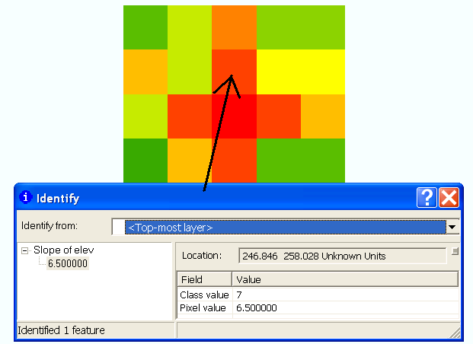

Other values are obtained similarly from identifying values in the ArcMap output.

Table of ArcGIS computed quantities
Cell | A | B
Slope | 6.5% | 8.68%
Aspect | 112.6 | 138.5
Flow Direction | 4 | 4
Hydrologic Slope (Percentage drop) | 10% | 5%
D∞ Slope | 0.104 | 0.05
D∞ direction (radians) | 5.0038 | 4.712
D∞ direction (degrees) | 286.7 | 270

These values corresponds with hand calculations

1.3 Model Builder model to do the above.
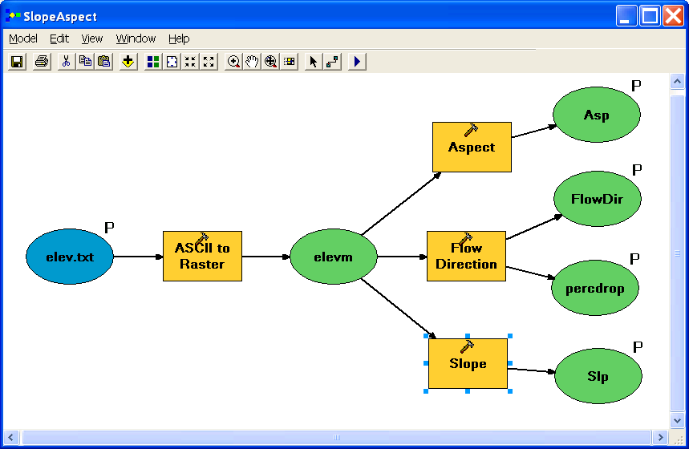

This tool is available on http://www.engineering.usu.edu/dtarb/giswr/2007/Ex3.tbx if you want to download and look at it.

Table of data ranges from model output using the file demo.asc

Grid | Minimum | Maximum
Aspect (-1 designates flat) | -1 | 360
Slope | 0 | 56.09º (148.8%)
Flow Direction | 1 | 128
Hydrologic Slope (percentage drop) | 0.067% | 146.67%

Part 2.
1. Loading the Data
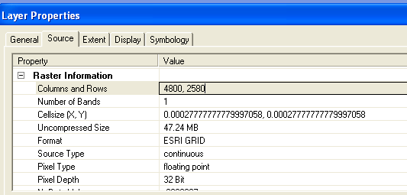

The number of columns and rows are 4800 and 2580 respectively,
cell size in the N-S directions in m = $\text{Re}Δφ$, where $Δφ$in rad and Re (Earth radius)
$\text{6370}×{\text{10}}^{3}×0\text{.}{\text{0002778}×Π}/{\text{180}}=\text{30}\text{.}\text{88}m$.
cell size in E-W direction must be adjusted for latitude.
cell size = $\text{Re}⋅\text{cos}φ⋅Δλ$ where, $Δλ$= longitude difference, use $φ$=29.82° (average of top and bottom latitudes) and $Δλ$= 0.0002778;
cell size E-W = 26.8 m

Spatial reference information for the San Marcos elevation dataset DEM ‘smdem_raw’ is;
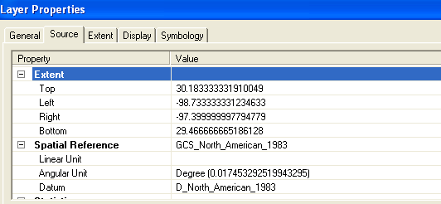

2. Projecting the DEM
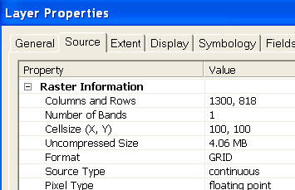

1300 columns, 818 rows. The minimum and maximum elevations in the San Marcos elevation dataset DEM ‘smdem_raw’ as well as the projected one ‘smdem’ are shown below. The difference in min and max is due to interpolation to a coarse grid.
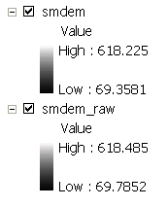

3. Exploring the DEM

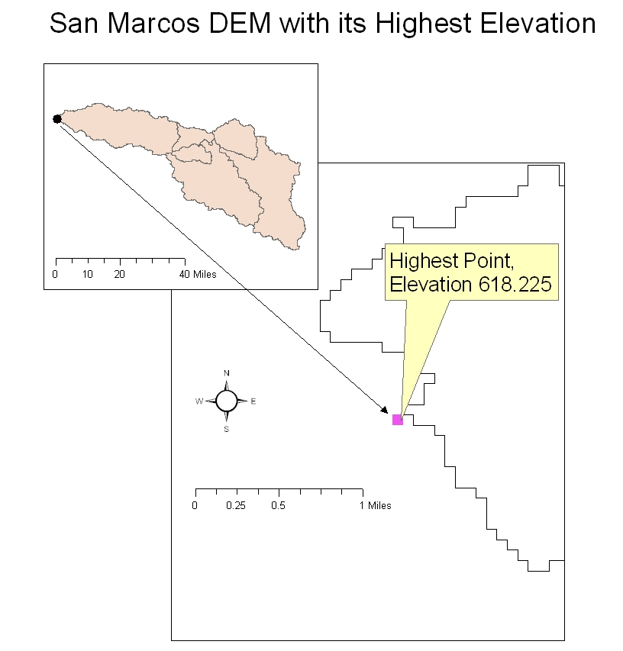
4. Contours, Hillshade and Slope

5. Zonal Average Calculation

HydroID | Name | MEAN Elevation (m) | Elevation RANGE (m) | Mean Slope (Percent)
537 | San Marcos | 137.616 | 138.211 | 2.167
538 | Blanco above Wimberley | 418.796 | 374.865 | 5.926
539 | Blanco above Kyle | 288.921 | 205.704 | 6.946
540 | Plum Creek | 190.023 | 136.813 | 2.464
541 | San Marcos ab San Marcos | 266.029 | 218.194 | 4.017
542 | San Marcos above Luling | 183.550 | 307.301 | 2.454

The subwatershed with highest mean elevation is Blanco above Wimberley (Note the point with the highest elevation is in the same subwatershed). The largest elevation range is found in the Blanco above Wimberley, too. The largest mean slope is noted in the Blanco above Kyle subwatershed.

6. Calculation of Area Average Precipitation using Thiessen Polygons

HydroID | Name | MEAN Annual Precip (100th's inches)
537 | San Marcos | 2509.94
538 | Blanco above Wimberley | 2450.71
539 | Blanco above Kyle | 2390.15
540 | Plum Creek | 2351.53
541 | San Marcos ab San Marcos | 2335.71
542 | San Marcos above Luling | 2383.02

The highest mean precipitation is found for the San Marcos subwatershed.

7. Estimate basin average mean annual precipitation using Spatial Interpolation/Surface fitting
HydroID | Name | Mean Precipitation (Tension Spline) in hundreds of inches
537 | San Marcos | 2521.50
538 | Blanco above Wimberley | 2457.75
539 | Blanco above Kyle | 2347.20
540 | Plum Creek | 2399.84
541 | San Marcos ab San Marcos | 2362.94
542 | San Marcos above Luling | 2372.20

San Marcos subwatershed has the highest mean precipitation when we used a Tension Spline Interpolation.

