Watershed and Stream Network Delineation
GIS in Water Resources
Fall 2007

Prepared by Venkatesh Merwade, David Maidment and Oscar Robayo
Center for Research in Water Resources
University of Texas at Austin
David Tarboton, Utah State University

Contents

Purpose
Computer and Data Requirements
Data description:
Getting Started
Open ArcMap and load Arc Hydro tools
Dataset Setup
Load the data to ArcMap
Terrain Preprocessing
1. DEM Reconditioning
2. Fill Sinks
3. Flow Direction
4. Flow Accumulation
5. Stream Definition
7. Catchment Grid Delineation
8. Catchment Polygon Processing
9. Drainage Line Processing
10. Adjoint Catchment Processing
11. Drainage Point Processing
12. Drainage Density Evaluation
Watershed Processing
1. Batch Watershed Delineation
2. Interactive Point Delineation
3. Batch Subwatershed Delineation
4. Flow Path Tracing
Summary of Items to turn in
Appendix. Procedures for correcting problems with vector processing due to X/Y domain problems.

Purpose
The purpose of this exercise is to illustrate, step-by-step, how to use the major functionality available in the Arc Hydro tools for Raster Analysis. In this exercise, the user will perform drainage analysis on a terrain model for the San Marcos Basin. The Arc Hydro tools are used to derive several data sets that collectively describe the drainage patterns of the catchment. Raster analysis is performed to generate data on flow direction, flow accumulation, stream definition, stream segmentation, and watershed delineation. These data will then be used to develop a vector representation of catchments and drainage lines from selected points. The utility of the Arc Hydro tools is demonstrated by applying them to develop attributes that are useful for hydrologic modeling.

Computer and Data Requirements
To carry out this exercise, you need to have a computer, which runs the ArcInfo version of ArcGIS. The data are provided in the accompanying zip file, Ex4.zip available at http://www.ce.utexas.edu/prof/maidment/giswr2007/Ex4/Ex4.zip . The data files used in the exercise consist of DEM grid for the San Marcos Basin in Texas and the hydrography data. Although the data are provided with this exercise, ready-to-work data are generally not available in real world, and the steps involved in downloading the NED and NHDPlus data from the USGS website are described in an addendum to this exercise at the following URL: Downloading_NED_NHD.doc. It is recommended that you go through the exercise of downloading the data to make yourself aware of the procedure involved.

Data description:
The contents of Ex4.zip when unzipped are illustrated below:
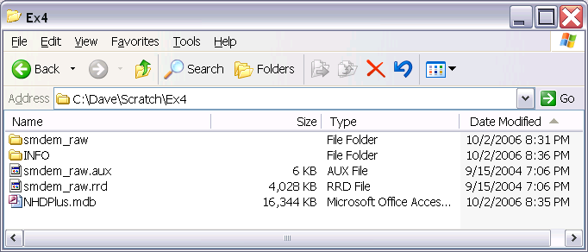
The geodatabase NHDPlus.mdb contains data from the National Hydrography Plus dataset. Inside NHDPlus.mdb, we are interested in the NHDFlowline and USGSGage feature classes stored in the Hydrography feature dataset and the Subbasin feature class contained in the HydrologicUnits feature dataset. The folder smdem_raw and associated files smdem_raw.aux, smdem_raw.rrd and files in the INFO folder contains the digital elevation model for this region obtained from the National Elevation dataset. (Remember that in ArcGIS single datasets are often stored in multiple files on the computer and these files should be manipulated using ArcCatalog. If you move the files using the Windows Explorer you may omit one of them and corrupt the data. Following is the ArcCatalog depiction of the data files provided
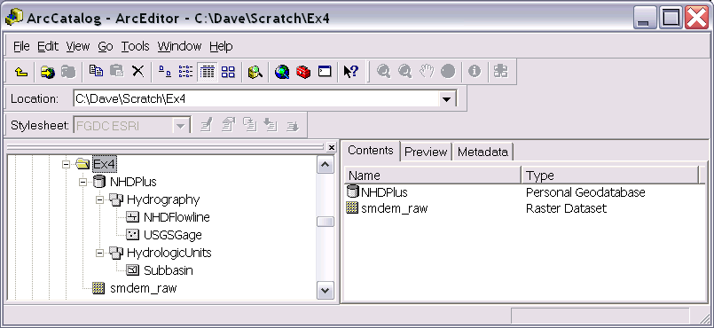

Getting Started

Open ArcMap and load Arc Hydro tools
Make sure the Arc Hydro tools are installed on the system. The ArcHydro installation file may be obtained from ESRI ArcHydro Online data support system: http://support.esri.com/index.cfm?fa=downloads.dataModels.filteredGateway&dmid=15. Click on the latest ArcHydro Tools version under Downloads. You will need to install both the ApFramework and ArcHydro setup files. If you want a more recent beta version of the ArcHydro tools, you can get the latest version from ftp://RiverHydraulics:river.1114@ftp.esri.com.

The ArcHydro Tools should already have been installed in the LRC lab at UT Austin and in the 3rd floor ENGR Lab at Utah State University.

Open ArcMap. Create a new empty map, and save it as Ex4.mxd (or any other name). Right click on the menu bar to pop up the context menu showing available tools as shown below.
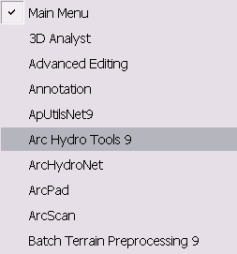

Check the Arc Hydro Tools menu. If the Arc Hydro Tools menu does not appear in the list, click on “Customize” (Scroll down the list to see “Customize”). In the Customize dialog that appears, check the Arc Hydro Tools box.

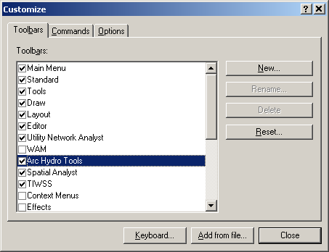

You should now see the Arc Hydro tools added to ArcMap as shown below. You can leave it floating or you may dock it in ArcMap.

Note
It is not necessary to load the Spatial Analyst, Utility Network Analyst, or Editor tools because Arc Hydro Tools will automatically use their functionality on as needed basis. These toolbars need to be loaded though if you want to use any general functionality that they provide (such as general editing functionality or network tracing).

However, the Spatial Analyst Extension needs to be activated, by clicking Tools>Extensions…, and checking the box next to Spatial Analyst.

Dataset Setup
The existing NHDPlus data to be used in this exercise are stored in a geodatabase and loaded in the map. All vector data created with the Arc Hydro tools will be stored in a new geodatabase that has the same name as the stored project or ArcMap document (unless pointed to an existing geodatabase) and in the same directory where the project has been saved (your folder for Ex4). By default, the new raster data are stored in a subdirectory with the same name as the dataset or Data Frame in the ArcMap document (called Layers by default and under the directory where the project is stored). The location of the vector, raster, and time series data can be explicitly specified using the function ApUtilities>Set Target Locations.

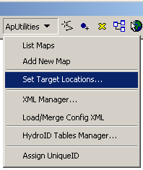
You can leave the default settings if they are pointing to the same directory where the ArcMap document is saved.

Load the data to ArcMap
Click on the icon to add the raster data. In the dialog box, navigate to the location of the data; select the raster file smdem_raw containing the DEM for San Marcos and click on the “Add” button. The added file will then be listed in the Arc Map Table of contents. When a new ArcMap document is created, it does not have any coordinate system, and its coordinate system is defined by the first dataset added to the map document. Look at the bottom-right corner of the document to see the geographic coordinates. This is because the DEM is in geographic coordinates. Therefore, the first step is projecting the data to a coordinate system. Click on the ArcToolbox button in ArcMap to display ArcToolbox. In ArcToolbox, select Data Management Tools→Projections and Transformations→Raster→Project Raster as shown below:

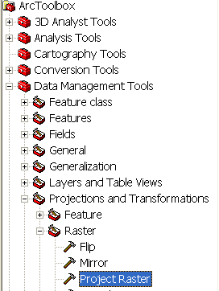

Double click on Project Raster to get the following form:

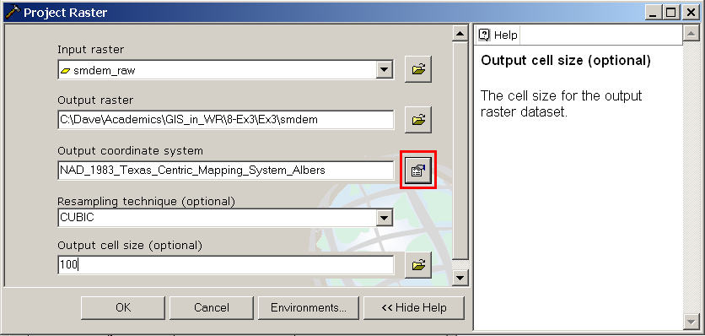

The input raster is smdem_raw already added to ArcMap, name the output raster as smdem, choose the output coordinate system by clicking at the button next to the input text-box to get the following form:
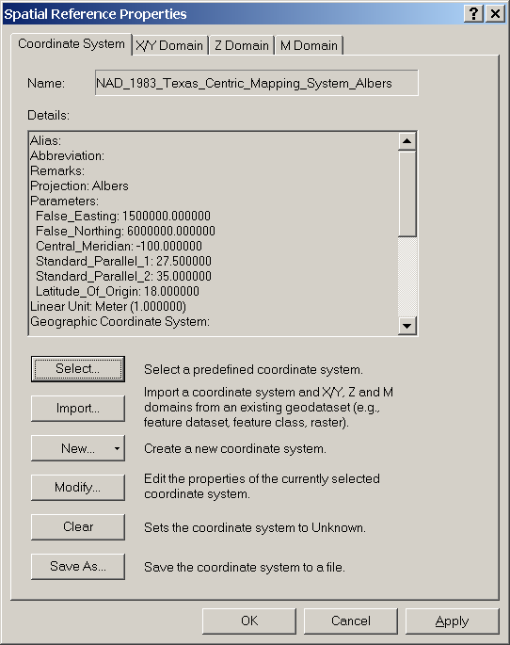

Then click on Select→Projected Coordinate System→State Systems and click on NAD 1983 Texas Centric Mapping System Albers.prj. Click Add, and press OK. Adjust the resampling technique to CUBIC and the output cell size to 100 m. (This NED data is at 1 arc second spacing which is close to 30 m, so in general 30 m would be a better choice here, but 100 m is chosen to reduce the size of the resulting grid and speed up data processing.) CUBIC refers to the cubic convolution method that determines the new cell value by fitting a smooth curve through the surrounding points. This works best for a continuous surface like topography at limiting artificial "striping" that can appear in a shaded relief map (see below) with the other methods. Click OK to invoke the tool. After the process is complete, the projected DEM, smdem, is added to ArcMap. You can see that the ArcMap document is still showing geographic coordinates (bottom-right corner). Right click on layers in the table of contents, click on Properties→Coordinate System and assign the coordinate system of smdem to the map document as shown below:
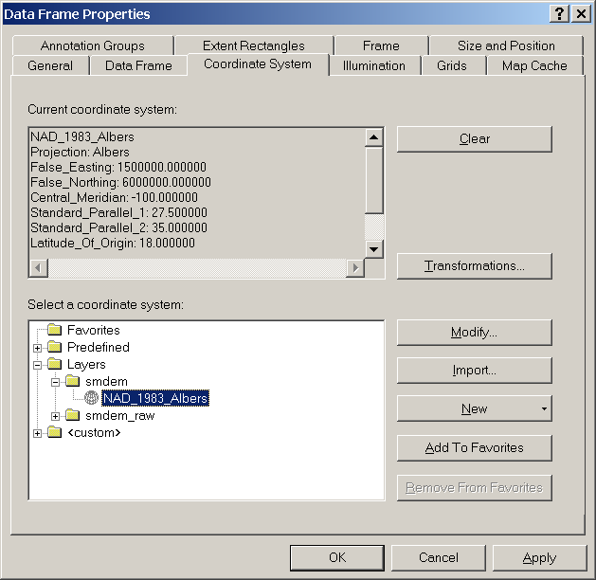

After defining the coordinate system for the map document, add NHDFlowline feature class from the Hydrography feature dataset within NHDPlus.mdb. The NHDFlowline feature class has geographic coordinate system. Project the NHDFlowline feature class by using the ArcTool box. Click on Data Management Tools→Projections and Transformations→Feature→Project. The input feature class is NHDFlowline. Save the output feature class as NHDFlowline_P within the NHDPlus.mdb geodatabase, and import a coordinate system from smdem to project the flowlines to the same coordinate system as smdem (NAD_1983_Albers).
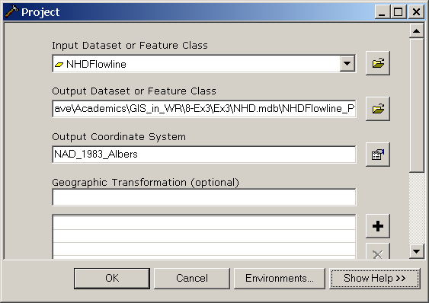

Remove the layers Smdem_raw and NHDFlowline from the ArcMap document. From now on we will work with projected data and do not want to inadvertently use the raw data that does not have the correct projection. Save and close the ArcMap document. You are now ready for terrain analysis! (Closing and reopening ArcMap has the effect of making the system "forget" some of the internal information involved with projections that confounds the ArcHydro processing later.)

Terrain Preprocessing
Terrain Preprocessing uses the DEM to identify the surface drainage pattern. Once preprocessed, the DEM and its derivatives can be used for efficient watershed delineation and stream network generation.

All the steps in the Terrain Preprocessing menu should be performed in sequential order, from top to bottom. All of the preprocessing must be completed before Watershed Processing functions can be used. DEM reconditioning and filling sinks might not be required depending on the quality of the initial DEM. DEM reconditioning involves modifying the elevation data to be more consistent with the input vector stream network (NHDPlus). This implies an assumption that the stream network data are more reliable than the DEM data, so you need to use knowledge of the accuracy and reliability of the data sources when deciding whether to do DEM reconditioning. By doing the DEM reconditioning you can increase the degree of agreement between stream networks delineated from the DEM and the input vector stream networks.

In general you should be aware that some of the terrain processes may take a long time to finish. Processes like DEM Reconditioning, Filling Sinks and Flow accumulation can take 10 to 15 minutes each for a grid with around 4000 x 4000 rows and columns. In this exercise the grid resolution has been degraded to 100 m to expedite the processing.

1. DEM Reconditioning
This function modifies a DEM by imposing linear features onto it (burning/fencing). It is an implementation of the AGREE method developed Center for Research in Water Resources at the University of Texas at Austin. For a full reference to the procedure refer to the web link: http://www.ce.utexas.edu/prof/maidment/GISHYDRO/ferdi/research/agree/agree.html.

The function needs as input a raw dem and a linear feature class (like the river network) that both have to be present in the map document.

Select Terrain Preprocessing | DEM Manipulation | DEM Reconditioning.

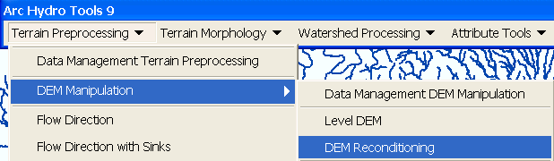

Select the appropriate Raw DEM (smdem) and AGREE stream feature (NHDFlowline_P). Set the Agree parameters as shown. You should reduce the Sharp drop parameter to 10 from its default 1000. The output is a reconditioned Agree DEM (default name AgreeDEM).

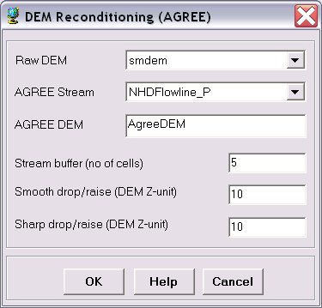

This process takes about 2 to 3 minutes! Examine the folder where you are working you will notice that a folder named Layers has been created. This is where ArcHydro outputs its grid results. A personal geodatabase with the same name as your ArcMap document has also been created. This is where ArcHydro outputs its vector feature class data.
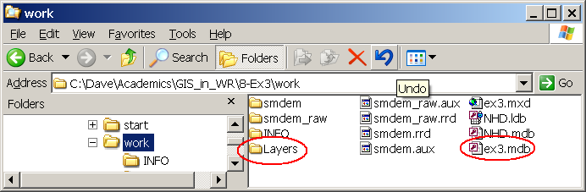
If you are curious you can examine what AGREE has done to the DEM. First examine AgreeDEM properties→Source. Check that the cellsize and number of rows and columns are the same as the original DEM. If these are changed then Agree has performed some sort of interpolation, which seems to occur if projections have been changed and can be avoided by closing and re-opening the ArcMap document. Next use 3D analyst to examine profiles across streams. Check that 3D Analyst is checked under Tools→Extensions. Then Activate 3D Analyst on View→Toolbars
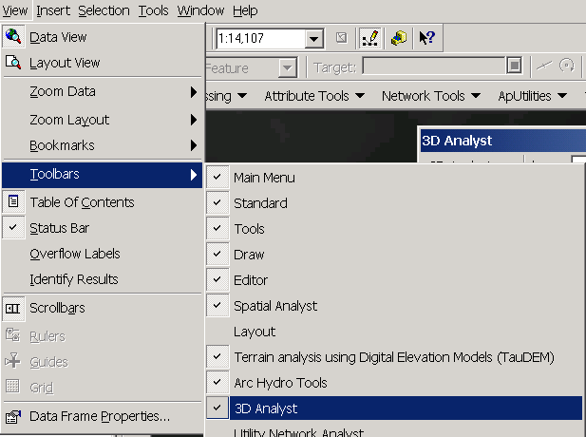
Use the Interpolate Line and Create Profile Graph tools to examine a profile cross section across a stream.
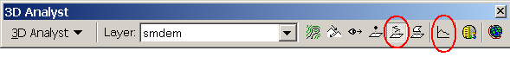
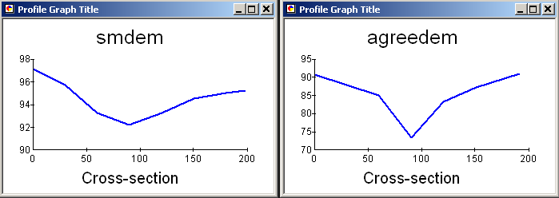

To turn in: Screen captures that illustrate the effect of AGREE DEM Reconditioning. Show the location where you made a cross section as well as the DEM cross sections with and without reconditioning.

2. Fill Sinks
This function fills the sinks in a grid. If cells with higher elevation surround a cell, the water is trapped in that cell and cannot flow. The Fill Sinks function modifies the elevation value to eliminate these problems.

Select Terrain Preprocessing | DEM Manipulation | Fill Sinks.

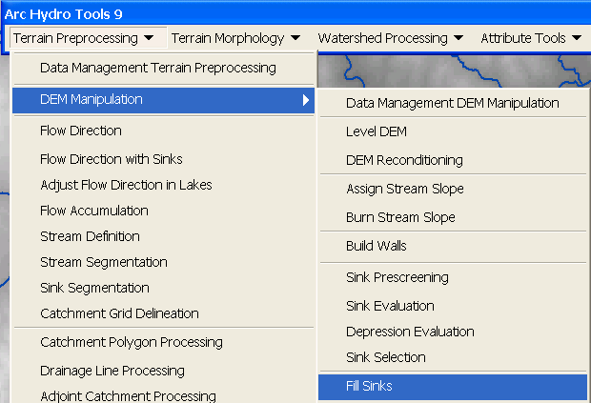

Confirm that the input for DEM is “AgreeDEM” (or your original DEM if Reconditioning was not implemented). The output is the Hydro DEM layer, named by default “Fil”. This default name can be overwritten. Press Help if you want to learn more about what this function does, for example what deranged polygons are.

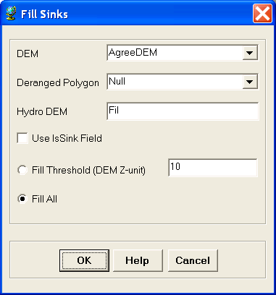

Press OK. Upon successful completion of the process, the “Fil” layer is added to the map. This process takes a few minutes.

3. Flow Direction
This function computes the flow direction for a given grid. The values in the cells of the flow direction grid indicate the direction of the steepest descent from that cell.

Select Terrain Preprocessing | Flow Direction.

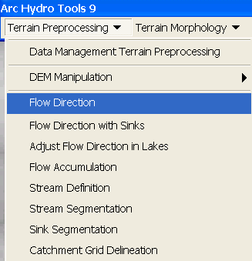

Confirm that the input for Hydro DEM is “Fil”. The output is the Flow Direction Grid, named by default “Fdr”. This default name can be overwritten.

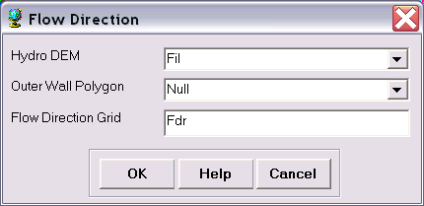

Press OK. Upon successful completion of the process, the flow direction grid “Fdr” is added to the map.

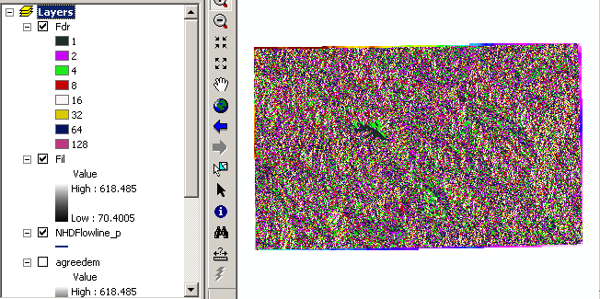

To be turned in: Make a screen capture of the attribute table of Fdr and give an interpretation for the values in the Value field using a sketch.

4. Flow Accumulation
This function computes the flow accumulation grid that contains the accumulated number of cells upstream of a cell, for each cell in the input grid.

Select Terrain Preprocessing | Flow Accumulation.

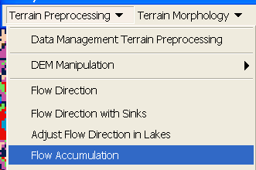
Confirm that the input of the Flow Direction Grid is “Fdr”. The output is the Flow Accumulation Grid having a default name of “Fac” that can be overwritten.

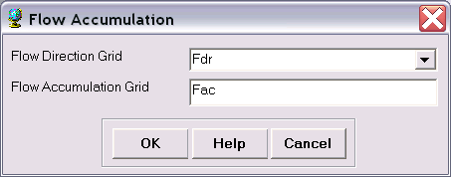
Press OK. Upon successful completion of the process, the flow accumulation grid “Fac” is added to the map. This process may take several minutes for a large grid! Adjust the symbology of the Flow Accumulation layer "Fac" to a multiplicatively increasing scale to illustrate the increase of flow accumulation as one descends into the grid flow network.

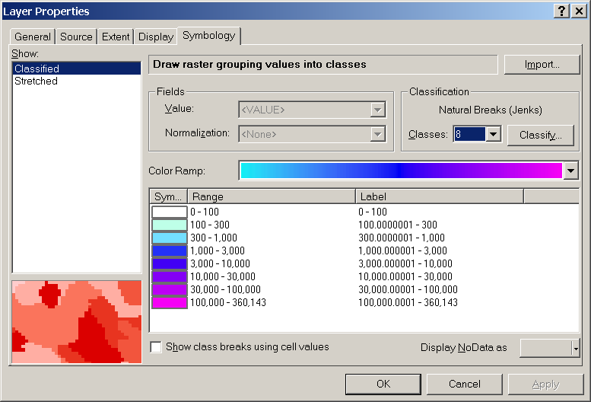

After applying this layer symbology you may right click on the "Fac" layer and Save As Layer File

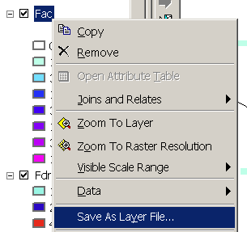

The saved Layer File may be imported to retrieve the symbology definition and apply it to other data.

Add the NHDPlus Subbasin feature class from the HydrologicUnits feature dataset in the NHDPlus geodatabase. This shows the outline of the HUC's surrounding the San Marcos basin. Change the symbology so that these are displayed as hollow and zoom in on the outlet in the South West corner. Use the identify tool to determine the value of "Fac" at the point where the main stream exits the area defined by the San Marcos Subbasin polygon. This location is indicated in the following figure.
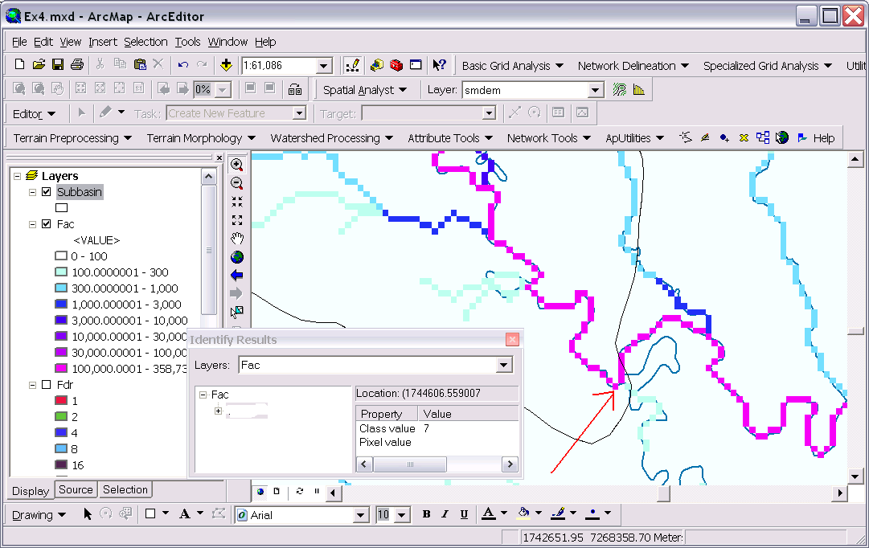

The value obtained represents the drainage area in number of 100 x 100 m grid cells. Calculate the drainage area in km². Notice that the coarseness of the DEM has resulted in some meanders being cut off. The outlet should be identified upstream of this location so as not to "capture" extraneous terrain from outside.

Also examine the southern rim of the basin where there is a NHDPlus stream crossing the NHDPlus subbasin boundary.

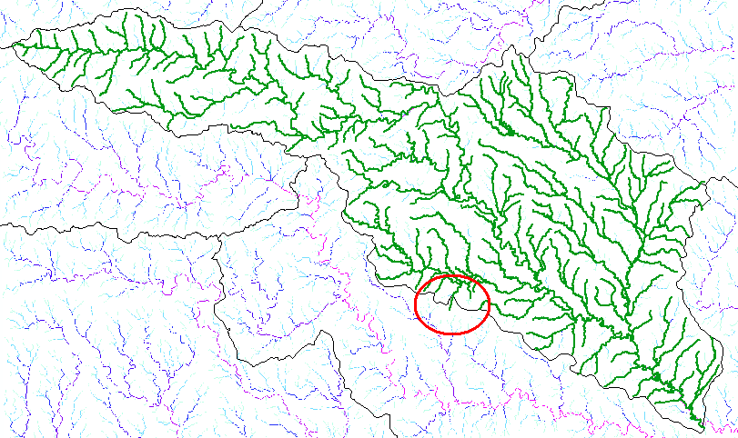

Zoom in on this location and use identify to determine the value of "fac" at the point where this small stream "enters" the delineated HUC. Determine the corresponding area in km². If we assume that the DEM (from NED) and NHDPlus flowline data is higher quality than the NHDPlus subbasin boundary this indicates an omission of area due to inaccurate delineation of the subbasin boundary.

To be turned in: Report the drainage area of the San Marcos basin in both number of 100 m grid cells and km² as estimated by flow accumulation. Report the omitted drainage area assumed due to imprecise delineation at the location indicated on the southern edge, in both number of 100 m grid cells and km².

5. Stream Definition
This function computes a stream grid which contains a value of "1" for all the cells in the input flow accumulation grid that have a value greater than the given threshold. All other cells in the Stream Grid contain no data.

Select Terrain Preprocessing | Stream Definition.
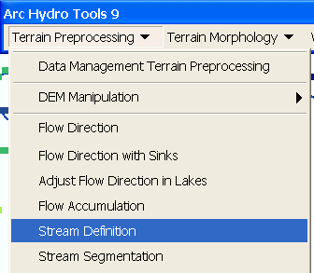

Confirm that the input for the Flow Accumulation Grid is “Fac”. The output is the Stream Grid. “Str” is its default name that can be overwritten.

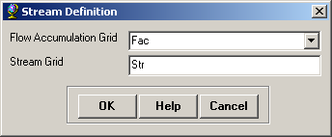
A default value is displayed for the river threshold. This value represents 1% of the maximum flow accumulation: a simple rule of thumb for stream determination threshold. The threshold drainage area to generate a stream is then 3586 x 100 x 100 / 1000000 = 35.9 km². However, any other value of threshold can be selected. For example, the USGS Elevation Derivatives for National Applications (EDNA http://edna.usgs.gov/) approach uses a threshold of 5000 30 x 30 m cells (an area of 4.5 km²) for catchment definition. A smaller threshold will result in a denser stream network and usually in a greater number of delineated catchments. Objective methods for the selection of the stream delineation threshold to derive the highest resolution network consistent with geomorphological river network properties have been developed and implemented in the TauDEM software (http://www.engineering.usu.edu/dtarb/taudem.)

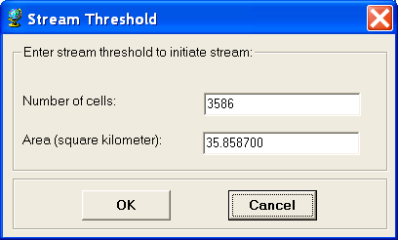

Press OK. Upon successful completion of the process, the stream grid “Str” is added to the map.

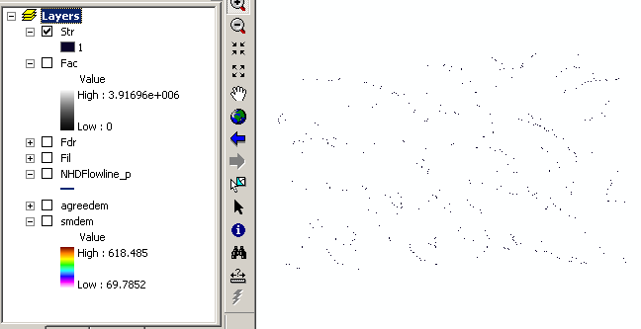

6. Stream Segmentation

This function creates a grid of stream segments that have a unique identification. Either a segment may be a head segment, or it may be defined as a segment between two segment junctions. All the cells in a particular segment have the same grid code that is specific to that segment.

Select Terrain Preprocessing | Stream Segmentation.

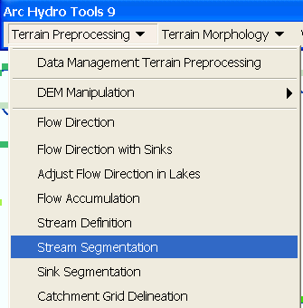

Confirm that “Fdr” and “Str” are the inputs for the Flow Direction Grid and the Stream Grid respectively. The output is the Link Grid, with the default name “Lnk” that can be overwritten.

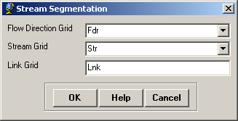

Press OK. Upon successful completion of the process, the link grid “Lnk” is added to the map.

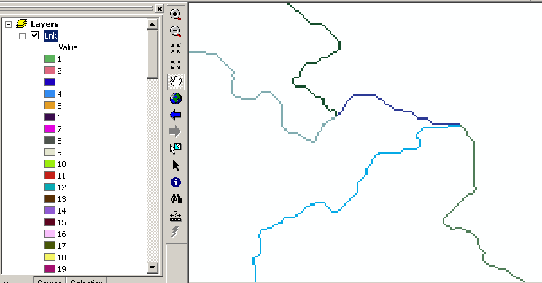

At this point, notice how each link has a separate value.

7. Catchment Grid Delineation
This function creates a grid in which each cell carries a value (grid code) indicating to which catchment the cell belongs. The value corresponds to the value carried by the stream segment that drains that area, defined in the stream segment link grid

Select Terrain Preprocessing | Catchment Grid Delineation.

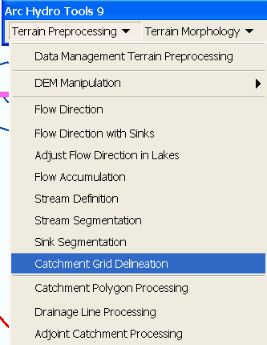

Confirm that the input to the Flow Direction Grid and Link Grid are “Fdr” and “Lnk” respectively. The output is the Catchment Grid layer. “Cat” is its default name that can be overwritten by the user.

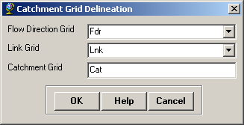

Press OK. Upon successful completion of the process, the Catchment grid “Cat” is added to the map. You can recolor the grid with unique values to get a nice display.

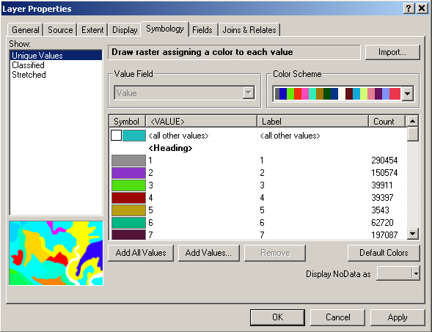

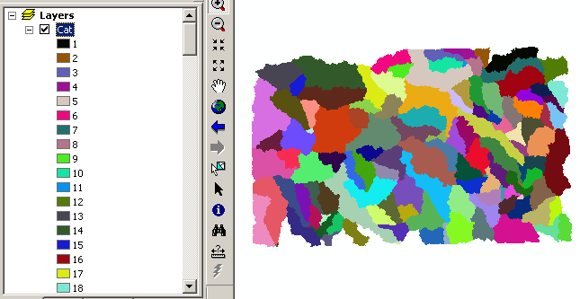

8. Catchment Polygon Processing
The three functions Catchment Polygon Processing, Drainage Line Processing and Adjoint Catchment Processing convert the raster data developed so far to vector format. The rasters created up to now have all been stored in a folder named "Layers". The vector data will be stored in a feature dataset also named "Layers" within the geodatabase associated with the map document. Unless otherwise specified under APUtilities→Set Target Locations the geodatabase inherits the name of the map document (Ex4.mdb in this case) and the folder and feature dataset inherit their names from the active data frame which by default is named "Layers".

Select Terrain Preprocessing | Catchment Polygon Processing.
This function converts a catchment grid into a catchment polygon feature.

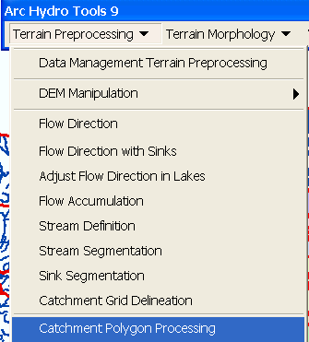

Confirm that the input to the CatchmentGrid is “Cat”. The output is the Catchment polygon feature class, having the default name “Catchment” that can be overwritten.

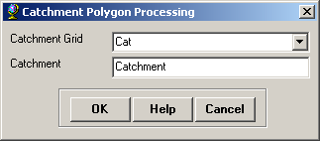
Press OK. Upon successful completion of the process, the polygon feature class “Catchment” is added to the map.
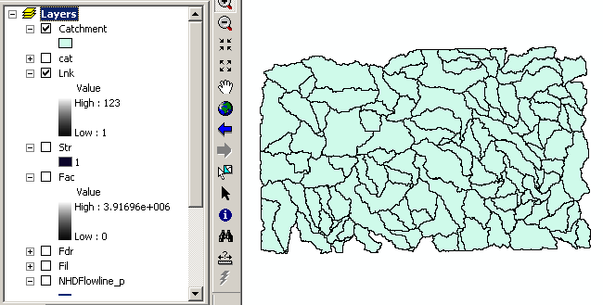

Open the attribute table of "Catchment". Notice that each catchment has a HydroID assigned that is the unique identifier of each catchment within ArcHydro. Each catchment also has Shape Length and Area attributes. These quantities are automatically computed when a feature class becomes part of a geodatabase.

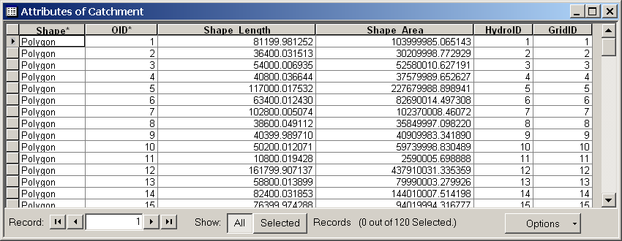

9. Drainage Line Processing
This function converts the input Stream Link grid into a Drainage Line feature class. Each line in the feature class carries the identifier of the catchment in which it resides.

Select Terrain Preprocessing | Drainage Line Processing.

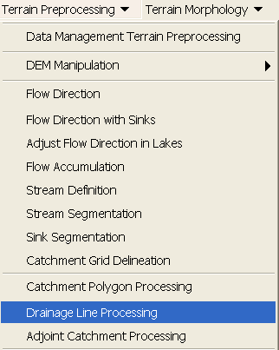

Confirm that the input to Link Grid is “Lnk” and to Flow Direction Grid “Fdr”. The output Drainage Line has the default name “DrainageLine”, that can be overwritten.
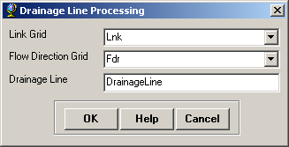

Press OK. Upon successful completion of the process, the linear feature class “DrainageLine” is added to the map.
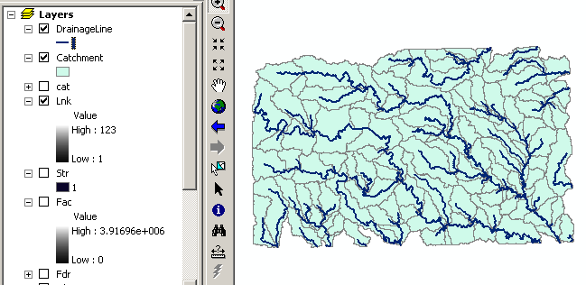

Compare the drainage lines delineated from the DEM procedure with the NHDPlus flowlines.

10. Adjoint Catchment Processing
This function generates the aggregated upstream catchments from the "Catchment" feature class. For each catchment that is not a head catchment, a polygon representing the whole upstream area draining to its inlet point is constructed and stored in a feature class that has an "Adjoint Catchment" tag. This feature class is used to speed up the point delineation process.

Select Terrain Preprocessing | Adjoint Catchment Processing.

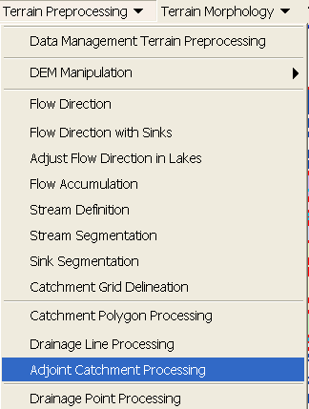

Confirm that the inputs to Drainage Line and Catchment are respectively “DrainageLine” and “Catchment”. The output is Adjoint Catchment, with a default name “AdjointCatchment” that can be overwritten.

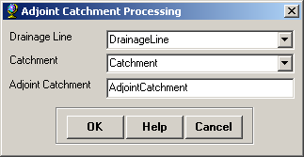
Press OK. Upon successful completion of the process, the polygon feature class “AdjointCatchment” is added to the map.
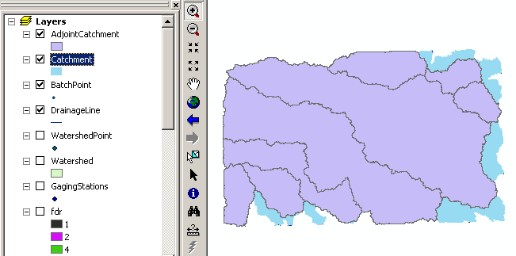

11. Drainage Point Processing
This function allows generating the drainage points associated to the catchments.

Select Terrain Preprocessing | Drainage Point Processing.

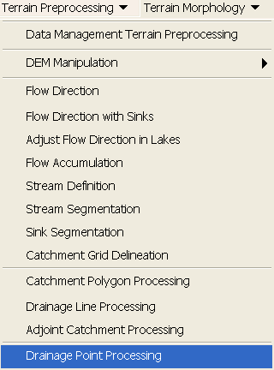

Confirm that the inputs are as below. The output is Drainage Point, having the default name “DrainagePoint” that can be overwritten.

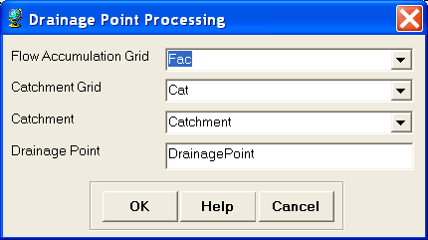

Press OK. Upon successful completion of the process, the point feature class “DrainagePoint” is added to the map.
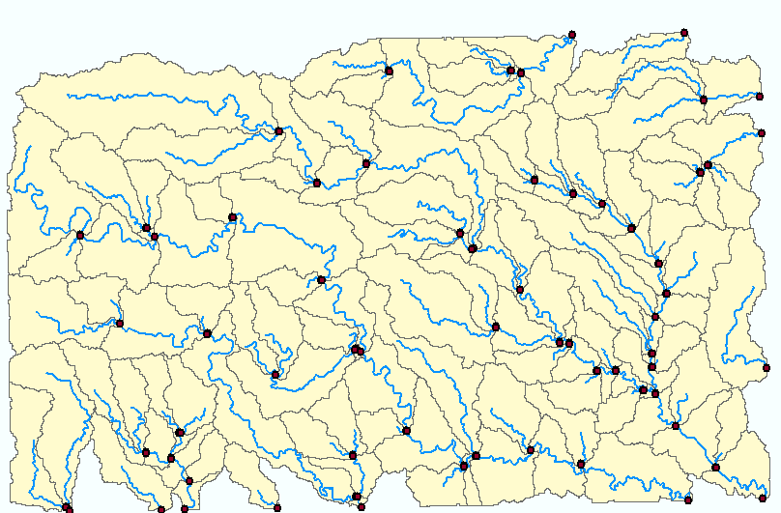
To turn in: How many DrainagePoints, DrainageLines and Catchments are there? What is the ID field in each feature class that associates the appropriate DrainagePoint with its DrainageLine and Catchment? Make a graphic showing how one associated DrainagePoint, DrainageLine and Catchment are related.

12. Drainage Density Evaluation
Now we will do some analysis to evaluate the drainage density of the San Marcos stream network. Drainage density is a fundamental property in Geomorphology because it specifies the scale where there is a transition from hillslope to channel processes. First we need to determine the drainage area of the San Marcos basin. We have one estimate from the flow accumulation grid above. How does this compare to area of the San Marcos subbasin HUC polygon?

The attribute table of the Subbasin feature class within the HydrologicUnits feature dataset in the NHDPlus geodatabase gives a shape area but the units of this are decimal degrees because the spatial reference of this feature class is geographic coordinates. To evaluate the area of the San Marcos Subbasin select it within the Subbasin feature class then right click on Subbasin in the table of contents and select Data→Export data:

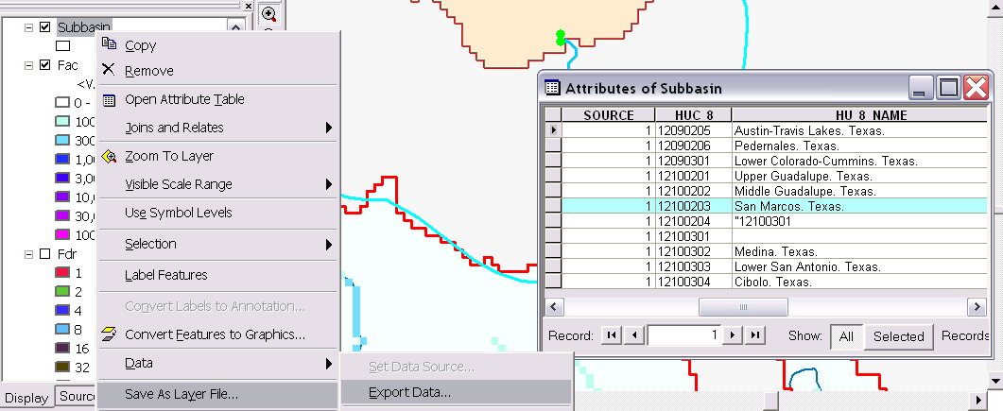

Designate the output feature class as one named SanMarcosSubbasin" within the project geodatabase feature dataset "Layers".

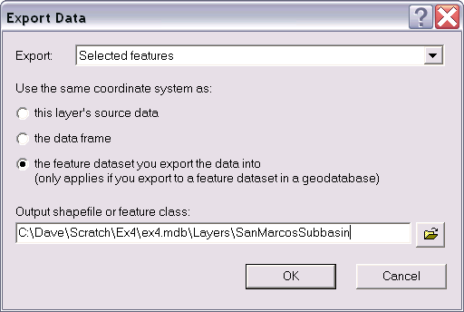

Click OK to add the exported data to the map. Open the attribute table of the feature class "SanMarcosSubbasin".

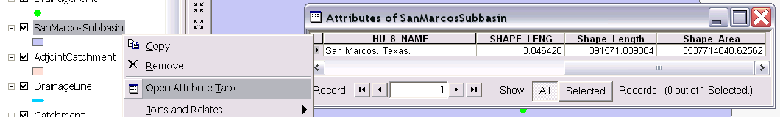

Notice that this has an attribute Shape Area that was created during the export of the feature class and is consistent with the spatial reference of the "Layers" feature dataset. This area is therefore in m² and may be compared to the drainage area obtained from flow accumulation. Note this drainage area.

Next we'll calculate the length associated with the DrainageLine feature class delineated from the DEM. This feature class includes streams outside the San Marcos basin. To obtain only those features within the San Marcos basin select: Selection→Select by Location

Select features from "DrainageLine" that intersect 'SanMarcosSubbasin" in the dialog below:

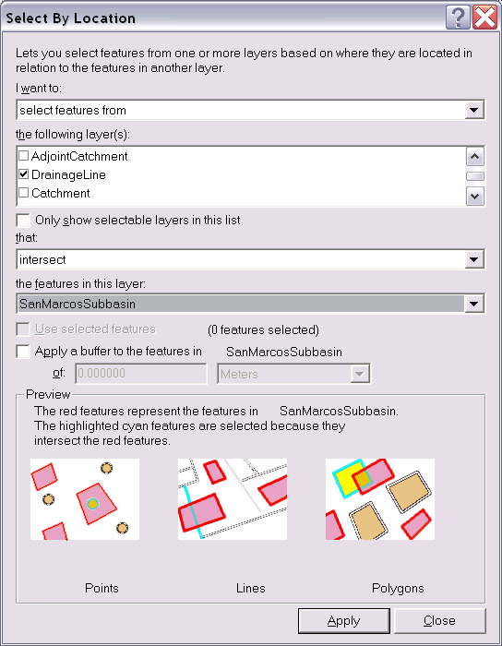

Click Apply and Close. The DrainageLine features that intersect with the San Marcos subbasin should be selected.

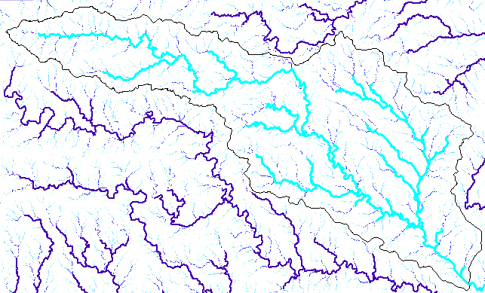

Open the attribute table associated with DrainageLine and Click Show "Selected"

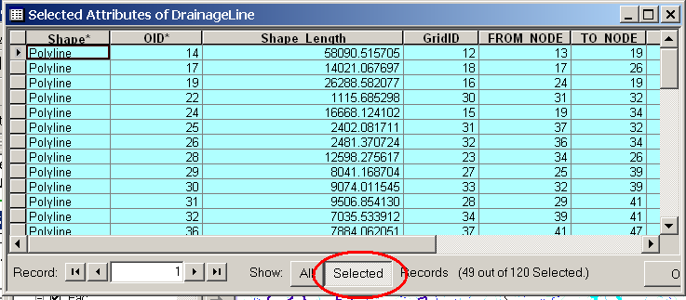

Right Click on Shape Length and select Statistics. Note the Sum in the statistics that are displayed. This represents the length of DrainageLine features that intersects with the San Marcos subbasin in meters. Note this result.

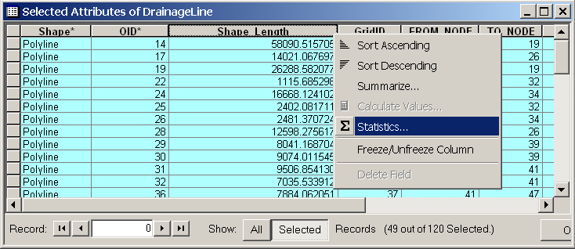

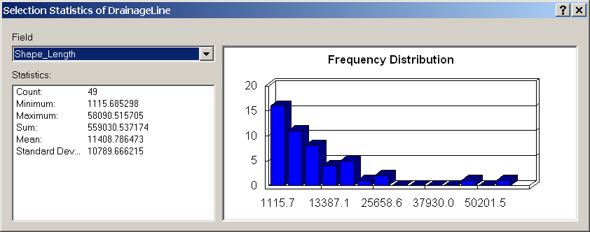

Export the selected DrainageLine features to a new feature class SanMarcosDrainageLine in the Layers feature dataset. Use this for preparing a map of the generated drainage lines for the San Marcos.

Use a similar procedure to select the features from the projected NHDFlowline feature class that intersect with Subbasin and use Statistics on Shape Length to obtain the total length of streams from NHDPlus. Export the selected NHDFlowline features to a new feature class SanMarcosNHDflowline. Use this for preparing a map of the NHD flow lines for the San Marcos Basin.

To turn in: A layout with a comparison of the generated DrainageLine and the NHDPlus river network for San Marcos. Make comments on this comparison and suggest ways to improve the match between them.

To turn in: Report the drainage area of the San Marcos basin in km² estimated from both the DEM flow accumulation and subbasin HUC. Report the length of streams in the San Marcos basin in km from both the DEM delineated drainage lines and NHDPlus flowlines. Calculate the drainage density (length/area) in km/km² for both the DEM delineated drainage lines and NHDPlus flowlines. Use the area that you feel is most appropriate. Comment on reasons for the differences in drainage density.

Watershed Processing
Arc Hydro also provides an extensive set of tools for delineating watersheds and subwatersheds. These tools rely on the datasets derived during terrain processing. This part of the exercise will expose you to some of the Watershed Processing functionality in Arc Hydro.

1. Batch Watershed Delineation
This function delineates the watershed upstream of each point in an input Batch Point feature class.

The Arc Hydro tools Batch Point Generation can be used to interactively create the Batch Point feature class. We will use this to locate the outlet of the watershed. Arrange your display so that the San Marcos HUC 8 outline (SanMarcosSubbasin), fac, DrainageLine and NHDFlowline_P datasets are visible. Zoom in near the outlet of the San Marcos basin (bottom right). The display should look similar to the below and be zoomed in sufficiently so you can see and click on individual grid cells. Our goal is to create an outlet point on the flow accumulation path indicated by "fac" where the flow leaves the San Marcos basin. Click on the icon in the Arc Hydro Tools toolbar. Click on the outlet grid cell where the SanMarcos Subbasin boundary (Subbasin) crosses the Fac flow path.
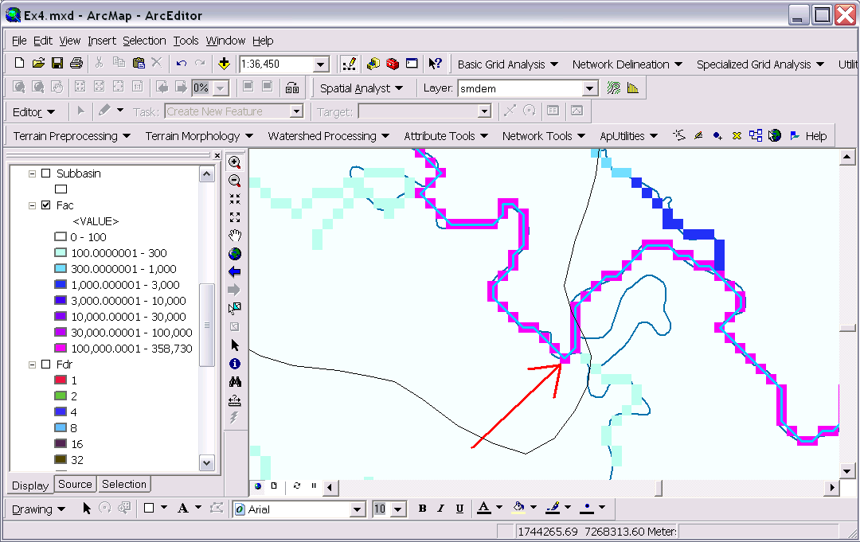

Confirm that the name of the batch point feature class is “BatchPoint”. A point is then created at the location of mouse click, and the following form is displayed:

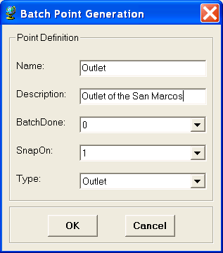
Fill in the fields Name and Description. Both are string fields. The BatchDone and SnapOn options can be used to turn on (select 1) or off (select 0) the batch processing and stream snapping for that point. Select the options shown above. The input information is saved in the attribute table of the BatchPoint feature class. Click OK. You should see that a single point feature class has been created comprising the outlet point where you clicked.

When snapping is turned on, if your point is sufficiently near to a drainage line (within around 5 grid cells) then the point will be snapped (i.e. moved) to a nearby drainage line before delineation of the upstream watershed, otherwise the local watershed draining to the point will be delineated. The following figure indicates the behavior you may expect from the delineation of watersheds upstream of input Batch Points.
To perform a batch watershed delineation
Select Watershed Processing | Batch Watershed Delineation.
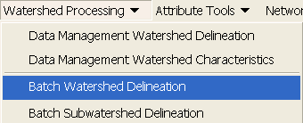

Confirm that “Fdr” is the input to Flow Direction Grid, “Str” to Stream Grid, “Catchment” to Catchment, “AdjointCatchment” to AdjointCatchment, and “BatchPoint” to “Batch Point”. For output, the Watershed Point is “WatershedPoint”, and Watershed is “Watershed”. “WatershedPoint” and “Watershed” are default names that can be overwritten.

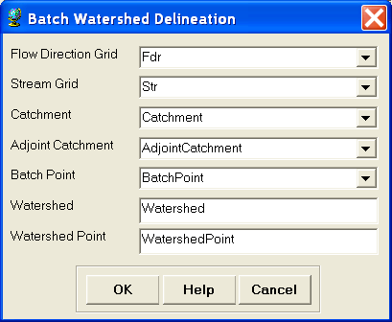
Press OK. The following message box appears on the screen, indicating that 1 point has been processed.

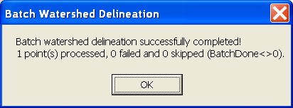

The delineated watersheds for the selected point should correspond closely to the outline of the San Marcos Watershed..

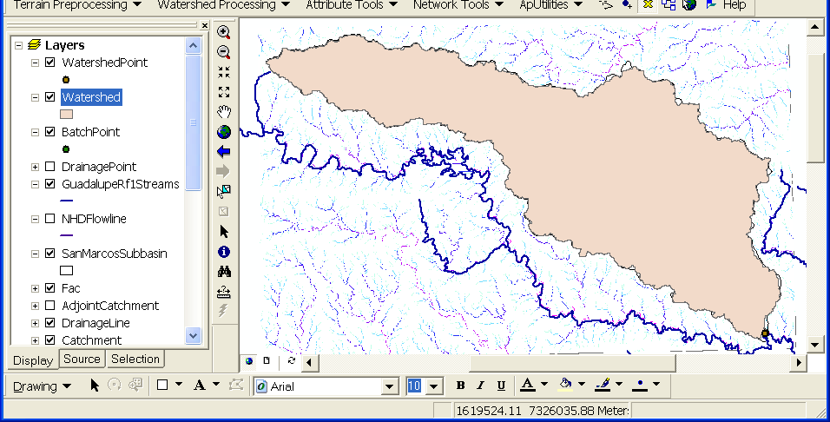

To be turned in: Make a layout showing the delineated watershed for your selected outlet. Report the Drainage Area of the watershed you delineated in km².

Delineating Watersheds from USGS gaging sites:

Add the USGSgage feature class from the Hydrography feature dataset within the NHDPlus.mdb geodatabase. Click OK if you receive the warning about the data being in a different projection. This is actually a "good" warning. It means that ArcGIS knows about the difference in projections and will project on the fly. These are the locations of the USGS gages within the San Marcos subbasin (a subset from http://water.usgs.gov/GIS/metadata/usgswrd/XML/streamgages.xml). Right click on USGSgage layer, and export the data to Ex4.mdb/Layers as a feature class named SanMarcosStreamGages. By saving this layer within the "Layers" feature dataset the system will do on the fly projection to the same spatial reference as the target feature dataset. Click OK to add the points to ArcMap.

To use these gages as watershed outlets these locations need to be appended to the Batchpoint feature class.

Open the Append tool in the Toolbox | Data Management Tools | General toolbox.

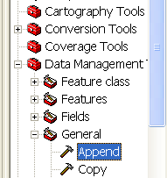

Set the input to SanMarcosStreamGages and Set the Output to BatchPoint. Click OK. Sometimes an append error occurs. I have been able to resolve this by saving the ArcMap document, closing it and then re-opening it.

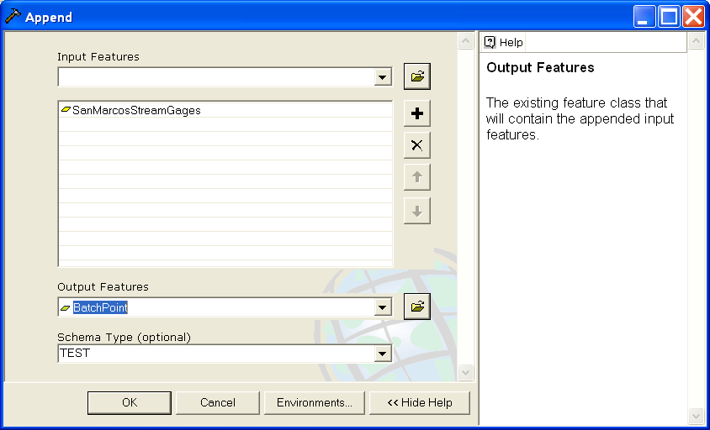

Open the BatchPoint Attribute table.

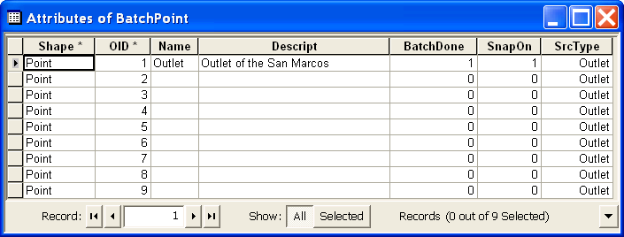

Notice that the 8 points from the SanMarcosStreamGages feature class have been appended to the outlet already there. To use these within Watershed Delineation we need to set the SnapOn field to 1. Right click on the SnapOn header and select Calculate Values.

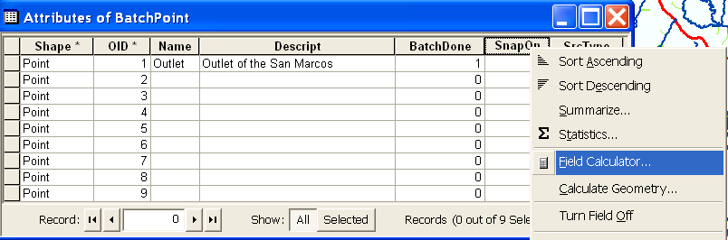

Click Yes to the field calculator warning about the calculations not being reversible.

Enter 1 in the SnapOn= field and click OK.
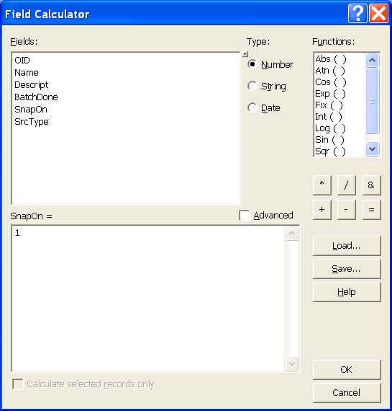

Notice that all the SnapOn values are now set to 1.

Close the attribute table and repeat the Watershed Processing→Batch Watershed Delineation function. The Watersheds draining to each stream gage should be delineated.
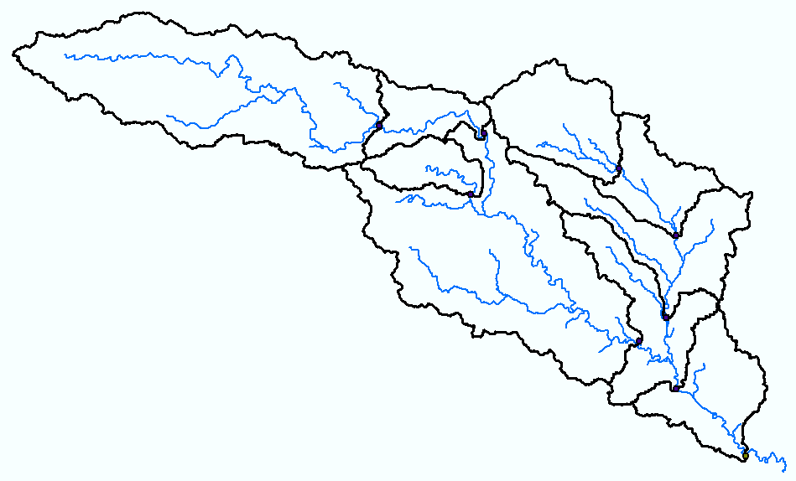

If you zoom in close to a gage location you will see that a WatershedPoint has been created on the stream very near to the USGS gage. This is the effect of snapping and accommodates the fact that USGS gage locations are not precisely aligned with the streams we delineated.
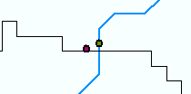

The attributes, such as names and USGS Site Number are not yet associated with the delineated watershed points. To remedy this we will use a Join based on spatial location to the USGSgage feature class. Right click on WatershedPoint/Joins and relates/Join

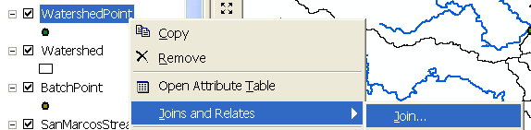

In the Join Data dialog specify Join data from another layer based on spatial location. Specify the layer to join to this layer as SanMarcosStreamGages. Under 2 specify each point given all the attributes in the layer closest to it. Specify the output feature class as Ex4.mdb\Layers\WatershedPointsWithStreamGages.

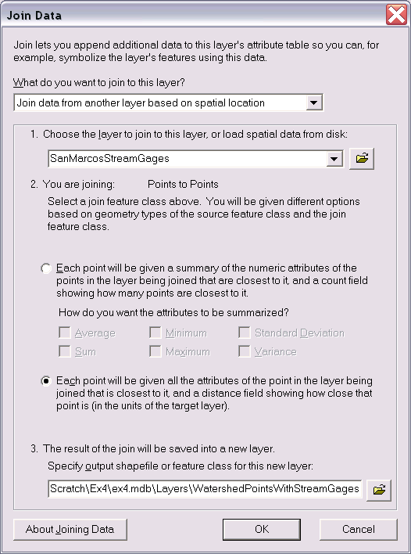

The attribute table of WatershedPointsWithStreamGages now includes all the USGS Stream Gaging site data. Open the attribute table of WatershedPointsWithStreamGages and scroll all the way to the right to see the last field "Distance".

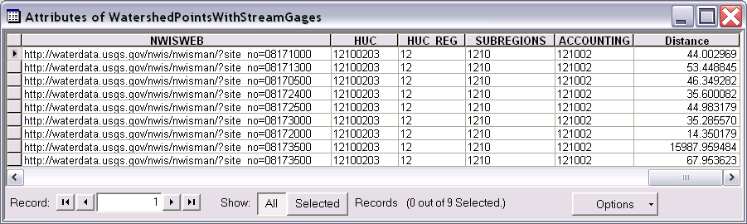

Notice that one watershed point has a very large distance compared to the others. This is the Outlet of the San Marcos feature which does not properly match with any USGS Gage and has been incorrectly associated with the nearest one, 15 km away. We will delete this particular record and only work with the USGS stream gage sites. To do this select View | Toolbars | Editor and then Editor | Start Editing. Select the Ex4.mdb that contains WatershedPointsWithStreamGages to edit.

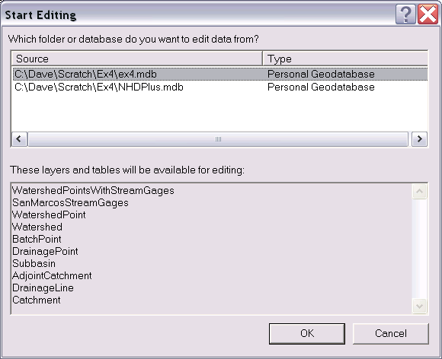

Select then delete the record containing the SanMarcos Outlet that we delineated.

We would now like to associate watershed attributes, such as drainage area from the Watershed feature class with these stream gages.

Open the attribute table for the "Watershed" feature class. Notice that it contains a field "HydroID". This is a unique identifier associated with each Watershed. The attribute table of "WatershedPointsWithStreamGages" contains fields "HydroID" and "DrainID". HydroID is again unique (i.e. different from the HydroID of Watersheds and all other objects) because Points are separate objects from Watersheds. The DrainID field gives the relationship between these tables with "DrainID" in WatershedPoints giving the HydroID of the corresponding Watershed. We can therefore join the Watersheds attribute table onto the WatershedPoints table to associate watershed attributes with their outlet points.

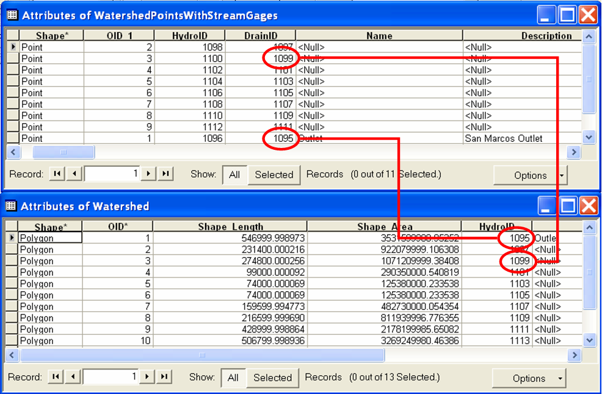

Right click on WatershedPointsWithStreamGages and select Joins and Relates/Join. Select to Join attributes from a table and select "DrainID" as the join field in this layer (WatershedPointsWithStreamGages). Select the "Watershed" table and HydroID field to join. Click OK.
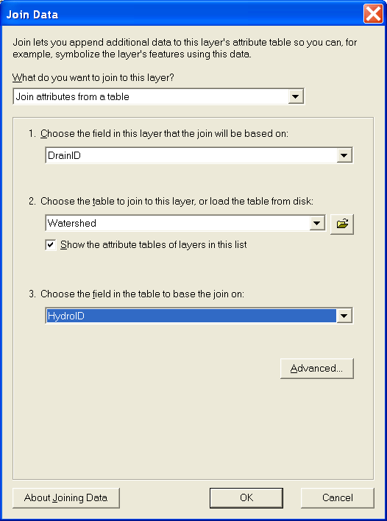

Click No to create index (indices are only really beneficial for large tables). Open the table attribute table for WatershedPointsWithStreamGages which now has watershed attributes joined to it. Note that this single (rather broad) table displays the watershed attributes adjacent to details of each stream gage. The most important attribute is Watershed area, because this is a quantity very important in properly interpreting streamflow. Click Options→Export to export the data into a DBF table.

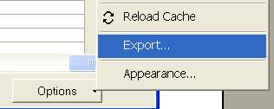

Open the DBF table that you obtain in Excel and use Excel to tidy it up and produce a presentation quality table that gives for each outlet point the following information:
Name, USGS site number, Watershed point HydroID, Watershed HydroID, Drainage area from ArcGIS (converted to km²), Drainage area from the USGS (converted to km²). The USGS area should be obtained from the field DA SQ MILE from the Stream gages table. Compare and comment on possible reasons for differences between the drainage area you get from ArcGIS and the drainage area that the USGS reports.

To be turned in: Make a layout showing the delineated watershed for each USGS Gauging Site. Label each watershed outlet with its contributing Drainage Area obtained from the Watershed Feature class. Prepare a table using Excel giving Name, USGS gage number, Watershed point HydroID, Watershed HydroID, Drainage area from ArcGIS (converted to km²), Drainage area from USGS (converted to km²). Discussion of differences between the drainage area you get from ArcGIS and the drainage area that the USGS reports.

2. Interactive Point Delineation

An alternative to delineate watersheds when you do not want to use the batch mode (process a group of points simultaneously) to generate the watershed for a single point of interest is the Point Delineation tool .
Click on the Point Delineation icon in the ArcHydro toolbar to activate the tool. Zoom in to the network and click the mouse (along the drainage line) to create your point of interest.
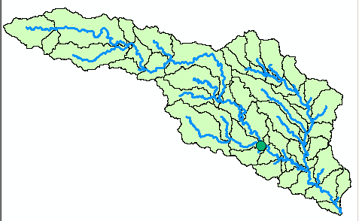
Click “Yes” if the following message is displayed.

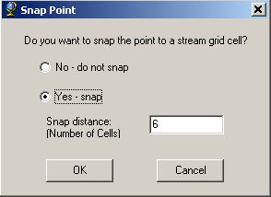

Press OK to snap the point to a stream grid cell (this form will not be presented if the point is already on the stream).
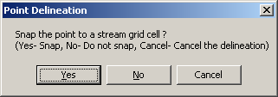
After the delineation is complete, fill in the name and comment as shown below in the form.

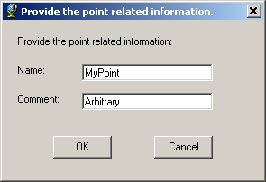

After all the information is fed, a watershed will be added to the “Watershed” feature class, and the point you created is added to the “WatershedPoint” feature class.

To show only the new watershed from the watershed feature class, use symbology→Unique Value→ use “Name” for the value field, and use Hollow symbols for other fields with “0” value for border width.

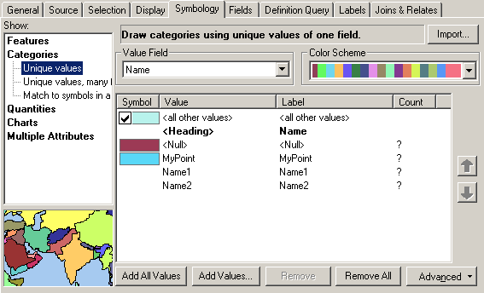

The delineated watershed for the selected point is shown below.
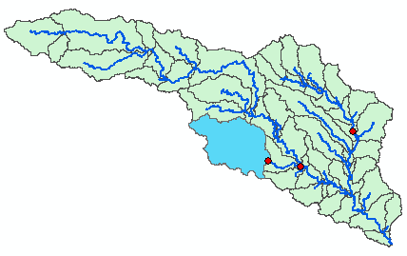

To be turned in: Make a layout showing the delineated watershed for your selected point including the DrainageLine and the Catchments

3. Batch Subwatershed Delineation
This function delineates subwatersheds for all the points in a selected Point Feature Class.
Input to the batch subwatershed delineation function is a point feature class with point locations of interest. In this context a watershed, such as was delineated above is the entire area upstream of a point, while a subwatershed is the area that drains directly to a point of interest excluding any area that is part of another subwatershed. Subwatersheds delineated from a set of points are therefore by definition non overlapping because the watershed draining to a point that is within another watershed is excluded from the subwatershed of the downstream point. On the other hand, watersheds may overlap. We will delineate subwatersheds from the same USGS stream gages plus outlet point as used for Watershed delineation.

Open the BatchPoint attribute table and use the field calculator to set BatchDone = 0. Select Watershed Processing | Batch Subwatershed Delineation.
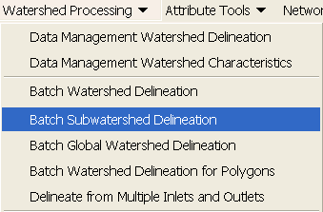
Confirm that the input to the Flow Direction Grid is “Fdr”, and the input to Stream Grid is “Str”. The output Subwatershed is named by default “Subwatershed”, and the output Subwatershed Point is named by default “SubwatershedPoint”.

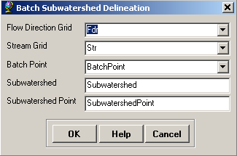
Press OK. The points are added to SubwatershedPoint, and the subwatersheds are added to Subwatershed. The delineated subwatersheds are shown below.

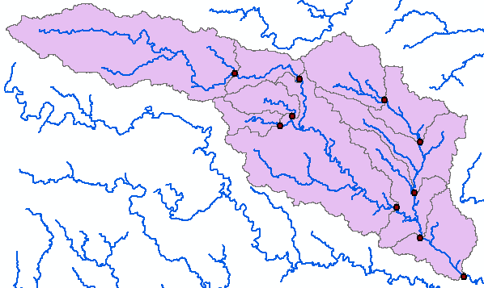

To be turned in: Make a layout showing the delineated subwatersheds the San Marcos stream gages and basin outlet point. Include the DrainageLine and the Catchments feature classes. Label each subwatershed with Area. This is the area draining directly to the subwatershed outlet point without first flowing through any other Watershed point. Prepare a table giving Name, USGS site number, watershed area and subwatershed area (converted km²) for each subwatershed. Show that the total watershed area is the sum of subwatershed areas.

4. Flow Path Tracing
Click on the Flow Path Tracing icon in the ArcHydro toolbar to activate the tool. If asked, confirm that the input of the Flow Direction Grid is “Fdr”.

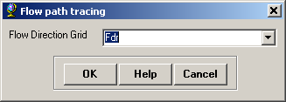

Click your mouse at any point to determine the flow path. The flow path defines the path of flow from the selected point to the outlet of the catchment following the steepest descent. If you select a point along the stream network, the flow path will follow the exact path of the stream.

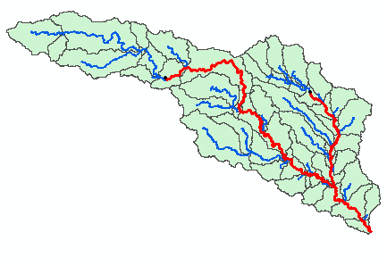

To be turned in: Make a layout showing the flow path for your selected point including the DrainageLine and the Catchments.

OK. You are done!

Summary of Items to turn in
- Screen captures that illustrate the effect of AGREE DEM Reconditioning. Show the location where you made a cross section as well as the DEM cross sections with and without reconditioning.
- Make a screen capture of the attribute table of Fdr and give an interpretation for the values in the Value field using a sketch.
- Report the drainage area of the San Marcos basin in both number of 100 m grid cells and km² as estimated by flow accumulation. Report the omitted drainage area assumed due to imprecise delineation at the location indicated on the southern edge, in both number of 100 m grid cells and km².
- How many DrainagePoints, DrainageLines and Catchments are there? What is the ID field in each feature class that associates the appropriate DrainagePoint with its DrainageLine and Catchment? Make a graphic showing how one associated DrainagePoint, DrainageLine and Catchment are related.
- A layout with a comparison of the generated DrainageLine and the NHDPlus river network for San Marcos. Make comments on this comparison and suggest ways to improve the match between them.
- Report the drainage area of the San Marcos basin in km² estimated from both the DEM flow accumulation and subbasin HUC. Report the length of streams in the San Marcos basin in km from both the DEM delineated drainage lines and NHDPlus flowlines. Calculate the drainage density (length/area) in km/km² for both the DEM delineated drainage lines and NHDPlus flowlines. Use the area that you feel is most appropriate. Comment on reasons for the differences in drainage density.
- Layout showing the delineated watershed for your selected outlet. Report the Drainage Area of the watershed you delineated in km².
- Layout showing the delineated watershed for each USGS Gauging Site. Label each watershed outlet with its contributing Drainage Area obtained from the Watershed Feature class. Prepare a table using Excel giving Name, USGS gage number, Watershed point HydroID, Watershed HydroID, Drainage area from ArcGIS (converted to km²), Drainage area from USGS (converted to km²). Discussion of differences between the drainage area you get from ArcGIS and the drainage area that the USGS reports.
- Layout showing the delineated watershed for your selected point including the DrainageLine and the Catchments.
- Layout showing the delineated subwatersheds the San Marcos stream gages and basin outlet point. Include the DrainageLine and the Catchments feature classes. Label each subwatershed with Area. This is the area draining directly to the subwatershed outlet point without first flowing through any other Watershed point. Prepare a table giving Name, USGS site number, watershed area and subwatershed area (converted km²) for each subwatershed. Show that the total watershed area is the sum of subwatershed areas.
- Layout showing the flow path for your selected point including the DrainageLine and the Catchments.

