GIS in Water Resources
Exercise 4 Addendum

This addendum is to clarify how to work around some problems that have been occurring in Exercise 4. The following problems have been reported.

- Error 13, Type Mismatch when trying to use ArcHydro functions.
- Page 22. Error with catchment polygon processing related to necessary extension not available
- Page 37 The append tool gives an error "SanMarcosStreamGages does not match the schema of target BatchPoint, Failed to execute".

Problems 1 and 2.
Both errors 1 and 2 are system errors that I believe are due to the incorrect APFramework having been installed with ArcHydro. This problem has been fixed in the Geomatics lab (ENGR225) so if you work there you should be OK. I have requested that this problem be fixed in the ENGR lab.

In the ENGR lab some computers have ArcGIS 9.1 and some have ArcGIS 9.2. Problems 1 and 2 do not occur with ArcGIS 9.1 so if you use a computer with ArcGIS 9.1 on it you should be OK. The exercise should work almost exactly the same with ArcGIS 9.1, however a few of the menu items are in a different place so screen shots will not be exactly as given in the exercise. You can use the command Help -> About ArcMap… to determine the ArcMap version.
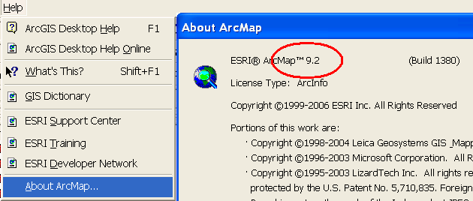

In ArcGIS 9.2 you need to uninstall and reinstall ArcHydro Tools and Water Utilities Application Framework9. To do this Open the Control Panel -> Add or Remove Programs.
Select Arc Hydro Tools 9 and click Change/Remove. Use the Automatic method and click Next till the removal is complete.
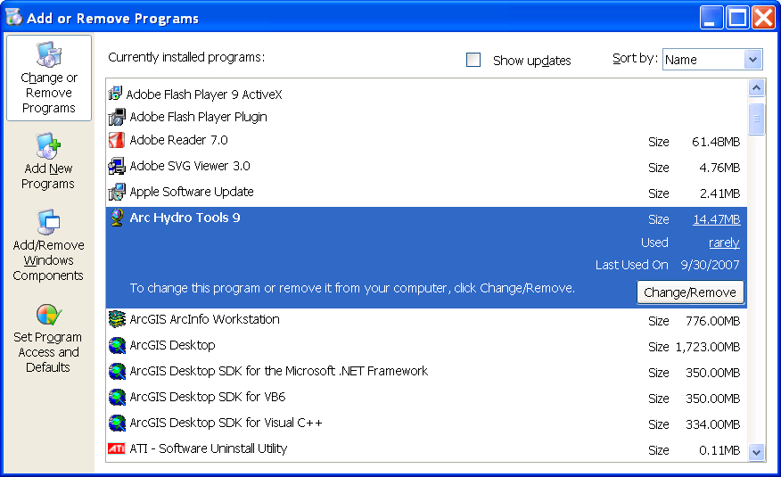

Then Select Water Utilities Application Framework9 and remove using the automatic method.
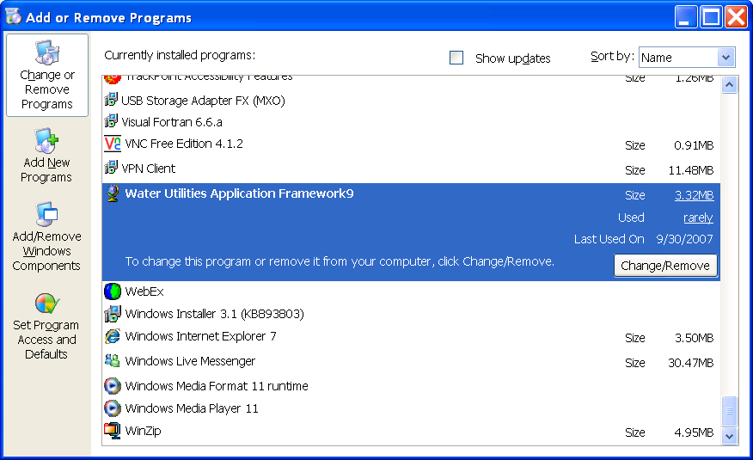

Download Arc Hydro Tools version 1.2 Final for ArcGIS 9.2 from http://support.esri.com/index.cfm?fa=downloads.dataModels.filteredGateway&dmid=15. 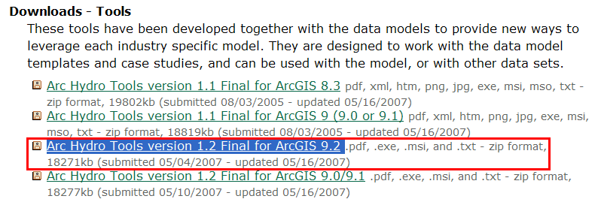

The downloaded zip file extracts into folders ApFramework92, ArcHydro92 1.2, and Documentation. Open Apframework92 and double click on the file ApFramework92_04242007_setup.EXE to install the ApFramework first. Then Open ArcHydro92 1.2 and double click on the file ArcHydro92_05042007_setup.exe to install ArcHydro.

Problem 3.
This problem is sometimes resolved by setting the schema type to NOTEST
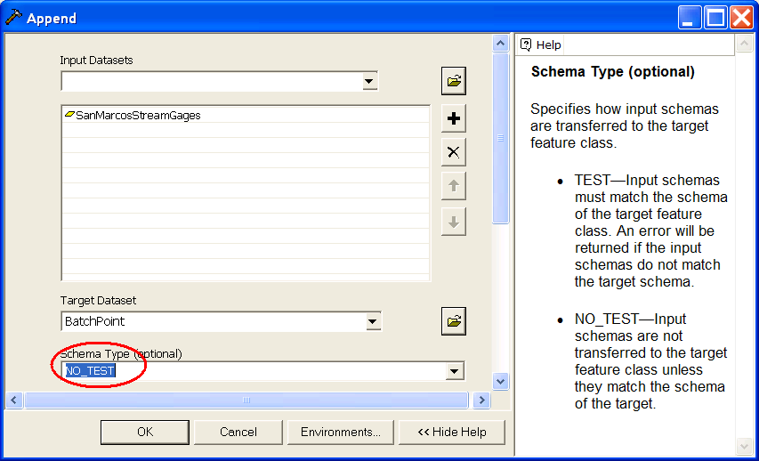

If that does not work, try the following.
Start Editing. Set the Editor target to batchpoint.
Open the attribute table for SanMarcosStreamGages (or the feature class that you want to copy points from ). Select all the records in this table. Select Edit->Copy followed by Edit->Paste from the main menu's. This will copy the selected points into the copy buffer then past them into the target layer being edited, resulting in the addition of the desired points to the BatchPoint feature class. Stop Editing, saving your edits, then proceed with the assignment.

