Addendum
Exercise 5: NHDPlus and Flow Networks

Prepared by Eric S. Hersh and David R. Maidment
GIS in Water Resources
Fall 2007

Goal

The purpose of this addendum is to learn how to develop longitudinal stream bed profiles of rivers and streams in ArcGIS using NHDPlus data. These profiles describe the way a stream’s elevation (vertical axis) changes over its distance downstream (horizontal axis).

Adding Data

Open ArcMap and from the SanMarcos_NHDPlus_Raw.mdb geodatabase, add the NHDFlowlineVAA and the flowlineattributesflow personal geodatabase tables, the NHDFlowline feature class from the Hydrography feature dataset, and the Subbasin feature class from the HydrologicUnits feature dataset. Save your map display as SanMarcosProfile.mxd.

Here is the map that I created:

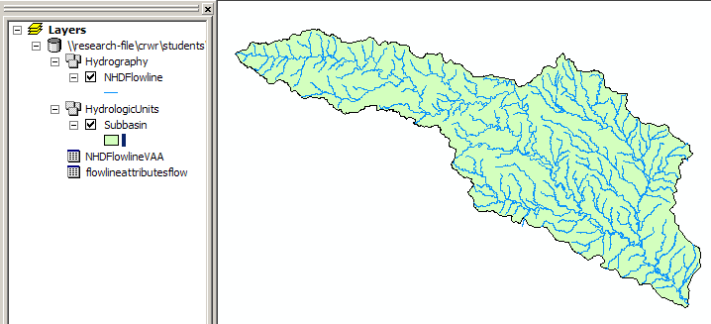

Selecting the San Marcos River and Assembling Relevant Data

As you have previously seen in this exercise, the key field that links the attribute tables with the features is COMID. We need to use data from the two personal geodatabase tables, so we’ll join both of them to the NHDFlowline feature class. Right click on the NHDFlowline feature class and select Joins and Relates/Join, fill in the fields as shown below, and say Yes when you are asked to do Indexing to support the relationship.

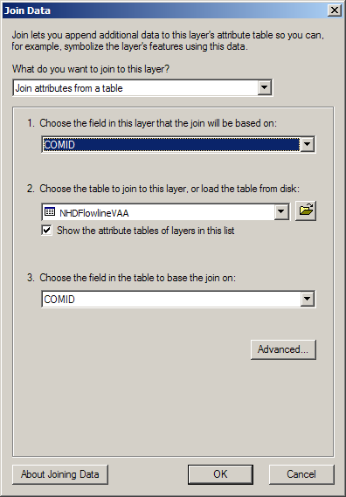

Next, right click again on the NHDFlowline feature class and select Joins and Relates/Join, fill in the fields as shown below, and again say Yes when you are asked to Index.
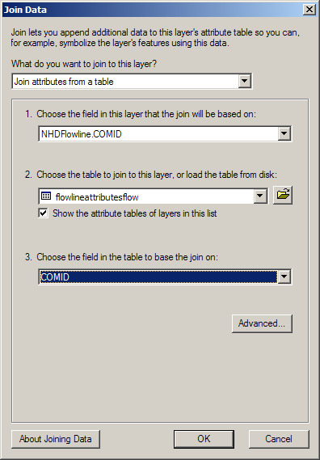

Now we have quite a bit of information linked to the NHD flowlines regarding flow (e.g.: velocity, elevation, slope, and drainage area) and network position (e.g.: stream order, stream level, path length, divergence, sequence); feel free to look through the joined attribute table.

We are going to develop a longitudinal stream bed profile for the San Marcos River main stem only, so next we need to select to San Marcos River reaches from the entire NHDFlowline feature class within the geodatabase.

Right click on the NHDFlowline feature class and select Open Attribute Table. In the attribute table, click the Options button and select Select By Attributes, then fill in the fields as shown below (it’s important to get the text, punctuation, and spacing exactly right here); click Apply.
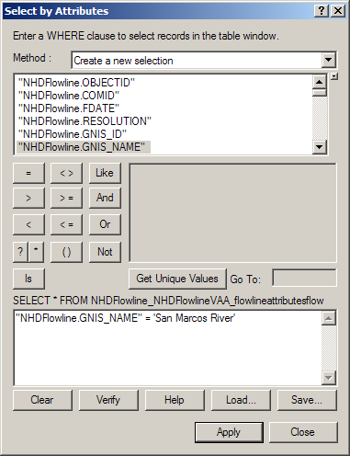

You should have 39 of the 557 records selected (as shown below); these are the all of the reaches of the San Marcos River.

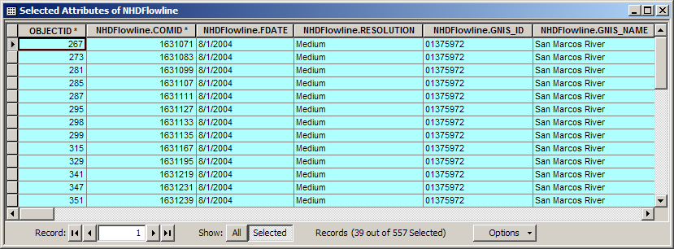

Since we are only interested in the San Marcos River, we are going to export these selected reaches as a new feature class. Go ahead and close the attribute table window.

Next, right click on the NHDFlowline feature class and select Data → Export Data. Export selected features as a File and Personal Geodatabase Feature Class named SanMarcosRiver within the Hydrography feature dataset in the SanMarcos_NHDPlus_Raw.mdb geodatabase, as shown below. Click Yes to add the exported data to the map as a layer.

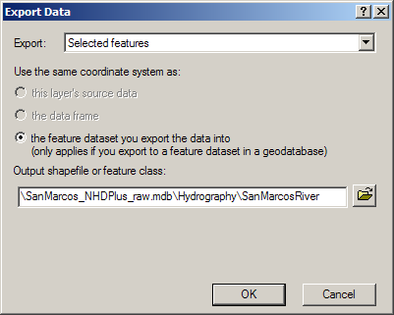

The new SanMarcosRiver feature class should look something like the blue line here:
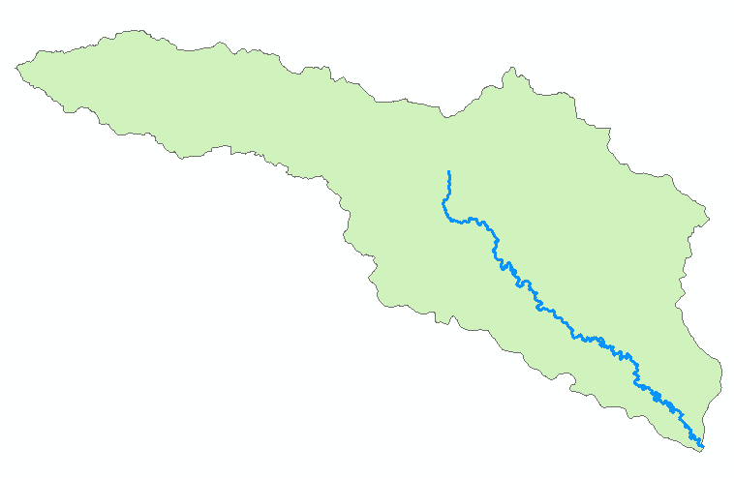

Graphing the Profile

All of the steps so far have been prep work- here comes the cool part!

From the Menu bar, select Tools → Graphs → Create. This will take us to the Create Graph Wizard.
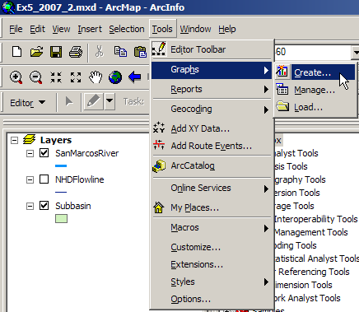

In the Create Graph Wizard, fill in the fields as shown below. You can choose whatever color, transparency, and border you like and feel free to experiment with the other controls in the Wizard.

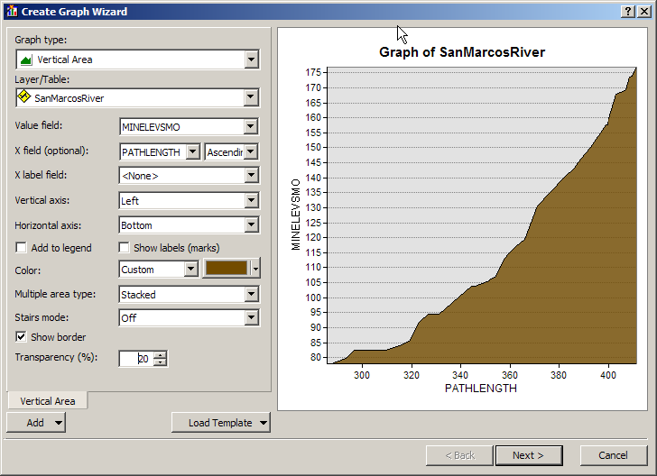

Here we are using the MINELEVSMO attribute from the flowlineattributesflow table as the Value field; the minimum elevation (smoothed) attribute is the lowest elevation within each stream reach, in meters above sea level.

We are plotting this elevation value as the Y axis against the PATHLENGTH attribute from the NHDFlowlineVAA table as the X axis. This attribute is the “distance to terminal flowline downstream along the main path.” In our case, this means distance along the San Marcos River to its confluence with the Guadalupe River, then distance along the Guadalupe River to the San Antonio River and San Antonio Bay near the Gulf of Mexico. PATHLENGTH is measured in kilometers from the terminal flowline. In our case, the terminal flowline is the last reach of the San Antonio River before it flows into San Antonio Bay.

Once you have filled in the fields in the initial Wizard screen, click Next and fill in the next set of fields as shown.

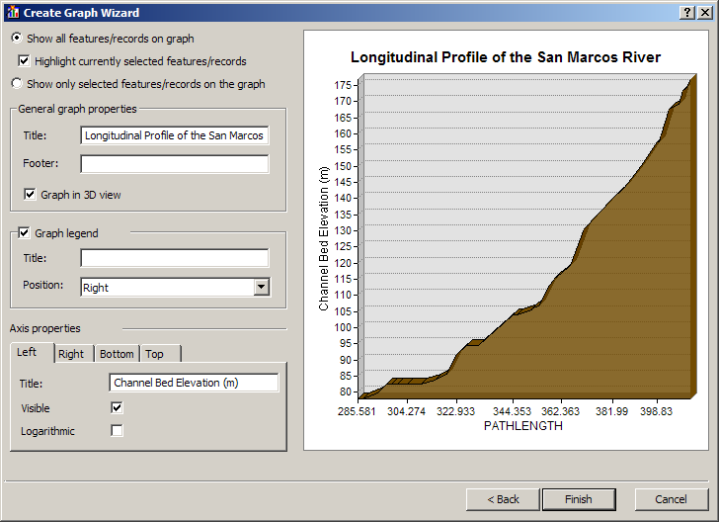

Also be sure to label the Bottom axis in the same screen:

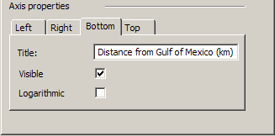

After you have finished the Create Graph Wizard, you will get a profile which is nearly done- one more step and the graphic will make much more sense!

Right click anywhere on the Graph Window and Select Advanced Properties:

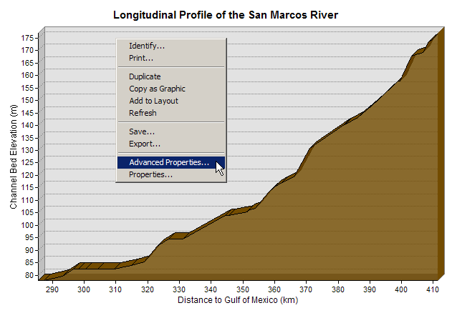

Select Axis from the Chart tree in the Table of Contents, click Bottom Axis from the list of Axes, and on the Scales Tab, click the Inverted check box. Again, feel free to experiment with the settings here.

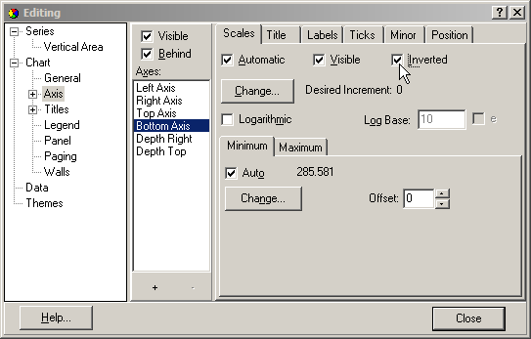

Click Close, and voila- a longitudinal stream bed profile of the main stem of the San Marcos River from its source at the San Marcos Springs to its confluence with the Guadalupe River!

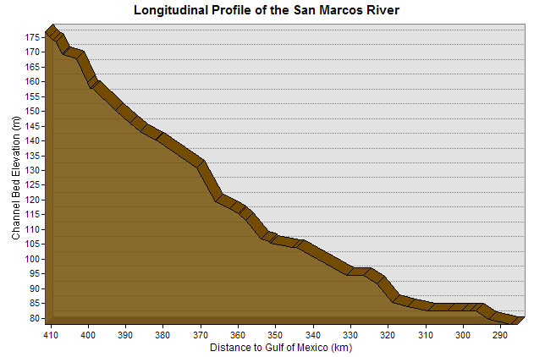

Here we can see that the San Marcos River is quite steep in its headwater region near the San Marcos Springs and the City of San Marcos and quite a bit gentler downstream through Luling, Ottine, and eventually at the confluence with the Guadalupe River near the City of Gonzales.

This concave longitudinal stream bed profile is characteristic of many rivers of the world, with steeper headwaters emanating in mountains or hills and a less steep outlet near the base control (ocean, lake, or larger river).

To be turned in:

(8) To be turned in: A graph of the longitudinal stream bed profile of the San Marcos River main stem with nice labels, axes, and colors.

